Update _2_0_171

Clinical Reminders

VA-COVID 19 TEMPLATE UPDATES

Install Guide

October 2020

Product Development
Office of Information Technology
Department of Veterans Affairs

Table of Contents
Introduction 1
Install Details 3
Install Example 4
Post Installation 7

Introduction

DESCRIPTION OF CHANGES:
- Update to the Covid 19 status adjustment clinical status:
Definition of COVID-19 RESOLVED matches prior updates to the other templates to reflect current CDC criteria:

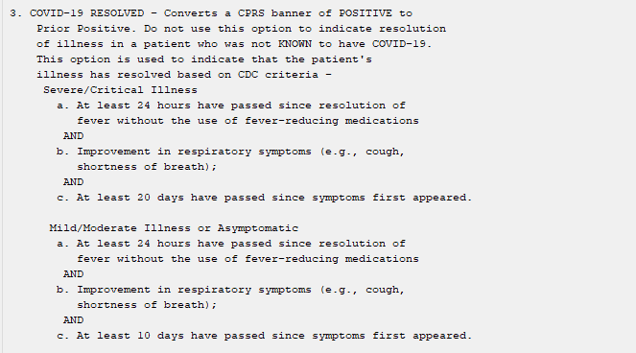

- Update to the Outside Lab section in the status adjustment, outside lab and telephone follow up templates:
- Added option to document NON-PCR ANTIGEN TEST done outside the VA:

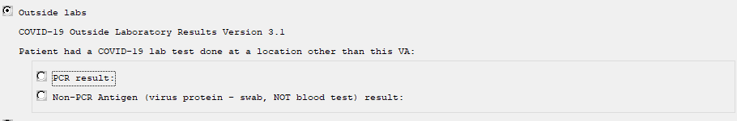

- The options to document a PCR Result were updated to simplify the wording:

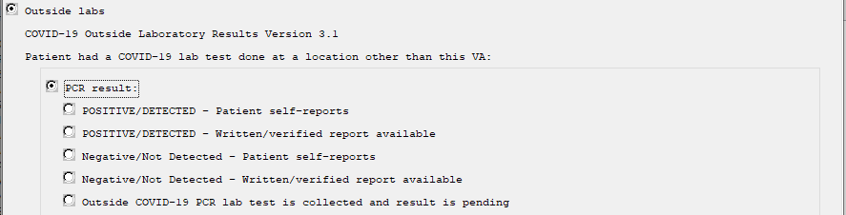
- The positive, negative and pending options should all impact the banner

- A new Non-PCR option was added:
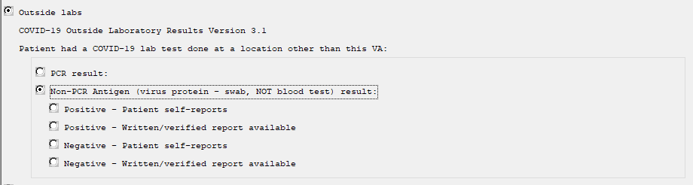
- Only the POSITIVE result will impact the banner as it is not clear clinically what a negative result indicates
- There is no pending result option as this test is a rapid test

- The reminder dialog groups used in the COVID-19 Telephone Follow Up note that indicate a patient can stop home isolation were changed to a class of local, these dialog groups are currently set to exclude from progress note, sites can change that locally if they would like to. The naming convention starts with VA instead of VAL but you should still be able to edit if needed:
VA-COVID-19 FOLLOW-UP CARE SEVERE ILLNESS 20D
VA-COVID-19 FOLLOW-UP CARE IMPROVE 10D
VA-COVID-19 FOLLOW-UP CARE SEVERE ILLNESS STABLE 20D
VA-COVID-19 FOLLOW-UP CARE STABLE 10D
VA-COVID-19 FOLLOW-UP CARE NOT IMMUNOCOMPRO 10D CRITERIA
VA-COVID-19 FOLLOW-UP CARE IMMUNOCOMPRO 20D GUIDELINES

UPDATE_2_0_171 contains 1 Reminder Exchange entry:
UPDATE_2_0_171 VA-COVID-19 TEMPLATE UPDATES

The exchange file contains the following components:

HEALTH FACTORS
VA-REMINDER UPDATES
VA-UPDATE_2_0_171
VA-COVID-19
VA-COVID-19 NON PCR AG LAB OUTSIDE POS
VA-COVID-19 OUTSIDE PCR SPEC COLLECTED
VA-COVID-19 PCR LAB OUTSIDE NEGATIVE
VA-COVID-19 PCR LAB OUTSIDE POSITIVE
VA-COVID-19 IMPROVE RELEASE ISOLATION
VA-COVID-19 STABLE RELEASE ISOLATION
VA-COVID-19 NON PCR AG LAB OUTSIDE NEG

REMINDER TERM
VA-REMINDER UPDATE_2_0_171
VA-COVID-19 OUTSIDE RESULTS
VA-COVID-19 OUTSIDE PCR LAB POSITIVE

REMINDER DIALOG
VA-COVID-19 UPDATE OCT 2020

Install Details

This update is being distributed as a web host file. The address for the host file is: https://REDACTED /UPDATE_2_0_171.PRD.
The file will be installed using Reminder Exchange, programmer access is not required.

Installation:
=============
This update can be loaded with users on the system. Installation will take less than 10 minutes.

Install Example
To Load the Web Host File. Navigate to Reminder exchange in Vista
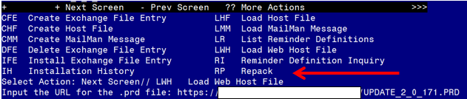

At the Select Action: prompt, enter LWH for Load Web Host File
At the Input the url for the .prd file: prompt, type the following web address:
https://REDACTED /UPDATE_2_0_171.PRD

You should see a message at the top of your screen that the file successfully loaded.

Search and locate an entry titled UPDATE_2_0_171 VA-COVID TEMPLATE UPDATES in reminder exchange. 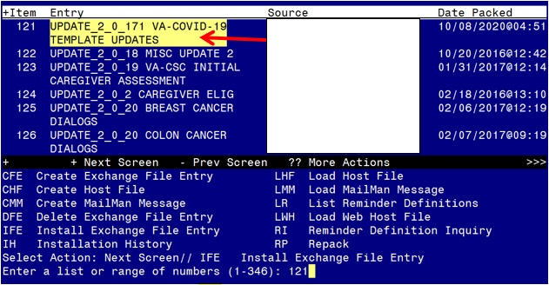

At the Select Action prompt, enter IFE for Install Exchange File Entry
Enter the number that corresponds with your entry UPDATE_2_0_171 VA-COVID TEMPLATE UPDATES (in this example it is entry 121 it will vary by site). The date of the exchange file should be 10/06/2020.
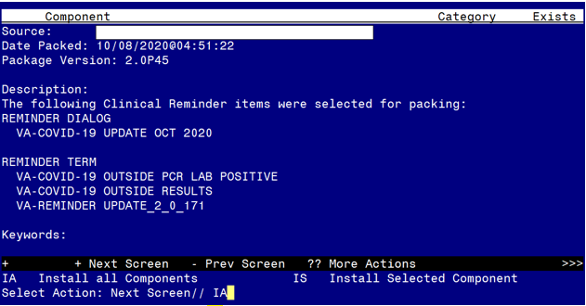

At the Select Action prompt, type IA for Install all Components and hit enter.
Select Action: Next Screen// IA Install all Components
You will see several prompts, for all new entries you will choose I to Install
For components that already exists but the packed component is different, you will choose O to OVERWRITE.

You will be promped to install the reminder dialog component – You will choose to install all even though the components have an X to indicate that they exist. These components have been updated and should be installed. 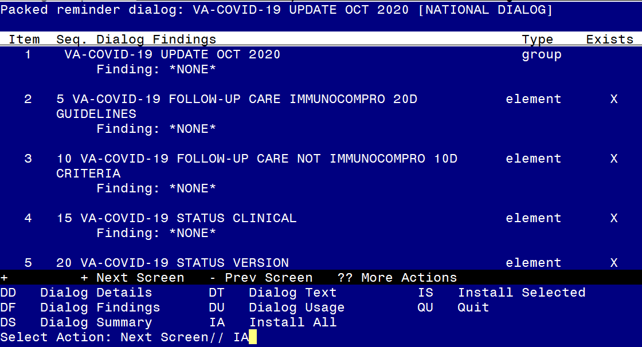
At the Select Action prompt, type IA to install the dialog – VA-COVID-19 UPDATE OCT 2020
Select Action: Next Screen// IA Install All
Install reminder dialog and all components with no further changes: Y// Yes
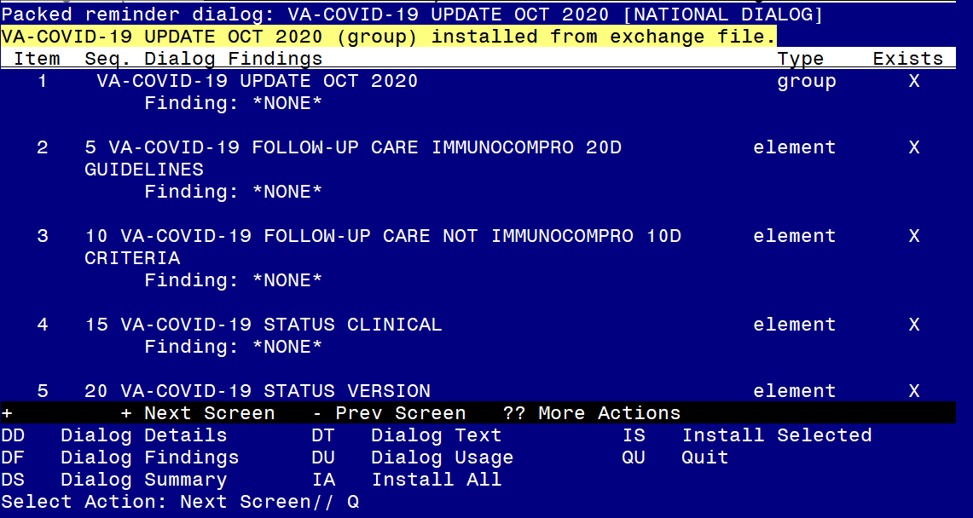

After completing this dialog install, you will type Q.
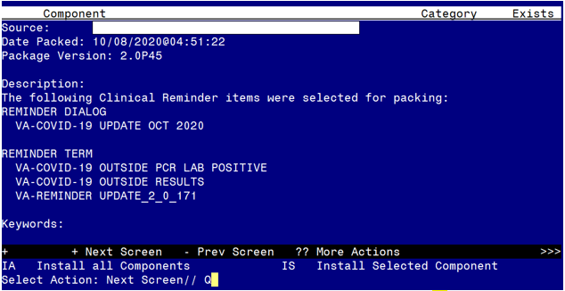

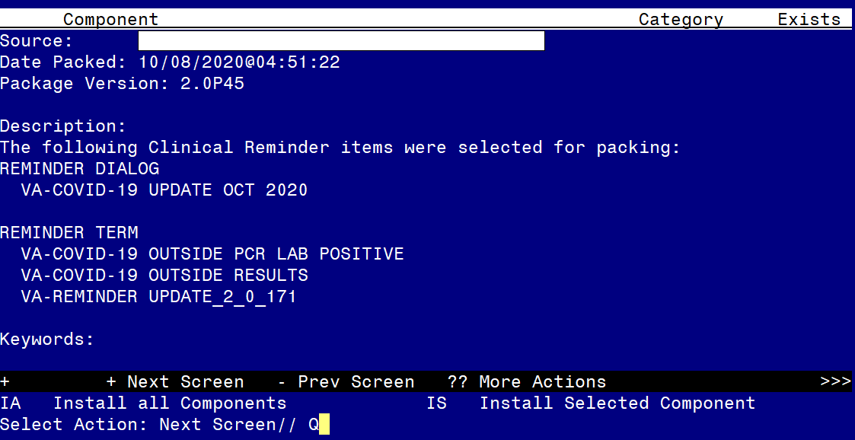
You will then be returned to this screen. At the Select Action prompt, type Q.

Install complete.

Post Installation

- Open the outside lab section in any of the COVID-19 templates and confirm that the version number is 3.1

