

**Update _2_0_172**

Clinical Reminders

VA-IMMUNIZATION REMINDER UPDATE

Install Guide

**OCTOBER 2020**

Product Development

Office of Information Technology

Department of Veterans Affairs

Table of Contents

Introduction 1

Pre-Install 5

Install Details 6

Install Example 6

Post Installation 9

# Introduction

DESCRIPTION:

An option to document that the reminder was addressed on a virtual/telehealth visit was added to the reminder dialogs for the following immunization clinical reminders:

Pneumococcal PPSV23 (Pneumovax)

Pneumococcal PCV13 (Prevnar13)

Herpes Zoster (Shingles) Vaccine

Meningococcal ACWY Immunization

Meningococcal B Immunization

Hepatitis B Serology/Immunization

Hepatitis B Immunization

Human Papillomavirus (HPV)

Here is one example:

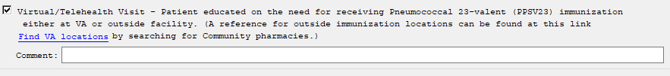

The national influenza reminder was updated.

* The language on the virtual care option was updated to include the VA location search
* The option to document that someone else administered the vaccine was edited and disabled and should no longer be available in the dialog by default:

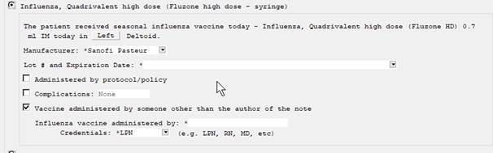Before:

After:

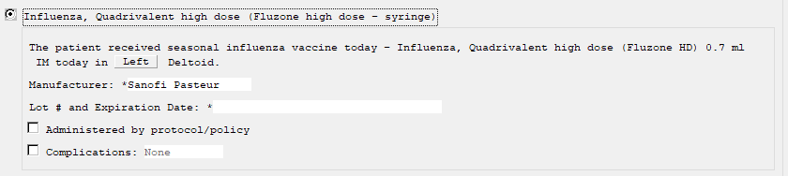

This update includes only the reminder dialog groups that the virtual option was added to, these dialog groups also contain the options to document administration of the immunizations. The administration groups were set to a class of local and many sites may have changed the wording or elements within these dialog groups. **Your local dialog changes will get over-written during installation**. It is important that you print out the reminder dialog groups in the preinstall to assist you in putting back any items that you had made local changes to post install.

UPDATE_2_0_172 contains 1 Reminder Exchange entry:

**UPDATE_2_0_172 VA-IMMUNIZATION UPDATE**

**The exchange file contains the following components:**

**TIU TEMPLATE FIELD**

EDIT 20+ REQ

VA-LOCATIONS

IM PNEUMO PRECAUT WARNING

IM PNEUMO CONTRA WARNING

IM PNEUMO PPSV23 DIAGNOSES

IM PNEUMO PPSV23 OUTSIDE RECORD

IM PPSV23 LOT# EXP DATE

IM COMMENT COMPLICATONS

IM VIS PPSV23 URL

IM VIS PPSV23 DT

IM PPSV23 MANUF

IM INJECTION RIGHT/LEFT

IM PNEUMO PCV13 DIAGNOSES

IM PCV13 LOT# EXP DATE

IM VIS PCV13 URL

IM VIS PCV13 DT

IM PCV13 MANUF

IM VACCINE PRECAUT WARNING

IM VACCINE CONTRA WARNING

IM MENING B LOT# EXP DATE

IM VIS MENING B URL

IM VIS MENING B DT

IM MENING B MANUF

IM MENING ACWY LOT# EXP DATE

IM VIS MENING ACWY URL

IM VIS MENING ACWY DT

IM MENING ACWY MENVEO MANUF

IM VIS HPV9 DT

IM HPV LOT# EXP DATE

IM HPV MANUF

IM INJECTION SQ SITE

IM ZOSTER SHINGRIX INFO URL

IM VIS ZOSTER SHINGRIX DT

IM ZOSTER LOT# INFORMATION

IM ZOSTER LOT# EXP DATE

IM ZOSTER SHINGRIX MANUF

IM VIS HBV URL

IM VIS HAV URL

IM VIS HBV DT

IM VIS HAV DT

IM HAV/HBV ADJ LOT# EXP DATE

IM HAV/HBV MANUF

IM VIS HBV ADJ URL

IM HBV ADJ LOT# EXP DATE

IM HBV ADJ MANUF

IM HBV LOT# EXP DATE

IM HBV MANUF

IM HBV DOSE

**HEALTH FACTORS**

VA-REMINDER UPDATES

VA-UPDATE_2_0_172

IMMUNIZATION

VA-FLU EDUCATION VIRTUAL/TELEHEALTH VST

VA-HBV AB EDUCATION VVC/TELEHEALTH VST

HEPATITIS B

HEPATITIS B SEROLOGY NOT INDICATED

REFUSED HEPATITIS B SEROLOGY

OUTSIDE SEROLOGY

OUTSIDE HEPATITIS B SURFACE AG POSITIVE

OUTSIDE HEPATITIS B SURFACE AG NEGATIVE

OUTSIDE HEPATITIS B SURFACE AB POSITIVE

OUTSIDE HEPATITIS B SURFACE AB NEGATIVE

OUTSIDE HEPATITIS B CORE AB POSITIVE

OUTSIDE HEPATITIS B CORE AB NEGATIVE

VA-PPSV23 EDUCATION VVC/TELEHEALTH VST

PNEUMOCOCCAL PPSV23 VACCINE PRECAUTION

PNEUMOCOCCAL PPSV23 VACCINE CONTRAIND

PNEUMOCOCCAL PPSV23 DX INCORRECT

REFUSED PNEUMOC VACCINE PPSV23

VA-PCV13 EDUCATION VVC/TELEHEALTH VST

PNEUMOCOCCAL PCV13 VACCINE PRECAUTION

PNEUMOCOCCAL PCV13 VACCINE CONTRAIND

PNEUMOCOCCAL PCV13 DX INCORRECT

REFUSED PNEUMOC VACCINE PCV13

VA-MEN B EDUCATION VVC/TELEHEALTH VST

MENINGOCOCCAL B DISEASE RISK

MENINGOCOCCAL B DISEASE - NOT AT RISK

MENINGOCOCCAL B DEFERRAL TEMPORARY

MENINGOCOCCAL ACWY DEFERRAL TEMPORARY

MENINGOCOCCAL B DEFERRAL PERMANENT

REFUSED MENINGOCOCCAL B VACCINE

VA-MEN ACWY EDUCATION VVC/TELEHEALTH VST

MENINGOCOCCAL ACWY DISEASE RISK

MENINGOCOCCAL ACWY DISEASE - NOT AT RISK

MENINGOCOCCAL ACWY DEFERRAL PERMANENT

REFUSED MENINGOCOCCAL ACWY VACCINE

VA-HPV EDUCATION VVC/TELEHEALTH VST

VA-HPV

VA-HPV DECLINED PERMANENTLY

VA-HPV PRECAUTION

VA-HPV CONTRAINDICATED

VA-HPV DECLINED

VA-ZOSTER EDUCATION VVC/TELEHEALTH VST

ZOSTER IMMUNIZATION

HERPES ZOSTER VACCINE UNAVAILABLE

HERPES ZOSTER IMMUN PRECAUTION

HERPES ZOSTER IMMUN CONTRAINDICATION

DECLINES HERPES ZOSTER IMMUNIZATION

VA-HEP B EDUCATION VVC/TELEHEALTH VST

HEPATITIS B VACCINATION DEFER TEMPORARY

HEPATITIS B VACCINATION NOT INDICATED

REFUSED HEPATITIS B VACCINE

**REMINDER SPONSOR**

NATIONAL CENTER FOR HEALTH PROMOTION AND DISEASE PREVENTION (NCP)

VA National Center for Health Promotion and Disease Prevention (NCP)

Office of Patient Care Services

**REMINDER TAXONOMY**

VA-PNEUMOC PPSV23 IMMUNIZATION

VA-PNEUMOC PCV13 IMMUNIZATION

VA-IMMUNIZATION INJECTION 90471

**REMINDER TERM**

VA-REMINDER UPDATE_2_0_172

VA-AGE >64

VA-PNEUMOC PPSV23 ORDER SUPPRESSION

VA-PNEUMOC PCV13 ORDER SUPPRESSION

VA-MENING B ADMIN SUPPRESSION

VA-MENING B ORDER SUPPRESSION

VA-MENING ACWY ADMIN SUPPRESSION

VA-MENING ACWY ORDER SUPPRESSION

VA-HPV DECLINE VACCINE PERMANENTLY (BL)

VA-HPV ADMINISTRATION SUPPRESSION

VA-HPV VACCINES

VA-HPV BL SERIES 2 VACCINES

VA-HPV ORDER SUPPRESSION

FEMALE

VA-ZOSTER ADMINISTRATION SUPPRESSION

VA-ZOSTER ORDER SUPPRESSION

VA-HBV ADMINISTRATION SUPPRESSION

**REMINDER DEFINITION**

VA-HPV BL SERIES 2 VACCINES

**REMINDER DIALOG**

VA-GP IMMUNIZATION VVC UPDATE OCT 2020

# Pre-Install

Inquire and save the following reminder dialog groups to identify any local changes you have made and also identify the quick orders used as a finding items in the order element options within the group, you will need to redo any local changes and also add these orders back post install:

VA-GP HBV IMMUNIZATION FOR SEROLOGY

VA-GP HBV SEROLOGY

VA-HERPES ZOSTER ADMIN OPTIONS

VA-HPV ADMIN OPTIONS

GP IM MENING ACWY ACTIONS

GP IM MENING B ACTIONS

VA-GP IM PNEUMOC PCV13 PREVNAR ACTIONS

VA-GP IM PNEUMOC PPSV23 PNEUMOVAX ACTIONS

These are the groups and elements that are included in the groups above that may have quick orders as finding items to place the orders:

**Elements:**

VA-HBV OI IMMUNIZATION

VA-HBV OI SEROLOGIC PANEL

VA-HBV OI IMMUNIZATION

**Groups:**

OI MENING ACWY OUTPT

OI MENING B OUTPT

OI PNEUMOC PCV13 OUTPT SHORT

OI PNEUMOC PPSV23 OUTPT

VA-HERPES ZOSTER ORDER

VAL-HPV ORDER OPTIONS

# Install Details

This update is being distributed as a web host file. The address for the host file is: **https://REDACTED /UPDATE_2_0_172.PRD**

The file will be installed using Reminder Exchange, programmer access is not required.

This update can be loaded with users on the system. Installation will take less than 5 minutes.

# Install Example

To Load the Web Host File. Navigate to Reminder exchange in VistA

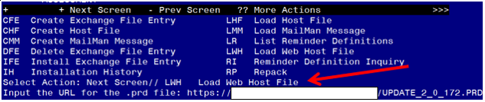

At the **Select Action:** prompt, enter **LWH** for Load Web Host File

At the **Input the url for the .prd file:** prompt, type the following web address:

**<https://REDACTED/UPDATE_2_0_172.PRD>**

You should see a message at the top of your screen that the file loaded successfully

Terminal window screen shot of the message displaying the URL of the file that was successfully loaded.  Part of the URL has been redacted as it is a VA only internal web site URL.

Search and locate an entry titled **UPDATE_2_0_172 VA-IMMUNIZATION UPDATE.**

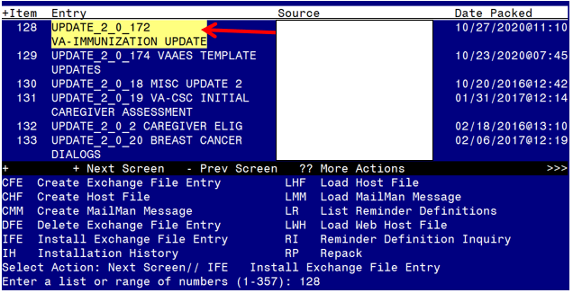

At the **Select Action** prompt, enter **IFE** for Install Exchange File Entry

Enter the number that corresponds with your entry **UPDATE_2_0_172 VA-IMMUNIZATION UPDATE.**  *(in this example it is entry 128 it will vary by site).* The date of the exchange file should be 10/27/2020.

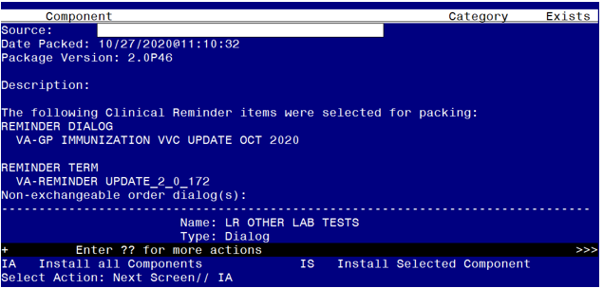

At the **Select Action** prompt, type **IA** for Install all Components and hit enter.

Select Action: Next Screen// IA Install all Components

When you are prompted to Install new items, choose I to INSTALL.

If you are prompted to overwrite ANY items, choose S to Skip.

**You will be promped to install the reminder dialog component – You will choose to install all even though some components may have an X to indicate that they exist.**

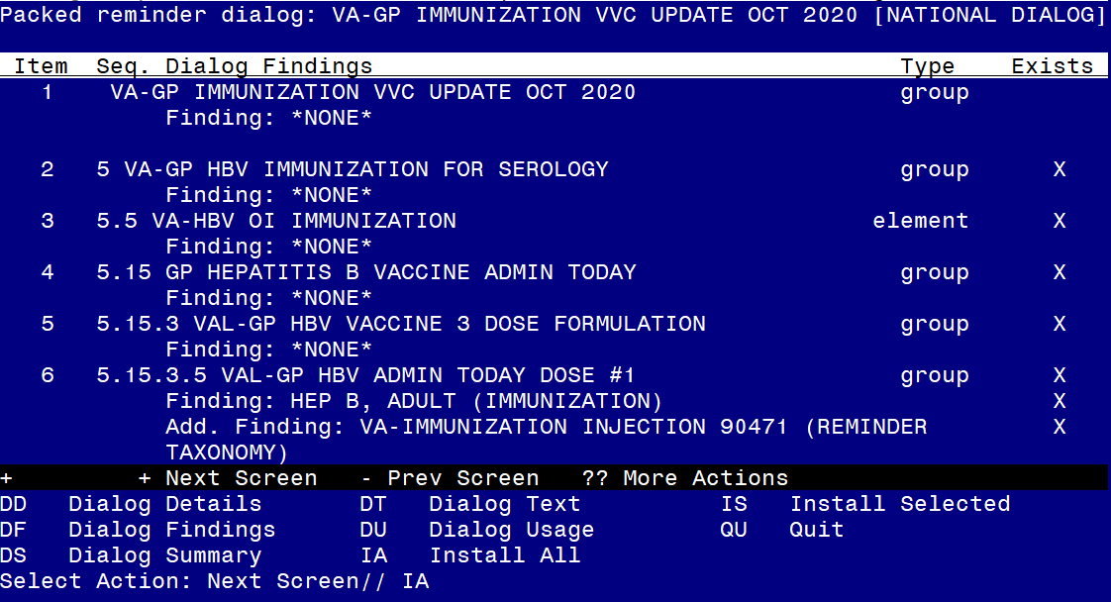

At the **Select Action** prompt, type **IA** to install the dialog – **VA-GP IMMUNIZATION VVC UPDATE OCT 2020**

Select Action: Next Screen// IA Install All

Install reminder dialog and all components with no further changes: Y// Yes

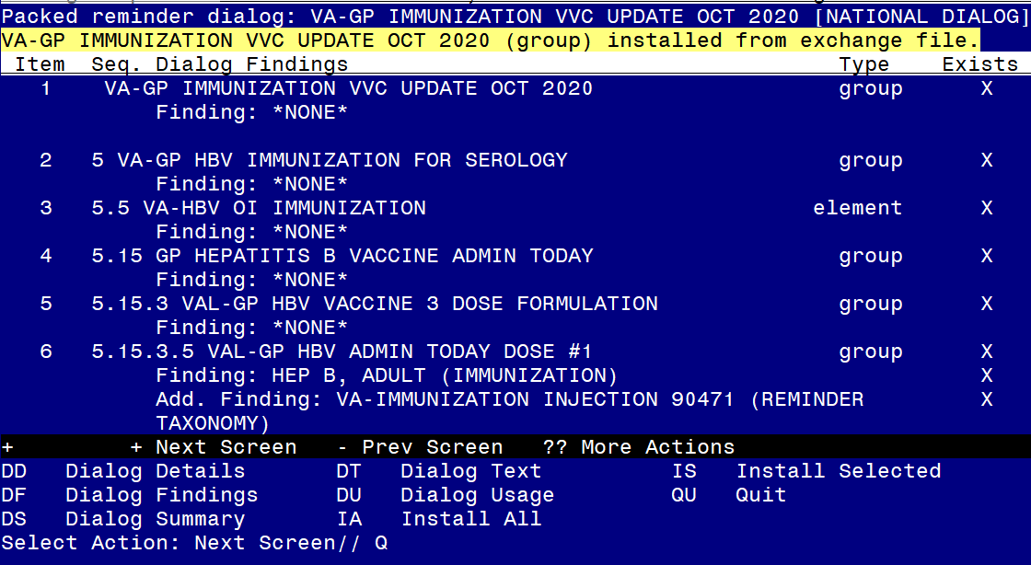

After completing this dialog install, you will type Q.

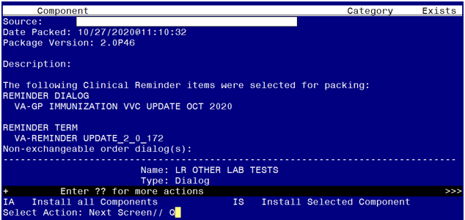

You will then be returned to this screen. At the **Select Action** prompt, type **Q.**

Install complete.

# Post Installation

1. Review the reminder dialog groups from the pre-install and put back any local changes within the components that you had previously made.

VA-GP HBV IMMUNIZATION FOR SEROLOGY

VA-GP HBV SEROLOGY

VA-HERPES ZOSTER ADMIN OPTIONS

VA-HPV ADMIN OPTIONS

GP IM MENING ACWY ACTIONS

GP IM MENING B ACTIONS

VA-GP IM PNEUMOC PCV13 PREVNAR ACTIONS

VA-GP IM PNEUMOC PPSV23 PNEUMOVAX ACTIONS

1. Edit the following reminder dialog groups and elements and add your local quick order as a finding item. You should have identified those quick orders in the pre-install:

**Elements:**

VA-HBV OI IMMUNIZATION

VA-HBV OI SEROLOGIC PANEL

VA-HBV OI IMMUNIZATION

**Groups:**

OI MENING ACWY OUTPT

OI MENING B OUTPT

OI PNEUMOC PCV13 OUTPT SHORT

OI PNEUMOC PPSV23 OUTPT

VA-HERPES ZOSTER ORDER

VAL-HPV ORDER OPTIONS

1. ***Optional*** – There is a reminder dialog group in the influenza reminder dialog for use at sites where someone other than the author of the note documents administration of the vaccination (e.g. large flu clinics). This dialog group installs as disabled but can be enabled at these specific sites. When enabled, the name of the person documenting for another staff member should be entered and will be included in the note. The person entering the note should be changing the author of the note to the person administering the vaccination and the person that administered the vaccination should sign the note. If your site uses this documentation practice, you will need to remove the disable flag from this reminder dialog group: GP IM INFLUENZA ADMIN BY OTHER USER and it will display as shown below.

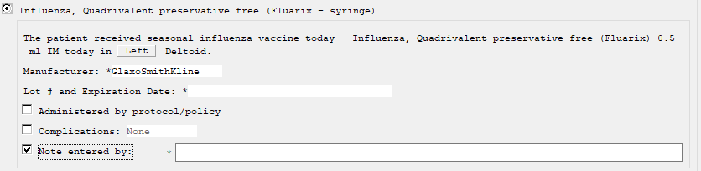

If your sites uses this documentation process, there is available training on how to review and sign notes in VistA that you can share.

[How to Review and Sign Unsigned Notes in Vista](https://foia-vista.worldvista.org/Patches_By_Application/PXRM-CLINIChttps:/Redacted/UnsignedNotesReviewandSigningInVistA.pptx) The information is also available in the CPRS users manual.

Note that this is not a Health Information Management Service (HIMS) recommended practice.