Update _2_0_173J_RS

Clinical Reminders

COVID-19 IMMUNIZATION RULE SET Update
Install Guide

August 2021

Product Development
Office of Information Technology
Department of Veterans Affairs

Table of Contents
Introduction 1
Install Details 1
Install Example 1
Post Installation 3

Introduction

Update _2_0_173J includes an update to the RS COVID 19 IMMUNIZATION patient list rule set, which allows sites to produce a list of patients who have received COVID-19 vaccinations. The rule set was initially released in Update 173A to build a reminder patient list. This update allows the reminder patient list to include dose 3 for the appropriate immunizations in the report.

UPDATE_2_0_173J will install 2 exchange files into your system. Each of these exchange file will have its own install guide

UPDATE_2_0_173 RS COVID 19 IMMUNIZATION
UPDATE_2_0_173 VA-COVID-19 IMMUNIZATION REMINDER

The exchange file contains the following components:

REMINDER TERM
VA-COVID-19 IMMUNIZATIONS DOSE 1
VA-COVID-19 IMMUNIZATIONS DOSE 2
VA-COVID-19 IMMUNIZATIONS DOSE 3

REMINDER LIST RULE
RS COVID 19 IMMUNIZATION
FR COVID-19 IMMUNIZATIONS DOSE 1
FR COVID-19 IMMUNIZATIONS DOSE 2
FR COVID-19 IMMUNIZATIONS DOSE 3

Install Details

This update can be loaded with users on the system. Installation will take less than 5 minutes.

Install Example

The exchange file for this update was loaded during the installation for Update 173J.

To install in VistA, search and locate an entry titled UPDATE_2_0_173 RS COVID 19 IMMUNIZATION
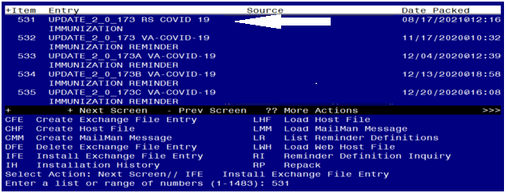

At the Select Action prompt, enter IFE for Install Exchange File Entry
Enter the number that corresponds with your entry UPDATE_2_0_173 RS COVID 19 IMMUNIZATION. (in this example it is entry 531 it will vary by site). The date of the exchange file should be 08/17/2021.

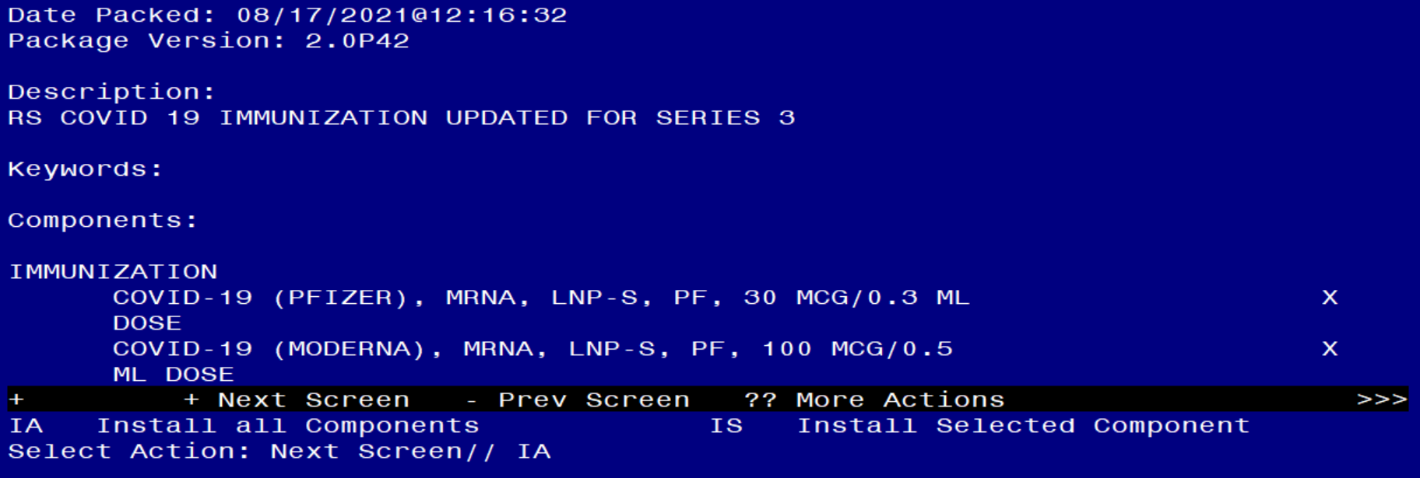

At the Select Action prompt, type IA for Install all Components and hit enter.
Select Action: Next Screen// IA Install all Components

During installation,

- Install all NEW items
- Skip the immunizations
- Overwrite all existing items

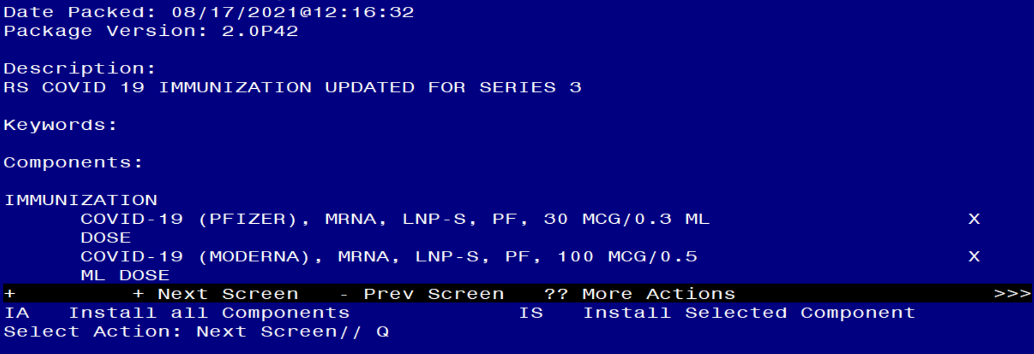

You will then be returned to this screen. At the Select Action prompt, type Q.

Install complete.

Post-Installation

- No changes are necessary to use the Patient List Rule Set. Follow instructions below to create a reminder patient list to display patients who have received a COVID-19 vaccination (as necessary).

- Run a patient list report. Navigate to the reminder manager menu.

CF Reminder Computed Finding Management ...
RM Reminder Definition Management ...
SM Reminder Sponsor Management ...
TXM Reminder Taxonomy Management
TRM Reminder Term Management ...
LM Reminder Location List Management ...
RX Reminder Exchange
RT Reminder Test
OS Other Supporting Menus ...
INFO Reminder Information Only Menu ...
DM Reminder Dialog Management ...
CP CPRS Reminder Configuration ...
RP Reminder Reports ...
MST Reminders MST Synchronization Management ...
PL Reminder Patient List Menu ...
PAR Reminder Parameters ...
VS NLM Value Set Menu
ROC Reminder Order Check Menu ...
CQM NLM Clinical Quality Measures Menu
XM Reminder Extract Menu ...

Select Reminder Managers Menu Option:

LRM List Rule Management
PLM Patient List Management

Select Reminder Patient List Menu Option:

Select Reminder Patient List Menu <TEST ACCOUNT> Option:
Select Item: Quit// Create Patient List
Select PATIENT LIST name: PL COVID-19 IMMUNIZATIONS Remember the name of the
patient list.
Are you adding 'PL COVID-19 IMMUNIZATIONS' as
a new REMINDER PATIENT LIST? No//
Secure list?:
Purge Patient List after 5 years?:
Select LIST RULE SET:
Enter Patient List BEGINNING DATE:
Enter Patient List ENDING DATE: T
Include deceased patients on the list? N// YES
Include test patients on the list?
Queue the Build Reminder Patient List for PL COVID-19 IMMUNIZATIONS:
Enter the date and time you want the job to start.
It must be after 11/020/2020@06:48:46
Start the task at: N

B. Access report and export to Excel (as necessary)

After the report runs, you can open it and choose the DEM option and decide what fields to include in your output, if you are not sure what fields to include, run a reminder test for the reminder term on one of the patients to get an idea of what populated the CSUB values.

Item Reminder Patient List Name Created Patients
1 AJM COVID 7/23/20@14:43 7
2 ALL FEMALES 7/3/19@07:04:53 24
3 ALL PATIENTS 7/3/19@07:03:26 79
4 TEST 11/18/20@05:55:18 2
5 EG COVID 4/20/20@04:35:14 4
6 HEP C LIST 5/6/20@14:30:19 53
7 JEFF TEST 8/14/20@09:21:46 1
8 MK MST DECLINES <PERIOD OF TIME> 3/9/15@08:53:04 0
9 PATIENT LIST 1/17/17@09:03:24 43
10 PATIENTS 3/18/13@17:05:19 37
11 PL COVID IMMUNIZATIONS 08/18/2021@04:45:35 9
12 PL INFLUENZA 2020 9/10/20@11:48:14 3
13 PL PHQ2 COMPLETE 09 10/10/18@05:31:45 4
14 PL TESTOSTERONE OCT 2019 10/25/19@06:27:19 3
15 PSUZ DALFAMPRIDINE HFS (PL) 12/23/11@09:48:20 1

+ Next Screen - Prev Screen ?? More Actions >>>
CO Copy Patient List DE Delete Patient List CV Change View
COE Copy to OE/RR Team DCD Display Creation Doc LRM List Rule Management
CR Create Patient List DSP Display Patient List QU Quit
Select Item: Quit// Select the item number of the report. In this
example, the item number is 11. The “SL” option can
be used to search for the patient list name.

Select Action: : (CO/COE/DE/DCD/DSP): Display Patient List

List Name: PL COVID IMMUNIZATION
Created: 08/18/2021@04:45:35 Creator: FAHNER,JEFF
Class: Local Type: PUBLIC
Source: List Rule - RS COVID 19 IMMUNIZATION
Number of patients: 7
Patient Name DFN (D=deceased, T=test)
1 BEAVIS,MISTER 59
2 BORIS,ILU 52
3 BUM,SICKLE 50
4 BURDICK,TEST 74
5 CARLSON,MARY 77
6 CHRISTMAS,MERRY 57
7 DOE,MARYJANE 54
8 OHARA,SCARLET 49
9 TEST,TUMOR 31

+ Next Screen - Prev Screen ?? More Actions >>>
CV Change View ED Edit Patient List
HSA Health Summary All USR View Users
HSI Health Summary Ind QU Quit
DEM Demographic Report

Select Item: Quit// Demographic Report A demographic report will display
details
Select the items to include on the report.
Select from the following address items:
1 - CURRENT ADDRESS
2 - PHONE NUMBER
Enter your selection(s): (1-2): Enter the item number to include in report
output or select Enter to skip the items
listed.
Select from the following future appointment items:
1 - APPOINTMENT DATE
2 - CLINIC
Enter your selection(s): (1-2):

Select from the following demographic items:
1 - SSN
2 - DATE OF BIRTH
3 - AGE
4 - SEX
5 - DATE OF DEATH
6 - REMARKS
7 - HISTORIC RACE
8 - RELIGION
9 - MARITAL STATUS
10 - ETHNICITY
11 - RACE
Enter your selection(s): (1-11): 1
Print full SSN: NO
Include the patient's preferred facility? NO
Select from the following eligibility items:
1 - PRIMARY ELGIBILITY CODE
2 - PERIOD OF SERVICE
3 - % SERVICE CONNECTED
4 - VETERAN
5 - TYPE
6 - ELIGIBILITY STATUS
7 - CURRENT MEANS TEST
Enter your selection(s): (1-7):
Select from the following patient data: The following list is information you
can include in your report output. The
list has data for series 1 and series 2 immunizations.

FYI:
COMMENTS provides lot number, not the LOT NUMBER field listed below.

Select from the following patient data:
1 - VA-COVID-19 IMMUNIZATIONS DOSE 1,"ADMIN ROUTE"
2 - VA-COVID-19 IMMUNIZATIONS DOSE 1,"ADMIN SITE"
3 - VA-COVID-19 IMMUNIZATIONS DOSE 1,"CODES","10D"
4 - VA-COVID-19 IMMUNIZATIONS DOSE 1,"CODES","CPT"
5 - VA-COVID-19 IMMUNIZATIONS DOSE 1,"CODES","CPTAI1"
6 - VA-COVID-19 IMMUNIZATIONS DOSE 1,"CODES","CPTAI2"
7 - VA-COVID-19 IMMUNIZATIONS DOSE 1,"COMMENTS"
8 - VA-COVID-19 IMMUNIZATIONS DOSE 1,"CONTRAINDICATED"
9 - VA-COVID-19 IMMUNIZATIONS DOSE 1,"CVX"
10 - VA-COVID-19 IMMUNIZATIONS DOSE 1,"DAS"
11 - VA-COVID-19 IMMUNIZATIONS DOSE 1,"DATA SOURCE"
12 - VA-COVID-19 IMMUNIZATIONS DOSE 1,"DATE RECORDED"
13 - VA-COVID-19 IMMUNIZATIONS DOSE 1,"DATE VISIT CREATED"
14 - VA-COVID-19 IMMUNIZATIONS DOSE 1,"DATE"
15 - VA-COVID-19 IMMUNIZATIONS DOSE 1,"DFN"
16 - VA-COVID-19 IMMUNIZATIONS DOSE 1,"DIVISION IEN"
17 - VA-COVID-19 IMMUNIZATIONS DOSE 1,"DIVISION"
18 - VA-COVID-19 IMMUNIZATIONS DOSE 1,"DOCUMENTER"
19 - VA-COVID-19 IMMUNIZATIONS DOSE 1,"DOSE UNITS"
20 - VA-COVID-19 IMMUNIZATIONS DOSE 1,"DOSE"
21 - VA-COVID-19 IMMUNIZATIONS DOSE 1,"DSS ID"
22 - VA-COVID-19 IMMUNIZATIONS DOSE 1,"ENCOUNTER PROVIDER"
23 - VA-COVID-19 IMMUNIZATIONS DOSE 1,"EVENT DATE AND TIME"
24 - VA-COVID-19 IMMUNIZATIONS DOSE 1,"EXPIRATION DATE"
25 - VA-COVID-19 IMMUNIZATIONS DOSE 1,"FINDING NAME"
26 - VA-COVID-19 IMMUNIZATIONS DOSE 1,"HLOC"
27 - VA-COVID-19 IMMUNIZATIONS DOSE 1,"HOSPITAL LOCATION"
28 - VA-COVID-19 IMMUNIZATIONS DOSE 1,"IMM NAME"
29 - VA-COVID-19 IMMUNIZATIONS DOSE 1,"IMMUNIZATION"
30 - VA-COVID-19 IMMUNIZATIONS DOSE 1,"INFO SOURCE"
31 - VA-COVID-19 IMMUNIZATIONS DOSE 1,"LOC. OF ENCOUNTER"
32 - VA-COVID-19 IMMUNIZATIONS DOSE 1,"LOT NUMBER"
33 - VA-COVID-19 IMMUNIZATIONS DOSE 1,"MANUFACTURER"
34 - VA-COVID-19 IMMUNIZATIONS DOSE 1,"OFFICAL VA NAME"
35 - VA-COVID-19 IMMUNIZATIONS DOSE 1,"ORDERING PROVIDER"
36 - VA-COVID-19 IMMUNIZATIONS DOSE 1,"OUTSIDE LOCATION"
37 - VA-COVID-19 IMMUNIZATIONS DOSE 1,"OVERRIDE REASON"
38 - VA-COVID-19 IMMUNIZATIONS DOSE 1,"PACKAGE"
39 - VA-COVID-19 IMMUNIZATIONS DOSE 1,"PRIMARY PROVIDER"
40 - VA-COVID-19 IMMUNIZATIONS DOSE 1,"REACTION"
41 - VA-COVID-19 IMMUNIZATIONS DOSE 1,"SERIES"
42 - VA-COVID-19 IMMUNIZATIONS DOSE 1,"SERVICE CATEGORY"
43 - VA-COVID-19 IMMUNIZATIONS DOSE 1,"STATION NUMBER"
44 - VA-COVID-19 IMMUNIZATIONS DOSE 1,"STATUS"
45 - VA-COVID-19 IMMUNIZATIONS DOSE 1,"STOP CODE"
46 - VA-COVID-19 IMMUNIZATIONS DOSE 1,"VACCINE GROUP",1,0
47 - VA-COVID-19 IMMUNIZATIONS DOSE 1,"VALUE"
48 - VA-COVID-19 IMMUNIZATIONS DOSE 1,"VISIT COMMENTS"
49 - VA-COVID-19 IMMUNIZATIONS DOSE 1,"VISIT ID"
50 - VA-COVID-19 IMMUNIZATIONS DOSE 1,"VISIT"
51 - VA-COVID-19 IMMUNIZATIONS DOSE 1,"WARNING ACK"
52 - VA-COVID-19 IMMUNIZATIONS DOSE 2,"ADMIN ROUTE"
53 - VA-COVID-19 IMMUNIZATIONS DOSE 2,"ADMIN SITE"
54 - VA-COVID-19 IMMUNIZATIONS DOSE 2,"CODES","10D"
55 - VA-COVID-19 IMMUNIZATIONS DOSE 2,"CODES","CPT"
56 - VA-COVID-19 IMMUNIZATIONS DOSE 2,"CODES","CPTAI1"
57 - VA-COVID-19 IMMUNIZATIONS DOSE 2,"CODES","CPTAI2"
58 - VA-COVID-19 IMMUNIZATIONS DOSE 2,"COMMENTS"
59 - VA-COVID-19 IMMUNIZATIONS DOSE 2,"CONTRAINDICATED"
60 - VA-COVID-19 IMMUNIZATIONS DOSE 2,"CVX"
61 - VA-COVID-19 IMMUNIZATIONS DOSE 2,"DAS"
62 - VA-COVID-19 IMMUNIZATIONS DOSE 2,"DATA SOURCE"
63 - VA-COVID-19 IMMUNIZATIONS DOSE 2,"DATE RECORDED"
64 - VA-COVID-19 IMMUNIZATIONS DOSE 2,"DATE VISIT CREATED"
65 - VA-COVID-19 IMMUNIZATIONS DOSE 2,"DATE"
66 - VA-COVID-19 IMMUNIZATIONS DOSE 2,"DFN"
67 - VA-COVID-19 IMMUNIZATIONS DOSE 2,"DIVISION IEN"
68 - VA-COVID-19 IMMUNIZATIONS DOSE 2,"DIVISION"
69 - VA-COVID-19 IMMUNIZATIONS DOSE 2,"DOCUMENTER"
70 - VA-COVID-19 IMMUNIZATIONS DOSE 2,"DOSE UNITS"
71 - VA-COVID-19 IMMUNIZATIONS DOSE 2,"DOSE"
72 - VA-COVID-19 IMMUNIZATIONS DOSE 2,"DSS ID"
73 - VA-COVID-19 IMMUNIZATIONS DOSE 2,"ENCOUNTER PROVIDER"
74 - VA-COVID-19 IMMUNIZATIONS DOSE 2,"EVENT DATE AND TIME"
75 - VA-COVID-19 IMMUNIZATIONS DOSE 2,"EXPIRATION DATE"
76 - VA-COVID-19 IMMUNIZATIONS DOSE 2,"FINDING NAME"
77 - VA-COVID-19 IMMUNIZATIONS DOSE 2,"HLOC"
78 - VA-COVID-19 IMMUNIZATIONS DOSE 2,"HOSPITAL LOCATION"
79 - VA-COVID-19 IMMUNIZATIONS DOSE 2,"IMM NAME"
80 - VA-COVID-19 IMMUNIZATIONS DOSE 2,"IMMUNIZATION"
81 - VA-COVID-19 IMMUNIZATIONS DOSE 2,"INFO SOURCE"
82 - VA-COVID-19 IMMUNIZATIONS DOSE 2,"LOC. OF ENCOUNTER"
83 - VA-COVID-19 IMMUNIZATIONS DOSE 2,"LOT NUMBER"
84 - VA-COVID-19 IMMUNIZATIONS DOSE 2,"MANUFACTURER"
85 - VA-COVID-19 IMMUNIZATIONS DOSE 2,"OFFICAL VA NAME"
86 - VA-COVID-19 IMMUNIZATIONS DOSE 2,"ORDERING PROVIDER"
87 - VA-COVID-19 IMMUNIZATIONS DOSE 2,"OUTSIDE LOCATION"
88 - VA-COVID-19 IMMUNIZATIONS DOSE 2,"OVERRIDE REASON"
89 - VA-COVID-19 IMMUNIZATIONS DOSE 2,"PACKAGE"
90 - VA-COVID-19 IMMUNIZATIONS DOSE 2,"PRIMARY PROVIDER"
91 - VA-COVID-19 IMMUNIZATIONS DOSE 2,"REACTION"
92 - VA-COVID-19 IMMUNIZATIONS DOSE 2,"SERIES"
93 - VA-COVID-19 IMMUNIZATIONS DOSE 2,"SERVICE CATEGORY"
94 - VA-COVID-19 IMMUNIZATIONS DOSE 2,"STATION NUMBER"
95 - VA-COVID-19 IMMUNIZATIONS DOSE 2,"STATUS"
96 - VA-COVID-19 IMMUNIZATIONS DOSE 2,"STOP CODE"
97 - VA-COVID-19 IMMUNIZATIONS DOSE 2,"VACCINE GROUP",1,0
98 - VA-COVID-19 IMMUNIZATIONS DOSE 2,"VALUE"
99 - VA-COVID-19 IMMUNIZATIONS DOSE 2,"VISIT COMMENTS"
100 - VA-COVID-19 IMMUNIZATIONS DOSE 2,"VISIT ID"
101 - VA-COVID-19 IMMUNIZATIONS DOSE 2,"VISIT"
102 - VA-COVID-19 IMMUNIZATIONS DOSE 2,"WARNING ACK"
103 - VA-COVID-19 IMMUNIZATIONS DOSE 3,"ADMIN ROUTE"
104 - VA-COVID-19 IMMUNIZATIONS DOSE 3,"ADMIN SITE"
105 - VA-COVID-19 IMMUNIZATIONS DOSE 3,"CODES","10D"
106 - VA-COVID-19 IMMUNIZATIONS DOSE 3,"CODES","CPT"
107 - VA-COVID-19 IMMUNIZATIONS DOSE 3,"CODES","CPTAI1"
108 - VA-COVID-19 IMMUNIZATIONS DOSE 3,"CODES","CPTAI2"
109 - VA-COVID-19 IMMUNIZATIONS DOSE 3,"COMMENTS"
110 - VA-COVID-19 IMMUNIZATIONS DOSE 3,"CONTRAINDICATED"
111 - VA-COVID-19 IMMUNIZATIONS DOSE 3,"CVX"
112 - VA-COVID-19 IMMUNIZATIONS DOSE 3,"DAS"
113 - VA-COVID-19 IMMUNIZATIONS DOSE 3,"DATA SOURCE"
114 - VA-COVID-19 IMMUNIZATIONS DOSE 3,"DATE RECORDED"
115 - VA-COVID-19 IMMUNIZATIONS DOSE 3,"DATE VISIT CREATED"
116 - VA-COVID-19 IMMUNIZATIONS DOSE 3,"DATE"
117 - VA-COVID-19 IMMUNIZATIONS DOSE 3,"DFN"
118 - VA-COVID-19 IMMUNIZATIONS DOSE 3,"DIVISION IEN"
119 - VA-COVID-19 IMMUNIZATIONS DOSE 3,"DIVISION"
120 - VA-COVID-19 IMMUNIZATIONS DOSE 3,"DOCUMENTER"
121 - VA-COVID-19 IMMUNIZATIONS DOSE 3,"DOSE UNITS"
122 - VA-COVID-19 IMMUNIZATIONS DOSE 3,"DOSE"
123 - VA-COVID-19 IMMUNIZATIONS DOSE 3,"DSS ID"
124 - VA-COVID-19 IMMUNIZATIONS DOSE 3,"ENCOUNTER PROVIDER"
125 - VA-COVID-19 IMMUNIZATIONS DOSE 3,"EVENT DATE AND TIME"
126 - VA-COVID-19 IMMUNIZATIONS DOSE 3,"EXPIRATION DATE"
127 - VA-COVID-19 IMMUNIZATIONS DOSE 3,"FINDING NAME"
128 - VA-COVID-19 IMMUNIZATIONS DOSE 3,"HLOC"
129 - VA-COVID-19 IMMUNIZATIONS DOSE 3,"HOSPITAL LOCATION"
130 - VA-COVID-19 IMMUNIZATIONS DOSE 3,"IMM NAME"
131 - VA-COVID-19 IMMUNIZATIONS DOSE 3,"IMMUNIZATION"
132 - VA-COVID-19 IMMUNIZATIONS DOSE 3,"INFO SOURCE"
133 - VA-COVID-19 IMMUNIZATIONS DOSE 3,"LOC. OF ENCOUNTER"
134 - VA-COVID-19 IMMUNIZATIONS DOSE 3,"LOT NUMBER"
135 - VA-COVID-19 IMMUNIZATIONS DOSE 3,"MANUFACTURER"
136 - VA-COVID-19 IMMUNIZATIONS DOSE 3,"OFFICAL VA NAME"
137 - VA-COVID-19 IMMUNIZATIONS DOSE 3,"ORDERING PROVIDER"
138 - VA-COVID-19 IMMUNIZATIONS DOSE 3,"OUTSIDE LOCATION"
139 - VA-COVID-19 IMMUNIZATIONS DOSE 3,"OVERRIDE REASON"
140 - VA-COVID-19 IMMUNIZATIONS DOSE 3,"PACKAGE"
141 - VA-COVID-19 IMMUNIZATIONS DOSE 3,"PRIMARY PROVIDER"
142 - VA-COVID-19 IMMUNIZATIONS DOSE 3,"REACTION"
143 - VA-COVID-19 IMMUNIZATIONS DOSE 3,"SERIES"
144 - VA-COVID-19 IMMUNIZATIONS DOSE 3,"SERVICE CATEGORY"
145 - VA-COVID-19 IMMUNIZATIONS DOSE 3,"STATION NUMBER"
146 - VA-COVID-19 IMMUNIZATIONS DOSE 3,"STATUS"
147 - VA-COVID-19 IMMUNIZATIONS DOSE 3,"STOP CODE"
148 - VA-COVID-19 IMMUNIZATIONS DOSE 3,"VACCINE GROUP",1,0
149 - VA-COVID-19 IMMUNIZATIONS DOSE 3,"VALUE"
150 - VA-COVID-19 IMMUNIZATIONS DOSE 3,"VISIT COMMENTS"
151 - VA-COVID-19 IMMUNIZATIONS DOSE 3,"VISIT ID"
152 - VA-COVID-19 IMMUNIZATIONS DOSE 3,"VISIT"
153 - VA-COVID-19 IMMUNIZATIONS DOSE 3,"WARNING ACK"

Enter your selections(s): (1-31): Enter your selections(s): (1-94): 7,14,29,41,58,65,80,92,109,116,131,143 – Choose the items you would like here
in any order.
For this report we will include data for ALL series terms. It is important to confirm the item numbers listed here are the same for your site. Select the appropriate item number for the desired data.
Select from the following inpatient items:
1 - WARD LOCATION
2 - ROOM-BED
3 - ADMISSION DATE/TIME
4 - ATTENDING PHYSICIAN
Enter your selection(s): (1-4):
Delimited Report:?
Select one of the following:
C Comma
M Semicolon
L Tilde
S Space
T Tab
U Up arrow
Specify REPORT DELIMITER CHARACTER: Each row in the report may wrap, which makes pasting into Excel more difficult. Consider changing your display settings before running the report.

DEVICE: HOME// ;99999;99999

Copy and paste into Excel. Dates from patient lists will display in FileMan format. Follow steps below to configure to understandable date format.

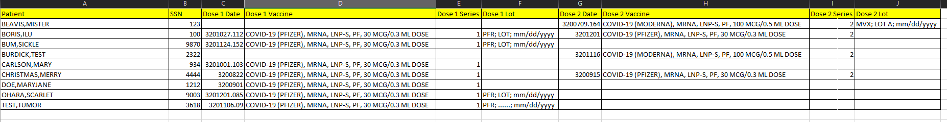
FYI:

Historical immunizations will not have a lot number in the report.
May help identify mistakes.

- Select date column.
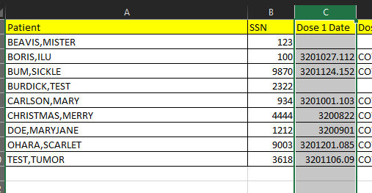

- Select “Text to Columns”, then select “Fixed width”, then “Next”

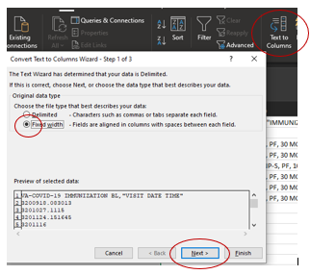

- Click between the 3 and the 2 to place a break line, then click before the “.” to create another break line, then Next”
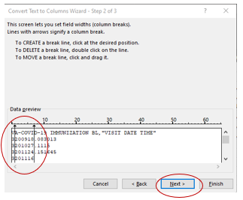

- Highlight the 1st column and select “Do not import”. Highlight 3rd column and select “Do not import”.
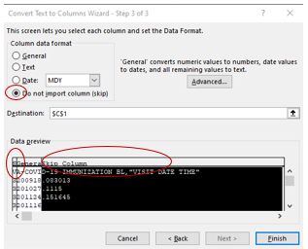

- Highlight middle column, select “Date”, and change format to “YMD”. Select “Finish.”

- 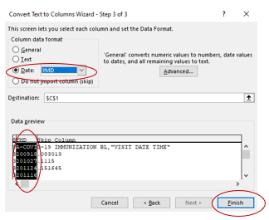

- The dates should display in a clear format.
