Update _2_0_173L

Clinical Reminders

VA-COVID-19 IMMUNIZATION REMINDER UPDATE
Install Guide

October 2021

Product Development
Office of Information Technology
Department of Veterans Affairs

Table of Contents
Introduction 1
Pre-Install 8
Install Details 8
Install Example 8
Post-Installation 13

Introduction

DESCRIPTION:
This reminder update sends out an updated version of the Covid Immunization reminder definition and a dialog component that is discussed below.

173L makes updates to the VA-SARS-COV-2 IMMUNIZATION reminder dialog, reminder definition and associated progress note template.

Updates are being made to prompt for booster doses of Moderna, second doses of Janssen vaccine and to facilitate and guide documentation for mix and match.

This is a very complicated update and you must follow the instructions completely.

You should back up all of your lot numbers for Pfizer, Moderna and J&J and then add them back in post install. The below link are the instructions for doing this that were included with the 173K release and can be used for this backup also.

https://REDACTED /COVID-19_LOCAL_BACKUP_173K.pdf

Reminder Logic Updates:
- Booster dose due 6 months after a completed primary series of Moderna vaccine for anyone age 65 and over or who is age 50+ and at high risk of severe disease. (same group as Pfizer booster that was part of 173K).

- Second dose of Janssen vaccine due for all who received dose more than 2 months ago.

- Combinations of vaccines will also resolve the reminder – this has been part of the logic in the past but is now enabled.

- Mental health conditions are added to the list of diagnoses for high risk of severe disease per change in CDC guidelines.

3 new reminders are added to allow branching logic to display guidance for the most common scenarios and what booster options are available.
- 2 prior doses of Moderna, last dose over 6 months ago, not immunocompromised
- 2 prior doses of Pfizer, last dose over 6 months ago, not immunocompromised
- 1 prior dose of Janssen, last dose over 56 days ago.

The reminders that control the branching logic for these informational messages are:
VAL-BL COVID-19 BOOSTER MODERNA
VAL-BL COVID-19 BOOSTER PFIZER
VAL-BL COVID-19 BOOSTER JANSSEN
And the template fields that control the informational message for each of these are:
IM SARS COV-2 C2 BOOSTER INFO
IM SARS COV-2 D2 BOOSTER INFO
IM SARS COV-2 A1 BOOSTER INFO

Reminder Dialog Updates:

- Branching logic is included to display booster information guidance from the template fields listed above. These can be modified locally.

Example:
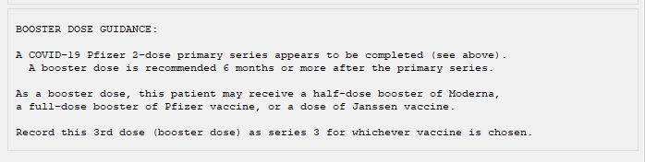

- Vaccine series are now counted by patient dose of any COVID-19 vaccine and not separately counted by manufacturer. Dose 1 of any vaccine is series 1, a second dose of any vaccine is series 2, and a 3rd dose of any vaccine, even if different, is series 3.

- Dose 1, 2, 3 for Pfizer and Moderna are suppressed if the dose has been given already and since these are now considered interchangeable, Pfizer will suppress Moderna options and Moderna will suppress Pfizer options.

- Janssen dose 1 will also suppress series 1 and 2 for Pfizer and Moderna since any mRNA dose given after an initial dose of Janssen is considered a booster dose if given 2 months or more after the initial Janssen dose. After a single dose of Janssen, the only option that will show for Moderna and Pfizer is for a booster dose and that dose will be a half-dose for Moderna and both will be defaulted to series 2.

  - Not all of these series suppression will occur in the historical section since outside doses may not have followed VA guidance.

- The booster dose message in the dialog for patients 65+ or 50+ with underlying conditions now also shows for Moderna recipients in this new update in addition to Pfizer recipients which was part of 173K.

- The immunosuppressed message now only shows for mRNA recipients or patients who have had no vaccine administered.

Thank you to the following test sites who installed and tested this reminder update:

New Mexico VA Health Care System (Albuquerque)
VA Nebraska Western Iowa Health Care System
Ralph J Johnson VA Medical Center (Charleston)
Aleda E. Lutz VA Medical Center (Saginaw)
VA Maryland Health Care System (Baltimore)
James J Peters VA Medical center (Bronx)

UPDATE_2_0_173L contains 1 Reminder Exchange entry:

UPDATE_2_0_173L VA-COVID-19 IMMUNIZATION REMINDER
TIU TEMPLATE FIELD
BLANK TEXT FIELD FOR DIALOGS
IM SCRIBE
IM SARS COV-2 OUTSIDE INSTR 2
IM SARS COV-2 OUTSIDE INSTR 1
IM SARS COV-2 OUTSIDE WARNING
IM SARS COV-2 ADMIN INFO POST TEXT D2 #2
IM SARS COV-2 D2 DOSE
IM SARS COV-2 DOSE D2 #B WARNING
IM SARS COV-2 D2 DOSE #3 BOOSTER
IM SARS COV-2 VIS/EUA INFO URL D2
IM SARS COV-2 ADMIN D2 INFO PRE TEXT
IM SARS COV-2 DOSE D2 #3 WARNING
IM SARS COV-2 D2 DOSE #3
IM SARS COV-2 DOSE #2 WARNING
IM SARS COV-2 ADMIN INFO POST TEXT D2 #1
IM SARS COV-2 VIS/EUA INFO URL E2
IM SARS COV-2 ADMIN E2 INFO PRE TEXT
IM SARS COV-2 ADMIN INFO POST TEXT E2 #2
IM SARS COV-2 E2 DOSE
IM SARS COV-2 DOSE E2 #3 WARNING
IM SARS COV-2 E2 DOSE #3
IM SARS COV-2 ADMIN INFO POST TEXT E2 #1
IM SARS COV-2 VA SIDE EFFECTS AE REPORTING
IM SARS COV-2 VIS/EUA INFO URL B1
IM SARS COV-2 ADMIN B1 INFO PRE TEXT
IM SARS COV-2 ADMIN INFO POST TEXT B1 #2
IM SARS COV-2 B1 DOSE
IM SARS COV-2 DOSE B1 #3 WARNING
IM SARS COV-2 B1 DOSE #3
IM SARS COV-2 ADMIN INFO POST TEXT B1 #1
IM SARS COV-2 VIS/EUA INFO URL A1
IM SARS COV-2 ADMIN A1 INFO PRE TEXT
IM SARS COV-2 ADMIN INFO POST TEXT A1 #B
IM SARS COV-2 A1 DOSE
IM SARS COV-2 DOSE SERIES BOOSTER WARNING
IM SARS COV-2 DOSE A1 #3 WARNING
IM SARS COV-2 A1 DOSE #3
IM SARS COV-2 A1 DOSE #2
IM SARS COV-2 ADMIN INFO POST TEXT A1
IM SARS COV-2 VIS/EUA INFO URL C2
IM SARS COV-2 ADMIN C2 INFO PRE TEXT
IM SARS COV-2 ADMIN INFO POST TEXT C2 #2
IM SARS COV-2 C2 DOSE 1/2 DOSE
IM SARS COV-2 DOSE C2 #B WARNING
IM SARS COV-2 C2 DOSE #3 BOOSTER
IM SARS COV-2 C2 DOSE
IM SARS COV-2 DOSE C2 #3 WARNING
IM SARS COV-2 C2 DOSE #3
IM SARS COV-2 ADMIN INFO POST TEXT C2 #1
IM SARS COV-2 INFO TEXT EUA AGES
IM SARS COV-2 CDC VACCINE ANAPHYLAXIS INFO URL
IM SARS COV-2 CDC VACCINE CLINICAL CONSIDERATION URL
IM SARS COV-2 CDC VACCINE INFO URL
IM SARS COV-2 VA PRE SCREEN FORM
IM SARS COV-2 VHA VACCINE INFO URL
IM SARS COV-2 PROVIDER EUA FACT URL A1
IM SARS COV-2 PROVIDER EUA FACT URL D2
IM SARS COV-2 PROVIDER EUA FACT URL C2
IM SARS COV-2 A1 BOOSTER INFO
IM SARS COV-2 D2 BOOSTER INFO
IM SARS COV-2 C2 BOOSTER INFO
IM SARS COV-2 ADOLESCENT-CHILD APPROVAL TEXT

HEALTH FACTORS
REMINDER FACTORS [C]
VA-UPDATE_2_0_173L
IMMUNIZATION [C]
VA-SARS-COV-2 VACCINE CONTRAIND B1
VA-SARS-COV-2 VACCINE CONTRAIND E2
VA-SARS-COV-2 VACCINE CONTRAIND A1
VA-SARS-COV-2 VACCINE CONTRAIND D2
VA-SARS-COV-2 VACCINE CONTRAIND C2
VA-SARS-COV-2 VACCINE DEFERRED
VA-SARS-COV-2 VACCINE REFUSAL
VA-SARS-COV-2 IMM REFUSAL - NVX CVX 211
VA-SARS-COV-2 IMM REFUSAL - AZN CVX 210
VA-SARS-COV-2 IMM REFUSAL - JSN CVX 212
VA-SARS-COV-2 IMM REFUSAL - UNS CVX 213
VA-SARS-COV-2 IMM REFUSAL - PFR CVX 208
VA-SARS-COV-2 IMM REFUSAL - MOD CVX 207
COVID-19 VERBAL REPORT COVID VACCINE
VA-SARS-COV-2 VACCINE ANATOMIC SITE
VA-TOBACCO USE SCREEN [C]
VA-TOBACCO FORMER USER
VA-TOBACCO USER SOME DAYS
VA-TOBACCO USER EVERY DAY
VA-SARS-COV-2 IMMUN EDUC VVC/TELE VST

REMINDER SPONSOR
VA NATIONAL CENTER FOR HEALTH PROMOTION AND
DISEASE PREVENTION (NCP)
NATIONAL CENTER FOR HEALTH PROMOTION AND DISEASE
PREVENTION (NCP)
OFFICE OF PATIENT CARE SERVICES
OFFICE OF PUBLIC HEALTH AND ENVIRONMENTAL HAZARDS

REMINDER TAXONOMY
VA-IMMUNIZATION ICD10 CODE
VA-SARS-COV-2 IMM PFIZER TRIS/SUC SERIES BOOSTER
VA-IMMUNOCOMPROMISED FOR COVID-19 ADDL DOSE
VA-HIV INFECTION
LONG TERM SYSTEMIC STEROID
VA-PNEUMOC DZ RISK - CHEMOTHERAPY
VA-SARS-COV-2 IMM PFIZER TRIS/SUC SERIES 3
VA-SARS-COV-2 IMM PFIZER TRIS/SUC SERIES 2
VA-SARS-COV-2 IMM PFIZER TRIS/SUC SERIES 1
VA-SARS-COV-2 IMM ASTRAZENECA SERIES 3
VA-SARS-COV-2 IMM ASTRAZENECA SERIES 2
VA-SARS-COV-2 IMM ASTRAZENECA SERIES 1
VA-SARS-COV-2 IMM NOVAVAX SERIES 3
VA-SARS-COV-2 IMM NOVAVAX SERIES 2
VA-SARS-COV-2 IMM NOVAVAX SERIES 1
VA-SARS-COV-2 IMM JANSSEN SERIES 2
VA-SARS-COV-2 IMM JANSSEN SERIES 1
VA-SARS-COV-2 IMM PFIZER SERIES BOOSTER
VA-SARS-COV-2 IMM PFIZER SERIES 3
VA-SARS-COV-2 IMM PFIZER SERIES 2
VA-SARS-COV-2 IMM PFIZER SERIES 1
VA-SARS-COV-2 IMM MODERNA SERIES BOOSTER
VA-SARS-COV-2 IMM MODERNA SERIES 3
VA-SARS-COV-2 IMM MODERNA SERIES 2
VA-SARS-COV-2 IMM MODERNA SERIES 1
MENTAL HEALTH DX FOR COVID-19
RADIATION TX FOR COVID-19 BOOSTER
CKD AND CHF FOR COVID-19 BOOSTER
NEUROLOGIC CONDITIONS FOR COVID-19 BOOSTER
LIVER DISEASE FOR COVID-19 BOOSTER
THALASSEMIA FOR COVID-19 BOOSTER
SUBSTANCE ABUSE FOR COVID-19 BOOSTER
LUNG DISEASE FOR COVID-19 BOOSTER
VA-IHD AND ASVD
VA-IMMUNOCOMPROMISED
VA-PALLI CONS CANCER/HEMA COND
VA-DIABETES
VA-HYPERTENSION
VA-TOBACCO USE

REMINDER TERM
VA-REMINDER UPDATE_2_0_173L
VA-CURRENT INPATIENT
VA-SARS-COV-2 VACCINE WHO APPROVED ALL (INCL US)
VA-SARS-COV-2 VACCINE A1 1 DOSE
VA-SARS-COV-2 VACCINE D2 3 DOSE
VA-SARS-COV-2 VACCINE D2 2 DOSE
VA-SARS-COV-2 VACCINE D2 1 DOSE
VA-SARS-COV-2 VACCINE C2 3 DOSE
VA-SARS-COV-2 VACCINE C2 2 DOSE
VA-SARS-COV-2 VACCINE C2 1 DOSE
VA-CD4 COUNT
VA-STEROID PREDN EQUIV 5-6.6MG
VA-STEROID PREDN EQUIV 6.6-9MG
VA-STEROID PREDN EQUIV 10-19MG
VA-STEROID PREDN EQUIV >=20MG
VA-CHEMO/IMMUNOSUPPRESSIVE DRUGS
VA-SARS-COV-2 IM DOSE NOT PFIZER
VA-SARS-COV-2 VACCINE E2 2 DOSE
VA-SARS-COV-2 IM DOSE NOT ASTRAZENECA
VA-SARS-COV-2 IM DOSE NOT MODERNA
VA-SARS-COV-2 VACCINE E2 1 DOSE
VA-SARS-COV-2 VACCINE B1 2 DOSE
VA-SARS-COV-2 VACCINE B1 1 DOSE
VA-SARS-COV-2 IM DOSE NOT NOVAVAX
VA-SARS-COV-2 IM DOSE NOT JANSSEN
VA-SARS-COV-2 VACCINE A1
VA-SARS-COV-2 VACCINE INDICATION ADDL DOSE NEEDED
VA-SARS-COV-2 VACCINES NO BOOSTER AUTHORIZED
VA-SARS-COV-2 VACCINES BOOSTER AUTHORIZED
COVID-19 VACCINE BOOSTER - UNDERLYING CONDITIONS
TOBACCO USE EVER FOR COVID-19 BOOSTER
VA-SARS-COV-2 VACCINE INDICATION MRNA BOOSTER
VA-SARS-COV-2 VACCINE D2
VA-SARS-COV-2 VACCINE C2
VA-COVID-19 ADOLESCENT AGE RANGE
VAL-SARS-COV-2 VACC FOR BOOSTER BL
VA-SARS-COV-2 VACCINE WHO APPROVED NON-US COMPLETED
VA-SARS-COV-2 VACCINE E2
VA-SARS-COV-2 VACCINE B1
VA-COVID-19 VACCINATION CLINIC FUTURE APPT
VA-SARS-COV-2 VACCINE DOSE #1 OF 2
VAL-SYSTEMIC STEROIDS
VA-SARS-COV-2 VACCINE REFUSAL
VA-SARS-COV-2 VACCINE CONTRAINDICATION
VA-SARS-COV-2 VACCINE INDICATION AGE
VA-SARS-COV-2 VACCINE INDICATION 5
VA-SARS-COV-2 VACCINE INDICATION 4
VA-SARS-COV-2 VACCINE INDICATION 3
VA-SARS-COV-2 VACCINE INDICATION 2
VA-SARS-COV-2 VACCINE INDICATION 1

REMINDER DEFINITION
VAL-IMMUNOCOMPROMISING DRUGS/LABS/DX FOR COVID-19
VAL-BL COVID-19 BOOSTER JANSSEN
VAL-COVID-19 BOOSTER AGE AND HIGH RISK
VAL-BL COVID-19 BOOSTER PFIZER
VAL-BL COVID-19 BOOSTER MODERNA
VA-SARS COV-2 IMMUNIZATION

HEALTH SUMMARY TYPE
SARS-COV-2 IMMUNIZATION
INDICATION BOOSTER DS COVID-19
INDICATION ADDL DOSE COVID-19

HEALTH SUMMARY OBJECTS
SARS-COV-2 IMMUNIZATION (TIU)
INDICATION BOOSTER DOSE COVID-19 (TIU)
INDICATION ADDL DOSE COVID-19 (TIU)

TIU DOCUMENT DEFINITION
SARS-COV-2 IMMUNIZATION
INDICATION BOOSTER DOSE COVID-19
INDICATION ADDL DOSE COVID-19

REMINDER DIALOG
VA-SARS-COV-2 IMMUNIZATION TEMPLATE
VA-SARS-COV-2 IMMUNIZATION

Pre-Install
- You should have installed update 173J and 173K prior to installing this update.
- Back up all your lot numbers as described previously
https://REDACTED/COVID-19_LOCAL_BACKUP_173K.pdf
– this update WILL OVERWRITE all your lot numbers and you will need to re-install them after installing this update. Find the previously packed lot numbers in the Reminder Exchange file entries and repack it to update it – use the Repack (RP) command to pack a fresh copy.
- Any local modifications to template fields or to the dialog will be overwritten. Please make note of your local modifications and evaluate whether they are still needed or valid prior to re-entering them in the post-install.
- Terms that are likely to have local mappings are highlighted in yellow above and you should not overwrite those. Make a note of those.

Install Details
This update is being distributed as a web host file. The address for the host file is: https://REDACTED /UPDATE_2_0_173L.PRD

The file will be installed using Reminder Exchange, programmer access is not required.
This update can be loaded with users on the system. Installation will take less than 5 minutes

Install Example
To Load the Web Host File. Navigate to Reminder exchange in Vista
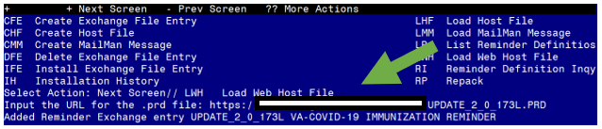

At the Select Action: prompt, enter LWH for Load Web Host File
At the Input the url for the .prd file: prompt, type the following web address:

https://REDACTED /UPDATE_2_0_173L.PRD

You should see a message that the file was successfully loaded.

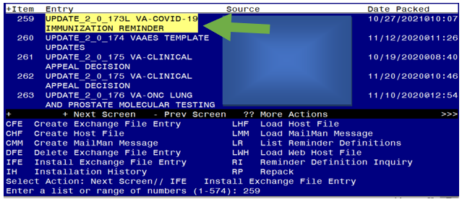

Search and locate an entry titled UPDATE_2_0_173L VA-COVID-19 IMMUNIZATION REMINDER.

At the Select Action prompt, enter IFE for Install Exchange File Entry
Enter the number that corresponds with your entry UPDATE_2_0_173L VA-COVID-19 IMMUNIZATION REMINDER. (in this example it is entry 259 it will vary by site). The date of the exchange file should be 10/27/2021.
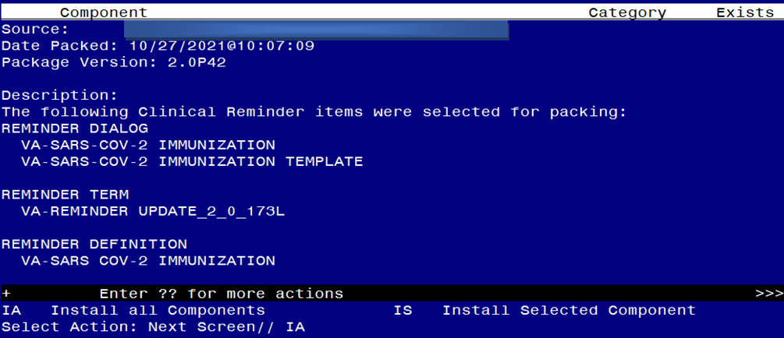
At the Select Action prompt, type IA for Install all Components and hit enter.
Any items that are NEW in any of the below categories, you should INSTALL
OVERWRITE any TIU TEMPLATE FIELDS that you are prompted to overwrite
SKIP any HEALTH FACTORS if you are prompted to overwrite
SKIP any REMINDER SPONSORS if you are prompted to overwrite
OVERWRITE any REMINDER TAXONOMIES that you are prompted to overwrite – the taxonomies in green above and listed again below have not been changed and do not need to be overwritten, if you are prompted SKIP them.
VA-IMMUNIZATION ICD10 CODE
VA-IMMUNOCOMPROMISED FOR COVID-19 ADDL DOSE
VA-HIV INFECTION
LONG TERM SYSTEMIC STEROID
VA-PNEUMOC DZ RISK - CHEMOTHERAPY
VA-IHD AND ASVD
VA-IMMUNOCOMPROMISED
VA-PALLI CONS CANCER/HEMA COND
VA-DIABETES
VA-HYPERTENSION
VA-TOBACCO USE
OVERWRITE any REMINDER TERMS that you are prompted to overwrite EXCEPT those that have local mappings as indicated in yellow above and listed again below. DO NOT overwrite your previously mapped terms for drugs and labs, if you are prompted SKIP the items below.
VA-CD4 COUNT
VA-STEROID PREDN EQUIV 5-6.6MG
VA-STEROID PREDN EQUIV 6.6-9MG
VA-STEROID PREDN EQUIV 10-19MG
VA-STEROID PREDN EQUIV >=20MG
TOBACCO USE EVER FOR COVID-19 BOOSTER
VA-COVID-19 VACCINATION CLINIC FUTURE APPT
VAL-SYSTEMIC STEROIDS
OVERWRITE any REMINDER DEFINITIONS that you are prompted to overwrite.
SKIP any HEALTH SUMMARY TYPE entries if you are prompted to overwrite
SKIP any HEALTH SUMMARY OBJECTS entries if you are prompted to overwrite
SKIP any TIU DOCUMENT DEFINITION entries if you are prompted to overwrite
You will then be prompted to install the dialog component. You will choose IA to install all even though some items will already have an X to indicate they exist.

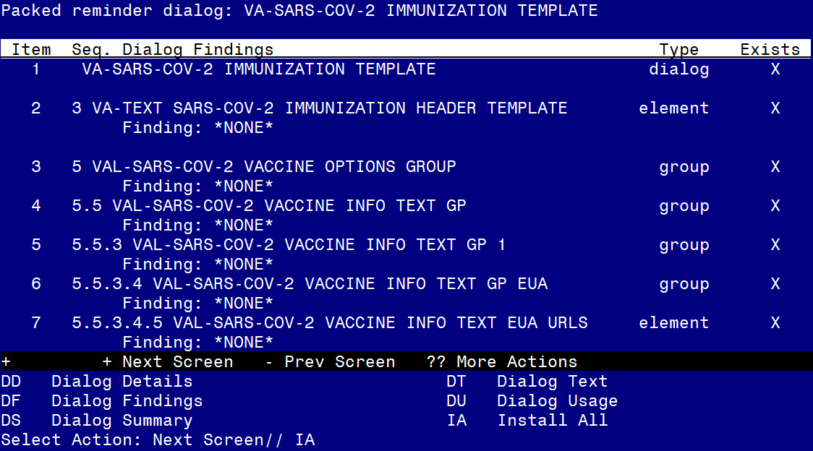

At the Select Action prompt, type IA to install the dialog – SARS-COV-2 IMMUNIZATION TEMPLATE

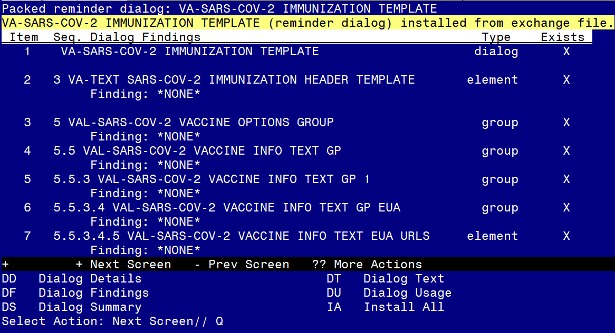
You will then be returned to this screen. At the Select Action prompt, type Q.
You will then be prompted to install the next dialog component. You will choose IA to install all even though some items will already have an X to indicate they exist.

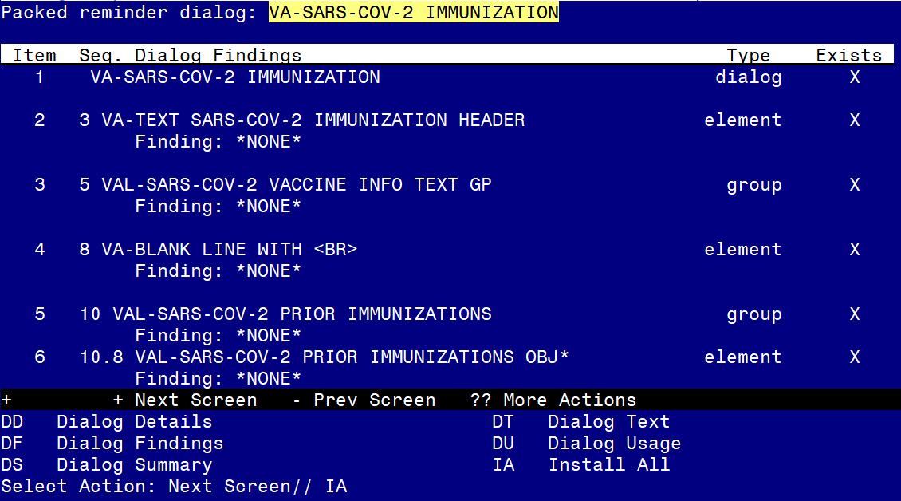

At the Select Action prompt, type IA to install the dialog – SARS-COV-2 IMMUNIZATION

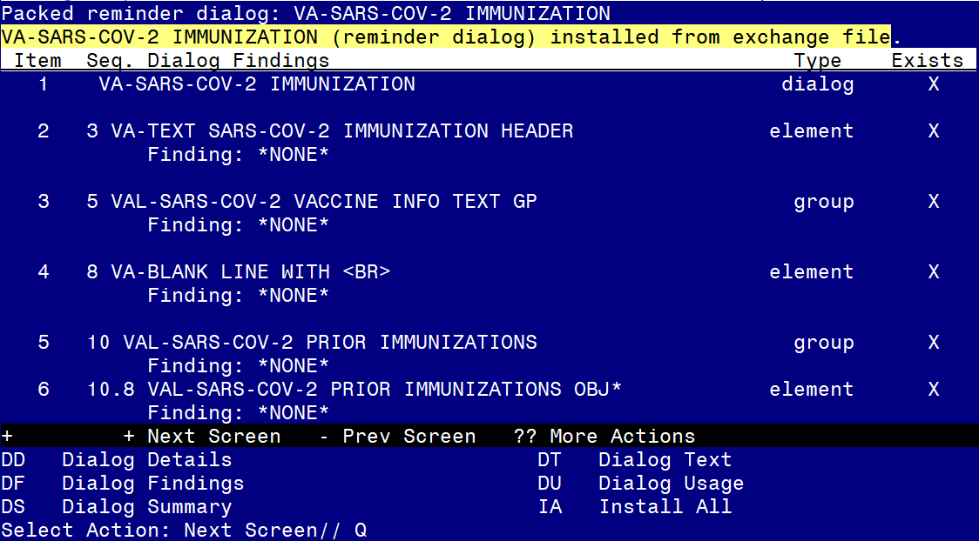
You will then be returned to this screen. At the Select Action prompt, type Q.

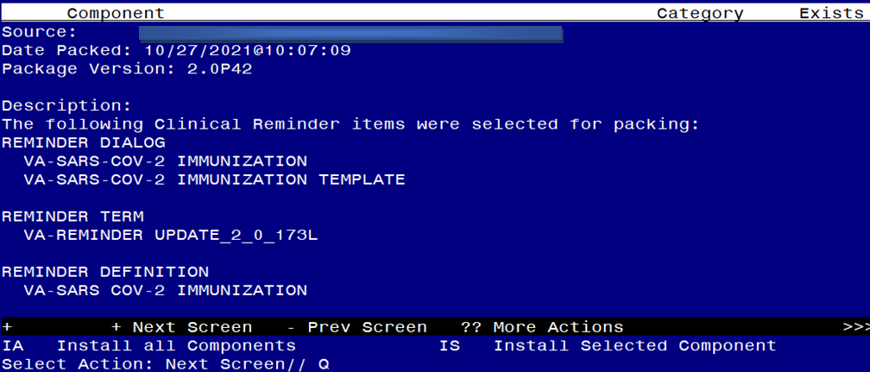

You will then be returned to this screen. At the Select Action prompt, type Q.

Install complete.

Post-Installation
- Reinstall your lot numbers from the backup exchange file created in the pre-install.
- Re-enter any required local modifications.
- Disable any dialog groups for vaccine types not in use at your site – E.g. if you are exclusively a Moderna & Janssen site, then disable the reminder dialog group for Pfizer: VAL-SARS-COV-2 VACCINE ADMIN D2 GP
- If you use the scribe option, then re-enable it.

