Update _2_0_173M

Clinical Reminders

VA-COVID-19 IMMUNIZATION REMINDER UPDATE
Install Guide

October 2021

Product Development
Office of Information Technology
Department of Veterans Affairs

Table of Contents
Introduction 1
Install Details 2
Install Example 2

Introduction

DESCRIPTION:
This is an update to taxonomies only. No reminder dialog or reminder definition changes.
These taxonomies are updated:
VA-SARS-COV-2 IMM MODERNA SERIES BOOSTER 0064A & 91306
VA-SARS-COV-2 IMM PFIZER SERIES BOOSTER 0004A & 91300
VA-SARS-COV-2 IMM PFIZER TRIS/SUC SERIES 1 0051A & 91305
VA-SARS-COV-2 IMM PFIZER TRIS/SUC SERIES 2 0052A & 91305
VA-SARS-COV-2 IMM PFIZER TRIS/SUC SERIES 3 0053A & 91305
VA-SARS-COV-2 IMM PFIZER TRIS/SUC SERIES BOOSTER 0054A & 91305
VA-SARS-COV-2 IMM NOVAVAX SERIES 1 0041A
VA-SARS-COV-2 IMM NOVAVAX SERIES 2 0042A
Please note – the recent Lexicon patch did not contain the new code for the Janssen 2nd /booster dose so that code could not be added to this update. For questions about that code, please contact your HIMS Department.
Thank you to the following test sites who installed and tested this reminder update:

James J Peters VA Medical Center (Bronx)
Chillicothe VA Medical Center
VA Nebraska Western Iowa Health Care System

UPDATE_2_0_173M contains 1 Reminder Exchange entry:

UPDATE_2_0_173M VA-COVID-19 IMMUNIZATION REMINDER

HEALTH FACTORS
REMINDER FACTORS [C]
VA-UPDATE_2_0_173M

REMINDER SPONSOR
NATIONAL CENTER FOR HEALTH PROMOTION AND DISEASE PREVENTION (NCP)

REMINDER TAXONOMY
VA-SARS-COV-2 IMM NOVAVAX SERIES 2
VA-SARS-COV-2 IMM NOVAVAX SERIES 1
VA-SARS-COV-2 IMM PFIZER TRIS/SUC SERIES BOOSTER
VA-SARS-COV-2 IMM PFIZER TRIS/SUC SERIES 3
VA-SARS-COV-2 IMM PFIZER TRIS/SUC SERIES 2
VA-SARS-COV-2 IMM PFIZER TRIS/SUC SERIES 1
VA-SARS-COV-2 IMM PFIZER SERIES BOOSTER
VA-SARS-COV-2 IMM MODERNA SERIES BOOSTER

REMINDER TERM
VA-REMINDER UPDATE_2_0_173M

Pre-Install
You should have installed update 173L prior to installing this update.

Install Details
This update is being distributed as a web host file. The address for the host file is: https://Redacted/UPDATE_2_0_173M.PRD

The file will be installed using Reminder Exchange, programmer access is not required.
This update can be loaded with users on the system. Installation will take less than 5 minutes

Install Example
To Load the Web Host File. Navigate to Reminder exchange in Vista
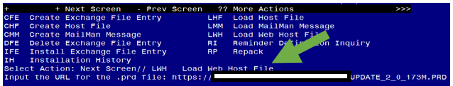

At the Select Action: prompt, enter LWH for Load Web Host File
At the Input the url for the .prd file: prompt, type the following web address:

https://Redacted/UPDATE_2_0_173M.PRD

You should see a message that the file was successfully loaded.

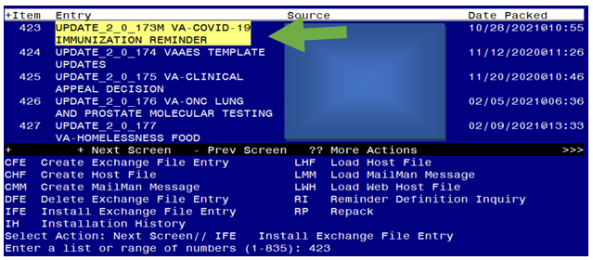

Search and locate an entry titled UPDATE_2_0_173M VA-COVID-19 IMMUNIZATION REMINDER.

At the Select Action prompt, enter IFE for Install Exchange File Entry
Enter the number that corresponds with your entry UPDATE_2_0_173M VA-COVID-19 IMMUNIZATION REMINDER. (in this example it is entry 423 it will vary by site). The date of the exchange file should be 10/28/2021.
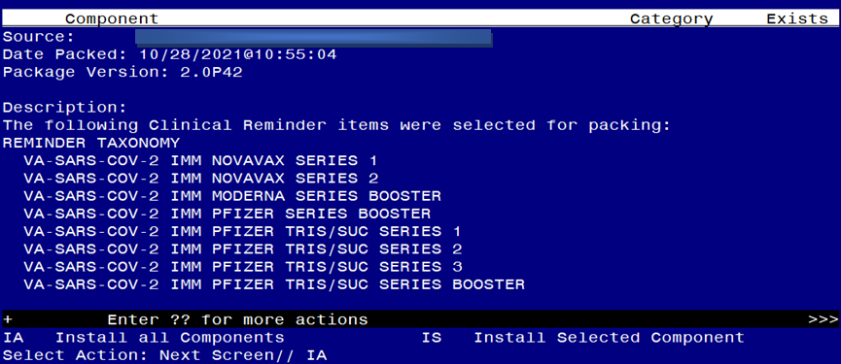
At the Select Action prompt, type IA for Install all Components and hit enter.
Any items that are NEW in any of the below categories, you should INSTALL
SKIP any HEALTH FACTORS if you are prompted to overwrite
OVERWRITE any REMINDER TAXONOMIES that you are prompted to overwrite

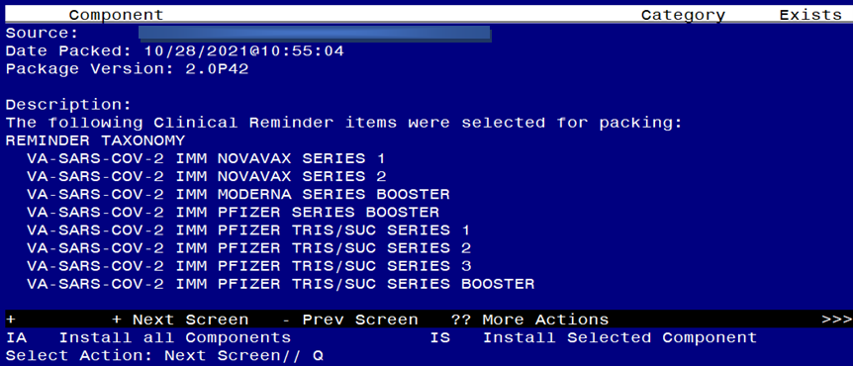

You will then be returned to this screen. At the Select Action prompt, type Q.

Install complete.

