Update _2_0_173N

Clinical Reminders

VA-COVID-19 IMMUNIZATION REMINDER UPDATE
Install Guide

December 2021

Product Development
Office of Information Technology
Department of Veterans Affairs

Table of Contents
Introduction 1
Pre-Install 7
Install Details 7
Install Example 7
Post-Installation 13

Introduction

DESCRIPTION:
This reminder update sends out an updated version of the Covid Immunization reminder definition and a dialog component that is discussed below.

173N makes updates to the VA-SARS-COV-2 IMMUNIZATION reminder dialog, reminder definition and associated progress note template.
Reminder exchange entry UPDATE_2_0_173N VA-COVID-19 IMMUNIZATION REMINDER

Updates are being made to have the reminder be due for patients for whom the Pfizer and Moderna vaccines are authorized for booster doses (age 18+) and also to match the new CDC guidance on time periods between doses.

This is a very complicated update and you MUST follow the instructions completely.

You should back up all of your lot numbers for Pfizer, Moderna and J&J and then add them back in post install. The below link is instructions for doing this.

Instructions in the Power Point document COVID-19_LOCAL_BACKUP_173I-508.

Update reminder logic
- Change to use the new CDC recommended intervals for first and second doses with grace periods. Was 1 day, now is >16 or >23 (4 day grace period).
- Add refusal and deferral options to the reminder definition
  - Refusal specifically of booster
  - Deferral after clinical review and determination that no addl doses are needed
RT VA-SARS-COV-2 VACCINE REFUSAL Finding # 17 T-14
HF VA-SARS-COV-2 IMM REFUSAL - BOOSTER/ADDL DOSE Finding # 2 T-6M
HF VA-SARS-COV-2 VACCINE REFUSAL Finding # 1 T-14
RT VA-SARS-COV-2 VACCINE DEFERRAL Finding # 18
HF VA-SARS-COV-2 IMM CLIN REV NO ADDL DOSE Finding # 2 no limit set
HF VA-SARS-COV-2 VACCINE DEFERRED Finding # 1 T-30

- Add COVAXIN to the terms where WHO approved, non-US vaccines are included; add Novavax to (b) and update the term description.
  - VA-SARS-COV-2 VACCINE WHO APPROVED ALL (INCL US
  - VA-SARS-COV-2 VACCINE WHO APPROVED NON-US COMPLETED
  - VA-SARS-COV-2 VACCINES
- Change from using a reminder definition for booster doses to instead use age 18+ as a computed finding in this term VA-SARS-COV-2 VACCINE INDICATION MRNA BOOSTER.

Dialog Updates:

- Add new options for refusal specifically for booster and deferral of additional doses after clinical review
  - These 2 options only show on patients who got prior doses that show a completed primary series and have the reminder due
- Update the dialog URLs for CDC and add the link for booster
  - VAL-SARS-COV-2 VACCINE INFO TEXT CDC URLS
- Change the booster text to show for anyone who got prior mRNA vaccine and change the text to indicate 18+ as recommended to receive vaccine: VAL-SARS-COV-2 BOOSTER DOSE GP CDC BOOSTER INFO updated and 2 template fields also updated.
- Add a text display under the immunocompromised dialog text to indicate the need for a booster 6 months later if there are 2 or more doses of mRNA vaccine already given
- Add the links for CDC booster information and the text about recommended vs authorized to the 50+ section also
- Remove the ‘exclude from progress note’ from 2 template fields
IM SARS COV-2 DOSE A1 #2 WARNING
IM SARS COV-2 DOSE C2 #B WARNING
- Update these template fields to show age 5-17 for recent EUA
IM SARS COV-2 INFO TEXT EUA AGES
IM SARS COV-2 ADOLESCENT-CHILD APPROVAL TEXT

Thank you to the following test sites who installed and tested this reminder update:

New Mexico VA Health Care System (Albuquerque)
VA Nebraska Western Iowa Health Care System
Ralph J Johnson VA Medical Center (Charleston)
Aleda E. Lutz VA Medical Center (Saginaw)
VA Maryland Health Care System (Baltimore)
VA Bronx
VA Kansas City

UPDATE_2_0_173N contains 1 Reminder Exchange entry:

TIU TEMPLATE FIELD
1 IM SARS COV-2 A1 BOOSTER INFO
2 IM SARS COV-2 D2 BOOSTER INFO
3 IM SARS COV-2 C2 BOOSTER INFO
4 IM SARS COV-2 ADOLESCENT-CHILD APPROVAL TEXT
5 BLANK TEXT FIELD FOR DIALOGS
6 IM SCRIBE
7 IM SARS COV-2 OUTSIDE INSTR 2
8 IM SARS COV-2 OUTSIDE INSTR 1
9 IM SARS COV-2 OUTSIDE WARNING
10 IM SARS COV-2 ADMIN INFO POST TEXT D2 #2
11 IM SARS COV-2 D2 DOSE
12 IM SARS COV-2 DOSE D2 #B WARNING
13 IM SARS COV-2 D2 DOSE #3 BOOSTER
14 IM SARS COV-2 VIS/EUA INFO URL D2
15 IM SARS COV-2 ADMIN D2 INFO PRE TEXT
16 IM SARS COV-2 DOSE D2 #3 WARNING
17 IM SARS COV-2 D2 DOSE #3
18 IM SARS COV-2 DOSE #2 WARNING
19 IM SARS COV-2 ADMIN INFO POST TEXT D2 #1
20 IM SARS COV-2 VIS/EUA INFO URL E2
21 IM SARS COV-2 ADMIN E2 INFO PRE TEXT
22 IM SARS COV-2 ADMIN INFO POST TEXT E2 #2
23 IM SARS COV-2 E2 DOSE
24 IM SARS COV-2 DOSE E2 #3 WARNING
25 IM SARS COV-2 E2 DOSE #3
26 IM SARS COV-2 ADMIN INFO POST TEXT E2 #1
27 IM SARS COV-2 VA SIDE EFFECTS AE REPORTING
28 IM SARS COV-2 VIS/EUA INFO URL B1
29 IM SARS COV-2 ADMIN B1 INFO PRE TEXT
30 IM SARS COV-2 ADMIN INFO POST TEXT B1 #2
31 IM SARS COV-2 B1 DOSE
32 IM SARS COV-2 DOSE B1 #3 WARNING
33 IM SARS COV-2 B1 DOSE #3
34 IM SARS COV-2 ADMIN INFO POST TEXT B1 #1
35 IM SARS COV-2 VIS/EUA INFO URL A1
36 IM SARS COV-2 ADMIN A1 INFO PRE TEXT
37 IM SARS COV-2 ADMIN INFO POST TEXT A1 #B
38 IM SARS COV-2 A1 DOSE
39 IM SARS COV-2 DOSE SERIES BOOSTER WARNING
40 IM SARS COV-2 DOSE A1 #3 WARNING
41 IM SARS COV-2 A1 DOSE #3
42 IM SARS COV-2 DOSE A1 #2 WARNING
43 IM SARS COV-2 A1 DOSE #2
44 IM SARS COV-2 ADMIN INFO POST TEXT A1
45 IM SARS COV-2 VIS/EUA INFO URL C2
46 IM SARS COV-2 ADMIN C2 INFO PRE TEXT
47 IM SARS COV-2 ADMIN INFO POST TEXT C2 #2
48 IM SARS COV-2 C2 DOSE 1/2 DOSE
49 IM SARS COV-2 DOSE C2 #B WARNING
50 IM SARS COV-2 C2 DOSE #3 BOOSTER
51 IM SARS COV-2 C2 DOSE
52 IM SARS COV-2 DOSE C2 #3 WARNING
53 IM SARS COV-2 C2 DOSE #3
54 IM SARS COV-2 ADMIN INFO POST TEXT C2 #1
55 IM SARS COV-2 CDC VACCINE CLINICAL CONSIDERATIONS
BOOSTERURL
56 IM SARS COV-2 INFO TEXT EUA AGES
57 IM SARS COV-2 CDC VACCINE UNDERLYING CONDITIONS
58 IM SARS COV-2 CDC VACCINE ANAPHYLAXIS INFO URL
59 IM SARS COV-2 CDC VACCINE CLINICAL CONSIDERATIONS
URL
60 IM SARS COV-2 CDC VACCINE INFO URL
61 IM SARS COV-2 VA PRE SCREEN FORM
62 IM SARS COV-2 VHA VACCINE INFO URL
63 IM SARS COV-2 PROVIDER EUA FACT URL A1
64 IM SARS COV-2 PROVIDER EUA FACT URL D2
65 IM SARS COV-2 PROVIDER EUA FACT URL C2

IMMUNIZATION
COVID-19 (SINOVAC), INACTIVATED VIRUS, NON-US
COVID-19 (BIBP, SINOPHARM) IV NON-US VACCINE
SARS-COV-2 (COVID-19) VACCINE, UNSPECIFIED
COVID-19 (ASTRAZENECA), VECTOR-NR, RS-CHADOX1,
PF, 0.5 ML
COVID-19 (NOVAVAX), SUBUNIT, RS-NANOPARTICLE+MATRI
X-M1 ADJUVANT, PF, 0.5 ML
COVID-19 (PFIZER), MRNA, LNP-S, PF, 30 MCG/0.3 ML
DOSE
COVID-19 (MODERNA), MRNA, LNP-S, PF, 100 MCG OR
50 MCG DOSE
COVID-19 (JANSSEN), VECTOR-NR, RS-AD26, PF, 0.5 ML
COVID-19 (COVAXIN) IV NON-US VACCINE
COVID-19 (QAZCOVID-IN) IV NON-US VACCINE
COVID-19 NON-US VACCINE, PRODUCT UNKNOWN
COVID-19 (EPIVACCORONA) PS NON-US VACCINEX
COVID-19 (JIANGSU PROVINCE CENTERS FOR DISEASE
CONTROL AND PREVENTION) PS NON-US VACCINE
COVID-19 (ANHUI ZHIFEI LONGCOM BIOPHARMACEUTICAL
+ INSTITUTE OF MICROBIOLOGY) PS NON-US VACCINE
COVID-19 (CANSINO BIOLOGICAL INC./BEIJING
INSTITUTE OF BIOTECHNOLOGY) VVNR NON-US VACCINE
COVID-19 (COVIVAC) LAV NON-US VACCINE
COVID-19 (SPUTNIK LIGHT) VVNR NON-US VACCINE
COVID-19 (SPUTNIK V) VVNR NON-US VACCINE
COVID-19 (PFIZER), MRNA, LNP-S, PF, 30 MCG/0.3 ML
DOSE, TRIS-SUCROSE (AGES 12+ YEARS)

HEALTH FACTORS
66 REMINDER FACTORS [C]
67 VA-UPDATE_2_0_173N
68 VA-COVID-19 [C]
69 VA-SARS-COV-2 IMM CLIN REV NO ADDL DOSE
70 IMMUNIZATION [C]
71 VA-SARS-COV-2 VACCINE DEFERRED
72 VA-SARS-COV-2 IMM REFUSAL - BOOSTER/ADDL DOSE
73 VA-SARS-COV-2 VACCINE REFUSAL
74 VA-SARS-COV-2 VACCINE CONTRAIND B1
75 VA-SARS-COV-2 VACCINE CONTRAIND A1
76 VA-SARS-COV-2 VACCINE CONTRAIND E2
77 VA-SARS-COV-2 VACCINE CONTRAIND C2
78 VA-SARS-COV-2 VACCINE CONTRAIND D2
79 VA-SARS-COV-2 IMM REFUSAL - NVX CVX 211
80 VA-SARS-COV-2 IMM REFUSAL - AZN CVX 210
81 VA-SARS-COV-2 IMM REFUSAL - JSN CVX 212
82 VA-SARS-COV-2 IMM REFUSAL - UNS CVX 213
83 VA-SARS-COV-2 IMM REFUSAL - PFR CVX 208
84 VA-SARS-COV-2 IMM REFUSAL - MOD CVX 207
85 COVID-19 VERBAL REPORT COVID VACCINE
86 VA-SARS-COV-2 VACCINE ANATOMIC SITE
87 VA-SARS-COV-2 IMMUN EDUC VVC/TELE VST

REMINDER SPONSOR
88 NATIONAL CENTER FOR HEALTH PROMOTION AND DISEASE
PREVENTION (NCP)
89 VA NATIONAL CENTER FOR HEALTH PROMOTION AND
DISEASE PREVENTION (NCP)

REMINDER COMPUTED FINDINGS
VA-REMINDER DEFINITION
VA-AGE
VA-IS INPATIENT
VA-APPOINTMENTS FOR A PATIENT

REMINDER TAXONOMY
90 VA-IMMUNOCOMPROMISED FOR COVID-19 ADDL DOSE
91 VA-HIV INFECTION
92 LONG TERM SYSTEMIC STEROID
93 VA-PNEUMOC DZ RISK - CHEMOTHERAPY
94 VA-IMMUNIZATION ICD10 CODE
95 VA-SARS-COV-2 IMM PFIZER TRIS/SUC SERIES BOOSTER
96 VA-SARS-COV-2 IMM PFIZER TRIS/SUC SERIES 3
97 VA-SARS-COV-2 IMM PFIZER TRIS/SUC SERIES 2
98 VA-SARS-COV-2 IMM PFIZER TRIS/SUC SERIES 1
99 VA-SARS-COV-2 IMM ASTRAZENECA SERIES 3
100 VA-SARS-COV-2 IMM ASTRAZENECA SERIES 2
101 VA-SARS-COV-2 IMM ASTRAZENECA SERIES 1
102 VA-SARS-COV-2 IMM NOVAVAX SERIES 3
103 VA-SARS-COV-2 IMM NOVAVAX SERIES 2
104 VA-SARS-COV-2 IMM NOVAVAX SERIES 1
105 VA-SARS-COV-2 IMM JANSSEN SERIES 2
106 VA-SARS-COV-2 IMM JANSSEN SERIES 1
107 VA-SARS-COV-2 IMM PFIZER SERIES BOOSTER
108 VA-SARS-COV-2 IMM PFIZER SERIES 3
109 VA-SARS-COV-2 IMM PFIZER SERIES 2
110 VA-SARS-COV-2 IMM PFIZER SERIES 1
111 VA-SARS-COV-2 IMM MODERNA SERIES BOOSTER
112 VA-SARS-COV-2 IMM MODERNA SERIES 3
113 VA-SARS-COV-2 IMM MODERNA SERIES 2
114 VA-SARS-COV-2 IMM MODERNA SERIES 1

REMINDER TERM
115 VA-REMINDER UPDATE_2_0_173N
116 VA-SARS-COV-2 IM DOSE NOT JANSSEN
117 VA-SARS-COV-2 VACCINE A1
118 VA-SARS-COV-2 IM DOSE NOT PFIZER
119 VA-CD4 COUNT
120 VA-STEROID PREDN EQUIV 5-6.6MG
121 VA-STEROID PREDN EQUIV 6.6-9MG
122 VA-STEROID PREDN EQUIV 10-19MG
123 VA-STEROID PREDN EQUIV >=20MG
124 VA-CHEMO/IMMUNOSUPPRESSIVE DRUGS
125 VA-SARS-COV-2 VACCINE INDICATION ADDL DOSE NEEDED
126 VA-SARS-COV-2 VACCINE INDICATION MRNA BOOSTER
127 VA-SARS-COV-2 VACCINE D2
128 VA-SARS-COV-2 IM DOSE NOT MODERNA
129 VA-SARS-COV-2 VACCINE C2
130 VA-COVID-19 ADOLESCENT AGE RANGE
131 VA-CURRENT INPATIENT
132 VA-COVID-19 VACCINATION CLINIC FUTURE APPT
133 VA-SARS-COV-2 VACCINE DOSE #1 OF 2
134 VAL-SYSTEMIC STEROIDS
135 VA-SARS-COV-2 VACCINE DEFERRAL
136 VA-SARS-COV-2 VACCINE REFUSAL
137 VA-SARS-COV-2 VACCINE CONTRAINDICATION
138 VA-SARS-COV-2 VACCINE E2
139 VA-SARS-COV-2 VACCINE B1
140 VA-SARS-COV-2 VACCINE INDICATION AGE
141 VA-SARS-COV-2 VACCINE WHO APPROVED ALL (INCL US)
142 VA-SARS-COV-2 VACCINE WHO APPROVED NON-US
COMPLETED
143 VA-SARS-COV-2 VACCINE INDICATION 5
144 VA-SARS-COV-2 VACCINE INDICATION 4
145 VA-SARS-COV-2 VACCINE INDICATION 3
146 VA-SARS-COV-2 VACCINE INDICATION 2
147 VA-SARS-COV-2 VACCINE INDICATION 1
148 VA-SARS-COV-2 VACCINE FOR BL
149 VA-SARS-COV-2 VACCINE DOSE C IN STD SERIES
150 VA-SARS-COV-2 VACCINE A1 1 DOSE
151 VA-SARS-COV-2 VACCINE D2 3 DOSE
152 VA-SARS-COV-2 VACCINE D2 2 DOSE
153 VA-SARS-COV-2 VACCINE D2 1 DOSE
154 VA-SARS-COV-2 VACCINE C2 3 DOSE
155 VA-SARS-COV-2 VACCINE C2 2 DOSE
156 VA-SARS-COV-2 VACCINE C2 1 DOSE
157 VA-SARS-COV-2 VACCINE E2 2 DOSE
158 VA-SARS-COV-2 IM DOSE NOT ASTRAZENECA
159 VA-SARS-COV-2 VACCINE E2 1 DOSE
160 VA-SARS-COV-2 VACCINE B1 2 DOSE
161 VA-SARS-COV-2 VACCINE B1 1 DOSE
162 VA-SARS-COV-2 IM DOSE NOT NOVAVAX
163 VAL-SARS-COV-2 VACC FOR BOOSTER BL

REMINDER DEFINITION
164 VAL-BL COVID-19 BOOSTER JANSSEN
165 VAL-IMMUNOCOMPROMISING DRUGS/LABS/DX FOR COVID-19
166 VAL-BL COVID-19 BOOSTER PFIZER
167 VAL-BL COVID-19 BOOSTER MODERNA
168 VA-SARS COV-2 IMMUNIZATION

HEALTH SUMMARY COMPONENT
PCE IMMUNIZATIONS SELECT CHRON
CLINICAL REMINDERS FINDINGS

HEALTH SUMMARY TYPE
169 SARS-COV-2 IMMUNIZATION
170 INDICATION ADDL DOSE COVID-19

HEALTH SUMMARY OBJECTS
171 SARS-COV-2 IMMUNIZATION (TIU)
172 INDICATION ADDL DOSE COVID-19 (TIU)

TIU DOCUMENT DEFINITION
173 SARS-COV-2 IMMUNIZATION
174 INDICATION ADDL DOSE COVID-19

REMINDER DIALOG
175 VA-SARS-COV-2 IMMUNIZATION TEMPLATE
176 VA-SARS-COV-2 IMMUNIZATION

Pre-Install
- You should have installed update 173L and 173M prior to installing this update.
- Back up all your lot numbers as described previously
Covid Lot # Backup

– this update WILL OVERWRITE all your lot numbers and you will need to re-install them after installing this update. Find the previously packed lot numbers in the Reminder Exchange file entries and repack it to update it – use the Repack (RP) command to pack a fresh copy.
- Any local modifications to template fields or to the dialog will be overwritten. Please make note of your local modifications and evaluate whether they are still needed or valid prior to re-entering them in the post-install.
- Terms that are likely to have local mappings are highlighted in GREEN above and you should not overwrite those. Make a note of those.
- Items in yellow have been changed or are new and you should expect to install or overwrite those.

Install Details
This update is being distributed as a web host file. The address for the host file is: https://Redacted /UPDATE_2_0_173N.PRD

The file will be installed using Reminder Exchange, programmer access is not required.
This update can be loaded with users on the system. Installation will take less than 5 minutes

Install Example
To Load the Web Host File. Navigate to Reminder exchange in Vista
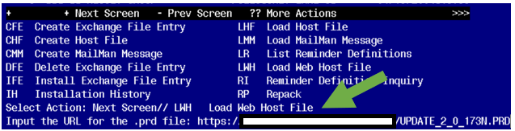

At the Select Action: prompt, enter LWH for Load Web Host File
At the Input the url for the .prd file: prompt, type the following web address:

https://Redacted/UPDATE_2_0_173N.PRD

You should see a message that the file was successfully loaded.

This will install one exchange entries in your exchange file

Added Reminder Exchange entry UPDATE_2_0_173N VA-COVID-19 IMMUNIZATION REMINDER
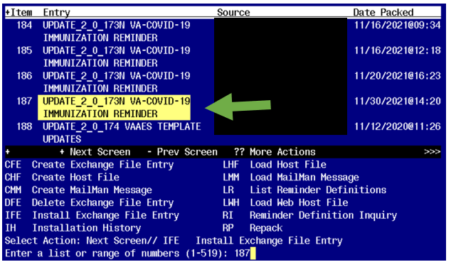

Search and locate an entry titled UPDATE_2_0_173N VA-COVID-19 IMMUNIZATION REMINDER.

At the Select Action prompt, enter IFE for Install Exchange File Entry
Enter the number that corresponds with your entry UPDATE_2_0_173N VA-COVID-19 IMMUNIZATION REMINDER. (in this example it is entry 187 it will vary by site). The date of the exchange file should be 11/30/2021.

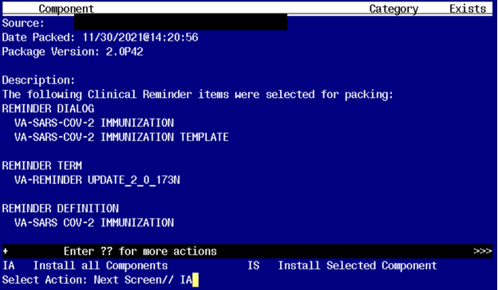
At the Select Action prompt, type IA for Install all Components and hit enter.

Any items that are NEW in any of the below categories, you should INSTALL

OVERWRITE any TIU TEMPLATE FIELDS that you are prompted to overwrite
SKIP any HEALTH FACTORS if you are prompted to overwrite
SKIP any REMINDER SPONSORS if you are prompted to overwrite
SKIP any REMINDER TAXONOMIES you are prompted to overwrite EXCEPT
VA-SARS-COV-2 IMM JANSSEN SERIES 2 This should be OVERWRITE action

OVERWRITE any REMINDER TERMS that you are prompted to overwrite EXCEPT those that have local mappings as indicated in GREEN above and listed again below. DO NOT overwrite your previously mapped terms for drugs and labs.
VA-CD4 COUNT
VA-STEROID PREDN EQUIV 5-6.6MG
VA-STEROID PREDN EQUIV 6.6-9MG
VA-STEROID PREDN EQUIV 10-19MG
VA-STEROID PREDN EQUIV >=20MG
VA-COVID-19 VACCINATION CLINIC FUTURE APPT
VAL-SYSTEMIC STEROIDS
OVERWRITE this REMINDER DEFINITION:
VA-SARS COV-2 IMMUNIZATION and
SKIP any HEALTH SUMMARY TYPE entries if you are prompted to overwrite
SKIP any HEALTH SUMMARY OBJECTS entries if you are prompted to overwrite
SKIP any TIU DOCUMENT DEFINITION entries if you are prompted to overwrite
You will then be prompted to install the dialog component. You will choose IA to install all even though some items will already have an X to indicate they exist.

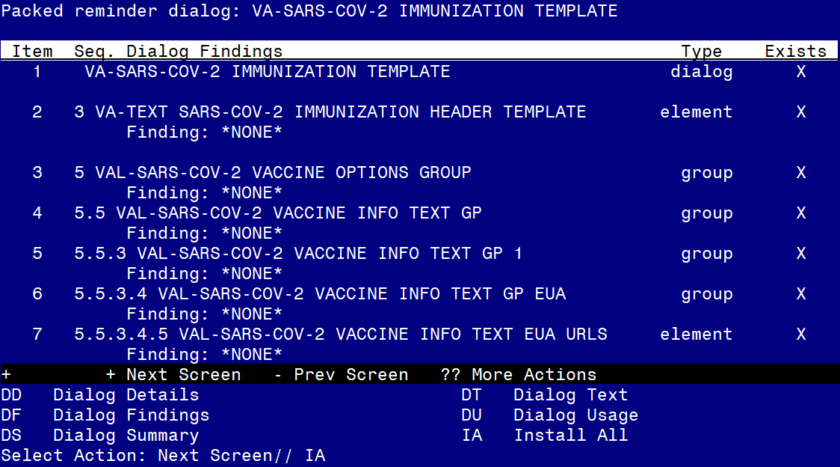

At the Select Action prompt, type IA to install the dialog – SARS-COV-2 IMMUNIZATION TEMPLATE

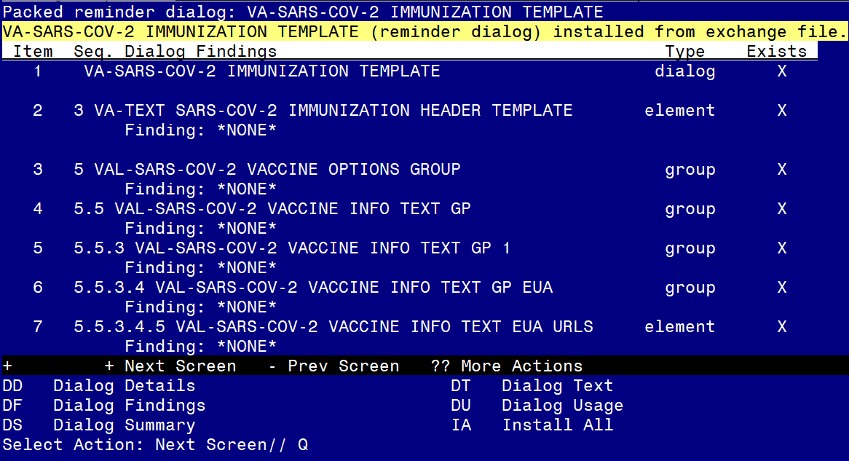
You will then be returned to this screen. At the Select Action prompt, type Q.
You will then be prompted to install the next dialog component. You will choose IA to install all even though some items will already have an X to indicate they exist.

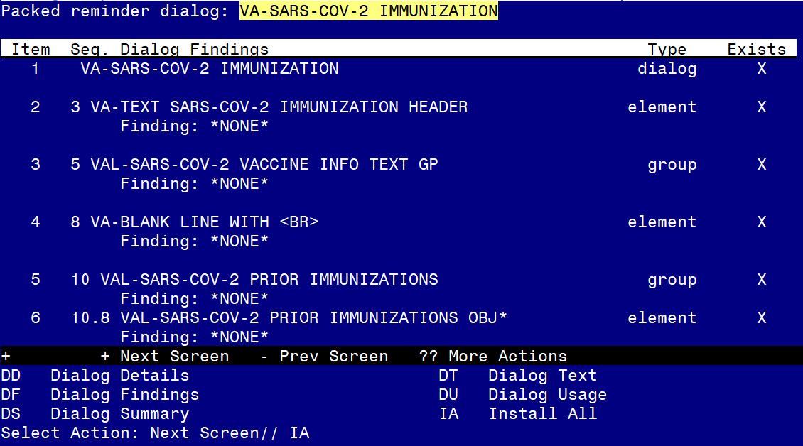

At the Select Action prompt, type IA to install the dialog – SARS-COV-2 IMMUNIZATION

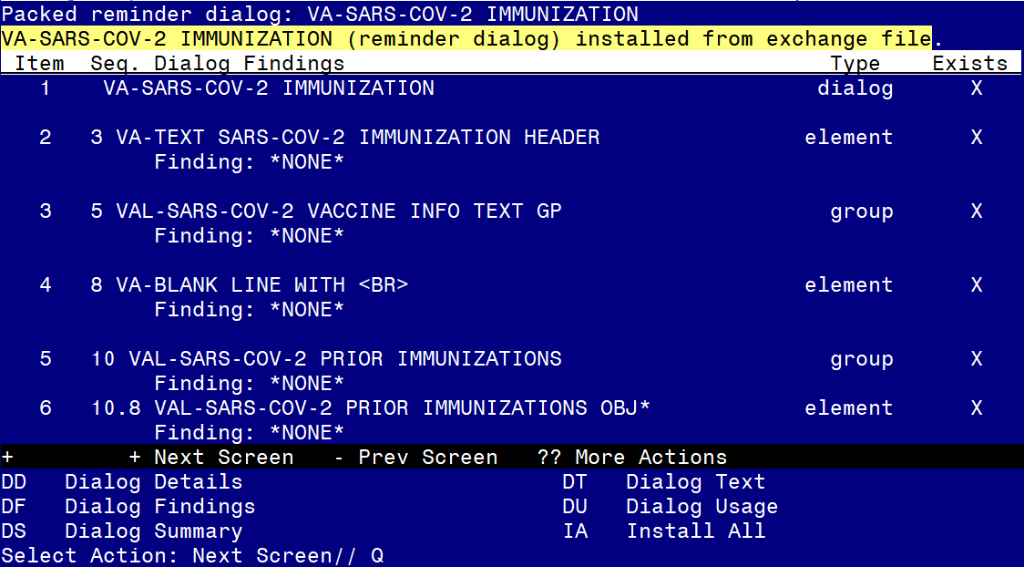
You will then be returned to this screen. At the Select Action prompt, type Q.

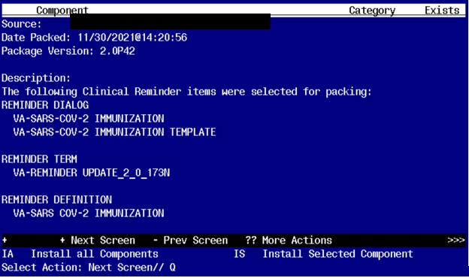

You will then be returned to this screen. At the Select Action prompt, type Q.

Install complete.

Post-Installation
- Reinstall your lot numbers from the backup exchange file created in the pre-install.
- Re-enter any required local modifications.
- Disable any dialog groups for vaccine types not in use at your site – E.g. if you are exclusively a Moderna & Janssen site, then disable the dialog group for Pfizer:
Group: VAL-SARS-COV-2 VACCINE ADMIN D2 GP
- If you use the scribe option, then re-enable it.

