Update _2_0_173P

Clinical Reminders

VA-COVID-19 IMMUNIZATION REMINDER UPDATE
Install Guide

December 2021

Product Development
Office of Information Technology
Department of Veterans Affairs

Table of Contents
Introduction 1
Pre-Install 3
Install Details 3
Install Example 4
Post-Installation 7

Introduction

DESCRIPTION:
This reminder update sends out an updated version of the Covid Immunization reminder dialogs and reminder definition that are discussed below.

173P makes updates to the VA-SARS-COV-2 IMMUNIZATION reminder dialog and associated progress note template.
Reminder exchange entry UPDATE_2_0_173P VA-COVID-19 IMMUNIZATION REMINDER

- Updates the template fields to match new CDC guidance that mRNA COVID-19 vaccines are highly preferred over Janssen vaccine for primary series and for booster doses.
- Updates the pre-vaccine text for Janssen to reflect the new warning and counseling.
- Adds a warning with details of the counseling required to the Janssen administration section.
- Updates the found text in the reminder definition to reflect that all patients 18 and older should get a booster dose of vaccine.

Thank you to the following test sites who installed and tested this reminder update:

New Mexico VA Health Care System (Albuquerque)
VA Nebraska Western Iowa Health Care System
Ralph J Johnson VA Medical Center (Charleston)
Aleda E. Lutz VA Medical Center (Saginaw)
VA Maryland Health Care System (Baltimore)
VA Bronx

UPDATE_2_0_173P contains 1 Reminder Exchange entry: UPDATE_2_0_173P VA-COVID-19 IMMUNIZATION REMINDER with the following components:

TIU TEMPLATE FIELDS
IM SARS COV-2 VIS/EUA INFO URL A1
IM SARS COV-2 ADMIN A1 INFO TTS COUNSELING
IM SARS COV-2 ADMIN A1 INFO PRE TEXT
IM SARS COV-2 A1 BOOSTER INFO
IM SARS COV-2 D2 BOOSTER INFO
IM SARS COV-2 C2 BOOSTER INFO

HEALTH FACTORS
REMINDER FACTORS [C]
VA-UPDATE_2_0_173P
VA-COVID-19 [C]
VA-SARS-COV-2 IMM CLIN REV NO ADDL DOSE
IMMUNIZATION [C]
COVID-19 VERBAL REPORT COVID VACCINE
VA-SARS-COV-2 VACCINE ANATOMIC SITE
VA-SARS-COV-2 VACCINE DEFERRED
VA-SARS-COV-2 IMM REFUSAL - BOOSTER/ADDL DOSE
VA-SARS-COV-2 VACCINE REFUSAL
VA-SARS-COV-2 VACCINE CONTRAIND B1
VA-SARS-COV-2 VACCINE CONTRAIND A1
VA-SARS-COV-2 VACCINE CONTRAIND E2
VA-SARS-COV-2 VACCINE CONTRAIND C2
VA-SARS-COV-2 VACCINE CONTRAIND D2

REMINDER SPONSOR
NATIONAL CENTER FOR HEALTH PROMOTION AND DISEASE PREVENTION (NCP)
VA NATIONAL CENTER FOR HEALTH PROMOTION AND DISEASE PREVENTION (NCP)

REMINDER TAXONOMY
VA-IMMUNOCOMPROMISED FOR COVID-19 ADDL DOSE
VA-HIV INFECTION
LONG TERM SYSTEMIC STEROID
VA-PNEUMOC DZ RISK - CHEMOTHERAPY

REMINDER TERM
VA-REMINDER UPDATE_2_0_173P
VA-SARS-COV-2 IM DOSE NOT JANSSEN
VA-SARS-COV-2 VACCINE A1
VA-SARS-COV-2 IM DOSE NOT PFIZER
VA-CD4 COUNT
VA-STEROID PREDN EQUIV 5-6.6MG
VA-STEROID PREDN EQUIV 6.6-9MG
VA-STEROID PREDN EQUIV 10-19MG
VA-STEROID PREDN EQUIV >=20MG
VA-CHEMO/IMMUNOSUPPRESSIVE DRUGS
VA-SARS-COV-2 VACCINE INDICATION ADDL DOSE NEEDED
VA-SARS-COV-2 VACCINE INDICATION MRNA BOOSTER
VA-SARS-COV-2 VACCINE D2
VA-SARS-COV-2 IM DOSE NOT MODERNA
VA-SARS-COV-2 VACCINE C2
VA-COVID-19 VACCINATION CLINIC FUTURE APPT
VA-SARS-COV-2 VACCINE DOSE #1 OF 2
VAL-SYSTEMIC STEROIDS
VA-SARS-COV-2 VACCINE DEFERRAL
VA-SARS-COV-2 VACCINE REFUSAL
VA-SARS-COV-2 VACCINE CONTRAINDICATION
VA-SARS-COV-2 VACCINE E2
VA-SARS-COV-2 VACCINE B1
VA-SARS-COV-2 VACCINE INDICATION AGE
VA-SARS-COV-2 VACCINE WHO APPROVED ALL (INCL US)
VA-SARS-COV-2 VACCINE WHO APPROVED NON-US COMPLETED
VA-SARS-COV-2 VACCINE INDICATION 5
VA-SARS-COV-2 VACCINE INDICATION 4
VA-SARS-COV-2 VACCINE INDICATION 3
VA-SARS-COV-2 VACCINE INDICATION 2
VA-SARS-COV-2 VACCINE INDICATION 1

REMINDER DEFINITION
VAL-BL COVID-19 BOOSTER JANSSEN
VAL-IMMUNOCOMPROMISING DRUGS/LABS/DX FOR COVID-19
VAL-BL COVID-19 BOOSTER PFIZER
VAL-BL COVID-19 BOOSTER MODERNA
VA-SARS COV-2 IMMUNIZATION

REMINDER DIALOG
SARS-COV-2 IMMUN UPDATE 173P V2.15

Pre-Install
- You should have installed the prior versions of the covid immunization reminder updates, the most recent being 173O prior to installing this update.
- Terms that are likely to have local mappings are highlighted in BLUE above and you should skip and not overwrite those .
- Items that should be overwritten are highlighted in GREEN above.
- Items in yellow are new and you should expect to install those.

Install Details
This update is being distributed as a web host file. The address for the host file is: https://REDACTED /UPDATE_2_0_173P.PRD

The file will be installed using Reminder Exchange, programmer access is not required.
This update can be loaded with users on the system. Installation will take less than 5 minutes

Install Example
To Load the Web Host File. Navigate to Reminder exchange in Vista
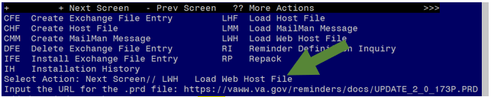
At the Select Action: prompt, enter LWH for Load Web Host File
At the Input the url for the .prd file: prompt, type the following web address:

https://Redacted /UPDATE_2_0_173P.PRD

You should see a message that the file was successfully loaded.

This will install one exchange entry in your exchange file.
Added Reminder Exchange entry UPDATE_2_0_173P VA-COVID-19 IMMUNIZATION REMINDER
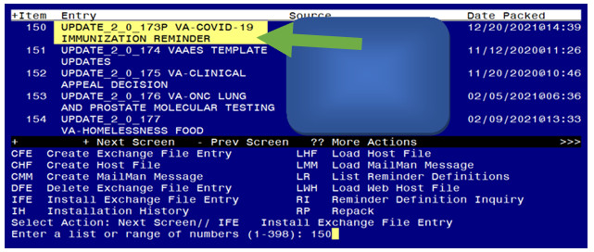

Search and locate an entry titled UPDATE_2_0_173P VA-COVID-19 IMMUNIZATION REMINDER.

At the Select Action prompt, enter IFE for Install Exchange File Entry
Enter the number that corresponds with your entry UPDATE_2_0_173P VA-COVID-19 IMMUNIZATION REMINDER. (in this example it is entry 150 it will vary by site). The date of the exchange file should be 12/20/2021. .

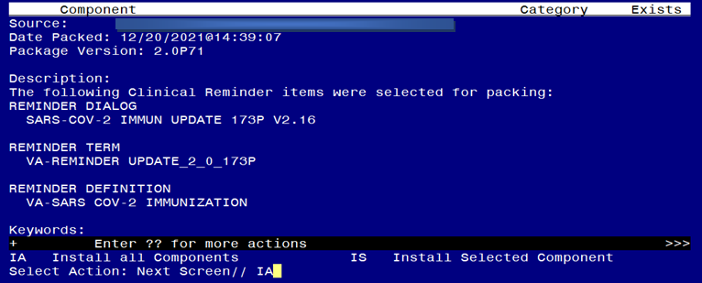
At the Select Action prompt, type IA for Install all Components and hit enter.
Any items that are NEW in any categories, you should INSTALL
You will overwrite the following txml fields:
IM SARS COV-2 ADMIN A1 INFO PRE TEXT
IM SARS COV-2 A1 BOOSTER INFO
IM SARS COV-2 D2 BOOSTER INFO
IM SARS COV-2 C2 BOOSTER INFO
If you are prompted to overwrite any health factors, you should choose SKIP
If you are prompted to overwrite any taxonomies, you should choose SKIP
If you are prompted to overwrite any reminder terms, you should choose SKIP
It is important that you skip and DO NOT overwrite your previously mapped terms for clinic visits, drugs and labs if you are prompted to overwrite:
VA-COVID-19 VACCINATION CLINIC FUTURE APPT
VA-CD4 COUNT
VA-STEROID PREDN EQUIV 5-6.6MG
VA-STEROID PREDN EQUIV 6.6-9MG
VA-STEROID PREDN EQUIV 10-19MG
VA-STEROID PREDN EQUIV >=20MG
VA-CHEMO/IMMUNOSUPPRESSIVE DRUGS
You should Overwrite the reminder definition VA-SARS COV-2 IMMUNIZATION when prompted. If you are prompted to overwrite any other definitions, choose SKIP.

You will then be prompted to install the reminder dialog component, you will choose IA to install even though most items will have an X to indicate they already exist.

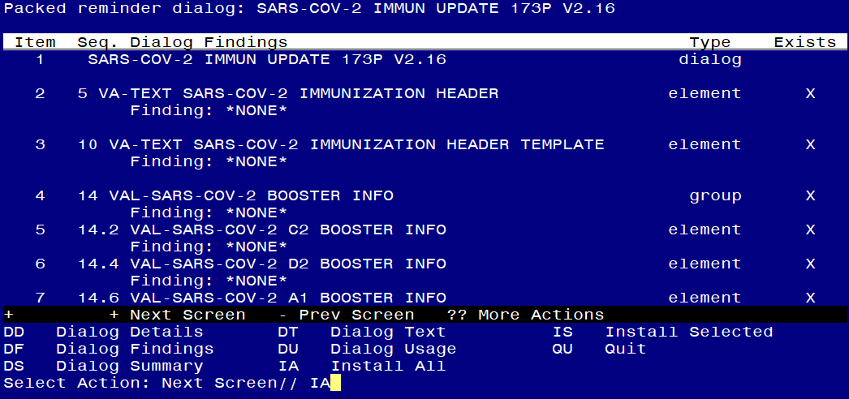

At the Select Action prompt, type IA to install the dialog – SARS-COV-2 IMMUN UPDATE 173P V2.16.

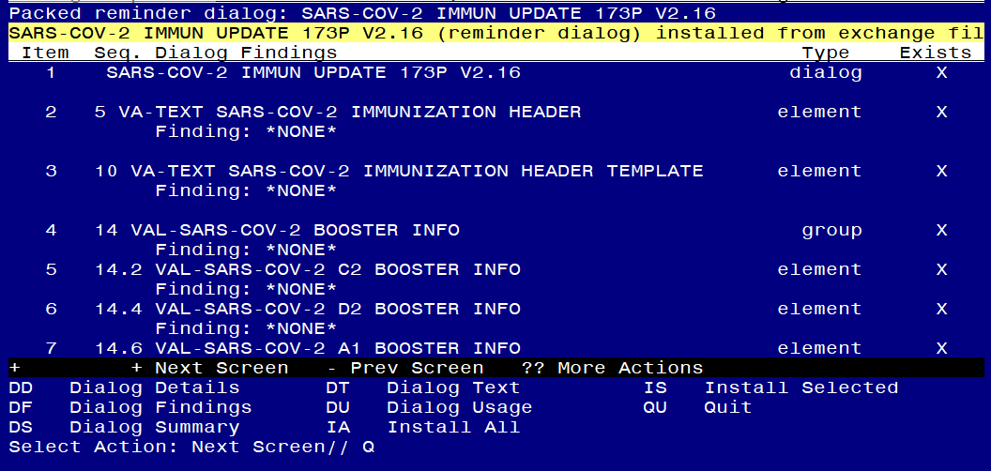
You will then be returned to this screen. At the Select Action prompt, type Q.

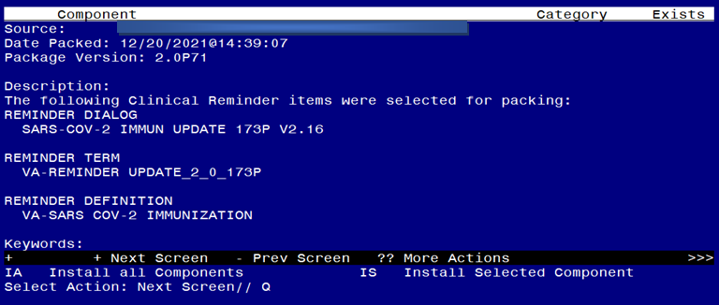

You will then be returned to this screen. At the Select Action prompt, type Q.

Install complete.

Post-Installation
- This update was sent out with the reminder dialog disassociated from the reminder definition. You will need to reassociate the reminder dialog to the reminder definition.
You can do this using the Vista Menu, Reminder Dialog Manager, Reminder Dialogs in Reminder view find the reminder definition VA-SARS COV-2 IMMUNIZATION choose that reminder and then use the LR feature to link the reminder to the dialog:
REMINDER NAME: VA-SARS COV-2 IMMUNIZATION
LINKED REMINDER DIALOG: VA-SARS
1 VA-SARS-COV-2 IMMUNIZATION reminder dialog NATIONAL
2 VA-SARS-COV-2 IMMUNIZATION TEMPLATE reminder dialog NATIONAL
CHOOSE 1-2: 1 VA-SARS-COV-2 IMMUNIZATION reminder dialog NATIONAL
- If your site is using or has switched to using the Tris-sucrose formulation of Pfizer vaccine, you will need to enable the dialog group for the TS formulation:
Group: VAL-SARS-COV-2 VACCINE ADMIN D2 TS GP (Disabled)

