Update _2_0_173Q

Clinical Reminders

VA-COVID-19 IMMUNIZATION REMINDER UPDATE
Install Guide

January 2022

Product Development
Office of Information Technology
Department of Veterans Affairs

Table of Contents
Introduction 1
Pre-Install 3
Install Details 5
Install Example 6
Post-Installation 10

Introduction

DESCRIPTION:
This reminder update sends out an updated version of the Covid Immunization reminder dialogs and reminder definition that are discussed below.

173Q makes updates to the VA-SARS-COV-2 IMMUNIZATION reminder dialog and associated progress note template.
Reminder exchange entry UPDATE_2_0_173Q VA-COVID-19 IMMUNIZATION REMINDER

DEFINITION CHANGES
- RT VA-SARS-COV-2 VACCINE INDICATION MRNA BOOSTER Finding # 6
Update to I V>11 for age, update found text

- FF 13,14, 16 and 43, 44, 46 changed to 5M from 6M

- Update taxonomy VA-SARS-COV-2 IMM JANSSEN SERIES 2 with code 0034A which was finally just released in a Lexicon patch.

- FF 60-73 change 150D to 120D

- Replace CVX 208 with both 208 & 217 in 61, 63, 65, 67, 71. Add FF 74 to add CVX217 since adding it to 73 is too long and fails. (see the Clinical Reminder Technical description for what was replaced in each of these FFs).

DIALOG CHANGES

The text in the following dialog elements and groups is updated by this reminder update to include the 5 month interval for Pfizer booster doses:
VAL-SARS-COV-2 BOOSTER DOSE DSP TEXT GP
VAL-SARS-COV-2 BOOSTER CDC INFO
VAL-SARS-COV-2 ADDL DOSE IMMUNOC BOOSTER INFO
VAL-SARS-COV-2 C2 BOOSTER INFO
VAL-SARS-COV-2 D2 BOOSTER INFO

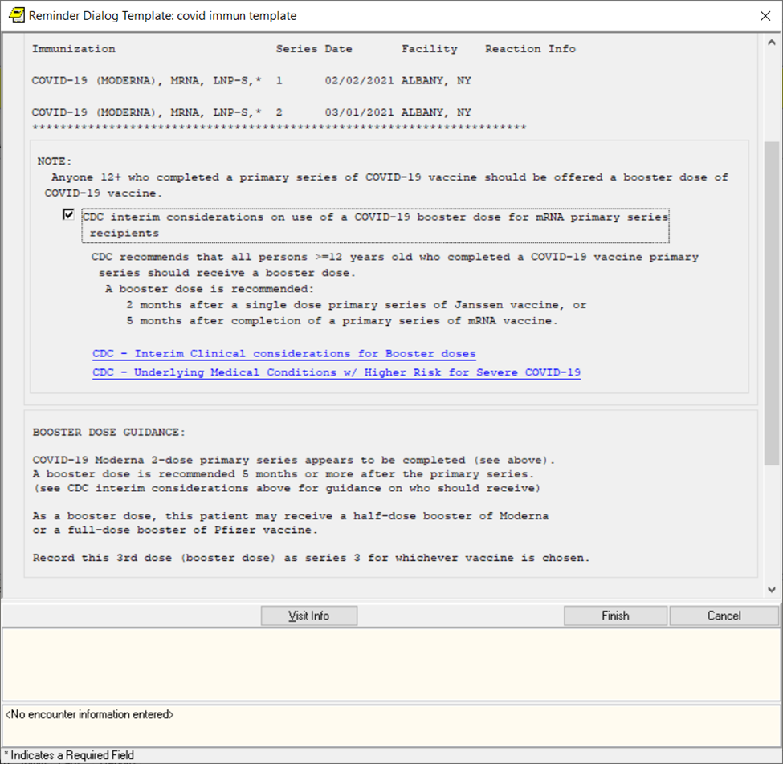

Thank you to the following test sites who installed and tested this reminder update:

New Mexico VA Health Care System (Albuquerque)
VA Nebraska Western Iowa Health Care System
Ralph J Johnson VA Medical Center (Charleston)
Aleda E. Lutz VA Medical Center (Saginaw)
VA Maryland Health Care System (Baltimore)
VA Bronx

UPDATE_2_0_173Q contains 1 Reminder Exchange entry: UPDATE_2_0_173Q VA-COVID-19 IMMUNIZATION REMINDER with the following components:

TIU TEMPLATE FIELD
1 IM SARS COV-2 CDC VACCINE CLINICAL CONSIDERATIONS
BOOSTERURL
2 IM SARS COV-2 A1 BOOSTER INFO
3 IM SARS COV-2 D2 BOOSTER INFO
4 IM SARS COV-2 C2 BOOSTER INFO

IMMUNIZATION
COVID-19 (PFIZER), MRNA, LNP-S, PF, 30 MCG/0.3 ML
DOSE, TRIS-SUCROSE (AGES 12+ YEARS)
COVID-19 (PFIZER), MRNA, LNP-S, PF, 30 MCG/0.3 ML
DOSE
COVID-19 (MODERNA), MRNA, LNP-S, PF, 100 MCG OR
50 MCG DOSE
COVID-19 (SINOVAC), INACTIVATED VIRUS, NON-US
COVID-19 (BIBP, SINOPHARM) IV NON-US VACCINE
SARS-COV-2 (COVID-19) VACCINE, UNSPECIFIED
COVID-19 (ASTRAZENECA), VECTOR-NR, RS-CHADOX1,
PF, 0.5 ML
COVID-19 (NOVAVAX), SUBUNIT, RS-NANOPARTICLE+MATRI
X-M1 ADJUVANT, PF, 0.5 ML
COVID-19 (JANSSEN), VECTOR-NR, RS-AD26, PF, 0.5 ML
COVID-19 (COVAXIN) IV NON-US VACCINE

HEALTH FACTORS
5 VA-REMINDER UPDATES [C]
6 VA-UPDATE_2_0_173Q
7 VA-COVID-19 [C]
8 VA-SARS-COV-2 IMM CLIN REV NO ADDL DOSE
9 IMMUNIZATION [C]
10 VA-SARS-COV-2 VACCINE DEFERRED
11 VA-SARS-COV-2 IMM REFUSAL - BOOSTER/ADDL DOSE
12 VA-SARS-COV-2 VACCINE REFUSAL
13 VA-SARS-COV-2 VACCINE CONTRAIND B1
14 VA-SARS-COV-2 VACCINE CONTRAIND A1
15 VA-SARS-COV-2 VACCINE CONTRAIND E2
16 VA-SARS-COV-2 VACCINE CONTRAIND C2
17 VA-SARS-COV-2 VACCINE CONTRAIND D2

REMINDER SPONSOR
18 NATIONAL CENTER FOR HEALTH PROMOTION AND DISEASE
PREVENTION (NCP)
19 VA NATIONAL CENTER FOR HEALTH PROMOTION AND
DISEASE PREVENTION (NCP)

REMINDER COMPUTED FINDINGS
VA-REMINDER DEFINITION
VA-AGE
VA-APPOINTMENTS FOR A PATIENT
VA-IS INPATIENT

REMINDER TAXONOMY
20 VA-SARS-COV-2 IMM JANSSEN SERIES 2
21 VA-IMMUNOCOMPROMISED FOR COVID-19 ADDL DOSE
22 VA-HIV INFECTION
23 LONG TERM SYSTEMIC STEROID
24 VA-PNEUMOC DZ RISK - CHEMOTHERAPY

REMINDER TERM
25 VA-REMINDER UPDATE_2_0_173Q
26 VAL-SARS-COV-2 VACC FOR BOOSTER BL
27 VA-SARS-COV-2 IM DOSE NOT JANSSEN
28 VA-SARS-COV-2 VACCINE A1
29 VA-SARS-COV-2 IM DOSE NOT PFIZER
30 VA-CD4 COUNT
31 VA-STEROID PREDN EQUIV 5-6.6MG
32 VA-STEROID PREDN EQUIV 6.6-9MG
33 VA-STEROID PREDN EQUIV 10-19MG
34 VA-STEROID PREDN EQUIV >=20MG
35 VA-CHEMO/IMMUNOSUPPRESSIVE DRUGS
36 VA-SARS-COV-2 VACCINE INDICATION ADDL DOSE NEEDED
37 VA-SARS-COV-2 VACCINE INDICATION MRNA BOOSTER
38 VA-SARS-COV-2 VACCINE D2
39 VA-SARS-COV-2 IM DOSE NOT MODERNA
40 VA-SARS-COV-2 VACCINE C2
41 VA-COVID-19 VACCINATION CLINIC FUTURE APPT
42 VA-SARS-COV-2 VACCINE DOSE #1 OF 2
43 VAL-SYSTEMIC STEROIDS
44 VA-SARS-COV-2 VACCINE DEFERRAL
45 VA-SARS-COV-2 VACCINE REFUSAL
46 VA-SARS-COV-2 VACCINE CONTRAINDICATION
47 VA-SARS-COV-2 VACCINE E2
48 VA-SARS-COV-2 VACCINE B1
49 VA-SARS-COV-2 VACCINE INDICATION AGE
50 VA-SARS-COV-2 VACCINE WHO APPROVED ALL (INCL US)
51 VA-SARS-COV-2 VACCINE WHO APPROVED NON-US
COMPLETED
52 VA-SARS-COV-2 VACCINE INDICATION 5
53 VA-SARS-COV-2 VACCINE INDICATION 4
54 VA-SARS-COV-2 VACCINE INDICATION 3
55 VA-SARS-COV-2 VACCINE INDICATION 2
56 VA-SARS-COV-2 VACCINE INDICATION 1

REMINDER DEFINITION
57 VAL-BL COVID-19 BOOSTER JANSSEN
58 VAL-IMMUNOCOMPROMISING DRUGS/LABS/DX FOR COVID-19
59 VAL-BL COVID-19 BOOSTER PFIZER
60 VAL-BL COVID-19 BOOSTER MODERNA
61 VA-SARS COV-2 IMMUNIZATION

REMINDER DIALOG
62 SARS-COV-2 IMMUN UPDATE 173Q V2.17

Pre-Install
- You should have installed the prior versions of the covid immunization reminder updates, the most recent being 173P prior to installing this update.
- Note, a prerequisite to installing this is that you MUST have patch OR*3.0*498 (part of the CPRS31B follow up bundle of patches) installed. The compliance date for these patches is January 21, 2022. If you try to install this reminder update prior to that, you will encounter errors when installing the dialog portion
- This update will NOT overwrite lot numbers
- Items that should be overwritten are highlighted in GREEN above.

Install Details
This update is being distributed as a web host file. The address for the host file is: https://Redacted /UPDATE_2_0_173Q.PRD

The file will be installed using Reminder Exchange, programmer access is not required.
This update can be loaded with users on the system. Installation will take less than 5 minutes

If you try to install before patch OR*3.0*498 has been installed into your system (per item 2 in Pre Install section), you will see this error

The test update failed, UPDATE^DIE returned the following error message:
MSG("DIERR")=1^1
MSG("DIERR",1)=701
MSG("DIERR",1,"PARAM",0)=3
MSG("DIERR",1,"PARAM",3)=RT.VAL-SARS-COV-2 VACC FOR BOOSTER BL
MSG("DIERR",1,"PARAM","FIELD")=1
MSG("DIERR",1,"PARAM","FILE")=801.41143
MSG("DIERR",1,"TEXT",1)=The value 'RT.VAL-SARS-COV-2 VACC FOR BOOSTER BL' for fi
eld EVALUATION ITEM in BRANCHING LOGIC SUB-FIELD in file REMINDER DIALOG is not
valid.
MSG("DIERR","E",701,1)=
REMINDER DIALOG entry VAL-SARS-COV-2 ADDL DOSE IMMUNOC BOOSTER INFO did not get
installed!
Examine the following error message for the reason.

The update failed, UPDATE^DIE returned the following error message:
MSG("DIERR")=1^1
MSG("DIERR",1)=701
MSG("DIERR",1,"PARAM",0)=3
MSG("DIERR",1,"PARAM",3)=RT.VAL-SARS-COV-2 VACC FOR BOOSTER BL
MSG("DIERR",1,"PARAM","FIELD")=1
MSG("DIERR",1,"PARAM","FILE")=801.41143
MSG("DIERR",1,"TEXT",1)=The value 'RT.VAL-SARS-COV-2 VACC FOR BOOSTER BL' for fi
eld EVALUATION ITEM in BRANCHING LOGIC SUB-FIELD in file REMINDER DIALOG is not
valid.
MSG("DIERR","E",701,1)=
.....

Install Example
To Load the Web Host File. Navigate to Reminder exchange in Vista
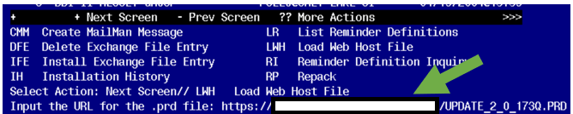
At the Select Action: prompt, enter LWH for Load Web Host File
At the Input the url for the .prd file: prompt, type the following web address:

https://Redacted /UPDATE_2_0_173Q.PRD

You should see a message that the file was successfully loaded.

This will install one exchange entry in your exchange file.
Added Reminder Exchange entry UPDATE_2_0_173Q VA-COVID-19 IMMUNIZATION REMINDER
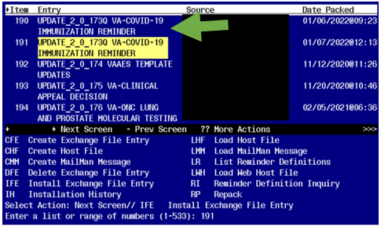

Search and locate an entry titled UPDATE_2_0_173Q VA-COVID-19 IMMUNIZATION REMINDER.

At the Select Action prompt, enter IFE for Install Exchange File Entry
Enter the number that corresponds with your entry UPDATE_2_0_173Q VA-COVID-19 IMMUNIZATION REMINDER. (in this example it is entry 190 it will vary by site). The date of the exchange file should be 1/07/2022. .

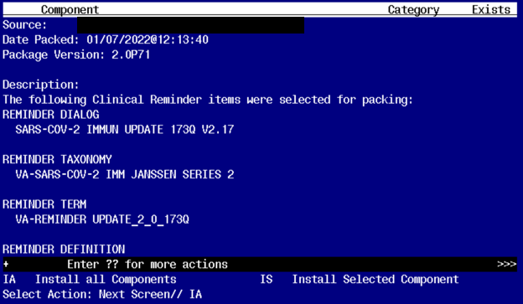
At the Select Action prompt, type IA for Install all Components and hit enter.
Any items that are NEW in any categories, you should INSTALL
Overwrite the following template fields:
IM SARS COV-2 C2 BOOSTER INFO
IM SARS COV-2 D2 BOOSTER INFO

If you are prompted to overwrite any health factors, you should choose SKIP

Overwrite the reminder taxonomy VA-SARS-COV-2 IMM JANSSEN SERIES 2.
If you are prompted to overwrite any other reminder taxonomies, you should choose SKIP

Overwrite the reminder term VA-SARS-COV-2 VACCINE INDICATION MRNA BOOSTER.
If you are prompted to overwrite any other reminder terms, you should choose SKIP

Overwrite the reminder definition VA-SARS COV-2 IMMUNIZATION when prompted.
If you are prompted to overwrite any other definitions, choose SKIP.

You will then be prompted to install the reminder dialog component, you will choose IA to install even though most items will have an X to indicate they already exist.

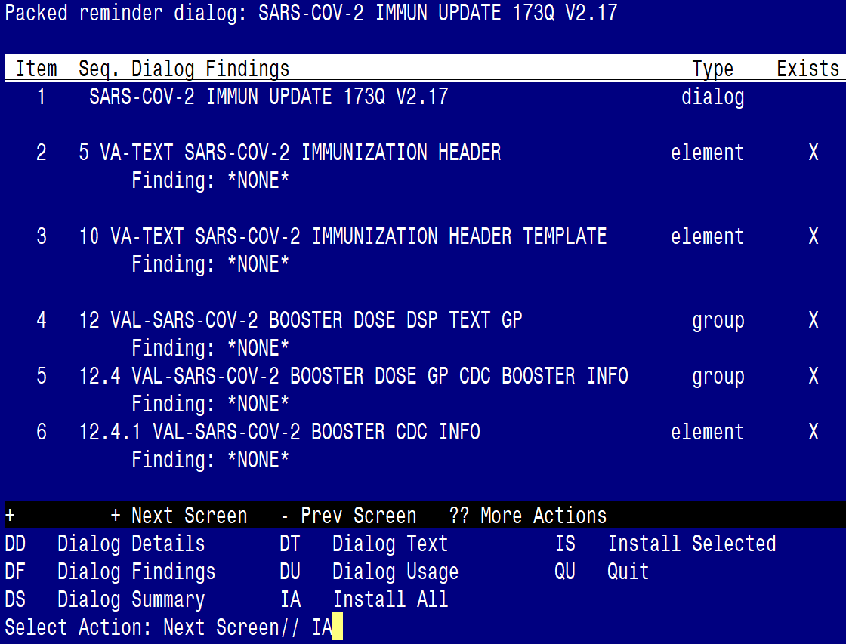

At the Select Action prompt, type IA to install the dialog – SARS-COV-2 IMMUN UPDATE 173Q V2.17.

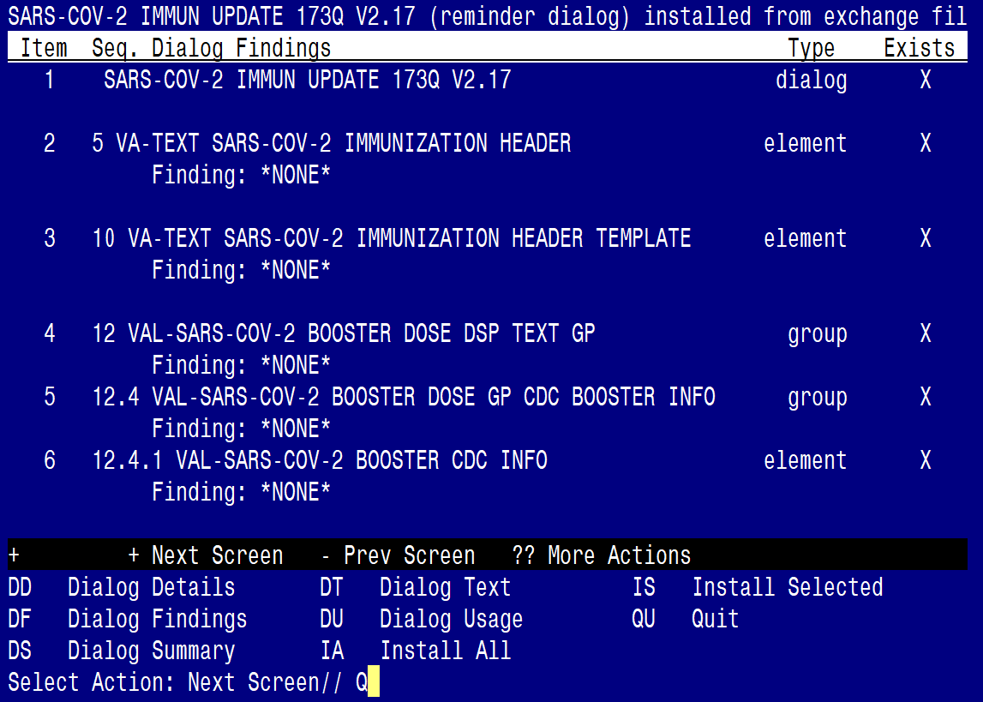
You will then be returned to this screen. At the Select Action prompt, type Q.

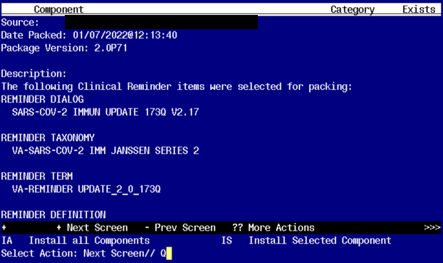

You will then be returned to this screen. At the Select Action prompt, type Q.

Install complete.

Post-Installation
- This update was sent out with the reminder dialog disassociated from the reminder definition. You will need to reassociate the reminder dialog to the reminder definition.
You can do this using the Vista Menu, Reminder Dialog Manager, Reminder Dialogs in Reminder view find the reminder definition VA-SARS COV-2 IMMUNIZATION choose that reminder and then use the LR feature to link the reminder to the dialog:
REMINDER NAME: VA-SARS-COV-2 IMMUNIZATION
LINKED REMINDER DIALOG: VA-SARS
1 VA-SARS-COV-2 IMMUNIZATION reminder dialog NATIONAL
2 VA-SARS-COV-2 IMMUNIZATION TEMPLATE reminder dialog NATIONAL
CHOOSE 1-2: 1 VA-SARS-COV-2 IMMUNIZATION reminder dialog NATIONAL

