Update _2_0_173R

Clinical Reminders

VA-COVID-19 IMMUNIZATION REMINDER UPDATE
Install Guide

February 2022

Product Development
Office of Information Technology
Department of Veterans Affairs

Table of Contents
Introduction 1
Install Details 2
Install Example 3
Post-Installation 6

Introduction

DESCRIPTION:
This reminder update will update four template fields used in the VA-SARS-COV-2 IMMUNIZATION reminder dialog and associated progress note template

The Moderna Vaccine has received full FDA approval. The following items were updated, the highlighted items below indicate the changes that were made:

- Dialog element: VAL-SARS-COV-2 EUA/FDA APPROVAL INFO
Template field: IM SARS COV-2 INFO TEXT EUA AGES

Vaccine Age range Approval
Pfizer-BioNTech COVID-19 Vaccine 16 years and older FDA Approved
Pfizer-BioNTech COVID-19 Vaccine 5 - 15 years old EUA
Moderna COVID-19 Vaccine 18 years and older FDA Approval
Janssen COVID-19 Vaccine 18 years and older EUA

- Dialog element: VAL-SARS-COV-2 VACCINE C2 URL
Template field: IM SARS COV-2 VIS/EUA INFO URL C2
Moderna Fact Sheet for Providers
Template field: IM SARS COV-2 PROVIDER EUA FACT URL C2
Moderna VIS for Recipients and Caregivers

- Dialog element: VAL-SARS-COV-2 VACCINE C2 PRE TEXT
Template field: IM SARS COV-2 ADMIN C2 INFO PRE TEXT

The patient was given the vaccine information fact sheet for this
vaccine which lists the benefits and side effects of the vaccine
and which reviews the risks of the vaccine. The fact sheet was
reviewed with the patient and they were given an opportunity to
ask questions.
The patient denied any prior severe reaction to this vaccine
or its components or a severe allergic reaction such as
anaphylaxis to any vaccine or to any injectable therapy.
The patient gave verbal consent to receive the vaccine.

These three template fields were put in a single new reminder dialog element to make installation easier. It is not necessary to install the dialog component for this update.

Thank you to the following test sites who installed and tested this reminder update:

New Mexico VA Health Care System (Albuquerque)
VA Nebraska Western Iowa Health Care System
Ralph J Johnson VA Medical Center (Charleston)
Aleda E. Lutz VA Medical Center (Saginaw)
VA Maryland Health Care System (Baltimore)
VA Bronx

UPDATE_2_0_173R contains 1 Reminder Exchange entry: UPDATE_2_0_173R VA-COVID-19 IMMUNIZATION REMINDER with the following components:

TIU TEMPLATE FIELD
IM SARS COV-2 PROVIDER EUA FACT URL C2
IM SARS COV-2 ADMIN C2 INFO PRE TEXT
IM SARS COV-2 VIS/EUA INFO URL C2
IM SARS COV-2 INFO TEXT EUA AGES

HEALTH FACTORS
VA-REMINDER UPDATES [C]
VA-UPDATE_2_0_173R

REMINDER TERM
VA-REMINDER UPDATE_2_0_173R

REMINDER DIALOG
VA-SARS-COV-2 173R

Install Details
This update is being distributed as a web host file. The address for the host file is: https://REDACTED /UPDATE_2_0_173R.PRD

The file will be installed using Reminder Exchange, programmer access is not required.
This update can be loaded with users on the system. Installation will take less than 2 minutes

YOU SHOULD HAVE INSTALLED THE PRIOR RELEASES (…173O, 173P, 173Q) PRIOR TO INSTALLING THIS UPDATE

Install Example
To Load the Web Host File. Navigate to Reminder exchange in Vista
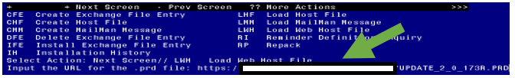

At the Select Action: prompt, enter LWH for Load Web Host File
At the Input the url for the .prd file: prompt, type the following web address:
https://REDACTED /UPDATE_2_0_173R.PRD An alternative site that may also have the file is Index of /Patches_By_Application/PXRM-CLINICAL REMINDERS/PRD-Files (worldvista.org)

You should see a message that the file was successfully loaded.

This will install one exchange entry in your exchange file.
Added Reminder Exchange entry UPDATE_2_0_173R VA-COVID-19 IMMUNIZATION REMINDER 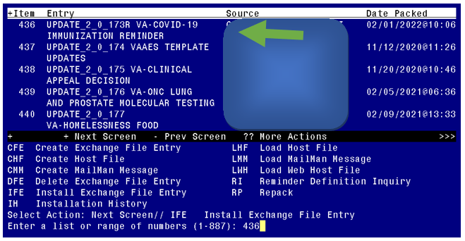

Search and locate an entry titled UPDATE_2_0_173R VA-COVID-19 IMMUNIZATION REMINDER.
At the Select Action prompt, enter IFE for Install Exchange File Entry
Enter the number that corresponds with your entry UPDATE_2_0_173R VA-COVID-19 IMMUNIZATION REMINDER. (in this example it is entry 436 it will vary by site). The date of the exchange file should be 02/01/2022. .

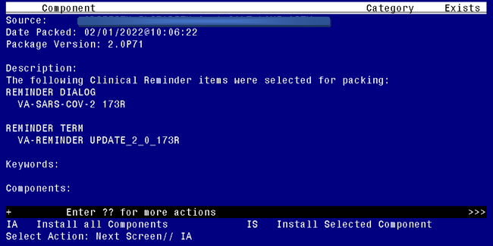
At the Select Action prompt, type IA for Install all Components and hit enter.
Any items that are NEW in any categories, you should INSTALL
Overwrite the following template fields:
IM SARS COV-2 PROVIDER EUA FACT URL C2
IM SARS COV-2 ADMIN C2 INFO PRE TEXT
IM SARS COV-2 VIS/EUA INFO URL C2
IM SARS COV-2 INFO TEXT EUA AGES

You will then be prompted to install the reminder dialog component, you do not need to install this component, choose Q to quit.

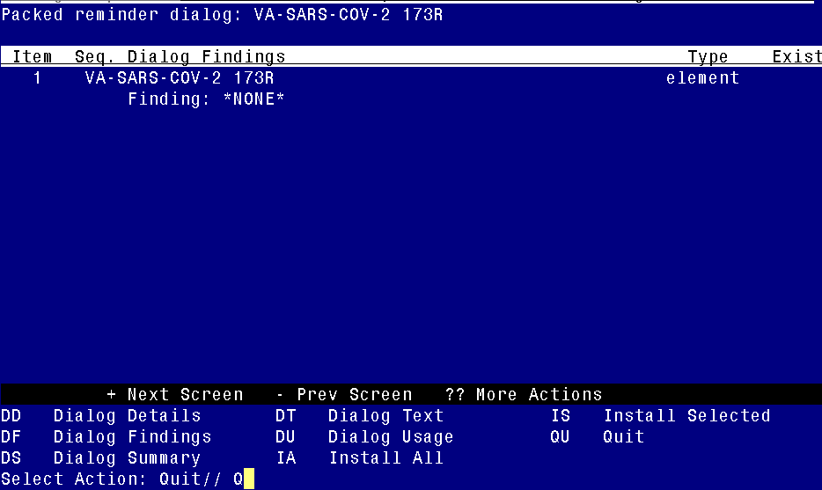
At the Select Action prompt, type Q.

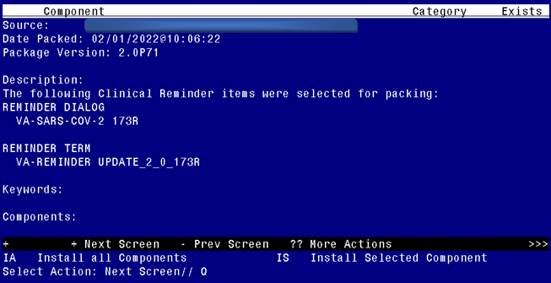

You will then be returned to this screen. At the Select Action prompt, type Q.

Install complete.

Post-Installation
There are no post installation steps required.

