Update _2_0_173S

Clinical Reminders

VA-COVID-19 IMMUNIZATION REMINDER UPDATE
Install Guide

February 2022

Product Development
Office of Information Technology
Department of Veterans Affairs

Table of Contents
Introduction 1
Pre-Install 2
Install Details 4
Install Example 4
Post-Installation 10

Introduction

DESCRIPTION:
This reminder update sends out an updated version of the Covid Immunization reminder dialogs and reminder definition that are discussed below.

173S makes updates to the VA-SARS-COV-2 IMMUNIZATION reminder dialog and associated progress note template.
Reminder exchange entry UPDATE_2_0_173S VA-COVID-19 IMMUNIZATION REMINDER

DEFINITION CHANGES
- For individuals with moderate to severe immune compromise
  - Changing booster timing to 3 months shorter interval, 5 months still recommended for everyone else)
  - Adding an additional dose of Pfizer or Moderna for those compromise who got a J and J vaccine
- For all patients
  - Updated boosters and additional doses for those vaccinated outside the U.S.
- Remove Function Findings 113, 114, 116, 143, 144 – all persons get booster, no longer limited to a subgroup
- Add Function Findings 30 and 31 – IC patients get additional dose of vaccine if they got Janssen at 28 days and booster dose at 2 months after the additional dose
- Modify Function Finding 41 so it only applies to NON-immunocompromised patients
- Add Function Findings 47, 48, 49 – Immunocompromised patients get booster dose 3 months after primary series and not at 5 months (non-immunocompromised remain at 5 months).
- Add to Function Finding 21 – and not immunocompromised
- Added Function Finding 26
- Change Function Findings 80 and 81 to not immunocompromised only
- Change Function Findings 12 and 15 to 5M
- Add Function Findings 19, 39, 59 to accommodate non-US vaccines for additional dose and booster and for different interval to booster for IC and not IC - also remove FF 55 which was taking any 2 doses of non-US as a completed series
- Remove the rank frequency and frequency from FI(7)
- Fix / add parentheses in Function Findings 32-35

Dialog Changes
- Element: VAL-SARS-COV-2 ADDL DOSE IMMUNOC BOOSTER INFO – change text from 5M to 3M, add information about 4th dose as booster, and remove the hide logic so it is hidden only if not IC and no JSN vaccine – removed hiding if the patient had AZN, NOV or other non-US

- Template field text changed: IM SARS COV-2 A1 DOSE #2
From Dose #2 (booster dose)
To: Additional dose or booster dose
Group: VAL-SARS-COV-2 VACCINE ADMIN A1 D#2 GP
Text: {FLD:IM SARS COV-2 A1 DOSE #2}
- Element: VAL-SARS-COV-2 VACCINE A1 OUTSIDE D#2 – change text to ‘Additional dose or booster dose’

Thank you to the following test sites who installed and tested this reminder update:

New Mexico VA Health Care System (Albuquerque)
VA Nebraska Western Iowa Health Care System
Ralph J Johnson VA Medical Center (Charleston)
Aleda E. Lutz VA Medical Center (Saginaw)
VA Maryland Health Care System (Baltimore)
VA Bronx

UPDATE_2_0_173S contains 1 Reminder Exchange entry: UPDATE_2_0_173S VA-COVID-19 IMMUNIZATION REMINDER with the following components:

TIU TEMPLATE FIELD
IM SARS COV-2 A1 DOSE #2

HEALTH FACTORS
VA-REMINDER UPDATES [C]
VA-UPDATE_2_0_173S
VA-COVID-19 [C]
VA-SARS-COV-2 IMM CLIN REV NO ADDL DOSE
IMMUNIZATION [C]
VA-SARS-COV-2 VACCINE DEFERRED
VA-SARS-COV-2 IMM REFUSAL - BOOSTER/ADDL DOSE
VA-SARS-COV-2 VACCINE REFUSAL
VA-SARS-COV-2 VACCINE CONTRAIND B1
VA-SARS-COV-2 VACCINE CONTRAIND A1
VA-SARS-COV-2 VACCINE CONTRAIND E2
VA-SARS-COV-2 VACCINE CONTRAIND C2
VA-SARS-COV-2 VACCINE CONTRAIND D2

REMINDER SPONSOR
NATIONAL CENTER FOR HEALTH PROMOTION AND DISEASE PREVENTION (NCP)
VA NATIONAL CENTER FOR HEALTH PROMOTION AND DISEASE PREVENTION (NCP)

REMINDER TAXONOMY
VA-IMMUNOCOMPROMISED FOR COVID-19 ADDL DOSE
VA-HIV INFECTION
LONG TERM SYSTEMIC STEROID
VA-PNEUMOC DZ RISK - CHEMOTHERAPY

REMINDER TERM
VA-COVID-19 IMMUNIZATION BL
VA-SARS-COV-2 IM DOSE NOT ASTRAZENECA
VA-SARS-COV-2 IM DOSE NOT JANSSEN
VA-SARS-COV-2 IM DOSE NOT MODERNA
VA-SARS-COV-2 IM DOSE NOT NOVAVAX
VA-SARS-COV-2 VACCINE C2 1 DOSE
VA-SARS-COV-2 VACCINE C2 2 DOSE
VA-SARS-COV-2 VACCINE C2 3 DOSE
VA-SARS-COV-2 VACCINE D2 1 DOSE
VA-SARS-COV-2 VACCINE D2 2 DOSE
VA-SARS-COV-2 VACCINE D2 3 DOSE
VA-SARS-COV-2 VACCINES
VA-REMINDER UPDATE_2_0_173S
VA-CD4 COUNT
VA-STEROID PREDN EQUIV 5-6.6MG
VA-STEROID PREDN EQUIV 6.6-9MG
VA-STEROID PREDN EQUIV 10-19MG
VA-STEROID PREDN EQUIV >=20MG
VA-CHEMO/IMMUNOSUPPRESSIVE DRUGS
VA-SARS-COV-2 VACCINE INDICATION ADDL DOSE NEEDE
VA-SARS-COV-2 VACCINE A1
VA-SARS-COV-2 VACCINE WHO APPROVED ALL (INCL US)
VA-COVID-19 VACCINATION CLINIC FUTURE APPT
VA-SARS-COV-2 VACCINE DOSE #1 OF 2
VAL-SYSTEMIC STEROIDS
VA-SARS-COV-2 VACCINE DEFERRAL
VA-SARS-COV-2 VACCINE REFUSAL
VA-SARS-COV-2 VACCINE CONTRAINDICATION
VA-SARS-COV-2 VACCINE E2
VA-SARS-COV-2 VACCINE D2
VA-SARS-COV-2 VACCINE C2
VA-SARS-COV-2 VACCINE B1
VA-SARS-COV-2 VACCINE INDICATION AGE
VA-SARS-COV-2 VACCINE WHO APPROVED NON-US COMPLETED
VA-SARS-COV-2 VACCINE INDICATION MRNA BOOSTER
VA-SARS-COV-2 VACCINE INDICATION 5
VA-SARS-COV-2 VACCINE INDICATION 4
VA-SARS-COV-2 VACCINE INDICATION 3
VA-SARS-COV-2 VACCINE INDICATION 2
VA-SARS-COV-2 VACCINE INDICATION 1

REMINDER DEFINITION
VAL-IMMUNOCOMPROMISING DRUGS/LABS/DX FOR COVID-19
VAL-BL COVID-19 BOOSTER JANSSEN
VA-SARS COV-2 IMMUNIZATION

HEALTH SUMMARY TYPE
INDICATION ADDL DOSE COVID-19
SARS-COV-2 IMMUNIZATION
HEALTH SUMMARY OBJECTS
INDICATION ADDL DOSE COVID-19 (TIU)
SARS-COV-2 IMMUNIZATION (TIU)
TIU DOCUMENT DEFINITION
INDICATION ADDL DOSE COVID-19
SARS-COV-2 IMMUNIZATION

REMINDER DIALOG
SARS-COV-2 IMMUN UPDATE 173S V2.19

Pre-Install
- You should have installed the prior versions of the covid immunization reminder updates, the most recent being 173R prior to installing this update.
- This update will NOT overwrite lot numbers
- Items that should be overwritten are highlighted in GREEN above.

Install Details
This update is being distributed as a web host file. The address for the host file is: https://REDACTED /UPDATE_2_0_173S.PRD

The file will be installed using Reminder Exchange, programmer access is not required.
This update can be loaded with users on the system. Installation will take less than 5 minutes

Install Example
To Load the Web Host File. Navigate to Reminder exchange in Vista
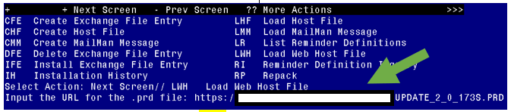
At the Select Action: prompt, enter LWH for Load Web Host File
At the Input the url for the .prd file: prompt, type the following web address:

https://REDACTED /UPDATE_2_0_173S.PRD An alternative site that might have the file is Index of /Patches_By_Application/PXRM-CLINICAL REMINDERS/PRD-Files (worldvista.org)

You should see a message that the file was successfully loaded.

This will install one exchange entry in your exchange file.
Added Reminder Exchange entry UPDATE_2_0_173S VA-COVID-19 IMMUNIZATION REMINDER
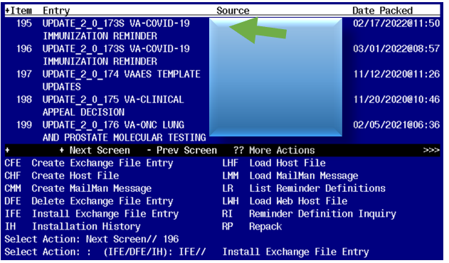

Search and locate an entry titled UPDATE_2_0_173S VA-COVID-19 IMMUNIZATION REMINDER.

At the Select Action prompt, enter IFE for Install Exchange File Entry
Enter the number that corresponds with your entry UPDATE_2_0_173S VA-COVID-19 IMMUNIZATION REMINDER. (in this example it is entry 196 it will vary by site). The date of the exchange file should be 03/02/2022.
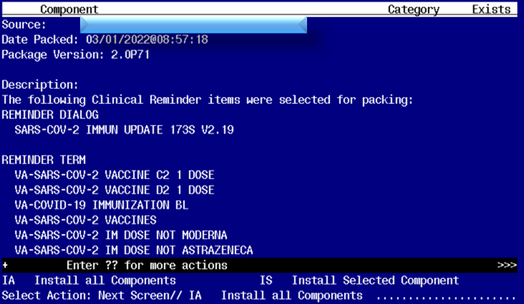
At the Select Action prompt, type IA for Install all Components and hit enter.
Any items that are NEW in any categories, you should INSTALL

Overwrite the following TIU TEMPLATE FIELD IM SARS COV-2 A1 DOSE #2.

If you are prompted to overwrite any HEALTH FACTORS, you should choose SKIP

If you are prompted, you may Overwrite only these REMINDER TERMS:
VA-COVID-19 IMMUNIZATION BL
VA-SARS-COV-2 IM DOSE NOT ASTRAZENECA
VA-SARS-COV-2 IM DOSE NOT JANSSEN
VA-SARS-COV-2 IM DOSE NOT MODERNA
VA-SARS-COV-2 IM DOSE NOT NOVAVAX
VA-SARS-COV-2 VACCINE C2 1 DOSE
VA-SARS-COV-2 VACCINE C2 2 DOSE
VA-SARS-COV-2 VACCINE C2 3 DOSE
VA-SARS-COV-2 VACCINE D2 1 DOSE
VA-SARS-COV-2 VACCINE D2 2 DOSE
VA-SARS-COV-2 VACCINE D2 3 DOSE
VA-SARS-COV-2 VACCINES
VA-SARS-COV-2 VACCINE DOSE #1 OF 2
VA-SARS-COV-2 VACCINE D2
VA-SARS-COV-2 VACCINE WHO APPROVED ALL (INCL US)
VA-SARS-COV-2 VACCINE C2

If you are prompted to overwrite any other reminder terms, you should choose SKIP

Overwrite the REMINDER DEFINITION VA-SARS COV-2 IMMUNIZATION when prompted.
Overwrite the REMINDER DEFINITION VAL-BL COVID-19 BOOSTER JANSSEN when prompted
If you are prompted to overwrite any other definitions, choose SKIP.

Overwrite the HEALTH SUMMARY TYPE INDICATION ADDL DOSE COVID-19
when prompted.
Overwrite the HEALTH SUMMARY TYPE SARS COV-2 IMMUNIZATION when prompted.

You will then be prompted to install the reminder dialog component, you will choose IA to install even though most items will have an X to indicate they already exist.

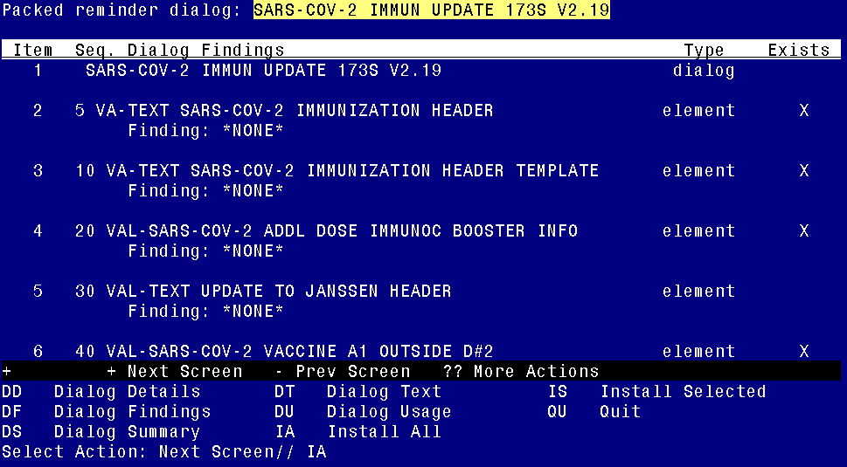

At the Select Action prompt, type IA to install the dialog – SARS-COV-2 IMMUN UPDATE 173S V2.19.

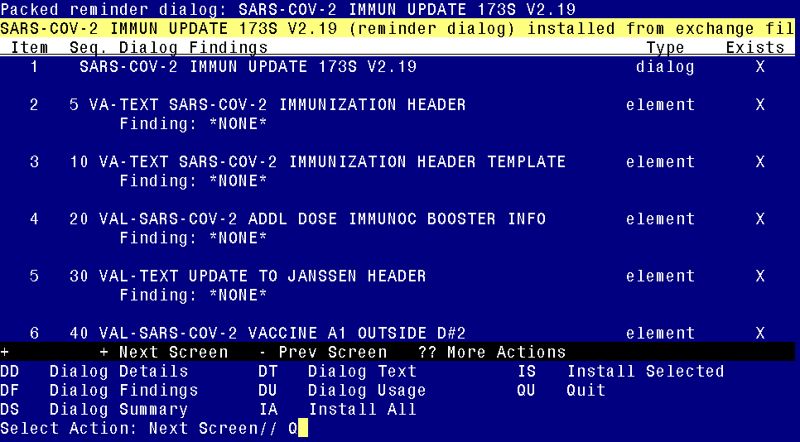
You will then be returned to this screen. At the Select Action prompt, type Q.

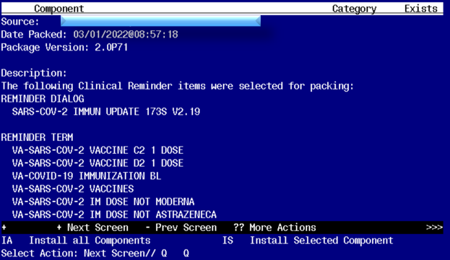

You will then be returned to this screen. At the Select Action prompt, type Q.

Install complete.

Post-Installation
- This update was sent out with the reminder dialog disassociated from the reminder definition. You will need to reassociate the reminder dialog to the reminder definition.
You can do this using the Vista Menu, Reminder Dialog Manager, Reminder Dialogs in Reminder view find the reminder definition VA-SARS COV-2 IMMUNIZATION choose that reminder and then use the LR feature to link the reminder to the dialog:
REMINDER NAME: VA-SARS-COV-2 IMMUNIZATION
LINKED REMINDER DIALOG: VA-SARS
1 VA-SARS-COV-2 IMMUNIZATION reminder dialog NATIONAL
2 VA-SARS-COV-2 IMMUNIZATION TEMPLATE reminder dialog NATIONAL
CHOOSE 1-2: 1 VA-SARS-COV-2 IMMUNIZATION reminder dialog NATIONAL

