Update _2_0_173T

Clinical Reminders

VA-COVID-19 IMMUNIZATION REMINDER UPDATE
Install Guide

March 2022

Product Development
Office of Information Technology
Department of Veterans Affairs

Table of Contents
Introduction 1
Pre-Install 1
Install Details 4
Install Example 4
Post-Installation 9

Introduction

DESCRIPTION:
This reminder update sends out an updated version of the Covid Immunization reminder dialogs and reminder definition that are discussed below.

173T makes updates to the VA-SARS-COV-2 IMMUNIZATION reminder dialog and associated progress note template.
Reminder exchange entry UPDATE_2_0_173T VA-COVID-19 IMMUNIZATION REMINDER

Note, this install will overwrite your lot numbers within your immunization dialog groups! In the Pre install section, there is a link that will take you to a pdf file that shows you how to back those up an then reinstall after this update is installed.

DEFINITION CHANGES
- No Definition changes

Dialog Changes
- If an immunocompromised patient had first dose of Janssen, is in need of the additional dose (second dose) and wants to receive that dose as Moderna, this wasn’t available because there was no option for full dose of Moderna. This was fixed.
- If an immunocompromised patient had first dose of Janssen, is in need of the additional dose (second dose) and wants to receive that dose as Pfizer, the option to give a correct dose was available but it was labeled as booster dose, there is now also an option for ‘additional dose’.
- Post administration text for Moderna and Pfizer will now use branching logic to show different text based on patient being less than 65 years of age to allow the administering staff to extend the interval for 2nd dose in young, healthy individuals to 8 weeks if they are not at high risk of exposure or disease.

Thank you to the following test sites who installed and tested this reminder update:

New Mexico VA Health Care System (Albuquerque)
VA Nebraska Western Iowa Health Care System
Ralph J Johnson VA Medical Center (Charleston)
Aleda E. Lutz VA Medical Center (Saginaw)
VA Maryland Health Care System (Baltimore)
VA Bronx

TIU TEMPLATE FIELD
1 IM SARS COV-2 ADMIN INFO POST TEXT D2 #2
2 IM SARS COV-2 D2 DOSE
3 IM SARS COV-2 DOSE D2 #3 WARNING
4 IM SARS COV-2 DOSE D2 #B WARNING
5 IM SARS COV-2 D2 DOSE #3 BOOSTER
6 BLANK TEXT FIELD FOR DIALOGS
7 IM SARS COV-2 DOSE SERIES BOOSTER WARNING
8 IM SARS COV-2 ADMIN INFO POST TEXT D2 #1 LONG
INTERVAL
9 IM SARS COV-2 ADMIN INFO POST TEXT D2 #1
10 IM SARS COV-2 ADMIN INFO POST TEXT C2 #1 LONG
INTERVAL
11 IM SARS COV-2 ADMIN INFO POST TEXT C2 #1
12 IM SARS COV-2 ADMIN INFO POST TEXT C2 #2
13 IM SARS COV-2 C2 DOSE
14 IM SARS COV-2 DOSE C2 #3 WARNING
15 IM SARS COV-2 C2 DOSE 1/2 DOSE
16 IM SARS COV-2 DOSE C2 #B WARNING
17 IM SARS COV-2 C2 DOSE #3 BOOSTER

IMMUNIZATION
COVID-19 (PFIZER), MRNA, LNP-S, PF, 3 MCG/0.2 ML
DOSE, TRIS-SUCROSE (AGES 2-4 YEARS)
COVID-19 (PFIZER), MRNA, LNP-S, PF, 10 MCG/0.2 ML
DOSE, TRIS-SUCROSE (AGES 5-11 YEARS)
COVID-19 (PFIZER), MRNA, LNP-S, PF, 30 MCG/0.3 ML
DOSE, TRIS-SUCROSE (AGES 12+ YEARS)
COVID-19 (PFIZER), MRNA, LNP-S, PF, 30 MCG/0.3 ML
DOSE
COVID-19 (MODERNA), MRNA, LNP-S, PF, 100
MCG/0.5ML DOSE OR 50 MCG/0.25ML DOSE
COVID-19 (ASTRAZENECA), VECTOR-NR, RS-CHADOX1,
PF, 0.5 ML
COVID-19 (NOVAVAX), SUBUNIT, RS-NANOPARTICLE+MATRI
X-M1 ADJUVANT, PF, 0.5 ML
COVID-19 (JANSSEN), VECTOR-NR, RS-AD26, PF, 0.5 ML

HEALTH FACTORS
18 VA-REMINDER UPDATES [C]
19 VA-UPDATE_2_0_173T
20 IMMUNIZATION [C]
21 VA-SARS-COV-2 VACCINE ANATOMIC SITE

REMINDER SPONSOR
22 NATIONAL CENTER FOR HEALTH PROMOTION AND DISEASE
PREVENTION (NCP)
23 VA NATIONAL CENTER FOR HEALTH PROMOTION AND
DISEASE PREVENTION (NCP)

REMINDER COMPUTED FINDINGS
VA-AGE

REMINDER TAXONOMY
24 VA-IMMUNOCOMPROMISED FOR COVID-19 ADDL DOSE
25 VA-HIV INFECTION
26 LONG TERM SYSTEMIC STEROID
27 VA-PNEUMOC DZ RISK - CHEMOTHERAPY
28 VA-SARS-COV-2 IMM PFIZER TRIS/SUC SERIES 2
29 VA-SARS-COV-2 IMM PFIZER TRIS/SUC SERIES BOOSTER
30 VA-SARS-COV-2 IMM PFIZER SERIES 2
31 VA-SARS-COV-2 IMM PFIZER SERIES BOOSTER
32 VA-SARS-COV-2 IMM MODERNA SERIES 2
33 VA-SARS-COV-2 IMM MODERNA SERIES BOOSTER

REMINDER TERM
34 VA-REMINDER UPDATE_2_0_173T
35 VA-SARS-COV-2 VACCINE D2 3 DOSE
36 VA-CD4 COUNT
37 VA-STEROID PREDN EQUIV 5-6.6MG
38 VA-STEROID PREDN EQUIV 6.6-9MG
39 VA-STEROID PREDN EQUIV 10-19MG
40 VA-STEROID PREDN EQUIV >=20MG
41 VA-CHEMO/IMMUNOSUPPRESSIVE DRUGS
42 VA-SARS-COV-2 VACCINE D2 2 DOSE
43 VA-AGE >64
44 VA-SARS-COV-2 VACCINE C2 3 DOSE

REMINDER DEFINITION
45 VAL-IMMUNOCOMPROMISING DRUGS/LABS/DX FOR COVID-19

REMINDER DIALOG
46 SARS-COV-2 IMMUN UPDATE 173T V2.20

Pre-Install
- You should have installed the prior versions of the covid immunization reminder updates, the most recent being 173S prior to installing this update.

- This update WILL OVERWRITE YOUR LOT NUMBERS!!
- Create a local backup of your lot numbers as outlined using the instructions COVID-19 Local Backup 173 T. See the Power Point COVID-19_LOCAL_BACKUP_173T. Outside the VA you can find it here: https://foia-vista.worldvista.org/Patches_By_Application/PXRM-CLINICAL%20REMINDERS/PRD-Files/Documents/COVID-19_LOCAL_BACKUP_173T-508.pptx

Install Details
This update is being distributed as a web host file. The address for the host file is: https://REDACTED /UPDATE_2_0_173T.PRD Alternatively, you may be able to find the file here: Index of /Patches_By_Application/PXRM-CLINICAL REMINDERS/PRD-Files (worldvista.org)

The file will be installed using Reminder Exchange, programmer access is not required.
This update can be loaded with users on the system. Installation will take less than 5 minutes

Install Example
To Load the Web Host File. Navigate to Reminder exchange in Vista
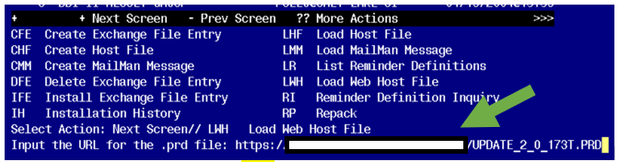
At the Select Action: prompt, enter LWH for Load Web Host File
At the Input the url for the .prd file: prompt, type the following web address:

https://REDACTED /UPDATE_2_0_173T.PRD

You should see a message that the file was successfully loaded.

This will install one exchange entry in your exchange file.
Added Reminder Exchange entry UPDATE_2_0_173T VA-COVID-19 IMMUNIZATION REMINDER
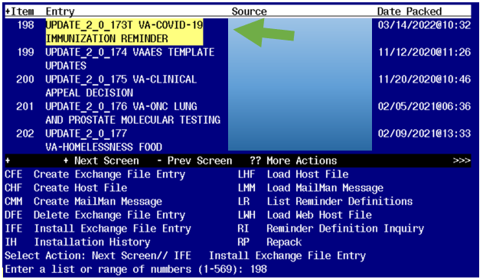

Search and locate an entry titled UPDATE_2_0_173T VA-COVID-19 IMMUNIZATION REMINDER.

At the Select Action prompt, enter IFE for Install Exchange File Entry
Enter the number that corresponds with your entry UPDATE_2_0_173T VA-COVID-19 IMMUNIZATION REMINDER. (in this example it is entry 198 it will vary by site). The date of the exchange file should be 03/14/2022.
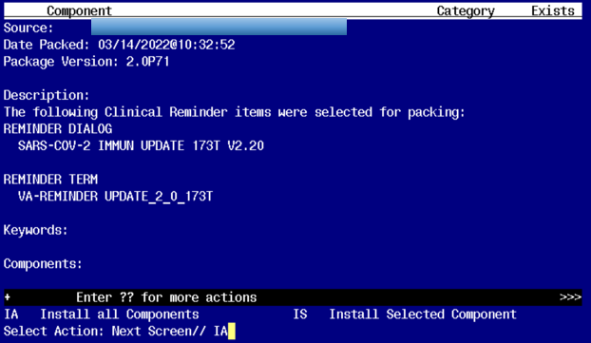
Another reminder to MAKE SURE you have created a back up of your lot numbers. If you don’t, they will be overwritten and then you will manually have to fix this!!! See Pre-Install Section for details!

At the Select Action prompt, type IA for Install all Components and hit enter.
Any items that are NEW in any categories, you should INSTALL

INSTALL any new components
For TXML that are different, use OVERWRITE action
For all reminder terms that exist, but are different, use SKIP action
For any taxonomies that exist, but are different, use SKIP action

You will then be prompted to install the reminder dialog component, you will choose IA to install even though most items will have an X to indicate they already exist.
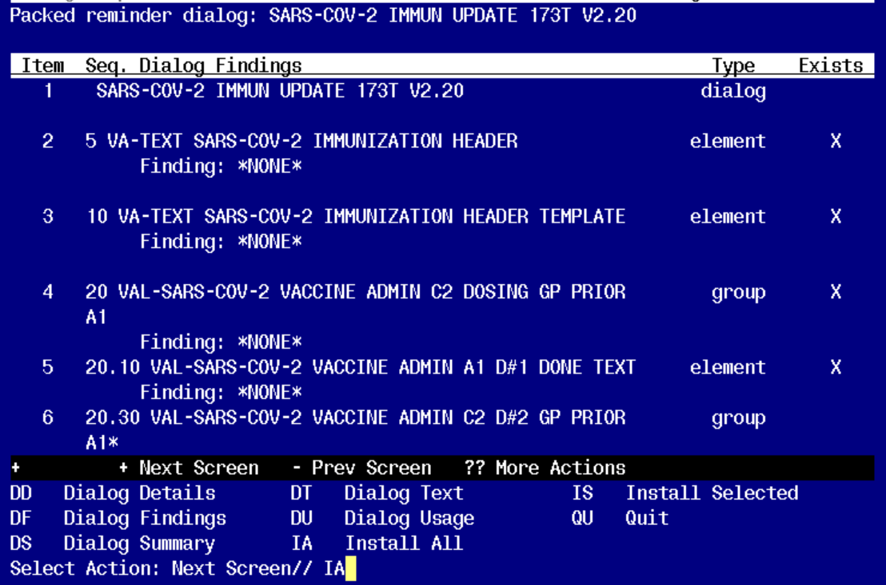

At the Select Action prompt, type IA to install the dialog – SARS-COV-2 IMMUN UPDATE 173T V2.20.

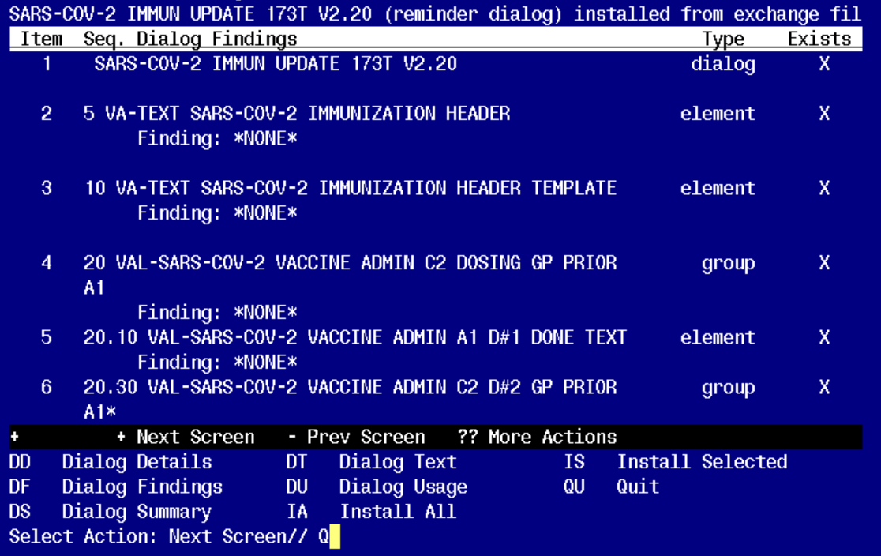
You will then be returned to this screen. At the Select Action prompt, type Q.

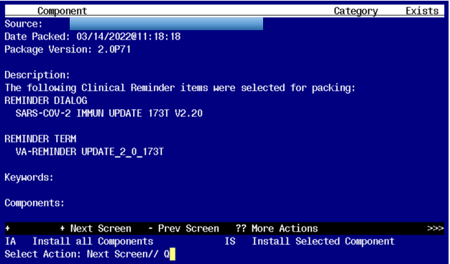

You will then be returned to this screen. At the Select Action prompt, type Q.

Install complete.

Post-Installation
- Reinstall from your lot number back up file created in post install to retrieve your lot numbers

