Update _2_0_173

Clinical Reminders

VA-COVID-19 IMMUNIZATION REMINDER
Install Guide

NOVEMBER 2020

Product Development Office of Information Technology Department of Veterans Affairs

Table of Contents
INTRODUCTION 1
INSTALL DETAILS 4
INSTALL EXAMPLE 4
POST INSTALLATION 9

Introduction
DESCRIPTION: This update includes the reminder definition and dialog for SARS CoV-2 immunization - built with placeholder terms for single and two dose vaccines and for multiple possible indications for vaccine. The included reminder definition will not be applicable to any patients as released. Instructions for configuring the reminder terms in the definition to meet vaccine guidance will be released once a vaccine is available. The definition findings and the dialog content should not be edited locally, unless instructed through national guidance.

Immunizations must be documented using the included reminder dialogs.
Inform the local Pharmacy ADPAC that the BCMA2PCE TASK should NOT be set up for any COVID-19 vaccine. The mapping of the pharmacy orderable item to the immunization should NOT be completed. Administration of the COVID-19 vaccines will need to be done using the reminder dialog template or the clinical reminder until further notice.

Two reminder dialogs are included.
- The VA-SARS-COV-2 IMMUNIZATION dialog is linked to the VA-SARS COV-2 IMMUNIZATION reminder definition.
- The VA-SARS-COV-2 IMMUNIZATION TEMPLATE dialog can be linked to a shared template, note title, or used in an existing local dialog. The template dialog should be linked to the note title, VAAES NSG COVID-19 VACCINE ADMINISTRATION as described in the post-installation instructions.

Throughout the dialog groups, elements, and additional prompts, and install guide, the COVID-19 placeholder immunizations are stored and represented as listed below. The Pfizer and Moderna immunizations have been updated in the IMMUNIZATION file, but some groups and elements may still be named according the table below.

Ensure to edit the groups, elements, and additional prompts for the appropriate corresponding vaccine.

Immunization | Placeholder for
SARS-COV-2 VACCINE A1 | To Be Determined
SARS-COV-2 VACCINE B1 | To Be Determined
SARS-COV-2 VACCINE C2 | Moderna Vaccine
SARS-COV-2 VACCINE D2 | Pfizer Vaccine
SARS-COV-2 VACCINE E2 | To Be Determined

UPDATE_2_0_173 contains 1 Reminder Exchange entry:

UPDATE_2_0_173 VA-COVID-19 IMMUNIZATION REMINDER

The exchange file contains the following components:

TIU TEMPLATE FIELD

BLANK TEXT FIELD FOR DIALOGS

IM SARS COV-2 VIS/EUA INFO URL E2

IM SARS COV-2 ADMIN E2 INFO PRE TEXT

IM SARS COV-2 ADMIN INFO POST TEXT

IM SARS COV-2 E2 DOSE

IM SARS COV-2 VIS/EUA INFO URL B1

IM SARS COV-2 ADMIN B1 INFO PRE TEXT

IM SARS COV-2 B1 DOSE

IM SARS COV-2 VIS/EUA INFO URL A1

IM SARS COV-2 ADMIN A1 INFO PRE TEXT

IM SARS COV-2 A1 DOSE

IM SARS COV-2 VIS/EUA INFO URL D2

IM SARS COV-2 ADMIN D2 INFO PRE TEXT

IM SARS COV-2 D2 DOSE

IM SARS COV-2 VIS/EUA INFO URL C2

IM SARS COV-2 ADMIN C2 INFO PRE TEXT

IM SARS COV-2 C2 DOSE

IM SARS COV-2 INFO TEXT

HEALTH FACTORS

VA-SARS-COV-2 IMMUN EDUC VVC/TELE VST

VA-SARS-COV-2 VACCINE DEFERRED

VA-SARS-COV-2 VACCINE REFUSAL

VA-SARS-COV-2 VACCINE ANATOMIC SITE

VA-SARS-COV-2 VACCINE CONTRAINDICATION

VA-UPDATE_2_0_173

REMINDER SPONSOR
NATIONAL CENTER FOR HEALTH PROMOTION AND DISEASE PREVENTION (NCP)
VA National Center for Health Promotion and Disease Prevention (NCP) Office of Patient Care Services

REMINDER TERM
VA-REMINDER UPDATE_2_0_173
VAL-BL SARS-COV-2 VACCINE
VA-SARS-COV-2 VACCINE E2 AVAILABLE
VA-SARS-COV-2 VACCINE D2 1 DOSE
VA-SARS-COV-2 VACCINE C2 1 DOSE
VA-SARS-COV-2 VACCINE E2 1 DOSE
VA-SARS-COV-2 VACCINE B1 AVAILABLE
VA-SARS-COV-2 VACCINE A1 AVAILABLE
VA-SARS-COV-2 VACCINE D2 AVAILABLE
VA-SARS-COV-2 VACCINE C2 AVAILABLE
VA-SARS-COV-2 VACCINE DOSE #1 OF 2
VA-SARS-COV-2 VACCINE INDICATION 27
VA-SARS-COV-2 VACCINE INDICATION 26
VA-SARS-COV-2 VACCINE INDICATION 25
VA-SARS-COV-2 VACCINE INDICATION 24
VA-SARS-COV-2 VACCINE INDICATION 23
VA-SARS-COV-2 VACCINE INDICATION 22
VA-SARS-COV-2 VACCINE INDICATION 21
VA-SARS-COV-2 VACCINE INDICATION AGE & COUNT>3
VA-SARS-COV-2 VACCINE INDICATION AGE & COUNT=3
VA-SARS-COV-2 VACCINE INDICATION AGE & COUNT=2
VA-SARS-COV-2 VACCINE REFUSAL
VA-SARS-COV-2 VACCINE CONTRAINDICATION
VA-SARS-COV-2 VACCINE E2
VA-SARS-COV-2 VACCINE D2
VA-SARS-COV-2 VACCINE C2
VA-SARS-COV-2 VACCINE B1
VA-SARS-COV-2 VACCINE A1
VA-SARS-COV-2 VACCINE INDICATION AGE
VA-SARS-COV-2 VACCINE INDICATION 9
VA-SARS-COV-2 VACCINE INDICATION 8
VA-SARS-COV-2 VACCINE INDICATION 7
VA-SARS-COV-2 VACCINE INDICATION 6
VA-COV-2 VACCINE INDICATION 5
VA-SARS-COV-2 VACCINE INDICATION 4
VA-SARS-COV-2 VACCINE INDICATION 3
VA-SARS-COV-2 VACCINE INDICATION 2
VA-SARS-COV-2 VACCINE INDICATION 1

REMINDER DEFINITION
VA-SARS COV-2 IMMUNIZATION

REMINDER DIALOG
VA-SARS-COV-2 IMMUNIZATION
VA-SARS-COV-2 IMMUNIZATION TEMPLATE

HEALTH SUMMARY TYPE
SARS-COV-2 IMMUNIZATION

Install Details

This update is being distributed as a web host file. The address for the host file is:

https://Redacted /UPDATE_2_0_173.PRD

The file will be installed using Reminder Exchange, programmer access is not required.

This update can be loaded with users on the system. Installation will take less than 5 minutes.

Install Example

To Load the Web Host File. Navigate to Reminder exchange in Vista

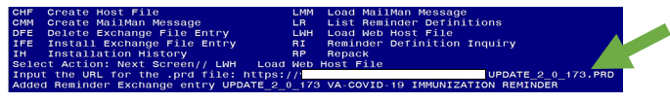At the Select Action: prompt, enter LWH for Load Web Host File
At the Input the url for the .prd file: prompt, type the following web address:

https://Redacted /UPDATE_2_0_173.PRD

You should see a message at the top of your screen that the file loaded successfully
Search and locate an entry titled UPDATE_2_0_173 VA-COVID-19 IMMUNIZATION REMINDER.

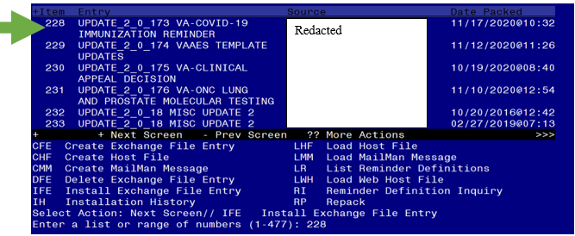

At the Select Action prompt, enter IFE for Install Exchange File Entry
Enter the number that corresponds with your entry UPDATE_2_0_173 VA-COVID-19 IMMUNIZATION REMINDER. (in this example it is entry 228 it will vary by site). The date of the exchange file should be 11/17/2020.
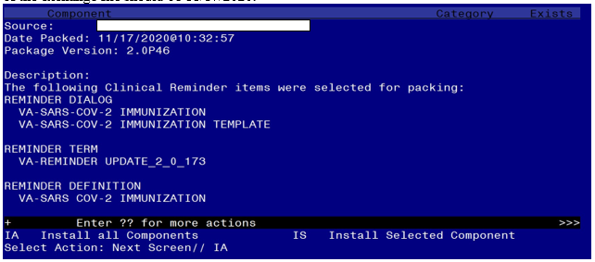

At the Select Action prompt, type IA for Install all Components and hit enter. Select Action: Next Screen// IA Install all Components
When you are prompted to Install new items, choose I to INSTALL. During installation,
- Replace the SARS-COV-2 VACCINE D2 vaccine with the COVID-19 (PFIZER) vaccine.

- Replace the SARS-COV-2 VACCINE C2 vaccine with the COVID-19 (MODERNA) vaccine.

FINDING entry IM.SARS-COV-2 VACCINE D2 does not exist.

Select one of the following:

D Delete
- Replace with an existing entry
- Quit the install

Enter response: P Replace with an existing entry
Select IMMUNIZATION NAME: COVID-19 (PFIZER), MRNA, LNP-S, PF, 30 MCG/0.3 ML DOSE

FINDING entry IM.SARS-COV-2 VACCINE C2 does not exist.

Select one of the following:

D Delete
- Replace with an existing entry
- Quit the install

Enter response: P Replace with an existing entry
Select IMMUNIZATION NAME: COVID-19 (MODERNA), MRNA, LNP-S, PF, 100 MCG/0.5 ML DOSE

You will be promped to install the 1st reminder dialog component – You will choose to install all.
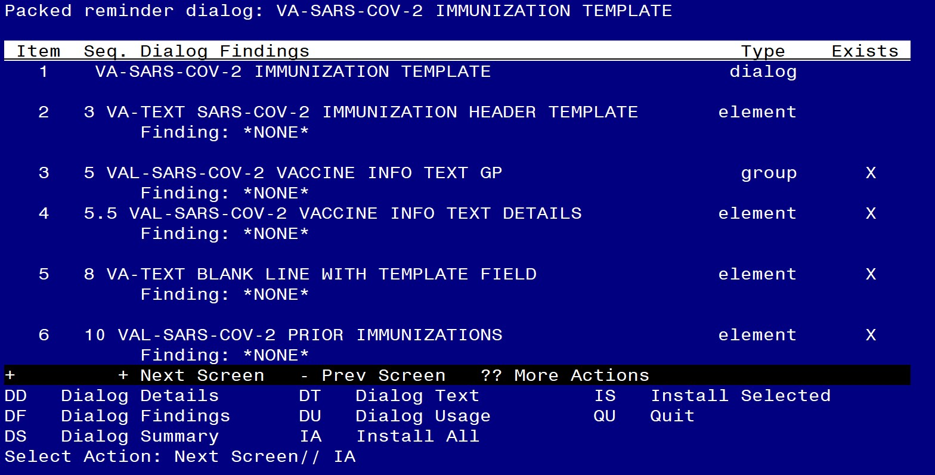

At the Select Action prompt, type IA to install the dialog –

Select Action: Next Screen// IA Install All
Install reminder dialog and all components with no further changes: Y// Yes
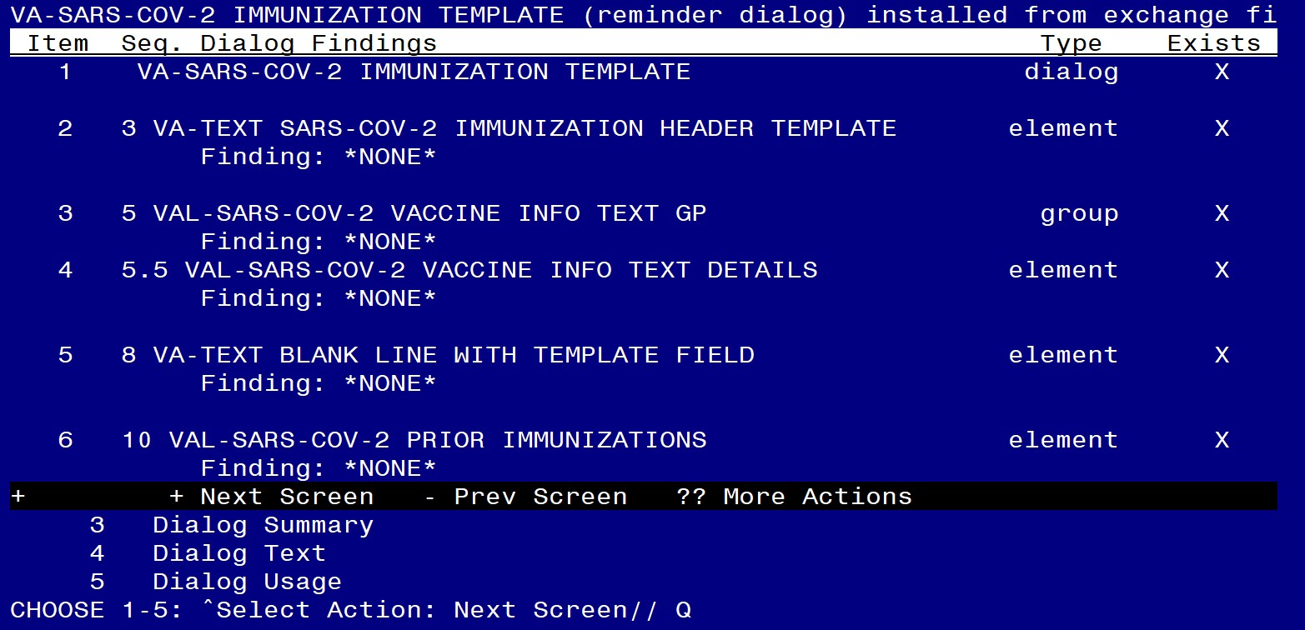
After completing this dialog install, you will type Q.

You will then be prompted to install the 2nd reminder dialog component – You will choose to install all.
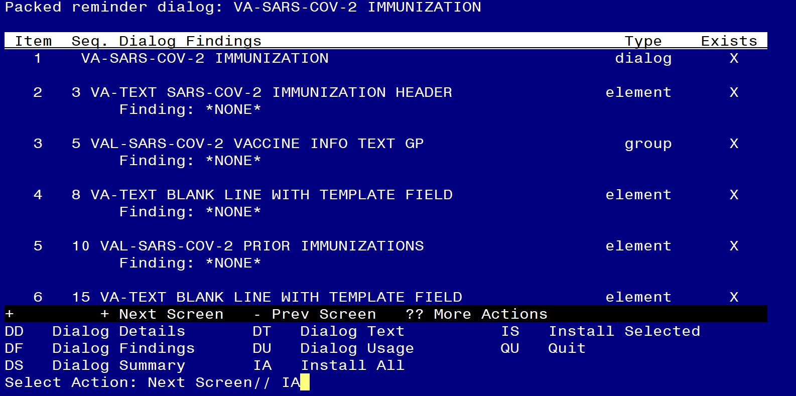
At the Select Action prompt, type IA to install the dialog – Select Action: Next Screen// IA Install All
Install reminder dialog and all components with no further changes: Y// Yes

Reminder Dialog VA-SARS-COV-2 IMMUNIZATION is not linked to a reminder.

Select Reminder to Link: VA-SARS COV-2 IMMUNIZATION// <enter>
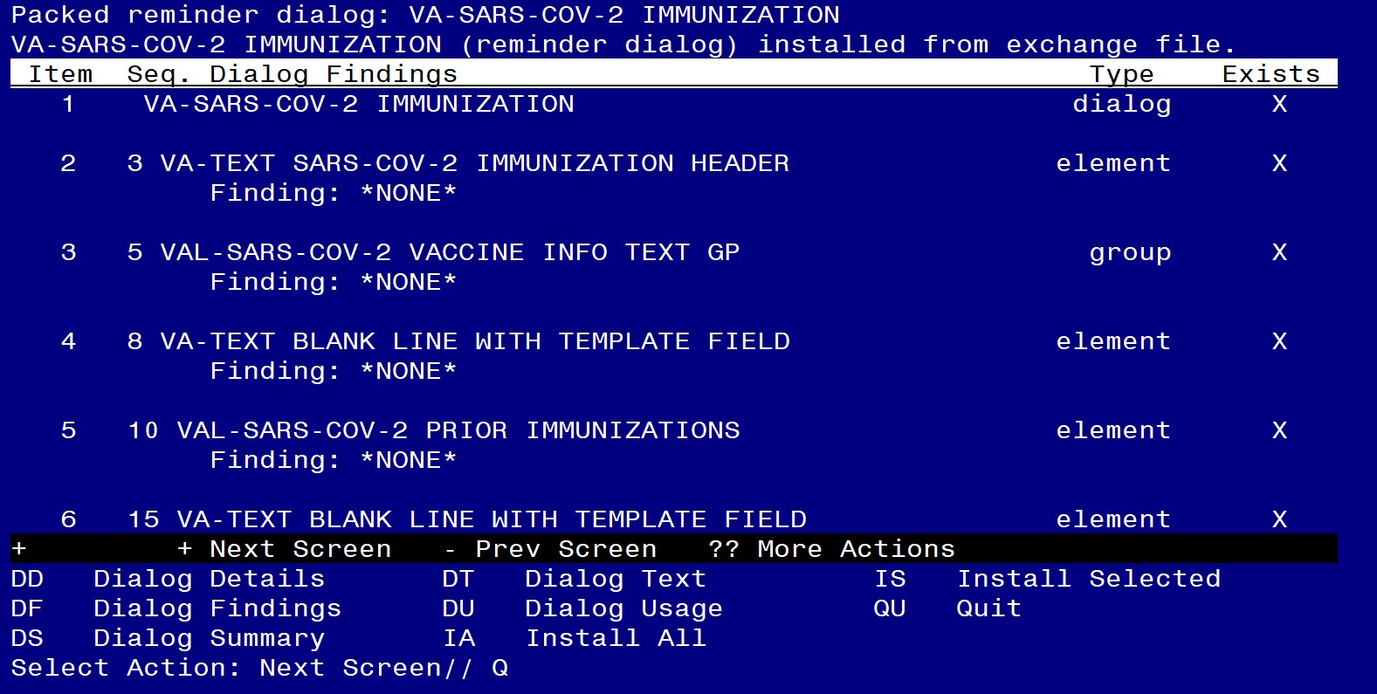

After completing this dialog install, you will type Q.

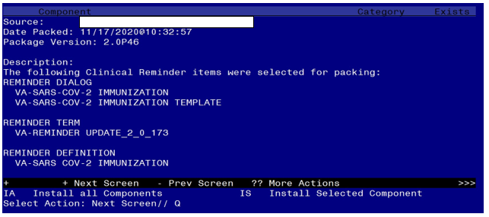

You will then be returned to this screen. At the Select Action prompt, type Q.

Install complete.

Post Installation

Setup of specific Note Titles
The following note title should be created to associate with the VA-SARS-COV-2 IMMUNIZATION TEMPLATE dialog. This is the title that should be used by nursing for inpatient documentation. Sites can also link the VA-SARS-COV-2 IMMUNIZATION TEMPLATE to additional local titles for use by personnel outside of nursing.

VAAES NSG COVID-19 VACCINE ADMINISTRATION

VHA Enterprise Standard Title: NURSING IMMUNIZATION NOTE

Note: Comprehensive information on Creating Document Definitions can be found beginning on page 47 of the TIU/ASU Implementation Guide.

Make the VA-SARS-COV-2 IMMUNIZATION TEMPLATE dialog able to be attached to a Personal/Shared template and/or progress note title.

CF Reminder Computed Finding Management ... RM Reminder Definition Management ...
SM Reminder Sponsor Management ... TXM Reminder Taxonomy Management TRM Reminder Term Management ...
LM Reminder Location List Management ... RX Reminder Exchange
RT Reminder Test
OS Other Supporting Menus ...
INFO Reminder Information Only Menu ... DM Reminder Dialog Management ...
CP CPRS Reminder Configuration ...
RP Reminder Reports ...
MST Reminders MST Synchronization Management ... PL Reminder Patient List Menu ...
PAR Reminder Parameters ...
VS NLM Value Set Menu
ROC Reminder Order Check Menu ...
CQM NLM Clinical Quality Measures Menu XM Reminder Extract Menu ...

Select Reminder Managers Menu <TEST ACCOUNT> Option: CP

CA Add/Edit Reminder Categories
CL CPRS Lookup Categories
CS CPRS Cover Sheet Reminder List
MH Mental Health Dialogs Active
PN Progress Note Headers
RA Reminder GUI Resolution Active
TIU TIU Template Reminder Dialog Parameter DEVL Evaluate Coversheet List on Dialog Finish DL Default Outside Location
PT Position Reminder Text at Cursor LINK Link Reminder Dialog to Template TEST CPRS Coversheet Time Test
NP New Reminder Parameters
GEC GEC Status Check Active
WH WH Print Now Active

Select CPRS Reminder Configuration <TEST ACCOUNT> Option: Link Reminder Dialog to Template

Select Dialog Definition: VA-SARS-COV-2 IMMUNIZATION TEMPLATE
...OK? Yes// Yes

Enter template name: VA-SARS-COV-2 IMMUNIZATION TEMPLATE

Link template to Document Title? YES

Select Document Definition: VAAES NSG COVID-19 VACCINE ADMINISTRATION

If linked to a shared template, the template may need moved to the appropriate local shared template folder.

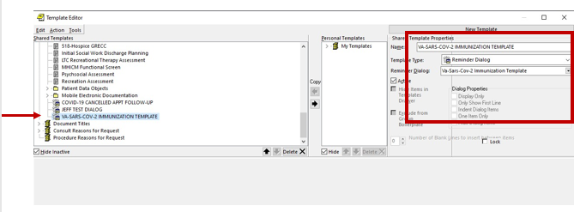Adding VA-SARS-COV-2 IMMUNIZATION TEMPLATE dialog to an existing local dialog (optional).

If adding the COVID immunization options to an existing local dialog, place the VAL- SARS-COV-2 VACCINE OPTIONS GROUP dialog group into the local dialog. This group serves as a header for all VA-SARS-COV-2 IMMUNIZATION TEMPLATE groups and elements.

Map appropriate quick orders into the dialog elements below (as necessary).

The dialog is deployed with the VAL-SARS-COV-2 VACCINE ORDER #1 element displaying in the dialog and four additional vaccine order elements disabled.

If more than one vaccine is available and additional order options need to display in the dialog, enable the appropriate elements.

Navigate to the appropriate vaccine order element. The names of the disabled elements are:
VAL-SARS-COV-2 VACCINE ORDER #1 VAL-SARS-COV-2 VACCINE ORDER #2 VAL-SARS-COV-2 VACCINE ORDER #3 VAL-SARS-COV-2 VACCINE ORDER #4 VAL-SARS-COV-2 VACCINE ORDER #5

Select the item number for the element and choose to edit. Follow the instructions below to enable the element, edit the text, and map the appropriate order dialog.

Select Dialog Element Action: Edit Dialog Element Type: E// <enter>
Current dialog element/group name: VAL-SARS-COV-2 VACCINE ORDER #2 Used by: VAL-SARS-COV-2 VACCINE ORDERING GP (Dialog Group)

NAME: VAL-SARS-COV-2 VACCINE ORDER #2 Replace <enter> DISABLE: DISABLE AND DO NOT SEND MESSAGE// @
SURE YOU WANT TO DELETE? Yes
CLASS: LOCAL// <enter> SPONSOR: <enter> REVIEW DATE: <enter>
RESOLUTION TYPE: ORDERED// <enter> ORDERABLE ITEM: <enter>
FINDING ITEM: Enter name of order dialog.

Additional Findings: None Select ADDITIONAL FINDING: DIALOG/PROGRESS NOTE TEXT:

Order vaccine formulation 2 Edit? NO// YES
==[ WRAP ]==[INSERT ]=======< DIALOG/PROGRESS NOTE TE[Press <PF1>H for
help]====
Order vaccine formulation 2 Revise this text for the appropriate vaccine.

Edit appropriate lot number prompts for the appropriate vaccines (as necessary). It is important to follow the formatting in the example.

Throughout the dialog groups, elements, and additional prompts, and install guide, the COVID-19 placeholder immunizations are stored and represented as listed below. The Pfizer and Moderna immunizations have been updated in the IMMUNIZATION file, but some groups and elements may still be named according the table below.

Ensure to edit the groups, elements, and additional prompts for the appropriate corresponding vaccine.

Immunization | Placeholder for
SARS-COV-2 VACCINE A1 | To Be Determined
SARS-COV-2 VACCINE B1 | To Be Determined
SARS-COV-2 VACCINE C2 | Moderna Vaccine
SARS-COV-2 VACCINE D2 | Pfizer Vaccine
SARS-COV-2 VACCINE E2 | To Be Determined

Navigate to reminder dialogs and change view to Additional Prompts.

DIALOG VIEW (REMINDER DIALOGS - SOURCE REMINDER NAME)

+Item Reminder Dialog Name Source Reminder Status
- VA-SARS-COV-2 IMMUNIZATION VA-SARS COV-2
- VA-SCREEN COVID *NONE*
- VA-SOC WORK ADVANCE CARE PLANNING GROUP *NONE*
- VA-SOC WORK ADVANCE CARE PLANNING GV-F/ *NONE*
- VA-SPINAL CORD INJURIES AND DISORDERS *NONE*
- VA-SRA-CONSULT RESPONSE (D) *NONE*
- VA-STAR ABC CARD *NONE*
- VA-STAR BEHAVIOR INCIDENT NOTE (BIN) *NONE*
- VA-TBI SCREENING VA-TBI SCREENING
- VA-TBI/POLYTRAUMA REHAB/REINTEGRATION P *NONE* Linked
- VA-TECS GLAUCOMA PHYSICIAN *NONE*

- VA-TECS GLAUCOMA TECHNICIAN *NONE*
- VA-TECS LETTERS *NONE*
- VA-TECS PHYSICIAN *NONE*
+ Enter ?? for more actions >>>
AD Add Reminder Dialog PT List/Print All QU Quit CV Change View RN Name/Print Name
Select Item: Next Screen// CV
Select one of the following: D Reminder Dialogs
- Dialog Elements
- Forced Values
- Dialog Groups
P Additional Prompts
R Reminders
RG Result Group (Mental Health) RE Result Element (Mental Health)

TYPE OF VIEW: R// P

Search list and navigate to the IM SARS-COV-2 VACCINE….. prompts

DIALOG VIEW (ADDITIONAL PROMPTS)

Item Dialog Name Dialog type Status
1 1 MJB COMMENT NONFORCED Additional Prompt 2 1 MJB READING Additional Prompt
- ARCH COMMENT Additional Prompt
- BP CUFF LARGE Additional Prompt
- BP CUFF MEDIUM Additional Prompt
- BP CUFF SMALL Additional Prompt
- BP CUFF THIGH Additional Prompt
- CKBOX NOT INDICATED/YES/NO Additional Prompt
- CKBOX VA PC F/UP ABDOMEN Additional Prompt
- CKBOX VA PC F/UP EXTREMITIES Additional Prompt
- CKBOX VA PC F/UP HEART Additional Prompt
- CKBOX VA PC F/UP LUNG Additional Prompt
- CKBOX VA PC F/UP MOOD Additional Prompt 14 CKBOX VA PC F/UP NASAL CAVITY Additional Prompt
+ + Next Screen - Prev Screen ?? More Actions >>> AD Add PT List/Print All QU Quit
CO Copy Dialog INQ Inquiry/Print
CV Change View TE Dialog Taxonomy Edit Select Item: Next Screen// SL
Search for: IM SARS-COV-2 VACCINE

Identify appropriate vaccine lot number prompt.
In this example, the lot information prompt for the C2 vaccine will be edited. All appropriate lot numbers for the C2 vaccine will be entered as unique sequence numbers in the C2 prompt.
Each available vaccine lot information prompt will need to be edited.

Instruct pharmacy of the need to be notified of new vaccines and/or lot numbers.

These prompts may need to be updated frequently.

+Item Dialog Name Dialog type Status
- IM SARS-COV-2 VACCINE C2 MVX LOT EXP Additional Prompt
- IM SARS-COV-2 VACCINE D2 MVX LOT EXP Additional Prompt
- IM SARS-COV-2 VACCINE E2 MVX LOT EXP Additional Prompt
- INFLUENZA H1N1 MANUFACTURERS Additional Prompt
- INFLUENZA HIGH DOSE MANUFACTURERS Additional Prompt
- ORZ PXRM COMMENT 2 Additional Prompt
- PXRM ADD TO PROBLEM LIST Additional Prompt
- PXRM BRADEN 10-12 Additional Prompt
- PXRM BRADEN 13-14 Additional Prompt
- PXRM BRADEN 15-18 Additional Prompt
- PXRM BRADEN 19-23 Additional Prompt
- PXRM BRADEN 6-8 Additional Prompt
- PXRM COMMENT Additional Prompt
- PXRM CONTRAINDICATED Additional Prompt
+ + Next Screen - Prev Screen ?? More Actions >>> AD Add PT List/Print All QU Quit
CO Copy Dialog INQ Inquiry/Print
CV Change View TE Dialog Taxonomy Edit
Select Item: Next Screen// 32 Enter item number for the appropriate prompt

Dialog Name: IM SARS-COV-2 VACCINE C2 MVX LOT EXP <enter>

Current dialog element/group name: IM SARS-COV-2 VACCINE C2 MVX LOT EXP Used by: VAL-SARS-COV-2 VACCINE C2 #1 GP (Dialog Group)
VAL-SARS-COV-2 VACCINE C2 #2 GP (Dialog Group)

NAME: IM SARS-COV-2 VACCINE C2 MVX LOT EXP Replace <enter>
DISABLE: <enter> CLASS: LOCAL// <enter> SPONSOR: <enter>

REVIEW DATE: <enter>
PROMPT CAPTION: MVX (Manuf); Lot#; Exp Date: Replace <enter>
EXCLUDE FROM PROGRESS NOTE: <enter>
DEFAULT VALUE: <enter>
Select CHECKBOX SEQUENCE: ? Enter ? to view list
Answer with CHECKBOX SEQUENCE Choose from:
1 MOD; LOT; mm/dd/yyyy

You may enter a new CHECKBOX SEQUENCE, if you wish Type a Number between 1 and 500, 0 Decimal Digits

Select CHECKBOX SEQUENCE: 1 Enter sequence number to be revised. Sequence 1 will

be the 1st checkbox at the top of the list in CPRS.
CHECKBOX SEQUENCE: 1// <enter>
TEXT: MOD; LOT; mm/dd/yyyy ... (Enter “…” to replace all)

With MOD; M3141; 12/01/2020 (This is an example only. Follow the exact formatting to

enter the MVX code, Lot Number, then Expiration Date. The information must be separated by a semi-colon.)
Replace ... With MOD; M3141; 12/01/2020 Replace <enter>
MOD; M3141; 12/01/2020

Select CHECKBOX SEQUENCE: 2 Enter sequence number to be revised. Continue until

all appropriate lot numbers for this vaccine are entered. Delete any unneeded default lot number sequences included in the update.

The TEXT field for each lot number must follow this format:

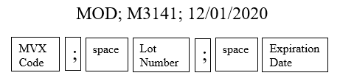
- Set-up Batch Print Locations
- List Batch Health Summary Locations
- CPRS Reports Tab 'Health Summary Types List' Menu ...

Select Health Summary Coordinator's Menu <TEST ACCOUNT> Option: 2

- Create/Modify Health Summary Type
- Delete Health Summary Type
- Health Summary Objects Menu ...
- Information Menu ...
- Print Health Summary Menu ...

Select Build Health Summary Type Menu <TEST ACCOUNT> Option: 1 Select Health Summary Type: SARS-COV-2 IMMUNIZATION
WARNING: You are about to edit a Health Summary Type that is being used by a Health Summary Object. Changing the structure of this Health Summary Type will alter how the Object will display.

Do want to continue? NO// YES
NAME: SARS-COV-2 IMMUNIZATION Replace <enter> TITLE: SARS-COV-2 IMMUNIZATION Replace <enter>
SUPPRESS PRINT OF COMPONENTS WITHOUT DATA: yes// <enter> SUPPRESS SENSITIVE PRINT DATA: <enter>

Review immunizations listed in health summary type.

Do you wish to review the Summary Type structure before continuing? NO// YES
HEALTH SUMMARY TYPE INQUIRY Type Name: SARS-COV-2 IMMUNIZATION
Title: SARS-COV-2 IMMUNIZATION Owner: CLINICAL COORDINATOR
SUPPRESS PRINT OF COMPONENTS WITHOUT DATA: yes SUPPRESS SENSITIVE PRINT DATA:

Max Hos ICD Pro CPT
Abb Ord Component Name Occ Time Loc Text Nar Mod Selection SIMC 5 COVID-19 Vaccination

VACCINE A1 VACCINE B1
(MODERNA), MRNA, LNP-
SARS-COV-2 SARS-COV-2 COVID-19

(PFIZER), MRNA, LNP-S VACCINE E2

Add appropriate immunizations (as necessary)

Select COMPONENT:SIMC

Select one of the following:

E Edit component parameters
D Delete component from summary

Select Action: Edit component parameters SUMMARY ORDER: 5// 5 <enter>
OCCURRENCE LIMIT: <enter> TIME LIMIT: <enter>
HEADER NAME: COVID-19 Vaccination Replace <enter>

Current selection items are: SARS-COV-2 VACCINE A1
SARS-COV-2 VACCINE B1 SARS-COV-2 VACCINE E2
COVID-19 SARS-COV-2

Select new items one at a time in the sequence you want them displayed. You may select any number of items.

Select SELECTION ITEM: SARS-COV-2 VACCINE E2// Enter name of new immunization

Edit following TIU template fields in CPRS (as necessary).

IM SARS COV-2 INFO TEXT
    - Information on vaccine formulations. This template field displays in the “Detailed information on vaccine for COVID-19” option at the top of the dialog.

IM SARS COV-2 VIS/EUA INFO URL A1
- URL for VIS/information for vaccine A1

IM SARS COV-2 VIS/EUA INFO URL B1
- URL for VIS/information for vaccine B1

IM SARS COV-2 VIS/EUA INFO URL C2
- URL for VIS/information for vaccine C2

IM SARS COV-2 VIS/EUA INFO URL D2
- URL for VIS/information for vaccine D2

IM SARS COV-2 VIS/EUA INFO URL E2
- URL for VIS/information for vaccine E2

IM SARS COV-2 A1 DOSE
- Dosage for vaccine A1

IM SARS COV-2 B1 DOSE
- Dosage for vaccine B1

IM SARS COV-2 C2 DOSE
- Dosage for vaccine C2

IM SARS COV-2 D2 DOSE
- Dosage for vaccine D2

IM SARS COV-2 E2 DOSE
- Dosage for vaccine E2

- Revise the display of available vaccines for administration (as necessary). The dialog is released with all vaccine administration groups disabled. Follow the instructions below to enable the appropriate vaccine group(s) to display in the administration section of the dialog.

The Pfizer and Moderna immunizations have been updated in the IMMUNIZATION file, but some groups and elements may still be named according the table below.

Ensure to edit the groups, elements, and additional prompts for the appropriate corresponding vaccine.

Immunization | Placeholder for
SARS-COV-2 VACCINE A1 | To Be Determined
SARS-COV-2 VACCINE B1 | To Be Determined
SARS-COV-2 VACCINE C2 | Moderna Vaccine
SARS-COV-2 VACCINE D2 | Pfizer Vaccine
SARS-COV-2 VACCINE E2 | To Be Determined

Navigate to the appropriate vaccine administration group. The names of the disabled groups are:
VAL-SARS-COV-2 VACCINE ADMIN C2 GP VAL-SARS-COV-2 VACCINE ADMIN D2 GP VAL-SARS-COV-2 VACCINE ADMIN A1 GP VAL-SARS-COV-2 VACCINE ADMIN B1 GP VAL-SARS-COV-2 VACCINE ADMIN E2 GP

Select the item number for the appropriate vaccine group and choose to edit. Follow the instructions below to enable the group and edit the text.

Current dialog element/group name: VAL-SARS-COV-2 VACCINE ADMIN A1 GP Used by: VAL-SARS-COV-2 VACCINE ADMINISTRATION GP (Dialog Group)

NAME: VAL-SARS-COV-2 VACCINE ADMIN A1 GP Replace <enter>

DISABLE: DISABLE AND DO NOT SEND MESSAGE// @ SURE YOU WANT TO DELETE? Yes
CLASS: LOCAL// <enter> SPONSOR: <enter> REVIEW DATE: <enter>
RESOLUTION TYPE: DONE AT ENCOUNTER//<enter> ORDERABLE ITEM: <enter>
FINDING ITEM: <enter>

Additional findings: none
Select ADDITIONAL FINDING: <enter> GROUP CAPTION: <enter>
PUT A BOX AROUND THE GROUP: <enter> SHARE COMMON PROMPTS: NO//<enter>
MULTIPLE SELECTION: NO SELECTION REQUIRED// <enter> HIDE/SHOW GROUP: HIDE// <enter>
GROUP HEADER DIALOG TEXT:
SARS-CoV-2 vaccine A1 Edit? NO// YES
==[ WRAP ]==[INSERT ]=======< GROUP HEADER DIALOG TEX[Press <PF1>H for

SARS-CoV-2 vaccine A1 Revise this text for the appropriate vaccine.

<=======T=======T=======T=======T=======T=======T=======T=======T=======T>====

- Revise the display of available vaccines for historical documentation (as necessary). The dialog is released with all historical vaccine groups disabled. Follow the instructions below to enable the appropriate vaccine group(s) to display in the historical section of the dialog.

The Pfizer and Moderna immunizations have been updated in the IMMUNIZATION file, but some groups and elements may still be named according the table below.

Ensure to edit the groups, elements, and additional prompts for the appropriate corresponding vaccine.

Immunization | Placeholder for
SARS-COV-2 VACCINE A1 | To Be Determined
SARS-COV-2 VACCINE B1 | To Be Determined
SARS-COV-2 VACCINE C2 | Moderna Vaccine
SARS-COV-2 VACCINE D2 | Pfizer Vaccine
SARS-COV-2 VACCINE E2 | To Be Determined

Navigate to the appropriate vaccine group. The names of the disabled groups are:
VAL-SARS-COV-2 VACCINE C2 OUTSIDE GP VAL-SARS-COV-2 VACCINE D2 OUTSIDE GP VAL-SARS-COV-2 VACCINE A1 OUTSIDE GP VAL-SARS-COV-2 VACCINE B1 OUTSIDE GP VAL-SARS-COV-2 VACCINE E2 OUTSIDE GP

Select the item number for the appropriate vaccine group and choose to edit. Follow the instructions below to enable the group and edit the text.

NAME: VAL-SARS-COV-2 VACCINE A1 OUTSIDE GP
Replace <enter>
DISABLE: DISABLE AND DO NOT SEND MESSAGE// @ SURE YOU WANT TO DELETE? Yes
CLASS: LOCAL// <enter> SPONSOR: <enter> REVIEW DATE: <enter>
RESOLUTION TYPE: DONE AT ENCOUNTER//<enter> ORDERABLE ITEM: <enter>
FINDING ITEM: <enter>

Additional findings: none
Select ADDITIONAL FINDING: <enter> GROUP CAPTION: <enter>
PUT A BOX AROUND THE GROUP: <enter> SHARE COMMON PROMPTS: NO//<enter>
MULTIPLE SELECTION: NO SELECTION REQUIRED// <enter> HIDE/SHOW GROUP: HIDE// <enter>
GROUP HEADER DIALOG TEXT:
SARS-CoV-2 vaccine A1 Edit? NO// YES
==[ WRAP ]==[INSERT ]=======< GROUP HEADER DIALOG TEX[Press <PF1>H for

SARS-CoV-2 Vaccine A1 given previously

Revise this text for the appropriate vaccine.

<=======T=======T=======T=======T=======T=======T=======T=======T=======T>====

Add the COVID-19 immunizations to the ORWPCE EXCLUDE IMMUNIZATIONS parameter, so they cannot be documented in an encounter without using the reminder dialogs.

Navigate to the General Parameter Tools menu.

LV List Values for a Selected Parameter LE List Values for a Selected Entity
LP List Values for a Selected Package
LT List Values for a Selected Template
EP Edit Parameter Values
ET Edit Parameter Values with Template EK Edit Parameter Definition Keyword

Select General Parameter Tools <TEST ACCOUNT> Option: EP

Select PARAMETER DEFINITION NAME: ORWPCE EXCLUDE IMMUNIZATIONS
Excluded Immunizations

Set parameter for the System level

ORWPCE EXCLUDE IMMUNIZATIONS may be set for the following:

1 User | USR | [choose from NEW PERSON]
2 Location | LOC | [choose from HOSPITAL LOCATION]
3 Service | SRV | [choose from SERVICE/SECTION]
4 Division | DIV | [choose from INSTITUTION]
5 System | SYS | [SCR.FO-SLC.MED.VA.GOV]
6 Package | PKG | [ORDER ENTRY/RESULTS REPORTING]

Enter selection: 5 System

Add each COVID-19 placeholder immunization.

Select Sequence: 1
Are you adding 1 as a new Sequence? YES

Sequence: 1//
Immunization: SARS-COV-2 VACCINE A1

Select Sequence: 2
Are you adding 2 as a new Sequence? Yes// YES

Sequence: 2// 2
Immunization: SARS-COV-2 VACCINE B1

Select Sequence: 3
Are you adding 3 as a new Sequence? Yes// YES

Sequence: 3// 3
Immunization: COVID-19 (MODERNA), MRNA, LNP-

Select Sequence: 4
Are you adding 4 as a new Sequence? Yes// YES

Sequence: 4// 4
Immunization: COVID-19 (PFIZER), MRNA, LNP-S

Select Sequence: 5
Are you adding 5 as a new Sequence? Yes// YES

Sequence: 5// 5
Immunization: SARS-COV-2 VACCINE E2
Select Sequence:

Inform the local Pharmacy ADPAC that the BCMA2PCE TASK should NOT be set up for any COVID-19 vaccine.

Immunizations must be documented using the included reminder dialogs.

The mapping of the pharmacy orderable item to the immunization should NOT be completed. Administration of the COVID-19 vaccines will need to be done using the reminder dialog template or the reminder dialog until further notice.

