Update _2_0_55

Clinical Reminders

VA-ATHLETES MEDICAL INFORMATION
Install Guide

December 2018

Product Development
Office of Information Technology
Department of Veterans Affairs

Table of Contents
Introduction 1
Install Details 2
Install Example 2
Post Installation 5

Introduction

Description:
This is a new reminder dialog template for national distribution to address identified needs of the National Veterans Golden Age Games to capture medical data to clear Veterans to participate in the Games at the time of screening.
- The annual National Veterans Golden Age Games (NVGAG) provides Veterans opportunities to engage in rehabilitative sport and recreation opportunities. It serves Veterans ages 55 years and older who are enrolled in the VA Health Care System.

- Participants learn to use the therapeutic value of sports, fitness and recreation through an active, healthy lifestyle by competing in sporting competitions for example air rifle, golf, swimming, track and field.

- By participating in NVGAG, Veterans reach their full potential, improve their independence, achieve a healthier lifestyle and enjoy a higher quality of life.

- This reminder template allows the VA provider to electronically capture medical data to determine participation in the National Veterans Golden Age Games.

- This will facilitate communication to health care providers at the Host Site Facility to ensure continuity of care while participation in the National Veterans Golden Age Games away from the Veterans primary site of care.

One reminder dialog is being distributed with this update:
VA-ATHLETES MEDICAL INFORMATION

UPDATE_2_0_55 contains 1 Reminder Exchange entry:
UPDATE_2_0_55 VA-ATHLETES MEDICAL INFORMATION

The exchange file contains the following components:
REMINDER DIALOG
VA-ATHLETES MEDICAL INFORMATION

TIU TEMPLATE FIELD
GOLDEN GAMES HL
ALLCOMMENT(4LINES)
BLANK SPACE1

HEALTH FACTORS
VA-REMINDER UPDATES
VA-UPDATE_2_0_55

REMINDER TERM
VA-REMINDER UPDATE_2_0_55

HEALTH SUMMARY TYPE
AH-BPR ACTIVE PROBLEMS

HEALTH SUMMARY OBJECTS
AH-BPR ACTIVE PROBLEMS (TIU)

TIU DOCUMENT DEFINITION
AH-BPR ACTIVE PROBLEMS

Install Details

This update is being distributed as a web host file. The address for the host file is: http://Redacted/UPDATE_2_0_55.PRD

The file will be installed using Reminder Exchange, programmer access is not required.

Installation:
=============
This update can be loaded with users on the system. Installation will take less than 15 minutes.

Install Example
To Load the Web Host File. Navigate to Reminder exchange in Vista
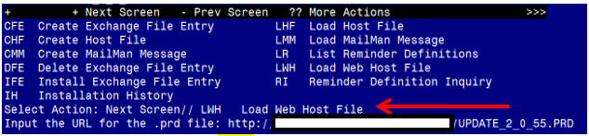
At the Select Action: prompt, enter LWH for Load Web Host File
At the Input the url for the .prd file: prompt, type the following web address:
http://Redacted /UPDATE_2_0_55.PRD
You should see a message at the top of your screen that the file successfully loaded.
Search and locate an entry titled UPDATE_2_0_55 VA-ATHLETES MEDICAL INFORMATION in reminder exchange 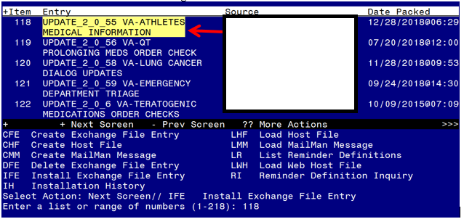

At the Select Action prompt, enter IFE for Install Exchange File Entry
Enter the number that corresponds with your entry titled UPDATE_2_0_55 VA-ATHLETES MEDICAL INFORMATION (in this example it is entry 118, it will vary by site)
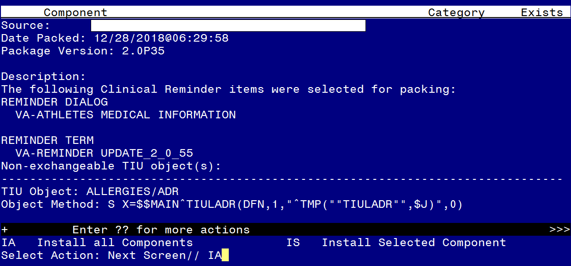
At the Select Action prompt, type IA for Install all Components and hit enter.
Select Action: Next Screen// IA Install all Components

You will see several prompts, for all new entries you will choose I to Install

You will be promped to install the reminder dialog component:
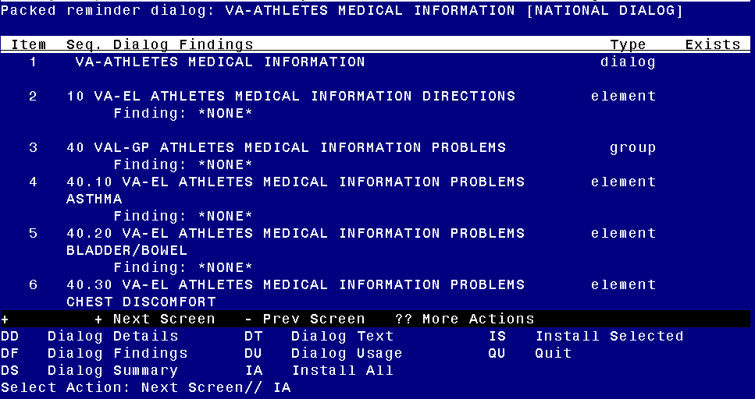
At the Select Action prompt, type IA to install the dialog – VA-ATHLETES MEDICAL INFORMATION
Select Action: Next Screen// IA Install All
Install reminder dialog and all components with no further changes: Y// Yes

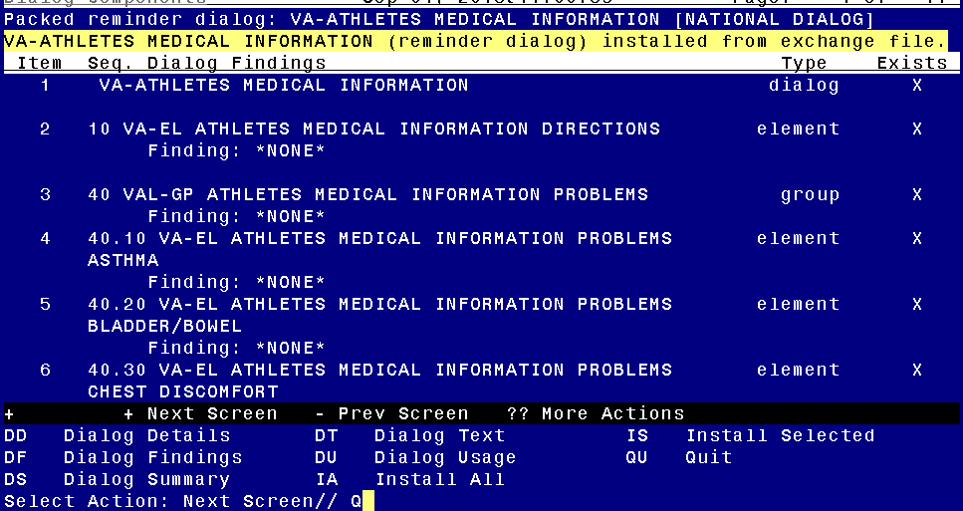
After the dialog installs, you will be returned to this prompt, at the Select Action prompt, type Q to quit.

You will then be prompted to install the health summary components, you WILL CHOOSE I to Install. If the components exist, you will choose S to SKIP these.

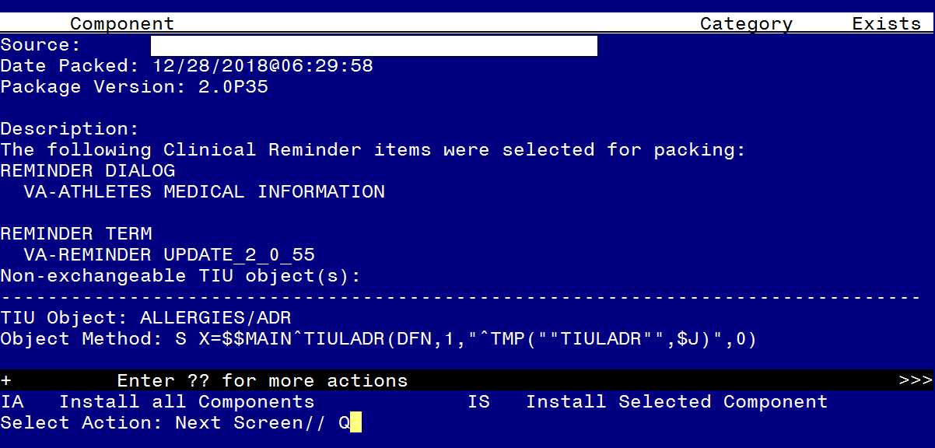
You will then be returned to this screen. At the Select Action prompt, type Q.

Install complete.

Post Installation

- Make the Dialog able to be attached to a Personal/Shared template or to a progress note title.
From the Reminders Manager Menu:
Select Reminder Managers Menu Option: CP CPRS Reminder Configuration
CA Add/Edit Reminder Categories
CL CPRS Lookup Categories
CS CPRS Cover Sheet Reminder List
MH Mental Health Dialogs Active
PN Progress Note Headers
RA Reminder GUI Resolution Active
TIU TIU Template Reminder Dialog Parameter
DL Default Outside Location
PT Position Reminder Text at Cursor
Select CPRS Reminder Configuration Option: TIU TIU Template Reminder Dialog Parameter
Reminder Dialogs allowed as Templates may be set for the following:
1 User USR [choose from NEW PERSON]
3 Service SRV [choose from SERVICE/SECTION]
4 Division DIV [choose from INSTITUTION]
5 System SYS [NATREM.FO-SLC.MED.VA.GOV]
Enter selection: 5 Choose the appropriate number for your site. Your site may do this by System or other levels. The example below uses SYSTEM level

Setting Reminder Dialogs allowed as Templates for System:
Select Display Sequence: ?

148 VA-VETERANS CHOICE NOTE
149 VA-TBI SCREENING
When you type a question mark above, you will see the list of #’s (with dialogs) that are already taken. Choose a number NOT on this list. For this example, looking above I see the number 150 is not present, so I will use 150.
Select Display Sequence: 150
Are you adding 150 as a new Display Sequence? Yes// Y YES
Display Sequence: 150// <Enter> 150
Clinical Reminder Dialog: type in the name of the dialog
VA-ATHLETES MEDICAL INFORMATION then <enter> reminder dialog NATIONAL
OK? Yes// <Enter> (Yes)

- Setup of Note title
A note title will need to be crated for use with this template. This note title is required.

Note Title: NATIONAL VETERANS GOLDEN AGE GAMES MEDICAL CLEARANCE FORM
The VHA Enterprise Standard Title will be:

PHYSICAL MEDICINE REHAB ADMINISTRATIVE NOTE

Comprehensive information on Creating Document Definitions can be found beginning on page 47 of the TIU/ASU Implementation Guide

- Associate the reminder dialog with the note title in CPRS.
To do this, go to Template Editor, then Document Titles, select the appropriate folder
(if applicable), and choose New Template (top right-hand corner).
Type in the following information:
Name: Athletes Medical Information
Template Type: Reminder Dialog
Reminder Dialog: VA-ATHLETES MEDICAL INFORMATION
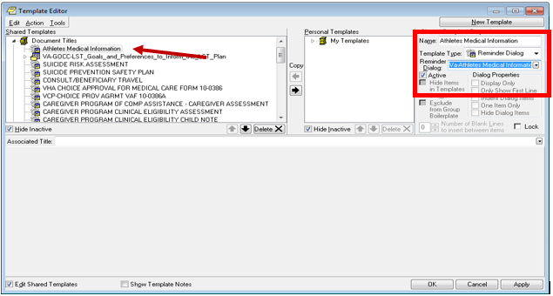
Next, type in the Associated Title, which in this case is:
NATIONAL VETERANS GOLDEN AGE GAMES MEDICAL CLEARANCE FORM
Hit Apply and OK

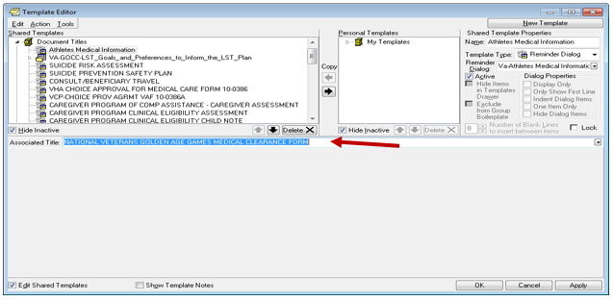

4. Insert your local data objects into the dialog. You will use the reminder dialog manager menu, reminder dialogs, and then change your view to GROUP or ELEMENT view. Search for and edit the following elements. You may need to edit both the dialog text and the alternate progress note text so please review both.
  - Insert your local objects for active problem list into the dialog text of GROUP VAL-GP ATHLETES MEDICAL INFORMATION PROBLEMS This element contains an object that may work in your system so review first to see if you need to replace.
  - Insert your local objects for active medications into the dialog text of ELEMENT VAL ATHLETES MEDICAL INFORMATION MEDICATION This element contains an object that may work in your system so review first to see if you need to replace.
  - Insert your local objects for allergies into the dialog text of GROUP VAL-GP ATHLETES MEDICAL INFORMATION ALLERGIES This element contains an object that may work in your system so review first to see if you need to replace

