Update _2_0_58

Clinical Reminders

VA-Lung Cancer Dialog Updates

Install Guide

February 2019

Product Development
Office of Information Technology
Department of Veterans Affairs

Table of Contents
Introduction 1
Install Details 19
Install Example 20
Post Installation 26

Introduction

Description:
Changes to National Oncology Lung Cancer Dialogs:

Added per new 2018 standards

ONC Lung Clinical-Summary Stage IA1
ONC Lung Clinical-Summary Stage IA2
ONC Lung Clinical-Summary Stage IA3
ONC Lung Clinical-Summary Stage IIIC
ONC Lung Clinical-Summary Stage IVA
ONC Lung Clinical-Summary Stage IVB
ONC Lung Clinical Primary Tumor-T1
ONC Lung Clinical Primary Tumor-T1c
ONC Lung Clinical Primary Tumor-Tis
ONC Lung Clinical Primary Tumor-T1a(mi)
ONC Lung Clinical Primary Tumor-T2
ONC Lung Clin Distant Metastasis-M1c
ONC Lung Pathological-Summary Stage IA1
ONC Lung Pathological-Summary Stage IA2
ONC Lung Pathological-Summary Stage IA3
ONC Lung Pathological-Summary Stage IIIC
ONC Lung Pathological-Summary Stage IVA
ONC Lung Pathological-Summary Stage IVB
ONC Lung Path Primary Tumor-T1a(mi)
ONC Lung Pathological Primary Tumor-T1
ONC Lung Pathological Primary Tumor-T1c
ONC Lung Pathological Primary Tumor-Tis
ONC Lung Pathological Primary Tumor-T2
ONC Lung Path Distant Metastasis-M1c

Clinical Summary Staging
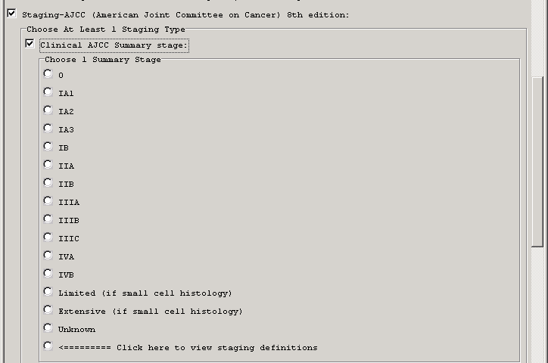

Clinical TNM Staging
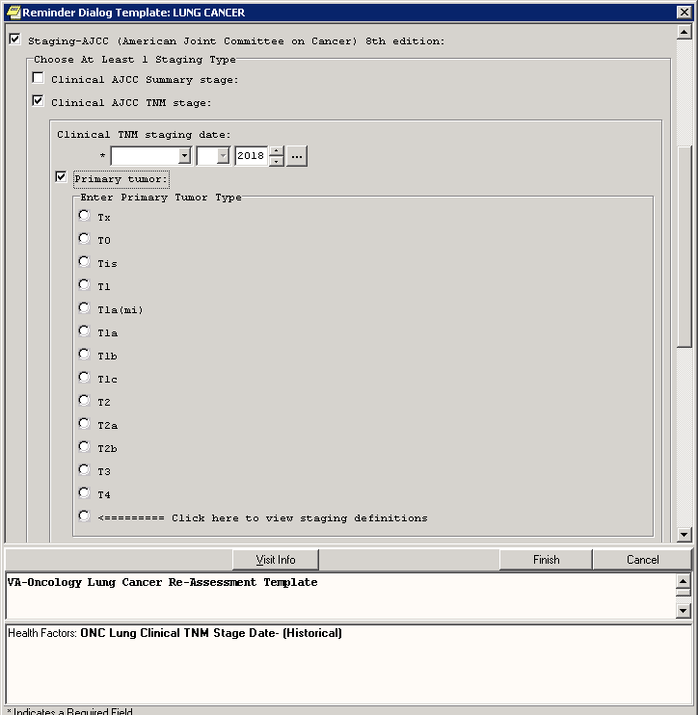

Pathological Summary Staging
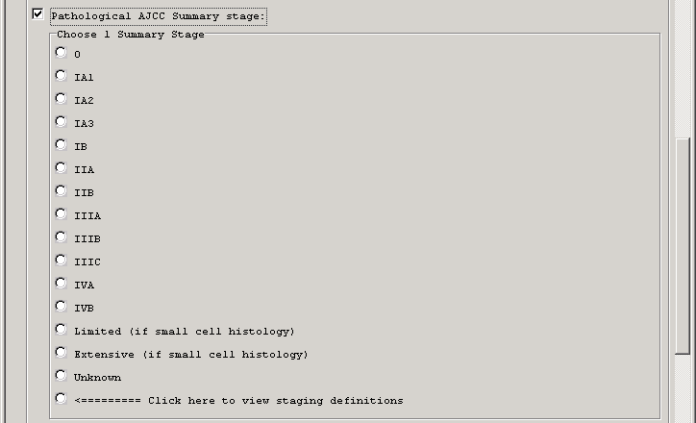

Pathological TNM Staging
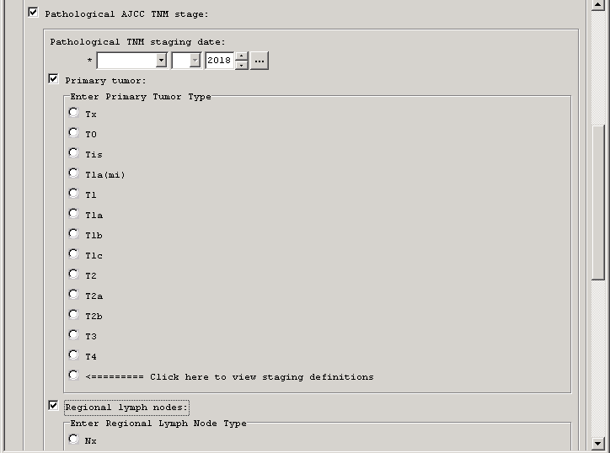

Chemotherapy
Obsolete/removed question asking why Bevacizumab not administered when indicated
Added new FDA approved lung CA chemo drugs:
Durvalumab
Atezolumumab
Brigatinib
Dabrafenib
Trametinib
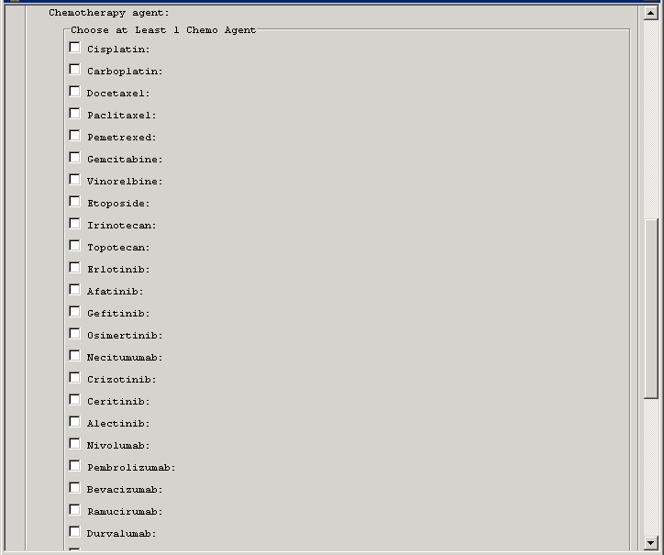
Surgery section added anatomical location to each option
Cancer surveillance
Added standard options for follow up
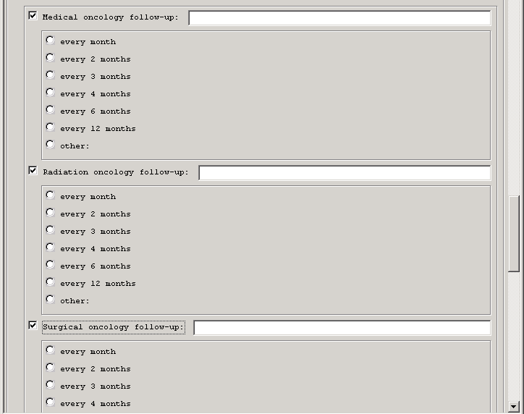

UPDATE_2_0_58 contains 1 Reminder Exchange entry:
UPDATE_2_0_58 VA-LUNG CANCER DIALOG UPDATES

The exchange file contains the following components:

TIU TEMPLATE FIELD
00 EDIT BOX 24
ONCOLOGY SYMPTOM DURING
00 EDIT BOX 12
TEXT (1-20 CHAR)
ONCOLOGY YES NO
ONCOLOGY CHEMO ROUTE
WORD PROCESSING SHORT
GEN TEXT BOX 50
ALLCOMMENT(4LINES)
ONC MDC CLICK HERE TO INCLUDE
WORD PROC 50X2
ONC LIFESTYLE
TEXT (1-60 CHAR)1
ONCOLOGY TRTMENT SYMPTOM

HEALTH FACTORS
VA-REMINDER UPDATES
VA-UPDATE_2_0_58
Oncology (ONC) Lung Cancer Diagnoses
ONC Lung Pathological Primary Tumor-T2
ONC Lung Pathological Primary Tumor-Tis
ONC Lung Pathological Primary Tumor-T1c
ONC Lung Pathological Primary Tumor-T1
ONC Lung Path Primary Tumor-T1a(mi)
ONC Lung Pathological-Summary Stage IVB
ONC Lung Pathological-Summary Stage IVA
ONC Lung Pathological-Summary Stage IIIC
ONC Lung Pathological-Summary Stage IA3
ONC Lung Pathological-Summary Stage IA2
ONC Lung Pathological-Summary Stage IA1
ONC Lung Clin Distant Metastasis-M1c
ONC Lung Clinical Primary Tumor-T2
ONC Lung Clinical Primary Tumor-T1a(mi)
ONC Lung Clinical Primary Tumor-Tis
ONC Lung Clinical Primary Tumor-T1c
ONC Lung Clinical Primary Tumor-T1
ONC Lung Molecular Test-Other
ONC Lung Precision Oncology
ONC Lung PD-L1-Negative
ONC Lung PD-L1-Positive
ONC Lung PD-L1-Results Pending
ONC Lung PD-L1-Not Done
ONC Lung ALK Translocation-Rearranged
ONC Lung ALK Translocation-Normal
ONC Lung ALK Translocation-Result Pendin
ONC Lung ALK Translocation-Not Done
ONC Lung EGFR Test-Mutant
ONC Lung EGFR Test-Wild Type
ONC Lung EGFR Test-Results Pending
ONC Lung EGFR Test-Not Done
ONC Lung Histology-Other
ONC Lung Histology-SCLC
ONC Lung Histology-NSCLC, NOS
ONC Lung Histology-Large Cell
ONC Lung Histology-Squamous Cell
ONC Lung Histology-Adenocarcinoma
ONC Lung Path Distant Metastasis-M1b
ONC Lung Path Distant Metastasis-M1a
ONC Lung Path Distant Metastasis-M1
ONC Lung Path Distant Metastasis-M0
ONC Lung Path Distant Metastasis-Mx
ONC Lung Path Regional Lymph Nodes-N3
ONC Lung Path Regional Lymph Nodes-N2
ONC Lung Path Regional Lymph Nodes-N1
ONC Lung Path Regional Lymph Nodes-N0
ONC Lung Path Regional Lymph Nodes-Nx
ONC Lung Pathological Primary Tumor-T4
ONC Lung Pathological Primary Tumor-T3
ONC Lung Pathological Primary Tumor-T2b
ONC Lung Pathological Primary Tumor-T2a
ONC Lung Pathological Primary Tumor-T1b
ONC Lung Pathological Primary Tumor-T1a
ONC Lung Pathological Primary Tumor-Tx
ONC Lung Pathological TNM Stage Date-
ONC Lung Pathological-Summary Stage Unk
ONC Lung Pathological-Summary Stage IIIB
ONC Lung Pathological-Summary Stage IIIA
ONC Lung Pathological-Summary Stage IIB
ONC Lung Pathological-Summary Stage IIA
ONC Lung Pathological-Summary Stage IB
ONC Lung Pathological-Summary Stage 0
ONC Lung Clin Distant Metastasis-M1b
ONC Lung Clin Distant Metastasis-M1a
ONC Lung Clin Distant Metastasis-M1
ONC Lung Clin Distant Metastasis-M0
ONC Lung Clin Distant Metastasis-Mx
ONC Lung Clin Regional Lymph Nodes-N3
ONC Lung Clin Regional Lymph Nodes-N2
ONC Lung Clin Regional Lymph Nodes-N1
ONC Lung Clin Regional Lymph Nodes-N0
ONC Lung Clin Regional Lymph Nodes-Nx
ONC Lung Clinical Primary Tumor-T4
ONC Lung Clinical Primary Tumor-T3
ONC Lung Clinical Primary Tumor-T2b
ONC Lung Clinical Primary Tumor-T2a
ONC Lung Clinical Primary Tumor-T1b
ONC Lung Clinical Primary Tumor-T1a
ONC Lung Clinical Primary Tumor-Tx
ONC Lung Clinical TNM Stage Date-
ONC Lung Clinical-Summary Stage Unknown
ONC Lung Clinical-Summary Stage IVB
ONC Lung Clinical-Summary Stage IVA
ONC Lung Clinical-Summary Stage IIIC
ONC Lung Clinical-Summary Stage IIIB
ONC Lung Clinical-Summary Stage IIIA
ONC Lung Clinical-Summary Stage IIB
ONC Lung Clinical-Summary Stage IIA
ONC Lung Clinical-Summary Stage IB
ONC Lung Clinical-Summary Stage IA3
ONC Lung Clinical-Summary Stage IA2
ONC Lung Clinical-Summary Stage IA1
ONC Lung Clinical-Summary Stage 0
ONC Lung Initial Diagnosis Date-
ONC Lung First Abnormal Radiology Date-
ONC Lung ECOG-Unknown
ONC Lung ECOG-5
ONC Lung ECOG-4
ONC Lung ECOG-3
ONC Lung ECOG-2
ONC Lung ECOG-1
ONC Lung ECOG-0
Oncology (ONC) Lung Cancer Treatments
ONC Lung Clinical Trial Stop Date
ONC Lung Clinical Trial Start Date
ONC Lung Clinical Trial
ONC Lung Chemo Not Admin-Other
ONC Lung Chemo Not Admin-Pt Declined
ONC Lung Chemo Not Admin-Not Recommended
ONC Lung Consent for Chemo Not Obtained
ONC Lung Consent for Chemo Obtained
ONC Lung Chemo Intent Discussed-Unknown
ONC Lung Chemo Intent Discussed-No
ONC Lung Chemo Intent Discussed-Yes
ONC Lung Chemo Intent-Single Modality
ONC Lung Chemo Intent-Concurrent
ONC Lung Chemo Intent-Neoadjuvant
ONC Lung Chemo Intent-Adjuvant
ONC Lung Chemo Intent-Not Determined
ONC Lung Chemo Intent-Palliative
ONC Lung Other RT Stop Date
ONC Lung Other RT Start Date
ONC Lung RT Site-Other
ONC Lung Bone RT Stop Date
ONC Lung Bone RT Start Date
ONC Lung RT Site-Bone
ONC Lung Brain RT Stop Date
ONC Lung Brain RT Start Date
ONC Lung RT Site-Brain
ONC Lung Chest RT Stop Date
ONC Lung Chest RT Start Date
ONC Lung RT Site-Chest
ONC Lung RT Intent-Not Determined
ONC Lung RT Intent-Single Modality
ONC Lung RT Type-Concurrent
ONC Lung RT Type-Neoadjuvant
ONC Lung RT Type-Adjuvant
ONC Lung RT Stopped-Other
ONC Lung RT Stopped-Site Change
ONC Lung RT Stopped-Patient Request
ONC Lung RT Stopped-Progression
ONC Lung RT Stopped-Toxicity
ONC Lung RT Stopped-Plan Completed
ONC Lung RT Not Admin-Other
ONC Lung RT Not Admin-Pt Declined
ONC Lung RT Not Admin-Contraindicated
ONC Lung Stereotactic Body RT-Unknown
ONC Lung Stereotactic Body RT-No
ONC Lung Stereotactic Body RT-Yes
ONC Lung RT Intent Discussed-Unknown
ONC Lung RT Intent Discussed-No
ONC Lung RT Intent Discussed-Yes
ONC Lung RT Intent-Curative
ONC Lung RT Intent-Palliative
ONC Lung LLL-Wedge Resection
ONC Lung LUL-Wedge Resection
ONC Lung RLL-Wedge Resection
ONC Lung RML-Wedge Resection
ONC Lung RUL-Wedge Resection
ONC Lung LUL-Segmentectomy
ONC Lung LLL-Segmentectomy
Oncology (ONC) Breast Diagnoses
ONC Lung RLL-Segmentectomy
ONC Lung RML-Segmentectomy
ONC Lung RUL-Segmentectomy
ONC Lung Left Side-Pneumonectomy
ONC Lung Right Side-Pneumonectomy
ONC Lung LLL-Lobectomy
ONC Lung LUL-Lobectomy
ONC Lung RLL-Lobectomy
ONC Lung RML-Lobectomy
ONC Lung RUL-Lobectomy
ONC Lung Surgery Outcome-Not Determined
ONC Lung Surgery Outcome-Result Pending
ONC Lung Surgery Outcome-Not Resectable
ONC Lung Surgery Outcome-+ Margins
ONC Lung Surgery Outcome-Clear Margins
ONC Lung Surgery No-Other Reason
ONC Lung Surgery No-Patient Declined
ONC Lung Surgery-Not Recommended
ONC Lung Path Distant Metastasis-M1c
ONC Lung Tissue Sample Sent to POP
ONC Lung Tissue Sample Sent
ONC Lung Presented To Tumor Board-Yes
Oncology (ONC) Lung Cancer Follow-Up
ONC Lung Complications From Treatment
ONC Lung Follow Up-Not Determined
ONC Lung Follow Up-Progression
ONC Lung Follow Up-No Recurrence
ONC Lung Follow Up-Recurrence
ONC Lung Follow Up-Stable Disease
ONC Lung Follow Up-Partial Respons
ONC Lung Follow Up-Complete Response
ONC Lung Chemo Stopped-Plan Completed
ONC Lung Chemo Stopped-Other
ONC Lung Chemo Stopped-Patient Request
ONC Lung Chemo Stopped-Progression
ONC Lung Chemo Stopped-Toxicity
ONC Lung Trametinib Stop Date
ONC Lung Trametinib Start Date
ONC Lung Dabrafenib Stop Date
ONC Lung Dabrafenib Start Date
ONC Lung Brigatinib Stop Date
ONC Lung Brigatinib Start Date
ONC Lung Atezolumumab Stop Date
ONC Lung Atezolumumab Start Date
ONC Lung Durvalumab Stop Date
ONC Lung Durvalumab Start Date
ONC Lung Topotecan Stop Date
ONC Lung Topotecan Start Date
ONC Lung Chemo Other Stop Date
ONC Lung Chemo Other Start Date
ONC Lung Chemo Type-Other
ONC Lung Ramucirumab Stop Date
ONC Lung Ramucirumab Start Date
ONC Lung Bevacizumab Stop Date
ONC Lung Bevacizumab Start Date
ONC Lung Chemo Type-Bevacizumab
ONC Lung Pembrolizumab Stop Date
ONC Lung Pembrolizumab Start Date
ONC Lung Nivolumab Stop Date
ONC Lung Nivolumab Start Date
ONC Lung Alectinib Stop Date
ONC Lung Alectinib Start Date
ONC Lung Ceritinib Stop Date
ONC Lung Ceritinib Start Date
ONC Lung Chemo Type-Ceritinib
ONC Lung Crizotinib Stop Date
ONC Lung Crizotinib Start Date
ONC Lung Chemo Type-Crizotinib
ONC Lung Necitumumab Stop Date
ONC Lung Necitumumab Start Date
ONC Lung Osimertinib Stop Date
ONC Lung Osimertinib Start Date
ONC Lung Gefitinib Stop Date
ONC Lung Gefitinib Start Date
ONC Lung Afatinib Stop Date
ONC Lung Afatinib Start Date
ONC Lung Vinorelbine Stop Date
ONC Lung Vinorelbine Start Date
ONC Lung Chemo Type-Vinorelbine
ONC Lung Erlotinib Stop Date
ONC Lung Erlotinib Start Date
ONC Lung Chemo Type-Erlotinib
ONC Lung Irinotecan Stop Date
ONC Lung Irinotecan Start Date
ONC Lung Chemo Type-Irinotecan
ONC Lung Etoposide Stop Date
ONC Lung Etoposide Start Date
ONC Lung Chemo Type-Etoposide
ONC Lung Gemitabine Stop Date
ONC Lung Gemitabine Start Date
ONC Lung Chemo Type-Gemcitabine
ONC Lung Pemetrexed Stop Date
ONC Lung Pemetrexed Start Date
ONC Lung Chemo Type-Pemetrexed
ONC Lung Paclitaxel Stop Date
ONC Lung Paclitaxel Start Date
ONC Lung Chemo Type-Paclitaxel
ONC Lung Docetaxel Stop Date
ONC Lung Docetaxel Start Date
ONC Lung Chemo Type-Docetaxel
ONC Lung Carboplatin Stop Date
ONC Lung Carboplatin Start Date
ONC Lung Chemo Type-Carboplatin
ONC Lung Cisplatin Stop Date
ONC Lung Cisplatin Start Date
ONC Lung Chemo Type-Cisplatin
ONC Lung Lab4 Other
ONC Lung Lab4 12
ONC Lung Lab4 6
ONC Lung Lab4 4
ONC Lung Lab4 3
ONC Lung Lab4 2
ONC Lung Lab4 1
ONC Lung Lab3 Other
ONC Lung Lab3 12
ONC Lung Lab3 6
ONC Lung Lab3 4
ONC Lung Lab3 3
ONC Lung Lab3 2
ONC Lung Lab3 1
ONC Lung Lab2 Other
ONC Lung Lab2 12
ONC Lung Lab2 6
ONC Lung Lab2 4
ONC Lung Lab2 3
ONC Lung Lab2 2
ONC Lung Lab2 1
ONC Lung Lab1 Other
ONC Lung Lab1 12
ONC Lung Lab1 6
ONC Lung Lab1 4
ONC Lung Lab1 3
ONC Lung Lab1 2
ONC Lung Lab1 1
ONC Lung Image Other Month
ONC Lung CT Q12 Month
ONC Lung Image Other Q6 Month
ONC Lung Image Other Q4 Month
ONC Lung Image Other Q3 Month
ONC Lung Image Other Q2 Month
ONC Lung Image Other Q1 Month
ONC Lung Film Other
ONC Lung Film Q12 Month
ONC Lung Film Q6 Month
ONC Lung Film Q4 Month
ONC Lung Film Q3 Month
ONC Lung Film Q2 Month
ONC Lung Film Q1 Month
ONC Lung PET Other
ONC Lung PET Q12 Month
ONC Lung MRI Q6 Month
ONC Lung PET Q4 Month
ONC Lung PET Q3 Month
ONC Lung PET Q2 Month
ONC Lung PET Q1 Month
ONC Lung MRI Other
ONC Lung MRI Q12 Month
ONC Lung MRI Q4 Month
ONC Lung MRI Q3 Month
ONC Lung MRI Q2 Month
ONC Lung MRI Q1 Month
ONC Lung CT Other
ONC Lung CT Q6 Month
ONC Lung CT Q4 Month
ONC Lung CT Q3 Month
ONC Lung CT Q2 Month
ONC Lung CT Q1 Month
ONC Lung Other Provider Other Month
ONC Lung Other Provider Q12 Month
ONC Lung Other Provider Q6 Month
ONC Lung Other Provider Q4 Month
ONC Lung Other Provider Q3 Month
ONC Lung Other Provider Q2 Month
ONC Lung Other Provider Q1 Month
ONC Lung Other Provider
ONC Lung Surg Oncology Other
ONC Lung Surg Oncology Q12 Month
ONC Lung Surg Oncology Q6 Month
ONC Lung Surg Oncology Q4 Month
ONC Lung Surg Oncology Q3 Month
ONC Lung Surg Oncology Q2 Month
ONC Lung Surg Oncology Q1 Month
ONC Lung Rad Oncology Other
ONC Lung Rad Oncology Q12 Month
ONC Lung Rad Oncology Q6 Month
ONC Lung Rad Oncology Q4 Month
ONC Lung Rad Oncology Q3 Month
ONC Lung Rad Oncology Q2 Month
ONC Lung Rad Oncology Q1 Month
ONC Lung Med Oncology Other
ONC Lung Med Oncology Q12 Month
ONC Lung Med Oncology Q6 Month
ONC Lung Med Oncology Q4 Month
ONC Lung Med Oncology Q3 Month
ONC Lung Med Oncology Q2 Month
ONC Lung Med Oncology Q1 Month
ONC Lung Palliative Referral
ONC Lung Hospice Referral
ONC Lung Referral-Yes
ONC Lung Referral-Other
ONC Lung Referral-Service Not Available
ONC Lung Referral-Not Appropriate
ONC Lung Referral-Patient Declined
ONC Lung PCU Referral-No
ONC Lung Presented To Tumor Board-No
ONC Lung Presented To Tumor Board-N/A
ONC Lung LN Sampling-Ultrasound
ONC Lung LN Sampling-Mediastinoscopy
ONC Lung LN Sampling-Surgery
ONC Lung LN Sampling Done-No
ONC Lung Doublet No-Contraindicated
ONC Lung Doublet No-Declined
ONC Lung Doublet No-N/A
ONC Lung Doublet No-Other
REMINDER SPONSOR
VHA ONCOLOGY
Office of Patient Care Services

REMINDER TERM
VA-REMINDER UPDATE_2_0_58
VA-ONC LUNG PERFORMANCE STATUS RT
VA-ONC LUNG CLINICAL TRIAL RT
VA-ONC LUNG DATE OF DIAGNOSIS RT
VA-ONC LUNG RADIATION THERAPY RT
VA-ONC LUNG SURGERY PERFORMED RT
VA-ONC LUNG HISTOLOGY RT
VA-ONC LUNG CLINICAL STAGE RT
VA-ONC LUNG MOLECULAR TESTING RT
VA-ONC LUNG FIRST ABNORMAL RADIOLOGY RT
VA-ONC LUNG REFERRAL RT
VA-ONC LUNG HEADER BRANCH RT
VA-ONC LUNG CHEMO RT
VA-ONC LUNG MEDIASTINOSCOPY RT
VA-ONC LUNG TUMOR BOARD RT
VA-ONC LUNG FOLLOW UP RT

REMINDER DEFINITION
VA-BODY SURFACE AREA

REMINDER DIALOG
VA-ONCOLOGY TREATMENT PLAN LUNG
VA-ONCOLOGY MDC THORACIC
VA-ONCOLOGY TREATMENT SUMMARY LUNG
VA-ONCOLOGY LUNG

HEALTH SUMMARY TYPE
VA-ONC LUNG HEADER
VA-ONC LUNG ECOG PS
VA-ONC LUNG CLINICAL TRIAL
VA-ONC LUNG DIAGNOSIS DATE
VA-ONC LUNG RADIATION THERAPY
VA-ONC LUNG SURGERY PERFORMED
VA-ONC LUNG HISTOLOGY
VA-ONC LUNG STAGING
VA-ONC BSA HSO
VA-ONC MDC PATH
VA-ONC MDC SURGERY
VA-ONC MDC RADIOLOGY
VA-ONC LUNG MOLECULAR TESTS
VA-ONC LUNG ABNORMAL RADIOLOGY
VA-ONC LUNG FOLLOW UP
VA-ONC LUNG CHEMOTHERAPY
VA-ONC LUNG HOSPICE REFERRAL
VA-ONC LUNG HEADER 3
VA-ONC LUNG HEADER 2
VA-ONC LUNG MEDIASTINOSCOPY
VA-ONC LUNG TUMOR BOARD

HEALTH SUMMARY OBJECTS
VA-ONC LUNG HEADER
VA-ONC LUNG ECOG PS
VA-ONC LUNG CLINICAL TRIAL
VA-ONC LUNG DIAGNOSIS DATE
VA-ONC LUNG RADIATION THERAPY
VA-ONC LUNG SURGERY PERFORMED
VA-ONC LUNG HISTOLOGY
VA-ONC LUNG STAGING
VA-ONC BSA HSO
VA-ONC MDC THORACIC PATH
VA-ONC MDC THORACIC SURGERY
VA-ONC MDC THORACIC RADIOLOGY
VA-ONC LUNG MOLECULAR TESTS
VA-ONC LUNG ABNORMAL RADIOLOGY
VA-ONC LUNG FOLLOW UP
VA-ONC LUNG CHEMOTHERAPY
VA-ONC LUNG HOSPICE REFERRAL
VA-ONC LUNG HEADER 3
VA-ONC LUNG HEADER 2
VA-ONC LUNG MEDIASTINOSCOPY
VA-ONC LUNG TUMOR BOARD

TIU DOCUMENT DEFNITION
VA-ONC LUNG HEADER
VA-ONC LUNG ECOG PS
VA-ONC LUNG CLINICAL TRIAL
VA-ONC LUNG DIAGNOSIS DATES
VA-ONC LUNG RADIATION THERAPY
VA-ONC LUNG SURGERY PERFORMED/OUTCOME
VA-ONC LUNG HISTOLOGY
VA-ONC LUNG STAGING
VA-ONC BSA HSO
PATIENT HEIGHT
PATIENT WEIGHT
PATIENT DATE OF BIRTH
PATIENT NAME
VA-ONC MDC PATH
VA-ONC MDC SURGERY
VA-ONC MDC RADIOLOGY
VA-ONC LUNG MOLECULAR TEST
VA-ONC LUNG FIRST ABNORMAL RADIOLOGY
VA-ONC LUNG FOLLOW UP
VA-ONC LUNG CHEMOTHERAPY
VA-ONC LUNG HOSPICE REFERRAL
VA-ONC LUNG HEADER 3
VA-ONC LUNG HEADER 2
VA-ONC LUNG MEDIASTINOSCOPY
VA-ONC LUNG TUMOR BOARD

Install Details

This update is being distributed as a web host file. The address for the host file is: http://vista.med.va.gov/reminders/UPDATE_2_0_58.PRD

The file will be installed using Reminder Exchange, programmer access is not required.

Installation:
=============
This update can be loaded with users on the system. Installation will take at least an hour or longer to install all four dialogs.

Pre-Install

You should have installed UPDATE_2_0_20 LUNG CANCER DIALOGS prior to installation of this update.

https://www.va.gov/vdl/documents/Clinical/CPRS-Clinical_Reminders/update_2_0_20_ig.pdf

Install Example
To Load the Web Host File. Navigate to Reminder exchange in Vista
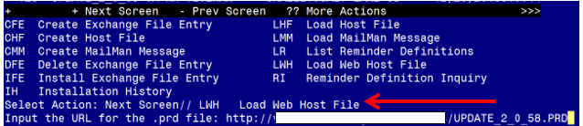
At the Select Action: prompt, enter LWH for Load Web Host File
At the Input the url for the .prd file: prompt, type the following web address:
http://vista.med.va.gov/reminders/UPDATE_2_0_58.PRD
You should see a message at the top of your screen that the file successfully loaded.

Search and locate an entry titled UPDATE_2_0_58 VA-LUNG CANCER DIALOG UPDATES NOTE in reminder exchange.
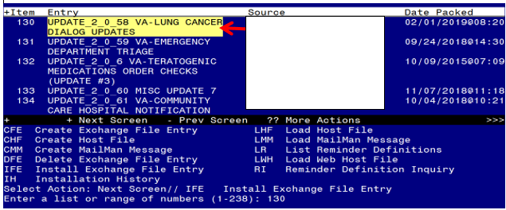

At the Select Action prompt, enter IFE for Install Exchange File Entry
Enter the number that corresponds with your entry titled UPDATE_2_0_58 VA-LUNG CANCER DIALOG UPDATES NOTE (in this example it is entry 130 it will vary by site)
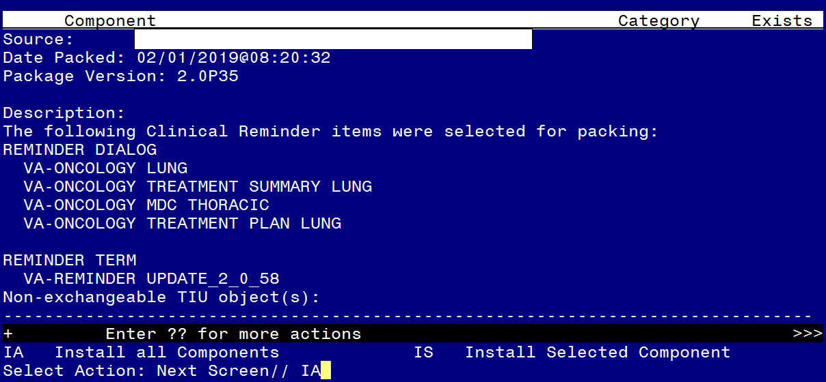
At the Select Action prompt, type IA for Install all Components and hit enter.
Select Action: Next Screen// IA Install all Components
You will see several prompts, for all new entries you will choose I to Install
For components that already exists but the packed component is different, you will choose O to Overwrite.
You will be promped to install the FIRST reminder dialog component – you should install every dialog even if there is an x that shows the item exists – this is an update and therefore you want to install to update your existing components:
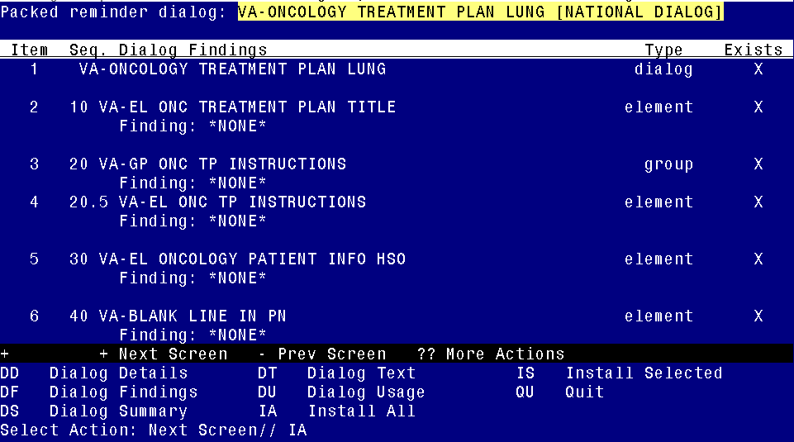
At the Select Action prompt, type IA to install the dialog – VA-ONCOLOGY TREATMENT PLAN LUNG Select Action: Next Screen// IA Install All
Install reminder dialog and all components with no further changes: Y// Yes
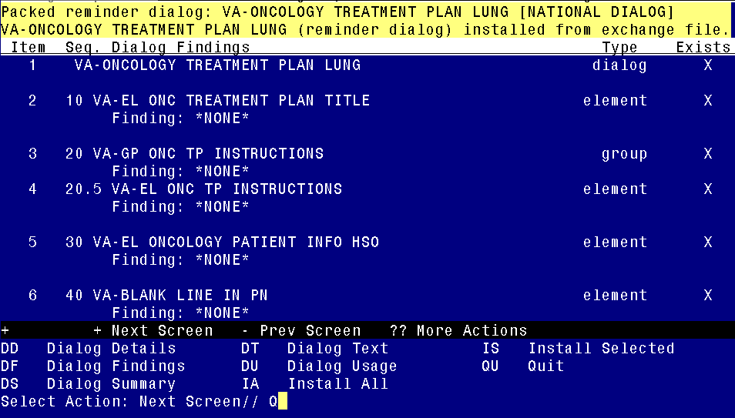
When the dialog has completed installation, you will then be returned to this screen. At the Select Action prompt, type Q.
You will be promped to install the NEXT reminder dialog component - you should install every dialog even if there is an X that shows the item exists – this is an update and therefore you want to install to update your existing components:
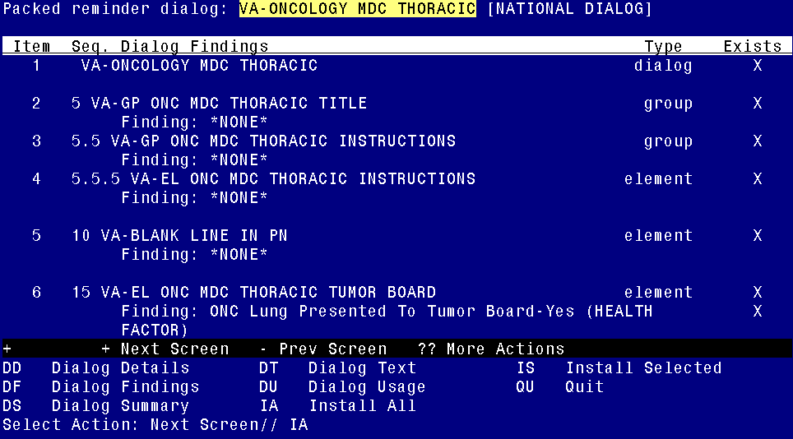
At the Select Action prompt, type IA to install the dialog – VA-ONCOLOGY MDC THORACIC
Select Action: Next Screen// IA Install All
Install reminder dialog and all components with no further changes: Y// Yes
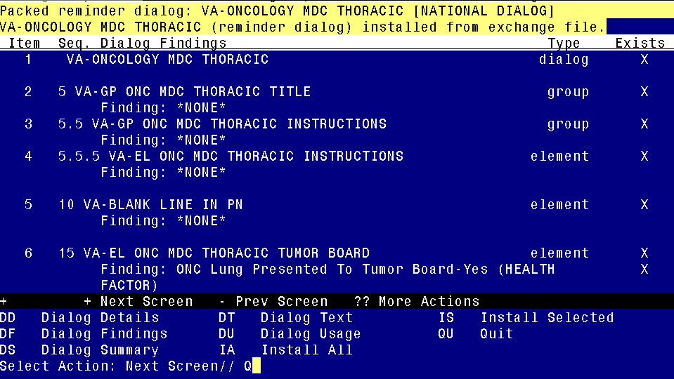
When the dialog has completed installation, you will then be returned to this screen. At the Select Action prompt, type Q.
You will be promped to install the NEXT reminder dialog component you should install every dialog even if there is an X that shows the item exists – this is an update and therefore you want to install to update your existing components:
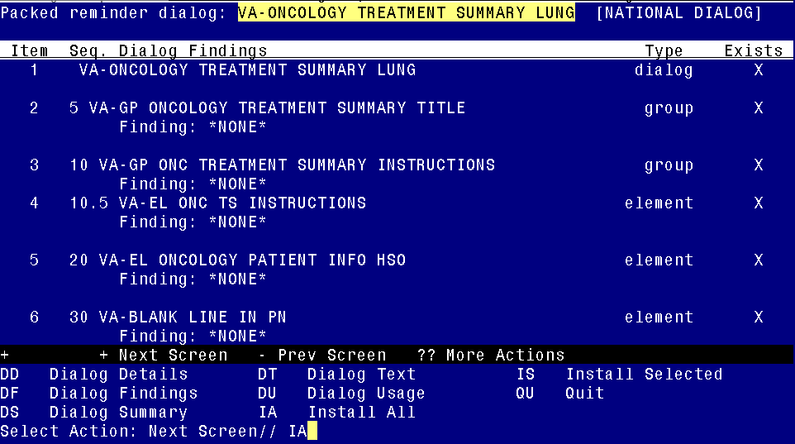
At the Select Action prompt, type IA to install the dialog – VA-ONCOLOGY TREATMENT SUMMARY LUNG
Select Action: Next Screen// IA Install All
Install reminder dialog and all components with no further changes: Y// Yes
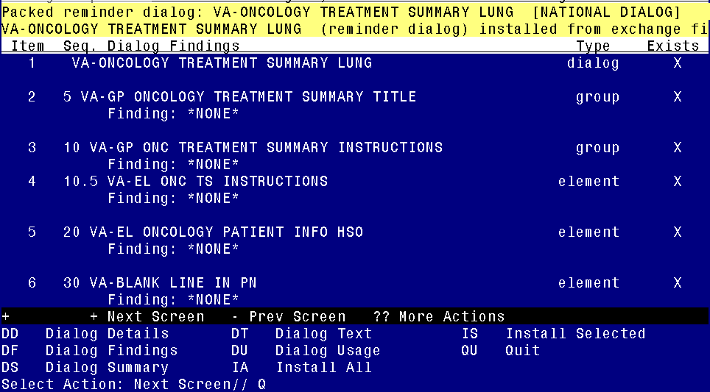
When the dialog has completed installation, you will then be returned to this screen. At the Select Action prompt, type Q.
You will be promped to install the fourth and LAST reminder dialog component - you should install every dialog even if there is an X that shows the item exists – this is an update and therefore you want to install to update your existing components::
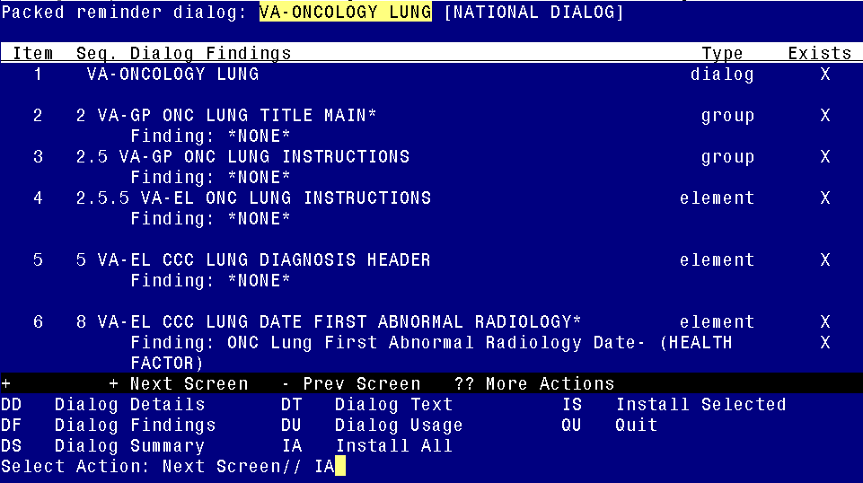
At the Select Action prompt, type IA to install the dialog – VA-ONCOLOGY LUNG
Select Action: Next Screen// IA Install All
Install reminder dialog and all components with no further changes: Y// Yes
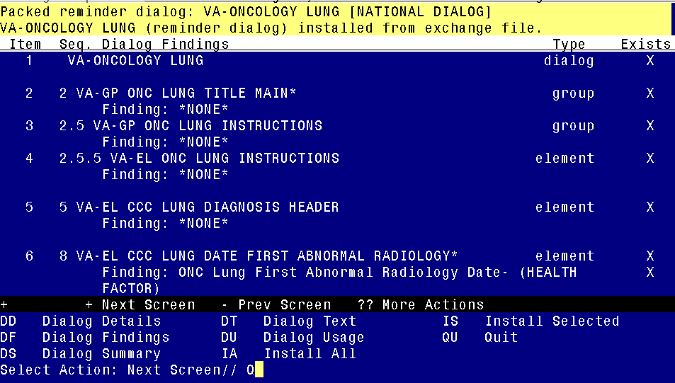
When the dialog has completed installation, you will then be returned to this screen. At the Select Action prompt, type Q.
You Will then be prompted to install the health summary components. For components that already exists but the packed component is different, you will choose O to Overwrite.

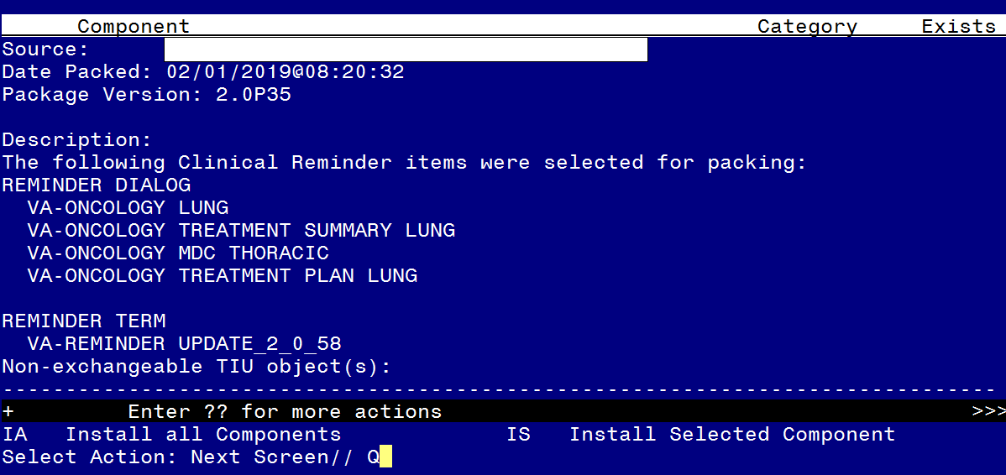
You will then be returned to this screen. At the Select Action prompt, type Q.

Install complete.

Post Installation

- Setup of Note title/ Associate the reminder dialog with the note title or shared template in CPRS
You should already have a note title or shared templates set up for use with these templates. No post install steps are required

NOTE: If you require further technical assistance, if there are any questions or problems during the installation, please notify your local IT support to log a national help desk ticket or contact the VA Service Desk and have them submit a national ticket to:
Category: Enterprise Applications
Subcategory: Applications
Enterprise Application: VistA - Clinical Reminders
Assignment Group: NTL SUP Clin 2

