Update_2_0_72

Clinical Reminders

VA-Opioid Use Disorder Assessment

Install Guide

May 2019

Product Development
Office of Information Technology
Department of Veterans Affairs

Table of Contents
Introduction 1
Install Details 3
Install Example 3
Post Installation 6

Introduction

The dramatic rise in opioid prescribing has been accompanied by parallel increases in nonmedical opioid use, overdose deaths, opioid use disorders (OUD) and treatment initiations for OUD. One initiative to address this problem in the Veteran Affairs (VA) healthcare system is the Stepped Care for Opioid Use Disorder Train-the-Trainer (SCOUTT), a model aiming to improve access to opioid use disorder (OUD) treatment and prevent suicide, two of the top five VA national priorities. As part of the national roll-out of SCOUTT that was launched in August 2018, this template is designed to facilitate documentation of assessments for OUD that are required before medications can be prescribed. The template should be used by those who have been trained in assessment for opioid use disorder and are authorized by the scope of their practice to make this diagnosis.
UPDATE_2_0_72 contains 1 Reminder Exchange entry:
UPDATE_2_0_72 OPIOID USE DISORDER ASSESSMENT

The exchange file contains the following components:

TIU TEMPLATE FIELD
VA-MH OUD OTHER NO INDENT
GEN TEXT BOX 50
GEN WORD PROC NARROW
00 EDIT BOX 70X5
VA-MH DOCUMENT NEXT STEPS
WP-2LINES
TEXT (1-60 CHAR)
VA-MH OUD OTHER
VA-MH EMPLOYMENT HX2
VA-MH HOUSING SITUATION
VA-MH RELATIONSHIP HX
VA-MH DIAGNOSIS HX
VA-MH OUD SPECIFY TEXT
VA-MH OUD FREQUENCY TEXT3
VA-MH OUD FREQUENCY TEXT1
VA-MH OUD FREQUENCY TEXT2
BLANK SPACE1
VA-MH OUD RISK FACTORS
MH OUD STORM REPORT
VA-MH YES/NO/NA
VA-MH REFERRAL SOURCE
VA-MH OUD MILD MOD SEVERE
00 EDIT BOX 12

HEALTH FACTORS
VA-REMINDER UPDATES
VA-UPDATE_2_0_72
VA-MH OUD TEMPLATES
VA-MH OUD ASSESS
VA-NALOXONE
VA-PATIENT DECLINED NALOXONE
VA-MH OUD ASSESS TREATMENT ACCEPTED
VA-MH OUD ASSESS TREATMENT OFFERRED
VA-MH OUD ASSESS MEETS CRITERIA
VA-MH OUD ASSESS DOES NOT MEET CRITERIA
VA-MH OUD ASSESS DSM 5-2 REDUCE USE
VA-MH OUD ASSESS DSM 5-11 WITHDRAWAL
VA-MH OUD ASSESS DSM 5-10 TOLERANCE
VA-MH OUD ASSESS DSM 5-9 PHYSICAL PROB
VA-MH OUD ASSESS DSM 5-8 HAZARDOUS
VA-MH OUD ASSESS DSM 5-7 ACTIVITIES
VA-MH OUD ASSESS DSM 5-6 SOCIAL PROBLEMS
VA-MH OUD ASSESS DSM 5-5 FAILURE
VA-MH OUD ASSESS DSM 5-4 CRAVING
VA-MH OUD ASSESS DSM 5-3 OBTAIN OPIOIDS
VA-MH OUD ASSESS DSM 5-1 LARGER AMOUNT

REMINDER SPONSOR
Office of Mental Health Services
Mental Health Services

REMINDER TERM
VA-REMINDER UPDATE_2_0_72

REMINDER DIALOG
VA-MH OUD ASSESSMENT TEMPLATE

HEALTH SUMMARY TYPE
OB AUDC

HEALTH SUMMARY OBJECTS
AUDC (TIU)

TIU DOCUMENT DEFINITION
AUDIT-C

Install Details

This update is being distributed as a web host file. The address for the host file is: http://Redacted/UPDATE_2_0_72.PRD

The file will be installed using Reminder Exchange, programmer access is not required.

Installation:
=============
This update can be loaded with users on the system. Installation will take less than 20 minutes.

Install Example
To Load the Web Host File. Navigate to Reminder exchange in Vista
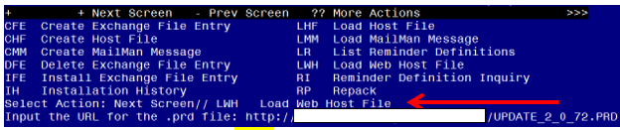
At the Select Action: prompt, enter LWH for Load Web Host File
At the Input the url for the .prd file: prompt, type the following web address:
http://REDACTED/UPDATE_2_0_72.PRD

You should see a message at the top of your screen that the file successfully loaded.
Search and locate an entry titled UPDATE_2_0_72 OPIOID USE DISORDER ASSESSMENT in reminder exchange
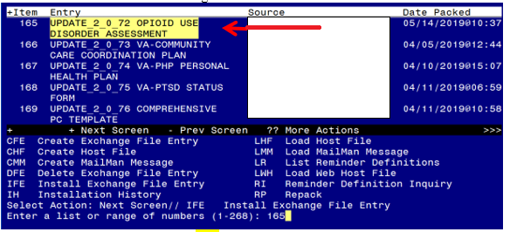
At the Select Action prompt, enter IFE for Install Exchange File Entry
Enter the number that corresponds with your entry titled UPDATE_2_0_72 OPIOID USE DISORDER ASSESSMENT (in this example it is entry 165, it will vary by site)
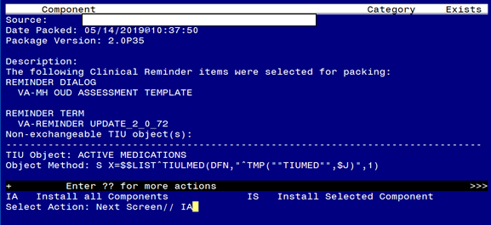
At the Select Action prompt, type IA for Install all Components and hit enter.
Select Action: Next Screen// IA Install all Components

During the installation, you will see several prompts: *Note that you will Install all new components*

You will be promped to install the dialog component:
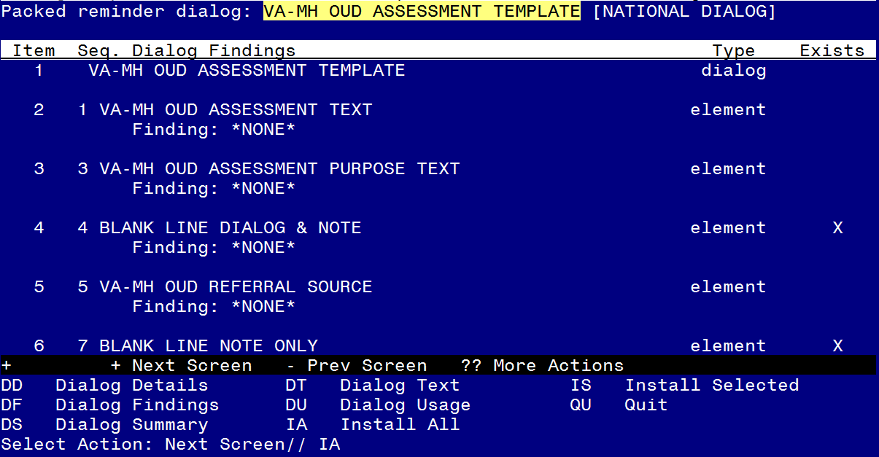
At the Select Action prompt, type IA to install the dialog – VA-MH OUD ASSESSMENT TEMPLATE
Select Action: Next Screen// IA Install All
Install reminder dialog and all components with no further changes: Y// ES

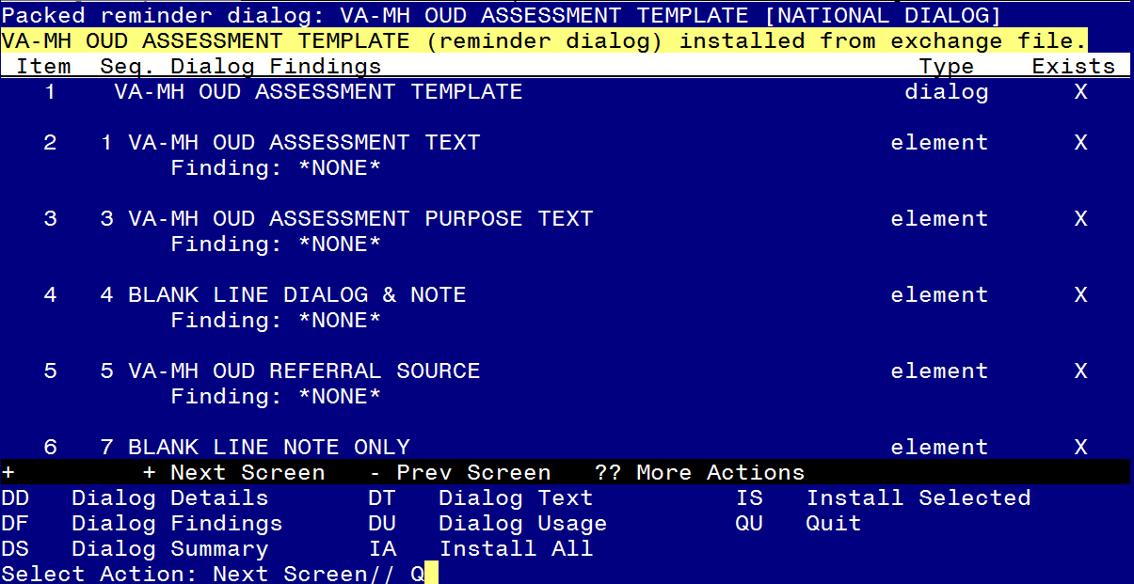
When the dialog has completed installation, you will then be returned to this screen. At the Select Action prompt, type Q.

You will then be prompted to install the remaining components:

HEALTH SUMMARY TYPE entry named OB AUDC already exists but the packed
component is different, what do you want to do?
Select one of the following:
C Create a new entry by copying to a new name
O Overwrite the current entry
U Update
Q Quit the install
S Skip, do not install this entry
Enter response: O// Skip, do not install this entry

HEALTH SUMMARY OBJECTS entry named AUDC (TIU) already exists and the
packed component is identical, skipping.

TIU DOCUMENT DEFINITION entry named AUDIT-C already exists and the
packed component is identical, skipping.

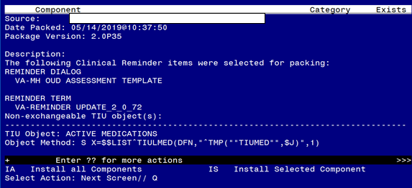You will be returned to this screen. Type Q to quit.

Install Completed

Post Installation

- Make the Dialog templates available to be attached to a Personal or Shared template or to be able to attach the dialog to a progress note title.
From the Reminders Manager Menu:
Select Reminder Managers Menu Option: CP CPRS Reminder Configuration
CA Add/Edit Reminder Categories
CL CPRS Lookup Categories
CS CPRS Cover Sheet Reminder List
MH Mental Health Dialogs Active
PN Progress Note Headers
RA Reminder GUI Resolution Active
TIU TIU Template Reminder Dialog Parameter
DL Default Outside Location
PT Position Reminder Text at Cursor
Select CPRS Reminder Configuration Option: TIU TIU Template Reminder Dialog
Parameter
Reminder Dialogs allowed as Templates may be set for the following:
1 User USR [choose from NEW PERSON]
3 Service SRV [choose from SERVICE/SECTION]
4 Division DIV [choose from INSTITUTION]
5 System SYS [NATREM.FO-SLC.MED.VA.GOV]
Enter selection: 5 Choose the appropriate number for your site. Your site may do
this by System or other levels. The example below uses SYSTEM level
Setting Reminder Dialogs allowed as Templates for System:
Select Display Sequence: ?

148 VA-VETERANS CHOICE NOTE
149 VA-TBI SCREENING
151 VACO TRANSPLANT REFERRAL (D)
When you type a question mark above, you will see the list of #’s (with dialogs) that
are already taken. Choose a number NOT on this list. For this example, looking
above I see the number 150 is not present, so I will use 150.

Select Display Sequence: 150
Are you adding 150 as a new Display Sequence? Yes// Y YES
Display Sequence: 150// <Enter>
Clinical Reminder Dialog: VA-MH OUD ASSESSMENT TEMPLATE<Enter>
OK? Yes// <Enter> (Yes)

- Setup of Note title
The new note title that needs to be created is:
OPIOID USE DISORDER ASSESSMENT
This note title is to be mapped to the following VHA Enterprise Standard Title:
MENTAL HEALTH NOTE

Comprehensive information on Creating Document Definitions can be found beginning on page 47 of the TIU/ASU Implementation Guide

Your site can also set up the template in your shared template folder. Staff may access the template either through the note title or the shared template folder.

3a. Associate the reminder dialog with the note title in CPRS
To do this, go to Template Editor, then Document Titles, select the appropriate folder (if applicable), and choose New Template (top right-hand corner).
Type in the following information:
Name: OPIOID USE DISORDER ASSESSMENT
Template Type: Reminder Dialog
Reminder Dialog: VA-OUD ASSESSMENT TEMPLATE
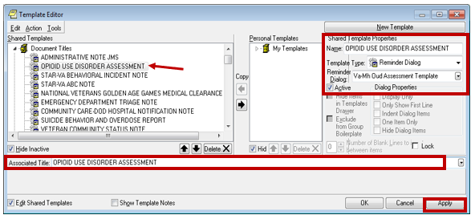

Next, type in the Associated Title, which in this case is OPIOID USE DISORDER ASSESSMENT and hit Apply.

3b. Add the dialog to a shared template in CPRS.
To do this, go to Template Editor, then Shared Templates, select the appropriate folder (if applicable), and choose New Template (top right-hand corner).
Type in the following information:
Name: OPIOID USE DISORDER ASSESSMENT
Template Type: Reminder Dialog
Reminder Dialog: VA-MH OUD ASSESSMENT TEMPLATE
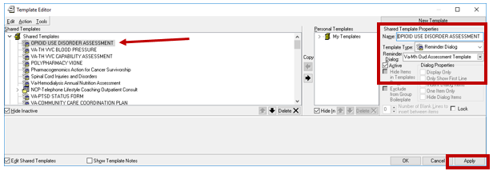

Hit Apply.

- Add your local quick orders as finding items to the following elements:
All of these elements are local so you can change the dialog text to match the services your facility provides if they do not match. You may also disable an element if your facility doesn’t offer one of these services.

Using the menu Reminder Dialog Management, Reminder Dialogs, change your view to Elements. Search for and edit the following element. VAL-MH OUD ASSESS NALOXONE ORDERED. Add your local quick order or menu for ordering naloxone to this element as an additional finding. Work with your Pharmacy ADPAC/Informaticist to help identify the correct order

Using the menu Reminder Dialog Management, Reminder Dialogs, change your view to Elements. Search for and edit the following element VAL-MH OUD ASSESS2 PLAN OFFER MAT CARE ACCEPTS UDAS. Add your local quick order for a urine drug screen as an additional finding on this element.

Using the menu Reminder Dialog Management, Reminder Dialogs, change your view to Group. Search for and edit the following group: VAL-MH OUD ASSESS2 PLAN OFFER REFERRAL ACCEPTS Add the order for a SUD referral or consult as an additional finding to this group. If you are unsure what order or menu to add, please work with your local MH services to identify the correct quick orders or menu to attach to each element.
- Add your local DATA OBJECT FOR ACTIVE MEDICATIONS to the following element:
Using the menu Reminder Dialog Management, Reminder Dialogs, change your view to Element. Search for and edit the following group: VAL-MH OUD ACTIVE MEDICATIONS If you prefer to use your local ACTIVE MEDICATIONS object, you can replace it with the current object in this element (i.e. |ACTIVE MEDICATIONS|).

