

**Update_2_0_97**

Clinical Reminders

VA-SPINAL CORD INJURIES AND DISORDERS and

**VA-COVID-19 SCI/D SCREEN**

Install Guide

**April 2020**

Product Development

Office of Information Technology

Department of Veterans Affairs

Table of Contents

Introduction 1

Pre-Installation 12

Install Details 13

Install Example 13

Post Installation 17

# Introduction

**VA-SPINAL CORD INJURIES AND DISORDERS Introduction**:

The [VSSC SCI/D Registry](https://reports.vssc.med.va.gov/ReportServer/Pages/ReportViewer.aspx?%2fMentalHealth%2fSCID%2fSCID+Summarynewv2&rs:Command=Render) was created to support the SCI/D System of Care in identifying and tracking Veterans with SCI/D who are eligible for SCI/D System of Care Services per VHA Directive 1176.  The SCI/D System of Care mission is to support, promote, and maintain the health, independence, quality of life, and productivity of individuals with SCI/D throughout their lives.  The [VSSC SCI/D Registry](https://reports.vssc.med.va.gov/ReportServer/Pages/ReportViewer.aspx?%2fMentalHealth%2fSCID%2fSCID+Summarynewv2&rs:Command=Render) is the informatics infrastructure which ensures quality and allows SCI/D national and local leaders to monitor areas of service delivery, which are identified as high-risk, high-volume, or problem-prone.  The VA-Spinal Cord Injuries and Disorders template items are an extension of the [VSSC SCI/D Registry](https://reports.vssc.med.va.gov/ReportServer/Pages/ReportViewer.aspx?%2fMentalHealth%2fSCID%2fSCID+Summarynewv2&rs:Command=Render) in that it allows clinicians, administrators and leaders to further refine searches for certain patients.  For example, patients with a high level of complete injury and who are actively using a ventilator, would be considered very high acuity regarding inpatient status.  The template information will be integrated into the [VSSC SCI/D Registry](https://reports.vssc.med.va.gov/ReportServer/Pages/ReportViewer.aspx?%2fMentalHealth%2fSCID%2fSCID+Summarynewv2&rs:Command=Render) and reports products such that more refined information can support operations and ultimately excellent service to Veterans.  This is the first time most of these SCI/D items have been automated. This template is mandatory for use at sites who are SCI/D centers. For any questions, contact: ([Redacted@va.gov](mailto:Redacted@va.gov))

**VA-COVID-19 SCI/D SCREEN Introduction**:

The Coronavirus Disease 2019 (COVID-19) SCI/D Screen template is the national CPRS template developed for use at the [SCI/D System of Care Hubs and Spokes](https://vaww.sci.va.gov/docs/CatchmentAreas.pdf).  Specifically, this template is to be completed by individuals as designated by appropriate facility officials for telephone, telehealth, or in-person screenings of individual Veterans included on the  [VHA VSSC Spinal Cord Injuries and Disorders (SCI/D) Registry](https://reports.vssc.med.va.gov/ReportServer/Pages/ReportViewer.aspx?%2fMentalHealth%2fSCID%2fSCID+Summarynewv2&rs:Command=Render) to determine whether the Veteran has been diagnosed with or tested for COVID-19 (including verification of information in the COVID-19 Status Indicator Banner, as applicable),  to identify potential health care and social needs, and learn about current use and interest in virtual care.  For this population, this template is to be used in place of the national COVID-19 Screen template; relevant information and questions from the national COVID-19 screen template have been integrated into the COVID-19 SCI/D Screen template.  If previously completed for a Veteran, the COVID-19 SCI Screen Template imports information from the Veteran’s completed SCI/D Status Update template in relation to diagnosis, living setting, and caregiver status.  Responses to the COVID-19 SCI/D Screen Template will be imported to the previously completed CPRS SCI/D Status Update template if there are changes in response.  If a Veteran included on the [VHA VSSC Spinal Cord Injuries and Disorders (SCI/D) Registry](https://reports.vssc.med.va.gov/ReportServer/Pages/ReportViewer.aspx?%2fMentalHealth%2fSCID%2fSCID+Summarynewv2&rs:Command=Render) is screened more than once for COVID-19, the COVID-19 SCI Screen template may be used for all instances of screening.  Please refer questions to the SCI/D System of Care National Program Office, at [Redacted@va.gov](mailto:Redacted@va.gov).

**UPDATE_2_0_97 contains 1 Reminder Exchange entry:**

UPDATE_2_0_97 VA-SPINAL CORD INJURIES AND DISORDERS

**The exchange file contains the following components:**

**TIU TEMPLATE FIELD**

BLANK SPACE1

MY HEALTHEVET ACCOUNT UPGRADE

MY HEALTHEVET ACCOUNT INSTRUCTIONS

DATE (*)

**HEALTH FACTORS**

VA-REMINDER UPDATES

VA-UPDATE_2_0_97

VA-SCI/D BLADDER MGMT-SURG PROCEDURES

VA SCI/D BLADDER SURG HX-OTHER

VA-SCI/D BLADDER SURG HX-SUPRAPUBIC CATH

VA-SCI/D BLADDER SURG HX-SPHINCTEROTOMY

VA-SCI/D BLADDER SURG HX-SACR ANT STIM

VA-SCI/D BLADDER SURG HX-ILEOVESICOSTOMY

VA-SCI/D BLADDER SURG HX-ILEAL CONDUIT

VA-SCI/D BLADDER SURG HX-CONTINENT STOMA

VA-SCI/D BLADDER SURG HX-AUGMENTATION

VA-SCI/D BLADDER SURG HX-ART SPHINCTER

VA-SCI/D BLADDER SURG HX-NONE

VA-SCI/D BLADDER MGMT-COLLECTION DEVICE

VA-SCI/D BLADDER COLLECTION-OSTOMY BAG

VA-SCI/D BLADDER COLLECTION-DIAPER/PAD

VA-SCI/D BLADDER COLLECTION-CONDOM CATH

VA-SCI/D BLADDER COLLECTION-NONE

VA-SCI/D BLADDER MGMT-EMPTYING METHOD

VA-SCI/D BLADDER-SACRAL ANT ROOT STIM

VA-SCI/D BLADDER EMPTY METHOD-UNKNOWN

VA-SCI/D BLADDER INTRMNT CATH-ATNDT

VA-SCI/D BLADDER INTRMNT CATH-SELF

VA-SCI/D BLADDER EMPTY METHOD-OTHER

VA-SCI/D BLADDER-DIALYSIS

VA-SCI/D BLADDER-UROSTOMY

VA-SCI/D BLADDER INDWELL CATH-SUPRAPUBIC

VA-SCI/D BLADDER INDWELL CATH-TRANSURETH

VA-SCI/D BLADDER REFLEX TRIG-EXT COMP

VA-SCI/D BLADDER REFLEX TRIG-STRAINING

VA-SCI/D BLADDER REFLEX TRIG-INVOLUNTARY

VA-SCI/D BLADDER REFLEX TRIG-VOLUNTARY

VA-SCI/D BLADDER-NORMAL VOIDING

VA-SCI/D REVIEW DATE

VA-SCI/D BLADDER MGMT REVIEW DATE

VA-SCI/D BLADDER SURG HX-OTHER

VA-SCI/D PQD

VA-SCI/D PQD-MOTOR NEURON OTHER

VA-SCI/D PQD-MOTOR NEURON POLIOMYELITIS

VA-SCI/D PQD-MOTOR NEURON PLS

VA-SCI/D PQD-MOTOR NEURON ALS

VA-SCI/D MOTOR NEURON REVIEW DATE

VA-SCI/D PQD-MOTOR NEURON DISORDER

VA-SCI/D KURTZKE SCALE

VA-SCI/D KURTZKE SCALE 10.0

VA-SCI/D KURTZKE SCALE 9.5

VA-SCI/D KURTZKE SCALE 9.0

VA-SCI/D KURTZKE SCALE 8.5

VA-SCI/D KURTZKE SCALE 8.0

VA-SCI/D KURTZKE SCALE 7.5

VA-SCI/D KURTZKE SCALE 7.0

VA-SCI/D KURTZKE SCALE 6.5

VA-SCI/D KURTZKE SCALE 6.0

VA-SCI/D KURTZKE SCALE 5.5

VA-SCI/D KURTZKE SCALE 5.0

VA-SCI/D KURTZKE SCALE 4.5

VA-SCI/D KURTZKE SCALE 4.0

VA-SCI/D KURTZKE SCALE 3.5

VA-SCI/D KURTZKE SCALE 3.0

VA-SCI/D KURTZKE SCALE 2.5

VA-SCI/D KURTZKE SCALE 2.0

VA-SCI/D KURTZKE SCALE 1.5

VA-SCI/D KURTZKE SCALE 1.0

VA-SCI/D KURTZKE SCALE 0.0

VA-SCI/D KURTZKE SCALE REVIEW DATE

VA-SCI/D PQD MS-DATE OF DX

VA-SCI/D PQD-MULTIPLE SCLEROSIS

VA-SCI/D ASIA

VA-SCI/D ASIA-UNKNOWN

VA-SCI/D ASIA-E

VA-SCI/D ASIA-D

VA-SCI/D ASIA-C

VA-SCI/D ASIA-B

VA-SCI/D ASIA-A

VA-SCI/D NEURO LEVEL-MOTOR RT

VA-SCI/D NLI-MR UNK/UNABLE

VA-SCI/D NLI-MR S04 S05 INTACT

VA-SCI/D NLI-MR S03

VA-SCI/D NLI-MR S02

VA-SCI/D NLI-MR S01

VA-SCI/D NLI-MR L05

VA-SCI/D NLI-MR L04

VA-SCI/D NLI-MR L03

VA-SCI/D NLI-MR L02

VA-SCI/D NLI-MR L01

VA-SCI/D NLI-MR T12

VA-SCI/D NLI-MR T11

VA-SCI/D NLI-MR T10

VA-SCI/D NLI-MR T09

VA-SCI/D NLI-MR T08

VA-SCI/D NLI-MR T07

VA-SCI/D NLI-MR T06

VA-SCI/D NLI-MR T05

VA-SCI/D NLI-MR T04

VA-SCI/D NLI-MR T03

VA-SCI/D NLI-MR T02

VA-SCI/D NLI-MR T01

VA-SCI/D NLI-MR C08

VA-SCI/D NLI-MR C07

VA-SCI/D NLI-MR C06

VA-SCI/D NLI-MR C05

VA-SCI/D NLI-MR C04

VA-SCI/D NLI-MR C03

VA-SCI/D NLI-MR C02

VA-SCI/D NLI-MR C01

VA-SCI/D NEURO LEVEL-MOTOR LT

VA-SCI/D NLI-ML UNK/UNABLE

VA-SCI/D NLI-ML S04 S05 INTACT

VA-SCI/D NLI-ML S03

VA-SCI/D NLI-ML S02

VA-SCI/D NLI-ML S01

VA-SCI/D NLI-ML L05

VA-SCI/D NLI-ML L04

VA-SCI/D NLI-ML L03

VA-SCI/D NLI-ML L02

VA-SCI/D NLI-ML L01

VA-SCI/D NLI-ML T12

VA-SCI/D NLI-ML T11

VA-SCI/D NLI-ML T10

VA-SCI/D NLI-ML T09

VA-SCI/D NLI-ML T08

VA-SCI/D NLI-ML T07

VA-SCI/D NLI-ML T06

VA-SCI/D NLI-ML T05

VA-SCI/D NLI-ML T04

VA-SCI/D NLI-ML T03

VA-SCI/D NLI-ML T02

VA-SCI/D NLI-ML T01

VA-SCI/D NLI-ML C08

VA-SCI/D NLI-ML C07

VA-SCI/D NLI-ML C06

VA-SCI/D NLI-ML C05

VA-SCI/D NLI-ML C04

VA-SCI/D NLI-ML C03

VA-SCI/D NLI-ML C02

VA-SCI/D NLI-ML C01

VA-SCI/D NEURO LEVEL-SENSORY RT

VA-SCI/D NLI-SR UNK/UNABLE

VA-SCI/D NLI-SR S04 S05 INTACT

VA-SCI/D NLI-SR S03

VA-SCI/D NLI-SR S02

VA-SCI/D NLI-SR S01

VA-SCI/D NLI-SR L05

VA-SCI/D NLI-SR L04

VA-SCI/D NLI-SR L03

VA-SCI/D NLI-SR L02

VA-SCI/D NLI-SR L01

VA-SCI/D NLI-SR T12

VA-SCI/D NLI-SR T11

VA-SCI/D NLI-SR T10

VA-SCI/D NLI-SR T09

VA-SCI/D NLI-SR T08

VA-SCI/D NLI-SR T07

VA-SCI/D NLI-SR T06

VA-SCI/D NLI-SR T05

VA-SCI/D NLI-SR T04

VA-SCI/D NLI-SR T03

VA-SCI/D NLI-SR T02

VA-SCI/D NLI-SR T01

VA-SCI/D NLI-SR C08

VA-SCI/D NLI-SR C07

VA-SCI/D NLI-SR C06

VA-SCI/D NLI-SR C05

VA-SCI/D NLI-SR C04

VA-SCI/D NLI-SR C03

VA-SCI/D NLI-SR C02

VA-SCI/D NLI-SR C01

VA-SCI/D NEURO LEVEL-SENSORY LT

VA-SCI/D NLI-SL UNK/UNABLE

VA-SCI/D NLI-SL S04 S05 INTACT

VA-SCI/D NLI-SL S03

VA-SCI/D NLI-SL S02

VA-SCI/D NLI-SL S01

VA-SCI/D NLI-SL L05

VA-SCI/D NLI-SL L04

VA-SCI/D NLI-SL L03

VA-SCI/D NLI-SL L02

VA-SCI/D NLI-SL L01

VA-SCI/D NLI-SL T12

VA-SCI/D NLI-SL T11

VA-SCI/D NLI-SL T10

VA-SCI/D NLI-SL T09

VA-SCI/D NLI-SL T08

VA-SCI/D NLI-SL T07

VA-SCI/D NLI-SL T06

VA-SCI/D NLI-SL T05

VA-SCI/D NLI-SL T04

VA-SCI/D NLI-SL T03

VA-SCI/D NLI-SL T02

VA-SCI/D NLI-SL T01

VA-SCI/D NLI-SL C08

VA-SCI/D NLI-SL C07

VA-SCI/D NLI-SL C06

VA-SCI/D NLI-SL C05

VA-SCI/D NLI-SL C04

VA-SCI/D NLI-SL C03

VA-SCI/D NLI-SL C02

VA-SCI/D NLI-SL C01

VA-SCI/D ASIA REVIEW DATE

VA-SCI/D NEURO LEVEL REVIEW DATE

VA-SCI/D ETIOLOGY

VA-SCI/D ETIOLOGY-OTH NON-TRAUMA

VA-SCI/D ETIOLOGY-RADIATION

VA-SCI/D ETIOLOGY-TOXIC

VA-SCI/D ETIOLOGY-GENETIC

VA-SCI/D ETIOLOGY-AUTOIMMUNE

VA-SCI/D ETIOLOGY-METABOLIC

VA-SCI/D ETIOLOGY-TUMOR

VA-SCI/D ETIOLOGY-SYRINGOMYELIA

VA-SCI/D ETIOLOGY-ARTHRITIC DZ

VA-SCI/D ETIOLOGY-COLUMNAR DEGEN

VA-SCI/D ETIOLOGY-INFECTION

VA-SCI/D ETIOLOGY-VASC CHNG

VA-SCI/D ETIOLOGY-OTH TRAUMA

VA-SCI/D ETIOLOGY-VIOLENCE

VA-SCI/D ETIOLOGY-VEHICULAR

VA-SCI/D ETIOLOGY-SPORTS

VA-SCI/D ETIOLOGY-FALL

VA-SCI/D ETIOLOGY REVIEW DATE

VA-SCI/D PQD-SCID

VA-SCI/D LIVING SETTING

VA-SCI/D LIVING SETTING-ADULT FAMILY

VA-SCI/D LIVING SETTING-STATE VET HOME

VA-SCI/D LIVING SETTING-VA SCI LTC

VA-SCI/D LIVING SETTING-NON CONTRACT NH

VA-SCI/D LIVING SETTING-MED FOSTER HOME

VA-SCI/D LIVING SETTING-HOTEL/MOTEL

VA-SCI/D LIVING SETTING-HOMELESS

VA-SCI/D LIVING SETTING-HOME W/ SOMEONE

VA-SCI/D LIVING SETTING-HOME ALONE

VA-SCI/D LIVING SETTING-GRP LIVING

VA-SCI/D LIVING SETTING-CORRECTION INST

VA-SCI/D LIVING SETTING-VA CONTRACT NH

VA-SCI/D LIVING SETTING-VA CLC

VA-SCI/D LIVING SETTING-ASSISTED LIVING

VA-SCI/D LIVING SETTING REVIEW DATE

VA-SCI/D VENT STATUS

VA-SCI/D VENT-ELEC STIM & MECH VENT

VA-SCI/D VENT-ELEC STIMULATION ONLY

VA-SCI/D VENT-NIMV UNK USE

VA-SCI/D VENT-NIMV INTERMITTENT

VA-SCI/D VENT-NIMV SLEEPING ONLY

VA-SCI/D VENT-NIMV 24 HRS

VA-SCI/D VENT-IMV UNK HRS

VA-SCI/D VENT-IMV < 24 HRS

VA-SCI/D VENT-IMV 24 HRS

VA-SCI/D VENT-NO

VA-SCI/D VENT STATUS REVIEW DATE

VA-SCI/D CAREGIVER STATUS

VA-SCI/D CAREGIVER-NO

VA-SCI/D VA BOWEL AND BLADDER

VA-SCI/D CAREGIVER-UNPAID NON FAM MEMBER

VA-SCI/D CAREGIVER-UNPAID FAMILY MEMBER

VA-SCI/D CAREGIVER-PAID FAMILY MEMBER

VA-SCI/D CAREGIVER-PAID NON AGENCY/FAM

VA-SCI/D CAREGIVER-PAID AGENCY

VA-SCI/D CAREGIVER STATUS REVIEW DATE

VA-SCI/D EDUCATION

VA-SCI/D EDUC SOME COLLEGE TRADE

VA-SCI/D EDUC-UNKNOWN

VA-SCI/D EDUC-OTHER

VA-SCI/D EDUC-DOCTORATE

VA-SCI/D EDUC-MASTER DEGREE

VA-SCI/D EDUC-BACHELOR DEGREE

VA-SCI/D EDUC-TECH/TRADE

VA-SCI/D EDUC-ASSOC DEGREE

VA-SCI/D EDUC-HS DIPLOMA/GED

VA-SCI/D EDUC-9-11

VA-SCI/D EDUC-K-8

VA-SCI/D EDUCATION REVIEW DATE

VA-SCI/D EMPLOYMENT

VA-SCI/D EMPLOY-OTHER

VA-SCI/D EMPLOY-UNKNOWN

VA-SCI/D EMPLOY-PART TIME

VA-SCI/D EMPLOY-FULL TIME

VA-SCI/D EMPLOY-VOLUNTEER

VA-SCI/D EMPLOY-UNEMPLOYED

VA-SCI/D EMPLOY-STUDENT

VA-SCI/D EMPLOY-WORKSHOP

VA-SCI/D EMPLOY-RETIRED/DISABILITY

VA-SCI/D EMPLOY-RETIRED AGE

VA-SCI/D EMPLOY-TRAINING

VA-SCI/D EMPLOY-HOMEMAKER

VA-SCI/D EMPLOY-SEEKING EMPLOYMNT

VA-SCI/D EMPLOYMENT REVIEW DATE

VA-SCI/D COVID BOWEL/BLADDER NO PLAN

VA-SCI/D COVID BOWEL/BLADDER PLAN

VA-SCI/D COVID CG-PAID AGENCY NO PLAN

VA-SCI/D COVID CG-PAID AGENCY PLAN

VA-SCI/D COVID CG-PAID FAM MEMB NO PLAN

VA-SCI/D COVID CG-PAID FAM MEMB PLAN

VA-SCI/D COVID CG-PAID NO AG/FAM NO PLAN

VA-SCI/D COVID CG-PAID NO AG/FAM PLAN

VA-SCI/D COVID CG-UNPAID FAM NO PLAN

VA-SCI/D COVID CG-UNPAID FAM PLAN

VA-SCI/D COVID CG-UNPAID NO FAM NO PLAN

VA-SCI/D COVID CG-UNPAID NO FAM PLAN

VA-SCI/D COVID NEW CONCERN ACTION

VA-SCI/D COVID NEW CONCERN BED/MATTRESS

VA-SCI/D COVID NEW CONCERN BLADDER

VA-SCI/D COVID NEW CONCERN BOWELS

VA-SCI/D COVID NEW CONCERN DYSREFLEXIA

VA-SCI/D COVID NEW CONCERN MED SUPPLIES

VA-SCI/D COVID NEW CONCERN MEDICATIONS

VA-SCI/D COVID NEW CONCERN OTHER

VA-SCI/D COVID NEW CONCERN W/C

VA-SCI/D COVID NEW CONCERN W/C CUSHION

VA-SCI/D COVID NEW CONCERN WOUND

VA-SCI/D COVID SCREEN

VA-SCI/D COVID SCREEN ADDL SYMPTOM

VA-SCI/D COVID SCREEN ADV DIR CHANGE YES

VA-SCI/D COVID SCREEN CONJUNCTIVITIS

VA-SCI/D COVID SCREEN EMERG CONTACT NO

VA-SCI/D COVID SCREEN FOOD NO

VA-SCI/D COVID SCREEN LOSS SMELL

**REMINDER SPONSOR**

OFFICE OF SPINAL CORD INJURIES AND DISORDERS (SCI/D)

OFFICE OF NURSING SERVICE

NATIONAL CENTER FOR HEALTH PROMOTION AND DISEASE PREVENTION (NCP)

**REMINDER TERM**

VA-REMINDER UPDATE_2_0_97

VA-SCI/D BLADDER MGMT-SURG HX (OBJ)

VA-SCI/D BLADDER MGMT-COLLECTION (OBJ)

VA-SCI/D BLADDER MGMT-EMPTYING METH (OBJ)

VA-SCI/D BLADDER MANAGEMENT STATUS

VA-SCI/D MOTOR NEURON (OBJ)

VA-SCI/D MS-KURTZKE SCALE (OBJ)

VA-SCI/D PQD-MS (OBJ)

VA-SCI/D ASIA GRADE (OBJ)

VA-SCI/D NEURO LEVEL-MOTOR LT (OBJ)

VA-SCI/D NEURO LEVEL-MOTOR RT (OBJ)

VA-SCI/D NEURO LEVEL-SENSORY LT (OBJ)

VA-SCI/D NEURO LEVEL-SENSORY RT (OBJ)

VA-SCI/D ETIOLOGY (OBJ)

VA-SCI/D PQD (OBJ)

VA-SCI/D PRIMARY DIAGNOSIS

VA-SCI/D LIVING SETTING (OBJ)

VA-SCI/D LIVING SETTING

VA-SCI/D VENT STATUS (OBJ)

VA-SCI/D VENTILATION STATUS

VA-SCI/D CAREGIVER STATUS

VA-SCI/D EDUCATION (OBJ)

VA-SCI/D EDUCATION

VA-SCI/D EMPLOYMENT

**REMINDER DEFINITION**

VA-OBJ SCI/D BLADDER MGMT-SURG HX

VA-OBJ SCI/D BLADDER MGMT-COLLECTION DEVICE

VA-OBJ SCI/D BLADDER MGMT-EMPTYING METHOD

VA-OBJ SCI/D PQD MN

VA-OBJ SCI/D MS-KURTZKE SCALE

VA-OBJ SCI/D PQD-MS

VA-OBJ SCI/D ASIA GRADE

VA-OBJ SCI/D PQD SCID-NL ML

VA-OBJ SCI/D PQD SCID-NL MR

VA-OBJ SCI/D PQD SCID-NL SL

VA-OBJ SCI/D PQD SCID-NL SR

VA-OBJ SCI/D ETIOLOGY

VA-OBJ SCI/D PRIMARY QUALIFYING DIAGNOSIS

VA-OBJ SCI/D LIVING SETTING

VA-OBJ SCI/D VENT STATUS

VA-OBJ SCI/D EDUCATION

**REMINDER DIALOG**

VA-SPINAL CORD INJURIES AND DISORDER

VA-COVID-19 SCI/D SCREEN

**HEALTH SUMMARY COMPONENT**

PCE HEALTH FACTORS SELECTED

CLINICAL REMINDER FINDINGS

**HEALTH SUMMARY TYPE**

VA-SCI/D BLADDER MGMT-SURG HX

VA-SCI/D BLADDER-COLL DEVICE

VA-SCI/D BLADDER MGT-EMP METH

VA-SCI/D BLADDER MGMT REV DATE

VA-SCI/D MOTOR NEURON D/O

VA-SCI/D MN REVIEW DATE

VA-SCI/D MS KURTZKE SCALE

VA-SCI/D PQD-MS

VA-SCI/D KURTZKE REVIEW DATE

VA-SCI/D MS DX DATE

VA-SCI/D ASIA

VA-SCI/D PQD NL-ML

VA-SCI/D PQD NL-MR

VA-SCI/D PQD NL-SL

VA-SCI/D PQD NL-SR

VA-SCI/D ASIA REVIEW DATE

VA-SCI/D NL REVIEW DATE

VA-SCI/D ETIOLOGY

VA-SCI/D ETIOLOGY REVIEW DATE

VA-SCI/D PRIM QUAL DIAGNOSIS

VA-SCI/D LIVING SETTING

VA-SCI/D LIVING SETTING REV DT

VA-SCI/D VENT STATUS

VA-SCI/D VENT REVIEW DATE

VA-SCI/D CAREGIVER STATUS

VA-SCI/D CAREGIVER REVIEW DATE

VA-SCI/D EDUCATION LEVEL

VA-SCI/D EDUC REVIEW DATE

VA-SCI/D EMPLOYMENT

VA-SCI/D EMPLOY REVIEW DATE

**HEALTH SUMMARY OBJECTS**

VA-SCI/D BLADDER MGMT-SURG HX (TIU)

VA-SCI/D BLADDER MGMT-COLLECTION DEVICE (TIU)

VA-SCI/D BLADDER MGMT-EMPTYING METHOD (TIU)

VA-SCI/D BLADDER MGMT REV DATE

VA-SCI/D MOTOR NEURON D/O

VA-SCI/D MN REVIEW DATE (TIU)

VA-SCI/D MS KURTZKE SCALE (TIU)

VA-SCI/D PQD-MS (TIU)

VA-SCI/D KURTZKE REVIEW DATE (TIU)

VA-SCI/D MS DX DATE

VA-SCI/D ASIA

VA-SCI/D PQD NL-ML (TIU)

VA-SCI/D PQD NL-MR (TIU)

VA-SCI/D PQD NL-SL (TIU)

VA-SCI/D PQD NL-SR (TIU)

VA-SCI/D ASIA REVIEW DATE (TIU)

VA-SCI/D NL REVIEW DATE

VA-SCI/D ETIOLOGY

VA-SCI/D ETIOLOGY REVIEW DATE (TIU)

VA-SCI/D PRIMARY QUALIFYING DIAGNOSIS (TIU)

VA-SCI/D LIVING SETTING (TIU)

VA-SCI/D LIVING SETTING REV DATE

VA-SCI/D VENT STATUS (TIU)

VA-SCI/D VENT REVIEW DATE

VA-SCI/D CAREGIVER STATUS

VA-SCI/D CAREGIVER REVIEW DATE (TIU)

VA-SCI/D EDUCATION LEVEL (TIU)

VA-SCI/D EDUC REVIEW DATE

VA-SCI/D EMPLOYMENT

VA-SCI/D EMPLOY REVIEW DATE

**TIU DOCUMENT DEFINITION**

VA-SCI/D BLADDER MGMT-SURG HX

VA-SCI/D BLADDER MGMT-COLLECTION DEVICE

VA-SCI/D BLADDER MGMT-EMPTYING METHOD

VA-SCI/D BLADDER MGMT REV DATE

VA-SCI/D MOTOR NEURON D/O

VA-SCI/D MN REVIEW DATE

VA-SCI/D MS KURTZKE SCALE

VA-SCI/D PQD-MS

VA-SCI/D KURTZKE REVIEW DATE

VA-SCI/D MS DX DATE

VA-SCI/D ASIA

VA-SCI/D PQD NL-ML

VA-SCI/D PQD NL-MR

VA-SCI/D PQD NL-SL

VA-SCI/D PQD NL-SR

VA-SCI/D ASIA REVIEW DATE

VA-SCI/D NL REVIEW DATE

VA-SCI/D ETIOLOGY

VA-SCI/D ETIOLOGY REVIEW DATE

VA-SCI/D PRIMARY QUALIFYING DIAGNOSIS

VA-SCI/D LIVING SETTING

VA-SCI/D LIVING SETTING REV DATE

VA-SCI/D VENT STATUS

VA-SCI/D VENT REVIEW DATE

VA-SCI/D CAREGIVER STATUS

VA-SCI/D CAREGIVER REVIEW DATE

VA-SCI/D EDUCATION LEVEL

VA-SCI/D EDUC REVIEW DATE

VA-SCI/D EMPLOYMENT

VA-SCI/D EMPLOY REVIEW DATE

# Pre-Installation

1. **The VA-COVID-19 SCI/D SCREEN dialog has several elements that require the user to document follow-up action taken regarding the reply in the dialog.** The local SCI/D staff should identify if any existing consults or order menus should be added to these elements. If an order isn’t appropriate for the section, then the appropriate action should be determined before using the template and the element can be left as deployed. **Informatics staff should coordinate with SCI/D staff to determine if a local order or menu is appropriate to embed in these elements or leave them as deployed.** A description of these sections is below. More details are also included in the post-installation instructions.
   1. **Medications/Medical supplies.** The patient is asked if they need someone to contact them regarding having enough medications and medical supplies. If the answer is yes, what action should the screener take?
      1. **Element Name:** VA-COVID-19 SCI MEDICATIONS ACTION
      2. **Element Name:** VA-COVID-19 SCI MEDICAL SUPPLIES ACTION
   2. **New Concerns.** The patient is asked if they have any new concerns regarding wounds, bladder/catheterization, bowels program, autonomic dysreflexia, wheelchairs, bed/mattress, or other equipment. If the answer is yes, what action should the screener take?
      1. **Element Name:** VA-COVID-19 SCI SCREEN CONCERN ACTION
   3. **Additional COVID-19 symptoms.** The patient is asked if they are experiencing a new onset of sore throat, myalgia, loss of taste, loss of smell, nausea, or conjunctivitis. If the answer is yes, what action should the screener take?
      1. **Element Name:** VA-COVID-19 SCI SCREEN ADDITIONAL ACTION INFO
   4. **Mental Health Professional.** The patient is asked if they would be interested in speaking to a mental health professional. If the answer is yes, what action should the screener take?
      1. **Element Name:** VA-COVID-19 SCI MENTAL HEALTH ACTION
   5. **Social Worker.** The patient is asked if they would be interested in speaking to a social worker. If the answer is yes, what action should the screener take?
      1. **Element Name:** VA-COVID-19 SCI SOCIAL WORK ACTION
   6. **Adequate food and water.** The patient is asked if they have adequate food and water. If the answer is no, what action should the screener take?
      1. **Element Name:** VA-COVID-19 SCI FOOD ACTION
   7. **Emergency numbers.** The patient is asked if they need a list of emergency numbers. If the answer is yes, what phone numbers should be provided to the patient?
      1. **Element Name:** VAL-COVID-19 SCI EMERGENCY NUMBERS PROVIDED
   8. **Advance Directive.** The patient is asked if they need to revise their advance directive. If the answer is yes, what action should the screener take?
      1. **Element Name:** VA-COVID-19 SCI ADVANCED DIRECTIVE ACTION

# Install Details

This update is being distributed as a web host file. The address for the host file is: **http://Redacted/UPDATE_2_0_97.PRD**

The file will be installed using Reminder Exchange, programmer access is not required.

**If your site is unable to use LWH, you will have a vista mail message with subject of UPDATE_2_0_97 VA-SPINAL CORD INJURIES AND DISORDERS.**

Installation:

=============

This update can be loaded with users on the system. Installation will take approximately 20-30 minutes.

# Install Example

If your site is unable to use LWH functionality, you will use vista mail to install the exchange file to Load the Web Host File. Navigate to Reminder exchange in Vista

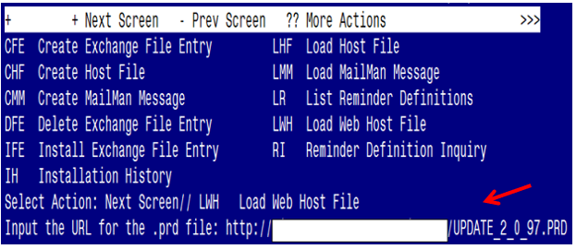

At the **Select Action:** prompt, enter **LWH** for Load Web Host File

At the **Input the url for the .prd file:** prompt, type the following web address:

[**http://REDACTED/UPDATE_2_0_97.PRD**](http://REDACTED/UPDATE_2_0_97.PRD)

**TAKE NOTE:** If you receive the following message **“**Could not load the .prd file: Error 404 Not Found”, use the LMM option to load the file from your VistA email.

Search and locate an entry titled **UPDATE_2_0_97 VA-SPINAL CORD INJURIES AND DISORDERS** in reminder exchange

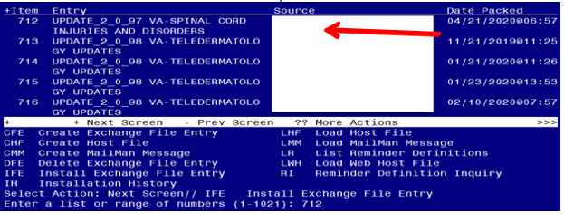

At the **Select Action** prompt, enter **IFE** for Install Exchange File Entry

Enter the number that corresponds with your entry titled **UPDATE_2_0_97 VA-SPINAL CORD INJURIES AND DISORDERS** *(in this example it is entry 712, it will vary by site)*

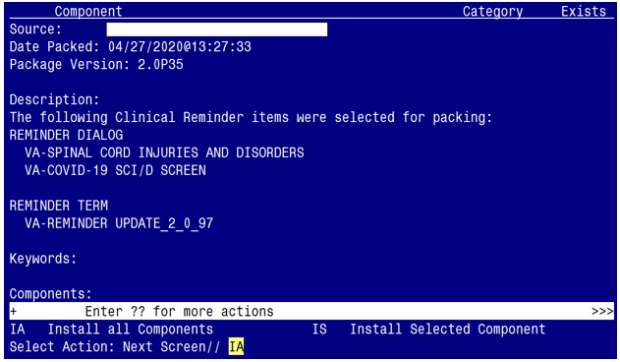

At the **Select Action** prompt, type **IA** for Install all Components and hit enter.

Select Action: Next Screen// IA Install all Components

During the installation, you will see several prompts to Install all new components

**You will be promped to install the the 1st dialog component (VA-COVID-19 SCI/D SCREEN):**

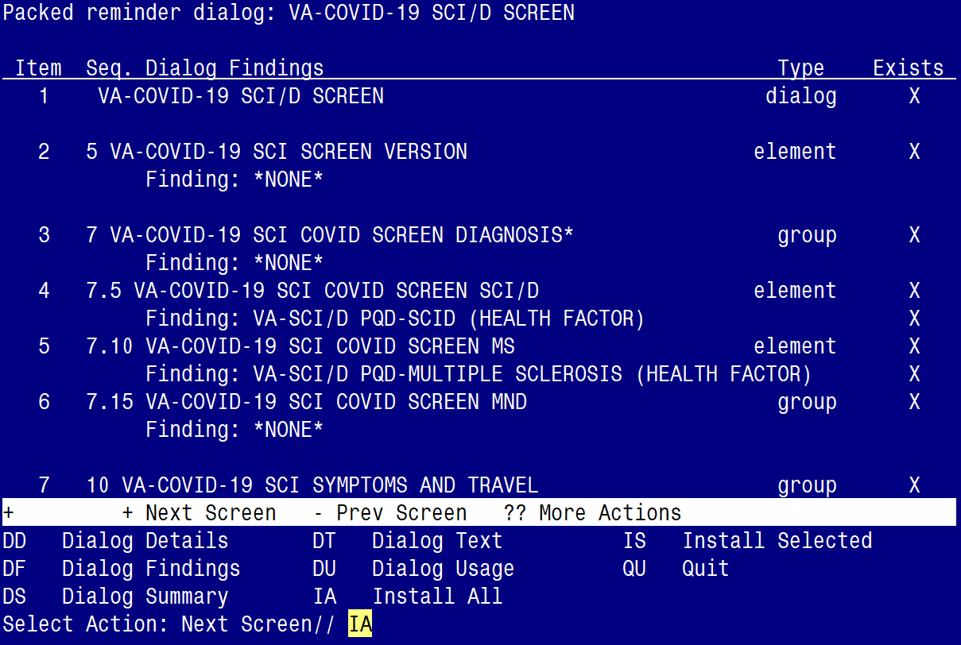

At the **Select Action** prompt, type **IA** to install the dialog – **VA-COVID-19 SCI/D SCREEN**

Select Action: Next Screen// IA Install All

Install reminder dialog and all components with no further changes: Y// ES

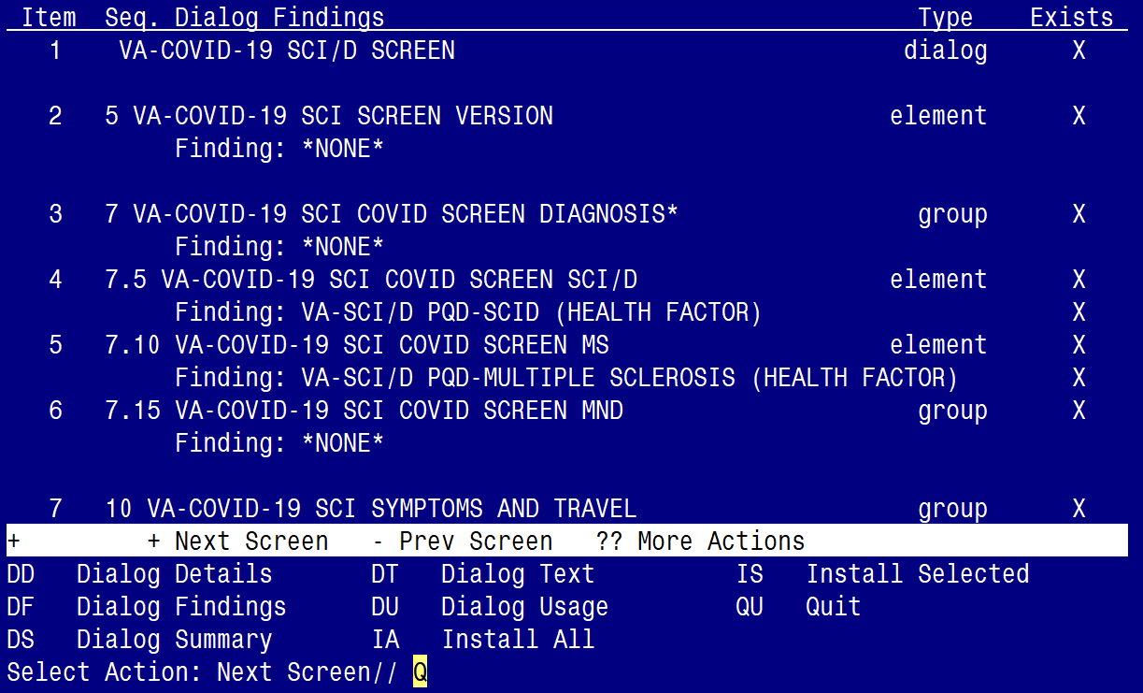

When the dialog has completed installation, you will then be returned to this screen. At the **Select Action** prompt, type **Q.**

**You will be promped to install the the 2nd dialog component (VA-SPINAL CORD INJURIES AND DISORDERS):**

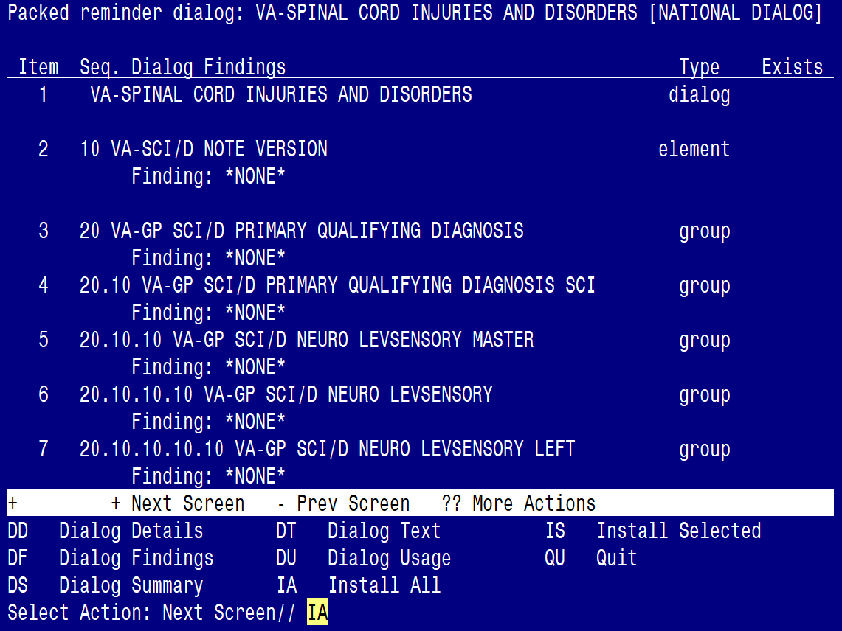

At the **Select Action** prompt, type **IA** to install the dialog – **VA-SPINAL CORD INJURIES AND DISORDERS**

Select Action: Next Screen// IA Install All

Install reminder dialog and all components with no further changes: Y// ES

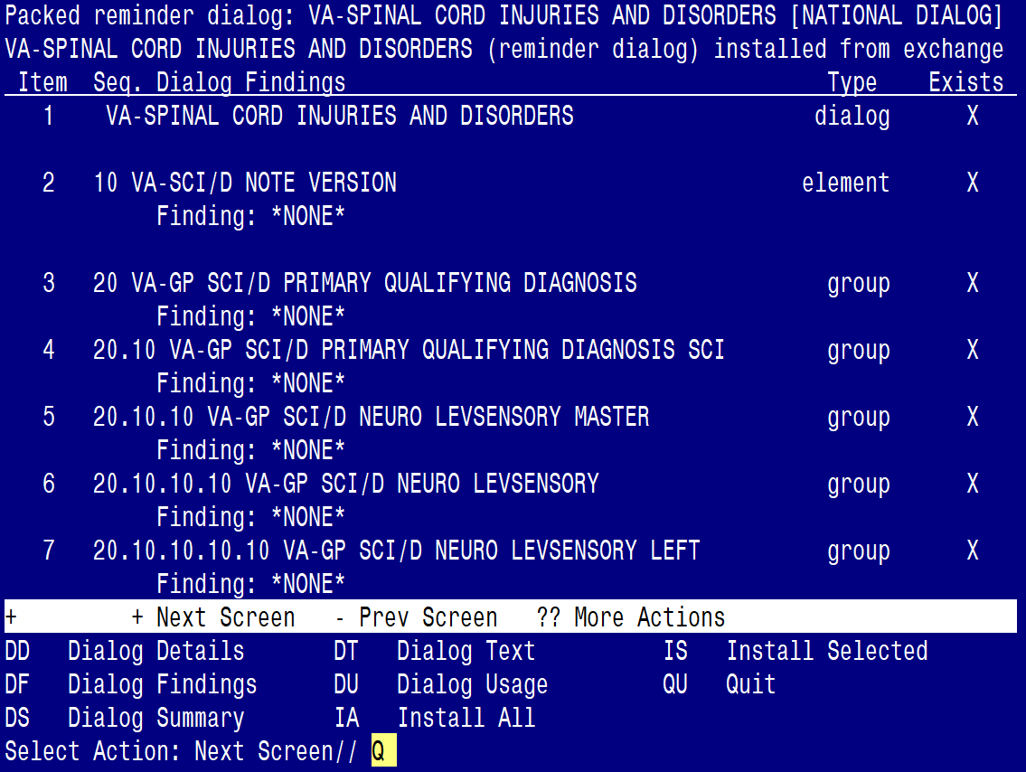

When the dialog has completed installation, you will then be returned to this screen. At the **Select Action** prompt, type **Q.**

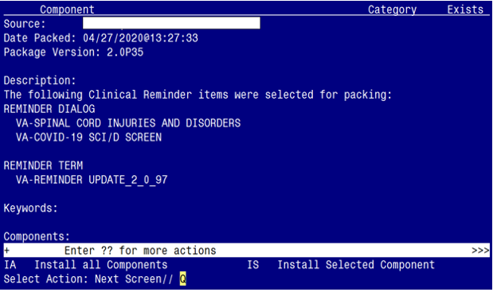

You will be returned to this screen. Type Q to quit.

Install Completed

# Post Installation

1. Map order or menu to the following elements/groups in the **VA-COVID-19 SCI/D SCREEN** dialog **if appropriate**. Coordination with SCI/D staff is necessary before mapping these items. These are the sections addressed in the pre-installation instructions. If an order or menu is not appropriate, then the element/group can be left as deployed.
   1. **Medications/Medical supplies.** The patient is asked if they need someone to contact them regarding having enough medications and medical supplies. If the answer is yes, what action should the screener take?

**Map order dialog to the following element:**

NAME: VA-COVID-19 SCI MEDICATIONS ACTION Replace

DISABLE:

CLASS: NATIONAL//

SPONSOR:

REVIEW DATE:

RESOLUTION TYPE:

ORDERABLE ITEM:

Finding item: HF VA-SCI/D COVID NEW CONCERN MEDICATIONS

FINDING ITEM: VA-SCI/D COVID NEW CONCERN MEDICATIONS

//

Additional findings: none

Select ADDITIONAL FINDING: Add order dialog name here

**Map order dialog to the following element:**

NAME: VA-COVID-19 SCI MEDICAL SUPPLIES ACTION Replace

DISABLE:

CLASS: NATIONAL//

SPONSOR:

REVIEW DATE:

RESOLUTION TYPE:

ORDERABLE ITEM:

Finding item: HF VA-SCI/D COVID NEW CONCERN MED SUPPLIES

FINDING ITEM: VA-SCI/D COVID NEW CONCERN MED SUPPLIES

//

Additional findings: none

Select ADDITIONAL FINDING: Add order dialog name here

* 1. **New Concerns.** The patient is asked if they have any new concerns regarding wounds, bladder/catheterization, bowels program, autonomic dysreflexia, wheelchairs, bed/mattress, or other equipment. If the answer is yes, what action should the screener take?

**Map order dialog to the following element:**

NAME: VA-COVID-19 SCI SCREEN CONCERN ACTION INFO Replace

DISABLE:

CLASS: NATIONAL//

SPONSOR:

REVIEW DATE:

RESOLUTION TYPE:

ORDERABLE ITEM:

Finding item: HF VA-SCI/D COVID NEW CONCERN ACTION

FINDING ITEM: VA-SCI/D COVID NEW CONCERN ACTION//

Additional findings: none

Select ADDITIONAL FINDING: Add order dialog name here

* 1. **Additional COVID-19 symptoms.** The patient is asked if they are experiencing a new onset of sore throat, myalgia, loss of taste, loss of smell, nausea, or conjunctivitis. If the answer is yes, what action should the screener take?

**Map order dialog to the following element:**

NAME: VA-COVID-19 SCI SCREEN ADDITIONAL ACTION INFO

Replace

DISABLE:

CLASS: NATIONAL//

SPONSOR:

REVIEW DATE:

RESOLUTION TYPE:

ORDERABLE ITEM:

Finding item: HF VA-SCI/D COVID SCREEN ADDL SYMPTOM

FINDING ITEM: VA-SCI/D COVID SCREEN ADDL SYMPTOM//

Additional findings: none

Select ADDITIONAL FINDING: Add order dialog name here

* 1. **Mental Health Professional.** The patient is asked if they would be interested in speaking to a mental health professional. If the answer is yes, what action should the screener take?

**Map order dialog to the following element:**

NAME: VA-COVID-19 SCI MENTAL HEALTH ACTION Replace

DISABLE:

CLASS: NATIONAL//

SPONSOR:

REVIEW DATE:

RESOLUTION TYPE:

ORDERABLE ITEM:

Finding item: HF VA-SCI/D COVID SCREEN MH PROF YES

FINDING ITEM: VA-SCI/D COVID SCREEN MH PROF YES//

Additional findings: none

Select ADDITIONAL FINDING: Add order dialog name here

* 1. **Social Worker.** The patient is asked if they would be interested in speaking to a social worker. If the answer is yes, what action should the screener take?

**Map order dialog to the following element:**

NAME: VA-COVID-19 SCI SOCIAL WORK ACTION Replace

DISABLE:

CLASS: NATIONAL//

SPONSOR:

REVIEW DATE:

RESOLUTION TYPE:

ORDERABLE ITEM:

Finding item: HF VA-SCI/D COVID SCREEN SW YES

FINDING ITEM: VA-SCI/D COVID SCREEN SW YES//

Additional findings: none

Select ADDITIONAL FINDING: Add order dialog name here

* 1. **Adequate food and water.** The patient is asked if they have adequate food and water. If the answer is no, what action should the screener take?

**Map order dialog to the following element:**

NAME: VA-COVID-19 SCI FOOD ACTION Replace

DISABLE:

CLASS: NATIONAL//

SPONSOR:

REVIEW DATE:

RESOLUTION TYPE:

ORDERABLE ITEM:

Finding item: HF VA-SCI/D COVID SCREEN FOOD NO

FINDING ITEM: VA-SCI/D COVID SCREEN FOOD NO//

Additional findings: none

Select ADDITIONAL FINDING: Add order dialog name here

* 1. **Emergency numbers.** The patient is asked if they need a list of emergency numbers. If the answer is yes, what phone numbers should be provided to the patient? To remove this section from the dialog, enter a “2” in the DISABLE field.

**Map order dialog to the following element:**

NAME: VAL-COVID-19 SCI EMERGENCY NUMBERS PROVIDED

Replace

DISABLE:

CLASS: LOCAL//

SPONSOR:

REVIEW DATE:

RESOLUTION TYPE:

ORDERABLE ITEM:

FINDING ITEM:

Additional findings: none

Select ADDITIONAL FINDING:

DIALOG/PROGRESS NOTE TEXT:

Provide patient with the following local emergency contact

resources/numbers:

Edit? NO// YES

==[ WRAP ]==[INSERT ]=======< DIALOG/PROGRESS NOTE TE[Press <PF1>H for help]====

Provide patient with the following local emergency contact

resources/numbers:

Add the local emergency numbers here

* 1. **Advance Directive.** The patient is asked if they need to revise their advance directive. If the answer is yes, what action should the screener take?

**Map order dialog to the following element:**

NAME: VA-COVID-19 SCI ADVANCED DIRECTIVE ACTION Replace

DISABLE:

CLASS: NATIONAL//

SPONSOR:

REVIEW DATE:

RESOLUTION TYPE:

ORDERABLE ITEM:

Finding item: HF VA-SCI/D COVID SCREEN ADV DIR CHANGE YES

FINDING ITEM: VA-SCI/D COVID SCREEN ADV DIR CHANGE YES

//

Additional findings: none

Select ADDITIONAL FINDING: Add order dialog name here

1. **A local group is included in the VA-COVID-19 SCI/D SCREEN if local information needs to be added to the dialog.** The group is named VAL-COVID-19 SCI LOCAL GROUP. It is deployed disabled. If the dialog needs to be used, enter @ in the DISABLE field.

Select one of the following:

E Edit

C Copy and Replace current element

D Delete element from this dialog

Select Dialog Element Action: Edit

NAME: VAL-COVID-19 SCI LOCAL GROUP Replace

DISABLE: DISABLE AND DO NOT SEND MESSAGE//@

1. **Make the Dialog templates available to be attached to a Personal or Shared template or to be able to attach the dialog to a progress note title.**

From the Reminders Manager Menu:

Select Reminder Managers Menu Option: **CP** CPRS Reminder Configuration

CA Add/Edit Reminder Categories

CL CPRS Lookup Categories

CS CPRS Cover Sheet Reminder List

MH Mental Health Dialogs Active

PN Progress Note Headers

RA Reminder GUI Resolution Active

TIU TIU Template Reminder Dialog Parameter

DL Default Outside Location

PT Position Reminder Text at Cursor

Select CPRS Reminder Configuration Option: **TIU** TIU Template Reminder Dialog

Parameter

Reminder Dialogs allowed as Templates may be set for the following:

1 User USR [choose from NEW PERSON]

3 Service SRV [choose from SERVICE/SECTION]

4 Division DIV [choose from INSTITUTION]

5 System SYS [NATREM.FO-SLC.MED.VA.GOV]

Enter selection*:* **5**  *Choose the appropriate number for your site. Your site may do*

*this by System or other levels. The example below uses SYSTEM level*

Setting Reminder Dialogs allowed as Templates for System:

Select Display Sequence: **?**

148 VA-VETERANS CHOICE NOTE

149 VA-TBI SCREENING

152 VACO TRANSPLANT REFERRAL (D)

*When you type a question mark above, you will see the list of #’s (with dialogs) that*

*are already taken. Choose a number* ***NOT*** *on this list. For this example, looking*

*above I see the number 150 and 151 are not present, so I will use 150 and 151.*

Select Display Sequence: **150**

Are you adding 150 as a new Display Sequence? Yes// **Y** YES

Display Sequence: 150// <Enter>

Clinical Reminder Dialog**: VA-SPINAL CORD INJURIES AND DISORDERS** Enter>

OK? Yes// <Enter> (Yes)

Select Display Sequence: **151**

Are you adding 151 as a new Display Sequence? Yes// **Y** YES

Display Sequence: 151// <Enter>

Clinical Reminder Dialog**: VA-COVID-19 SCI/D SCREEN** Enter>

OK? Yes// <Enter> (Yes)

1. **Setup of Note title**

The new note titles that needs to be created are:

**SCID STATUS UPDATE and SCID COVID-19 SCREEN**

1. The SCID STATUS UPDATE title should be created for use with the reminder dialog named **VA-SPINAL CORD INJURIES AND DISORDERS**.

Name: SCID STATUS UPDATE

VHA Enterprise Standard Title: SPINAL CORD INJURY NOTE

1. The SCID COVID-19 SCREEN title should be created for use with the reminder dialog named **VA-COVID-19 SCI/D SCREEN**

Name: SCID COVID-19 SCREEN

VHA Enterprise Standard Title: SPINAL CORD INJURY NOTE

Note: Comprehensive information on Creating Document Definitions can be found beginning on page 47 of the [TIU/ASU Implementation Guide](http://www.va.gov/vdl/documents/Clinical/CPRS-Text_Integration_Utility_(TIU)/tiuim.pdf)

1. **Associate the reminder dialogs with the note titles in CPRS**

To do this, go to Template Editor, then Document Titles, select the appropriate folder (if applicable), and choose New Template (top right-hand corner).

1. Type in the following information:

Name: VA-SPINAL CORD INJURIES AND DISORDERS

Template Type: Reminder Dialog

Reminder Dialog: VA-SPINAL CORD INJURIES AND DISORDERS

Next, type in the Associated Title, which in this case is SCID STATUS UPDATE and hit

Apply.

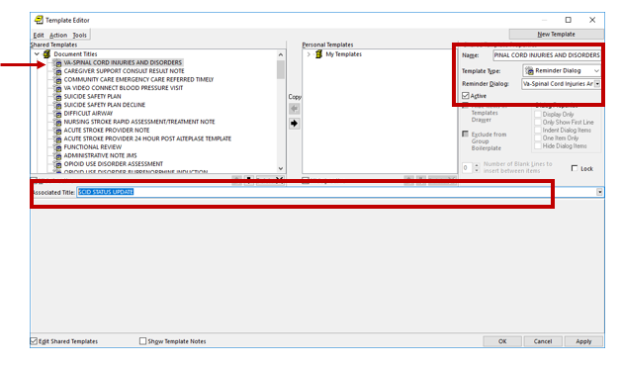

1. Type in the following information:

Name: SCID COVID-19 SCREEN

Template Type: Reminder Dialog

Reminder Dialog: VA-COVID-19 SCI/D SCREEN

Next, type in the Associated Title, which in this case is SCID COVID-19 SCREEN and hit

Apply.

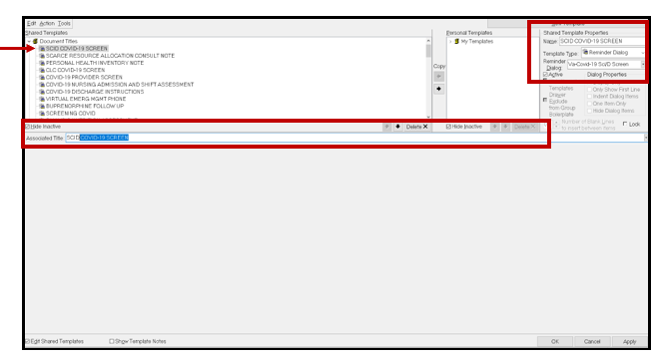

1. **Add the reminder dialog templates as stand-alone shared templates**

* Open Template Editor
* Click ‘triangle’ to left of Shared Templates to expand
* Select the folder(s) that the reminder dialog template should be located

Screen shot showing the Shared Template file cabinet icon and text highlighted as described in the text.

1. Add VA-SPINAL CORD INJURIES AND DISORDERS
   * Click New Template button
   * Type SCID STATUS UPDATE in the Name box
   * Click down arrow and Click on Reminder Dialog in Template Type Box
   * Type VA-SPINAL CORD INJURIES AND DISORDERS in Reminder Dialog box
   * Click Apply

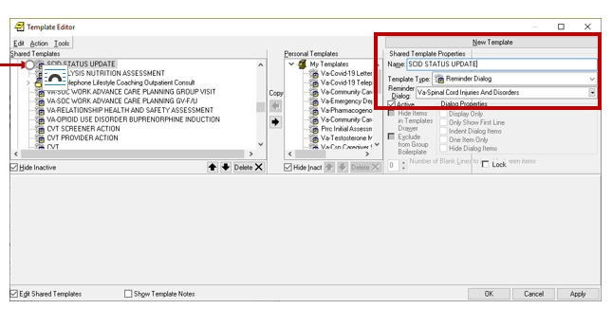

1. Add VA-COVID-19 SCI/D SCREEN
   * Click New Template button
   * Type VA-COVID-19 SCI/D SCREEN in the Name box
   * Click down arrow and Click on Reminder Dialog in Template Type Box
   * Type VA-COVID-19 SCI/D SCREEN in Reminder Dialog box
   * Click Apply

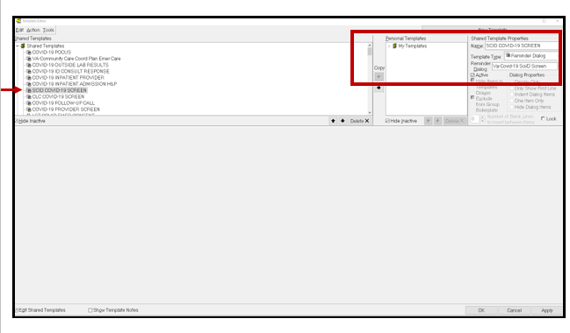

Test the shared template in CPRS to verify that the template opens when selected