Department of Veterans Affairs

Office of Information & Technology (OIT) Product Development

VistA Mental Health Clinical Reminder Dialog Templates

User Manual
PXRM*2.0*29

September 2014
Version 1.2

Revision History

Date | Version | Description | Author
August 2013 | 1.1 | Document specific to PXRM*2.0*29 (Increments 1 & 2) | Information Innovators Inc.
January 2013 | 1.0 | Initial draft | K&R Consulting, Inc.

Contents
Introduction 1
Target audience 1
Other sources of information 1
Related documentation 1
Background 1
About the MHA application 2
MHCR dialog templates for PXRM*2.0*29 2
To access and complete an MHCR dialog template 2
About signing your progress note 8
To sign your progress note 8
Appendix A 9
Prolonged Exposure Therapy Findings Items 9
Appendix B 11
Cognitive Processing Therapy Findings Items 11
Appendix C 13
Cognitive Behavioral Therapy for Depression Findings Items 13
Appendix D 15
Acceptance and Commitment Therapy for Depression Findings Items 15

Introduction
The purpose of this document is to provide clinicians with the information they need to use the Mental Health Clinical Reminder (MHCR) Dialog Templates (patch PXRM*2.0*29) in the VA’s Computerized Patient Record System (CPRS). It is not intended to provide basic information such as logging in to CPRS, or getting help. For information on those and other fundamentals, see Related Documentation.

Target audience
The intended users are the Mental Health clinicians who deliver these particular Evidence-Based Psychotherapies (EBPs) at VHA facilities. The Clinical Reminder Dialog Templates (patch PXRM*2.0*29) will be made available to all clinicians engaged in the supported therapy protocols. Proficiency in CPRS is the only user requirement.

Other sources of information
Other relevant information is also available on the Clinical Reminders website: http://vista.med.va.gov/reminders/

Related documentation
The following manuals are available from the VistA Documentation Library (VDL) http://www.va.gov/vdl:

Documentation | Documentation file name
Computerized Patient Record System (CPRS) User Guide GUI version February 2012 | cprsguium.PDF
Mental Health Clinical Reminders Dialog Installation and Setup Guide | PXRM_2.0_29_IG.PDF
MHCR Release Notes | PXRM_2.0_29_UM.PDF
Clinical Reminders Manager’s Manual | PXRM_2.0_MM.PDF
Clinical Reminders Technical Manual | PXRM_2.0_TM.PDF
VistA MHA 3 User Manual Patch YS*5.01*76,  MHA3 User Manual (Patch YS*5.1*104), or other update | Patch YS*5.01*76 Patch YS*5.1*104

Background
The Improve Veterans’ Mental Health (IVMH) Initiative is part of the Department of Veterans Affairs (VA)’s set of 21st century transformational initiatives (T21). The Mental Health Clinical Reminders (MHCR) project was designed to help facilitate IVMH by providing a national distribution of MHCR dialog templates appropriate for some of the Evidence Based Psychotherapy (EBP) protocols sponsored by Mental Health Services (VACO). The protocols will be used for the treatment of mental health conditions, including depression and post- traumatic stress disorder. The national reminder dialog templates will facilitate uniform data collection. This will allow Mental Health Services (MHS) the ability to effectively monitor implementation of these therapy protocols as well as evaluate the effectiveness of the therapies. The templates will assist in providing uniformity across mental services within the VA.

Access to the MHCR templates is through the CPRS environment. All of the templates will use the existing Clinical Reminder dialog functionalities; no new functionalities have been created to support the protocols.

About the MHA application
The dialog templates may include Mental Health Assistant (MHA) instruments as part of the template dialog. If so, you will have the option to complete the instruments. Depending on how your site has configured the reminder dialogs, the assessment will appear in the progress note or not. (Both approaches are used in the EBP templates included in this project.)

MHCR dialog templates for PXRM*2.0*29
CPT - Cognitive Processing Therapy
- VA-MH CPT 1 INITIAL
- VA-MH CPT 2 MEANING SESSION
- VA-MH CPT 3 ABC SHEET
- VA-MH CPT 4 TRAUMA EVENT SESSION
- VA-MH CPT 5 REWRITE EVENT
- VA-MH CPT 6 CHALLENGING QUESTIONS
- VA-MH CPT 7 PROBLEMATIC THINKING
- VA-MH CPT 8 SAFETY
- VA-MH CPT 9 TRUST
- VA-MH CPT 10 POWER CONTROL
- VA-MH CPT 11 ESTEEM
- VA-MH CPT 12 FINAL
- VA-MH CPT EARLY TERMINATION
PEI - Prolonged Exposure
- VA-MH PEI 1 INITIAL
- VA-MH PEI 2nd SESSION
- VA-MH PEI 3rd SESSION
- VA-MH PEI 4 IMAGINAL SESSIONS
- VA-MH PEI 5 FINAL SESSION
- VA-MH PEI EARLY TERMINATION
ACT-D - Acceptance and Commitment Therapy for Depression
- VA-MH ACT-D 1 BEGINNING PHASE
- VA-MH ACT-D 2 ACTION PHASE
- VA-MH ACT-D 3 CLOSING PHASE
- VA-MH ACT-D EARLY TERMINATION
CBT-D - Cognitive Behavior Therapy for Depression
- VA-MH CBT-D 1 INITIAL PHASE
- VA-MH CBT-D 2 MIDDLE PHASE
- VA-MH CBT-D 3 FINAL PHASE
- VA-MH CBT-D EARLY TERMINATION

To access and complete an MHCR dialog template
- Sign onto CPRS.
The Patient Selection window opens:
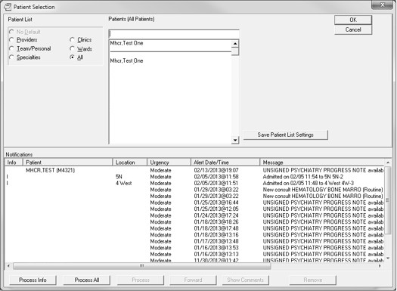
- Select the patient you want to work with, in your usual manner. The patient’s record opens in Cover Sheet view (default view):
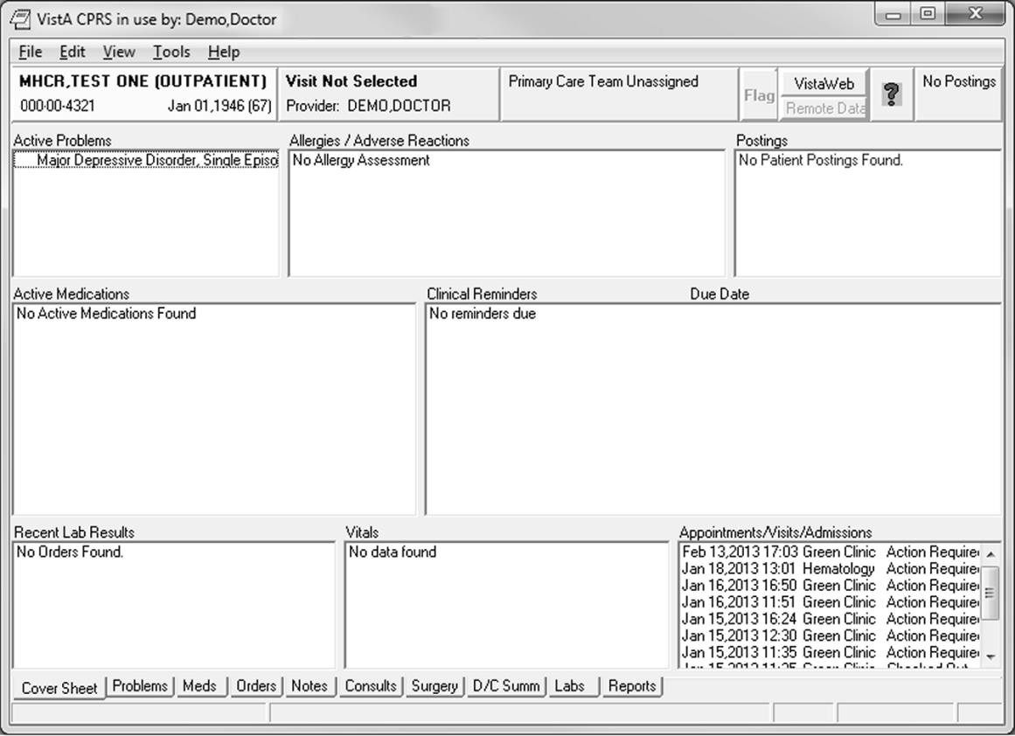

- Click the Notes tab.
The Notes view opens, showing a New Note button:
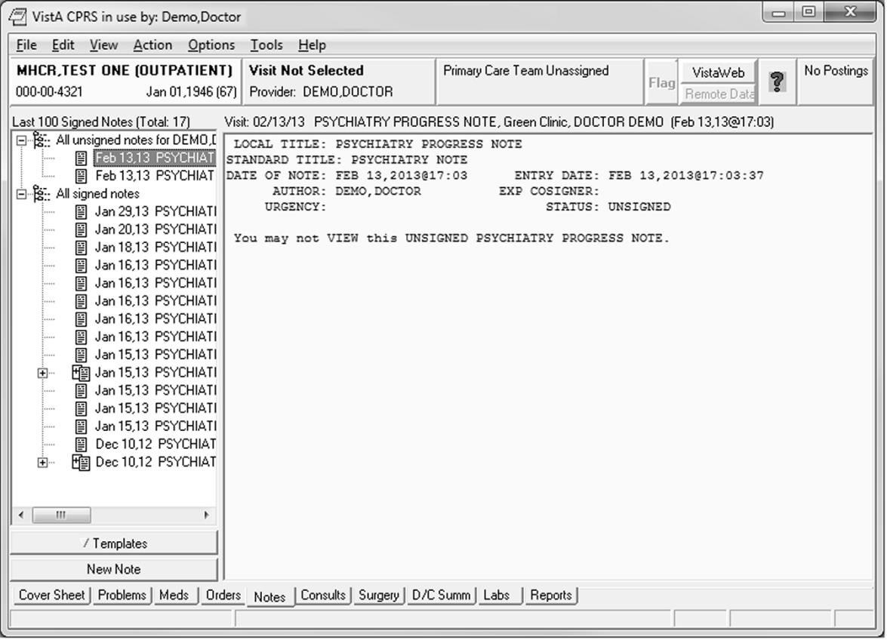

- Click New Note.
The Location for Current Activities window opens:
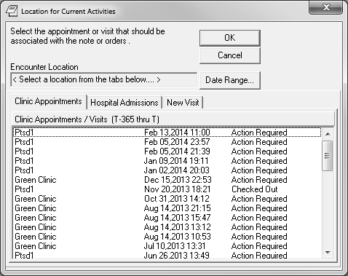

- Select a location.
The location displays in the Encounter Location read-only field.
--OR--
Click the tab for Hospital Admissions or New Visit. If New Visit, select a Visit Location and a Date and Time of Visit.
- Click OK.
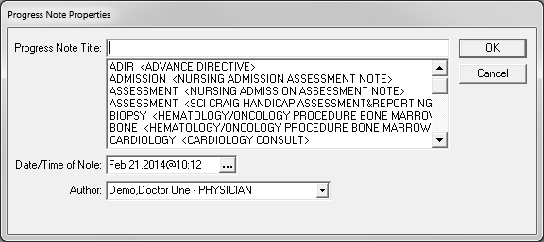
The Progress Note Properties window opens.
- Type the note title into the Progress Note Title field or select from the list, then click OK. You are returned to the Notes tab view:
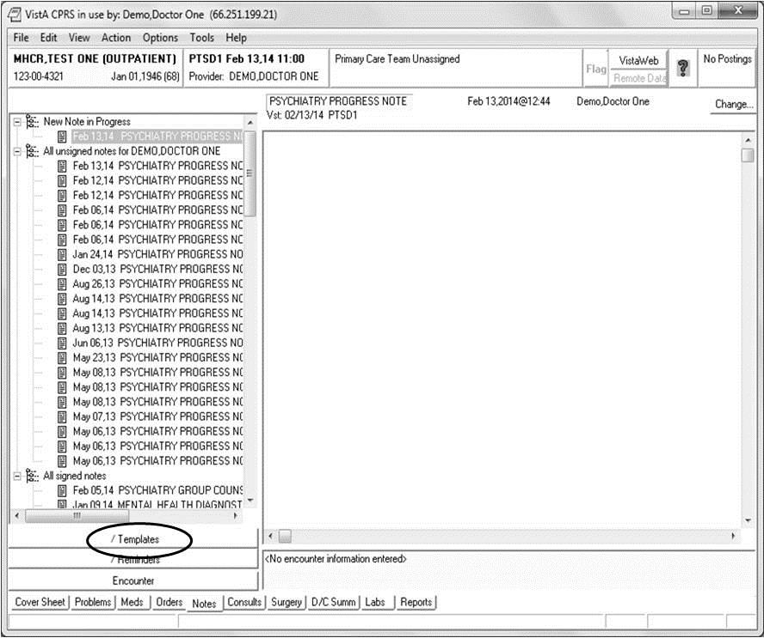

- Click Templates.
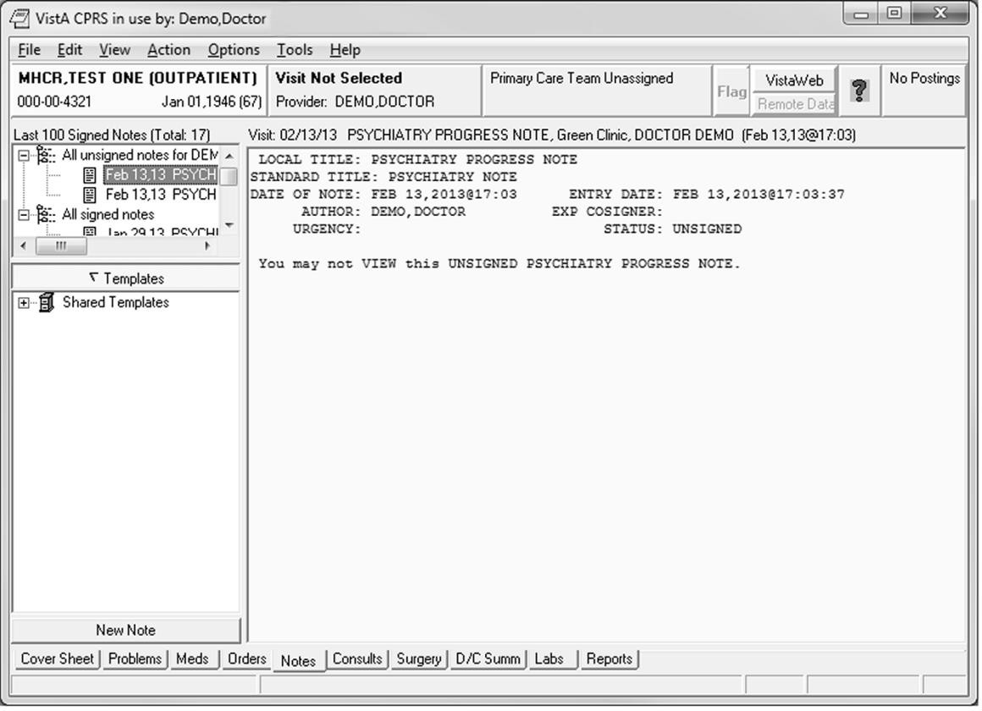The Templates section opens:

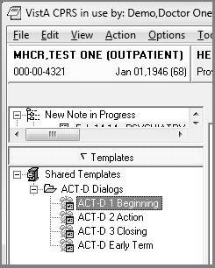
- Expand the list of Shared Templates by clicking +, then double-click the template you want, as shown in the section view:

The template opens:

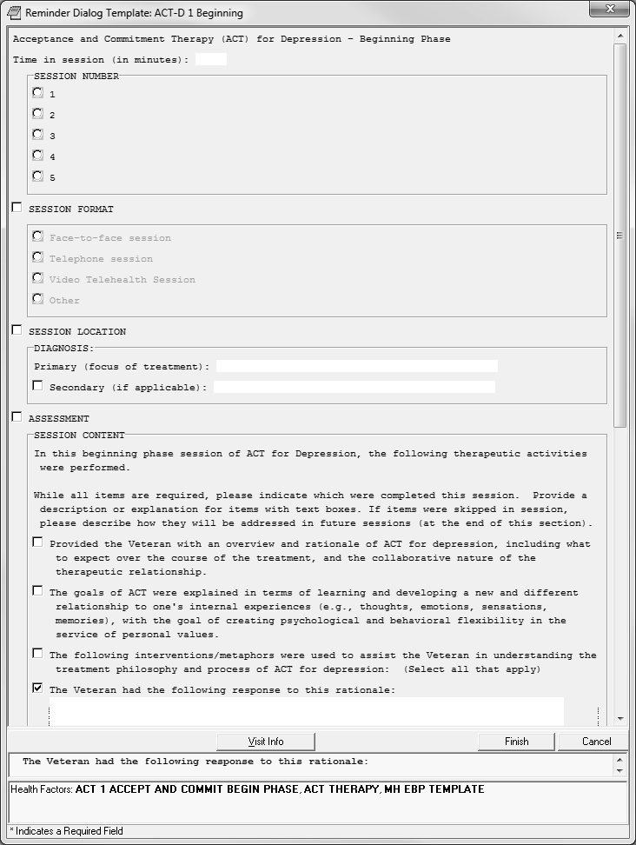

- Click to select the items you want; continue scrolling to review the entire template.
Note: Selecting some options opens a text field for data entry.

- Type data in the text fields as necessary.
- When you have completed the template, click Finish.
The template window closes, and you are returned to the CPRS Notes view, showing the information you entered in the form of a progress note.

About signing your progress note
You must sign the note with your electronic signature before it can become a note that other CPRS users can see, as well as a permanent entry in the patient’s record.

To sign your progress note
- Click the Action menu (top of window), and select Sign Note Now. The Sign Note dialog box opens.
- Type your electronic signature code into the Signature Code field, then click OK. Your note is signed, and you are returned to the CPRS Notes view.

Appendix A

Prolonged Exposure Therapy Findings Items

HEALTH FACTORS  7 MH EVIDENCED BASED |  |  |  | PSYCHOTHER | TEMPLATES | CATEGORY X | EXISTS  X
8 | MH | EBP | TEMPLATE |  |  |  | X
9 | MH | PEI | TEMPLATES |  |  | X | X
10 | MH | PEI | THERAPY |  |  |  | X
11 | MH | PEI | 4 IMAGINAL SSN |  |  |  | X
12 | MH | PEI | SESSION NUMBER>20 |  |  |  | X
13 | MH | PEI | SESSION NUMBER 20 |  |  |  | X
14 | MH | PEI | SESSION NUMBER 19 |  |  |  | X
15 | MH | PEI | SESSION NUMBER 18 |  |  |  | X
16 | MH | PEI | SESSION NUMBER 17 |  |  |  | X
17 | MH | PEI | SESSION NUMBER 16 |  |  |  | X
18 | MH | PEI | SESSION NUMBER 15 |  |  |  | X
19 | MH | PEI | SESSION NUMBER 14 |  |  |  | X
20 | MH | PEI | SESSION NUMBER 13 |  |  |  | X
21 | MH | PEI | SESSION NUMBER 12
22 | MH | PEI | SESSION NUMBER 11 |  |  |  | X
23 | MH | PEI | SESSION NUMBER 10 |  |  |  | X
24 | MH | PEI | SESSION NUMBER 9 |  |  |  | X
25 | MH | PEI | SESSION NUMBER 8 |  |  |  | X
26 | MH | PEI | SESSION NUMBER 7 |  |  |  | X
27 | MH | PEI | SESSION NUMBER 6 |  |  |  | X
28 | MH | PEI | SESSION NUMBER 5 |  |  |  | X
29 | MH | PEI | SESSION NUMBER 4 |  |  |  | X
30 | MH | PEI | SESSION NUMBER 3 |  |  |  | X
31 | MH | EBP | PLAN REFERRAL |  |  |  | X
32 | MH | EBP | EARLY TERM NO CONTACT |  |  |  | X
33 | MH | EBP | EARLY TERM AGREE |  |  |  | X
34 | MH | EBP | EARLY TERM SYMPTOMS REMIT |  |  |  | X
35 | MH | EBP | EARLY TERM DISCONT TX |  |  |  | X
36 | MH | EBP | COLLABORATION HIGH |  |  |  | X
37 | MH | EBP | COLLABORATION MEDIUM |  |  |  | X
38 | MH | EBP | COLLABORATION LOW |  |  |  | X
39 | MH | EBP | MOTIVATION ENHANCE BARRIERS |  |  |  | X
40 | MH | EBP | MOTIVATION ENHANCE ATTITUDES |  |  |  | X
41 | MH | EBP | MOTIVATION ENHANCE BENEFITS |  |  |  | X
42 | MH | EBP | MOTIVATION ENHANCE CONSEQUENCES |  |  |  | X
43 | MH | EBP | MOTIVATION ENHANCE GOALS |  |  |  | X
44 | MH | PEI | 4 CONTENT EXPOSURE IN SESSION |  |  |  | X
45 | MH | PEI | 4 |  |  | X | X
46 | MH | PEI | 4 CONTENT HMWRK NOT DONE |  |  |  | X
47 | MH | PEI | 4 CONTENT HMWRK |  |  |  | X
48 | MH | EBP | PLAN PT AGREE |  |  |  | X
49 | MH | EBP | PLAN BOOSTER SESSION |  |  |  | X
50 | MH | EBP | PLAN TX COMPLETE |  |  |  | X
51 | MH | PEI | 5 PROLONGED EXPOSURE IND FINAL |  |  |  | X

52 | MH | PEI | 5 CONTENT EXPOSURE IN SESSION |  |  |  |  |  | X
53 | MH | PEI | 5 FINAL |  |  |  |  | X | X
54 | MH | PEI | 5 CONTENT HMWRK NOT DONE |  |  |  |  |  | X
55 | MH | PEI | INITIAL |  |  |  |  | X | X
56 | MH | PEI | INDEX TRAUMA OTHER |  |  |  |  |  | X
57 | MH | PEI | INDEX TRAUMA MST |  |  |  |  |  | X
58 | MH | PEI | INDEX TRAUMA COMBAT |  |  |  |  |  | X
59 | MH | PEI | 1 INITIAL |  |  |  |  |  | X
60 | MH | PEI | SESSION NUMBER 2 |  |  |  |  |  | X
61 | MH | PEI | SESSION NUMBER 1 |  |  |  |  |  | X
62 | MH | PEI | 1 CONTENT TRAUMA INTERVIEW |  |  |  |  |  | X
63 | MH | PEI | 2ND SSN |  |  |  |  |  | X
64 | MH | PEI | 2 |  |  |  |  | X | X
65 | MH | PEI | 2 CONTENT HIERARCHY |  |  |  |  |  | X
66 | MH | PEI | 2 CONTENT SUDS |  |  |  |  |  | X
67 | MH | PEI | 2 CONTENT HMWRK NOT DONE |  |  |  |  |  | X
68 | MH | PEI | 3RD SSN |  |  |  |  |  | X
69 | MH | PEI | 3 |  |  |  |  | X | X
70 | MH | PEI | 3 CONTENT |  | EXPOSURE |  |  | X
71 | MH | PEI | SESSION | NUMBER |  | COMPLETED | 20+ | X
72 | MH | PEI | SESSION | NUMBER |  | COMPLETED | 4 | X
73 | MH | PEI | SESSION | NUMBER |  | COMPLETED | 3 | X
74 | MH | PEI | SESSION | NUMBER |  | COMPLETED | 2 | X
75 | MH | PEI | SESSION | NUMBER |  | COMPLETED | 1 | X
76 | MH | PEI | SESSION | NUMBER |  | COMPLETED | 19 | X
77 | MH | PEI | SESSION | NUMBER |  | COMPLETED | 18 | X
78 | MH | PEI | SESSION | NUMBER |  | COMPLETED | 17 | X
79 | MH | PEI | SESSION | NUMBER |  | COMPLETED | 16 | X
80 | MH | PEI | SESSION | NUMBER |  | COMPLETED | 15 | X
81 | MH | PEI | SESSION | NUMBER |  | COMPLETED | 14 | X
82 | MH | PEI | SESSION | NUMBER |  | COMPLETED | 13 | X
83 | MH | PEI | SESSION | NUMBER |  | COMPLETED | 12 | X
84 | MH | PEI | SESSION | NUMBER |  | COMPLETED | 11 | X
85 | MH | PEI | SESSION | NUMBER |  | COMPLETED | 10 | X
86 | MH | PEI | SESSION | NUMBER |  | COMPLETED | 9 | X
87 | MH | PEI | SESSION | NUMBER |  | COMPLETED | 8 | X
88 | MH | PEI | SESSION | NUMBER |  | COMPLETED | 7 | X
89 | MH | PEI | SESSION | NUMBER |  | COMPLETED | 6 | X
90 | MH | PEI | SESSION | NUMBER |  | COMPLETED | 5 | X
91 MH PEI EARLY TERM OUTSIDE OF SSN X

Appendix B

Cognitive Processing Therapy Findings Items

HEALTH FACTORS |  |  |  |  |  |  | CATEGORY |  | EXISTS
6 MH CPT TEMPLATES (COGNITIVE PROCESSING) |  |  |  |  |  |  | X |  | X
7 | MH | CPT | SESSION | NUMBER | COMPLETED | 20+ | X
8 | MH | CPT | SESSION | NUMBER | COMPLETED | 4 | X
9 | MH | CPT | SESSION | NUMBER | COMPLETED | 3 | X
10 | MH | CPT | SESSION | NUMBER | COMPLETED | 2 | X
11 | MH | CPT | SESSION | NUMBER | COMPLETED | 1 | X
12 | MH | CPT | SESSION | NUMBER | COMPLETED | 19 | X
13 | MH | CPT | SESSION | NUMBER | COMPLETED | 18 | X
14 | MH | CPT | SESSION | NUMBER | COMPLETED | 17 | X
15 | MH | CPT | SESSION | NUMBER | COMPLETED | 16 | X
16 | MH | CPT | SESSION | NUMBER | COMPLETED | 15 | X
17 | MH | CPT | SESSION | NUMBER | COMPLETED | 14 | X
18 | MH | CPT | SESSION | NUMBER | COMPLETED | 13 | X
19 | MH | CPT | SESSION | NUMBER | COMPLETED | 12 | X
20 | MH | CPT | SESSION | NUMBER | COMPLETED | 11 | X
21 | MH | CPT | SESSION | NUMBER | COMPLETED | 10 | X
22 | MH | CPT | SESSION | NUMBER | COMPLETED | 9 | X
23 | MH | CPT | SESSION | NUMBER | COMPLETED | 8 | X
24 | MH | CPT | SESSION | NUMBER | COMPLETED | 7 | X
25 | MH | CPT | SESSION | NUMBER | COMPLETED | 6 | X
26 | MH | CPT | SESSION | NUMBER | COMPLETED | 5 | X
27 | MH | EVIDENCED BASED PSYCHOTHER TEMPLATES |  |  |  |  | X | X
28 | MH | EBP PLAN REFERRAL |  |  |  |  |  | X
29 | MH | EBP EARLY TERM AGREE |  |  |  |  |  | X
30 | MH | EBP EARLY TERM NO CONTACT |  |  |  |  |  | X
31 | MH | EBP EARLY TERM DISCONT TX |  |  |  |  |  | X
32 | MH | EBP EARLY TERM SYMPTOMS REMIT |  |  |  |  |  | X
33 | MH | EBP TEMPLATE |  |  |  |  |  | X
34 | MH | CPT THERAPY |  |  |  |  |  | X
35 | MH | CPT EARLY TERM OUTSIDE OF SSN |  |  |  |  |  | X
36 | MH | EBP PLAN PT AGREE |  |  |  |  |  | X
37 | MH | EBP PLAN BOOSTER SESSION |  |  |  |  |  | X
38 | MH | EBP PLAN TX COMPLETE |  |  |  |  |  | X
39 | MH | CPT SESSION NUMBER 15 |  |  |  |  |  | X
40 | MH | CPT SESSION NUMBER 14 |  |  |  |  |  | X
41 | MH | CPT SESSION NUMBER 13 |  |  |  |  |  | X
42 | MH | CPT SESSION NUMBER 12 |  |  |  |  |  | X
43 | MH | CPT SESSION NUMBER 11 |  |  |  |  |  | X
44 | MH | CPT 12 FINAL |  |  |  |  |  | X
45 | MH | EBP COLLABORATION HIGH |  |  |  |  |  | X
46 | MH | EBP COLLABORATION MEDIUM |  |  |  |  |  | X
47 | MH | EBP COLLABORATION LOW |  |  |  |  |  | X
48 | MH | EBP MOTIVATION ENHANCE BARRIERS |  |  |  |  |  | X
49 | MH | EBP MOTIVATION ENHANCE ATTITUDES |  |  |  |  |  | X
50 | MH | EBP MOTIVATION ENHANCE BENEFITS |  |  |  |  |  | X

51 | MH | EBP | MOTIVATION ENHANCE CONSEQUENCES | X
52 | MH | EBP | MOTIVATION ENHANCE GOALS | X
53 | MH | CPT | SESSION NUMBER 10 | X
54 | MH | CPT | 11 ESTEEM | X
55 | MH | CPT | SESSION NUMBER 9 | X
56 | MH | PCT | 10 POWER | X
57 | MH | CPT | 9 CONTENT CHALLENGING BELIEFS REV | X
58 | MH | CPT | SESSION NUMBER 8 | X
59 | MH | CPT | 9 TRUST | X
60 | MH | CPT | 9 PRACTICE CHALLENGE BELIEFS | X
61 | MH | CPT | 8 CONTENT CHALLENGING BELIEFS REV | X
62 | MH | CPT | SESSION NUMBER 7 | X
63 | MH | CPT | 8 SAFETY | X
64 | MH | CPT | 8 PRACTICE CHALLENGING BELIEFS | X
65 | MH | CPT | 7 CONTENT REVIEWED HOMWK PROB PAT | X
66 | MH | CPT | SESSION NUMBER 6 | X
67 | MH | CPT | 7 PROBLEM THNK | X
68 | MH | CPT | 7 PRACTICE CHALLENGING BELIEFS | X
69 | MH | CPT | 6 CONTENT REVIEWED HOMEWORK (CQS) | X
70 | MH | CPT | SESSION NUMBER 5 | X
71 | MH | CPT | 6 CHALLENGE QUESTION | X
72 | MH | CPT | 6 PRACTICE PROBLEMATIC WORKSHEET | X
73 | MH | CPT | SESSION NUMBER 4 | X
74 | MH | CPT | 5 REWRITE EVENT | X
75 | MH | CPT | 4 CONTENT TRAUMA ACCOUNT COLLECT | X
76 | MH | CPT | 4 CONTENT TRAUMA ACCOUNT NOT DONE | X
77 | MH | CPT | SESSION NUMBER 3 | X
78 | MH | CPT | 4 TRAUMA EVENT | X
79 | MH | CPT | 4 PRACTICE REWRITE TRAUMA ACCOUNT | X
80 | MH | CPT | 3 CONTENT NO SHEETS | X
81 | MH | CPT | 3 CONTENT REVIEWED HOMEWORK | X
82 | MH | CPT | SESSION NUMBER 2 | X
83 | MH | CPT | 3 ABC SHEET | X
84 | MH | CPT | 3 TRAUMA ACCOUNT WRITE | X
85 | MH | CPT | 2 CONTENT COLLECT STATEMENT | X
86 | MH | CPT | 2 MEANING | X
87 | MH | CPT | SESSION NUMBER 1 | X
88 | MH | CPT | 1 CONTENT IMPACT STATEMENT | X
89 | MH | CPT | 1 INITIAL | X

Appendix C

Cognitive Behavioral Therapy for Depression Findings Items

HEALTH FACTORS  7 MH CBT-D |  |  | TEMPLATES (COG |  | BEHAVIORAL) |  | CATEGORY X | EXISTS  X
8 | MH | CBT-D | SESSION | NUMBER | COMPLETED | 20+ | X
9 | MH | CBT-D | SESSION | NUMBER | COMPLETED | 4 | X
10 | MH | CBT-D | SESSION | NUMBER | COMPLETED | 3 | X
11 | MH | CBT-D | SESSION | NUMBER | COMPLETED | 2 | X
12 | MH | CBT-D | SESSION | NUMBER | COMPLETED | 1 | X
13 | MH | CBT-D | SESSION | NUMBER | COMPLETED | 19 | X
14 | MH | CBT-D | SESSION | NUMBER | COMPLETED | 18 | X
15 | MH | CBT-D | SESSION | NUMBER | COMPLETED | 17 | X
16 | MH | CBT-D | SESSION | NUMBER | COMPLETED | 16 | X
17 | MH | CBT-D | SESSION | NUMBER | COMPLETED | 15 | X
18 | MH | CBT-D | SESSION | NUMBER | COMPLETED | 14 | X
19 | MH | CBT-D | SESSION | NUMBER | COMPLETED | 13 | X
20 | MH | CBT-D | SESSION | NUMBER | COMPLETED | 12 | X
21 | MH | CBT-D | SESSION | NUMBER | COMPLETED | 11 | X
22 | MH | CBT-D | SESSION | NUMBER | COMPLETED | 10 | X
23 | MH | CBT-D | SESSION | NUMBER | COMPLETED | 9 | X
24 | MH | CBT-D | SESSION | NUMBER | COMPLETED | 8 | X
25 | MH | CBT-D | SESSION | NUMBER | COMPLETED | 7 | X
26 | MH | CBT-D | SESSION | NUMBER | COMPLETED | 6 | X
27 | MH | CBT-D | SESSION | NUMBER | COMPLETED | 5 | X
28 | MH | EVIDENCED BASED PSYCHOTHER TEMPLATES |  |  |  |  | X | X
29 | MH | EBP PLAN REFERRAL |  |  |  |  |  | X
30 | MH | EBP EARLY TERM AGREE |  |  |  |  |  | X
31 | MH | EBP EARLY TERM NO CONTACT |  |  |  |  |  | X
32 | MH | EBP EARLY TERM DISCONT TX |  |  |  |  |  | X
33 | MH | EBP EARLY TERM SYMPTOMS REMIT |  |  |  |  |  | X
34 | MH | CBT-D THERAPY |  |  |  |  |  | X
35 | MH | EBP TEMPLATE |  |  |  |  |  | X
36 | MH | CBT-D EARLY TERM OUTSIDE OF SSN |  |  |  |  |  | X
37 | MH | EBP COLLABORATION HIGH |  |  |  |  |  | X
38 | MH | EBP COLLABORATION MEDIUM |  |  |  |  |  | X
39 | MH | EBP COLLABORATION LOW |  |  |  |  |  | X
40 | MH | EBP MOTIVATION ENHANCE BARRIERS |  |  |  |  |  | X
41 | MH | EBP MOTIVATION ENHANCE ATTITUDES |  |  |  |  |  | X
42 | MH | EBP MOTIVATION ENHANCE BENEFITS |  |  |  |  |  | X
43 | MH | EBP MOTIVATION ENHANCE CONSEQUENCES |  |  |  |  |  | X

44 | MH | EBP MOTIVATION ENHANCE GOALS |  | X
45 | MH | CBT-D SESSION NUMBER 3 |  | X
46 | MH | CBT-D SESSION NUMBER 2 |  | X
47 | MH | CBT-D SESSION NUMBER 1 |  | X
48 | MH | CBT-D 1 COGNITIVE BEHAVIORAL | INITIAL | X
49 | MH | CBT-D SESSION NUMBER 19 |  | X
50 | MH | CBT-D SESSION NUMBER 18 |  | X
51 | MH | CBT-D SESSION NUMBER 17 |  | X
52 | MH | CBT-D SESSION NUMBER 16 |  | X
53 | MH | CBT-D SESSION NUMBER 15 |  | X
54 | MH | CBT-D SESSION NUMBER 14 |  | X
55 | MH | CBT-D SESSION NUMBER 13 |  | X
56 | MH | CBT-D SESSION NUMBER 12 |  | X
57 | MH | CBT-D SESSION NUMBER 11 |  | X
58 | MH | CBT-D SESSION NUMBER 10 |  | X
59 | MH | CBT-D SESSION NUMBER 9 |  | X
60 | MH | CBT-D SESSION NUMBER 8 |  | X
61 | MH | CBT-D SESSION NUMBER 7 |  | X
62 | MH | CBT-D SESSION NUMBER 6 |  | X
63 | MH | CBT-D SESSION NUMBER 5 |  | X
64 | MH | CBT-D SESSION NUMBER 4 |  | X
65 | MH | CBT-D 2 COGNITIVE BEHAVIORAL | MIDDLE | X
66 | MH | EBP PROG OTHER RPT DECREASE DEP |  | X
67 | MH | EBP PROG RPT DECREASE DEPRESSION |  | X
68 | MH | EBP PROG PHQ9 DECREASE |  | X
69 | MH | EBP PLAN PT AGREE |  | X
70 | MH | EBP PLAN BOOSTER SESSION |  | X
71 | MH | EBP PLAN TX COMPLETE |  | X
72 | MH | CBT-D SESSION NUMBER 20+ |  | X
73 | MH | CBT-D SESSION NUMBER 20 |  | X
74 | MH | CBT-D 3 COGNITIVE BEHAVIORAL FINAL |  | X

Appendix D

Acceptance and Commitment Therapy for Depression Findings Items

HEALTH FACTORS |  |  |  |  |  |  | CATEGORY |  | EXISTS
7 MH ACT TEMPLATES (ACCEPT & COMMITMENT) |  |  |  |  |  |  | X |  | X
8 | MH | ACT | SESSION | NUMBER | COMPLETED | 20+ | X
9 | MH | ACT | SESSION | NUMBER | COMPLETED | 4 | X
10 | MH | ACT | SESSION | NUMBER | COMPLETED | 3 | X
11 | MH | ACT | SESSION | NUMBER | COMPLETED | 2 | X
12 | MH | ACT | SESSION | NUMBER | COMPLETED | 1 | X
13 | MH | ACT | SESSION | NUMBER | COMPLETED | 19 | X
14 | MH | ACT | SESSION | NUMBER | COMPLETED | 18 | X
15 | MH | ACT | SESSION | NUMBER | COMPLETED | 17 | X
16 | MH | ACT | SESSION | NUMBER | COMPLETED | 16 | X
17 | MH | ACT | SESSION | NUMBER | COMPLETED | 15 | X
18 | MH | ACT | SESSION | NUMBER | COMPLETED | 14 | X
19 | MH | ACT | SESSION | NUMBER | COMPLETED | 13 | X
20 | MH | ACT | SESSION | NUMBER | COMPLETED | 12 | X
21 | MH | ACT | SESSION | NUMBER | COMPLETED | 11 | X
22 | MH | ACT | SESSION | NUMBER | COMPLETED | 10 | X
23 | MH | ACT | SESSION | NUMBER | COMPLETED | 9 | X
24 | MH | ACT | SESSION | NUMBER | COMPLETED | 8 | X
25 | MH | ACT | SESSION | NUMBER | COMPLETED | 7 | X
26 | MH | ACT | SESSION | NUMBER | COMPLETED | 6 | X
27 | MH | ACT | SESSION | NUMBER | COMPLETED | 5 | X
28 | MH | EVIDENCED BASED PSYCHOTHER TEMPLATES |  |  |  |  | X | X
29 | MH | EBP PLAN REFERRAL |  |  |  |  |  | X
30 | MH | EBP EARLY TERM AGREE |  |  |  |  |  | X
31 | MH | EBP EARLY TERM NO CONTACT |  |  |  |  |  | X
32 | MH | EBP EARLY TERM DISCONT TX |  |  |  |  |  | X
33 | MH | EBP EARLY TERM SYMPTOMS REMIT |  |  |  |  |  | X
34 | MH | ACT THERAPY |  |  |  |  |  | X
35 | MH | EBP TEMPLATE |  |  |  |  |  | X
36 | MH | ACT EARLY TERM OUTSIDE OF SSN |  |  |  |  |  | X
37 | MH | EBP MOTIVATION ENHANCE BARRIERS |  |  |  |  |  | X
38 | MH | EBP MOTIVATION ENHANCE ATTITUDES |  |  |  |  |  | X
39 | MH | EBP MOTIVATION ENHANCE BENEFITS |  |  |  |  |  | X
40 | MH | EBP MOTIVATION ENHANCE CONSEQUENCES |  |  |  |  |  | X
41 | MH | EBP MOTIVATION ENHANCE GOALS |  |  |  |  |  | X
42 | MH | ACT SESSION NUMBER 5 |  |  |  |  |  | X
43 | MH | ACT SESSION NUMBER 4 |  |  |  |  |  | X
44 | MH | ACT SESSION NUMBER 3 |  |  |  |  |  | X
45 | MH | ACT SESSION NUMBER 2 |  |  |  |  |  | X
46 | MH | ACT SESSION NUMBER 1 |  |  |  |  |  | X
47 | MH | EBP COLLABORATION HIGH |  |  |  |  |  | X
48 | MH | EBP COLLABORATION MEDIUM |  |  |  |  |  | X
49 | MH | EBP COLLABORATION LOW |  |  |  |  |  | X
50 | MH | ACT 1 CONTENT GOALS EXPLAINED |  |  |  |  |  | X
51 | MH | ACT 1 ACCEPT AND COMMIT BEGIN PHASE |  |  |  |  |  | X

52 | MH | ACT | SESSION NUMBER 19 |  | X
53 | MH | ACT | SESSION NUMBER 18 |  | X
54 | MH | ACT | SESSION NUMBER 17 |  | X
55 | MH | ACT | SESSION NUMBER 16 |  | X
56 | MH | ACT | SESSION NUMBER 15 |  | X
57 | MH | ACT | SESSION NUMBER 14 |  | X
58 | MH | ACT | SESSION NUMBER 13 |  | X
59 | MH | ACT | SESSION NUMBER 12 |  | X
60 | MH | ACT | SESSION NUMBER 11 |  | X
61 | MH | ACT | SESSION NUMBER 10 |  | X
62 | MH | ACT | SESSION NUMBER 9 |  | X
63 | MH | ACT | SESSION NUMBER 8 |  | X
64 | MH | ACT | SESSION NUMBER 7 |  | X
65 | MH | ACT | SESSION NUMBER 6 |  | X
66 | MH | ACT | 2 ACTION PHASE | X | X
67 | MH | ACT | 2 CONTENT DEFUSION OBSERVER |  | X
68 | MH | ACT | 2 CONTENT DEFUSION MILK |  | X
69 | MH | ACT | 2 TIME IN SESSION |  | X
70 | MH | ACT | 2 CONTENT TREATMENT OBJECTIVES |  | X
71 | MH | ACT | 2 CONTENT CREATIVE HANDCUFFS |  | X
72 | MH | ACT | 2 CONTENT CREATIVE PERSON |  | X
73 | MH | ACT | 2 CONTENT CREATIVE TUG |  | X
74 | MH | ACT | 2 CONTENT CREATIVE STRUGGLE |  | X
75 | MH | ACT | 2 CONTENT CREATIVE OTHER |  | X
76 | MH | ACT | 2 CONTENT CREATIVE DISCUSSED |  | X
77 | MH | ACT | 2 CONTENT CREATIVE NUMBERS |  | X
78 | MH | ACT | 2 CONTENT CREATIVE PAIN |  | X
79 | MH | ACT | 2 CONTENT CREATIVE HOPELESS |  | X
80 | MH | ACT | 2 CONTENT ACCEPTANCE EYES |  | X
81 | MH | ACT | 2 CONTENT ACCEPTANCE SCALES |  | X
82 | MH | ACT | 2 CONTENT ACCEPTANCE POLYGRAPH |  | X
83 | MH | ACT | 2 CONTENT ACCEPTANCE TIGER |  | X
84 | MH | ACT | 2 CONTENT ACCEPTANCE SCREECH |  | X
85 | MH | ACT | 2 CONTENT ACCEPTANCE OTHER |  | X
86 | MH | ACT | 2 CONTENT ACCEPTANCE PROBLEM |  | X
87 | MH | ACT | 2 CONTENT ACCEPTANCE DESCRIPTION |  | X
88 | MH | ACT | 2 CONTENT DEFUSION 2 COMP MET |  | X
89 | MH | ACT | 2 CONTENT DEFUSION MIND |  | X
90 | MH | ACT | 2 CONTENT DEFUSION RIGHT |  | X
91 | MH | ACT | 2 CONTENT DEFUSION THOUGHT |  | X
92 | MH | ACT | 2 CONTENT DEFUSION COKE |  | X
93 | MH | ACT | 2 CONTENT DEFUSION LEAVES |  | X
94 | MH | ACT | 2 CONTENT DEFUSION OTHER |  | X
95 | MH | ACT | 2 CONTENT CONTACT BE |  | X
96 | MH | ACT | 2 CONTENT CONTAC BREATHING |  | X
97 | MH | ACT | 2 CONTENT CONTAC SILENT |  | X
98 | MH | ACT | 2 CONTENT CONTACT MINDFUL |  | X
99 | MH | ACT | 2 CONTENT CONTACT SITTING |  | X
100 | MH | ACT | 2 CONTENT CONTACT OTHER |  | X
101 | MH | ACT | 2 CONTENT SELF CHESSBOARD |  | X
102 | MH | ACT | 2 CONTENT SELF OBSERVER |  | X
103 | MH | ACT | 2 CONTENT SELF PHYSICAL |  | X
104 | MH | ACT | 2 CONTENT SELF OTHER |  | X
105 | MH | ACT | 2 CONTENT SELF DESCRIPTIONS |  | X

106 | MH | ACT | 2 | CONTENT | CLARIFYING | HEADSTONE | X
107 | MH | ACT | 2 | CONTENT | CLARIFYING | PASSENGER | X
108 | MH | ACT | 2 | CONTENT | CLARIFYING | SWAMP | X
109 | MH | ACT | 2 | CONTENT | CLARIFYING | FUNERAL | X
110 | MH | ACT | 2 | CONTENT | CLARIFYING | VALUES | X
111 | MH | ACT | 2 | CONTENT | CLARIFYING | DIRECTION | X
112 | MH | ACT | 2 | CONTENT | CLARIFYING | PROCESS | X
113 | MH | ACT | 2 | CONTENT | CLARIFYING | OTHER | X
114 | MH | ACT | 2 | CONTENT | CLARIFYING | DESCRIPTION | X
115 | MH | ACT | 2 | CONTENT | COMMITTED STAND |  | X
116 | MH | ACT | 2 | CONTENT | COMMITTED CHARACTER |  | X
117 | MH | ACT | 2 | CONTENT | COMMITTED WILLINGNESS |  | X
118 | MH | ACT | 2 | CONTENT | COMMITTED BARRIERS |  | X
119 | MH | ACT | 2 | CONTENT | COMMITTED OTHER |  | X
120 | MH | ACT | 2 | CONTENT | COMMITTED DESCRIPTION |  | X
121 | MH | ACT | 2 | HOMEWORK |  |  | X
122 | MH | ACT | 2 | TREATMENT PROGRESS |  |  | X
123 | MH | ACT | 2 | CONTENT CONTACT RAISINS |  |  | X
124 | MH | ACT | 2 | CONTENT DEFUSION DONUT |  |  | X
125 | MH | ACT | 2 | CONTENT COMMITTED FEELINGS |  |  | X
126 | MH | ACT | 2 | CONTENT SELF TIN CAN |  |  | X
127 | MH | ACT | 2 | CONTENT CLARIFYING BULLS EYE |  |  | X
128 | MH | ACT | 2 | CONTENT SELF LOVE |  |  | X
129 | MH | ACT | 2 | CONTENT DEFUSION NUMBERS |  |  | X
130 | MH | ACT | 2 | CONTENT COMMITTED CONCESSION |  |  | X
131 | MH | EBP | PROG OTHER RPT DECREASE DEP |  |  |  |  | X
132 | MH | EBP | PROG RPT DECREASE DEPRESSION |  |  |  |  | X
133 | MH | EBP | PROG PHQ9 DECREASE |  |  |  |  | X
134 | MH | EBP | PLAN PT AGREE |  |  |  |  | X
135 | MH | EBP | PLAN BOOSTER SESSION |  |  |  |  | X
136 | MH | EBP | PLAN TX COMPLETE |  |  |  |  | X
137 | MH | ACT | SESSION NUMBER 20+ |  |  |  |  | X
138 | MH | ACT | SESSION NUMBER 20 |  |  |  |  | X
139 | MH | ACT | 3 CLOSING PHASE |  |  |  | X | X
140 | MH | ACT | 3 CONTENT PATIENT PROCESSES |  |  |  |  | X

