VA Oncology Symptom Assessment System (VSAS) User Guide

- Background Information
The National Oncology Program Office seeks to provide tools to VA facilities to enable providers to format essential clinical data so that it is readily available for clinical care and to measure the quality of care in the VA in a prospective, timely, and cost-efficient manner. Using Reminder Dialog Templates in CPRS is one mechanism to support these goals. Templates will include information necessary for quality assessment as defined by the National Quality Forum, ASCO's Quality Oncology Practice Initiative, and other reliable and up-to-date sources. Templates will enable the standardization of clinical information necessary for quality indicators into a discrete format and obtain key elements to continuously monitor the quality of cancer care.

General Information
The purpose of this guide is to provide the end-user with direction on documenting using the VA Oncology Symptom Assessment System (VSAS) template. The VSAS template was developed and is supported by the National Oncology Program Office in Specialty Care Services (part of Patient Care Services). REDACTED. The VSAS is a standardized tool that provides a method for documenting a patient’s cancer symptoms.

Recommended Users
The primary users of the VSAS are oncology clinic nurses and oncology clinic health technicians. Secondary users are oncology providers, chemotherapy nurses, oncology clinical pharmacists, radiation oncology providers, oncology triage nurse.

Documentation
VSAS should be used for oncology patients at their initial visit and at every return visit whenever vital signs and pain score are obtained. The VSAS includes 13 defined symptoms: pain, tiredness, anorexia, nausea, vomiting, diarrhea, constipation, shortness of breath at rest, shortness of breath with exertion, drowsiness, depression, anxiety, and distress. A fourteenth field allows
clinical staff to designate an “other” symptom that is not listed. For each symptom, clinical staff score the patient’s symptom on a scale of 0 to 10 where 0 = no symptom and 10 = worst possible symptom. Selective use of the symptoms in VSAS may also be patient-specific, for example, based on the cancer or treatment type. If clinical staff cannot score a symptom, no score should be entered for that symptom.

Definitions for Each Section
- Pain = an unpleasant sensation occurring in varying degrees of severity: Ask patient to rate current pain level 0-10

Tiredness/fatigue = lack of energy:
Ask patient to rate tiredness symptom 0-10

Anorexia = lack of appetite:
Ask patient to rate anorexia symptom 0-10

Nausea = sickness at the stomach:
Ask patient to rate nausea symptom 0-10

- Vomiting = to eject part or all of the stomach contents through the mouth: Ask patient to rate vomiting symptom 0-10

Diarrhea = excessive and frequent evacuation of watery feces:
Ask patient to rate diarrhea symptom 0-10

Constipation = difficult, incomplete, or infrequent bowel evacuation:
Ask patient to rate constipation symptom 0-10

- Shortness of breath at rest = difficult/labored breathing while at rest: Ask patient to rate shortness of breath symptom 0-10

Shortness of breath with exertion = difficult/labored breathing that is out of proportion to the level of physical activity:
Ask patient to rate shortness of breath symptom 0-10

Drowsiness = feeling sleepy:
Ask patient to rate depression symptom 0-10

Depression = feeling sad:
Ask patient to rate depression symptom 0-10

Anxiety = feeling nervous
Ask patient to rate anxiety symptom 0-10

Distress = feeling uneasy, worry, anger, helplessness, or guilt
Ask patient to rate distress symptom 0-10

Other:
Ask patient to describe and rate 0-10 any other cancer symptom not contained in VSAS. Enter and score symptom.

Entries
Users should document only in sections that are pertinent to their patient. There are no required fields at this point. However, once a section is opened, users are required to rate the cancer symptom, or uncheck the box for that section (in which case no information from that section will be included in the progress note).

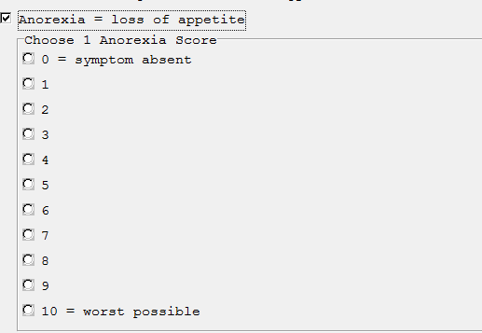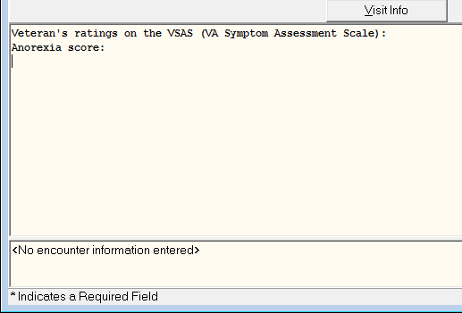
When a section is checked open the user must select one score. Note - symptom definitions are excluded from the progress note.

Missing Required Fields:
Whenever a section is opened the user is required to document a score in that section. If the user clicks on finish without scoring a symptom a pop-up box will appear directing the user back to that the specific unanswered symptom. For example, the ANOREXIA symptom section is not a required entry unless the user clicks on the checkbox for that section. Once that section is opened the user is required to select a score from the list. If the user clicks on finish without selecting an ANOREIXA score the user will get the following error message:
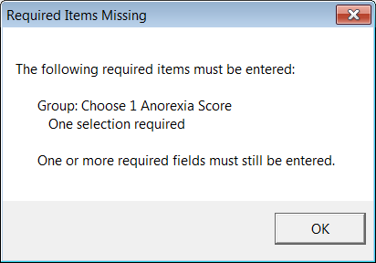

Pain Section
The pain symptom section is different from the other sections because it is part of the vital package, which means this score will display on the patient’s cover sheet
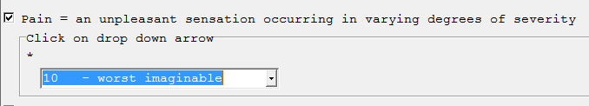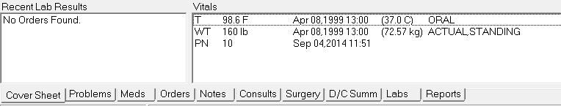

Instruction box for using the VA-Oncology Symptom Assessment Scale Template is included in template
