Advance Directive Notification and Screening Reminder Dialog
PXRM*2.0*57
INSTALLATION and SETUP GUIDE
March 2015

Product Development Department of Veterans Affairs

- Contents
- Introduction 3
- Pre-Installation 4
- Installation 6
- Post-Installation 9
  - VistA/CPRS Preparation 9
  - OPTIONAL - Set Up the Advance Directive Notification and Screening Progress Note Title in the VistA Text Integration Utility (TIU) 9
  - OPTIONAL - Activate the Reminder Dialog for TIU Use 15
  - OPTIONAL - Link the Advance Directive Notification and Screening Progress Note Title to the VA-ADVANCE DIRECTIVE NOTIFICATION AND SCREENING Reminder Dialog 17
Appendix A: Installation Example 20
Appendix B - Acronyms 22
Appendix C – Health Factors and Template Fields 23

Introduction

Patch PXRM*2.0*57 releases a new reminder dialog template to the field, without any changes to routines, data dictionaries, or other package functions; it deals with content only. The new reminder dialog template is:
VA-ADVANCE DIRECTIVE NOTIFICATION AND SCREENING.

This reminder dialog template is mandated for installation, but optional for use. While use of the reminder dialog template is optional, all sites are required to use two of the health factors exported by this template/patch. All sites will have to include the health factors, “Advance Directive Yes” and “Advance Directive No”, in their advance directive notification and screening processes as required by the Veterans Health Administration (VHA) Handbook 1004.02, “Advance Care Planning and Management of Advance Directives.” The use of this template and the associated health factors will help sites comply with the advance directive notification and screening requirements set forth in this Handbook.

Facilities will be required to install this template within normal installation timelines as established by OIT. The National Center for Ethics in Health Care (NCEHC) is the Program Office with oversight of this template and its associated processes.

Sites may wish to associate this reminder dialog template with the local and national enterprise standard progress note title, “ADVANCE DIRECTIVE NOTIFICATION AND SCREENING.”

Multiple installation steps will be required for this patch installation, and some actions will be optional. These actions should to be accomplished in your VistA/CPRS test account and then transitioned to your live account after successful testing.

These processes are outlined in the following guidance, but an overview is provided here:

• Pre-Installation. If your site has locally developed the two health factors, ADVANCE DIRECTIVE YES and ADVANCE DIRECTIVE NO, then you will have to take some pre- installation actions to modify these local health factors to allow for their national health factor equivalents to be installed via this patch. If not, the local health factors will be overwritten by the installation of the national health factors delivered in this patch.
- Post-Installation. Sites will need to ensure that the nationally delivered health factors, ADVANCE DIRECTIVE YES and ADVANCE DIRECTIVE NO, are incorporated into local processes for documenting Advance Directive Notification and Screening, as required by VHA Handbook 1004.02, Advance Care Planning and Management of Advance Directives.

Pre-Installation

Required Software for PXRM*2.0*57
Package/Patch | Namespace | Version | Comments
Clinical Reminders | PXRM | 2.0 | Fully patched
Health Summary | GMTS | 2.7 | Fully patched
Kernel | XU | 8.0 | Fully patched
VA FileMan | DI | 22 | Fully patched

Related Documentation
Documentation | Documentation File name
Installation and Setup Guide | PXRM*2.0*57_IG.PDF

Web Sites
Site | URL | Description
National Clinical Reminders site | http://vista.med.va.gov/reminders | Contains manuals, PowerPoint presentations, and other information about Clinical  Reminders
National Clinical Reminders Committee | http://vaww.portal.va.gov/sites/ncrc public/default.aspx | This committee directs the development of new and revised  national reminders
VistA Document Library | http://www.va.gov/vdl/ | Contains manuals for Clinical Reminders
Health Factor Set Up. If your site has locally developed and installed the two health factors, ADVANCE DIRECTIVE YES and ADVANCE DIRECTIVE NO, then you will have to take some pre-installation actions to modify these local health factors, changing their names, to allow for the installation of the national versions of these health factors via this patch. (***Note: The patch installation will overwrite the local health factors with the national health factors if they already exist in your VistA system. However, the associated health factor category will be different and this will likely impact your clinical reminder processes.)
• This patch installs multiple national health factors. However, sites may have already locally built the two health factors required to be used at all facilities in accordance with VHA Handbook 1004.02, “Advance Care Planning and Management of Advance Directives.” These are: ADVANCE DIRECTIVE YES and ADVANCE DIRECTIVE NO. Their
national standardization is needed to support Meaningful Use certification of the VA electronic health record. This patch will either overwrite your local health factors with the same name or fail to import these two national health factors. These issues can be avoided by changing the local health factor names to something else (e.g. ADVANCE DIRECTIVE YES-LOCAL and ADVANCE DIRECTIVE NO-LOCAL.)
• If needed, change the name of your two local health factors, ADVANCE DIRECTIVE YES and ADVANCE DIRECTIVE NO, to something else (locally determined). This will allow the new health factors to be installed in your Vista system via this patch. Then, after the patch is installed, replace the locally developed health factors in your local reminder dialogs

and/or clinical reminders with the nationally provided health factors delivered via this patch. Adjust the resolution logic of any clinical reminders to use the new health factors going forward and locally developed health factors for historical instances. This will allow for the use of the new, national health factors in your local processes going forward.
Changing the name of the Health Factors can be accomplished a couple of ways
- 1. Using fileman and editing the name of the health factor to include some local designation to differentiate them from the national Health Factors being installed
- 2. Using menu option PXTT EDIT HEALTH FACTORS

Installation
This patch can be installed with users on the system, but it should be done during non-peak hours. Estimated Installation Time: 1-2 minutes.

The installation needs to be done by a person with DUZ(0) set to "@."

Retrieve the host file from one of the following locations (with the ASCII file type):

Albany | REDACTED | REDACTED
Hines | REDACTED | REDACTED
Salt Lake City | REDACTED | REDACTED

Install the patch first in a training or test account.

Installing in a non-production environment will give you time to get familiar with new functionality and complete the setup for reminders and dialogs prior to installing the software in production.

Load the distribution.

Using the Kernel Installation & Distribution System menu (XPD MAIN), LOAD the Distribution. Enter <your directory name>PXRM_2_0_57.KID at the Host File prompt.

Example
Select Installation Option: LOAD a Distribution
Enter a Host File: <your directory name>PXRM_2_0_57.KID KIDS Distribution saved on

From the Installation menu, you may elect to use the following options:

Backup a Transport Global

This option will create a backup message of any routines exported with the patch. It will NOT back up any other changes such as DDs or templates.

a. Compare Transport Global to Current System

This option will allow you to view all changes that will be made when the patch is installed. It compares all components of the patch (routines, DDs, templates, etc.).

Install the build.

From the Installation menu on the Kernel Installation and Distribution System (KIDS) menu, run the option Install Package(s). Select the build PXRM*2.0*57 and proceed with the install. If you have problems with the installation, log a Remedy ticket and/or call the National Help Desk to report the problem.
Select Installation & Distribution System Option: Installation
Select Installation Option: INSTALL PACKAGE(S)
Select INSTALL NAME: PXRM*2.0*57

Answer "NO" to the following prompts:

NO//
Want KIDS to INHIBIT LOGONs during install? NO// NO
Want to DISABLE Scheduled Options, Menu Options, and Protocols?

NOTE: DO NOT QUEUE THE INSTALLATION, because this installation asks questions requiring responses and queuing will stop the installation. A Reminders Manager or CAC should be present to respond to these.

Installation Example

See Appendix A.

Install File Print

Use the KIDS Install File Print option to print out the results of the installation process. You can select the multi-package build or any of the individual builds included in the multi- package build.
Select Utilities Option: Install File Print Select INSTALL NAME: PXRM*2.0*57

Build File Print

Use the KIDS Build File Print option to print out the build components.
Select Utilities Option: Build File Print Select BUILD NAME: PXRM*2.0*57
DEVICE: HOME//

Post-installation routines

After successful installation, the following init routines may be deleted:

PXRMP57E PXRMP57I

Post-Installation

VistA/CPRS Preparation
After the patch is installed, ensure that all health factors installed by this patch have populated into the VistA Patient Care Encounter package, including the correct health factor category (see Appendix C for a list of the expected health factors.) If applicable, your site will need to replace the locally developed health factors in your local reminder dialogs and/or clinical reminders with the nationally provided health factors (ADVANCE DIRECTIVE YES and ADVANCE DIRECTIVE NO) delivered via this patch. Adjust the resolution logic of any clinical reminders to use the new health factors going forward and locally developed health factors for historical instances. This will allow for the use of the new, national health factors in your local processes going forward.

If you do not have a locally developed clinical reminder or reminder dialog template, you may link the associated reminder dialog template delivered with this patch to the new progress note title, ADVANCE DIRECTIVE NOTIFICATION AND SCREENING. You may also place this reminder dialog template in the Shared Templates section of CPRS Notes, for use with other progress note titles.

OPTIONAL - Set Up the Advance Directive Notification and Screening Progress Note Title in the VistA Text Integration Utility (TIU)
The Advance Directive Notification and Screening progress note title may be built using the Text Integration Utility in VistA. Note: The progress note title associated with this reminder dialog template must NOT be and should not be a CWAD posting progress note title.

Summary of actions:

    - Go into CPRS Configuration (Clinical Coordinator) Menu
    - Follow the menu path: TIU Maintenance Menu > Document Definitions (Manager)
> Create Document Definitions > Navigate to a locally developed progress note Document Class (NOT a CWAD Document Class)> Title > Advance Directive Notification and Screening
Select CPRS Configuration (Clin Coord) <TEST ACCOUNT> Option: ^

PXRM Reminder Managers Menu ... [PXRM MANAGERS MENU]
TIU TIU Maintenance Menu ... [TIU IRM MAINTENANCE MENU]
GMTS Health Summary Overall Menu ... [GMTS MANAGER] PCE PCE Coordinator Menu ... [PX PCE COORDINATOR MENU]
CPRS CPRS Configuration (Clin Coord) ... [OR PARAM COORDINATOR MENU]

Select Option: TIU Maintenance Menu

- TIU Parameters Menu ... [TIU SET-UP MENU]
- Document Definitions (Manager) ... [TIUF DOCUMENT DEFINITION MGR]
- User Class Management ... [USR CLASS MANAGEMENT MENU]
- TIU Template Mgmt Functions ... [TIU IRM TEMPLATE MGMT]
- TIU Alert Tools [TIU ALERT TOOLS]
7 TIUHL7 Message Manager [TIUHL7 MSG MGR]
Title Mapping Utilities ... [TIU MAP TITLES MENU]
6 Active Title Cleanup Report [TIU ACTIVE TITLE CLEANUP]

Select TIU Maintenance Menu <TEST ACCOUNT> Option: Document Definitions (Manager)
--- Manager Document Definition Menu ---

- Edit Document Definitions
- Sort Document Definitions
- Create Document Definitions
- Create Objects
- Create TIU/Health Summary Objects

Select Document Definitions (Manager) <TEST ACCOUNT> Option: Create Document Definitions

  - Create Document Definitions
  - Create Objects
  - Create TIU/Health Summary Objects

CHOOSE 1-3: 1 Create Document Definitions.............

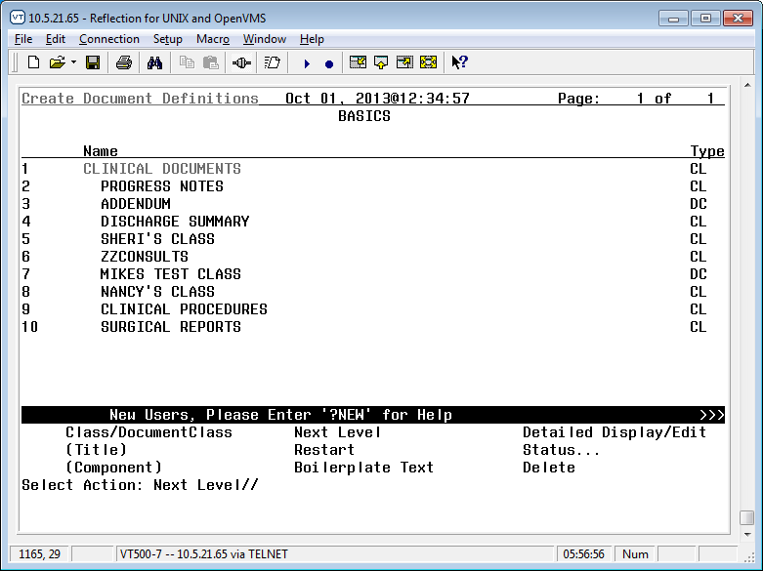
Select Action: Next Level// next Next Level
Select CLINICAL DOCUMENTS Item (Line 2-10): 2 (Progress Notes)

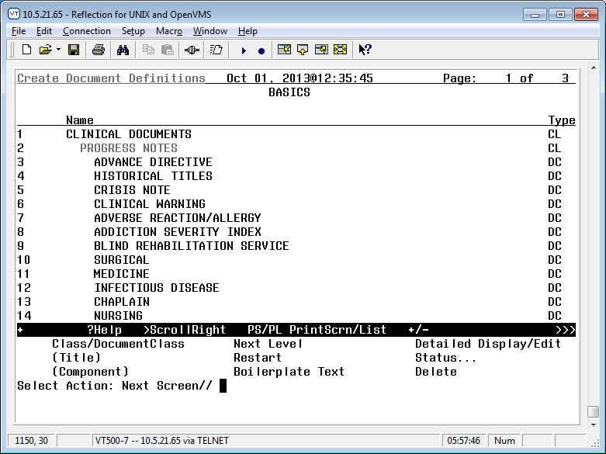
Select Action: Next Screen// Next Level
Select PROGRESS NOTES Item (Line 3-48): (enter number for the preferred, locally developed Progress Note Document Class…e.g., 45 for Paul’s Test Notes)

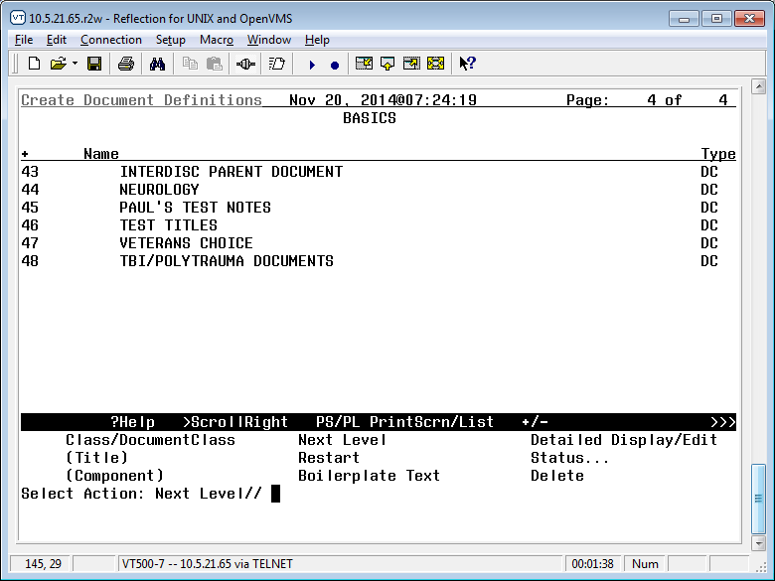

Select Action: Title//
Enter the Name of a new PAUL’S TEST NOTES: ADVANCE DIRECTIVE NOTIFICATION AND SCREENING
CLASS OWNER: CLINICAL COORDINATOR//
EVERY Local Title must be mapped to a VHA Enterprise Standard Title. Direct Mapping to Enterprise Standard Title...
Your LOCAL Title is: ADVANCE DIRECTIVE NOTIFICATION AND SCREENING

NOTE: Only ACTIVE Titles may be selected...
Select VHA ENTERPRISE STANDARD TITLE: ADVANCE DIRECTIVE NOTIFICATION AND SCREENING
I found a match of: ADVANCE DIRECTIVE NOTIFICATION AND SCREENING
... OK? Yes// YES

Ready to map LOCAL Title: ADVANCE DIRECTIVE NOTIFICATION AND
SCREENING to VHA Enterprise Standard Title: ADVANCE DIRECTIVE NOTIFICATION AND SCREENING.
... OK? Yes// YES
Done.

STATUS: (A/I/T): INACTIVE// ACTIVE Entry Activated. SEQUENCE:
MENU TEXT: ADVANCE DIRECTIVE NOTIFICATION AND SCREENING //

Entry Created
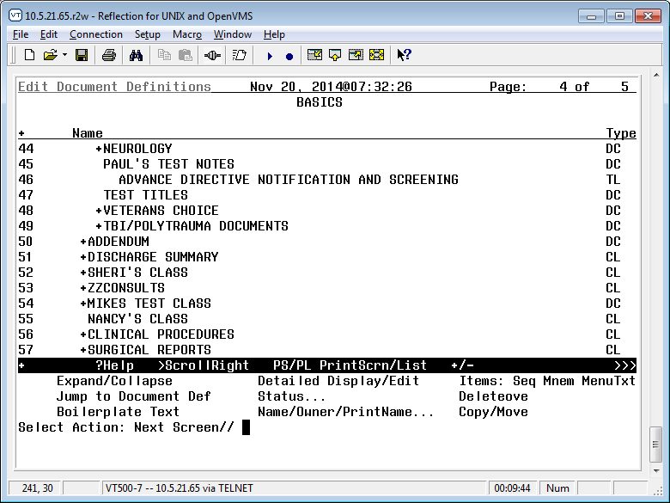

The Advance Directive Notification and Screening progress note title has now been created. It is active and available for use.

OPTIONAL - Activate the Reminder Dialog for TIU Use
You will need to activate the VA-ADVANCE DIRECTIVE NOTIFICATION AND SCREENING reminder dialog template for TIU use prior to linking it to the progress note title.
Summary of actions:

    - In VistA go to the PCRM Reminder Managers Menu
    - Follow the menu path: CP – CPRS Reminders Configuration > TIU - TIU Template Reminder Dialog Parameter > System

Select NATIONAL CONTENT DEVELOPMENT <TEST ACCOUNT> Option: PXRM
Reminder Managers Menu

CF Reminder Computed Finding Management ... RM Reminder Definition Management ...
SM Reminder Sponsor Management ... TXM Reminder Taxonomy Management ... TRM Reminder Term Management ...
LM Reminder Location List Management ... RX Reminder Exchange
RT Reminder Test
OS Other Supporting Menus ...
INFO Reminder Information Only Menu ... DM Reminder Dialog Management ...
CP CPRS Reminder Configuration ...
RP Reminder Reports ...
MST Reminders MST Synchronization Management ... PL Reminder Patient List Menu ...
PAR Reminder Parameters ...
ROC Reminder Order Check Menu ... XM Reminder Extract Menu ...
GEC GEC Referral Report

Select Reminder Managers Menu <TEST ACCOUNT> Option: CP CPRS Reminder Configuration

CA Add/Edit Reminder Categories CL CPRS Lookup Categories
CS CPRS Cover Sheet Reminder List MH Mental Health Dialogs Active PN Progress Note Headers
RA Reminder GUI Resolution Active
TIU TIU Template Reminder Dialog Parameter
DL Default Outside Location
PT Position Reminder Text at Cursor NP New Reminder Parameters

GEC WH
GEC Status Check Active WH Print Now Active
Select CPRS Reminder Configuration <TEST ACCOUNT> Option: TIU TIU Template Reminder Dialog Parameter

Reminder Dialogs allowed as Templates may be set for the following:
Enter selection: 5 System NATREM.FO-SLC.MED.VA.GOV

Setting Reminder Dialogs allowed as Templates for System: NATREM.FO- SLC.MED.VA.GOV
Select Display Sequence: ? to find the LAST sequence number available Then select the next number available.
Select Display Sequence: 99
Are you adding 99 as a new Display Sequence? Yes// YES
Display Sequence: 99//
99
Clinical Reminder Dialog: VA-ADVANCE DIRECTIVE NOTIFICATION AND SCREENING (D)
Select Display Sequence:

1 | User | USR | [choose | from NEW PERSON]
3 | Service | SRV | [choose | from SERVICE/SECTION]
4 | Division | DIV | [SALT LAKE CITY]
5 | System | SYS | [NATREM.FO-SLC.MED.VA.GOV]

OPTIONAL - Link the Advance Directive Notification and Screening Progress Note Title to the VA-ADVANCE DIRECTIVE NOTIFICATION AND SCREENING Reminder Dialog
Once the VA-ADVANCE DIRECTIVE NOTIFICATION AND SCREENING reminder dialog template is imported via the patch and you have set up the appropriate progress note title, you may add the reminder dialog template to the notes tab in CPRS and link it to the Advance Directive Notification and Screening progress note title.

You will need the ability to “Edit Shared Templates” in CPRS. Summary of actions:
- Go into CPRS Notes tab
- Follow the menu path: Options > Edit Shared Templates > Template Editor Window
- In CPRS, from the Notes Tab
  - Select the drop down for “Options”
  - Select “Edit Shared Templates”
- This will launch the “Template Editor” window.
  - Ensure that the box is checked for “Edit Shared Templates”
  - Select (single click) “Document Titles”
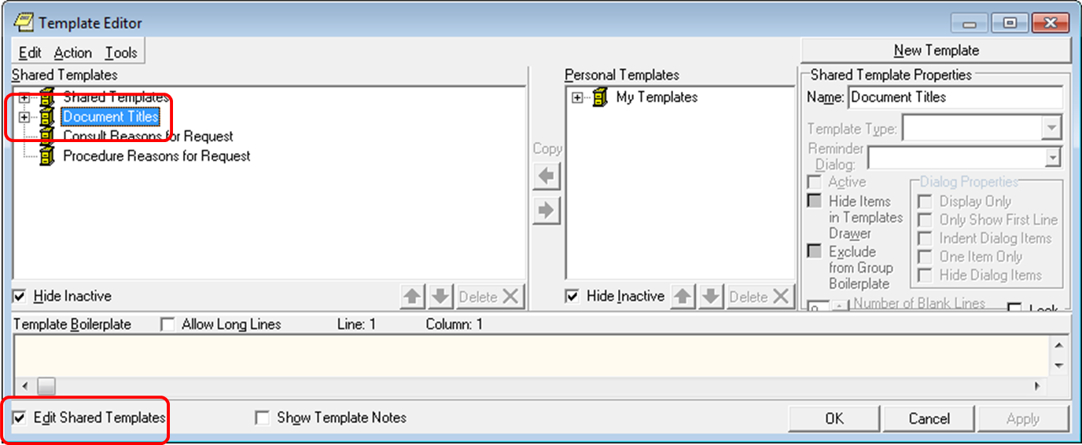

While still in the “Template Editor” window:
- Select “New Template”
- Replace the name “New Template” with “ADVANCE DIRECTIVE NOTIFICATION AND SCREENING”
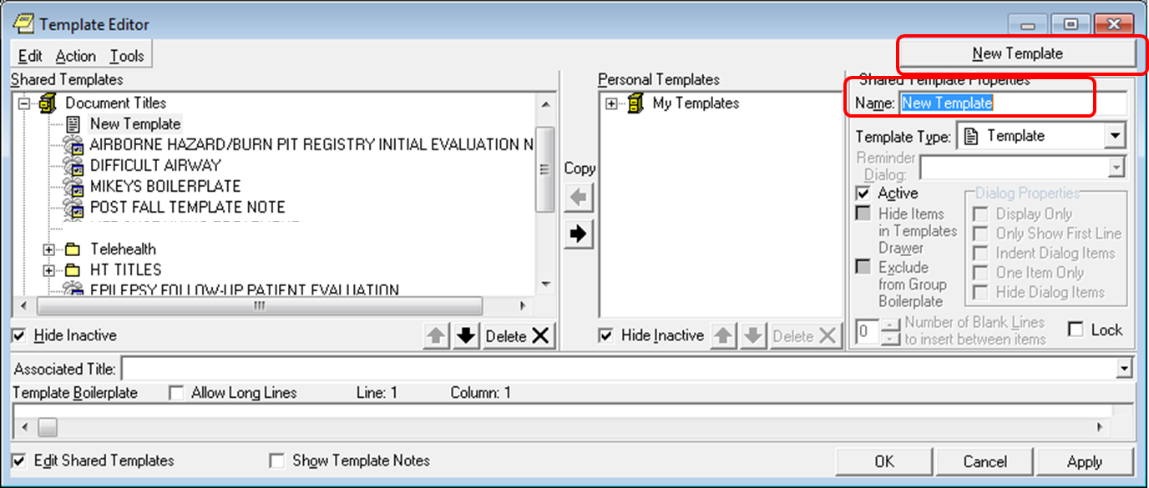

While still in the “Template Editor” window:
- Select “Reminder Dialog” on the drop down for “Template Type”
- Select “VA- ADVANCE DIRECTIVE NOTIFICATION AND SCREENING” on the drop down for “Reminder Dialog”
- Select “ADVANCE DIRECTIVE NOTIFICATION AND SCREENING” on the drop down for “Associated Title”
- Click “OK”

Here is an example of these actions. Please note that some options will be site-specific.
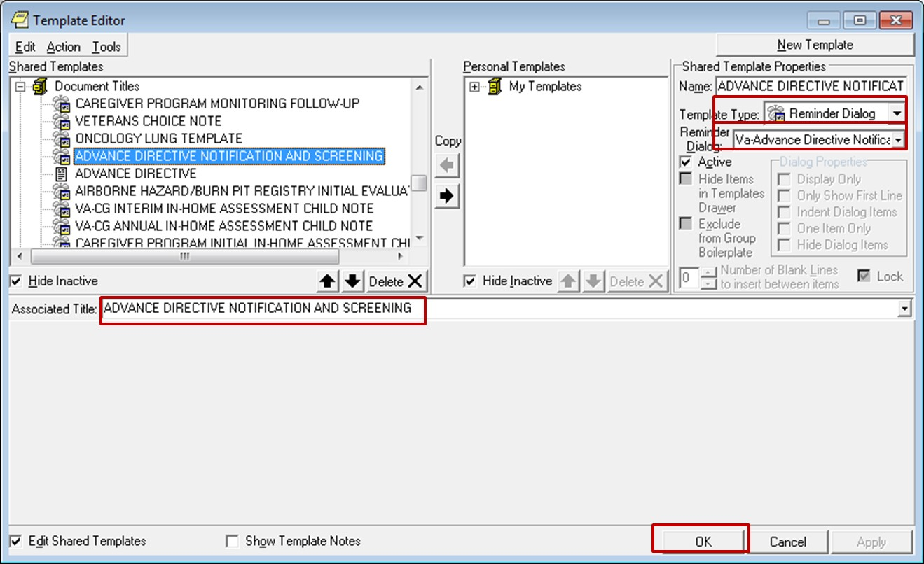
The VA-ADVANCE DIRECTIVE NOTIFICATION AND SCREENING reminder dialog
should now be available in CPRS, linked to the CPRS progress note title “Advance Directive Notification and Screening.” Test this by starting a new note with the title “Advance Directive Notification and Screening.” The reminder dialog template should launch and display the reminder dialog wizard.

Appendix A: Installation Example

Select Installation <TEST ACCOUNT> Option: 1 Load a Distribution Enter a Host File: <your directory>PXRM_2_0_57.KID

KIDS Distribution saved on Dec 22, 2014@10:35:15 Comment: VA-ADVANCED DIRECTIVE

This Distribution contains Transport Globals for the following Package(s): Build PXRM*2.0*57 has been loaded before, here is when:
PXRM*2.0*57 Install Completed
was loaded on Dec 22, 2014@10:40:37 OK to continue with Load? NO// YES

Distribution OK!

Want to Continue with Load? YES// Loading Distribution...

PXRM*2.0*57
Use INSTALL NAME: PXRM*2.0*57 to install this Distribution.

- Load a Distribution
- Verify Checksums in Transport Global
- Print Transport Global
- Compare Transport Global to Current System
- Backup a Transport Global
- Install Package(s)
Restart Install of Package(s) Unload a Distribution

Select Installation <TEST ACCOUNT> Option: INstall Package(s) Select INSTALL NAME: PXRM*2.0*57 12/31/14@07:12:11
=> VA-ADVANCED DIRECTIVE ;Created on Dec 22, 2014@10:35:15

This Distribution was loaded on Dec 31, 2014@07:12:11 with header of VA-ADVANCED DIRECTIVE ;Created on Dec 22, 2014@10:35:15
It consisted of the following Install(s): PXRM*2.0*57
Checking Install for Package PXRM*2.0*57 Install Questions for PXRM*2.0*57 Incoming Files:
811.8 REMINDER EXCHANGE (including data)
Note: You already have the 'REMINDER EXCHANGE' File. I will OVERWRITE your data with mine.

Want KIDS to INHIBIT LOGONs during the install? NO//
Want to DISABLE Scheduled Options, Menu Options, and Protocols? NO//

Enter the Device you want to print the Install messages.
You can queue the install by enter a 'Q' at the device prompt. Enter a '^' to abort the install.

DEVICE: HOME// TELNET PORT
--------------------------------------------------------------------------------

Install Started for PXRM*2.0*57 : Dec 31, 2014@07:12:24
Build Distribution Date: Dec 22, 2014 Installing Routines:
Dec 31, 2014@07:12:24
Running Pre-Install Routine: PRE^PXRMP57I Installing Data Dictionaries:
Dec 31, 2014@07:12:24

Installing Data:
Dec 31, 2014@07:12:26

Running Post-Install Routine: POST^PXRMP57I

There are 1 Reminder Exchange entries to be installed.
1. Installing Reminder Exchange entry PXRM*2.0*57 VA-ADVANCE DIRECTIVE NOTIFICATION AND SCREENING (D)
Updating Routine file... Updating KIDS files... PXRM*2.0*57 Installed.
Dec 31, 2014@07:12:37

Not a production UCI

PXRM*2.0*57

Install Completed

Appendix B - Acronyms

The OIT Master Glossary is available at: http://vaww.oed.wss.va.gov/process/Library/master_glossary/masterglossary.htm

Term | Definition
ADNS | Advance Directive Notification And Screening
CPRS | Computerized Patient Record System
CWAD | Crisis, Warning, Allergy and Advance Directive
NCEHC | National Center for Ethics in Health Care
OIT/OI&T | Office of Information Technology
TIU | Text Integration Utility
VHA | Veterans Health Administration

Appendix C – Health Factors and Template Fields

ADNS Reminder Dialog - Health Factors
Health Factor Category | Health Factor | Life-Sustaining Treatment Template Location
ETHICS-ADVANCE DIRECTIVE SCREENING | ADVANCE DIRECTIVE YES | VA-ADNS ADVANCE DIRECTIVE  HEADER YES-ON FILE (G)
ETHICS-ADVANCE DIRECTIVE SCREENING | ADVANCE DIRECTIVE YES | VA-ADNS ADVANCE DIRECTIVE  HEADER YES-NOT ON FILE (G)
ETHICS-ADVANCE DIRECTIVE SCREENING | ADVANCE DIRECTIVE NO | VA-ADNS ADVANCE DIRECTIVE HEADER NO (G)
ETHICS-ADVANCE DIRECTIVE SCREENING | ADVANCE DIRECTIVE  UNKNOWN | VA-ADNS ADVANCE DIRECTIVE  HEADER UNKNOWN (G)
ETHICS-ADVANCE DIRECTIVE SCREENING | ADVANCE DIRECTIVE-MH  PREFERENCES-YES | VA-ADNS MH PREFERENCES-YES  (G)
ETHICS-ADVANCE DIRECTIVE SCREENING | ADVANCE DIRECTIVE-MH PREFERENCES-NO | VA-ADNS MH PREFERENCES-NO (G)

CPRS Template Fields Delivered by the ADNS Reminder Dialog
VA-ETHICS-LINK-HB-1004-02
VA-ETHICS-WORD PROCESS 2 LINES REQ
VA-ETHICS-REQ COMMENT-DISP
VA-ETHICS-WP 2 LINE
VA-ETHICS-OPTIONAL COMMENT-DISP ONLY
VA-ETHICS-FORM 10-0137B
VA-ETHICS-FORM 10-0137A

12/31/2014 Clinical Reminders PXRM*2.0*57 Installation and Setup Guide 23

