Td, Tdap, Zoster, and Pneumococcal Vaccine Reminders – Update to Hepatitis C Risk reminder
PXRM*2.0*63

INSTALLATION and SETUP GUIDE
May 2016

Product Development Department of Veterans Affairs

Contents

Introduction 3
Pre-Installation 10
Installation 11
Post-Install Set-up Instructions 13
Appendix A: Installation Example 22
The OIT Master Glossary 29

Introduction

This patch does the following during installation:
- There 2 Reminder Exchange entry to be installed: PXRM*2.0*63 TDAP ZOSTER PNEUMO PXRM*2.0*63 HEP C RISK SCREEN
- Reminders Definitions:
VA-HEPATITIS C RISK SCREEN LONG TERM STEROID USE
VA-BL PNEUMOC RECENT CHEMO/IMMUNOSUPPRESSION VA-OB PNEUMOCOCCAL PRIOR VACCINATIONS
VA-OB PNEUMOCOCCAL PPSV23 INDICATIONS VA-OB ZOSTER VACCINE DATE
VA-BL PNEUMOC RISK IMMUNOCOMPROMISED VA-PNEUMOCOCCAL IMMUNIZATION PPSV23 VA-OB PNEUMOCOCCAL PCV13 INDICATIONS VA-OB TD/TDAP PRIOR VACCINATIONS
VA-TETANUS/DIPHTHERIA/PERTUSSIS (TDAP) IMMUNIZATION VA-TETANUS/DIPHTHERIA (TD) IMMUNIZATION
VA-HERPES ZOSTER (SHINGLES) IMMUNIZATION
- Reminder Dialogs
VA-HEPATITIS C RISK SCREEN
VA-PNEUMOCOCCAL IMMUNIZATION PCV13 PREVNAR
VA-PNEUMOCOCCAL IMMUNIZATION PPSV23 PNEUMOVAX VA-TETANUS/DIPHTHERIA/PERTUSSIS (TDAP) IMMUNIZATION VA-TETANUS/DIPHTHERIA (TD) IMMUNIZATION
VA-HERPES ZOSTER VACCINE
- Taxonomies
VA-HEPATITIS C SEROPOSITIVE
VA-DRUG ABUSE FOR HCV TESTING VA-HIV INFECTION
VA-ALCOHOL ABUSE
VA-PNEUMOC DZ RISK - CHEMOTHERAPY
VA-PNEUMOC DZ RISK - HIGHEST/NOT IMMUNO COMP VA-PNEUMOC DZ RISK - HIGH
VA-PNEUMOC PPSV23 IMMUNIZATION
VA-PNEUMOC DZ RISK - IMMUNOCOMPROMISED VA-PNEUMOC PCV13 IMMUNIZATION
VA-TDAP VACCINE (RD)
VA-TD VACCINE ADSORBED GENERIC (RD)
VA-TD VACCINE PRESERV FREE ADSORBED (RD) VA-HERPES ZOSTER (SHINGLES) IMMUNIZATION VA-IMMUNOCOMPROMISED
VA-TERMINAL CANCER PATIENTS

Description:

Tdap Vaccine:
A single dose of Tdap (Tetanus Toxoid, Reduced Diphtheria Toxoid and Acellular Pertussis vaccine) should be given regardless of when the last Tetanus containing product was received in adults who have not previously received Tdap. In addition, pregnant women should receive an additional dose during each pregnancy.
TdaP Contraindications:
- A history of serious allergic reaction (i.e., anaphylaxis) to any component of the vaccine.
- A history of encephalopathy (e.g., coma or prolonged seizures) not attributable to an identifiable cause within 7 days of administration of a vaccine with pertussis components. This contraindication is for the pertussis components, and these persons should receive Td instead of Tdap.

PREGNANT/BREASTFEEDING WOMEN:
Women's health care providers should implement a Tdap vaccination program for pregnant women. Health care providers should administer Tdap during each pregnancy, preferably during the third trimester (between 27-36 weeks gestation), although Tdap may be given at any time during pregnancy. If Tdap is not administered during pregnancy, Tdap should be administered immediately postpartum. The rationale for repeat vaccination during each pregnancy is that reported cases of pertussis continue to increase, uptake of Tdap vaccine among pregnant women remains low and new data indicate that maternal anti- pertussis antibodies are short-lived, thus Tdap vaccination in one pregnancy will not provide high levels of antibodies to protect newborns during subsequent pregnancies. The rationale for administration during the third trimester (between week 27-36 weeks gestation) is that this would provide the highest concentration of maternal antibodies to be transferred closer to birth, but also allow for the 2 weeks (before birth) required to mount a maximal immune response to the vaccine antigens.

**Since Tdap was NOT available before 2005 and was NOT given prior to 2006, any record of Tdap prior to these dates will be ignored and assumed to be an incorrect entry.

Td Vaccine:
Td (Tetanus and Diphtheria Toxoids) should be given to adults every 10 years as booster doses after the primary series of three vaccinations against diphtheria, tetanus, and pertussis that was received during infancy and childhood. If a dose is given sooner as part of wound management, the next booster is not needed until 10 years thereafter.

CONTRAINDICATIONS:
A contraindication is a condition in a recipient that increases the risk for a serious adverse reaction. A vaccine should not be administered when a contraindication is present.
- A history of serious allergic reaction (i.e., anaphylaxis) to any component of the vaccine.
- A history of a neurologic or severe hypersensitivity reaction following a previous dose.

This reminder is applicable only if a prior Tdap has been administered. This prevents both the Tdap reminder and this reminder from displaying at the same time in the same patient's record.

How the TDAP/TD reminders work:
Only one reminder would be due at a time – never both

Td:
- The reminder will apply to all adults aged 19 and older. A Td Vaccine is recommended every 10 years.
- This reminder is applicable only if a prior Tdap has been administered. This prevents both the Tdap reminder and this reminder from displaying at the same time in the same patient's record.
- Reminder Term, "VA-TETANUS/DIPHTHERIA IMMUNIZATION" includes the standardized immunization for Td. Sites should also include the immunizations that
were used for Td vaccines.
- Reminder Term, "VA-TETANUS/DIPHTHERIA DEFERRALS " should include any Health Factors that
have been in use at a VAMC to indicate the following items:
  - Td Immunization Refusal
  - Acute Febrile Illness
Any finding in this reminder term will resolve the reminder for predetermined amount of time.
- Reminder Term, "VA-TETANUS/DIPHTHERIA CONTRAINDICATION" contains computed findings looking for allergies to Tetanus or Diphtheria that
have been documented in the Allergy/Adverse Drug Reaction package. If found, the reminder will not apply - AND NOT Cohort Logic. Health Factors in use locally to document allergy to Td should also be included in the reminder term.
- Reminder Term, "VA-TETANUS/DIPHTHERIA ORDERS" should contain any orders for the Td vaccine. Sites should map any orders that are used for the Td
immunization. The reminder will be resolved for 28 days by the order for Td vaccine.
- COHORT:
  - Due for patient that have had the Tdap Immunization
  - Not applicable for patients with a Td Contraindication
- RESOLUTION:
  - Td immunization
  - Td Deferrals
  - Td Order

Tdap:
**Since Tdap was NOT available before 2005 and was NOT given prior to 2006, any record of Tdap prior to these dates will be ignored and assumed to be an incorrect entry.
- Reminder Term, "VA-TDAP IMMUNIZATION" includes the standardized immunization for Tdap. Sites should also include any locally
created immunizations that were used for Tdap vaccines.
- Reminder Term "VA-TDAP DEFERRALS" should include any Health Factors that have been in use at a VAMC to indicate the following items:
  - Tdap Immunization Refusal

  - Acute Febrile Illness
Any finding in this Reminder Term will resolve the reminder for predetermined amount of time.
- The Reminder Term, "VA-TDAP CONTRAINDICATION", contains Computed Findings looking for allergies to TETANUS, DIPHTHERIA or PERTUSSIS that have been documented in the Allergy/Adverse Drug Reaction package. If found, the reminder will not apply - AND NOT Cohort Logic.
- Reminder Term, "VA-TDAP ORDERS" should contain any orders for the Tdap vaccine. Sites should map any orders that are used for the Tdap
vaccine. The reminder will be resolved for 28 days by the order for TdaP vaccine.
- COHORT:
Not applicable for patients with a Tdap Contraindication
- RESOLUTION:
  - Tdap Immunization
  - Tdap Deferrals
  - Tdap Orders

Herpes Zoster (Shingles) Vaccine:

Zoster is a localized, generally painful cutaneous eruption that occurs most frequently among older adults and immunocompromised persons. It is caused by reactivation of latent varicella zoster virus (VZV) sometimes decades after initial VZV infection is established. A common complication of zoster is postherpetic neuralgia (PHN), a chronic, often debilitating pain condition that can last months or even years.

Zoster vaccine is partially efficacious at preventing zoster, at reducing the severity and duration of pain and at preventing postherpetic neuralgia (PHN) among those developing zoster. A single dose of shingles vaccine is recommended for adults 60 years of age and older who does not have contraindications to the vaccine.
Patients with a history of zoster CAN be vaccinated. CONTRAINDICATIONS:
- History of anaphylactic reaction to any component of the vaccine, including gelatin and
neomycin.
- Persons with primary or acquired immunodeficiency including, leukemia, lymphomas, or other malignant neoplasms affecting the bone marrow or lymphatic system.
- AIDS or other clinical manifestations of HIV.
- Persons on immunosuppressive therapy, including high-dose corticosteroids.
- Persons receiving recombinant human immune mediators and immune modulators.
- Persons undergoing hematopoietic stem cell transplantation (HSCT).
- Pregnant or might be pregnant.

PRECAUTIONS:
- Persons who have severe acute illness should be postponed until recovery.
- Zoster should be deferred in patients with active, untreated tuberculosis.

How the Herpes Zoster reminder works:

- The reminder applies to all adults aged 60 and older.
- Reminder Term, "VA-ZOSTER IMMUNIZATION" includes the standardized immunization for herpes zoster.
- Reminder Term, "VA-ZOSTER DEFERRALS" should include any Health Factors that have been in use at a VAMC to indicate the following items:
  - Herpes Zoster refusal
  - A precaution
  - Herpes Zoster vaccine unavailable
Any finding in this reminder term will resolve the reminder for 3 months.
- Reminder Term, "VA-ZOSTER CONTRAINDICATION" contains computed findings looking for allergies to gelatin, neomycin, or zoster vaccine documented in the Allergy/Adverse Drug Reaction package and health factors representing a contraindication. If found, the reminder will not apply.
- Reminder Term, "VA-ZOSTER ORDERS" should contain any orders for the vaccine. Map any orderable items for administering the Herpes Zoster Vaccine. The reminder will be resolved for 28 days by the order for herpes zoster vaccine.
- Three reminder terms VA-CHEMO/IMMUNOSUPPRESSIVE DRUGS, VA-HIGH DOSE STEROIDS, and VA-IMMUNOCOMPROMISED represent contraindications for the herpes zoster vaccine. If found, the reminder will not apply.
- COHORT:
  - Patients 60 yo and older
  - Not applicable for patients with a herpes zoster contraindication
- RESOLUTION:
  - Zoster immunization
  - Zoster Deferrals
  - Zoster Order

Updates to PPSV23/PCV13 national reminders

Update June 2015 - ACIP changed the recommendations to increase time period from PCV13 to PPSV23 to one year for patients age 65 and older who are not immunocompromised. The time period remains 2 months for patients age <65 or for patients who are immunocompromised. The PPSV23 reminder definition has been updated to follow this guidance.

Both reminders, VA-PNEUMOCOCCAL IMMUNIZATION PCV13 and VA-PNEUMOCOCCAL
IMMUNIZATION PPSV23 had a few entries for found text in the reminder definition that are updated in this version. The basic logic of the PCV13 reminder has not been changed.

There was one update to the dialog element VA-IM PNEUMOC VHA GUIDANCE LINKS, outlining the new guidelines. The VIS date for PPSV23 was also updated in dialog element TEXT PNEUMOC PPSV23 VIS.

Technical Description of changes to the PPSV23 reminder definition

Update June 2015 - ACIP changes recommendations to increase time period from PCV13 to PPSV23 to one year for patients age 65 and older who are not immunocompromised. Remains 8 weeks for patients
<65 or who are immunocompromised.

Two new function findings are added to the PPSV23 reminder: FF(22) and FF(23)

The time period for waiting ((2M for <65 or IC, 1Y for >64 and not IC) is based on the age of the patient at the time of the vaccine administration.
In FF(22) this is represented by the DIFF_DATE function which compares the date of birth to the date of administration of PCV13. The DTIME_DIFF function in FF(22) and FF(23) compares the date of the most recent dose to today's date.
FF(22) (((DTIME_DIFF(7,1,"DATE",19,1,"DATE","D","A")>55)&(FI(17)!
(DIFF_DATE(19,1)<23742)))!(DTIME_DIFF(7,1,"DATE",19,1,"DATE","D","A")>364)&FI(19))! (FI(15)&'FI(19))

PCV13 >55 days ago if administered <65 or immunocompromised,
PCV13 over 1 year ago, or contraindication to PCV13 and has not had PCV13

FF(23) ((DTIME_DIFF(7,1,"DATE",19,1,"DATE","D","A")>55)&FI(19))!'FI(19)

PCV13 over 56 days ago,
Or has not had PCV13
(since this FF is used only on patients <65, it does not need to explicitly include an age like FF(22) does)

The cohort logic is divided into 2 sections - 1. for patients who need PCV13 first and 2. for patients who do not need PCV13.

1. (((FI(3)&FF(12))!FI(4)!FI(7)!FI(18)!(FI(16)&(FF(16)!FF(17)!FF(18)!FF(19))))&FF(22))

2. !(((FI(2)&FF(13)&FF(23)))&'((FI(3)&FF(12))!FI(4)!FI(7)!FI(18)
(FI(16)&(FF(16)!FF(17)!FF(18)!FF(19)))))&'FI(8)

Part 1 will not be true if unless PCV13 was given outside the required time periods (2M for <65 or IC, 1Y for >64 not IC), so PCV13 must be given and the time period must have elapsed or the patient has a contraindication and then FF(22) will be true.

Part 2 will not be true if PCV13 was administered in the past 2 months, this part of the logic only applies to patients less than 65 who do not require PCV13.

Name change - VA-HEPATITIS C RISK SCREEN
It was identified at specific sites that including the word “Assessment” in the title of the HEPATITIS C Risk Screening Clinical Reminder prevented particular clinicians from being able to perform the Hepatitis C Risk Screen. In order to support all sites, the name of the Clinical Reminder has been changed from Hepatitis C Risk Assessment to Hepatitis C Risk Screen

This patch will update your existing reminder VA-HEPATITIS C RISK ASSESSMENT to the name VA-HEPATITIS C RISK SCREEN.

The reminder definition, print name, reminder term, reminder dialog and health factor names have all been changed from ASSESSMENT to SCREEN. No content or functionality has changed

This reminder was originally installed with patch PXRM*2.0*52 with the name VA-HEPATITIS C RISK ASSESSMENT.

Pre-Installation

Required Software for PXRM*2*63
Package/Patch | Namespace | Version | Comments
Clinical Reminders | PXRM | 2.0 | Fully patched
Health Summary | GMTS | 2.7 | Fully patched
Kernel | XU | 8.0 | Fully patched
NATIONAL DRUG FILE | PSN | 4.0 | Fully patched
Pharmacy Data Management | PSS | 1.0 | Fully patched
Outpatient Pharmacy | PSO | 7.0 | Fully patched
VA FileMan | DI | 22 | Fully patched

Related Documentation
Documentation | Documentation File name
Installation and Setup Guide | PXRM_2_0 IG.PDF
Web Sites
Site | URL | Description
National Clinical Reminders site | http://vista.med.va.gov/reminders | Contains manuals, PowerPoint  presentations, and other information about Clinical Reminders
National Clinical Reminders Committee | http://vaww.portal.va.gov/sites/ncrc public/default.aspx | This committee directs the development of new and revised  national reminders
VistA Document  Library | http://www.va.gov/vdl/ | Contains manuals for Clinical  Reminders and

- Do a reminder inquiry on both the reminders VA-PNEUMOCOCCAL IMMUNIZATION PPSV23 and VA-PNEUMOCOCCAL IMMUNIZATION PCV13 and save this as a reference for post installation, you will need to re-map several reminder terms post-install.
- Check the dialog groups for quick orders for the immunizations and record those entries so they can be re-entered after installation:
OI PNEUMOC PCV13 OUTPT SHORT OI PNEUMOC PPSV23 OUTPT

Do a reminder inquiry for the reminder definition VA-HEPATITIS C RISK ASSESSMENT and save this as a reference for post installation, you will need to re-map several reminder terms post-install.
- Check the dialog element VA-HEP C TESTING ORDER ANTI-HCV for a quick order finding item for the Hep C lab test and record that entry so it can be re-entered after installation.
- Review and print term VA-BL HEP C RISK ASSMNT ORDERS OPTION prior to install to compare to term VA-BL HEP C RISK SCREEN ORDERS OPTION post install. (this term will be renamed during the installation)

Installation

This patch can be installed with users on the system, but it should be done during non-peak hours. Estimated Installation Time: 10-15 minutes

The installation needs to be done by a person with DUZ(0) set to "@."

NOTE: We recommend that a Clinical Reminders Manager or CAC be present during the install, so that if questions occur during the install of Reminder Exchange entries, a knowledgeable person can respond to them.
- Retrieve the host file from one of the following Secure FTP sites (with the ASCII file type):
REDACTED
REDACTED
REDACTED
Albany Hines
Salt Lake City

- Install the patch first in a training or test account.
Installing in a non-production environment will give you time to get familiar with new functionality and complete the setup for reminders and dialogs prior to installing the software in production.

Load the distribution.
In programmer mode type, D ^XUP, select the Kernel Installation & Distribution System menu (XPD MAIN), then the Installation option, and then the option LOAD a Distribution. Enter your directory name. KID at the Host File prompt.

Example

From the Installation menu, you may elect to use the following options:

Backup a Transport Global
This option will create a backup message of any routines exported with the patch. It will NOT back up any other changes such as DDs or templates.

Compare Transport Global to Current System
This option will allow you to view all changes that will be made when the patch is installed. It compares all components of the patch (routines, DDs, templates, etc.).

Install the build.
From the Installation menu on the Kernel Installation and Distribution System (KIDS) menu, run the option Install Package(s). Select the build PXRM*2.0*63 and proceed with the install. If you have problems with the installation, log a Remedy ticket and/or call the National Help Desk to report the problem.

Answer "NO" to the following prompt:

Want KIDS to INHIBIT LOGONs during install? NO// NO

NOTE: DO NOT QUEUE THE INSTALLATION, because this installation asks questions requiring responses and queuing will stop the installation. A Reminders Manager or CAC should be present to respond to these.

Installation Example
See Appendix A.

Install File Print
Use the KIDS Install File Print option to print out the results of the installation process. You can select the multi-package build or any of the individual builds included in the multi-package build.

Build File Print
Use the KIDS Build File Print option to print out the build components.

Post-installation routines

After successful installation, the following init routines may be deleted:

Post-Install Set-up Instructions Td Reminder
- Map your local Td immunization types in the Reminder Term: VA-
TETANUS/DIPHTHERIA IMMUNIZATION
- Map your local health factors used to indicate Td Immunization Refusal or Acute Febrile Illness in the Reminder Term: VA-TETANUS/DIPHTHERIA DEFERRALS and add appropriate beginning dates to temporarily resolve the reminder, dependent upon the reason for deferral and according to local policy.
- Map your local health factors used to indicate Td Allergy in the Reminder Term: VA- TETANUS/DIPHTHERIA CONTRAINDICATION
- Map your local orderable items for immunizations if you want the active/pending order to resolve the reminder (optional) in the Reminder Term: VA-TETANUS/DIPHTHERIA ORDERS Limit the finding status to ACTIVE, PENDING, and RENEWED.
- Add any local order/orderable item to element: OI TD OUTPT
- Two template fields are used for Lot #s and expiration dates and manufacturer. They are exported as EDIT BOXES, for free text entry. Sites may choose to change the TYPE to a COMBO box and then populate the template fields with local lot #s and expiration dates.
  - IM TD LOT# EXP DATE
  - IM TD MANUF

Changing the type is done in CPRS under Template Editor on the Notes Tab.
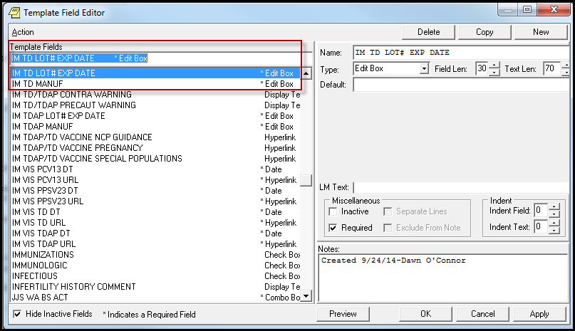

Tdap Reminder:
- Map your local Tdap immunization types in the Reminder Term: VA-TDAP IMMUNIZATION
- Map your local health factors used to indicate Tdap Immunization Refusal or Acute Febrile Illness in the Reminder Term : VA-TDAP DEFERRALS and add appropriate beginning dates to temporarily resolve the reminder, dependent upon the reason for deferral and according to local policy.
- Map your local health factors used to indicate Tdap Allergy in the Reminder Term: VA-TDAP CONTRAINDICATION
- Map your local orderable items for immunizations if you want the active/pending order to resolve the reminder (optional) in the Reminder Term: VA-TDAP ORDERS Limit the finding status to ACTIVE, PENDING, and RENEWED.
- Add any local order/orderable item to element: OI TDAP OUTPT
- Two template fields are used for Lot #s and expiration dates and manufacturer. They are exported as EDIT BOXES, for free text entry. Sites may choose to change the TYPE to a COMBO box and then populate the template fields with local lot #s and expiration dates.
  - IM TDAP LOT# EXP DATE
  - IM TDAP MANUF

Changing the type is done in CPRS under Template Editor on the Notes Tab.
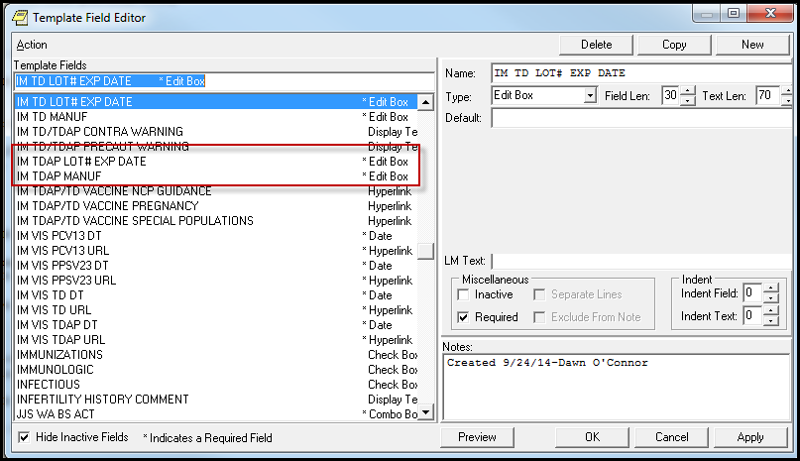

TD and TDAP reminder term used for order suppression:
The order option in the dialog can be suppressed for specific user classes or for everyone using the reminder term:

VA-TD/TDAP ORDER SUPPRESSION
Finding:
- To suppress for specific user classes, in the above Term configure the VA-ASU USER CLASS computed finding and DELETE the VA-AGE finding. NOTE: If the Age finding is not deleted, the user class settings will not work.
VA-ASU USER CLASS
Enter the user class in the Computed Finding Parameter field that should NOT see the option to order the TD/TDAP vaccines.
If more than one user class is needed, add additional findings of the CF VA-ASU USER CLASS for each one as needed.

- To suppress for EVERYONE, in the above term DELETE the VA-ASU USER CLASS finding and edit the VA-AGE computed finding.
VA-AGE
To suppress the order from being seen by ANYONE, delete the Condition within the VA-AGE computed finding.

Zoster Reminder:
- Map your local Zoster immunization types in the Reminder Term : VA-ZOSTER IMMUNIZATION
- Map your local health factors used to indicate Zoster immunization refusal, deferral, or vaccine unavailable in the Reminder Term : VA-ZOSTER DEFERRALS and add appropriate beginning dates to temporarily resolve the reminder, dependent upon the reason for deferral and according to local policy.
- Map your local health factors used to indicate Zoster allergy or other contraindications in the Reminder Term: VA-ZOSTER CONTRAINDICATION.
- Map your local orderable items for administering the Herpes Zoster vaccine for active/pending orders in the Reminder Term : VA-ZOSTER ORDERS. Limit the finding status to ACTIVE, PENDING, and RENEWED.
- Map local dosage formulations for high dose corticosteroids in the Reminder Term : VA-HIGH DOSE STEROIDS.

Include the below drugs and any higher dosages (if available):
PREDNISONE 20MG TAB, PREDNISONE 50MG TAB, DEXAMETHASONE 4MG, CORTISONE 100MG TAB, HYDROCORTISONE 80MG, TRIAMCINOLONE 16MG, METHYLPREDNISOLONE 16MG, BETAMETHASONE 3MG
It is important to consult your local Pharmacy to insure all appropriate dosage formulations are entered in the term.
High dose steroids are a contraindication to administration of the Herpes Zoster vaccine. The dose that is considered high enough to be a contraindication is 20mg per day or higher of prednisone (or the equivalent dose of other steroids) for longer than 2 weeks.

The Guidance Statement posted on the NCP web page has this information included:
Persons on immunosuppressive therapy, including high-dose corticosteroids (>20 mg/day of prednisone or equivalent) lasting two or more weeks. Zoster vaccination should be deferred for at least 1 month after discontinuation of such therapy. http://vaww.prevention.va.gov/Herpes_Zoster_Shingles_Immunization.asp#precautions

Clinical reminders cannot easily interpret a dose from the drug findings available in the prescription file. Reminders can use the dosage formulation – tablet size - to try and infer a total dosage. The day’s supply and tablets dispensed could be used in complex logic but that logic would be different for each tablet size. For this reason, sites need to work with their Medical Staff and Pharmacy to determine the optimal dosage formulations to put into the reminder term VA- HIGH DOSE STEROIDS.

Prednisone 20mg is equivalent to: Cortisone 100mg PO Hydrocortisone 80mg PO Prednisolone 20mg PO Triamcinolone 16mg PO Methylprednisolone 16mg PO

Betamethasone 3mg PO Dexamethasone 3mg PO

In general, it would be appropriate to include any dosage formulation of >20mg of prednisone or the equivalent in the reminder term which make the reminder not applicable. The common tablet sizes that represent this dose or higher are:
Prednisone 20mg and 50mg Methylprednisolone 16mg and 32 mg Dexamethasone 3mg, 4mg and 6mg

However, many sites use smaller pill sizes to give high dose steroids. For example, 5 or 10mg tablets of prednisone may be dispensed to give a 25mg or 40 mg total dose. As a site, you need to work with your Medical Staff to decide which of these to include (if any) in the reminder term.

If you do include 5mg of prednisone in the reminder term, then the reminder will be not applicable for some patients who are on a low dose steroid and who would benefit from the vaccine. And, if you do not include the 5mg dose in the reminder term, the reminder may be due for some patients who are on a multiple tablet regimen that is a high dose steroid and for whom the vaccine is contraindicated. You need to work with your Medical Staff, Primary Care providers and Pharmacy to determine the best cut off to use at your facility to avoid missing opportunities to offer the vaccine and to avoid giving the vaccine to those on high dose steroids for whom it is contraindicated.

- Place your local quick order used to order herpes zoster vaccine as a finding item in dialog group: VA-HERPES ZOSTER ORDER
- Two template fields are used for Lot #s and expiration dates and manufacturer. They are exported as EDIT BOXES, for free text entry. Sites may choose to change the TYPE to a COMBO box and then populate the template fields with local lot #s and expiration dates.
  - IM ZOSTER LOT# EXP DATE
  - IM ZOSTER MANUF

Changing the template field is done in CPRS under Template Editor on the Notes Tab.
1. Check the mapping of the reminder terms in the reminder definitions by comparing the reminder inquiry that was save prior to installation with a reminder inquiry post-install.
2. Check the reminder terms for the 2 immunizations and include any local entries. The national entries for these 2 immunizations are included:
PNEUMOCOCCAL CONJUGATE PCV 13 PNEUMOCOCCAL POLYSACCHARIDE PPV23

3. Check that the order dialogs are present in the 2 reminder dialog elements for ordering the immunizations from the pre-install steps.

The order option in the dialog can be suppressed for specific user classes or for everyone using the reminder terms:
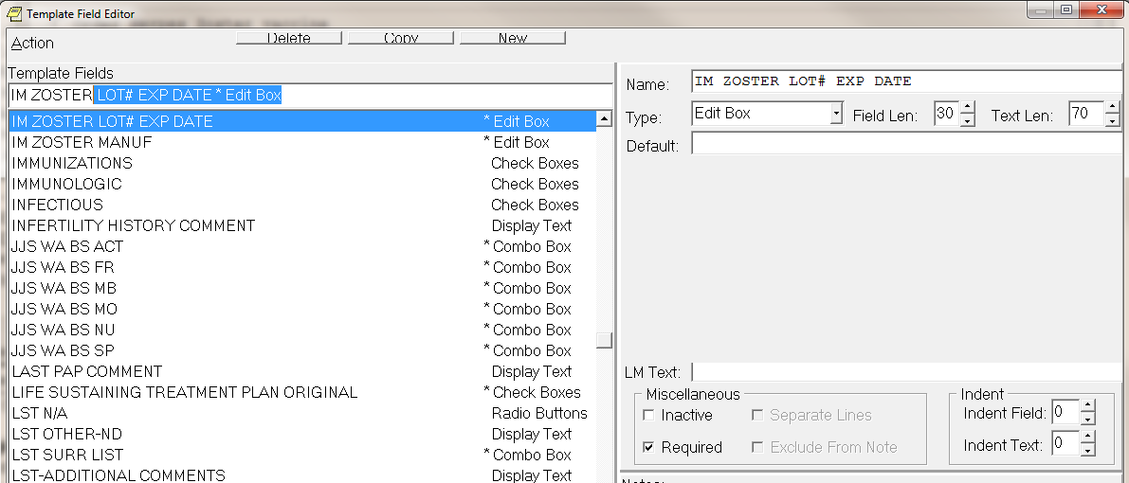

Herpes Zoster reminder term used for order suppression:
The order option in the dialog can be suppressed for specific user classes or for everyone using the reminder term:

VA-ZOSTER ORDER SUPPRESSION
Finding:
- To suppress for specific user classes, in the above Term configure the VA-ASU USER CLASS computed finding and DELETE the VA-AGE finding. NOTE: If the Age finding is not deleted, the user class settings will not work.
VA-ASU USER CLASS
Enter the user class in the Computed Finding Parameter field that should NOT see the option to order the Zoster vaccine.
If more than one user class is needed, add additional findings of the CF VA-ASU USER CLASS for each one as needed.

- To suppress for EVERYONE, in the above term DELETE the VA-ASU USER CLASS finding and edit the VA-AGE computed finding.
VA-AGE
To suppress the order from being seen by ANYONE, delete the Condition within the VA-AGE computed finding.

Herpes Zoster reminder term used to suppress documentation of Administration:
The option to document administration in the dialog can be suppressed for specific user classes or for everyone using the reminder terms. If the option to document administration is suppressed, the reminder would be used to place the order or document a historical vaccination:

VA-ZOSTER ADMINISTRATION SUPPRESSION
Finding:
- To suppress for specific user classes, in the above Term configure the VA-ASU USER CLASS computed finding and DELETE the VA-AGE finding. NOTE: If the Age finding is not deleted, the user class settings will not work.
VA-ASU USER CLASS
Enter the user class in the Computed Finding Parameter field that should NOT see the option to document administration of the Herpes Zoster vaccine.
If more than one user class is needed, add additional findings of the CF VA-ASU USER CLASS for each one as needed.

- To suppress for EVERYONE, in the above term DELETE the VA-ASU USER CLASS finding and edit the VA-AGE computed finding.
VA-AGE
To suppress the option to document administration from being seen by ANYONE, delete the Condition within the VA-AGE computed finding.

Pneumococcal Reminders:
- Check the mapping of the reminder terms in the reminder definitions by comparing the reminder inquiry that was save prior to installation with a reminder inquiry post-install.
- Check the reminder terms for the 2 immunizations and include any local entries. The national entries for these 2 immunizations are included:
PNEUMOCOCCAL CONJUGATE PCV 13 PNEUMOCOCCAL POLYSACCHARIDE PPV23
- Check that the order dialogs are present in the 2 reminder dialog elements for ordering the immunizations from the pre-install steps.
- Two template fields are used for Lot #s and expiration dates. They are exported as EDIT BOXES, for free text entry. Sites may choose to change the TYPE to a COMBO box and then populate the template fields with local lot #s and expiration dates. Verify that these are still set up to your sites preference

IM PCV13 LOT# EXP DATE IM PPSV23 LOT# EXP DATE
Changing the type is done in CPRS under Template Editor on the Notes Tab.
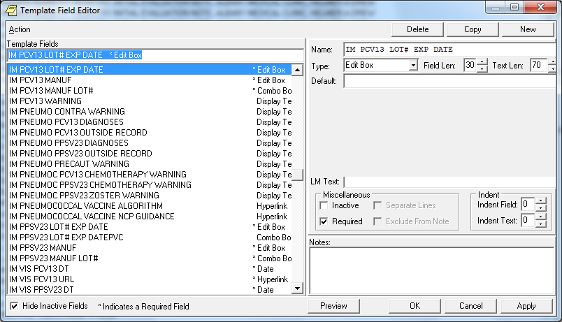

Pneumococcal reminder term used for order suppression:
The order option in the dialog can be suppressed for specific user classes or for everyone using the reminder terms:

VA-PNEUMOC PCV13 ORDER SUPPRESSION VA-PNEUMOC PPSV23 ORDER SUPPRESSION

- To suppress for specific user classes, in the above Terms configure the VA-ASU USER CLASS computed finding and DELETE the VA-AGE finding. NOTE: If the Age finding is not deleted, the user class settings will not work.

VA-ASU USER CLASS
Enter the user class in the Computed Finding Parameter field that should NOT see the option to order the pneumococcal vaccines.
If more than one user class is needed, add additional findings of the CF VA-ASU USER CLASS for each one as needed.

- To suppress for EVERYONE, in the above TERMS DELETE the VA-ASU USER CLASS finding and edit the VA-AGE computed finding.
VA-AGE
To suppress the order from being seen by ANYONE, delete the Condition within the VA-AGE computed finding.

Hepatitis C Risk Screen:
- Check the mapping of the reminder terms in the reminder definition by comparing the reminder inquiry that was saved prior to installation with a reminder inquiry post-install.
- Add the quick order for your local Hepatitis C lab test to dialog element VA-HEP C TESTING ORDER ANTI-HCV as a finding.
- Decide whether or not to include the Hepatitis C Testing options in the Hepatitis C Risk Screen.

The Hepatitis C Risk Screen dialog includes the options for documenting Hepatitis C Testing in the positive risk screen option (below). This is included for sites that want the ability to resolve both reminders in the same encounter as their reminder processing allows. This function is optional. The Hepatitis C Testing functions and documentation are inherently the responsibility of a practitioner (for example, physician, nurse practitioner or physician’s assistant) and if sites elect to combine the two reminders, assignment to/completion of this clinical reminder should be limited to practitioners with the authority to complete all of the associated actions in the clinical record (e.g., obtaining and documenting specific informed consent for testing; ordering of the lab test; and documenting a patient’s reason(s) for declining the test and the expected outcome.) If you have previously combined the two reminders, you may need to separate out the Hepatitis C Risk Screen from the Hepatitis C testing functions if they are being completed by medical staff such as LVNs and RNs without a scope of practice sufficient to complete all associated actions.

The testing options section in the risk screen is controlled with branching logic within the VA- HEPATITIS C RISK SCREEN dialog. The group named VA HEP C RISK SCREEN TESTING
HEADER has a reminder term VA-BL HEP C RISK SCREEN ORDERS OPTION, which decides whether to display the options or not.

To see how your site had the order option configured prior to this update, review the printout of term VA-BL HEP C RISK ASSMNT ORDERS OPTION that was printed as part of the pre-install instructions.
The reminder term, VA-BL HEP C RISK SCREEN ORDERS OPTION, is installed WITHOUT a mapped finding. As installed, the term will evaluate as FALSE and the testing options will NOT display to the user in the VA HEPATITIS C RISK SCREEN.

If your site does NOT want the testing options displayed in the Risk Screen dialog: DO NOTHING. Leave the term blank.

To display the testing options in the risk screen:

Add the Computed finding VA-AGE to the term, VA-BL HEP C RISK SCREEN ORDERS OPTION, which will evaluate as TRUE for all patients and display the testing options. You do not need to add any conditions to the finding
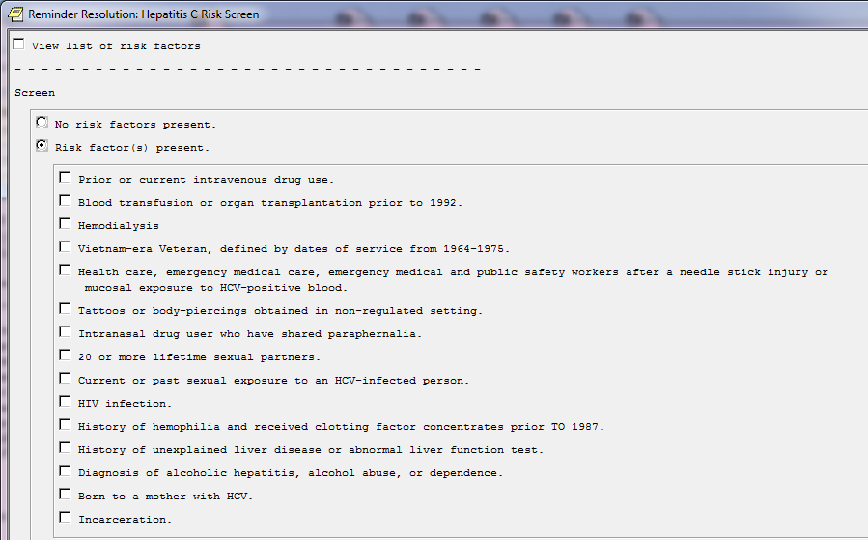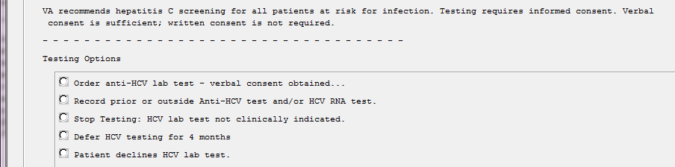

Appendix A: Installation Example
Select Installation <TEST ACCOUNT> Option: INSTAll Package(s) Select INSTALL NAME: PXRM*2.0*63 4/29/16@11:41:19
=> TDAP/Zoster/PNEUMO, HepC Screen Reminder Updates ;Created on Mar 10, This Distribution was loaded on Apr 29, 2016@11:41:19 with header of
TDAP/Zoster/PNEUMO, HepC Screen Reminder Updates ;Created on Mar 10, 2016@08
:58:32
It consisted of the following Install(s):
PXRM*2.0*63
Checking Install for Package PXRM*2.0*63 Install Questions for PXRM*2.0*63 Incoming Files:
811.8 REMINDER EXCHANGE (including data)
Note: You already have the 'REMINDER EXCHANGE' File. I will OVERWRITE your data with mine.
Want KIDS to INHIBIT LOGONs during the install? NO//
Want to DISABLE Scheduled Options, Menu Options, and Protocols? NO// Enter the Device you want to print the Install messages.
You can queue the install by enter a 'Q' at the device prompt. Enter a '^' to abort the install.
DEVICE: HOME// SSH Virtual Terminal

Install Started for PXRM*2.0*63 : Apr 29, 2016@11:43:28
Build Distribution Date: Mar 10, 2016 Installing Routines:
Apr 29, 2016@11:43:28
Running Pre-Install Routine: PRE^PXRMP63I DISABLE options.
DISABLE protocols. Installing Data Dictionaries:
Apr 29, 2016@11:43:29
Installing Data:
Apr 29, 2016@11:43:32
Running Post-Install Routine: POST^PXRMP63I ENABLE options.
ENABLE protocols.
There are 2 Reminder Exchange entries to be installed.
- Installing Reminder Exchange entry PXRM*2.0*63 HEP C RISK SCREEN
- Installing Reminder Exchange entry PXRM*2.0*63 TDAP ZOSTER PNEUMO Updating Routine file...
Updating KIDS files... PXRM*2.0*63 Installed.
Apr 29, 2016@11:49:31

Not a production UCI
PXRM*2.0*63
Install Completed

Note: You MAY see the following errors during the installation. NO ACTION is needed. IMMUNIZATION entry PNEUMOCOCCAL CONJUGATE PCV 13 did not get installed! Examine the following error message for the reason.

The test update failed, UPDATE^DIE returned the following error message: MSG("DIERR")=1^1
MSG("DIERR",1)=405 MSG("DIERR",1,"PARAM",0)=2 MSG("DIERR",1,"PARAM",1)=9999999.14 MSG("DIERR",1,"PARAM","FILE")=9999999.14
MSG("DIERR",1,"TEXT",1)=Entries in file 9999999.14 cannot be edited. MSG("DIERR","E",405,1)=
MSG("DIMSG")=1
MSG("DIMSG",1)= Entries must be added via the Master File Server(MFS). IMMUNIZATION entry PNEUMOCOCCAL CONJUGATE PCV 13 did not get installed!
Examine the following error message for the reason.

The update failed, UPDATE^DIE returned the following error message: MSG("DIERR")=1^1
MSG("DIERR",1)=405 MSG("DIERR",1,"PARAM",0)=2 MSG("DIERR",1,"PARAM",1)=9999999.14 MSG("DIERR",1,"PARAM","FILE")=9999999.14
MSG("DIERR",1,"TEXT",1)=Entries in file 9999999.14 cannot be edited. MSG("DIERR","E",405,1)=
MSG("DIMSG")=1
MSG("DIMSG",1)= Entries must be added via the Master File Server(MFS).

IMMUNIZATION entry PNEUMOCOCCAL POLYSACCHARIDE PPV23 did not get installed! Examine the following error message for the reason.

The test update failed, UPDATE^DIE returned the following error message: MSG("DIERR")=1^1
MSG("DIERR",1)=405 MSG("DIERR",1,"PARAM",0)=2 MSG("DIERR",1,"PARAM",1)=9999999.14 MSG("DIERR",1,"PARAM","FILE")=9999999.14
MSG("DIERR",1,"TEXT",1)=Entries in file 9999999.14 cannot be edited. MSG("DIERR","E",405,1)=
MSG("DIMSG")=1
MSG("DIMSG",1)= Entries must be added via the Master File Server(MFS). IMMUNIZATION entry PNEUMOCOCCAL POLYSACCHARIDE PPV23 did not get installed! Examine the following error message for the reason.

The update failed, UPDATE^DIE returned the following error message: MSG("DIERR")=1^1
MSG("DIERR",1)=405 MSG("DIERR",1,"PARAM",0)=2 MSG("DIERR",1,"PARAM",1)=9999999.14 MSG("DIERR",1,"PARAM","FILE")=9999999.14
MSG("DIERR",1,"TEXT",1)=Entries in file 9999999.14 cannot be edited. MSG("DIERR","E",405,1)=
MSG("DIMSG")=1
MSG("DIMSG",1)= Entries must be added via the Master File Server(MFS). IMMUNIZATION entry ZOSTER did not get installed!

Examine the following error message for the reason.

The test update failed, UPDATE^DIE returned the following error message: MSG("DIERR")=1^1
MSG("DIERR",1)=405 MSG("DIERR",1,"PARAM",0)=2 MSG("DIERR",1,"PARAM",1)=9999999.14 MSG("DIERR",1,"PARAM","FILE")=9999999.14
MSG("DIERR",1,"TEXT",1)=Entries in file 9999999.14 cannot be edited. MSG("DIERR","E",405,1)=
MSG("DIMSG")=1
MSG("DIMSG",1)= Entries must be added via the Master File Server(MFS). IMMUNIZATION entry ZOSTER did not get installed!
Examine the following error message for the reason.

The update failed, UPDATE^DIE returned the following error message: MSG("DIERR")=1^1
MSG("DIERR",1)=405 MSG("DIERR",1,"PARAM",0)=2 MSG("DIERR",1,"PARAM",1)=9999999.14 MSG("DIERR",1,"PARAM","FILE")=9999999.14
MSG("DIERR",1,"TEXT",1)=Entries in file 9999999.14 cannot be edited. MSG("DIERR","E",405,1)=
MSG("DIMSG")=1
MSG("DIMSG",1)= Entries must be added via the Master File Server(MFS).

IMMUNIZATION entry MENINGOCOCCAL MCV4, UNSPECIFIED FORMULATION did not get
installed!
Examine the following error message for the reason.

The test update failed, UPDATE^DIE returned the following error message: MSG("DIERR")=1^1
MSG("DIERR",1)=405 MSG("DIERR",1,"PARAM",0)=2 MSG("DIERR",1,"PARAM",1)=9999999.14 MSG("DIERR",1,"PARAM","FILE")=9999999.14
MSG("DIERR",1,"TEXT",1)=Entries in file 9999999.14 cannot be edited. MSG("DIERR","E",405,1)=
MSG("DIMSG")=1
MSG("DIMSG",1)= Entries must be added via the Master File Server(MFS). IMMUNIZATION entry MENINGOCOCCAL MCV4, UNSPECIFIED FORMULATION did not get
insta lled!
Examine the following error message for the reason.

The update failed, UPDATE^DIE returned the following error message: MSG("DIERR")=1^1
MSG("DIERR",1)=405 MSG("DIERR",1,"PARAM",0)=2 MSG("DIERR",1,"PARAM",1)=9999999.14 MSG("DIERR",1,"PARAM","FILE")=9999999.14
MSG("DIERR",1,"TEXT",1)=Entries in file 9999999.14 cannot be edited. MSG("DIERR","E",405,1)=
MSG("DIMSG")=1
MSG("DIMSG",1)= Entries must be added via the Master File Server(MFS).

IMMUNIZATION entry MENINGOCOCCAL MCV4O did not get installed! Examine the following error message for the reason.

The test update failed, UPDATE^DIE returned the following error message: MSG("DIERR")=1^1
MSG("DIERR",1)=405 MSG("DIERR",1,"PARAM",0)=2 MSG("DIERR",1,"PARAM",1)=9999999.14 MSG("DIERR",1,"PARAM","FILE")=9999999.14
MSG("DIERR",1,"TEXT",1)=Entries in file 9999999.14 cannot be edited. MSG("DIERR","E",405,1)=
MSG("DIMSG")=1
MSG("DIMSG",1)= Entries must be added via the Master File Server(MFS). IMMUNIZATION entry MENINGOCOCCAL MCV4O did not get installed!
Examine the following error message for the reason.

The update failed, UPDATE^DIE returned the following error message: MSG("DIERR")=1^1
MSG("DIERR",1)=405 MSG("DIERR",1,"PARAM",0)=2 MSG("DIERR",1,"PARAM",1)=9999999.14 MSG("DIERR",1,"PARAM","FILE")=9999999.14
MSG("DIERR",1,"TEXT",1)=Entries in file 9999999.14 cannot be edited. MSG("DIERR","E",405,1)=
MSG("DIMSG")=1
MSG("DIMSG",1)= Entries must be added via the Master File Server(MFS).

IMMUNIZATION entry MENINGOCOCCAL MCV4P did not get installed! Examine the following error message for the reason.

The test update failed, UPDATE^DIE returned the following error message: MSG("DIERR")=1^1
MSG("DIERR",1)=405 MSG("DIERR",1,"PARAM",0)=2 MSG("DIERR",1,"PARAM",1)=9999999.14 MSG("DIERR",1,"PARAM","FILE")=9999999.14
MSG("DIERR",1,"TEXT",1)=Entries in file 9999999.14 cannot be edited. MSG("DIERR","E",405,1)=
MSG("DIMSG")=1
MSG("DIMSG",1)= Entries must be added via the Master File Server(MFS). IMMUNIZATION entry MENINGOCOCCAL MCV4P did not get installed!
Examine the following error message for the reason.

The update failed, UPDATE^DIE returned the following error message: MSG("DIERR")=1^1
MSG("DIERR",1)=405 MSG("DIERR",1,"PARAM",0)=2 MSG("DIERR",1,"PARAM",1)=9999999.14 MSG("DIERR",1,"PARAM","FILE")=9999999.14
MSG("DIERR",1,"TEXT",1)=Entries in file 9999999.14 cannot be edited. MSG("DIERR","E",405,1)=
MSG("DIMSG")=1
MSG("DIMSG",1)= Entries must be added via the Master File Server(MFS). IMMUNIZATION entry MENINGOCOCCAL C CONJUGATE did not get installed!

Examine the following error message for the reason.

The test update failed, UPDATE^DIE returned the following error message: MSG("DIERR")=1^1
MSG("DIERR",1)=405 MSG("DIERR",1,"PARAM",0)=2 MSG("DIERR",1,"PARAM",1)=9999999.14 MSG("DIERR",1,"PARAM","FILE")=9999999.14
MSG("DIERR",1,"TEXT",1)=Entries in file 9999999.14 cannot be edited. MSG("DIERR","E",405,1)=
MSG("DIMSG")=1
MSG("DIMSG",1)= Entries must be added via the Master File Server(MFS). IMMUNIZATION entry MENINGOCOCCAL C CONJUGATE did not get installed!
Examine the following error message for the reason.

The update failed, UPDATE^DIE returned the following error message: MSG("DIERR")=1^1
MSG("DIERR",1)=405 MSG("DIERR",1,"PARAM",0)=2 MSG("DIERR",1,"PARAM",1)=9999999.14 MSG("DIERR",1,"PARAM","FILE")=9999999.14
MSG("DIERR",1,"TEXT",1)=Entries in file 9999999.14 cannot be edited. MSG("DIERR","E",405,1)=
MSG("DIMSG")=1
MSG("DIMSG",1)= Entries must be added via the Master File Server(MFS).

IMMUNIZATION entry TD (ADULT) did not get installed! Examine the following error message for the reason.

The test update failed, UPDATE^DIE returned the following error message: MSG("DIERR")=1^1
MSG("DIERR",1)=405 MSG("DIERR",1,"PARAM",0)=2 MSG("DIERR",1,"PARAM",1)=9999999.14 MSG("DIERR",1,"PARAM","FILE")=9999999.14
MSG("DIERR",1,"TEXT",1)=Entries in file 9999999.14 cannot be edited. MSG("DIERR","E",405,1)=
MSG("DIMSG")=1
MSG("DIMSG",1)= Entries must be added via the Master File Server(MFS). IMMUNIZATION entry TD (ADULT) did not get installed!
Examine the following error message for the reason.

The update failed, UPDATE^DIE returned the following error message: MSG("DIERR")=1^1
MSG("DIERR",1)=405 MSG("DIERR",1,"PARAM",0)=2 MSG("DIERR",1,"PARAM",1)=9999999.14 MSG("DIERR",1,"PARAM","FILE")=9999999.14
MSG("DIERR",1,"TEXT",1)=Entries in file 9999999.14 cannot be edited. MSG("DIERR","E",405,1)=
MSG("DIMSG")=1
MSG("DIMSG",1)= Entries must be added via the Master File Server(MFS).

IMMUNIZATION entry TDAP did not get installed! Examine the following error message for the reason.

The test update failed, UPDATE^DIE returned the following error message: MSG("DIERR")=1^1
MSG("DIERR",1)=405 MSG("DIERR",1,"PARAM",0)=2 MSG("DIERR",1,"PARAM",1)=9999999.14 MSG("DIERR",1,"PARAM","FILE")=9999999.14
MSG("DIERR",1,"TEXT",1)=Entries in file 9999999.14 cannot be edited. MSG("DIERR","E",405,1)=
MSG("DIMSG")=1
MSG("DIMSG",1)= Entries must be added via the Master File Server(MFS). IMMUNIZATION entry TDAP did not get installed!
Examine the following error message for the reason.

The update failed, UPDATE^DIE returned the following error message: MSG("DIERR")=1^1
MSG("DIERR",1)=405 MSG("DIERR",1,"PARAM",0)=2 MSG("DIERR",1,"PARAM",1)=9999999.14 MSG("DIERR",1,"PARAM","FILE")=9999999.14
MSG("DIERR",1,"TEXT",1)=Entries in file 9999999.14 cannot be edited. MSG("DIERR","E",405,1)=
MSG("DIMSG")=1
MSG("DIMSG",1)= Entries must be added via the Master File Server(MFS).

IMMUNIZATION entry TD (ADULT) PRESERVATIVE FREE did not get installed! Examine the following error message for the reason.

The test update failed, UPDATE^DIE returned the following error message: MSG("DIERR")=1^1
MSG("DIERR",1)=405 MSG("DIERR",1,"PARAM",0)=2 MSG("DIERR",1,"PARAM",1)=9999999.14 MSG("DIERR",1,"PARAM","FILE")=9999999.14
MSG("DIERR",1,"TEXT",1)=Entries in file 9999999.14 cannot be edited. MSG("DIERR","E",405,1)=
MSG("DIMSG")=1
MSG("DIMSG",1)= Entries must be added via the Master File Server(MFS). IMMUNIZATION entry TD (ADULT) PRESERVATIVE FREE did not get installed!
Examine the following error message for the reason.

The update failed, UPDATE^DIE returned the following error message: MSG("DIERR")=1^1
MSG("DIERR",1)=405 MSG("DIERR",1,"PARAM",0)=2 MSG("DIERR",1,"PARAM",1)=9999999.14 MSG("DIERR",1,"PARAM","FILE")=9999999.14
MSG("DIERR",1,"TEXT",1)=Entries in file 9999999.14 cannot be edited. MSG("DIERR","E",405,1)=
MSG("DIMSG")=1
MSG("DIMSG",1)= Entries must be added via the Master File Server(MFS).

IMMUNIZATION entry TD (ADULT), ADSORBED did not get installed! Examine the following error message for the reason.

The test update failed, UPDATE^DIE returned the following error message: MSG("DIERR")=1^1

MSG("DIERR",1)=405 MSG("DIERR",1,"PARAM",0)=2 MSG("DIERR",1,"PARAM",1)=9999999.14 MSG("DIERR",1,"PARAM","FILE")=9999999.14
MSG("DIERR",1,"TEXT",1)=Entries in file 9999999.14 cannot be edited. MSG("DIERR","E",405,1)=
MSG("DIMSG")=1
MSG("DIMSG",1)= Entries must be added via the Master File Server(MFS). IMMUNIZATION entry TD (ADULT), ADSORBED did not get installed!
Examine the following error message for the reason.

The update failed, UPDATE^DIE returned the following error message: MSG("DIERR")=1^1
MSG("DIERR",1)=405 MSG("DIERR",1,"PARAM",0)=2 MSG("DIERR",1,"PARAM",1)=9999999.14 MSG("DIERR",1,"PARAM","FILE")=9999999.14
MSG("DIERR",1,"TEXT",1)=Entries in file 9999999.14 cannot be edited. MSG("DIERR","E",405,1)=
MSG("DIMSG")=1
MSG("DIMSG",1)= Entries must be added via the Master File Server(MFS).

IMMUNIZATION entry TD(ADULT) UNSPECIFIED FORMULATION did not get installed! Examine the following error message for the reason.

The test update failed, UPDATE^DIE returned the following error message: MSG("DIERR")=1^1
MSG("DIERR",1)=405 MSG("DIERR",1,"PARAM",0)=2 MSG("DIERR",1,"PARAM",1)=9999999.14 MSG("DIERR",1,"PARAM","FILE")=9999999.14
MSG("DIERR",1,"TEXT",1)=Entries in file 9999999.14 cannot be edited. MSG("DIERR","E",405,1)=
MSG("DIMSG")=1
MSG("DIMSG",1)= Entries must be added via the Master File Server(MFS). IMMUNIZATION entry TD(ADULT) UNSPECIFIED FORMULATION did not get installed! Examine the following error message for the reason.

The update failed, UPDATE^DIE returned the following error message: MSG("DIERR")=1^1
MSG("DIERR",1)=405 MSG("DIERR",1,"PARAM",0)=2
PXRM*2.0*63 MSG("DIERR",1,"PARAM",1)=9999999.14 MSG("DIERR",1,"PARAM","FILE")=9999999.14
MSG("DIERR",1,"TEXT",1)=Entries in file 9999999.14 cannot be edited. MSG("DIERR","E",405,1)=
MSG("DIMSG")=1
MSG("DIMSG",1)= Entries must be added via the Master File Server(MFS).

The OIT Master Glossary is available at
http://vaww.oed.wss.va.gov/process/Library/master_glossary/masterglossary.htm

Term | Definition
ASU | Authorization/Subscription Utility
Clin4 | National Customer Support team that supports Clinical Reminders
CPRS | Computerized Patient Record System
DBA | Database Administration
DG | Registration and Enrollment Package namespace
ESM | Enterprise Systems Management (ESM)
FIM | Functional Independence Measure
GMTS | Health Summary namespace (also HSUM)
GUI | Graphic User Interface
HRMH/HRMHP | High Risk Mental Health Patient
IAB | Initial Assessment & Briefing
ICD-10 | International Classification of Diseases, 10th Edition
ICR | Internal Control Number
IOC | Initial Operating Capabilities
LSSD | Last Service Separation Date
MH | Mental Health
MHTC | Mental Health Treatment Coordinator
OHI | Office of Health Information
OI | Office of Information
OIF/OEF | Operation Iraqi Freedom/Operation Enduring Freedom
OIT/OI&T | Office of Information Technology
OMHS | Office of Mental Health Services
ORR | Operational Readiness Review
PCS | Patient Care Services
PD | Product Development
PIMS | Patient Information Management System
PMAS | Program Management Accountability System
PTM | Patch Tracker Message
PXRM | Clinical Reminder Package namespace

Term | Definition
RSD | Requirements Specification Document
SD | Scheduling Package Namespace
SQA | Software Quality Assurance
USR | ASU package namespace
VA | Department of Veteran Affairs
VHA | Veterans Health Administration
VISN | Veterans Integrated Service Network
VistA | Veterans Health Information System and Technology Architecture

