VA-COVID-19 CPRS STATUS VERSION 5

Clinical Reminders Install Guide

August 2020

Product Development Office of Information Technology Department of Veterans Affairs

Table of Contents
INTRODUCTION 1
PRE-INSTALL 2
INSTALL DETAILS 2
INSTALL EXAMPLE 2

Introduction

This update will update the CPRS BANNER to Version 5. To keep from having to remap your Lab and Orderable Item terms, we will ask you to do an INSTALL SELECTED for items 10,22 and 25. Detailed information provided below in installation section.

This reminder content contains 1 Reminder Exchange entry:

VA-COVID-19 CPRS STATUS VERSION 5
The exchange file contains the following components: HEALTH FACTORS
VA-COVID-19
VA-COVID-19 NO LONGER SUSPECTED
VA-COVID-19 INCORRECT PRIOR POSITIVE PCR VA-COVID-19 RESOLVED
VA-COVID-19 SUSPECTED
VA-COVID-19 OUTSIDE PCR SPEC COLLECTED VA-COVID-19 PCR LAB OUTSIDE NEGATIVE VA-COVID-19 PCR LAB OUTSIDE POSITIVE

REMINDER COMPUTED FINDINGS
VA-DATE OF DEATH

REMINDER TAXONOMY
VA-COVID-19 SNOMED CODES

REMINDER TERM
VA-COVID-19 PROB LIST DX VA-COVID-19 PCR LAB ORDERS VA-COVID-19 CLINICAL INFO
VA-COVID-19 OUTSIDE RESULTS VA-COVID-19 PRESUMED
VA-COVID-19 ANTIBODY LAB TEST VA-COVID-19 PCR/AG LAB RESULTS VA-COVID-19 NO LONGER PRESUMED
VA-COVID-19 INCORRECT PRIOR POSITIVE PCR RESULT VA-COVID-19 PCR LAB RESULTS POSITIVE
VA-COVID-19 OUTSIDE PCR LAB POSITIVE
VA-COVID-19 OUTSIDE PCR SPECIMEN COLLECTED VA-COVID-19 RECOVERED
VA-COVID-19 OUTSIDE PCR LAB NEGATIVE VA-COVID-19 PCR LAB RESULTS NEGATIVE

REMINDER DEFINITION
VA-COVID-19 CPRS STATUS

Pre-install

You may want to save a printout of your reminder terms which contain your COVID-19 lab tests and COVID-19 Orderable items in case these are accidentally overwritten.
The terms you may want to save are:

VA-COVID-19 ANTIBODY LAB TEST – only for COVID antibody Lab Tests VA-COVID-19 PCR LAB ORDERS – only for PCR Orderable items
VA-COVID-19 PCR LAB RESULTS NEGATIVE – only for PCR Lab Tests VA-COVID-19 PCR LAB RESULTS POSITIVE – only for PCR Lab Tests
VA-COVID-19 PCR/AG LAB RESULTS – only for PCR Lab tests

Install Details

This update is being distributed as a web host file. The address for the host file is:
REDACTED

The file will be installed using Reminder Exchange, programmer access is not required.

Installation:
=============
This update can be loaded with users on the system. Installation will take less than 10 minutes

Install Example

To Load the Web Host File. Navigate to Reminder exchange in Vista
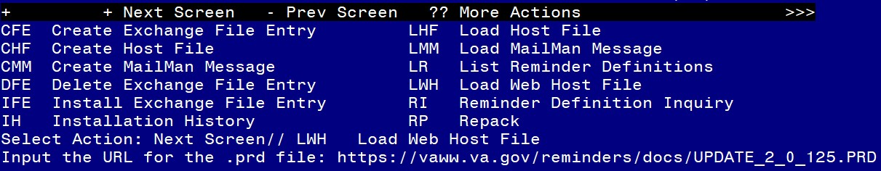
At the Select Action: prompt, enter LWH for Load Web Host File
At the Input the url for the .prd file: prompt, type the following web address: https://vaww.va.gov/reminders/docs/COVID_VERSION_5.PRD You should see a message at the top of your screen that the file loaded successfully

Search and locate an entry titled VA-COVID-19 CPRS STATUS VERSION 5 in reminder exchange
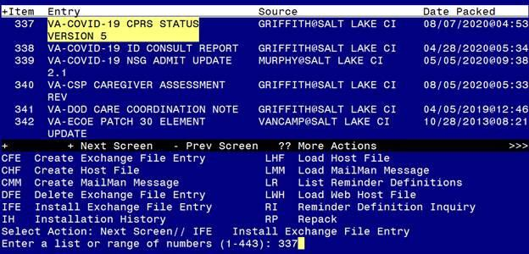
At the Select Action prompt, enter IFE for Install Exchange File Entry
Enter the number that corresponds with your entry titled VA-COVID-19 CPRS STATUS VERSION 5 (in this example it is entry 337, it will vary by site). Ensure the date of the exchange file is 08/07/2020

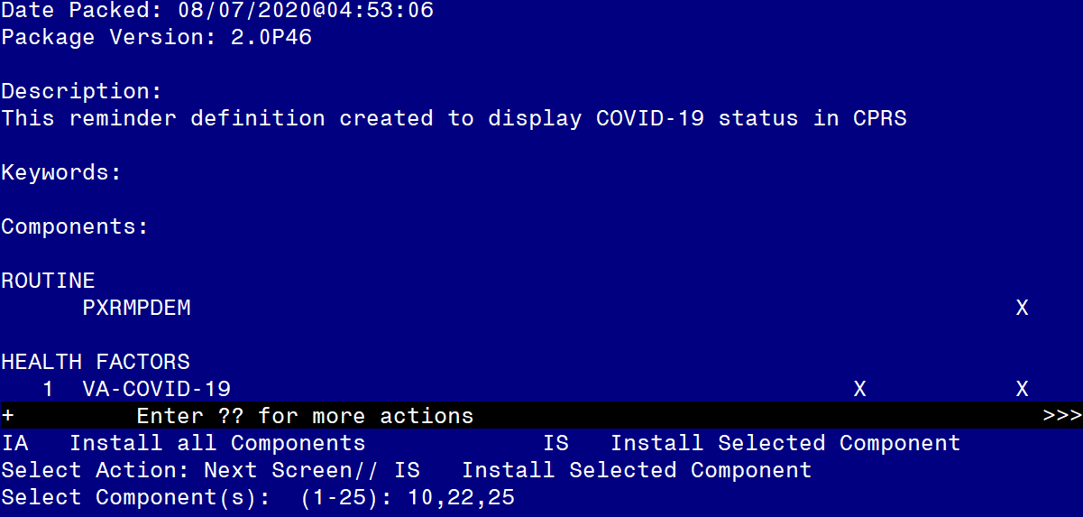

At the Select Action prompt, type IS for Install Selected Components. Choose items 10, 22 and 25 to install and hit enter.

You will INSTALL all NEW components. When prompted for an action on the Reminder Definition, user OVERWRITE action

REMINDER TERM entry VA-COVID-19 PROB LIST DX is NEW,
what do you want to do?
Select one of the following:
C Create a new entry by copying to a new name I Install
Q Quit the install
S Skip, do not install this entry Enter response: I// nstall
REMINDER TERM entry named VA-COVID-19 RECOVERED already exists but the packed component is different, what do you want to do?
Select one of the following:
C Create a new entry by copying to a new name M Merge findings
O Overwrite the current entry
U Update
Q Quit the install
S Skip, do not install this entry Enter response: O// verwrite the current entry
Are you sure you want to overwrite? N// YES

REMINDER DEFINITION entry named VA-COVID-19 CPRS STATUS already exists but the packed component is different, what do you want to do?
Select one of the following:
C Create a new entry by copying to a new name O Overwrite the current entry
U Update
Q Quit the install
S Skip, do not install this entry Enter response: O// verwrite the current entry
Are you sure you want to overwrite? N// Y

You may then Quit the Install

REDACTED

