

**Update _2_0_173U**

Clinical Reminders

VA-COVID-19 IMMUNIZATION REMINDER UPDATE

Install Guide

**April 2022**

Product Development

Office of Information Technology

Department of Veterans Affairs

Table of Contents

Introduction 1

Pre-Install 2

Install Details 5

Install Example 5

Post-Installation 10

# Introduction

DESCRIPTION:

This reminder update sends out an updated version of the Covid Immunization reminder dialogs and reminder definition that are discussed below.

173U makes updates to the VA-SARS COV-2 IMMUNIZATION reminder definition, VA-SARS-COV-2 IMMUNIZATION reminder dialog and associated progress note template.

Reminder exchange entry UPDATE_2_0_173U VA-COVID-19 IMMUNIZATION REMINDER

This update includes changes in the dialog to explain the 2nd booster dose for patients age 50 and older and those patients who are immunocompromised and changes to the reminder definition to prompt for the second booster in those patients. This update also adds some options for deferring the booster doses since this 2nd booster is a permissive recommendation and there may be reasons to defer.

**DEFINITION CHANGES**

1. Add age >49 in a reminder term – Finding 19.
2. Edit existing Function findings to give 2nd booster at 4M: 41, 70-74, 82,83
3. Add Function Findings to give 2nd booster dose at 4M for >=50 and IC. Also, for 18-49 if 2 Janssen doses: 90-97
4. Add Function Findings to set to 99Y after 2nd booster dose: 100-115, 120-126
5. Add CSUB object of immunizations to the FOUND Text of finding 9 to show immunizations in summary format
6. Add FF 11 to catch any patient who got more than one dose of vaccine but no other criteria are met. E.g. one dose of MOD + one dose of PFZ <16 days apart.
7. Add new deferral health factors to the logic to reset the frequency and resolve the reminder temporarily/indefinitely. Options only show if the primary series is completed.
8. Reminder term: VA-SARS-COV-2 VACCINE WHO APPROVED ALL (INCL US) remove series 2 condition from COVAXIN

**Dialog Changes**

1. Update this dialog group to add text information on 5th dose for IC  
   VAL-SARS-COV-2 ADDL DOSE IMMUNOCOMP DSP TEXT GP
   1. Update this dialog element with information about the series for IC who started with Janssen (this element is included under the one above)  
      VAL-SARS-COV-2 ADDL DOSE IMMUNOC BOOSTER INFO
      1. Move the Janssen info into a new element under this one
2. Update this dialog group to have statement about offering 2nd booster to some populations  
   VAL-SARS-COV-2 BOOSTER DOSE DSP TEXT GP
   1. Update this dialog element – in group from above  
      VAL-SARS-COV-2 BOOSTER CDC INFO
3. Template fields – update text (included in dialog group: VAL-SARS-COV-2 BOOSTER INFO)
   1. IM SARS COV-2 C2 BOOSTER INFO
   2. IM SARS COV-2 D2 BOOSTER INFO
   3. IM SARS COV-2 A1 BOOSTER INFO
4. Deferrals
   1. Add branching logic to show some different options when deferring a booster dose. A patient may decline, or review of doses may show no need for booster. More deferral options for these scenarios. (included in dialog group: VAL-SARS-COV-2 VACCINE DEFERRAL GP)

Thank you to the following test sites who installed and tested this reminder update:

New Mexico VA Health Care System (Albuquerque)

VA Nebraska Western Iowa Health Care System

Ralph J Johnson VA Medical Center (Charleston)

Aleda E. Lutz VA Medical Center (Saginaw)

VA Maryland Health Care System (Baltimore)

VA Bronx

TIU TEMPLATE FIELD

1 IM SARS COV-2 A1 BOOSTER INFO

2 IM SARS COV-2 D2 BOOSTER INFO

3 IM SARS COV-2 C2 BOOSTER INFO

4 IM SARS COV-2 CDC VACCINE CLINICAL CONSIDERATIONS

BOOSTERURL

IMMUNIZATION

COVID-19 (PFIZER), MRNA, LNP-S, PF, 3 MCG/0.2 ML

DOSE, TRIS-SUCROSE (AGES 2-4 YEARS)

COVID-19 (PFIZER), MRNA, LNP-S, PF, 10 MCG/0.2 ML

DOSE, TRIS-SUCROSE (AGES 5-11 YEARS)

COVID-19 (PFIZER), MRNA, LNP-S, PF, 30 MCG/0.3 ML

DOSE, TRIS-SUCROSE (AGES 12+ YEARS)

COVID-19 (SINOVAC), INACTIVATED VIRUS, NON-US

COVID-19 (BIBP, SINOPHARM) IV NON-US VACCINE

SARS-COV-2 (COVID-19) VACCINE, UNSPECIFIED

COVID-19 (ASTRAZENECA), VECTOR-NR, RS-CHADOX1,

PF, 0.5 ML

COVID-19 (NOVAVAX), SUBUNIT, RS-NANOPARTICLE+MATRI

X-M1 ADJUVANT, PF, 0.5 ML

COVID-19 (PFIZER), MRNA, LNP-S, PF, 30 MCG/0.3 ML

DOSE

COVID-19 (MODERNA), MRNA, LNP-S, PF, 100

MCG/0.5ML DOSE OR 50 MCG/0.25ML DOSE

COVID-19 (JANSSEN), VECTOR-NR, RS-AD26, PF, 0.5 ML

COVID-19 (MODERNA), MRNA, LNP-S, PF, 50 MCG/0.5

ML DOSE

COVID-19 (COVAXIN) IV NON-US VACCINE

HEALTH FACTORS

5 VA-REMINDER UPDATES [C]

6 VA-UPDATE_2_0_173U

7 IMMUNIZATION [C]

8 VA-COVID-19 VACCINE DEFER PERMANENT

9 VA-COVID-19 [C]

10 VA-SARS-COV-2 IMM CLIN REV NO ADDL DOSE

11 VA-COVID-19 VACCINE DEFER 1Y

12 VA-COVID-19 VACCINE DEFER 6M

13 VA-COVID-19 VACCINE DEFER 3M

14 VA-SARS-COV-2 VACCINE DEFERRED

15 VA-SARS-COV-2 IMM REFUSAL - BOOSTER/ADDL DOSE

16 VA-SARS-COV-2 VACCINE REFUSAL

17 VA-SARS-COV-2 VACCINE CONTRAIND B1

18 VA-SARS-COV-2 VACCINE CONTRAIND A1

19 VA-SARS-COV-2 VACCINE CONTRAIND E2

20 VA-SARS-COV-2 VACCINE CONTRAIND C2

21 VA-SARS-COV-2 VACCINE CONTRAIND D2

REMINDER SPONSOR

22 NATIONAL CENTER FOR HEALTH PROMOTION AND DISEASE

PREVENTION (NCP)

23 VA NATIONAL CENTER FOR HEALTH PROMOTION AND

DISEASE PREVENTION (NCP)

REMINDER COMPUTED FINDINGS

VA-REMINDER DEFINITION

VA-AGE

VA-APPOINTMENTS FOR A PATIENT

VA-IS INPATIENT

REMINDER TAXONOMY

24 VA-IMMUNOCOMPROMISED FOR COVID-19 ADDL DOSE

25 VA-HIV INFECTION

26 LONG TERM SYSTEMIC STEROID

27 VA-PNEUMOC DZ RISK - CHEMOTHERAPY

REMINDER TERM

28 VA-REMINDER UPDATE_2_0_173U

29 VA-CD4 COUNT

30 VA-STEROID PREDN EQUIV 5-6.6MG

31 VA-STEROID PREDN EQUIV 6.6-9MG

32 VA-STEROID PREDN EQUIV 10-19MG

33 VA-STEROID PREDN EQUIV >=20MG

34 VA-CHEMO/IMMUNOSUPPRESSIVE DRUGS

35 VA-SARS-COV-2 VACCINE INDICATION ADDL DOSE NEEDED

36 VA-SARS-COV-2 IM DOSE NOT JANSSEN

37 VA-SARS-COV-2 VACCINE A1

38 VA-SARS-COV-2 IM DOSE NOT PFIZER

39 VA-SARS-COV-2 VACCINE INDICATION MRNA BOOSTER

40 VA-SARS-COV-2 VACCINE D2

41 VA-SARS-COV-2 IM DOSE NOT MODERNA

42 VA-SARS-COV-2 VACCINE C2

43 VA-COVID-19 VACCINATION CLINIC FUTURE APPT

44 VA-SARS-COV-2 VACCINE DOSE #1 OF 2

45 VA-COVID-19 IM DEFER INDEFINITE

46 VAL-SYSTEMIC STEROIDS

47 VA-AGE >49

48 VA-SARS-COV-2 VACCINE DEFERRAL

49 VA-SARS-COV-2 VACCINE REFUSAL

50 VA-SARS-COV-2 VACCINE CONTRAINDICATION

51 VA-SARS-COV-2 VACCINE E2

52 VA-SARS-COV-2 VACCINE B1

53 VA-SARS-COV-2 VACCINE INDICATION AGE

54 VA-SARS-COV-2 VACCINE WHO APPROVED ALL (INCL US)

55 VA-SARS-COV-2 VACCINE WHO APPROVED NON-US

COMPLETED

56 VA-SARS-COV-2 VACCINE INDICATION 5

57 VA-SARS-COV-2 VACCINE INDICATION 4

58 VA-SARS-COV-2 VACCINE INDICATION 3

59 VA-SARS-COV-2 VACCINE INDICATION 2

60 VA-SARS-COV-2 VACCINE INDICATION 1

61 VA-SARS-COV-2 VACCINE FOR BL

62 VA-SARS-COV-2 VACCINE DOSE C IN STD SERIES

REMINDER DEFINITION

63 VAL-IMMUNOCOMPROMISING DRUGS/LABS/DX FOR COVID-19

64 VAL-BL COVID-19 BOOSTER JANSSEN

65 VAL-BL COVID-19 BOOSTER PFIZER

66 VAL-BL COVID-19 BOOSTER MODERNA

67 VAL-BL COVID-19 PRIMARY SERIES COMPLETE

68 VA-SARS COV-2 IMMUNIZATION

HEALTH SUMMARY COMPONENT

CLINICAL REMINDERS FINDINGS

HEALTH SUMMARY TYPE

69 INDICATION ADDL DOSE COVID-19

HEALTH SUMMARY OBJECTS

70 INDICATION ADDL DOSE COVID-19 (TIU)

TIU DOCUMENT DEFINITION

71 INDICATION ADDL DOSE COVID-19

REMINDER DIALOG

72 SARS-COV-2 IMMUN UPDATE 173U V2.21

# Pre-Install

1. You should have installed the prior versions of the covid immunization reminder updates, the most recent being 173T prior to installing this update.

# Install Details

This update is being distributed as a web host file. The address for the host file is: **https://REDACTED /UPDATE_2_0_173U.PRD**

The file will be installed using Reminder Exchange, programmer access is not required.

This update can be loaded with users on the system. Installation will take less than 5 minutes

# Install Example

To Load the Web Host File. Navigate to Reminder exchange in Vista

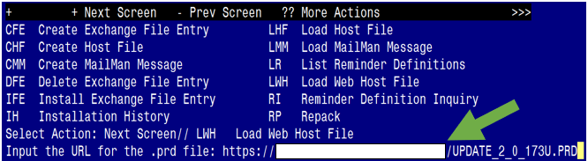

At the **Select Action:** prompt, enter **LWH** for Load Web Host File

At the **Input the url for the .prd file:** prompt, type the following web address:

**https://REDACTED/UPDATE_2_0_173U.PRD**

**You should see a message that the file was successfully loaded.**

**Terminal window screen shot of the message displaying the URL of the file that was successfully loaded.  Part of the URL has been redacted as it is a VA only internal web site URL.**

**This will install one exchange entry in your exchange file.**

Added Reminder Exchange entry UPDATE_2_0_173U VA-COVID-19 IMMUNIZATION REMINDER

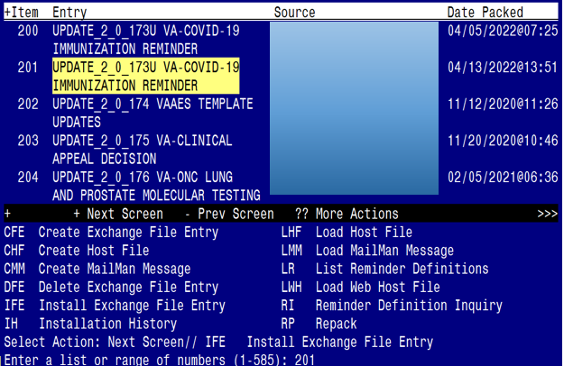

Search and locate an entry titled **UPDATE_2_0_173U VA-COVID-19 IMMUNIZATION REMINDER.**

At the **Select Action** prompt, enter **IFE** for Install Exchange File Entry

Enter the number that corresponds with your entry **UPDATE_2_0_173U VA-COVID-19 IMMUNIZATION REMINDER.**  *(in this example it is entry 201 it will vary by site).* The date of the exchange file should be 04/013/2022.

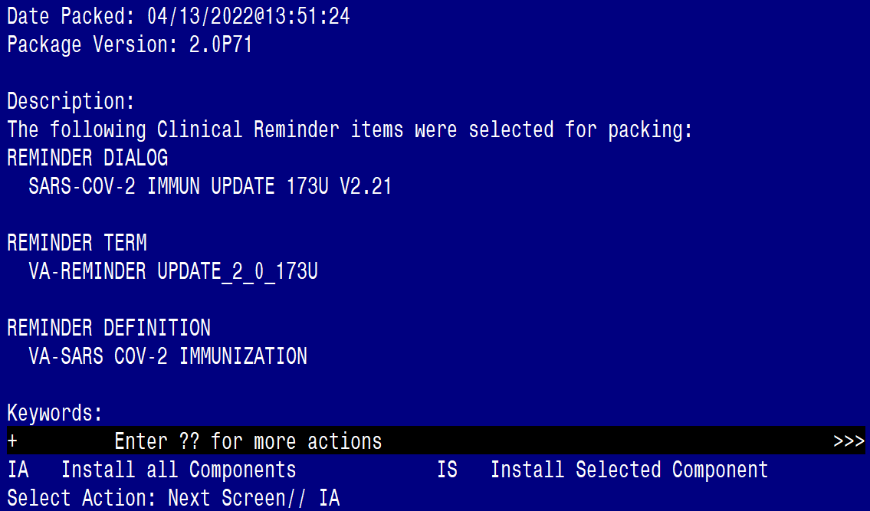

At the **Select Action** prompt, type **IA** for **Install all Components** and hit enter.

Any items that are NEW in any categories, you should INSTALL

INSTALL any new components

For TXML that are different, use OVERWRITE action

For reminder term VA-SARS-COV-2 VACCINE WHO APPROVED ALL (INCL US) use the OVERWRITE action

For all reminder terms that exist, but are different, use SKIP action

For any taxonomies that exist, but are different, use SKIP action

For any reminder definitions that exist, but are different, use OVERWRITE action

For any Health Summary items that exist, but are different, use OVERWRITE action

You will then be prompted to install the reminder dialog component, you will choose IA to install even though most items will have an X to indicate they already exist.

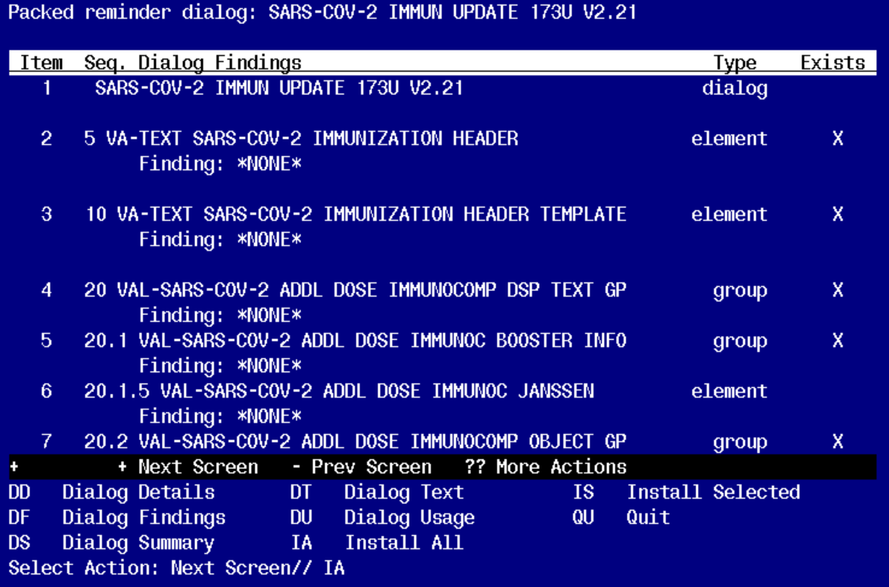

At the **Select Action** prompt, type **IA** to install the dialog – **SARS-COV-2 IMMUN UPDATE 173U V2.21.**

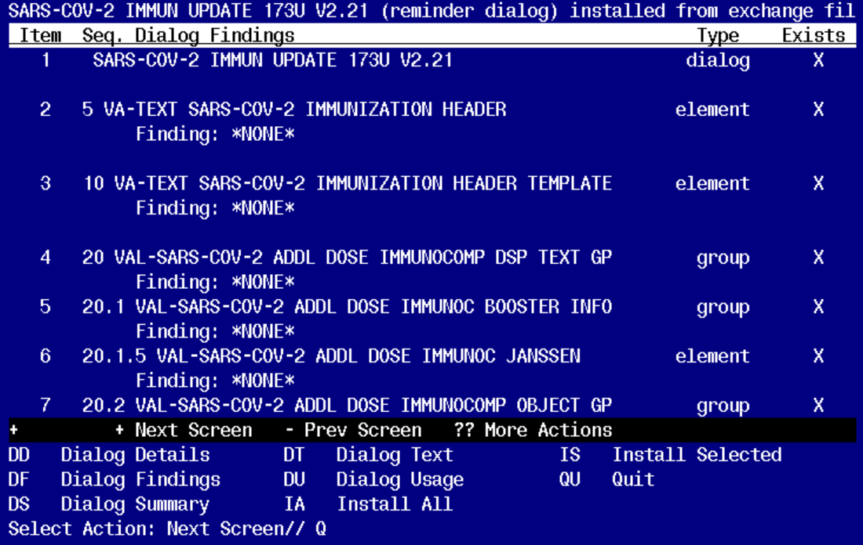

You will then be returned to this screen. At the **Select Action** prompt, type **Q.**

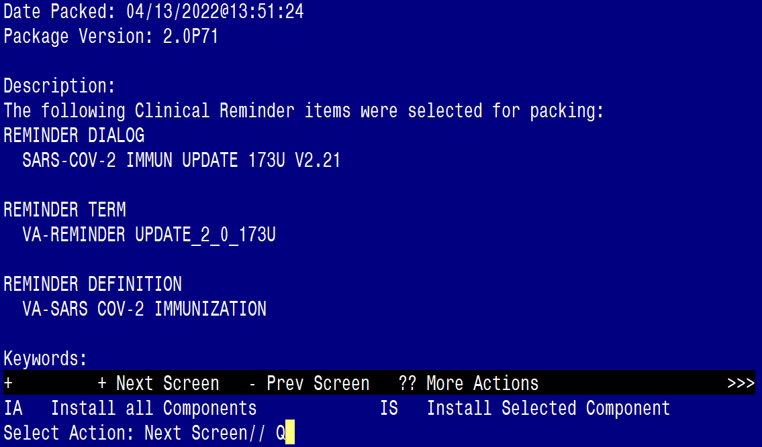

You will then be returned to this screen. At the **Select Action** prompt, type **Q.**

Install complete.

# Post-Installation

1. Relink dialog VA-SARS-COV-2 IMMUNIZATION to reminder definition VA-SARS- COV-2 IMMUNIZATION