June 2009

This distribution contains change pages for patch MD*1.0*11 of the Clinical Procedures 1.0 User Manual.

The change pages for CP Patch 2, CP Patch 10, CP Patch 4, and CP Patch 14 should be inserted before the change pages for CP Patch 11:

File Name: Patch:
MD_1_P2_UM.PDF MD*1.0*2
MD_1_P10_UM.PDF MD*1.0*10
MD_1_P4_UM.PDF MD*1.0*4
MD_1_P14_UM.PDF MD*1.0*14

Patch MD*1.0*11 pages:

Replace Pages: With Pages:
Title page Title page
Revision History Revision History
Table of Contents Table of Contents
3-33 to 3-34 3-33 to 3-38
4-7 to 4-8 4-7 to 4-8

CLINICAL PROCEDURES USER MANUAL

Version 1.0
April 2004

Revised June 2009

Department of Veterans Affairs Office of Information & Technology Office of Enterprise Development

Revision History

Description | Date | Technical Writer
Originally released. | April 2004
1Patch MD*1.0*2 released. | July 2004
2Patch MD*1.0*10 released. | March 2005
3Patch MD*1.0*4 released. | September 2006 | REDACTED
4Patch MD*1.0*14 released. Added  new sections for Auto Study Check- In to Ch. 3. | March 2008 | REDACTED
5Patch MD*1.0*11 released. Added  new section in Ch. 3 for handling appointment no shows and cancellation with the auto study check-in. Replaced provider name in Ch. 4 with generic name.  Updated product line on title page. | June 2009 | REDACTED

1 Patch MD*1.0*2 July 2004 Patch 2 release added.
2 Patch MD*1.0*10 March 2005 Patch 10 release added.
3 Patch MD*1.0*4 September 2006 Patch 4 release added.
4 Patch MD*1.0*14 March 2008 Patch release added.
5 Patch MD*1.0*11 June 2009 Patch release added.

Table of Contents

Introduction 1-1

Intended Audience 1-6

Related Manuals 1-6

Product Benefits 1-6

Working with CP User 2-1

Opening CP User 2-1

Defining CP User Icons 2-1

Selecting a Patient 2-2

Defining the Parts of the Main CP User Window 2-3

Clinical Procedures Process, Part 1 3-1

Ordering a Consult Procedure in CPRS 3-1

Auto Study Check-In 3-9

Auto Check-In Without Appointment 3-10
Setting Up the Procedure 3-10
Procedure Request in CPRS 3-15
Confirm the Auto Study Check-In 3-17

Auto Study Check-In With Appointment 3-17

Check-In a New Study 3-26

Updating Study Status to Correct Errors 3-32

Appointment No Shows and Cancellation 3-33

Clinical Procedures Process, Part 2 4-1

Completing the Procedure 4-1
Entering the interpretation into the TIU Note 4-1
Entering Encounter Information 4-7
Signing Off 4-12

Viewing Clinical Procedures Results 4-14

Linking Consent Forms and Images to CP Documents 4-19

Viewing the Reports 5-1
Abnormal 5-3
Brief Report 5-7
Full Captioned 5-8
Full Report 5-13
Procedures (local only) 5-18
Procedures 5-21

Configuring the Medicine Report to Display in CPRS 5-23

Glossary 6-1

Index 7-1

April 2004 Clinical Procedures V. 1.0 i User Manual

Table of Contents

ii Clinical Procedures V. 1.0 April 2004 User Manual

Clinical Procedures Process, Part 1

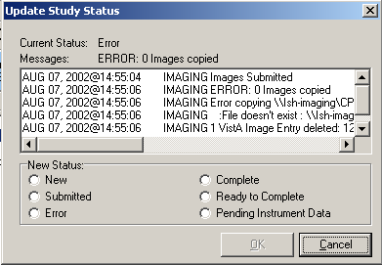
Figure 3-28

1Appointment No Shows and Cancellation

When an appointment is scheduled for a future date/time, the appointment can later be cancelled or the appointment can be changed to “No show” because the patient was a no show for the appointment. With patch MD*1.0*11, an option called MD PROCESS NOSHOW/CANCEL was introduced. Once scheduled to run daily, it will pick up the no show and cancelled appointments and cancel the associated CP study that was created.

Figure 3-29 shows a study with the status of “New” created from an auto study check-in.

1 Patch MD*1.0*11 June 2009 Add new section on appointment no show and cancellation.

April 2004 Clinical Procedures V. 1.0 3-33
User Manual

Clinical Procedures Process, Part 1

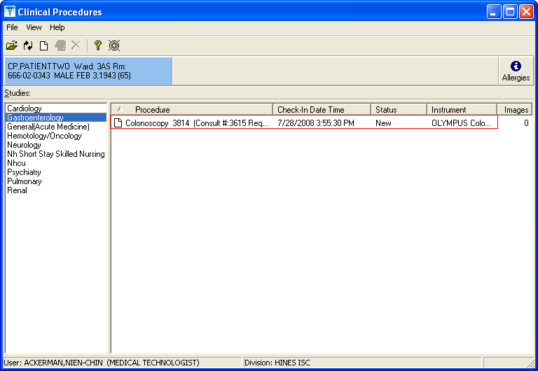

Figure 3-29

The patient has an appointment scheduled shown in figure 3-30 for the procedure in figure 3-29.
Appt Mgt Module Jul 28, 2008@16:03:25 Page: 1 of 1
Patient: CP,PATIENTTWO (0343) Ward: 3AS
Total Appointment Profile * - New GAF Required 06/28/08 thru 04/23/11

 | Clinic | Appt Date/Time | Status
1 | Gi Lab | 07/28/2008@12:00 | Inpatient/Act | Req | 12:00

Enter ?? for more actions
CI Check In CD Change Date Range DX Diagnosis Update UN Unscheduled Visit EP Expand Entry DL Wait List Display
MA | Make Appointment | AE | Add/Edit | DE | Delete Check Out
CA | Cancel Appointment | RT | Record Tracking | WD | Wait List Disposition
NS | No Show | PD | Patient Demographics | CP | Procedure Update
DC | Discharge Clinic | CO | Check Out | PC | PCMM Assign or Unassign
AL | Appointment Lists | EC | Edit Classification | TI | Display Team Information
PT | Change Patient | PR | Provider Update
CL | Change Clinic | WE | Wait List Entry
Select Action: Quit//

Figure 3-30

3-34 Clinical Procedures V. 1.0 April 2004 User Manual

Clinical Procedures Process, Part 1

The appointment was cancelled and re-booked in figure 3-31.

 | Clinic | Appt Date/Time | Status
1 | Gi Lab | 07/28/2008@12:00 | Cancelled By Patient
2 | Gi Lab | 08/08/2008@08:00 | Inpatient/Future

MA | Make Appointment | AE | Add/Edit | DE | Delete Check Out
CA | Cancel Appointment | RT | Record Tracking | WD | Wait List Disposition
NS | No Show | PD | Patient Demographics | CP | Procedure Update
DC | Discharge Clinic | CO | Check Out | PC | PCMM Assign or Unassign
AL | Appointment Lists | EC | Edit Classification | TI | Display Team Information
PT | Change Patient | PR | Provider Update
CL | Change Clinic | WE | Wait List Entry

Figure 3-31
Appt Mgt Module
Patient: CP,PATIENTTWO (0343)
Total Appointment Profile
Jul 28, 2008@16:09:29
Page:
1 of
1
Ward: 3AS
* - New GAF Required
06/28/08 thru 04/23/11
Enter ?? for more actions
CI Check In CD Change Date Range UN Unscheduled Visit EP Expand Entry
DX Diagnosis Update DL Wait List Display
Select Action: Quit//

Figure 3-32 shows the study cancelled by the task MD PROCESS NOSHOW/CANCEL and a new study was generated for the re-booking of the new appointment.

April 2004 Clinical Procedures V. 1.0 3-35
User Manual

Clinical Procedures Process, Part 1

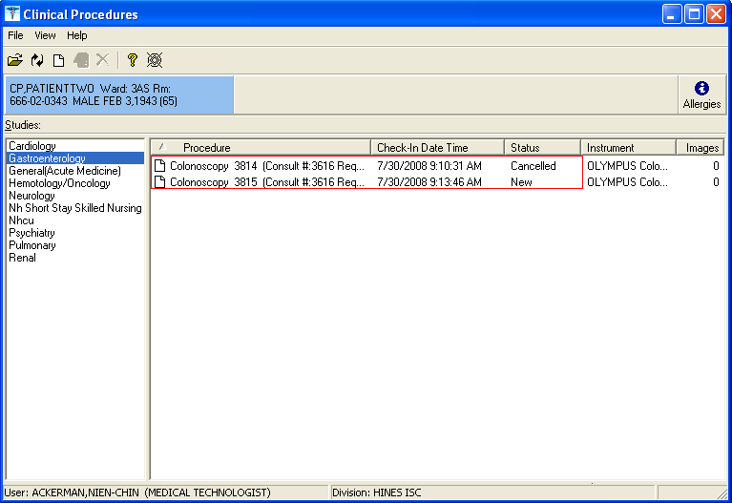
Figure 3-32

Note: If during appointment cancellation, no re-booking was selected, the user will need to remove the new study created.

3-36 Clinical Procedures V. 1.0 April 2004 User Manual

Clinical Procedures Process, Part 1

Figure 3-33 shows an example of an appointment with a status of a “No Show” and no auto re- booking of a future appointment.

Patient: RAYMOND,LOUIS (2382)  Total Appointment Profile |  | * - New GAF Required | Outpatient 06/30/08 thru 04/25/11
1 | Clinic Gi Lab | Appt Date/Time 07/30/2008@10:00 | Status No-show

MA | Make Appointment | AE | Add/Edit | DE | Delete Check Out
CA | Cancel Appointment | RT | Record Tracking | WD | Wait List Disposition
NS | No Show | PD | Patient Demographics | CP | Procedure Update
DC | Discharge Clinic | CO | Check Out | PC | PCMM Assign or Unassign
AL | Appointment Lists | EC | Edit Classification | TI | Display Team Information
PT | Change Patient | PR | Provider Update
CL | Change Clinic | WE | Wait List Entry

Figure 3-33
Appt Mgt Module
Jul 30, 2008@09:27:55
Page:
1 of
1
Enter ?? for more actions
CI Check In CD Change Date Range UN Unscheduled Visit EP Expand Entry
DX Diagnosis Update DL Wait List Display
Select Action: Quit//

Figure 3-34 shows the study cancelled for the appointment with “No Show” and a new study is created. The user can highlight the study with “New” status and click button to delete it or select the File|| Delete Study to remove it.

April 2004 Clinical Procedures V. 1.0 3-37
User Manual

Clinical Procedures Process, Part 1

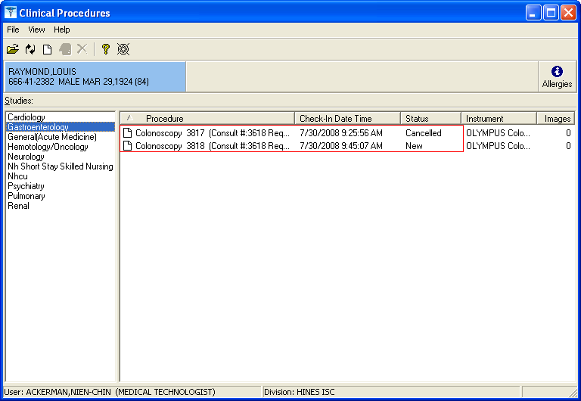

Figure 3-34

3-38 Clinical Procedures V. 1.0 April 2004 User Manual

Clinical Procedures Process, Part 2

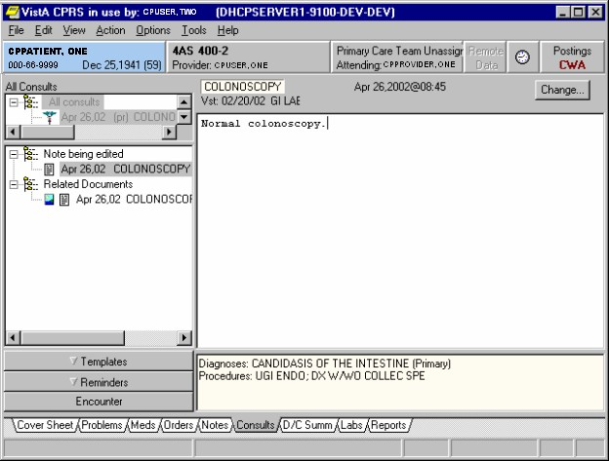
Fig 4-6

  - Enter an interpretation in the space on the right side of the screen for the highlighted (current) consult procedure (Fig. 4-6).

Entering Encounter Information
You can now enter encounter form information.

  - To enter the encounter information and complete the consult procedure, you must select

Action > Consult Results > Sign Note Now.

You can also select the Encounter drawer (Fig. 4-6) to directly enter encounter information.

April 2004 Clinical Procedures V. 1.0 4-7
User Manual

Clinical Procedures Process, Part 2

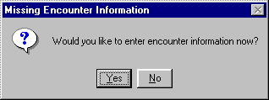
Fig. 4-7

This window (Fig. 4-7) asks if you want to enter encounter information now. (Fig. 4-7 is displayed depending on how CPRS parameters are set. See the Implementation Guide for information on defining CPRS parameters.)

  - Click Yes to enter encounter information, or click No to skip this step. If you choose No, you can enter the information at a later time. In this example, the Yes button is clicked and encounter information is entered.
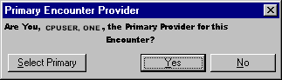
Fig. 4-8

Figure 4-8 allows you to verify the primary provider for this encounter form.

  - Click Yes.

CPRS brings up the Encounter Form that was set up for the Hospital Location, where the procedure was performed. The Visit Type tab is displayed.

  - Enter appropriate information for visit type. For example, in Figure 4-9, the following information was entered:

Type of Visit. Established Patient

Section Name. Intermediate Exam 11-19 Min.

Visit Related to Service Connected Condition. Yes

Current providers for this encounter. 1CPUSER, ONE

1 Patch MD*1.0*11 June 2009 Replaced provider name with generic name.

4-8 Clinical Procedures V. 1.0 April 2004 User Manual

