Community Viewer (CV) 3.8

Production Operations Manual
October 2021
Version 2.0
Department of Veterans Affairs
Office of Information and Technology (OIT)

Revision History
Date | Version | Description | Author
09/20/2021 | 2.0 | Addressed feedback and submitting the document for final approval | Liberty ITS
09/16/2021 | 1.1 | Comments addressed and updates included | Liberty ITS
09/14/2021 | 1.0 | Addressed feedback and submitting the document for approval | Liberty ITS
08/27/2021 | 0.2 | Comments addressed and updates included | Liberty ITS
08/10/2021 | 0.1 | Initial draft of document created from the last approved | Liberty ITS

Artifact Rationale
The Production Operations Manual (POM) provides the information needed by the Production Operations Team to maintain and troubleshoot the product. The POM must be provided prior to release of the product.
Table of Contents
1. Introduction 1
2. Routine Operations 1
2.1. Administrative Procedures 1
2.1.1. System Startup 1
2.1.1.1. System Startup from Emergency Shutdown 4
2.1.2. System Shutdown 4
2.1.2.1. Emergency System Shutdown 4
2.1.3. Backup and Restore 4
2.1.3.1. Backup Procedures 4
2.1.3.2. Restore Procedures 5
2.1.3.3. Backup Testing 6
2.1.3.4. Storage and Rotation 7
2.2. Security/Identification (ID) Management 7
2.2.1. Identity Management 8
2.2.2. Access Control 8
2.3. User Notifications 9
2.3.1. User Notification Points of Contact 9
2.3.2. CV Quality of Service (QoS) Mail Groups 11
2.3.3. Scheduled Downtime Notifications 12
2.3.3.1. ServiceNow (SNOW) Process 14
2.3.3.2. Patch Release Notification E-mail (Example) 15
2.3.4. Unscheduled Outage Notifications 15
2.3.4.1. Initial Response to Issues Within 30 Minutes of Alert 15
2.3.4.1.1. Initial Outage Response Notification E-Mail (Example) 16
2.3.4.2. Outage Escalation to External Teams 17
2.3.4.2.1. Outage Escalation to External Teams E-Mail (Example) 17
2.3.4.2.2. Outage Update E-Mail (Example) 17
2.3.5. Announcement Banners 18
2.3.5.1. Placing Announcement Banners 20
2.3.5.2. Removing Announcement Banners 21
2.3.5.2.1. Manual Removal 21
2.3.5.2.2. Automatic Expiration 21
2.3.5.2.3. Announcement Banner Extensions 21
2.4. System Monitoring, Reporting, and Tools 22
2.4.1. Dataflow Diagram 22
2.4.2. Availability Monitoring 22
2.4.2.1. Domain-Level Availability Monitoring 23
2.4.3. Performance/Capacity Monitoring 23
2.4.4. Critical Metrics 23
2.5. Routine Updates, Extracts, and Purges 24
2.5.1. Routine Updates 24
2.5.2. Quarterly Update of the VistA Site List 25
2.5.3. Extracts 25
2.5.4. Purges 25
2.6. Scheduled Maintenance 25
2.7. Unscheduled Outage Triage Process 26
2.7.1. Outage Triage Timeline 26
2.7.2. Escalation 27
2.7.3. Issue Resolution and After Action 28
2.8. Capacity Planning 28
2.8.1. Initial Capacity Plan 28
3. Exception Handling 28
3.1. Routine Errors 28
3.1.1. Security Errors 28
3.1.2. Timeouts 29
3.1.2.1. Application Timeout 29
3.1.2.2. Connection Errors 30
3.1.3. Concurrency 30
3.2. Significant Errors 30
3.2.1. Application Error Logs 31
3.2.2. Application Error Codes and Descriptions 32
3.2.3. Infrastructure Errors 32
3.2.3.1. Database (DB) 32
3.2.3.2. Web Server 36
3.2.3.3. Application Server 36
3.2.3.4. Network 36
3.2.3.5. Authentication and Authorization (A&A) 36
3.2.3.6. Logical and Physical Descriptions 37
3.3. Dependent System(s) 37
3.4. Troubleshooting 38
3.5. System Recovery 38
3.5.1. Restart After Unscheduled System Interruption 38
3.5.2. Restart After DB Restore 38
3.5.3. Backout Procedures 38
3.5.4. Rollback Procedures 38
4. Operations and Maintenance Responsibilities 38
5. Approval Signatures 41
A. Acronyms and Abbreviations 42

Table of Figures
Figure 1: Database Names Tree 5
Figure 2: Source, Device, and Database Dialog Box 5
Figure 3: Restore Plan Dialog Box 6
Figure 4: Mockup of Regularly Scheduled Downtimes 12
Figure 5: Scheduled Downtime Notification Process 14
Figure 6: Release Integration Scheduler (SNOW) Process 15
Figure 7: User-facing Banner on the CV Login Page 20
Figure 8: Connection Status Details 23
Figure 9: Patching Process for CV Components 24
Figure 10: Scheduled and Unscheduled Outage Overview 26
Figure 11: Outage Event Activities and Timeline 27
Figure 12: Session Timeout Notification 29
Figure 13: Session Timeout 29
Figure 14: Connection Error 30
Figure 15: jMeadows Log Output 31
Figure 16: CV VAS Application Context 33
Figure 17: CV CCP Application Context 34
Figure 18: Audit Log 35

Table of Tables
Table 1: Access Control Design 8
Table 2: CV Scheduled Downtime Notification List (VA Stakeholders) 9
Table 3: Announcement Banner Content for Maintenance Events Impacting End Users 19
Table 4: Database Table Entry Prior to Manual Removal 21
Table 5: Database Table Entry After Manual Removal 21
Table 6: Database Table Entry for a Planned Maintenance Announcement Banner 21
Table 7: Database Table Entry, as Initially Posted 22
Table 8: Database Table Entry, After a Date Extension Update 22
Table 9: Services Monitored by QoS 22
Table 10: Response Time Log Location 31
Table 11: User Authentication Sequence Overview 36
Table 12: CV External Dependent Systems 37
Table 13: Operations and Maintenance Responsibility Matrix 38
Table 14: Acronyms and Abbreviations 42

Introduction
Community Viewer (CV) is a browser-based software application that facilitates the secure exchange of data between Department of Veterans Affairs (VA) systems and authorized non-VA providers, known as Community Care Providers (CCPs) or Provider Profile Management System (PPMS) providers. The exchange of data improves the coordination of care and continuity of care for VA patients receiving treatment outside of the VA network.
CV pulls information from VA health care systems in real time for viewing within a web browser. Through CV, VA Staff (VAS) assign patients to CCPs and Risk Management (RM) users, allowing them access to view consolidated patient data from multiple Veterans Information Systems and Technology Architecture (VistA) systems.
NOTE: Additional functionality was added to align with the Joint Longitudinal Viewer (JLV) version 2.9.4.0.3 product release. In particular, CV now connects to the Joint Longitudinal Viewer (JLV) Electronic Health Record Modernization (EHRM) Service which adds Cerner Millennium to the set of external data sources that CV can retrieve clinical data from. This set of data, known collectively as the Federal Electronic Health Record (FEHR) includes Department of Defense (DoD) medical treatment facilities and VA sites that have transitioned from VistA to Cerner Millennium. At this time, the required approvals are not in place to allow CV to display DoD data to its CCP users. Therefore, all data from Cerner Millennium are turned off.

Routine Operations
Routine operations are performed by system administrators to ensure the upkeep, configuration, and reliable operation of computer systems. System administrators also ensure that the uptime, performance, resources, and security of the systems meet the needs of the end users.

Administrative Procedures
The current Production environment is held at the Philadelphia Information Technology Center (PITC), with the Austin Information Technology Center (AITC) serving as a failover site. A detailed list of the servers referenced throughout the system startup procedures can be found in the CV AITC and PITC Production Virtual Machine (VM) Inventory REDACTED and Server counts and configurations can be found in the VM Hardware Specifications table of the CV 3.8 Deployment, Installation, Backout and Rollback Guide (DIBRG), posted to the VA CV Product Repository on GitHub.

System Startup
The following procedures apply to both the VA Staff and CCP modules of CV.
- Start the CV database (DB) servers (performed by Liberty Operations Team)
  - The DB server processes are configured to run as system services and are automatically started with the DB servers
  - Validation
    - Startup is validated through the successful smoke test of the application; loading the CV Login page and logging in to the application confirms that the DB servers are up and operational
    - The Operations Team logs in to each DB server to validate that the Microsoft (MS) Structured Query Language (SQL) Server service has started; if the service has started, it signifies that the DB servers are up and operational
    - The Operations Team logs in to each DB server, opens SQL Server Management Studio (SSMS) and connects to the DB; the connection is successful if the DB servers are up and operational
- Start the VistA Data Service (VDS) servers (performed by Liberty Operations Team)
  - The service processes are configured to run as system services and are automatically started with the VDS servers
  - Validation
    - Startup is validated through the successful smoke test of the application; loading the CV Login page and logging in to the application confirms that the servers are up and operational
    - Review each WebLogic-managed web server for connection and/or application errors
    - If startup is unsuccessful, the Operations Team investigates the server log files and determines the correct resolution, possibly server reboots
- Start the jMeadows servers (performed by Liberty Operations Team)
  - The service processes are configured to run as system services, which are automatically started with the servers
  - Validation
    - Startup is validated through the successful smoke test of the application; loading the CV Login page and logging in to the application confirms that the servers are up and operational
    - Review each WebLogic-managed web server for connection and/or application errors
    - If startup is unsuccessful, the Operations Team investigates the server log files and determines the correct resolution, possibly server reboots
- Start the CV VAS web application front-end web servers and the Apache Single Sign-On Internal (SSOi) service (performed by Liberty Operations Team).
  - The service processes are configured to run as system services and are automatically started with the servers
  - Validation:
    - Startup is validated through the successful smoke test of the application; loading the CV Login page and logging in to the application confirms that the dependent back-end CV systems are up and operational (Detailed information can be found in the Installation Verification Procedures section of the CV 3.8 DIBRG posted in the VA CV Product Repository on GitHub. See Administrative Procedures for information on the repository.)
    - Review each WebLogic-managed web server for connection and/or application errors
    - Access and launch the CV VA Staff Universal Resource Locator (URL), also referred to as the Global Traffic Manager (GTM) URL in a web browser
      - Log in with a VA Staff user test account:
        - Use a Personal Identity Verification (PIV) card and Personal Identification Number (PIN), when prompted
          - Community Viewer is compatible with PIV cards
        - Verify that the CV Login page for VA Staff displays as expected and that the system status indicates services are online and connected
        - Enter Access/Verify codes
        - Verify VA Staff Portal loads
    - If startup is unsuccessful, the Operations Team investigates the server log files and determines the correct resolution, possibly server reboots
- Start the CV web application servers for CCPs in the non-cloud (on prem) environment (performed by Infrastructure Operations [IO])
  - The service processes are configured to run as system services and are automatically started with the servers
  - Validation
    - Startup is validated through the successful smoke test of the application; loading the CV Login page and logging in to the application confirms that the servers are up and operational (Detailed information can be found in Section 4.9: Installation Verification Procedures of the CV 3.8 DIBRG posted in the VA CV Product Repository on GitHub. See Administrative Procedures for information on the repository.)
      - Log in to the CV web application with a CCP test username and password:
        - Verify that the CV Login page for CCPs displays as expected and indicates that the system status indicates that services are online and connected
        - Enter username (National Provider Identifier [NPI] or non-VA email address) and password
        - Verify the Provider Portal loads
    - Review each WebLogic-managed web server for connection and/or application errors
    - If startup is unsuccessful, IO investigates the server log files and determines the correct resolution, possibly server reboots

System Startup from Emergency Shutdown
If there is a power outage or other abrupt termination of the server operating systems, start up the servers as detailed in System Startup and allow the operating system to check the disks for corruption. Consult with IO to ensure that the DB successfully recovers.

System Shutdown
Shutdown procedures are performed during a published maintenance window, when there are few users accessing the system, to avoid impacting transactions in progress. The CV AITC and PITC Production VM Inventory and CV 3.8 DIBRG (Table 4) both list the servers. A diagram of the CV Production environment can also be found in the CV 3.8 DIBRG (Figure 1). Once approved, all project documentation is available in the VA CV Product Repository on GitHub. See Administrative Procedures for information on the repository.
- Shut down the WebLogic services on the CV VAS web application servers
- Shut down the WebLogic services on the CV CCP web application servers
- Shut down the WebLogic services on the jMeadows servers
- Shut down the WebLogic services on the VDS servers
- Shut down the CV DB servers

Emergency System Shutdown
The emergency system shutdown procedure is to shut down all servers in any order.
A detailed list of the servers referenced throughout this POM can be found in the VA CV Product Repository on GitHub. See Administrative Procedures for information on the repository.

Backup and Restore
This section provides a high-level description of the backup and restore strategy, including all components that require backup and the devices or infrastructure that perform the backup and restore procedures.
IO manages the platform and installation of both the operating systems and the baseline installation of the MS SQL Server in the VA Production environment.

Backup Procedures
Backups of the CV DB are configured to run, automatically, at midnight daily. The DB servers are backed up at the IO data center by the Systems Administrators using IO’s backup solution. The DB servers also have a MS SQL DB maintenance that automatically backs up each DB to the following location on each server:
A detailed list of the servers referenced throughout this POM can be found in the VA CV Product Repository on GitHub. See Administrative Procedures for information on the repository.
- D:\DBBackups
- D:\DBBackups\TransactionLogs

Restore Procedures
The items necessary for the recovery of the DBs are:
- DB backup (.bak) file for the CV DB
- Encryption keys for the DB
Restore a full DB backup:
- Connect to the appropriate instance of the MS SQL Server DB Engine in SSMS
- Click the server name to expand the server tree
- Right-click Databases
Figure 1: Database Names Tree
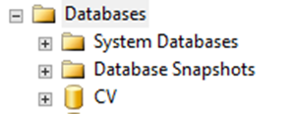
- Click Restore Database
- Use the Source section on the General page to specify the source and location of the backup sets to restore; select the following options:
  - Click the Browse (...) button to open the Select Backup Devices dialog box
  - Select File in the Backup Media Type box, then click Add
  - Navigate to the location of the backup file (.bak) of the CV DB, then click OK
  - After you add the devices you want to the Backup Media Type box, click OK to return to the General page
  - Select the name of the DB to be restored (CV) in the Source Device: DB List box
Figure 2: Source, Device, and Database Dialog Box
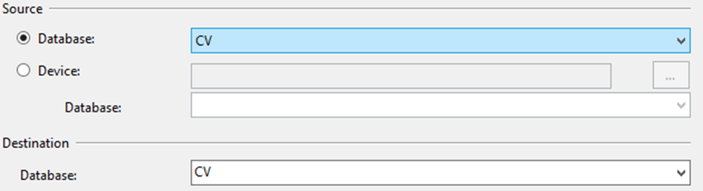
- The Database box in the Destination section automatically populates with the name of the DB to be restored
  - Select CV from the dropdown
- Leave the default in the Restore To box as the last backup taken, or click Timeline to access the Backup Timeline dialog box to manually select a point in time to stop the recovery action
- Select the backups to restore in the Backup Sets to Restore grid
  - This grid displays the backups available for the specified location
  - By default, a recovery plan is suggested; to override the suggested recovery plan, change the selections in the grid
Figure 3: Restore Plan Dialog Box
Figure REDACTED due to PII
  - Backups dependent upon the restoration of an earlier backup are automatically deselected when the earlier backup is deselected
NOTE: Default options are not selected if an attribute necessary for restoration is not contained within the default backup.
- Alternatively, click Files in the Select a Page pane to access the Files dialog box
  - Restore the DB to a new location by specifying a new restore destination for each file in the Restore the database files as grid

Backup Testing
A detailed list of the servers referenced throughout this POM can be found in the VA CV Product Repository on GitHub. See Administrative Procedures for information on the repository.
- Servers
  - Backups of the VMs are done at the VA data center by IO Systems Administrators
  - Backups are performed daily
  - Testing of the backups is performed by IO
  - Validation of restorations are confirmed by:
    - Validating that all software/configurations are restored from the expected configuration
    - Confirming that the configuration files contain server-specific settings
    - Validating that the application server starts as expected through logs and a smoke test of the application
- DB
  - Backups are performed at midnight daily
  - Backups are periodically restored, on an ad hoc basis, to the backup DB servers to test the restore procedures and the integrity of the backup files
    - CV Support restores CV PROD DB backups to our CV PREPROD database machine and have a CV PREPROD CV application that is configured to use the CV PREPROD DB machine
  - IO system administrators validate that data in the DB contains up-to-date entries for the user profiles and audit logging
  - Validation of operations is confirmed through a smoke test of the application

Storage and Rotation
IO manages the platform and any storage and rotation scheduling in the CV Production environment. IO ensures the system and storage arrays are operating properly, with daily inspections of CV Quality of Service (QoS) logs and system notifications.
The Liberty Project Team is responsible for ensuring that the partition structure in use is sufficient ensuring there is enough storage space.

Security/Identification (ID) Management
Access to CV is restricted to authorized VistA users within, and authorized providers outside of, the VA. Authorized VistA users are referred to as VA Staff. Authorized providers outside of the VA are referred to as CCPs (or PPMS providers) and Risk Management (RM). CV utilizes HyperText Transfer Protocol (HTTP) Strict Transport Security (HSTS) which is a web security policy mechanism that helps to protect websites against protocol downgrade attacks and cookie hijacking.
Three tables within the CV DB are used for ID management: the PPMS_Provider table, the C_Provider table, and the VAS_UserRole table:
- The PPMS_Provider table within the CV DB lists CCPs’ first names, last names, e-mail address, and their associated NPI numbers
- The C_Provider table within the CV DB lists CCPs’ and RM users’ first names, last names, and their associated e-mail addresses
- The VAS_UserRole table within the CV DB assigns roles to VA Staff users specific to their function (e.g., Tier 1 VA Staff, Tier 2 VA Staff, Risk Management Provider Manager [RMPM], or Service Desk User [SDU]) and stores their associated PIV information
The CV VAS Login page guides VA Staff users through the login process, including, where necessary, fields to enter specific credentials. The CV VAS Login page fields request the VA Staff user’s Access/Verify Codes, Agency, and Site. VA Staff users must have their PIV card in place before entering the CV URL into the address bar of a supported browser.
SDUs must have their PIV card in place before entering the CV VAS Login page URL into the address bar of a supported browser. SDUs log in with their PIV card and PIN but are not required to have or use Access/Verify codes.
CCPs can use either the non-VA e-mail address associated with their account or their NPI, and a password to log in to the CV CCP Login page. CV queries PPMS during login to see if a provider has an NPI listed within PPMS. If they do, they are considered “active.” If there is no NPI listed for a provider, they are not considered active, and will be unable to log in to CV.
NOTE: The username field of the CV Login page has been made a free text field to accommodate either a non-VA e-mail address or NPI entry.
A detailed overview of the login process, from the user’s perspective, can be found in the CV 3.8 VA Staff User Guide, the CV 3.8 Community Care Provider (CCP) User Guide, and the CV 3.8 Risk Management VA Staff User Guide. Once approved, all project documentation is available in the REDACTED. See Administrative Procedures for information on the repository.

Identity Management
Any VA user with VistA credentials can access either the Community Care PPMS Provider Management widget or the Risk Management Provider Management widget on the CV VA Staff portal page, depending on their role.
CCP user accounts are created by VA Staff. Detailed instructions for creating CCP user accounts are found in the CV 3.8 VA Staff User Guide. Once approved, all project documentation is available in the REDACTED. See Administrative Procedures for information on the repository.

Access Control
CV access control for CCPs consists of the validation of user credentials, retrieved from the Login page, against the CV DB. When the user’s credentials are found in the PPMS_Provider table of the CV DB, the user is granted access to CV. CCPs may encounter a login error message if they attempt to access CV when their status is not set to active in PPMS: There is an issue preventing your access to Community Viewer. Please contact your VA Contractor or VA Medical Center for assistance.
VA Staff control CCP access to patient records by making assignments for a specified date range. A CCP can access only the records of the patient with whom they have an assigned consultation for the time period set by VA Staff.
SDUs must be added to the VAS_UserRole table as authorized users. Once authorized, they use their PIV card and PIN to gain access to the application via the REDACTED.
VA Staff use their PIV card, PIN, and VistA credentials to access either the Community Care PPMS Provider Management widget or the Risk Management Provider Management widget on the VA Staff portal page, depending on their role.
Table 1 summarizes the CV system components and the settings utilized for access control.
Table 1: Access Control Design
Component | Description
DB | The PPMS_Provider table within the DB contains NPI values used as usernames for CCPs.  The C_Provider table within the DB contains e-mail addresses used as usernames for CCPs and RM users.  The VAS_UserRole table controls access to VAS and RM functions within CV.  System design specifications and diagrams can be found in the VA CV Product Repository on GitHub.
DB script | A DB script is used to deliver changes or updates to the pertinent tables within the CV DB.
Configuration settings | A configuration setting within the appconfig-production.properties file that enables access control.  - Enable VA Access Control, On/Off: This setting enables access control for VA Staff.

User Notifications
CV is comprised of hardware and software interfaces to the dependent partner systems such as PPMS and the Master Person Index (MPI), as well as other infrastructure necessary to deliver the CV application. Each of the individual components may undergo scheduled downtime for maintenance on a periodic basis. CV Support follows a notification process to alert VA stakeholders of pending downtime in advance of each known event.
Notifications are sent via e-mail to VA Stakeholders when there are scheduled or unscheduled changes in system state, including but not limited to: planned restarts, system upgrades, maintenance work, and any unexpected system outages. OIT project management and CV Project Team are responsible for crafting and approving outage notification messages before they are posted to the Announcements section of the CV Login page and banners within the application.
Notifications for planned outages are initiated 24 hours in advance of anticipated system downtime, and notification of an unscheduled outage occurs if an error does not clear within 15 minutes. The notification process for unscheduled outages is as follows:
- The CV Support Team monitors and evaluates all system issues
- The QoS service alerts are e-mailed to the CV Support Team and a defined list of contacts when a service disruption occurs using the SNOW (ServiceNow) CV incident email group.

User Notification Points of Contact
Table 2 details the current notification list for alerting VA stakeholders of scheduled CV downtime. This list is maintained by the Liberty Project Team.
Table 2: CV Scheduled Downtime Notification List (VA Stakeholders)
Name | Organization | Email Address
REDACTED | VA-Government | REDACTED
REDACTED | VA-Government | REDACTED
REDACTED | VA-Government | REDACTED
REDACTED | VA-Government | REDACTED
REDACTED | VA-Government | REDACTED
REDACTED | VA-Government | REDACTED
REDACTED | VA-Government | REDACTED
REDACTED | VA-Government | REDACTED
REDACTED | VA-Government | REDACTED
REDACTED | Government CIO | REDACTED
REDACTED | Government CIO | REDACTED
REDACTED | Government CIO | REDACTED
REDACTED | Liberty | REDACTED
REDACTED | Liberty | REDACTED
REDACTED | Liberty | REDACTED
REDACTED | Liberty | REDACTED
REDACTED | Liberty | REDACTED
REDACTED | Liberty | REDACTED
REDACTED | Liberty | REDACTED
REDACTED | Liberty | REDACTED
REDACTED | Liberty | REDACTED
REDACTED | Liberty | REDACTED
REDACTED | Liberty | REDACTED
REDACTED | Liberty | REDACTED
REDACTED | Liberty | REDACTED
REDACTED | RavenTek | REDACTED
REDACTED | Seawolf | REDACTED

CV Quality of Service (QoS) Mail Groups
VA:
REDACTED
Liberty Team:
REDACTED

Scheduled Downtime Notifications
CV Support monitors the maintenance schedules of systems that provide notification of planned outages, then communicates the upcoming downtime to VA stakeholders.
NOTE: CV Support depends on the receipt of timely information from dependent systems and infrastructure. Not all systems and/or infrastructure teams provide downtime notices to CV Support.
Figure 4 shows a typical calendar of regularly scheduled downtimes for CV and external systems. For a complete list of planned downtimes, refer to the detailed list following the calendar mockup.
Figure 4: Mockup of Regularly Scheduled Downtimes
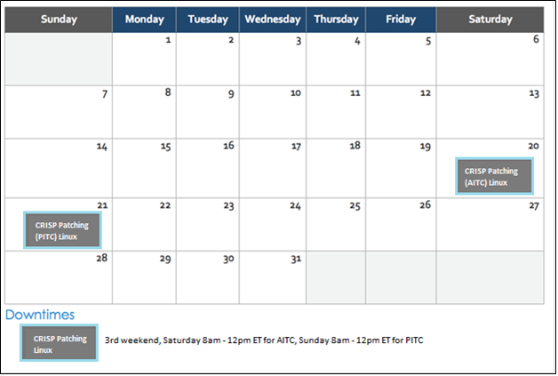
The following list details the maintenance notices currently known to CV Support.
- IO (PITC/AITC)
- Organization: VA
- Frequency: Monthly, the 3rd week
- 3rd Saturday and Sunday of each month, Linux updates
- Scheduled Time Frame: Saturday from 8:00 am to 12:00 pm ET for AITC Linux Patching, Sunday from 8:00 am – 12:00 pm ET for PITC Linux Patching
- Email Subject: Monthly Security Patching
- POC: REDACTED
- VA Authentication Federation Infrastructure (VAAFI)
- Organization: VA
- Frequency: As needed
- Time Frame: Varies
- Email Subject: VAAFI Datacenter flip Miami to Culpeper
- POC: REDACTED
- MPI
- Organization: VA
- Frequency: As needed
- Time Frame: Varies, typically the 3rd weekend and from 3:00 pm to 9:00 pm
- Email Subject: VAAFI Data center flip Miami to Culpeper
- POC: REDACTED
CV Support actively monitors all relevant system maintenance schedules and follows the planned downtime notification process for CV application code-driven patch releases (see Figure 5).
- CV Support notifies VA stakeholders when CV is restored to service
- The VHA CV team crafts and approves messages to notify CV users of estimated system downtime when CV is unavailable and when the system is restored
NOTE: The process flow (shown in Figure 5) is designed primarily for CV application code-driven patch releases. It is also used as a guide for scheduled downtime notifications; however, not all steps may apply to downtimes triggered by scheduled maintenance/outages on external components that are outside the control of CV Support.
Figure 5: Scheduled Downtime Notification Process
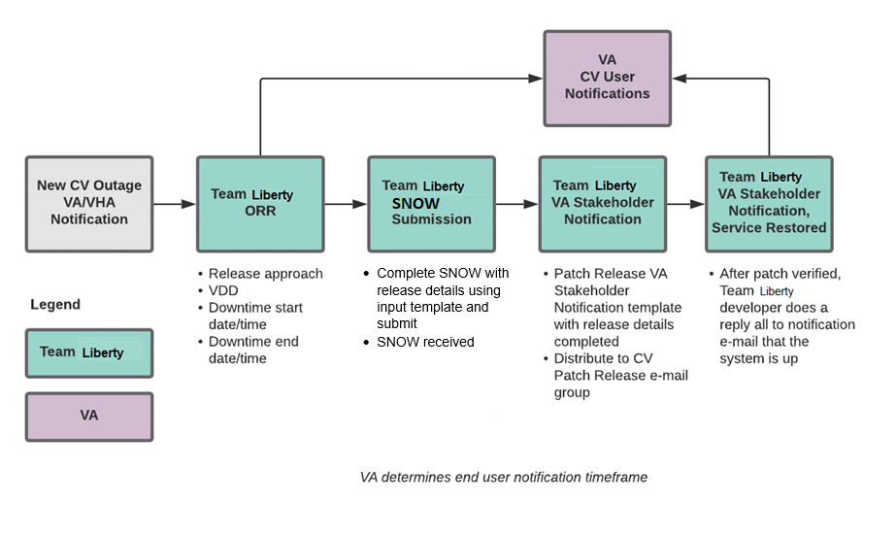
While all CV scheduled downtime communications follow a similar format, each is tailored to the specific activity and system/service affected.

ServiceNow (SNOW) Process
2.3.3.1.1. Creating a new Release
Once the Office of Information Technology (OIT) Project Manager (PM) and Project Team has decided to develop and make available a group of changes as a Release, the Release Manager from the Project Team will enter a new Release into ServiceNow.
For detailed instructions on how to add a new Release to SNOW, please consult the following work instruction: REDACTED.
Figure 6: Release Integration Scheduler (SNOW) Process
Figure REDACTED due to PII
The Change Order (CHG) notifies the Enterprise Service Desk (ESD) of the planned event. Once the form has been completed and submitted, the ESD responds via e-mail within approximately 15 minutes with the associated ESD ticket number. The CHG and ESD ticket numbers are provided in the notification e-mail as shown in REDACTED.

Patch Release Notification E-mail (Example)
All,
This is to notify you of the upcoming Production release of the CV Enterprise Patch x.x.x.x.x.
- The CHG number is CHGxxxxx
- The ServiceNow Ticket number is INCxxxxxxx
- CV Enterprise Patch version x.x.x.x.x will be released to VA Production environments on <Day>, <Month> <Day>, <Year> starting at <Time 24-hour clock> (Time am/pm) ET. Patching is expected to be completed by <Time 24-hour clock> (Time am/pm) ET, <Day>, <Month> <Day>, <Year>. CV-Enterprise will be unavailable during this time.

Unscheduled Outage Notifications

Initial Response to Issues Within 30 Minutes of Alert
The following steps represent the response to a reported issue, to occur within 30 minutes of the initial alert:
- If a QoS e-mail is received and errors have not been cleared within 30 minutes of receipt of the initial error alert, proceed to Step 2
- Within 30 minutes of the initial error e-mail, CV Support (Table 13) will send an e-mail to the CV stakeholders (Table 2) to inform them that the Support Team is investigating the issue
  - Use the e-mail example below, tailored to the specific activity and the system(s)/service(s) that are affected

Initial Outage Response Notification E-Mail (Example)
Subject: ALERT: CV Service Degradation - (Affected Service) Errors - (insert error start time YYYYMMDD 24:00 ET)
All,
CV is currently experiencing an error in the <Environment Name> environment.
The error detail is: <Error from QoS>
This error impacts <service impacted> (choose one from list below)
- MPI: The users’ ability to retrieve VA records
- VDS: The users’ ability for VA users to log in and retrieve VA records
- Database: The ability for the application to check the authorized users list, retrieve a user's profile, generate a site list for the log in, and the ability for CV to log auditing records
- jMeadows: The application’s ability to connect to external sources; users will not be able to log in to CV until service is restored.
- FEHR: The users’ ability to retrieve Cerner data
NOTE: At this time CV does not display Cerner data.
The CV Engineering team has determined the following:
- Severity: Severity Level ONE
- Impact: <List impacted users and state which services are impacted, and the functionality lost>
- Fault is isolated to: <Where the error resides (local CV servers, local CV DB, network (provide details if possible) or external application>
- Estimated Time of Service Restoration: <Estimated time frame of restoration>
- CHG Number: <CHG number, only if applicable and approved by VA CV PM>
- Ticket Number: <Ticket number submitted to the VA service desks, only if issue is with the network or external application>
The CV Engineering team will continue to monitor and troubleshoot the issue. Updates will be provided every 2 hours until the issue is resolved.

Thank you.

Outage Escalation to External Teams
The following information details the escalation process to external teams in the case of an issue caused by a service outside CV Support’s purview. A status update is requested within 2 hours of the initial alert.
- Send an e-mail to the applicable external service group as specified in Table 13
- Request the status of the issue within 2 hours of the initial alert
  - Copy CV Support (Table 13)
  - Use the e-mail example(s) below, tailored to the specific activity and system(s)/service(s) that are affected

Outage Escalation to External Teams E-Mail (Example)
Subject: CV Service Verification Request
All,
The CV application is currently experiencing an error in the <Environment Name> environment.
The error detail is: <Error from QoS>
This error impacts <service impacted> (choose one from list below)
- MPI: The users’ ability to retrieve VA records
- VDS: The users’ ability to authenticate and retrieve VA records
- PPMS:The ability for VA Staff to retrieve provider profiles
- VistA Host: The ability for CV to retrieve records for the specified VistA host
- jMeadows: The application’s ability to connect to external sources; users will not be able to log in to CV until service is restored.
- FEHR: The users’ ability to retrieve Cerner data
NOTE: At this time CV does not display Cerner data.
CV Support would like to verify that <application/service> is up, running, and not experiencing any errors.
Optional: CV Support has verified that network connectivity is not the issue. Please verify and respond to CV Support with your findings.
Thank you for your assistance in troubleshooting this issue.
- Generate a trouble ticket and assign it to the appropriate application team
- Send a notification to the CV stakeholders (Table 2) with all pertinent information
  - Use the e-mail example(s) below, tailored to the specific activity and system(s)/service(s) that are affected

Outage Update E-Mail (Example)
Subject: Update: CV Service Degradation - (Affected Service) Errors - (insert error start time YYYYMMDD 24:00 ET)
All,
The CV application is currently experiencing an error in the <Environment Name> environment.
The error detail is: <Error from QoS>
- MPI: The users’ ability to retrieve VA records
- VDS: The users’ ability to authenticate and retrieve VA records
- PPMS: The ability for VA Staff to retrieve provider profiles
- VistA Host: The ability for CV to retrieve records for the specified VistA host
- jMeadows: The application’s ability to connect to external sources; users will not be able to log in to CV until service is restored
- FEHR: The users’ ability to retrieve Cerner data
NOTE: At this time CV does not display Cerner data.
The CV Engineering team has determined the following:
- Severity: Severity Level ONE
- Impact: <List impacted users, and state which services are impacted, and the functionality lost>
- Fault is isolated to: <Where the error resides (local CV servers, local CV database, network (provide details if possible) or external application>
- Estimated Time of Service Restoration: <Estimated time frame of restoration>
- CHG Number: <CHG number, only if applicable and approved by VA CV PM >
- Ticket Number: <Ticket number submitted to the VA service desk, only if the issue is with the network or an external application>
The CV Engineering team will continue to monitor and troubleshoot the issue. Updates will be provided every 2 hours until the issue is resolved.
Thank you.
- Continue monitoring the issue
- Provide updates every 2 hours to the CV stakeholders (Table 2) until issue is resolved:
  - Liberty Emergency Contact: REDACTED
  - Liberty Alternate Contact: REDACTED
  - Liberty Alternate Contact: REDACTED
CV Ops Team Support Hours: 24x7x365

Announcement Banners
Announcement banners are provided for the end users’ benefit and information. They appear in the Announcements section of the CV Login page, and within the CV application in the form of banners.
The primary goal of announcement banners is to inform end users of important information about their use of CV. The use of acronyms and Information Technology (IT) jargon within announcement banners is minimized to clearly communicate any temporary limitations of CV.
It is important to note that the system maintenance notices shared among technical groups are different from the application-level announcement banners as they are not appropriate for end users.
Announcement banners are posted no more than 24 hours prior to a planned event and removed immediately upon completion of the planned event.
Announcement banners for an unplanned outage are posted immediately after the confirmation of the outage and are removed immediately upon resolution of the outage.
The following announcement banners are prioritized:
- Patient Safety
- Newly discovered defects/issues with broad impact
- Unplanned outages or unexpected loss of data lasting more than 2 hours that are not already communicated by System Status notifications
- Planned maintenance/outages with expected impacts or disruptions
  - Maintenance events no or inconsequential impact should not be posted
End users can become desensitized to the important information in announcement banners when too many alerts are posted too often. The plan to minimize alert fatigue is as follows:
- Display announcement banners by severity
  - Add a prefix category (Patient Safety, Issue, Outage, Maintenance, etc.) to announcement banner titles and content to further differentiate context and priority
- Post only those alerts that impact end users
  - Informational announcement banners for maintenance events where there is no expected or an inconsequential impact should not be posted
- Set an expiration date for announcement banners, and remove them as soon as possible after the event has completed or the issue has been corrected
The following groups have the responsibility and authority to enable certain types of announcement banners:
- CV Project Support Team: Maintenance-related notifications that impact end users
- CV OIT Team: Notifications regarding patient safety and other critical issues that impact end users
Table 3 lists the announcement banner content for maintenance events with expected user impact and for special events and issues.
Table 3: Announcement Banner Content for Maintenance Events Impacting End Users
Maintenance Event Titles (50-character limit) | “More” Hyperlink Expanded Content (255-character limit)
MAINTENANCE VA Patient Identity System -5/17 More | Maintenance window : 05/17/18 9pm ET -05/18/18 12pm ET  Impact: Users may experience problems with patient search.
MAINTENANCE Community Partner System- 6/29 More | Maintenance window : 06/29/18 8pm ET - 06/29/18 11 pm ET  Impact: CV will be available for use, but Documents & Images widget may not retrieve records. If you experience this problem, please try again later.
PATIENT SAFETY Contrast Allergies More | CV is currently not displaying VA allergies for Contrast media entered through the Radiology option “Update Patient Record” [RA PTEDIT].
ISSUE Imaging not available More | VA images are not currently being displayed in CV. The issue is being analyzed and a patch to resolve the issue will be deployed as soon as possible.
OUTAGE Community Partner Records More | VA is currently unable to retrieve records from community partners. Engineers are working to restore connections as quickly as possible. (add details on anticipated resolution, etc. if available).

Placing Announcement Banners
When there is a major system outage, service degradation, scheduled downtime, or patient safety issue, an announcement banner will be placed on the Login page for the affected environment at the T+60-time frame. The announcement banner placement in any environment is accomplished via the database associated with that environment.
NOTE: Current functionality does not allow for a specific time frame, like 2:00 pm to 8:00 pm, to be provided. At present, the system only allows for an expiration date, formatted as Month/Day/Year.
An example of the script used to place an announcement banner is as follows:
execute dbo.createNotification
@startDate='10/17/2018'
,@endDate='10/30/2018'
,@announcement='Lab Results'
,@userGroup='ALL'
,@description='Temporarily, some laboratory test results may not appear when a panel test is selected from the Lab Results widget.'
The resulting announcement banner, as viewed on the application Login page, is shown in Figure 7.
Figure 7: User-facing Banner on the CV Login Page
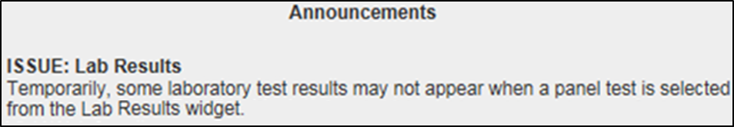

Removing Announcement Banners
There are two methods used to remove a banner from the application Login page: manual and automatic expiration.
- Manual
- Automatic expiration

Manual Removal
The manual removal method is used when a system degradation has been resolved or the planned outage has been completed prior to the designated end date.
Manual removal is accomplished by accessing the database tables and manually changing the end date (shown below in red text) to match the start date associated with the announcement banner to be removed. Database entries demonstrating the announcement banner prior to (Table 4) and after (Table 5) manual removal follow.
Table 4: Database Table Entry Prior to Manual Removal
Start Date | End Date | Title | Announcement Banner Text
2018-10-17 | 2018-10-30 | ISSUE: Lab Results | Temporarily, some laboratory test results may not appear when a panel test is selected from the Lab Results widget.
Table 5: Database Table Entry After Manual Removal
Start Date | End Date | Title | Announcement Banner Text
2018-10-17 | 2018-10-17 | ISSUE: Lab Results | Temporarily, some laboratory test results may not appear when a panel test is selected from the Lab Results widget.

Automatic Expiration
Automatic expiration of an announcement banner occurs when the designated end date of the announcement banner has been reached (shown below in red text). Expiration dates are set based on when the issue can be resolved by an authorized member of CV Support. A database entry demonstrating a planned maintenance announcement banner as shown in Table 6.
Table 6: Database Table Entry for a Planned Maintenance Announcement Banner
Start Date | End Date | Title | Announcement Banner Text
2018-10-26 | 2018-10-27 | ISSUE: System performance upgrades | System may temporarily be down for system performance upgrades between 8pm ET 26 October 2018–12am ET 27 October 2018.

Announcement Banner Extensions
If a service degradation or other event will exceed the planned end date of an existing announcement banner, CV Support can manually extend the duration of the announcement banner by changing the end date to a date in the future (shown below in red text). Database entries demonstrating the announcement banner prior to (Table 7) and after (Table 8) a date extension.
Table 7: Database Table Entry, as Initially Posted
Start Date | End Date | Title | Announcement Banner Text
2018-10-26 | 2018-10-27 | ISSUE: System performance upgrades | System may temporarily be down for system performance upgrades between 8pm ET, 26 October 2018–12am ET 27 October 2018.
Table 8: Database Table Entry, After a Date Extension Update
Start Date | End Date | Title | Announcement Banner Text
2018-10-26 | 2018-10-29 | ISSUE: System performance upgrades | System may temporarily be down for system performance upgrades between 8pm ET, 26 October 2018–12am ET 29 October 2018.

System Monitoring, Reporting, and Tools
CV traces and audits actions that a user executes within the application. CV audits are provided through audit trails and audit logs that offer a backend view of system use, in addition to storing user views of patient data. Audit trails and logs record key activities (date and time of the event, patient identifiers, user identifiers, type of action, and access location) to show system threads of access and the views of patient records. Refer to Application Error Logs for more information about audit and server logs.
The CV QoS service monitors the availability of data sources. Refer to Availability Monitoring for more information.

Dataflow Diagram
The data retrieval sequences are detailed in the CV 3.8 CCP and VAS System Design Documents (SDDs). Once approved, all project documentation is available on the REDACTED. See Administrative Procedures for information on the repository.

Availability Monitoring
The QoS monitors the health of the CV application and checks for the availability or disruption of dependent services within the systems in VA environments (Table 9).
Table 9: Services Monitored by QoS
Service | Description
MPI (VA) | Retrieves VA patient ID
CV DB Server | Contains CV database information
jMeadows Data Service | Connects to MPI, DB, and VDS
VDS | VA Log in/Data
PPMS | Retrieves CCP profile information
FEHR | Retrieves Cerner data
System status is displayed on the Login page and in the application when there is a degradation. System status events are logged to the CV DB, and users are notified of system status via the Login page. Detailed information on system status checks is in the CV 3.8 CCP and VAS SDDs. Once approved, all project documentation is available on the REDACTED. See Administrative Procedures for information on the repository.

Domain-Level Availability Monitoring
CV displays interface status icons on the toolbars of multiple Patient Portal widgets to communicate the status of the data source for the widget’s clinical domain. There are two conditions:
- The information icon indicates that all sources are available
- The warning icon indicates one or more data sources are unavailable
Both icons are used to provide status for data sources. Clicking the status icon opens interface status details in a separate window, as shown in Figure 8.
Figure 8: Connection Status Details
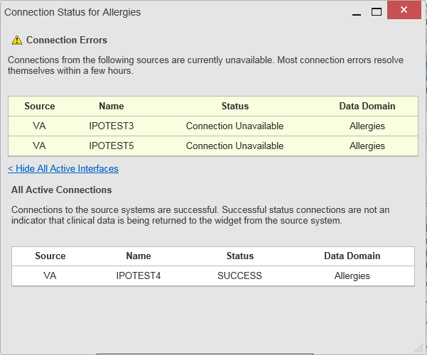

Performance/Capacity Monitoring
Query times for each web service call in to jMeadows and VDS are recorded to a file in the /u01/CV_HOME/logs/ directory on the server, where the services are installed. VA AppDynamics is deployed across the CV production environments and monitors environment metrics, as well as application performance.
Refer to Application Error Logs for more information on audit and server logs.

Critical Metrics
The CV Development team adds metric requirement reporting to the product backlog as metrics are defined. Current metrics considered critical are user metrics, core system metrics, user transactions, error logging, QoS metrics (service stability/availability), and other industry-standard system/performance metrics. The metric data is reported in the weekly Operations report and the weekly/monthly usage report.
Examples of the critical metrics listed above, and captured in the Operations and Usage reports, include:
- User Access: CV traces and audits the actions a user executes within the application
- Audit data is provided via audit trails and audit logs that offer a backend view of system use and store user views of patient data
- Interface with jMeadows: jMeadows retains user actions within CV
- Specific events (user transactions) are audited or captured in log files, including but not limited to user ID, date and time of the event, type of event, success or failure of the event, successful login, and the identity of the information system component where the event occurred
Each time an attempt is made to interface with jMeadows, whether it is a service communication or a user searching for a patient, the activity is logged and stored in the CV data store. The purpose of retention is for traceability; specifically, to show which calls/actions were made, where, by whom, and when they terminated. Each CV query for data is audited and has the user ID linked to it.

Routine Updates, Extracts, and Purges
CV system updates, and other routine actions on systems within the cloud environment, are handled by the CV Support Team, as needed. Updates to the CV web application servers within the non-cloud (on prem) environment are performed by AITC personnel.
A detailed list of the servers referenced throughout this POM can be found in the VA CV Product Repository on SharePoint. See Administrative Procedures for information on the GitHub repository.

Routine Updates
Patches and other routine updates follow the CV patching process, shown in Figure 9.
Figure 9: Patching Process for CV Components
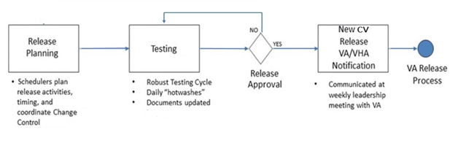

Quarterly Update of the VistA Site List
The CV Support Team monitors the VistA site list for any changes and updates the DB quarterly.

Extracts
Extracts of the CV audit logs and server logs are available by request only, as needed. The VA Program Manager (PgM) or PM must approve requests for extracts. Approvals are dependent on the type of request and the organization of the requester. Once a request is approved, an authorized system administrator extracts the requested data and sends it to the requestor, via an encrypted method. Refer to Application Error Logs for more information on audit and server logs.

Purges
Neither data, nor audit log entries from the CV DB, nor other system components, are purged.

Scheduled Maintenance
Scheduled downtime typically occurs after 8:00 pm ET, and service is restored by 8:00 am ET. Any planned downtimes (within VA control) outside of these hours require justification and approval by Veterans Health Administration (VHA) CV team and the OIT PgM or PM/ Contracting Officer’s Representative (COR).
The Liberty Operations Team actively monitors all relevant systems maintenance schedules and follows the scheduled downtime notification process for CV application code-driven patch releases. A representative from the CV Support Team notifies the VA stakeholders and the ESD when the CV system is restored to service.
Figure 10 depicts the CV process for monitoring, analyzing, and initiating the notification for an outage.
Figure 10: Scheduled and Unscheduled Outage Overview
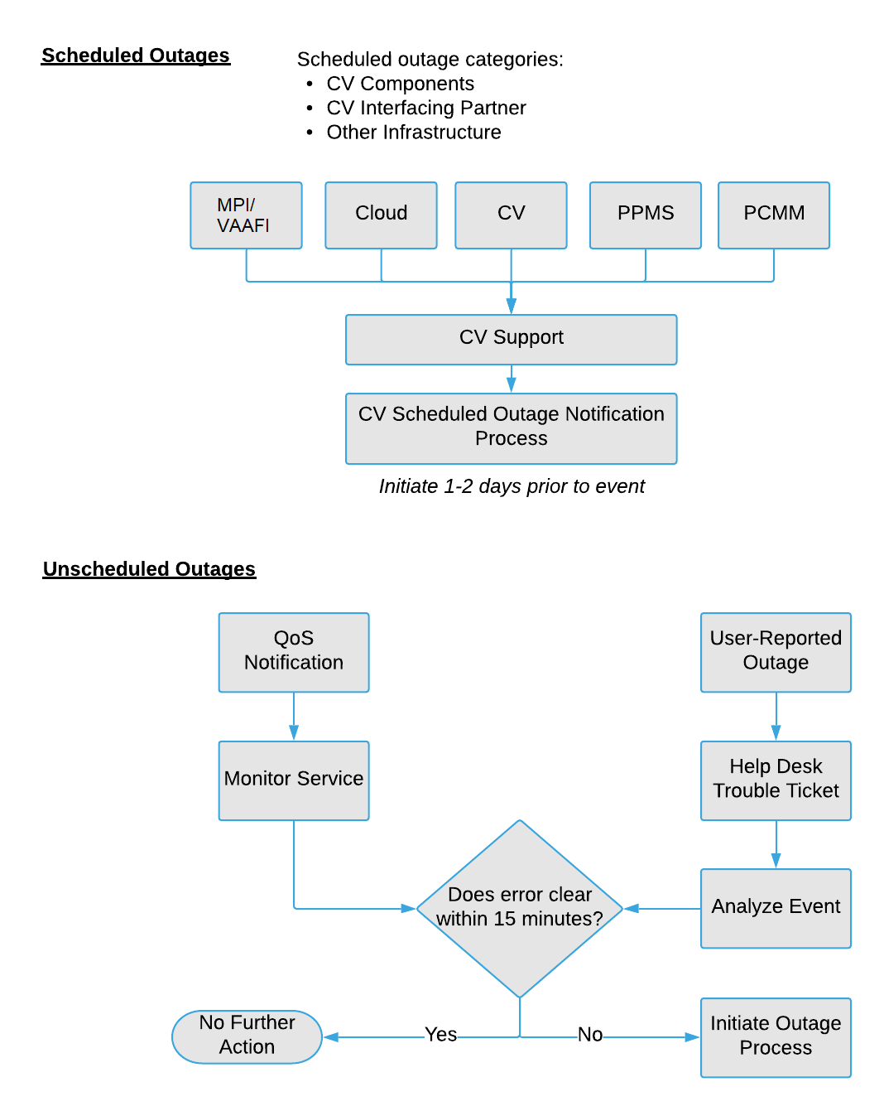

Unscheduled Outage Triage Process
An unscheduled outage typically occurs when there is a major unexpected Production issue. As such, the processes in the following sections are triggered (i.e., when the entire CV application is down and/or a significant number of end users are impacted).
NOTE: The QoS tool is the primary means of monitoring the CV application. The processes described below are specific to the QoS tool and its related incident responses. The VHA CV team is responsible for notifying end users.

Outage Triage Timeline
The CV Outage Triage process is executed by CV Support in coordination with the VA CV interface systems teams (e.g., MPI), as necessary.
The following steps represent routine system monitoring:
- Monitor e-mail to see if the CV application corrects itself
  - Wait 15 minutes to see if a QoS e-mail arrives indicating that there are no errors (e.g., AITC - CVQoS Report: NO ERRORS DETECTED)
  - Check junk e-mail folder for QoS alerts
- If a QoS e-mail is received indicating “NO ERRORS DETECTED,” the system is connected and executing properly

Escalation
The escalation process typically follows this progression:
- The problem is reported
  - QoS reports a problem that remains unresolved for over 30 minutes (See Availability Monitoring)
OR
  - A VA Staff user calls the ESD to open trouble tickets
NOTE: There are instances when a VA user may bypass the ESD and go directly to the VA PM/COR or other program contact. Should this occur, direct the user to the ESD to complete an official trouble ticket.
- CV Support analyzes the problem and determines whether to initiate the triage process
- Once the triage process is initiated, CV Support follows the analysis and notification timeline and escalation (as necessary) processes, and includes external systems teams (Figure 11)
NOTE: Discoveries made regarding the root cause of an issue and the service restoration time frame are communicated via e-mail to the stakeholders as soon as they come to light.
Figure 11: Outage Event Activities and Timeline
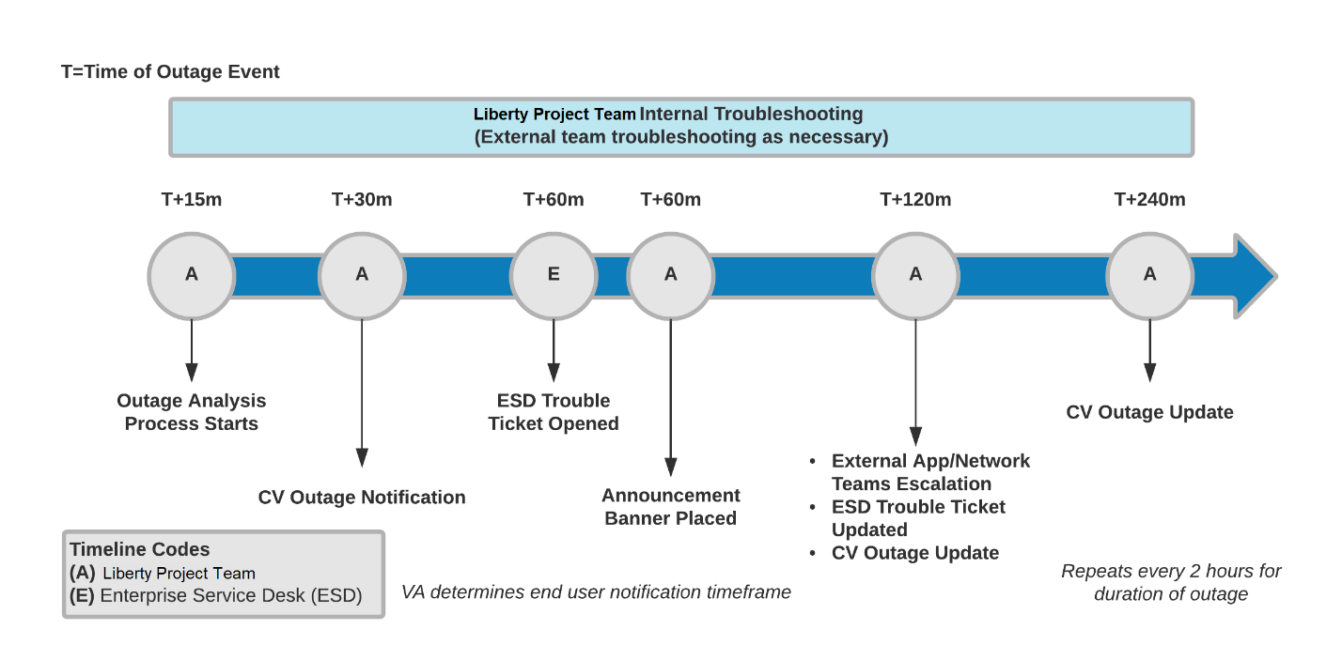

Issue Resolution and After Action
The following steps are taken after the issue is resolved:
- After the issue is resolved, determine if the root cause was internal to the CV application
  - If the problem was with an external system/service, obtain the root cause from the applicable team (Table 13)
- Send an e-mail to the CV stakeholders (Table 2) stating that CV is back online and available for use
  - Include the root cause of the issue and details of the fix required to resolve the issue, if available

Capacity Planning
The CV Support Team monitors the performance of CV, the associated servers, user onboarding, and user behavior on a weekly basis. Server resources and CV application data are collected by the PITC Monitoring group, using the AppDynamics Monitoring Tool.
VA AppDynamics monitors and stores data and sends alerts to notify the members of the CV Operations Team e-mail distribution group when any metric exceeds its upper or lower boundary. The e-mail distribution group is maintained by the CV Support Team.

Initial Capacity Plan
Server processing capacity forecasts and workload modeling is conducted in an ad hoc manner. These forecasts are used to project server capacity based on Production data, CV requirements, and CV application changes planned for future releases.

Exception Handling
Like most systems, CV may generate a small set of errors that are considered routine, in the sense that they have minimal impact on users and do not compromise the operational state of the system. Most errors are transient in nature and are resolved by the user trying to execute an operation again. The following subsections describe these errors, their causes, and what, if any, response an operator should take.

Routine Errors
While the occasional occurrence of errors may be routine, encountering many individual errors over a short period of time is an indication of a more serious problem. In that case, the error must be treated as a significant error. Refer to Significant Errors for more information.

Security Errors
A VA Staff user may encounter the login error message, “Not a valid ACCESS/VERIFY CODE pair,” if they mistype their VistA Access or Verify code.
CCPs may encounter a login error message if they attempt to access CV when their status is not set to active in PPMS: “There is an issue preventing your access to Community Viewer. Please contact your VA Contractor or VA Medical Center for assistance.” CCPs may also encounter the error message, “Username and/or Password is incorrect,” if they enter an invalid username/password combination.
A VA Staff user’s login credentials will be locked after five (5) incorrect login attempts by the VistA service to which CV connects. If this occurs, the VA user contacts the ESD and opens a service request ticket to resolve their login issue. The user’s local VistA Administrator can unlock their account.

Timeouts
Each section below describes a possible timeout error.

Application Timeout
CV has a timeout feature that is set to 60 minutes of inactivity. If users leave the CV application idle for 55 minutes, they receive an audible and visual Session Timeout Notification (Figure 12). If the user would like to extend the session, they can click the OK button to continue using CV.
Figure 12: Session Timeout Notification
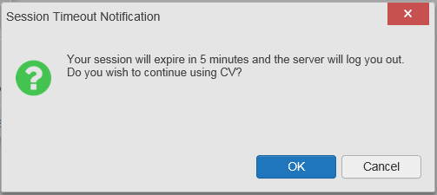
If the user does not interact with the Session Timeout Notification message within the 30-minute time limit, the CV session times out (Figure 13). The user must then close the browser, reopen the browser, and log back into CV.
Figure 13: Session Timeout
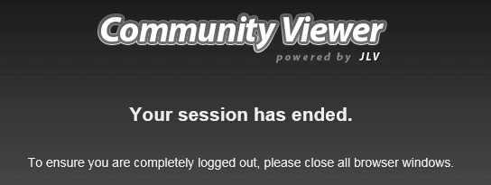

Connection Errors
If users encounter a web browser timeout error or the browser displays, “This page can’t be displayed,” when accessing the correct URL, it indicates that CV application services are either not running or there is a network outage.
Either the CV Support Team or the active site’s system administrators may attempt to remote desktop into each CV application server to ensure the WebLogic services are running. If they are running, system administrators contact IO to verify that the Local Traffic Manager (LTM) is operating correctly.
CV may also report timeouts to external systems within widgets by displaying a message that one or more data sources could not be connected (Figure 14).
Figure 14: Connection Error
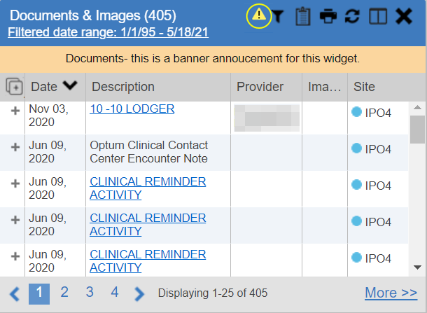
NOTE: Connection errors that persist for more than 5 minutes must be investigated by Tier 3 support.

Concurrency
Concurrency is monitored and handled by IO. They optimize the load balancing of the application using an F5 appliance to handle concurrent user sessions.

Significant Errors
Significant errors are defined as errors or conditions that affect the system stability, availability, performance, or otherwise make the system unavailable to its user base. The following subsections contain information to aid administrators, operators, and other support personnel in the resolution of significant errors, conditions, or other issues.

Application Error Logs
jMeadows retains user actions in an audit log and stores it in the CV data store. Specific events regarding user transactions are also audited (captured in log files), including but not limited to user ID, date and time of the event, type of event, success or failure of the event, successful and failed login attempts, and the identity of the information system component in which the event occurred.
Each time an attempt is made to interface with jMeadows, whether it is a service communication or a user searching for a patient, the activity is logged and stored in the CV data store. The purpose of retention is for traceability; specifically, to show what calls/actions were made, where, by whom, and when they terminated. Each query for data is audited and has both the user and patient ID linked to it. Only one audit log is produced, and it is included in the overall VM backup.
Query times for each web service call in to jMeadows and VDS are recorded to a file in the /u01/CV_HOME/logs/ directory on the server, where the services are installed. A log file output for jMeadows Data Service provided in Figure 15. Table 10 lists the response time log locations.
Table 10: Response Time Log Location
Data Service | Log File Name
jMeadows Data Service | jmeadows-sql.txt
VDS | vds-sql.txt
Figure 15: jMeadows Log Output
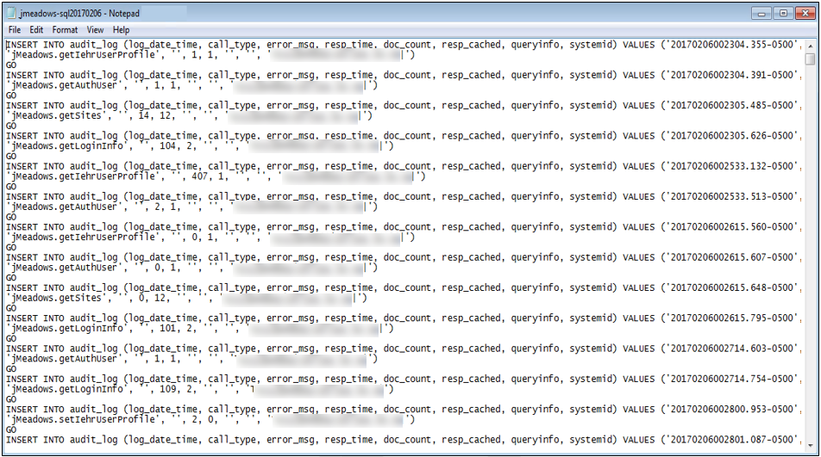
The QoS service deployed with the CV web application monitors the availability of services that connect to CV data sources and other outside systems. Connection errors within the CV environment are written to the QOS_LOGS table within the CV DB and displayed in the CV web application.
Service interruptions detected by the QoS service are reported to the CV Support Team via e-mail. An automated e-mail notification is sent every 6 hours, unless a status change is detected. Detection of a status change immediately triggers an e-mail notification, and the 6-hour timer is reset. The next e-mail is generated after 6 hours if no further system status changes are detected. The QoS service does not send service interruption notices to external systems or services. Each backend server has its own functional and service-specific application store, for example: /u01/apps/oracle/mwhome/user_projects/domains/<DOMAIN_NAME>/servers/<MGD_SERVER_NAME>/logs. Application information and errors are logged to those stores. Error logs are kept indefinitely.
The CV Support Team utilizes system notifications generated from the QoS service to diagnose service interruptions and troubleshoot potential issues.
Standard SQL server, WebLogic, Java, Hypertext Markup Language (HTML), and PPMS error codes, generated by the system and recorded in application logs, are used to identify, triage, and resolve complex issues that may arise during system operation.

Application Error Codes and Descriptions
The CV Support Team utilizes system notifications generated from the QoS service to diagnose service interruptions and troubleshoot potential issues.
Standard SQL Server, WebLogic, Java, and Hypertext Markup Language (HTML) error codes - generated by the system and recorded in the application logs - are used to identify, triage, and resolve complex issues that may arise during system operation.

Infrastructure Errors

Database (DB)
The CV DB is a relational DB used to store user profile information and audit data. It also stores terminology mappings (both local terminology and national standards). The DB does NOT store, neither long term nor temporarily, patient or provider electronic health records (EHRs) from source systems.
The CV DB sits on a dedicated server within the deployed CV VAS (Figure 16) and CCP (Figure 17) architecture, alongside the server hosting the CV application and VDS. Only the CV application and components of the CV system connect to, and utilize, the CV DB.
Figure 16: CV VAS Application Context
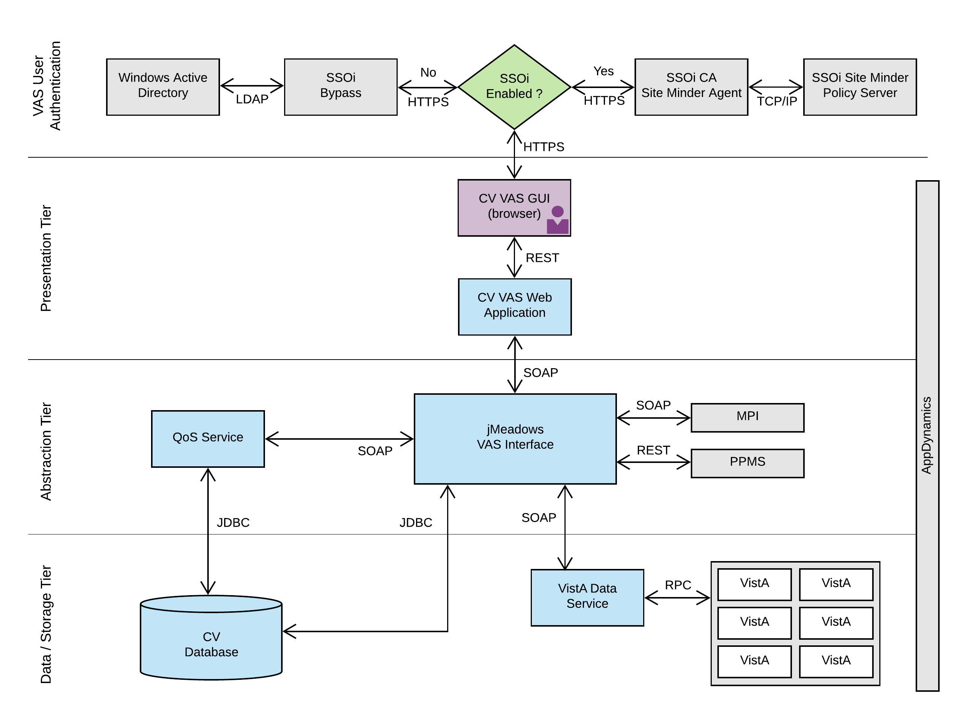
NOTE: SSOi is currently not enabled in CV.
Figure 17: CV CCP Application Context
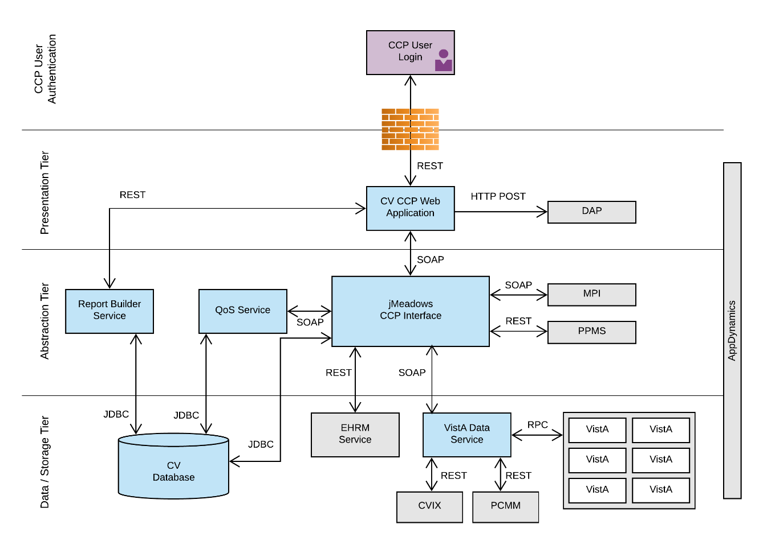
For detailed information about errors and events for the SQL Server DB Engine, please see the website REDACTED.
The CV DB has a table to audit user actions within the application within the AUDIT DB table. This table collects system usage data and provides the CV Support Team the ability to create reports and extract pertinent information from the DB, as needed. A sample of the Audit log can be seen in Figure 18.
NOTE: Additional functionality was added to align with the JLV version 2.9.4.0.3 product release. In particular, CV now connects to the JLV EHRM Service which adds Cerner Millennium to the set of external data sources that CV can retrieve clinical data from. This set of data, known collectively as the Federal Electronic Health Record (FEHR) includes DoD medical treatment facilities and VA sites that have transitioned from VistA to Cerner Millennium. At this time, the required approvals are not in place to allow CV to display DoD data to its CCP users. Therefore, all data from Cerner Millennium are turned off.
Figure 18: Audit Log
Figure REDACTED due to PII

Web Server
CV uses Oracle WebLogic as its web server in the VA environment. CV does not implement any custom WebLogic error handling or reporting. Please refer to the REDACTED for more information.

Application Server
CV uses Oracle WebLogic as its application server in the VA environment. CV does not implement any custom WebLogic error handling or reporting. Please refer to the Oracle REDACTED for more information.

Network
CV utilizes the network infrastructure provided at PITC as the primary site with AITC serving as a failover site. Any network errors that arise are corrected by the team associated with the location of the error.

Authentication and Authorization (A&A)
User access control and authentication takes place before CV interfaces with jMeadows. The user is authenticated to their user profile, granting them access to the presentation layer. jMeadows retrieves user profile information from the CV DB, based on their credentials.
VAS users currently must provide their VistA Access and Verify codes to log in. If credentials are not found the message, “Not a valid Access Code/Verify Code pair.” displays.
If CCP credentials are not found or are inactive in the CV DB, the message, “There is an issue preventing your access to Community Viewer. Please contact your VA Contractor or your VA Medical Center for assistance.” displays. In either case, the login process stops for the user, and no further options appear.
Other A&A error messages are:
- Smart Card Required: The user has not inserted their PIV card into the card reader
- ActivClient: The user’s PIV PIN was entered incorrectly
- Missing Code: The user has not entered their Access/Verify code(s)
- Invalid Access Code: The user has entered an incorrect Access/Verify code
Table 11 provides an overview of the authentication sequence for each user.
Table 11: User Authentication Sequence Overview
User | Authentication Sequence Overview
VA Staff | - VA Staff users must provide their PIV and PIN to log in, as well as their VistA Access and Verify codes
CCP | - CCPs are required to use their NPI or the e-mail address associated with their account in the username field, and a password to log in  - CV validates their e-mail address against the C_Provider table  OR  - CV validates their NPI against the PPMS_Provider table  - jMeadows retrieves information from PPMS, determines if the CCP exists in PPMS, and verifies the CCP has a status of “active” in PPMS
RM User (Provider) | - RM users are required to use their e-mail address (username) and a password to log in  - CV validates their credentials against the C_Provider table
RM VA Staff | - RMPMs must be added to the VAS_UserRole table as authorized users  - RMPM users must provide their PIV and PIN to log in, as well as their VistA Access and Verify codes  - UserRole field of VAS_UserRole set to “RMP” provides RM VA Staff access to the RMP Management Widget
A detailed overview of the login process from the user’s perspective is provided in the CV 3.8 VA Staff User Guide, the CV 3.8 CCP User Guide, and the CV 3.8 Risk Management VA Staff User Guide. Once approved, all project documentation is available in the VA CV Product Repository on GitHub. See Administrative Procedures for information on the repository.

Logical and Physical Descriptions
System design specifications and diagrams can be found in the VA CV Product Repository on GitHub. See Administrative Procedures for information on the repository.

Dependent System(s)
Table 12 lists the external VA systems upon which CV depends, and the errors related to each dependent system. Tier 3 System Engineers follow a triage process to determine the root cause of the error and coordinate with the Point of Contact (POC) for the external systems, as needed.
Table 12: CV External Dependent Systems
Other VA System | Related Error(s)
Site VistA instances | If a VistA site is unavailable, CV displays the Connection Unavailable row in the widgets as shown in Figure 11.
MPI | If MPI is unavailable, CV may display patient search errors or the “Patient records unavailable” error message.
PPMS | If PPMS is unavailable, CV displays the “Failed to retrieve a PPMS response.” error message.
CVIX | If the CVIX service is not available, a message states, “There was an issue retrieving the CVIX URL.”
PCMM | If PCMM is unavailable, CV displays the error message: “The connection to PCMM is unavailable. The patient’s assigned clinical teams may not display.”
Cerner FHIR APIs | Federal EHR (Cerner) is currently unavailable. The source connection is down and some Federal EHR data may not display.

Troubleshooting
Tier 1 troubleshooting for VA users is handled through the ESD.
Tier 2 issues are handled by Health Product Support (HPS).
Tier 3 support and troubleshooting is handled directly by the CV Support Team.

System Recovery
The following subsections define the processes and procedures necessary to restore the system to a fully operational state after a service interruption. Each of the subsections starts at a specific system state and ends with a fully operational system.

Restart After Unscheduled System Interruption
The simplest way to bring the system back to normal operation after the crash of a component is to restart the affected server(s). See System Startup from Emergency Shutdown for guidance.

Restart After DB Restore
Refer to System Startup for system startup procedures.

Backout Procedures
Backout procedures vary depending on the specific release. Please see the CV DIBRG specific to the version to be backed out for more information. Once approved, all project documentation is available in the VA CV Product Repository on GitHub. See Administrative Procedures for information on the repository.

Rollback Procedures
Rollback procedures are dependent on each specific release. Please see the CV DIBRG specific to the version to be rolled back for more information. Once approved, all project documentation is available in the VA CV Product Repository on GitHub. See Administrative Procedures for information on the repository.

Operations and Maintenance Responsibilities
Table 13 represents the operational roles and responsibilities for CV.
Table 13: Operations and Maintenance Responsibility Matrix
Name/Organization | Role/Responsibility | Phone Number | E-mail Address
VA ESD | N/A | REDACTED | REDACTED
VA CV Project Office | Office of Information Technology (OIT) and VHA Stakeholders | N/A | N/A
REDACTED | CV Program Manager (PgM) | REDACTED | REDACTED
REDACTED | CV Project Manager (PM) | REDACTED | REDACTED
Liberty Team | CV Support | N/A | N/A
REDACTED | Contract Program Manager (PgM) | REDACTED | REDACTED
REDACTED | Contract PM | REDACTED | REDACTED
REDACTED | Contract PM | REDACTED | REDACTED
REDACTED | CV Operations Lead | REDACTED | REDACTED
REDACTED | CV Operations | REDACTED | REDACTED
REDACTED | CV Operations | REDACTED | REDACTED
VAAFI Data Power | Technical Issues/Support Contacts | N/A | N/A
REDACTED | VAAFI Lead | REDACTED | REDACTED
REDACTED | Deputy PM SSOi | REDACTED | REDACTED
REDACTED | VAAFI | REDACTED | REDACTED
REDACTED | VAAFI | REDACTED | REDACTED
IO | Technical Issues/ Support Contacts | N/A | N/A
REDACTED | WebLogic / Java Admin | REDACTED | REDACTED
REDACTED | Windows Admin | REDACTED | REDACTED
REDACTED | Linux Admin (Saturday patching) | REDACTED | REDACTED
REDACTED | Linux Admin (Sunday patching) | REDACTED | REDACTED
MPI (VA) | Technical Issues/ Support Contacts | N/A | In VA ServiceNow assigned under: VA—Development—DEV-Person Service  REDACTED
REDACTED | MPI/VAAFI Lead Developer/Architect | REDACTED | REDACTED
REDACTED | MPI Point of Contact (POC) | REDACTED | REDACTED
REDACTED | MPI POC | REDACTED | REDACTED
REDACTED |  | REDACTED | REDACTED
REDACTED | MPI POC | REDACTED | REDACTED
REDACTED | SSOi POC | REDACTED | REDACTED
PPMS | Technical Issues/Support Contact | N/A | N/A
REDACTED | PPMS POC | REDACTED | REDACTED
VA Network Security Operations Center (NSOC) | Technical Issues/Support Contacts | REDACTED | In VA ServiceNow assigned under: VA NSOC Business Partner Extranet (BPE) Operations OR Network Support Center (NSC) BPE Operations  REDACTED
REDACTED | Triple-I/VA-NSOC | REDACTED | REDACTED

Approval Signatures

Signed: _______________________________________________________________________
REDACTED, Project Manager/Receiving Organization
Signed: _______________________________________________________________________
REDACTED, Product Owner
- Acronyms and Abbreviations
Table 14 lists the acronyms and abbreviations used throughout this document and their descriptions.
Table 14: Acronyms and Abbreviations
Acronym | Definition
A&A | Authentication and Authorization
AITC | Austin Information Technology Center
API | Application Programming Interface
APM | Application Performance Management
BPE | Business Partner Extranet
BSE | Broker Security Enhancement
CA | Computer Associates
CCP | Community Care Provider
CHG | Change Order
CPU | Central Processing Unit
CRISP | Continuous Readiness in Information Security Program
CV | Community Viewer
CVIX | Central VistA Imaging Exchange
DAP | Digital Analytics Program
DB | Database
DIBRG | Deployment, Installation, Backout, and Rollback Guide
DoD | Department of Defense
DWS | Data Web Service
EHR | Electronic Health Record
EHRM | Electronic Health Record Modernization
ESD | Enterprise Service Desk
ET | Eastern Time
FEHR | Federal Electronic Health Record
FHIR | Fast Healthcare Interoperability Resources
GB | Gigabyte
GTM | Global Traffic Manager
GUI | Graphical User Interface
HPS | Health Product Support
HSTS | HTTP Strict Transport Security
HTML | Hypertext Markup Language
HTTP | HyperText Transfer Protocol
ICD | Interface Control Document
ICN | Integration Control Number
ID | Identification
IEN | Internal Entry Number
IO | Infrastructure Operations
IT | Information Technology
JDBC | Java Database Connectivity
JLV | Joint Longitudinal Viewer
JPEG | Joint Photographic Experts Group
JSON | JavaScript Object Notation
LTM | Local Traffic Manager
MPI | Master Person Index
MS | Microsoft
NPI | National Provider Identifier
NSC | Network Support Center
NSOC | Network Security Operations Center
OIT | Office of Information and Technology
PCMM | Primary Care Management Module
PDF | Portable Document Format
PIN | Personal Identification Number
PITC | Philadelphia Information Technology Center
PIV | Personal Identity Verification
PgM | Program Manager
PM | Project Manager
POC | Point of Contact
POM | Production Operations Manual
PPMS | Provider Profile Management System
QoS | Quality of Service
RAM | Random Access Memory
REST | Representational State Transfer
RM | Risk Management
RMPM | Risk Management Provider Manager
RPC | Remote Procedure Call
SDD | System Design Document
SDU | Service Desk User
SMS | Systems Made Simple
SNOW | Service Now
SOAP | Simple Object Access Protocol
SQL | Structured Query Language
SSMS | SQL Server Management Studio
SSOi | Single Sign-On Internal
URL | Uniform Resource Locator
VA | Department of Veterans Affairs
VAAFI | VA Authentication Federation Infrastructure
VAS | VA Staff
VDD | Version Description Document
VDS | VistA Data Service
VHA | Veterans Health Administration
VI | VistA Imaging
VistA | Veterans Information Systems and Technology Architecture
VM | Virtual Machine

NOTE: Access to the VA CV Product Repository on GitHub is restricted and must be requested.
Central VistA Imaging Exchange (CVIX), Java Database Connectivity (JDBC), Digital Analytics Program (DAP), Primary Care Management Module (PCMM), Remote Procedure Calls (RPCs), REpresentational State Transfer (REST), Simple Object Access Protocol (SOAP).

