Community Viewer (CV) Version 1.5 User Guide

December 2016
Version 1.3

Department of Veterans Affairs (VA) Office of Information and Technology (OI&T)

Revision History

Date | Version | Description | Author
12/30/2016 | 1.3 | Addressed per client feedback and resubmitted | AbleVets
12/28/2016 | 1.2 | Updated per client comments and resubmitted | AbleVets
12/09/2016 | 1.1 | Resubmitted to client. Updated for security banner information. Client comments addressed | AbleVets
11/04/2016 | 1.0 | Submitted for CLIN 000AM | AbleVets
10/28/2016 | 0.1 | Initial draft of document | AbleVets

Table of Contents

- Introduction 1
  - Purpose 1
  - Document Orientation 1
    - Organization of the Document 1
    - Assumptions 1
    - Coordination 2
    - Disclaimers 2
      - Software Disclaimer 2
      - Documentation Disclaimer 2
    - Documentation Conventions 2
    - References and Resources 3
  - Organizational Contacts 3
- System Summary 4
  - System Requirements 4
  - User Access Levels 4
  - Continuity of Operations 5
- Getting Started 6
  - Logging On 6
    - VAS User Login 6
    - CCP User Login 7
  - System Menu 11
    - Viewing System Status 12
    - Configuring Your User Profile 13
    - Setting the User Interface Theme 13
    - Setting up the CV Web Application for Accessibility 14
      - Keyboard Focus and Screen Navigation in Accessible Theme 15
  - Changing the User ID and Password 16
  - Exit System 17
  - Caveats and Exceptions 17
- Using the Software 18
4 1. Working with the Community Care Provider Management Module (VAS Users Only) 18
    - About VA Facilities and Provider Groups 19
    - Creating Community Care Provider Groups 20
    - Creating Providers 22
    - Assigning Patient Consults 24
    - Setting Record Display Limits 27
  - Editing Provider Groups and Profiles 28
    - Editing Provider Groups 28
    - Editing Provider Profiles 30
    - Deleting Providers 32
    - Resetting Provider Passwords 33
  - Accessing Patient Data for CCP Users 34
  - Patient Data Display for CCP and VAS Users 35
    - Accessing and Opening Widgets 37
    - Widget Navigation and Display Options 38
    - Minimized vs. Expanded Widget View 39
    - Creating Additional Widget Displays using Custom Tabs 39
    - Refreshing Widgets 40
  - Patient Portal Data 40
    - Patient Demographics 40
      - Viewing Third-party Insurance Information 40
      - Race Data Terminology Normalization 41
    - Admissions 41
      - Admissions Widget Data 41
      - Display and Filter Options 42
      - Terminology Normalization in the Admissions Widget 42
    - Allergies 42
      - Allergies Widget Data 42
      - Viewing Allergy Details 43
      - Terminology Normalization in the Allergies Widget 43
    - Appointments 43
      - Appointments Widget Data 44
      - Viewing Appointment Details 44
      - Display and Filter Options 44
      - Terminology Normalization in the Appointments Widget 45
    - Clinical Reminders 45
      - Clinical Reminders Widget Data 45
      - Display and Filter Options 45
      - Viewing Clinical Reminder Details 46
    - Consults 46
      - Consults Widget Data 46
      - Viewing Consult Encounter Details 46
      - Display and Filter Options 47
      - Terminology Normalization in the Consults Widget 47
    - Discharge/Essentris Notes 47
      - Discharge/Essentris Notes Widget Data 47
      - Viewing Discharge/Essentris Notes Details 48
      - Display and Filter Options 48
      - Terminology Normalization in the Discharge/Essentris Notes Widget 49
    - Encounters 49
      - Encounters Widget Data 49
      - Viewing Encounter Details 50
      - Viewing Encounter Notes 50
      - Additional Display and Filter Options in the Encounters Widget 50
      - Terminology Normalization in the Encounters Widget 51
    - Immunizations 51
      - Viewing Immunization Details 52
      - Display and Filter Options 52
      - Terminology Normalization in the Immunizations Widget 52
    - Inpatient Medications 52
      - Inpatient Medications Widget Data 53
      - Viewing Inpatient Medication Details 53
      - Display and Filter Options 53
      - Terminology Normalization in the Inpatient Medications Widget 54
    - Lab Panel Results 54
      - Lab Panel Results Widget Data 55
      - Viewing Lab Panel Results Details 55
      - Display and Filter Options 55
      - Terminology Normalization in the Lab Panel Results Widget 56
    - Lab Results 56
      - Lab Results Widget Data 56
      - Display and Filter Options 57
      - Viewing Abnormal Results in the Lab Results Widget 57
      - Viewing Lab Results Details 58
      - Table View in the Lab Results Widget 58
      - Graph View in the Lab Results Widget 58
      - Terminology Normalization in the Lab Results Widget 59
    - Outpatient Medications 59
      - Outpatient Medications Widget Data 59
      - Viewing Outpatient Medication Details 60
      - Display and Filter Options 61
      - Terminology Normalization in the Outpatient Medications Widget 62
    - Orders 62
      - Orders Widget Data 62
      - Viewing Order Details 63
      - Display and Filter Options 63
      - Terminology Normalization in the Orders Widget 64
    - Problem List 64
      - Problem List Widget Data 64
      - Viewing Problem List Details 65
      - Display and Filter Options 65
      - Terminology Normalization in the Problem List Widget 65
    - Procedures 66
      - Procedures Widget Data 66
      - Display and Filter Options 66
      - Terminology Normalization in the Procedures Widget 67
    - Progress Notes 67
      - Progress Notes Widget Data 67
      - Viewing Progress Notes Details 68
      - Display and Filter Options 68
      - Terminology Normalization in the Progress Notes Widget 69
    - Radiology Exams 69
      - Radiology Exams Widget Data 69
      - Viewing Radiology Report Details 70
      - Display and Filter Options 70
      - Terminology Normalization in the Radiology Exams Widget 71
    - Vitals 71
      - Vitals Widget Data 72
      - Display and Filter Options 72
      - Graph View in the Vitals Widget 73
      - Table View in the Vitals Widget 73
      - Terminology Normalization in the Vitals Widget 73
- Troubleshooting 75
  - Special Instructions for Error Correction 75
    - Patient Search Troubleshooting 76
- Acronyms and Abbreviations 78

Table of Figures
Figure 1: User Workflow 4
Figure 2: Sample Login Page for VAS Users 7
Figure 3: Authorized Use Message 8
Figure 4: Sample CCP User Login Page 9
Figure 5: CCP VA Privacy and Security Awareness Training Page 9
Figure 6: CV Portal Tools 11
Figure 7: Sample System Status Hover Text 12
Figure 8: Configuration Settings 13
Figure 9: Sample User Interface Theme – Blue 14
Figure 10: User Interface Theme – Accessible 15
Figure 11: Sample CCPM Screen 19
Figure 12: Sample Default VA Facility 20
Figure 13: Sample Create Provider Group Screen 21
Figure 14: Sample Community Provider Group Fields 22
Figure 15: Create Providers 23
Figure 16: Search Providers 24
Figure 17: Sample Edit Provider Fields 25
Figure 18: Patient Search 26
Figure 19: Sample Selected Patient and Available Consults 27
Figure 20: Configuring the Default Date Range 28
Figure 21: Edit Provider Group 29
Figure 22: Add or Remove Providers from Group 30
Figure 23: Edit Provider Profile 31
Figure 24: Assigned Patients and Previously Assigned Patients in Provider Profile 32
Figure 25: Delete Provider 33
Figure 26: Community Care Provider Password Reset 34
Figure 27: Sample Assigned Patient List on Provider Portal 35
Figure 28: Sample Widget Display on the Patient Portal 36
Figure 29: Widget Tray on the Patient Portal 37
Figure 30: Sample Expanded View Widget Display 39
Figure 31: Outpatient Medications Widget – Details of VA Medication 61
Figure 32: Radiology Exams Details Window (VA Record) 70

Table of Tables
Table 1: Documentation Symbols and Descriptions 3
Table 2: System Users, Roles, and Access Levels 4
Table 3: Keyboard Accessible Keystrokes 16
Table 4: Widget Navigation Tool Descriptions 38
Table 5: Login Page Error Message Troubleshooting 75
Table 6: Patient Search Error Message Troubleshooting 76
Table 7: Acronyms and Abbreviations 78

Introduction
Community Viewer (CV) is a browser-based software application built on the Joint Legacy Viewer (JLV) system. CV facilitates the secure exchange of data between Veterans Administration (VA) systems and non-VA providers, known as Community Care Providers (CCPs). The exchange of data improves care coordination and continuity of care for VA patients receiving treatment outside of the VA network.
CV pulls information from VA health care systems in real time for viewing within a web browser. Through CV, VA Administrative Staff (VAS) can assign consultations to CCPs and provision CCP use within the CV system, allowing non-VA providers access to view patient records from multiple VistA systems.

NOTE: In this release, the data retrieved and viewed through CV is limited to VA only; the retrieval and display of VA Virtual Lifetime Electronic Record (VLER), DoD, and DoD VLER data is not yet supported.

Purpose
This guide defines the users of the CV web application, and provides information and instructions to familiarize users with the important features and navigational elements of this release.

Document Orientation
This document provides a detailed look at the features of the CV web application. The guide is geared toward VAS users, CCP users, and System Administrators, who require an understanding of the system from the end user’s perspective.

Organization of the Document
This document provides information in the following sections:
      - Section 2, System Summary
      - Section 3, Getting Started
      - Section 4, Using the Software
      - Section 5, Troubleshooting

Assumptions
This document was written with the following assumed experience/skills of CV end users:
- User has basic knowledge of accessing and using web-based applications (such as a web browser, including onscreen commands, menu options, and navigation tools).
- User has been provided the appropriate access credentials, Uniform Resource Locator (URL) for the login page, system user names, access/verify codes (for VAS users), and passwords (for CCP users), required for the CV web application.

- VAS users are using the CV web application to assign patient consults to providers outside the VA network.
- CCP users are using the CV web application to view VA patient data relevant to assigned consults.

Coordination
Installation coordination activities are detailed in the Deployment, Installation, Backout, and Rollback Guide, submitted with this release.
Primary CV consult assignment and coordination tasks are performed by VAS. VAS users create CCP CV accounts, assign consults to CCPs, and coordinate the distribution of access credentials. CCPs use CV to view VA Electronic Health Records (EHR) for veterans under their care.

Disclaimers

Software Disclaimer
This software was developed at the VA, by employees of the Federal Government, in the course of their official duties. Pursuant to Title 17, Section 105 of the United States Code, this software is not subject to copyright protection, and is in the public domain. VA assumes no responsibility whatsoever for its use by other parties, and makes no guarantees, expressed or implied, about its quality, reliability, or any other characteristic. VA would appreciate acknowledgement if the software is used. This software can be redistributed and/or modified freely, as long as any derivative work bears some notice that it is derived from this software, and any modified version bears some notice that has been modified.

Documentation Disclaimer
The appearance of external hyperlink references in this manual does not constitute endorsement by the VA of the web site or the information, products, or services contained therein. The VA does not exercise any editorial control over the information found at these locations. Such links are provided, and are consistent with, the stated purpose of the VA.

Documentation Conventions
This manual uses several methods to highlight different aspects of the material. Cross-references to other sections within this document are hyperlinked. File names of external documents are italicized.
Various symbols are used throughout the documentation to alert the reader to special information. Table 1 gives a description of each of these symbols.

Table 1: Documentation Symbols and Descriptions
Description

Symbol
NOTE:
Used to inform the reader of general information including references to additional reading material
CAUTION:
Used to caution the reader to take special notice of critical information

References and Resources
The following references and resources were used to create this document:
- Joint Legacy Viewer/Community (JLV-C) Pilot User Guide (JLV-GTDB User Guide 7-1-2016)
- System Requirements (Community Viewer 5 Requirements 08 31 16)
- Community Viewer Overview Slides (Community Viewer 101 20161011)

Organizational Contacts
Authorized users of the CV web application should contact Veteran Health Affairs (VHA) Community Support when in need of technical assistance with the application.
E-mail: REDACTED

System Summary
The system provides clinicians streamlined access to complete patient histories displayed in a single, customizable, secure, and easy-to-use interface. The system also offers clinical knowledge enrichment, and clinical decision support services, that provide the right data at the right time. Figure 1 provides a graphic representing typical user workflow.

Figure 1: User Workflow
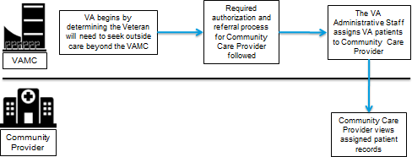

System Requirements
The CV application interface is a front-end web application, designed to run in a web browser. Internet Explorer (IE) 11 is the recommended browser for optimal use. The minimum required browser that can be used to access CV is IE 10.

User Access Levels
Table 2 summarizes the roles and functionality available to end users of the CV web application.

Table 2: System Users, Roles, and Access Levels

User | Role | Functions
VAS | Establish and maintain CCP access to the system for specific patient data related to specific patient consults, based on a pre-determined data, date range. | - Create and manage CCP accounts.  - Notify CCP users of account credentials (login).  - Assign approved patients, consults, and data, date ranges to CCP accounts.
CCP | Provide authorized healthcare services to consenting VHA qualified patients. | View (read only) the Veteran patient’s health record information available from VistA host systems.

Continuity of Operations
The CV system is maintained with combined efforts of Austin Information Technology Center (AITC) personnel, Enterprise Operations (EO), and the JLV Support team.
The AITC overarching Continuity of Operations Procedure (COOP) dictates that the primary recovery location is at the Philadelphia Information Technology Center (PITC). Recovery, should it happen, includes only the production environment servers and data connections.
At the time of this writing, it is the business office’s intention to have a no more than 72 hour recovery time objective. This means that, in the event that the COOP is activated, the services for CV could be down for both VAS and CCP users for the duration of the recovery period.

Getting Started

Logging On

VAS User Login
Authorized, registered users within the VA are provided access information to log on to CV. If VAS users have not received credentials to access CV, they must first request access through the appropriate service lead or facility, or contact VHA Community Support.
CV authenticates all VA users against a list of authorized, registered users in combination with the user's Personal Identification Verification (PIV) card and credentials. During log in, first- time CV users are prompted to enter their agency, site, and user settings. This data is used to create a CV user profile, and is utilized during future login sessions.
The following steps apply to VHA and VAS users accessing CV through a URL. VAS users are VHA users, and should, therefore, follow the steps outlined below.
If you have not received credentials to access CV, you must first request access through the appropriate VA service lead.
To log into CV:
- Insert your PIV card into your computer or card reader.
- Open your Internet browser. (IE 10 is required; IE 11 is recommended.)
- Enter the URL for the CV web application, as provided in the invitation letter sent via e- mail.
- When prompted, select the appropriate, current digital certificate.
- When prompted, enter your PIV Personal Identification Number (PIN).
- Click I Accept after reading the important user consent information regarding accessing a government information system.
- Enter the following information in the fields on the Login page. (Example shown in Figure 2):
  - Enter your VistA Access Code.
  - Enter your VistA Verify Code.
  - Select VA from the Agency field.
  - Select your local VistA host site from the Site field.
- Click Login.

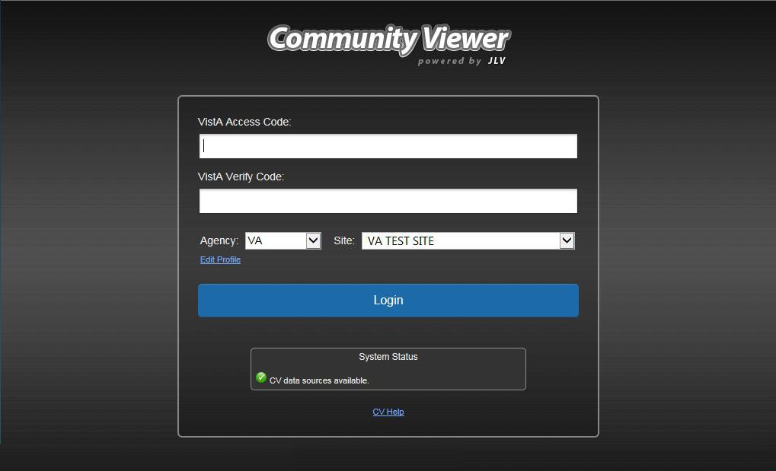
Figure 2: Sample Login Page for VAS Users

NOTE: Users who are not authorized to access CV see an Access denied message. Access to CV is limited to authorized users, and is configured by System Administrators. If you believe you have received the message in error, please contact VHA Community Support.
During future log in attempts, the lower-left corner of the Login page displays the user’s last successful login and the last unsuccessful login attempt, which includes the date, local time, and IP address from which access or attempted access was made.

CCP User Login
During log in, CV authenticates all CCPs against a registered list of users provisioned by VAS. If you have not received credentials to access CV, you must first request access through the appropriate VAS liaison.
NOTE: Prior to accessing the functionality of the CV application for the first time, (or 365 days after the date of their first log in), CCP users are required to perform acknowledgement tasks.
- Open your Internet browser. (IE 10 is required; IE 11 is recommended.)
- Enter the URL for the CV web application, as provided by VAS. The Authorized Use message (Figure 3), a security and legal disclaimer, appears.
- Click OK to confirm that you are aware you are accessing a government information system that is provided for authorized users only.

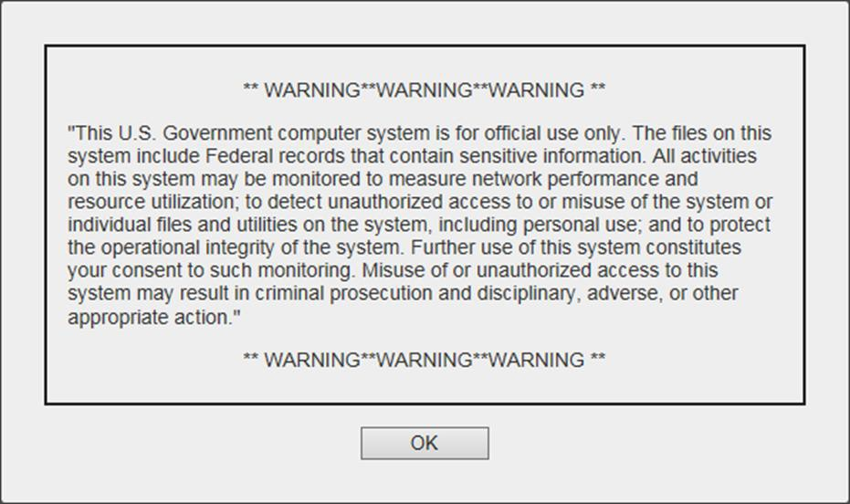
Figure 3: Authorized Use Message

- Enter the username and password, provided by VAS, in the fields on the Login page (Figure 4):
  - The username is the e-mail address associated with your account.
  - If you do not have, or have forgotten, your password, click the Forgot Password?
link on the Login page.

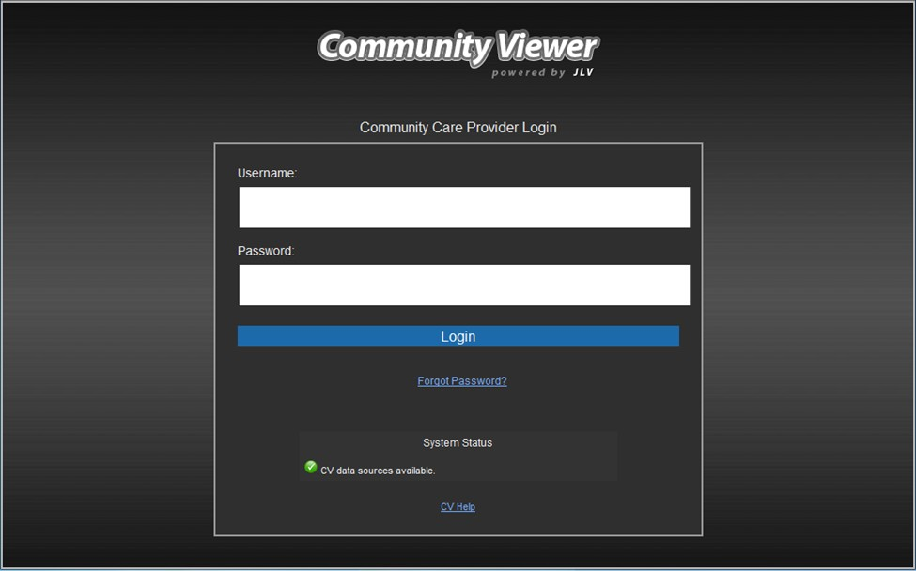
Figure 4: Sample CCP User Login Page

- Click Login.
- If you are logging in to the CV application for the first time, or if you are logging in 365 days after your first log in, the VA Privacy and Security Awareness Training page (Figure 5) appears.

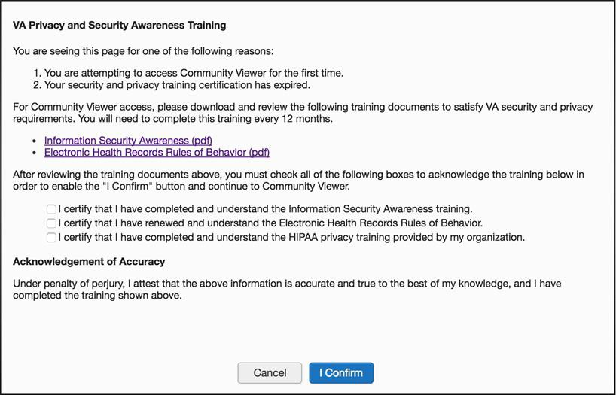
Figure 5: CCP VA Privacy and Security Awareness Training Page

NOTE: The VA Privacy and Security Awareness Training page appears the first
time the CPP user accesses the CV application, and again every 365 days after the
first successful log in, as training certification must be renewed each year.

- Download and read the Information Security Awareness Training PDF document.
- Download and read the Electronic Health Records Rules and Behavior PDF document.
- Click the checkbox to certify that you have completed and understand the Information Security Awareness training.
- Click the checkbox to certify that you have read and understand the Electronic Health Records Rules and Behavior.
- Click the checkbox to certify that you have completed and understand the Health Insurance Portability and Accountability Act (HIPAA) Privacy training through your organization.
- Click the I Confirm button to proceed to the application.

System Menu
Each CV portal contains icons and tools, highlighted in the top-right corner of Figure 6, that enable quick access to the following:
- View status of data source connections. See Section 3.2.1, Viewing System Status.
- Configure your user profile. Click the cog wheel in the top-right corner of either the Provider Portal or Patient Portal page to configure user settings, including the on-screen theme. See Section 3.2.2, Configuring Your User Profile.
- Access online help. Click Help in the top-right corner of either the Provider Portal or Patient Portal page to open web-based, online help.
- Open the widget tray and add additional clinical domain widgets. See Section 4.4.1, Accessing and Opening Widgets.
- Log out. Click Logout to terminate your CV session.
NOTE: The symbol seen to the right of the System Status indicator represents clinical context management through the Clinical Context Object Workgroup (CCOW). This service is disconnected. CCOW is utilized within VA environments as a way for multiple applications to synchronize clinical context based on the Health Level 7 (HL7) CCOW standard. This feature is not applicable for CCP users accessing the CV web application.

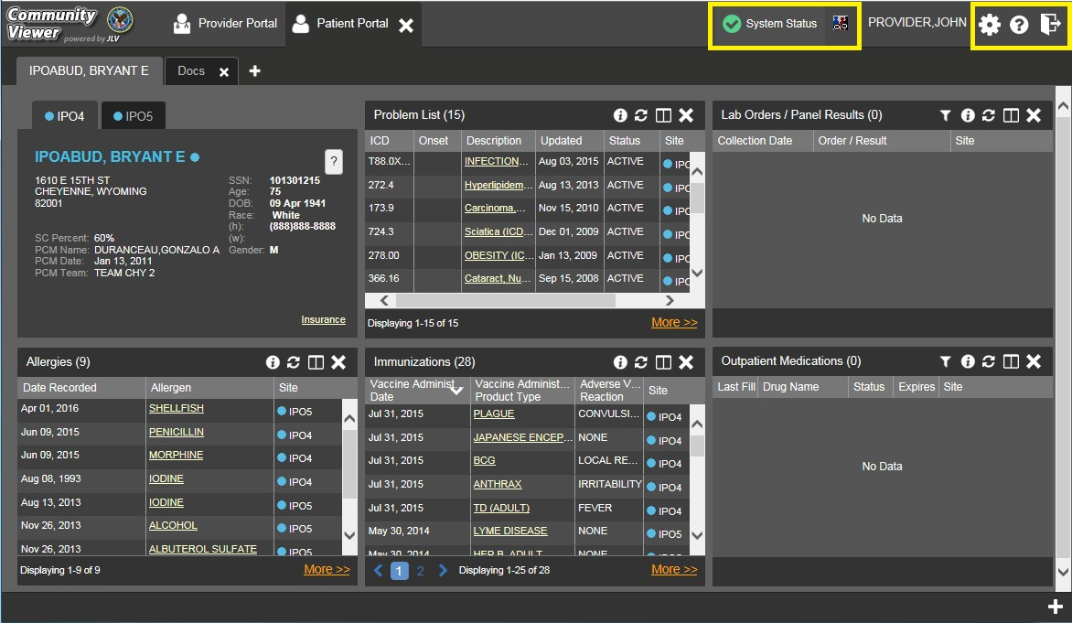
Figure 6: CV Portal Tools

Viewing System Status
System status updates are received from CV’s Health Monitor, which monitors the services that CV uses to connect to VA data sources. Monitored services include: Master Veteran Index (MVI), VistA Data Service, and jMeadows Data Service.
There are two areas of the CV where system status is displayed:
- On the Login page, and at the top of either the Provider or Patient Portal page (example shown in Figure 6).
- Once logged in, hovering the mouse pointer over System Status provides any additional information available for the system status update, as well as the e-mail address for VHA Community Support.
When all monitored systems and services are online and connected, a green icon appears next to status, with the message CV data sources are available (Figure 7).
When one or more monitored systems or services are offline or unavailable, a yellow warning icon appears with the message CV is having problems. Notification of unavailable systems persisting longer than ten (10) minutes should be reported to VHA Community Support.
When the Health Monitor is unable to retrieve system status information, a red icon appears with the message, System status is unavailable. This is not an indicator that data sources are unavailable to CV. One possible cause for this status is that the jMeadows Data Service is unavailable or an internal jMeadows Data Service error has occurred. Users may not be able to log into CV or view patient data until the jMeadows connection is restored.

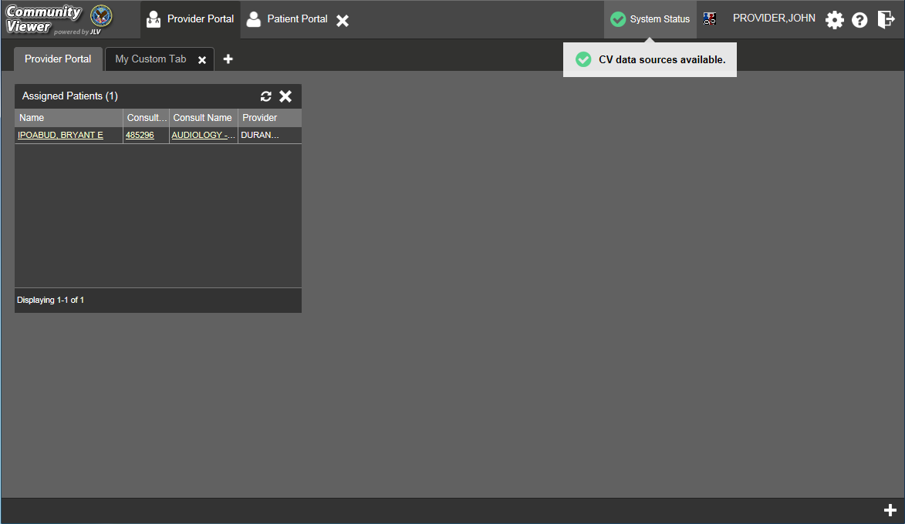
Figure 7: Sample System Status Hover Text

Configuring Your User Profile
After logging in, a user can access the profile settings by clicking the cog wheel located in the top-right corner of the portal page (Figure 8).
In this release, the configuration options are limited to theme. See Section 3.2.3, Setting the User Interface Theme.

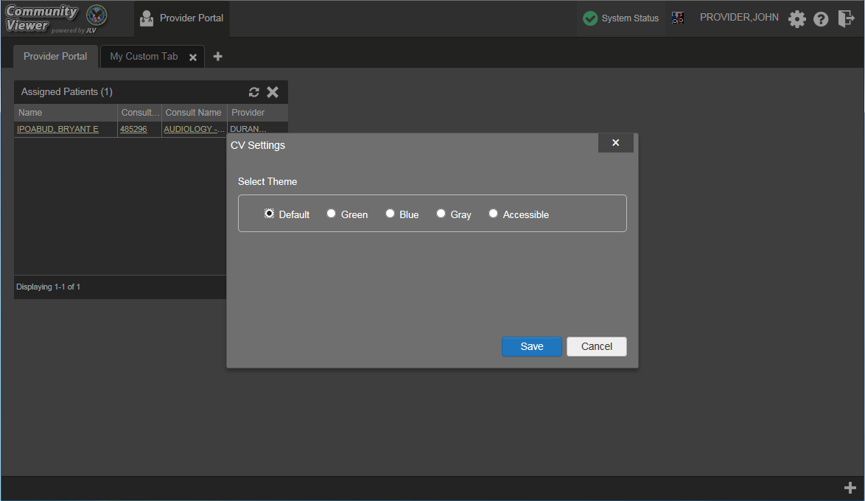
Figure 8: Configuration Settings

Setting the User Interface Theme
Selecting the User Interface Theme setting within the user profile settings allows you to pick the font color, foreground, and background colors of the CV Graphical User Interface (GUI), which would apply to all onscreen elements, including widgets, toolbars, and dialog boxes. The themes are Default, Green, Blue, Gray, and Accessible.
Figure 9 presents the Blue theme. For comparison, the example provides the same test patient data and screen layout shown in Figure 28, which displays the Default theme. A sample of the Accessible theme is shown in Figure 10.

NOTE: The Accessible theme includes larger fonts, enhanced tab and keystroke functionality, and screen reader compatibility to support Federal accessibility requirements and Section 508 compliance. Refer to Section 3.2.4, Setting up the CV Web Application for Accessibility for more information.

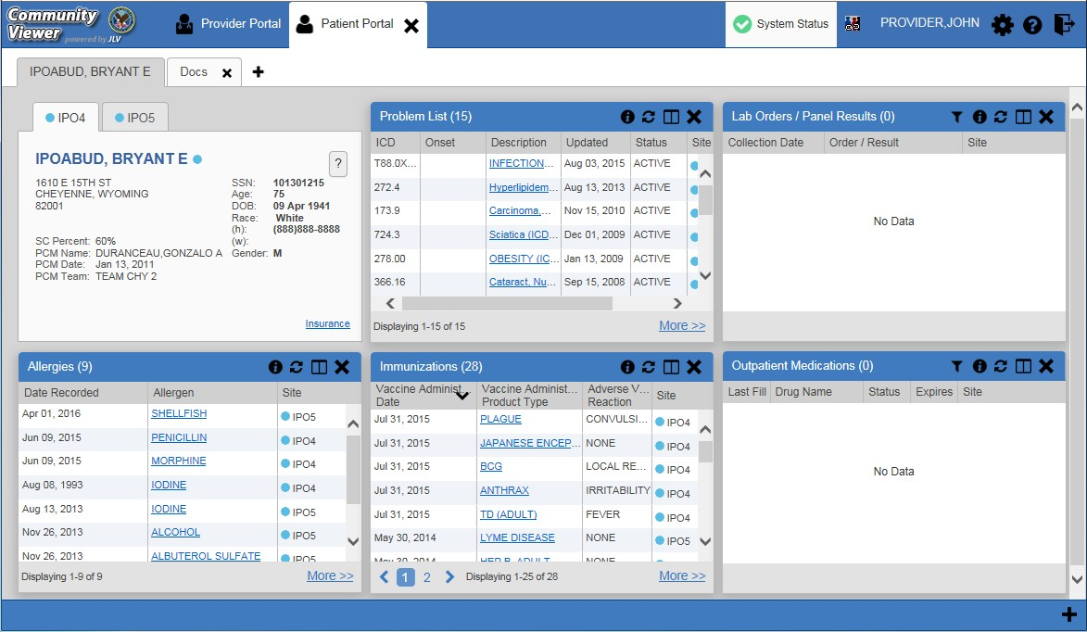
Figure 9: Sample User Interface Theme – Blue
The user interface theme setting is saved in the user profile, and is seen in all subsequent user sessions. After logging in, you can also set the user interface theme by clicking the cog wheel on the top-right corner of the portal page.

Setting up the CV Web Application for Accessibility
To set up the CV web application for Section 508 compliance after logging in:
- Click the cog wheel in the upper-right corner of the Patient or Provider Portal page.
- Select Accessible from the User Configuration dialog box, and click Save.
- After clicking Save, click Yes to reload the application to apply the settings. Click
Cancel to exit and restore the previous theme.

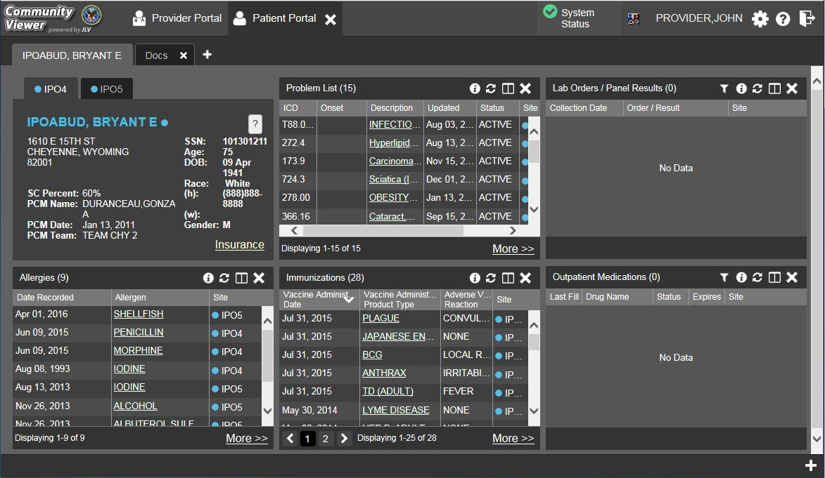
Figure 10: User Interface Theme – Accessible

3.2.4.1. Keyboard Focus and Screen Navigation in Accessible Theme
Keyboard focus is the highlighting of on-screen elements that enables the interaction with, and navigation of, the web application through the keyboard and keystrokes. The user interface item which currently has keyboard focus is outlined. The CV web application uses a gold-colored border or outline as a visual indicator of which element currently has keyboard focus.
CV enables the use of Windows keyboard keystrokes (i.e., Tab, Shift + Tab, arrow keys, Enter), and other keyboard shortcuts to move the on-screen focus to all menus, and activate all functions on the menus. All user interface items are accessible via the keyboard under the Accessible theme.
Generally, pressing Enter or Spacebar, when an element that provides action is in keyboard focus, performs the associated action. For example, pressing Enter or Spacebar when the Settings button is in keyboard focus on the portal screen opens the User Configuration dialog box. Using the arrow keys or the Tab key allow a user to move between keyboard focus items to navigate through on-screen elements. A complete listing of keyboard accessible keystrokes can be found in Table 3.

Table 3: Keyboard Accessible Keystrokes

Keystroke | Description
Application and Portal Navigation
ENTER | Press to transfer keyboard focus to the highlighted widget.
TAB | Press to transfer keyboard focus to other user interface items.
ESC | Press to return keyboard focus to the panel containing the user interface item with keyboard focus or to exit a window or widget.
SPACEBAR | Press to activate any user interface item (for example, click a button).
Arrow Keys | When keyboard focus is on a widget, press the arrow keys to change page viewing in a widget's data table.  When keyboard focus is on a dropdown list, press the down arrow to view the contents.
Tab Panels
Arrow Keys | Use the left and right arrow keys to change tab panels.  To add a tab panel, press the right arrow key until the last tab (+) is selected. A dialog prompts the user to enter the tab name.
Ctrl + x | To close a tab, focus on the tab panel and press Ctrl + x.
Windows and Dialog Boxes
TAB | Press the Tab key to move the keyboard focus to other user interface items within the window.
Adding Widgets to the On-screen Portal
SHIFT +  (Number position) | To add a widget from the widget tray using keystrokes:  - Determine which column (1, 2, or 3) to place the widget on the portal page.  - Focus the desired widget icon in the widget tray and press the Shift key along with the 1, 2, or 3 key, depending on the desired column placement.

Changing the User ID and Password
For VAS users, CV authenticates all VA users against an authorized, registered list of VHA/VAS users, in combination with the user's PIV card and credentials. User Identification (ID) and access code/verify code changes or resets are not performed in CV for the VAS user.
CCP users follow the steps outlined below to request a password reset. To request a password reset:
- Enter the URL for the CV web application, provided by VAS, in the address bar of your Internet browser.
- Click the Forgot Password? link.
- Enter your name, e-mail address, and phone number in the fields provided in the dialog box.

- Click Send.
- An e-mail message is generated to VHA Community Support requesting that an associate contact you, at the phone number you provide, with a new password.

Exit System
You may intentionally log off and end a CV user session by clicking Logout at any time. If you fail to log off on your own, your session terminates automatically after five (5) minutes of inactivity. Automatic termination of a user session does not clear the screen; however, your user session is terminated.

Caveats and Exceptions
There are no caveats or exceptions known at this time.

Using the Software

Working with the Community Care Provider Management Module (VAS Users Only)
After logging in, VAS users see the Provider Portal and the Community Care Provider Management (CCPM) module. This module is the starting point for assigning a patient consult to a CCP outside of the VA network.

NOTE: Throughout this document, the Community Care Provider Management module may also be referenced as the CCPM module.
If the CCPM module is not already open on the screen, click the plus + sign in the lower-right corner of the screen, as seen in Figure 11, to open the widget tray. The widget tray for VAS users is modified to include the CCPM module. Left-click and drag the icon from the widget tray to the screen, and drop the widget in the desired location on the portal page.
A VAS user assigns a CCP a patient consult through the CCPM module. The workflow for this process is typically as follows:
- Create Community Care Provider Groups
- Create/Edit Providers
- Assign a Patient Consults
- Set Record Display Limits

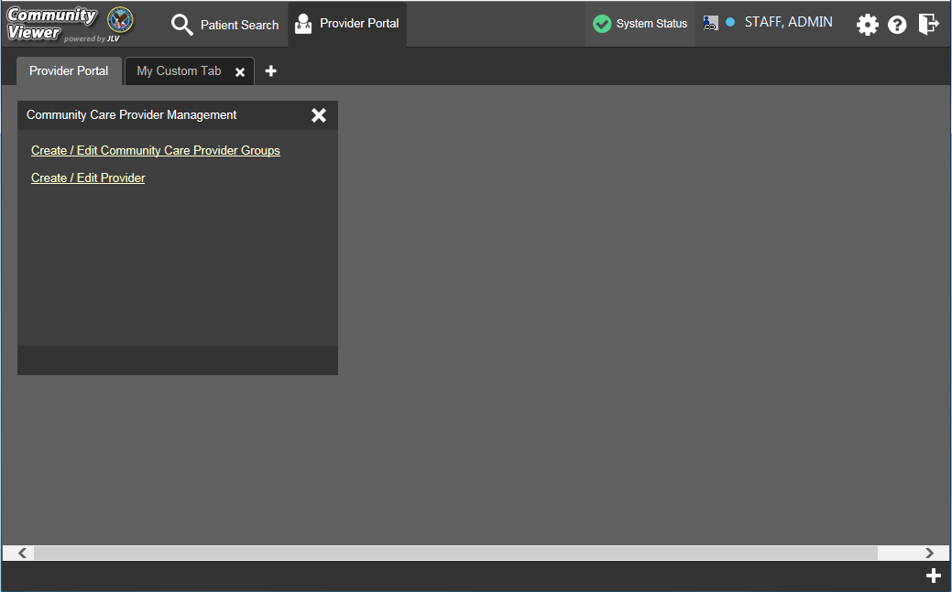
Figure 11: Sample CCPM Screen

About VA Facilities and Provider Groups
In CV, CCPs must be assigned to a provider group when their account is created. Provider groups may contain one or more VA facilities.
By default, after a VAS user logs in and opens the CCPM module and clicks the Create/Edit Community Care Provider Groups link (shown above in Figure 11), the Facilities field in the resulting Create/Edit Provider screen is automatically populated with the user’s local VA site, as selected on the Login page. A sample is shown in Figure 12. See Section 4.1.2, Creating Community Care Provider Groups, for more information.

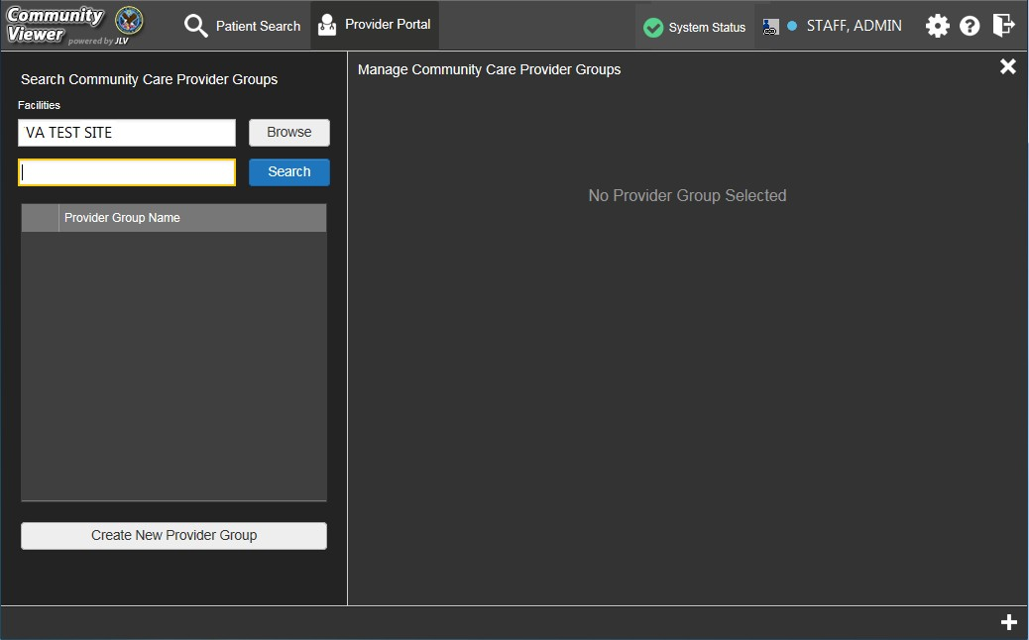
Figure 12: Sample Default VA Facility

Creating Community Care Provider Groups
Before assigning a patient consult to a CCP, a VAS user creates a provider group so that when a CCP account is created, the VAS user can associate the provider with a CCP Group in his/her provider profile.
A CCP Group is typically an outside clinic, or one or more associated facilities with which a provider works. After a CCP Group is created, individual providers can be associated with that group.
Perform the following steps to create a Community Care Provider Group if one is needed. To create a provider group:
- Open the CCPM module. See Section 4.1, Working with the Community Care Provider Management Module (VAS Users Only).
- Click the Create/Edit Community Care Provider Groups link, shown in Figure 11.
- Click Create New Provider Group.

Figure 13: Sample Create Provider Group Screen

- To add a facility, click Browse next to the Facilities field (Figure 14) and select the desired facility from the list that appears.
- Enter information for the CCP group in the remaining fields.
- Click Save.

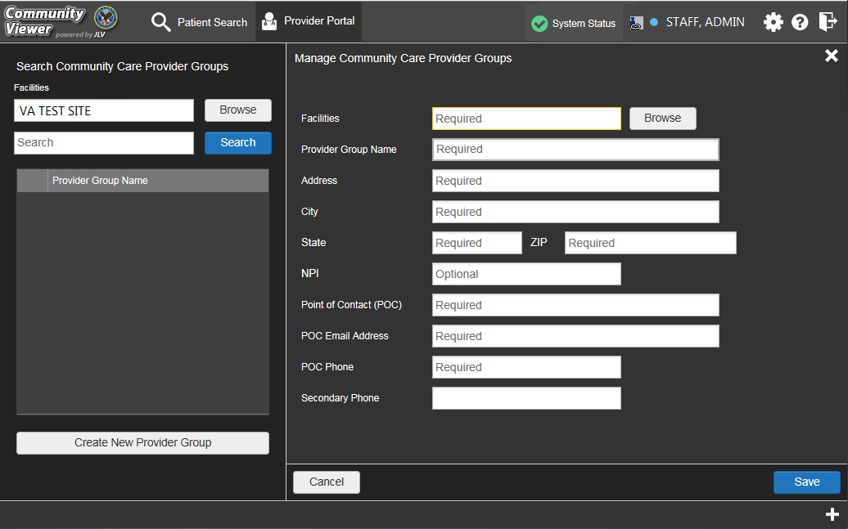
Figure 14: Sample Community Provider Group Fields

- When the Provider Group successfully created message appears, you are given the following options:
- Click Create Providers and follow the steps outlined in Section 4.1.3, Creating Providers.
- Click OK to return to the CCPM module.

Creating Providers
All CCP user accounts are created by VAS users in the CCPM module. Creating a CCP creates the provider’s associated account and user profile. A VAS user can assign consult patients to CCPs after their account is created.
To create a provider:
- Open the CCPM module. See Section 4.1,Working with the Community Care Provider Management Module (VAS Users Only).
- Click the Create/Edit Provider link, as shown in Figure 11.
- Click Create New Provider, shown in Figure 15.
- A provider account must be associated with a CCP Group. If you’ve entered the screen immediately after creating a provider group, the Provider Group field is pre-populated, and you can skip the Provider Group search displayed in Figure 15. If not, click Browse next to the Provider Group field to search for an existing group.

- From the list of Community Care Groups that appears, select the group and click OK.

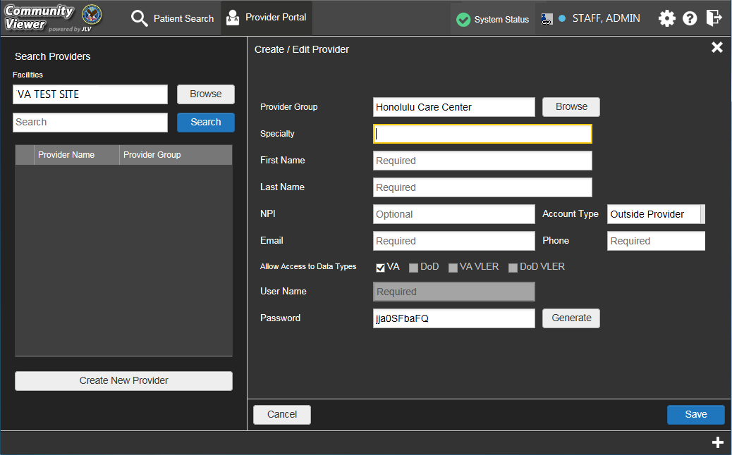
Figure 15: Create Providers

- Enter the provider information in the fields on the screen. See Figure 15. Required fields are noted.
- Select Outside Provider from the Account Type list for CCP users.
- The User Name field is automatically populated with the address entered in the E-mail
field.
- Enter a password in the Password field, or click Generate to create a random password. CCP user passwords must be at least 8 characters long. Passwords must also include:
  - At least one uppercase letter and one lowercase letter
  - At least one number
  - At least one special character, such as ! @ # ? $ % &
  - Passwords are case-sensitive.
- Record the User Name and Password as displayed on the screen. It is the responsibility of the VAS user to provide the CCP with his/her user name and password for the CV web application.
- Click Save.
- When the Provider successfully created message appears, you are given two options:

- Click Assign Patients and follow the steps outlined in Section 4.1.4, Assigning Patient Consults.
- Click OK to return to the CCPM module.

Assigning Patient Consults
A VAS user can assign patients to CCPs once their account has been created. To assign patient consults to a provider:
- Open the CCPM module, as seen in Section 4.1, Working with the Community Care Provider Management Module (VAS Users Only).
- Click the Create/Edit Provider link, as shown in Figure 11.
- Enter the provider’s name in the field next to the Search button within the Search Providers pane (Figure 16).
- Click Search. If you’ve entered this screen immediately after creating a provider, the screen is pre-populated with the provider’s profile information, and you can skip the search.

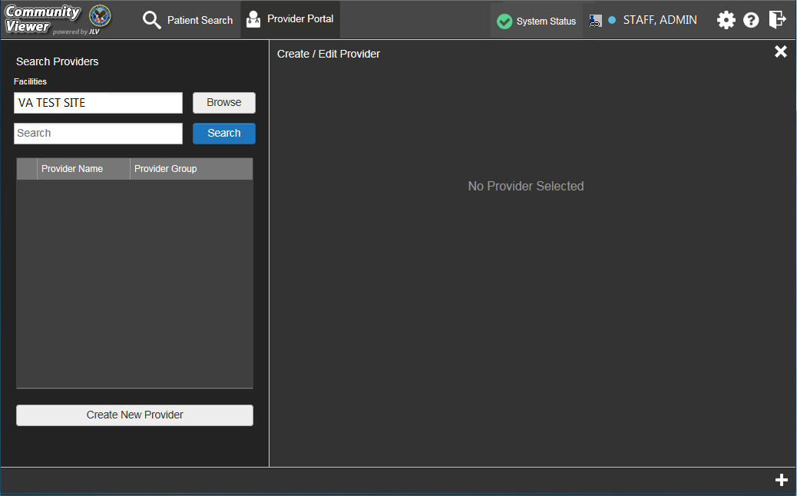
Figure 16: Search Providers

- Select the Provider from the list that appears.
- Click the + Assign New Patient link in Create/Edit Provider screen, as seen Figure 17. If necessary, scroll down to access the lower half of the screen to view the option.

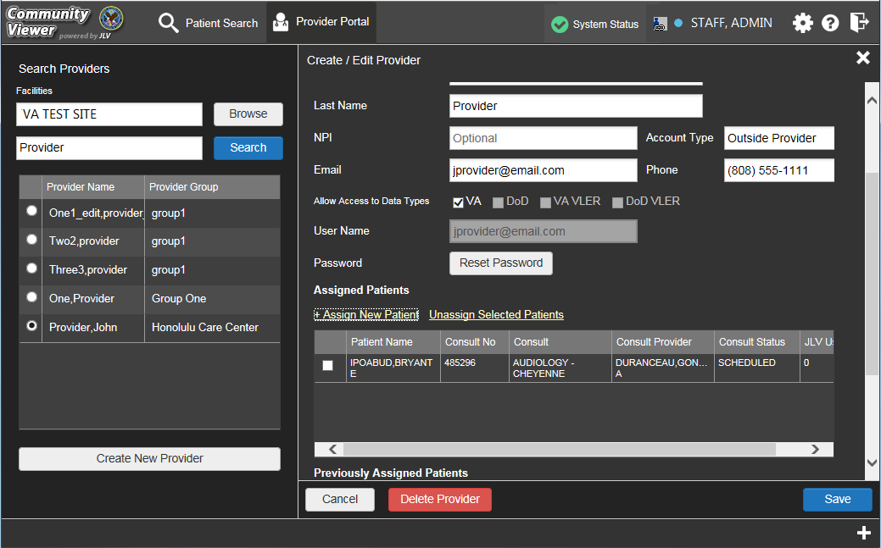
Figure 17: Sample Edit Provider Fields

- At the top of the Patient Search window (Figure 18), enter the patient name in the blank field and click Search.

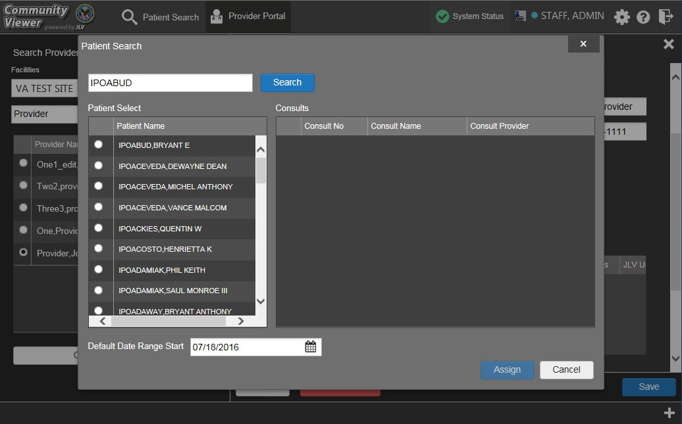
Figure 18: Patient Search

- Select a patient from the search results, as seen in Figure 18.
- Select the desired consult from the list of consults that appear for the selected patient, displayed below in Figure 19.
- Consult status must be active or scheduled for the consult to appear in the list.
- You can control or limit the data seen by the assigned CCP by adjusting the Default Date Range Start. The default setting is to allow CCPs to view records for the three (3) months prior to the date of the consult. See Section 4.1.5, Setting Record Display Limits for more information.
- Click Assign.

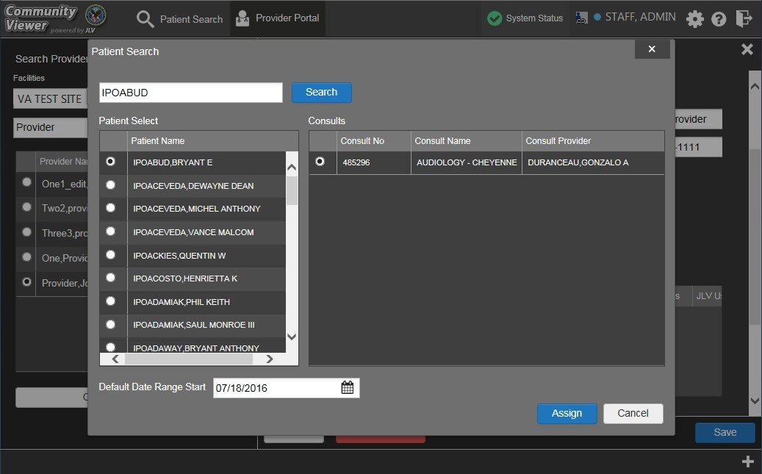
Figure 19: Sample Selected Patient and Available Consults

Setting Record Display Limits
A VAS user can set record display limits to control the records seen by the assigned provider. The default setting is to allow CCPs to view records for the three (3) months prior to the date of the consult.
To assign patient consults to a provider:
- Open the CCPM module.
- Click the Create/Edit Provider link. (Figure 11).
- Create a Provider Group, if necessary.
- Create a Provider Profile, if necessary.
- Click the Assign New Patient link (Figure 17).
- Click the calendar icon to open the calendar controls (Figure 20). The default setting allows the assigned provider to view patient records for the three (3) months prior to the date of the consult.
- Select a date and click Assign.

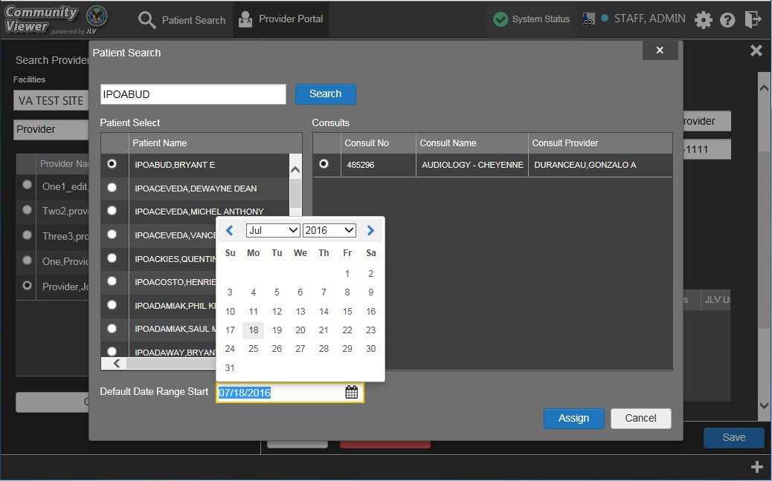
Figure 20: Configuring the Default Date Range

Editing Provider Groups and Profiles
Provider groups and provider profiles can be edited through the CCPM module, as described in the following sections:
- Section 4.2.1, Editing Provider Groups
- Section 4.2.2, Editing Provider Profiles
- Section 4.2.3, Deleting Providers
- Section 4.2.4, Resetting Provider Passwords

Editing Provider Groups
A VAS user can edit a Provider Group through the CCPM. To edit a provider group:
- Open the CCPM module.
- Click the Create/Edit Community Care Provider Groups link (Figure 11).
- Enter the Provider Group name in the Search field on the left and click Search.
- Select the desired provider group from the search results within the Provider Group list (Figure 21).
- Edit the Provider Group fields on the right side of the Manage Community Care Provider Group window as needed.

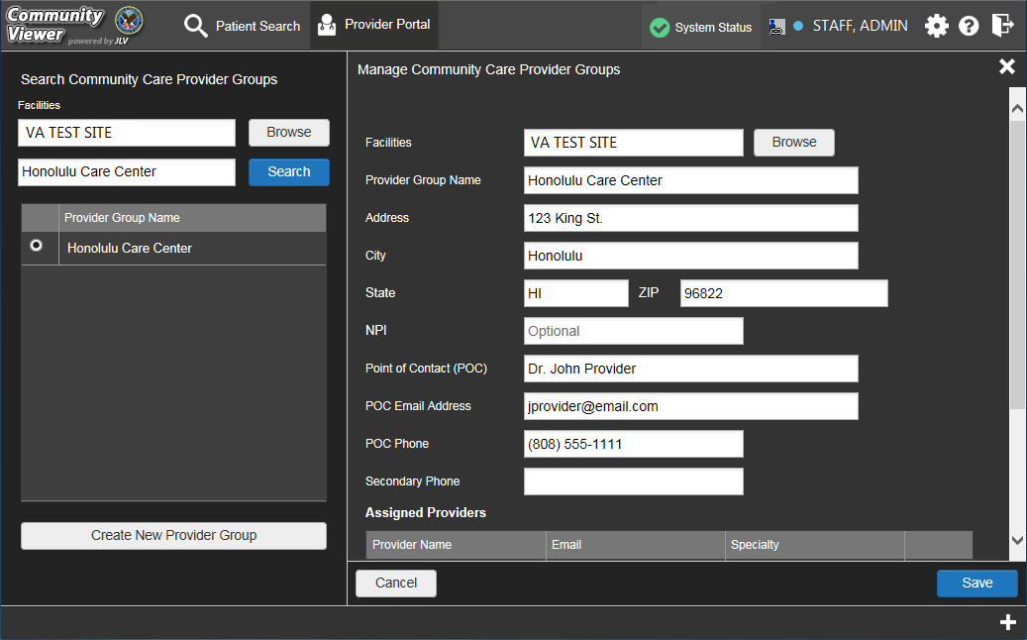
Figure 21: Edit Provider Group

- To add or edit a facility, click Browse next to the Facilities field, and select the desired facility from the list that appears.
- Providers assigned to the Provider Group are listed in the lower-right portion of the screen. Edit provider profiles, or remove providers from the group, using the Edit or Delete links within the Assigned Providers list (Figure 22).
- Click Save.

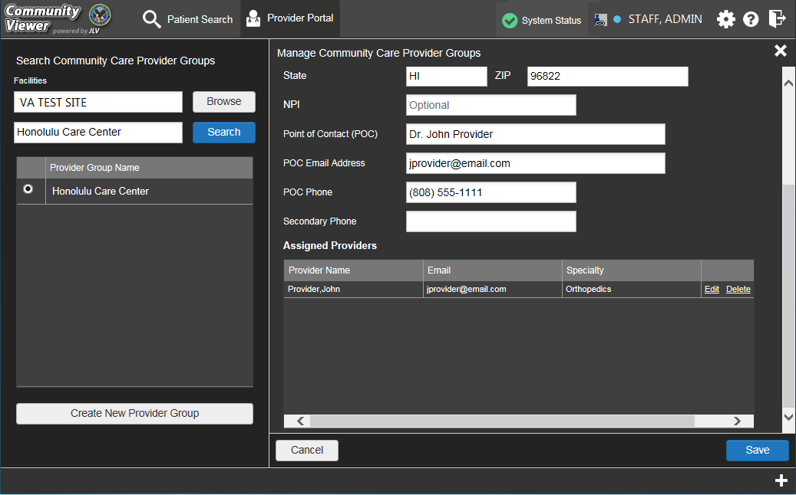
Figure 22: Add or Remove Providers from Group

Editing Provider Profiles
All CCP accounts are created by VAS users in the CCPM module. Creating an account for a CCP user creates a user profile in CV that can be edited. Editing the provider profile includes assigning or removing patient consults.
To edit a provider profile:
- Open the CCPM module.
- Click the Create/Edit Provider link (Figure 11).
- Enter the provider’s name in the field next to the Search button within the Search Providers pane, and click Search.
- Select the desired provider from the search results (Figure 23).
- Edit information for the Provider in the fields provided as necessary.
- To change the provider password, enter a password in the Password field, or click Generate to create a new, random password. CCP user passwords must be at least 8 characters long. Passwords must also include:
  - At least one uppercase letter and one lowercase letter
  - At least one number
  - At least one special character, such as ! @ # ? $ % &
  - Passwords are case-sensitive.

- Record the User Name and Password as displayed on the screen. It is the responsibility of the VAS user to provide the CCP with their user name and password for the CV web application.

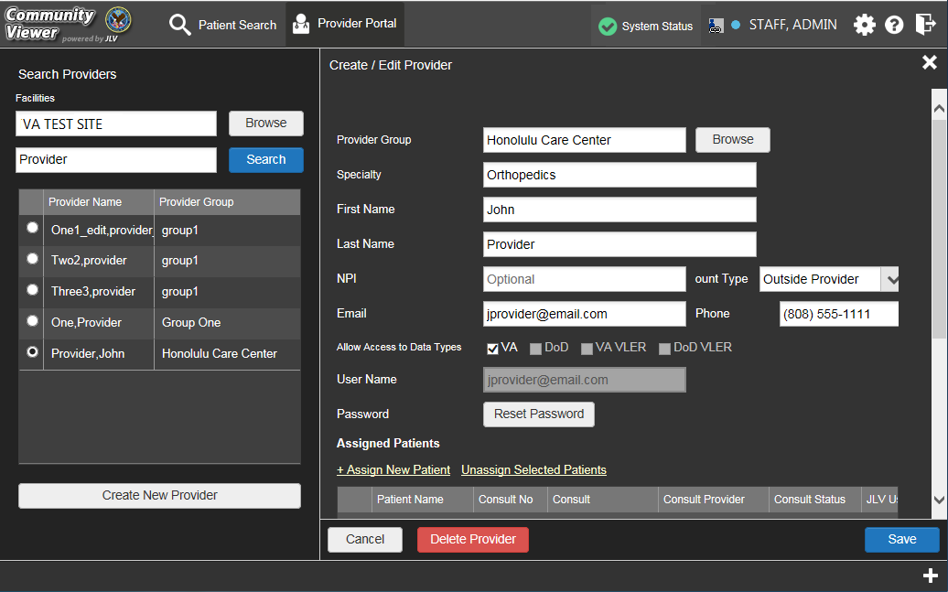
Figure 23: Edit Provider Profile

- Use the + Assign New Patient and Unassign Selected Patient links to change the patient consults assigned to the provider, if desired (Figure 23).
- Click Save.
Figure 24 provides an expanded view of the previous screen example (Figure 23). Open to display the Assigned Patients and Previously Assigned Patient lists.

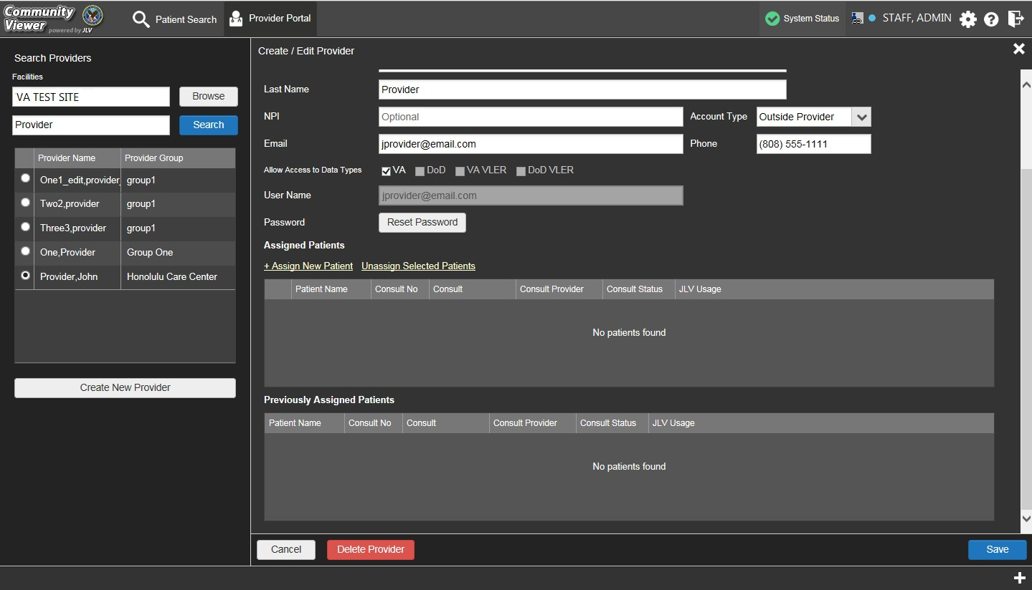
Figure 24: Assigned Patients and Previously Assigned Patients in Provider Profile

Deleting Providers
Deleting providers from the system disables their account and prevents future access to the CV web application.
To delete a provider:
- Open the CCPM module.
- Click the Create/Edit Provider link (Figure 11).
- Enter the provider’s name in the field next to the Search button (within the Search Providers pane), and click Search.
- Select the desired provider from the search results.
- In the Create/Edit Provider screen, click Delete Provider (the red button as shown in Figure 25).

Figure 25: Delete Provider

Resetting Provider Passwords
The login page for a CCP user has a Forgot Password? link. When clicked, a window opens that enables the user to send a password reset request directly to VHA Community Support. Password resets are performed in the CCPM module.
To reset the password for a provider:
- Open the CCPM module.
- Click the Create/Edit Provider link (Figure 11).
- Enter the provider’s name in the field next to the Search button (within the Search Providers pane), and click Search.
- Select the desired provider from the search results.
- In the Create/Edit Provider screen, click Reset Password (Figure 26).
- Enter a password in the field provided. You may also generate a new, random password by clicking Generate.
- Record the new password. It is the responsibility of the VAS user to provide the CCP with his/her user name and password for the CV web application.
- Click Save.

Figure 26: Community Care Provider Password Reset

Accessing Patient Data for CCP Users
CCP users can access a patient record using the Assigned Patients widget to open the record in the Patient Portal.
After a CCP user logs in, the Assigned Patients widget appears with a list of patient consults. Click the hyperlinks in the consult record within the Assigned Patients widget, as seen in Figure 27, to open the Patient Portal.
If the Assigned Patients widget is not already open on the screen after logging in, click the plus (+) sign in the lower-right corner of the screen to open the widget tray. The widget tray for CCP users is modified to include the Assigned Patients widget. Left-click and drag the widget icon from the tray to the screen, and drop in the desired location.
The Assigned Patients widget lists Active and Scheduled consults for the provider group that the provider belongs to. If there are two Active or Scheduled consults for one patient, the patient is listed twice.
For each consult listed in the widget, the following is available:
- Patient name. Click the entry to open the patient’s record in the Patient Portal.
- Consult No. This is a number generated by the VA system. Click the entry to open the patient’s record in the Patient Portal.
- Consult Name. This is a label generated by the VA system. Click the entry to open the patient’s record in the Patient Portal.

- Provider. The assigned VA Provider, or the provider who ordered the consult.
NOTE: VAS users do not see the Assigned Patients widget, and do not have access
to patient data through this point of access.

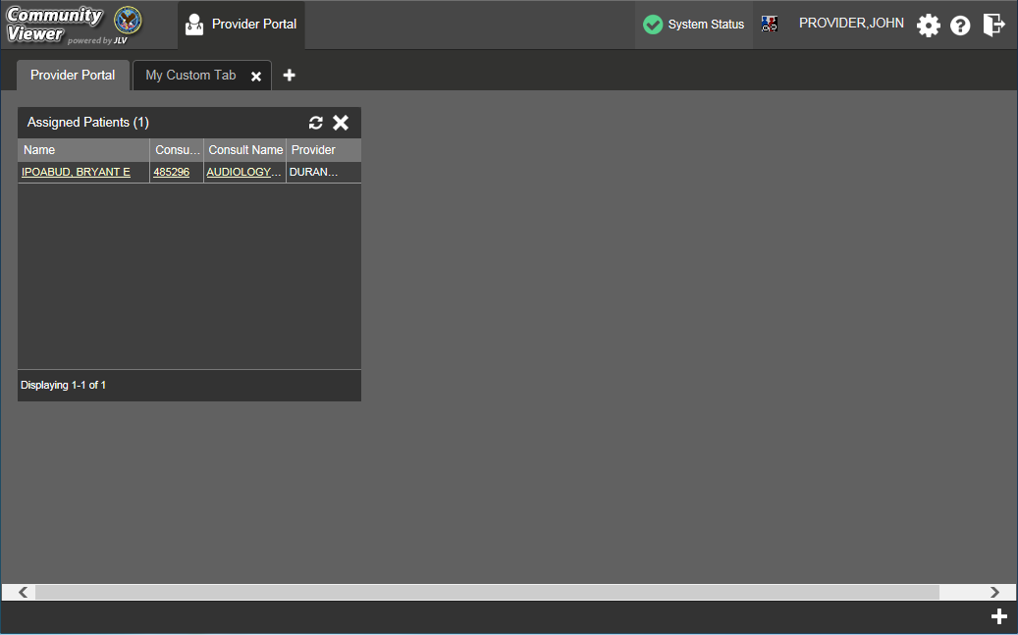
Figure 27: Sample Assigned Patient List on Provider Portal

Patient Data Display for CCP and VAS Users
For both VAS and CCP users, patient-centric information is displayed in the Patient Portal through widgets. Widgets are elements within the CV portals that contain and display data specific to an administrative or clinical domain.

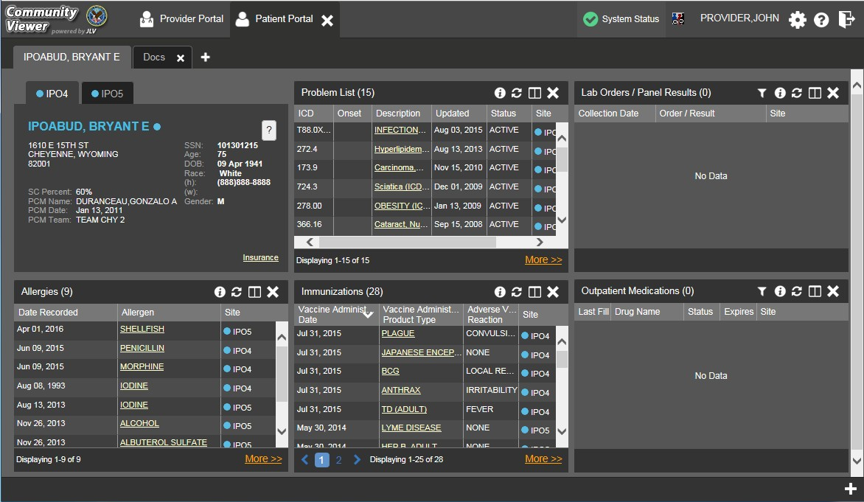
Figure 28: Sample Widget Display on the Patient Portal

On the Patient Portal, the list of available widgets is provided in a horizontal tray at the bottom of the page (shown in Figure 29). When accessing the Patient Portal for the first time, a preset widget display opens on the portal page.
The Patient Portal displays the patient's clinical records and other patient-centric information from VA systems for the following clinical domains:
- Patient Demographics
- Admissions
- Allergies
- Appointments
- Clinical Reminders
- Consults
- Discharge/Essentris Notes
- Encounters
- Immunizations
- Inpatient Medications
- Lab Panel Results
- Lab Results
- Outpatient Medications

- Orders
- Problem List
- Procedures
- Progress Notes
- Radiology Exams
- Vitals
NOTE: Widgets may take anywhere between three (3) and ten (10) seconds to load.

Accessing and Opening Widgets
To view a widget in the Patient Portal, locate the widget name in the horizontal tray that is displayed on the bottom of the portal (Figure 29). Left-click and drag the selected widget from the tray to the portal screen. This action opens the minimized view of the widget on the portal.

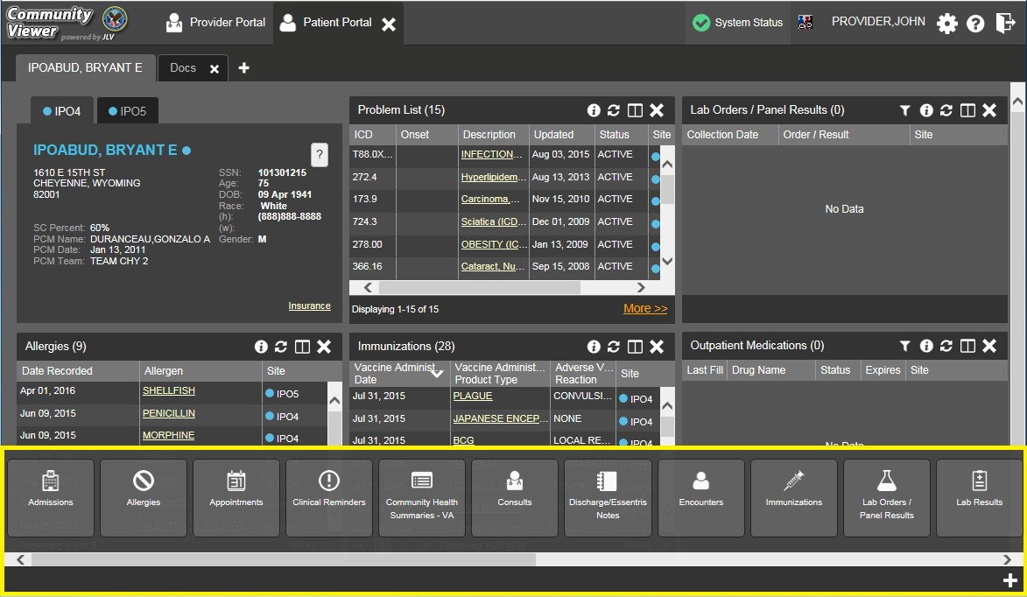
Figure 29: Widget Tray on the Patient Portal

The example in Figure 29 displays the Patient Portal with an open widget tray highlighted at the bottom of the screen. If the widget tray is not open, click the plus sign (+) in the lower right-hand corner of the portal screen. This button opens the tray on the portal.
To view all clinical domains available in the Patient Portal in the widget tray, use the arrows (< or >) placed below the tray buttons in the lower left-hand and right-hand corners of the portal screen to scroll left to right or right to left through the tray.

NOTE: Widgets can be removed by clicking Close in the top-right corner.

Widget Navigation and Display Options
Navigation tools and display options are provided within each widget that allow you to navigate through sections of data results within the widget. A vertical scroll bar allows you to scroll and view data that is in the widget page, while options at the bottom of the widget allow for navigation through all records for that domain loaded into CV.
Click More >> in the lower-right corner of a widget in minimized view to open the widget in expanded view. A sample widget is provided in Figure 30.
A widget in expanded view also contains the Show All link which opens all records for a given widget in a scrollable window. Click Show Paged to return to the display of records grouped by pages.

Table 4: Widget Navigation Tool Descriptions

Widget Element | Meaning | Description
 | Go to Previous Page | Changes the focus of the widget to the previous group or page of records within the results display.
 | Jump to Page | Changes the focus of the widget to the page number selected.
 | Go to Next Page | Changes the focus of the widget to the next group or page of records within the results display.
More >> | Go to Expanded View | Available in minimized views only. Opens the expanded view of the widget in a secondary window.
[variable] of # | Record Display Indicator | Indicates the number of records displayed in that widget page out of the total number of results for that widget.
Show All/Show Paged | Display Setting | Click Show All to open all records for a given widget in a scrollable window.  Click Show Paged to return to the display of records grouped by pages.

Minimized vs. Expanded Widget View
Each widget can be displayed in a minimized view or an expanded view. The first rendering or display of a widget is a minimized view as shown in Figure 28. Click the More >> link available at the bottom of the widget in minimized view to open the expanded view (sample shown in Figure 30).
Accessing the expanded view of the widget provides additional display and filtering options. Click Configure Filter from the widget toolbar if the additional display configuration options are not displayed in an open expanded view.

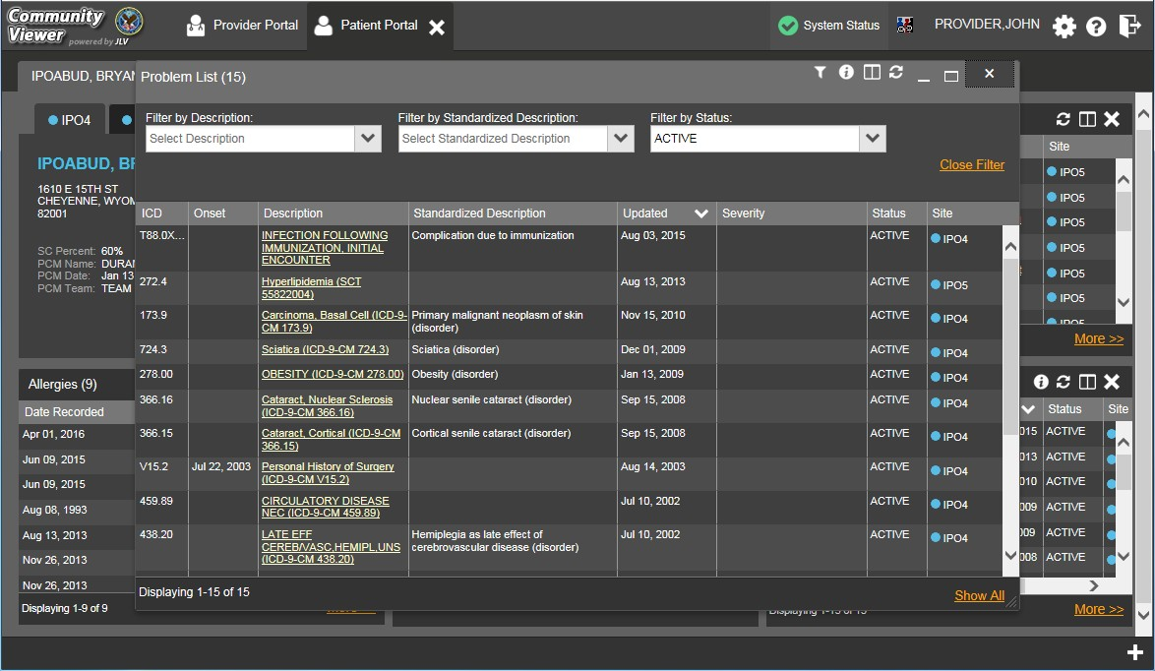
Figure 30: Sample Expanded View Widget Display

Creating Additional Widget Displays using Custom Tabs
For ease of use and quick reference, you can use the tabs function to create additional widget configurations on the portal. Changes made to the display of the patient portal (included widgets and custom tabs) are saved to the user profile and is displayed in future sessions.
To set up a customized tab:
- Click the tab with the plus sign + in the upper-left corner of the screen (sample Patient Portal screen is seen in Figure 28).
- In the Add Tab dialog box, type in the name of the new tab and click OK.
- Within the new tab space, you can access the widget tray, left-click, and drag the widgets to the screen.

- Click between tabs at any time, without losing any of the widget configurations created in the tabs. Tabs persist when a patient change is made.

Refreshing Widgets
Data in the widget display can be refreshed by clicking Refresh . This action refreshes the widget and displays the data the CV web application has stored in a cache.

Patient Portal Data
The Patient Portal displays the selected patient's clinical records and other patient-centric information for the supported clinical domains.
NOTE: Users can configure the layout of widgets on the Patient Portal and create
multiple widget tabs. Configurations persist to the CV database. When you log in to
the system in the future, the last configuration utilized is displayed.

Patient Demographics
A summary of the patient’s demographics (personal data) appears in the upper-left section of the Patient Portal. The tabs above the patient’s name provide the patient’s demographics summary at each VA site that the patient has visited.
The patient’s name is displayed in color and followed by an icon. The blue font color and a blue circle represent data retrieved from a VA system. You can also click the patient's name to open a separate window that provides patient demographics details.

Viewing Third-party Insurance Information
Third-party payers and additional insurance information are available from a link within the Demographics widget on the Patient Portal. Click the Insurance link in the Demographics widget to open a separate window with a detailed list of insurance information for the patient.
Insurance information includes:
- Health Plan Type
- Health Plan Name
- Standardized Insurance Type
- Plan Effective Date
- Plan Expiration Date
- Site
- Group Number
- Member ID
- Subscriber ID
- Subscriber Date of Birth
- Subscriber’s Relationship to Insurer

- Health Plan Mailing Address
- Health Plan Contact Information
Use the Insurance Information window’s horizontal scroll bar to view additional columns not seen within the default window size.
In the window, data appearing in the Standardized Insurance Type column is normalized to the X12 Health Insurance Type standard. Hovering over entries in this column displays the standardized name and standardized code for the insurance type.

Race Data Terminology Normalization
Race data from VA sources appearing in the Demographics summary is normalized. Hovering over the Race field displays the standardized name and standardized code for the race classification, normalized to the national Centers for Disease Control and Prevention (CDC) Race standard.

Admissions
The Admissions widget displays the patient’s admissions information. The information is displayed in reverse chronological order by the admission date.
To open the widget, left-click Admissions from the widget tray that appears at the bottom of the Patient Portal, drag the icon to the screen, and drop where desired on the portal.

Admissions Widget Data
In the minimized view of the Admissions widget, the admissions information includes:
- Administration (Adm) Date
- Discharge Date
- Diagnosis
- Ward
- Site
Click More >> from the minimized view of the Admissions widget to open an expanded view of the widget. In the expanded view, the admissions information includes:
- Admission (Adm) Date
- Discharge Date
- Ward
- Provider
- Provider Specialty
- Diagnosis
- Standardized Diagnosis

- Registration Number
- Site

Display and Filter Options
Display and filter options within the Admissions widget include:
- Click the column title to sort records according to data in that column. If a user sorts on a column that appears in both minimized and expanded views of the widget, the sort is saved in the user profile and persists to the next user session. If a user sorts on a column that is only in the expanded view of the widget, the next user session restores the default widget sort, or the last sort saved to the user profile.
- Click Column Settings in the widget toolbar to hide or show the columns within the widget. Check/uncheck the column names that appear in the pop-up box and click Apply.
- Specify the date range for which records are displayed in the widget using the Quick Date Range Selector or the Start Date and End Date calendars. If the information you expect does not appear in the widget display, use the Start Date and End Date filter options to expand the date range. CCP users may have limited access to records depending on the date range set when the consult was assigned by the VAS user.
- Use the Filter by Provider Specialty drop-down box to re-draw the widget to show only the records for the selected provider type.

Terminology Normalization in the Admissions Widget
Terminology normalization is provided in the Admissions widget through the following GUI elements:
- The data in the Provider and Provider Specialty columns in the minimized and expanded views of the widget are normalized to the National Uniform Claim Committee Taxonomy (NUCC) standard. Hovering over the entries in these columns displays the standardized name and standardized code for the provider.
- The data in the Diagnosis and Standardized Diagnosis columns in the minimized and expanded views of the widget are normalized to the Systematized Nomenclature of Medicine Clinical Terms (SNOMED CT) standard. Hovering over the entries in these columns displays the standardized name and standardized code for the diagnosis.

Allergies
The Allergies widget displays the patient’s allergy information. To open the widget, left- click Allergies from the widget tray that appears at the bottom of the Patient Portal, drag the icon to the screen, and drop where desired on the portal.

Allergies Widget Data
In the minimized view of the Allergies widget, the allergy information includes:
- Date Recorded

- Allergen
- Site
Click the column title to sort records according to data in that column. If a user sorts on a column that appears in both minimized and expanded views of the widget, the sort is saved in the user profile and persists to the next user session. If a user sorts on a column that is only in the expanded view of the widget, the next user session restores the default widget sort, or the last sort saved to the user profile.
Click More >> from the minimized view of the Allergies widget to open an expanded view of the widget. In the expanded view, the allergy information includes:
- Date Recorded
- Allergen
- Standardized Allergen
- Reaction
- Severity
- Comments
- Site

Viewing Allergy Details
Click a hyperlinked entry in the Allergen column in either the minimized or expanded views of the Allergies widget to open a separate window containing the details of the allergy record.

Terminology Normalization in the Allergies Widget
Terminology normalization is provided in the Allergies widget through the following GUI elements:
- The Allergen column displays allergy information contained in the patient's record. Hovering over an entry in this column displays the standard used for terminology normalization for the clinical domain (RxNorm), the standardized allergen name, and the standardized RxNorm code for that allergen.
- The Standardized Allergen column displays the standardized name for the corresponding entry in the Allergen column, mapped to the RxNorm standard. In addition to the standardized name, hovering over an entry in this column displays the standard used for terminology normalization for the clinical domain (RxNorm), and the RxNorm code for that allergen.

Appointments
The Appointments widget displays the patient’s appointment information. The information is displayed in reverse chronological order by the appointment date. To open the widget, left- click Appointments from the widget tray that appears at the bottom of the Patient Portal, drag the icon to the screen, and drop where desired on the portal.

Appointments Widget Data
In the minimized view of the Appointments widget, the appointment information includes:
- Scheduled Date/Time
- Clinic
- Provider1
- Site
Click More >> from the minimized view of the Appointments widget to open an expanded view of the widget. In the expanded view, the appointment information includes:
- Scheduled Date/Time
- Clinic
- Provider
- Provider Specialty
- Appointment Status
- Type
- Reason
- Site

Viewing Appointment Details
Where record details are available for a VA appointment, the entry displays a link in the Scheduled Date/Time column. Clicking this link in either the minimized or expanded views of the Appointments widget opens a separate window containing the details of the record.

Display and Filter Options
Display and filter options within the Appointments widget include:
- Click the column title to sort records according to data in that column. If a user sorts on a column that appears in both minimized and expanded views of the widget, the sort is saved in the user profile and persists to the next user session. If a user sorts on a column that is only in the expanded view of the widget, the next user session restores the default widget sort, or the last sort saved to the user profile.
- Click Column Settings in the widget toolbar to hide or show the columns within the widget. Check/uncheck the column names that appear in the pop-up box and click Apply.
- Specify the date range for which records are displayed in the widget using the Quick Date Range Selector or the Start Date and End Date calendars. If the information you expect does not appear in the widget display, use the Start Date and End Date filter

1 Hovering over the Provider column in the minimized and expanded views of the Appointments widget displays the address and phone number for the provider, where available, in the patient record.

options to expand the date range. CCP users may have limited access to records, depending on the date range set when the consult was assigned by the VAS user.
- Use the Filter by Clinic drop-down box to re-draw the widget to show only the records for the selected clinic.
- Use the Filter by Provider Specialty drop-down box to re-draw the widget to show only the records for the selected provider type.

Terminology Normalization in the Appointments Widget
Terminology normalization is provided in the Appointments widget through the following GUI elements:
- The data in the Provider and Provider Specialty columns in the minimized and expanded views of the widget are normalized to the NUCC standard. Hovering over the entries in these columns displays the standardized name and standardized code for the provider.

Clinical Reminders
The Clinical Reminders widget displays the patient’s clinical reminder information. The information is displayed in reverse chronological order by the due date.
To open the widget, left-click Clinical Reminders from the widget tray that appears at the bottom of the Patient Portal, drag the icon to the screen, and drop where desired on the portal.

Clinical Reminders Widget Data
In the minimized and expanded views of the Clinical Reminders widget, the clinical reminder information includes the following for VA records:
- Due
- Last Done
- Reminder
- Site

Display and Filter Options
Display and filter options within the Clinical Reminders widget include:
- Click the column title to sort records according to data in that column. If a user sorts on a column that appears in both minimized and expanded views of the widget, the sort is saved in the user profile and persists to the next user session. If a user sorts on a column that is only in the expanded view of the widget, the next user session restores the default widget sort, or the last sort saved to the user profile.
- Use the Filter by Site drop-down box to re-draw the widget to show only the records for the desired site.

Viewing Clinical Reminder Details
Click a hyperlinked entry in the Reminder column in either the minimized or expanded views of the Clinical Reminders widget to open a separate window containing the details of the record.

Consults
The Consults widget displays the patient’s outpatient consult encounter information. The information is displayed in reverse chronological order by the consult date.
To open the widget, left-click Consults from the widget tray that appears at the bottom of the Patient Portal, drag the icon to the screen, and drop where desired on the portal.

Consults Widget Data
In the minimized view of the Consults widget, the consult encounter information includes:
- Due
- Consult Order
- Status
- Site
Click a hyperlinked entry in the Consult Order column to open a separate window containing a report of the record. Refer to Section 4.5.6.2, Viewing Consult Encounter Details for more information.
Click More >> from the minimized view of the Consults widget to open an expanded view of the widget. In the expanded view, the consult encounter information includes:
- Due
- Consult Order
- Provider
- Provider Specialty
- Status
- Site
Click a hyperlinked entry in the Consult Order column to open a separate window containing a report of the record. Refer to Section 4.5.6.2, Viewing Consult Encounter Details for more information.

Viewing Consult Encounter Details
Click a hyperlinked entry in the Consult Order column of either the minimized or expanded view of the Consults widget to open a separate window containing a report of the record.

Display and Filter Options
Display and filter options within the Consults widget include:
- Click the column title to sort records according to data in that column. If a user sorts on a column that appears in both minimized and expanded views of the widget, the sort is saved in the user profile and persists to the next user session. If a user sorts on a column that is only in the expanded view of the widget, the next user session restores the default widget sort, or the last sort saved to the user profile.
- Click Column Settings in the widget toolbar to hide or show the columns within the widget. Check/uncheck the column names that appear in the pop-up box and click Apply.
- Specify the date range for which records are displayed in the widget using the Quick Date Range Selector or the Start Date and End Date calendars. If the information you expect does not appear in the widget display, use the Start Date and End Date filter options to expand the date range. CCP users may have limited access to records depending on the date range set when the consult was assigned by the VAS user.
- Use the Filter by Consult Order drop-down box to re-draw the widget to show only the records for the selected consult.
- Use the Filter by Provider Specialty drop-down box to re-draw the widget to show only the records for the selected provider type.

Terminology Normalization in the Consults Widget
Terminology normalization is provided in the Consults widget through the following GUI elements:
- The data in the Provider and Provider Specialty columns in the widget are normalized to the NUCC standard. Hovering over the entries in these columns displays the standardized name and standardized code for the provider.

Discharge/Essentris Notes
The Discharge/Essentris Notes widget displays the patient’s discharge summaries, as well as history and physical summaries. The information is displayed in reverse chronological order by the note date.
To open the widget, left-click Discharge/Essentris Notes from the widget tray that appears at the bottom of the Patient Portal, drag the icon to the screen, and drop where desired on the portal.

Discharge/Essentris Notes Widget Data
In the minimized view of the Discharge/Essentris Notes widget, the column display includes:
- Date
- Note Type/Title
- Site

Click Configure Filter from the widget toolbar to display the filter options in the minimized view of the widget. Using expanded search dates within the widget is recommended to display notes started prior to admission and notes signed after discharge. Refer to Section 4.5.2.2, Display and Filter Options, for more information.
Click the hyperlink in the Note Type/Title column of either view of the Discharge/Essentris Notes widget to open a separate window containing the detail of the note. Refer to Section 4.5.7.2, Viewing Discharge/Essentris Notes Details for more information.
Click More >> from the minimized view of the Discharge/Essentris Notes widget to open an expanded view of the widget. In the expanded view, the column display includes:
- Date
- Note Type/Title
- Provider
- Provider Specialty
- Location
- Visit/Adm Date
- Status
- Site
Data in the Provider Specialty column within the Discharge/Essentris Notes widget is populated with VA data only.
NOTE: Using expanded search dates within the widget is recommended to display notes started prior to admission and notes signed after discharge.

Viewing Discharge/Essentris Notes Details
Click the hyperlink in the Note Type/Title column of either view of the Discharge/Essentris Notes widget to open a separate window containing the detail of the note.

Display and Filter Options
Display and filter options within the Discharge/Essentris Notes widget include:
- Click from the widget toolbar to display the filter options in the minimized view of the widget.
- Click the column title to sort records according to data in that column. If a user sorts on a column that appears in both minimized and expanded views of the widget, the sort is saved in the user profile and persists to the next user session. If a user sorts on a column that is only in the expanded view of the widget, the next user session restores the default widget sort, or the last sort saved to the user profile.
- Click Column Settings in the widget toolbar to hide or show the columns within the widget. Check/uncheck the column names that appear in the pop-up box and click Apply.

- Specify the date range for which records are displayed in the widget using the Quick Date Range Selector or the Start Date and End Date calendars. If the information you expect does not appear in the widget display, use the Start Date and End Date filter options to expand the date range. CCP users may have limited access to records depending on the date range set when the consult was assigned by the VAS user.
- Use the Filter by Note Type/Title drop-down box to re-draw the widget to show only the records for the selected note type.
- Use the Filter by Provider drop-down box to re-draw the widget to show only the records for the selected provider.
- Use the Filter by Provider Specialty drop-down box to re-draw the widget to show only the records for the selected provider type.
- Use the Filter by Location drop-down box to re-draw the widget to show only the records for the selected location.

Terminology Normalization in the Discharge/Essentris Notes Widget
Terminology normalization is provided in the Discharge/Essentris Notes widget through the following GUI elements:
- The data in the Provider and Provider Specialty columns in the widget are normalized to the NUCC standard. Hovering over the entries in these columns displays the standardized name and standardized code for the provider.

Encounters
The Encounters widget includes clinical data for outpatient encounters.
To open the widget, left-click Encounters from the patient widget tray that appears at the bottom of the Patient Portal, drag the icon to the screen, and drop where desired on the portal.

Encounters Widget Data
In the minimized view of the Encounters widget, the outpatient encounter information includes:
- Date
- Clinic
- Provider
- Diagnosis
- Site
Refer to Section 4.5.8.2, Viewing Encounter Details and Section 4.5.2.2, Display and Filter Options for more information about the Details and Note links in the Date column.
Click More >> from the minimized view of the Encounters widget to open an expanded view of the widget. In the expanded view, the outpatient encounter information includes:
- Date

- Clinic
- Status
- Type
- Provider
- Provider Specialty
- Reason
- Diagnosis
- Standardized Diagnosis
- Site
Refer to Section 4.5.8.2, Viewing Encounter Details and Section 4.5.2.2, Display and Filter Options for more information about the Details and Note links in the Date column.

Viewing Encounter Details
Where available for the record, click the Details hyperlink in the Date column of either view of the Encounters widget to open a separate window containing the detail of the encounter.

Viewing Encounter Notes
Where available for the record, click the Note hyperlink in the Date column of either view of the Encounters widget to view notes of the outpatient encounter record. VA encounter notes open in a separate window.

Additional Display and Filter Options in the Encounters Widget
Display and filter options within the Encounters widget include:
- Click the column title to sort records according to data in that column. If a user sorts on a column that appears in both minimized and expanded views of the widget, the sort is saved in the user profile and persists to the next user session. If a user sorts on a column that is only in the expanded view of the widget, the next user session restores the default widget sort, or the last sort saved to the user profile.
- Click Column Settings in the widget toolbar to hide or show the columns within the widget. Check/uncheck the column names that appear in the pop-up box and click Apply.
- Specify the date range for which records are displayed in the widget using the Quick Date Range Selector or the Start Date and End Date calendars. If the information you expect does not appear in the widget display, use the Start Date and End Date filter options to expand the date range. CCP users may have limited access to records, depending on the date range set when the consult was assigned by the VAS user.
- Use the Filter by Clinic drop-down box to re-draw the widget to show only the records for the selected clinic.

- Use the Filter by Provider Specialty drop-down box to re-draw the widget to show only the records for the selected provider type.

Terminology Normalization in the Encounters Widget
Terminology normalization is provided in the Encounters widget through the following GUI elements:
- The data in the Provider and Provider Specialty columns in the minimized and expanded views of the widget are normalized to the NUCC standard. Hovering over the entries in these columns displays the standardized name and standardized code for the provider.
- The data in the Diagnosis and Standardized Diagnosis columns in the minimized and expanded views of the widget are normalized to the SNOMED CT standard. Hovering over the entries in these columns displays the standardized name and standardized code for the diagnosis.

Immunizations
The Immunizations widget displays the patient’s immunization history. The information is displayed in reverse chronological order by the immunization administration date.
To open the widget, left-click Immunizations from the widget tray that appears at the bottom of the Patient Portal, drag the icon to the screen, and drop where desired on the portal.
In the minimized view of the Immunizations widget, the immunizations information includes:
- Vaccine Administered Date
- Vaccine Administered Product Type
- Adverse Vaccine Reaction
- Site
Click More >> from the minimized view of the Immunizations widget to open an expanded view of the widget. In the expanded view, the immunizations information includes:
- Vaccine Administered Date
- Vaccine Administered Product Type
- Standardized Vaccine Product Type
- Series
- Immunization Result
- Adverse Vaccine Reaction
- Exemption/Refusal Reason
- Exemption/Refusal Date
- Site

Viewing Immunization Details
Click a hyperlinked entry in the Vaccine Administered Product Type column of either the minimized or expanded view of the Immunizations widget to open a separate window containing a report of the record.

Display and Filter Options
Display and filter options within the Immunizations widget include:
- Click the column title to sort records according to data in that column. If a user sorts on a column that appears in both minimized and expanded views of the widget, the sort is saved in the user profile and persists to the next user session. If a user sorts on a column that is only in the expanded view of the widget, the next user session restores the default widget sort, or the last sort saved to the user profile.
- Use the Filter by Vaccine Administered Product Type drop-down box to re-draw the widget to show only the records for the selected vaccine.
- Use the Filter by Standardized Vaccine Product Type drop-down box to re-draw the widget to show only the records for the selected vaccine.

Terminology Normalization in the Immunizations Widget
Terminology normalization is provided in the Immunizations widget through the following GUI elements:
- The Vaccine Administered Product Type column displays immunizations data within the patient's record. Hovering over an entry in this column displays the standard used for terminology normalization for the clinical domain Code for Vaccines Administered (CVX), the standardized vaccine name, and the standardized CVX code for that immunization.
- The Standardized Vaccine Product Type column displays the standardized name for the corresponding entry in the Vaccine Administered Product Type column, mapped to the CVX standard. In addition to the standardized name, hovering over an entry in this column displays the standard used for terminology normalization for the clinical domain (CVX), and the CVX code for that immunization.

Inpatient Medications
The Inpatient Medications widget displays the patient’s inpatient medication information. The medications are grouped by the order number where available.
To open the widget, left-click Inpatient Medications from the widget tray that appears at the bottom of the Patient Portal, drag the icon to the screen, and drop where desired on the portal.

Inpatient Medications Widget Data
In the minimized view of the Inpatient Medications widget, the inpatient medication information includes:
- Order Number2
- Drug Name
- Status
- Stop Date
- Site
Click More >> from the minimized view of the Inpatient Medications widget to open an expanded view of the widget. In the expanded view, the inpatient medication information includes:
- Order Number
- Order Start Date
- Order Stop Date
- Drug Name
- Standardized Drug Name
- Status
- Ordering Health Care Provider (HCP)
- Ordering HCP Specialty
- Schedule
- Quantity
- Site

Viewing Inpatient Medication Details
Click the hyperlink in the Drug Name column of either view of the Inpatient Medications
widget to open a separate window containing the detail of the medication.

Display and Filter Options
Display and filter options within the Inpatient Medications widget include:
- Click the column title to sort records according to data in that column. If a user sorts on a column that appears in both minimized and expanded views of the widget, the sort is saved in the user profile and persists to the next user session. If a user sorts on a column that is only in the expanded view of the widget, the next user session restores the default

2 When there are multiple drugs with the same order number, CV maintains the grouping by order number when a column sort is applied in the widget.

widget sort, or the last sort saved to the user profile. When there are multiple drugs with the same order number, CV maintains the grouping by order number when a column sort is applied in the widget.
- Click Column Settings in the widget toolbar to hide or show the columns within the widget. Check/uncheck the column names that appear in the pop-up box and click Apply.
- Specify the date range for which records are displayed in the widget using the Quick Date Range Selector or the Start Date and End Date calendars. If the information you expect does not appear in the widget display, use the Start Date and End Date filter options to expand the date range. CCP users may have limited access to records, depending on the date range set when the consult was assigned by the VAS user.
- Use the Filter by Drug Name drop-down box to re-draw the widget to show only the records for the selected medication.
- Use the Filter by Standardized Drug Name drop-down box to re-draw the widget to show only the records for the selected medication.
- Use the Filter by Ordering HCP Specialty drop-down box to re-draw the widget to show only the records for the ordering HCP.

Terminology Normalization in the Inpatient Medications Widget
Terminology normalization is provided in the Inpatient Medications widget through the following GUI elements:
- The Drug Name column displays a medication within the patient's record. Hovering over an entry in this column displays the standard used for terminology normalization for the clinical domain (RxNorm), the standardized RxNorm name, and the standardized RxNorm code for that medication.
- The Standardized Drug Name column displays the standardized name for the corresponding entry in the Drug Name column, mapped to the RxNorm standard. In addition to the standardized name, hovering over an entry in this column displays the standard used for terminology normalization for the clinical domain (RxNorm), and the standardized code for that medication.
- The data in the Ordering HCP and Ordering HCP Specialty columns in the minimized and expanded views of the widget are normalized to the NUCC standard. Hovering over the entries in these columns displays the standardized name and standardized code for the ordering HCP (provider).

Lab Panel Results
The Lab Panel Results widget displays the patient’s lab panels and associated results and interpretations. The information is displayed in reverse chronological order by collection date.
To open the widget, left-click Lab Panel Results from the widget tray that appears at the bottom of the Patient Portal, drag the icon to the screen, and drop where desired on the portal.

Lab Panel Results Widget Data
In the minimized view of the Lab Panel Results widget, the lab information includes:
- Collection Date
- Order/Result
- Site
Click a hyperlinked entry in the Order/Result column to open a separate window containing details for that record. Refer to Section 4.5.11.2, Viewing Lab Panel Results Details for more information.
Click More >> from the minimized view of the Lab Panel Results widget to open an expanded view of the widget. In the expanded view, the lab results information includes:
- Collection Date
- Order Number
- Order/Results
- Ordering HCP
- Ordering HCP Specialty
- Sample
- Status
- Site
Click a hyperlinked entry in the Order/Results column to open a separate window containing details for that record. Refer to Section 4.5.11.2, Viewing Lab Panel Results Details for more information.

Viewing Lab Panel Results Details
Click a hyperlinked entry in the Order/Results column of the Lab Panel Results widget to open a separate window containing a report of the record. The contents of the window may vary depending on the lab type and what is contained in the patient record.

Display and Filter Options
Display and filter options within the Lab Panel Results widget include:
- Click the column title to sort records according to data in that column. If a user sorts on a column that appears in both minimized and expanded views of the widget, the sort is saved in the user profile and persists to the next user session. If a user sorts on a column that is only in the expanded view of the widget, the next user session restores the default widget sort, or the last sort saved to the user profile.
- Click Column Settings in the widget toolbar to hide or show the columns within the widget. Check/uncheck the column names that appear in the pop-up box and click Apply.

- Specify the date range for which records are displayed in the widget using the Quick Date Range Selector or the Start Date and End Date calendars. If the information you expect does not appear in the widget display, use the Start Date and End Date filter options to expand the date range. CCP users may have limited access to records, depending on the date range set when the consult was assigned by the VAS user.
- Use the Filter by Order/Results drop-down box to re-draw the widget to show only the records for the selected result.

Terminology Normalization in the Lab Panel Results Widget
Terminology normalization is provided in the Lab Panel Results widget through the following GUI elements:
- The data in the Ordering HCP and Ordering HCP Specialty columns in the widget are normalized to the NUCC standard. Hovering over the entries in these columns displays the standardized name and standardized code for the healthcare provider.

Lab Results
The Lab Results widget displays the patient’s lab result information, as well as skin test data and blood transfusion history where available in the patient’s record. The information is displayed in reverse chronological order by the last lab results date.
To open the widget, left-click Lab Results from the widget tray that appears at the bottom of the Patient Portal, drag the icon to the screen, and drop where desired on the portal.

Lab Results Widget Data
In the minimized view of the Lab Results widget, the lab result information includes:
        - Collection Date
        - Lab Test
        - Result
        - Site
Click More >> from the minimized view of the Lab Results widget to open an expanded view of the widget. In the expanded view, the lab result information includes:
        - Collection Date
        - Order Number
        - Status
        - Ordering HCP
        - Ordering HCP Specialty
        - Lab Test
        - Standardized Lab Test

        - Type
        - Specimen Source
        - Result
        - Interpretation
        - Units
        - Ref Range
        - Site

Display and Filter Options
Display and filter options within the Lab Results widget include:
        - Click the column title to sort records according to data in that column. If a user sorts on a column that appears in both minimized and expanded views of the widget, the sort is saved in the user profile and persists to the next user session. If a user sorts on a column that is only in the expanded view of the widget, the next user session restores the default widget sort, or the last sort saved to the user profile.
        - Click Column Settings in the widget toolbar to hide or show the columns within the widget. Check/uncheck the column names that appear in the pop-up box and click Apply.
        - Specify the date range for which records are displayed in the widget using the Quick Date Range Selector or the Start Date and End Date calendars. If the information you expect does not appear in the widget display, use the Start Date and End Date filter options to expand the date range. CCP users may have limited access to records, depending on the date range set when the consult was assigned by the VAS user.
        - Use the Filter by Lab Test drop-down box to re-draw the widget to show only the records for the selected test.
        - Use the Filter by Standardized Lab Test drop-down box to re-draw the widget to show only the records for the selected test.
        - Use the Filter by Type drop-down box to re-draw the widget to show only the records for the selected type.
        - Use Graph View to display multiple records of the same type in a graph. Refer to Section 4.5.12.6, Graph View in the Lab Results Widget for more information.
        - Use Table View to display multiple records of the same type in a tabular format. Refer to Section 4.5.12.6, Graph View in the Lab Results Widget for more information.

Viewing Abnormal Results in the Lab Results Widget
For records in the Lab Results widget where result values fall within a calculated reference range for abnormal within the originating source system, CV highlights the row for that record in the minimized and expanded views of the widget.

Pink highlighting represents either H (high) or L (low) abnormal indicators. Red highlighting represents that the abnormal indicator has an asterisk (i.e., H* or L*) or the result is critical.

Viewing Lab Results Details
Clicking a hyperlinked entry in the Lab Test column of the Lab Results widget opens a separate window containing a report of the record.

Table View in the Lab Results Widget
The Lab Results widget provides the option to display multiple records of the same type in a table. By default, the Show Table link in the expanded view of the Lab Results widget is disabled until the user narrows the data selection using display filters.
To view lab results in Table View:
- Left-click Lab Results from the widget tray that appears at the bottom of the Patient Portal, drag the icon to the screen, and drop where desired on the portal.
- Click More >> from the minimized view of the Lab Results widget to open an expanded view of the widget.
- In the expanded view, select one entry from the Filter by drop down boxes (except for the Filter by Type filter option). This action enables the Show Graph and Show Table links.
NOTE: The Show Graph and Show Table links are not enabled after selecting one
lab type from the Filter by Type drop down box.

- Click Show Table.
- A separate window opens, displaying a table containing the records of the type selected in the filter.

Graph View in the Lab Results Widget
The Lab Results widget provides the option to display multiple records of the same type in a graph. By default, the Show Graph link in the expanded view of the Lab Results widget is disabled until the user narrows the data selection using display filters.
To view lab results in Graph View:
- Left-click Lab Results from the widget tray that appears at the bottom of the Patient Portal, drag the icon to the screen, and drop where desired on the portal.
- Click More >> from the minimized view of the Lab Results widget to open an expanded view of the widget.
- In the expanded view, select an available filter from the Filter by drop down boxes (except for the Filter by Type filter option). This action enables the Show Graph and Show Table links.

NOTE: The Show Graph and Show Table links are not enabled after selecting one lab type from the Filter by Type drop down box.

- Click Show Graph.
- A separate window opens, displaying a graph of the multiple records of the type selected in the filter.

Terminology Normalization in the Lab Results Widget
Terminology normalization is provided in the Lab Results widget through the following GUI elements:
        - The Lab Test column displays the name of a lab test within the patient's record. Hovering over an entry in this column displays the standard used for terminology normalization for the clinical domain Logical Observation Identifiers Names and Codes (LOINC), the standardized lab test name, and the standardized code for that test.
        - The Standardized Lab Test column displays the standardized name for the corresponding entry in the Lab Test column, mapped to the LOINC standard. In addition to the standardized name, hovering over an entry in this column displays the standard used for terminology normalization for the clinical domain (LOINC), and the standardized code for that test.

Outpatient Medications
The Outpatient Medications widget displays the patient’s outpatient medication information. The information is displayed in reverse chronological order by the last fill date.
To open the widget, left-click Outpatient Medications from the widget tray that appears at the bottom of the Patient Portal, drag the icon to the screen, and drop where desired on the portal.

Outpatient Medications Widget Data
In the minimized view of the Outpatient Medications widget, the outpatient medication information includes:
        - Last Fill
        - Drug Name
        - Status
        - Expires
        - Site
Click the hyperlink in the Drug Name column within either view of the widget to open a separate window containing details for that record. Refer to Section 4.5.13.2, Viewing Outpatient Medication Details for more information.

Click More >> from the minimized view of the Outpatient Medications widget to open an expanded view of the widget. In the expanded view, the outpatient medication information includes:
        - Last Fill
        - Drug Name
        - Standardized Drug Name
        - Sig
        - Quantity
        - Days’ Supply
        - Refills Left
        - Status
        - Ordering HCP
        - Ordering HCP Specialty
        - Expires
        - Site

Viewing Outpatient Medication Details
Click the hyperlink in the Drug Name column from either view of the Outpatient Medications widget (Figure 31) to open a separate window containing the detail of the medication. Where available in the record, this window displays the dispensing pharmacy.

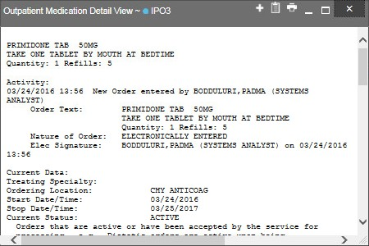
Figure 31: Outpatient Medications Widget – Details of VA Medication

Display and Filter Options
Display and filter options within the Outpatient Medications widget include:
        - Click the column title to sort records according to data in that column. If a user sorts on a column that appears in both minimized and expanded views of the widget, the sort is saved in the user profile and persists to the next user session. If a user sorts on a column that is only in the expanded view of the widget, the next user session restores the default widget sort or the last sort saved to the user profile.
        - Click Column Settings in the widget toolbar to hide or show the columns within the widget. Check/uncheck the column names that appear in the pop-up box and click Apply.
        - Specify the date range for which records are displayed in the widget using the Quick Date Range Selector or the Start Date and End Date calendars. If the information you expect does not appear in the widget display, use the Start Date and End Date filter options to expand the date range. CCP users may have limited access to records, depending on the date range set when the consult was assigned by the VAS user.
        - Click Rx from the widget toolbar to convert the medications data within the widget to text and opens text in a pop-up window.
        - Use the Filter by Drug Name drop-down box to re-draw the widget to show only the records for the selected medication.
        - Use the Filter by Standardized Drug Name drop-down box to re-draw the widget to show only the records for the selected medication.

        - Use the Filter by Ordering HCP Specialty drop-down box to re-draw the widget to show only the records for the ordering HCP.

Terminology Normalization in the Outpatient Medications Widget
Terminology normalization is provided in the Outpatient Medications widget through the following GUI elements:
        - The Drug Name column displays a prescription within the patient's record. Hovering over an entry in this column displays the standard used for terminology normalization for the clinical domain (RxNorm), the standardized RxNorm name, and the standardized RxNorm code for that prescription.
        - The Standardized Drug Name column displays the standardized name for the corresponding entry in the Drug Name column, mapped to the RxNorm standard. In addition to the standardized name, hovering over an entry in this column displays the standard used for terminology normalization for the clinical domain (RxNorm), and the standardized code for that prescription.
        - The data in the Ordering HCP and Ordering HCP Specialty columns in the minimized and expanded views of the widget are normalized to the NUCC standard. Hovering over the entries in these columns displays the standardized name and standardized code for the ordering HCP (provider).

Orders
The Orders widget displays the patient’s medications, consults, radiology, and lab orders. The records are displayed in reverse chronological order by the order date.
To open the widget, left-click Orders from the widget tray that appears at the bottom of the Patient Portal, drag the icon to the screen, and drop where desired on the portal.

Orders Widget Data
In the minimized view of the Orders widget, the orders information includes:
        - Order Date
        - Description
        - Status/Priority
        - Type
        - Site
Click the hyperlink in the Description column of either view of the Orders widget to open a separate window containing the detail of the order. Refer to Section 4.5.14.2, Viewing Order Details for more information.
Click More >> from the minimized view of the Orders widget to open an expanded view of the widget. In the expanded view, the orders information includes:
        - Order Date

        - Order Number
        - Description
        - Status/Priority
        - Type
        - Standardized Type
        - Provider
        - Provider Specialty
        - Site
Click the hyperlink in the Description column of either view of the Orders widget to open a separate window containing the detail of the order. Refer to Section 4.5.14.2, Viewing Order Details for more information.

Viewing Order Details
Click the hyperlink in the Description column of either view of the Orders widget to open a separate window containing the detail of the order.

Display and Filter Options
Display and filter options within the Orders widget include:
        - Click the column title to sort records according to data in that column. If a user sorts on a column that appears in both minimized and expanded views of the widget, the sort is saved in the user profile and persists to the next user session. If a user sorts on a column that is only in the expanded view of the widget, the next user session restores the default widget sort, or the last sort saved to the user profile.
        - Click Column Settings in the widget toolbar to hide or show the columns within the widget. Check/uncheck the column names that appear in the pop-up box and click Apply.
        - Specify the date range for which records are displayed in the widget using the Quick Date Range Selector or the Start Date and End Date calendars. If the information you expect does not appear in the widget display, use the Start Date and End Date filter options to expand the date range. CCP users may have limited access to records, depending on the date range set when the consult was assigned by the VAS user.
        - Use the Filter by Type drop-down box to re-draw the widget to show only the records for the selected order type.
        - Use the Filter by Standardized Type drop-down box to re-draw the widget to show only the records for the selected order type.
        - Use the Filter by Provider Specialty drop-down box to re-draw the widget to show only the records for the selected provider type.

Terminology Normalization in the Orders Widget
Terminology normalization is provided in the Orders widget through the following GUI elements:
        - The Description column displays the name for a type of order within the patient's record. Medication orders are mapped using the RxNorm standard. Laboratory and radiology orders are mapping using the LOINC standard. Hovering over an entry in this column displays the standard used for terminology normalization for the clinical domain (LOINC or RxNorm), the standardized name, and the standardized code for that order type.
        - The Standardized Type column displays the standardized order type for the corresponding entry in the Type column, mapped to the LOINC or RxNorm standard. Medications orders are mapped using the RxNorm standard. Laboratory and radiology orders are mapping using the LOINC standard. In addition to the standardized name, hovering over an entry in this column displays the standard used for terminology normalization for the clinical domain (LOINC or RxNorm), and the standardized code for that order type.
        - The data in the Provider and Provider Specialty columns in the widget are normalized to the NUCC standard. Hovering over the entries in these columns displays the standardized name and standardized code for the provider.

Problem List
The Problem List widget displays the patient’s problem list information. The information is displayed in reverse chronological order by the last modified date.
To open the widget, left-click Problem List from the widget tray that appears at the bottom of the Patient Portal, drag the icon to the screen, and drop where desired on the portal.

Problem List Widget Data
In the minimized view of the Problem List widget, the problem list information includes:
        - ICD
        - Onset
        - Description
        - Updated
        - Status
        - Site
Click a hyperlinked entry in the Description column in either the minimized or expanded views of the widget to open a separate window containing the detailed report of the record. Refer to Section 4.5.15.2, Viewing Problem List Details for more information.
Click More >> from the minimized view of the Problem List widget to open an expanded view of the widget. In the expanded view, the problem list information includes:
        - ICD

        - Onset
        - Description
        - Standardized Description
        - Updated
        - Severity
        - Status
        - Site
Click a hyperlinked entry in the Description column in either the minimized or expanded views of the widget to open a separate window containing the detailed report of the record. Refer to Section 4.5.15.2, Viewing Problem List Details for more information.

Viewing Problem List Details
Click a hyperlinked entry in the Description column in either the minimized or expanded views of the Problem List widget to open a separate window containing the detailed report of the record.

Display and Filter Options
Display and filter options within the Problem List widget include:
        - Click the column title to sort records according to data in that column. If a user sorts on a column that appears in both minimized and expanded views of the widget, the sort is saved in the user profile and persists to the next user session. If a user sorts on a column that is only in the expanded view of the widget, the next user session restores the default widget sort, or the last sort saved to the user profile.
        - Use the Filter by Description drop-down box to re-draw the widget to show only the records for the selected problem.
        - Use the Filter by Standardized Description drop-down box to re-draw the widget to show only the records for the selected problem.
        - Use the Filter by Status drop-down box to re-draw the widget to show only the records with the selected status.

Terminology Normalization in the Problem List Widget
Terminology normalization is provided in the Problem List widget through the following GUI elements:
        - The Description column displays a description of a problem within the patient's record. Hovering over an entry in this column displays the standard used for terminology normalization for the clinical domain (SNOMED CT), the standardized SNOMED CT name, and the standardized code for that problem.
        - The Standardized Description column displays the standardized name for the corresponding entry in the Problem Description column, mapped to the SNOMED CT

standard. In addition to the standardized name, hovering over an entry in this column displays the standard used for terminology normalization for the clinical domain (SNOMED CT), and the standardized code for that problem.

Procedures
The Procedures widget displays the patient’s procedures. The information is displayed in reverse chronological order by the last modified date.
To open the widget, left-click Procedures from the widget tray that appears at the bottom of the Patient Portal, drag the icon to the screen, and drop where desired on the portal.

Procedures Widget Data
In the minimized view of the Procedures widget, the procedure information includes:
        - Date/Time
        - Location
        - Provider
        - Procedure Description
        - Site
Click More >> from the minimized view of the Procedures widget to open an expanded view of the widget. In the expanded view, the procedure information includes:
        - Date/Time
        - Location
        - Provider
        - Provider Specialty
        - Current Procedural Terminology (CPT) Code
        - Procedure Description
        - Standardized Procedure Description
        - Site

Display and Filter Options
Display and filter options within the Procedures widget include:
        - Click the column title to sort records according to data in that column. If a user sorts on a column that appears in both minimized and expanded views of the widget, the sort is saved in the user profile and persists to the next user session. If a user sorts on a column that is only in the expanded view of the widget, the next user session restores the default widget sort, or the last sort saved to the user profile.
        - Click Column Settings in the widget toolbar to hide or show the columns within the widget. Check/uncheck the column names that appear in the pop-up box and click Apply.

        - Specify the date range for which records are displayed in the widget using the Quick Date Range Selector or the Start Date and End Date calendars. If the information you expect does not appear in the widget display, use the Start Date and End Date filter options to expand the date range. CCP users may have limited access to records, depending on the date range set when the consult was assigned by the VAS user.
        - Use the Filter by Provider Specialty drop-down box to re-draw the widget to show only the records for the selected provider. To undo the filter, select All from the drop- down box.

Terminology Normalization in the Procedures Widget
Terminology normalization is provided in the Procedures widget through the following GUI elements:
        - The data in the Provider and Provider Specialty columns in the minimized and expanded views of the widget are normalized to the NUCC standard. Hovering over the entries in these columns displays the standardized name and standardized code for the provider.
        - The data in the Procedure Description and Standardized Procedure Description columns in the minimized and expanded views of the widget are normalized to the CPT standard. Hovering over the entries in these columns displays the standardized name and standardized code for the procedure.

Progress Notes
The Progress Notes widget provides the patient’s progress notes documents, displayed in reverse chronological order by the note date.
To open the widget, left-click Progress Notes from the widget tray that appears at the bottom of the Patient Portal, drag the icon to the screen, and drop where desired on the portal.

Progress Notes Widget Data
In the minimized view of the Progress Notes widget, information for each document includes:
        - Date
        - Document Type/Title
        - Provider
        - Site
The Document Type/Title column displays the document title, where available. Click a hyperlinked entry in the Document Type/Title column in either the minimized or expanded views of the widget to open the document. Refer to Section 4.5.17.2, Viewing Progress Notes Details for more information.
Click More >> from the minimized view of the Progress Notes widget to open an expanded view of the widget. In the expanded view, information for each document includes:
        - Date

        - Document Type/Title
        - Standardized Document Type
        - Provider
        - Provider Specialty
        - Clinic
        - Site
The Description column displays the document title, where available. Click a hyperlinked entry in the Description column to open the document. Refer to Section 4.5.17.2, Viewing Progress Notes Details for more information.

Viewing Progress Notes Details
Click a hyperlinked entry in the Document Type/Title column in either the minimized or expanded views of the Progress Notes widget to access additional information from the record.
Outpatient encounter records from VA sites displayed in the Progress Notes widget may also have a Details link enabled in the Date column. Click Details as available to open a details window for records of this type.

Display and Filter Options
Display and filter options within the Progress Notes widget include:
        - Click the column title to sort records according to data in that column. If a user sorts on a column that appears in both minimized and expanded views of the widget, the sort is saved in the user profile and persists to the next user session. If a user sorts on a column that is only in the expanded view of the widget, the next user session restores the default widget sort, or the last sort saved to the user profile.
        - Click Column Settings in the widget toolbar to hide or show the columns within the widget. Check/uncheck the column names that appear in the pop-up box and click Apply.
        - Specify the date range for which records are displayed in the widget using the Quick Date Range Selector or the Start Date and End Date calendars. If the information you expect does not appear in the widget display, use the Start Date and End Date filter options to expand the date range. CCP users may have limited access to records, depending on the date range set when the consult was assigned by the VAS user.
        - Use the Filter by Document Type/Title drop-down box to re-draw the widget to show only the records for the selected document type.
        - Use the Filter by Provider drop-down box to re-draw the widget to show only the records for the selected provider.
        - Use the Filter by Provider Specialty drop-down box to re-draw the widget to show only the records for the selected provider type.

Terminology Normalization in the Progress Notes Widget
Terminology normalization is provided in the Progress Notes widget through the following GUI elements:
        - The Document Type/Title column displays the name of a note or document within the patient's record. Hovering over an entry in this column displays the standard used for terminology normalization for the clinical domain Logical Observation Identifiers Names and Codes (LOINC), the standardized LOINC name, and the standardized code for that document.
        - The Standardized Document Type/Title column displays the standardized name for the corresponding entry in the Description column, mapped to the LOINC standard. In addition to the standardized name, hovering over an entry in this column displays the standard used for terminology normalization for the clinical domain (LOINC), and the standardized code for that document.
        - The data in the Provider and Provider Specialty columns in the minimized and expanded views of the widget are normalized to the NUCC standard. Hovering over the entries in these columns displays the standardized name and standardized code for the provider.

Radiology Exams
The Radiology Exams widget displays the patient’s radiology exam information. The information is displayed in reverse chronological order by the date/time taken.
To open the widget, left-click Radiology Exams from the widget tray that appears at the bottom of the Patient Portal, drag the icon to the screen, and drop where desired on the portal.

Radiology Exams Widget Data
In the minimized view of the Radiology Exams widget, the radiology information includes:
        - Date
        - Exam
        - Image
        - Site
Click a hyperlinked entry in the Exam column in either the minimized or expanded views of the widget to open a separate window containing the detailed report of the record. Refer to Section 4.5.18.2, Viewing Radiology Report Details for more information.
Click More >> from the minimized view of the Radiology Exams widget to open an expanded view of the widget. In the expanded view, the radiology information includes:
        - Date
        - Exam Number
        - Exam
        - Standardized Radiology Exam

        - CPT Description
        - Status
        - Abnormal
        - Image
        - Site
Click a hyperlinked entry in the Exam column in either the minimized or expanded views of the widget to open a separate window containing the detailed report of the record. Refer to Section 4.5.18.2, Viewing Radiology Report Details for more information.

Viewing Radiology Report Details
Click a hyperlinked entry in the Exam column in either the minimized or expanded views of the Radiology Exams widget to open a separate window (Figure 32) containing the detailed report of the record. The contents of the window may vary depending on the site and what is contained in the patient record.

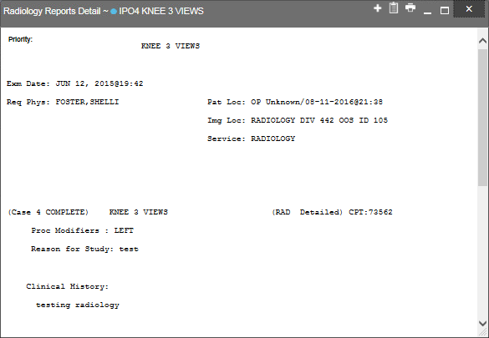
Figure 32: Radiology Exams Details Window (VA Record)

Display and Filter Options
Display and filter options within the Radiology Exams widget include:

        - Click the column title to sort records according to data in that column. If a user sorts on a column that appears in both minimized and expanded views of the widget, the sort is saved in the user profile and persists to the next user session. If a user sorts on a column that is only in the expanded view of the widget, the next user session restores the default widget sort, or the last sort saved to the user profile.
        - Click Column Settings in the widget toolbar to hide or show the columns within the widget. Check/uncheck the column names that appear in the pop-up box and click Apply.
        - Specify the date range for which records are displayed in the widget using the Quick Date Range Selector or the Start Date and End Date calendars. If the information you expect does not appear in the widget display, use the Start Date and End Date filter options to expand the date range. CCP users may have limited access to records depending on the date range set when the consult was assigned by the VAS user.
        - Use the Filter by Exam drop-down box to re-draw the widget to show only the records for the selected exam.
        - Use the Filter by Standardized Radiology Exam drop-down box to re-draw the widget to show only the records for the selected standardized exam.

Terminology Normalization in the Radiology Exams Widget
Terminology normalization is provided in the Radiology Exams widget through the following GUI elements:
        - The Exam column displays an exam within the patient's record. When a LOINC mapping is available, hovering over an entry in this column displays the standard used for terminology normalization for the clinical domain (LOINC), the standardized LOINC name, and the standardized LOINC code for that exam. If LOINC mappings are not available, CV looks for CPT mappings and display CPT normalization for standardized type and standardized code, if found.
        - The Standardized Radiology Exam column displays the standardized name for the corresponding entry in the Exam column, mapped to the LOINC standard. In addition to the standardized name, hovering over an entry in this column displays the standard used for terminology normalization for the clinical domain (LOINC), and the standardized code for that exam.
        - The CPT Description column provides mappings for VA records. When CPT mappings are available, this column displays the standardized type for the corresponding entry in the Exam column, mapped to the CPT standard. In addition to the standardized type, hovering over an entry in this column displays the standard type used for terminology normalization for the clinical domain (CPT), and the standardized code for that exam.

Vitals
The Vitals widget displays the patient’s vital information. The information is grouped and displayed in reverse chronological order by the date taken.

To open the widget, left-click Vitals from the widget tray that appears at the bottom of the Patient Portal, drag the icon to the screen, and drop where desired on the portal. Click the plus + and minus - icons next to the Data Taken row header to expand or minimize the group of vitals.

Vitals Widget Data
In the minimized view of the Vitals widget, the information is grouped by Date Taken. Vitals information includes:
        - Date Taken
        - Type
        - Result
        - Units
        - Site
Click More >> from the minimized view of the Vitals widget to open an expanded view of the widget. Click the plus + and minus - icons next to the Data Taken row header to expand or minimize the group of vitals. In the expanded view, the Vitals information includes:
        - Date Taken
        - Type
        - Standardized Type
        - Result
        - Units
        - Site

Display and Filter Options
Display and filter options within the Vitals widget include:
        - Click the column title to sort records according to data in that column. If a user sorts on a column that appears in both minimized and expanded views of the widget, the sort is saved in the user profile and persists to the next user session. If a user sorts on a column that is only in the expanded view of the widget, the next user session restores the default widget sort, or the last sort saved to the user profile.
        - Click Column Settings in the widget toolbar to hide or show the columns within the widget. Check/uncheck the column names that appear in the pop-up box and click Apply.
        - Specify the date range for which records are displayed in the widget using the Quick Date Range Selector or the Start Date and End Date calendars. If the information you expect does not appear in the widget display, use the Start Date and End Date filter options to expand the date range. CCP users may have limited access to records, depending on the date range set when the consult was assigned by the VAS user.
        - Use the Filter by Type drop-down box to re-draw the widget to show only the records for the selected vitals type.

        - Use the Filter by Standardized Type drop-down box to re-draw the widget to show only the records for the selected vitals type.
        - Use Graph View to display multiple records of the same type in a graph. Refer to Section 4.5.19.3, Graph View in the Vitals Widget for more information.
        - Use Table View to display multiple records of the same type in a tabular format. Refer to Section 4.5.19.4, Table View in the Vitals Widget for more information.

Graph View in the Vitals Widget
The Vitals widget provides the option to display multiple records of the same type in a graph. By default, the Show Graph link in the expanded view of the Vitals widget is disabled until the user narrows the data selection using display filters.
To view vitals in Graph View:
- Left-click Vitals from the widget tray that appears at the bottom of the Patient Portal, drag the icon to the screen, and drop where desired on the portal.
- Click More >> from the minimized view of the Vitals widget to open an expanded view of the widget.
- In the expanded view, select an available filter from the Filter by drop down boxes. This action enables the Show Graph and Show Table links.
- Click Show Graph.
A separate window opens, displaying a graph of the records of the type selected in the filter.

Table View in the Vitals Widget
The Vitals widget provides the option to display multiple records of the same type in a table. By default, the Show Table link in the expanded view of the Vitals widget is disabled until the user narrows the data selection using display filters.
To view vitals in Table View:
- Left-click Vitals from the widget tray that appears at the bottom of the Patient Portal, drag the icon to the screen, and drop where desired on the portal.
- Click More >> from the minimized view of the Vitals widget to open an expanded view of the widget.
- In the expanded view, select an available filter from the Filter by drop down boxes. This action enables the Show Graph and Show Table links.
- Click Show Table.
A separate window opens, displaying a table containing multiple records of the type selected in the filter.

Terminology Normalization in the Vitals Widget
Terminology normalization is provided in the Vitals widget through the following GUI elements:

        - The Type column displays a vital type within the patient's record. Hovering over an entry in this column displays the standard used for terminology normalization for the clinical domain (LOINC), the standardized LOINC name, and the standardized LOINC code for that vital.
        - The Standardized Type column displays the standardized name for the corresponding entry in the Type column, mapped to the LOINC standard. In addition to the standardized name, hovering over an entry in this column displays the standard used for terminology normalization for the clinical domain (LOINC), and the standardized code for that vital.

Troubleshooting

Special Instructions for Error Correction
NOTE: The following sections apply only to VAS users.
CV utilizes access control and authentication services to limit access to registered, authorized users. When enabled, CV validates a user against information retrieved from that user’s smart card. If you are experiencing other trouble logging in to CV, please review Table 5 before contacting VHA Community Support.

Table 5: Login Page Error Message Troubleshooting

Error Message | Resolution Steps
Access denied. You are not an authorized user. | WHAT? Error message indicating Access Denied. You are not an authorized User.  WHY? PIV card processing problem or invalid security certificate chosen.  FIX IT:  - Close browser window.  - Re-insert PIV card and re-launch the CV link.  - Select a certificate that is not expired and specifies Issued by: Veterans Affairs CA B1.  If this is unsuccessful, fully reboot your system. This refreshes all connections and resolves greater than 95% of any remaining problems.
Could not save User Profile | WHAT? Error message indicating Could not save User Profile.  WHY? Error occurred during PIV authentication for VA users - typically a PIV card processing problem or an invalid security certificate chosen.  FIX IT:  - Close your browser window.  - Re-insert PIV card and re-launch the CV link.  - Select a certificate that is not expired and specifies Issued by: Veterans Affairs CA B1.  If this is unsuccessful, fully reboot your system. This refreshes all connections and resolves greater than 95% of any remaining problems.
Not a valid ACCESS/VERIFY  CODE pair | WHAT? Not a valid ACCESS CODE/VERIFY CODE pair” error at login screen.  WHY? 1) CV could not match your access and verify codes to the Site selected in the drop down or VA, or 2) Username and password were entered instead of access/verify codes.  FIX IT:  - VHA users must select the parent VistA host site for their facility (e.g., Wichita uses Kansas City, Missouri [MO]).  - Re-enter correct Access and Verify codes (CPRS codes for VHA users).

Error Message | Resolution Steps
Page cannot be displayed | WHAT? You receive a Page cannot be displayed error when launching CV.  WHY? The CV Uniform Resource Locator (URL) requires certain internet explorer settings  FIX IT:  - With Internet Explorer open, click the Tools menu or press ALT-X.  - Select Internet Options.  - When the dialog opens, select the Advanced tab.  - Scroll down in the list until you see the settings below and assure Secure Socket Layer (SSL) 2.0 is NOT checked and that Transport Layer Security (TLS) 1.0, 1.1 and 1.2 are checked.  - Click OK, then re-launch CV and the page should load.
SmartCard required | WHAT? Error Message Smart Card Required.  WHY? Smart card not read by Windows Security and CV before launching CV link.  FIX IT:  - Close all browser sessions/browser-based applications.  - Re-insert PIV card and re-launch CV link.  - If this is unsuccessful, fully reboot your system to refreshes all connections. This resolves greater than 95% of any remaining problems.
VERIFY CODE must  be changed before continued use | WHAT? Receive VERIFY CODE must be changed before continued use error at login screen.  WHY? CPRS VERIFY CODE has expired.  FIX IT:  - Open CPRS.  - Select the Change Verify Code checkbox on the sign-on dialog before clicking OK.  - You are prompted to create a new Verify Code.  - Once your Verify Code is changed for CPRS, CV recognizes the new code immediately.

Patient Search Troubleshooting
The following error messages may appear when a VAS user is searching for a patient in the CCPM module. If you are experiencing errors while searching for patients, please review Table 6 before contacting VHA Community Support.

Table 6: Patient Search Error Message Troubleshooting

Error Message | Resolution Steps
An invalid search criteria was entered. | Invalid patient name entered. Please try your search again.  When searching by patient name, enter at least two characters of the patient’s

Error Message | Resolution Steps
Please enter at least 2 characters. | first and last name. Search results will display the closest match to the characters entered in the format of [last name],[first name].
An invalid SSN format was entered. Please enter a 9-digit SSN. | Invalid SSN entered. Please try your search again.  When searching by patient SSN, you are required to enter the patient’s full 9- digit SSN. Dashes are allowed (e.g., 123-45-6789).
An invalid last 5 format was entered. Please enter the first letter of the last name followed by the last 4-digits of the SSN. | Invalid patient name or SSN entered. Please try your search again.  Patient search allows you to search for a patient using the first initial of the patient’s last name and the last 4 digits of the patient’s SSN. Please try your  search again using the first initial of the patient’s last name and the last 4 digits of the patient’s SSN.
An error occurred during your search. Please try your search again. | This error may display when invalid patient identifiers were entered or an error occurred at the service layer or with an external system. Please try your search again.

Acronyms and Abbreviations
Table 7 lists the acronyms and abbreviations used throughout this document, and their descriptions.

Table 7: Acronyms and Abbreviations

Acronym | Description
Adm | Admission
AITC | Austin Information Technology Center
CCD | Continuity of Care Document
CCOW | Clinical Context Object Workgroup
CCP | Community Care Provider
CDC | Centers for Disease Control
CLIN | Contract Line Item Number
COOP | Continuity of Operations Procedure
CPRS | Computerized Patient Record System
CPT | Current Procedural Terminology
CT | Clinical Terms
CVX | Code for Vaccines Administered
DOB | Date of Birth
DoD | Department of Defense
EHR | Electronic Health Records
EMR | Electronic Medical Record
GUI | Graphical User Interface
HCP | Health Care Provider
HIE | Health Information Exchange
HIPAA | Health Insurance Portability and Accountability Act
ICD | International Classification of Diseases
ID | User Identification
IE | Internet Explorer
IEN | Employer Identification Number
IP | Internet Protocol
IT | Information Technology
JLV | Joint Legacy Viewer
LOINC | Logical Observation Identifiers Names and Codes
MVI | Master Veteran Index
NUCC | National Uniform Claim Committee

Acronym | Description
OI&T | Office of Information and Technology
PDF | Portable Document Format
PIN | Personal Identification Number
PITC | Philadelphia Information Technology Center
PIV | Personal Identification Verification
SDD | System Design Document
SNOMED CT | Systematized Nomenclature of Medicine Clinical Terms
SSL | Secure Socket Layer
SSN | Social Security Number
TLS | Transport Layer Security
UI | User Interface
URL | Uniform Resource Locator
VA | Department of Veterans Affairs
VAS | VA Administrative Staff
VHA | Veterans Health Administration
VistA | Veterans Health Information Systems and Technology Architecture
VLER | Virtual Lifetime Electronic Record
VSA | VistA Services Assembler

