Community Viewer (CV) Version 2.0 User Guide

April 2017
Version 1.3

Department of Veterans Affairs (VA) Office of Information and Technology (OI&T)

Revision History

Date | Version | Description | Author
04/25/2017 | 1.3 | Edited for CD2 comment | AbleVets
04/20/2017 | 1.2 | Privacy/Warning verbiage added. Document approved | AbleVets
04/18/2017 | 1.1 | Changes addressed. Submitted for review two | AbleVets
04/06/2017 | 1.0 | Draft submitted for review one | AbleVets
02/15/2017 | 0.1 | Initial draft of document | AbleVets

Table of Contents

- Introduction 1
  - Purpose of the Guide 2
    - Guide Conventions 2
  - Intended Audience 2
  - System Requirements 2
  - Getting Help 3
    - VAS Users 3
    - CCP Users 3
- Logging in to CV 4
  - VAS User Login 4
    - Changing User ID and Password 5
  - CCP User Login 6
    - Changing User ID and Password 9
  - Editing Your User Profile at Login 9
    - VAS User Customizations 9
    - CCP User Customizations 9
  - The CV Portal Pages 10
    - VAS User Default View 10
    - CCP User Default View 11
    - Viewing System Status 12
    - Configuring Your User Profile 13
    - Setting the User Interface Theme 13
    - Using the Accessible Theme’s Functionality 15
      - Keyboard Focus and Screen Navigation in Accessible Theme 15
  - Exit the System 16
- Using CV: VAS Users 17
  - Working with the CCP Management Module 17
    - About VA Facilities and Provider Groups 18
    - Creating Providers 18
    - Assigning Patients 20
    - Setting Record Display Limits 22
  - Editing Provider Groups and Profiles 23
    - Editing Provider Groups 24
    - Editing Provider Profiles 25
    - Resetting Provider Passwords 26
  - CCP Access to Patient Data 27
- Widgets 29
  - Accessing and Opening Widgets 30
  - Widget Navigation and Display Options 30
  - Minimized vs. Expanded Widget View 31
  - Displaying Widgets on Custom Tabs 32
  - Refreshing Widget Data 32
  - Examples of Widget Functionality 32
    - Patient Demographics 33
      - Viewing Third-party Insurance Information 33
    - Inpatient Medications 34
      - Inpatient Medications Widget Data 34
      - Viewing Inpatient Medication Details 35
      - Inpatient Medication Display and Filter Options 35
    - Lab Results 36
      - Lab Results Widget Data 36
      - Lab Results Display and Filter Options 37
      - Viewing Abnormal Results in the Lab Results Widget 37
      - Viewing Lab Results Details 38
      - Table View in the Lab Results Widget 38
      - Graph View in the Lab Results Widget 38
    - Problem List 39
      - Problem List Widget Data 39
      - Viewing Problem List Details 40
      - Problem List Display and Filter Options 40
- Troubleshooting 41
  - Special Instructions for Error Correction 41
    - Patient Search Errors 42
- Acronyms and Abbreviations 44

Table of Figures
Figure 1: Login Page for VAS Users 5
Figure 2: Authorized Use Message 6
Figure 3: CCP User Login Page 7
Figure 4: CCP VA Privacy and Security Awareness Training Page 8
Figure 5: CV Portal Tools 10
Figure 6: VAS User Default View 11
Figure 7: CCP User Default View 12
Figure 8: System Status Indicator on the Portal Pages 12
Figure 9: The CV Settings Dialog 13
Figure 10: Blue UI Theme 14
Figure 11: Green UI Theme 14
Figure 12: Accessible UI Theme 15
Figure 13: Default VAS User Portal Pages (Green Theme) 17
Figure 14: The CCPM Module 18
Figure 15: Search Provider and Create/Edit Provider Panes 19
Figure 16: Search Providers Pane 20
Figure 17: Edit Provider Fields 21
Figure 18: Patient Search Dialog 21
Figure 19: Data Access Controls 23
Figure 20: Search and Manage CCP Groups Panes 24
Figure 21: Add or Remove Providers from a Group 25
Figure 22: Search and Create/Edit Provider Panes 26
Figure 23: CCP Password Reset 27
Figure 24: Assigned Patients Widget 28
Figure 25: Widget Display on the Patient Portal 29
Figure 26: Widget Tray on the Patient Portal 30
Figure 27: Expanded View Widget Display 32
Figure 28: Patient Demographics Summary 33
Figure 29: Inpatient Medications 34
Figure 30: Lab Results 36
Figure 31: Problem List Widget 39

Table of Tables
Table 1: Keyboard Accessible Keystrokes 16
Table 2: Assignment Rules Examples 22
Table 3: Widget Navigation Tool Descriptions 31
Table 4: Login Page Error Message Troubleshooting 41
Table 5: Patient Search Error Messages and Resolution Steps 42
Table 6: Acronyms and Abbreviations 44

Introduction
Community Viewer (CV) is a browser-based software application built on the Joint Legacy Viewer (JLV) system. CV facilitates the secure exchange of data between Department of Veterans Affairs (VA) systems and non-VA providers, known as Community Care Providers (CCPs). The exchange of data improves care coordination and continuity of care for VA patients receiving treatment outside of the VA network.
CV pulls information from VA health care systems in real time for viewing within a web browser. Through CV, VA Administrative Staff (VAS) can assign patients to CCPs and provision CCP use within the CV system, allowing CCPs access to view consolidated patient data from multiple Veterans Health Information Systems and Technology Architecture (VistA) systems.
The data retrieved and viewed through CV is limited to VA only. In this release, the retrieval and display of VA Virtual Lifetime Electronic Record (VLER), DoD, and DoD VLER data is not supported.

VAS users use the Community Care Provider Management (CCPM) module in CV to perform the following tasks:
  - Create Providers
  - Assign Patients
  - Restrict Data Access
CCP users can perform the following tasks:
  - Request Password Reset
  - Access/View Patient Data

Please read and bear the following warning in mind before using Community Viewer:
** WARNING**WARNING**WARNING **

"This U.S. Government computer system is for official use only.
The files on this system include Federal records that contain sensitive information.

All activities on this system may be monitored to detect unauthorized access to
or misuse of the system or individual files and utilities on the system,
including copying, printing, or personal use.

Further use of this system constitutes your consent to such monitoring.

Misuse of or unauthorized access to this system may result in criminal prosecution
and disciplinary, adverse, or other appropriate action."

** WARNING**WARNING**WARNING **

Purpose of the Guide
The purpose of the User Guide is to familiarize VAS and CCP users with the important features and navigational elements of the CV application.

Guide Conventions
This document is designed for both online and hardcopy consumption.
  - Cross References are indicated by blue, underlined text, and provide a hyperlink to figures, tables, and other sections within this guide
  - The conventions used in this document for emphasis are bold and italicized text
  - The information symbol is used to inform the reader of additional information

Intended Audience
The User Guide is written from the perspective of VAS and CCP users, with the following assumed experience/skills:
  - Users have basic knowledge of accessing and using web-based applications (such as a web browser, including onscreen commands, menu options, and navigation tools)
  - Users have been provided the appropriate access credentials, Uniform Resource Locator (URL) for the login page, system user names, access/verify codes (for VAS users), and passwords (for CCP users), required for launching the CV web application
  - VAS users utilize CV to assign patients to providers outside the VA network
  - CCPs use CV to view VA patient data relevant to assignments

System Requirements
The CV application interface is a front-end web application, designed to run in a web browser. If you are accessing CV through a browser or device that is not fully compatible with the application, certain features may not work as expected. Mobile devices are not supported with this release.
It is recommended that CV is accessed from a desktop PC using one of the following supported browsers:
  - Chrome v54
  - Firefox v50
  - Edge v25
  - Internet Explorer v11
  - Safari v10

Getting Help

VAS Users
If you are an authorized VAS user, having trouble logging in to CV, or experiencing other application issues, please contact the Enterprise Service Desk (ESD) for assistance.
Prior to contacting the ESD for support, please refer to Section 2, Logging in to CV, for detailed information about how to access CV, and to Section 5, Troubleshooting, for suggested resolution steps and troubleshooting information.

VA Enterprise Service Desk
REDACTED

CCP Users
If you are an authorized CCP user in need of technical assistance, contact Veterans Health Administration (VHA) Community Support.

VHA Community Support
REDACTED

If you are an authorized CCP user and do not have your password, follow the steps outlined in Section 2.2.1, Changing User ID and Password to request a password reset.

Logging in to CV
Before logging in to and utilizing the functionality of Community Viewer, please read the following:
** WARNING**WARNING**WARNING **

"This U.S. Government computer system is for official use only.
The files on this system include Federal records that contain sensitive information.

All activities on this system may be monitored to detect unauthorized access to
or misuse of the system or individual files and utilities on the system,
including copying, printing, or personal use.

Further use of this system constitutes your consent to such monitoring.

Misuse of or unauthorized access to this system may result in criminal prosecution
and disciplinary, adverse, or other appropriate action."

** WARNING**WARNING**WARNING **

VAS User Login
Authorized, registered users within the VA are provided access information to log on to the CCPM module in CV. If you have not received credentials to access CV, you must first request access through the appropriate service lead or facility.
CV authenticates all VA users against a list of authorized, registered users in combination with the user's Personal Identification Verification (PIV) card and credentials. During login, first-time CV users are prompted to enter their agency, site, and user settings. This data is used to create a CV user profile, and is utilized during future login sessions.
To log in to CV:
- Insert your PIV card into your computer or card reader.
- Open a supported Internet browser.
- Enter the URL for the CV web application into the address bar of the browser.
- When prompted, select the appropriate, current digital certificate.
- When prompted, enter your PIV Personal Identification Number (PIN).
- Click I Accept after reading the important user consent information regarding accessing a government information system.
- Enter the following information in the fields on the login page. (Example shown in Figure 1):
  - Enter your VistA Access Code.
  - Enter your VistA Verify Code.

  - Select VA from the Agency field.
  - Select your local VistA host site from the Site field.
- Click Login.

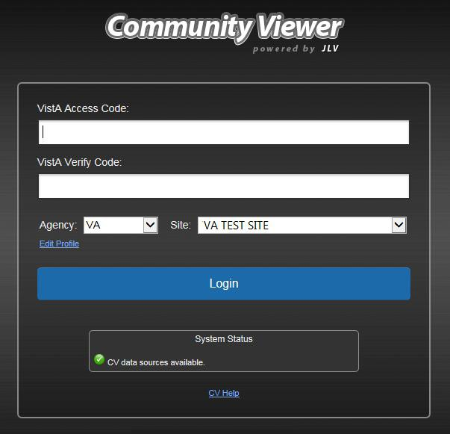
Figure 1: Login Page for VAS Users

NOTE: VA users who are not authorized to access CV see an Access denied message. Access to CV is limited to authorized users, and is configured by System Administrators. If you believe you have received the message in error, please contact the ESD.

Changing User ID and Password
CV authenticates all VA users against an authorized, registered list of VHA/VAS users, in combination with the user's PIV card and VistA credentials. User Identification (ID) and access code/verify code changes or resets are not performed in CV for the VAS user.
For more information and troubleshooting tips, see Section 5, Troubleshooting.

CCP User Login
During login, CV authenticates all CCPs against a registered list of users provisioned by VAS. If you have not received credentials to access CV, you must first request access through the appropriate VAS liaison.

NOTE: Prior to accessing the functionality of the CV application for the first time, (or 365 days after the date of their first login), CCP users are required to perform acknowledgement tasks.

- Open a supported Internet browser.
- Enter the URL for the CV web application, provided by VAS, in the address bar of an approved Internet browser.
- The Authorized Use message (Figure 2), a security and legal disclaimer, appears.
- Click OK to confirm that you are aware you are accessing a government information system that is provided for authorized users only.

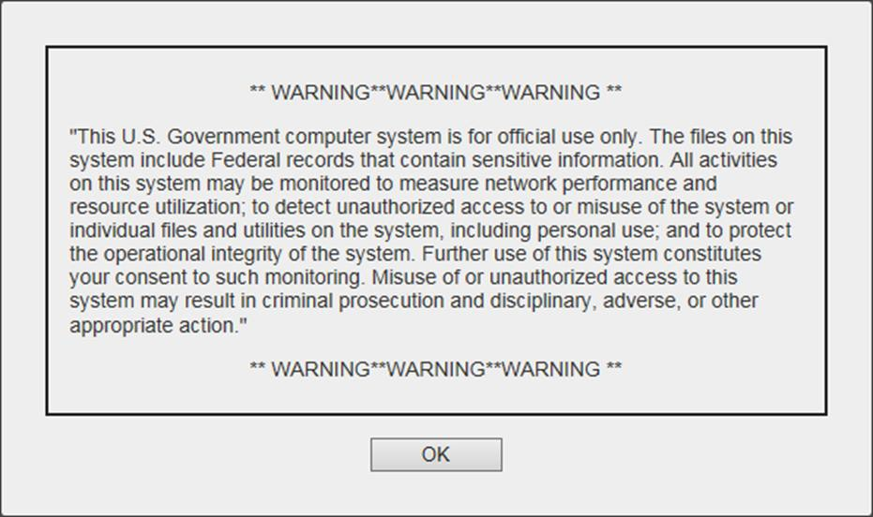
Figure 2: Authorized Use Message

- Enter the user name and password, provided by VAS, in the fields on the Login page (Figure 3):
  - The user name is the e-mail address associated with your account.
  - If you do not have, or have forgotten your password, click the Forgot Password?
link on the Login page.

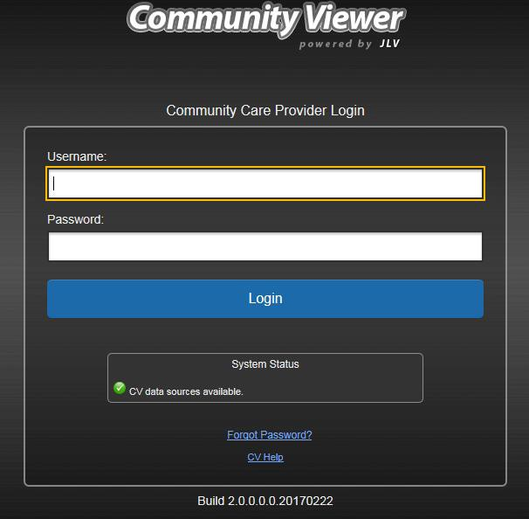
Figure 3: CCP User Login Page

- Click Login.
- If you are logging in to the CV application for the first time, or 365 days after your first login, the VA Privacy and Security Awareness Training page (Figure 4) appears.

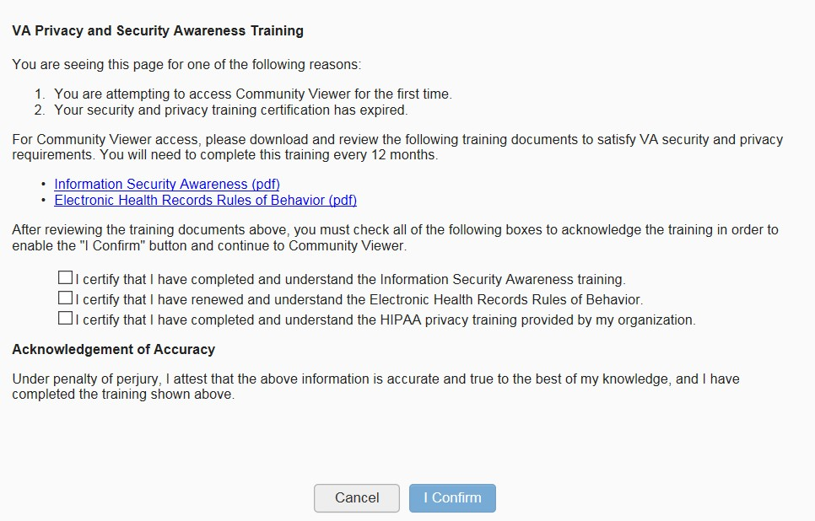Figure 4: CCP VA Privacy and Security Awareness Training Page

NOTE: The VA Privacy and Security Awareness Training page appears the first time the CCP user accesses the CV application, and again every 365 days after the first successful login, as training certification must be renewed each year.

- Download and read the Information Security Awareness Training PDF document.
- Download and read the Electronic Health Records Rules and Behavior PDF document.
- Click the checkbox to certify that you have completed and understand the Information Security Awareness training.
- Click the checkbox to certify that you have read and understand the Electronic Health Records Rules and Behavior.
- Click the checkbox to certify that you have completed and understand the Health Insurance Portability and Accountability Act (HIPAA) Privacy training through your organization.
- Click I Confirm to proceed to the application.

After logging in to CV:
  - Your user name is displayed in the top-right corner of the page.
  - Any patient consults assigned to you are shown in the Assigned Patients widget.
  - You will be able to view consults assigned to your Provider Group, even if you do not have any active or scheduled consult assignments.

Changing User ID and Password
The user ID (user name) for CCP users is the e-mail address associated with their account. It cannot be changed unless the provider’s e-mail address changes. CCP users have the option to request a password reset.
To request a password reset:
- Enter the URL for the CV web application, provided by VAS, in the address bar of an approved Internet browser.
- Click the Forgot Password? link.
- Enter your name, e-mail address, and phone number in the fields provided in the dialog box.
- Click Send.
- An e-mail message is generated to VHA Community Support requesting that an associate contact you, at the phone number you provide, with a new password.

Editing Your User Profile at Login
Both VAS and CCP users can customize their user profiles from the login page.

VAS User Customizations
First-time CV users will be prompted to enter their agency, site, and User Interface (UI) theme settings before logging in. Once saved, the profile information is used each time you log in to CV.
UI theme preferences can also be set after logging in to CV. See Section 2.4.4, Configuring Your User Profile.
To edit the user profile at login:
- Click the Edit Profile link on the login page. Profile options are presented.
- Enter your agency and site in the fields provided.
- Select the desired UI theme.
- Click Save and Login.

CCP User Customizations
CCP users can customize the UI theme from the login page. UI theme preferences can also be set after logging in to CV. See Section 2.4.4, Configuring Your User Profile.
To edit the user profile at login:
- Click the Edit Profile link on the login page. Profile options are presented.
- Select the desired UI theme.
- Click Save and Login.

The CV Portal Pages
The CV portal pages have tools that enable quick access to basic features. These tools appear in the top-right corner of the portal pages (Figure 5).
  - View the status of data source connections. See Section 2.4.3, Viewing System Status.
  - Configure your user profile. Click the cog wheel in the top-right corner of the portal pages to configure user settings, including the UI theme. See Section 2.4.4, Configuring Your User Profile.
  - Access online help. Click Help in the top-right corner of portal pages to open web- based, online help.
  - Access widgets from the widget tray. See Section 4.1, Accessing and Opening Widgets.
  - Log out. Click Logout to terminate the current CV session.

NOTE: The symbol seen to the right of the System Status indicator represents clinical context management through the Clinical Context Object Workgroup (CCOW). CCOW is disabled in Community Viewer.

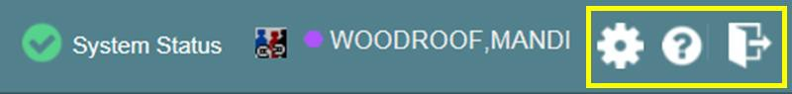
Figure 5: CV Portal Tools

VAS User Default View
The default view for a VAS user includes the CCPM module (Figure 6).

NOTE: If the CCPM module is not displayed on the provider portal, click the plus
+ sign in the lower-right corner of the screen, (Figure 6) to open the widget tray. Click and drag the icon from the widget tray to the screen, and drop the widget in the desired location.

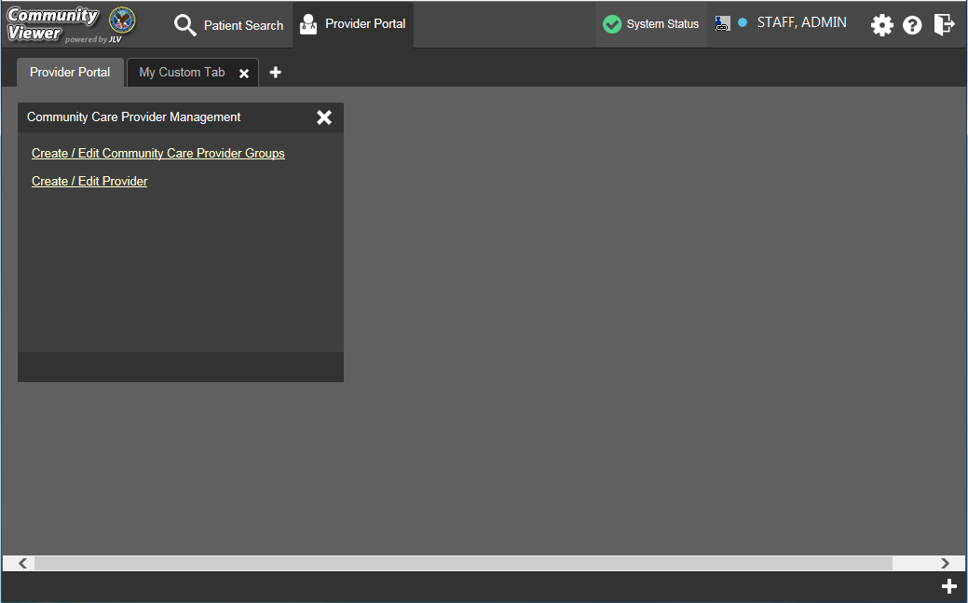
Figure 6: VAS User Default View

CCP User Default View
The default view for a CCP user includes the Assigned Patients widget (Figure 7).

NOTE: If the Assigned Patients widget is not already open on the screen, click the plus + sign in the lower-right corner of the screen, (Figure 7) to open the widget tray. Click and drag the icon from the widget tray to the screen, and drop the widget in the desired location.

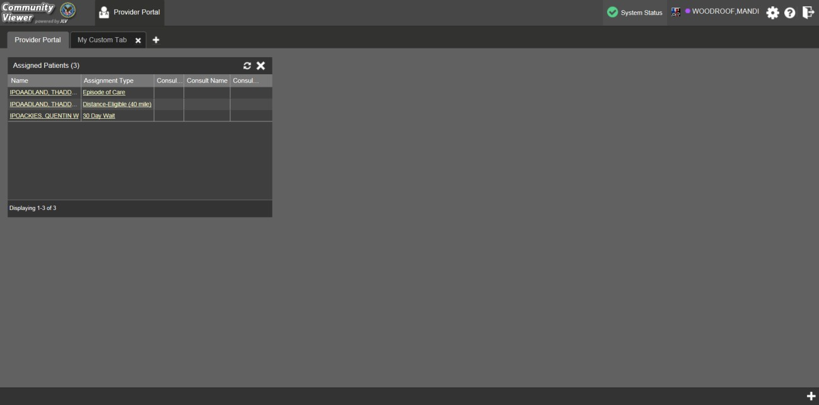
Figure 7: CCP User Default View

Viewing System Status
System status updates are received from CV’s Health Monitor, which monitors the services that CV uses to connect to VA data sources. Monitored services include: Master Veteran Index (MVI), VistA Data Service, and jMeadows Data Service.
There are two areas of CV where system status is displayed:
- On the login page
- On the portal pages (highlighted in Figure 8)
When all monitored systems and services are online and connected, a green icon appears next to the status, with the message CV data sources are available (Figure 8).
When one or more monitored systems or services are offline or unavailable, a yellow warning icon appears with the message CV is having problems.
When CV’s health monitor is unable to retrieve and report system status information, a red icon appears with the message, System status is unavailable. Users may not be able to log into CV
or view patient data until the connection is restored.

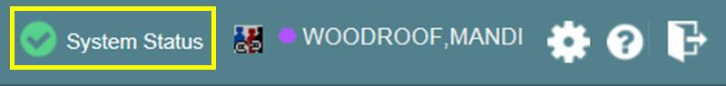
Figure 8: System Status Indicator on the Portal Pages

Configuring Your User Profile
Profile settings are accessible within CV by clicking the cog wheel located in the top-right corner of the portal pages (Figure 9).
In this release, the configuration options are limited to theme. See Section 2.4.5, Setting the User Interface Theme.

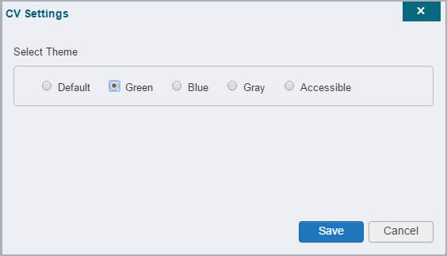
Figure 9: The CV Settings Dialog

Setting the User Interface Theme
Selecting the User Interface Theme sets the font color, foreground, and background colors of the CV Graphical User Interface (GUI). Themes apply to all onscreen elements, including widgets, toolbars, and dialog boxes. Theme choices are Default, Green, Blue, Gray, and Accessible.
To set the UI theme on the CV portal pages:
- Click the cog wheel in the top-right corner of the portal pages
- The CV Settings dialog opens (Figure 9)
- Click the radio button next to the desired theme
- Click Save
- After clicking Save, you are asked whether or not to save the configuration. Click Yes to reload the application and apply the selected theme -OR-
- Click Cancel to exit the CV Settings dialog and restore the previous theme
Examples of the UI themes are displayed in the figures below. The Default theme was presented in Section 2.4.1, VAS User Default View, and in Section 2.4.2, CCP User Default View.

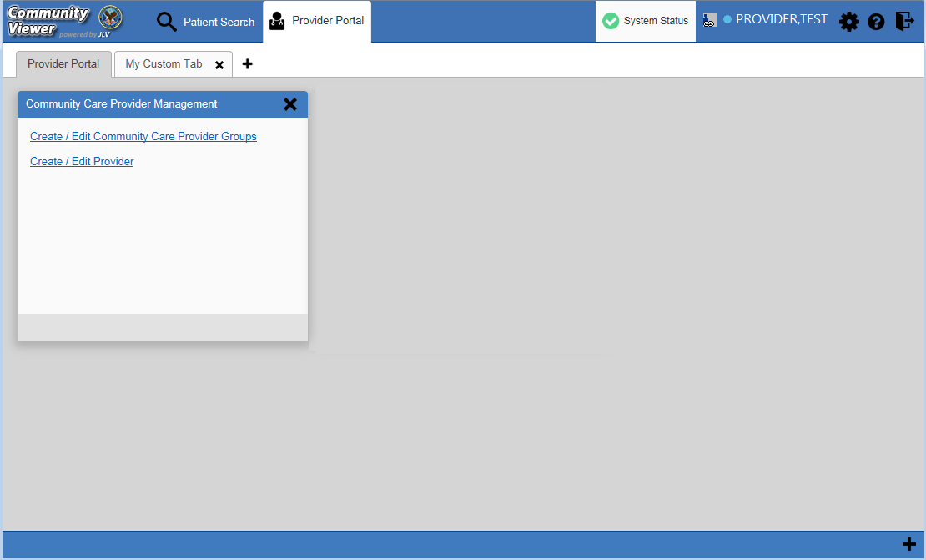
Figure 10: Blue UI Theme

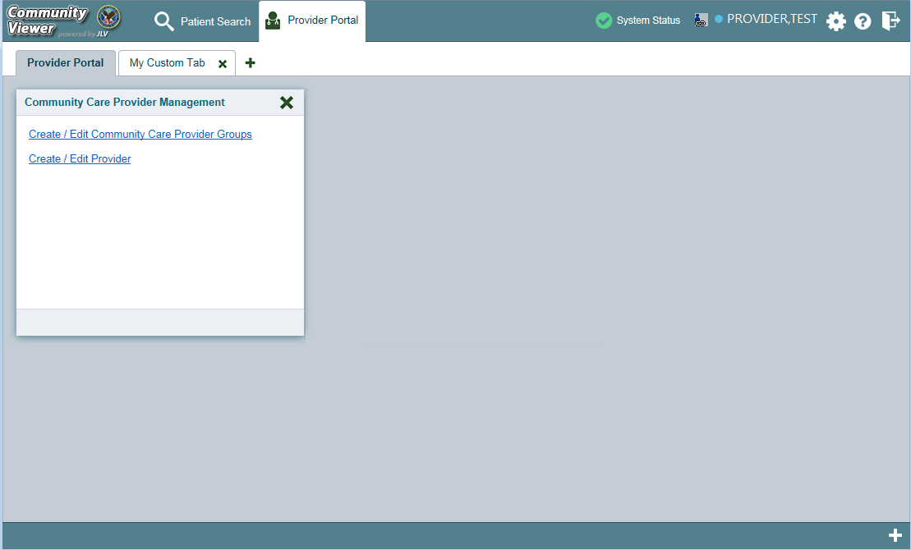
Figure 11: Green UI Theme

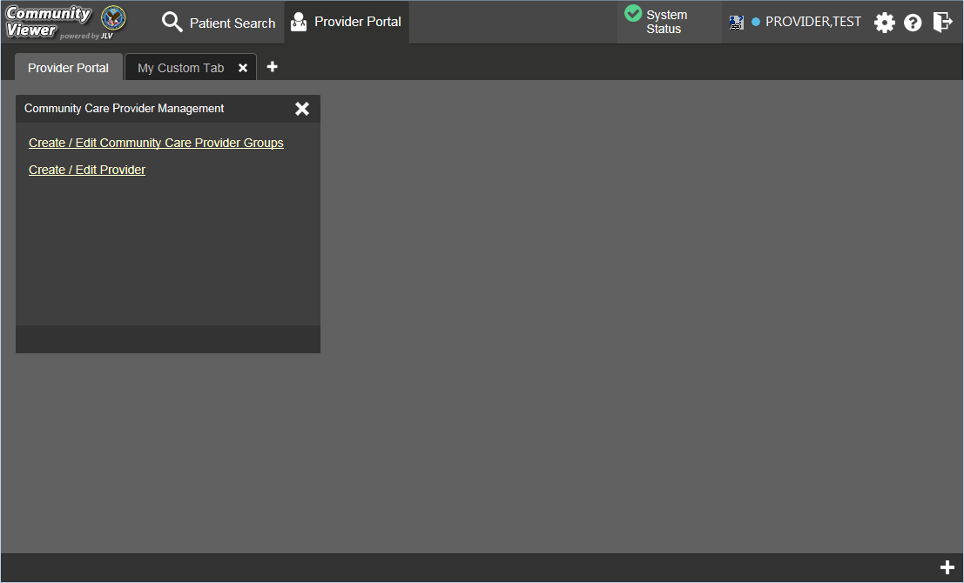
Figure 12: Accessible UI Theme

Using the Accessible Theme’s Functionality
The Accessible theme includes larger fonts, enhanced tab and keystroke functionality, and screen reader compatibility to support Federal accessibility requirements and Section 508 compliance.

Keyboard Focus and Screen Navigation in Accessible Theme
Keyboard focus is the highlighting of on-screen elements that enables the interaction with, and navigation of, the web application through the keyboard and keystrokes. The on-screen item that currently has keyboard focus is outlined. The CV web application uses a gold-colored outline as a visual indicator of the element with keyboard focus.
CV enables the use of common Windows keyboard keystrokes (Tab, Shift + Tab, arrow keys, Enter), and other keyboard shortcuts to move the on-screen focus to all menus, and activate all functions on the menus. All user interface items are accessible via the keyboard under the Accessible theme.
Pressing Enter or the Spacebar, when an element that provides action is in keyboard focus, performs the associated action. For example, pressing Enter or the Spacebar when the cog wheel icon is in keyboard focus results in opening the CV Settings dialog box. Using the arrow keys or the Tab key allows a user to move between keyboard focus items to navigate through on-screen elements. A complete list of accessible keystrokes is provided in Table 1.

Table 1: Keyboard Accessible Keystrokes

Keystroke | Description
Application and Portal Navigation
ENTER | Press to transfer keyboard focus to the highlighted widget.
TAB | Press to transfer keyboard focus to other user interface items.
ESC | Press to return keyboard focus to the panel containing the user interface item with keyboard focus or to exit a window or widget.
SPACEBAR | Press to activate any user interface item (for example, click a button).
Arrow Keys | When keyboard focus is on a widget, press the arrow keys to change page viewing in a widget's data table.  When keyboard focus is on a dropdown list, press the down arrow to view the contents.
Tab Panels
Arrow Keys | Use the left and right arrow keys to change tab panels.  To add a tab panel, press the right arrow key until the last tab (+) is selected. A dialog prompts the user to enter the tab name.
Ctrl + x | To close a tab, focus on the tab panel and press Ctrl + x.
Windows and Dialog Boxes
TAB | Press the Tab key to move the keyboard focus to other user interface items within the window.
Adding Widgets to the Portal Pages
SHIFT +  (Number position) | To add a widget from the widget tray using keystrokes:  - Determine which column (1, 2, or 3) to place the widget on the portal page.  - Focus the desired widget icon in the widget tray and press the Shift key along with the 1, 2, or 3 key, depending on the desired column placement.

Exit the System
You may intentionally log off to end a CV session by clicking Logout at any time. If you fail to log out, your session will terminate automatically after five (5) minutes of inactivity. You will be redirected to the login page when any new activity is attempted.

Using CV: VAS Users

Working with the CCP Management Module
After logging in, VAS users see the CCPM module on the portal pages by default.

NOTE: If the CCPM module is not open on the screen, click the plus + sign in the lower-right corner of the screen, (Figure 13) to open the widget tray. Click and drag the icon from the widget tray to the screen, and drop the widget in the desired location on the portal page.

Figure 13: Default VAS User Portal Pages (Green Theme)

A VAS user creates providers, assigns patients to CCPs, and grants the CCP limited access to patient records within the CCPM module.
There are two workflow options (Figure 14) within the CCPM:
- Create/Edit Community Care Provider Groups
- Create/Edit Provider

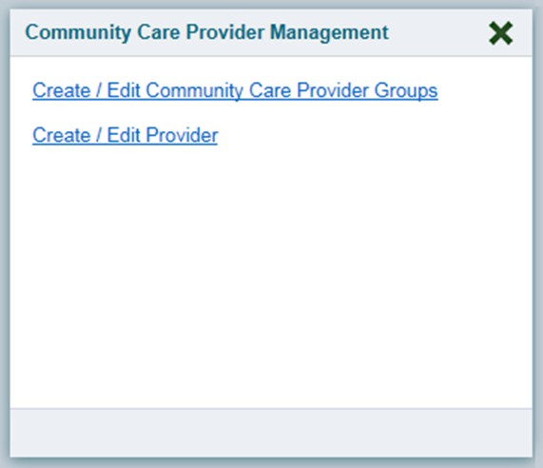
Figure 14: The CCPM Module

About VA Facilities and Provider Groups
Before a VAS user can assign a patient to a CCP, the CCP must be assigned to a provider group.
EXAMPLE 1: Dr. Hanyok works with a family practice called Evergreen Health Care. Dr. Hanyok is the Provider, and Evergreen Health Care is the Group to which she is assigned.
EXAMPLE 2: Dr. Woodroof, the Provider, is a sole practitioner. The Group name for a sole practitioner is also the provider’s name; in this case, Dr. Woodroof.
CV has been pre-populated with over 200,000 groups and providers. VAS users can edit existing groups, but in this release, the task of creating provider groups is performed by Tier 2 Administrators. VAS users should contact the ESD to request the creation of a new group.
Each group is associated with one or more local VA sites, referred to as Facilities. A facility is a local VA site associated with a provider group. Provider groups can contain one or more VA facilities.

Creating Providers
All CCP accounts are created by VAS users in the CCPM module. Creating a CCP creates the provider’s associated account and user profile. A VAS user can assign consults to CCPs after their account has been created.
To create a provider:
- Click the Create/Edit Provider link (Figure 14) in the CCPM module
- Click Create New Provider in the Search Providers pane, shown in Figure 15
- Click Browse to the right of the Provider Group field to search for an existing group
- Select the desired group from the list of results and click OK

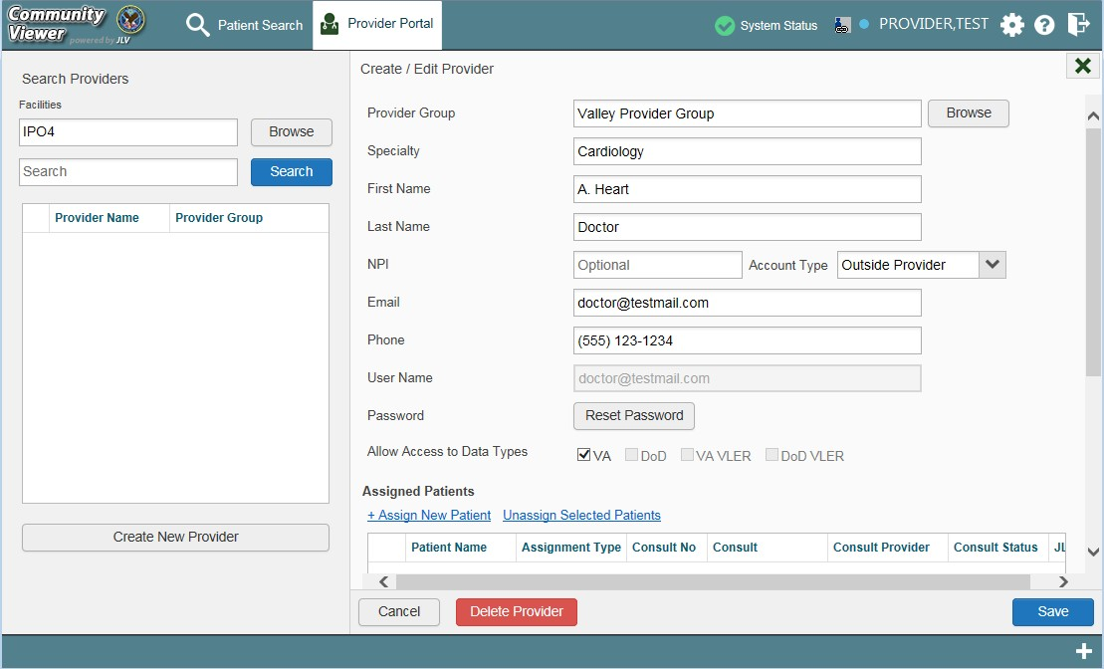
Figure 15: Search Provider and Create/Edit Provider Panes

- Enter the provider information in each of the fields on the Create/Edit Provider pane (Figure 15). Required fields are noted
- Select Outside Provider from the Account Type list
- The User Name field is automatically populated with the address entered in the E-mail
field.
- Enter a password in the Password field, or click Generate for the system to create a random password. CCP user passwords must be at least 8 characters long. Passwords must also include:
  - At least one uppercase letter and one lowercase letter
  - At least one number
  - At least one special character, such as ! @ # ? $ % &
NOTE: Passwords are case-sensitive.
- Record the User Name and Password as displayed. It is the responsibility of the VAS user to provide the CCP with his/her user name and password for CV
- Click Save
- When the Provider successfully created message appears, there are two options:
- Click Assign Patients and follow the steps outlined in Section 3.1.3, Assigning Patient Consults -OR-

- Click OK to return to the CCPM module

Assigning Patients
Once a CCP user’s account is created, a VAS user can assign patients to the CCP. To assign patient(s) to a CCP:
- Click the Create/Edit Provider link in the CCPM module
- Enter the provider’s name in the field to the left of the Search button within the Search Providers pane (Figure 16)
- Click Search

NOTE: If you’ve entered this screen immediately after creating a provider, the screen is pre-populated with the provider’s profile information. No search is necessary.

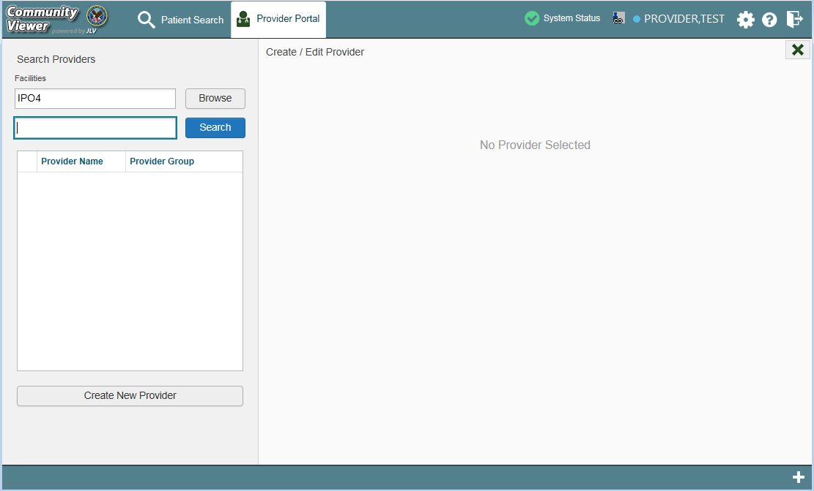
Figure 16: Search Providers Pane

NOTE: In this release, the task of deleting a provider is performed by Tier 2 Administrators. VAS users will not see the Delete Provider button. Instead, they must contact the ESD to request that a provider be deleted.
- Select the Provider from the list of results
- Click the + Assign New Patient link in Create/Edit Provider pane (Figure 17)

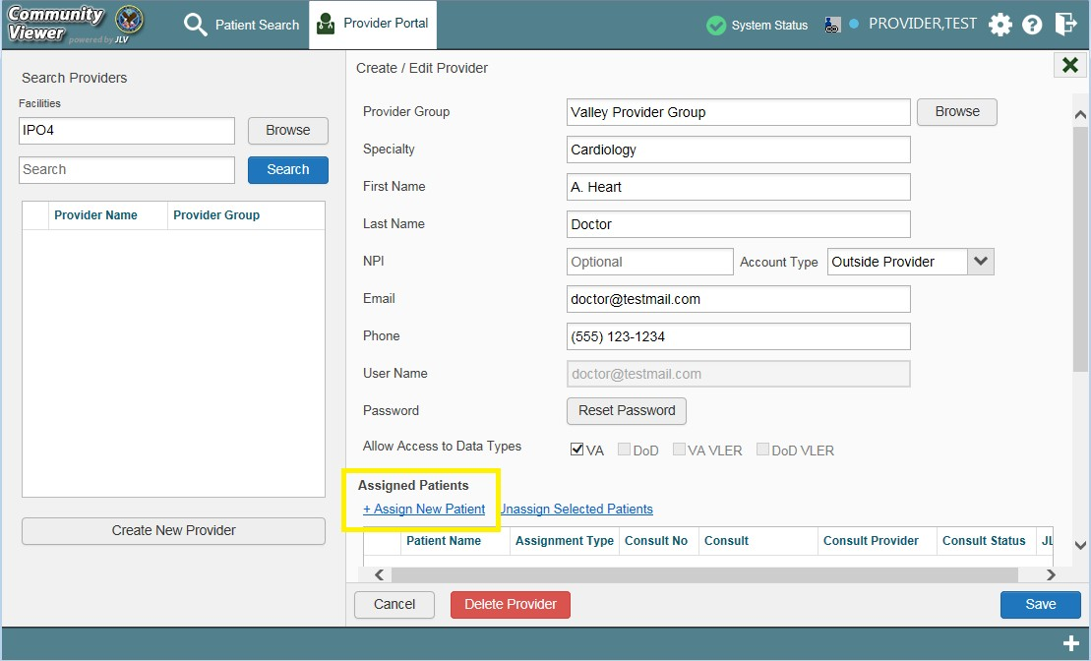
Figure 17: Edit Provider Fields

- Enter the patient name in the blank field at the top of the Patient Search dialog (Figure 18)

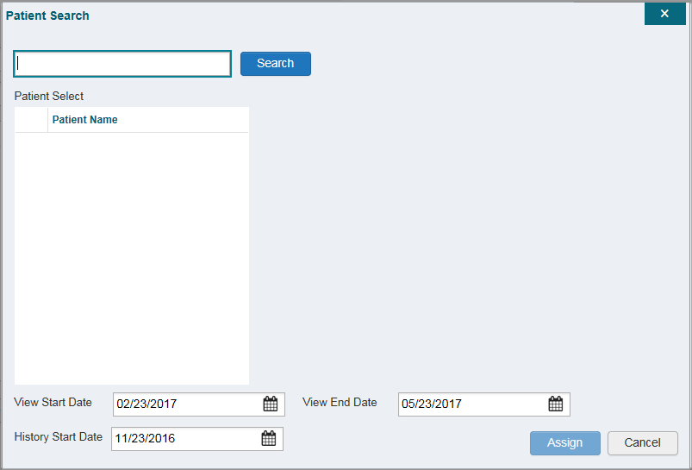
Figure 18: Patient Search Dialog
- Click Search

- Select a patient from the search results (Figure 18)
- Select the Assignment Type from the dropdown list: 30 Day Wait, Consult, Distance-
Eligible (40 mile), or Episode of Care
  - If Consult is specified, select one consult record from the list for the selected patient. The consult status must be Active or Scheduled for the consult to appear in the list
- If desired, adjust the default View Start/End and History dates to restrict the data seen by the CCP. (See Section 3.1.4, Setting Record Display Limits)
- Click Assign
CV uses the following rules to manage patient assignments:
- A specific Veteran may be assigned to multiple CCPs
- A Veteran may be assigned to more than one CCP for the following Assignment Types:
  - 30 Day Wait
  - Distance Eligible
  - Episode of Care
- A specific Veteran/consult combination may only be assigned to a single CCP

Table 2: Assignment Rules Examples

Veteran John Davis has multiple active referrals to be assigned:
Referral 1 | 30 Day Wait for Dental | Assign to CCP A | A Veteran may have multiple, active assignments in a particular Assignment Type
Referral 2 | 30 Day Wait for Podiatry | Assign to CCP B
Referral 3 | 30 Day Wait for Podiatry | Assign to CCP C
Referral 4 | Episode of Care for Optometry | Assign to CCP D
Referral 5 | Consult for Cardiology | Assign to CCP E | This specific consult can only be assigned to one CCP at a time
Referral 6 | Consult for Chiropractic | Assign to CCP F | This specific consult can only be assigned to one CCP at a time

NOTE: Alternatively, patient consults can be removed using the Unassign Selected Patients link (Figure 17).

Setting Record Display Limits
A VAS user has the ability to limit the patient records available to the assigned CCP. The default setting is three (3) months prior to the date of the assignment. There are two settings that control access to patient data:
- View Start Date and View End Date: These fields represent how long the CCP user will have access to the patient records through CV. The default start date is the date the

patient is assigned to the CCP. The default end date is three (3) months from the start date.
- History Start Date: This setting represents how far back in a patient's VA medical history the CCP is permitted to view. For example, if the history start date is set to 01/01/2012, the CCP has access to the patient's records from available VA facilities from 2012 to present.
Data access controls are set by the VAS user during the patient assignment process prior to completing the assignment.
- Click the calendar next to the View Start Date and the View End Date fields
- Select the start and end dates (Figure 19)
- Alternatively, click the calendar icon next to the History Start Date
- Select a date
- Click Assign

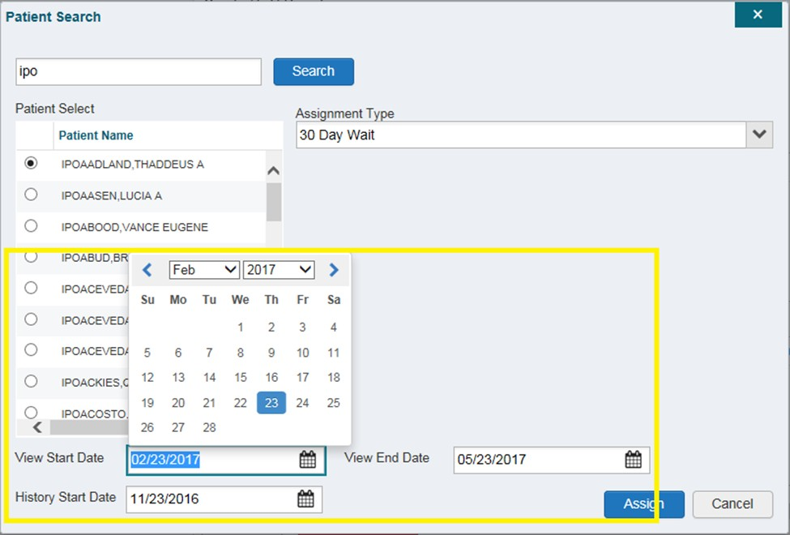
Figure 19: Data Access Controls

Editing Provider Groups and Profiles
Provider groups and provider profiles can be edited through the CCPM module.

    - Editing Provider Groups Provider groups can be edited through the CCPM. To edit a provider group:
- Click the Create/Edit Community Care Provider Groups link in the CCPM module
- Enter the provider group name in the Search field
- Click Search
- Select the desired provider group from the search results (Figure 20)
- Edit the provider group fields as needed

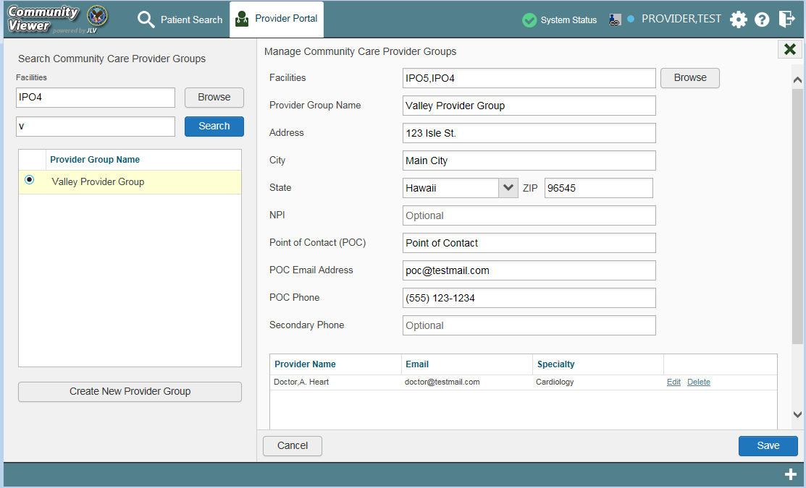
Figure 20: Search and Manage CCP Groups Panes

To add or edit a facility
- Click Browse next to the Facilities field, and select the desired facility from the list
- Providers assigned to the provider group are listed in the lower-right portion of the screen. Edit provider profiles or remove providers from the group using the Edit link within the Assigned Providers list (Figure 21)
- Click Save

NOTE: In this release, the task of deleting a provider is performed by Tier 2 Administrators. VAS users will not see a Delete link, and should contact the ESD to request that a provider be deleted.

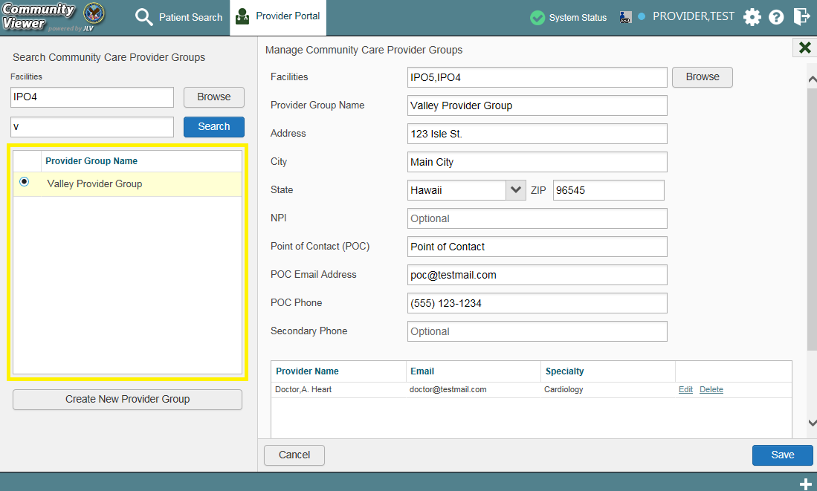
Figure 21: Add or Remove Providers from a Group

Editing Provider Profiles
VAS users can edit a CCP’s profile within the CCPM module. To edit a CCP’s information in his/her profile:
- Click the Create/Edit Provider link in the CCPM module
- Enter the provider name in the Search field
- Click Search
- Select the desired provider from the search results (Figure 22)
- Edit the provider information in the fields provided, as necessary
- Click Save

NOTE: If a provider is assigned to the wrong group, VAS users can change the group on this screen. If the provider will be added to an additional group, VAS users must click Add New Provider in the Search Providers pane and create the provider within the new group. The provider name can be the same, but a different
e-mail address must be used.

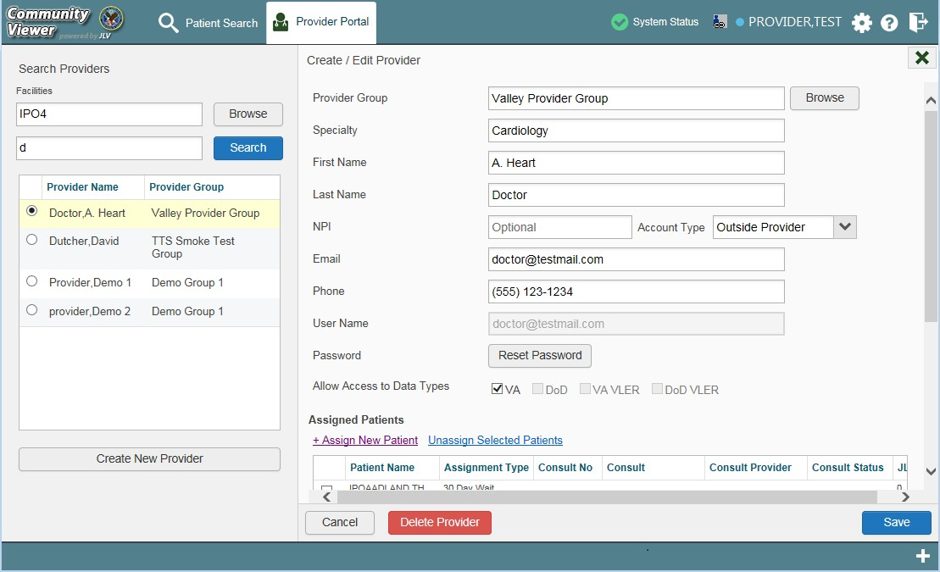
Figure 22: Search and Create/Edit Provider Panes

Resetting Provider Passwords
If a CCP user has forgotten his/her password, there is a Forgot Password? link on the log in page (Figure 3). Clicking the link opens a window that enables the user to send a password reset request directly to VHA Community Support. Password resets are performed in the CCPM module.
To reset a CCP’s password:
- Click the Create/Edit Provider link in the CCPM module
- Enter the provider name in the Search field
- Click Search
- Select the desired provider from the search results
- Click Reset Password (Figure 23) in the Create/Edit Provider pane
- Enter a password in the field provided. You may also generate a new, random password by clicking Generate
- Record the new password. It is the responsibility of the VAS user to provide the CCP with his/her password for CV
- Click Save

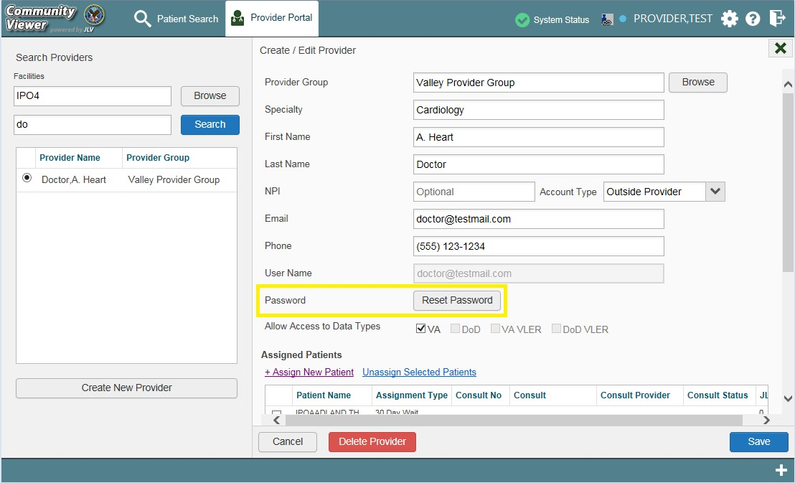
Figure 23: CCP Password Reset

CCP Access to Patient Data
Prior to accessing patient data in Community Viewer, please read the following:
** WARNING**WARNING**WARNING **

"This U.S. Government computer system is for official use only.
The files on this system include Federal records that contain sensitive information.

All activities on this system may be monitored to detect unauthorized access to
or misuse of the system or individual files and utilities on the system,
including copying, printing, or personal use.

Further use of this system constitutes your consent to such monitoring.

Misuse of or unauthorized access to this system may result in criminal prosecution
and disciplinary, adverse, or other appropriate action."

** WARNING**WARNING**WARNING **

CCP users can access a patient record using the Assigned Patients widget to open the record in the Patient Portal.
After a CCP user logs in, the Assigned Patients widget appears with a list of patient consults. Clicking a hyperlink in the Assigned Patients widget, (Figure 24) opens the Patient Portal.

NOTE: If the Assigned Patients widget is not open after logging in, click the plus (+) sign in the lower-right corner of the screen to open the widget tray. Click and drag the widget icon from the tray to the screen, and drop in the desired location.

The Assigned Patients widget lists active and scheduled assignments for all providers in the group the provider belongs to. If there are two active assignments for one patient, the patient is listed twice.
The following information is available for each assignment listed in the widget:
- Patient Name: Click the entry to open the patient’s record in the Patient Portal.
- Assignment: This is the assignment type.
- Consult No.: This is a number generated by the VA system. Click the entry to open the patient’s record in the Patient Portal. This information is only shown for patients with a Consult assignment type.
- Consult Name: This is a label generated by the VA system. Click the entry to open the patient’s record in the Patient Portal. This information is only shown for patients with a Consult assignment type.
- Consult Provider: The assigned VA Provider, or the provider who ordered the consult. This information is only shown for patients with a Consult assignment type.

NOTE: VAS users do not see the Assigned Patients widget, and do not have access to patient data through this point of access.

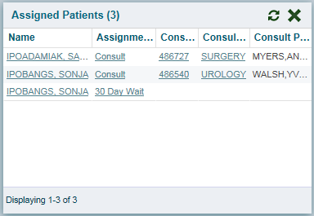
Figure 24: Assigned Patients Widget

Widgets
Patient-centric information is displayed in the Patient Portal through widgets for both CCPs and VAS users (Figure 25). Widgets are elements within the CV portal pages that display data specific to an administrative or clinical domain. Widget data is generally displayed in reverse chronological order, by date.

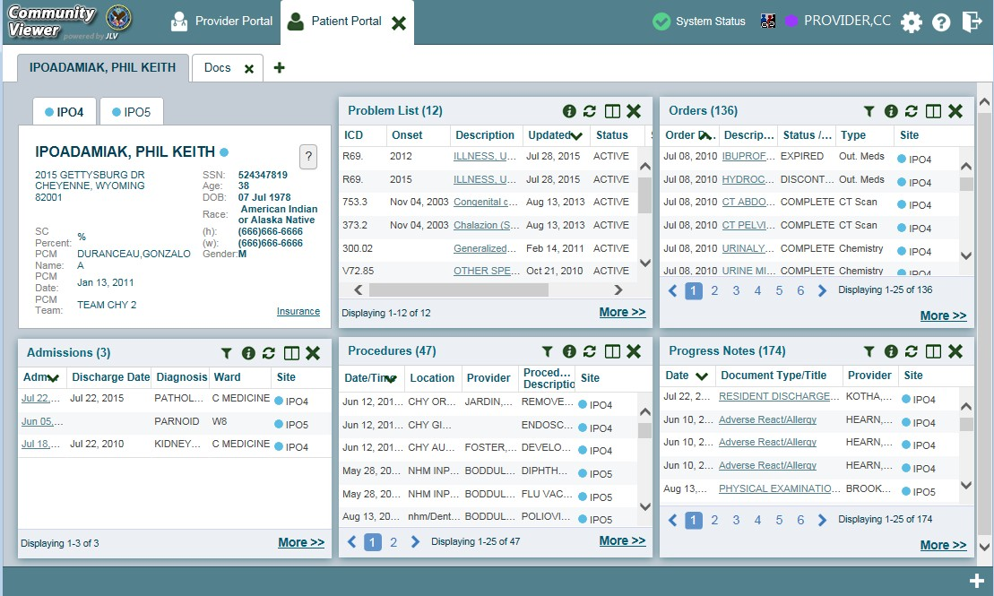
Figure 25: Widget Display on the Patient Portal

The list of available widgets on the Patient Portal is provided in a horizontal tray at the bottom of the page (Figure 26). To open the widget tray, click the + in the lower-right corner of the portal page. When accessing the Patient Portal for the first time, a preset widget display opens.
The Patient Portal displays the patient's clinical records and other patient-centric information from VA systems for the following clinical domains:

• | Patient Demographics | • | Lab Panel Results
• | Admissions | • | Lab Results
• | Allergies | • | Outpatient Medications
• | Appointments | • | Orders
• | Clinical Reminders | • | Problem List
• | Consults | • | Procedures
• | Discharge/Essentris Notes | • | Progress Notes
• | Encounters | • | Radiology Exams
• | Immunizations | • | Vitals
• | Inpatient Medications

NOTE: Widgets may take anywhere between three (3) and ten (10) seconds to load.

Accessing and Opening Widgets
To view a widget in the Patient Portal, locate the widget name in the horizontal tray displayed at the bottom of the portal (Figure 26). To open the widget tray, click the + in the lower-right corner of the portal page. Click and drag the selected widget from the tray to the portal screen. This action opens the widget in minimized view, and docks it on the portal.

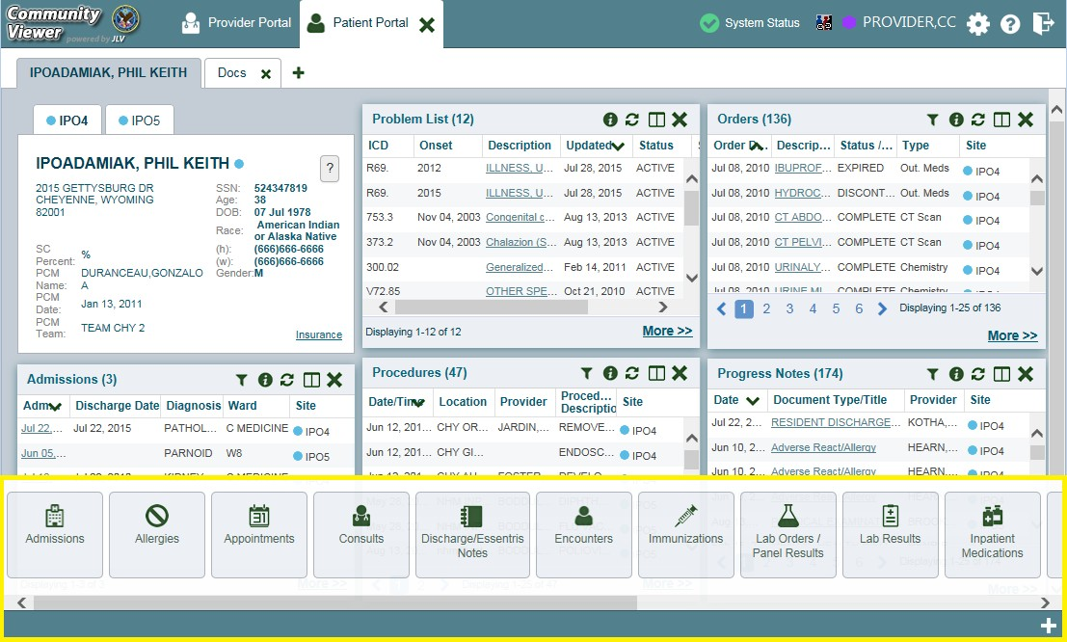
Figure 26: Widget Tray on the Patient Portal

The example in Figure 26 displays the Patient Portal with an open widget tray highlighted at the bottom of the screen. If the widget tray is not open, click the plus sign (+) in the lower right-hand corner of the portal screen. This button opens the tray on the portal.
To view all clinical domains available in the Patient Portal in the widget tray, use the arrows (< or >) placed below the tray buttons in the lower left-hand and right-hand corners of the portal screen to scroll left to right or right to left through the tray.

NOTE: Widgets can be removed from the portal page and placed back into the widget tray by clicking Close in the top-right corner.

Widget Navigation and Display Options
Navigation tools and display options are provided within each widget (Table 3).

Click More >> in the lower-right corner of a widget in minimized view to open the widget in expanded view, as seen in Figure 27.
A widget in expanded view contains the Show All link which opens all records for a given widget in a scrollable window. Click Show Paged to return to the display of records grouped by pages.

Table 3: Widget Navigation Tool Descriptions

Widget Element | Meaning | Description
 | Go to Previous Page | Changes the focus of the widget to the previous group or page of records within the results display.
 | Jump to Page | Changes the focus of the widget to the page number selected.
 | Go to Next Page | Changes the focus of the widget to the next group or page of records within the results display.
More >> | Go to Expanded View | Available in minimized views only. Opens the expanded view of the widget in a secondary window.
[variable] of # | Record Display Indicator | Indicates the number of records displayed in that widget page out of the total number of results for that widget.
Show All/Show Paged | Display Setting | Click Show All to open all records for a given widget in a scrollable window.  Click Show Paged to return to the display of records grouped by pages.

Minimized vs. Expanded Widget View
Each widget can be displayed in either minimized view or expanded view. The default rendering of a widget is in minimized view (Figure 25). Click the More >> link at the bottom of the widget in minimized view to open the expanded view (Figure 27).
The expanded view of a widget provides additional display and filtering options. Click Configure Filter from the widget toolbar if the additional display configuration options are not displayed in expanded view.

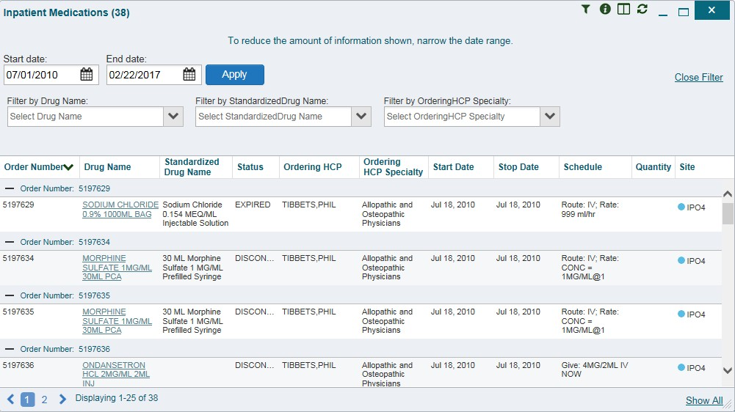Figure 27: Expanded View Widget Display

Displaying Widgets on Custom Tabs
For ease of use and quick reference, use the custom tabs function to create additional widget configurations on the portal pages. Changes made to the patient portal display (widget layouts and custom tabs) are saved to the user profile, and are displayed in future sessions.
To set up a customized tab:
- Click the tab with the plus sign + in the top-left corner of the screen (Figure 25).
- In the Add Tab dialog box, type in a name for the new tab and click OK.
- Within the new tab space, access the widget tray, and click and drag the desired widgets to the screen.
- Click between tabs at any time, without losing any of the configurations created in the tabs. Tabs persist when a patient change is made.

Refreshing Widget Data
Data in the widget display can be refreshed by clicking Refresh . This action refreshes the widget and displays the data within CV.

Examples of Widget Functionality
The Patient Portal displays the selected patient's clinical records and other patient-centric information. The Patient Demographics, Inpatient Medications, Lab Results, and Problem List widgets, detailed in the following subsections, provide examples of widget functionality.

NOTE: To see detailed information for any of the widgets available in CV, click
Help in the top-right corner of the portal pages.

Patient Demographics
A summary of the patient’s demographics (personal data) appears in the top-left section of the Patient Portal. The tabs above the patient’s name provide the patient’s demographics summary at each VA site that the patient has visited.
The patient’s name is displayed in color and followed by an icon. The blue circle represents data retrieved from a VA system. Click the patient's name to open a separate window that provides patient demographics details.

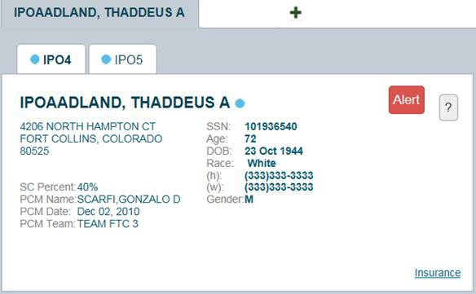
Figure 28: Patient Demographics Summary

Viewing Third-party Insurance Information
Third-party payers and additional insurance information are available from a link within the Demographics widget on the Patient Portal. Click the Insurance link in the Demographics widget to open a separate window with a detailed list of insurance information for the patient. Displayed insurance information includes:

        - Health Plan Type • Member ID
        - Health Plan Name • Subscriber ID
        - Standardized Insurance Type • Subscriber Date of Birth
        - Plan Effective Date • Subscriber’s Relationship to Insurer
        - Plan Expiration Date • Health Plan Mailing Address
        - Site • Health Plan Contact Information
        - Group Number

Use the horizontal scroll bar to view additional columns not seen within the default window size.

Data in the Standardized Insurance Type column is normalized to the X12 Health Insurance Type standard. Hover over entries in this column to display the standardized name and code for the insurance type.

Inpatient Medications
The Inpatient Medications widget displays the patient’s inpatient medication information. The medications are grouped by the order number where available.
To open the widget, click Inpatient Medications from the widget tray that appears at the bottom of the Patient Portal, drag the icon to the screen, and drop where desired on the portal.

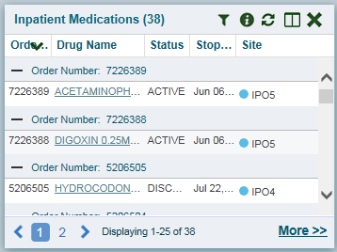
Figure 29: Inpatient Medications

Inpatient Medications Widget Data
In the minimized view of the Inpatient Medications widget, the inpatient medication information includes:
- Order Number1
- Drug Name
- Status
- Stop Date
- Site

1 When there are multiple drugs with the same order number, CV maintains the grouping by order number when a column sort is applied in the widget.

Click More >> from the minimized view of the Inpatient Medications widget to open an expanded view of the widget. In the expanded view, the inpatient medication information includes:
- Order Number
- Order Start Date
- Order Stop Date
- Drug Name
- Standardized Drug Name
- Status
- Ordering Health Care Provider (HCP)
- Ordering HCP Specialty
- Schedule
- Quantity
- Site

Viewing Inpatient Medication Details
Click the hyperlink in the Drug Name column of either view of the Inpatient Medications
widget to open a separate window containing the detail of the medication.

Inpatient Medication Display and Filter Options
Display and filter options within the Inpatient Medications widget include:
- Click the column title to sort records according to data in that column. If a user sorts on a column that appears in both minimized and expanded views of the widget, the sort is saved in the user profile and persists to the next user session. If a user sorts on a column that is only in the expanded view of the widget, the next user session restores the default widget sort, or the last sort saved to the user profile. When there are multiple drugs with the same order number, CV maintains the grouping by order number when a column sort is applied in the widget.
- Click Column Settings in the widget toolbar to hide or show the columns within the widget. Check/uncheck the column names that appear in the pop-up box and click Apply.
- Specify the date range for which records are displayed in the widget using the Quick Date Range Selector or the Start Date and End Date calendars. If the information you expect does not appear in the widget display, use the Start Date and End Date filter options to expand the date range. CCP users may have limited access to records, depending on the date range set when the consult was assigned by the VAS user.
- Use the Filter by Drug Name drop-down box to re-draw the widget to show only the records for the selected medication.
- Use the Filter by Standardized Drug Name drop-down box to re-draw the widget to show only the records for the selected medication.

- Use the Filter by Ordering HCP Specialty drop-down box to re-draw the widget to show only the records for the ordering HCP.

Lab Results
The Lab Results widget displays the patient’s lab result information, as well as skin test data and blood transfusion history where available in the patient’s record. The information is displayed in reverse chronological order by the last lab results date.
To open the widget, click Lab Results from the widget tray that appears at the bottom of the Patient Portal, drag the icon to the screen, and drop where desired on the portal.

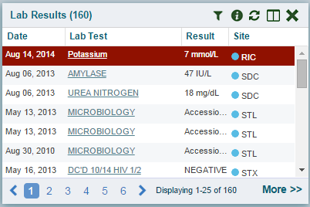
Figure 30: Lab Results

Lab Results Widget Data
In the minimized view of the Lab Results widget, the lab result information includes:
        - Collection Date
        - Lab Test
        - Result
        - Site
Click More >> from the minimized view of the Lab Results widget to open an expanded view of the widget. In the expanded view, the lab result information includes:
        - Collection Date
        - Order Number
        - Status
        - Ordering HCP
        - Ordering HCP Specialty
        - Lab Test

        - Standardized Lab Test
        - Type
        - Specimen Source
        - Result
        - Interpretation
        - Units
        - Ref Range
        - Site

Lab Results Display and Filter Options
Display and filter options within the Lab Results widget include:
        - Click the column title to sort records according to data in that column. If a user sorts on a column that appears in both minimized and expanded views of the widget, the sort is saved in the user profile and persists to the next user session. If a user sorts on a column that is only in the expanded view of the widget, the next user session restores the default widget sort, or the last sort saved to the user profile.
        - Click Column Settings in the widget toolbar to hide or show the columns within the widget. Check/uncheck the column names that appear in the pop-up box and click Apply.
        - Specify the date range for which records are displayed in the widget using the Quick Date Range Selector or the Start Date and End Date calendars. If the information you expect does not appear in the widget display, use the Start Date and End Date filter options to expand the date range. CCP users may have limited access to records, depending on the date range set when the consult was assigned by the VAS user.
        - Use the Filter by Lab Test drop-down box to re-draw the widget to show only the records for the selected test.
        - Use the Filter by Standardized Lab Test drop-down box to re-draw the widget to show only the records for the selected test.
        - Use the Filter by Type drop-down box to re-draw the widget to show only the records for the selected type.
        - Use Graph View to display multiple records of the same type in a graph. Refer to Section 4.6.3.6, Graph View in the Lab Results Widget for more information.
        - Use Table View to display multiple records of the same type in a tabular format. Refer to Section 4.6.3.5, Table View in the Lab Results Widget for more information.

Viewing Abnormal Results in the Lab Results Widget
For records in the Lab Results widget where result values fall within a calculated reference range for abnormal within the originating source system, CV highlights the row for that record in the minimized and expanded views of the widget.
Pink highlighting represents either H (high) or L (low) abnormal indicators. Red highlighting represents that the abnormal indicator has an asterisk (i.e., H* or L*) or the result is critical.

Viewing Lab Results Details
Clicking a hyperlinked entry in the Lab Test column of the Lab Results widget opens a separate window containing a report of the record.

Table View in the Lab Results Widget
The Lab Results widget provides the option to display multiple records of the same type in a table. By default, the Show Table link in the expanded view of the Lab Results widget is disabled until the user narrows the data selection using display filters.
To view lab results in Table View:
- Click Lab Results from the widget tray that appears at the bottom of the Patient Portal, drag the icon to the screen, and drop where desired on the portal.
- Click More >> from the minimized view of the Lab Results widget to open an expanded view of the widget.
- In the expanded view, select one entry from the Filter by drop down boxes (except for the Filter by Type filter option). This action enables the Show Graph and Show Table links.

NOTE: The Show Graph and Show Table links are not enabled after selecting one lab type from the Filter by Type drop down box.

- Click Show Table.
- A separate window opens, displaying a table containing the records of the type selected in the filter.

Graph View in the Lab Results Widget
The Lab Results widget provides the option to display multiple records of the same type in a graph. By default, the Show Graph link in the expanded view of the Lab Results widget is disabled until the user narrows the data selection using display filters.
To view lab results in Graph View:
- Click Lab Results from the widget tray that appears at the bottom of the Patient Portal, drag the icon to the screen, and drop where desired on the portal.
- Click More >> from the minimized view of the Lab Results widget to open an expanded view of the widget.
- In the expanded view, select an available filter from the Filter by drop down boxes (except for the Filter by Type filter option). This action enables the Show Graph and Show Table links.

NOTE: The Show Graph and Show Table links are not enabled after selecting one lab type from the Filter by Type drop down box.

- Click Show Graph.

- A separate window opens, displaying a graph of the multiple records of the type selected in the filter.

Problem List
The Problem List widget displays the patient’s problem list information. The information is displayed in reverse chronological order by the last modified date.
To open the widget, click Problem List from the widget tray that appears at the bottom of the Patient Portal, drag the icon to the screen, and drop where desired on the portal.

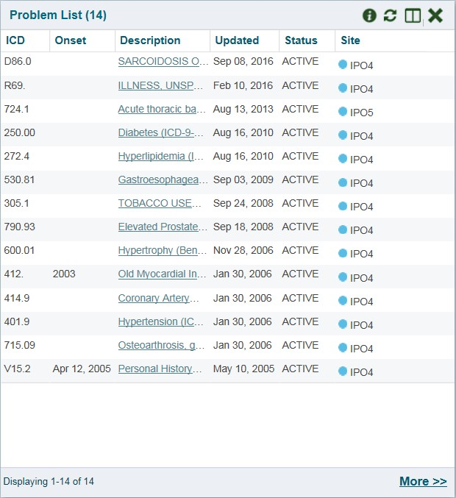
Figure 31: Problem List Widget

Problem List Widget Data
In the minimized view of the Problem List widget, the problem list information includes:
        - International Classification of Diseases (ICD)
        - Onset
        - Description
        - Updated
        - Status
        - Site

Click a hyperlinked entry in the Description column in either the minimized or expanded views of the widget to open a separate window containing the detailed report of the record. Refer to Section 4.6.4.2, Viewing Problem List Details for more information.
Click More >> from the minimized view of the Problem List widget to open an expanded view of the widget. In the expanded view, the problem list information includes:
        - ICD
        - Onset
        - Description
        - Standardized Description
        - Updated
        - Severity
        - Status
        - Site
Click a hyperlinked entry in the Description column in either the minimized or expanded views of the widget to open a separate window containing the detailed report of the record. Refer to Section 4.6.4.2, Viewing Problem List Details for more information.

Viewing Problem List Details
Click a hyperlinked entry in the Description column in either the minimized or expanded views of the Problem List widget to open a separate window containing the detailed report of the record.

Problem List Display and Filter Options
Display and filter options within the Problem List widget include:
        - Click the column title to sort records according to data in that column. If a user sorts on a column that appears in both minimized and expanded views of the widget, the sort is saved in the user profile and persists to the next user session. If a user sorts on a column that is only in the expanded view of the widget, the next user session restores the default widget sort, or the last sort saved to the user profile.
        - Use the Filter by Description drop-down box to re-draw the widget to show only the records for the selected problem.
        - Use the Filter by Standardized Description drop-down box to re-draw the widget to show only the records for the selected problem.
        - Use the Filter by Status drop-down box to re-draw the widget to show only the records with the selected status.

Troubleshooting

Special Instructions for Error Correction
NOTE: The following information applies only to VAS users.
Access to CV is limited to registered, authorized users. CV validates user access against information retrieved from that user’s smart card. If you are experiencing trouble logging in to CV, please review Table 4 before contacting the service desk.

Table 4: Login Page Error Message Troubleshooting

Error Message | Resolution Steps
Access denied. You are not an authorized user. | WHAT? Error message indicating Access Denied. You are not an authorized User.  WHY? PIV card processing problem or invalid security certificate chosen.  FIX IT:  - Close browser window.  - Re-insert PIV card and re-launch the CV link.  - Select a certificate that is not expired and specifies Issued by: Veterans Affairs CA B1.  If this is unsuccessful, fully reboot your system. This refreshes all connections and resolves greater than 95% of any remaining problems.
Could not save User Profile | WHAT? Error message indicating Could not save User Profile.  WHY? Error occurred during PIV authentication for VA users - typically a PIV card processing problem or an invalid security certificate chosen.  FIX IT:  - Close your browser window.  - Re-insert PIV card and re-launch the CV link.  - Select a certificate that is not expired and specifies Issued by: Veterans Affairs CA B1.  If this is unsuccessful, fully reboot your system. This refreshes all connections and resolves greater than 95% of any remaining problems.
Not a valid ACCESS/VERIFY  CODE pair | WHAT? Not a valid ACCESS CODE/VERIFY CODE pair” error at login screen.  WHY? 1) CV could not match your access and verify codes to the Site selected in the drop down or VA, or 2) Username and password were entered instead of access/verify codes.  FIX IT:  - VHA users must select the parent VistA host site for their facility (e.g., Wichita uses Kansas City, Missouri [MO]).  - Re-enter correct Access and Verify codes (Computerized Patient Record System (CPRS) or VistA codes for VHA users).

Error Message | Resolution Steps
Page cannot be displayed | WHAT? You receive a Page cannot be displayed error when launching CV.  WHY? The CV URL requires certain internet explorer settings  FIX IT:  - With Internet Explorer open, click the Tools menu or press ALT-X.  - Select Internet Options.  - When the dialog opens, select the Advanced tab.  - Scroll down in the list until you see the settings below and assure Secure Socket Layer (SSL) 2.0 is NOT checked and that Transport Layer Security (TLS) 1.0, 1.1 and 1.2 are checked.  - Click OK, then re-launch CV and the page should load.
Smart Card required | WHAT? Error Message Smart Card Required.  WHY? Smart card not read by Windows Security and CV before launching CV link.  FIX IT:  - Close all browser sessions/browser-based applications.  - Re-insert PIV card and re-launch CV link.  - If this is unsuccessful, fully reboot your system to refreshes all connections. This resolves greater than 95% of any remaining problems.
VERIFY CODE must  be changed before continued use | WHAT? Receive VERIFY CODE must be changed before continued use error at login screen.  WHY? CPRS VERIFY CODE has expired.  FIX IT:  - Open CPRS.  - Select the Change Verify Code checkbox on the sign-on dialog before clicking OK.  - You are prompted to create a new Verify Code.  - Once your Verify Code is changed for CPRS, CV recognizes the new code immediately.

Patient Search Errors
The following error messages may appear when a VAS user is searching for a patient in the CCPM module. If you are experiencing errors while searching for patients, please review Table 5 before contacting the service desk.

Table 5: Patient Search Error Messages and Resolution Steps

Error Message | Resolution Steps
An invalid search criteria was entered. Please enter at least 2 | Invalid patient name entered. Please try your search again.  When searching by patient name, enter at least two characters of the patient’s first and last name. Search results will display the closest match to the

Error Message | Resolution Steps
characters. | characters entered in the format of [last name], [first name].
An invalid Social Security Number (SSN) format was entered. Please enter a 9-digit SSN. | Invalid SSN entered. Please try your search again.  When searching by patient SSN, you are required to enter the patient’s full 9- digit SSN. Dashes are allowed (e.g., 123-45-6789).
An invalid last 5 format | Invalid patient name or SSN entered. Please try your search again.
was entered. Please | Patient search allows you to search for a patient using the first initial of the
enter the first letter of
 | patient’s last name and the last 4 digits of the patient’s SSN. Please try your
the last name followed
 | search again using the first initial of the patient’s last name and the last 4 digits
by the last 4-digits of
 | of the patient’s SSN.
the SSN.
An error occurred | This error may display when invalid patient identifiers were entered or an error
during your search. | occurred at the service layer or with an external system. Please try your search
Please try your search | again.
again.

Acronyms and Abbreviations
Table 6 lists the acronyms and abbreviations used throughout this document, and their descriptions.

Table 6: Acronyms and Abbreviations

Acronym | Description
CCOW | Clinical Context Object Workgroup
CCP | Community Care Provider
CCPM | Community Care Provider Management
CPRS | Computerized Patient Record System
CV | Community Viewer
ESD | Enterprise Service Desk
GUI | Graphical User Interface
HCP | Health Care Provider
HIPAA | Health Insurance Portability and Accountability Act
ICD | International Classification of Diseases
ID | Identification
IE | Internet Explorer
JLV | Joint Legacy Viewer
MVI | Master Veteran Index
OI&T | Office of Information and Technology
PIN | Personal Identification Number
PIV | Personal Identification Verification
SSL | Secure Socket Layer
SSN | Social Security Number
TLS | Transport Layer Security
UI | User Interface
URL | Uniform Resource Locator
VA | Department of Veterans Affairs
VAS | VA Administrative Staff
VHA | Veterans Health Administration
VistA | Veterans Health Information Systems and Technology Architecture
VLER | Virtual Lifetime Electronic Record

