Community Viewer Version 2.5 User Guide for Community Care Providers

August 2017

Department of Veterans Affairs (VA) Office of Information and Technology (OI&T)

Table of Contents

- Introduction 1
  - Purpose of the Guide 2
    - Guide Conventions 2
    - Terminology 2
  - assumptions…………………………………………………………………………………….2.
  - System Requirements 2
  - Getting Help 3
- Logging in to CV 4
  - Changing Your Password 7
  - Editing Your User Profile at Login 7
  - The CV Portal Pages 7
    - Default View 8
    - Viewing System Status 8
    - Profile Settings 9
    - Using the Accessible Theme’s Functionality 12
      - Keyboard Focus and Screen Navigation in Accessible Theme 12
  - Logging Out of the Current CV Session 13
- Using CV 14
  - Access to Patient Data 14
- Widgets 16
  - Accessing and Opening Widgets 17
  - Widget Navigation and Display Options 17
  - Minimized vs. Expanded Widget View 18
  - Displaying Widgets on Custom Tabs 19
  - Refreshing Widget Data 19
  - Printing 20
  - Examples of Widget Functionality 21
    - Patient Demographics 21
      - Viewing Detailed Patient Demographic Information 21
      - Viewing Third-party Insurance Information 21
    - Inpatient Medications 22
      - Inpatient Medications Widget Data 22
      - Viewing Inpatient Medication Details 23
      - Inpatient Medication Display and Filter Options 23
    - Lab Results 24
      - Lab Results Widget Data 24
      - Lab Results Display and Filter Options 25
      - Viewing Abnormal Results in the Lab Results Widget 25
      - Viewing Lab Results Details 26
      - Table View 26
      - Graph View 26
    - Problem List 27
      - Problem List Widget Data 27
      - Viewing Problem List Details 28
      - Problem List Display and Filter Options 28

Table of Figures
Figure 1: Authorized Use Message 5
Figure 2: CCP User Login Page 5
Figure 3: CCP VA Privacy and Security Awareness Training Page 6
Figure 4: CV Portal Tools 8
Figure 5: Default View 8
Figure 6: System Status Indicator on the Portal Pages 9
Figure 7: The CV Settings Dialog 10
Figure 8: Blue Theme 10
Figure 9: Gray Theme 11
Figure 10: Green Theme 11
Figure 11: Accessible (508 Compliant) Theme 12
Figure 12: Assigned Patients Widget 15
Figure 13: Widget Display on the Patient Portal 16
Figure 14: Widget Tray on the Patient Portal 17
Figure 15: Expanded View Widget Display 19
Figure 16: Widget Toolbar 20
Figure 17: Windows Print Dialog 20
Figure 18: Patient Demographics Summary 21
Figure 19: Inpatient Medications 22
Figure 20: Lab Results 24
Figure 21: Problem List Widget 27

Table of Tables
Table 1: Keyboard Accessible Keystrokes 13
Table 2: Widget Navigation Tool Descriptions 18

Introduction
Community Viewer (CV) is a browser-based software application that facilitates the secure exchange of data between Department of Veterans Affairs (VA) systems and authorized non-VA providers, known as Community Care Providers. The exchange of data improves the coordination of care and continuity of care for VA patients receiving treatment outside of the VA network.
CV pulls information from VA health care systems in real time for viewing within a web browser. Through CV, VA Administrative Staff assign patients to providers and provision their use within the CV system, allowing providers access to view consolidated patient data from multiple Veterans Information Systems and Technology Architecture systems.
This User Guide is written for Community Care Providers, to give instruction on the general functionality of the application. Community Care Providers will use CV to perform the following tasks:

  - Request Password Reset
  - Access/View Patient Data
Please read, and bear in mind, the following warning before using Community Viewer:
**WARNING**WARNING**WARNING**

“This U.S. Government computer system is for official use only.
The files on this system include Federal records that contain sensitive information.

All activities on this system may be monitored to detect unauthorized access to, or misuse of, the system or individual files and utilities on the system,
including personal use.

Further use of this system constitutes your consent to such monitoring.

Misuse of, or unauthorized access to, this system may result in criminal prosecution and disciplinary, adverse, or other appropriate action.”

**WARNING**WARNING**WARNING**

Purpose of the Guide
The purpose of this guide is to familiarize users with the important features and navigational elements of the CV application.

Guide Conventions
This document is designed for both online and hardcopy consumption. The following conventions are used throughout:
  - Cross References are indicated by blue, underlined text, and provide a hyperlink to figures, tables, and other sections within this guide
  - The conventions used in this document for emphasis are bold and italicized text
  - The information symbol is used to inform the reader of additional information

Terminology
The following standard terms are used throughout this guide:
  - Patient Portal: The page that displays patient data via widgets
  - Provider Portal: The landing page, or default view, of CV that opens after logging into the application. The portal page displays widgets and the tools that enable quick access to basic features.
  - Widget: A component of the CV interface that enables a user to perform a function or access a service.
  - Widget Tray: An expandable and collapsible tray at the bottom of both portal pages that provides access to the widgets that are available for placement on each portal page.

Assumptions
This User Guide is written from the perspective of Community Care Providers, assuming the following:
  - You can open, navigate, and use the menu options of a web browser
  - You can use web-based applications, their menu options, and navigation tools
  - You have received the required access credentials and the Uniform Resource Locator (URL) for the CV log in page
  - You will use CV to view VA patient data, relevant to patient assignments

System Requirements
CV is a front-end web application, designed to run in a web browser. Accessing CV through a browser or device that is not fully compatible with the application may result in certain features not working as expected.

NOTE: This release does not support mobile devices

It is recommended that CV is accessed from a desktop or laptop PC using a supported browser, such as:
  - Chrome v54
  - Firefox v50
  - Edge v25
  - Internet Explorer v11
  - Safari v10

Getting Help
If you are an authorized user in need of technical assistance, contact the Community Provider Technical Service Desk.
Prior to contacting support, please refer to Section 2, Logging in to CV, for detailed information about how to access CV.

Community Provider Technical Service Desk
REDACTED

If you are an authorized user and do not have your password, follow the steps outlined in Section 2.1, Changing Your Password to request a password reset.

Logging in to CV
Before logging in to and utilizing the functionality of Community Viewer, please read the following:
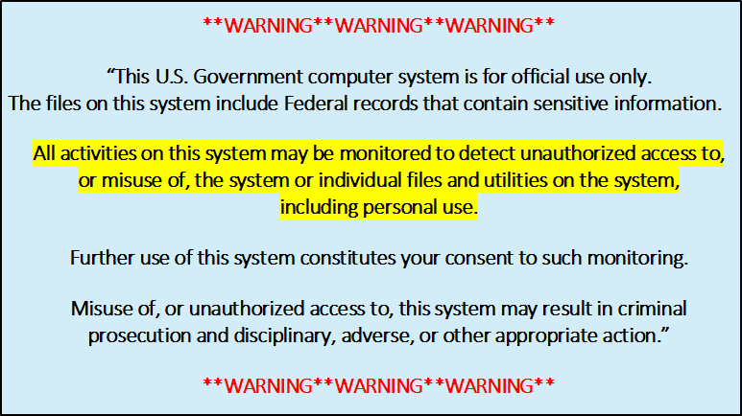

During login, CV authenticates all providers against a registered list, provisioned by VA Administrative Staff. If you have not received credentials to access CV, you must first request access through the Community Provider Technical Service Desk.
To log in to CV:

- Open a supported Internet browser
- Enter the web address for CV, provided by VA Administrative Staff, in the address bar of an approved Internet browser
- The Authorized Use message (Figure 1), a security and legal disclaimer, appears
- Click OK to confirm that you are aware you are accessing a government information system that is provided for authorized users only

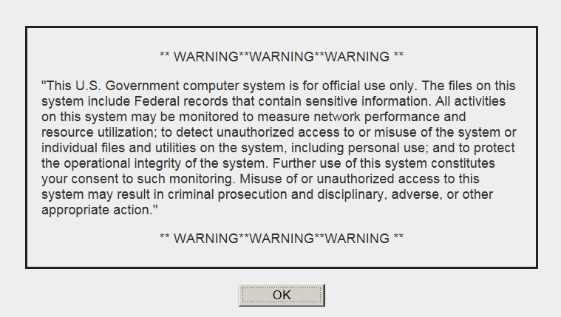Figure 1: Authorized Use Message

- Enter your user name and password, provided by VA Administrative Staff, in the fields on the Login page (Figure 2):
  - Your user name is the e-mail address associated with your account
  - If you do not have, or have forgotten, your password, click the Forgot Password?
link

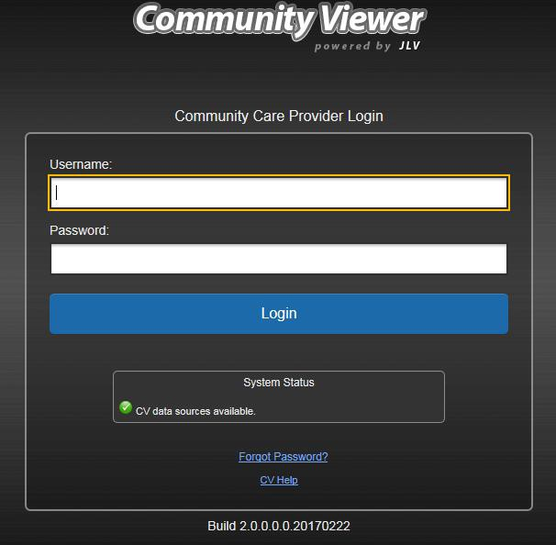
Figure 2: CCP User Login Page

- Click Login

- If you are logging in to the CV application for the first time, (or 365 days after your first log in), the VA Privacy and Security Awareness Training page (Figure 3) appears

NOTE: Users are required to perform all acknowledgement tasks before access to CV is granted.

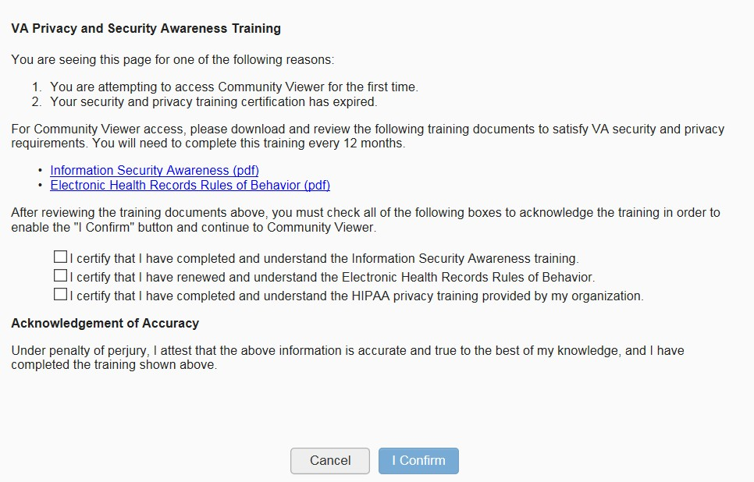Figure 3: CCP VA Privacy and Security Awareness Training Page

NOTE: The VA Privacy and Security Awareness Training page appears the first time you access the CV application, and again every 365 days after the first successful log in, as training certification must be renewed each year.

ALL of the acknowledgment tasks (Steps 8 – 13) must be completed to gain access to CV

- Download and read the Information Security Awareness Training PDF document
- Download and read the Electronic Health Records Rules and Behavior PDF document
- Click the checkbox to certify that you have completed and understand the Information Security Awareness training
- Click the checkbox to certify that you have read and understand the Electronic Health Records Rules and Behavior
- Click the checkbox to certify that you have completed and understand the HIPAA Privacy training through your organization
- Click I Confirm to proceed to the application

After logging in to CV:
  - Your user name is displayed in the top-right corner of the page
  - Any patients assigned to you are shown in the Assigned Patients widget
  - You will be able to view patients assigned to your Provider Group, even if you do not have any active or scheduled patient assignments

Changing Your Password
Your user ID (user name) is the e-mail address associated with your account. It cannot be changed unless your e-mail address changes. Users have the option to request a password reset.
To request a password reset:
- Enter the web address for CV, provided by VA Administrative Staff, in the address bar of an approved Internet browser
- Click the Forgot Password? link
- Enter your name, e-mail address, and phone number in the fields provided in the dialog box
- Click Send
- An e-mail message is generated to Community_Provider_Technical_Service_Desk@va.gov requesting that an associate contact you, at the phone number you provide, with a new password

Editing Your User Profile at Login
Users can customize the User Interface (UI) theme from the login page. UI theme preferences can also be set after logging in to CV. See Section 2.3.3, Profile Settings.
To edit the user profile at login:
- Click the Edit Profile link on the login page. UI theme options are presented
- Select the desired UI theme
- Click Save and Login

The CV Portal Pages
The CV portal pages have tools that enable quick access to basic features. These tools appear in the top-right corner of the application window (detailed in Figure 4).
  - Select the UI theme: Click the cog wheel to configure the UI theme. See Section 2.3.3, Profile Settings.
  - Access online help: Click Help to open web-based, online help.
  - Log out: Click Logout to terminate the current CV session

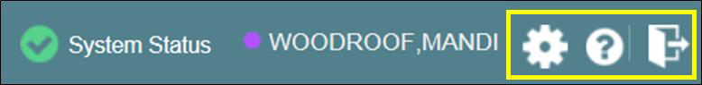
Figure 4: CV Portal Tools

Default View
The default view of CV includes the Assigned Patients widget (Figure 5).

NOTE: If the Assigned Patients widget is not open, click the plus (+) sign in the lower-right corner of the screen (Figure 5) to open the Widget Tray. Click, hold, and drag the widget icon from the tray to the screen, and drop in the desired location.

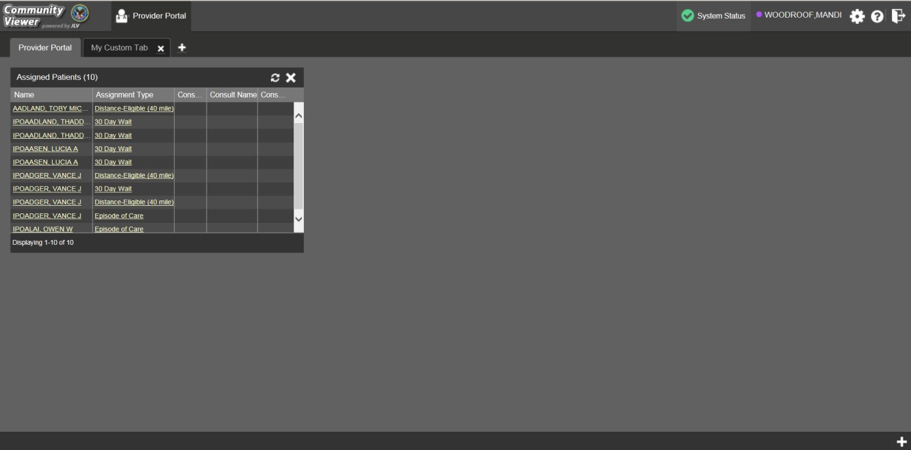
Figure 5: Default View

Viewing System Status
System status updates are received from CV’s Health Monitor, which monitors the services that CV uses to connect to VA data sources.
There are two areas of CV where system status is displayed:
- On the login page
- On the portal pages (highlighted in Figure 6)
When all monitored systems and services are online and connected, a green icon appears next to the status, with the message CV data sources are available (Figure 6).

When one or more monitored systems or services are offline or unavailable, a yellow warning icon appears with the message CV is having problems.
When CV’s health monitor is unable to retrieve and report system status information, a red icon appears with the message, System status is unavailable. Users may not be able to log into CV
or view patient data until the connection is restored. See Section 1.4, Getting Help, for information on how to contact support.

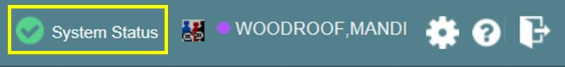
Figure 6: System Status Indicator on the Portal Pages

Profile Settings
Profile settings are accessible within CV by clicking the cog wheel located in the top-right corner of the portal pages (Figure 5).

NOTE: In this release, the configuration options are limited to choosing a UI theme.

Selecting a User Interface Theme sets the font color, foreground, and background colors of CV. Themes apply to all application elements, including widgets, toolbars, and dialog boxes. The UI theme color choices are Default, Green, Blue, Gray, and Accessible. The Accessible theme (Figure 11) is 508-compliant, and designed to work with the accessibility features installed on a user’s device.
To set the UI theme:
- Click the cog wheel in the top-right corner of the application
- The CV Settings dialog opens (Figure 7)
- Click the radio button next to the desired theme
- Click Save
- After clicking Save, you are asked whether or not to save the configuration. Click Yes to reload the application and apply the selected theme -OR-
- Click Cancel to exit the CV Settings dialog and restore the previous theme

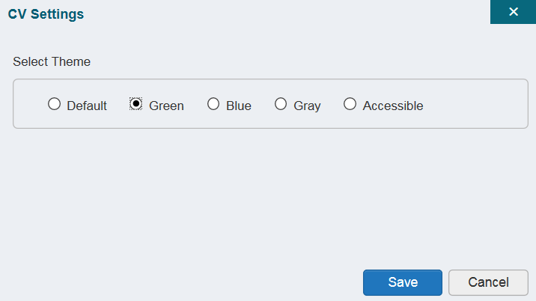Figure 7: The CV Settings Dialog

Examples of the UI themes are displayed in the figures below. The Default theme was presented in Section 2.3.1, Default View.

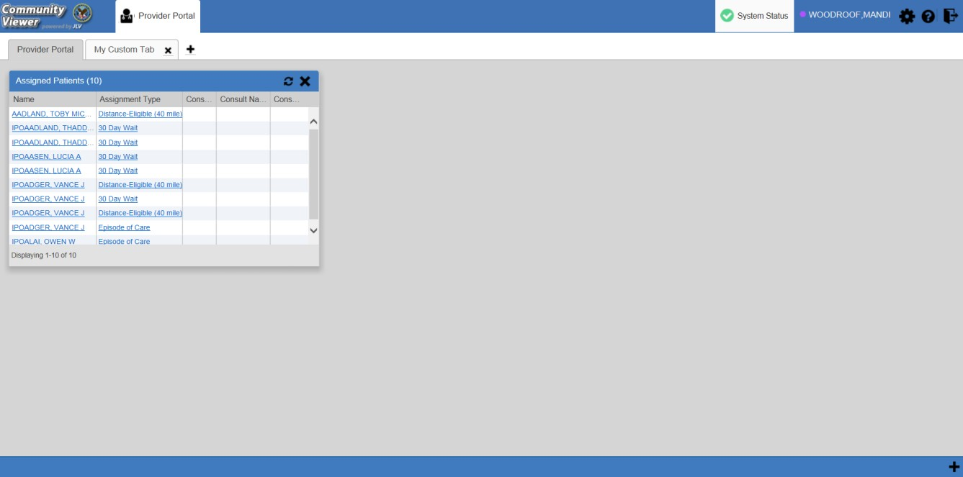Figure 8: Blue Theme

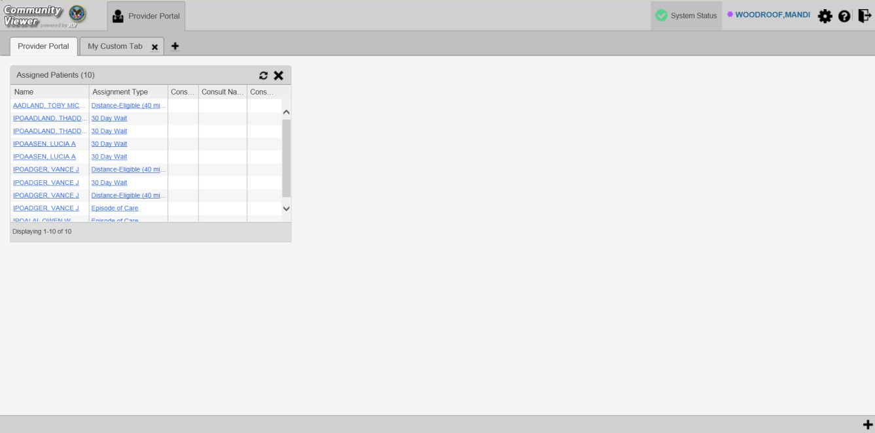Figure 9: Gray Theme

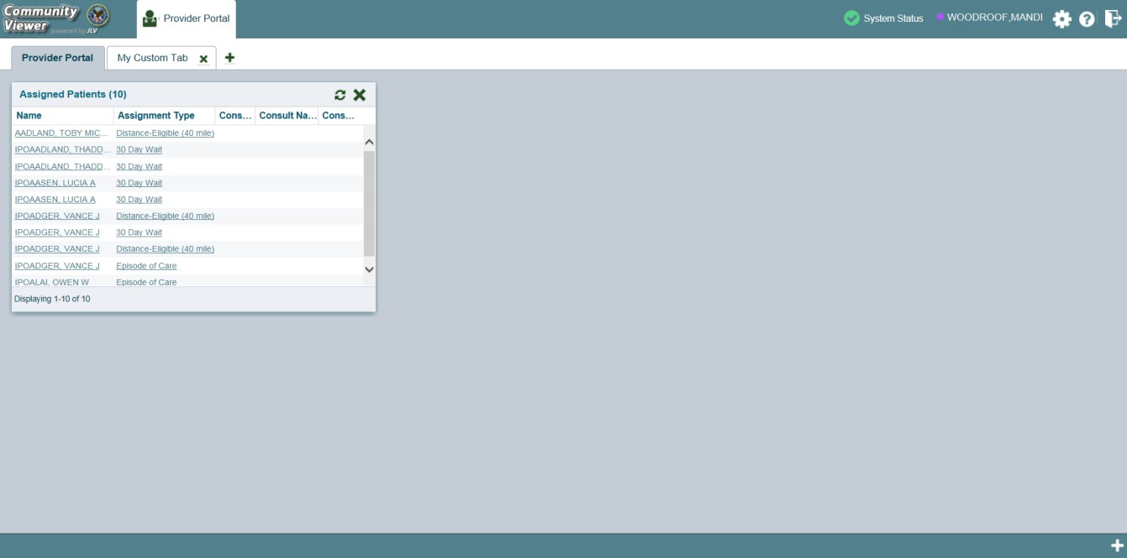Figure 10: Green Theme

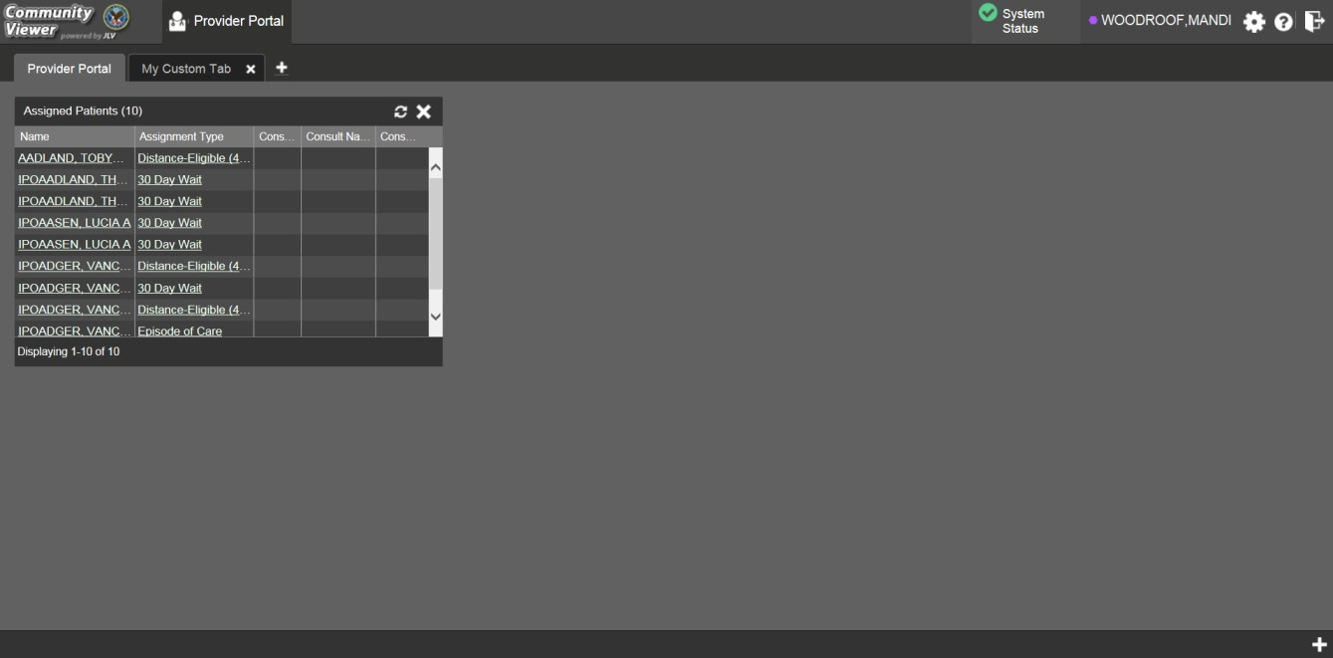Figure 11: Accessible (508 Compliant) Theme

Using the Accessible Theme’s Functionality
The Accessible theme includes larger fonts, enhanced tab and keystroke functionality, and screen reader compatibility to support Federal accessibility requirements and Section 508 compliance.

Keyboard Focus and Screen Navigation in Accessible Theme
Keyboard focus is the highlighting of screen elements that enables interaction with, and the navigation of, the web application through the keyboard and keystrokes. The on-screen item in focus is outlined. CV uses a gold outline as a visual indicator of the element with keyboard focus.
CV enables the use of standard Windows keystrokes (Tab, Shift + Tab, arrow keys, Enter), and keyboard shortcuts to move the focus to all menus, and activate all functions on the menus. All user interface items are accessible via the keyboard under the Accessible theme.
Pressing Enter or the Spacebar when an element that provides action is in keyboard focus performs the associated action. For example, pressing Enter or the Spacebar when the cog wheel icon is in focus opens the CV Settings dialog. Using the arrow keys or the Tab key allows a user to move between keyboard focus items to navigate through screen elements. A complete list of accessible keystrokes is provided in Table 1.

Table 1: Keyboard Accessible Keystrokes
Keystroke | Description
Application and Portal Navigation
ENTER | Press to transfer keyboard focus to the highlighted widget.
TAB | Press to transfer keyboard focus to other user interface items.
ESC | Press to return keyboard focus to the panel containing the user interface item with keyboard focus or to exit a window or widget.
SPACEBAR | Press to activate any user interface item (for example, click a button).
Arrow Keys | When keyboard focus is on a widget, press the arrow keys to change page viewing in a widget's data table.  When keyboard focus is on a dropdown list, press the down arrow to view the contents.
Tab Panels
Arrow Keys | Use the left and right arrow keys to change tab panels.  To add a tab panel, press the right arrow key until the last tab (+) is selected. A dialog prompts the user to enter the tab name.
Ctrl + x | To close a tab, focus on the tab panel and press Ctrl + x.
Windows and Dialog Boxes
TAB | Press the Tab key to move the keyboard focus to other user interface items within the window.
Adding Widgets to the Portal Pages
SHIFT +  (Number position) | To add a widget from the widget tray using keystrokes:  - Determine which column (1, 2, or 3) to place the widget on the portal page.  - Focus the desired widget in the widget tray and press the Shift key along with the 1, 2, or 3 key, depending on the desired column placement.

2.4. Logging Out of the Current CV Session
You may intentionally log out to end a CV session by clicking Logout at any time. If you fail to log out, your session will automatically terminate after five minutes of inactivity. You will be redirected to the Login page when any new activity is attempted.

Using CV

Access to Patient Data
Prior to accessing patient data in Community Viewer, please read the following:

After you log in to CV, the Assigned Patients widget appears, displaying a list of patient assignments. Click a patient’s name in the Assigned Patients widget (Figure 12) to open their records in the Patient Portal.

NOTE: If the Assigned Patients widget is not open, click the plus (+) sign in the lower-right corner of the portal to open the Widget Tray. Click, hold, and drag the widget from the tray to the screen, and drop in the desired location.

The Assigned Patients widget lists the active and scheduled assignments for all providers in the group to which the provider belongs. If there are two active assignments for one patient, the patient is listed twice.
The following information is available for each assignment listed in the widget:
- Patient Name: Click the entry to open the patient’s record in the Patient Portal
- Assignment: The type of assignment that initiated the patient referral:
  - 30 Day Wait
  - Consult
  - Distance Eligible
  - Episode of care
- Consult No.: A number generated by the VA system. Click the entry to open the patient’s record in the Patient Portal. This information is only shown for patients with a Consult assignment type

- Consult Name: A label generated by the VA system. Click the entry to open the patient’s record in the Patient Portal. This information is only shown for patients with a Consult assignment type
- Consult Provider: The VA provider who ordered the consult. This information is only shown for patients with a Consult assignment type

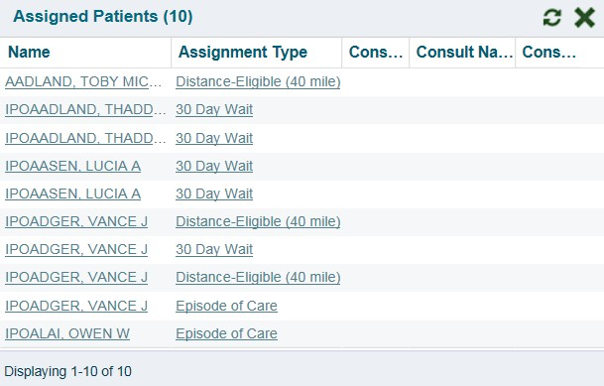Figure 12: Assigned Patients Widget

NOTE: Figure 12 depicts the default view of the Assigned Patients widget.
Because the widget is width-constrained, some of the column headings will appear in an abbreviated manner.

Widgets
Patient-centric information is displayed on the Patient Portal through widgets (Figure 13). Widgets are elements of CV that display data specific to an administrative or clinical domain. Widget data is generally displayed in reverse chronological order, by date.

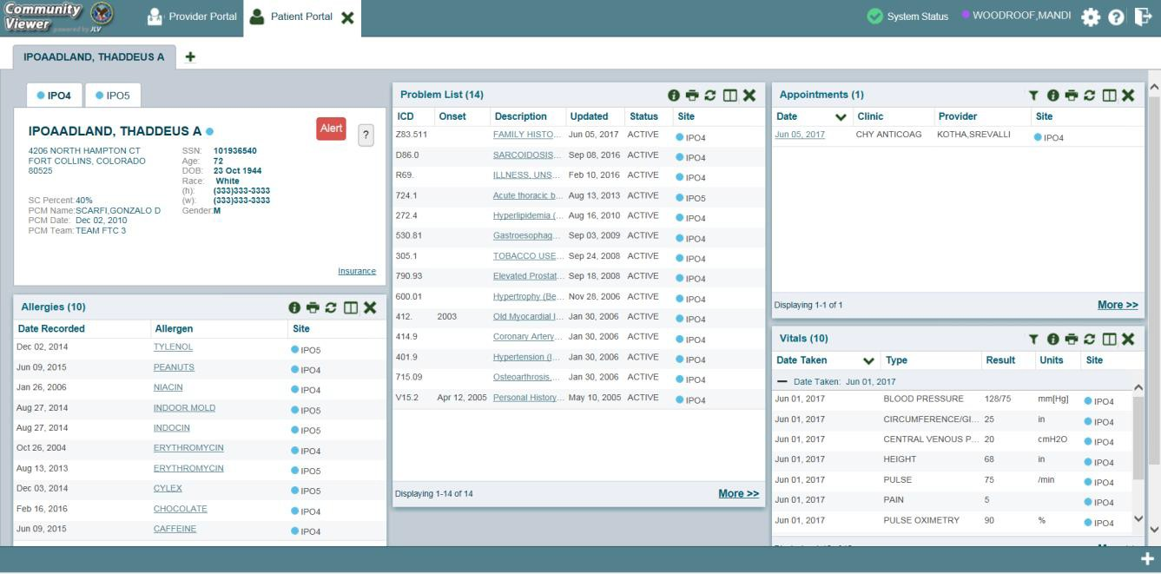Figure 13: Widget Display on the Patient Portal

The list of available widgets on the Patient Portal is presented in a horizontal tray at the bottom of the page (highlighted in Figure 14). When accessing the Patient Portal for the first time, a preset widget configuration is displayed.
The Patient Portal displays a patient's clinical records and other patient-centric information from VA systems for the following VA clinical domains:

- Patient Demographics  - Admissions  - Allergies  - Appointments  - Clinical Reminders  - Consults  - Discharge/Essentris Notes  - Encounters  - Immunizations  - Inpatient Medications | - Lab Panel Results  - Lab Results  - Outpatient Medications  - Orders  - Problem List  - Procedures  - Progress Notes  - Radiology Exams  - Vitals

NOTE: Widgets may take anywhere between three (3) and ten (10) seconds to load.

Accessing and Opening Widgets
Figure 14 depicts the Patient Portal with an open Widget Tray, highlighted at the bottom of the screen. To open the Widget Tray, click the plus sign (+) in the lower right-hand corner. Click, hold, and drag a widget from the tray to the portal. This action opens the widget in minimized view, and docks it on the portal.
To view all available clinical domains in the widget tray, use the arrows (< or >) placed below the tray icons in the lower left- and right-hand corners of the screen. Clicking the arrows will scroll left to right, or right to left through the tray.

NOTE: Widgets can be removed from a portal page and placed back into the widget tray by clicking Close in the top-right corner of the docked widget.

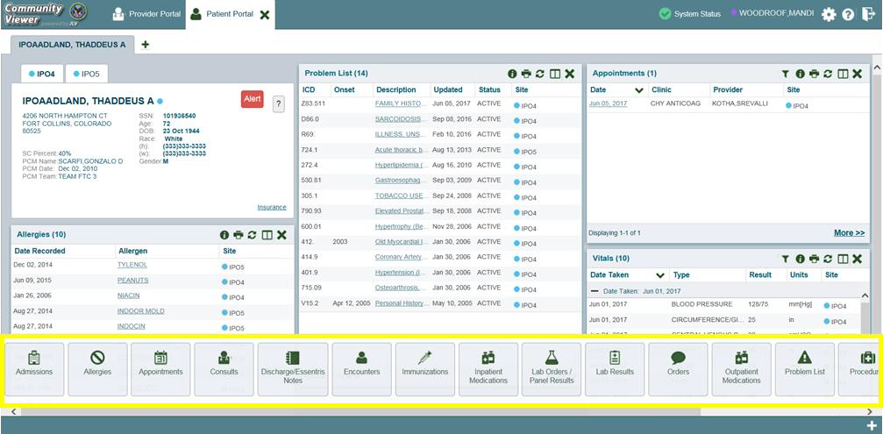Figure 14: Widget Tray on the Patient Portal

Widget Navigation and Display Options
Navigation tools and display options are provided within each widget (listed in Table 2).
Click More >> in the lower-right corner of a widget in minimized view to open the widget in expanded view, as seen in Figure 15.
A widget in expanded view contains the Show All link which opens all records for a given widget in a scrollable window. Click the Show Paged link to return a display of records grouped by pages.

Table 2: Widget Navigation Tool Descriptions
Widget Element | Meaning | Description
 | Go to Previous Page | Changes the focus of the widget to the previous group or page of records within the results display.
 | Jump to Page | Changes the focus of the widget to the page number selected.
 | Go to Next Page | Changes the focus of the widget to the next group or page of records within the results display.
More >> | Go to Expanded View | Available in minimized views only. Opens the expanded view of the widget in a secondary window.
[variable] of # | Record Display Indicator | Indicates the number of records displayed in that widget page out of the total number of results for that widget.
Show All/Show Paged | Display Setting | Click Show All to open all records for a given widget in a scrollable window.  Click Show Paged to return to the display of records grouped by pages.

Minimized vs. Expanded Widget View
Each widget can be displayed in either a minimized or expanded view. The default rendering of a widget is in minimized view (Figure 13). Click the More >> link at the bottom of the widget in minimized view to open the expanded view (Figure 15).
The expanded view of a widget provides additional display and filtering options. Click Configure Filter from the widget toolbar if the additional display configuration options are not displayed in expanded view.

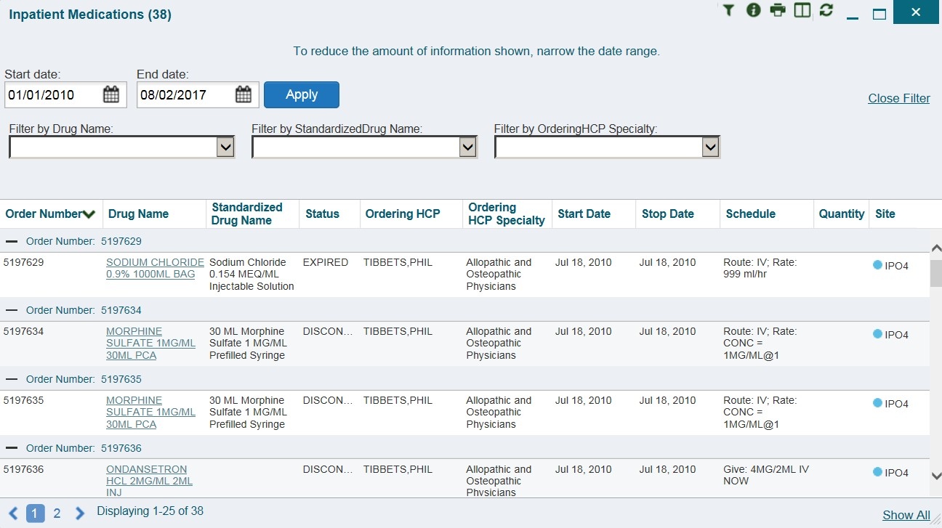Figure 15: Expanded View Widget Display

Displaying Widgets on Custom Tabs
You can use the custom tabs feature to create additional widget configurations for ease of use and quick reference. Changes made to the patient portal display (widget layouts and custom tabs) are saved to the user profile, and are displayed in future sessions.
To set up a customized tab:
- Click the plus sign + to the right of the patient’s name (Figure 13). The Add Tab dialog box opens
- Type a name for the new tab in the Add Tab dialog box, and click OK
- Open the Widget Tray within the new tab space, then click, hold, and drag each of the desired widgets to the screen
- Click between tabs at any time, without losing any of the configurations created in the tabs. Tabs persist, even when a patient change is made

Refreshing Widget Data
Data in the widget display can be refreshed by clicking Refresh . This action updates the data in the widget.

Printing
You can print the information within the CV widgets from either the minimized or expanded views.
If printing from the default (minimized) view of a widget, the information that is presented by default is captured for printing.
If you have filtered the information in the widget, the filtered information is captured for printing.

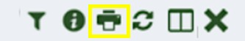Figure 16: Widget Toolbar

To print information from a widget:
- Click the Print icon (highlighted in Figure 16) at the top of either the minimized or expanded view of a widget
- A new window opens and displays either the default or filtered widget information
- The Windows Print dialog (Figure 17) opens and lists the available printers

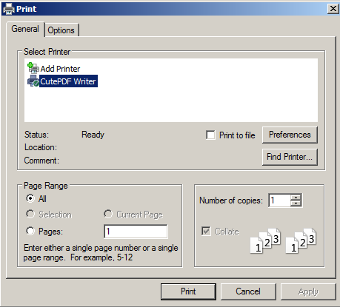
Figure 17: Windows Print Dialog

- Select the desired printer
- Click Print

Examples of Widget Functionality
The Patient Portal displays the selected patient's clinical records and other patient-centric information. The Patient Demographics, Inpatient Medications, Lab Results, and Problem List widgets, detailed in the following subsections, provide examples of widget functionality.

NOTE: To see detailed information for any of the widgets available in CV, click
Help in the top-right corner of the portal pages.

Patient Demographics
A summary of the patient’s demographics (personal data) appears in the top-left section of the Patient Portal. The tabs above the patient’s name provide the patient’s demographics summary at each VA site that the patient has visited.
The patient’s name is displayed in color and is followed by a blue circle. The blue circle represents that the data was retrieved from a VA system.

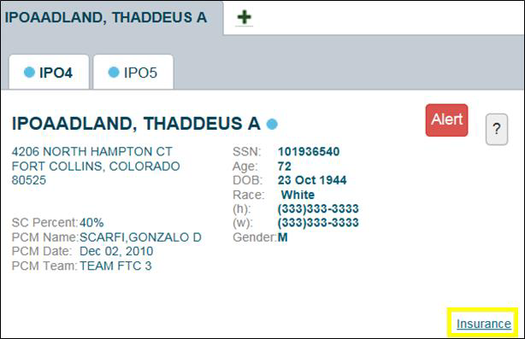
Figure 18: Patient Demographics Summary

Viewing Detailed Patient Demographic Information
Additional patient demographic information is available from the Demographics widget on the Patient Portal. Click the patient’s name to open a separate window that provides a detailed list of demographic information for that patient.

Viewing Third-party Insurance Information
Third-party payers and additional insurance information are available from a link within the Demographics widget on the Patient Portal (highlighted in Figure 18). Click the Insurance link in the Demographics widget. A separate window opens to display a detailed list of insurance information for the patient.
Use the horizontal scroll bar to view additional columns not seen within the default window size.

Data in the Standardized Insurance Type column is normalized to the X12 Health Insurance Type standard. Hover over entries in this column to display the standardized name and code for the insurance type.

Inpatient Medications
The Inpatient Medications widget displays inpatient medication information. The medications are grouped by the order number, where available.
To open the widget, click and hold Inpatient Medications in the widget tray, drag it to the desired location on the screen, and drop it.

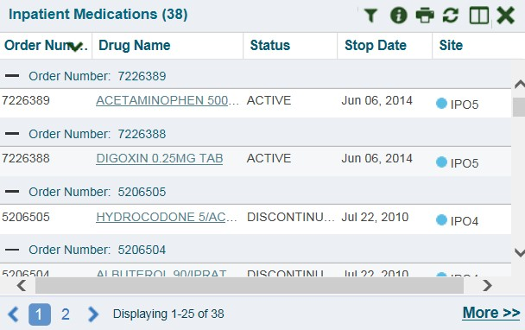Figure 19: Inpatient Medications

NOTE: In the minimized view, the sort arrow for the Order Number column overlaps the text.

Inpatient Medications Widget Data
The columns of information in the minimized view of the Inpatient Medications widget are:
- Order Number1
- Drug Name
- Status
- Stop Date
- Site

1 When there are multiple drugs with the same order number, CV maintains the grouping by order number when a column sort is applied in the widget.

Click More >> from the minimized view of the Inpatient Medications widget to open an expanded view of the widget. The columns of information in the expanded view are:
- Order Number
- Order Start Date
- Order Stop Date
- Drug Name
- Standardized Drug Name
- Status
- Ordering Health Care Provider (HCP)
- Ordering HCP Specialty
- Schedule
- Quantity
- Site

Viewing Inpatient Medication Details
Click the hyperlink in the Drug Name column of either view of the Inpatient Medications
widget to open a separate window that displays detailed information about the medication.

Inpatient Medication Display and Filter Options
Display and filter options within the Inpatient Medications widget include:
- Click the column title to sort records according to data in that column. If a user sorts on a column that appears in both the minimized and expanded views, the sort is saved in the user profile and persists to the next user session. If a user sorts on a column that appears only in the expanded view of the widget, the next user session restores the default widget sort, or the last sort saved to the user profile. When there are multiple drugs with the same order number, CV maintains the grouping by order number when a column sort is applied in the widget
- Click Column Settings in the widget toolbar to show or hide the columns within the widget. Check or uncheck the column names that appear in the pop-up box and click Apply
- Specify the date range for the records displayed in the widget using the Quick Date Range Selector or the Start Date and End Date calendars. If the information you expect does not appear in the widget display, use the Start Date and End Date filter options to expand the date range

NOTE: CCP users have limited access to records, and can only specify dates within the range set by the VA staff user who created the patient assignment.

- Use the Filter by Drug Name dropdown to re-draw the widget to show only the records for the selected medication

- Use the Filter by Standardized Drug Name dropdown to re-draw the widget to show only the records for the selected medication
- Use the Filter by Ordering HCP Specialty dropdown to re-draw the widget to show only the records for the ordering HCP

Lab Results
The Lab Results widget displays the patient’s lab result information, as well as skin test data and blood transfusion history, where available in the patient’s record. The information is displayed in reverse chronological order, by the date of the last lab results.
To open the widget, click and hold Lab Results in the widget tray, drag it to the desired location on the screen, and drop it.

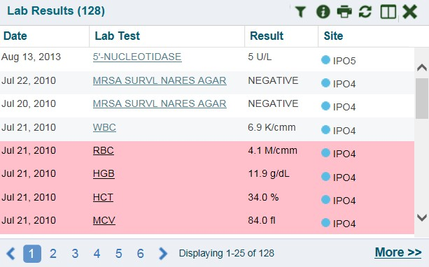Figure 20: Lab Results

Lab Results Widget Data
The columns of information in the minimized view of the Lab Results widget are:
        - Date
        - Lab Test
        - Result
        - Site
Click More >> from the minimized view of the Lab Results widget to open an expanded view of the widget. The columns of information in the expanded view of the Lab Results widget are:
        - Collection Date
        - Order Number
        - Status
        - Ordering HCP

        - Ordering HCP Specialty
        - Lab Test
        - Standardized Lab Test
        - Type
        - Specimen Source
        - Result
        - Interpretation
        - Units
        - Ref Range
        - Site

Lab Results Display and Filter Options
Display and filter options within the Lab Results widget include:
        - Click the column title to sort records according to data in that column. If a user sorts on a column that appears in both the minimized and expanded views, the sort is saved in the user profile and persists to the next user session. If a user sorts on a column that appears only in the expanded view of the widget, the next user session restores the default widget sort, or the last sort saved to the user profile
        - Click Column Settings in the widget toolbar to show or hide the columns within the widget. Check or uncheck the column names that appear in the pop-up box and click Apply
        - Specify the date range for the records displayed in the widget using the Quick Date Range Selector or the Start Date and End Date calendars. If the information you expect does not appear in the widget display, use the Start Date and End Date filter options to expand the date range
        - Use the Filter by Lab Test dropdown to re-draw the widget to show only the records for the selected test
        - Use the Filter by Standardized Lab Test dropdown to re-draw the widget to show only the records for the selected test
        - Use the Filter by Type dropdown to re-draw the widget to show only the records for the selected type
        - Use Graph View to display multiple records of the same type in graph format. See Section 4.7.3.6, Graph View for more information.
        - Use Table View to display multiple records of the same type in tabular format. See Section 4.7.3.5, Table View for more information.

Viewing Abnormal Results in the Lab Results Widget
CV highlights results whose values fall within a calculated reference range for abnormal in the minimized and expanded views of the widget.

Pink highlighting represents either H (high) or L (low) abnormal indicators. Red highlighting represents that the abnormal indicator has an asterisk (H* or L*), or the result is critical.

Viewing Lab Results Details
Clicking a hyperlinked entry in the Lab Test column opens a separate window that displays the detailed test report.

Table View
There is an option to display multiple records of the same type in a table. By default, the Show Table link in the expanded view of the Lab Results widget is disabled until the user narrows the data selection, using display filters.
To view lab results in Table View:
- Click More >> in the minimized view of the Lab Results widget to open expanded view
- Select one entry from the Filter by dropdown (except for the Filter by Type option). This action enables the Show Graph and Show Table links

NOTE: The Show Graph and Show Table links are not enabled after selecting one lab type from the Filter by Type drop down box.

- Click Show Table
- A separate window opens, displaying the records of the type selected in the filter in a table

Graph View
There is an option to display multiple records of the same type in a graph. By default, the Show Graph link in the expanded view of the Lab Results widget is disabled until the user narrows the data selection, using display filters.
To view lab results in Graph View:
- Click More >> in the minimized view of the Lab Results widget to open expanded view
- Select an available filter from the Filter by dropdown (except for the Filter by Type
option). This action enables the Show Graph and Show Table links

NOTE: The Show Graph and Show Table links are not enabled after selecting one lab type from the Filter by Type drop down box.

- Click Show Graph
- A separate window opens, displaying the records of the type selected in the filter in graph format

Problem List
The Problem List widget displays a list of the patient’s health issues. The information is displayed in reverse chronological order, by the last modified date.
To open the widget, click and hold Problems List in the widget tray, drag it to the desired location on the screen, and drop it.

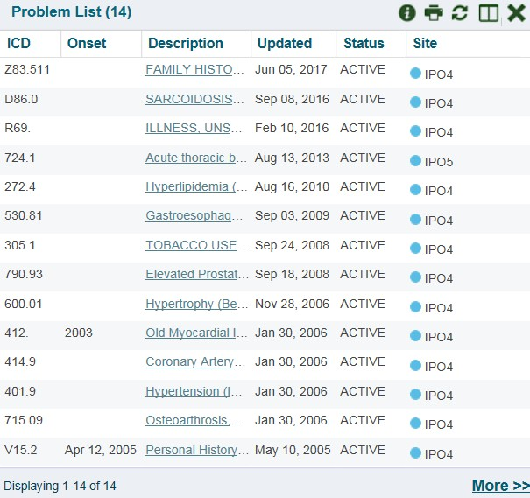Figure 21: Problem List Widget

Problem List Widget Data
The columns of information in the minimized view of the Problem List widget are:
        - International Classification of Diseases (ICD)
        - Onset
        - Description
        - Updated
        - Status
        - Site
Click More >> in the minimized view to open expanded view. The columns of information in the expanded view of the widget are:
        - ICD
        - Onset

        - Description
        - Standardized Description
        - Updated
        - Severity
        - Status
        - Site

Viewing Problem List Details
Clicking a hyperlinked entry in the Description column in either the minimized or expanded views of the widget opens a separate window that displays a detailed report of the record.

Problem List Display and Filter Options
Display and filter options within the Problem List widget include:
        - Click the column title to sort records according to data in that column. If a user sorts on a column that appears in both the minimized and expanded views, the sort is saved in the user profile and persists to the next user session. If a user sorts on a column that appears only in the expanded view of the widget, the next user session restores the default widget sort, or the last sort saved to the user profile
        - Click Column Settings in the widget toolbar to show or hide the columns within the widget. Check or uncheck the column names that appear in the pop-up box and click Apply
        - Use the Filter by Description dropdown to re-draw the widget to show only the records for the selected problem
        - Use the Filter by Standardized Description dropdown to re-draw the widget to show only the records for the selected problem
        - Use the Filter by Status dropdown to re-draw the widget to show only the records with the selected status
        - Specify the date range for the records displayed in the widget using the Quick Date Range Selector or the Start Date and End Date calendars. If the information you expect does not appear in the widget display, use the Start Date and End Date filter options to expand the date range

For more information about the general functionality of CV and to see a list of all of the other widgets available in the application, please open the Online Help index within CV. If you need technical assistance, please see Section 1.4, Getting Help.

