Community Viewer (CV) Version 2.6 User Guide for VA Staff

December 2017
Version 1.1

Department of Veterans Affairs (VA) Office of Information and Technology (OIT)

Revision History

Date | Version | Description | Author
12/22/2017 | 1.1 | All review comments addressed. Submitted for PM approval | AbleVets
10/30/2017 | 1.0 | Submitted for review | AbleVets
09/07/2017 | 0.1 | Initial draft of document | AbleVets

Table of Contents
- Introduction 1
  - Purpose of the Guide 3
    - Guide Conventions 3
    - Terminology 3
  - Assumptions 4
  - System Requirements 4
  - Getting Help 4
- Logging in to CV 5
  - Editing Your User Profile at Log in 6
  - The CV Portal Pages 7
    - Default View 7
    - Viewing System Status 8
    - Profile Settings 8
    - Using the Accessible Theme’s Functionality 11
      - Keyboard Focus and Screen Navigation in Accessible Theme 11
  - Logging Out of the Current CV Session 12
- Using CV 13
  - Working with the CCPM Widget 13
    - About Provider Groups and Facilities 14
    - Searching within the CCPM 14
    - Creating Provider Accounts 15
    - Assigning Patients 16
    - Setting Record Display Limits 20
  - Editing Provider Groups and Profiles 21
    - Editing Provider Groups 21
    - Editing Provider Profiles 22
    - Resetting Provider Passwords 23
- Widgets: What Community Providers See 25
- Troubleshooting 26
  - Special Instructions for Error Correction 26
    - Patient Search Errors 28
- Acronyms and Abbreviations 29

Table of Figures
Figure 1: User Workflow 2
Figure 2: Login Page 6
Figure 3: CV Portal Tools 7
Figure 4: Default View 7
Figure 5: System Status Indicator 8
Figure 6: The CV Settings Dialog 9
Figure 7: Blue UI Theme 9
Figure 8: Gray UI Theme 10
Figure 9: Green UI Theme 10
Figure 10: Accessible (508 Compliant) UI Theme 11
Figure 11: Default Portal Page (Green Theme) 13
Figure 12: The CCPM Widget 14
Figure 13: Search Providers and Create/Edit Provider Panes 15
Figure 14: Search Providers Pane 17
Figure 15: Create/Edit Provider Fields Detail 18
Figure 16: Patient Search Dialog Box 19
Figure 17: Data Access Controls 21
Figure 18: Search and Manage CCP Groups Panes 22
Figure 19: Search Providers and Create/Edit Provider Panes 23
Figure 20: CCP Password Reset 24
Figure 21: Widget Display on the Patient Portal 25

Table of Tables
Table 1: Keyboard Accessible Keystrokes 11
Table 2: Assignment Rules Examples 20
Table 3: Login Page Error Message Troubleshooting 26
Table 4: Patient Search Error Messages and Resolution Steps 28
Table 5: Acronyms and Abbreviations 29

Introduction
Community Viewer (CV) is a browser-based software application that facilitates the secure exchange of data between Department of Veterans Affairs (VA) systems and authorized non-VA providers, known as Community Care Providers (CCPs). The exchange of data improves the coordination of care and continuity of care for VA patients receiving treatment outside of the VA network.
CV pulls information from VA health care systems in real time for viewing within a web browser. Through CV, VA Staff assign patients to CCPs and provision CCP use within the CV system, allowing CCPs access to view consolidated patient data from multiple Veterans Information Systems and Technology Architecture (VistA) systems.
This User Guide is intended for VA Staff users who use the CCPM widget of CV to perform the following tasks:
  - Create Providers
  - Assign Patients
  - Manage Data Access Parameters

There are notations throughout this guide to indicate functionality that is available
only to CV Portal Administrators, VA Staff users with administrative privileges.

IMPORTANT:

CV is designed to improve the community providers’ ability to
view comprehensive VA health information for Veterans.

CV does NOT replace the creation and uploading of documentation packages to the Third Party Administrator (TPA) portals.
VA Administrative Staff must continue to create and upload documentation packages as specified in the current SOP.

Figure 1 provides a graphic representing typical user workflow.

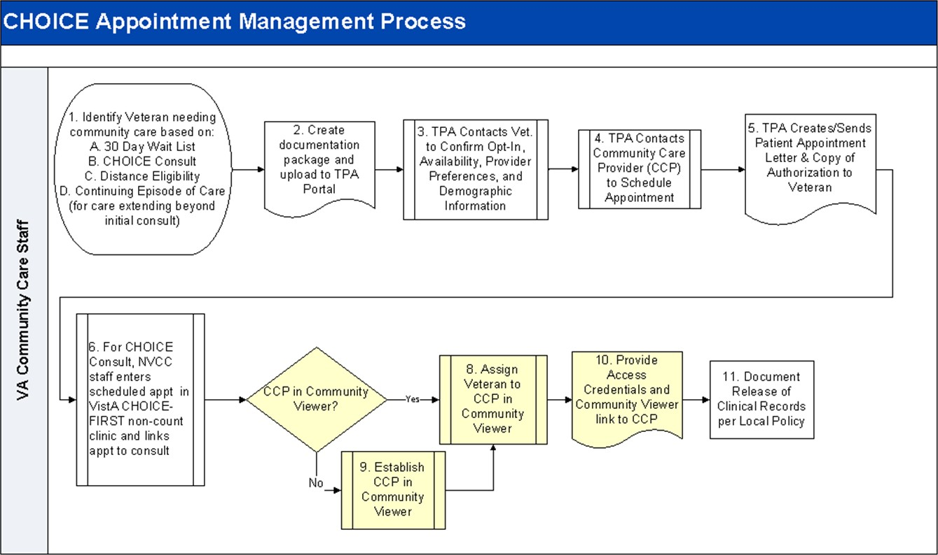
Figure 1: User Workflow

Please read and bear the following warning in mind before using Community Viewer:
**WARNING**WARNING**WARNING**

“This U.S. Government computer system is for official use only.
The files on this system include Federal records that contain sensitive information.

All activities on this system may be monitored to detect unauthorized access to, or misuse of, the system or individual files and utilities on the system,
including personal use.

Further use of this system constitutes your consent to such monitoring.

Misuse of, or unauthorized access to, this system may result in criminal prosecution and disciplinary, adverse, or other appropriate action.”

**WARNING**WARNING**WARNING**

Purpose of the Guide
The purpose of the User Guide is to familiarize users with the important features and navigational elements of the CCPM widget of CV.

Guide Conventions
This document is designed for both online and hardcopy consumption.
  - Cross References are indicated by blue, underlined text, and provide a hyperlink to figures, tables, and other sections within this guide
  - Emphasis is expressed by bold and italicized text
  - The information symbol calls the reader’s attention to additional information

Terminology
The following standard terms are used throughout this guide:
  - Provider Portal: The landing page, or default view, of CV that appears after logging in to the application. The portal page displays widgets and the tools that enable quick access to basic features
  - Widget: A component of the CV interface that enables a user to view information or perform a function
  - Widget Tray: An expandable and collapsible tray at the bottom of the portal page that provides access to the widgets available for placement on the portal page

Assumptions
The User Guide is written from the perspective of VA Staff, assuming the following:
  - You can open, navigate, and use a web browser
  - You can use web-based applications, their menu options, and navigation tools
  - You have the Uniform Resource Locator (URL) for the CV log in page, system user names, and access/verify codes required for launching CV
  - You will use the CCPM to make patient assignments to providers who practice outside the VA network

System Requirements
CV is a front-end web application, designed to run in a web browser on the VA network. Accessing CV through a browser or device that is not fully compatible with the application may result in certain features not working as expected.

This release does not support mobile devices
It is recommended that CV is accessed from a desktop or laptop PC using a supported browser, such as:
  - Chrome v59
  - EdgeHTML v14
  - Firefox v54
  - Internet Explorer (IE) v11
  - Safari v10

Getting Help
Authorized users who have trouble logging in to CV, or experience other application issues, should contact the Enterprise Service Desk (ESD) for assistance.

VA Enterprise Service Desk
REDACTED

Prior to contacting the ESD for support, please refer to Section 2, Logging in to CV, for detailed information about how to access CV, and to Section 5, Troubleshooting, for suggested resolution steps and troubleshooting information.

Logging in to CV
Before logging in to and utilizing the functionality of the CCPM widget, please read the following:
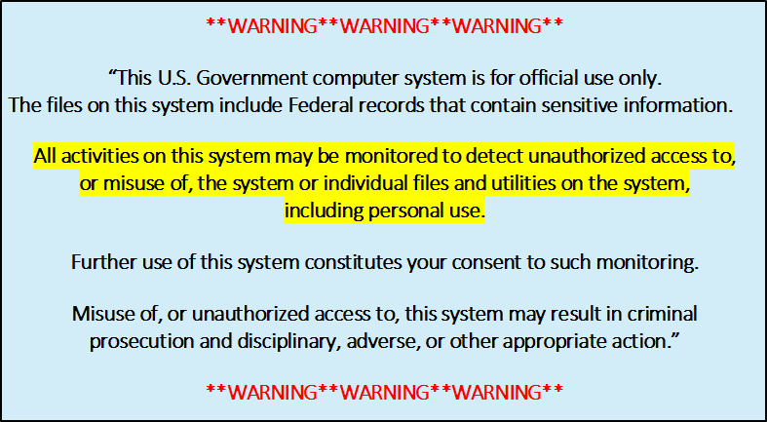

If you have not received an access confirmation e-mail, you must first request access through your facility Community Care lead, or your VISN Business Integration Manager (BIM).
CV authenticates all VA users using their Personal Identification Verification (PIV) card, their credentials, and the master list of registered users. During log in, first-time CV users are prompted to enter their agency, site, and user settings. This data is used to create a CV user profile, and is utilized during future log in sessions.
To log in to CV:
- Insert your PIV card into your computer or card reader
- Open a supported Internet browser
- Enter the URL for the CV web application into the address bar of the browser
- When prompted with a certificate list, select the PIV Authentication certificate
- When prompted, enter your PIV Personal Identification Number (PIN)
- Click I Accept after reading the important user consent information regarding accessing a government information system
- Enter the following information in the fields on the log in page. (See Figure 2):
  - VistA Access Code
  - VistA Verify Code
  - Select VA from the Agency field
  - Select your local VistA host site from the Site dropdown menu

- Click Login.

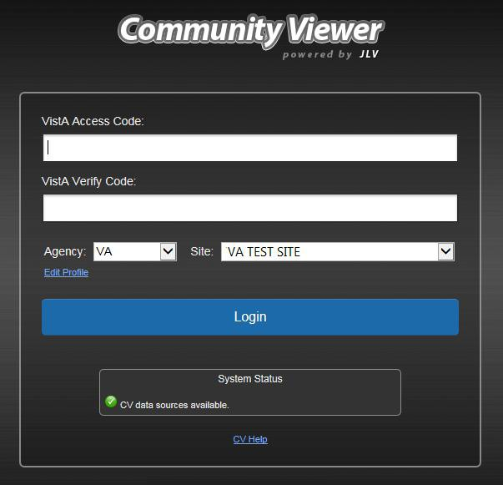Figure 2: Login Page

Users who are not authorized to access CV receive an Access denied message. Access to CV is limited to authorized users, and is configured by System Administrators. If you believe you have received the message in error, please contact the ESD. See Section 1.4, Getting Help, for details.

Editing Your User Profile at Log in
Users can customize their profile from the log in page. First-time CV users will be prompted to enter their agency, site, and User Interface (UI) theme settings before logging in. Once saved, the profile information is used each time you log in to CV.
UI theme preferences can also be set within CV. See Section 2.2.3, Profile Settings. To edit the user profile at log in:
- Click the Edit Profile link on the Login page. Profile options are presented
- Enter your agency and site in the fields provided
- Select the desired UI theme

- Click Save and Login

The CV Portal Pages
The CV portal pages have tools that enable quick access to basic features. These tools appear in the top-right corner of the application window (detailed in Figure 3).
  - Select the UI theme: Click the cog wheel to select the UI theme. See Section 2.2.3, Profile Settings
  - Access online help: Click Help to open web-based, online help
  - Log out: Click Logout to terminate the current CV session

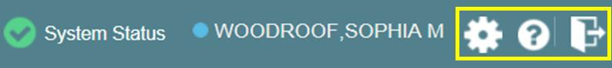Figure 3: CV Portal Tools

Default View
After logging in to CV, the Provider Portal opens. The default view of the Provider Portal
includes the Community Care Provider Management widget (Figure 4).

If the Community Care Provider Management widget is not displayed, click the plus + sign in the lower-right corner of the screen, (Figure 4) to open the Widget Tray. Click, hold, and drag the icon from the Widget Tray to the screen, and drop the widget in the desired location.

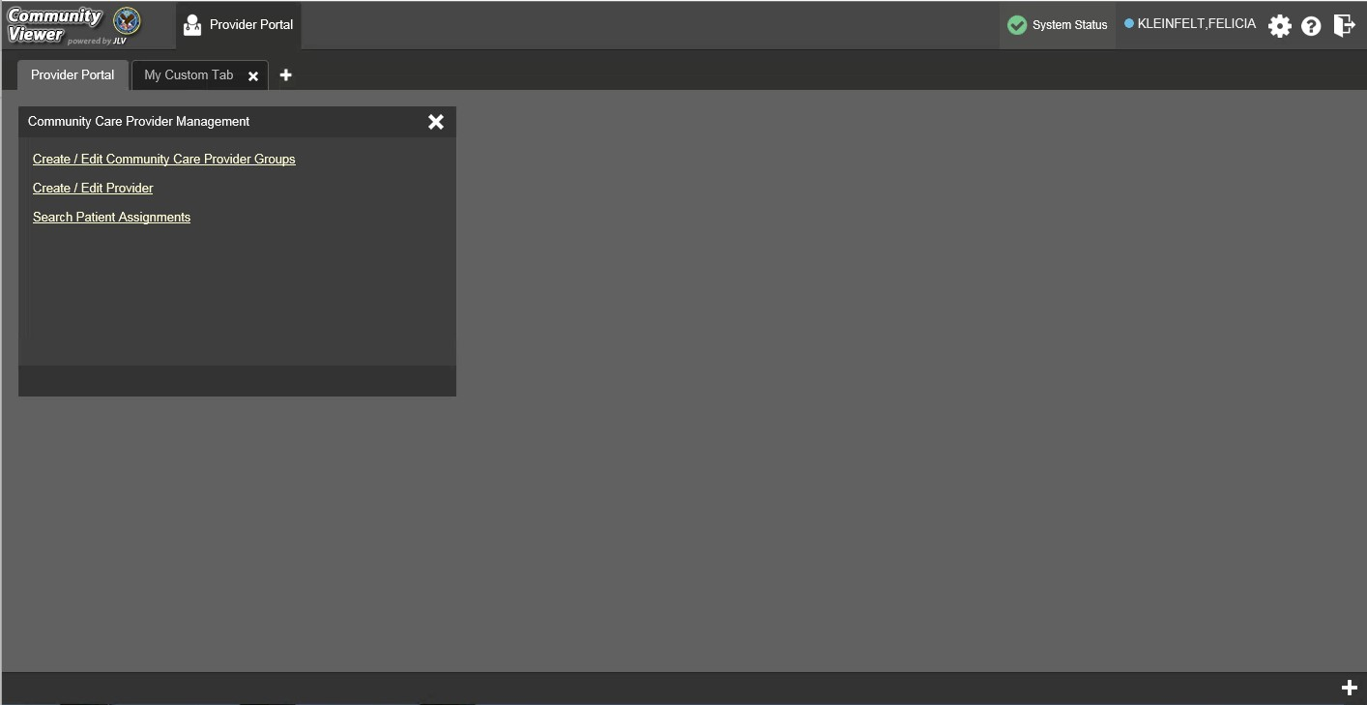
Figure 4: Default View

Viewing System Status
CV’s Health Monitor provides system status updates, and monitors the services CV uses to connect to VA data sources. The services that are monitored include: Master Veteran Index (MVI), VistA Data Service (VDS), and jMeadows Data Service.
The system status is displayed in two areas:
- On the Login page
- Atop the Provider Portal page (highlighted in Figure 5)
When all monitored systems and services are online and connected, a green icon appears next to the status, with the message CV data sources are available (Figure 5).
When one or more monitored systems or services are offline or unavailable, a yellow warning icon appears with the message CV is having problems.
When CV’s health monitor is unable to retrieve and report system status information, a red icon appears with the message, System status is unavailable. When this status appears, you may
not be able to log into CV or view patient data until the connection is restored. See Section 1.4, Getting Help, for information on how to contact the ESD.

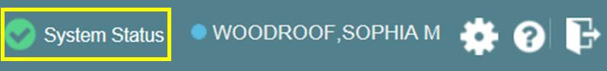Figure 5: System Status Indicator

Profile Settings
Profile settings are accessible within CV by clicking the cog wheel located in the top-right corner of the portal pages (Figure 4).

In this release, the configuration options are limited to choosing a UI theme.
Selecting a User Interface Theme sets the font color, foreground, and background colors of the CV Graphical User Interface (GUI). Themes apply to all application elements, including widgets, toolbars, and dialog boxes. Theme choices are Default, Green, Blue, Gray, and Accessible. The Accessible theme (Figure 10) is 508-compliant, and designed to work with the accessibility features installed on a user’s device.
To set the UI theme:
1. Click the cog wheel in the top-right corner of the portal pages
- The CV Settings dialog opens (Figure 6)
- Click the radio button next to the desired theme
- Click Save

- After clicking Save, you are asked whether or not to save the configuration. Click Yes to reload the application and apply the selected theme -OR-
- Click Cancel to exit the CV Settings dialog and restore the previous theme

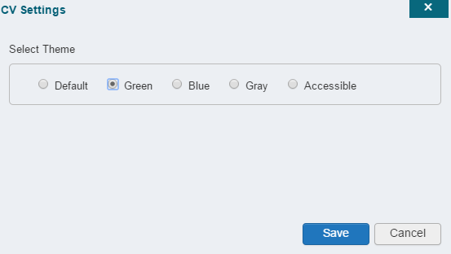Figure 6: The CV Settings Dialog

UI theme choices are displayed in the figures below. The Default theme was presented in Section 2.2.1, Default View.

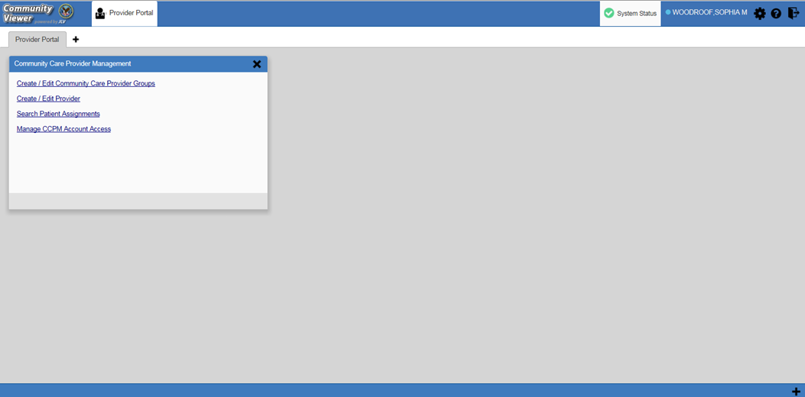Figure 7: Blue UI Theme

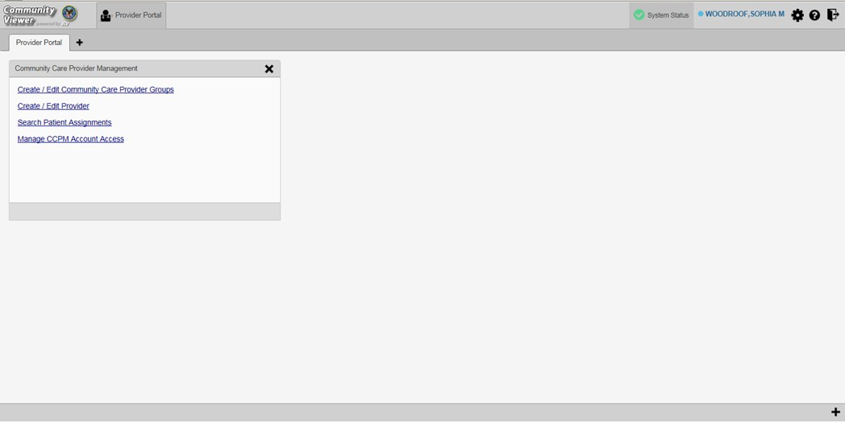Figure 8: Gray UI Theme

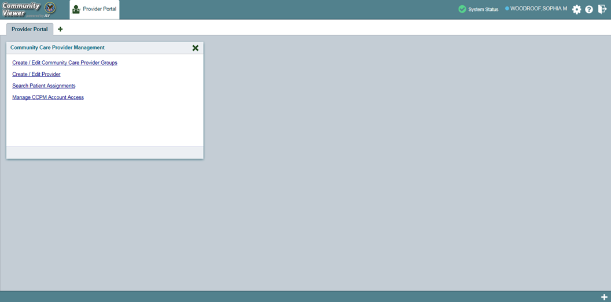Figure 9: Green UI Theme

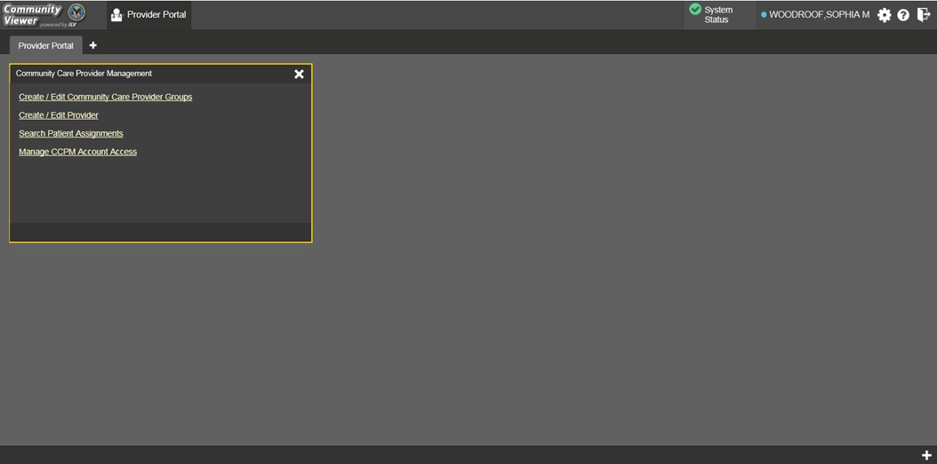Figure 10: Accessible (508 Compliant) UI Theme

Using the Accessible Theme’s Functionality
The Accessible theme includes larger fonts, enhanced tab and keystroke functionality, and screen reader compatibility to support Federal accessibility requirements and Section 508 compliance.

Keyboard Focus and Screen Navigation in Accessible Theme
Keyboard focus is the highlighting of screen elements that enables interaction with, and the navigation of, the web application through the keyboard and keystrokes. The screen element in focus is outlined in gold (Figure 10) as a visual indicator of keyboard focus.
CV enables the use of Windows keystrokes (Tab, Shift + Tab, arrow keys, Enter), and keyboard shortcuts to move the focus to all menus, and activate all functions on the menus. All user interface items are accessible via the keyboard under the Accessible theme.
Pressing Enter or the Spacebar when an element that provides action is in keyboard focus performs the associated action. For example, pressing Enter or the Spacebar when the cog wheel icon is in focus opens the CV Settings dialog. Using the arrow keys or the Tab key allows a user to move between keyboard focus items to navigate through screen elements. A complete list of accessible keystrokes is provided in Table 1.

Table 1: Keyboard Accessible Keystrokes
Keystroke | Description
Application and Portal Navigation
ENTER | Press to transfer keyboard focus to the highlighted widget.
TAB | Press to transfer keyboard focus to other user interface items.

Keystroke | Description
ESC | Press to return keyboard focus to the panel containing the user interface item with keyboard focus or to exit a window or widget.
SPACEBAR | Press to activate any user interface item (for example, click a button).
Arrow Keys | When keyboard focus is on a widget, press the arrow keys to change page viewing in a widget's data table.  When keyboard focus is on a dropdown list, press the down arrow to view the contents.
Tab Panels
Arrow Keys | Use the left and right arrow keys to change tab panels.  To add a tab panel, press the right arrow key until the last tab (+) is selected. A dialog prompts the user to enter the tab name.
Ctrl + x | To close a tab, focus on the tab panel and press Ctrl + x.
Windows and Dialog Boxes
TAB | Press the Tab key to move the keyboard focus to other user interface items within the window.
Adding Widgets to the Portal Pages
SHIFT +  (Number position) | To add a widget from the widget tray using keystrokes:  - Determine which column (1, 2, or 3) to place the widget on the portal page.  - Focus the desired widget icon in the widget tray and press the Shift key along with the 1, 2, or 3 key, depending on the desired column placement.

Logging Out of the Current CV Session
You may intentionally log out to end a CV session by clicking Logout at any time. If you fail to log out, the current session will terminate automatically after five minutes of inactivity. You will be redirected to the Login page when any new activity is attempted.

Using CV

Working with the CCPM Widget
After logging in, users see the CCPM widget on the Provider Portal by default.

If the Community Care Provider Management widget is not displayed, click the plus + sign in the lower-right corner of the screen (Figure 11) to open the Widget Tray. Click, hold, and drag the icon from the Widget Tray to the screen, and drop it in the desired location.

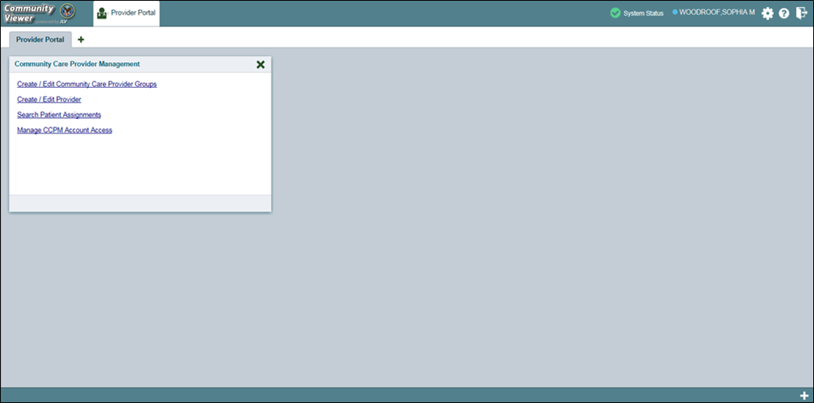
Figure 11: Default Portal Page (Green Theme)

Users create providers, assign patients to CCPs, and grant the CCP limited access to patient records within the CCPM widget.
There are four workflow options (Figure 12) within the CCPM:
- Create/Edit Community Care Provider Groups
- Create/Edit Provider
- Search Patient Assignments
- Manage CCPM Account Access

The Manage CCPM Account Access link is only available to CV Portal Administrators.

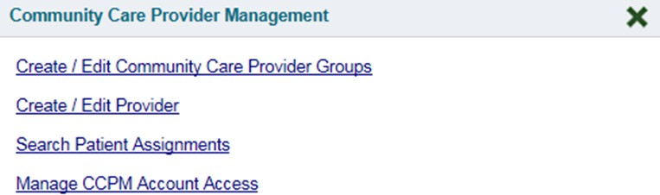Figure 12: The CCPM Widget

About Provider Groups and Facilities
Before a user can assign a patient to a CCP, the CCP must be assigned to a provider group.
CV has been pre-populated with over 200,000 groups and providers. Users can edit existing groups, but in this release, the task of creating provider groups is performed by CV Portal Administrators. Users should contact a CV Portal Administrator to request the creation of a new group.

Provider Groups are validated on the combination of the group name and street address, in order to avoid the creation of duplicates.

Each group is associated with one or more local VA sites, referred to as Facilities. A facility is a local VA site associated with a provider group. Provider groups can contain one or more VA facilities.
EXAMPLE 1: Dr. Hanyok works with a family practice called Evergreen Health Care. In this example, Dr. Hanyok is the Provider, and Evergreen Health Care is the Provider Group to which she is assigned.
EXAMPLE 2: Dr. Woodroof, the Provider, is a sole practitioner. The Provider Group name for a sole practitioner may be a business name, or can be the provider’s name; in this example, Dr.
Woodroof.

Searching within the CCPM
CV’s search feature is used to find a provider group, a provider, or a patient who will be assigned to a provider. There are two types of patient searches in CV:
- My Site Search: Searches the user’s local VistA. The patients listed in the search results are registered to that local VistA only.

- Enterprise Search: Searches all VistAs across the Enterprise. The patients listed in the search results are registered to one or more VistAs. In this release, an Enterprise search can be performed only by a CV Portal Administrator.
Please see Section 3.1.4, Assigning Patients, for detailed instructions on how to run a My Site
search.

Creating Provider Accounts
All CCP accounts are created in the CCPM widget. When a CCP account is created, so is their user profile. Users can assign patients to CCPs once their account has been created.
To create a provider:
- Click the Create/Edit Provider link (Figure 12) in the CCPM widget
- Click Create New Provider in the Search Providers pane, on the left side of the application window, as shown in Figure 13. The Create/Edit Provider pane opens on the right side of the application window.
- Click Browse to the right of the Provider Group field to search for an existing group
- Select the desired group from the list of results and click OK

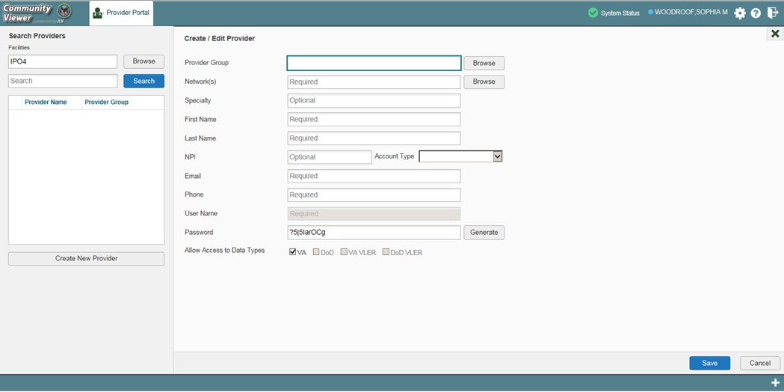Figure 13: Search Providers and Create/Edit Provider Panes

- Enter the provider information in each of the required fields on the Create/Edit Provider
pane (Figure 13)

Providers are differentiated by the combination of their name and e-mail address. When a new provider is created, both identifiers are validated, in order to avoid the creation of duplicates.
- Click Browse to select the Network(s) to which the provider belongs from the following options: Health Net, PC3, Provider Agreement, TriWest, or Other. A free-text field opens when Other is selected
- Enter the provider’s First Name and Last Name

- Select Outside Provider from the Account Type dropdown list

- Enter the provider’s E-mail address and Phone number
- The User Name field is automatically populated with the address entered in the Email
field
- Click Generate to have the system create the CCP’s password

Passwords are case-sensitive.
- Record the User Name and Password as displayed. It is the responsibility of VA Staff to provide the CCP with his/her user name and password for CV
- Click Save
- When the Provider successfully created message appears, there are two options:
  - Click Assign Patients and follow the steps outlined in Section 3.1.4, Assigning Patients -OR-
  - Click OK to return to the CCPM widget
CCPs can now request access to CV from the CCP log in page. When a CCP clicks the New User link, s/he sees a message directing them to contact their local VA Medical Center for access. They are then given a link to a list of VA points of contact (POCs) from whom they can request access to the application.

Assigning Patients
Once the CCP’s account has been created, patients can be assigned to them.
If you chose Assign Patients immediately after creating the provider, the search pane is pre-populated with that provider’s profile information, and no search is necessary.
To assign patient(s) to a CCP:
- Click the Create/Edit Provider link in the CCPM widget
- Enter the provider’s name in the field to the left of the Search button within the Search Providers pane (Figure 14)
- Click Search

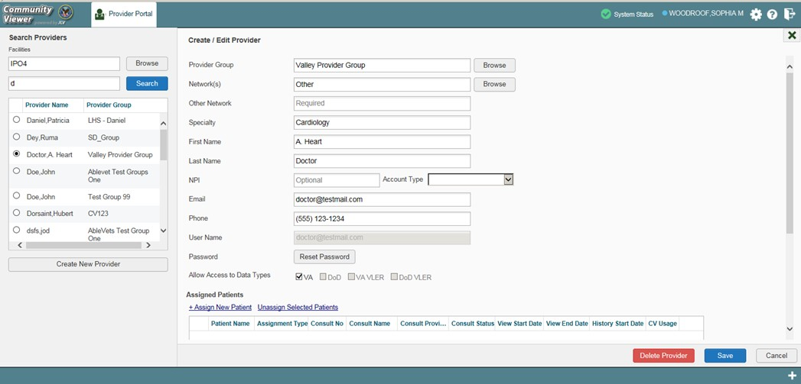Figure 14: Search Providers Pane

In this release, the task of deleting a provider is performed by CV Portal Administrators. VA Staff users will not see the Delete Provider button. Instead, they must contact a CV Portal Administrator to request that a provider be deleted.

- Select the Provider from the list of results. The Create/Edit Provider pane opens with the provider’s information
- Click the + Assign New Patient link (highlighted in Figure 15). The Patient Search
dialog opens

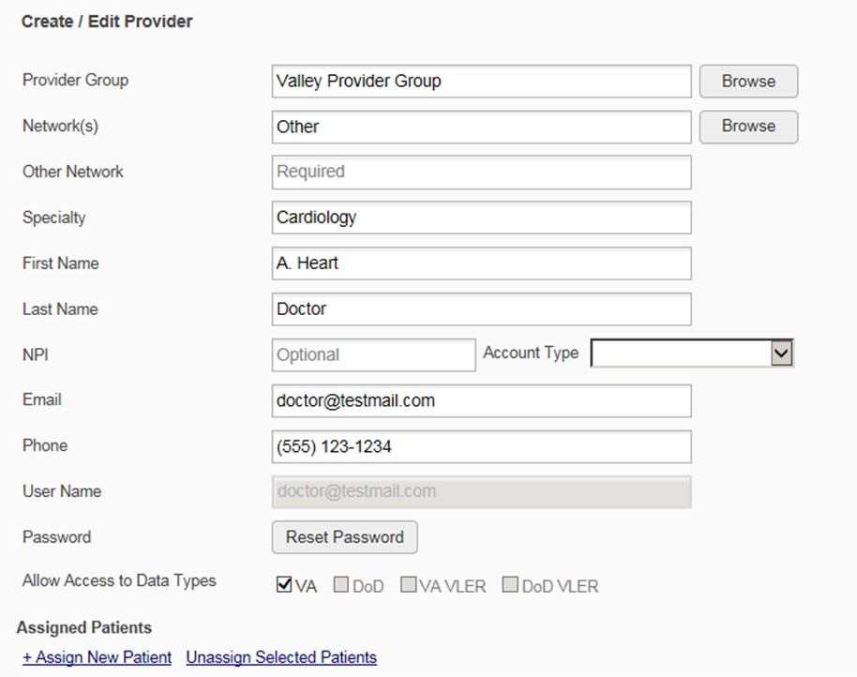Figure 15: Create/Edit Provider Fields Detail

- Enter the patient name in the blank field at the top of the Patient Search dialog (Figure 16)
- Select the My Site search option and enter the search criteria:
  - The patient's last name, followed by a comma and either the first initial or full spelling of the patient's first name (Smith, J or Smith, John)
  - You may also enter the patient's full Social Security Number (SSN) (123456789), or first letter of the patient's last name followed by the last 4 digits of the patient's SSN (S6789)

In this release, only CV Portal Administrators can see the option for, and perform,
an Enterprise patient search.

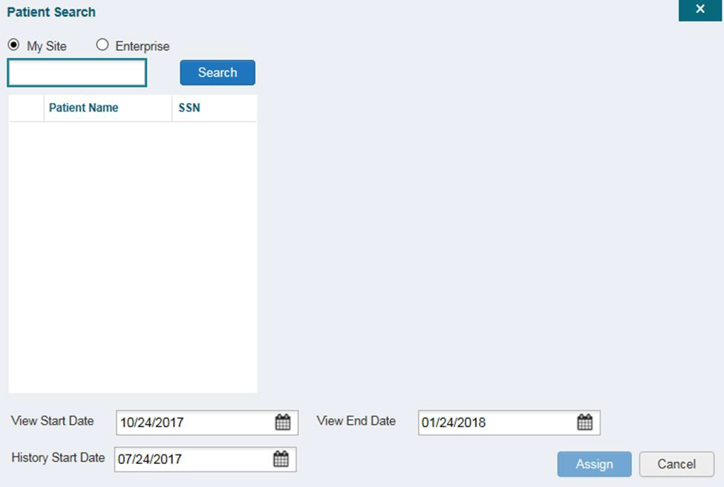Figure 16: Patient Search Dialog Box

- Click Search
- Select a patient from the search results list
- Select the Assignment Type from the dropdown list: 30 Day Wait, Consult, Distance- Eligible (40 mile), or Episode of Care
  - If Consult is specified, select one consult record from the list for the selected patient. The consult status must be Active or Scheduled for the consult to appear in the list
- If desired, adjust the default View Start Date, View End Date, and History Start Date fields to restrict the data seen by the CCP. (See Section 3.1.5, Setting Record Display Limits)
- Click Assign

CV uses the following rules to manage patient assignments:
- A specific Veteran may be assigned to multiple CCPs
- A Veteran may be assigned to more than one CCP for the following Assignment Types:
  - 30 Day Wait
  - Distance Eligible
  - Episode of Care
- A specific Veteran/consult combination may only be assigned to a single CCP

Table 2: Assignment Rules Examples
Veteran John Davis has multiple active referrals to be assigned:
Referral 1 | 30 Day Wait for Dental | Assign to CCP A | A Veteran may have multiple, active assignments in a particular Assignment Type
Referral 2 | 30 Day Wait for Podiatry | Assign to CCP B
Referral 3 | 30 Day Wait for Podiatry | Assign to CCP C
Referral 4 | Episode of Care for Optometry | Assign to CCP D
Referral 5 | Consult for Cardiology | Assign to CCP E | This specific consult can only be assigned to one CCP at a time
Referral 6 | Consult for Chiropractic | Assign to CCP F | This specific consult can only be assigned to one CCP at a time

Alternatively, patient consults can be removed using the Unassign Selected Patients link (Figure 15).

Setting Record Display Limits
User can limit the patient records made available to the assigned CCP by using Data Access Controls. The default date setting is three months prior to the date of the assignment. There are two settings that control access to patient data:
- View Start Date and View End Date: These fields set the length of time the CCP will have access to the patient records through CV. The default start date is the date the patient is assigned to the CCP. The default end date is three months from the start date.
- History Start Date: This setting represents how far back in a patient's VA medical history the CCP is permitted to view. For example, if the history start date is set to 01/01/2012, the CCP has access to the patient's records from available VA facilities from 2012 to present.
Data access controls are set by the user during the patient assignment process. To set the Data Access Controls:
- Click the calendar next to the View Start Date and the View End Date fields
- Select the start and end dates (Figure 17)
- Alternatively, click the calendar icon next to the History Start Date
- Select a date
- Click Assign

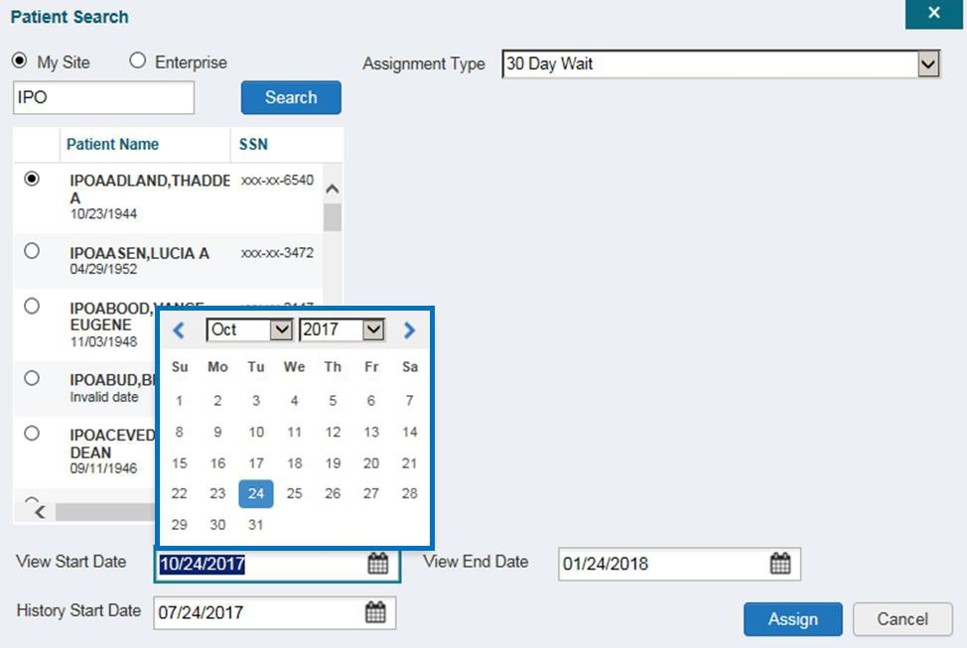Figure 17: Data Access Controls

Editing Provider Groups and Profiles
Provider groups and provider profiles can be edited through the CCPM widget.

Editing Provider Groups
Provider groups can be edited through the CCPM widget. To edit a provider group:
- Click the Create/Edit Community Care Provider Groups link in the CCPM widget
- Enter the provider group name in the Search field
- Click Search
- Select the desired provider group from the search results (Figure 18)
- Edit the provider group fields as needed

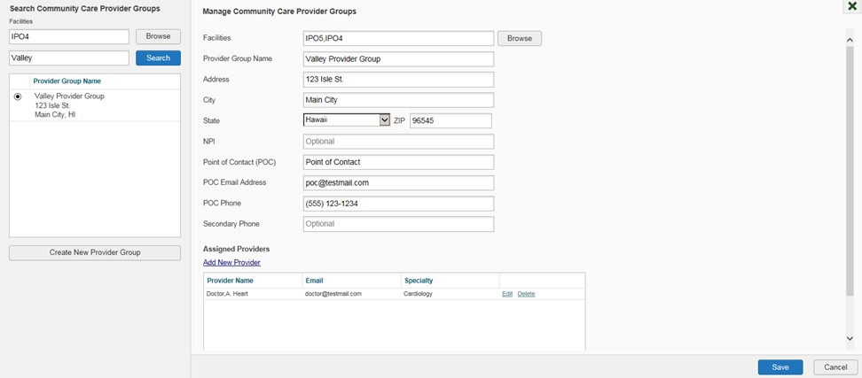Figure 18: Search and Manage CCP Groups Panes

To edit a facility
- Click Browse next to the Facilities field, and select the desired facility from the list
- Providers assigned to the provider group are listed in the lower-right portion of the screen. Edit provider profiles or remove providers from the group using the Edit link within the Assigned Providers list (Figure 18)
- Click Save

In this release, the tasks of adding new groups and deleting providers are performed by CV Portal Administrators. VA Staff users will not see the Create New Provider Group button, the Delete Provider button, or the Delete link. Contact a CV Portal Administrator for assistance with these tasks.

Editing Provider Profiles
You can edit a CCP’s profile using the CCPM widget. To edit a CCP’s information in his/her profile:
- Click the Create/Edit Provider link in the CCPM widget
- Enter the provider name in the Search field, and click Search
- Select the desired provider from the search results (Figure 19)
- Edit the provider information in the fields provided, as necessary
- Click Save

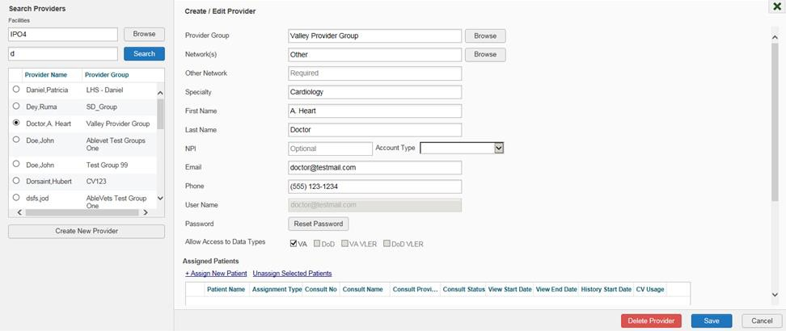Figure 19: Search Providers and Create/Edit Provider Panes

If a provider is assigned to the wrong group, you can assign the provider to a different, existing group on this screen.
If the provider will be added to another practice group, users must click Add New Provider in the Search Providers pane and create the provider within the additional practice group. The provider name can be the same, but a different e-mail address must be used.

Resetting Provider Passwords
If a CCP user has forgotten his/her password, there is a Forgot Password? link on the log in page. Clicking the link opens a window that enables the user to send a password reset request directly to Community Provider Technical Service Desk. Password resets can also be performed by VA Staff, using the CCPM widget.
To reset a CCP’s password:
- Click the Create/Edit Provider link in the CCPM widget
- Enter the provider name in the Search field
- Click Search
- Select the desired provider from the search results
- Click Reset Password (highlighted in Figure 20) in the Create/Edit Provider pane
- Click Generate to allow the system to create a new, random password
- Record the new password. It is the responsibility of the VA Staff user to provide the CCP with his/her password for CV
- Click Save

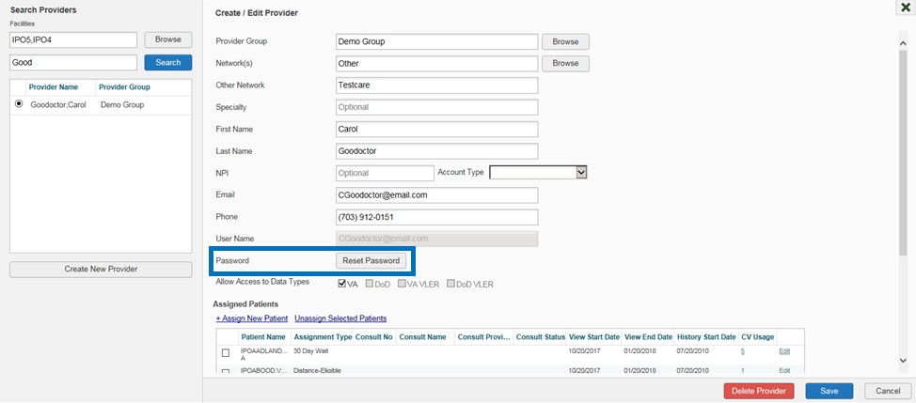Figure 20: CCP Password Reset

Widgets: What Community Providers See
Once the CCP has been granted access to CV, they can see their assigned patient’s VA health information on the Patient Portal. Patient data is presented through widgets (Figure 21), each displaying data specific to an administrative or clinical domain. The Encounter, Results, Medications, Documents, Consults, and Immunization tabs provide unique widget layouts.

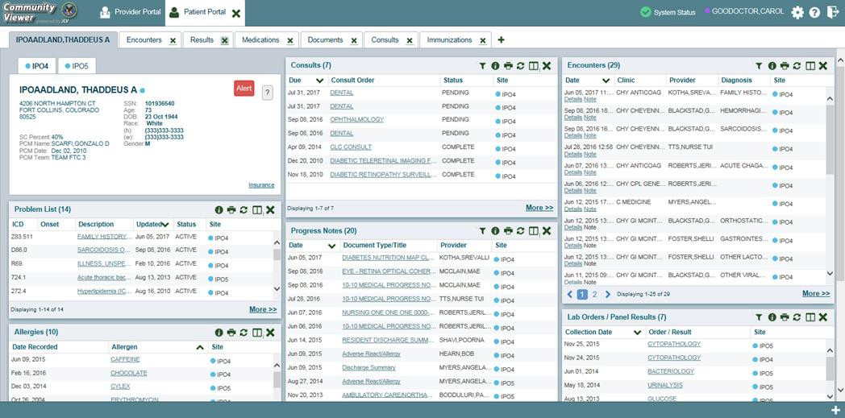Figure 21: Widget Display on the Patient Portal
**Primary Care Management (PCM)

All widgets available for display on the Patient Portal are housed in a horizontal tray at the bottom of the page, the Widget Tray. When customizing their view of CV, CCPs click the + icon in the lower-right corner of the page (Figure 21) to open the Widget Tray.
The widgets that are available for display on the Patient Portal are:

- Patient Demographics  - Admissions  - Allergies  - Appointments  - Clinical Reminders  - Consults  - Discharge/Essentris Notes  - Encounters  - Immunizations  - Inpatient Medications | - Lab Panel Results  - Lab Results  - Outpatient Medications  - Orders  - Problem List  - Procedures  - Progress Notes  - Radiology Exams  - Vitals

Troubleshooting

Special Instructions for Error Correction
Access to CV is limited to registered, authorized users. CV validates user access against information retrieved from your smart card. If you are experiencing trouble logging in to CV, please review Table 3 before contacting the service desk.

Table 3: Login Page Error Message Troubleshooting

Error Message | Resolution Steps
Access denied. You are not an authorized user. | WHAT? Error message indicating Access Denied. You are not an authorized User.  WHY? PIV card processing problem or invalid security certificate chosen.  FIX IT:  - Close browser window.  - Re-insert PIV card and re-launch the CV link.  - Select a certificate that is not expired and specifies Issued by: Veterans Affairs CA B1.  If this is unsuccessful, fully reboot your system. This refreshes all connections and resolves greater than 95% of any remaining problems.
Could not save User Profile | WHAT? Error message indicating Could not save User Profile.  WHY? Error occurred during PIV authentication for VA users - typically a PIV card processing problem or an invalid security certificate chosen.  FIX IT:  - Close your browser window.  - Re-insert PIV card and re-launch the CV link.  - Select a certificate that is not expired and specifies Issued by: Veterans Affairs CA B1.  If this is unsuccessful, fully reboot your system. This refreshes all connections and resolves greater than 95% of any remaining problems.
Not a valid ACCESS/VERIFY  CODE pair | WHAT? Receive Not a valid ACCESS CODE/VERIFY CODE pair error on the  Login page.  WHY? 1) CV could not match your access and verify codes to the Site selected in the drop down or VA, or 2) Username and password were entered instead of access/verify codes.  FIX IT:  - Veterans Health Administration (VHA) users must select the parent VistA host site for their facility.  - Re-enter correct Access and Verify codes (Computerized Patient Record System (CPRS) or VistA codes for VHA users).

Error Message | Resolution Steps
Page cannot be displayed | WHAT? You receive a Page cannot be displayed error when launching CV.  WHY? The CV URL requires certain internet explorer settings  FIX IT:  - With IE open, click the Tools menu or press ALT-X.  - Select Internet Options.  - When the dialog opens, select the Advanced tab.  - Scroll down in the list until you see the settings below and assure Secure Socket Layer (SSL) 2.0 is NOT checked and that Transport Layer Security (TLS) 1.0, 1.1 and 1.2 are checked.  - Click OK, then re-launch CV and the page should load.
Smart Card required | WHAT? Error Message Smart Card Required.  WHY? Smart card not read by Windows Security and CV before launching CV link.  FIX IT:  - Close all browser sessions/browser-based applications.  - Re-insert PIV card and re-launch CV link.  - If this is unsuccessful, fully reboot your system to refreshes all connections. This resolves greater than 95% of any remaining problems.
VERIFY CODE must  be changed before continued use | WHAT? Receive VERIFY CODE must be changed before continued use error on the Login page.  WHY? CPRS VERIFY CODE has expired.  FIX IT:  - Open CPRS.  - Select the Change Verify Code checkbox on the sign-on dialog before clicking OK.  - You are prompted to create a new Verify Code.  - Once your Verify Code is changed for CPRS, CV recognizes the new code immediately.

Patient Search Errors
The following error messages may appear when you are searching for a patient in the CCPM widget. If you are experiencing errors while searching for patients, please review Table 4 before contacting the service desk.

Table 4: Patient Search Error Messages and Resolution Steps

Error Message | Resolution Steps
An invalid search criterion was entered. Please enter at least 2 characters. | Invalid patient name entered. Please try your search again.  When searching by patient name, enter at least two characters of the patient’s first and last name. Search results will display the closest match to the characters entered in the format of [last name], [first name].
An invalid Social SSN format was entered. Please enter a 9-digit SSN. | Invalid SSN entered. Please try your search again.  When searching by patient SSN, you are required to enter the patient’s full 9- digit SSN. Dashes are allowed (e.g., 123-45-6789).
An invalid last-5 format was entered. Please enter the first letter of the last name followed by the last 4-digits of the SSN. | Invalid patient name or SSN entered. Please try your search again.  Patient search allows you to search for a patient using the first initial of the patient’s last name and the last 4 digits of the patient’s SSN. Please try your  search again using the first initial of the patient’s last name and the last 4 digits of the patient’s SSN.
An error occurred during your search. Please try your search again. | This error may display when invalid patient identifiers were entered or an error occurred at the service layer or with an external system. Please try your search again.

Acronyms and Abbreviations
Table 5 lists the acronyms and abbreviations used throughout this document, and their descriptions.

Table 5: Acronyms and Abbreviations

Acronym | Description
BIM | Business Integration Manager
CCP | Community Care Provider
CCPM | Community Care Provider Management
CPRS | Computerized Patient Record System
CV | Community Viewer
ESD | Enterprise Service Desk
GUI | Graphical User Interface
IE | Internet Explorer
MVI | Master Veteran Index
OIT | Office of Information and Technology
PCM | Primary Care Management
PIN | Personal Identification Number
PIV | Personal Identification Verification
POC | Point of Contact
SSL | Secure Socket Layer
SSN | Social Security Number
TLS | Transport Layer Security
UI | User Interface
URL | Uniform Resource Locator
VA | Department of Veterans Affairs
VDS | VistA Data Service
VHA | Veterans Health Administration
VistA | Veterans Health Information Systems and Technology Architecture
VLER | Virtual Lifetime Electronic Record

