Community Viewer (CV) Version 2.7 User Guide for VA Staff

June 2018
Version 1.2 Department of Veterans Affairs
Office of Information and Technology (OIT)

Revision History

Date | Version | Description | Author
06/19/2018 | 1.2 | Document date change per request from HPS for FORUM | AbleVets
04/24/2018 | 1.1 | Review comments addressed. Submitted for approval | AbleVets
04/11/2018 | 1.0 | Submitted for review | AbleVets
03/19/2018 | 0.1 | Initial draft of document | AbleVets

Table of Contents
- Introduction 1
  - Purpose of the Guide 3
    - Guide Conventions 3
    - Terminology 3
  - Assumptions 4
  - System Requirements 4
  - Getting Help 4
- Logging in to CV 5
  - System Notifications 6
  - Editing Your User Profile at Log in 7
  - The CV Portal Pages 7
    - Default View 7
    - Viewing System Status 8
    - Profile Settings 9
    - Using the Accessible Theme’s Functionality 11
      - Keyboard Focus and Screen Navigation in Accessible Theme 12
2.4. Logging Out of the Current CV Session 13
- Using CV 14
  - About Provider Groups and Facilities 15
  - Editing Provider Groups 15
    - Deleting a Provider Group 17
    - Creating Provider Accounts 18
    - Editing Provider Profiles 21
    - Resetting Provider Passwords 22
    - Searching Within the CCPM Widget 22
    - Assigning and Unassigning Patients 24
    - Setting Record Display Limits 28
- Widgets: What Community Providers See 30
  - Nondiagnostic Images 31
- Troubleshooting 34
  - Special Instructions for Error Correction 34
    - Patient Search Errors 35
- Acronyms and Abbreviations 37

Table of Figures
Figure 1: Third-Party Administrator (TPA) Portals Notice 1
Figure 2: User Workflow 2
Figure 3: CV Authorized Use Only Warning 3
Figure 4: Login Page 6
Figure 5: CV Portal Tools 7
Figure 6: Default View 8
Figure 7: System Status Indicator 8
Figure 8: The CV Settings Dialog 9
Figure 9: Blue UI Theme 10
Figure 10: Gray UI Theme 10
Figure 11: Green UI Theme 11
Figure 12: Accessible (508-Compliant) UI Theme 11
Figure 13: Default Portal Page (Green Theme) 14
Figure 14: The CCPM Widget 15
Figure 15: Search and Manage CCP Groups Panes 16
Figure 16: Search and Manage CCP Groups Panes, Assigned Providers Edit and Delete Links 17
Figure 17: Provider Group Deletion Error Message 17
Figure 18: Provider Group Has Providers Without Patient Assignments 18
Figure 19: Search Providers and Manage Providers Panes 19
Figure 20: Username Already Exists Error Message 20
Figure 21: Search Providers and Manage Providers Panes 21
Figure 22: CCP Password Reset 22
Figure 23: Browse Facilities Dialog Box–CCP Provider Groups 23
Figure 24: CV CCP Group Search Too Many Results Notification 24
Figure 25: Search Providers Pane 25
Figure 26: Manage Providers Fields Detail 26
Figure 27: Patient Search Dialog Box 27
Figure 28: Data Access Controls 29
Figure 29: Widget Display on the Patient Portal 30
Figure 30: Radiology Exams Widget (Minimized View)–Nondiagnostic Images 31
Figure 31: Radiology Exams Detail–Nondiagnostic Images 31
Figure 32: Single Encounter Nondiagnostic Image 32
Figure 33: Multiple Radiology Nondiagnostic Images 32
Figure 34: Progress Note Images–Unable to Retrieve Images Error 33

Table of Tables
Table 1: Keyboard Accessible Keystrokes 12
Table 2: Assignment Rules Examples 28
Table 3: Login Page Error Message Troubleshooting 34
Table 4: Patient Search Error Messages and Resolution Steps 35
Table 5: Acronyms and Abbreviations 37

Introduction
Community Viewer (CV) is a browser-based software application that facilitates the secure exchange of data between Department of Veterans Affairs (VA) systems and authorized non-VA providers, known as Community Care Providers (CCPs). The exchange of data improves the coordination of care and continuity of care for VA patients receiving treatment outside of the VA network.
CV pulls information from VA health care systems in real time for viewing within a web browser. Through CV, VA Staff assign patients to CCPs and provision CCP use within the CV system, allowing CCPs access to view consolidated patient data from multiple Veterans Information Systems and Technology Architecture (VistA) systems.
This User Guide is intended for VA Staff users who use the functionality within the Community Care Provider Management (CCPM) widget of CV to:
- Create and edit providers
- Assign patients
- Search patient assignments
- Manage patient data access parameters

There are notations throughout this guide to indicate functionality that is available only to CV Portal Administrators, VA Staff users with administrative privileges.

Figure 1: Third-Party Administrator (TPA) Portals Notice
IMPORTANT:

CV is designed to improve the community providers’ ability to
view comprehensive VA health information for Veterans.

CV does NOT replace the creation and uploading of documentation packages to the Third Party Administrator (TPA) portals.
VA Administrative Staff must continue to create and upload documentation packages as specified in the current SOP.

Figure 2 depicts the typical user workflow.

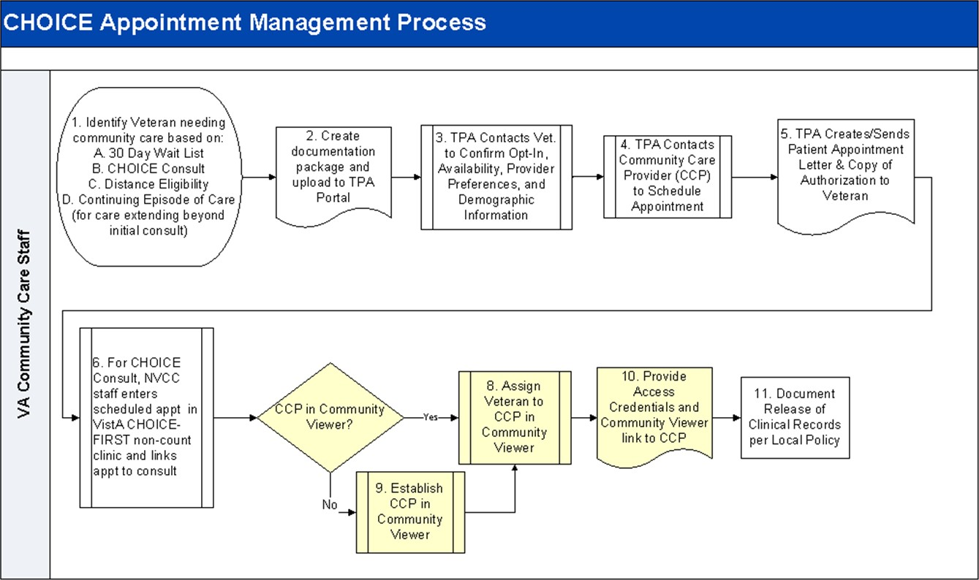
Figure 2: User Workflow

Please read and bear in mind the warning displayed in Figure 3 before using CV.

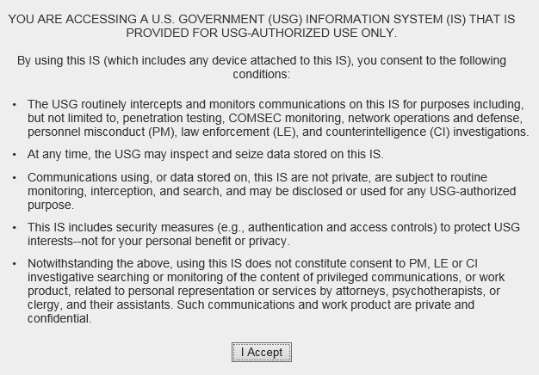Figure 3: CV Authorized Use Only Warning

Purpose of the Guide
The purpose of this User Guide is to familiarize VA Staff with the important features and navigational elements of the CCPM widget of CV.

    - Guide Conventions
This document is designed for both online and hardcopy consumption.
- Cross-References are indicated by blue, underlined text, and provide a hyperlink to figures, tables, and other sections within this guide
- Emphasis is expressed by bold, underlined, and italicized text
- The information symbol calls the reader’s attention to additional information
    - Terminology
The following standard terms are used throughout this guide:
- VA Staff Portal: The landing page, or default view, of CV that appears after logging in; the portal page displays widgets and the tools that enable quick access to basic features
- Widget: A component of the CV interface that enables a user to view information or perform a function
- Widget Tray: An expandable and collapsible tray at the bottom of the portal page that provides access to the widgets available for placement on the portal page

Assumptions
The User Guide is written from the perspective of VA Staff and assumes that:
- You can open, navigate, and use a web browser
- You can use web-based applications, their menu options, and navigation tools
- You have the Uniform Resource Locator (URL) for the CV Login page, system user names, a Personal Identification Verification (PIV) card, and Access/Verify codes required for launching CV
- You will use CCPM to make patient assignments to providers and manage providers who practice outside the VA network

System Requirements
CV is a front-end web application, designed to run in a web browser on the VA network. Accessing CV through a browser or device that is not fully compatible with the application may result in certain features not working as expected.

This release does not support mobile devices.
It is recommended that CV is accessed from a desktop or laptop PC using a supported browser, such as:
- Chrome v54 or higher
- Microsoft Edge v41
- Firefox v58
- Internet Explorer (IE) v11
- Safari v11

Getting Help
Authorized users who have trouble logging in to CV or experience other application issues should call the Enterprise Service Desk (ESD) for assistance, or create a ticket using the YourIT self-service portal.
IT Enterprise Service Desk
REDACTED

Prior to contacting the ESD for support, please refer to Section 2, Logging in to CV, for detailed information about how to access CV, and to Section 5, Troubleshooting, for suggested resolution steps and troubleshooting information.

Logging in to CV
Before logging in to and utilizing the functionality of the CCPM widget, please read the
Sensitive Information warning in Figure 1.
If you have not received an access confirmation e-mail, you must first request access through your facility Community Care lead or your VISN Business Integration Manager (BIM).
CV authenticates all VA users using their PIV card, their credentials, and the master list of registered users. During log in, first-time CV users are prompted to enter their agency, site, and user settings. This data is used to create a CV user profile, and it is utilized during future login sessions.
To log in to CV:
- Ensure your PIV card is inserted into your computer or card reader
- Open a supported Internet browser
- Enter the URL for the CV web application into the address bar of the browser
- When prompted with a certificate list, select the PIV Authentication certificate
- When prompted, enter your PIV Personal Identification Number (PIN)
- Click I Accept after reading the important user consent information regarding accessing a government information system (Figure 3)
- Enter the following information in the fields on the Login page (Figure 4):
  - VistA Access Code
  - VistA Verify Code
  - Select VA from the Agency field
  - Select your local VistA host site from the Site dropdown
- Click Login

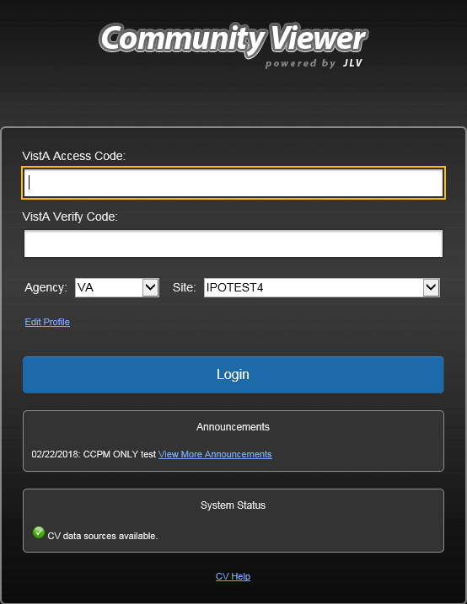Figure 4: Login Page

Users who are not authorized to access CV receive an Access denied message. Access to CV is limited to authorized users and is configured by System Administrators. If you believe you have received the message in error, please contact the ESD. See Section 1.4, Getting Help, for details.

System Notifications
The CV Login page displays system notifications to alert you to system outages, scheduled system activities, and important upgrades. The Login page also displays a notification when your VistA Verify code must be reset. The CV Help link opens CV online help, which guides you through the steps to reset your Verify code.

Editing Your User Profile at Log in
Users can customize their profile from the Login page. First-time CV users will be prompted to enter their agency, site, and User Interface (UI) theme settings before logging in. Once saved, the profile information is used each time you log in to CV.
UI theme preferences can also be set within CV. See Section 2.3.3, Profile Settings. To edit the user profile at log in:
- Click the Edit Profile link on the Login page
  - Profile options are presented
- Enter your agency and site in the fields provided
- Select the desired UI theme
- Click Save and Login

The CV Portal Pages
The CV portal pages have tools that enable quick access to basic features. These tools appear in the upper right corner of the application window (highlighted in Figure 5).
- Select the UI theme: Click Settings to select the UI theme (See Section 2.3.3, Profile Settings)
- Access online help: Click Help to open web-based, online help
- Log out: Click Logout to terminate the current CV session

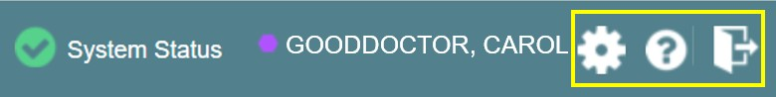Figure 5: CV Portal Tools

    - Default View
After logging in to CV, the VA Staff Portal opens. The default view of the VA Staff Portal
includes the CCPM widget (Figure 6).

If the CCPM widget is not displayed, click the plus + sign in the lower right corner of the screen, (Figure 6) to open the Widget Tray. Click, hold, and drag the icon from the Widget Tray to the screen, and drop the widget
in the desired location.

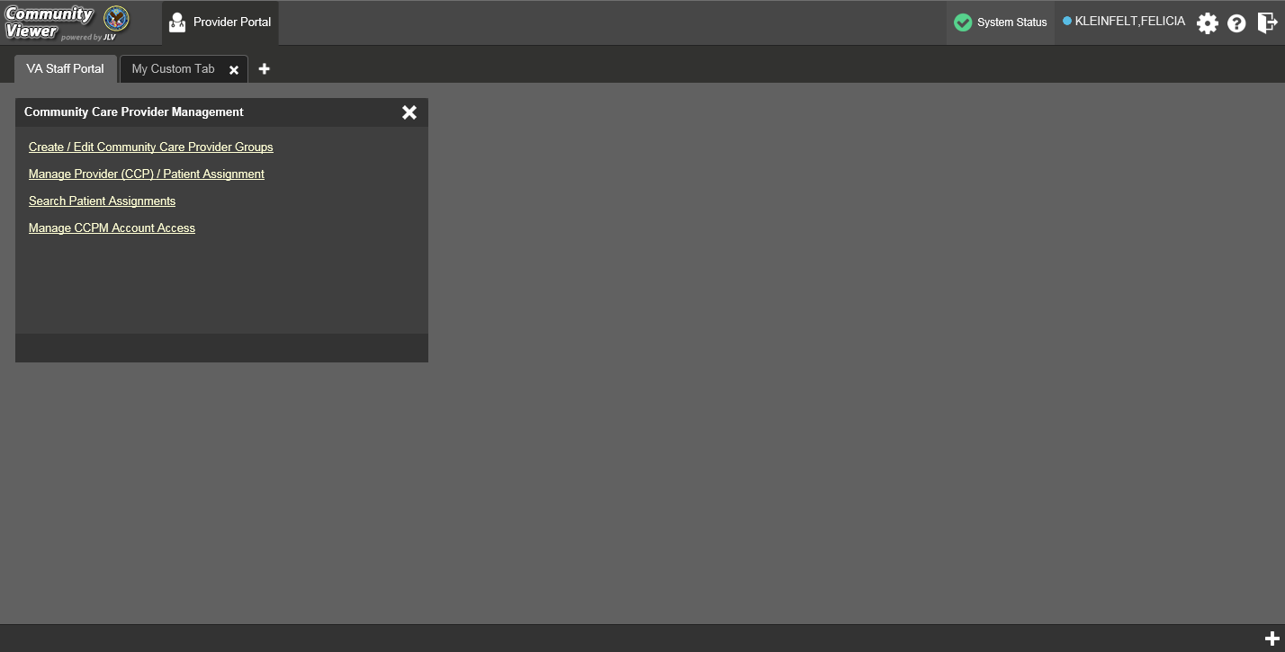Figure 6: Default View

    - Viewing System Status
CV’s Health Monitor provides system status updates and monitors the services CV uses to connect to VA data sources. The services that are monitored include: Master Veteran Index (MVI), VistA Data Service (VDS), and jMeadows Data Service.
The system status is displayed in two areas:
- On the Login page (Figure 4)
- Atop the VA Staff Portal page (highlighted in Figure 7)
When all monitored systems and services are online and connected, a green icon appears next to the status, with the message, “CV data sources available” (Figure 4).
When one or more monitored systems or services are offline or unavailable, a yellow warning icon appears with the message, “CV is having problems.”
When CV’s health monitor is unable to retrieve and report system status information, a red icon appears with the message, “System status is unavailable.” When this status appears, you may
not be able to log into CV or view patient data until the connection is restored. See Section 1.4, Getting Help, for information on how to contact the ESD.

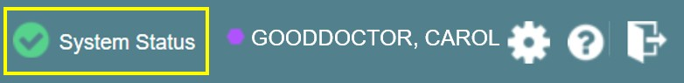Figure 7: System Status Indicator

    - Profile Settings
Profile settings are accessible within CV by clicking Settings located in the upper right corner of the portal pages (Figure 6).

In this release, the configuration options are limited to choosing a UI theme.

Selecting a UI Theme sets the font color, foreground, and background colors of the CV Graphical User Interface (GUI). Themes apply to all application elements, including widgets, toolbars, and dialog boxes. Theme choices are Default, Green, Blue, Gray, and Accessible. The Accessible theme (Figure 12) is 508-compliant, and it is designed to work with the accessibility tools installed on a user’s device.
To set the UI theme:
- Click Settings in the upper right corner of the portal pages
- The CV Settings dialog opens (Figure 8)
- Click the radio button next to the desired theme
- Click Save
- Click Cancel to exit the CV Settings dialog and restore the previous theme

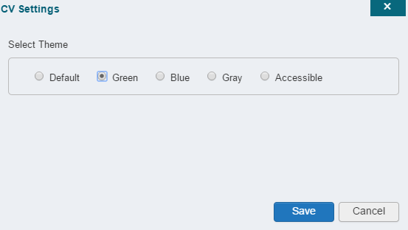Figure 8: The CV Settings Dialog

UI theme choices are displayed in the figures below. The Default theme was presented in Section 2.3.1, Default View, Figure 6.

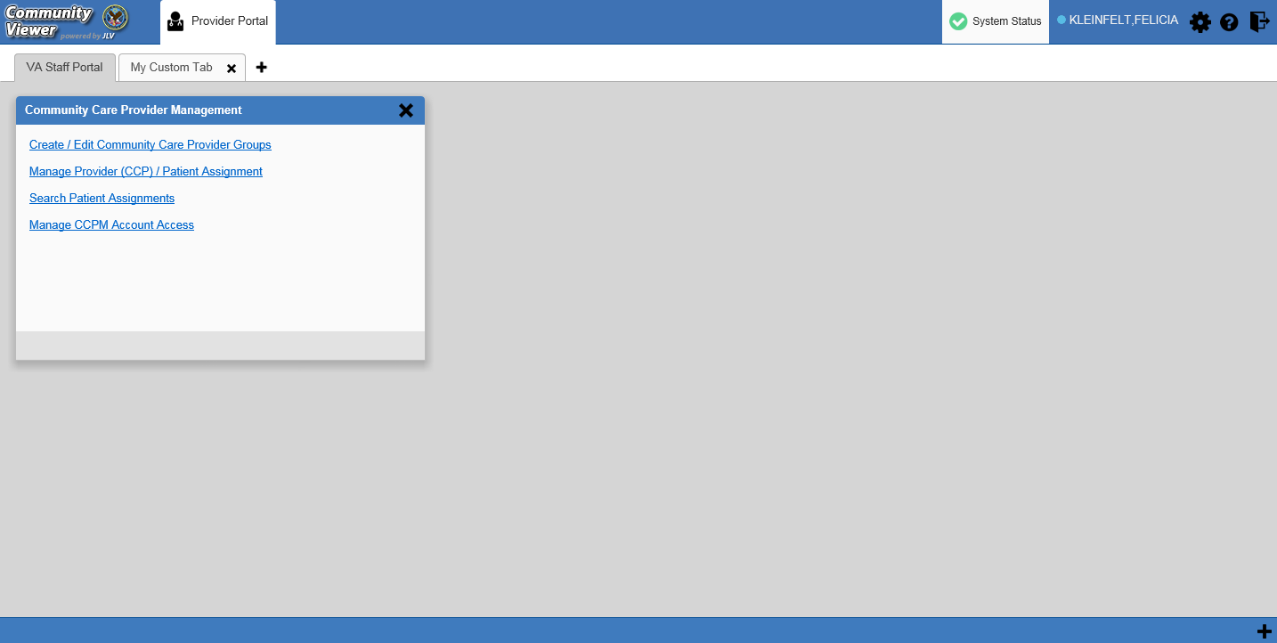Figure 9: Blue UI Theme

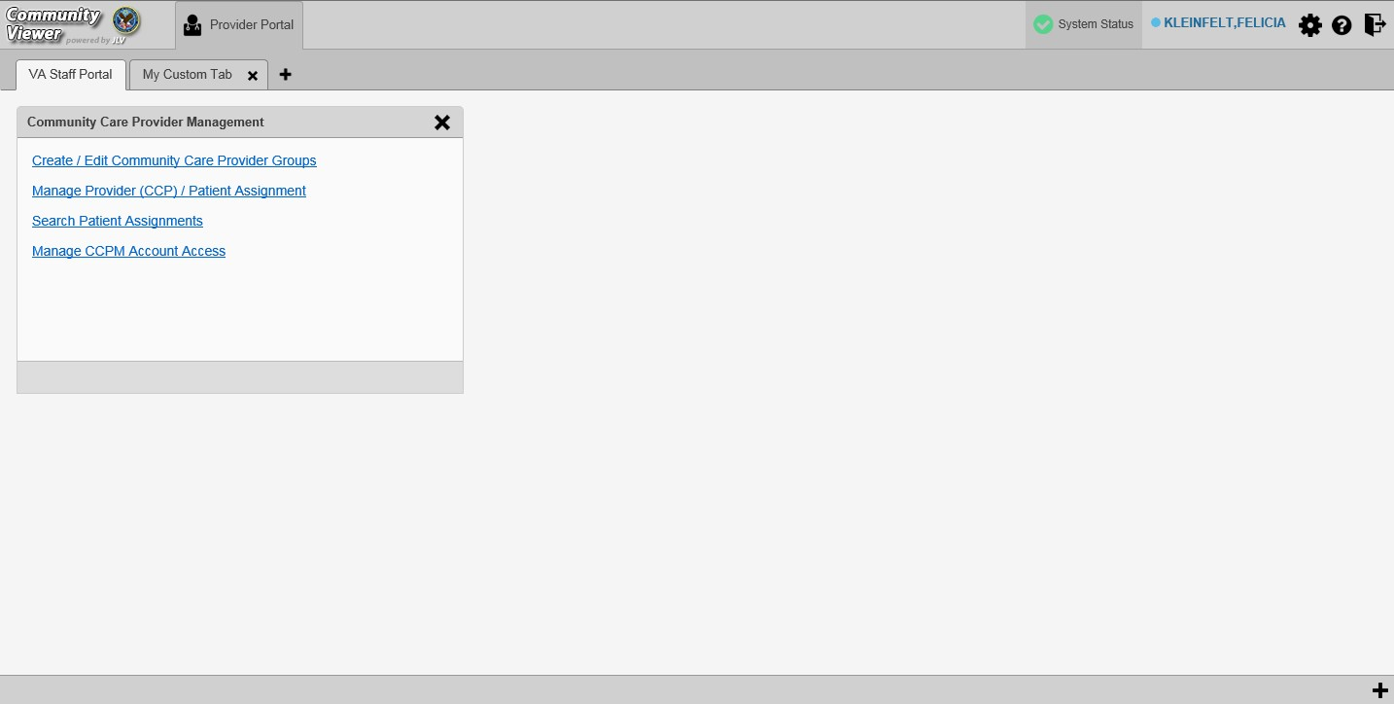Figure 10: Gray UI Theme

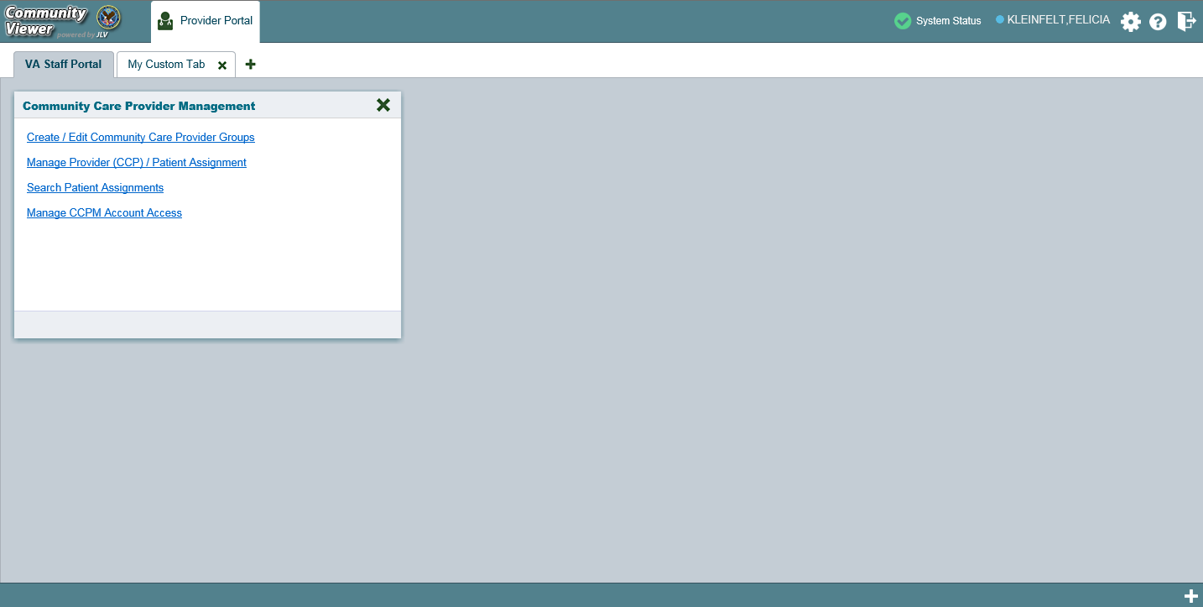Figure 11: Green UI Theme

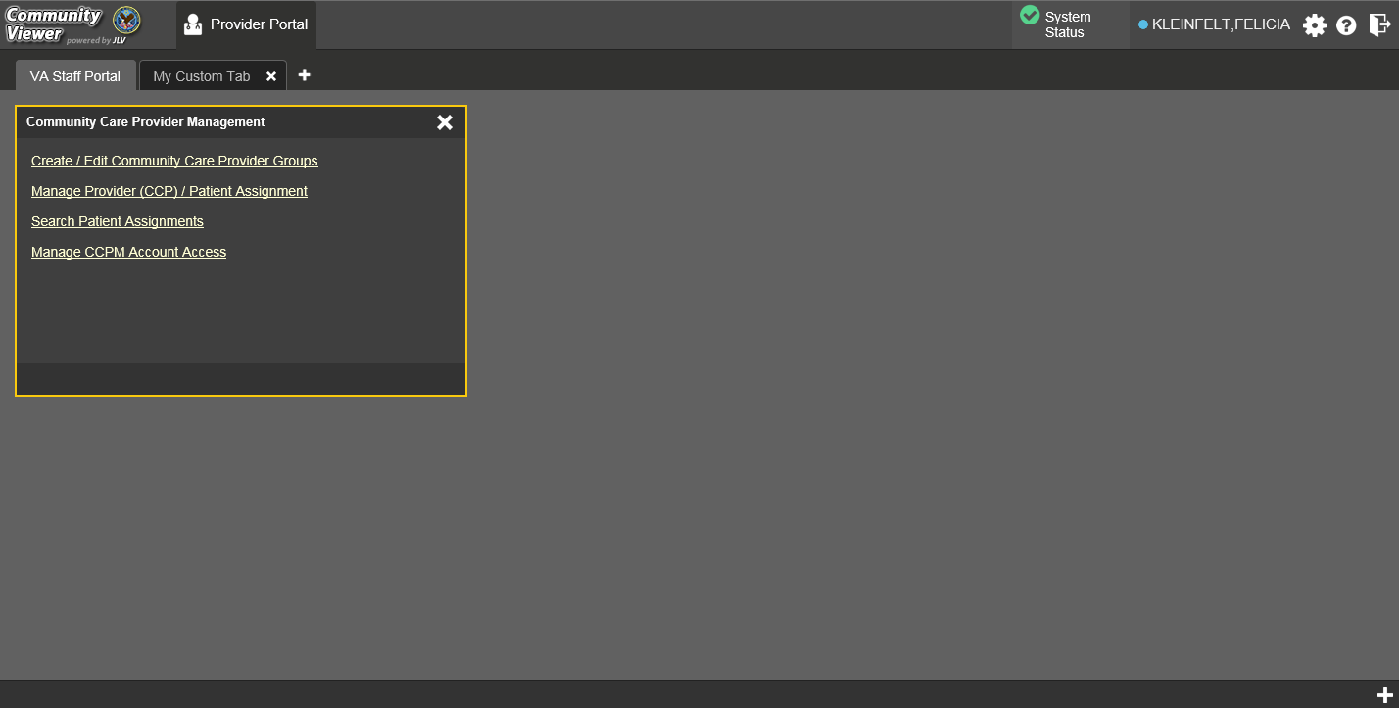Figure 12: Accessible (508-Compliant) UI Theme

    - Using the Accessible Theme’s Functionality
The Accessible theme includes larger fonts, enhanced tab and keystroke functionality, and screen reader compatibility to support Federal accessibility requirements and Section 508 compliance.

      - Keyboard Focus and Screen Navigation in Accessible Theme
Keyboard focus is the highlighting of screen elements that enables interaction with, and the navigation of, the web application through the keyboard and keystrokes. The screen element in focus is outlined in gold (Figure 12) as a visual indicator of keyboard focus.
CV enables the use of Windows keystrokes (Tab, Shift + Tab, arrow keys, Enter), and keyboard shortcuts to move the focus to all menus, and activate all functions on the menus. All UI items are accessible via the keyboard under the Accessible theme.
Pressing Enter or the Spacebar when an element that provides action is in keyboard focus performs the associated action. For example, pressing Enter or the Spacebar when the Settings icon is in focus opens the CV Settings dialog. Using the arrow keys or the Tab key allows a user to move between keyboard focus items to navigate through screen elements. A complete list of accessible keystrokes is provided in Table 1.

Table 1: Keyboard Accessible Keystrokes

Keystroke | Description
Application and Portal Navigation
Alt+4 | Press to transfer keyboard focus to the main or top screen element: Focus is transferred to the Provider Portal tab on a Portal Page.  Focus is transferred to the first link or data element in a widget.  Focus is transferred to the dialog box’s close button (X).
Alt+5 | Press on a page with two panels to toggle keyboard focus between the main or top element on left and right panels.
ENTER | Press to transfer keyboard focus to the highlighted widget.
TAB | Press to transfer keyboard focus to other UI items.
ESC | Press to return keyboard focus to the panel containing the UI item with keyboard focus or to exit a window or widget.
SPACEBAR | Press to activate any UI item (for example, click a button).
Arrow Keys | When keyboard focus is on a widget, press the arrow keys to change page viewing in a widget's data table.  When keyboard focus is on a dropdown, press the down arrow to view the contents.
Portal Tabs
Arrow Keys | Use the left and right arrow keys to navigate between tabs. Add a Tab:  - Press the right arrow key until Add Tab (+) is in focus.  - Press Enter.  - The new tab dialog box opens and prompts you to enter a name for the new tab.
TAB | Press one or more times when focus is on a portal tab to place the (+) in keyboard focus.
ENTER | Press while the (+) is in focus to add a new portal tab. A dialog will prompt the user to enter a name for the tab.
ESC | Focus on a tab and press Esc to remove it.
Windows and Dialog Boxes
TAB | Press the Tab key to move the keyboard focus to other UI items within the window.

Keystroke | Description
Adding Widgets to the Portal Pages
Alt + 1, 2, or 3 | Add a widget to a Portal Page from the Widget Tray:  - Determine which column (1, 2, or 3) of the Portal Page you want to place the widget.  - Focus on the desired widget icon in the Widget Tray.  - Press Alt + 1, 2, or 3, depending on the desired column.

2.4. Logging Out of the Current CV Session
You may intentionally log out to end a CV session by clicking Logout at any time. If you fail to log out, the current session will terminate automatically after 30 minutes of inactivity. You will be redirected to the Login page when any new activity is attempted.

Using CV
After logging in, VA Staff see the CCPM widget on the VA Staff Portal tab by default.

If the CCPM widget is not displayed, click the plus + sign in the lower right corner of the portal page (Figure 13) to open the Widget Tray. Click, hold, and drag the icon from the Widget Tray to the portal page, and drop it in the desired location.

Figure 13: Default Portal Page (Green Theme)

VA Staff create providers, assign patients to CCPs, and grant the CCP limited access to patient records within the CCPM widget.
There are four workflow options (Figure 14) within the CCPM:
- Create/Edit Community Care Provider Groups
- Manage Provider (CCP)/Patient Assignment
- Search Patient Assignments
- Manage CCPM Account Access

The Manage CCPM Account Access link is available only to CV Portal
Administrators.

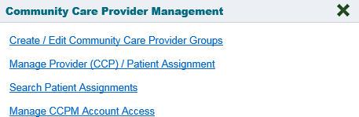Figure 14: The CCPM Widget

About Provider Groups and Facilities
Before a user can assign a patient to a CCP, the CCP must be assigned to a provider group.
CV has been prepopulated with over 200,000 groups and providers. Users can edit existing groups, but in this release, the task of creating provider groups is performed by CV Portal Administrators. Users should contact a CV Portal Administrator to request the creation of a new group.

Provider Groups are validated on the combination of the group name and street address, in order to avoid the creation of duplicates.

Each group is associated with one or more local VA sites, referred to as Facilities. A facility is a local VA site. Provider groups can contain one or more VA facilities.
EXAMPLE 1: Dr. Hanyok works with a family practice called Evergreen Health Care. In this example, Dr. Hanyok is the Provider, and Evergreen Health Care is the Provider Group to which she is assigned.
EXAMPLE 2: Dr. Woodroof, the Provider, is a sole practitioner. The Provider Group name for a sole practitioner may be a business name or can be the provider’s name; in this example, Dr.
Woodroof.

Editing Provider Groups
Provider groups can be edited through the CCPM widget (Figure 15).

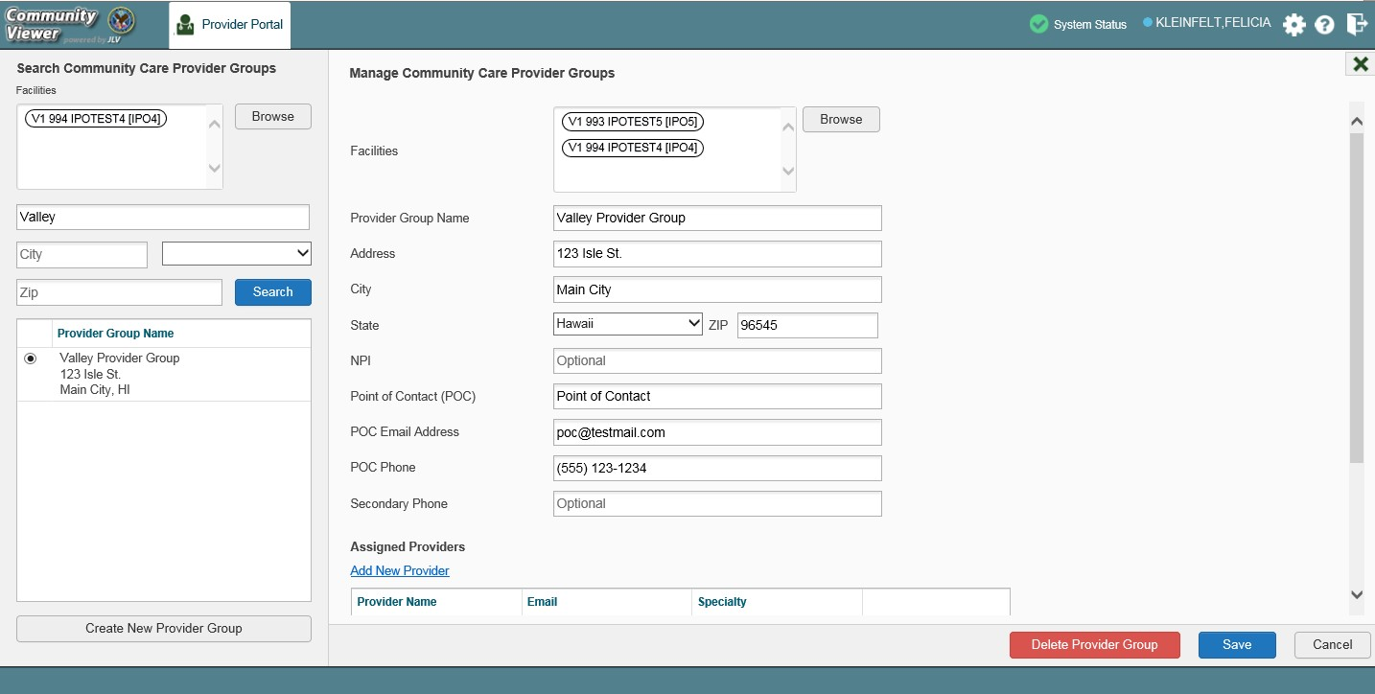Figure 15: Search and Manage CCP Groups Panes

To edit a provider group (Figure 15):
- Click the Create/Edit Community Care Provider Groups link in the CCPM widget
- Enter the provider group name in the Search field
- Click Search
- Select the desired provider group from the search results
- Edit the provider group fields as needed
- Click Browse next to the Facilities field, and select the desired facility from the list
- Providers assigned to the provider group are listed in the lower right portion of the screen
  - Edit provider profiles or remove providers from the group using the Edit link within the
Assigned Providers list (Figure 16)
- Click Save

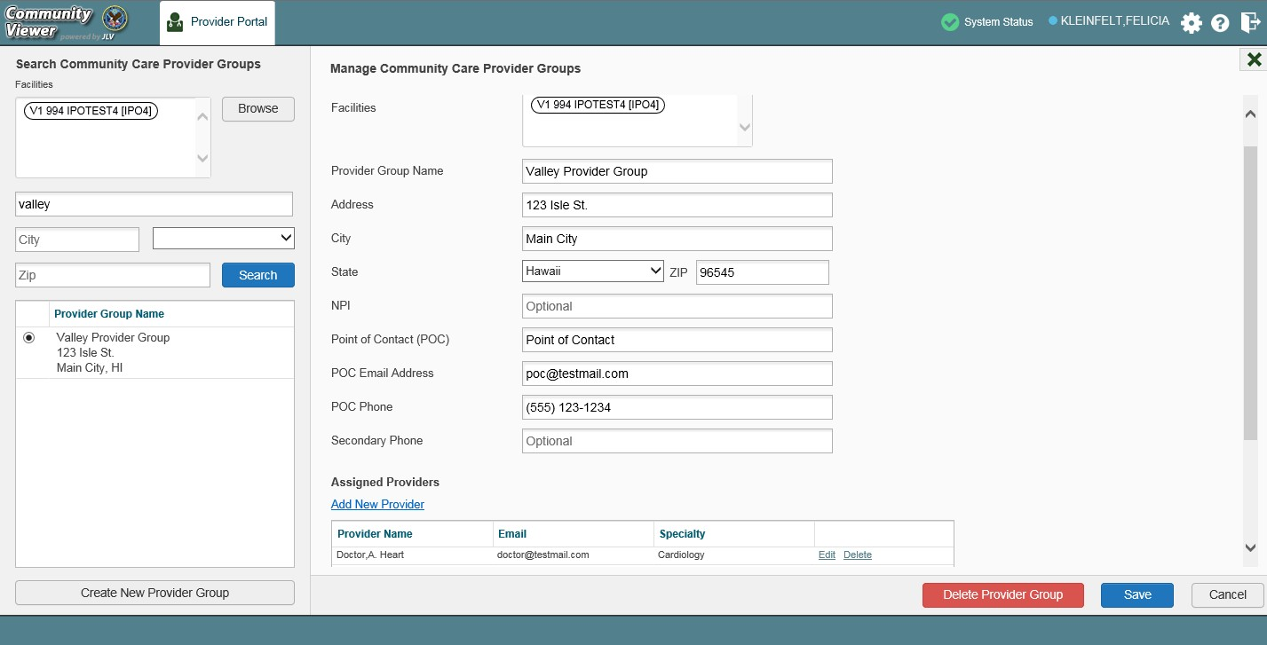Figure 16: Search and Manage CCP Groups Panes, Assigned Providers Edit and Delete Links

In this release, the tasks of adding new groups and deleting providers are performed by CV Portal Administrators. VA Staff users will not see the Create New Provider Group button, the Delete Provider button, or the Delete link. Contact a CV Portal Administrator for assistance with these tasks.

    - Deleting a Provider Group
CV Portal Administrators may only delete a provider group when the individual providers within that group have no patient assignments. If any patients are assigned to a provider within the provider group, the error message in Figure 17 will display. Section 3.2.6, Assigning and Unassigning Patients, details steps to unassign patients from an individual provider.

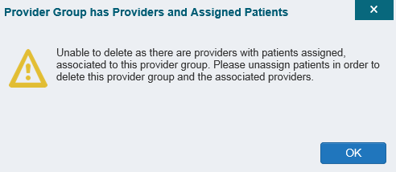Figure 17: Provider Group Deletion Error Message

To delete a provider group:
- Click the Create/Edit Community Care Provider Groups link in the CCPM widget
- Enter the provider group name in the Search field
- Click Search
- Select the desired provider group from the search results
- Select the Delete Provider Group button
A CV Portal Administrator can delete providers along with their associated provider group as long as they do not have patients assigned. If the provider group has associated providers that you intend to also delete, select the Yes button when prompted.

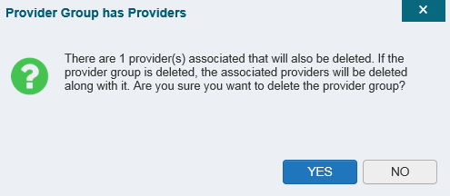Figure 18: Provider Group Has Providers Without Patient Assignments

    - Creating Provider Accounts
All CCP accounts are created in the CCPM widget. When a CCP account is created, so is their user profile. Users can assign patients to CCPs once their account has been created.
To create a provider:
- Click the Manage Provider (CCP)/Patient Assignment link (Figure 14) in the CCPM
widget
- Click Create New Provider in the Search Providers pane, on the left side of the application window, as shown in Figure 19
  - The Create/Edit Provider pane opens on the right side of the application window
- Click Browse to the right of the Provider Group field to search for an existing group
- Select the desired group from the list of results and click OK

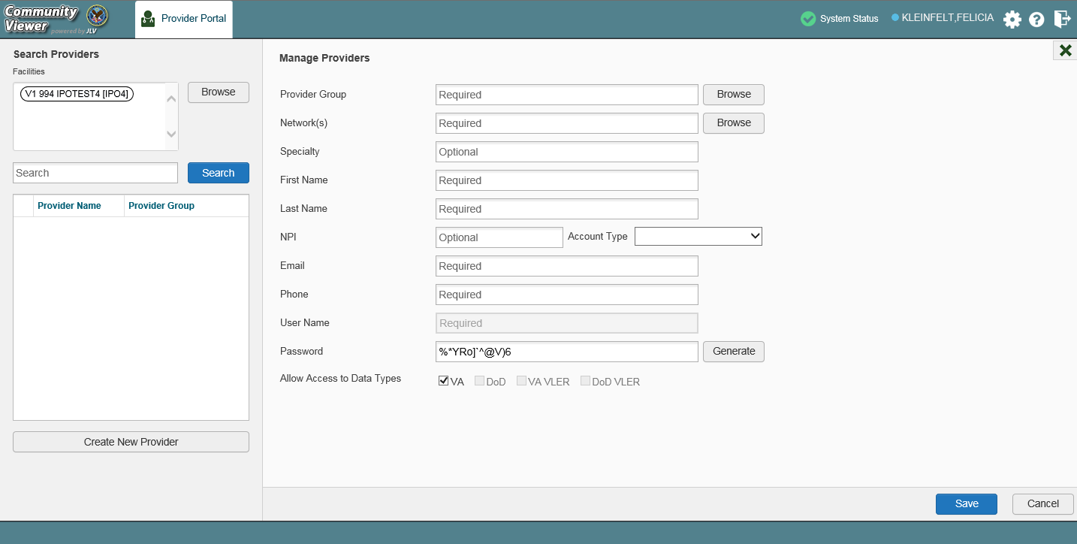Figure 19: Search Providers and Manage Providers Panes

- Enter the provider information in each of the required fields on the Manage Providers pane (Figure 19)

Providers are differentiated by their e-mail address. When a new provider is created, the e-mail address, which also serves as the provider’s username, is validated in order to avoid the creation of duplicates. If an e-mail address is already associated with a provider in CV, a, “Username already exists”
message displays (Figure 20).

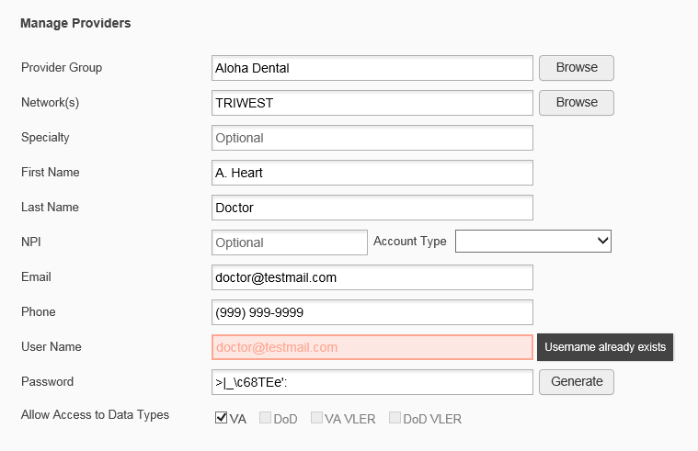Figure 20: Username Already Exists Error Message

- Click Browse to select the Provider Group
- Click Browse to select the Network(s) to which the provider belongs from the following options: Health Net, PC3, Provider Agreement, TriWest, or Other
  - A free-text field labeled Other Network opens when Other is selected
- Enter a Specialty as needed
- Enter the provider’s First Name and Last Name
- Enter the provider’s National Provider Identifier (NPI) if available
- Select Outside Provider from the Account Type dropdown
- Enter the provider’s E-mail address and Phone number
- The User Name field is automatically populated with the address entered in the Email field
- Click Generate to have the system create the CCP’s password
- Users can manually enter a password that meets 6500 security compliance criteria , then select the Save button

Passwords are case-sensitive.
- Record the User Name and Password as displayed
  - It is the responsibility of VA Staff to securely provide the CCP with his/her user name and password for CV using VirtuPro or phone
- Click Save
- When the Provider successfully created message appears, there are two options:
  - Click Assign Patients and follow the steps outlined in Section 3.2.6, Assigning and Unassigning Patients
-OR-

  - Click OK to return to the CCPM widget
CCPs can now request access to CV from the CCP Login page. When a CCP clicks the New User link, s/he sees a message directing them to contact their local VA Medical Center for access. They are then given a link to a list of VA points of contact (POCs) from whom they can request access to the application.

    - Editing Provider Profiles
You can edit a CCP’s profile using the CCPM widget. To edit a CCP’s information in his/her profile:
- Click the Manage Provider (CCP)/Patient Assignment link in the CCPM widget
- Enter the provider name in the Search field, and click Search
- Select the desired provider from the search results (Figure 21)
- Edit the provider information in the fields provided, as necessary
- Click Save

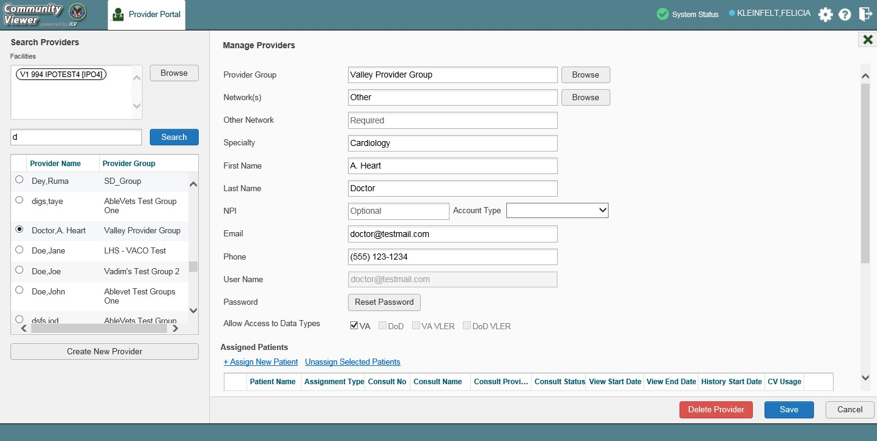Figure 21: Search Providers and Manage Providers Panes

If a provider is assigned to the wrong group, you can assign the provider to a different, existing group on this screen.
If the provider will be added to another practice group, users must click Add New Provider in the Search Providers pane and create the provider within the additional practice group. The provider name can be the same, but a different e-mail address must be used for each unique provider.

    - Resetting Provider Passwords
If a CCP user has forgotten his/her password, there is a Forgot Password? link on the Login page. Clicking the link opens a window that enables the user to send a password reset request directly to Community Provider Technical Service Desk. Password resets can also be performed by VA Staff, using the CCPM widget.
To reset a CCP’s password:
- Click the Manage Provider (CCP)/Patient Assignment link in the CCPM widget
- Enter the provider name in the Search field
- Click Search
- Select the desired provider from the search results
- Click Reset Password (highlighted in Figure 22) in the Manage Providers pane
- Click Generate to allow the system to create a new, random password
- Users can manually enter a password that meets 6500 security compliance criteria, then select the Save button
- Record the new password
  - It is the responsibility of the VA Staff user to securely provide the CCP with his/her password for CV using VirtuPro or phone
- Click Save

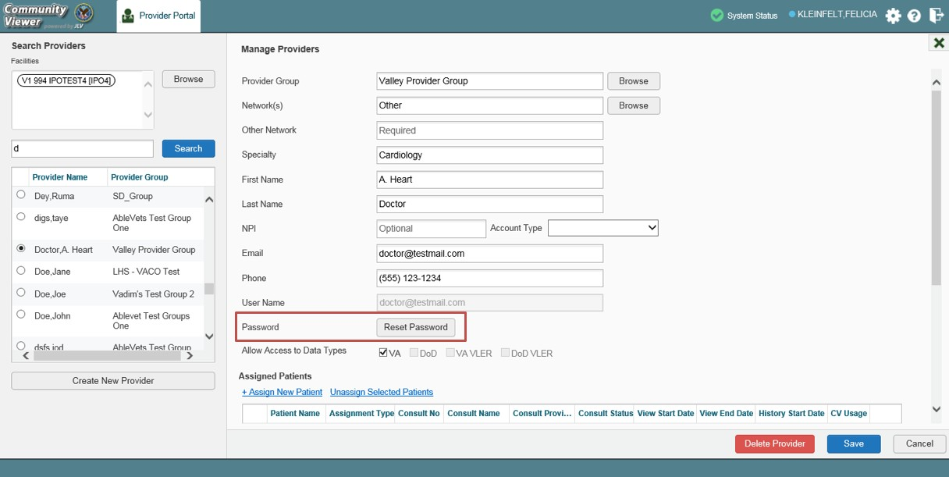Figure 22: CCP Password Reset

    - Searching Within the CCPM Widget
CV’s search feature is used to find a provider group, a provider, or a patient who will be assigned to a provider. There are two types of patient searches in CV:

- My Site Search: Searches the user’s local VistA; the patients listed in the search results are registered to that local VistA only
- Enterprise Search: Searches all VistAs across the Enterprise; the patients listed in the search results are registered to one or more VistAs

In this release, an Enterprise Search can only be performed by a CV Portal Administrator.

When using the Create/Edit Community Care Provider Groups feature, users can perform a detailed search within Search Community Care Provider Groups (Figure 23):
- Search by facility, or provider group name, or city and state, or zip code
- Search by facility name, facility short name, or site ID
- Sort the facilities list by state, when browsing for a facility

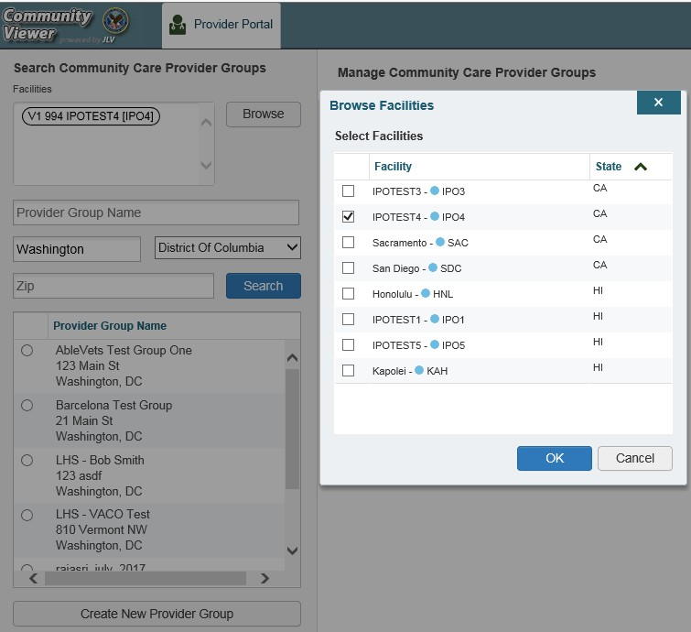Figure 23: Browse Facilities Dialog Box–CCP Provider Groups

When searching for a Community Care Provider Group, users will:
- See the VISN, site ID, facility name, and facility short name within the search results
- Receive a notification to refine the search by inputting additional search criteria when a large number of results are returned (Figure 24)

NOTE: Figures 23 and 24 depict searches within and information from test databases.

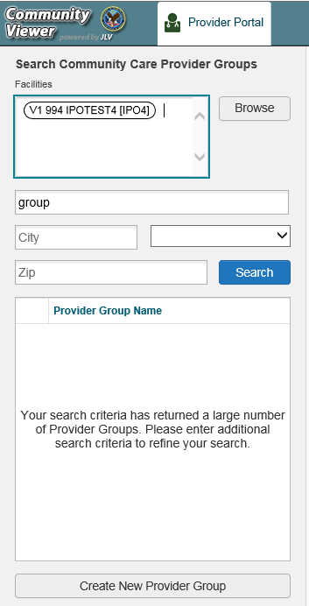Figure 24: CV CCP Group Search Too Many Results Notification

When using the Patient search and the Patient Assignment search features, search results display with the ability to scroll through multiple pages or select a specific page.
Please see Section 3.2.6, Assigning and Unassigning Patients, for detailed instructions on how to run a My Site search.

    - Assigning and Unassigning Patients
Once the CCP’s account has been created, patients can be assigned to them.

If you chose Assign Patients immediately after creating the provider, the search pane is prepopulated with that provider’s profile information, and no search is necessary.

To assign patient(s) to a CCP:
- Click the Manage Provider (CCP)/Patient Assignment link in the CCPM widget
- Enter the provider’s name in the field to the left of the Search button within the Search Providers pane (Figure 25)
- Click Search

Figure 25: Search Providers Pane

In this release, the task of deleting a provider is performed by CV Portal Administrators. VA Staff users will not see the Delete Provider button. Instead, they must contact a CV Portal Administrator to request that a provider be deleted.

- Select the Provider from the list of results
  - The Manage Providers pane opens with the provider’s information
- Click the + Assign New Patient link (highlighted in Figure 26)
  - The Patient Search dialog opens

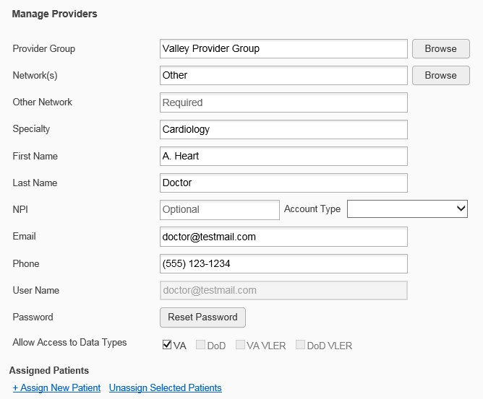Figure 26: Manage Providers Fields Detail

- Enter the patient name in the blank field at the top of the Patient Search dialog (Figure 27)
- Select the My Site search option and enter the search criteria:
  - The patient's last name, followed by a comma and either the first initial or full spelling of the patient's first name (Smith, J or Smith, John)
  - You may also enter the patient's full Social Security Number (SSN) (123456789), or first letter of the patient's last name followed by the last 4 digits of the patient’s SSN (S6789)

In this release, only CV Portal Administrators can see the option for, and
perform, an Enterprise patient search.

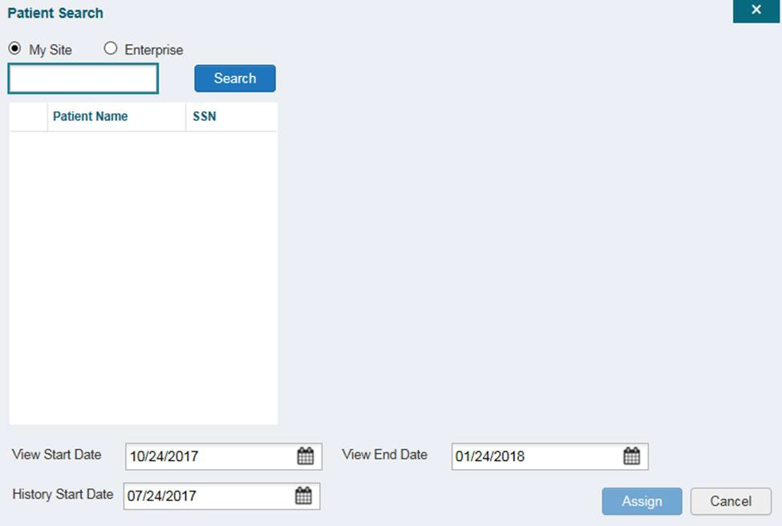Figure 27: Patient Search Dialog Box

- Click Search
- Select a patient from the search results list
- Select the Assignment Type from the dropdown: 30 Day Wait, Consult, Distance-Eligible (40 mile), or Episode of Care
  - If Consult is specified, select one consult record from the list for the selected patient. The consult status must be Active or Scheduled for the consult to appear in the list
- If desired, adjust the default View Start Date, View End Date, and History Start Date
fields to restrict the data seen by the CCP (See Section 3.2.7, Setting Record Display Limits.)
- Click Assign
CV uses the following rules to manage patient assignments:
- A specific Veteran may be assigned to multiple CCPs
- A Veteran may be assigned to more than one CCP for the following Assignment Types:
  - 30 Day Wait
  - Distance Eligible
  - Episode of Care
- A specific Veteran/consult combination may only be assigned to a single CCP

Table 2: Assignment Rules Examples
 | Veteran John Davis has multiple active referrals to be assigned:
Referral 1 |  | 30 Day Wait for Dental | Assign to CCP A | A Veteran may have multiple, active assignments in a particular Assignment Type
Referral 2 |  | 30 Day Wait for Podiatry | Assign to CCP B
Referral 3 |  | 30 Day Wait for Podiatry | Assign to CCP C
Referral 4 |  | Episode of Care for Optometry | Assign to CCP D
Referral 5 |  | Consult for Cardiology | Assign to CCP E | This specific consult can only be assigned to one CCP at a time
Referral 6 |  | Consult for Chiropractic | Assign to CCP F | This specific consult can only be assigned to one CCP at a time
To unassign patient(s) from a CCP:
- Repeat steps 1–4 from the CCPM widget or select the Edit link from the Manage CCP Groups pane (Figure 16) to navigate to the Manage Providers pane
- Click the Unassign Selected Patients link (highlighted in Figure 26)

    - Setting Record Display Limits
Users can limit the patient records made available to the assigned CCP. There are two settings that control access to patient data:
- View Start Date and View End Date: These fields set the length of time the CCP will have access to the patient records through CV
  - The default View Start Date is the date the patient is assigned to the CCP
  - The default View End Date is 3 months from the default start date
- History Start Date: This setting represents how far back in a patient's VA medical history the CCP is permitted to view
  - For example, if the history start date is set to 01/01/2012, the CCP has access to the patient's records from available VA facilities from 2012 to present
Data access controls are set by the user during the patient assignment process. To set the Data Access Controls:
- Click the Calendar icon next to the View Start Date and the View End Date fields
- Select the start and end dates (Figure 28)
- Alternatively, click the calendar icon next to the History Start Date
- Select a date
- Click Assign

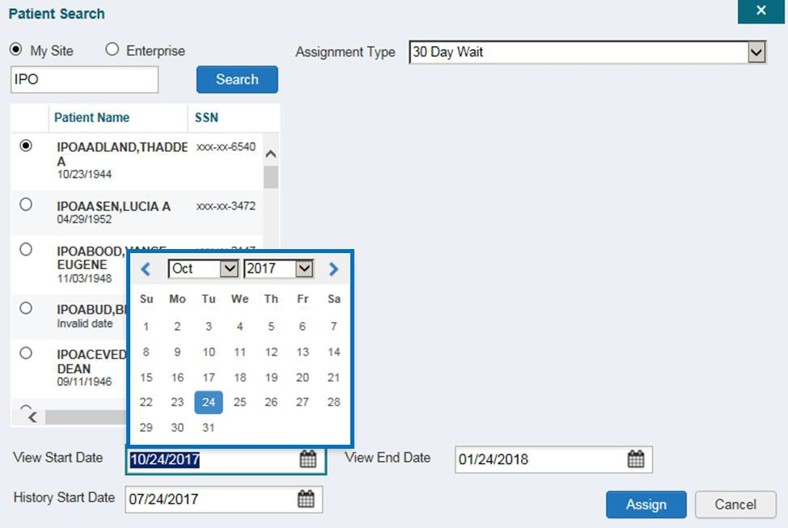Figure 28: Data Access Controls

Widgets: What Community Providers See
Once the CCP has been granted access to CV, they can see their assigned patient’s VA health information on the Patient Portal. Patient data is presented through widgets (Figure 29), each displaying data specific to an administrative or clinical domain. The Encounter, Results, Medications, Documents, Consults, and Immunization tabs provide unique widget layouts.

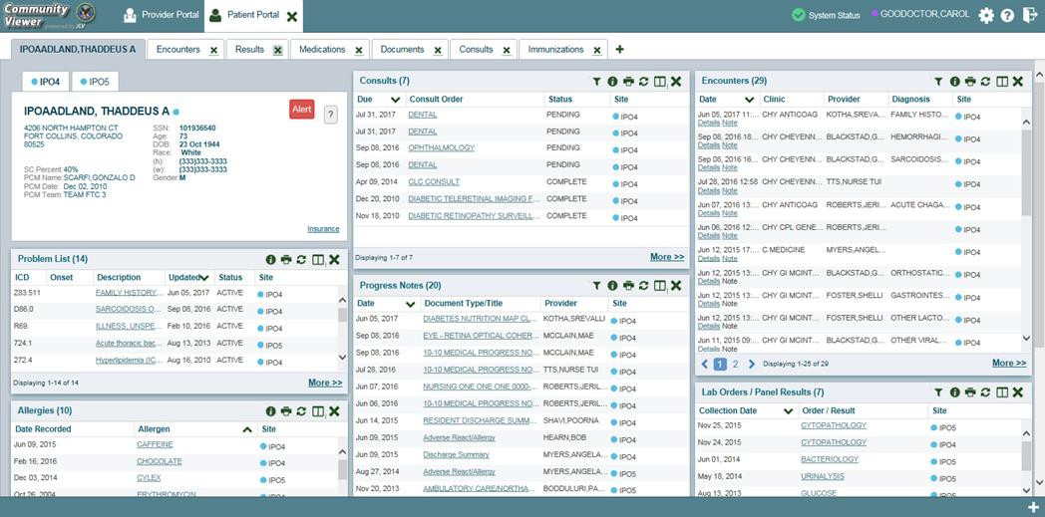Figure 29: Widget Display on the Patient Portal
**Primary Care Management (PCM)
All widgets available for display on the Patient Portal are housed in a horizontal tray at the bottom of the page, the Widget Tray. When customizing their view of CV, CCPs click the + icon in the lower right corner of the page (Figure 29) to open the Widget Tray.
The widgets that are available for display on the Patient Portal are:

- Patient Demographics  - Admissions  - Allergies  - Appointments  - Clinical Reminders  - Consults  - Discharge/Essentris Notes  - Encounters  - Immunizations  - Inpatient Medications | - Lab Panel Results  - Lab Results  - Outpatient Medications  - Orders  - Problem List  - Procedures  - Progress Notes  - Radiology Exams  - Vitals

Nondiagnostic Images
Nondiagnostic images are available in JPEG format from the Encounters, Progress Notes, and
Radiology Exams widgets.
A Camera icon in the Image column of a widget in minimized view indicates one or more images are associated with that record (Figure 30). Clicking the Camera icon in a supported widget opens the list of images associated with the record. See Figure 32 and Figure 33 below.

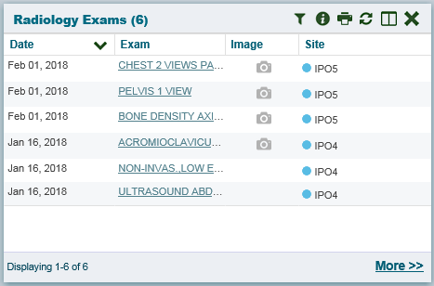Figure 30: Radiology Exams Widget (Minimized View)–Nondiagnostic Images

Clicking the Click Image to open Viewer link in the Detail view (Figure 31) of a widget opens the list of images associated with that record.

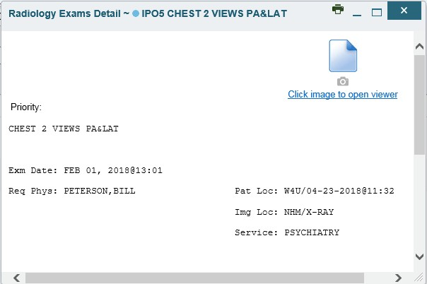Figure 31: Radiology Exams Detail–Nondiagnostic Images

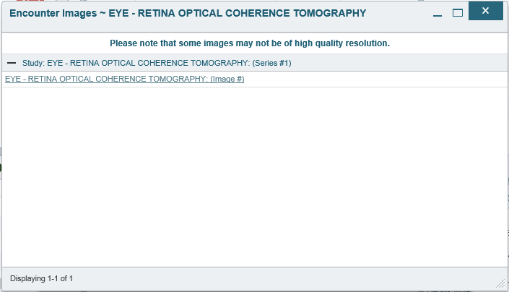Figure 32: Single Encounter Nondiagnostic Image

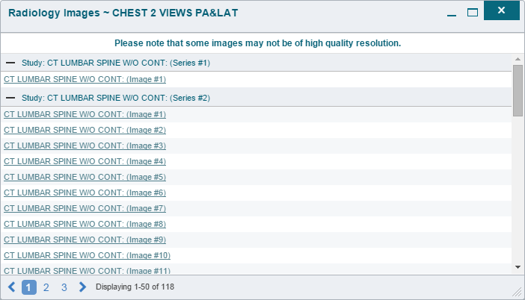Figure 33: Multiple Radiology Nondiagnostic Images

If an image is temporarily unavailable, users will see a “System is unable to retrieve images at this time” message (Figure 34).

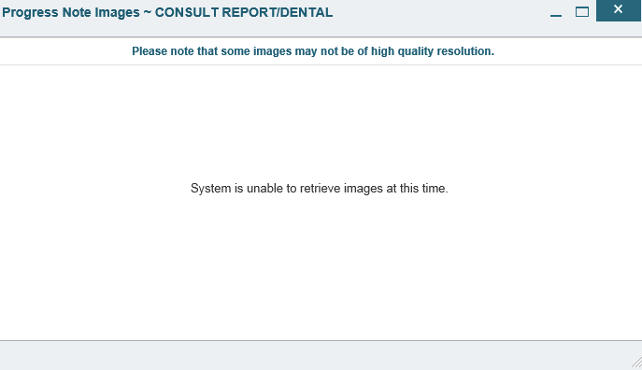Figure 34: Progress Note Images–Unable to Retrieve Images Error

Troubleshooting

Special Instructions for Error Correction
Access to CV is limited to registered, authorized users. CV validates user access against information retrieved from your smart card. If you are experiencing trouble logging in to CV, please review Table 3 before contacting the service desk.

Table 3: Login Page Error Message Troubleshooting

Error Message | Resolution Steps
Access denied. You are not an authorized user. | WHAT? Error message indicating Access Denied. You are not an authorized User.  WHY? PIV card processing problem or invalid security certificate chosen.  FIX IT:  - Close browser window.  - Reinsert PIV card and relaunch the CV link.  - Select a certificate that is not expired and specifies Issued by: Veterans Affairs CA B1.  If this is unsuccessful, fully reboot your system. This refreshes all connections and resolves greater than 95% of any remaining problems.
Could not save User Profile | WHAT? Error message indicating Could not save User Profile.  WHY? Error occurred during PIV authentication for VA users. Typically, this is a PIV card processing problem, or an invalid security certificate chosen.  FIX IT:  - Close your browser window.  - Reinsert PIV card and relaunch the CV link.  - Select a certificate that is not expired and specifies Issued by: Veterans Affairs CA B1.  If this is unsuccessful, fully reboot your system. This refreshes all connections and resolves greater than 95% of any remaining problems.
Not a valid ACCESS/VERIFY  CODE pair | WHAT? Receive Not a valid ACCESS CODE/VERIFY CODE pair error on the Login page.  WHY? 1) CV could not match your Access and Verify codes to the Site selected in the dropdown or VA; or 2) A username and password were entered instead of Access/Verify codes.  FIX IT:  - Veterans Health Administration (VHA) users must select the parent VistA host site for their facility.  - Reenter correct Access and Verify codes (Computerized Patient Record System (CPRS) or VistA codes for VHA users).

Error Message | Resolution Steps
Page cannot be displayed | WHAT? You receive a Page cannot be displayed error when launching CV.  WHY? The CV URL requires certain IE settings.  FIX IT:  - With IE open, click the Tools menu or press ALT-X.  - Select Internet Options.  - When the dialog opens, select the Advanced tab.  - Scroll down in the list until you see the settings below and ensure Secure Socket Layer (SSL) 2.0 is NOT checked and that Transport Layer Security (TLS) 1.0, 1.1, and 1.2 are checked.  - Click OK, then relaunch CV and the page should load.
Smart Card required | WHAT? Error Message Smart Card Required.  WHY? Smart card not read by Windows Security and CV before launching CV link.  FIX IT:  - Close all browser sessions/browser-based applications.  - Reinsert PIV card and relaunch CV link.  - If this is unsuccessful, fully reboot your system to refreshes all connections. This resolves greater than 95% of any remaining problems.
VERIFY CODE must  be changed before continued use | WHAT? Receive VERIFY CODE must be changed before continued use error  on the Login page.  WHY? CPRS VERIFY CODE has expired.  FIX IT:  - Open CPRS.  - Select the Change Verify Code checkbox on the sign-on dialog before clicking OK.  - You are prompted to create a new Verify Code.  - Once your Verify Code is changed for CPRS, CV recognizes the new code immediately.

    - Patient Search Errors
The following error messages may appear when you are searching for a patient in the CCPM widget. If you are experiencing errors while searching for patients, please review Table 4 before contacting the service desk.

Table 4: Patient Search Error Messages and Resolution Steps
Error Message | Resolution Steps
An invalid search criteria was entered. Please enter at least 2 characters. | Invalid patient name entered. Please try your search again.  When searching by patient name, enter at least two characters of the patient’s first and last name. Search results will display the closest match to the characters entered in the format of [last name], [first name].
An invalid SSN format was entered. Please enter a 9-digit SSN. | Invalid SSN entered. Please try your search again.  When searching by patient SSN, you are required to enter the patient’s full 9- digit SSN. Dashes are allowed (e.g., 123-45-6789).

Error Message | Resolution Steps
An invalid last 5 format was entered. Please enter the first letter of the last name followed by the last 4- digits of the SSN. | Invalid patient name or SSN entered. Please try your search again.  Patient search allows you to search for a patient using the first initial of the  patient’s last name and the last four digits of the patient’s SSN. Please try your search again using the first initial of the patient’s last name and the last four digits of the patient’s SSN.
An error occurred during your search. Please try your search again. | This error may display when invalid patient identifiers were entered, or an error occurred at the service layer or with an external system. Please try your search again.

Acronyms and Abbreviations
Table 5 lists the acronyms and abbreviations used throughout this document and their descriptions.

Table 5: Acronyms and Abbreviations
Acronym | Description
BIM | Business Integration Manager
CCP | Community Care Provider
CCPM | Community Care Provider Management
CPRS | Computerized Patient Record System
CV | Community Viewer
ESD | Enterprise Service Desk
GUI | Graphical User Interface
IE | Internet Explorer
MVI | Master Veteran Index
OIT | Office of Information and Technology
PCM | Primary Care Management
PIN | Personal Identification Number
PIV | Personal Identification Verification
SSL | Secure Socket Layer
SSN | Social Security Number
TLS | Transport Layer Security
UI | User Interface
URL | Uniform Resource Locator
VA | Department of Veterans Affairs
VDS | VistA Data Service
VHA | Veterans Health Administration
VistA | Veterans Health Information Systems and Technology Architecture

