Community Viewer (CV) Version 2.8 User Guide for VA Staff

September 2018
Version 1.1

Department of Veterans Affairs (VA) Office of Information and Technology (OIT)

Revision History

Date | Version | Description | Author
08/28/2018 | 1.1 | PM approved | AbleVets
08/27/2018 | 1.1 | Review comments addressed. Submitted for PM approval | AbleVets
08/15/2018 | 1.0 | Submitted for review in Rational | AbleVets
07/23/2018 | 0.1 | Initial draft created from last approved | AbleVets

Table of Contents

- Introduction 1
  - Purpose of the Guide 3
    - Guide Conventions 3
    - Terminology 3
  - Assumptions 4
  - System Requirements 4
  - Getting Help 4
- Logging in to CV 5
  - System Notifications 6
    - Viewing Announcements 6
  - Editing Your User Profile at Log in 7
  - The CV Portal Pages 7
    - Default View 7
    - Viewing System Status 8
    - Profile Settings 9
    - Using the Accessible Theme’s Functionality 11
      - Keyboard Focus and Screen Navigation 12
      - Accessible Theme Screen Navigation 13
2.4. Logging Out of the Current CV Session 15
- Using CV 15
  - Searches 16
    - Provider Group Search 16
    - Provider Search 18
    - Patient Search 19
  - About Provider Groups and Facilities 21
    - Editing Provider Groups 22
    - Deleting a Provider Group 23
  - About Provider Accounts 24
    - Creating Provider Accounts 24
    - Editing Provider Profiles 27
    - Resetting Provider Passwords 28
    - Assigning and Unassigning Patients 28
    - Setting Record Display Limits 31
- Widgets: What Community Providers See 33
  - Nondiagnostic Images 34
- Troubleshooting 37
  - Special Instructions for Error Correction 37
    - Patient Search Errors 39
- Acronyms and Abbreviations 40

Table of Figures
Figure 1: User Workflow 2
Figure 2: CV Authorized Use Only Warning 3
Figure 3: Login Page 6
Figure 4: CV Portal Tools 7
Figure 5: Default View 8
Figure 6: System Status Indicator 8
Figure 7: The CV Settings Dialog 9
Figure 8: Blue UI Theme 10
Figure 9: Gray UI Theme 10
Figure 10: Green UI Theme 11
Figure 11: Accessible (508-Compliant) UI Theme 11
Figure 12: Navigation Using Elements with Keyboard Focus 14
Figure 13: Browse Networks Dialog with Keyboard Focus 14
Figure 14: Default Portal Page (Green Theme) 15
Figure 15: The CCPM Widget 16
Figure 16: Browse Facilities Dialog Box–CCP Provider Groups 17
Figure 17: CV CCP Group Search Too Many Results Notification 18
Figure 18: Browse Facilities Dialog Box–Search Providers 19
Figure 19: My Site Patient Search 20
Figure 20: Enterprise Patient Search 21
Figure 21: Search and Manage CCP Groups Panes 22
Figure 22: Search and Manage CCP Groups Panes, Assigned Providers Edit and Delete Links 23
Figure 23: Provider Group Deletion Error Message 24
Figure 24: Provider Group Has Providers Without Patient Assignments 24
Figure 25: Search Providers and Manage Providers Panes 25
Figure 26: Username Already Exists Error Message 26
Figure 27: Search Providers and Manage Providers Panes 27
Figure 28: CCP Password Reset 28
Figure 29: Search Providers Pane 29
Figure 30: Manage Providers Fields Detail 30
Figure 31: Patient Search Dialog Box 30
Figure 32: Data Access Controls 32
Figure 33: Widget Display on the Patient Portal 33
Figure 34: Pain Management Widget (Minimized View)–Nondiagnostic Images 34
Figure 35: Radiology Exams Widget (Minimized View)–Nondiagnostic Images 34
Figure 36: Radiology Exams Detail–Nondiagnostic Images 35
Figure 37: Single Encounter Nondiagnostic Image 35

Figure 38: Multiple Radiology Nondiagnostic Images 36
Figure 39: Progress Note Images–Unable to Retrieve Images Error 36

Table of Tables
Table 1: Keyboard Accessible Keystrokes 12
Table 2: Assignment Rules Examples 31
Table 3: Login Page Error Message Troubleshooting 37
Table 4: Patient Search Error Messages and Resolution Steps 39
Table 5: Acronyms and Abbreviations 40

Introduction
Community Viewer (CV) is a browser-based software application that facilitates the secure exchange of data between Department of Veterans Affairs (VA) systems and authorized non-VA providers, known as Community Care Providers (CCPs). The exchange of data improves the coordination of care and continuity of care for VA patients receiving treatment outside of the VA network.
CV pulls information from VA health care systems in real time for viewing within a web browser. Through CV, VA Staff assign patients to CCPs and provision CCP use within the CV system, allowing CCPs access to view consolidated patient data from multiple Veterans Information Systems and Technology Architecture (VistA) systems.
This User Guide is intended for VA Staff users who use the functionality within the Community Care Provider Management (CCPM) widget of CV to:
- Create and edit providers
- Assign patients
- Search patient assignments
- Manage patient data access parameters

NOTE: There are notations throughout this guide to indicate functionality that is available only to CV Portal Administrators, VA Staff users with administrative privileges.
IMPORTANT:

CV is designed to improve the community providers’ ability to
view comprehensive VA health information for Veterans.

CV does NOT replace the creation and uploading of documentation packages to the Third Party Administrator (TPA) portals.
VA Administrative Staff must continue to create and upload documentation packages as specified in the current SOP.

Figure 1 depicts the typical user workflow.

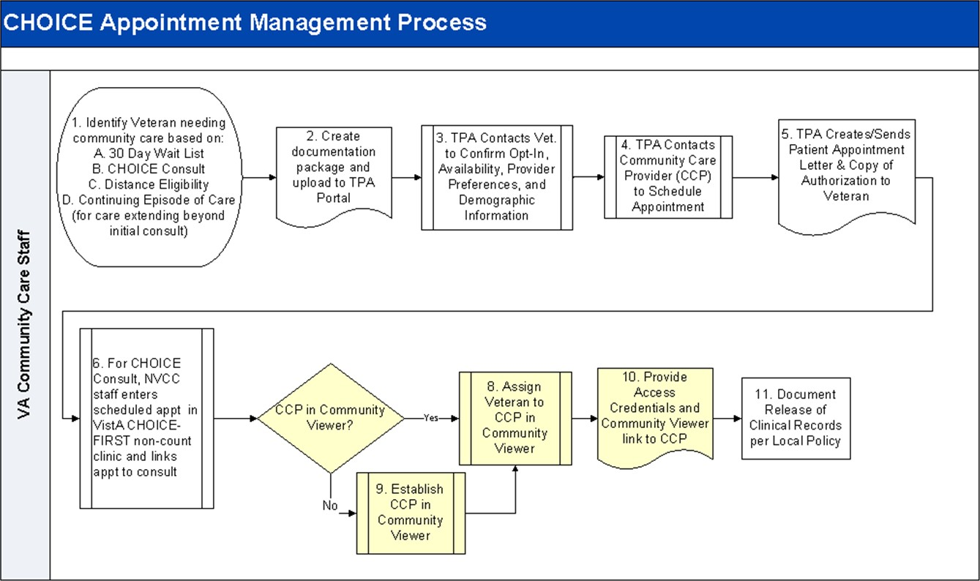
Figure 1: User Workflow

Please read and bear in mind the warning displayed in Figure 2 before using CV.

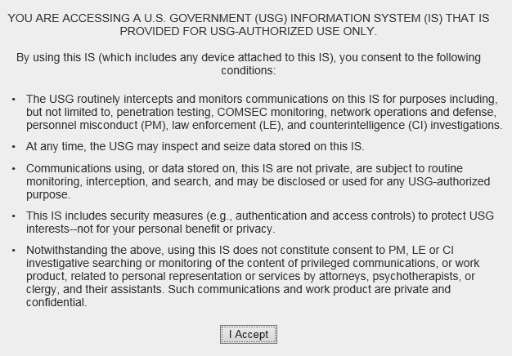Figure 2: CV Authorized Use Only Warning

Purpose of the Guide
The purpose of this user guide is to familiarize VA Staff with the important features and navigational elements of the CCPM widget of CV.

    - Guide Conventions
This document is designed for both online and hardcopy consumption.
  - Cross-References are indicated by blue, underlined text, and provide a hyperlink to figures, tables, and other sections within this guide
  - Emphasis is expressed by bold, underlined, and italicized text
  - The information symbol calls the reader’s attention to additional information
    - Terminology
The following standard terms are used throughout this guide:
  - VA Staff Portal: The landing page, or default view, of CV that appears after logging in; the portal page displays widgets and the tools that enable quick access to basic features
  - Widget: A component of the CV interface that enables a user to view information or perform a function
  - Widget Tray: An expandable and collapsible tray at the bottom of the portal page that provides access to the widgets available for placement on the portal page

Assumptions
The user guide is written from the perspective of VA Staff and assumes that:
  - You can open, navigate, and use a web browser
  - You can use web-based applications, their menu options, and navigation tools
  - You have the Uniform Resource Locator (URL) for the CV Login page, system user names, a Personal Identification Verification (PIV) card, and the Access/Verify codes required to launch CV
  - You use CCPM to make patient assignments to providers and manage providers who practice outside the VA network

System Requirements
CV is a front-end web application, designed to run in a web browser on the VA network. Accessing CV through a browser or device that is not fully compatible with the application may result in certain features not working as expected.

NOTE: This release does not support mobile devices.
It is recommended that CV is accessed from a desktop or laptop PC using a supported browser, such as:
  - Chrome v64
  - Microsoft Edge v41
  - Firefox v58
  - Internet Explorer (IE) v11
  - Safari v11

Getting Help
Authorized users who have trouble logging in to CV or experience other application issues should call the Enterprise Service Desk (ESD) for assistance, or create a ticket using the YourIT self-service portal.
IT Enterprise Service Desk
REDACTED

Prior to contacting the ESD for support, please refer to Logging in to CV for detailed information about how to access CV, and to Troubleshooting for suggested resolution steps and troubleshooting information.

Logging in to CV
Before logging in to and utilizing the functionality of the CCPM widget, please read the Sensitive Information warning in the Introduction.
CV authenticates all VA users using their PIV card and their VistA Access and Verify codes. During log in, first-time CV users are prompted to enter their agency, site, and user settings. This data is used to create a CV user profile, and it is utilized during future login sessions.
- Ensure your PIV card is inserted into your computer or card reader
- Open a supported Internet browser
- Enter the URL for the CV web application into the address bar of the browser
- When prompted with a certificate list, select the PIV Authentication certificate
- When prompted, enter your PIV Personal Identification Number (PIN)
- Click I Accept after reading the important user consent information regarding accessing a government information system (Figure 2)
- Enter the following information in the fields on the Login page (Figure 3):
  - VistA Access Code
  - VistA Verify Code
  - Select “VA” from the Agency field
  - Select your local VistA host site from the Site dropdown

NOTE: Users should review the Announcements and System Status panes on the Login page for information that may impact CV functionality or data availability. See Viewing Announcements and Viewing System Status for detailed information.

- Click Login

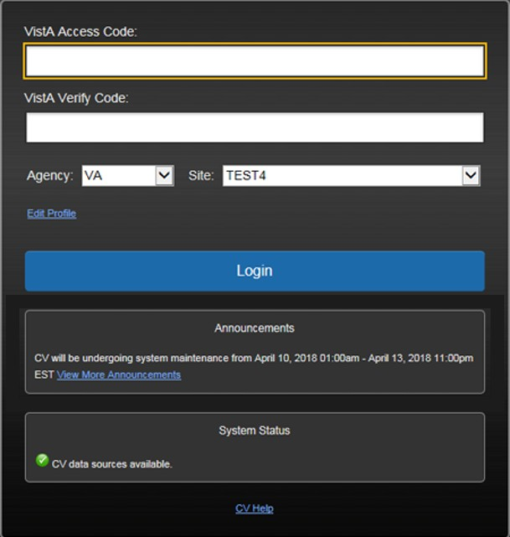
Figure 3: Login Page

NOTE: Users who are not authorized to access CV receive an “Access denied” message. If you believe you have received the message in error, please contact the ESD. See Getting Help for details.

System Notifications
The CV Login page displays system notifications to alert you to system outages, scheduled system activities, and important upgrades. The Login page also displays a notification when your VistA Verify code must be reset. The CV Help link opens CV online help, which guides you through the steps to reset your Verify code.

    - Viewing Announcements
System announcements are provided by the VA and displayed on the Login page when scheduled system activities may impact the user or CV system availability. The View More Announcements link opens additional announcement information.

NOTE: Announcements are separate from the system status messages displayed on the Login page. See Viewing System Status for details.

Editing Your User Profile at Log in
Users can customize their profile from the Login page. First-time CV users are prompted to enter their agency, site, and User Interface (UI) theme settings before logging in. Once saved, the profile information is used each time you log in to CV.
UI theme preferences can also be set within CV. See Profile Settings.
- Click the Edit Profile link on the Login page
  - Profile options are presented
- Enter your VistA Access and Verify codes in the fields provided
- Enter your agency and site in the fields provided
- Select the desired UI theme
- Click Save and Login

The CV Portal Pages
The CV portal pages have tools that enable quick access to basic features. These tools appear in the upper right corner of the application window (Figure 4).
- Select the UI theme: Click Settings to select the UI theme (See Profile Settings)
- Access online help: Click Help to open web-based, online help
- Log out: Click Logout to terminate the current CV session

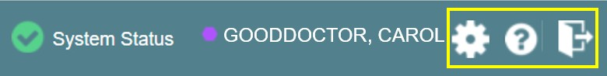Figure 4: CV Portal Tools

    - Default View
After logging in to CV, the VA Staff Portal opens. The default view of the VA Staff Portal
includes the CCPM widget (Figure 5).

NOTE: If the CCPM widget is not displayed, click the plus + sign in the lower right corner of the screen (Figure 5) to open the Widget Tray.
Click, hold, and drag the icon from the Widget Tray to the screen, and drop the widget in the desired location.

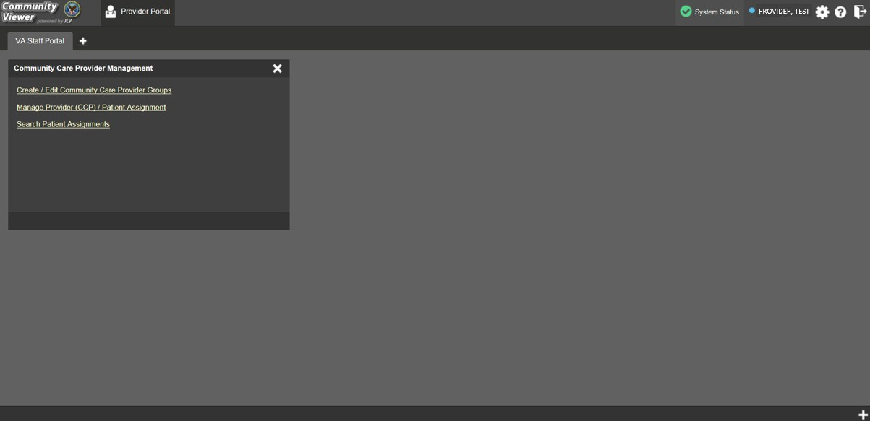Figure 5: Default View

    - Viewing System Status
CV’s Health Monitor provides system status updates and monitors the services CV uses to connect to VA data sources. The services that are monitored include: Master Veteran Index (MVI), VistA Data Service (VDS), and jMeadows Data Service.
The system status is displayed in two areas:
- On the Login page (Figure 3)
- Atop the VA Staff portal page (Figure 6)
When all monitored systems and services are online and connected, a green icon appears next to the status with the message, “CV data sources available” (Figure 3).
When one or more monitored systems or services are offline or unavailable, a yellow warning icon appears with the message, “CV is having problems.”
When CV’s health monitor is unable to retrieve and report system status information, a red icon appears with the message, “System status is unavailable.” When this status appears, you may
not be able to log into CV or view patient data until the connection is restored. See Getting Help for information on how to contact the ESD.

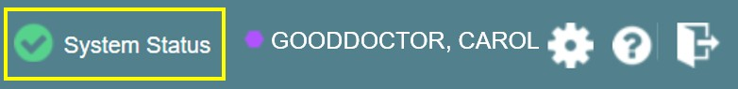Figure 6: System Status Indicator

    - Profile Settings
Profile settings are accessible within CV by clicking Settings located in the upper right corner of the portal pages (Figure 5).

NOTE: The configuration options are limited to choosing a UI theme in this release.
Selecting a UI Theme sets the font color, foreground, and background colors of the CV Graphical User Interface (GUI). Themes apply to all application elements, including widgets, toolbars, and dialog boxes. Theme choices are Default, Green, Blue, Gray, and Accessible. The Accessible theme (Figure 11) is 508-compliant, and it is designed to work with the accessibility tools installed on a user’s device.
- Click Settings in the upper right corner of the portal pages
- The CV Settings dialog opens (Figure 7)
- Click the radio button next to the desired theme
- Click Save
- Click Cancel to exit the CV Settings dialog and restore the previous theme

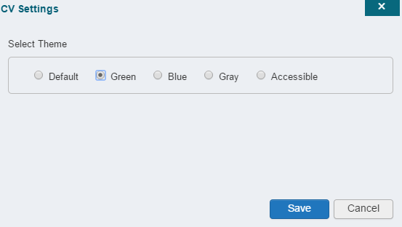Figure 7: The CV Settings Dialog

UI theme choices are displayed in the figures below. The Default theme was presented in Default View, Figure 5.

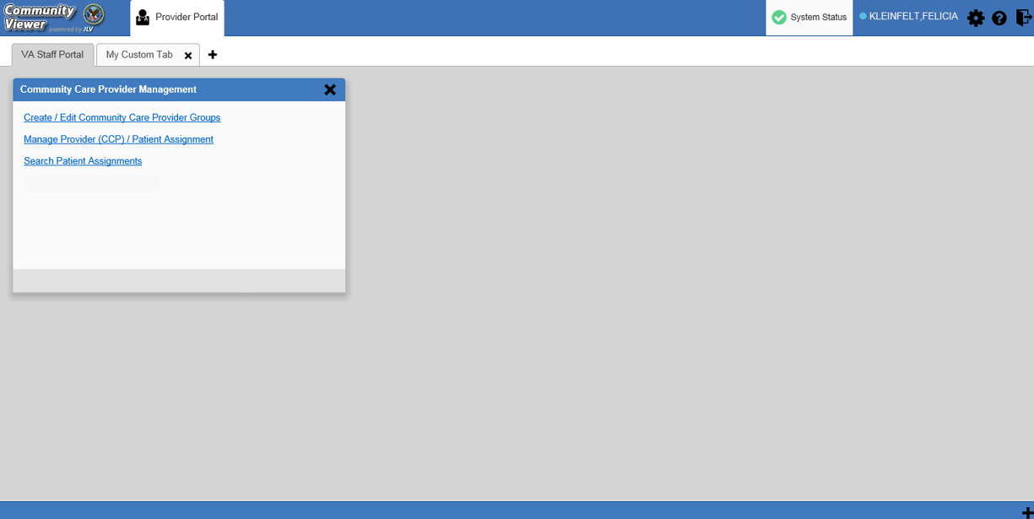Figure 8: Blue UI Theme

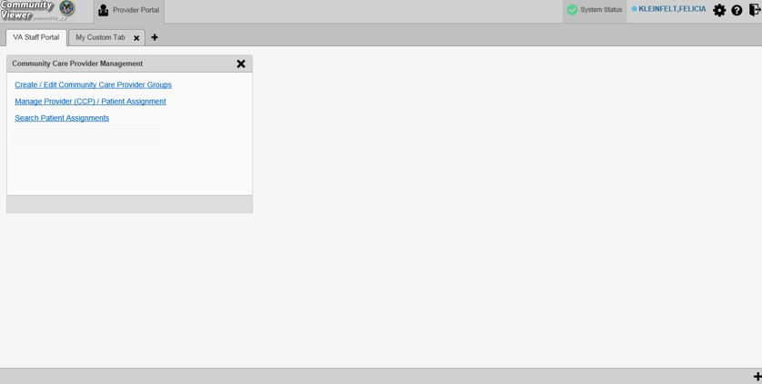Figure 9: Gray UI Theme

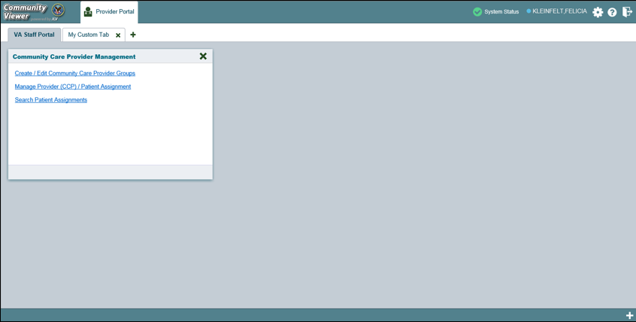Figure 10: Green UI Theme

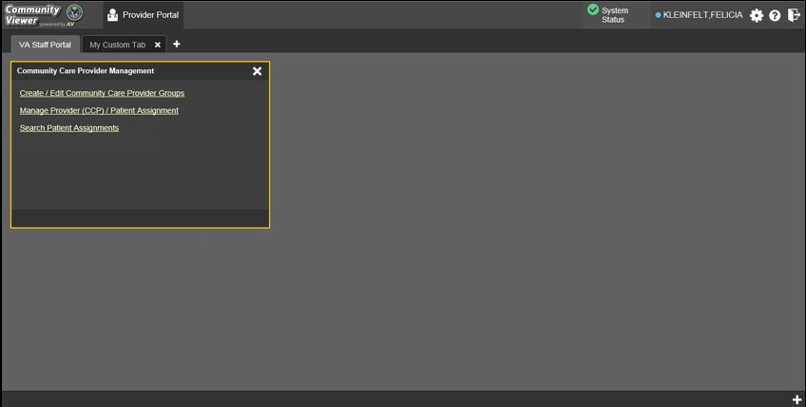
Figure 11: Accessible (508-Compliant) UI Theme

    - Using the Accessible Theme’s Functionality
The Accessible theme includes larger fonts, enhanced tab and keystroke functionality, and screen reader compatibility to support Federal accessibility requirements and Section 508 compliance.

NOTE: The Accessible theme is available for users who have adaptive technologies installed on their computers.

      - Keyboard Focus and Screen Navigation
Keyboard focus is the highlighting of screen elements that enables interaction with, and the navigation of, the web application through the keyboard and keystrokes. The screen element in focus is outlined in gold (Figure 11) as a visual indicator of keyboard focus.
CV enables the use of Windows keystrokes (Tab, Shift + Tab, arrow keys, Enter), and keyboard shortcuts to move the focus to all menus, and activate all functions on the menus. All UI items are accessible via the keyboard under the Accessible theme.
Pressing Enter or the Spacebar when an element that provides action is in keyboard focus performs the associated action. Pressing Enter or the Spacebar when the Settings icon is in focus, for example, opens the CV Settings dialog. Using the arrow keys or the Tab key allows a user to move between keyboard focus items to navigate through screen elements. Table 1 provides a complete list of accessible keystrokes.

Table 1: Keyboard Accessible Keystrokes

Keystroke | Description
Application and Portal Navigation
Alt+4 | Press to transfer keyboard focus to the main or top screen element: Focus is transferred to the Provider portal tab on a portal page.  Focus is transferred to the first link or data element in a widget.  Focus is transferred to the dialog box’s Close button (X).
Alt+5 | Press on a page with two panels to toggle keyboard focus between the main or top element on left and right panels.
ENTER | Press to transfer keyboard focus to the highlighted widget.
TAB | Press to transfer keyboard focus to other UI items.
ESC | Press to return keyboard focus to the panel containing the UI item with keyboard focus or to exit a window or widget.
SPACEBAR | Press to activate any UI item (for example, click a button).
Arrow Keys | When keyboard focus is on a widget, press the arrow keys to change page viewing in a widget's data table.  When keyboard focus is on a dropdown, press the down arrow to view the contents.
Portal Tabs
Arrow Keys | Use the left and right arrow keys to navigate between tabs. Add a Tab:  - Press the right arrow key until Add Tab (+) is in focus.  - Press Enter.  - The new tab dialog box opens and prompts you to enter a name for the new tab.
TAB | Press one or more times when focus is on a portal tab to place the (+) in keyboard focus.
ENTER | Press while the (+) is in focus to add a new portal tab. A dialog prompts the user to enter a name for the tab.

Keystroke | Description
ESC | Focus on a tab and press Esc to remove it.
Windows and Dialog Boxes
TAB | Press the Tab key to move the keyboard focus to other UI items within the window.
Adding Widgets to the Portal Pages
Alt + 1, 2, or 3 | Add a widget to a Portal page from the Widget Tray:  - Determine in which column (1, 2, or 3) of the Portal page to place the widget.  - Focus on the desired widget icon in the Widget Tray.  - Press Alt + 1, 2, or 3, depending on the desired column.

      - Accessible Theme Screen Navigation
An element with keyboard focus is the starting point for screen navigation. Pressing the Enter or
Spacebar keys when a screen element or icon has keyboard focus mimics a mouse click.
Figure 12 depicts the Manage Providers pane with Provider Group field as the keyboard focus. Focus can be changed by pressing Tab key. Pressing the Tab key in this example shifts the keyboard focus from the Provider Group field to the field immediately below the Provider Group field. Press Shift + Tab to navigate back up through the fields. Pressing the Alt + 4 keys shifts the keyboard focus back to the Provider Group field.

NOTE: Focus on the element within the widget that has hover text. After a small delay, the text appears as if the user hovered over the element with a mouse cursor.

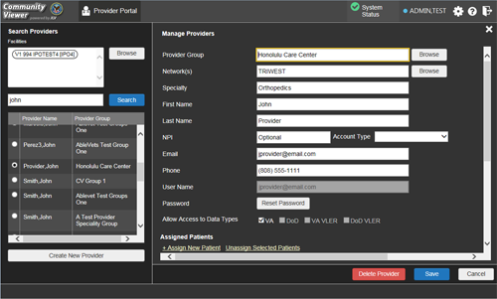Figure 12: Navigation Using Elements with Keyboard Focus

The Browse Networks dialog opens with Close (X) as the keyboard focus (Figure 13). Focus can be changed by pressing the Tab key. Pressing the Tab key in this example shifts the keyboard focus to the checkbox of listed networks. Pressing the Spacebar key to check or uncheck the checkbox. Move to OK and press Enter to save changes. Press Alt + 4 keys shifts focus to Close (X) and press Enter to close dialog box without changes.

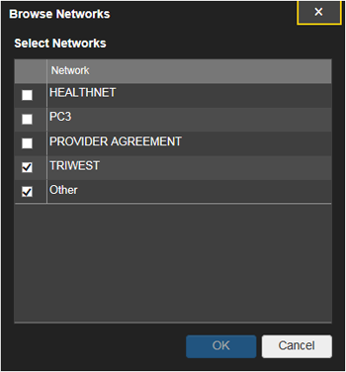
Figure 13: Browse Networks Dialog with Keyboard Focus

2.4. Logging Out of the Current CV Session
You may intentionally log out to end a CV session by clicking Logout at any time. If you fail to log out, the current session terminates automatically after 30 minutes of inactivity. You are redirected to the Login page when any new activity is attempted.

Using CV
After logging in, VA Staff see the CCPM widget on the VA Staff portal tab by default.

NOTE: If the CCPM widget is not displayed, click the plus + icon in the lower right corner of the portal page (Figure 14) to open the Widget Tray. Click, hold, and drag the icon from the Widget Tray to the portal page, and drop it in the desired location.

Figure 14: Default Portal Page (Green Theme)

VA Staff create providers, assign patients to CCPs, and grant the CCP limited access to patient records within the CCPM widget.
There are three workflow options (Figure 15) within the CCPM widget:
- Create/Edit Community Care Provider Groups
- Manage Provider (CCP)/Patient Assignment
- Search Patient Assignments

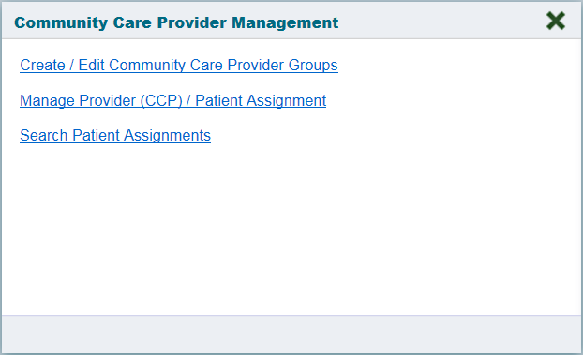Figure 15: The CCPM Widget

Searches
CV’s search features are used to find a provider group, a provider, or a patient. The subsections below detail the
    - Provider Group Search
When using the Create/Edit Community Care Provider Groups feature, users can perform a detailed search within the Search Community Care Provider Groups pane (Figure 16):
- Search by facility (Veterans Integrated Service Network [VISN], site identification [ID], facility name, and facility short name), provider group name, city and state, or zip code
- Sort the facilities list by state, when browsing for a facility

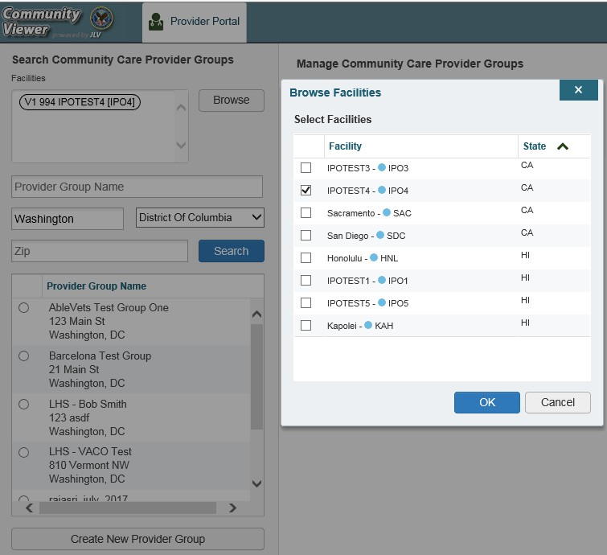Figure 16: Browse Facilities Dialog Box–CCP Provider Groups

When searching for a Community Care Provider Group, users:
- See the provider group name and address within the search results
- Receive a notification to refine the search by inputting additional search criteria when a large number of results are returned (Figure 17)

NOTE: Figure 17 and Figure 29 depict searches within and information from test databases.

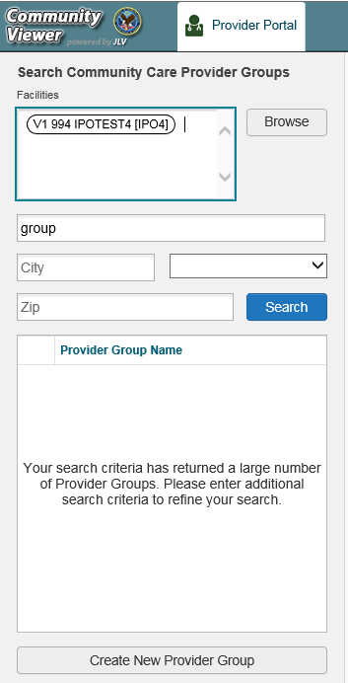Figure 17: CV CCP Group Search Too Many Results Notification

    - Provider Search
When using the Manage Provider (CCP)/Patient Assignment feature, users can perform a detailed search within the Search Providers pane (Figure 18):
- Search by facility (VISN, site ID, facility name, and facility short name), provider group name, or provider name
- Sort the facilities list by state, when browsing for a facility

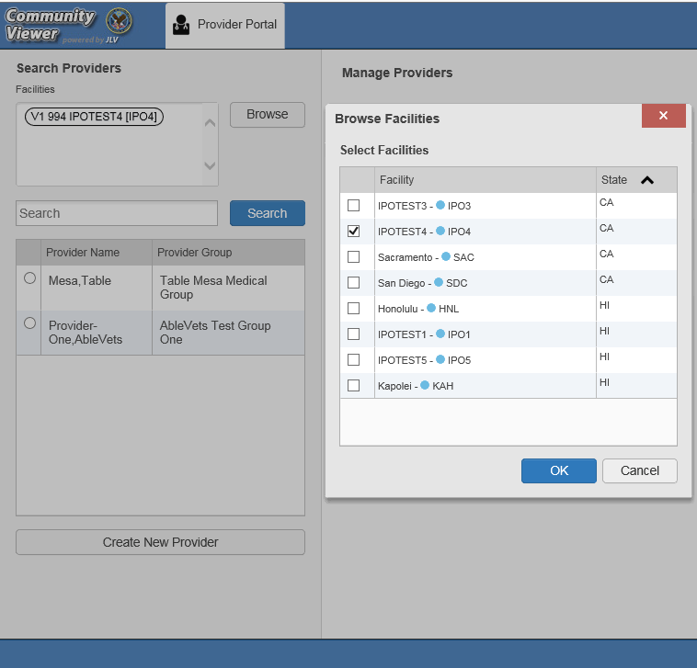
Figure 18: Browse Facilities Dialog Box–Search Providers

When searching for a provider, users see the provider name and provider group within the search results.

    - Patient Search
There are two types of patient searches in CV from the Search Patient Assignments feature:
- My Site Search: Searches the user’s local VistA (also known as facility or site); the patients listed in the search results are registered to that local VistA only
- Enterprise Search: Searches all VistAs across the Enterprise; the patients listed in the search results are registered to one or more VistAs
When searching for a patient within your site:
- Select the Search Patient Assignments link from the CCPM widget
- Confirm the My Site radio button is selected by default
- Enter search criteria into the Patient Search field:
  - A minimum of two characters of the patient’s last name -OR-
  - The patient's last name, followed by a comma and either the first initial or full spelling of the patient's first name (Smith, J or Smith, John) -OR-
  - The patient's full SSN (123456789) -OR-

  - The first letter of the patient's last name followed by the last 4 digits of the patient’s SSN (S6789)
- Click Search or press Enter

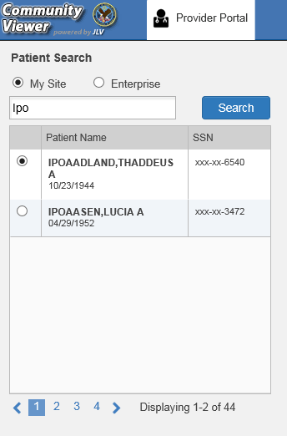Figure 19: My Site Patient Search

When searching for a patient across the Enterprise:
- Select the Search Patient Assignments link from the CCPM widget
- Select the Enterprise radio button
- Enter the patient’s Social Security Number (SSN) into the required Patient SSN field
- Enter the patient’s full last name into the required Last Name field
- Enter the patient’s date of birth (DOB) in the optional DOB field
- Enter the patient’s first name in the optional First Name field
- Click Search or press Enter
When using the Patient Search and the Patient Assignment search features, search results display with the ability to scroll through multiple pages or select a specific page.

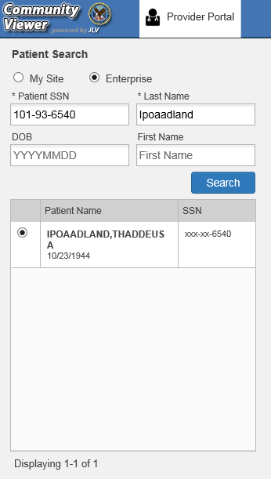Figure 20: Enterprise Patient Search

Please see Assigning and Unassigning Patients for detailed instructions on how to run a My Site
or Enterprise search from the Manage Providers pane.

About Provider Groups and Facilities
Before a user can assign a patient to a CCP, the CCP must be assigned to a provider group.
CV has been prepopulated with over 200,000 groups and providers. Users can edit existing groups, but in this release, the task of creating provider groups is performed by CV Portal Administrators. Users should contact a CV Portal Administrator to request the creation of a new group.

NOTE: Provider groups are validated on the combination of the group name and street address to avoid the creation of duplicates.

Each group is associated with one or more local VA sites, referred to as Facilities. A facility is a local VA site. Provider groups can contain one or more VA facilities.
EXAMPLE 1: Dr. Hanyok works with a family practice called Evergreen Health Care. Dr. Hanyok is the Provider in this example, and Evergreen Health Care is the Provider Group to which she is assigned.
EXAMPLE 2: Dr. Woodroof, the Provider, is a sole practitioner. The Provider Group name for a sole practitioner may be a business name or can be the provider’s name; in this example, Dr.
Woodroof.

    - Editing Provider Groups
Provider groups can be edited through the CCPM widget (Figure 21).
- Click the Create/Edit Community Care Provider Groups link in the CCPM widget
- Enter the facility, provider group name, city and state, or zip code in the Search fields
- Click Search
- Select the desired provider group from the search results
- Edit the provider group fields as needed
- Click Browse next to the Facilities field, and select the desired facility from the list

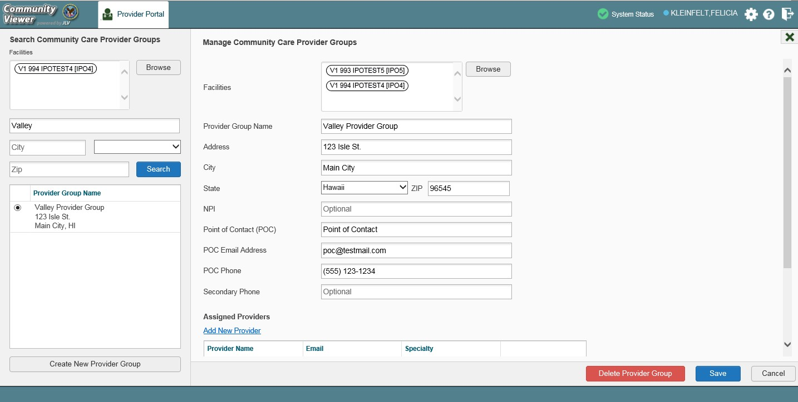Figure 21: Search and Manage CCP Groups Panes

- Providers assigned to the provider group are listed in the lower right portion of the screen
  - Edit provider profiles or remove providers from the group using the Edit link within the
Assigned Providers list (Figure 22)
- Click Save

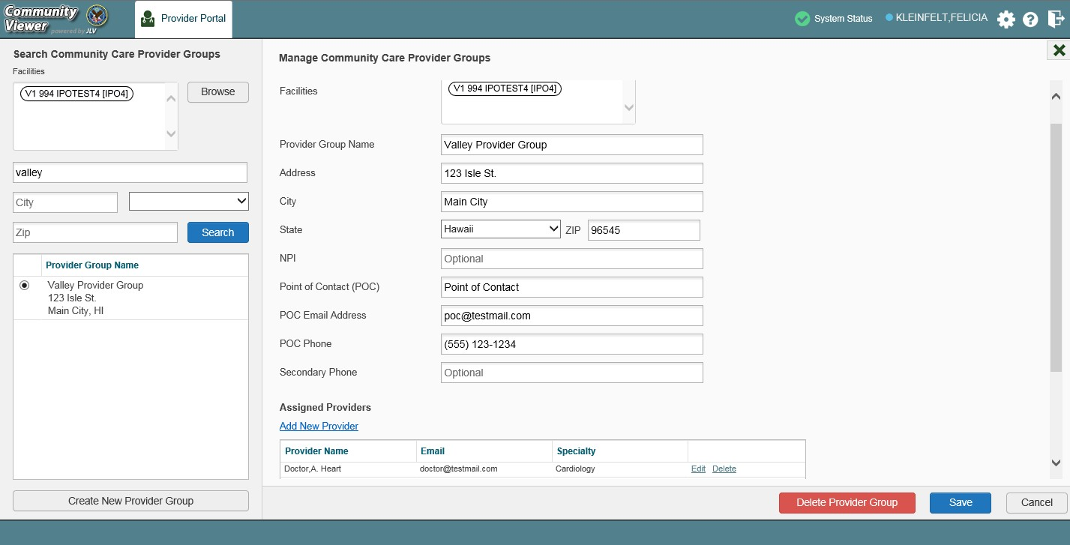Figure 22: Search and Manage CCP Groups Panes, Assigned Providers Edit and Delete Links

NOTE: Only CV Portal Administrators can add new groups, delete provider groups, and delete providers from a group in this release. VA Staff users cannot see the Create New Provider Group button, the Delete Provider Group button, or the Delete link. Contact a CV Portal Administrator for assistance with these tasks.

    - Deleting a Provider Group
CV Portal Administrators may only delete a provider group when the individual providers within that group have no patient assignments. If any patients are assigned to a provider within the provider group, the error message in Figure 23 displays. Assigning and Unassigning Patients details steps to unassign patients from an individual provider.
- Click the Create/Edit Community Care Provider Groups link in the CCPM widget
- Enter the facility, provider group name, city and state, or zip code in the Search field
- Click Search
- Select the desired provider group from the search results
- Select the Delete Provider Group button

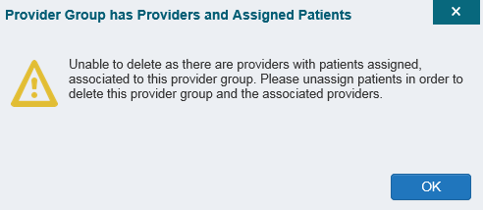Figure 23: Provider Group Deletion Error Message
A CV Portal Administrator can delete providers along with their associated provider group if they do not have patients assigned. If the provider group has associated providers that you intend to also delete, select the Yes button when prompted.

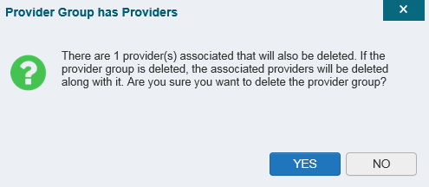Figure 24: Provider Group Has Providers Without Patient Assignments

About Provider Accounts
All CCP accounts are created in the CCPM widget. When a CCP account is created, so is their user profile.

    - Creating Provider Accounts
Users can assign patients to CCPs once their account has been created.
- Click the Manage Provider (CCP)/Patient Assignment link (Figure 15) in the CCPM
widget
- Click Create New Provider in the Search Providers pane, on the left side of the application window, as shown in Figure 25
  - The Create/Edit Provider pane opens on the right side of the application window
- Click Browse to the right of the Provider Group field to search for an existing group
- Select the desired group from the list of results and click OK

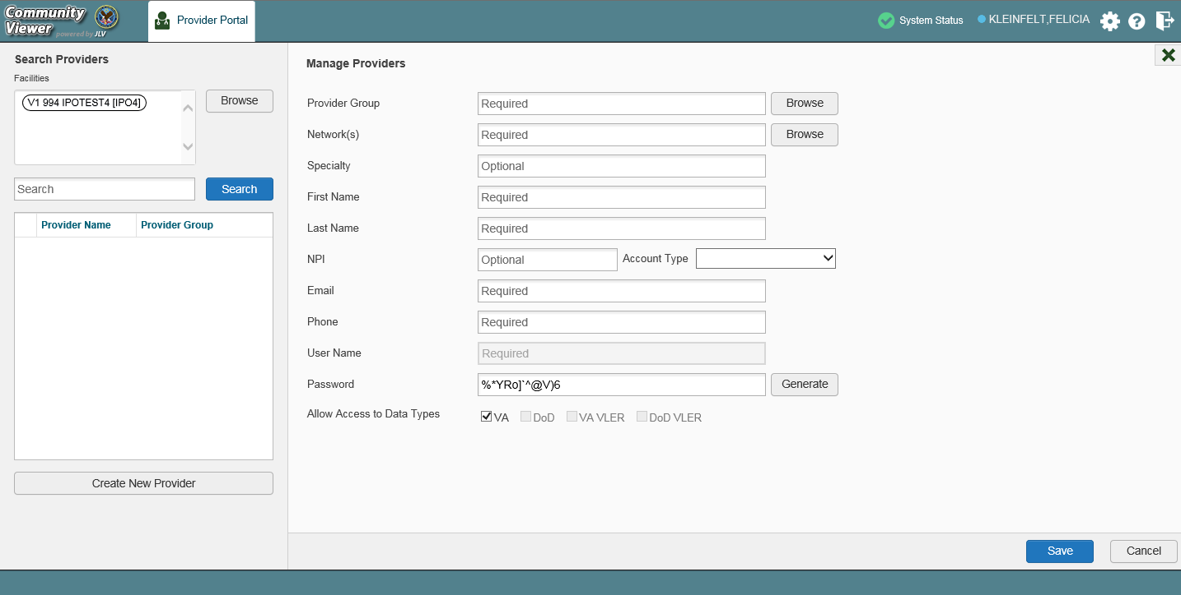Figure 25: Search Providers and Manage Providers Panes

- Enter the provider information in each of the required fields on the Manage Providers pane (Figure 25)

NOTE: Providers are differentiated by their e-mail address. If a provider is associated with multiple provider groups, they must provide a unique e- mail address for each provider group. When a new provider is created, their e-mail address, which also serves as their username, is validated to avoid the creation of duplicates. If an e-mail address is already associated with a provider in CV, a “Username already exists” message displays (Figure 26).

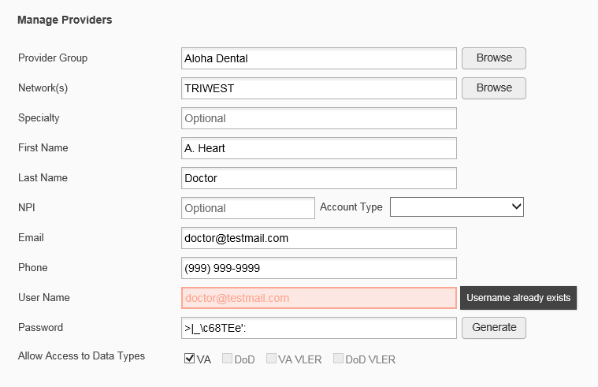Figure 26: Username Already Exists Error Message

- Click Browse to select the Provider Group
- Click Browse to select the Network(s) to which the provider belongs from the following options: Health Net, PC3, Provider Agreement, TriWest, or Other
  - A free-text field labeled Other Network opens when Other is selected
- Enter a Specialty as needed
- Enter the provider’s First Name and Last Name
- Enter the provider’s National Provider Identifier (NPI) if available
- Select Outside Provider from the Account Type dropdown
- Enter the provider’s E-mail address and Phone number
- The User Name field is automatically populated with the address entered in the Email field
- Either have the system create the CCP’s password or manually enter a password

NOTE: Passwords are case-sensitive and must meet the 6500 security compliance criteria.
  - Click Generate, record the User Name and Password as displayed, then click Save
-OR-
  - Manually enter a password that meets 6500 security compliance criteria, then click Save
- Securely provide the CCP with his/her user name and password for CV using VirtuPro or phone
- When the Provider successfully created message appears, there are two options:
  - Click Assign Patients and follow the steps outlined in Assigning and Unassigning Patients
-OR-

  - Click OK to return to the CCPM widget
CCPs can now request access to CV from the CCP Login page. When a CCP clicks the New User link, s/he sees a message directing them to contact their local VA Medical Center for access. They are then given a link to a list of VA points of contact (POCs) from whom they can request access to the application.

    - Editing Provider Profiles
You can edit a CCP’s profile using the CCPM widget.
- Click the Manage Provider (CCP)/Patient Assignment link in the CCPM widget
- Enter the provider name in the Search field, and click Search
- Select the desired provider from the search results (Figure 27)
- Edit the provider information in the fields provided, as necessary
- Click Save

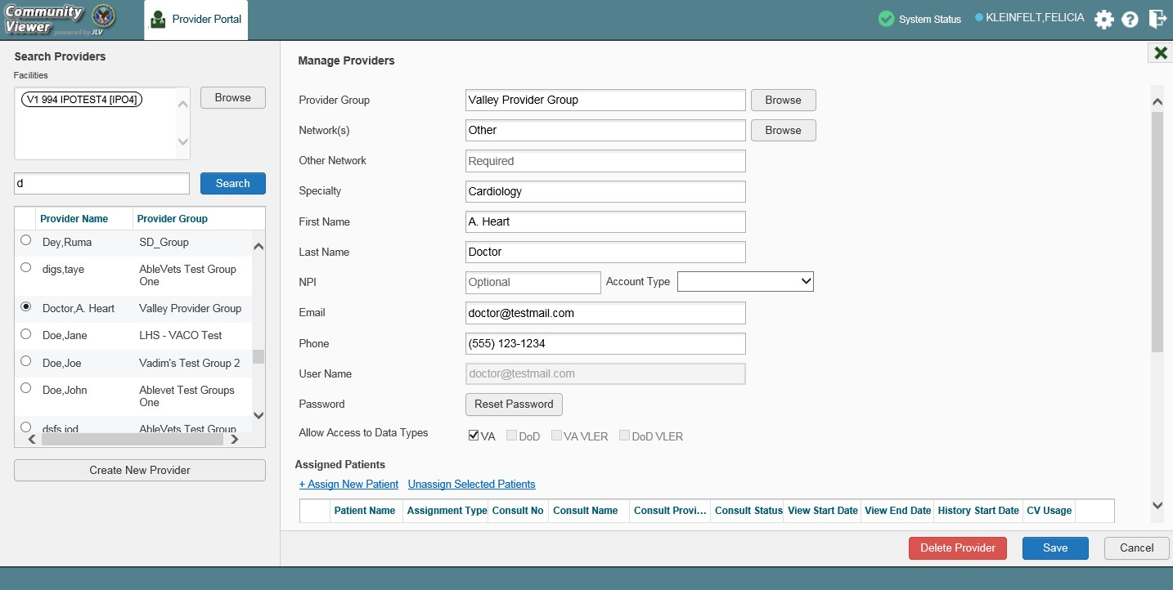Figure 27: Search Providers and Manage Providers Panes

If a provider is assigned to the wrong group, you must request the deletion of the provider from the incorrect provider group from a CV Portal Administrator or the ESD. See Deleting a Provider Group for more information.
If the provider needs to be added to another practice group, users must click Add New Provider in the Search Providers pane and create the provider within the additional practice group. The provider name can be the same, but a different e-mail address must be used for each unique provider.

    - Resetting Provider Passwords
If a CCP user has forgotten his/her password, they can click the Reset Password link on the Login page to open a window that enables the provider to send a password reset link directly to their e-mail address, which they can then use to reset their own password. Password resets can also be performed by VA Staff, using the CCPM widget.
- Click the Manage Provider (CCP)/Patient Assignment link in the CCPM widget
- Enter the provider name in the Search field
- Click Search
- Select the desired provider from the search results
- Click Reset Password (highlighted in Figure 28) in the Manage Providers pane
  - Click Generate to allow the system to create a new, random password, record the new password, then click Save
-OR-
  - Manually enter a password that meets 6500 security compliance criteria, then click Save
- Securely provide the CCP with his/her new password for CV using VirtuPro or by phone
- Click Save

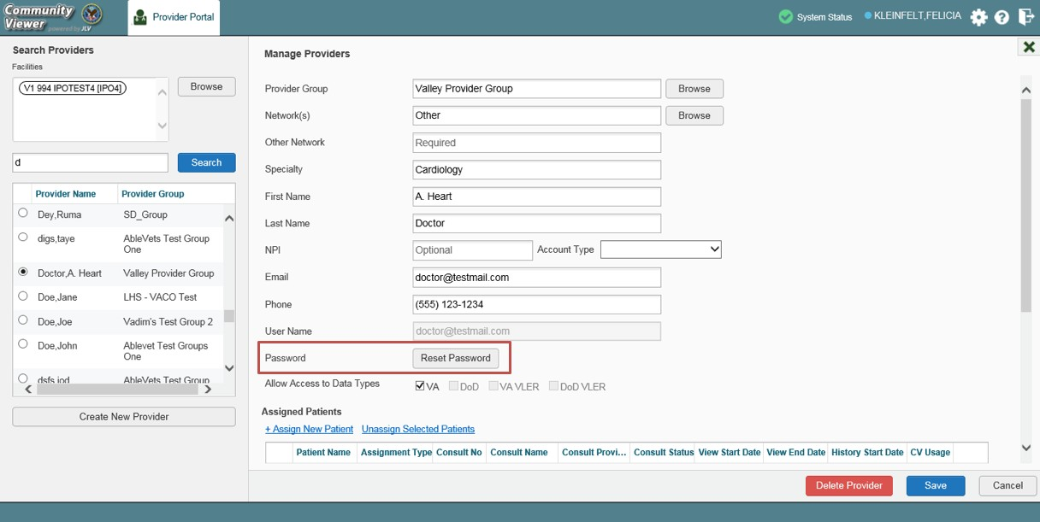Figure 28: CCP Password Reset

    - Assigning and Unassigning Patients
Once the CCP’s account has been created, patients can be assigned to them.

NOTE: If you chose Assign Patients immediately after creating the provider, the Search pane is prepopulated with that provider’s profile information, and no search is necessary.

- Click the Manage Provider (CCP)/Patient Assignment link in the CCPM widget
- Enter the provider’s name in the field to the left of the Search button within the Search Providers pane (Figure 29)
- Click Search

Figure 29: Search Providers Pane

NOTE: The task of deleting a provider is performed by CV Portal Administrators in this release. VA Staff users cannot see the Delete Provider button. Instead, they must contact a CV Portal Administrator to request that a provider be deleted.

- Select the provider from the list of results
  - The Manage Providers pane opens with the provider’s information
- Click the + Assign New Patient link (highlighted in Figure 30)
  - The Patient Search dialog opens

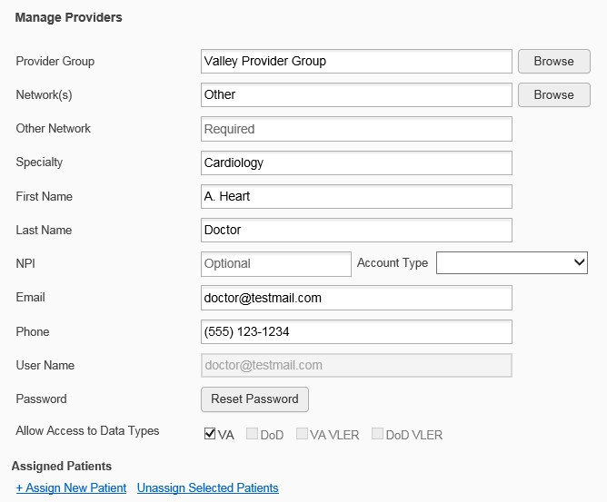Figure 30: Manage Providers Fields Detail

- Enter the patient name in the blank field at the top of the Patient Search dialog (Figure 31)
- Select the My Site or Enterprise search option and enter the search criteria (Please refer to Patient Search for details)

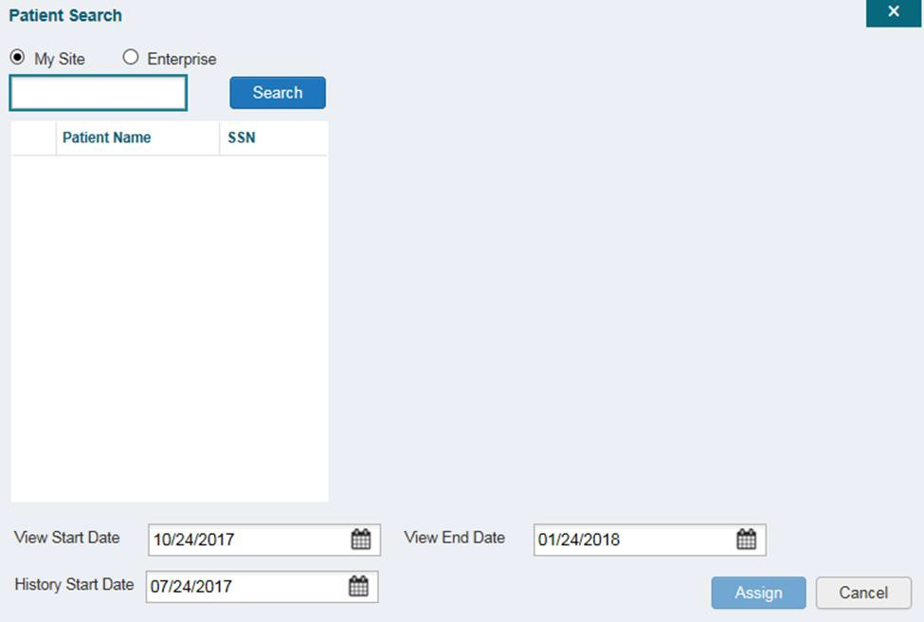Figure 31: Patient Search Dialog Box

- Click Search

- Select a patient from the search results list
- Select the Assignment Type from the dropdown: 30 Day Wait, Consult, Distance-Eligible (40 mile), or Episode of Care
  - If Consult is specified, select one consult record from the list for the selected patient; the consult status must be Active or Scheduled for the consult to appear in the list
- If desired, adjust the default View Start Date, View End Date, and History Start Date
fields to restrict the data seen by the CCP (See Setting Record Display Limits.)
- Click Assign
CV uses the following rules to manage patient assignments:
- A specific Veteran may be assigned to multiple CCPs
- A Veteran may be assigned to more than one CCP for the following Assignment Types:
  - 30 Day Wait
  - Distance Eligible
  - Episode of Care
- A specific Veteran/consult combination may only be assigned to a single CCP

Table 2: Assignment Rules Examples

 | Veteran John Davis has multiple active referrals to be assigned:
Referral 1 |  | 30 Day Wait for Dental | Assign to CCP A | A Veteran may have multiple, active assignments for an Assignment Type
Referral 2 |  | 30 Day Wait for Podiatry | Assign to CCP B
Referral 3 |  | 30 Day Wait for Podiatry | Assign to CCP C
Referral 4 |  | Episode of Care for Optometry | Assign to CCP D
Referral 5 |  | Consult for Cardiology | Assign to CCP E | This specific consult can only be assigned to one CCP at a time
Referral 6 |  | Consult for Chiropractic | Assign to CCP F | This specific consult can only be assigned to one CCP at a time
When it is necessary to unassign patient(s) from a CCP:
- Repeat steps 1–4 from the CCPM widget or select the Edit link from the Manage CCP Groups pane (Figure 22) to navigate to the Manage Providers pane
- Click the Unassign Selected Patients link (highlighted in Figure 30)

    - Setting Record Display Limits
Users can limit the patient records made available to the assigned CCP. There are two settings that control access to patient data:
- View Start Date and View End Date: These fields set the length of time the CCP has access to the patient records through CV
  - The default View Start Date is the date the patient is assigned to the CCP
  - The default View End Date is 3 months from the default start date

- History Start Date: This setting represents how far back in a patient's VA medical history the CCP is permitted to view
  - If the history start date is set to 01/01/2012, for example, the CCP has access to the patient's records from available VA facilities from 2012 to present
Data access controls are set by the user during the patient assignment process.
- Click the Calendar icon next to the View Start Date and the View End Date fields
- Select the start and end dates (Figure 32)
- Alternatively, click the Calendar icon next to the History Start Date
- Select a date
- Click Assign

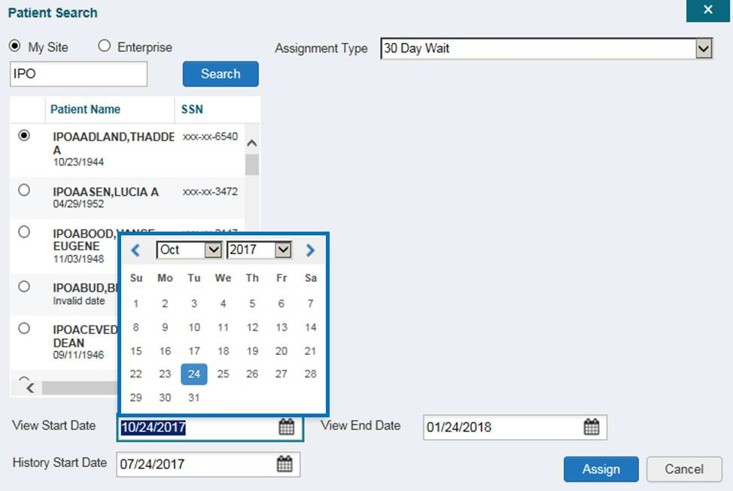Figure 32: Data Access Controls

Widgets: What Community Providers See
Once the CCP has been granted access to CV, they can see their assigned patient’s VA health information on the Patient Portal. Patient data is presented through widgets (Figure 33), each displaying data specific to an administrative or clinical domain. A summary of the patient’s demographics (personal data) appears in the upper left section of the Patient Portal. The Pain Management widget is a static widget permanently positioned to the right of the Demographics widget. The Demographics widget and the default instance of the Pain Management widget are static widgets that cannot be removed from the Patient Portal or moved to a different position. The Encounter, Results, Medications, Documents, Consults, and Immunization tabs provide unique widget layouts.

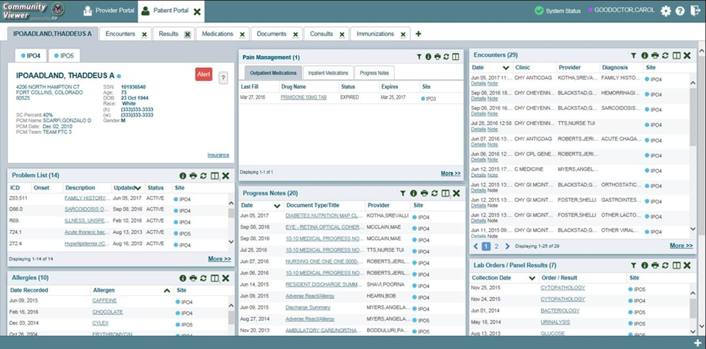
Figure 33: Widget Display on the Patient Portal
**Primary Care Management (PCM)
All widgets available for display on the Patient Portal are housed in a horizontal tray at the bottom of the page, the Widget Tray. When customizing their view of CV, CCPs click the + icon in the lower right corner of the page (Figure 33) to open the Widget Tray.
The widgets that are available for display on the Patient Portal are:

- Patient Demographics  - Admissions  - Allergies  - Appointments  - Clinical Reminders  - Consults  - Discharge/Essentris Notes  - Encounters | - Lab Panel Results  - Lab Results  - Outpatient Medications  - Orders  - Pain Management  - Problem List  - Procedures  - Progress Notes

- Immunizations  - Inpatient Medications | - Radiology Exams  - Vitals

Nondiagnostic Images
Nondiagnostic images are available in JPEG and PDF format from the Encounters, Progress Notes, and Radiology Exams widgets, in addition to the Progress Notes tab of the Pain Management widget (Figure 34).

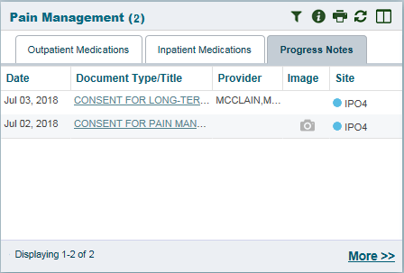Figure 34: Pain Management Widget (Minimized View)–Nondiagnostic Images

A Camera icon in the Image column of a widget in minimized view indicates one or more images are associated with that record (Figure 35). Clicking the Camera icon in a supported widget opens the list of images associated with the record. See Figure 37 and Figure 38.

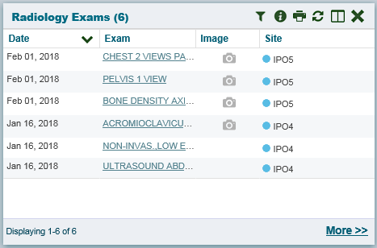Figure 35: Radiology Exams Widget (Minimized View)–Nondiagnostic Images

Clicking the Click Image to Open Viewer link in the Detail view (Figure 36) of a widget opens the list of images associated with that record.

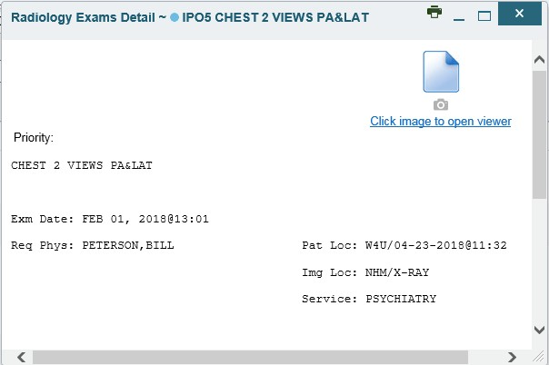Figure 36: Radiology Exams Detail–Nondiagnostic Images

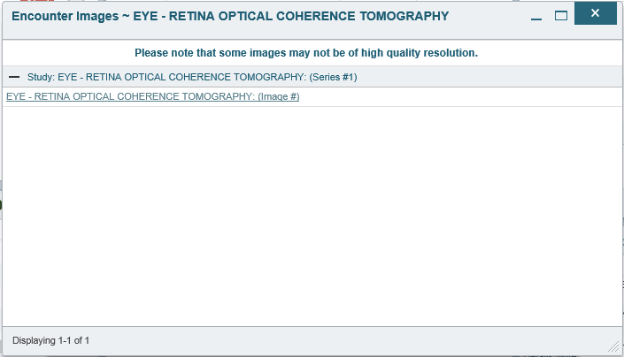Figure 37: Single Encounter Nondiagnostic Image

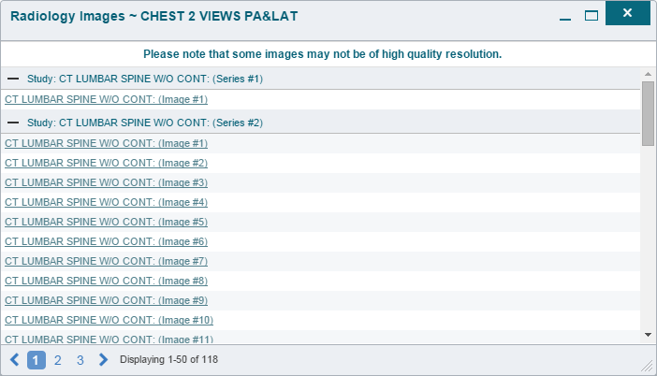Figure 38: Multiple Radiology Nondiagnostic Images

If an image is temporarily unavailable, users see a “System is unable to retrieve images at this time” message (Figure 39).

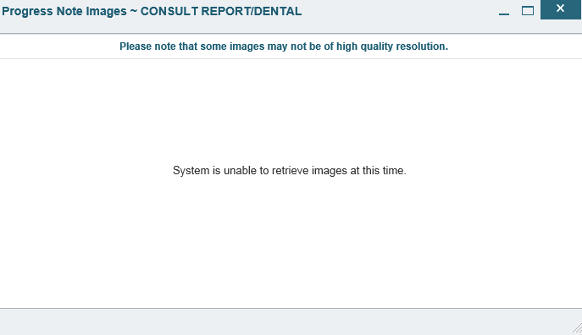Figure 39: Progress Note Images–Unable to Retrieve Images Error

Troubleshooting

Special Instructions for Error Correction
Access to CV is limited to registered, authorized users. CV validates user access against information retrieved from your smart card. If you are experiencing trouble logging in to CV, please review Table 3 before contacting the ESD.

Table 3: Login Page Error Message Troubleshooting

Error Message | Resolution Steps
Access denied. You are not an authorized user. | WHAT? Error message indicating Access Denied. You are not an authorized User.  WHY? PIV card processing problem or invalid security certificate chosen.  FIX IT:  - Close browser window.  - Reinsert PIV card and relaunch the CV link.  - Select a certificate that is not expired and specifies Issued by: Veterans Affairs CA B1.  If this is unsuccessful, fully reboot your system. This refreshes all connections and resolves greater than 95% of any remaining problems.
Could not save User Profile | WHAT? Error message indicating Could not save User Profile.  WHY? Error occurred during PIV authentication for VA users. Typically, this is a PIV card processing problem, or an invalid security certificate chosen.  FIX IT:  - Close your browser window.  - Reinsert PIV card and relaunch the CV link.  - Select a certificate that is not expired and specifies Issued by: Veterans Affairs CA B1.  If this is unsuccessful, fully reboot your system. This refreshes all connections and resolves greater than 95% of any remaining problems.
Not a valid ACCESS/VERIFY  CODE pair | WHAT? Receive Not a valid ACCESS CODE/VERIFY CODE pair error on the  Login page.  WHY? 1) CV could not match your Access and Verify codes to the Site selected in the dropdown or VA; or 2) A username and password were entered instead of Access/Verify codes.  FIX IT:  - Veterans Health Administration (VHA) users must select the parent VistA host site for their facility.  - Reenter correct Access and Verify codes (Computerized Patient Record System (CPRS) or VistA codes for VHA users).

Error Message | Resolution Steps
Page cannot be displayed | WHAT? You receive a Page cannot be displayed error when launching CV.  WHY? The CV URL requires certain IE settings.  FIX IT:  - With IE open, click the Tools menu or press ALT-X.  - Select Internet Options.  - When the dialog opens, select the Advanced tab.  - Scroll down in the list until you see the settings below and ensure Secure Socket Layer (SSL) 2.0 is NOT checked and that Transport Layer Security (TLS) 1.0, 1.1, and 1.2 are checked.  - Click OK, then relaunch CV and the page should load.
Smart Card required | WHAT? Error Message Smart Card Required.  WHY? Smart card not read by Windows Security and CV before launching CV link.  FIX IT:  - Close all browser sessions/browser-based applications.  - Reinsert PIV card and relaunch CV link.  - If this is unsuccessful, fully reboot your system to refreshes all connections. This resolves greater than 95% of any remaining problems.
VERIFY CODE must  be changed before continued use | WHAT? Receive VERIFY CODE must be changed before continued use error on the Login page.  WHY? CPRS VERIFY CODE has expired.  FIX IT:  - Open CPRS.  - Select the Change Verify Code checkbox on the sign-on dialog before clicking OK.  - You are prompted to create a new Verify Code.  - Once your Verify Code is changed for CPRS, CV recognizes the new code immediately.

    - Patient Search Errors
The following error messages may appear when you are searching for a patient in the CCPM widget. If you are experiencing errors while searching for patients, please review Table 4 before contacting the ESD.

Table 4: Patient Search Error Messages and Resolution Steps
Error Message | Resolution Steps
An invalid search criterion was entered. Please enter at least 2 characters. | Invalid patient name entered. Please try your search again.  When searching by patient name, enter at least two characters of the patient’s first and last name. Search results display the closest match to the characters entered in the format of [last name], [first name].
An invalid SSN format was entered. Please enter a 9- digit SSN. | Invalid SSN entered. Please try your search again.  When searching by patient SSN, you are required to enter the patient’s full 9- digit SSN. Dashes are allowed (e.g., 123-45-6789).
An invalid last 5 format was entered. Please enter the first letter of the last name followed by the last 4-digits of the SSN. | Invalid patient name or SSN entered. Please try your search again. Patient search allows you to search for a patient using the first initial of the patient’s last name and the last four digits of the patient’s SSN. Please try  your search again using the first initial of the patient’s last name and the last  four digits of the patient’s SSN.
An error occurred during your search. Please try your search again. | This error may display when invalid patient identifiers were entered, or an error occurred at the service layer or with an external system. Please try your search again.

Acronyms and Abbreviations
Table 5 lists the acronyms and abbreviations used throughout this document and their descriptions.

Table 5: Acronyms and Abbreviations
Acronym | Description
CCP | Community Care Provider
CCPM | Community Care Provider Management
CPRS | Computerized Patient Record System
CV | Community Viewer
ESD | Enterprise Service Desk
GUI | Graphical User Interface
ID | Identification
IE | Internet Explorer
MVI | Master Veteran Index
OIT | Office of Information and Technology
PCM | Primary Care Management
PIN | Personal Identification Number
PIV | Personal Identification Verification
SSL | Secure Socket Layer
SSN | Social Security Number
TLS | Transport Layer Security
UI | User Interface
URL | Uniform Resource Locator
VA | Department of Veterans Affairs
VDS | VistA Data Service
VHA | Veterans Health Administration
VISN | Veterans Integrated Service Network
VistA | Veterans Health Information Systems and Technology Architecture

