Community Viewer (CV) Version 2.9.1 User Guide for VA Staff

April 2019
Version 1.3

Department of Veterans Affairs (VA) Office of Information and Technology (OIT)

Revision History

Date | Version | Description | Author
04/01/2019 | 1.3 | Received PM/COR approval | AbleVets
03/29/2019 | 1.3 | Submitted for PM/COR approval | AbleVets
03/20/2019 | 1.2 | Rewritten guide resubmitted for review | AbleVets
03/18/2019 | 1.1 | Major rewrite of the guide requested in the approval meeting | AbleVets
03/11/2019 | 1.0 | Delivered for review | AbleVets
02/24/2019 | 0.1 | Initial draft created from last approved | AbleVets

Table of Contents
- Introduction 1
  - Purpose of the Guide 2
    - Guide Conventions 2
    - Terminology 2
  - Assumptions 2
  - System Requirements 3
  - Getting Help 3
- Logging in to CV 4
  - System Notifications 5
    - Viewing Announcements 5
  - Editing Your User Profile at Login 6
  - The CV Portal Pages 6
    - Default View 6
    - Viewing System Status 7
    - Profile Settings 8
    - Using the Accessible Theme’s Functionality 11
      - Keyboard Focus and Screen Navigation 11
      - Accessible Theme Screen Navigation 13
  - Logging Out of the Current CV Session 14
- Using CV 14
  - The Widget Tray 14
  - About the Community Care PPMS Provider Management Widget 14
  - About Search 15
    - Searching Providers 15
    - Searching Patients 16
  - Resetting Provider Passwords 18
    - Managing Passwords 19
  - Assigning and Unassigning Patients 20
    - Assigning Patients 20
    - Setting Record Display Limits 23
- Troubleshooting 25
  - Login Page Errors 25
  - Provider Search Errors 26
  - Patient Search Errors 27
- Acronyms and Abbreviations 28

Table of Figures
Figure 1: CV Authorized Use Only Warning 1
Figure 2: Login Page 5
Figure 3: CV Portal Tools 6
Figure 4: Default View 7
Figure 5: System Status Indicator 8
Figure 6: The CV Settings Dialog 8
Figure 7: Default Theme 9
Figure 8: Blue UI Theme 9
Figure 9: Gray UI Theme 10
Figure 10: Green UI Theme 10
Figure 11: Accessible (508-Compliant) UI Theme 11
Figure 12: Navigation Using Elements with Keyboard Focus 13
Figure 13: Widget Tray 14
Figure 14: Community Care PPMS Provider Management Widget 15
Figure 15: PPMS Provider Search 16
Figure 16: My Site Patient Search 17
Figure 17: Enterprise Patient Search 18
Figure 18: CCP Password Generation or Reset Dialog 19
Figure 19: PPMS Patient Assignment Pane 21
Figure 20: Patient Search Dialog Box 22
Figure 21: The Patient Search Dialog Box, Showing Results 23
Figure 22: Data Access Controls 24

Table of Tables
Table 1: Keyboard Accessible Keystrokes 12
Table 2: Assignment Rules Examples 20
Table 3: Login Page Error Message Troubleshooting 25
Table 4: Provider Search Error Messages and Resolution Steps 26
Table 5: Patient Search Error Messages and Resolution Steps 27
Table 6: Acronyms and Abbreviations 28

Introduction
Community Viewer (CV) is a browser-based software application that facilitates the secure exchange of data between Department of Veterans Affairs (VA) systems, authorized non-VA providers, known as Community Care Providers (CCPs). The exchange of data improves the coordination of care and continuity of care for VA patients receiving treatment outside of the VA network.
CV pulls information from VA health care systems in real time for viewing within a web browser. VA Staff assign patients to CCPs through CV, allowing them access to view consolidated patient data from multiple Veterans Information Systems and Technology Architecture (VistA) systems.
This User Guide is intended for VA Staff who use the functionality within the Community Care Provider Profile Management System (PPMS) Provider Management widget.

NOTE: CV does NOT replace the creation and uploading of documentation packages to the Third-Party Administrator (TPA) portals. VA Staff must continue to create and upload documentation packages as specified in their facility’s current SOP.

Please read and bear in mind the warning displayed in Figure 1 before using CV.

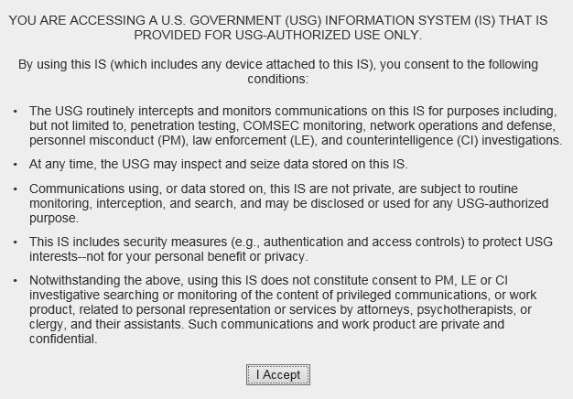Figure 1: CV Authorized Use Only Warning

VA Staff use the Community Care PPMS Provider Management widget to perform the following tasks:
- View CCP profiles
- Assign/unassign patients
- Search patient assignments
- Manage CCP access to patient data
- Perform My Site and Enterprise patient searches
- Generate or reset passwords

Purpose of the Guide
The purpose of this user guide is to familiarize VA Staff with the important features and navigational elements of CV.

    - Guide Conventions
This document is designed for both online and hardcopy consumption.
- Cross-References are indicated by blue, underlined text, and provide a hyperlink to figures, tables, and other sections within this guide
- Emphasis is expressed by bold, underlined, and italicized text
- The information symbol calls the reader’s attention to additional information
    - Terminology
The following standard terms are used throughout this guide:
- VA Staff Portal: The landing page, or default view, of CV that appears after logging in; the portal page displays widgets and the tools that enable quick access to basic features
- Widget: A component of the CV interface that enables a user to view information or perform a function
- Widget Tray: An expandable and collapsible tray at the bottom of the portal page that provides access to the widgets available for placement on the portal page

Assumptions
The user guide is written from the perspective of VA Staff and assumes that:
- You can open, navigate, and use a web browser
- You can use web-based applications, their menu options, and navigation tools
- You have the Uniform Resource Locator (URL) for the CV Login page, system user names, a Personal Identification Verification (PIV) card, and the VistA Access/Verify codes required to launch CV

System Requirements
CV is a front-end web application, designed to run in a web browser on the VA network. Accessing CV through a browser or device that is not fully compatible with the application may result in certain features not working as expected.

NOTE: Mobile devices are not supported in this release.
It is recommended that CV be accessed from a desktop or laptop PC using a supported browser, such as:
- Internet Explorer (IE) v11
- Chrome v71
- Microsoft Edge v44
- Safari v12

Getting Help
Authorized users who have trouble logging in to CV or experience other application issues should call the Enterprise Service Desk (ESD) for assistance or create a ticket using the YourIT self-service portal.
IT Enterprise Service Desk
REDACTED

Prior to contacting the ESD for support, please refer to Logging in to CV for detailed information about how to access CV, and to Troubleshooting for suggested resolution steps and troubleshooting information.

Logging in to CV
Before logging in to and utilizing CV functionality, please read the Sensitive Information warning in the Introduction.
CV authenticates all VA users using their PIV card and their VistA Access and Verify codes. During log in, first-time CV users are prompted to enter their agency, site, and user settings. This data is used to create a CV user profile, and it is utilized during future login sessions.
- Ensure your PIV card is inserted into your computer or card reader
- Open a supported Internet browser
- Enter the URL for the CV web application into the address bar of the browser
- When prompted with a certificate list, select the PIV Authentication certificate
- When prompted, enter your PIV Personal Identification Number (PIN)
- Click I Accept after reading the important user consent information regarding accessing a Government information system (Figure 1)
- Enter the following information in the fields on the Login page (Figure 2):
  - VistA Access code
  - VistA Verify code
  - Select “VA” from the Agency field
  - Select your local VistA from the Site dropdown

NOTE: Users should review the Announcements and System Status panes on the Login page for information that may impact CV functionality or data availability. See Viewing Announcements and Viewing System Status for detailed information.

- Click Login

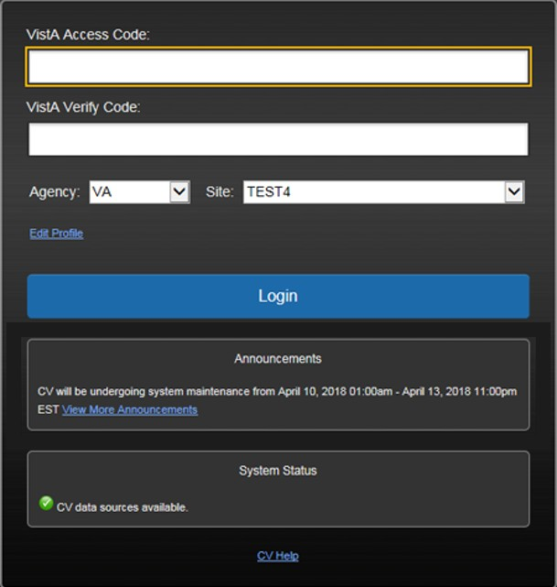
Figure 2: Login Page

System Notifications
The CV Login page displays system notifications to alert you to system outages, scheduled system activities, and important upgrades. The Login page also displays a notification when your VistA Verify code must be reset. The CV Help link opens CV online help, which guides you through the steps to reset your Verify code.

    - Viewing Announcements
System announcements are provided by the VA and displayed on the Login page when scheduled system activities may impact the user or CV system availability. The View More Announcements link opens additional announcement information.

NOTE: Announcements are separate from the system status messages displayed on the Login page. See Viewing System Status for details.

Editing Your User Profile at Login
You can customize your profile from the Login page. First-time CV users are prompted to enter their agency, site, and User Interface (UI) theme settings before logging in. Once saved, the profile information is used each time you log in to CV.
UI theme preferences can also be set within CV. See Profile Settings.
- Click the Edit Profile link on the Login page
  - Profile options are presented
- Enter your VistA Access and Verify codes in the fields provided
- Enter your agency and site in the fields provided
- Select the desired UI theme
- Click Save and Login

The CV Portal Pages
The CV portal pages have tools that enable quick access to basic features. These tools appear in the upper right corner of the application window (Figure 3).
- Select the UI theme: Click Settings to select the UI theme (See Profile Settings)
- Access online help: Click Help to open web-based, online help
- Log out: Click Logout to terminate the current CV session

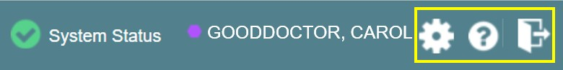Figure 3: CV Portal Tools

    - Default View
After logging in to CV, the VA Staff Portal opens. The default view of the VA Staff Portal is blank. The Community Care PPMS Provider Management widget is not open by default. You must launch it from the Widget Tray.
Click the Plus + sign in the lower right corner of the portal page (Figure 4) to open the Widget Tray. Click, hold, and drag the icon from the Widget Tray to the portal, and drop the widget in the desired location. Your widget configurations are saved to your profile and used each time you log in to CV.

Figure 4: Default View

VA Staff assign patients to CCPs and grant them limited access to patient records within the
Community Care PPMS Provider Management widget. There are two workflow options:
- Manage PPMS Provider (CCP)/Patient Assignment
- Search Patient Assignments
    - Viewing System Status
CV’s Health Monitor provides system status updates and monitors the services CV uses to connect to VA data sources. The services that are monitored include: Master Veteran Index (MVI), VistA Data Service (VDS), and jMeadows Data Service.
The system status is displayed in two areas:
- On the Login page (Figure 2)
- Atop the VA Staff Portal page (Figure 5)
When all monitored systems and services are online and connected, a green icon appears next to the status with the message, “CV data sources available” (Figure 2).
When one or more monitored systems or services are offline or unavailable, a yellow warning icon appears with the message, “CV is having problems.”
When CV’s Health Monitor is unable to retrieve and report system status information, a red icon appears with the message, “System status is unavailable.” When this status appears, you may
not be able to log in to CV or view patient data until the connection is restored. See Getting Help for information on how to contact the ESD.

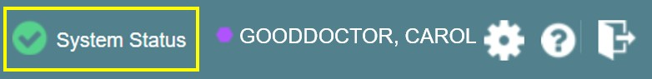Figure 5: System Status Indicator

    - Profile Settings
Profile settings are accessible within CV by clicking Settings located in the upper right corner of the portal pages (Figure 4).

NOTE: The configuration options are limited to choosing a UI theme in this release.
Selecting a UI Theme sets the font color, foreground, and background colors of the CV Graphical User Interface (GUI). Themes apply to all application elements, including widgets, toolbars, and dialog boxes. Theme choices are Default, Green, Blue, Gray, and Accessible. The Accessible theme (Figure 11) is 508-compliant, and it is designed to work with the accessibility tools installed on a user’s device.
- Click Settings in the upper right corner of the portal pages
- The CV Settings dialog opens (Figure 6)
- Click the radio button next to the desired theme
- Click Save
- Click Cancel to exit the CV Settings dialog and restore the previous theme

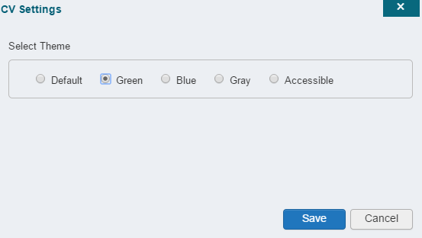Figure 6: The CV Settings Dialog

UI theme choices are displayed in figures 7 through 11.

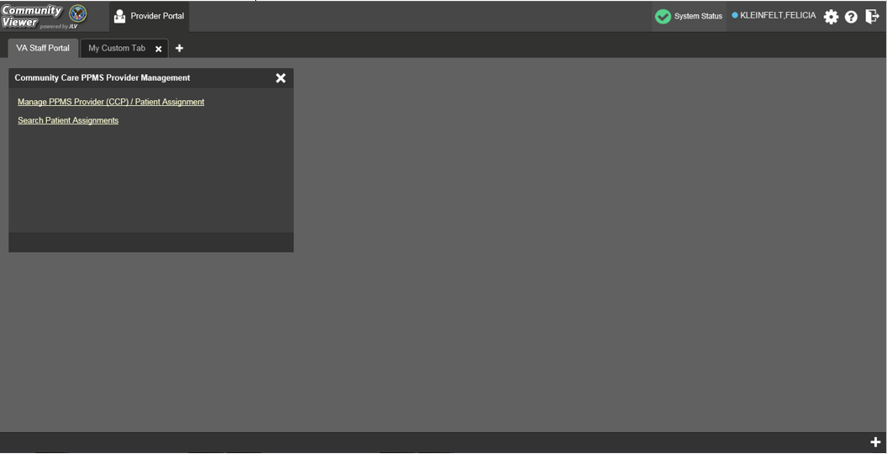Figure 7: Default Theme

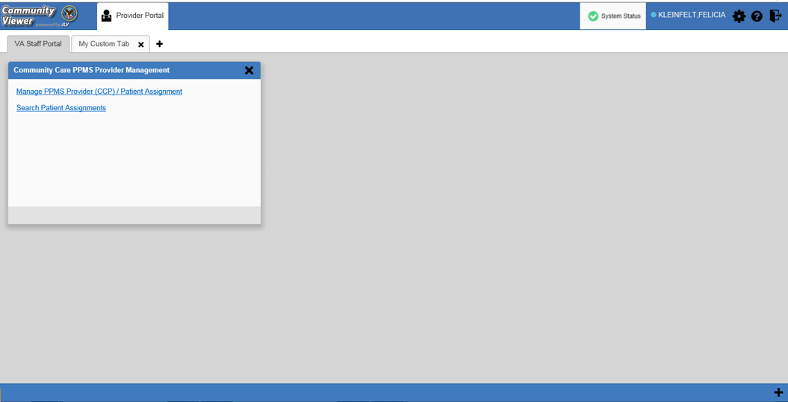Figure 8: Blue UI Theme

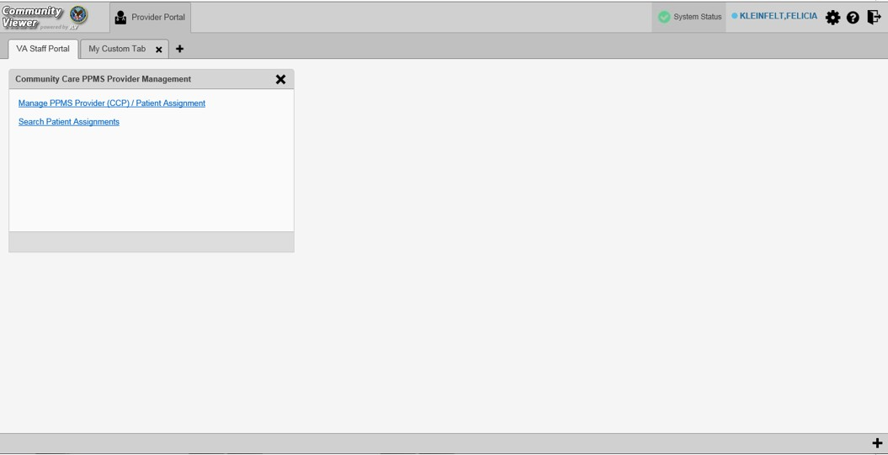Figure 9: Gray UI Theme

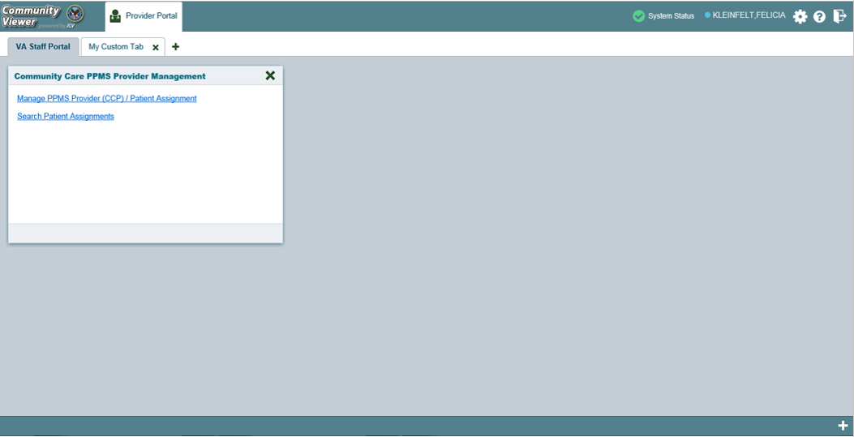Figure 10: Green UI Theme

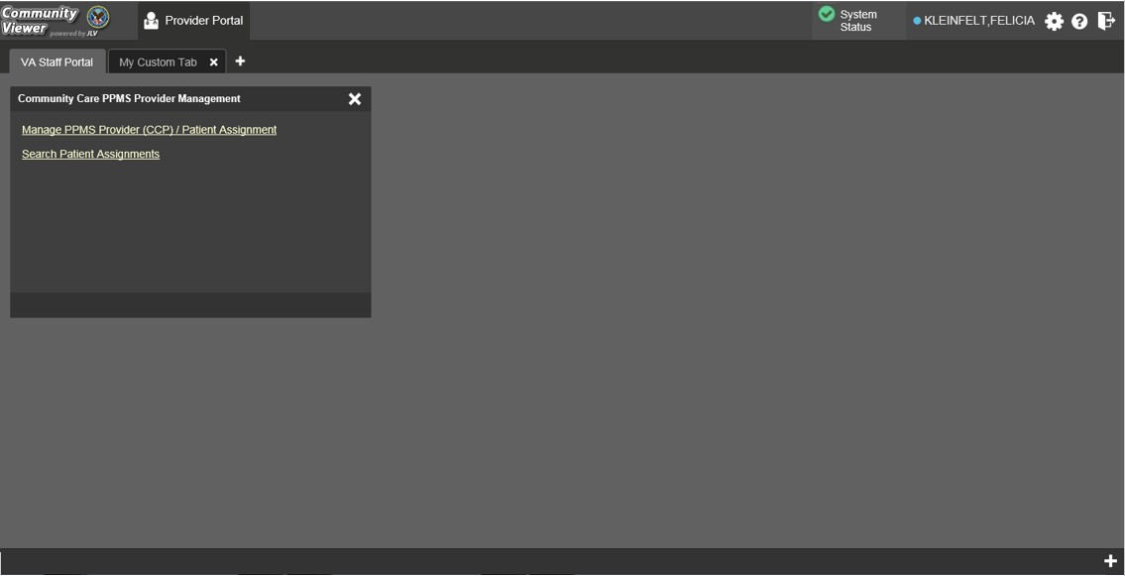Figure 11: Accessible (508-Compliant) UI Theme

    - Using the Accessible Theme’s Functionality
The Accessible theme includes larger fonts, enhanced tab and keystroke functionality, and screen reader compatibility to support Federal accessibility requirements and Section 508 compliance.

NOTE: The Accessible theme is available for users who have adaptive technologies installed on their computers.
      - Keyboard Focus and Screen Navigation
Keyboard focus is the highlighting of screen elements that enables interaction with, and the navigation of, the web application through the keyboard and keystrokes. The screen element in focus is outlined in gold (Figure 11) as a visual indicator of keyboard focus.
CV enables the use of Windows keystrokes (Tab, Shift + Tab, arrow keys, Enter), and keyboard shortcuts to move the focus to all menus, and activate all functions on the menus. All UI items are accessible via the keyboard under the Accessible theme.

NOTE: If you focus on an element within the widget that has hover text, the text appears after a small delay as if the user hovered over the element with a mouse cursor.

Pressing Enter or the Spacebar when an element that provides action is in keyboard focus performs the associated action. Pressing Enter or the Spacebar when the Settings icon is in focus, for example, opens the CV Settings dialog. Using the arrow keys or the Tab key allows a user to move between keyboard focus items to navigate through screen elements. Table 1 provides a complete list of accessible keystrokes.

Table 1: Keyboard Accessible Keystrokes
Keystroke | Description
Application and Portal Navigation
Alt+4 | Press to transfer keyboard focus to the main or top screen element: Focus is transferred to the Provider portal tab on a portal page.  Focus is transferred to the first link or data element in a widget.  Focus is transferred to the dialog box’s Close button (X).
Alt+5 | Press on a page with two panels to toggle keyboard focus between the main or top element on left and right panels.
ENTER | Press to transfer keyboard focus to the highlighted widget.
TAB | Press to transfer keyboard focus to other UI items.
ESC | Press to return keyboard focus to the panel containing the UI item with keyboard focus or to exit a window or widget.
SPACEBAR | Press to activate any UI item (for example, click an icon).
Arrow Keys | When keyboard focus is on a widget, press the arrow keys to change page viewing in a widget's data table.  When keyboard focus is on a dropdown, press the down arrow to view the contents.
Portal Tabs
Arrow Keys | Use the left and right arrow keys to navigate between tabs.
TAB | Press one or more times when focus is on a portal tab to place Add Tab (+) in keyboard focus.  Add a Tab:  - Press Tab until Add Tab (+) is in focus.  - Press Enter.  - The new tab dialog box opens and prompts you to enter a name for the new tab.  - Tab to the Add button to confirm the new tab name or tab to the Cancel button to discard the new tab.
ENTER | Press while the (+) is in focus to add a new portal tab. A dialog prompts the user to enter a name for the tab.
ESC | Focus on a tab and press ESC to remove it.
Windows and Dialog Boxes
TAB | Press the Tab key to move the keyboard focus to other UI items within the window.
Adding Widgets to the Portal Pages
Alt + 1, 2, or 3 | Add a widget to a Portal page from the Widget Tray:  - Determine in which column (1, 2, or 3) of the Portal page to place the widget.  - Focus on the desired widget icon in the Widget Tray.  - Press Alt + 1, 2, or 3, depending on the desired column.

      - Accessible Theme Screen Navigation
An element with keyboard focus is the starting point for screen navigation. Pressing the Enter or
Spacebar keys when a screen element or icon has keyboard focus mimics a mouse click.
Figure 12 depicts the Patient Assignments pane of the Community Care PPMS Provider Management widget.
- Focus can be changed by pressing Tab key; pressing the Tab key in this example shifts the keyboard focus from the My Site radio button to the Patient Search field immediately below
- Typing at least two characters in the Patient Search field and pressing Enter, or tabbing to the Search button and pressing Enter, initiates a search
- Press Tab to navigate through the results
  - Tab once to focus first on the entire row of the patient result, then Tab again to put focus on the radio button associated with that record
- Press Spacebar with a radio button in focus to select a patient from the results
  - If you have a radio button selected, press the arrow keys up or down to navigate through the radio buttons for each patient result
  - If you have no radio buttons selected, Shift + Tab to navigate back up through the result rows
- Use Alt + 5 on to toggle between the Patient Search and Patient Assignments panes.

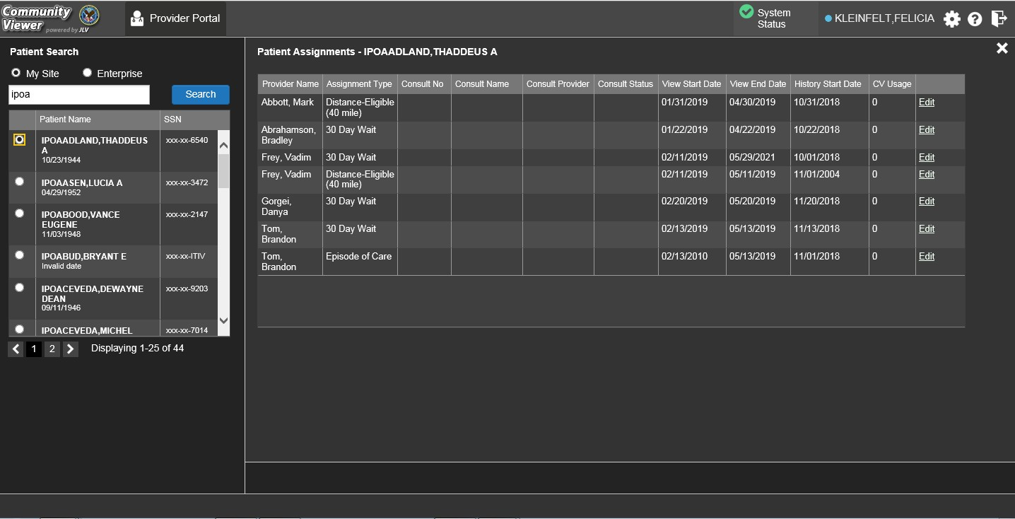
Figure 12: Navigation Using Elements with Keyboard Focus

2.4. Logging Out of the Current CV Session
You may intentionally log out to end a CV session by clicking Logout at any time. If you fail to log out, the current session terminates automatically after 30 minutes of inactivity. You are redirected to the Login page when any new activity is attempted.

Using CV

The Widget Tray
The Provider Portal contains the VA Staff Portal tab, which holds the Community Care PPMS Provider Management widget.
You can launch the Community Care PPMS Provider Management widget from the Widget Tray if it is not displayed immediately after you log in (Figure 13).
Click the Plus + icon in the lower right corner of the portal to open the Widget Tray (the widget tray and Plus + icon are highlighted in the following figure). Click, hold, and drag the icon from the Widget Tray to the portal page, and drop the widget in the desired location.

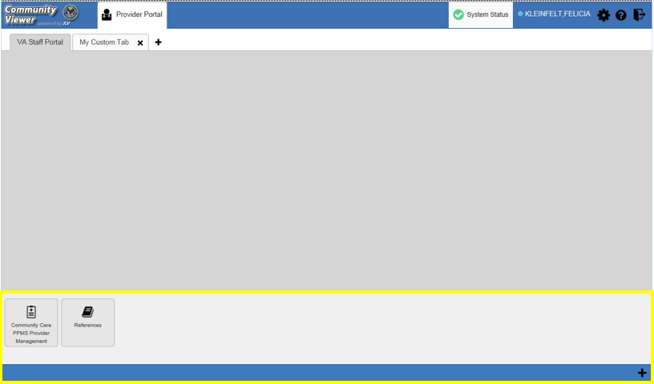
Figure 13: Widget Tray

About the Community Care PPMS Provider Management Widget
The Community Care PPMS Provider Management widget within the VA Staff Portal
(Figure 14) provides a read-only view of individual CCP profile data and is the starting point for

multiple tasks, including assigning a VA patient to a CCP, setting limits on the CCP’s access to the patient's VA medical record, and generating or resetting CCP passwords.
The following tasks (links) are available:
- Manage PPMS Provider (CCP)/Patient Assignment
- Search Patient Assignments

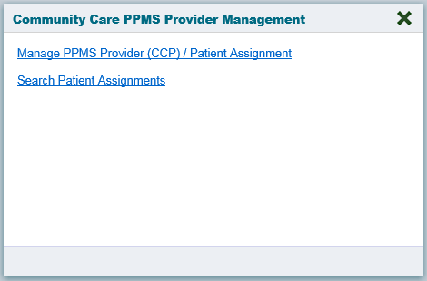
Figure 14: Community Care PPMS Provider Management Widget

About Search
The Community Care PPMS Provider Management widget’s search features are used to find a provider or a patient.

NOTE: All search figures depict searches within and information from test databases.
    - Searching Providers
When using the Manage PPMS Provider (CCP)/Patient Assignment feature in the Community Care PPMS Provider Management widget, you can search for providers by entering a 10-digit National Provider Identifier (NPI) in the Search Providers field and selecting the Search button (Figure 15). The Search button remains disabled if you enter any value other than 10 digits. You can also use the PPMS Provider Locator or NPI Registry links to find the NPI value if you do not already have it.

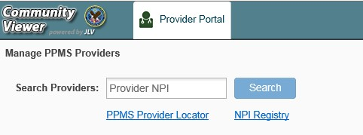Figure 15: PPMS Provider Search

    - Searching Patients
There are two types of patient searches in CV from the Search Patient Assignments feature:
- My Site Search: Searches the user’s local VistA (also known as facility or site); the patients listed in the search results are registered to that local VistA only (Figure 16)
- Enterprise Search: Searches all VistAs across the Enterprise; the patients listed in the search results are registered to one or more VistAs (Figure 17)
When searching for a patient within your site:
- Select the Search Patient Assignments link from the Community Care PPMS Provider Management widget
- Confirm the My Site radio button is selected by default
- Enter search criteria into the Patient Search field:
  - A minimum of two characters of the patient’s last name -OR-
  - The patient's last name, followed by a comma and either the first initial or full spelling of the patient's first name (Smith, J or Smith, John) -OR-
  - The patient's full Social Security Number (SSN) (123456789) -OR-
  - The first letter of the patient's last name followed by the last 4 digits of the patient’s SSN (S6789)
- Click Search or press Enter

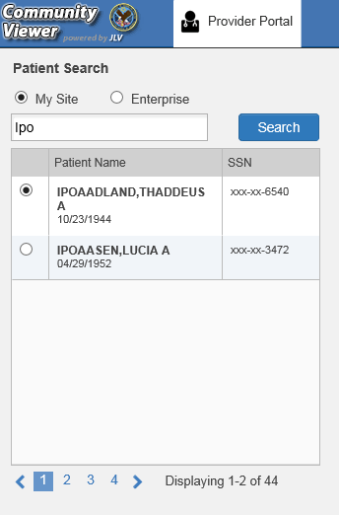Figure 16: My Site Patient Search

When searching for a patient across the Enterprise:
- Select the Search Patient Assignments link from the Community Care PPMS Provider Management widget
- Select the Enterprise radio button
- Enter the patient’s SSN into the required Patient SSN field (required)
- Enter the patient’s full last name into the required Last Name field (required)
- Enter the patient’s date of birth (DOB) in the optional DOB field (optional)
- Enter the patient’s first name in the optional First Name field (optional)
- Click Search or press Enter

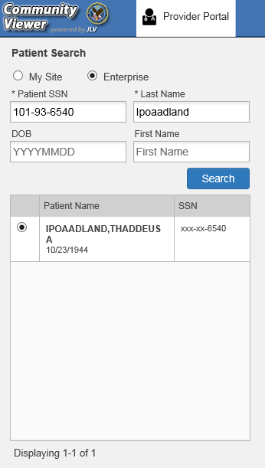Figure 17: Enterprise Patient Search

Please see Assigning and Unassigning Patients for detailed instructions on how to run either a
My Site or Enterprise search from the Manage Providers pane.

Resetting Provider Passwords
If a provider has forgotten his/her password, they can click the Reset Password link on the Login page to open a window that enables the provider to send a password reset link directly to their e-mail address, which they can then use to reset their own password. The password reset link is valid for 24 hours. Password resets can also be performed manually by VA Staff.

    - Managing Passwords
Follow the detailed steps below to automatically generate or manually create a CCP’s password.
- Open the Community Care PPMS Provider Management widget
- Click the Manage PPMS Provider (CCP)/Patient Assignment link
- Enter the provider’s NPI in the Search Providers field (Figure 18)
- Click Search
- Click Generate to allow the system to create a new, random password or manually enter a password that meets VA Directive 6500 security compliance criteria

NOTE: CCPs must have an e-mail address listed in their PPMS profile before a password can be generated in CV.
- Record the new password
- Click Save
- Securely provide the CCP with his/her new password for CV using VirtuPro or by phone

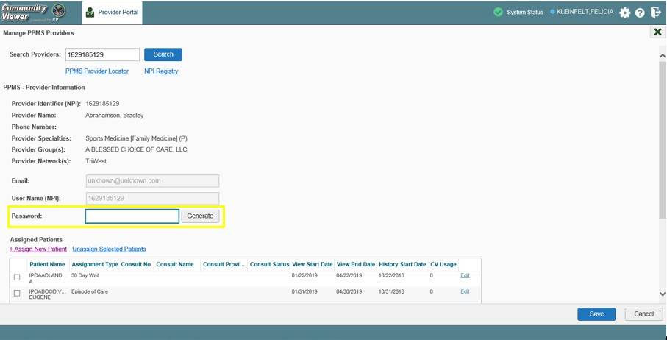Figure 18: CCP Password Generation or Reset Dialog

NOTE: VA Staff are required to generate a password before CCPs can log in for the first time. CV enforces the password requirements outlined in the VA Handbook 6500.

Assigning and Unassigning Patients
You can assign patients to CCPs using the Community Care PPMS Provider Management
widget.

NOTE: VA Staff cannot create CCP accounts in the Community Care PPMS Provider Management widget. See Using CV for more information.

CV uses the following rules to manage patient assignments:
- A Veteran may be assigned to more than one CCP for the following Assignment Types:
  - 30 Day Wait
  - Distance Eligible
  - Episode of Care
- A specific Veteran/consult combination may only be assigned to a single CCP

Table 2: Assignment Rules Examples

 | Veteran John Davis has multiple active referrals to be assigned:
Referral 1 |  | 30 Day Wait for Dental | Assign to CCP A | A Veteran may have multiple, active assignments for an Assignment Type
Referral 2 |  | 30 Day Wait for Podiatry | Assign to CCP B
Referral 3 |  | 30 Day Wait for Podiatry | Assign to CCP C
Referral 4 |  | Episode of Care for Optometry | Assign to CCP D
Referral 5 |  | Consult for Cardiology | Assign to CCP E | This specific consult can only be assigned to one CCP at a time
Referral 6 |  | Consult for Chiropractic | Assign to CCP F | This specific consult can only be assigned to one CCP at a time

    - Assigning Patients
Once the CCP’s account has been created in PPMS, VA Staff can assign them patients in CV.
- Click the Manage Provider PPMS (CCP)/Patient Assignment link in the Community Care PPMS Provider Management widget
- Enter the provider’s NPI in the Search Providers field
- Click Search
- The provider’s information displays under PPMS Provider Information

- Click the + Assign New Patient link under Assigned Patients (Figure 19)
  - The Patient Search dialog opens

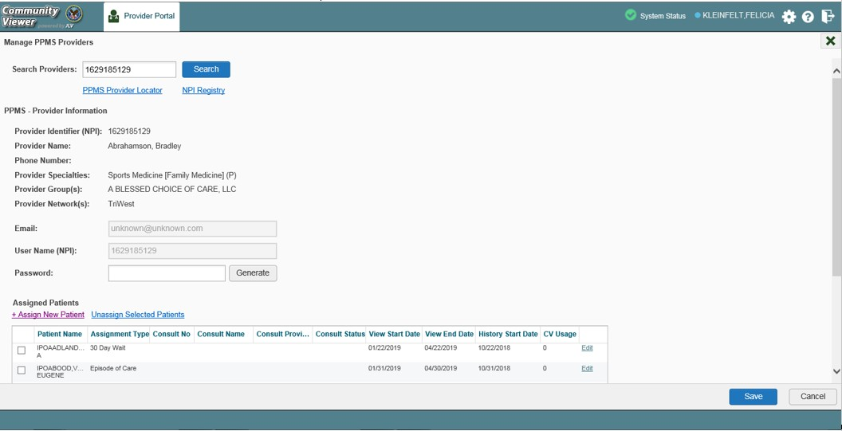Figure 19: PPMS Patient Assignment Pane

- Enter the patient name in the blank field at the top of the Patient Search dialog (Figure 20)
- Select the My Site or Enterprise search option and enter the search criteria (Please refer to Searching Patients for details)

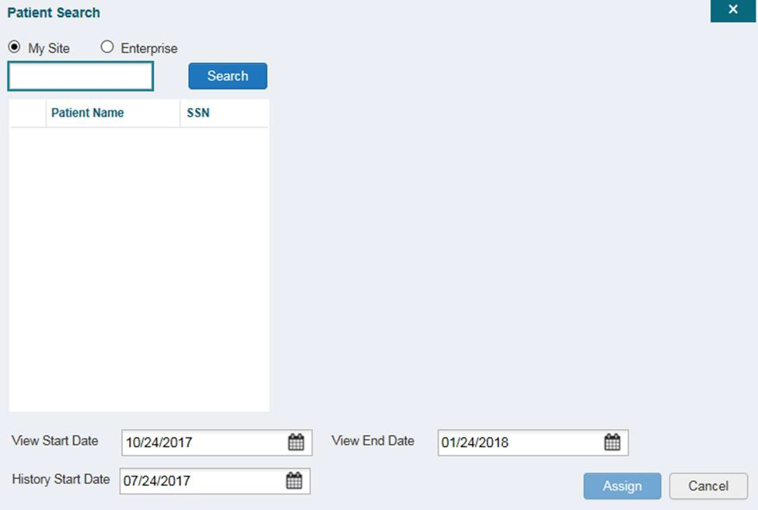Figure 20: Patient Search Dialog Box

- Click Search
- Select a patient from the search results list (Figure 21)
- Select the Assignment Type from the dropdown: 30 Day Wait, Consult (available when search was performed through My Site only), Distance-Eligible (40 mile), or Episode of Care
  - If Consult is specified, select one consult record from the list that appears (Consult status must be Active or Scheduled for the consult to appear in the list.)

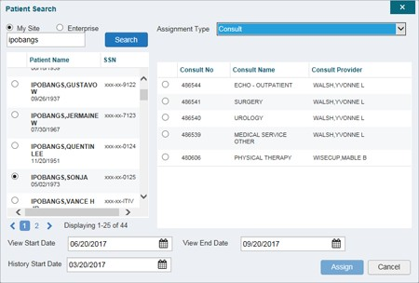
Figure 21: The Patient Search Dialog Box, Showing Results

- If desired, adjust the default View Start Date, View End Date, and History Start Date
fields to restrict the patient data seen by the CCP
- Click Assign
- A notification is generated and sent to the CCP
  - Review the message and edit as needed
- Click Send E-mail
When it is necessary to unassign patient(s) from a CCP:
- Repeat steps 1 - 4 from the Community Care PPMS Provider Management widget to
navigate to the Manage PPMS Providers page
- Click the Unassign Selected Patients link

    - Setting Record Display Limits
VA Staff can limit the patient records made available to the assigned CCP. There are two settings that control access to patient data:
- View Start Date and View End Date: These fields set the length of time the CCP has access to the patient records through CV
  - The default View Start Date is the date the patient is assigned to the CCP
  - The default View End Date is 3 months from the default start date
- History Start Date: This setting represents how far back in a patient's VA medical history the CCP is permitted to view
  - The default history start date is 3 months prior to the current date

  - If the history start date is set to 01/01/2012, for example, the CCP has access to the patient's records from available VA facilities from 2012 to the present
Data access controls are set by VA Staff during the patient assignment process.
- Click the Calendar icon next to the View Start Date and the View End Date fields
- Select the start and end dates (Figure 22)
- Alternatively, click the Calendar icon next to the History Start Date
- Select a date
- Click Assign

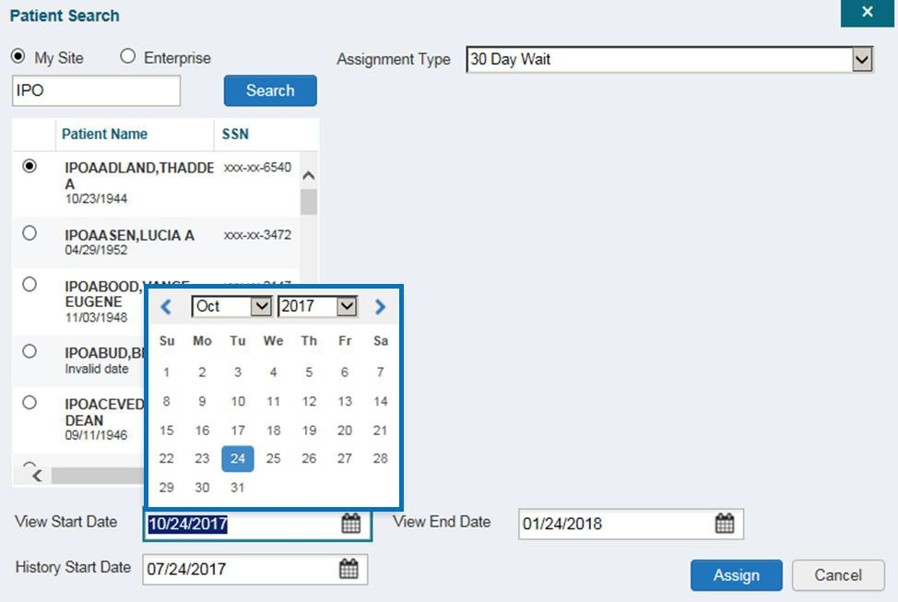Figure 22: Data Access Controls

Troubleshooting

Login Page Errors
Access to CV is limited to registered, authorized users. CV validates user access against information retrieved from your smart card. If you have trouble logging in to CV, please review Table 3 before contacting the ESD.

Table 3: Login Page Error Message Troubleshooting

Error Message | Resolution Steps
There is an issue preventing your access to Community Viewer. Please contact your VA Contractor or your VA Medical Center for assistance. | WHY? A CCP attempted to log in without an active status.  FIX IT: Update the status to “active” in PPMS.
Could not save User Profile | WHY? The error occurred during PIV authentication for VA users. It is typically a PIV card processing problem, or the wrong security certificate was chosen.  FIX IT:  - Close your browser window  - Reinsert your PIV card and relaunch CV  - Select a certificate that is not expired and specifies: “Issued by: Veterans Affairs CA B1”  - If this is unsuccessful, close all open IE windows/tabs, then open IE and try CV again
Not a valid ACCESS/VERIFY  CODE pair | WHY? 1) CV could not match your Access and Verify codes to the Site selected in the dropdown or VA; or 2) A username and password were entered instead of Access/Verify codes.  FIX IT:  - Veterans Health Administration (VHA) users must select the parent VistA host site for their facility  - Reenter your Access and Verify codes (Computerized Patient Record System [CPRS] or VistA codes for VHA users)
Page cannot be displayed | WHY? The CV URL requires certain IE settings.  FIX IT:  - Click the Tools menu (press ALT-X) in IE  - Select Internet Options  - When the dialog opens, select the Advanced tab  - Scroll down in the list until you see the Secure Sockets Layer (SSL) 2.0 setting (Windows 7 machine), or the Secure Sockets Layer 3.0 setting (Windows 10 machine), and ensure it is NOT checked  - Ensure that Transport Layer Security (TLS) 1.0, 1.1, and 1.2 ARE checked  - Click OK to close the dialog box, then relaunch CV (The page should load)

Error Message | Resolution Steps
Smart Card required | WHY? Your Smart Card was not read by Windows Security and CV before opening the CV URL.  FIX IT:  - Close all browser sessions/browser-based applications  - Reinsert PIV card and relaunch CV  - If this is unsuccessful, fully reboot your system to refresh all connections (This resolves greater than 95% of any remaining problems.)
VERIFY CODE must  be changed before continued use | WHY? Your CPRS VERIFY CODE has expired.  FIX IT:  - Open CPRS or VistA  - If prompted for a PIV card certificate by CPRS, click Cancel  - Select the Change Verify Code checkbox on the sign-on dialog before clicking OK  - You are prompted to create a new Verify code  - Once your Verify code is changed for CPRS, CV recognizes the new code immediately

Provider Search Errors
The following error messages may appear when searching for a provider in the Community Care PPMS Provider Management widget. If you encounter error messages while searching for providers, please review Table 4 before contacting the ESD.

Table 4: Provider Search Error Messages and Resolution Steps
Error Message | Resolution Steps
Patients may only be assigned to active individual (Type I) providers. Utilize PPMS to locate an individual (Type I) provider associated to the group (Type II) provider you entered. | WHY? CV can only retrieve individual (Type 1) providers. Provider groups (Type II) are not supported.  FIX IT: Locate an individual (Type I) provider associated with the group (Type II) in PPMS.
Patients may only be assigned to active individual (Type I) providers. Utilize PPMS to research why the provider you entered is not active. | WHY? CV can only retrieve providers with an active status.  FIX IT: Use PPMS to research why the provider you searched does not have an active status.
Email is required to ensure notifications occur when patients are assigned. To continue with this provider, add the provider’s email address in PPMS and search again. | WHY? The e-mail address is blank in the PPMS profile.  FIX IT: Update the provider’s e-mail address in PPMS.

Error Message | Resolution Steps
NPI entered not found. Validate the NPI in the NPI Registry. If the NPI is valid, follow the appropriate business process in PPMS. | WHY? NPIs must be 10-digits and belong to active, individual (Type 1) providers.  FIX IT: Use the PPMS Provider Locator or NPI Registry links to verify the NPI value. If the NPI value is valid, follow the appropriate business process to add the provider to PPMS.

Patient Search Errors
The following error messages may appear when searching for a patient in the Community Care PPMS Provider Management widget. If you encounter error messages while searching for patients, please review Table 5 before contacting the ESD.

Table 5: Patient Search Error Messages and Resolution Steps
Error Message | Resolution Steps
An invalid search criterion was entered. Please enter at least 2 characters. | WHY? You entered an invalid patient name.  FIX IT: Please try your search again.  When searching by patient name, enter at least two characters of the patient’s first and last name. Search results display the closest match to the characters entered in the format of [last name], [first name].
An invalid SSN format was entered. Please enter a 9- digit SSN. | WHY? You entered an invalid SSN.  FIX IT: Please try your search again.  When searching by patient SSN, you are required to enter the patient’s full 9- digit SSN. Dashes are allowed (e.g., 123-45-6789).
An invalid last 5 format was entered. Please enter the first letter of the last name followed by the last 4-digits of the SSN. | WHY? You entered an invalid patient name or SSN.  FIX IT: Please try your search again.  Patient search allows you to search for a patient using the first initial of the patient’s last name and the last four digits of the patient’s SSN. Please try your search again using the first initial of the patient’s last name and the last four digits of the patient’s SSN.
An error occurred during your search. Please try your search again. | WHY? This error may display when invalid patient identifiers were entered, or an error occurred at the service layer or with an external system.  FIX IT: Please try your search again.

Acronyms and Abbreviations
Table 6 lists the acronyms and abbreviations used throughout this document and their descriptions.

Table 6: Acronyms and Abbreviations
Acronym | Description
CCP | Community Care Provider
CPRS | Computerized Patient Record System
CV | Community Viewer
DOB | Date of Birth
ESD | Enterprise Service Desk
GUI | Graphical User Interface
IE | Internet Explorer
MVI | Master Veteran Index
NPI | National Provider Identifier
OIT | Office of Information and Technology
PIN | Personal Identification Number
PIV | Personal Identification Verification
PPMS | Provider Profile Management System
SSL | Secure Sockets Layer
SSN | Social Security Number
TLS | Transport Layer Security
TPA | Third-Party Administrator
UI | User Interface
URL | Uniform Resource Locator
VA | Department of Veterans Affairs
VDS | VistA Data Service
VHA | Veterans Health Administration
VistA | Veterans Health Information Systems and Technology Architecture

