Community Viewer (CV) Version 3.0 Risk Management VA Staff User Guide

June 2019
Version 1.0 Department of Veterans Affairs (VA)
Office of Information and Technology (OIT)

Revision History

Date | Version | Description | Author
06/12/2019 | 1.1 | Received Approval from VA PM/COR | AbleVets
06/11/2019 | 1.1 | Delivered for PM/COR Approval | AbleVets
06/03/2019 | 1.0 | Delivered for Review | AbleVets
04/01/2019 | 0.1 | Initial draft of document created | AbleVets

Table of Contents

- Introduction 1
  - Purpose of the Guide 2
    - Guide Conventions 2
    - Terminology 2
  - Assumptions 2
  - System Requirements 2
  - Getting Help 3
- Logging in to CV 3
  - System Notifications 4
    - Viewing System Status 4
    - Viewing Announcements 5
  - Editing Your User Profile at Login 5
  - The CV Portal Pages 6
    - Default View 6
    - Profile Settings 7
    - Using the Accessible Theme’s Functionality 10
      - Keyboard Focus and Portal Navigation 10
      - Accessible Theme Portal Navigation 11
  - Logging Out of the Current CV Session 12
- Using CV 13
  - The Widget Tray 13
  - About the RMPM Widget 13
  - About RMP Accounts 14
    - Creating RMP Accounts 14
    - Editing RMP Profiles 16
    - Deleting RMP Accounts 17
  - About Provider Groups and Facilities 18
    - Creating Provider Groups 18
    - Editing Provider Groups 18
    - Deleting a Provider Group 20
  - About Search 21
    - Searching Provider Groups 21
    - Searching Providers 23
    - Searching Patients 24
  - Managing Passwords 26
    - Resetting Provider Passwords 26
  - Assigning and Unassigning Patients 27
    - Creating Patient Assignments 28
    - Removing Patient Assignments 30
    - Setting Record Display Limits 30
- Troubleshooting 31
  - Login Page Errors 31
  - Patient Search Errors 32
- Acronyms and Abbreviations 33

Table of Figures
Figure 1: CV Authorized Use Only Warning 1
Figure 2: Login Page 4
Figure 3: System Status Indicator 5
Figure 4: CV Portal Tools 6
Figure 5: Default View 6
Figure 6: The CV Settings Dialog 7
Figure 7: Default Theme 8
Figure 8: Blue UI Theme 8
Figure 9: Gray UI Theme 9
Figure 10: Green UI Theme 9
Figure 11: Accessible (508-Compliant) UI Theme 10
Figure 12: Navigation Using Elements with Keyboard Focus 12
Figure 13: Widget Tray 13
Figure 14: The RMPM Widget 14
Figure 15: Search Providers and Manage Providers Panes 15
Figure 16: Username Already Exists Error Message 15
Figure 17: Search Providers and Manage Providers Panes 17
Figure 18: Search and Manage Community Care Provider Groups Panes 19
Figure 19: Assigned Providers Edit and Delete Links 20
Figure 20: Provider Group Deletion Error Message 20
Figure 21: Provider Group Has Providers Without Patient Assignments 21
Figure 22: Browse Facilities Dialog Box–Community Care Provider Groups 22
Figure 23: CV Community Care Provider Group Search: Too Many Results Notification 23
Figure 24: Browse Facilities Dialog Box–Search Providers 24
Figure 25: My Site Patient Search 25
Figure 26: Enterprise Patient Search 26
Figure 27: RMP Password Reset 27
Figure 28: Search Providers Pane 28
Figure 29: Manage Providers Fields Detail 29
Figure 30: Patient Search Dialog Box 29
Figure 31: Data Access Controls 31

Table of Tables
Table 1: Keyboard Accessible Keystrokes 11
Table 2: Assignment Rules Examples 28
Table 3: Login Page Error Message Troubleshooting 31
Table 4: Patient Search Error Messages and Resolution Steps 32
Table 5: Acronyms and Abbreviations 33

Introduction
Community Viewer (CV) is a browser-based software application that facilitates the secure exchange of data between Department of Veterans Affairs (VA) systems and Risk Management Providers (RMPs). The exchange of data improves the coordination and quality of care for VA patients by allowing for quality assurance reviews to be performed outside of the VA network.
CV pulls information from VA health care systems in real time for viewing within a web browser. Risk Management (RM) VA Staff assign patients to RMPs through CV, allowing them access to view consolidated patient data from multiple Veterans Information Systems and Technology Architecture (VistA) systems.
This User Guide is intended for RM VA Staff who use the functionality within the Risk Management Provider Management (RMPM) widget of CV to view profile information and manage patient assignments for RMPs.
Please read and bear in mind the warning displayed in Figure 1 before using CV.

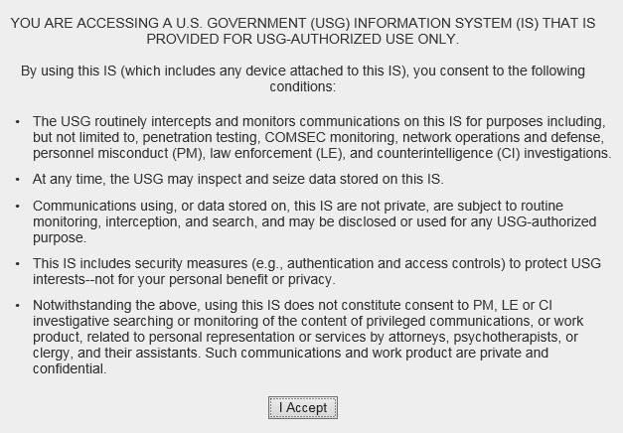Figure 1: CV Authorized Use Only Warning

RM VA Staff use the RMPM widget to perform the following tasks for RMPs:
- Create, edit, and delete individual RMP profiles
- Create, edit, and delete RM community care provider groups
- Assign/unassign patients
- Search patient assignments
- Manage access to patient data
- Perform My Site and Enterprise patient searches

- Generate or reset passwords
- Generate system reports

Purpose of the Guide
The purpose of this user guide is to familiarize RM VA Staff with the important features and navigational elements of CV. This guide indicates when specific features are restricted to specific user groups.

    - Guide Conventions
This document is designed for both online and hardcopy consumption.
- Cross-References are indicated by blue, underlined text, and provide a hyperlink to figures, tables, and other sections within this guide
- Emphasis is expressed by bold, underlined, and italicized text
- The information symbol calls the reader’s attention to additional information
    - Terminology
The following standard terms are used throughout this guide:
- VA Staff Portal: The landing page, or default view, of CV that appears after logging in; the portal page displays widgets and the tools that enable quick access to basic features
- Widget: A component of the CV interface that enables a user to view information or perform a function
- Widget Tray: An expandable and collapsible tray at the bottom of the portal page that provides access to the widgets available for placement on the portal page

Assumptions
The user guide is written from the perspective of RM VA Staff and assumes that:
- You can open, navigate, and use a web browser
- You can use web-based applications, their menu options, and navigation tools
- You have the Uniform Resource Locator (URL) for the CV Login page, system user names, a Personal Identification Verification (PIV) card (also referred to as a Smart Card), and the VistA Access/Verify codes required to launch CV

System Requirements
CV is a front-end web application, designed to run in a web browser on the VA network. Accessing CV through a browser or device that is not fully compatible with the application may result in certain features not working as expected.

NOTE: Mobile devices are not supported in this release.

It is recommended that CV be accessed from a desktop or laptop PC using a supported browser, such as:
- Internet Explorer (IE) v11
- Chrome v73
- Microsoft Edge v44
- Safari v12

Getting Help
Authorized users who have trouble logging in to CV or experience other application issues should call the Enterprise Service Desk (ESD) for assistance or create a ticket using the YourIT self-service portal.
IT Enterprise Service Desk
REDACTED

Prior to contacting the ESD for support, please refer to Logging in to CV for detailed information about how to access CV, and to Troubleshooting for suggested resolution steps and troubleshooting information.

Logging in to CV
Before logging in to and utilizing CV functionality, please read the Sensitive Information warning in the Introduction.
CV authenticates all VA users using their PIV card (also known as a Smart Card) and their VistA Access and Verify codes. During log in, first-time CV users are prompted to enter their agency, site, and user settings. This data is used to create a CV user profile, and it is utilized during future login sessions.
- Ensure your PIV card is inserted into your computer or card reader
- Open a supported Internet browser
- Enter the URL for the CV web application into the address bar of the browser
- When prompted with a certificate list, select the PIV Authentication certificate
- When prompted, enter your PIV Personal Identification Number (PIN)
- Click I Accept after reading the important user consent information regarding accessing a Government information system (Figure 1)
- Enter the following information in the fields on the Login page (Figure 2):
  - VistA Access code
  - VistA Verify code
  - Select “VA” from the Agency field
  - Select your local VistA from the Site dropdown

NOTE: Users should review the Announcements and System Status panes on the Login page for information that may impact CV functionality or data availability. See Viewing System Status and Viewing Announcements for detailed information.

- Click Login

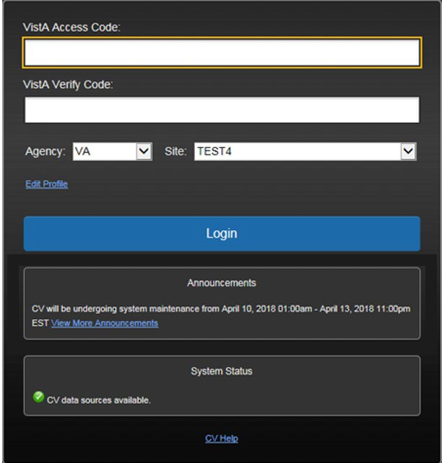
Figure 2: Login Page

System Notifications
The CV Login page displays system notifications to alert you to system outages, scheduled system activities, and important upgrades. The Login page also displays a notification when your VistA Verify code must be reset. The CV Help link opens CV online help, which guides you through the steps to reset your Verify code.

    - Viewing System Status
CV’s Health Monitor provides system status updates and monitors the services CV uses to connect to VA data sources. The services that are monitored include: Master Veteran Index (MVI), VistA Data Service (VDS), and jMeadows Data Service.

The system status is displayed in two areas:
- On the Login page (Figure 2)
- Atop the VA Staff Portal (Figure 3)
When all monitored systems and services are online and connected, a green icon appears next to the status with the message, “CV data sources available” (Figure 2).
When one or more monitored systems or services are offline or unavailable, a yellow warning icon appears with the message, “CV is having problems.”
When CV’s Health Monitor is unable to retrieve and report system status information, a red icon appears with the message, “System status is unavailable.” When this status appears, you may not be able to log in to CV or view patient data until the connection is restored. See Getting Help for information on how to contact the ESD.

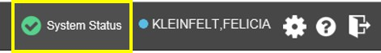
Figure 3: System Status Indicator

    - Viewing Announcements
System announcements are provided by VA and displayed on the Login page when scheduled system activities may impact the user or CV system availability. The View More Announcements link opens additional announcement information.

NOTE: Announcements are separate from the system status messages displayed on the Login page. See Viewing System Status for details.

Editing Your User Profile at Login
You can customize your profile from the Login page. First-time CV users are prompted to enter their agency, site, and User Interface (UI) theme settings before logging in. Once saved, the profile information is used each time you log in to CV.
UI theme preferences can also be set within CV. See Profile Settings.
- Click the Edit Profile link on the Login page
  - Profile options are presented
- Enter your VistA Access and Verify codes in the fields provided
- Enter your agency and site in the fields provided
- Select the desired UI theme
- Click Save and Login

The CV Portal Pages
The CV portal pages have tools that enable quick access to basic features. These tools appear in the upper right corner of the application window (Figure 4).
- Select the UI theme: Click the Settings icon to select the UI theme (See Profile Settings)
- Access online help: Click the Help icon to open web-based help
- Log out: Click the Logout icon to terminate the current CV session

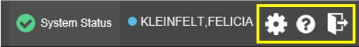
Figure 4: CV Portal Tools

    - Default View
After logging in to CV, the VA Staff Portal opens, displaying the VA Staff Portal tab. The default view of the VA Staff Portal is blank. The RMPM widget is not open by default. You must launch it from the Widget Tray.
Click the Plus + sign in the lower right corner of the portal (Figure 5) to open the Widget Tray. Click, hold, and drag the icon from the Widget Tray to the portal, and drop the widget in the desired location. Your widget configurations are saved to your profile and used each time you log in to CV.

Figure 5: Default View

    - Profile Settings
Profile settings are accessible within CV by clicking the Settings icon, located in the upper right corner of the portal pages (Figure 5).

NOTE: The configuration options are limited to choosing a UI theme in this release.

Selecting a UI Theme sets the font color, foreground, and background colors of CV. Themes apply to all application elements, including widgets, toolbars, and dialog boxes. Theme choices are Default, Green, Blue, Gray, and Accessible. The Accessible theme (Figure 11) is 508- compliant, and it is designed to work with the accessibility tools installed on your device.
- Click Settings in the upper right corner of the portal pages
  - The CV Settings dialog opens (Figure 6)
- Click the radio button next to the desired theme
- Click Save to apply the selected theme -OR-
- Click Cancel to exit the CV Settings dialog and restore the previous theme

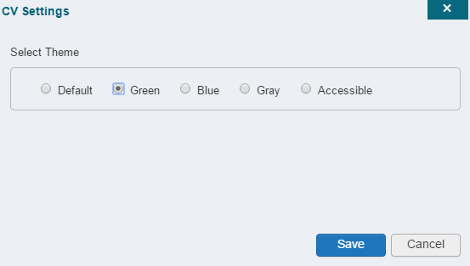Figure 6: The CV Settings Dialog

UI theme choices are displayed in the following figures.

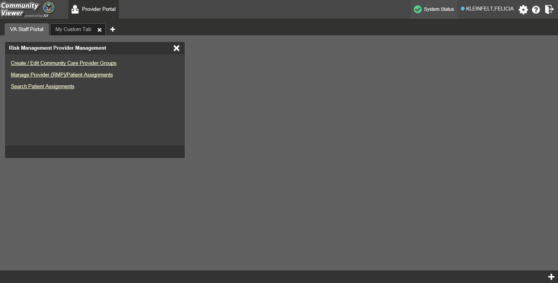Figure 7: Default Theme

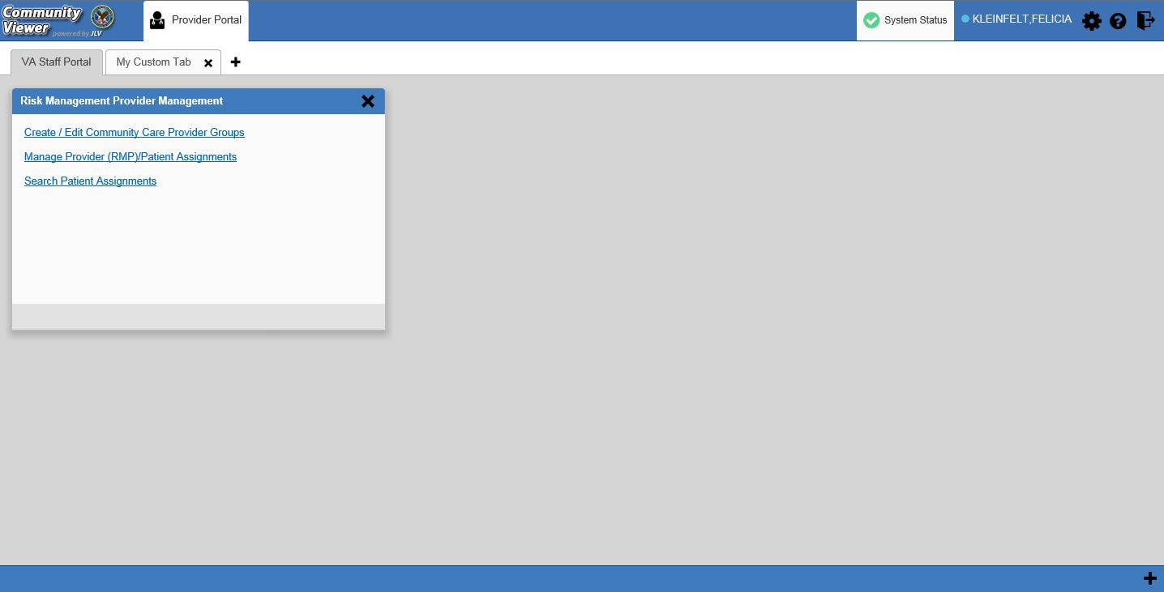Figure 8: Blue UI Theme

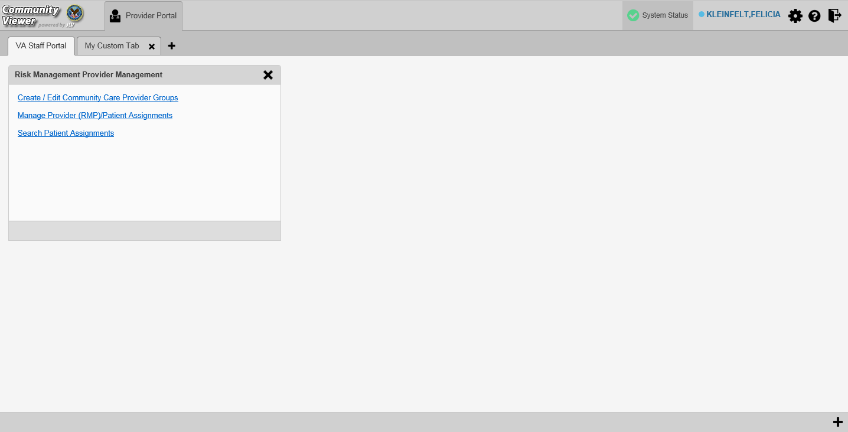Figure 9: Gray UI Theme

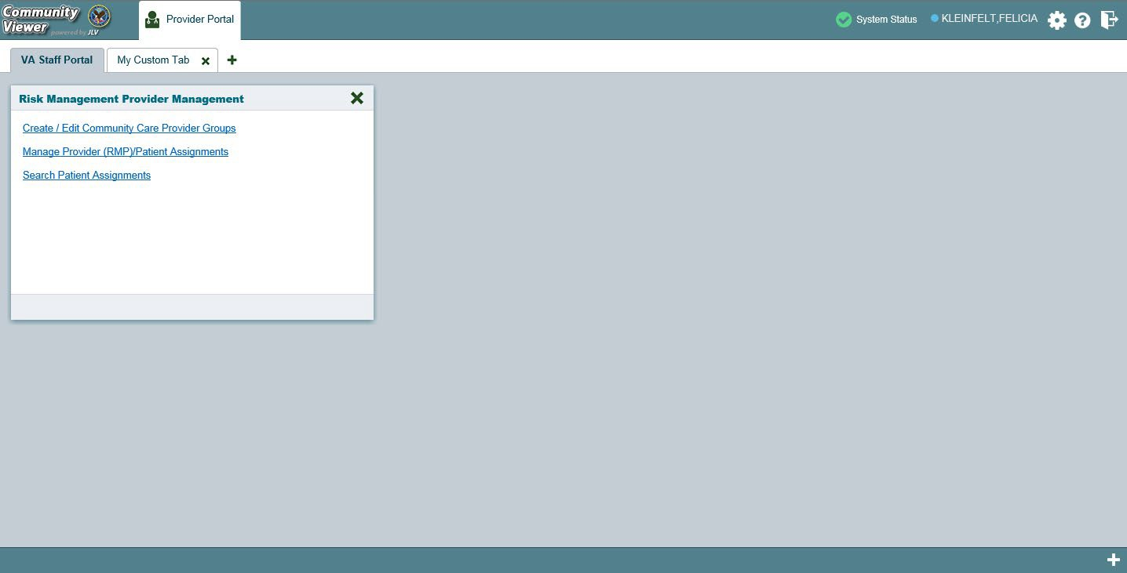Figure 10: Green UI Theme

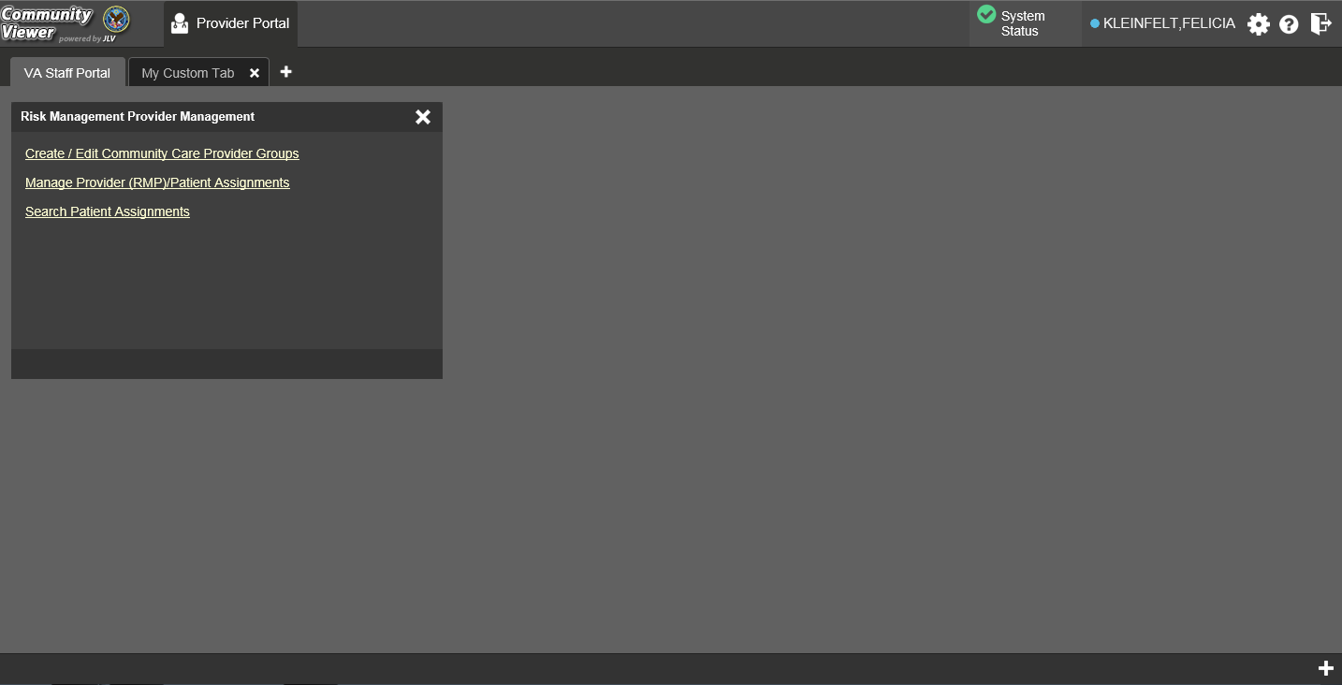Figure 11: Accessible (508-Compliant) UI Theme

    - Using the Accessible Theme’s Functionality
The Accessible theme includes larger fonts, enhanced tab and keystroke functionality, and screen reader compatibility to support Federal accessibility requirements and Section 508 compliance.

NOTE: The Accessible theme is available for users who have adaptive technologies installed on their computers.

      - Keyboard Focus and Portal Navigation
Keyboard focus is the highlighting of portal elements that enables interaction with, and the navigation of, the web application through the keyboard and keystrokes. The portal element in focus is outlined in gold (Figure 11) as a visual indicator of keyboard focus.
CV enables the use of Windows keystrokes (Tab, Shift + Tab, arrow keys, Enter), and keyboard shortcuts to move the focus to all menus, and activate all functions on the menus. All application components are accessible via the keyboard when the Accessible theme is in use.

NOTE: If you focus on an element within the widget that has hover text, the text appears after a small delay as if the user hovered over the element with a mouse cursor.

Pressing Enter or the Spacebar when an element that provides action is in keyboard focus performs the associated action. Pressing Enter or the Spacebar when the Settings icon is in focus, for example, opens the CV Settings dialog. Using the arrow keys or the Tab key allows a user to move between keyboard focus items to navigate through portal elements. Table 1 provides a complete list of accessible keystrokes.

Table 1: Keyboard Accessible Keystrokes

Keystroke | Description
Application and Portal Navigation
Alt+4 | Press to transfer keyboard focus to the main or top portal element: Focus is transferred to the Provider Portal tab on a portal page. Focus is transferred to the first link or data element in a widget.  Focus is transferred to the dialog box’s Close button (X).
Alt+5 | Press on a page with two panes to toggle keyboard focus between the main or top element on left and right panes.
ENTER | Press to transfer keyboard focus to the highlighted widget.
TAB | Press to transfer keyboard focus to other UI items.
ESC | Press to return keyboard focus to the pane containing the UI item with keyboard focus or to exit a window or widget.
SPACEBAR | Press to activate any UI item (for example, click an icon).
Arrow Keys | When keyboard focus is on a widget, press the arrow keys to change page viewing in a widget's data table.  When keyboard focus is on a dropdown, press the down arrow to view the contents.
Portal Tabs
Arrow Keys | Use the left and right arrow keys to navigate between tabs.
TAB | Press one or more times when focus is on a portal tab to place Add Tab (+) in keyboard focus.  Add a Tab:  - Press Tab until Add Tab (+) is in focus.  - Press Enter.  - The new tab dialog box opens and prompts you to enter a name for the new tab.  - Tab to the Add button to confirm the new tab name or tab to the Cancel button to discard the new tab.
ENTER | Press while the (+) is in focus to add a new portal tab. A dialog prompts the user to enter a name for the tab.
ESC | Focus on a tab and press ESC to remove it.
Windows and Dialog Boxes
TAB | Press the Tab key to move the keyboard focus to other UI items within the window.
Adding Widgets to the Portal Pages
Alt + 1, 2, or 3 | Add a widget to a Portal page from the Widget Tray:  - Determine in which column (1, 2, or 3) of the Portal page to place the widget.  - Focus on the desired widget icon in the Widget Tray.  - Press Alt + 1, 2, or 3, depending on the desired column.

      - Accessible Theme Portal Navigation
An element with keyboard focus is the starting point for portal navigation. Pressing the Enter or
Spacebar keys when a portal element or icon has keyboard focus mimics a mouse click. Figure 12 depicts the Patient Assignments pane of the RMPM widget.
- Focus can be changed by pressing Tab key

  - Pressing the Tab key in this example shifts the keyboard focus from the My Site radio button to the Patient Search field immediately below
- Typing at least two characters in the Patient Search field and pressing Enter, or tabbing to the Search button and pressing Enter, initiates a search
- Press Tab to navigate through the results
  - Tab once to focus first on the entire row of the patient result, then Tab again to put focus on the radio button associated with that record
- Press Spacebar with a radio button in focus to select a patient from the results
  - If you have a radio button selected, press the arrow keys up or down to navigate through the radio buttons for each patient result
  - If you have no radio buttons selected, Shift + Tab to navigate back up through the result rows
- Use Alt + 5 on to toggle between the Patient Search and Patient Assignments panes.

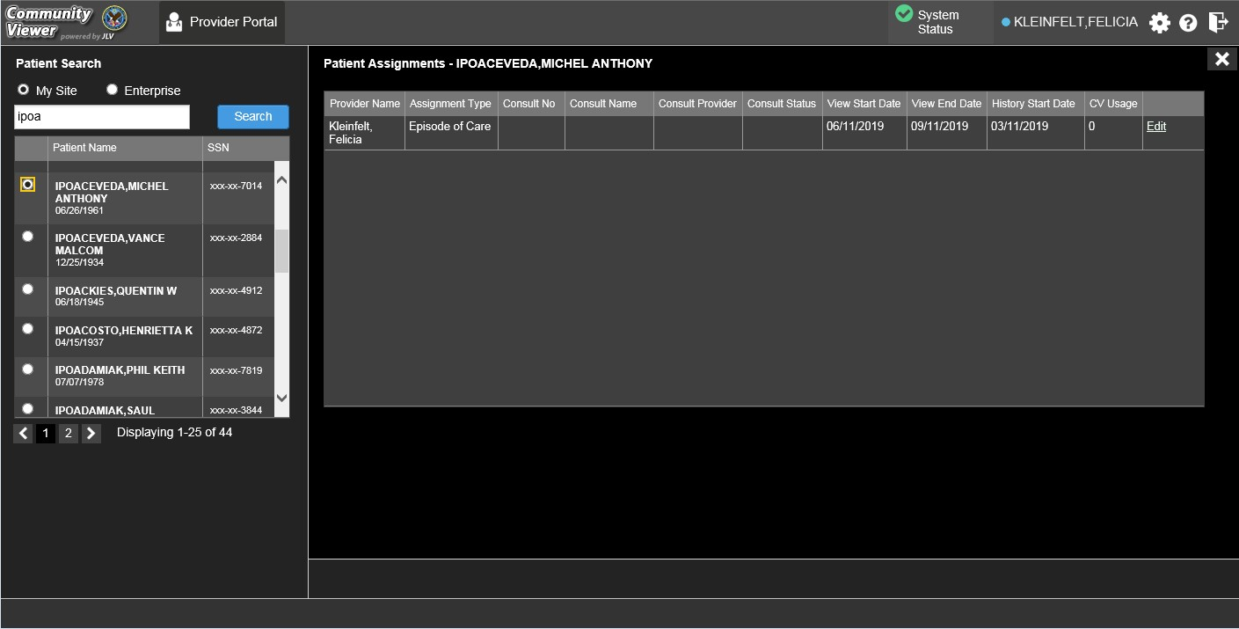
Figure 12: Navigation Using Elements with Keyboard Focus

Logging Out of the Current CV Session
You may intentionally log out to end a CV session by clicking Logout at any time. If you fail to log out, the current session terminates automatically after 30 minutes of inactivity. You are redirected to the Login page when you attempt any new activity.

Using CV

The Widget Tray
The Provider Portal contains the VA Staff Portal tab, which holds the RMPM widget.
You can launch the RMPM widget from the Widget Tray if it is not immediately displayed when you log in (Figure 13).
Click the Plus + icon in the lower right corner of the portal to open the Widget Tray (the widget tray and Plus + icon are highlighted in Figure 13). Click, hold, and drag the icon from the Widget Tray to the portal page, and drop the widget in the desired location.

Figure 13: Widget Tray

About the RMPM Widget
The RMPM widget within the VA Staff Portal (Figure 14) is the starting point for multiple tasks, including creating, editing, and deleting individual provider and provider group profiles, setting limits on an RM provider’s access to a patients VA medical record, and generating or resetting RM provider passwords.
The following tasks (links) are available:
- Create/Edit Community Care Provider Groups
- Manage Provider (RMP)/Patient Assignments
- Search Patient Assignments

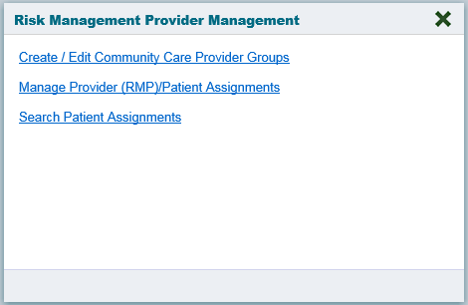
Figure 14: The RMPM Widget

About RMP Accounts
All RMP accounts are created in the RMPM widget. When an RMP account is created, so is their user profile.
RMPs can request access to CV via the Login page. When an RMP clicks the New User link, a message directs them to contact their local VA Medical Center for access. They are then given a link to a list of VA Points of Contact (POCs) from whom they can request CV access.

    - Creating RMP Accounts
RMP accounts are created via the RMPM widget. RM VA Staff can assign patients to an RMP once their account has been created.
- Click the Manage Provider (RMP)/Patient Assignment link in the RMPM widget (Figure 14)
- Click Create New Provider in the Search Providers pane, on the left side of the application window, as shown in Figure 15
  - The Create/Edit Provider pane opens on the right side of the application window
- Click Browse to the right of the Provider Group field to search for an existing group
- Select the desired group from the list of results and click OK

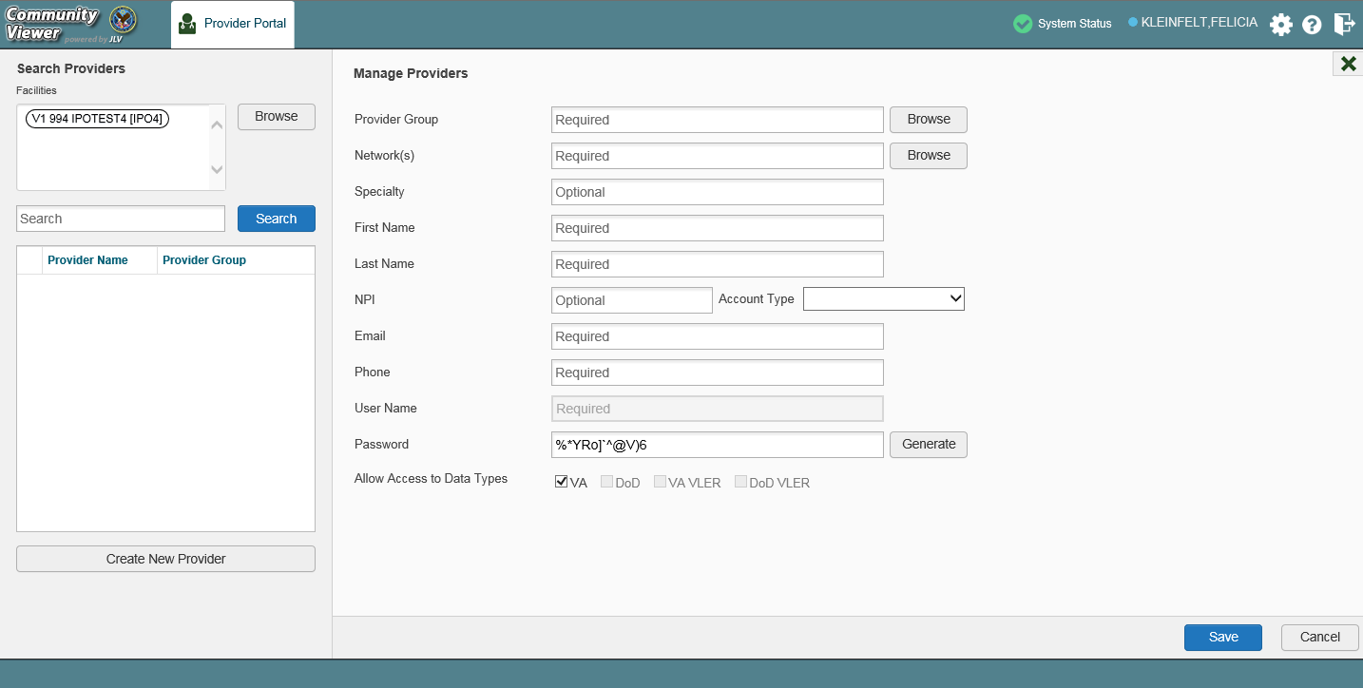Figure 15: Search Providers and Manage Providers Panes

- Enter the provider information in each of the required fields on the Manage Providers pane (Figure 15)

NOTE: If a provider is associated with multiple provider groups, they must provide a unique e-mail address for each. When a new provider is created, their e-mail address is validated to avoid the creation of duplicates. If an e-mail address is already associated with a provider in CV, a “Username already exists” message displays (Figure 16).

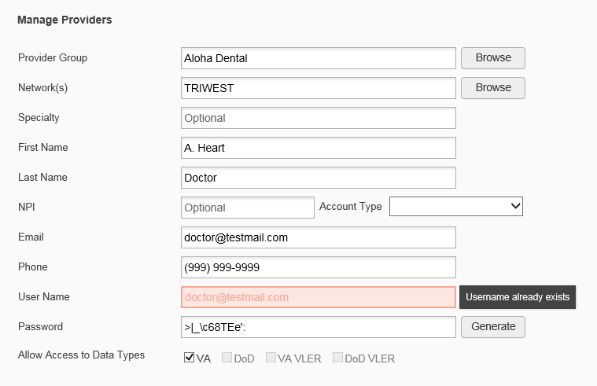Figure 16: Username Already Exists Error Message

- Click Browse to select the Provider Group
- Click Browse to select the Network(s) to which the provider belongs from the following options: Health Net, PC3, Provider Agreement, TriWest, or Other
  - A free-text field labeled Other Network opens when Other is selected
- Enter a Specialty as needed
- Enter the provider’s First Name and Last Name
- Enter the provider’s National Provider Identifier (NPI), if available
- Select "Outside Provider from the Account Type dropdown
- Enter the provider’s E-mail address and Phone number
  - The User Name field automatically populates with the address entered in the Email field
- Click Generate to allow the system to create a new, random password or manually enter a password that meets VA Directive 6500 security compliance criteria

NOTE: Passwords are case-sensitive and must enforce the requirements outlined in VA Handbook 6500.

- Click Save
- Securely provide the RMP with his/her password for CV
- When the “Provider successfully created” message appears, there are two options:
  - Click Assign Patients and follow the steps outlined in Creating Patient Assignments
-OR-
  - Click OK to return to the RMPM widget

    - Editing RMP Profiles
You can edit an RMP’s profile using the RMPM widget.
- Click the Manage Provider (RMP)/Patient Assignment link in the RMPM widget
- Enter the provider name in the Search field, and click Search
- Select the desired provider from the search results (Figure 17)
- Edit the provider information in the fields provided reset the RMP’s password, and assign or unassign patients, as necessary
- Click Save

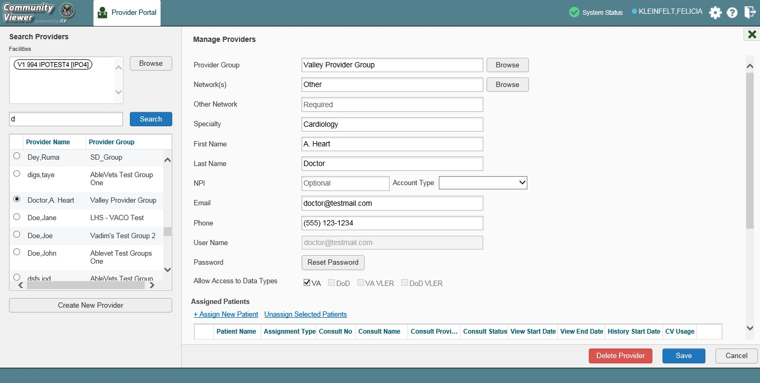Figure 17: Search Providers and Manage Providers Panes

If a provider is assigned to the wrong group, edit the provider group using the RMPM widget. See Editing Provider Groups for more information.
Providers can be added to more than one provider group. Click Create New Provider in the
Search Providers pane to add the provider to another provider group.

NOTE: Providers must have a unique e-mail address associated with their name in each provider group to which they belong.

    - Deleting RMP Accounts
Deleting an RMP from the system disables their account and prevents access to CV. You may only delete an RMP when there are no patient assignments. See Removing Patient Assignments for more information.
- Open the RMPM widget
- Click the Manage Provider (RMP)/Patient Assignment link
- Enter the search criteria in the fields provided in the Search Providers pane on the right
- Click Search
- Select the provider from the results list
- Click Delete Provider (red button at the bottom of the Manage Providers pane)
  - Scroll to the bottom half of the Manage Providers pane, if needed, to see the Delete Provider button
Once deleted, the RMP account cannot be restored. The account would need to be re-created to reinstate RMP access. See Creating RMP Accounts for more information.

About Provider Groups and Facilities
Before RM VA Staff can assign a patient to an RMP, they must be assigned to a provider group. RM VA Staff can create, edit, and delete provider groups and individual provider accounts.

NOTE: Provider groups are validated on the combination of the group name and street address to avoid the creation of duplicates.

Each group is associated with one or more local VA sites, referred to as Facilities. A facility is a local VA site. Provider groups can contain one or more VA facilities.
EXAMPLE 1: Dr. Hanyok works with a family practice called Evergreen Health Care. Dr. Hanyok is the Provider in this example, and Evergreen Health Care is the Provider Group to which she is assigned.
EXAMPLE 2: Dr. Woodroof, the Provider, is a sole practitioner. The Provider Group name for a sole practitioner may be a business name or can be the provider’s name; in this example, Dr.
Woodroof.

    - Creating Provider Groups
When an RMP's account is created, VA Staff can associate the RMP with a provider group within their profile. An RMP must belong to a Provider Group before assigning them a VA patient.
- Open the RMPM widget
- Click the Create/Edit Community Care Provider Groups link
- Click Create New Provider Group at the bottom of the right-hand pane
- Click Browse to the right of the Facilities field and type the name of the facility

NOTE: As you type a facility name in the field, CV automatically fills in facilities matching the entered characters in a dropdown list.

- Select one or more facilities from the resulting list and click OK from the Browse Facilities
dialog box
- Enter information for the provider group in the remaining fields on the left pane of the dialog box
- Click Save
- When the Provider Group successfully created message appears, you are given the following options:
  - Click Create Providers and follow the steps outlined in Creating RMP Accounts
  - Click OK

    - Editing Provider Groups
You can edit provider groups using the RMPM widget (Figure 14).
- Click the Create/Edit Community Care Provider Groups link

- Enter the facility, provider group name, city and state, or zip code in the Search fields (Figure 18)
- Click Search
- Select the desired provider group from the search results
- Edit the provider group fields as needed
- Click Browse next to the Facilities field, and select the desired facility from the list

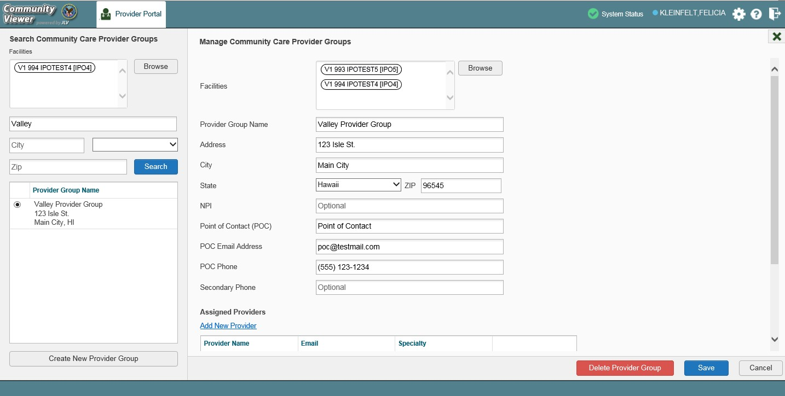Figure 18: Search and Manage Community Care Provider Groups Panes

- Click the Add New Provider link to add a new provider to the group in the Manage Providers
pane
  - Click the Save button
    - Click the Create Another Provider button to return to a new Manage Providers
pane to add another provider - OR-
    - Click the Assign Patients button to return to the same Manage Providers pane to add patients - OR-
    - Click the OK button to return to the Manage Community Care Provider Groups
pane
- Providers assigned to the provider group are listed in the lower right portion of the portal
  - Edit provider profiles or remove providers from the group using the Edit link within the
Assigned Providers list (Figure 19)
- Click Save

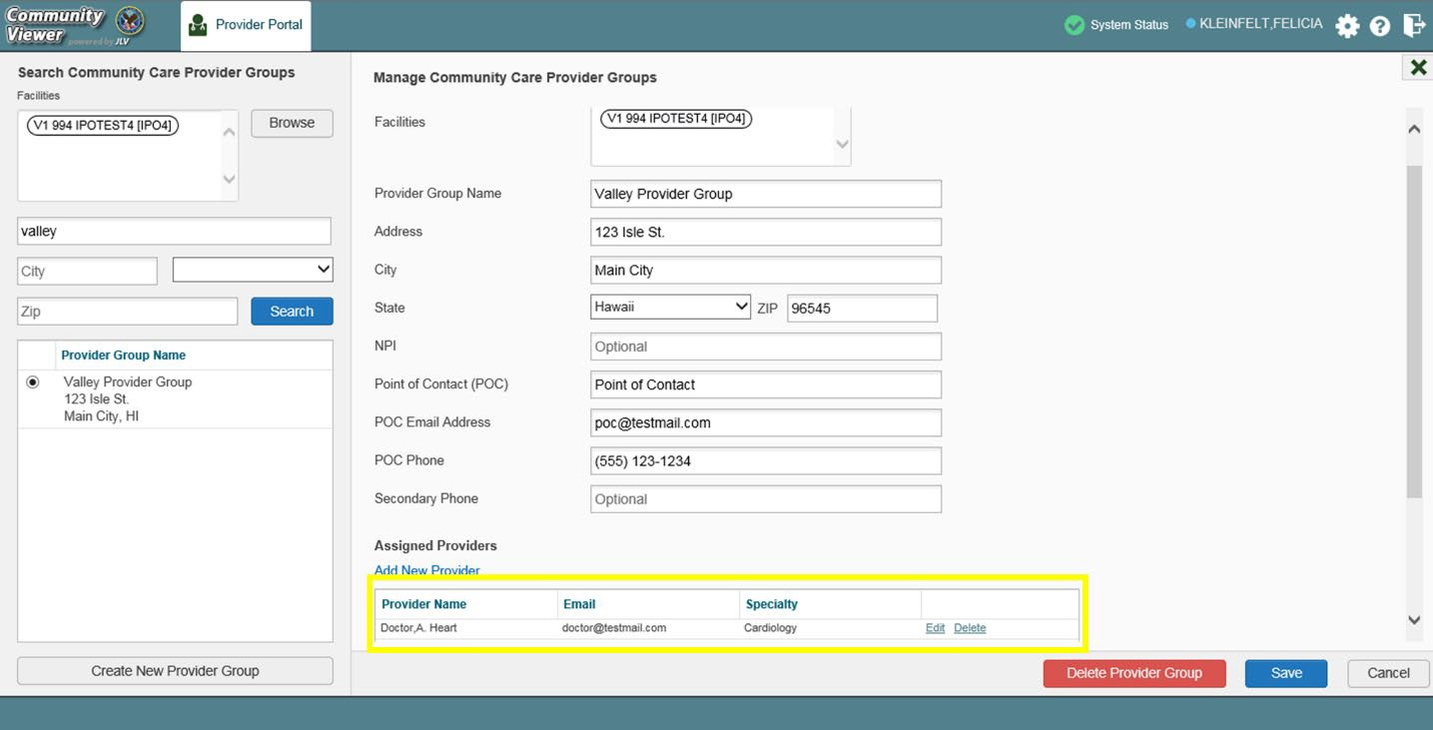Figure 19: Assigned Providers Edit and Delete Links

    - Deleting a Provider Group
You may only delete a provider group when the individual providers within that group have no patient assignments. If any patients are assigned to a provider within the provider group, the error message in Figure 20 displays. Assigning and Unassigning Patients details steps to unassign patients from an individual provider.
- Click the Create/Edit Community Care Provider Groups link
- Enter the facility, provider group name, city and state, or zip code in the Search field
- Click Search
- Select the desired provider group from the search results
- Select the red Delete Provider Group button (Figure 19)

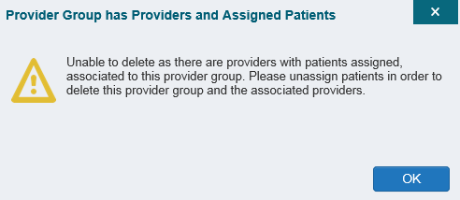Figure 20: Provider Group Deletion Error Message

You can delete providers along with their associated provider group if they do not have assigned patients. If the provider group has associated providers that you intend to also delete, select the Yes button when prompted (Figure 21).

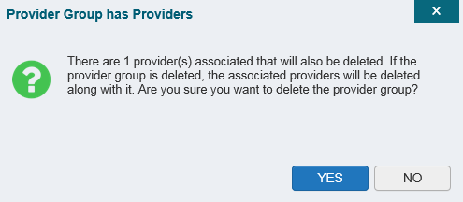Figure 21: Provider Group Has Providers Without Patient Assignments

About Search
The RMPM widget’s search features are used to find a provider group, a provider, or a patient.

NOTE: All search figures depict searches within and information from test databases.

    - Searching Provider Groups
When using the Create/Edit Community Care Provider Groups feature, you can perform a detailed search within the Search Community Care Provider Groups pane (Figure 22):
- Search by facility (Veterans Integrated Service Network [VISN], site identification [ID], facility name, and facility short name), provider group name, city and state, or zip code
- Sort the facilities list by state, when browsing for a facility

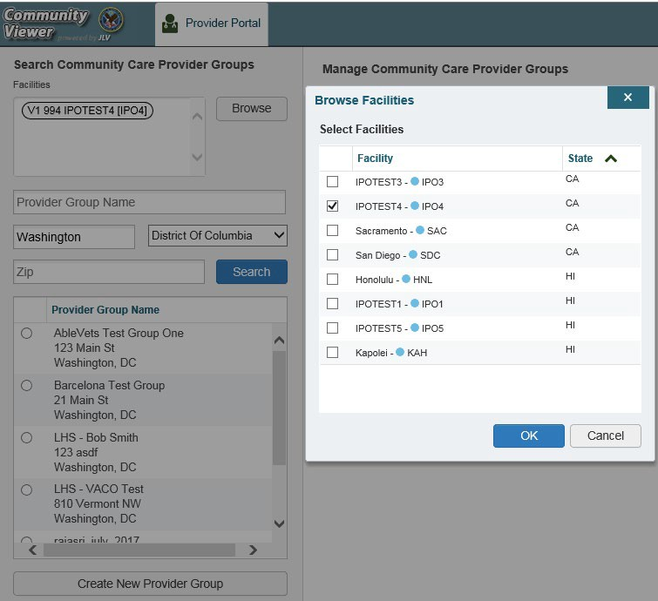Figure 22: Browse Facilities Dialog Box–Community Care Provider Groups

When searching for a Community Care Provider Group, users:
- See the provider group name and address within the search results
- Receive a notification to refine the search by inputting additional search criteria when a large number of results are returned (Figure 23)

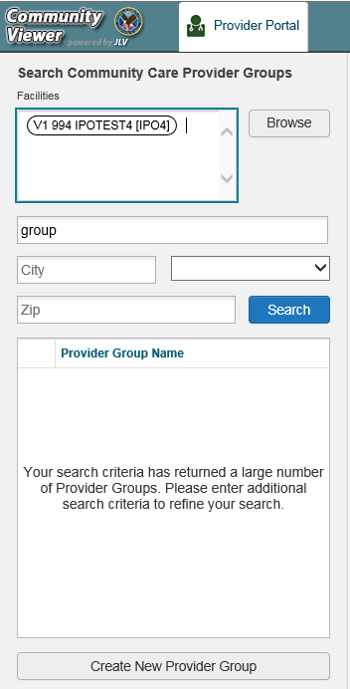Figure 23: CV Community Care Provider Group Search: Too Many Results Notification

    - Searching Providers
When using the Manage Provider (RMP)/Patient Assignment feature in the RMPM widget, you can perform a detailed search within the Search Providers pane (Figure 24) by facility (VISN, site ID, facility name, and facility short name), provider group name, or provider name. You can also sort the facilities list by state when browsing for a facility and view the provider name and provider group within the search results.

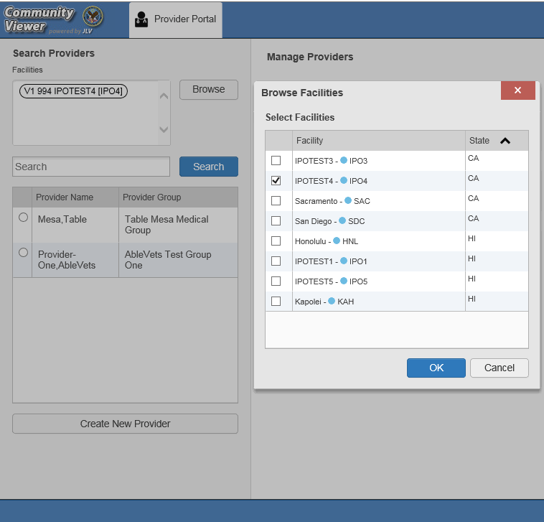
Figure 24: Browse Facilities Dialog Box–Search Providers

    - Searching Patients
There are two types of patient searches in CV from the Search Patient Assignments feature:
- My Site Search: Searches the user’s local VistA (also known as facility or site); the patients listed in the search results are registered to that local VistA only (Figure 25)
- Enterprise Search: Searches all VistAs across the Enterprise; the patients listed in the search results are registered to one or more VistAs (Figure 26)
When searching for a patient within your site:
- Select the Search Patient Assignments link from the RMPM widget
- Confirm the My Site radio button is selected by default
- Enter search criteria into the Patient Search field:
  - A minimum of two characters of the patient’s last name -OR-
  - The patient's last name, followed by a comma and either the first initial or full spelling of the patient's first name (Smith, J or Smith, John) -OR-
  - The patient's full Social Security Number (SSN) (123456789) -OR-
  - The first letter of the patient's last name followed by the last 4 digits of the patient’s SSN (S6789)
- Click Search or press Enter

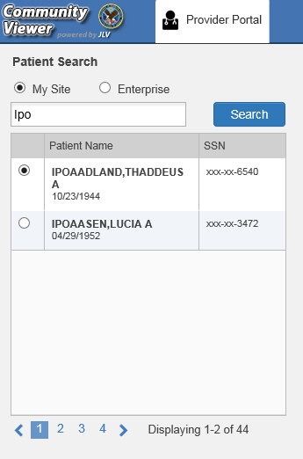Figure 25: My Site Patient Search

When searching for a patient across the Enterprise:
- Select the Search Patient Assignments link from the RMPM widget
- Select the Enterprise radio button
- Enter the patient’s SSN into the required Patient SSN field (required)
- Enter the patient’s full last name into the required Last Name field (required)
- Enter the patient’s date of birth (DOB) in the optional DOB field (optional)
- Enter the patient’s first name in the optional First Name field (optional)
- Click Search or press Enter
When using the Patient Search and the Patient Assignment search features, search results display with the ability to scroll through multiple pages or select a specific page.

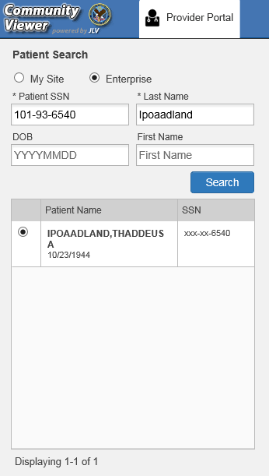Figure 26: Enterprise Patient Search

Please see Assigning and Unassigning Patients for detailed instructions on how to run either a
My Site or Enterprise search from the Manage Providers pane.

Managing Passwords
If a provider has forgotten his/her password, they can click the Reset Password link on the Login page to open a window that enables the provider to send a password reset link directly to their e-mail address, which they can then use to reset their own password. The password reset link is valid for 24 hours. Password resets can also be performed manually by RM VA Staff.

    - Resetting Provider Passwords
- Click the Manage Provider (RMP)/Patient Assignment link in the RMPM widget
- Enter the provider name in the Search field

- Click Search
- Select the desired provider from the search results
- Click Reset Password (highlighted in Figure 27) in the Manage Providers pane
  - Click Generate to allow the system to create a new, random password, record the new password, then click Save
-OR-
  - Manually enter a password that meets VA Directive 6500 security compliance criteria, then click Save
- Securely provide the RMP with his/her new password for CV
- Click Save

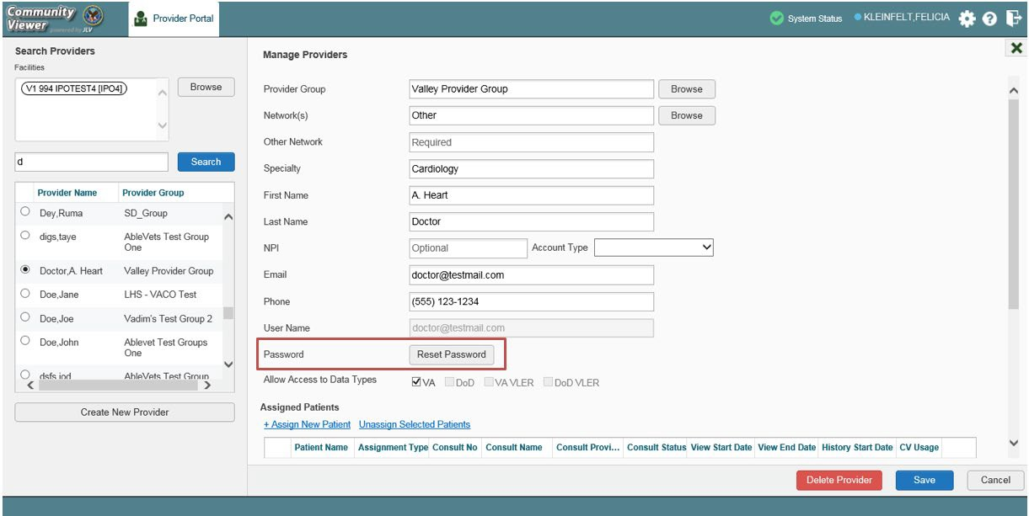Figure 27: RMP Password Reset

Assigning and Unassigning Patients
You can assign patients to an RMP via the Risk Management Provider Management widget.

NOTE: If you chose Assign Patients immediately after creating the RMP’s profile, the Search pane is prepopulated with that provider’s profile information and no search is necessary.

CV uses the following rules to manage patient assignments:
- A Veteran may be assigned to more than one RMP for the following Assignment Types:
  - Episode of Care
- A specific Veteran/consult combination may only be assigned to a single RMP

Table 2: Assignment Rules Examples

Veteran John Davis has multiple active referrals to be assigned:
Referral 1 | Episode of Care for Optometry | Assign to CCP A | A Veteran may have multiple, active assignments for an Assignment Type
Referral 2 | Consult for Cardiology | Assign to CCP B | This specific consult can only be assigned to one CCP at a time
Referral 3 | Consult for Chiropractic | Assign to CCP C | This specific consult can only be assigned to one CCP at a time

    - Creating Patient Assignments
- Click the Manage Provider (RMP)/Patient Assignment link in the RMPM widget
- Enter the provider’s name in the field to the left of the Search button within the Search Providers pane (Figure 28)
- Click Search

Figure 28: Search Providers Pane

- Select the provider from the list of results
  - The Manage Providers pane opens with the provider’s information
- Click the + Assign New Patient link (highlighted in Figure 29)
  - The Patient Search dialog opens

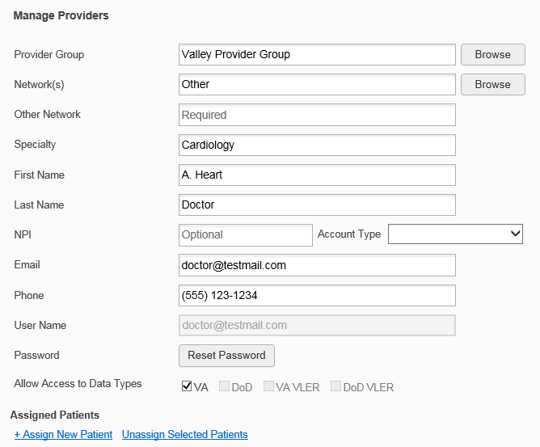Figure 29: Manage Providers Fields Detail

- Enter the patient name in the blank field at the top of the Patient Search dialog (Figure 30)
- Select the My Site or Enterprise search option and enter the search criteria (Please refer to Searching Patients for details.)

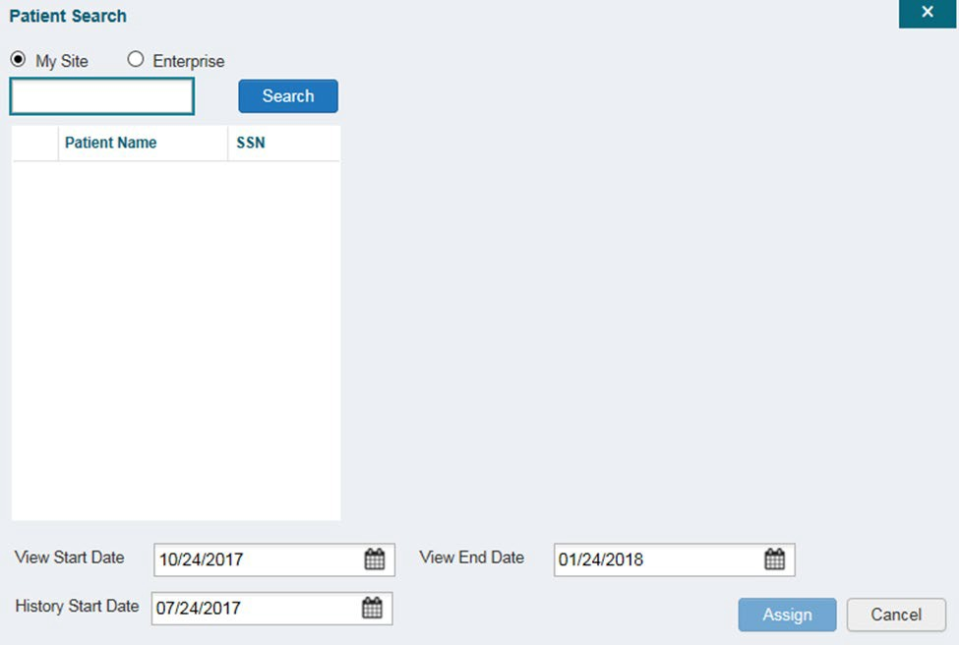Figure 30: Patient Search Dialog Box

- Click Search

- Select a patient from the search results list
- Select the Assignment Type from the dropdown: Consult or Episode of Care
  - If Consult is specified, select one consult record from the list for the selected patient; the consult status must be Active or Scheduled for the consult to appear in the list
- If desired, adjust the default View Start Date, View End Date, and History Start Date
fields to restrict the data seen by the RMP (See Setting Record Display Limits.)
- Click Assign
- A notification is generated
  - Review the message and edit as needed
- Click Send Email or Cancel

    - Removing Patient Assignments
When it is necessary to unassign one or more patients from an RMP:
- Repeat steps 1 - 3 from Creating Patient Assignments to navigate to the Manage PPMS Providers page
- Select checkboxes for each patient you want to unassign
- Click the Unassign Selected Patients link (highlighted in Figure 29)

    - Setting Record Display Limits
You can limit the patient records made available to the assigned RMP. There are two settings that control access to patient data:
- View Start Date and View End Date: These fields set the length of time the RMP has access to the patient records through CV
  - The default View Start Date is the date the patient is assigned to the RMP
  - The default View End Date is 3 months from the default start date
- History Start Date: This setting represents how far back in a patient's VA medical history the RMP is permitted to view
  - The default history start date is 3 months prior to the current date
  - If the history start date is set to 01/01/2012, for example, the RMP has access to the patient's records from available VA facilities from 2012 to present
Data access controls are set by the user during the patient assignment process.
- Click the Calendar icon next to the View Start Date and the View End Date fields
- Select the start and end dates (Figure 31)
- Alternatively, click the Calendar icon next to the History Start Date
- Select a date
- Click Assign

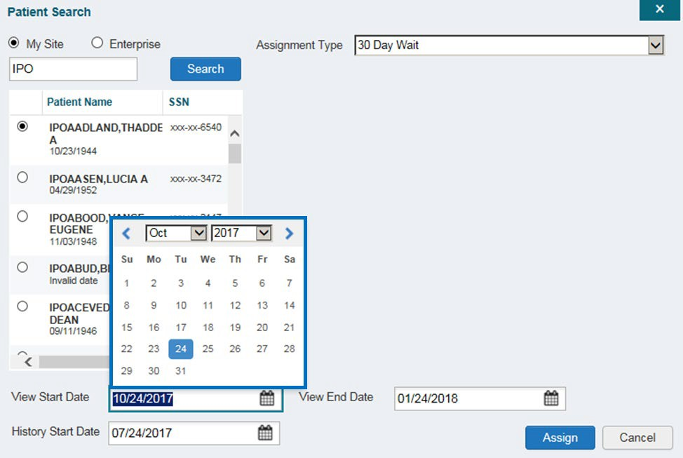Figure 31: Data Access Controls

Troubleshooting

Login Page Errors
Access to CV is limited to registered, authorized users. CV validates user access against information retrieved from your smart card. If you have trouble logging in to CV, please review Table 3 before contacting the ESD.

Table 3: Login Page Error Message Troubleshooting

Error Message | Resolution Steps
Could not save User Profile | WHY? The error occurred during PIV authentication for VA users. It is typically a PIV card processing problem, or the wrong security certificate was chosen.  FIX IT:  - Close your browser window  - Reinsert your PIV card and relaunch CV  - Select a certificate that is not expired and specifies: “Issuer: Veterans Affairs User CA B1”  - If this is unsuccessful, close all open IE windows/tabs, then open IE and try CV again
Not a valid ACCESS/VERIFY  CODE pair | WHY? 1) CV could not match your Access and Verify codes to the Site selected in the dropdown; or 2) A username and password were entered instead of Access/Verify codes.  FIX IT:  - Veterans Health Administration (VHA) users must select the parent VistA host site for their facility  - Reenter your Access and Verify codes (Computerized Patient Record System [CPRS] or VistA codes for VHA users)

Page cannot be displayed | WHY? The CV URL requires certain IE settings.  FIX IT:  - Click the Tools menu (press ALT-X) in IE  - Select Internet Options  - When the dialog opens, select the Advanced tab  - Scroll down in the list until you see the Secure Sockets Layer (SSL) 2.0 setting (Windows 7 machine), or the Secure Sockets Layer 3.0 setting (Windows 10 machine), and ensure it is NOT checked  - Ensure that Transport Layer Security (TLS) 1.0, 1.1, and 1.2 ARE checked  - Click OK to close the dialog box, then relaunch CV (The page should load)
Smart Card required | WHY? Your PIV (Smart Card) was not read by Windows Security and CV before opening the CV URL.  FIX IT:  - Close all browser sessions/browser-based applications  - Reinsert PIV card (Smart Card) and relaunch CV  - If this is unsuccessful, fully reboot your system to refresh all connections (This resolves greater than 95% of any remaining problems.)
VERIFY CODE  must be changed before continued use | WHY? Your CPRS VERIFY CODE has expired.  FIX IT:  - Open CPRS or VistA  - If prompted for a PIV card certificate by CPRS, click Cancel  - Select the Change Verify Code checkbox on the sign-on dialog before clicking OK  - You are prompted to create a new Verify code  - Once your Verify code is changed for CPRS, CV recognizes the new code immediately

Patient Search Errors
The following error messages may appear when searching for a patient in the RMPM widget. If you encounter error messages while searching for patients, please review Table 4 before contacting the ESD.

Table 4: Patient Search Error Messages and Resolution Steps
Error Message | Resolution Steps
An invalid search criterion was entered. Please enter at least 2 characters. | WHY? You entered an invalid patient name.  FIX IT: Please try your search again.  When searching by patient name, enter at least two characters of the patient’s first and last name. Search results display the closest match to the characters entered in the format of [last name], [first name].
An invalid SSN format was entered. Please enter a 9-digit SSN. | WHY? You entered an invalid SSN.  FIX IT: Please try your search again.  When searching by patient SSN, you are required to enter the patient’s full 9-digit SSN. Dashes are allowed (e.g., 123-45-6789).

An invalid last 5 format was entered. Please enter the first letter of the last name followed by the last 4-digits of the SSN. | WHY? You entered an invalid patient name or SSN.  FIX IT: Please try your search again.  Patient search allows you to search for a patient using the first initial of the patient’s last name and the last four digits of the patient’s SSN. Please try your search again using the first initial of the patient’s last name and the last four digits of the patient’s SSN.
An error occurred during your search. Please try your search again. | WHY? This error may display when invalid patient identifiers were entered, or an error occurred at the service layer or with an external system.  FIX IT: Please try your search again.

Acronyms and Abbreviations
Table 5 lists the acronyms and abbreviations used throughout this document and their descriptions.
Table 5: Acronyms and Abbreviations

Acronym | Description
CPRS | Computerized Patient Record System
CV | Community Viewer
DOB | Date of Birth
ESD | Enterprise Service Desk
ID | Identification
IE | Internet Explorer
MVI | Master Veteran Index
NPI | National Provider Identifier
OIT | Office of Information and Technology
PIN | Personal Identification Number
PIV | Personal Identification Verification
POCs | Points of Contact
RM | Risk Management
RMP | Risk Management Provider
RMPM | Risk Management Provider Management
SSL | Secure Sockets Layer
SSN | Social Security Number
TLS | Transport Layer Security
UI | User Interface
URL | Uniform Resource Locator
VA | Department of Veterans Affairs
VDS | VistA Data Service
VHA | Veterans Health Administration
VISN | Veterans Integrated Service Network
VistA | Veterans Health Information Systems and Technology Architecture

