Community Viewer Version 3.2
Community Care Provider User Guide

January 2020

Department of Veterans Affairs (VA)

Office of Information and Technology (OIT)

Table of Contents

- Introduction 1
  - Purpose of the Guide 1
    - Guide Conventions 1
    - Terminology 2
  - Assumptions 2
  - System Requirements 2
  - Getting Help 3
- Logging in to CV 3
  - Changing Your Password 6
    - Password Requirements 8
  - The CV Portal Pages 9
    - System Menu 9
    - Default View 10
    - Customizing CV 10
  - Logging Out of the Current CV Session 14
- Using CV 14
  - Accessing Patient Data via the Assigned Patients Widget 14
  - Viewing System Notifications 16
    - Viewing Announcements 16
    - Viewing System Status 18
    - Viewing Connection Status 18
  - Using Report Builder 21
    - About Report Builder 21
    - Generating a Report 21
      - Adding Multiple Records with EZ Select 25
      - Adding One Record 26
      - Adding Only Record Details or Notes 26
      - Adding Patient Demographics 27
    - Opening a Report 28
    - Deleting a Report 30
  - Using the Accessible Theme’s Functionality 30
    - Keyboard Focus and Portal Navigation in the Accessible Theme 30
    - Using Report Builder in the Accessible Theme 31
  - Printing 32
- Widgets 33
  - Accessing and Opening Widgets 33
    - Sort and Filter Options 34
      - Setting Multiple Filters in Widgets 35
      - Widget Date Range Filters 35
        - Quick Date Range Filter 36
        - Start and End Date Filter 38
      - Tab Date Range Tool 40
      - Text Filter 41
  - Widget Navigation and Display Options 43
  - Minimized vs. Expanded Widget View 43
  - Displaying Widgets on Custom Tabs 44
  - Refreshing Widget Data 44
  - Nondiagnostic Images 45
  - Widget Functionality 47
    - Patient Demographics 47
      - Viewing Detailed Patient Demographic Information 48
      - Viewing Third-Party Insurance Information 48
    - Pain Management 48
    - Outpatient Medications 50
      - Outpatient Medications Widget Data 50
      - Viewing Outpatient Medication Details 51
    - Inpatient Medications 51
      - Inpatient Medications Widget Data 52
      - Viewing Inpatient Medication Details 52
    - Progress Notes 52
      - Progress Notes Widget Data 53
      - Viewing Progress Notes Details 53
    - Lab Results 54
      - Lab Results Widget Data 54
      - Viewing Abnormal Results in the Lab Results Widget 55
      - Viewing Lab Results Details 55
      - Graph/Table View from the Lab Results Widget 55
    - Problem List 57
      - Problem List Widget Data 58
      - Viewing Problem List Details 59

Table of Figures
Figure 1: Authorized Use Message 1
Figure 2: CCP User Login Page 4
Figure 3: CCP VA Privacy and Security Awareness Training Page 5
Figure 4: Password Reset Dialog Box 6
Figure 5: Confirmation of Request Sent to Reset Password 6
Figure 6: Password Reset E-mail 7
Figure 7: Password Reset Page 7
Figure 8: Password Reset Confirmation Message 8
Figure 9: Password Expiration Notice on the Login Page 9
Figure 10: CV Portal Tools 10
Figure 11: Default View 10
Figure 12: The CV Settings Dialog Box 11
Figure 13: Blue Theme 12
Figure 14: Green Theme 12
Figure 15: Dark Gray Theme 13
Figure 16: Gray Theme 13
Figure 17: Accessible (508-Compliant) Theme 14
Figure 18: Minimized View of the Assigned Patients Widget 15
Figure 19: Expanded View of the My Assigned Patients Widget 16
Figure 20: Announcements on the Login Page 17
Figure 21: Announcements Banner 17
Figure 22: System Status Indicator on the Portal Pages 18
Figure 23: Connection Status Icon, Documents Widget 19
Figure 24: Connection Status Details, Active Interfaces Shown 20
Figure 25: Connection Status Details View, Active Interfaces Hidden 20
Figure 26: Report Builder Icon on the Patient Portal Toolbar 21
Figure 27: Report Builder Current Report Tab 22
Figure 28: Report Builder Name Report Dialog 23
Figure 29: Report Builder Patient Reports Tab 24
Figure 30: Report is Ready Indicator on Toolbar 24
Figure 31: Report Builder Select All Icon 25
Figure 32: All Records on a Single Widget Page Added to Report Builder 25
Figure 33: Single Record Added to Report Builder 26
Figure 34: Add Detail and Add Record Row Dropdown 27
Figure 35: Demographics Widget’s Add to Report Builder Icon 28
Figure 36: Report Contents Dialog 29
Figure 37: Report Builder in Accessible Theme 32
Figure 38: Widget Tray on the Patient Portal 34
Figure 39: Filtered Date Range Examples 36
Figure 40: Quick Date Range Filters 37
Figure 41: Quick Date Range Filter (5y) Outside CCP’s Permitted History Dates 38
Figure 42: Lab Results Widget Start and End Date Filters 39
Figure 43: Radiology Reports Widget Start and End Date Calendar 40

Figure 44: Tab Date Tool 41
Figure 45: Vitals Widget Text Filter 42
Figure 46: Expanded View Widget Display 44
Figure 47: Nondiagnostic Images in the Minimized View of the Radiology Reports Widget 45
Figure 48: Multiple Nondiagnostic Radiology Images 46
Figure 49: Nondiagnostic Images in the Radiology Reports Detail View 46
Figure 50: Radiology Images Unable to Retrieve Images Error 47
Figure 51: Patient Demographics Widget 48
Figure 52: Pain Management Widget 49
Figure 53: Outpatient Medications 50
Figure 54: Inpatient Medications Widget 51
Figure 55: Progress Notes Widget 53
Figure 56: Lab Results Widget 54
Figure 57: Lab Results Graph/Table View 56
Figure 58: Lab Results Graph Table View, Select a Lab Test 57
Figure 59: Problem List Widget 58

Table of Tables
Table 1: System Status Notices 18
Table 2: Accessible Keystrokes 30
Table 3: Widget Navigation Tool Descriptions 43

Introduction
Community Viewer (CV) is a browser-based software application that facilitates the secure exchange of data between Department of Veterans Affairs (VA) systems and authorized non-VA providers, known as Community Care Providers (CCPs). The exchange of data improves the coordination of care and continuity of care for VA patients receiving treatment outside of the VA network.
CV pulls information from VA health care systems in real time for viewing within a web browser. Through CV, VA Staff assign patients to providers and provision their use within the CV system, allowing providers access to view consolidated patient data from multiple Veterans Information Systems and Technology Architecture (VistA) systems.
This user guide is written for CCPs who use CV to:
- Access and view patient data
- Request a password reset
Please read and bear in mind the following warning before using CV.

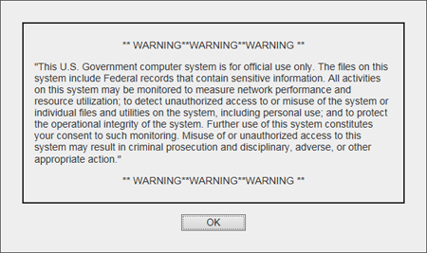
Figure 1: Authorized Use Message

Purpose of the Guide
The purpose of this guide is to familiarize users with the important features and navigational elements of the CV application.

    - Guide Conventions
This document is designed for both online and hardcopy consumption. The following conventions are used throughout:

- Cross-references are indicated by blue, underlined text, and provide a hyperlink to figures, tables, and other sections within this guide
- Emphasis is conveyed by using bold, underlined, and italicized text
- The information icon is used to inform the reader of additional information
    - Terminology
The following standard terms are used throughout this guide:
- CCP: You, an authorized non-VA provider
- Patient Portal: The page that displays patient data via widgets
- Provider Portal: The landing page, or default view, of CV that opens after logging into the application; the Provider Portal displays widgets and the tools that enable quick access to basic features
- Widget: A component of the CV interface that enables a user to perform a function or access a service
- Widget Tray: The expandable and collapsible tray at the bottom of both portal pages that provides access to all widgets available for placement on the portal pages

Assumptions
This user guide is written from the perspective of CCPs, assuming the following:
- You can open, navigate, and use the menu options of a web browser
- You can use web-based applications, their menu options, and navigation tools
- You have received the required access credentials and the Uniform Resource Locator (URL) for the CV Login page
- You use CV to view VA patient data relevant to patient assignments

System Requirements
CV is a front-end web application designed to run in a web browser. Accessing CV through a browser or device that is not fully compatible with the application may result in certain features not working as expected.

NOTE: This release does not support mobile devices.
It is recommended that users access CV from a desktop or laptop PC, using one of the supported browsers:
- Internet Explorer (IE) v11
- Chrome v76
- Microsoft Edge v44
- Safari v12

Getting Help
If you are an authorized user in need of technical assistance, contact the Community Provider Technical Service Desk. Prior to contacting support, please refer to Logging in to CV for detailed information about how to access CV.

Community Provider Technical Service Desk
REDACTED

If you are an authorized user and do not have your password, follow the steps outlined in Changing Your Password to request a password reset.
Please open the Online Help index within CV for more information about the general functionality of CV and a complete list of the widgets available in the application.

Logging in to CV
Before logging in to and utilizing the functionality of CV, please read the warning in Figure 1.
During log in, CV authenticates all providers against a registered list, provisioned by VA Staff. If you have not received credentials to access CV, you can either request access through the Community Provider Technical Service Desk or by clicking the New User Request link on the Login page as highlighted in Figure 2.
- Open a supported Internet browser
- Enter the CV URL, https://www.communityviewer.va.gov/Community, provided by VA Staff, in the address bar of the Internet browser
- Review the Authorized Use message (Figure 1)
- Click OK to confirm that you are aware you are accessing a Government information system that is provided for authorized users only
- Enter your username and password, provided by VA Staff, in the fields on the Login page (Figure 2):
  - Your username is the National Provider Identifier (NPI) number associated with your account

NOTE: If your username is not found or is not active, the error message displays and no further options appear: “There is an issue preventing your access to Community Viewer. Please contact your VA Contractor or your VA Medical Center for assistance.”

  - If you have forgotten your password, click the Reset Password link
  - If you are not already an authorized user, click on the New User Request link for guidance on obtaining access to CV

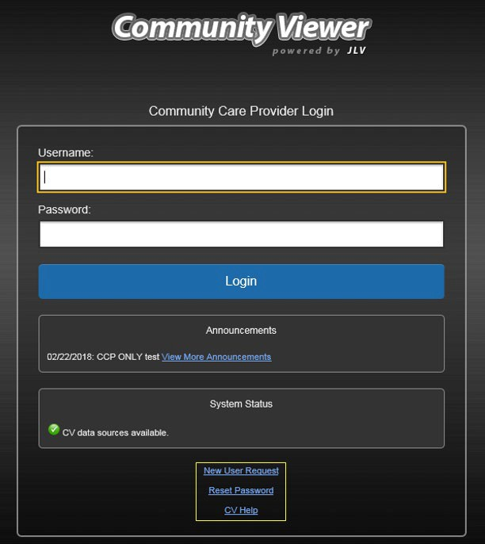Figure 2: CCP User Login Page

- Click Login
- If you are logging in to the CV application for the first time (or 365 days after your first login), the VA Privacy and Security Awareness Training page (Figure 3) appears

NOTE: Users are required to perform all acknowledgement tasks before access to CV is granted.

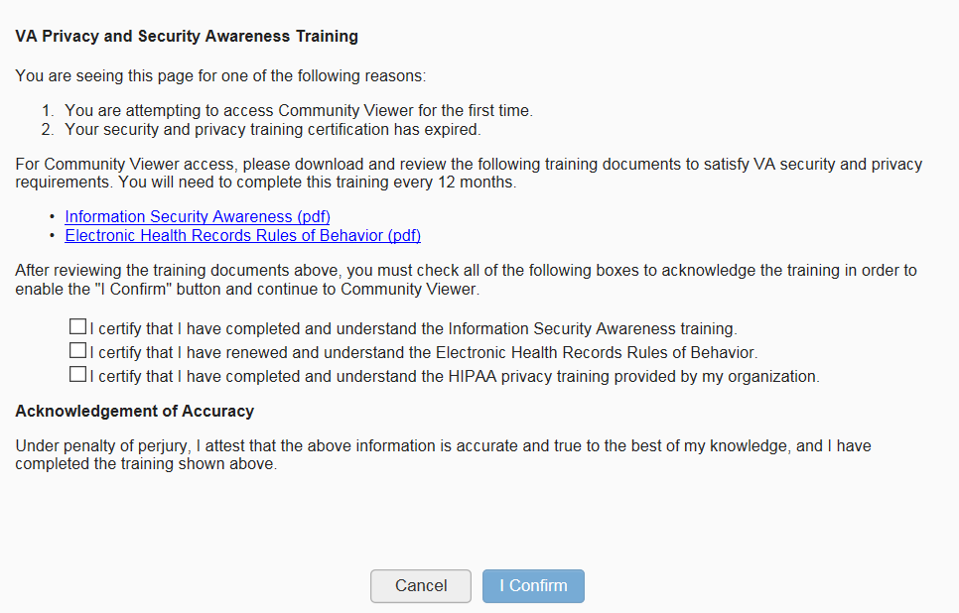Figure 3: CCP VA Privacy and Security Awareness Training Page

NOTE: The VA Privacy and Security Awareness Training page appears the first time you access the CV application and again every 365 days after the first successful log in since training certification must be renewed each year.

ALL the acknowledgment tasks (Steps 8 - 13) must be completed to gain access to CV:
- Download and read the Information Security Awareness Training PDF document
- Download and read the Electronic Health Records Rules and Behavior PDF document
- Click the checkbox to certify that you have completed and understand the Information Security Awareness training
- Click the checkbox to certify that you have read and understand the Electronic Health Records Rules and Behavior
- Click the checkbox to certify that you have completed and understand the HIPAA Privacy training through your organization
- Click I Confirm to proceed to the application After logging in to CV:
- Your username is displayed in the upper right corner of the page
- The patients assigned to you are shown in the Assigned Patients widget, under the My Assigned Patients tab
- The patients assigned to your practice group are shown in the Assigned Patients widget, under the Group Assigned Patients tab
- You can see the patients assigned to your practice group even if you do not have any active or scheduled patient assignments

Changing Your Password
If you forgot or want to reset your password, you can request a reset by using the Reset Password link on the Login page, highlighted in Figure 2.
- Click the Reset Password link
- The Password Reset dialog box opens (Figure 4)

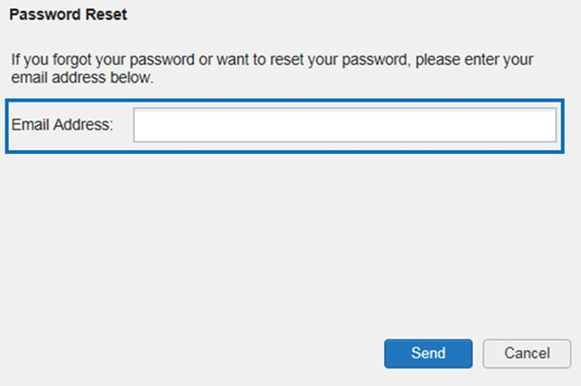Figure 4: Password Reset Dialog Box

- Enter your e-mail address in the field provided in the dialog box
- Click Send
- A confirmation message displays (Figure 5) and an e-mail message is generated to Community_Provider_Technical_Service_Desk@va.gov

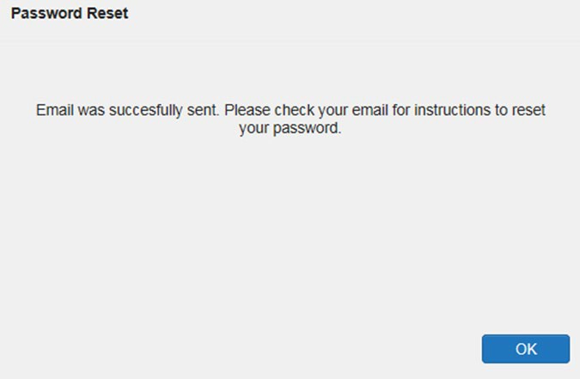Figure 5: Confirmation of Request Sent to Reset Password

- A password reset link is sent to the e-mail address you provided

NOTE: The password reset link is active for 24 hours. After that, you must use the Reset Password link to reset your password.

Once you receive the password reset e-mail:
- Click the link in the password reset e-mail (Figure 6)

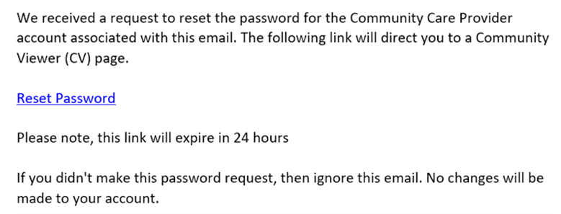Figure 6: Password Reset E-mail

- The Password Reset page opens (Figure 7)

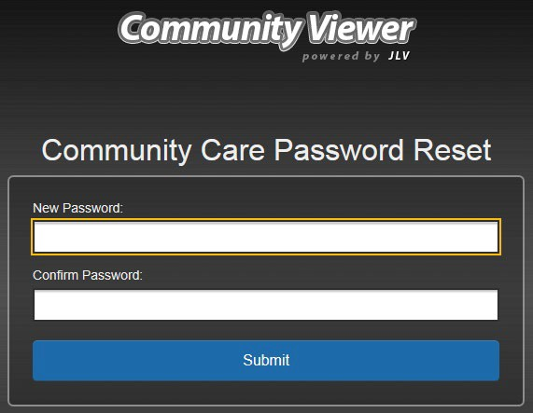Figure 7: Password Reset Page

- Create a new password following the password guidelines (See Password Requirements), and enter it in the New Password field
- Repeat the password in the Confirm Password field

- You receive a confirmation message when your password has been successfully reset (Figure 8)

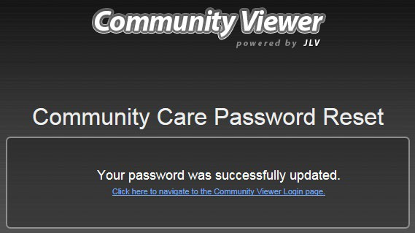Figure 8: Password Reset Confirmation Message

    - Password Requirements
You are prompted to change your password every 90 days. Passwords are case sensitive and must comply with the following structure guidelines:
- Must be a minimum of 8 characters (no blank spaces can be used)
- Must contain characters from 3 of these 4 categories:
  - An uppercase letter
  - A lowercase letter
  - A number
  - A special character (! @ # ? $ % &)
- Six of the characters cannot occur more than once in the password

NOTE: Passwords cannot be reused within a 2-year period.
When your password has expired, you see the message highlighted in Figure 9 after an attempt to log in.

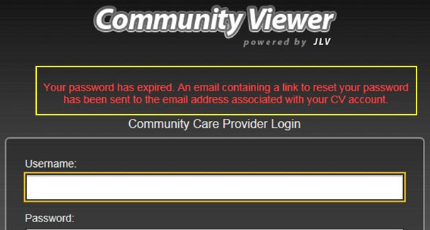Figure 9: Password Expiration Notice on the Login Page

The CV Portal Pages
After a successful login, your username is shown in the upper right corner of the application, and the CV portal pages are displayed. The CV portal pages are:
- The Patient Portal
- The Provider Portal
NOTE: Switching from the Patient Portal to the Provider Portal closes all associated patient tabs and windows to prevent confusion between patient records.

Upon login, you see the Provider Portal . The portal displays the Assigned Patients widget by default (Figure 11).

    - System Menu
The CV portal pages have tools that enable quick access to basic features. These tools appear in the upper right corner of the application window (detailed in Figure 10).
- Select the User Interface (UI) theme: Click the Settings icon to configure the UI theme (See Customizing CV)
- Report Builder: Click the Report Builder icon on the Patient Portal to create custom reports
- Access Online Help: Click the Help icon to open web-based help
- Log out: Click the Logout icon to terminate the current CV session

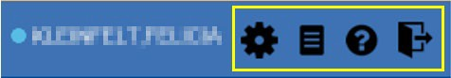
Figure 10: CV Portal Tools

    - Default View
The default view of CV includes the Assigned Patients widget (Figure 11).

NOTE: If the Assigned Patients widget is not open, click the plus (+) sign in the lower right corner of the portal (Figure 11) to open the Widget Tray. Click, hold, and drag the widget icon from the tray to the portal, and drop it in the desired location. Click the minus (-) sign in the lower right corner of the portal to close the widget tray.

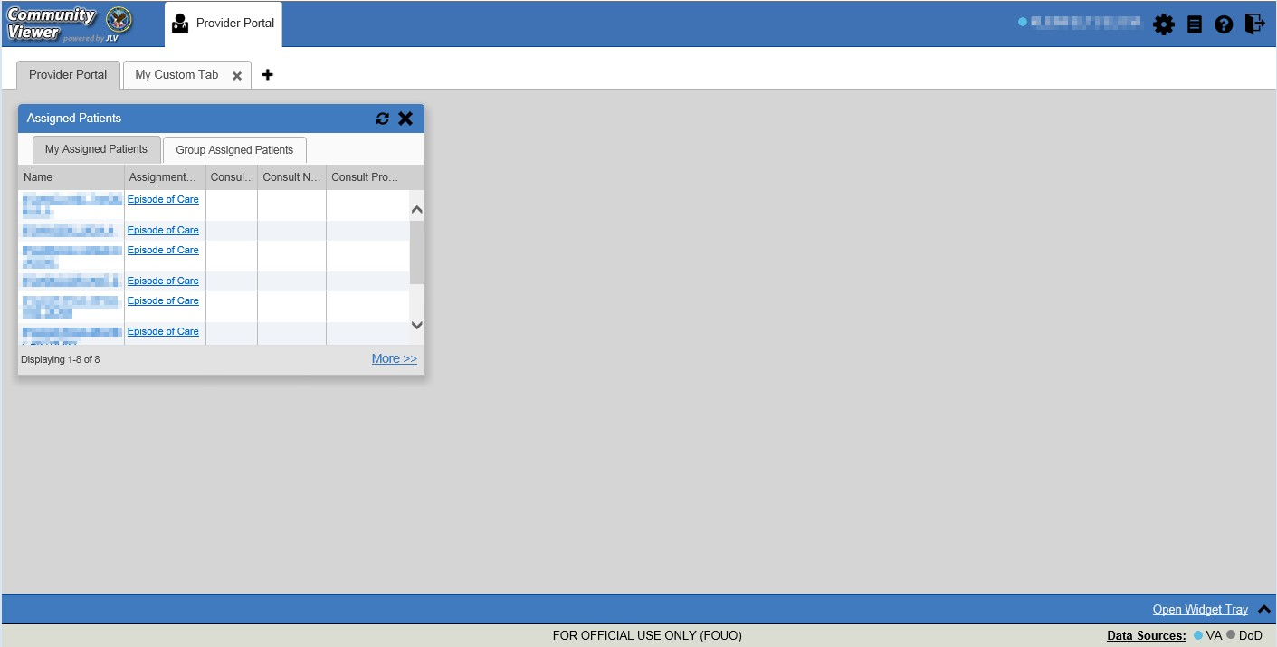
Figure 11: Default View

    - Customizing CV
Configuration options can be set within CV by clicking the Settings icon in the upper right corner of the portal pages (Figure 11). The data source and UI settings are part of your user profile and apply to future sessions until changed.

NOTE: Changing the data sources or UI theme requires you to reselect and reload the current patient.

Choosing a data source allows you to configure whether you see VA data, Department of Defense (DOD) data, or both. A circular, blue icon in the Data Sources pane indicates that VA data is enabled; a square, orange icon indicates that DOD data is enabled; and a circular, gray icon indicates either VA or DOD data is disabled. One primary data source is required.

NOTE: Data sources are restricted to VA for this release. The DOD data source option is disabled.

Choosing a UI theme sets the font color, foreground color, and background color of CV. Themes apply to all application elements, including widgets, toolbars, and dialog boxes. The UI theme color choices are Default, Green, Blue, Gray, and Accessible. The Accessible theme (Figure 17) is 508-compliant and designed to work with the accessibility tools installed on a user’s device.
- Click Settings in the upper right corner of the portal page or the Data Sources link in the bottom left of the portal page
- The CV Settings dialog opens (Figure 12)
- Select the desired data source
- Click the radio button next to the desired theme
- Click Save to apply the selected theme -OR-
- Click Cancel to exit the CV Settings dialog box and restore the previous theme

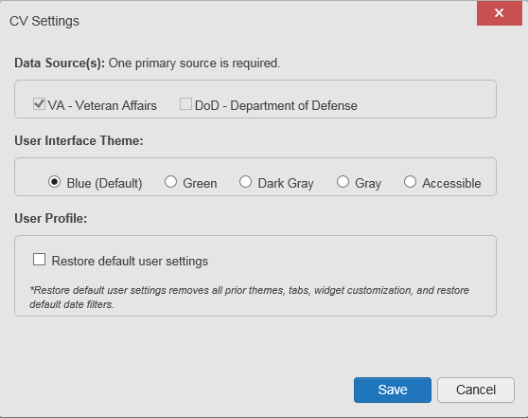Figure 12: The CV Settings Dialog Box

Examples of the UI themes are displayed in the figures that follow.

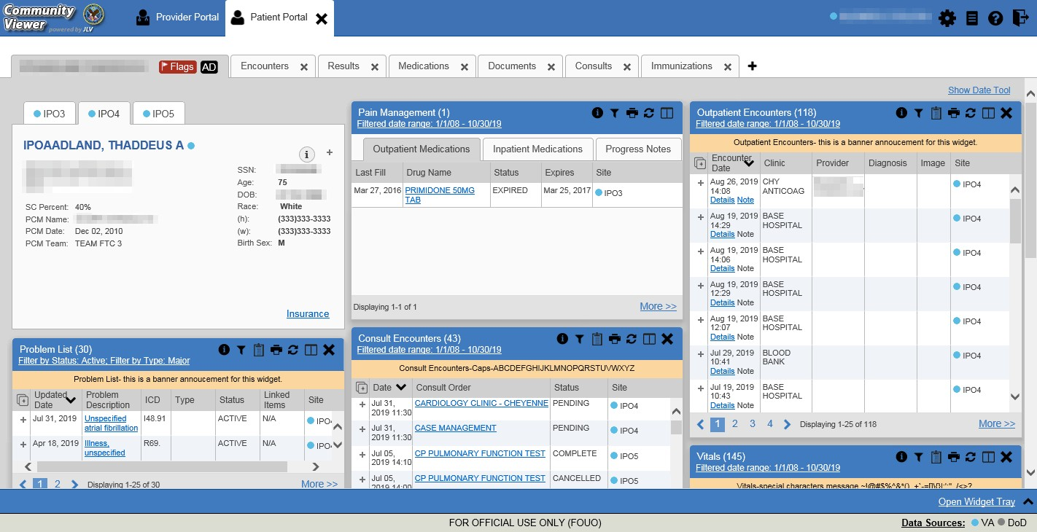Figure 13: Blue Theme

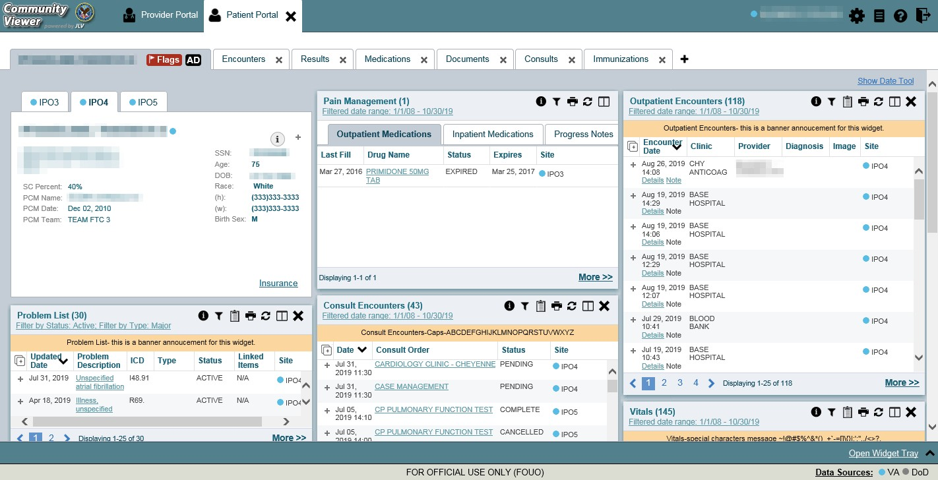Figure 14: Green Theme

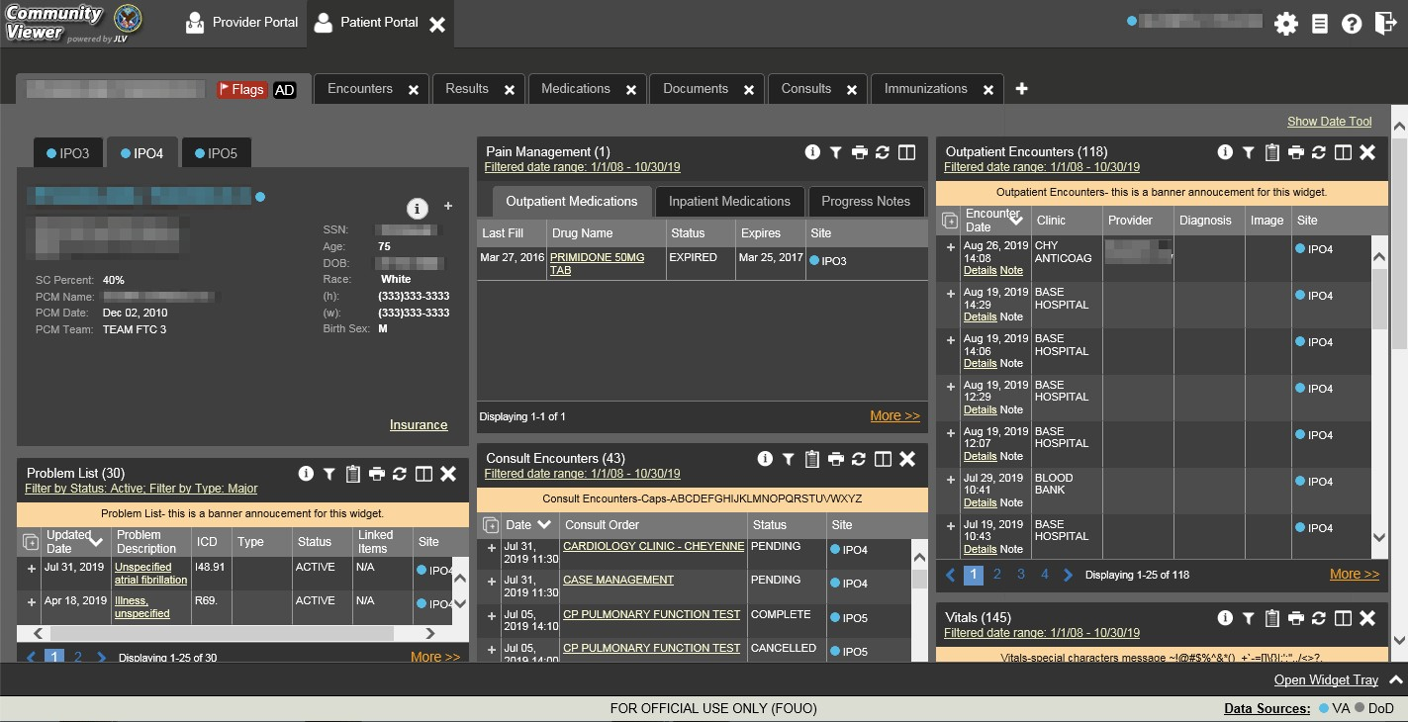Figure 15: Dark Gray Theme

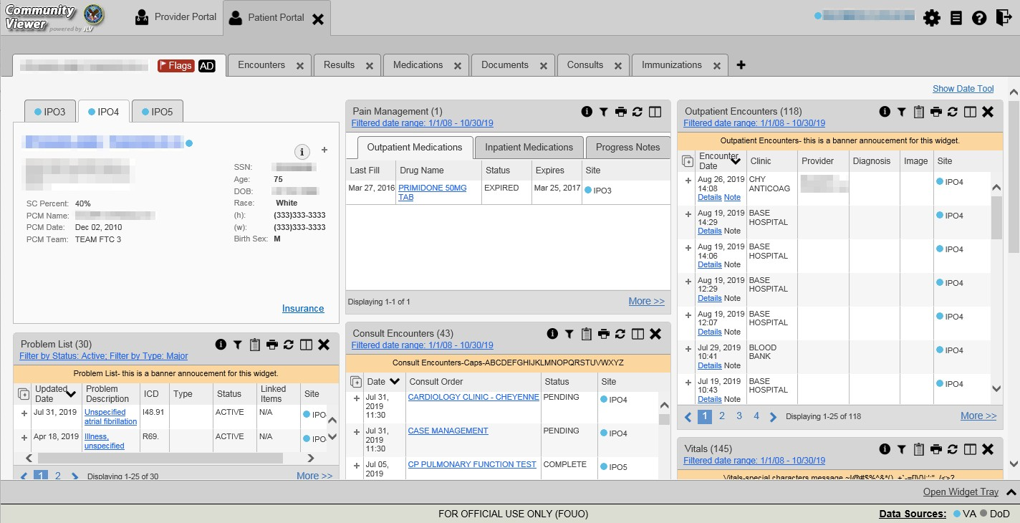Figure 16: Gray Theme

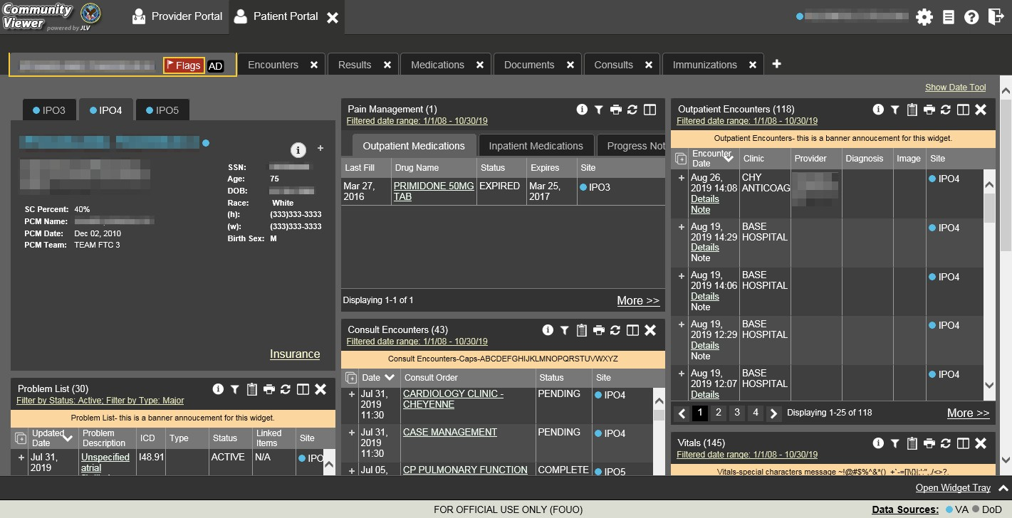Figure 17: Accessible (508-Compliant) Theme

Logging Out of the Current CV Session
You may intentionally log out to end a CV session by clicking Logout at any time. A CV session ends automatically after 30 minutes of inactivity. You receive an audible and visual warning that the current session is about to terminate after 25 minutes of inactivity. Automatic termination of a session logs you out of the application, closes all CV tabs and windows, and displays the Logout page. Close and reopen the browser and return to the CV Login page to initiate a new CV session.

Using CV

Accessing Patient Data via the Assigned Patients Widget
Prior to accessing patient data in CV, please read the warning displayed in Introduction.
After you log in to CV, the Assigned Patients widget appears, displaying a list of your patient assignments. Click a patient’s name in the list on the My Assigned Patients tab (Figure 18) to open their records in the Patient Portal.

NOTE: If the Assigned Patients widget is not open, click the plus (+) sign in the lower right corner of the portal to open the Widget Tray.
Click, hold, and drag the widget from the tray to the portal, and drop it in the desired location. Click the minus (-) sign in the lower right corner of the portal to close the widget tray.

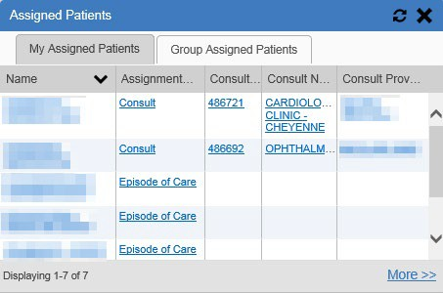Figure 18: Minimized View of the Assigned Patients Widget

The Assigned Patients widget also lists the active and scheduled assignments for all providers in the group to which you belong on the Group Assigned Patients tab. If there are two active assignments for one patient, the patient is listed twice.
The following information is available for each assignment listed in the widget. Click the hyperlinked entries to open the patient’s record in the Patient Portal.
- Name: The patient’s name
- Assignment Type: The type of assignment that initiated the patient referral; assignment types include Consult and Episode of Care
- Columns of information that only contain data for patients with a Consult assignment type (Figure 19)
  - Consult No.: A number generated by the VA system for the patient consult
  - Consult Name: A label generated by the VA system
  - Consult Provider: The VA provider who ordered the consult
The tab in the Assigned Patients widget that is active (currently selected) is highlighted. My Assigned Patients is the active tab, by default. Clicking the More>> link in the bottom right corner of the widget opens the expanded view of the active tab (Figure 19).

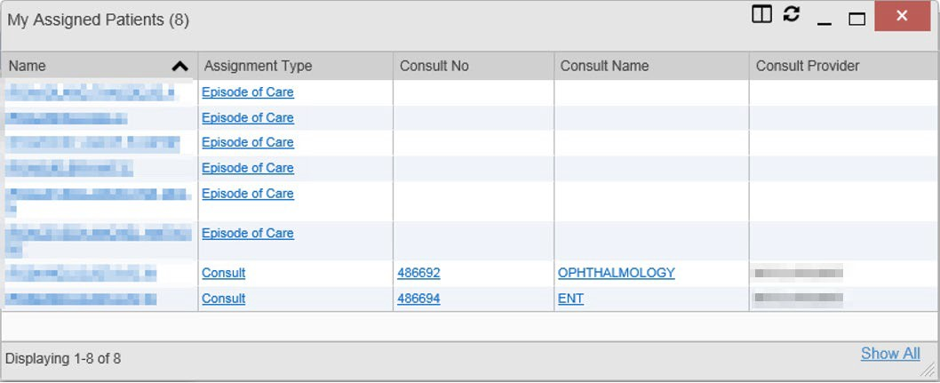Figure 19: Expanded View of the My Assigned Patients Widget

Viewing System Notifications
CV uses announcements, system status messages, and connection status messages to notify you of system maintenance events and data source availability.

    - Viewing Announcements
System announcements display on the Login page before you log in (Figure 20) and in a banner at the top of the portal (Figure 21). Announcements are provided by VA and communicate upcoming system maintenance or other scheduled events that may impact you or CV system availability. An example announcement on the Login page is shown in the following figure.
Where available, click the link to View More Announcements for additional information.

NOTE: Announcements are separate from the System Status messages displayed on the Login page. System Status monitors the services that CV uses to connect to VA data sources. System Status updates continue to display on the Login page if there are no announcements when you access CV.

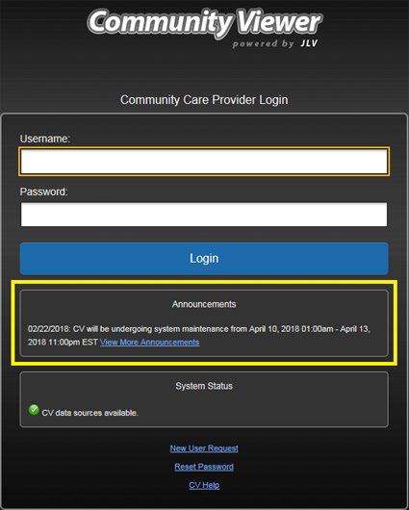
Figure 20: Announcements on the Login Page

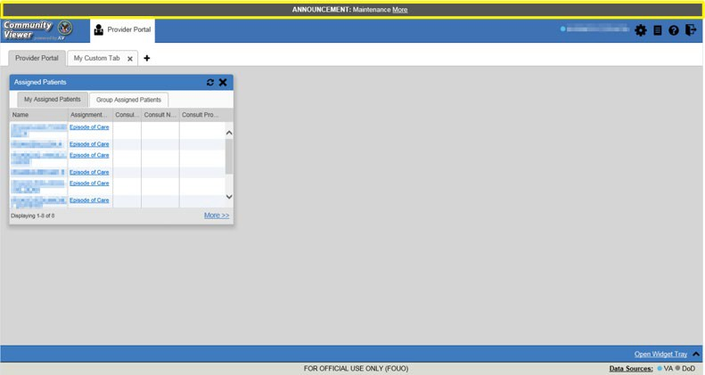Figure 21: Announcements Banner

    - Viewing System Status
The system status reports the condition of the CV application. System status updates are received from CV’s Health Monitor, which monitors the services that CV uses to connect to VA data sources.
There are two areas of CV where system status is displayed:
- On the Login page (Figure 2)
- On the portal pages (highlighted in Figure 22)
When all monitored systems and services are online and connected, a green icon appears beside System Status. The message, “CV data sources are available” (Figure 22) appears on the Login page.
When one or more monitored systems or services are offline or unavailable, a yellow warning icon appears with the message, “Services are not available to CV.”
When CV’s Health Monitor is unable to retrieve and report system status information, a red icon appears with the message, “System status is unavailable.” When this status appears, you may not be able to log in to CV or view patient data until the connection is restored. See Getting Help for information on how to contact support.

Figure 22: System Status Indicator on the Portal Pages

These warnings may be accompanied by one or more of the notices listed in the table, depending on which services are unavailable.

Table 1: System Status Notices
Service | Notice
jMeadows | “The service that gathers patient data and prepares it for display in CV is unavailable. CV is available for login but may not function otherwise.”
Master Veteran Index (MVI) | “VA Patient Identity Service is unavailable. VA data may not display.”
VistA Data Service (VDS) | “The connection to VA sites is unavailable. VA patient records of all types from all sites may not display.”
Provider Profile Management System (PPMS) | “The PPMS is unavailable. Providers may be unable to log in or provider data may not display.

    - Viewing Connection Status
CV widgets display the status of their connection to data sources. Connection status information is available for each widget.

NOTE: The Connection Status reports the condition of the connection between CV and its external resources, while System Status reports the overall condition of the CV application.

The Connection Status icon on a widget toolbar indicates the state of the connection to data sources. There are two status conditions:
• all sources are connected (available)
• one or more sources are not connected (unavailable)
Figure 23 shows a connection status indicator icon displayed on the Documents widget toolbar.

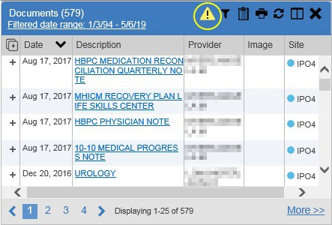
Figure 23: Connection Status Icon, Documents Widget

Clicking a Connection Status icon opens a standalone window with information about the connection to data sources. Clicking the <Hide All Active Interfaces link in the Connection Status window (Figure 24) hides the detailed All Active Connections view and displays only the connection errors.

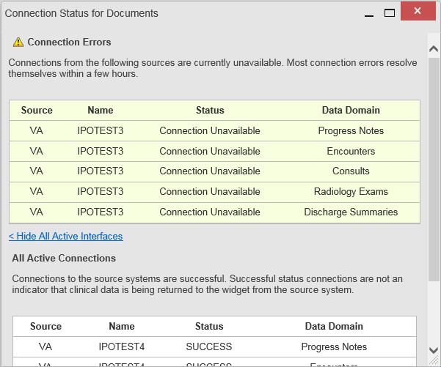
Figure 24: Connection Status Details, Active Interfaces Shown

Clicking the >Show All Active Interfaces link in the Connection Status window (Figure 25) opens a Connection Status Details view.

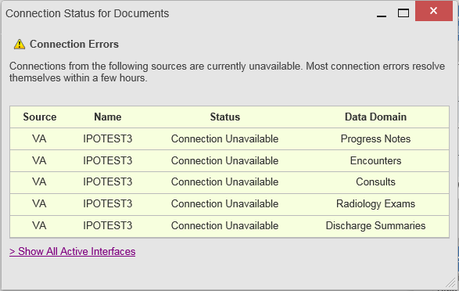
Figure 25: Connection Status Details View, Active Interfaces Hidden

Using Report Builder
The Report Builder feature is used to create custom PDF reports using patient data and records displayed in CV widgets. Content for reports can be selected from either the minimized or expanded view of a supported widget. Report Builder is accessed from the Patient Portal toolbar (Figure 26).

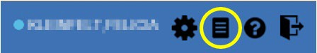
Figure 26: Report Builder Icon on the Patient Portal Toolbar

    - About Report Builder
The Report Builder pane is comprised of the Current Report tab and the Patient Reports tab. When open, the Report Builder appears over the left side of the CV portal window. Click the left (collapse) or right (expand) arrow buttons to collapse or expand the Report Builder. Any report configurations in progress are saved when collapsing or closing the Report Builder and restored when the Report Builder is displayed again.
The Current Report tab (Figure 27) is used to build the custom report. The patient data and/or records are listed here as you select and add them. The records can be previewed and can be arranged in the desired order for the final report.
The Patient Reports tab (Figure 29) presents a list of all completed reports, the status of the report generation progress, the date the report expires, and a hyperlink to the contents of the completed report.
Actions within widgets to add patient data can be performed when the Report Builder is open on the Patient Portal or when it is closed. CV enforces a maximum number of 50 records per report.

    - Generating a Report
The selected records appear in the Report Builder pane (Figure 27).

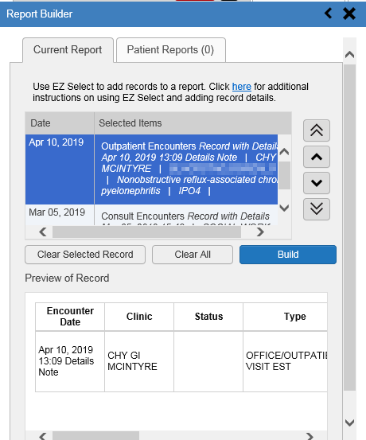Figure 27: Report Builder Current Report Tab

- Use the navigation arrows to the right of the listed records to arrange the records in the desired order in the generated report
  - Records can be removed by clicking Clear Selected Record or Clear All
- When a record is selected for the report, it appears in the Preview of Record area of the
Report Builder pane
- Click Build to validate the selected records and prepare the report
  - If a record is added to the report without an error, a Ready notation displays next to it in the Status column
  - If a record cannot be added to the report, an Error notation appears next to the record
- Name the report when prompted and click OK

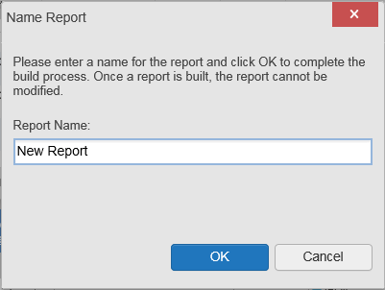Figure 28: Report Builder Name Report Dialog

- The Patient Reports tab opens and displays a report processing indicator in the Status
column (Figure 29)
- When processing is complete, the Status column displays either COMPLETED or ERROR
  - An ERROR in the Status column does not indicate the report failed to build, it is an indicator that one or more records could not be included in the generated report
  - Both the COMPLETED and ERROR entries include a Contents link, which provides a list of the records that appear in the generated report

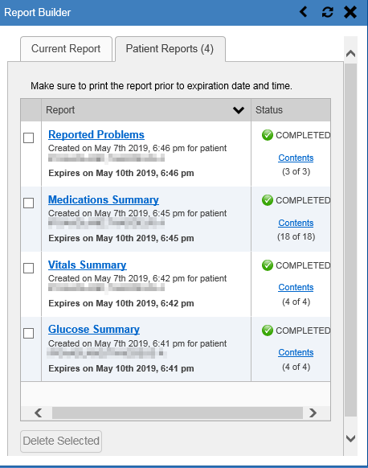Figure 29: Report Builder Patient Reports Tab

  - A report ready message appears for 6 seconds on the portal page when the report has been built and is ready to be printed
  - A red bell icon appears over the Report Builder icon when report builder is closed to indicate that a report is ready to be printed (Figure 30)

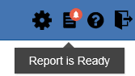Figure 30: Report is Ready Indicator on Toolbar

NOTE: Once a report is created, it is available on the Patient Reports tab for 72 hours. After 72 hours, the report expires, is removed from the Patient Reports tab, and must be re-created.

      - Adding Multiple Records with EZ Select
EZ Select allows you to add all records displayed on a single page of a single widget to the Report Builder with one click. Click the Select All icon at the top of the left column (Figure
31) to add data from all records shown in the widget's page display to the Report Builder, including the details and notes associated with the record. EZ Select is available from the minimized and expanded views as well as the Patient Flags and Postings dialog box.

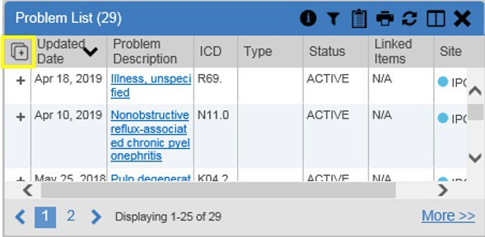Figure 31: Report Builder Select All Icon

The Add to Report Builder icon in each row changes to the Added to Report Builder
icon to confirm the record has been added (Figure 32).

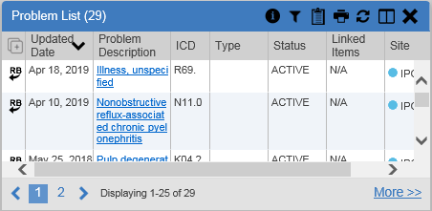
Figure 32: All Records on a Single Widget Page Added to Report Builder

      - Adding One Record
Click the Add to Report Builder icon next to a record in a widget to add data from that record to the Report Builder, including the details and notes associated with the record. The Add to Report Builder icon in the row changes to the Added to Report Builder icon to confirm the record has been added to the Report Builder (Figure 33). This applies to both minimized and expanded widget views and the Patient Flags and Postings dialog box.

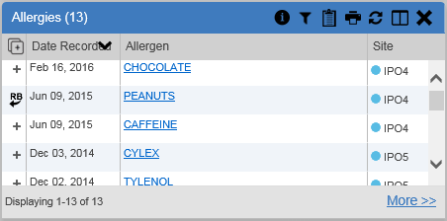
Figure 33: Single Record Added to Report Builder

      - Adding Only Record Details or Notes
When adding records to a report using the Select All icon or the Add to Report Builder icon in the widget, CV adds the data displayed in the widget, as well as any details and notes associated with the record, by default. This applies to both the minimized and expanded widget views, and the Patient Flags and Postings dialog box. If you would like to add just the details and notes or the record row data:
1. Select and hold the Add to Report Builder icon to access these options
- Select Add Detail or Add Detail/Note to add the details and/or notes associated with the record as well as the record row data to the Report Builder (Figure 34)
- Select the Add Record Row option to add only the data displayed in the widget display for that record and not the information provided in the details and/or notes

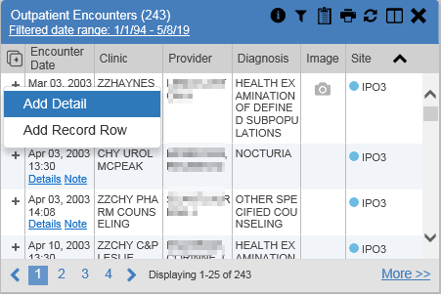
Figure 34: Add Detail and Add Record Row Dropdown

NOTE: Once you add a record to Report Builder using either the Add to Report Builder icon, Add Detail/Note, or Add Record Row option, you cannot change the record data included in the report without first clearing the record from the report and adding it again.

      - Adding Patient Demographics
Clicking the Add to Report Builder icon in the upper right corner of the Demographics widget adds the patient's demographics details for that site to the Report Builder (Figure 35). The Add to Report Builder icon changes to the Added to Report Builder icon to confirm the demographics data has been added. Click additional site tabs within the Demographics widget and repeat as desired to add demographics details from other sites within the patient's health record.

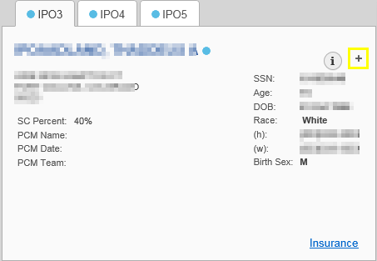
Figure 35: Demographics Widget’s Add to Report Builder Icon

    - Opening a Report
- Click the report name in the Report column of the Patient Reports tab (Figure 29) -OR-
- Click the Contents link in the Status column of the Patient Reports tab to open a list of the records included in the report in the Report Contents window (Figure 29) -OR-
- Click the blue, hyperlinked report name in the Report Contents window (Figure 36)

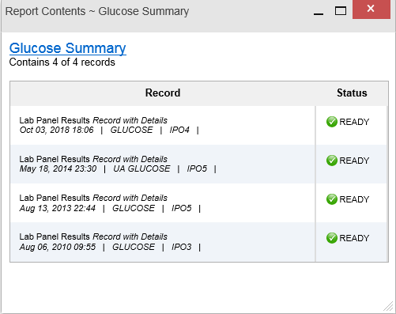Figure 36: Report Contents Dialog

NOTE: The Report Builder prints the report content to a file in PDF format. It is recommended that you have the latest Adobe Reader installed on the system from which you access CV to utilize the Report Builder and other CV features.

The report opens in a standalone browser tab. Reports are available until the expiration date and time shown. If necessary, print the report before the report expires.

NOTE: If you closed the Report Builder while a report was IN PROGRESS, a report ready indicator () appears over the Report Builder icon in the top corner of the CV portal when the report is available.
Clicking opens the Report Builder.
NOTE: Clicking Synchronize Available Reports in the upper right corner of the Report Builder (when open to the Patient Reports tab) synchronizes the list of reports shown with the Report Builder Service so that all available reports are displayed.

    - Deleting a Report
- Select the checkbox to the left of the report name on the Patient Reports tab (Figure 29)
- Click the Delete Selected button
- Click OK to confirm deletion

Using the Accessible Theme’s Functionality
The Accessible theme provides larger fonts, enhanced tab and keystroke functionality, and screen reader compatibility to support Federal accessibility requirements and Section 508 compliance.

    - Keyboard Focus and Portal Navigation in the Accessible Theme
Keyboard focus is the highlighting of portal elements that enables interaction with, and the navigation of, the web application through the keyboard and keystrokes. The portal element in focus is outlined in gold (Figure 17) as a visual indicator of keyboard focus.
CV uses standard Windows keystrokes (Tab, Shift + Tab, arrow keys, Enter) and keyboard shortcuts to move the focus to all menus, and activate all functions on the menus. All UI items are accessible via the keyboard when using the Accessible theme.
Pressing Enter or the Spacebar when an element that provides action is in keyboard focus performs the associated action. Pressing Enter or the Spacebar when the Settings icon is in focus, for example, opens the CV Settings dialog box. The Tab or arrow keys allow a user to move between keyboard focus items to navigate through portal elements. A complete list of accessible keystrokes is provided in Table 2.

Table 2: Accessible Keystrokes

Keystroke | Description
Application and Portal Navigation
Alt + 4 | Press to transfer keyboard focus to the main or top portal element: Focus is transferred to the Provider Portal tab on a portal page. Focus is transferred to the first link or data element in a widget.  Focus is transferred to the dialog box’s Close (X) icon.
ENTER | Press to transfer keyboard focus to the highlighted widget.
TAB | Press to transfer keyboard focus to other UI items.
ESC | Press to return keyboard focus to the pane containing the UI item with keyboard focus, or to exit a window, widget, or tab.
SPACEBAR | Press to activate any UI item (for example, click an icon).
Arrow Keys | When keyboard focus is on a widget, press the arrow keys to change page viewing in a widget's data table.  When keyboard focus is on a dropdown list, press the down arrow to view the list contents.
Portal Tabs
Arrow Keys | Use the left and right arrow keys to navigate between tabs.

Keystroke | Description
TAB | Press one or more times when focus is on a portal tab to place Add Tab (+) in keyboard focus.  Add a Tab:  - Press Tab until Add Tab (+) is in focus.  - Press Enter.  - The new tab dialog box opens and prompts you to enter a name for the new tab.  - Tab to the Add button to confirm the new tab name or tab to the Cancel button to discard the new tab.
ENTER | Press while Add Tab (+) is in focus to add a new portal tab. A dialog box prompts you to enter a name for the tab.
ESC | Focus on a tab and press Esc to remove it.
Windows and Dialog Boxes
TAB | Press Tab to move keyboard focus through the items within the window.
Adding Widgets to the Portal Pages
Alt + 1, 2, or 3 | Add a widget to a portal page from the Widget Tray:  - Determine which column (1, 2, or 3) of the portal page you want to place the widget.  - Focus on the desired widget icon in the Widget Tray.  - Press Alt + 1, 2, or 3, depending on the desired column.

    - Using Report Builder in the Accessible Theme
The Report Builder allows you to build a custom report of multiple patient records displayed in CV (including patient demographics, supported documents, record details, and record notes) and exports the contents of the records to a single report. Use keystroke navigation to place the Report Builder button in focus and press Enter to open the Report Builder.
There are multiple ways to add records and other patient data to a report. Actions can be performed within the widgets to add patient data when the Report Builder is open on the Patient Portal (Figure 37) or when the Report Builder is closed or minimized. The Report Builder can be minimized by pressing Enter when the left arrow button is in focus, as shown in the example below. This action collapses the Report Builder on the left side of the portal. Closing the window with the Close button removes the Report Builder from the portal.
Use keystrokes to navigate between elements on the Current Report tab (open in the following example). When an element is in focus, press Enter to perform the action.

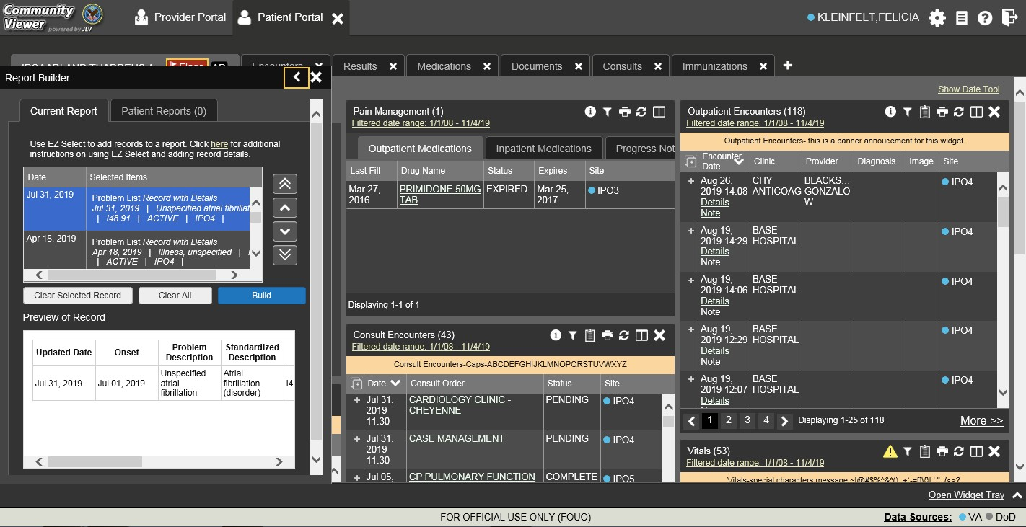Figure 37: Report Builder in Accessible Theme

Jump between the Current Report tab and the Patient Reports tab using the left and right arrow keys when either tab is in focus. Tasks performed on the Patient Reports tab include:
- Opening reports in a standalone window by pressing Tab until focus is on the report name within the Report column and press Enter
- Viewing report contents by pressing Tab until focus is placed on the Contents link in the
Status column and then pressing Enter
- Deleting reports by pressing Tab until the focus is on the report checkbox, checking the box, then pressing Tab until the Delete Selected button is in focus, and pressing Enter

Printing
The data list of a widget in either minimized or expanded view, the details window of a widget, and reports created in Report Builder can be printed.
Click the Print icon on the desired widget’s toolbar to print the data list of a widget in either minimized or expanded view.
Click the Print icon on the details window’s toolbar to print the details window of a widget. Click the (PDF) Print icon within the report window to print a report created in Report Builder.
NOTE: Each report generated using Report Builder includes this disclaimer: The information contained in this transmission may contain privileged and confidential information, including patient information protected by federal and state privacy laws.

Widgets
Patient-centric information is displayed on the Patient Portal through widgets. Widgets are elements of CV that display data specific to an administrative or clinical domain. Data is generally displayed in reverse chronological order, by date.

NOTE: Widgets may take anywhere between 3 to 10 seconds to load.
The default layout of the Patient Portal for a first-time CV user is shown in Figure 13. The widgets presented are Patient Demographics, Problem List, Allergies, Outpatient Medications, Pain Management, Consult Encounters, Progress Notes, Outpatient Encounters, and Vitals.
First-time CV users see a default series of tabs, each providing a different widget layout, in addition to the default widget layout on the Patient Portal:
- Encounters Tab: Outpatient Encounters, Appointments, and Progress Notes widgets
- Results Tab: Radiology Reports, Lab Results, Procedures, Progress Notes, and Lab Results widgets
- Medications Tab: Allergies, Inpatient Medications, Orders, and Outpatient Medications widgets
- Documents Tab: Outpatient Encounters, Inpatient Summaries, and Progress Notes widgets
- Consults Tab: Consult Encounters, Inpatient Summaries, and Progress Notes widgets
- Immunizations Tab: Immunizations, Problem List, and Progress Notes widgets

Accessing and Opening Widgets
Figure 38 depicts the Patient Portal with an open Widget Tray, highlighted at the bottom of the portal. Click the Open Widget Tray link in the lower right-hand corner to open the Widget Tray. Click, hold, and drag a widget from the tray to the portal. These actions dock the widget on the portal page. Once docked, the widget opens in minimized view.
Use the tray navigation tools (<< More Widgets or More Widgets >>) placed above the tray or the arrows (< or >) placed below the tray icons in the lower left and right corners of the portal to scroll through all clinical domains available in the Patient Portal.

NOTE: Widgets can be removed from a portal page and placed back into the Widget Tray by clicking Close in the upper right corner of the docked widget.

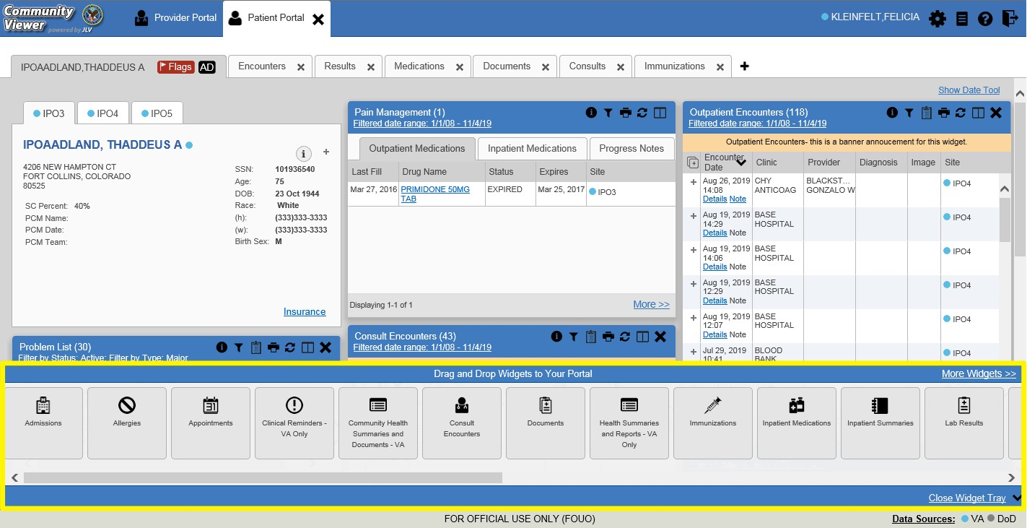Figure 38: Widget Tray on the Patient Portal

The list of widgets available for display on the Patient Portal is presented in a horizontal tray at the bottom of the portal (highlighted in Figure 38). Data from VA systems is available for the following VA clinical domains:

- Admissions  - Allergies  - Appointments  - Clinical Reminders  - Community Health Summaries and Documents1  - Consult Encounters  - Documents  - Health Summaries and Reports | - Immunizations  - Inpatient Medications  - Inpatient Summaries  - Lab Results  - MHS GENESIS1  - Orders  - Outpatient Encounters  - Outpatient Medications  - Pain Management  - Problem List | - Procedures  - Progress Notes  - Questionnaires and Deployment Assessments1  - Radiology Reports  - Social, Family, and Other Past Histories1  - Surgery/Procedure Reports  - Vitals

    - Sort and Filter Options
Widgets have a variety of methods to sort and filter data:
- Click a column title to sort records according to data in that column; an up or down arrow appearing next to the column title provides a visual indicator that a sort is applied to that column

1 While available in the widget tray, some widgets display “Data source not enabled” or a connectivity error until data sources are connected in a future release.

  - If you sort a column that appears in both minimized and expanded views of the widget, the sort saves in your user profile and persists
  - If you sort a column that is only in the expanded view of the widget, your next session restores the default widget sort or the last sort saved to your user profile
  - If you sort a Date column that has some partial or missing date values, understand:
    - Dates that have month and year but lack a day are treated as though the day were “00” (e.g., July 2018 sorts between June 30, 2018 and July 01, 2018)
    - Dates that have a year only are treated as though the month is January and the day is “00” (e.g., 2018 sorts between December 31, 2017 and January 01, 2018
- Click Column Settings in the widget toolbar to hide or show the columns within the widget; check/uncheck the column names that appear in the pop-up box, and click Apply
- When there are multiple drugs with the same order number, CV maintains the grouping by order number when a column sort is applied in the widget
Sort and filter capabilities are specific to the data presented in each widget and may vary between the minimized and expanded views of an individual widget or between widgets. Select All from the Filter by… dropdown to undo an individual filter, or click the Remove All Filters link shown in each widget to undo all filters.
Some widgets also have the capability to configure data to display multiple records of the same type in a graph or table view. See Graph/Table View from the Lab Results Widget for more information.

      - Setting Multiple Filters in Widgets
CV supports the application of multiple filters in any of the widgets with two or more Filter by options in the expanded view. The sequence in which the filters are applied impacts the data that displays in the widget. The second or subsequent filter selected is applied to the subset of data from the previous filter.

      - Widget Date Range Filters
Patient data displayed within a widget can be filtered by date range, if date filters are available on the widget.

NOTE: CCPs have limited access to records and can only retrieve records within the date range set by the VA Staff user who created the patient assignment.

If a date range filter is applied, the selected range is indicated in the widget header, below the title (Figure 39). Click the Configure Filter icon or the Filtered Date Range link on the widget toolbar to change the date range of the data displayed.

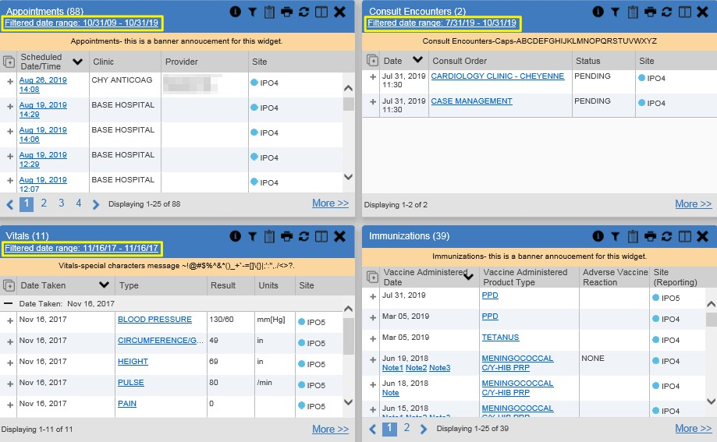Figure 39: Filtered Date Range Examples

There are two ways to filter the date range of data displayed in a widget: The Quick Date Range filter and the Start and End Date filter. If the expected information does not appear in the widget display, use the date filter options to change the date range.

NOTE: Changes made to the date range in a widget persist from minimized to expanded view, patient to patient, and session to session, until the widget is either removed or the date range is changed.

NOTE: When looking for Essentris information associated with a specific admission in the Inpatient Summaries widget, expand your search date ranges to include additional days before and after the admission where possible. This includes preadmission notes as well as notes signed after the patient was discharged in the filtered widget display.

        - Quick Date Range Filter
Use the preset, Quick Date Range filter to set or limit the display of patient records within a widget. This option is available by clicking the Filtered Date Range link or by clicking the Configure Filter icon in a widget on the Patient Portal.
Clicking a Quick Date Range filter refreshes the data displayed to show only the records for the selected range. Selecting Cancel, which is the Apply button while the data refresh is running, stops the query. The options represent time counting back from the present day (for example,

selecting 2y displays only records within the last 2 years). Examples of preset date ranges include 1w (last 7 days), 6m (last 6 months), and 3y (last 3 years).

NOTE: The Quick Date Range filter is contextual. If today is February 2, 2017, the preset filter counts backwards using that date. If today is April 16, 2017, the preset filter counts backwards using that date.

Figure 40 highlights the Quick Date Range filter options in the expanded view of the
Appointments widget.

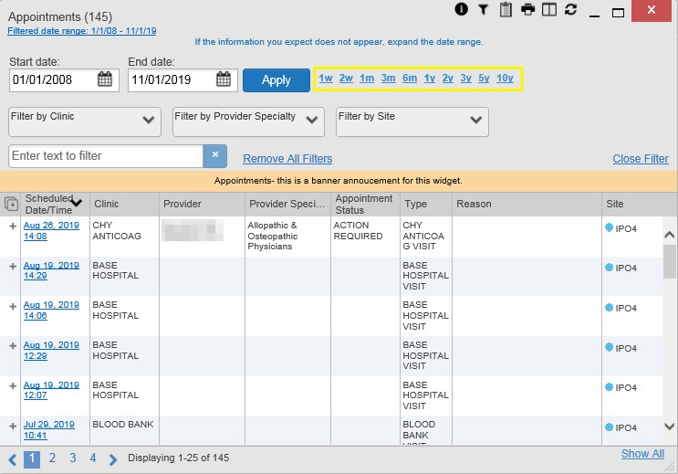Figure 40: Quick Date Range Filters

CCPs have limited access to records and can only retrieve records within the date range set by the VA Staff user who created the patient assignment. Figure 41 shows a CCP restricted to records from 07/20/2019 to present, in this case 10/31/2019, which is shown by default in the Start Date and End Date fields. When the 5y Quick Date Range filter is applied, the Filtered Date Range shows the entire 5-year period (10/31/14–10/31/19), which includes the date range history the CCP is permitted to view. However, records between the Filtered Date Range start date and the day before the CCP’s permitted history start date (10/31/14–07/19/2019) will not display.

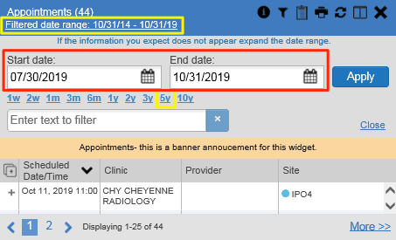Figure 41: Quick Date Range Filter (5y) Outside CCP’s Permitted History Dates

        - Start and End Date Filter
VA Staff set a date filter to control the records within widgets seen by the CCP. The CCP can set additional display filters within the set range by clicking Filter from the widget's toolbar. Use the Start Date and End Date filter to display data for a specific time range (Figure 42). The start and end date fields are available at the top of multiple widgets by clicking the Filtered Date Range link or the Configure Filter icon .

NOTE: The Start and End Date filter is static. If the start date is set to June 2, 2018 and the end date is set to June 2, 2019, the data in that date range displays, no matter what today’s date is.

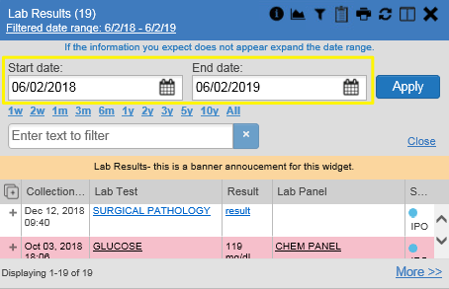Figure 42: Lab Results Widget Start and End Date Filters

Figure 43 provides an example of the start and end date filter fields in the expanded view of the
Radiology Reports widget.

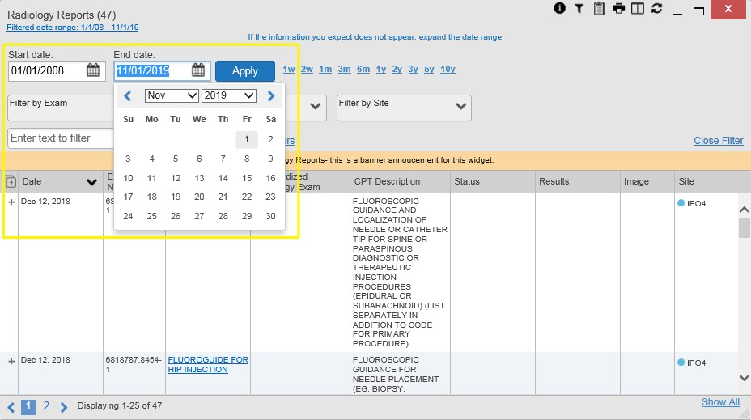Figure 43: Radiology Reports Widget Start and End Date Calendar

- Click the Calendar icon next to Start Date
- Select a month, day, and year start date for the display filter

NOTE: Prior day selections persist if you change only the month or year. If you change the month or year and the prior day value does not exist, the calendar will default to the last day of the new month. For example, changing only the month value of an existing August 31, 2018 entry to February would set the date to February 28, 2018 because there are less days in February. Similarly, if you had February 29, 2016 selected, a day which only exists in a leap year, switching the year to 2015 would set the date to February 28, 2015, the last day of the month in a standard year.

- Click the Calendar icon next to End Date
- Select the month, day, and year end date for the display filter
- When both a start and end date have been chosen, click Apply
- Click Cancel to stop the query
The widget refreshes and displays only the records that fall within the custom date range. The date range in use is displayed in the widget header.

      - Tab Date Range Tool
All tabs in the Patient Portal have a Tab Date tool that you can use to filter all widgets on a single tab by the same date range. The Tab Date tool has the same Start and End Date and

Quick Date Range filters available on most individual widgets, but it applies the date filter to all widgets on an individual tab.
- Select the Show Date Tool hyperlink in the upper right corner of a new or existing tab
- Enter dates in the Start Date and End Date fields, and select the Apply to All Widgets on This Tab button -OR-
- Select a Quick Date Range value in the Tab Date tool
The Tab Date tool (Figure 44) is hidden by default, and it hides again automatically after you apply a date filter to the tab. Should you decide not to apply a date filter to the tab, select the Hide Date Tool hyperlink to hide the tab-level date filters.

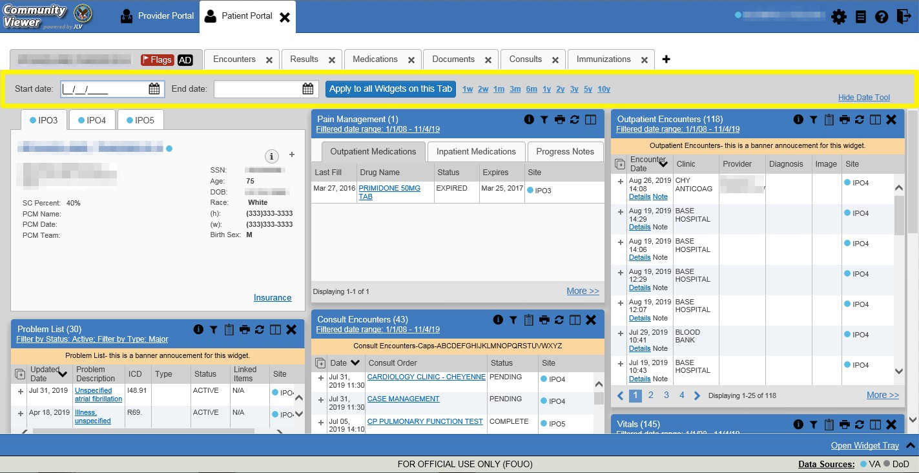Figure 44: Tab Date Tool

The Tab Date tool only filters widgets currently displayed on the active tab that support date range filtering. Widgets that display all data, without a date range, will continue to do so.
Filtering only applies to widgets on the tab at the time you apply the Tab Date tool and will not affect new widgets added to the tab. You may still apply widget-level date filters to individual widgets after using the Tab Date tool.

      - Text Filter
Clinical data widgets on the Patient portal and the Patient Flags and Postings dialog box provide a text search filter option, allowing you to quickly locate relevant patient data using keywords or characters (Figure 45). Text filters are performed on the information displayed in all columns within a widget, including hidden columns. Filters are not performed on notes, attachments, or details associated with patient records.

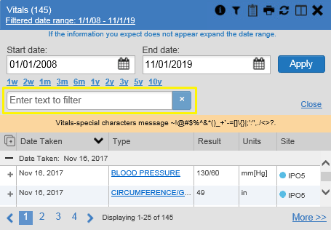Figure 45: Vitals Widget Text Filter

Click the Configure Filter icon in the minimized view of a widget to display the Enter text to filter field. If the filter options are not displayed in the expanded view of the widget, clicking the Configure Filter icon also opens the filter options. Keep in mind:
- Text filtering applies only to one widget
- Text filters are performed within the subset of filtered data if a date range filter or other dropdown filters are applied within the widget
- Text filters are performed on data within all columns shown in the expanded view of the widget even if the term is entered in the text filter field of the minimized view
- Text filters entered in the minimized view of a widget persist when you open the widget in expanded view
- On widgets with site tabs, text filters entered on one site tab persist when you select other site tabs
- All records across the widget pages are filtered if the widget has multiple page views
- The Enter text to filter field is not case sensitive and allows up to 25 characters, including numeric and special characters
- CV begins to filter when you pause while typing the term in the Enter text to filter field
- Text filtering is not available in the Demographics widget

Widget Navigation and Display Options
Navigation tools and display options are provided within each widget (listed in Table 3).
Click More >> in the lower right corner of a widget in minimized view to open the widget in expanded view, as seen in Figure 46.

Table 3: Widget Navigation Tool Descriptions

Widget Element | Meaning | Description
 | Go to Previous Page | Changes the focus of the widget to the previous group or page of records within the results display.
 | Jump to Page | Changes the focus of the widget to the page number selected.
 | Go to Next Page | Changes the focus of the widget to the next group or page of records within the results display.
More >> | Go to Expanded View | Available in minimized views only. Opens the expanded view of the widget in a secondary window.
[record range] of [record total] | Record Display Indicator | Indicates the number of records displayed in that widget page out of the total number of records for that widget.
Show All/ Show Paged | Display Setting | Click Show All to open all records for a given widget in a scrollable window.  Click Show Paged to return to the display of records grouped by pages.

Minimized vs. Expanded Widget View
Each widget can be displayed in either a minimized or expanded view. The default rendering of a widget is in minimized view (Figure 13).

NOTE: Some of the column headings appear in an abbreviated manner in minimized view because the widgets are width-constrained. Click and drag the column header to resize the columns in minimized or expanded view.

Click the More >> link at the bottom of the widget in minimized view to launch the expanded view (Figure 46), which provides additional display and filtering options.
Click Configure Filter from the widget toolbar if the additional display configuration options are not displayed in expanded view.

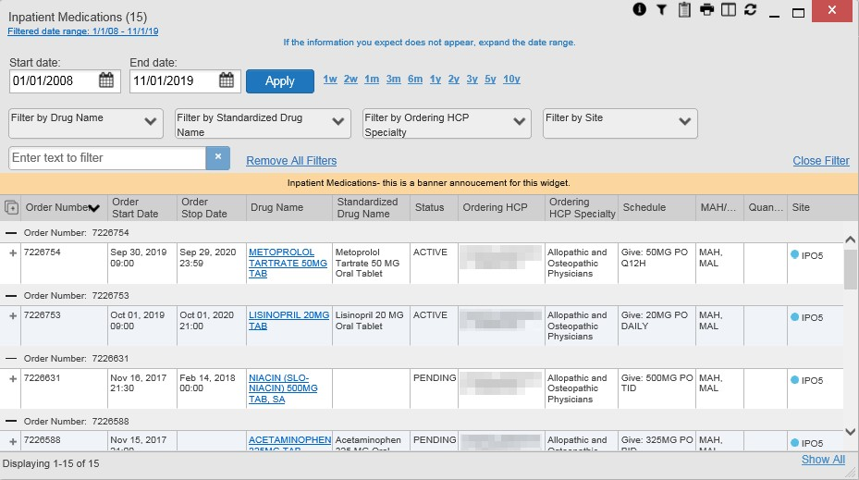Figure 46: Expanded View Widget Display

Displaying Widgets on Custom Tabs
You can use the custom tabs feature to create additional widget configurations for ease of use and quick reference. Changes made to the Patient Portal display (widget layouts and custom tabs) are saved to the user profile and display in future CV sessions.
- Click the plus sign + to the right of the tabs along the top of the Patient Portal (Figure 13)
  - The Add Tab dialog box opens
- Type a name for the new tab in the Add Tab dialog box, and click Add
- Open the Widget Tray within the new tab space, then click, hold, and drag each of the desired widgets to the portal page

NOTE: Tab configurations remain set until you manually change them or restore your profile to default in the CV Settings dialog, which will remove all custom tabs.

- Click between preset and custom tabs at any time without losing any of the configurations created on the custom tabs
  - Tabs persist, even when a patient change is made
  - Custom tabs can be renamed by double-clicking the tab name

Refreshing Widget Data
Data in the widget display can be refreshed by clicking Refresh . This action updates the data in the widget.

NOTE: Records previously added to a report remain in the Report Builder after a widget refresh. Clicking Refresh in the widget refreshes
the widget data display and resets the state of the Added to Report Builder icon in the left column Add to Report Builder icon, even if the
record has been added to the Report Builder.

Nondiagnostic Images
Nondiagnostic images are available in JPEG and PDF formats in the Documents, Outpatient Encounters, Procedures, Progress Notes, Radiology Reports, and Surgery/Procedure Reports widgets, in addition to the Progress Notes tab of the Pain Management widget.
When a Camera icon appears in the Image column (Figure 47), one or more images are associated with that record.

NOTE: Images are nondiagnostic and may not be of high-quality resolution.

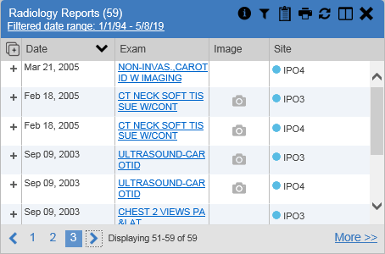
Figure 47: Nondiagnostic Images in the Minimized View of the Radiology Reports Widget

Click the Camera icon to display a list of link(s) to the image(s) (Figure 48). Click the hyperlinked name of the image to open it.

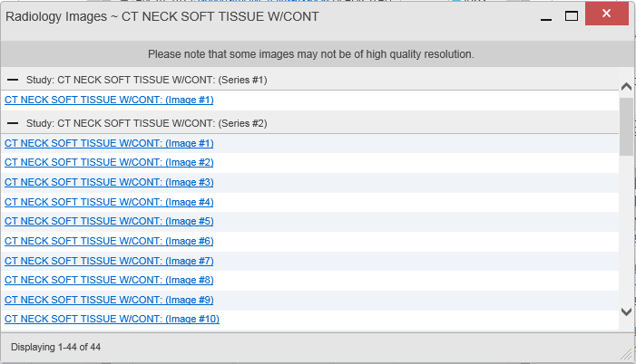
Figure 48: Multiple Nondiagnostic Radiology Images

When in Detail view, click the Click image to open viewer link (Figure 49) to open the associated image.

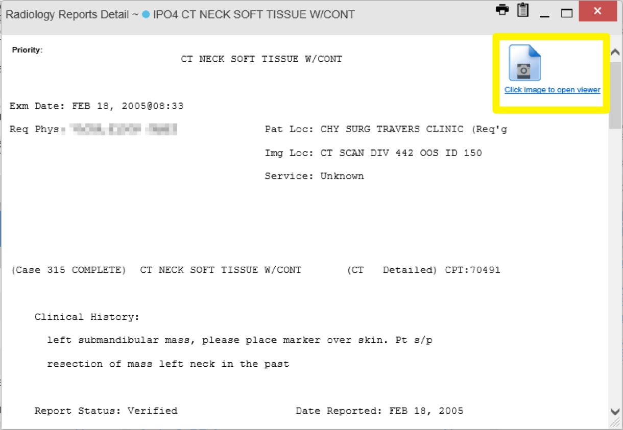
Figure 49: Nondiagnostic Images in the Radiology Reports Detail View

If an image is temporarily unavailable, users may see the message: “System is unable to retrieve images at this time” (Figure 50). Try to retrieve the image later, or contact the Community Provider Technical Service Desk if the problem persists (Getting Help).

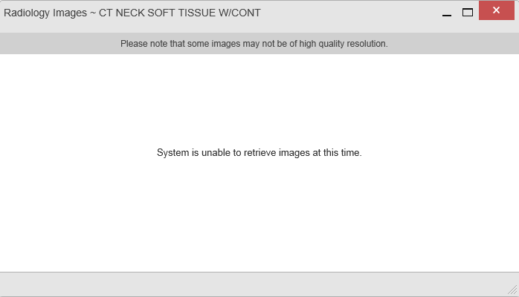Figure 50: Radiology Images Unable to Retrieve Images Error

Widget Functionality
The Patient Portal displays the selected patient's clinical records and other patient-centric information. The Patient Demographics, Inpatient Medications, Lab Results, and Problem List widgets, detailed in the following subsections, provide examples of widget functionality.

NOTE: Click Help in the upper right corner of the portal pages to see detailed information for all available widgets in CV.
    - Patient Demographics
A summary of the patient’s demographics (personal data) appears in the upper left section of the Patient Portal (Figure 51). This static widget cannot be removed from the Patient Portal or moved to a different position. The tabs above the patient’s name provide the patient’s demographics summary at each VA site that the patient has visited.
The patient’s name is displayed in color and is followed by a blue circle. The blue circle represents that the data was retrieved from a VA system.
When the Flags icon appears in the right corner of the Demographics widget, click the Flags icon to display information on the Patient Flags and Postings dialog, which only displays if there are alerts on the patient’s record.

The Advance Directives icon launches the Advance Directives dialog. The icon displays gray and does not launch the Advance Directives dialog if there are no advance directives on the patient’s record.

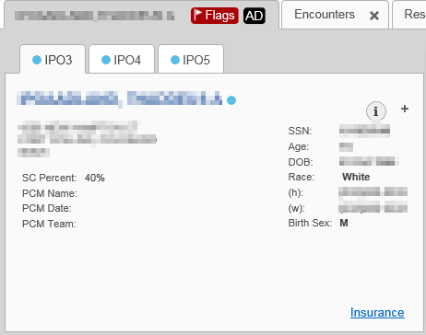
Figure 51: Patient Demographics Widget

      - Viewing Detailed Patient Demographic Information
Additional patient demographic information is available from the Demographics widget on the Patient Portal. Click the patient’s name to open a separate window that provides a detailed list of demographic information for that patient.

      - Viewing Third-Party Insurance Information
Third-party payers and additional insurance information are available from a link within the Demographics widget on the Patient Portal (Figure 51). Click the Insurance link in the Demographics widget to open a separate window that displays detailed insurance information for the patient.
Use the horizontal scroll bar to view additional columns not seen within the default window size.
Data in the Standardized Insurance Type column is normalized to the X12 Health Insurance Type standard. Hover over entries in this column to display the standardized name and code for the insurance type.

    - Pain Management
The Pain Management widget (Figure 52) displays a patient’s pain management treatment history, an up-to-date list of current and prior pain medications, and drugs that may interact with those pain medications.

The Pain Management widget is a static widget permanently positioned to the right of the Demographics widget on the Patient Portal (Figure 13). The default instance of the Pain Management widget cannot be moved or removed.

NOTE: Multiple instances of the Pain Management widget can be added to any portal tab. This allows for multiple views of the same pain management data (Figure 52). These additional instances of the widget can be moved or removed.

The tabs of information in the minimized view of the Pain Management widget display a data subset of the Outpatient Medications, Inpatient Medications, and Progress Notes widgets.

NOTE: Any tab of the Pain Management widget that does not have associated pain management records for the patient displays a “No Data” message.

Click More >> in the minimized view of the Pain Management widget to open an expanded view of each tab. The columns of information in the expanded view represent each clinical domain shown in the Pain Management widget (See Outpatient Medications, Inpatient Medications, and Progress Notes for more information).

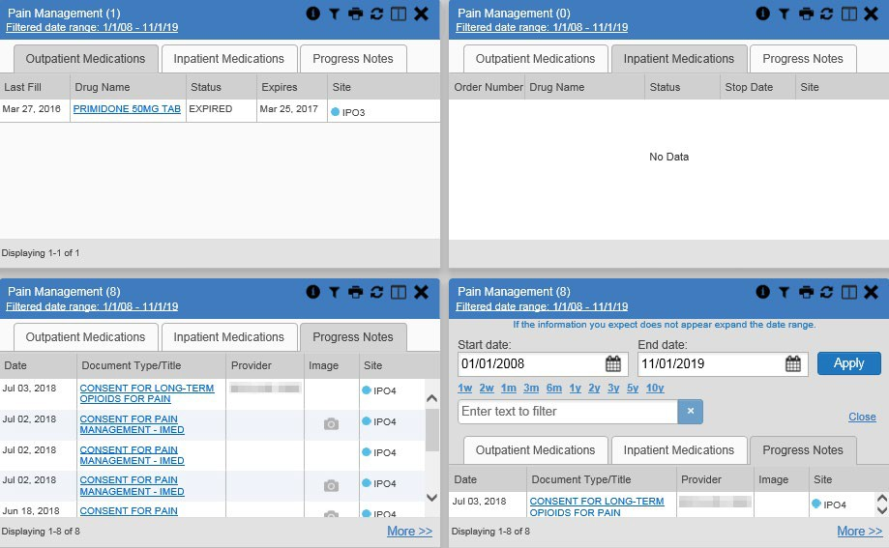Figure 52: Pain Management Widget

    - Outpatient Medications
The Outpatient Medications widget (Figure 53) displays outpatient medication information, including active medications and medications that have expired or been discontinued within the past 120 days. The information is displayed in reverse chronological order by the last fill order date.
Click Rx () from the widget toolbar in minimized or expanded view to convert the active medications data within the widget to text for display within a separate window.

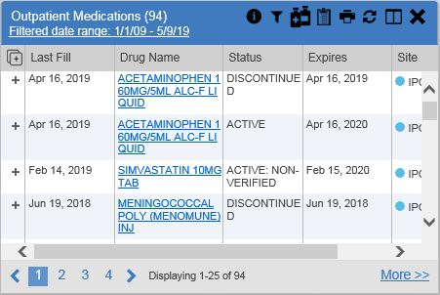
Figure 53: Outpatient Medications

      - Outpatient Medications Widget Data
The columns of information in the minimized view of the Outpatient Medications widget are:
- Last Fill
- Drug Name
- Status
- Expires
- Site
Click More >> in the minimized view of the Outpatient Medications widget to open the expanded view. The columns of information in the expanded view are:
- Last Fill
- Drug Name
- Standardized Drug Name
- Prescription Number
- Sig

- Quantity
- Days’ Supply
- Refills Left
- Status
- Ordering Health Care Provider (HCP)
- Ordering HCP Specialty
- Expires
- Site
      - Viewing Outpatient Medication Details
Click the hyperlink in the Drug Name column of either view of the Outpatient Medications
widget to open a separate window that displays detailed information about the medication.

    - Inpatient Medications
The Inpatient Medications widget (Figure 54) displays inpatient medication information. The medications are grouped by the order number, where available.

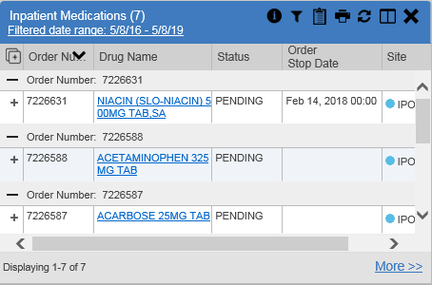Figure 54: Inpatient Medications Widget

NOTE: The sort arrow for the Order Number column overlaps the text in the minimized view.

      - Inpatient Medications Widget Data
The columns of information in the minimized view of the Inpatient Medications widget are:
- Order Number2
- Drug Name
- Status
- Order Stop Date
- Site
Click More >> in the minimized view of the Inpatient Medications widget to open the expanded view. The columns of information in the expanded view are:
- Order Number2
- Order Start Date
- Order Stop Date
- Drug Name
- Standardized Drug Name
- Status
- Ordering HCP
- Ordering HCP Specialty
- Schedule
- MAH/MAL3
- Quantity
- Site
      - Viewing Inpatient Medication Details
Click the hyperlink in the Drug Name column of either view of the Inpatient Medications
widget to open a separate window that displays detailed information about the medication.
CV inserts Medication Administration History report text at the bottom of the Details view of all VA records in the Inpatient Medications widget. By default, the history report displays the previous 7 days.

    - Progress Notes
The Progress Notes widget (Figure 55) displays the patient’s progress notes information, displayed in reverse chronological order by the note date.
When a Camera icon appears in the Image column, one or more images are associated with that record (See Nondiagnostic Images for more information).

2 When there are multiple drugs with the same order number, CV maintains the grouping by order number when a column sort is applied in the widget.
3 The Medication Administration History (MAH) / Medication Administration Log (MAL) column is a placeholder that will hold links to MAH/MAL reports in a future release.

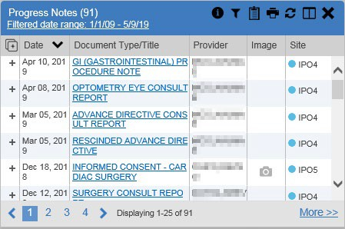
Figure 55: Progress Notes Widget

      - Progress Notes Widget Data
The columns of information in the minimized view of the Progress Notes widget are:
- Date
- Document Type/Title
- Provider
- Image
- Site
Click More >> in the minimized view of the Progress Notes widget to open the expanded view. The columns of information in the expanded view are:
- Date
- Document Type/Title
- Standardized Document Type
- Provider
- Provider Specialty
- Clinic
- Image
- Site
      - Viewing Progress Notes Details
Click hyperlink in the Document Type/Title column of either view of the Progress Notes
widget to open a separate window that displays detailed information about the record.

    - Lab Results
The Lab Results widget (Figure 56) displays the patient’s lab result information for chemistry, anatomic pathology, microbiology labs, as well as skin test data and blood transfusion history, where available in the patient’s record. The information is displayed in reverse chronological order by the collection date.

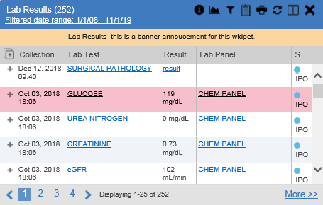Figure 56: Lab Results Widget

      - Lab Results Widget Data
The columns of information in the minimized view of the Lab Results widget are:
- Collection Date
- Lab Test
- Result
- Lab Panel
- Site
Click More >> in the minimized view of the Lab Results widget to open the expanded view. The columns of information in the expanded view are:
- Collection Date
- Specimen Source
- Lab Test
- Result
- Interpretation
- Units
- Ref Range

- Lab Panel
- Type
- Order Number
- Ordering HCP
- Status
- Site

NOTE: While the Standardized Lab Test and Ordering HCP Specialty columns are not listed by default, you may add them to the expanded view by selecting their corresponding checkboxes in the Column Settings.
      - Viewing Abnormal Results in the Lab Results Widget
CV highlights result values that fall within a calculated reference range for abnormal in both the minimized and expanded views of the widget.
Pink highlighting represents either H (high) or L (low) abnormal indicators. Red highlighting represents that the abnormal indicator has an asterisk (H* or L*) or the result is critical.

      - Viewing Lab Results Details
Clicking a hyperlinked entry in the Lab Test column opens a separate window that displays the detailed test report.

      - Graph/Table View from the Lab Results Widget
The Lab Results widget provides the option to display multiple results for the same lab test in a graph and table.
- Select the Graph icon from the widget toolbar in either minimized or expanded view -OR-
- Click More >> from the minimized view of the Lab Results widget to open an expanded view of the widget, then select the Show Graph/Table link
- Select a value from the Select a Lab Test dropdown in the Lab Results Graph/Table dialog
  - The graph displays with corresponding table values beneath
- Select the Show Labels checkbox to toggle data labels on or off in the graph
- Select the Close button to exit Graph/Table view and return to the minimized or expanded view of the Lab Results widget
Figure 57 displays an example Graph/Table view of the lab test results.

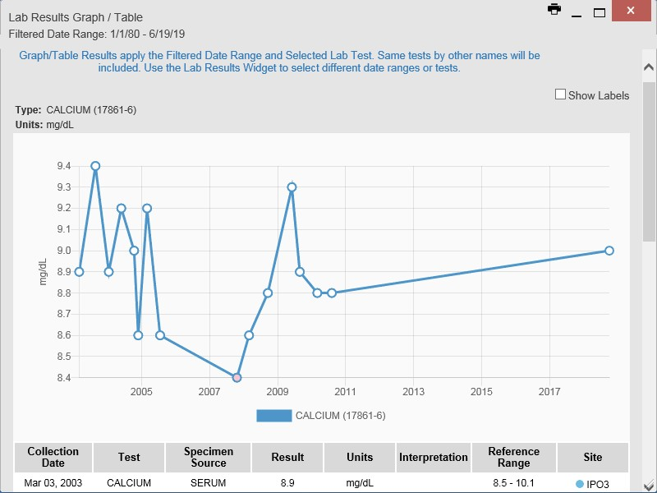Figure 57: Lab Results Graph/Table View

In the expanded view of the Lab Results Widget, selecting one or more values in the Filter by Lab Test dropdown will disable all other filter dropdowns until the filtered selections are removed. The lab test values in the Filter by Lab Test dropdown dynamically increase or decrease depending on the date filter criteria you apply. Tests with the same LOINC code (shown in parentheses following the lab test name) as the ones selected will be automatically included in the filtered results displayed in the widget.
You may only use the graph/table feature for a single lab test LOINC value. All lab tests with the same LOINC will be graphed even if the lab test names differ. While you can select multiple lab test values in the Filter by Lab Test dropdown, you will be forced to select a single lab test value from the Select a Lab Test dropdown in the Lab Results Graph/Table dialog (Figure 58) once you select either the Graph icon or the Show Graph/Table link. The lab test values in the Select a Lab Test dropdown also dynamically increase or decrease depending on the filter criteria applied in the Lab Results Widget.

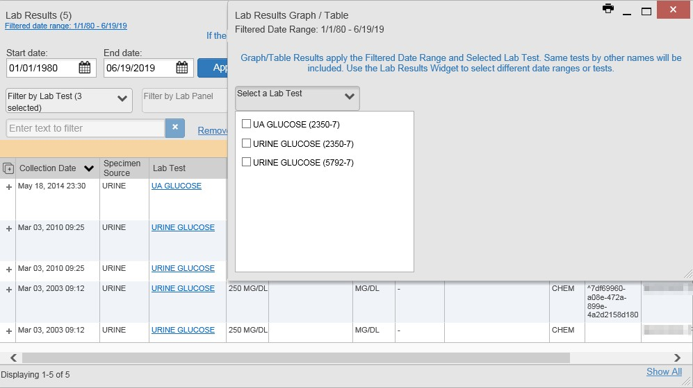Figure 58: Lab Results Graph Table View, Select a Lab Test

You may also generate a graph for all lab tests with the same LOINC code by selecting the
Graph icon from the Lab Results Details view.
    - Problem List
The Problem List widget (Figure 59) displays a list of the patient’s health issues. The information is first sorted by ACTIVE status and then displayed in reverse chronological order.

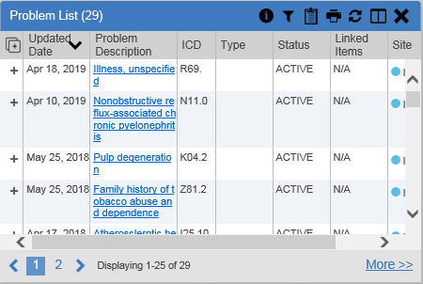Figure 59: Problem List Widget

      - Problem List Widget Data
The columns of information in the minimized view of the Problem List widget are:
- Updated Date
- Problem Description
- International Classification of Diseases (ICD)
- Type
- Status
- Linked Items (DOD records only)
- Site

NOTE: Linked items are available for DOD records only and will be blank until DOD data is added to CV. CV inserts “N/A” in the Linked Items column for all records from VA VistA sites.
Click More >> in the minimized view of the Problem List widget to open expanded view. The columns of information in the expanded view are:
- Updated Date
- Onset
- Problem Description
- Standardized Description
- ICD
- Severity
- Type

- Status
- Linked Items
- Site
      - Viewing Problem List Details
Clicking a hyperlinked entry in the Description column in either the minimized or expanded views of the widget opens a separate window that displays a detailed report of the record.

