Community Viewer Version 3.5

Community Care Provider User Guide



December 2020

Version 2.0

Department of Veterans Affairs (VA)

Office of Information and Technology (OIT)

**Revision History**

|  |  |  |  |
| --- | --- | --- | --- |
| Date | Version | Description | Author |
| 12/15/2020 | 2.0 | Delivered for Approval | Liberty ITS |
| 12/10/2020 | 1.4 | Addressed initial feedback and submitting for second review | Liberty ITS |
| 11/16/2020 | 1.3 | Delivered for Review | Liberty ITS |

Table of Contents

1. Introduction 1

1.1. Purpose of the Guide 2

1.1.1. Guide Conventions 2

1.1.2. Terminology 2

1.2. Assumptions 3

1.3. System Requirements 3

1.4. Getting Help 3

2. Logging in to CV 3

2.1. Changing Your Password 6

2.1.1. Password Requirements 8

2.2. The CV Portal Pages 9

2.2.1. The CV Portal Toolbar 9

2.2.2. Default View 10

2.2.3. Customizing CV 10

2.3. Logging Out of the Current CV Session 15

3. Using CV 15

3.1. Accessing Patient Data via the Assigned Patients Widget 15

3.2. Viewing System Notifications 17

3.2.1. Viewing Announcements 17

3.2.2. Viewing System Status 19

3.2.3. Viewing Connection Status 20

3.3. Using Report Builder 22

3.3.1. About Report Builder 22

3.3.2. Generating a Report 23

3.3.2.1. Adding Multiple Records with EZ Select 25

3.3.2.2. Adding One Record 26

3.3.2.3. Adding Details from Multiple Dates 26

3.3.2.4. Adding Only Record Details or Notes 26

3.3.2.5. Adding Patient Demographics 27

3.3.3. Opening a Report 27

3.3.4. Deleting a Report 29

3.4. Using the Accessible Theme’s Functionality 29

3.4.1. Keyboard Focus and Portal Navigation in the Accessible Theme 29

3.4.2. Using Report Builder in the Accessible Theme 30

3.5. Printing 31

4. Widgets 32

4.1. Accessing and Opening Widgets 32

4.1.1. Sort and Filter Options 33

4.1.1.1. Setting Multiple Filters in Widgets 35

4.1.1.2. Widget Date Range Filters 35

4.1.1.2.1. Quick Date Range Filter 36

4.1.1.2.2. Start and End Date Filter 38

4.1.1.3. Tab Date Range Tool 40

4.1.1.4. Text Filter 41

4.2. Portal and Widget Toolbars 42

4.3. Widget Navigation and Display Options 43

4.4. Minimized vs. Expanded Widget View 44

4.5. Displaying Widgets on Custom Tabs 45

4.6. Refreshing Widget Data 46

4.7. Nondiagnostic Images 46

4.8. Widget Functionality 48

4.8.1. Patient Demographics 48

4.8.1.1. Viewing Detailed Patient Demographic Information 49

4.8.1.2. Viewing Third-Party Insurance Information 49

4.8.2. Pain Management 49

4.8.3. Outpatient Medications 50

4.8.3.1. Outpatient Medications Widget Data 51

4.8.3.2. Viewing Outpatient Medication Details 52

4.8.4. Inpatient Medications 52

4.8.4.1. Inpatient Medications Widget Data 52

4.8.4.2. Viewing Inpatient Medication Details 53

4.8.5. Progress Notes 53

4.8.5.1. Progress Notes Widget Data 54

4.8.5.2. Viewing Progress Notes Details 54

4.8.6. Lab Results 55

4.8.6.1. Lab Results Widget Data 55

4.8.6.2. Viewing Abnormal Results in the Lab Results Widget 56

4.8.6.3. Viewing Lab Results Details 56

4.8.6.4. Graph/Table View from the Lab Results Widget 56

4.8.7. Problem List 58

4.8.7.1. Problem List Widget Data 59

4.8.7.2. Viewing Problem List Details 60

5. Acronyms and Abbreviations 61

Table of Figures

Figure 1: Mann-Grandstaff (Spokane) Announcement 1

Figure 2: Authorized Use Message 2

Figure 3: CCP User Login Page 4

Figure 4: CCP VA Privacy and Security Awareness Training Page 5

Figure 5: Password Reset Dialog Box 6

Figure 6: Confirmation of Request Sent to Reset Password 7

Figure 7: Password Reset E-mail 7

Figure 8: Password Reset Page 8

Figure 9: Password Reset Confirmation Message 8

Figure 10: Password Expiration Notice on the Login Page 9

Figure 11: CV Portal Tools 10

Figure 12: Default View 10

Figure 13: The CV Settings Dialog Box 12

Figure 14: Blue Theme 13

Figure 15: Green Theme 13

Figure 16: Dark Gray Theme 14

Figure 17: Gray Theme 14

Figure 18: Accessible (508-Compliant) Theme 15

Figure 19: Minimized View of the Assigned Patients Widget 16

Figure 20: Expanded View of the My Assigned Patients Widget 17

Figure 21: Announcements on the Login Page 18

Figure 22: Announcements Banner 18

Figure 23: System Status Indicator on the Portal Pages 19

Figure 24: Demographics Widget, PCMM Connection Status Unavailable 20

Figure 25: Connection Status Icon, Documents Widget 21

Figure 26: Connection Status Details, Active Interfaces Shown 21

Figure 27: Connection Status Details View, Active Interfaces Hidden 22

Figure 28: Report Builder Icon on the Patient Portal Toolbar 22

Figure 29: Report Builder Current Report Tab 23

Figure 30: Report Builder Name Report Dialog 23

Figure 31: Report Builder Patient Reports Tab 24

Figure 32: Report is Ready Indicator on Toolbar 25

Figure 33: Report Builder Select All Icon 25

Figure 34: All Records on a Single Widget Page Added to Report Builder 26

Figure 35: Single Record Added to Report Builder 26

Figure 36: Add Detail and Add Record Row Dropdown 27

Figure 37: Demographics Widget’s Add to Report Builder Icon 27

Figure 38: Report Contents Dialog 28

Figure 39: Report Builder in Accessible Theme 31

Figure 40: Widget Tray on the Patient Portal 33

Figure 41: Filtered Date Range Examples 36

Figure 42: Quick Date Range Filters 37

Figure 43: Quick Date Range Filter (5y) Outside CCP’s Permitted History Dates 38

Figure 44: Lab Results Widget Start and End Date Filters 39

Figure 45: Radiology Reports Widget Start and End Date Calendar 39

Figure 46: Tab Date Tool 41

Figure 47: Vitals Widget Text Filter 42

Figure 48: Expanded View Widget Display 45

Figure 49: Nondiagnostic Images in the Minimized View of the Radiology Reports Widget 46

Figure 50: Multiple Nondiagnostic Radiology Images 47

Figure 51: Nondiagnostic Images in the Radiology Reports Detail View 47

Figure 52: Radiology Images Unable to Retrieve Images Error 48

Figure 53: Patient Demographics Widget 49

Figure 54: Pain Management Widget 50

Figure 55: Outpatient Medications 51

Figure 56: Inpatient Medications Widget 52

Figure 57: Progress Notes Widget 54

Figure 58: Lab Results Widget 55

Figure 59: Lab Results Graph/Table View 57

Figure 60: Lab Results Graph Table View, Select a Lab Test 58

Figure 61: Problem List Widget 59

Table of Tables

Table 1: System Status Notices 19

Table 2: Accessible Keystrokes 29

Table 3: Toolbar Buttons 43

Table 4: Widget Navigation Tool Descriptions 44

Table 5: Acronyms and Abbreviations 61

# Introduction

Community Viewer (CV) is a browser-based software application that facilitates the secure exchange of data between Department of Veterans Affairs (VA) systems and authorized non-VA providers, known as Community Care Providers (CCPs). The exchange of data improves the coordination and continuity of care for VA patients receiving treatment outside of the VA network.

* **NOTE:** Health information for patients treated at Mann-Grandstaff (Spokane) after 10/23/2020 does not display in the following widgets: Allergies, Appointments, Inpatient Medications, Outpatient Medications, Orders, Progress Notes, Social, Family and Other Histories, as well as demographic information. Please see the screenshot below for the Announcement information located on the login screen.

Figure 1: Mann-Grandstaff (Spokane) Announcement

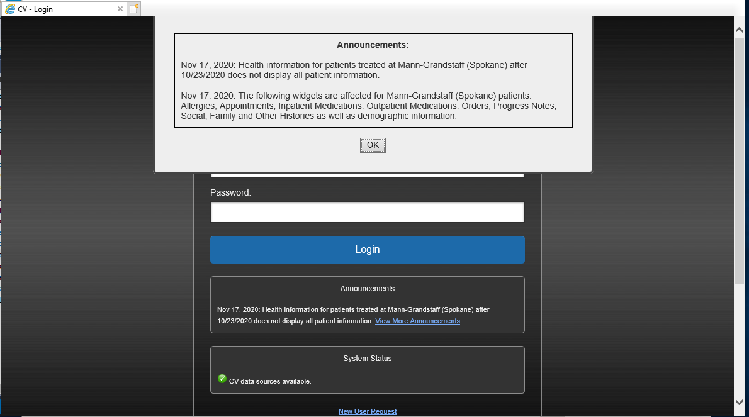

CV pulls information from VA health care systems in real time for viewing within a web browser. Through CV, VA Staff assign patients to providers and provision their use within the CV system, allowing providers access to view consolidated patient data from multiple Veterans Information Systems and Technology Architecture (VistA) systems.

This user guide is written for CCPs who use CV to:

* Access and view patient data
* Request a password reset

Please read and bear in mind the following warning before using CV.

Figure 2: Authorized Use Message

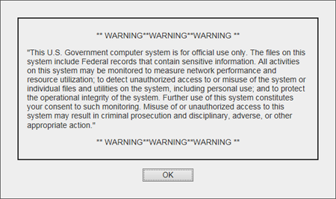

## Purpose of the Guide

The purpose of this guide is to familiarize users with the important features and navigational elements of the CV application.

### Guide Conventions

This document is designed for both online and hardcopy consumption. The following conventions are used throughout:

* Cross-references are indicated by blue, underlined text and provide a hyperlink to figures, tables, and other sections within this guide
* Emphasis is conveyed by using **bold**, underlined, and italicized text
*  is used to inform the reader of additional information

### Terminology

The following standard terms are used throughout this guide:

* **CCP:** You, an authorized non-VA provider
* Patient Portal icon **Patient Portal:** The page that displays patient data via widgets
* Provider Portal icon **Provider Portal:** The landing page, or default view, of CV that opens after logging into the application; the Provider Portal icon **Provider Portal** displays widgets and the tools that enable quick access to basic features
* **Widget:** A component of the CV interface that enables a user to perform a function or access a service
* **Widget Tray:** The expandable and collapsible tray on the portal pages that provides access to all widgets available for placement on the portal pages

## Assumptions

This user guide is written from the perspective of CCPs, assuming the following:

* You can open, navigate, and use the menu options of a web browser
* You can use web-based applications, their menu options, and navigation tools
* You have received the required access credentials and the Uniform Resource Locator (URL) for the CV **Login** page
* You use CV to view VA patient data relevant to patient assignments

## System Requirements

CV is a front-end web application designed to run in a web browser. Mobile devices are not supported in this release. Accessing CV through a browser or device that is not fully compatible with the application may result in certain features not working as expected. Access CV from a desktop or laptop PC using one of the supported browsers:

* Chrome v86
* Microsoft Edge v84
* Internet Explorer (IE) v11
* Safari v14

## Getting Help

If you are an authorized user in need of technical assistance, contact the Community Provider Technical Service Desk. Prior to contacting support, please refer to Logging in to CV for detailed information about how to access CV.

|  |  |
| --- | --- |
| Image of the official seal of the VA | **Community Provider Technical Service Desk**  Phone: REDACTED  E-mail: REDACTED |

If you are an authorized user and do not have your password, follow the steps outlined in Changing Your Password to request a password reset.

Please open the **Online Help** index within CV for more information about the general functionality of CV and a complete list of the widgets available in the application.

# Logging in to CV

Before logging in to and utilizing the functionality of CV, please read the warning in Figure 2.

During log in, CV authenticates all providers against a registered list, provisioned by VA Staff. If you have not received credentials to access CV, you can either request access through the Community Provider Technical Service Desk or by clicking the New User Request link on the **Login** page as highlighted in Figure 3.

1. Open a supported Internet browser
2. Enter the CV URL, REDACTED, in the address bar of the Internet browser
3. Review the **Authorized Use** message (Figure 2)
4. Click **OK** to confirm that you are aware you are accessing a Government information system that is provided for authorized users only
5. Enter your username and password, provided by VA Staff, in the fields on the **Login** page (Figure 3):
   1. Your username is the National Provider Identifier (NPI) number associated with your account

 **NOTE:** If your username is not found or is not active, no further options appear, and an error message displays: “There is an issue preventing your access to Community Viewer. Please contact your VA Contractor or your VA Medical Center for assistance.”

* 1. If you have forgotten your password, click the Reset Password link
  2. If you are not already an authorized user, click on the New User Request link for guidance on obtaining access to CV

Figure 3: CCP User Login Page

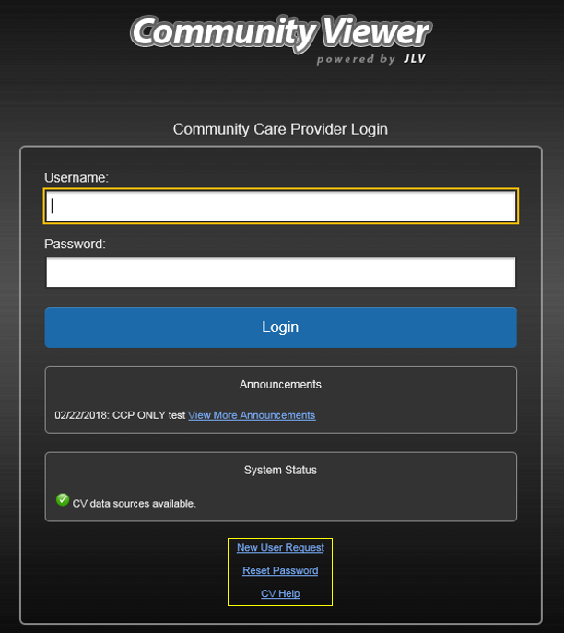

1. Click **Login**
2. If you are logging in to the CV application for the first time (or 365 days after your first login), the **VA Privacy and Security Awareness Training** page (Figure 4) appears

 **NOTE:** Users are required to perform **all** acknowledgement tasks before access to CV is granted.

Figure 4: CCP VA Privacy and Security Awareness Training Page

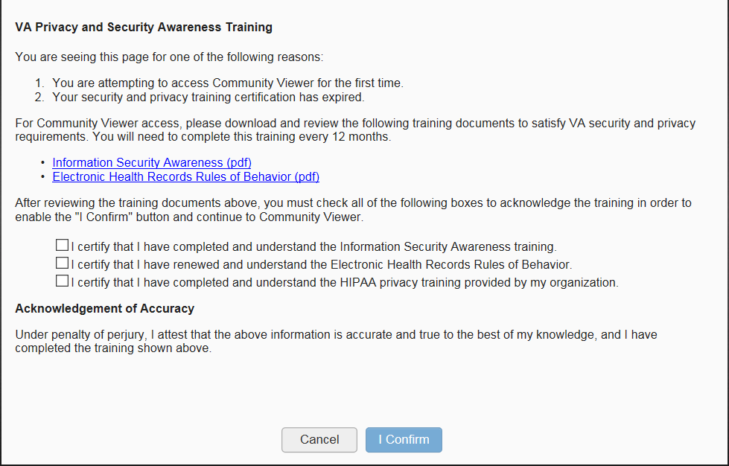

 **NOTE:** The **VA Privacy and Security Awareness Training** page appears the first time you access the CV application and again every 365 days after the first successful log in since training certification must be renewed each year.

**ALL the acknowledgment tasks (Steps 8–13) must be completed to gain access to CV:**

1. Download and read the Information Security Awareness Training PDF document
2. Download and read the Electronic Health Records (EHR) Rules and Behavior PDF document
3. Click the checkbox to certify that you have completed and understand the Information Security Awareness training
4. Click the checkbox to certify that you have read and understand the EHR Rules and Behavior
5. Click the checkbox to certify that you have completed and understand the Health Insurance Portability and Accountability Act (HIPAA) Privacy training through your organization
6. Click **I Confirm** to proceed to the application

After logging in to CV:

* Your username is displayed on the portal toolbar
* The patients assigned to you are shown in the **Assigned Patients** widget, under the **My Assigned Patients** tab
* The patients assigned to your practice group are shown in the **Assigned Patients** widget, under the **Group Assigned Patients** tab
* You can see the patients assigned to your practice group even if you do not have any active or scheduled patient assignments

## Changing Your Password

If you forgot or want to reset your password, you can request a reset by using the Reset Password link on the **Login** page, highlighted in Figure 3.

1. Click the Reset Password link
2. The **Password Reset** dialog box opens (Figure 5)

Figure 5: Password Reset Dialog Box

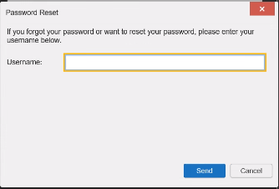

1. Enter your Username in the field provided in the dialog box
2. Click **Send**
3. A confirmation message displays (Figure 6) and an e-mail message is generated to REDACTED

Figure 6: Confirmation of Request Sent to Reset Password

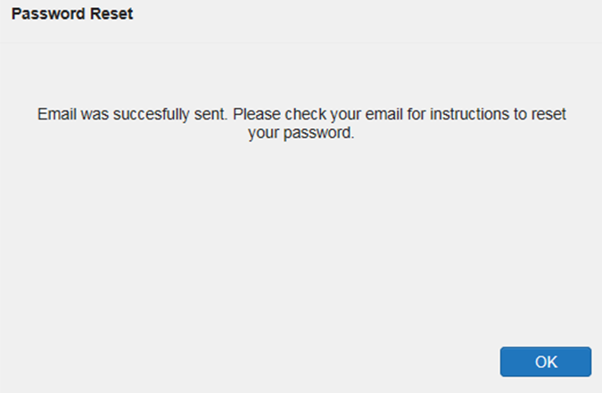

1. A password reset link is sent to the e-mail address you provided

 **NOTE:** The password reset link is active for 24 hours. After that, you must use the Reset Password link to reset your password.

Once you receive the password reset e-mail:

1. Click the link in the password reset e-mail (Figure 7)

Figure 7: Password Reset E-mail

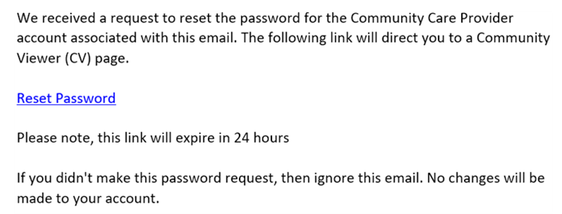

1. The **Password Reset** page opens (Figure 8)

Figure 8: Password Reset Page

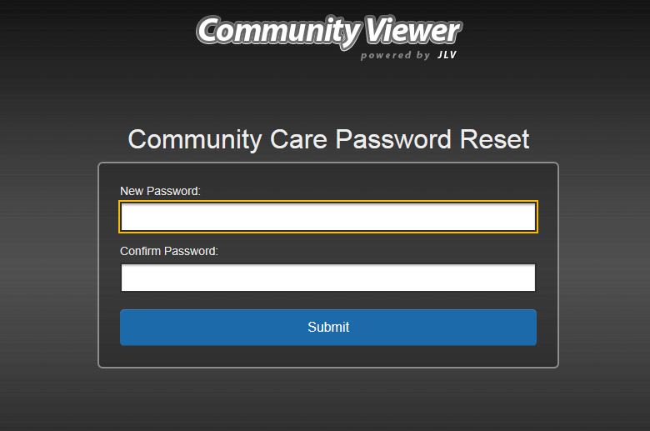

1. Create a new password following the password guidelines (See Password Requirements), and enter it in the **New Password** field
2. Repeat the password in the **Confirm Password** field
3. You receive a confirmation message when your password has been successfully reset (Figure 9)

Figure 9: Password Reset Confirmation Message

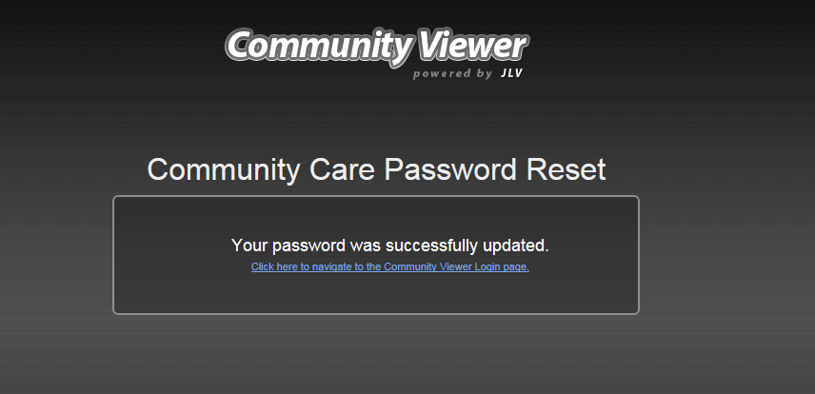

### Password Requirements

You are prompted to change your password every 90 days. Passwords are case sensitive and must comply with the following guidelines:

* Must be a minimum of eight characters (no blank spaces can be used)
* Must contain characters from three of these four categories:
  + An uppercase letter
  + A lowercase letter
  + A number
  + A special character (! @ # ? $ % &)
* Six of the characters cannot occur more than once in the password
* Passwords cannot be reused within a 2-year period

When your password has expired, you see the message highlighted in Figure 10 after an attempt to log in.

Figure 10: Password Expiration Notice on the Login Page

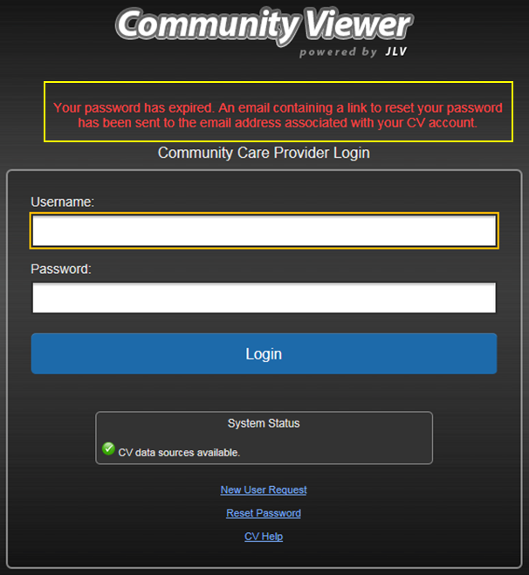

## The CV Portal Pages

After a successful login, your username is shown on the portal toolbar and the CV portal pages are displayed. The CV portal pages are:

* The Patient Portal icon **Patient Portal**
* The Provider Portal icon **Provider Portal**

 **NOTE:** Switching from the Patient Portal icon **Patient Portal** to the Provider Portal icon **Provider Portal** closes all associated patient tabs and windows to prevent confusion between patient records.

Upon login, you see the Provider Portal icon **Provider Portal**. The portal displays the **Assigned Patients** widget by default (Figure 12).

### The CV Portal Toolbar

The CV portal pages have tools that enable quick access to basic features (shown in Figure 11, and detailed in Table 3).

* **Settings:** Click the Settings menu button to set your preferences, including the UI theme (See Customizing CV)
* **Report Builder:** Click the Report Builder button on the Patient Portal icon **Patient Portal** to create custom reports
* **Online Help:** Click the Help button to open web-based help
* **Log Out:** Click the Logout button to terminate the current CV session

Figure 11: CV Portal Tools

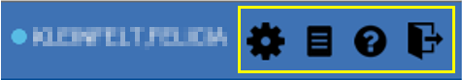

### Default View

The default view of CV includes the **Assigned Patients** widget (Figure 12).

 **NOTE:** If the **Assigned Patients** widget is not open, click the Open Widget Tray link to open the widget tray. Click, hold, and drag the widget from the tray to the portal, and drop it in the desired location. Click the Close Widget Tray link to close the widget tray.

Figure 12: Default View

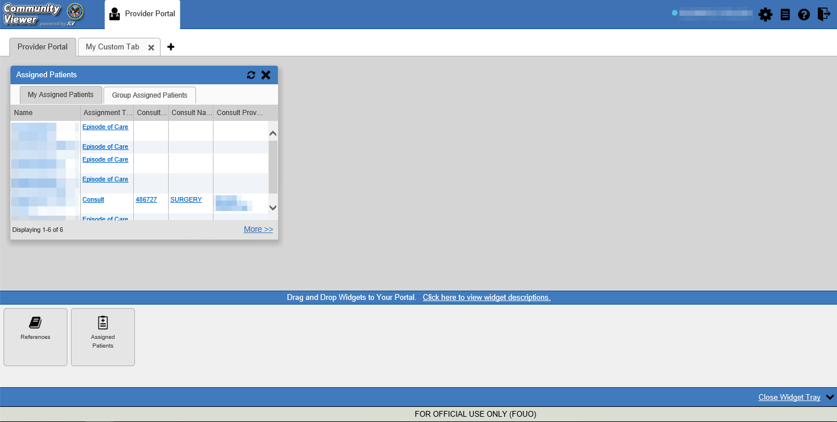

### Customizing CV

Configuration options can be set within CV by clicking the Settings menu button (Figure 12). The data source and UI settings are part of your user profile and apply to future sessions until changed.

 **NOTE:** Changing the data sources or UI theme requires you to reselect and reload the current patient.

Choosing a data source allows you to configure whether you see VA data, Department of Defense (DOD) data, or both. A circular, blue icon in the **Data Sources** pane indicates that VA data is enabled; a square, orange icon indicates that DOD data is enabled (disabled in the CV 3.5 release, see Section 1: Introduction); and a circular, gray icon indicates either VA or DOD data is disabled. One primary data source is required.

* **NOTE**: Data sources are restricted to VA for this release, and the DOD data radiology images option is disabled.
* **NOTE:** Health information for patients treated at Mann-Grandstaff (Spokane) after 10/23/2020 does not display in the following widgets: Allergies, Appointments, Inpatient Medications, Outpatient Medications, Orders, Progress Notes, Social, Family and Other Histories, as well as demographic information.

Choosing a **UI theme** sets the font color, foreground color, and background color of CV. Themes apply to all application elements, including widgets, toolbars, and dialog boxes. The UI theme color choices are Blue (Default), Green, Dark Gray, Gray, and Accessible. The Accessible theme (Figure 18) is 508-compliant and designed to work with the accessibility tools installed on a user’s device.

1. Click the Settings menu button
2. The **CV Settings** dialog opens (Figure 13)
3. Select the desired data source
4. Click the radio button next to the desired theme
5. Click **Save** to apply the selected theme **OR**
6. Click **Cancel** to exit the **CV Settings** dialog box and restore the previous theme

Figure 13: The CV Settings Dialog Box

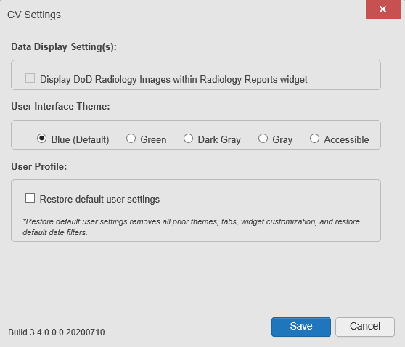

Examples of the UI themes are displayed in the figures that follow.

Figure 14: Blue Theme

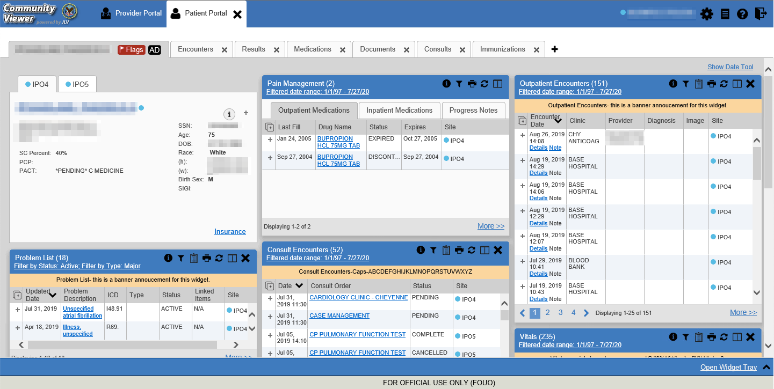

Figure 15: Green Theme

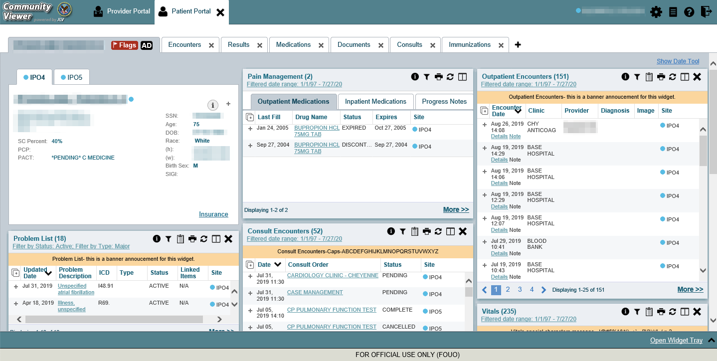

Figure 16: Dark Gray Theme

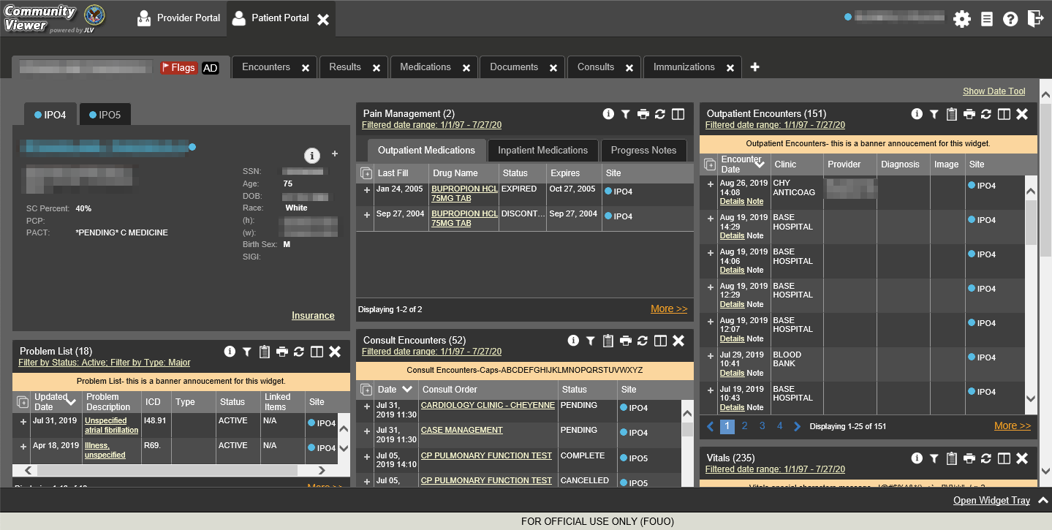

Figure 17: Gray Theme

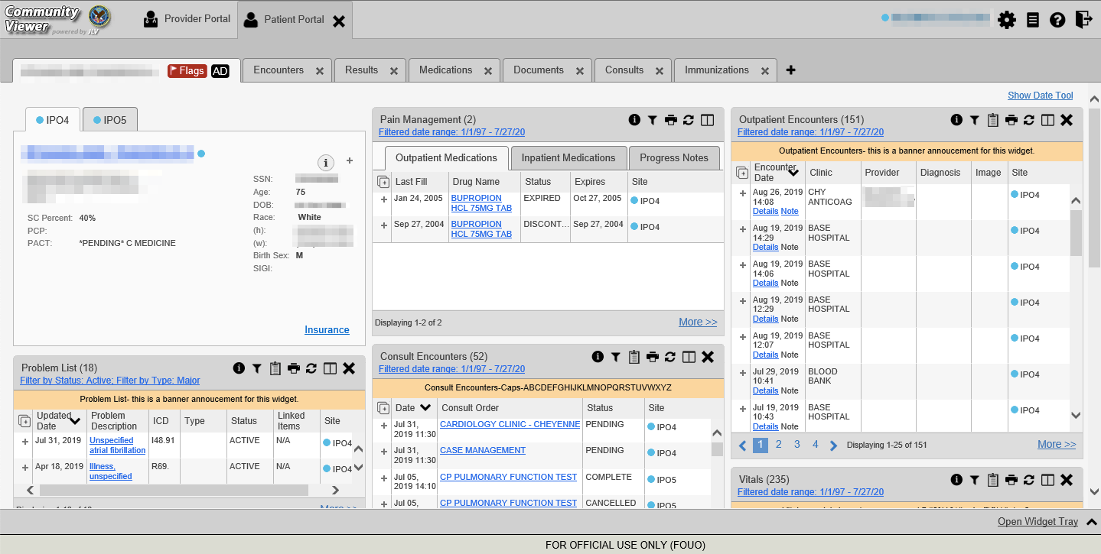

Figure 18: Accessible (508-Compliant) Theme

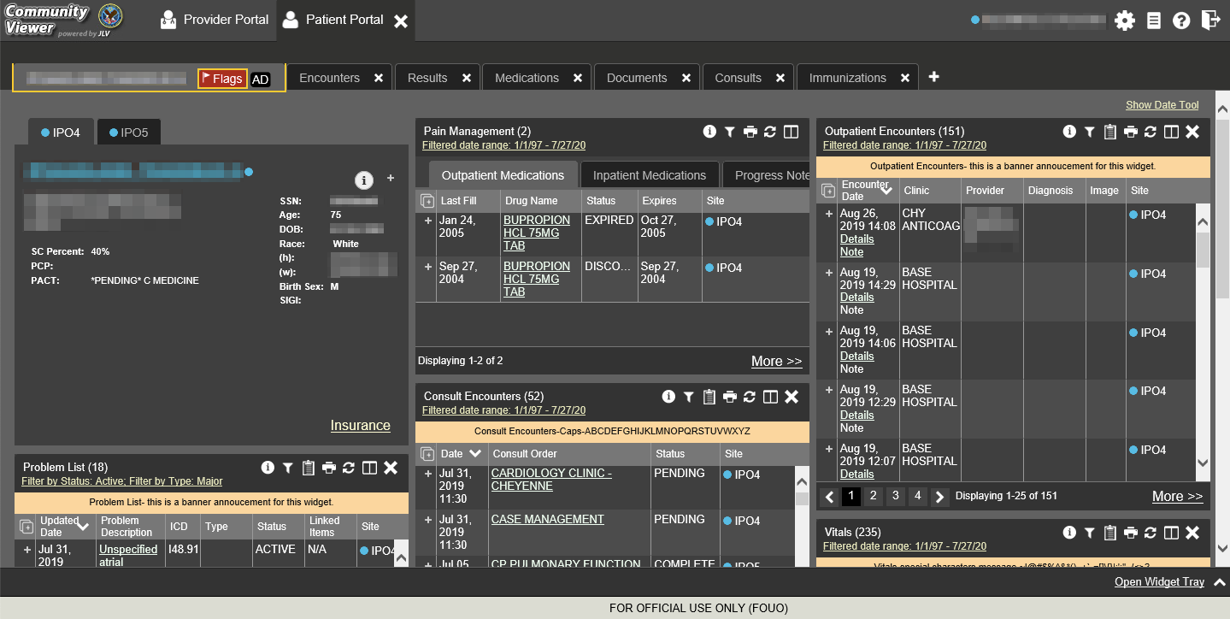

## Logging Out of the Current CV Session

You may intentionally log out to end a CV session by clicking the Logout button at any time. A CV session ends automatically after 30 minutes of inactivity. You receive an audible and visual warning that the current session is about to terminate after 25 minutes of inactivity. Automatic termination of a session logs you out of the application, closes all CV tabs and windows, and displays the **Logout** page. Close and reopen the browser and return to the CV **Login** page to initiate a new CV session.

# Using CV

## Accessing Patient Data via the Assigned Patients Widget

Prior to accessing patient data in CV, please read the warning displayed in Introduction.

After you log in to CV, the **Assigned Patients** widget appears, displaying a list of your patient assignments. Click a patient’s name in the list on the **My Assigned Patients** tab ( Figure 19) to open their records in the Patient Portal icon **Patient Portal**.

 **NOTE:** If the **Assigned Patients** widget is not open, click the Open Widget Tray link to open the widget tray. Click, hold, and drag the widget from the tray to the portal, and drop it in the desired location. Click the Close Widget Tray link to close the widget tray.

Figure 19: Minimized View of the Assigned Patients Widget

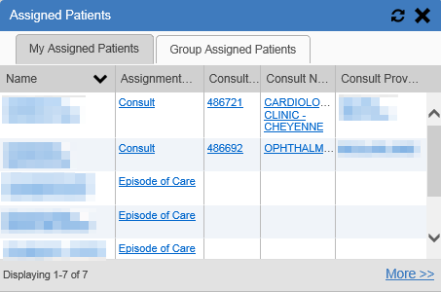

The **Assigned Patients** widget also lists the active and scheduled assignments for all providers in the group to which you belong on the **Group Assigned Patients** tab. If there are two active assignments for one patient, the patient is listed twice.

The following information is available for each assignment listed in the widget. Click the hyperlinked entries to open the patient’s record in the Patient Portal icon **Patient Portal**.

* **Name:** The patient’s name
* **Assignment Type:** The type of assignment that initiated the patient referral; assignment types include Consult and Episode of Care
* Columns of information that only contain data for patients with a Consult assignment type(Figure 20)
  + **Consult No.:**  A number generated by the VA system for the patient consult
  + **Consult Name:** A label generated by the VA system
  + **Consult Provider:** The VA provider who ordered the consult

The tab in the **Assigned Patients** widget that is active (currently selected) is highlighted. **My Assigned Patients** is the active tab, by default. Clicking the More>> link on the widget opens the expanded view of the active tab (Figure 20).

Figure 20: Expanded View of the My Assigned Patients Widget

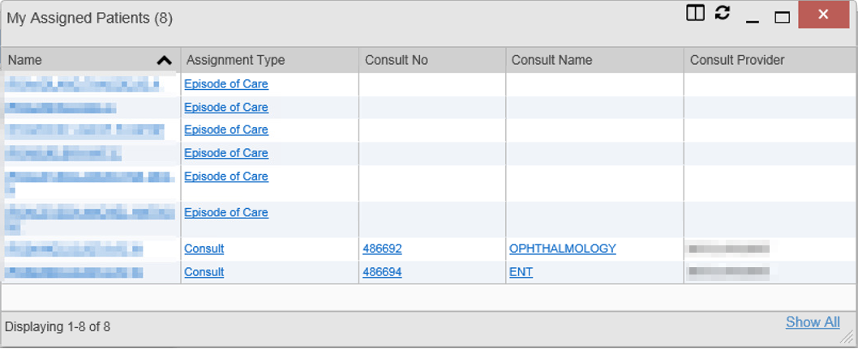

## Viewing System Notifications

CV uses announcements, system status messages, and connection status messages to notify you of system maintenance events and data source availability.

### Viewing Announcements

System announcements display on the **Login** page (Figure 21) and in a banner on the portal page (Figure 22). Announcements are provided by VA and communicate upcoming system maintenance or other scheduled events that may impact you or CV system availability. An example announcement on the **Login** page is shown in the following figure. Where available, click the link to View More Announcements for additional information.

**NOTE:** Announcements are separate from the System Status messages displayed on the **Login** page. System Status monitors the services that CV uses to connect to VA data sources. System Status updates continue to display on the **Login** page if there are no announcements when you access CV.



Figure 21: Announcements on the Login Page

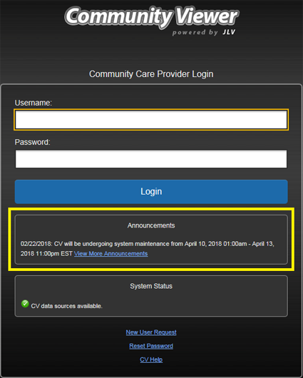

Figure 22: Announcements Banner

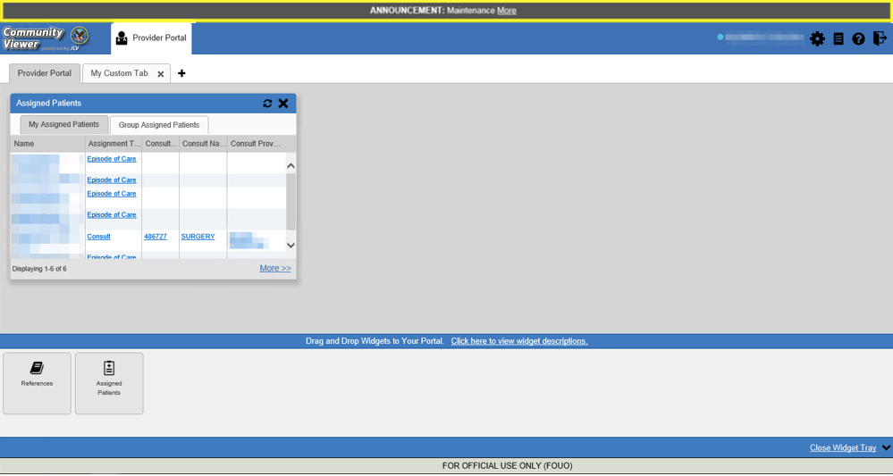

### Viewing System Status

The system status reports the condition of the CV application. System status updates are received from CV’s Health Monitor, which monitors the services that CV uses to connect to VA data sources.

There are two areas of CV where system status displays:

* On the **Login** page (Figure 3)
* On the portal pages (highlighted in Figure 23)

When all monitored systems and services are online and connected, the data sources available indictor appears with the message, “CV data sources are available.”

When one or more monitored systems or services are offline or unavailable, the connection status warning indicator appears with the message, “*Services are not available to CV*” (Figure 23).

When CV’s Health Monitor is unable to retrieve and report system status information, the system status unavailable indicator appears with the message, “System status is unavailable.” When this status appears, you may not be able to log in to CV or view patient data until the connection is restored. See Getting Help for information on how to contact support.

Figure 23: System Status Indicator on the Portal Pages

Screenshot of the system status indicator on CV's portal pages

These warnings may be accompanied by one or more of the notices listed in the table, depending on which services are unavailable.

Table 1: System Status Notices

|  |  |
| --- | --- |
| Service | Notice |
| jMeadows | “**The service that gathers patient data and prepares it for display in CV is unavailable.** CV is available for login but may not function otherwise.” |
| Master Person Index (MPI) | “**VA Patient Identity Service is unavailable.** VA data may not display.” |
| VistA Data Service (VDS) | “**The connection to VA sites is unavailable.** VA patient records of all types from all sites may not display.” |
| Provider Profile Management System (PPMS) | “**The PPMS is unavailable.** Providers may be unable to log in or provider data may not display. |

### Viewing Connection Status

CV widgets display the status of their connection to data sources. Connection status information is available for each widget.

 **NOTE:** The Connection Status reports the condition of the connection between CV and its external resources, while System Status reports the overall condition of the CV application.

The **Connection Status** icon on a widget toolbar indicates the state of the connection to data sources. There are two status conditions:

* the interface status button all sources are connected (available)
* the connection status warning indicator one or more sources are not connected (unavailable)

Figure 24 shows the services are not available warning indicator connection status button in the **Demographics** widget. When the Primary Care Management Module (PCMM) service is unavailable, the primary care fields in the **Demographics** widget display this error message: “Team assignment system is currently unavailable.”

Figure 24: Demographics Widget, PCMM Connection Status Unavailable

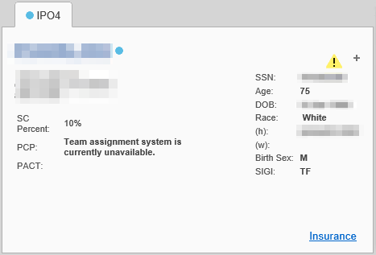

Figure 25 shows a connection status indicator icon displayed on the **Documents** widget toolbar.

Figure 25: Connection Status Icon, Documents Widget

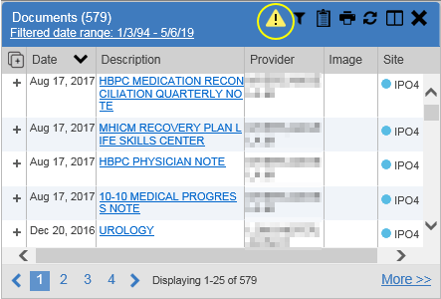

Clicking a **Connection Status** icon opens a standalone window with information about the connection to data sources. Clicking the <Hide All Active Interfaces link in the Connection Status window (Figure 26) hides the detailed **All Active Connections** view and displays only the connection errors.

Figure 26: Connection Status Details, Active Interfaces Shown

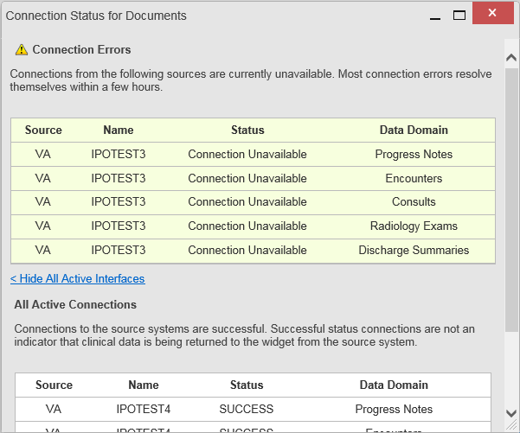

Clicking the >Show All Active Interfaces link in the **Connection Status** window (Figure 27) opens a **Connection Status** details view.

Figure 27: Connection Status Details View, Active Interfaces Hidden

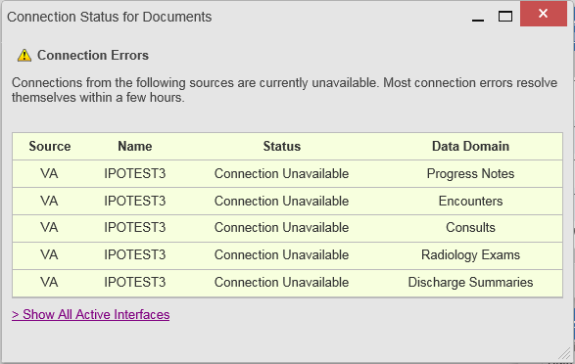

## Using Report Builder

The **Report Builder** feature is used to create custom PDF reports using patient data and records displayed in CV widgets. Content for reports can be selected from either the minimized or expanded view of a supported widget. Select the Report Builder button to access **Report Builder** from the Patient Portal icon **Patient Portal** toolbar (Figure 28).

Figure 28: Report Builder Icon on the Patient Portal Toolbar



### About Report Builder

The **Report Builder** pane is comprised of the **Current Report** tab and the **Patient Reports** tab. When open, the **Report Builder** appears docked on the CV portal. Click the minimize report builder button or the maximize report builder button. to minimize or maximize the **Report Builder**. Any report configurations in progress are saved when collapsing or closing the Report Builder and restored when the Report Builder is displayed again.

The **Current Report** tab (Figure 29) is used to build the custom report. The patient data and/or records are listed here as you select and add them. The records can be previewed and can be arranged in the desired order for the final report.

The **Patient Reports** tab (Figure 31) presents a list of all completed reports, the status of the report generation progress, the date the report expires, and a hyperlink to the contents of the completed report.

Actions within widgets to add patient data can be performed when the Report Builder is open or closed on the Patient Portal icon **Patient Portal**. CV enforces a maximum number of 50 records per report.

### Generating a Report

The selected records appear in the **Report Builder** pane (Figure 29).

Figure 29: Report Builder Current Report Tab

Figure REDACTED due to PII

1. Use the navigation arrows to arrange the records in the desired order in the generated report
   1. Records can be removed by clicking **Clear Selected Record** or **Clear All**
2. When a record is selected for the report, it appears in the **Preview of Record** area of the **Report Builder** pane
3. Click **Build** to validate the selected records and prepare the report
   1. If a record is added to the report without an error, a **Ready** notation displays next to it in the **Status** column
   2. If a record cannot be added to the report, an **Error** notation appears next to the record
4. Name the report when prompted and click **OK (**Figure 30**)**

Figure 30: Report Builder Name Report Dialog

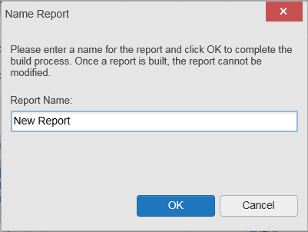

1. The **Patient Reports** tab opens and displays a report processing indicator in the **Status** column (Figure 31)
2. When processing is complete, the **Status** column displays either COMPLETED or ERROR
   1. An ERROR in the **Status** column does not indicate the report failed to build, it is an indicator that one or more records could not be included in the generated report
   2. Both the COMPLETED and ERROR entries include a Contents link, which provides a list of the records that appear in the generated report (Figure 31)

Figure 31: Report Builder Patient Reports Tab

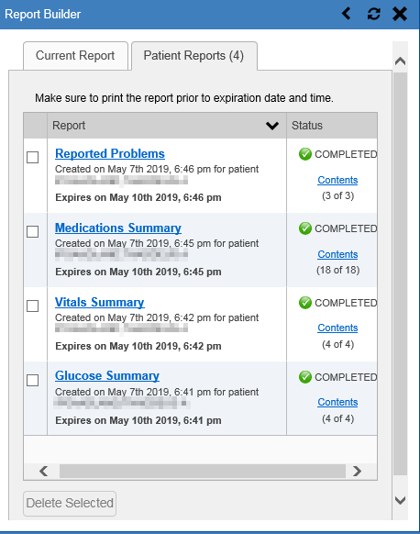

* 1. A report ready message appears for 6 seconds on the portal page when the report has been built and is ready to be printed
  2. changes to  the Report Ready indicatorwhen report builder is closed to indicate that a report is ready to be printed (Figure 32)



Figure 32: Report is Ready Indicator on Toolbar

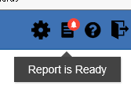

 **NOTE:** Once a report is created, it is available on the **Patient Reports** tab for 72 hours. After 72 hours, the report expires, is removed from the **Patient Reports** tab, and must be re-created.

#### Adding Multiple Records with EZ Select

EZ Select allows you to add all records displayed on a single page of a single widget to the Report Builder with one click. Click the selecting all records for this page button (Figure 33) to add data from all records shown in the widget’s page display to the Report Builder, including the details and notes associated with the record. EZ Select is available from the minimized and expanded views as well as the **Patient Flags and Postings** dialog box.

 **NOTE:** MAH/MAL reports accessed from the **Inpatient Medications** widget cannot be added using EZ Select. You must add them to a report one at a time, and you can only add MAH/MAL to reports from **Detail** view in the **Inpatient Medications** widget. However, you can use EZ Select to add MAH/MAL reports to Report Builder from the **Health Summaries and Reports** widget.

Figure 33: Report Builder Select All Icon

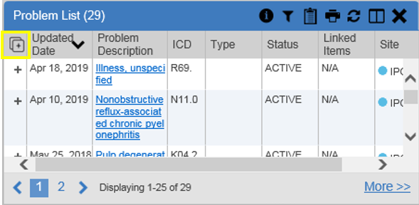

the Add to Report builder button in each row changes to the record was added to Report Builder indicator to confirm the record has been added (Figure 34).

Figure 34: All Records on a Single Widget Page Added to Report Builder

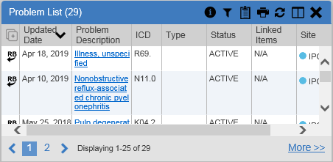

#### Adding One Record

Click the Add to Report builder button next to a record in a widget to add data from that record to the Report Builder, including the details and notes associated with the record. the Add to Report builder button in the row changes to the record was added to Report Builder indicator to confirm the record has been added to the Report Builder (Figure 35). This applies to both minimized and expanded widget views and the **Patient Flags and Postings** dialog box.

Figure 35: Single Record Added to Report Builder

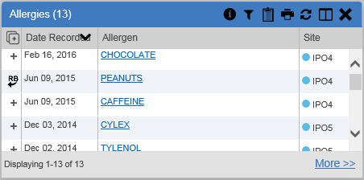

#### Adding Details from Multiple Dates

When the details view of a record has a date filter—as in the **Health Summaries and Reports**, **Inpatient Medications**, and **Procedures** widgets—the record was added to Report Builder indicator resets to the Add to Report builder button each time you change the date range, allowing you to build date-flexible reports using records from multiple date ranges.

#### Adding Only Record Details or Notes

When adding records to a report using the selecting all records for this page button or the Add to Report builder button, CV adds the data displayed in the widget, as well as any details and notes associated with the record, by default. This applies to both the minimized and expanded widget views, and the **Patient Flags and Postings** dialog box. If you would like to add just the details and notes or the record row data:

1. Select and hold the Add to Report builder button to access these options
2. Select **Add Detail** or **Add Detail/Note** to add the details and/or notes associated with the record as well as the record row data to the Report Builder (Figure 36)
3. Select the **Add Record Row** option to add only the data displayed in the widget display for that record and not the information provided in the details and/or notes

Figure 36: Add Detail and Add Record Row Dropdown

Figure REDACTED due to PII

 **NOTE:** Once you add a record to Report Builder using either the Add to Report builder button, **Add Detail/Note,** or **Add Record Row** option, you cannot change the record data included in the report without first clearing the record from the report and adding it again.

#### Adding Patient Demographics

Clicking the add demographics to Report Builder button in the **Demographics** widget adds the patient's demographics details for that site to the Report Builder (Figure 37). the add demographics to Report Builder button changes to the record was added to Report Builder indicator to confirm the demographics data has been added. Click additional site tabs within the **Demographics** widget and repeat as desired to add demographics details from other sites within the patient's health record.

Figure 37: Demographics Widget’s Add to Report Builder Icon

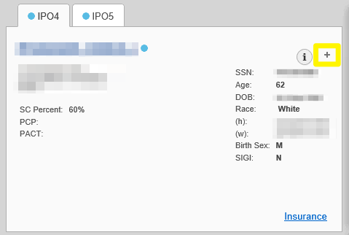

### Opening a Report

1. Click the report name in the **Report** column of the **Patient Reports** tab (Figure 31) **OR**
2. Click the Contents link in the **Status** column of the **Patient Reports** tab to open a list of the records included in the report in the **Report Contents** window (Figure 31) **OR**
3. Click the blue, hyperlinked report name in the **Report Contents** window (Figure 38)

Figure 38: Report Contents Dialog

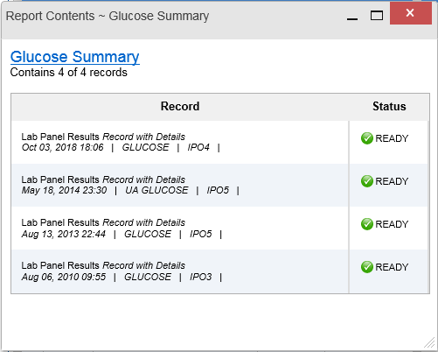

 **NOTE:** The Report Builder prints the report content to a file in PDF format. It is recommended that you have the latest Adobe Reader installed on the system from which you access CV to utilize the Report Builder and other CV features.

The report opens in a standalone browser tab. Reports are available until the expiration date and time shown. If necessary, print the report before the report expires.

 **NOTE:** If you closed the Report Builder while a report was IN PROGRESS,  the Report Ready indicator appears on the portal toolbar when the report is available. Clicking the Report Ready indicator opens the Report Builder.

 **NOTE:** Clicking the Synchronize Available Reports button in Report Builder (when open to the **Patient Reports** tab) synchronizes the list of reports shown with the Report Builder Service so that all available reports are displayed.

### Deleting a Report

1. Select the checkbox for the report on the **Patient Reports** tab (Figure 31)
2. Click the **Delete Selected** button
3. Click **OK** to confirm deletion

## Using the Accessible Theme’s Functionality

The Accessible theme provides larger fonts, enhanced tab and keystroke functionality, and screen reader compatibility to support Federal accessibility requirements and Section 508 compliance.

### Keyboard Focus and Portal Navigation in the Accessible Theme

Keyboard focus is the highlighting of portal elements that enables interaction with, and the navigation of, the web application through the keyboard and keystrokes. The portal element in focus is outlined in gold (Figure 18) as a visual indicator of keyboard focus.

CV uses standard Windows keystrokes (**Tab**, **Shift + Tab**, arrow keys, **Enter**) and keyboard shortcuts to move the focus to all menus, and activate all functions on the menus. All UI items are accessible via the keyboard when using the Accessible theme.

Pressing **Enter** or the **Spacebar** when an element that provides action is in keyboard focus performs the associated action. Pressing **Enter** or the **Spacebar** when the Settings menu button is in focus, for example, opens the **CV Settings** dialog box. The **Tab** or arrow keys allow a user to move between keyboard focus items to navigate through portal elements. A complete list of accessible keystrokes is provided in Table 2.

Table 2: Accessible Keystrokes

| Keystroke | Description |
| --- | --- |
| *Portal and Widget Navigation* | |
| Alt + 4 | Press to transfer keyboard focus to the main or top portal element:  Focus is transferred to the the Provider Portal icon **Provider Portal** tab on a portal page.  Focus is transferred to the first link or data element in a widget.  Focus is transferred to the dialog boxes the close button. |
| ENTER | Press to transfer keyboard focus to the highlighted widget. |
| TAB | Press to transfer keyboard focus to other UI items. |
| ESC | Press to return keyboard focus to the pane containing the UI item with keyboard focus or to exit a window, widget, or tab. |
| SPACEBAR | Press to activate any UI item (for example, click a button). |
| Arrow Keys | When keyboard focus is on a widget, press the arrow keys to change page viewing in a widget's data table.  When keyboard focus is on a dropdown list, press the down arrow to view the list contents. |
| Ctrl + d | Place keyboard focus on a reference or row within the **References** widget on the Provider Portal icon **Provider Portal** and press **Ctrl + d** to remove the reference URL. Removing a default reference is not allowed. |
| Ctrl + f | Use standard browser find functionality to search text in the active window. |
| *Portal Tabs* | |
| Arrow Keys | Use the left and right arrow keys to navigate between tab panels. |
| TAB | 1. Press **Tab** until the Add Tab button is in focus 2. Press **Enter** 3. The new tab dialog box opens and prompts you to enter a name for the new tab 4. Tab to the **Add** button to confirm the new tab name or tab to the **Cancel** button to discard the new tab |
| ENTER | Press while the Add Tab button is in focus to add a new portal tab. A dialog box prompts you to enter a name for the tab. |
| ESC | Focus on a tab and press **Esc** to remove it. |
| *Windows and Dialog Boxes* | |
| TAB | Press **Tab** to move keyboard focus through the items within the window. |
| *Adding Widgets to the Portal Pages* | |
| Alt + 1, 2, or 3 | Add a widget to a portal page from the widget tray:   1. Determine in which column (1, 2, or 3) to place the widget 2. Focus on the desired widget icon in the widget tray 3. Press **Alt + 1**, **2**, or **3**, depending on the desired column |

### Using Report Builder in the Accessible Theme

Report Builder allows you to build a custom report of multiple patient records displayed in CV (including patient demographics, supported documents, record details, and record notes) and exports the contents of the records to a single report. Use keystroke navigation to place the Report Builder button in focus and press **Enter** to open the Report Builder.

There are multiple ways to add records and other patient data to a report. Actions can be performed within the widgets to add patient data when the Report Builder is open on the Patient Portal icon **Patient Portal** (Figure 39) or when the Report Builder is closed or minimized. The Report Builder can be minimized by pressing **Enter** when the minimize report builder button is in focus, as shown in Figure 39. This action collapses the Report Builder on the portal. Closing the window with the close button removes the Report Builder from the portal.

Use keystrokes to navigate between elements on the **Current Report** tab (open in the following example). When an element is in focus, press **Enter** to perform the action.

Figure 39: Report Builder in Accessible Theme

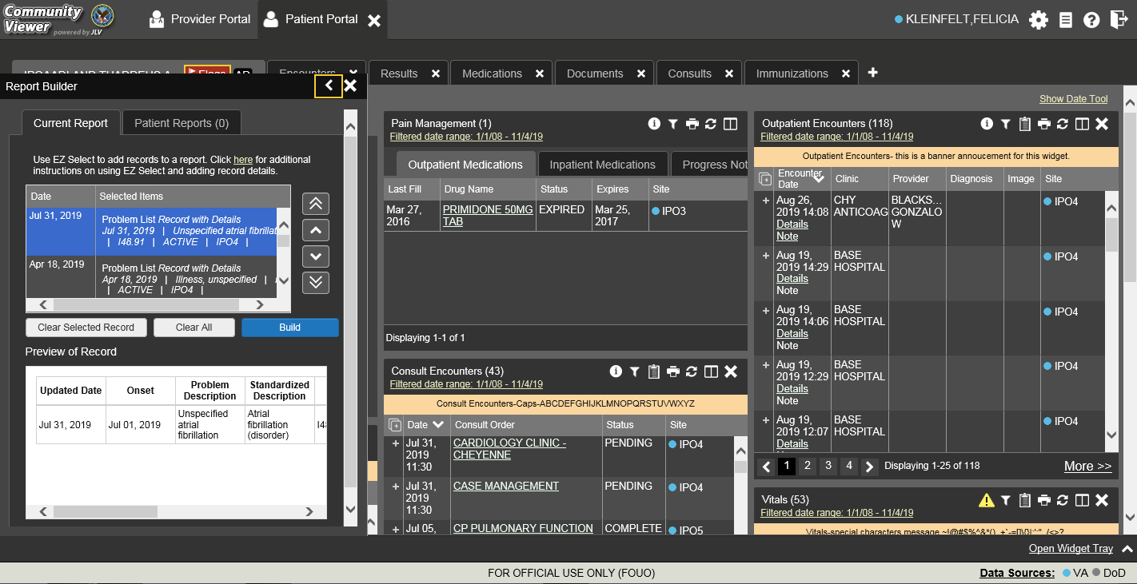

Jump between the **Current Report** tab and the **Patient Reports** tab using the left and right arrow keys when either tab is in focus. Tasks performed on the **Patient Reports** tab include:

* Opening reports in a standalone window by pressing **Tab** until focus is on the report name within the **Report** column and press **Enter**
* Viewing report contents by pressing **Tab** until focus is placed on the Contents link in the **Status** column and then pressing **Enter**
* Deleting reports by pressing **Tab** until the focus is on the report checkbox, checking the box, then pressing **Tab** until the **Delete Selected** button is in focus, and pressing **Enter**

## Printing

The data list of a widget in either minimized or expanded view, the details window of a widget, and reports created in **Report Builder** can be printed.

Click the Print button. on the desired widget’s toolbar to print the data list of a widget in either minimized or expanded view.

Click the Print button. on the details window’s toolbar to print the details window of a widget.

Click the (PDF) **Print** icon within the report window to print a report created in **Report Builder**.

 **NOTE:** Each report generated using **Report Builder** includes this disclaimer: The information contained in this transmission may contain privileged and confidential information, including patient information protected by federal and state privacy laws.

# Widgets

Patient-centric information is displayed on the Patient Portal icon **Patient Portal** through widgets. Widgets are elements of CV that display data specific to an administrative or clinical domain. Data is generally displayed in reverse chronological order, by date.

 **NOTE:** Widgets may take anywhere between 3 to 10 seconds to load.

The default layout of the Patient Portal icon **Patient Portal** for a first-time CV user is shown in Figure 14. The widgets presented are **Patient Demographics**, **Problem List**, **Allergies**, **Outpatient Medications**, **Pain Management**, **Consult Encounters**, **Progress Notes**, **Outpatient** **Encounters**, and **Vitals**.

First-time CV users see a default series of tabs, each providing a different widget layout, in addition to the default widget layout on the Patient Portal icon **Patient Portal**:

* **Encounters Tab:** Outpatient Encounters, Appointments, and Progress Notes
* **Results Tab:** Radiology Reports, Lab Results, Procedures, and Progress Notes
* **Medications Tab:** Outpatient Medications, Inpatient Medications, Orders, and Allergies
* **Documents Tab:** Progress Notes, Outpatient Encounters, and Inpatient Summaries
* **Consults Tab:** Consult Encounters, Progress Notes, and Inpatient Summaries
* **Immunizations Tab:** Immunizations, Problem List, and Progress Notes

CV can display up to 12 widgets per tab. CV also allows you to add more than one instance of the same widget to a tab. CV displays a **Duplicate Widget** notice if you attempt to add a second instance of any widget already on the current tab. Click **OK** to confirm you want to add another instance of a widget to the same tab, or click **Cancel**.

## Accessing and Opening Widgets

Figure 40 depicts the Patient Portal icon **Patient Portal** with an open widget tray. Click the Open Widget Tray link to open the widget tray. Hover over a widget icon to view a description of the widget. Click, hold, and drag a widget from the tray to the portal. These actions dock the widget on the portal page. Once docked, the widget opens in minimized view.

Use the tray navigation tools (<< More Widgetsor More Widgets >>) or the arrows (< or >) to scroll through all clinical domains available in the Patient Portal icon **Patient Portal**.

 **NOTE:** Widgets can be removed from a portal page by clicking the close button in the docked widget.

Figure 40: Widget Tray on the Patient Portal

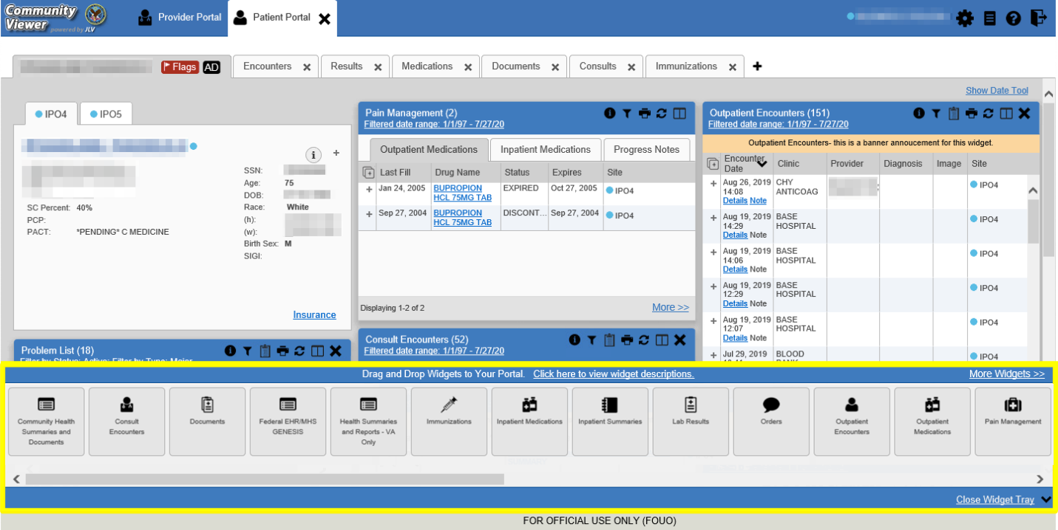

The list of widgets available for display on the Patient Portal icon **Patient Portal** is presented in the horizontal widget tray on the portal (highlighted in Figure 40). Data from VA systems is available for the following VA clinical domains[1],:

* Admissions
* Allergies
* Appointments
* Clinical Reminders
* Community Health Summaries and Documents1
* Consult Encounters
* Documents
* Health Summaries and Reports
* Immunizations
* Inpatient Medications
* Inpatient Summaries
* Lab Results
* Orders
* Outpatient Encounters
* Outpatient Medications
* Pain Management
* Problem List
* Procedures
* Progress Notes
* Questionnaires and Deployment Assessments1
* Radiology Reports
* Social, Family, and Other Past Histories1
* Surgery/Procedure Reports
* Vitals

### Sort and Filter Options

Widgets have a variety of methods to sort and filter data:

* Click a column title to sort records according to data in that column; an **up** or **down** arrow appearing next to the column title provides a visual indicator that a sort is applied to that column
  + If you sort a column that appears in both minimized and expanded views of the widget, the sort saves in your user profile and persists
  + If you sort a column that is only in the expanded view of the widget, your next session restores the default widget sort, or the last sort saved to your user profile
  + If you sort a **Date** column that has some partial or missing date values, understand:
    - Dates that have month and year but lack a day are treated as though the day were “00” (e.g., July 2018 sorts between June 30, 2018 and July 01, 2018)
    - Dates that have a year only are treated as though the month is January and the day is “00” (e.g., 2018 sorts between December 31, 2017 and January 01, 2018
* Click the Column Settings button in the widget toolbar to hide or show the columns within the widget; check/uncheck the column names that appear in the pop-up box, and click **Apply**
* When there are multiple drugs with the same order number, CV maintains the grouping by order number when a column sort is applied in the widget

Sort and filter capabilities are specific to the data presented in each widget and may vary between the minimized and expanded views of an individual widget or between widgets. Select **All** from the **Filter by…** dropdown to undo an individual filter or click the Remove All Filters link shown in each widget to undo all filters.

Some widgets also have the capability to configure data to display multiple records of the same type in a graph or table view. See Graph/Table View from the Lab Results Widget for more information.

#### Setting Multiple Filters in Widgets

CV supports the application of multiple filters in any of the widgets with two or more Filter by options in the expanded view. The sequence in which the filters are applied impacts the data that displays in the widget. The second or subsequent filter selected is applied to the subset of data from the previous filter.

#### Widget Date Range Filters

Patient data displayed within a widget can be filtered by date range, if date filters are available on the widget.

 **NOTE:** CCPs have limited access to records and can only retrieve records within the date range set by the VA Staff user who created the patient assignment.

If a date range filter is applied, the selected range is indicated in the widget header, below the title (Figure 41). Click the Filter button or the Filtered Date Range link on the widget toolbar to change the date range of the data displayed.

Figure 41: Filtered Date Range Examples

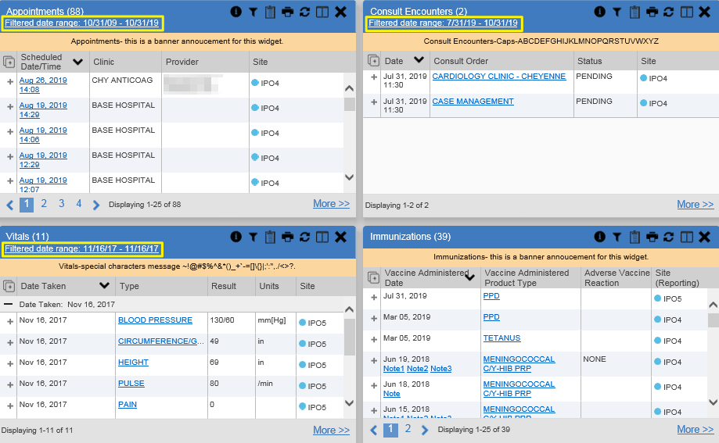

There are two ways to filter the date range of data displayed in a widget: The **Quick Date Range** filter and the **Start and End Date** filter. If the expected information does not appear in the widget display, use the date filter options to change the date range.

 **NOTE:** Changes made to the date range in a widget persist from minimized to expanded view, patient to patient, and session to session, until the widget is either removed or the date range is changed.

##### Quick Date Range Filter

Use the preset, **Quick Date Range** filter to set or limit the display of patient records within a widget. This option is available by clicking the Filtered Date Range link or by clicking the Filter button in a widget on the Patient Portal icon **Patient Portal**.

Clicking a **Quick Date Range** filter refreshes the data displayed to show only the records for the selected range. Selecting **Cancel**, which is the **Apply** button while the data refresh is running, stops the query. The options represent time counting back from the present day (for example, selecting 2y displays only records within the last 2 years). Examples of preset date ranges include 1w (last 7 days), 6m (last 6 months), and 3y (last 3 years).

 **NOTE:** The **Quick Date Range** filter is contextual, meaning it counts backwards from today’s date.

Figure 42 highlights the **Quick Date Range** filter options in the expanded view of the **Appointments** widget.

Figure 42: Quick Date Range Filters

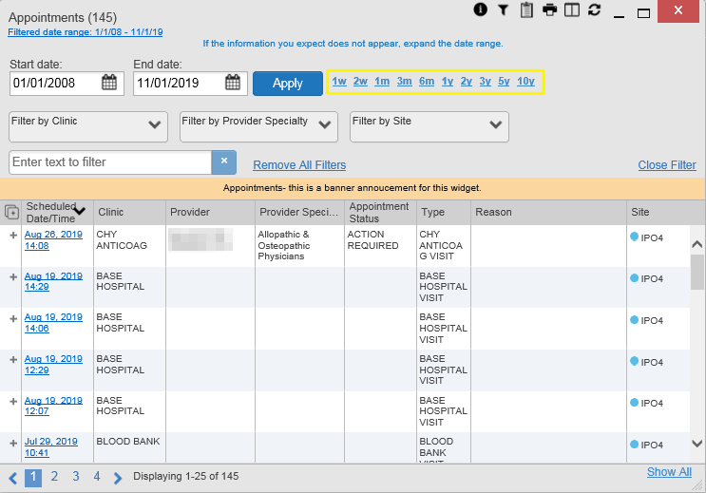

CCPs have limited access to records and can only retrieve records within the date range set by the VA Staff user who created the patient assignment. Figure 43 shows a CCP restricted to records from 07/20/2019 to present, in this case 10/31/2019, which is shown by default in the **Start Date** and **End Date** fields. When the 5y **Quick Date Range** filter is applied, the **Filtered Date Range** shows the entire 5-year period (10/31/14–10/31/19), which includes the date range history the CCP is permitted to view. However, records between the **Filtered Date Range** start date and the day before the CCP’s permitted history start date (10/31/14–07/19/2019) will not display.

Figure 43: Quick Date Range Filter (5y) Outside CCP’s Permitted History Dates

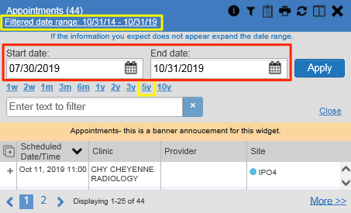

##### Start and End Date Filter

VA Staff set a date filter to control the records within widgets seen by the CCP. The CCP can set additional display filters within the set range by clicking the Filter button from the widget's toolbar. Use the **Start Date** **and End Date** filter to display data for a specific time range (Figure 44). The start and end date fields are accessible from by clicking the Filtered Date Range link or the Filter button.

 **NOTE:** The **Start and End Date** filter is static. If the start date is set to June 2, 2018 and the end date is set to June 2, 2019, the data in that date range displays, no matter what today’s date is.

Figure 44: Lab Results Widget Start and End Date Filters

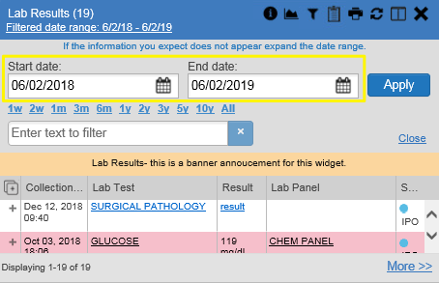

Figure 45 provides an example of the start and end date filter fields in the expanded view of the **Radiology Reports** widget.

Figure 45: Radiology Reports Widget Start and End Date Calendar

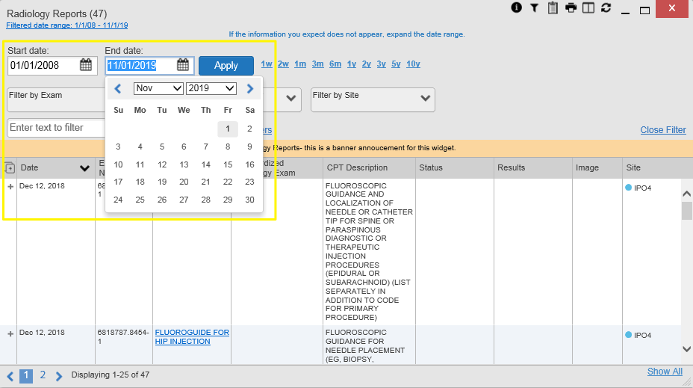

1. Click the show calendar button next to **Start Date**
2. Select a month, day, and year start date for the display filter
3. Click the show calendar button next to **End Date**
4. Select the month, day, and year end date for the display filter
5. When both a start and end date have been chosen, click **Apply**
6. (Optional) Click **Cancel** to stop the query

 **NOTE:** Prior day selections persist if you change only the month or year. If you change the month or year and the prior day value does not exist, the calendar will default to the last day of the new month. For example, changing only the month value of an existing August 31, 2018 entry to February would set the date to February 28, 2018 because there are less days in February. Similarly, if you had February 29, 2016 selected, a day which only exists in a leap year, switching the year to 2015 would set the date to February 28, 2015, the last day of the month in a standard year.

The widget refreshes and displays only the records that fall within the custom date range. The date range in use is displayed in the widget header.

#### Tab Date Range Tool

All tabs in the Patient Portal icon **Patient Portal** have a **Tab Date** tool that you can use to filter all widgets on a single tab by the same date range. The **Tab Date** tool has the same **Start and End Date** and **Quick Date Range** filters available on most individual widgets, but it applies the date filter to all widgets on an individual tab.

1. Select the Show Date Tool hyperlink
2. Enter dates in the **Start Date** and **End Date** fields, and select the **Apply to All Widgets on This Tab** button **OR**
3. Select a **Quick Date Range** value in the **Tab Date** tool

The **Tab Date** tool (Figure 46) is hidden by default, and it hides again automatically after you apply a date filter to the tab. Should you decide not to apply a date filter to the tab, select the Hide Date Tool hyperlink to hide the tab-level date filters.

Figure 46: Tab Date Tool

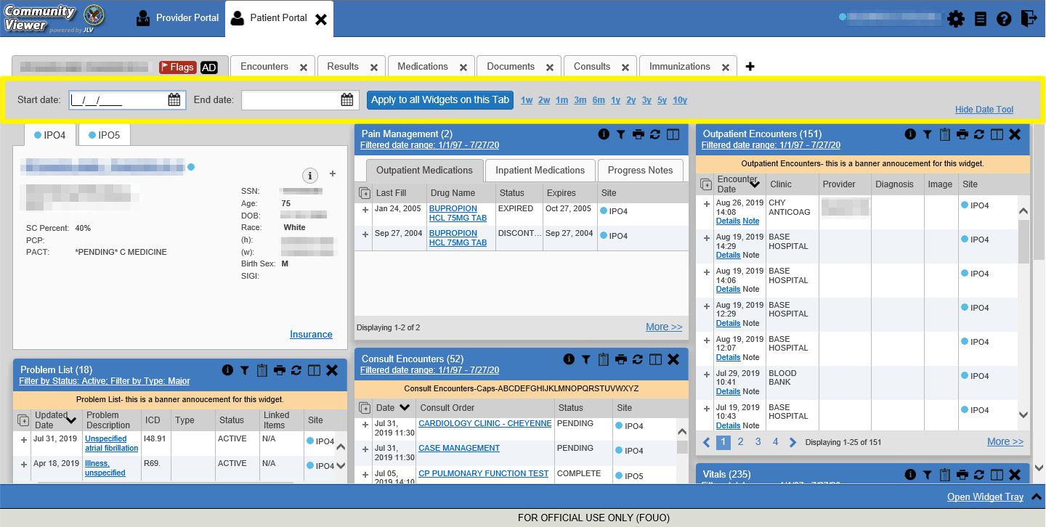

The **Tab Date** tool only filters widgets currently displayed on the active tab that support date range filtering. Widgets that display all data, without a date range, will continue to do so. Filtering only applies to widgets on the tab at the time you apply the **Tab Date** tool and will not affect new widgets added to the tab. You may still apply widget-level date filters to individual widgets after using the **Tab Date** tool.

#### Text Filter

Clinical data widgets on the Patient Portal icon **Patient Portal** and the **Patient Flags and Postings** dialog box provide a text search filter option, allowing you to quickly locate relevant patient data using keywords or characters (Figure 47). Text filters are performed on the information displayed in all columns within a widget, including hidden columns. Filters are not performed on notes, attachments, or details associated with patient records.

Figure 47: Vitals Widget Text Filter

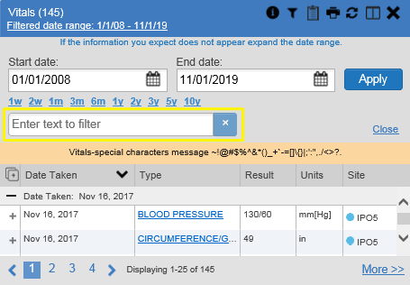

Click the Filter button in the minimized view of a widget to display the **Enter text to filter** field. If the filter options are not displayed in the expanded view of the widget, clicking the Filter button also opens the filter options. Keep in mind:

* Text filtering applies only to one widget
* Text filters are performed within the subset of filtered data if a date range filter or other dropdown filters are applied within the widget
* Text filters are performed on data within all columns shown in the expanded view of the widget even if the term is entered in the text filter field of the minimized view
* Text filters entered in the minimized view of a widget persist when you open the widget in expanded view
* On widgets with site tabs, text filters entered on one site tab persist when you select other site tabs
* All records across the widget pages are filtered if the widget has multiple page views
* The **Enter text to filter** field is not case sensitive and allows up to 25 characters, including numeric and special characters
* CV begins to filter when you pause while typing the term in the **Enter text to filter** field
* Text filtering is not available in the **Demographics** widget

## Portal and Widget Toolbars

There is a toolbar on the CV portal pages, the minimized and expanded views of each widget, and most dialog boxes. The buttons on each toolbar vary. Table 3 describes the functionality of each toolbar button.

Table 3: Toolbar Buttons

| Icon | Name | Function |
| --- | --- | --- |
| the Add to Report Builder button | **Add to Report Builder** | Adds the information displayed in the window to the Report Builder. This icon is available for supported domains when a record has a details or notes view that displays in a standalone window. |
| the Close button | **Close** | Removes the widget from the portal or closes a dialog box. |
| the Column Settings button | **Column Settings** | Configures the columns within the widget. Turn the columns on or off by checking the column names that appear in the pop-up box and checking **Apply**. |
| the Filter toggle button | **Configure Filter** | Filters specific record types or other elements within the widget, including a date filter. If a date range filter is applied in an open widget, the date range is displayed in the widget header.  **NOTE:** After setting a filter, the Close Filter option is enabled in the widget. Clicking Close Filter restores the full display of records within the widget. |
| the Copy to Clipboard button | **Copy to Clipboard** | Copies the content of the open window to the clipboard for pasting into another application. **Copy to Clipboard** is disabled in the widget toolbar after clicking Show All within a widget. |
| the Interface Status button Services are not available connection status warning indicator | **Connection Status** | Both icons provide a status indicator for data sources. the interface Status button indicates all sources are available. Services are not available connection status warning indicator indicates one or more data sources are unavailable. Clicking either status icon opens the connection status details in a separate window. |
| the Graph data button | **Graph** | Displays multiple results for the same lab test in a graph and table in the **Lab Results** widget. |
| the Help button | **Help** | Launches CV's online help. |
| the Logout button | **Logout** | Logs out of CV. |
| the Print button | **Print** | Prints the contents of the open window. Printing is disabled in the widget toolbar after clicking **Show All** within a widget.  **NOTE:** It is recommended that you have the latest Adobe Reader installed for the Report Builder and other printing features. |
| the Refresh button | **Refresh** | Refreshes the widget or window display. Only the data within that widget’s dataset is updated. |
| the Report Builder button | **Report Builder** | Launches Report Builder. |
| the Copy Active Rxs in date range to clipboard button | **Rx** | Converts the medication data within the widget to text and opens the text in a pop-up window. Available from the **Outpatient Medications** widget. |
| the Settings menu button | **Settings** | Launches the **CV Settings** dialog. |

## Widget Navigation and Display Options

Navigation tools and display options are provided within each widget (listed in Table 4). Click More >> in minimized view to open the widget in expanded view, as seen in Figure 48.

Table 4: Widget Navigation Tool Descriptions

|  |  |  |
| --- | --- | --- |
| Widget Element | Meaning | Description |
| the Previous Page button | **Go to Previous Page** | Changes the focus of the widget to the previous group or page of records within the results display. |
| Image of the Jump to Page icon. | **Jump to Page** | Changes the focus of the widget to the page number selected. |
| the Next Page button. | **Go to Next Page** | Changes the focus of the widget to the next group or page of records within the results display. |
| **More >>** | **Go to Expanded View** | Available in minimized views only. Opens the expanded view of the widget in a secondary window. |
| [record range] of [record total] | **Record Display Indicator** | Indicates the number of records displayed in that widget page out of the total number of records for that widget. |
| **Show All/ Show Paged** | **Display Setting** | Click Show All to open all records for a given widget in a scrollable window.  Click Show Paged to return to the display of records grouped by pages. |

## Minimized vs. Expanded Widget View

Each widget can be displayed in either a minimized or expanded view. The default rendering of a widget is in minimized view (Figure 14).

 **NOTE:** Some of the column headings appear in an abbreviated manner in minimized view because the widgets are width constrained. Click and drag the column header to resize the columns in minimized or expanded view.

Click the More >> link in minimized view to launch expanded view (Figure 48), which provides additional display and filtering options.

Click the Filter button from the widget toolbar if the additional display configuration options are not displayed in expanded view.

Figure 48: Expanded View Widget Display

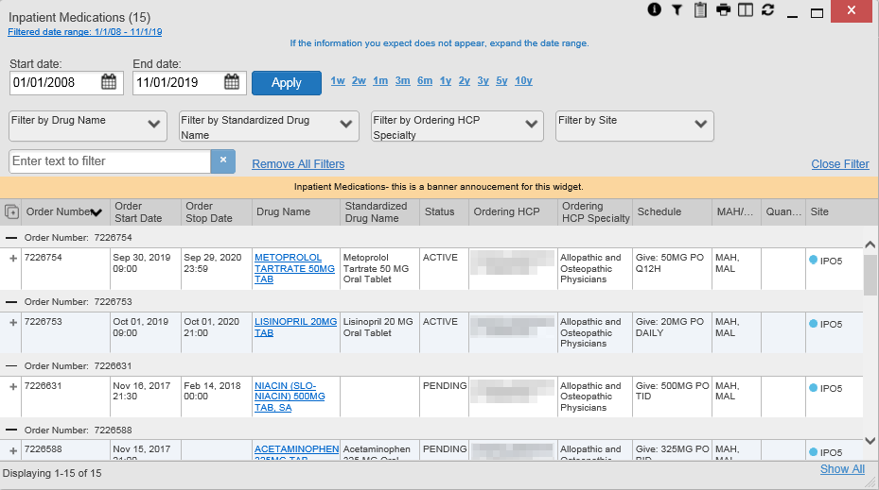

## Displaying Widgets on Custom Tabs

You can use the custom tabs feature to create additional widget configurations for ease of use and quick reference. Changes made to the Patient Portal icon **Patient Portal** display (widget layouts and custom tabs) are saved to the user profile and display in future CV sessions.

1. Click the Add Tab button on the Patient Portal icon **Patient Portal** (Figure 14)
   1. The **Add Tab** dialog box opens
2. Type a name for the new tab in the **Add Tab** dialog box, and click **Add**
3. Open the widget tray within the new tab space, then click, hold, and drag each of the desired widgets to the portal page (max 12)

 **NOTE:** Tab configurations remain set until you manually change them or restore your profile to default in the **CV Settings** dialog, which will remove all custom tabs.

1. Click between preset and custom tabs at any time without losing any of the configurations created on the custom tabs
   1. Tabs persist, even when a patient change is made
   2. Custom tabs can be renamed by double-clicking the tab name

## Refreshing Widget Data

Data in the widget display can be refreshed by clicking the Refresh button. This action updates the data in the widget.

 **NOTE:**  Records previously added to a report remain in the Report Builder after a widget refresh. Clicking the Refresh button in the widget refreshes the clinical data, refreshes the widget data display, and resets the record was added to Report Builder indicator to the Add to Report builder button, even if the record has been added to the Report Builder. Records previously added to a report prior to the refresh remain in the Report Builder after a widget refresh.

## Nondiagnostic Images

Nondiagnostic images are available in JPEG and PDF formats in the **Advance Directives dialog and the** **Documents**, **Outpatient** **Encounters**, **Procedures**, **Progress Notes**, **Radiology Reports**, and **Surgery/Procedure Reports** widgets, in addition to the **Progress Notes** tab of the **Pain Management** widget.

When the view in VistA Imaging Viewer button appears in the **Image** column (Figure 49), one or more images are associated with that record.

 **NOTE:** CV does not support VistA Imaging Viewer. Images are nondiagnostic and may not be of high-quality resolution.

 **NOTE:** While the view in VistA Imaging Viewer button appears in the **Advanced Directives’ Image** column, images cannot be launched from this window in this release.

Figure 49: Nondiagnostic Images in the Minimized View  
of the Radiology Reports Widget

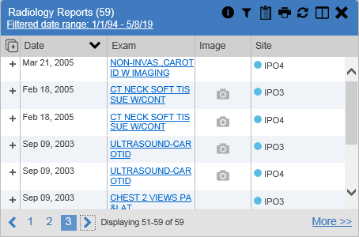

Click the view in VistA Imaging Viewer button to display a list of link(s) to the image(s) (Figure 50). Click the hyperlinked name of the image to open it.

Figure 50: Multiple Nondiagnostic Radiology Images

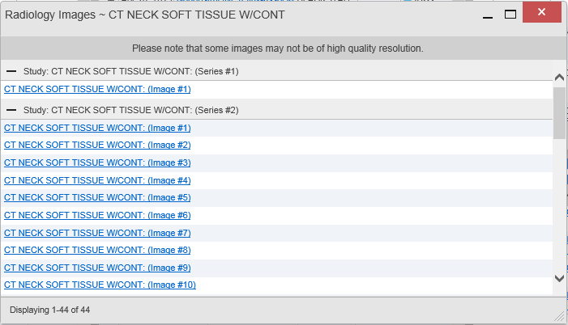

When in detail view, click the Click image to open viewer link (Figure 51) to open the associated image.

Figure 51: Nondiagnostic Images in the Radiology Reports Detail View

Figure REDACTED due to PII

If an image is temporarily unavailable, users may see the message: “System is unable to retrieve images at this time” (Figure 52). Try to retrieve the image later or contact the Community Provider Technical Service Desk if the problem persists (Getting Help).

Figure 52: Radiology Images Unable to Retrieve Images Error

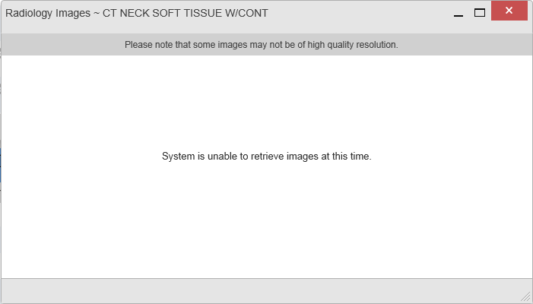

## Widget Functionality

The Patient Portal icon **Patient Portal** displays the selected patient's clinical records and other patient-centric information. The **Patient Demographics**, **Inpatient Medications**, **Lab Results**, and **Problem List** widgets, detailed in the following subsections, provide examples of widget functionality.

 **NOTE:** Click the Help button to see detailed information for all available widgets.

### Patient Demographics

The **Demographics** widget displays a summary of the patient’s nonclinical, personal data on the primary Patient Portal icon **Patient Portal** tab (Figure 53). This static widget cannot be removed from the Patient Portal icon **Patient Portal** or moved to a different position. The site tabs provide the patient’s demographics summary at each VA site that the patient has visited.

The patient’s name is displayed in color and is followed by a blue circle. The blue circle represents that the data was retrieved from a VA system.

Click the Flags button when it appears on the main **Demographics** widget tab to display information on the **Patient Flags and Postings** dialog, which only displays if there are alerts on the patient’s record.

the Advanced Directives button launches the **Advance Directives** dialog. Screenshot of the no advance directives indicator (greyed out) displays and does not launch the **Advance Directives** dialog if there are no advance directives on the patient’s record.

Figure 53: Patient Demographics Widget

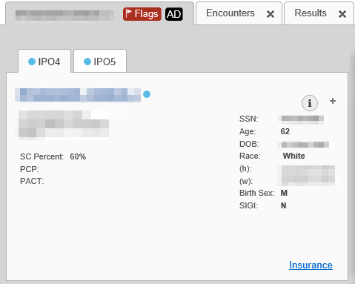

#### Viewing Detailed Patient Demographic Information

Additional patient demographic information is available from the **Demographics** widget on the Patient Portal icon **Patient Portal**. Click the patient’s name to open a separate window that provides a detailed list of demographic information for that patient.

#### Viewing Third-Party Insurance Information

Third-party payers and additional insurance information are available from a link within the **Demographics** widget on the Patient Portal icon **Patient Portal** (Figure 53). Click the Insurance link in the **Demographics** widget to open a separate window that displays detailed insurance information for the patient.

Use the horizontal scroll bar to view additional columns not seen within the default window size.

Data in the **Standardized Insurance Type** column is normalized to the X12 Health Insurance Type standard. Hover over entries in this column to display the standardized name and code for the insurance type.

### Pain Management

The **Pain Management** widget (Figure 54) displays a patient’s pain management treatment history, an up-to-date list of current and prior pain medications, and drugs that may interact with those pain medications.

The **Pain Management** widget is a static widget permanently positioned near the **Demographics** widget on the Patient Portal icon **Patient Portal** (Figure 14). The default instance of the **Pain Management** widget cannot be moved or removed.

 **NOTE:** Multiple instances of the **Pain Management** widget can be added to any portal tab. This allows for multiple views of the same pain management data (Figure 54). These additional instances of the widget can be moved or removed.

The tabs of information in the minimized view of the **Pain Management** widget display a data subset of the **Outpatient Medications**, **Inpatient Medications**, and **Progress Notes** widgets.

the information icon **NOTE:** Any tab of the **Pain Management** widget that does not have associated pain management records for the patient displays a “No Data” message.

Click More >> in the minimized view of the **Pain Management** widget to open an expanded view of each tab. The columns of information in the expanded view represent each clinical domain shown in the **Pain Management** widget (See Outpatient Medications, Inpatient Medications, and Progress Notes for more information).

Figure 54: Pain Management Widget

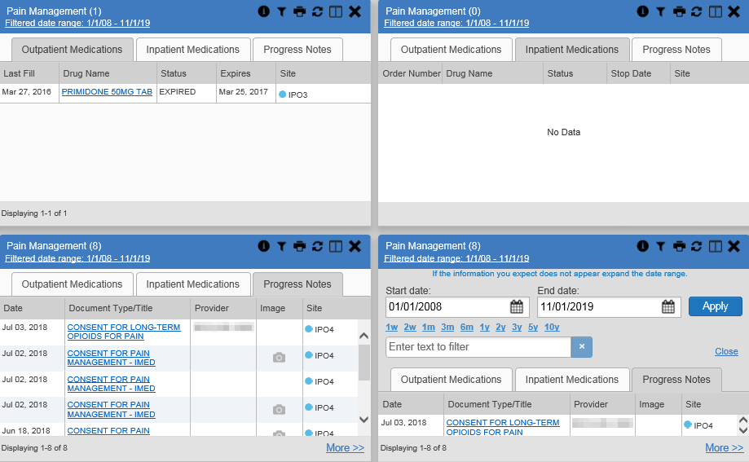

### Outpatient Medications

The **Outpatient Medications** widget (Figure 55) displays outpatient medication information, including active medications and medications that have expired or been discontinued within the past 120 days. The information is displayed in reverse chronological order by the last fill order date.

Click the copy active Rxs in date range to clipboard button from the widget toolbar in minimized or expanded view to convert the active medications data within the widget to text for display within a separate window.

Figure 55: Outpatient Medications

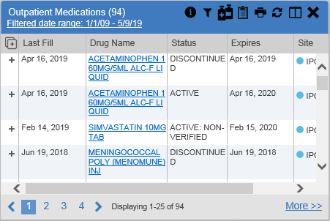

#### Outpatient Medications Widget Data

The columns of information in the minimized view of the **Outpatient Medications** widget are:

* Last Fill
* Drug Name
* Status
* Expires
* Site

Click More >> in the minimized view of the **Outpatient Medications** widget to open the expanded view. The columns of information in the expanded view are:

* Last Fill
* Drug Name
* Standardized Drug Name
* Prescription Number
* Sig
* Quantity
* Days’ Supply
* Refills Left
* Status
* Ordering HCP[2]
* Ordering HCP Specialty
* Expires
* Site

#### Viewing Outpatient Medication Details

Click the hyperlink in the **Drug Name** column of either view of the **Outpatient Medications** widget to open a separate window that displays detailed information about the medication.

### Inpatient Medications

The **Inpatient Medications** widget (Figure 56) displays inpatient medication information. The medications are grouped by the order number, where available.

Figure 56: Inpatient Medications Widget

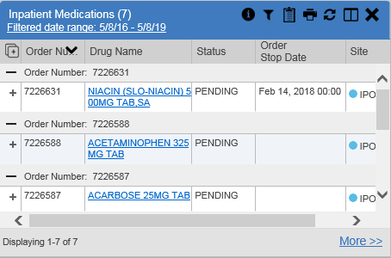

 **NOTE:** The sort arrow for the **Order Number** column overlaps the text in the minimized view.

#### Inpatient Medications Widget Data

The columns of information in the minimized view of the **Inpatient Medications** widget are:

* Order Number[3]
* Drug Name
* Status
* Order Stop Date
* Site

Click More >> in the minimized view of the **Inpatient Medications** widget to open the expanded view. The columns of information in the expanded view are:

* Order Number3
* Order Start Date
* Order Stop Date
* Drug Name
* Standardized Drug Name
* Status
* Ordering HCP
* Ordering HCP Specialty
* Schedule
* MAH/MAL[4]
* Quantity
* Site

#### Viewing Inpatient Medication Details

Click the hyperlink in the **Drug Name** column of either view of the **Inpatient Medications** widget to open a separate window that displays detailed information about the medication.

CV inserts MAH report text in details view of all VA records in the **Inpatient Medications** widget.

The MAH presents data within the last week by default, but you can adjust it to any 7-day range. The MAL presents data within the last 2 weeks prior to and through the end of the medication end date by default, but you can adjust it to any 14-day range. You can add MAH/MAL reports to Report Builder only from the **Inpatient Medications MAH/MAL** details view, not by selecting the selecting all records for this page button or the Add to Report builder button from the **Inpatient Medications** widget.

### Progress Notes

The **Progress Notes** widget (Figure 57) displays the patient’s progress notes information, displayed in reverse chronological order by the note date.

When the view in VistA Imaging Viewer button appears in the **Image** column, one or more images are associated with that record (See Nondiagnostic Images for more information).

Figure 57: Progress Notes Widget

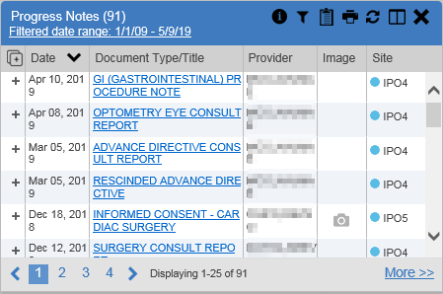

#### Progress Notes Widget Data

The columns of information in the minimized view of the **Progress Notes** widget are:

* Date
* Document Type/Title
* Provider
* Image
* Site

Click More >> in the minimized view of the **Progress Notes** widget to open the expanded view. The columns of information in the expanded view are:

* Date
* Document Type/Title
* Standardized Document Type
* Provider
* Provider Specialty
* Clinic
* Image
* Site

#### Viewing Progress Notes Details

Click hyperlink in the **Document Type/Title** column of either view of the **Progress Notes** widget to open a separate window that displays detailed information about the record.

### Lab Results

The **Lab Results** widget (Figure 58) displays the patient’s lab result information, as well as skin test data and blood transfusion history when available in the patient’s record. The information is displayed in reverse chronological order by the collection date.

Figure 58: Lab Results Widget

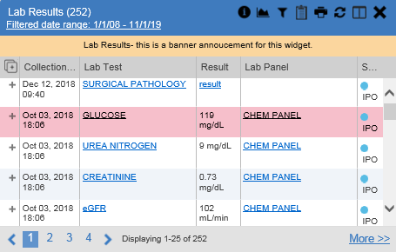

#### Lab Results Widget Data

The columns of information in the minimized view of the **Lab Results** widget are:

* Collection Date
* Lab Test
* Result
* Lab Panel
* Site

Click More >> in the minimized view of the **Lab Results** widget to open the expanded view. The columns of information in the expanded view are:

* Collection Date
* Specimen Source
* Lab Test
* Result
* Interpretation
* Units
* Ref Range
* Lab Panel
* Type
* Order Number
* Ordering HCP
* Status
* Site

 **NOTE:** While the **Standardized Lab Test** and **Ordering HCP Specialty** columns are not listed by default, you may add them to the expanded view by selecting their corresponding checkboxes in the Column Settings button.

#### Viewing Abnormal Results in the Lab Results Widget

CV highlights result values that fall within a calculated reference range for abnormal in both the minimized and expanded views of the widget.

Pink highlighting represents either H (high) or L (low) abnormal indicators. Red highlighting represents that the abnormal indicator has an asterisk (H* or L*) or the result is critical.

#### Viewing Lab Results Details

Clicking a hyperlinked entry in the **Lab Test** column opens a separate window that displays the detailed test report.

#### Graph/Table View from the Lab Results Widget

The **Lab Results** widget provides the option to display multiple results for the same lab test in a graph and table.

1. Select the Graph data button from the widget toolbar in either minimized or expanded view **OR**
2. Click More >> from the minimized view of the **Lab Results** widget to open an expanded view of the widget, then select the Show Graph/Table link
3. Select a value from the **Select a Lab Test** dropdown in the **Lab Results Graph/Table** dialog
   1. The graph displays with corresponding table values beneath (Figure 59)
4. Select the **Show Labels** checkbox to toggle graph data labels on or off
5. Select the close button to exit **Graph/Table** view and return to the minimized or expanded view of the **Lab Results** widget

Figure 59: Lab Results Graph/Table View

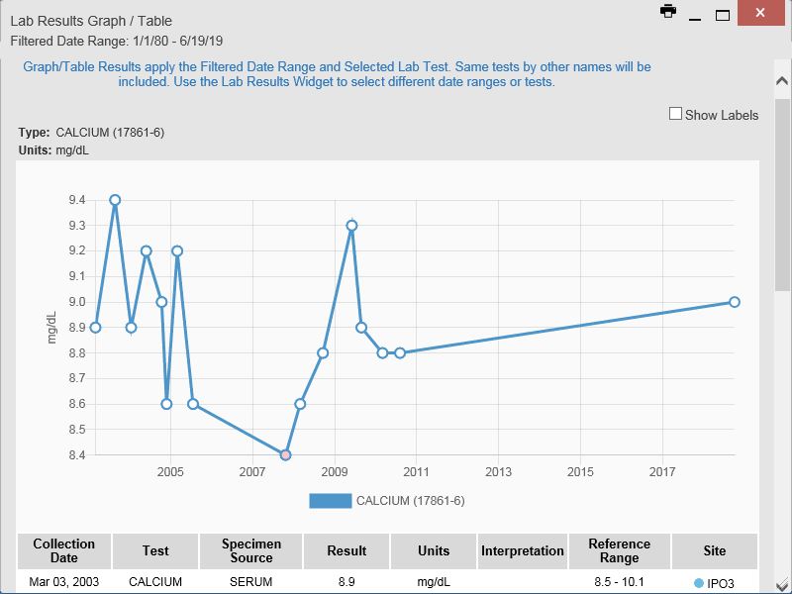

In the expanded view of the **Lab Results** widget, selecting one or more values in the **Filter by Lab Test** dropdown will disable all other filter dropdowns until the filtered selections are removed. The lab test values in the **Filter by Lab Test** dropdown dynamically increase or decrease depending on the date filter criteria you apply. Tests with the same LOINC code (shown in parentheses following the lab test name) as the ones selected will be automatically included in the filtered results displayed in the widget.

You may only use the graph/table feature for a single lab test LOINC value. All lab tests with the same LOINC will be graphed even if the lab test names differ. While you can select multiple lab test values in the **Filter by Lab Test** dropdown, you will be forced to select a single lab test value from the **Select a Lab Test** dropdown in the **Lab Results Graph/Table** dialog (Figure 60) once you select either the Graph data button or the Show Graph/Table link. The lab test values in the **Select a Lab Test** dropdown also dynamically increase or decrease depending on the filter criteria applied in the **Lab Results** widget.

Figure 60: Lab Results Graph Table View, Select a Lab Test

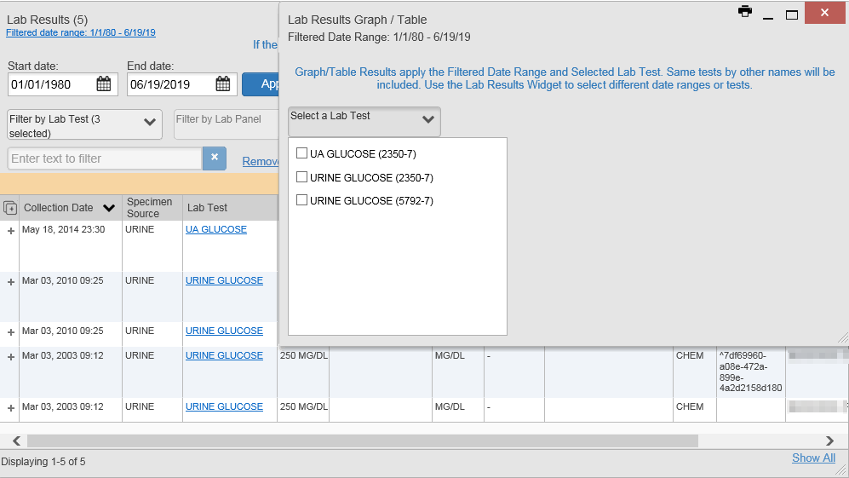

You may also generate a graph for all lab tests with the same LOINC code by selecting the Graph data button from the **Lab Results** details view.

### Problem List

The **Problem List** widget (Figure 61) displays a list of the patient’s health issues. The information is first sorted by ACTIVE status and then displayed in reverse chronological order.

Figure 61: Problem List Widget

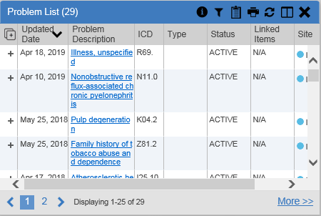

#### Problem List Widget Data

The columns of information in the minimized view of the **Problem List** widget are:

* Updated Date
* Problem Description
* International Classification of Diseases (ICD)
* Type
* Status
* Linked Items (DOD records only)
* Site

 **NOTE:** Linked items are available for DOD records only, which will not display until DOD data is added to CV. CV inserts “N/A” in the **Linked Items** column for all records from VA VistA sites.

Click More >> in the minimized view of the **Problem List** widget to open expanded view. The columns of information in the expanded view are:

* Updated Date
* Onset
* Problem Description
* Standardized Description
* ICD
* Severity
* Type
* Status
* Linked Items
* Site

#### Viewing Problem List Details

Clicking a hyperlinked entry in the **Description** column in either the minimized or expanded views of the widget opens a separate window that displays a detailed report of the record.

# Acronyms and Abbreviations

Table 5: Acronyms and Abbreviations

| Acronym | Description |
| --- | --- |
| CAPRI | Compensation and Pension Record Interchange |
| CCP | Community Care Providers |
| CPRS | Computerized Patient Record System |
| CV | Community Viewer |
| DOD | Department of Defense |
| EHR | Electronic Health Record |
| FEHR | Federal Electronic Health Record |
| FHIR | Fast Healthcare Interoperability Resources |
| HCP | Health Care Provider |
| HIPAA | Health Insurance Portability and Accountability Act |
| ICD | International Classification of Diseases |
| ID | Identification |
| IE | Internet Explorer |
| JLV | Joint Longitudinal Viewer |
| LOINC | Logical Observation Identifiers Names and Codes |
| MPI | Master Person Index |
| NPI | National Provider Identifier |
| OIT | Office of Information and Technology |
| PCMM | Primary Care Management Module |
| PDF | Portable Document Format |
| PIN | Personal Identification Number |
| PIV | Personal Identification Verification |
| POCs | Points of Contact |
| PPMS | Provider Profile Management System |
| SSN | Social Security Number |
| UI | User Interface |
| URL | Uniform Resource Locator |
| VA | Department of Veterans Affairs |
| VDS | VistA Data Service |
| VHA | Veterans Health Administration |
| VISN | Veterans Integrated Service Network |
| VistA | Veterans Health Information Systems and Technology Architecture |

1. While available in the widget tray, some widgets display “Data source not enabled,” “Connection unavailable,” or a connectivity error until data sources are connected in a future release.
2. Health Care Provider (HCP)
3. When there are multiple drugs with the same order number, CV maintains the grouping by order number when a column sort is applied in the widget.
4. Medication Administration History (MAH) / Medication Administration Log (MAL)