CPRS Patch OR*3.0*296 (CPRS GUI v.27.90)
Release Notes

August 2009

Table of Contents
Table of Contents 2
Installation Requirements 3
Required Patches 3
Related Patches 3
Release Method: Monitored Release 3
Patient Safety Issues 3
Known Issue 5
New Functionality 6
Combat Veteran Markers 6
Mental Health 10
Defect Fixes 11
Bidirectional Health Information Exchange (BHIE) 11
CPRS Splash Screen 11
Delayed Orders/Encounter Information 12
Display Issue (PSPO 1089) Warning 12
Document Searches 12
Encounters 12
Encounter Location Switching Form 13
Graphing 13
Labs Tab 13
Medication Quick Orders 14
Notifications 15
Orders 15
Problem List 21
Reminders 21
Remote Data 22
Reports 23
Templates 24
Template Editor 24
VBECS (Blood Bank) 24
Vitals Lite 27

Installation Requirements
Required Patches
Below is a list of patches that you must verify are properly installed on your system before OR*3.0*296 can be installed:
- OR*3.0*283
- OR*3.0*292
- OR*3.0*301
- OR*3.0*303
- OR*3.0*304
- YS*5.01*98
Related Patches
The following patches are required for functionality but are not required for installation:
- GMRC*3.0*65
- GMRC*3.0*69

Note: OR*3.0*296 (CPRS GUI version 27.90) requires Internet Explorer 4.0 (IE4) or later. However, Public Key Infrastructure (PKI) functionality requires IE 5.5 or later with 128-bit encryption.

Release Method: Monitored Release
OR*3.0*296 will follow a Monitored Release. A Monitored Release consists of releasing software that is closely monitored by an Implementation Team to assess impact and limit potential negative consequences. A Monitored Release does not intend to replace or remove any of the current testing and release processes, but rather to enhance the release phase with additional monitoring for earlier detection of issues.

Patient Safety Issues
- PSPO 1072: Change the Max to 100 for Labs (Remedy 274357) – In Computerized Patient Record System (CPRS) Graphical User Interface (GUI) v.27, the maximum number of reports and labs was changed from 100 to 10. (This item also listed under Reports.)
In CPRS v.26, if you asked to view microbiology results on the Labs tab, you viewed ALL results. Now with v.27, the default is 7 days and if you select All results, you see the last 10 reports. The same applies to the reports tab. Those settings can be changed at the Individual Reports level, which with v.27 is now set to a max of 10, whereas with v.26 that max setting was 100. The reports now look the same in both the Labs tab and the Reports tab.
Resolution: Developers changed the maximum back to 100 for both Labs and Reports tabs.

- PSPO 1082: IV Orders Were Coming across Differently in Pharmacy Package – Previously, when a user entered “IN” in Infusion Order dialog’s Type filed, CPRS correctly displayed “Intermittent”, but when a pharmacy user finished the order, the Intravenous (IV) order defaulted to “Admixture”, which was incorrect.
Resolution: Developers corrected the problem. Now, when a user enters the “IN”, it correctly defaults in the dialog, and when finished in Pharmacy, the IV is a “Piggyback”, which is correct.

- PSPO 1097: Remove CR from “Reason for Study” Field (Remedy 276791, 277509, 277788, 278589, 296988) – CPRS did not strip out carriage returns from the text included in the new “Reason for Study” field. This generally occurs when users copy text and paste it into the “Reason for Study” field. The consequence is that CPRS passes the data to the Radiology application and Radiology passes the data to PowerScribe with a carriage return, causing PowerScribe to experience an order processing error.
Resolution: This problem will be resolved in two steps:
1) OR*3.0*303 and RA*5.0*98 will be released as an interim fix. These patches will detect the problem and correct the data before storing it.
2) OR*3*296 (CPRS GUI v27.90) will correct the source of the problem by removing any carriage returns from the text entered through the CPRS GUI. The CPRS GUI modification will resolve the problem before the data is stored or passed.

- PSPO 1209: EDIT/RESUBMIT “New Comments” Stored as One Long String in the GMR(123 Node – Previously, when a user cancelled/denied a consult and added a comment using the Edit/Resubmit button, the comment was stored as a single long comment. Because it was a single long comment, the text displayed inappropriately as a long line that went off the dialog without wrapping. The way it was stored also caused problems with Health Level 7 (HL7) transmissions.
Resolution: Developers changed the way the comments were stored. The comment should now wrap appropriately in the display and should not cause problems with HL7 transmissions for Inter-Facility Consults.

- PSPO 1321: Graphing: Sometimes Lab Test Being Graphed May Not Display Its Most Recent Value (Remedy 288907) – Previously when graphing lab data for a patient and there was data caching, one of the lab tests would not display its most recent value. Data caching occurs only when the user has previously used graphing on a specific patient. Which lab test had its value dropped depended on what collection of lab tests the patient has (based on an internal number for the test). This makes the problem appear sporadic.
Resolution: Developers corrected this problem in CPRS. All values should now appear.
- PSPO 1349: Provider Orders BID Schedule but Gets a Different Admin Time Stored with the Order (Remedy 294361) – If a user typed in a non-unique schedule and pressed the <Enter> key, CPRS allowed the order to be accepted with a non-unique schedule and the wrong administration time.
Resolution: Developers made several changes to resolve these issues.
- Developers changed CPRS to require a unique schedule when leaving the schedule field in the Unit Dose dialog.
- Developers changes what happens when the user presses the <Enter> key while the focus is still on a drop-down list. Previously, pressing the <Enter> key selected the item and accepted the order, but now pressing the <Enter> key will be the same as pressing the <Tab> key—it will select the item and move to the next field.
- CPRS will also check for a control character in the schedule field when placing an order. If CPRS finds a control character, then it displays an error message to the user and the order cannot be saved until the schedule field is corrected.

Known Issue
- Remedy 337505: NCHC--Consult “Reason for Request” Scrollbar Limitation – Northern California Health Care System reported a problem with the Consult/Procedure dialog, specifically the reason for request field. The reported issue was the scrollbar did not expand properly when text or number of lines filled the reason for request field, resulting in no visibility of text being typed in text field. This limitation does not exist during the display of the Reason for Request field.
Workaround:
- Option #1; When user comes to the end of the reason for request field and scroll bar does not expand, user can hit enter 2-3 times and scroll bar will be enabled and text will be visible.
- Option #2: For long reason for requests, users may use a word processing tool to write reason for request. Then, copy and paste test in to the reason for request field.
Resolution: Developers will correct this issue in CPRS GUI v.28.

- Remedy 345650: Personal Quick Orders Don't Save All Values Entered for Some Meds – Providers noticed that their personal quick orders did not retain the saved Quantity value. Instead, the personal quick order defaulted to a Quantity of zero. This issue only occurs with outpatient medications saved as personal quick orders involving medications where the Quantity cannot be calculated (i.e., supply orders, inhalants).
Workaround:
- When using personal quick orders and the stored quantity value is replaced with the value of zero, the clinician will have to manually update the quantity field to proceed with the order.
Resolution: Developers will correct this issue in CPRS GUI v. 28.
New Functionality
Combat Veteran Markers
CPRS has new Combat Veteran (CV) markers to help users recognize that a veteran has Combat Veteran status. The markers are found on the patient selection screen, on the consult tab, on notifications, order details screen, on the SF-513, and on a button available from any tab.
Note: The Combat Veteran marker does not take into account the type of military discharge. Whether the discharge is honorable, dishonorable, etc., the CV marker is the same.

- Patient Selection Screen: When the user selects a patient with Combat Veteran status, CPRS indicates that patient is a combat veteran by displaying the letters CV and a date below the normal demographic information on the Patient Selection screen and above the Save Patient List Settings button. The marker is shown in the screen capture below surrounded by a red box.
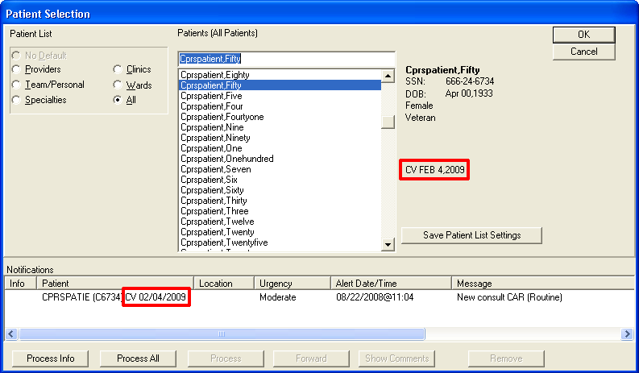

- New Service Consult/Request Notifications: The lower portion of the Patient Selection screen is the list of notifications for the user that is logged in. For a new consult or procedure request for a veteran with Combat Veteran status, the letters CV and the date display behind the abbreviated patient identifier in the Patient column. The Combat Veteran notification marker is shown in the above screen capture outlined in red.
- Combat Veteran Button and Consult Details: Available from any CPRS tab, the Combat Veteran button displays the letters CV and the expiration date of Combat Veteran Status. The Button displays when the selected patient has Combat Veteran status. The button shares space with the Flag button. The Combat Veteran button only displays for patients with the status, otherwise, the Flag button is whole.
- To get details, the user selects the button to display the Combat Veteran Details dialog. See Combat Veteran Details Dialog below.
- When the user selects the consults from the treeview, the consults details show in the pane to the right. In this view, the Combat Veteran status is shown underneath the primary eligibility.
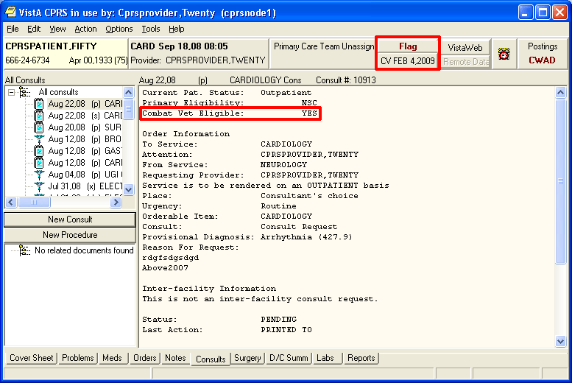

- Combat Veteran Details Dialog: When the user selects the Combat Veteran button, the Combat Veteran Details dialog displays with the following items:
- Service Branch
- Status
- Separation Date
- Expiration Date
- OEF/OIF (If the patient served in Operation Enduring Freedom (OEF) or Operation Iraqi Freedom (OIF)
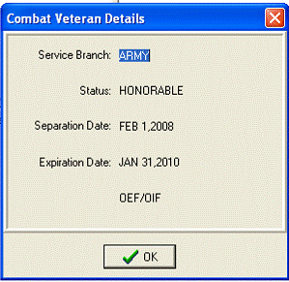

- Consult Order Dialog: The Combat Veteran status and expiration date display near the top of the Consult Order dialog.
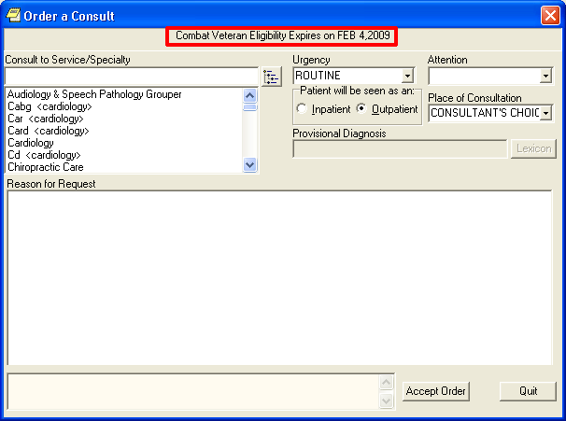
- SF-513 Form: Several changes were made to this form:
- At the top of the page on the SF-513, the Combat Veteran marker displays with the demographic information.
- The patient’s name was moved to the top of this form.
- When printed, the patient’s identifying information will be printed at the top of each page.
- When printed, a page number will be printed at the bottom of each page.
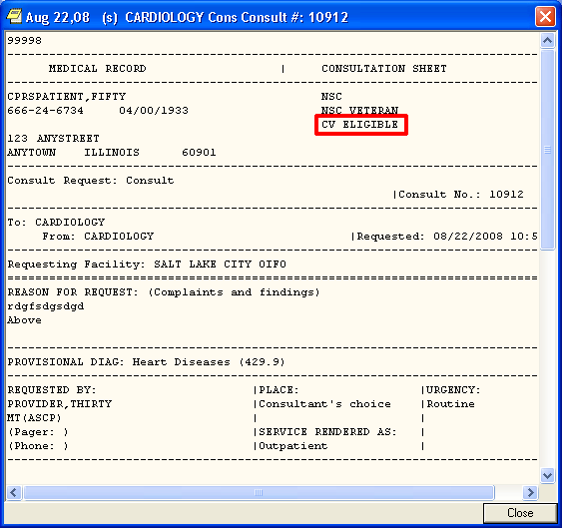

Mental Health
- CPRS Support for the New Mental Health DLL – The Mental Health package created a patch to address an issue with temporary files. To avoid confusion with the previous dynamic link library (DLL), the name of the DLL was changed. CPRS made the changes necessary to support the changes to the new DLL, YS_MHA_A.DLL.

Defect Fixes
Bidirectional Health Information Exchange (BHIE)
- Graphing Not Working Correctly with Department of Defense (DoD) Data – When remote DoD data was being used for graphing, a graph would sometimes display briefly, but it would then disappear.
Resolution: Developers fixed this problem and CPRS should refresh correctly now.

CPRS Splash Screen
- 508 Email Address on the CPRS Splash Screen – Previously, the CPRS splash screen, the one that displays after the user launches CPRS and before the Patient Selection screen appears, had the 508 team’s email address.
Resolution: CPRS developers replaced the 508 team’s email with information on entering a Remedy Ticket if any issues are encountered:
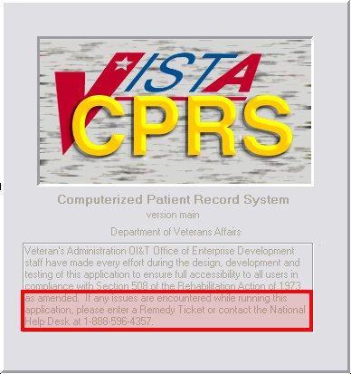

Delayed Orders/Encounter Information
- Adding to Delayed Orders - No Encounter Provider Update Dialog – Previously, if a user who did not have the PROVIDER or ORES key, attempted to add orders to a group of existing orders, CPRS did not prompt the user to define the encounter provider. When the user tried to accept the orders, CPRS displayed the error Unable to Save Order error and did not accept the order.
Similarly, if a similar type of user tried to enter new delayed orders or tried to add to existing delayed orders, CPRS prompted the user for a provider and a location. The location was not necessary for the delayed orders.
Resolution: Developers changed CPRS to prompt for the encounter provider if needed, but the encounter location is not required for delayed orders. When a user, who is not assigned as the encounter provider and who does not hold the Provider key, is writing new delayed orders or adding to existing delayed orders, CPRS will force the user to select an encounter provider, but CPRS does not force the user to enter an encounter location.

Display Issue (PSPO 1089) Warning
- Reference to PSPO 1089 Removed from Warning Message – When the display issue that created this patient safety issue was resolved, the warning message to users included a reference to PSPO 1089.
Resolution: Under the direction of the Patient Safety Office, developers removed the reference because it was not necessary. The rest of the text provides the needed information.

Document Searches
- CPRS Not Highlighting Key Words in a Search – The CPRS search for items in a note or other document was not functioning correctly. The user would search for a term and CPRS would not highlight the item in the text of the note.
Resolution: CPRS now highlights the searched item in the note text.

Encounters
- Encounter Form Data from Patient A Displays on Patient B – Previously, new encounter information was carrying over to another patient encounter form incorrectly under the following circumstances:
- A provider was entering encounter information, for two patients with the same appointment date/time.
- The provider was entering encounter data for an appointment—not editing a note.
- No notes were showing on the patient’s notes tab.

Resolution: Developers changed CPRS to prevent the previous patient’s encounter data from carrying over to the second patient’s chart.

Encounter Location Switching Form
- Delayed Orders on Form Cause Access Violation – Previously, delayed orders could display on the encounter location switching form although they were not supposed to display there. The delayed orders caused an access violation.
Resolution: Developers changed CPRS so that delayed order no longer display on the Encounter Location switching form.

Graphing
- Graphing: Sometimes Lab Test Being Graphed May Not Display Its Most Recent Value (PSPO 1321, Remedy 288907) – Previously when graphing lab data for a patient and there was data caching, one of the lab tests would not display its most recent value. Data caching occurs only when the user has previously used graphing on a specific patient. Which lab test had its value dropped depended on what collection of lab tests the patient had (based on an internal number for the test). This makes the problem appear sporadic.
Resolution: Developers corrected this problem in CPRS. All values should now appear.

- Graphing Background Processing to Cache Patient Data May Cause System Slow Down – CPRS will sometimes create a cache of patient data to provide a faster user response for graphing. Sometimes this additional background processing can slow overall system performance.
Resolution: To address the possibility of too heavy a load on the system, developers added a way to disable the background process to cache patient data.

Labs Tab
- Remote Data Tabs on the Labs Tab Not Displaying – On the Labs tab, CPRS displays some remote data—using a tab for each location. This was not functioning correctly. (This item is duplicated under the heading “Remote Data”.)
Resolution: Developers corrected this problem, and the tabs will now display for remote data when appropriate.

- Change the Max to 100 for Labs (PSPO 1072, Remedy 274357) – In CPRS GUI v.27, the maximum number of reports and labs was changed from 100 to 10.
Resolution: Developers changed the maximum back to 100.

- Changing the Value for the Max Number of Labs Does Not Stick (Remedy 274357) – In CPRS GUI v.27, the maximum number of reports and labs was changed from 100 to 10. When users changed the number of labs to a different value, CPRS did not keep the changed value.
In CPRS v.26, if you asked to view microbiology results on the lab tab you viewed ALL results. Now with v.27, the default is 7 days and if you select All results, you see the last 10 reports. The same applies to the reports tab. Those settings can be changed at the Individual Reports, which with v.27 is now set to a max of 10 whereas with v.26 that max setting was 100. The display of the reports now looks the same in both the lab tab and the reports tab.
Resolution: Developers ensured that the changed value stays.

- CANNOT FOCUS A DISABLED WINDOW and “Lab Result” Item Selection Missing (Remedy 274661) – There are some reports on the Labs tab that do not retrieve remote data, only local data These include Selected Tests By Date, Worksheet and Graph. These reports were incorrectly being evoked when the user added or subtracted remote sites from on the Remote site list, and sometimes CPRS displayed the error “Cannot Focus on a disabled window”.
Resolution: Developers corrected this problem.

- Most Recent Labs Data Disappearing – When a user brought up the Labs tab with the Most Recent Labs option, the data displayed correctly. If, however, the user tried another option, such as “Selected Test by Date”, but before the data was displayed, the user canceled, the appropriate data from the Most Recent Labs option did not display. The user could see older results, but not the most recent.
Resolution: This problem occurred when a user cancelled out of a test selection screen on the Selected Tests report because the previous report was activated but not reselected. Developers changed CPRS to reselect the report, thus repopulating the report screen with the correct data.

Medication Quick Orders
- Typos in Report from MED QUICK ORDERS W/ ANCESTORS
Resolution: Developers corrected the errors in the text.

- OR MEDICATION QO CHECKER--Report w/o Ancestors Is Empty (Remedy 273607, 273794) – There was some confusion over use of the term “ancestor” in this quick order (QO) report. It was used in different ways in this report and with another option, ORCM SEARCH/REPLACE.
Resolution: The description of this option was rewritten to better define what the report shows.

- Quick Order Prompt (Auto-accept this order?) Is Appearing Erratically – Previously, the quick order editor displayed the prompt “Auto-accept this order?” erratically.
Resolution: For IV medication quick orders, CPRS now checks whether the auto-accept prompt should display based on whether the quick order provides all the information to complete the order. If the user creating or editing the quick order has defined all the necessary information, then the quick order editor displays the auto-accept prompt. If the quick order will need additional user interaction, the quick order cannot be auto-accepted and the prompt will not display.

- VistA Quick Orders Do Not Allow Fractional Number for Infusion Rate of Continuous Infusion Orders – Previously, CPRS did not allow the user creating a Veterans Health Information Systems and Technology Architecture (VistA) quick order to enter a fractional infusion rate (such as 5.5) for continuous IV quick orders.
Resolution: Developers changed VistA quick orders to accept a fractional amount for an infusion rate.

Notifications
- Problem with Removing a Notifications Surrogate (Remedy 266981) – When the user selected Tools | Options and then the Notifications tab, CPRS was not removing the surrogate when the user selected Remove Surrogate.
Resolution: Developers corrected this problem and CPRS will now remove the surrogate appropriately.

Orders
- <UNDEFINED>INF+6^ORCDPSIV (Remedy 274902) – Previously, if the user entered text into the Infusion dialog’s Infuse Over Time field when setting up a VistA quick order, the user would get this error: <UNDEFINED>INF+6^ORCDPSIV.
Resolution: Developers changed CPRS so that the Infuse Over Time field only accepts numbers—preventing this error.

- Type “IN” for IV Type (Infusion Dialog), Order Is Filed as Continuous – Previously, if a user was trying to select the IV Type of Intermittent and the user typed “IN”, CPRS selected the Continuous type instead of the Intermittent type.
Resolution: Developers corrected CPRS to select the appropriate item when the user types the letters.

- When Entering an Intermittent Infusion Order with Schedule Type Prompt, OTHER, No Scheduling Box Is Displayed (Remedy 273911) – Previously, if the user entered an Intermittent IV type order, and typed “other” or some variant, the Day of Week Schedule Builder did not display. It worked correctly if the user selected other using the mouse.
Resolution: Developers corrected CPRS and users can either type the letters or use the mouse to select “Other”.

- When an Intermittent IV QO Does Not Have “Infuse Over Time” Defined, but Is Set-Up to Be Verified, the Verify Order (Accept/Edit/Cancel) Form Does NOT Display – If a user selected a quick order for an intermittent IV, and the quick order is set to have the user verify the order, the Verify Order (Accept/Edit/Cancel) form does not display as it should. The form should display and give the user the chance to edit or not, but CPRS incorrectly put the user directly into the dialog to edit the order.
Resolution: Developers corrected this problem, and the Verify Order form displays so that the user can choose what to do.

- Infusion Order Dialog: Typing in OTHER in Schedule Box, Select OTHER Using Arrow Keys, Drop Down Box Remains On Screen – Previously, if the user typed in the first few letters of the word “other” in the Schedule field and then used the arrow keys to select OTHER, the display was not updated correctly. Part of the drop-down box remained displayed on the dialog and covered some of the times so that the user could not select them.
Resolution: Developers corrected this problem: The dialog will now behave appropriately.

- Launch the DOW Schedule Builder by Typing OTHER, the Admin Time Is Not Updated – Previously, if the user launched the Day-of Week schedule builder by typing “other”, the administration time was not updated. If the user entered other by selecting it with the mouse, the administration time was updated.
Resolution: Developers corrected this problem and the administration time will update appropriately.

- If an Intermittent QO Has an Additive with a Strength and/or a Solution, It Should Auto-Accept (Remedy 275722) – With the changes for CPRS GUI v.27, users could enter an infusion order for an additive with a strength or a solution, whereas prior to v.27, the additive would have required a solution. This scenario worked correctly if the user entered the order through the dialog, but if a quick order was created with the same characteristics, it would not auto-accept.
Resolution: Developers made changes so that the order can now be set to auto-accept.

- Infusion QO Retains Fields when Switching IV Types in the VistA Quick Order Editor – Previously, if a user was creating IV orders in the quick order editor and entered values in the Schedule, Infuse over time, or Infusion rate field and then changed IV types (from Intermittent to Continuous or from Continuous to Intermittent), CPRS should have removed the values when the type changed, but the values inappropriately remained.
Resolution: Developers corrected this problem, and changing from one IV Type to another clears the appropriate fields.

- OR MEDICATION QO CHECKER Lacks a Description of the Option Functionality and a Prompt to Proceed – When using the OR MEDICATION QO CHECKER, there was no description of the option telling the user what would happen if the user ran the option. Users in the field also asked that a prompt be provided so that the user could decide if they wanted to proceed.
Resolution: Developers changed this option to include the prompt and the following description:
The option generates two reports (printed to an e-mail message sent to the originator of the report) of Quick Orders that should be evaluated due to the addition of three new fields in CPRS 27: Route, IV Type and Schedule. One report includes QOs that are contained in an order menu, order set or a reminder dialog. The other report includes QOs that are stand alone and not included in another entry.

- Convert IV Inpatient QO to Infusion QO Has a Typo – There was a typographical error in the text for the conversion utility. The word “move” should have been “moved”.
Resolution: Developers corrected the spelling error.

- Intermittent QO Created without Schedule and Set for Auto-Accept Results in Released Order without a Schedule – Previously, if sites created an Intermittent IV quick order without a schedule and set the order to be an auto-accept order, CPRS did not display the dialog to require a schedule. The order could therefore be placed while missing the schedule.
Resolution: CPRS should now catch the problem, display the dialog, and require the user to enter a schedule.

- When Adding to Delayed Orders, Non-Provider Key Holders Prompted for a Provider and a Location – Previously, when a nurse was adding to existing delayed orders or entering new delayed orders, the nurse had to select both a location and a provider. This was confusing because the location was unnecessary and could cause the orders to print at a location that was not ready to receive the patient.
Resolution: Developers changed CPRS. Now, when a nurse is writing new delayed orders or adding to existing delayed orders, CPRS requires the nurse to select a provider, but the nurse will not be required to select a location.

- Quick Order Editor Inappropriately Moves Data between Fields when Switching IV Types – In the Infusion Order dialog when the user changed the IV Type either from continuous to intermittent or from intermittent to continuous, the Schedule field and the Infusion Rate/Infuse over Time field were being carried over.
Resolution: When switching the IV Type from either continuous to intermittent or from intermittent to continuous, both the Schedule field and the Infusion Rate/Infuse over Time field will be blanked out.

- Schedule Functionality different between Infusion Order Dialog and Medication Order Dialog – Previously, on the Inpatient Medication order dialog, if the user entered a free-text schedule, CPRS would auto-match even if the letters entered did not uniquely identify a schedule.
Resolution: Developers changed the Inpatient Medication order dialog’s Schedule field will not auto-match unless enough characters have been entered to uniquely identify a schedule.

- <Enter> Key Will Not Default to Activate the Accept Button on IV, Outpatient, Unit Dose, and Non-VA Meds Dialogs – Previously, if on the IV, Outpatient, Unit Dose, and Non-VA Meds dialogs, the user pressed the <Enter> key, it was the same as selecting the item that had focus and pressing the Accept button. The order might be accepted with unintentional or inaccurate items selected.
Resolution: Developers changed these dialogs so that the <Enter> key will work as it does on other order dialogs. If in a drop-down box, for example, pressing the <Enter> key will activate the selected item and move to the next control (drop-down, text field, etc.) and will not accept the order. The user will need to explicitly click the Accept button or tab to it and then press Enter in order to accept the order.

- Prevent Display of Admin Times for PRN Schedules – When a user opens an inpatient medication quick order (QO) with a PRN schedule defined in the administration file, file #51.1, and if the site had defined administration times for the PRN schedule, the administration times would display when the QO was opened in CPRS. The administration times should not display for a PRN schedule.
Resolution: Developers changed CPRS so that administration times for a PRN schedule do not display—even if the schedule has administration times defined.

- Changed Order Display Includes a Schedule of PRN and a Check in the PRN Checkbox, Plus PRN Only Schedule for Inpt. Med Displays “Expected First Dose” – Previously, when a user changed a PRN order that only had the PRN checkbox checked in the initial order, the order dialog would display with PRN in the schedule field and the PRN checkbox would be checked. Also, if the user unchecked the PRN checkbox and if a PRN schedule was not set-up in the ADMINISTRATION SCHEDULE file, file #51.1, the Expected First Dose value would still display in the order dialog incorrectly.
Resolution: Developers changed CPRS to only check the PRN checkbox for a changed order in the above scenario if a PRN schedule is not defined. This change also fixes the problem with the Expected First Dose value appearing incorrectly.

- CPRS Does Not Allow First Action on Change Orders, Copy Orders, or Quick Orders (Remedy 278833) – In CPRS v.27, when the user selected any action that loaded previously defined order data, such as quick orders, transfer orders, change orders, or copy orders, CPRS did not correctly adjust the Quantity field in outpatient order dialog for the first change that a user would make. For example, if a user selected an order and selected the Change action, and then subsequently changed the free-text schedule to a defined schedule (such as BID), the quantity field would recalculate. But if the user then changed back to the free-text schedule, the quantity field would keep the same quantity as when the BID schedule was there. Another example would be if the user selected Change order and then changed the Days Supply value, the quantity field would not adjust.
Resolution: Developers changed CPRS to recognize the first action correctly so that the quantity field will calculate, as it should. In the above scenario, CPRS will readjust the quantity to zero if the user has not done a manual correction to the quantity value. If the user does manually change the Quantity value and then makes any adjustment to the schedule, the Days Supply value should update and not the quantity value. This returns to the functionality that existed in CPRS GUI v.26.

- Backspace Issue: Modify Patient Selection and Med Dialogs to Prevent Retention of Previously Selected Entry – Previously, if the user selected a value in a medication order dialog or the patient selection dialog drop-down list, highlighted the selected value at the top of the drop-down list, and pressed the <Backspace> key, the text would be deleted from the drop-down list. However, the drop-down list would maintain the deleted value as the selected value. This could have caused a problem if the user pressed the <Enter> key right after deleting the text.
Resolution: Developers changed CPRS so that the drop-down list does not maintain the value when the user pressed the <Backspace> key for the Patient Selection screen and the Medication Order dialog.

- Pressing <Enter> Key Too Rapidly Can Save Orders without Appropriate Information or with Inaccurate Information
- Can Enter Order with Missing or Invalid Schedule – If the user does the following, CPRS could possibly save an order with no schedule or control character in the Schedule field.
- Launch the Inpatient Medications order dialog.
- Select the Complex tab.
- In lower case (this must be lower case), type the first few characters of a schedule such as BID —choose a schedule for which the first few characters are NOT unique (i.e., BID is not enough to unique match between BID and BID AC). Or, type in an invalid schedule.
- Without leaving the Schedule field, press CTRL+ENTER to activate the default button on the form (Accept Order).
The order saves without a schedule. If you entered an invalid schedule, CPRS displays several error dialogs: first, CPRS displays the invalid schedule dialog, and then two "Cannot focus on a disabled or invisible window" messages.

- Inpatient Med with Incorrect Admin Time, via Complex Tab – If the user does the following, the user can save an order with the wrong administration time.
- Launch the Inpatient Medications order dialog.
- Switch to the Complex tab.
- In lower case (this must be lower case), type the first few characters of a schedule such as BID —choose a schedule for which the first few characters are NOT unique (i.e., BID is not enough to unique match between BID and BID AC) .
- While still in the Schedule field, click the X (Close button) in the upper right corner.

- Can Change Some Outpatient Medication Fields and Save the Order before Other Fields Auto-Update – For an Outpatient Medication order, if a user was editing an item in a drop-down list and pressed the <Enter> key, CPRS could possibly save the order with the wrong Days Supply and Quantity values because the fields did not have a chance to update.

- Provider Orders BID Schedule but Gets a Different Admin Time Stored with the Order (PSPO 1349, Remedy 294361) – If a user typed in a non-unique schedule and pressed the <Enter> key, CPRS allowed the order to be accepted with a non-unique schedule and the wrong administration time.

- Modify UD, OPT Meds, and Non-VA Meds Dialogs to Prevent Saving of Order when Editing Dosage, Route, Schedule and Pressing the <Enter> Key – If the user presses the <Enter> key while they are in a drop-down list in the Dosage tab of the Unit Dose, Outpatient Medications, or Non-VA Meds dialog, CPRS would save an order.

Resolution: Developers made several changes to resolve these issues.
- Developers changed CPRS to require a unique schedule when leaving the schedule field in the Unit Dose dialog.
- Developers changes what happens when the user presses the <Enter> key while the focus is still on a drop-down list. Previously, pressing the <Enter> key selected the item and accepted the order, but now pressing the <Enter> key will be the same as pressing the <Tab> key—it will select the item and move to the next field.
- CPRS will also check for a control character in the schedule field when placing an order. If CPRS finds a control character, then it displays an error message to the user and the order cannot be saved until the schedule field is corrected.

- NF Alternative Med Highlighted and Accepted, CPRS Does Not Go to the Alternative (Remedy 297310) – This problem occurred when the user types in the medication name—not using the mouse. In the order dialog, if the user types the name of a non-formulary (NF) medication with a formulary alternative, CPRS displays a dialog with the formulary alternative. If the user selects the formulary alternative, the order dialog displayed with the original medication name at the top, but the correct medication in the order sig at the bottom of the order dialog.
Resolution: Developers corrected this problem.

Problem List
- Pass a Null Value to Problem List for Edited Problem List Entries with a PRIORITY of UKNOWN—Entered via Problems Tab – A problem was introduced with OR*3.0*243 that allowed a null value, which should not have been allowed, to be passed to the Problem List package when a user entered a problem with a priority of UNKNOWN on the Problems tab. This null value caused some reminders to not be displayed that would be related to the problem
Resolution: Two patches fixed this error: GMPL*2.0*37 and this patch, OR*3.0*296. The first patch went through and corrected null entries that were in the sites’ databases. Patch OR*3.0*296, CPRS GUI v.27.90, prevents the null value from being set or passed to the Problem List package.

- New Problems with Priority of Unknown Creates Bad Data – In CPRS v.27, a change was made that created an error: If a user entered a new problem and left the priority as “unknown”, CPRS sent incorrect data to the problem list application. The Reminders Index then used the Problem List as a source, and the bad data meant that some reminders were not correctly evaluated.
Resolution: Developer corrected the problem list so that it now sends the correct data. A separate Problem List patch will correct the incorrect data.
Reminders
- Remote Procedure ORWCV POLL is not registered to the option YSBROKER1 (Remedy 276139) – In CPRS v.27, when processing a Mental Health test from a Clinical Reminder dialog, the following error occurs sporadically:
“Remote Procedure ORWCV POLL is not registered to the option YS BROKER1.”
Resolution: OWCV POLL RPC is a background job that CPRS checks every couple of seconds for the cover sheet data. This error occurs if a Mental Health test is accessed while this background job is processing. Developers modified CPRS to pause in checking the OWCV POLL job while the Mental Health DLL is open.

- Reminders Due Folder Displays, but Contains No Due Reminders – Sites discovered a problem with the Reminders evaluation that conflicted with use of the Vitals dynamic link library (DLL) in CPRS. When a user opens a patient record in CPRS, several processes occur, including a Reminders evaluation to see if any Reminders are due for the selected patient. While this is happening, the Reminders icon shows the magnifying glass going in circles.
The conflict occurred when the user opened the Vitals DLL while the Reminders evaluation was occurring. When the Vitals DLL is launched, CPRS gave control over to the DLL. When the DLL closed, it gave control back to CPRS, but the Reminders evaluation did not complete, so no Reminders were shown as due.
Resolution: Developers changed CPRS to begin the Reminders evaluation again if it is not complete.

Remote Data
- Remote Data Tabs on the Labs Tab Not Displaying – On the Labs tab, CPRS displays some remote data using tab for each location. This was not functioning correctly. (This item is duplicated under the heading “Labs Tab”.)
Resolution: Developers corrected this problem, and the tabs will now display for remote data when appropriate.

- Second Button Appears for Patients with More Than One Selection under Remote Data View (Remedy 276181) – When a user was using Remote Data Views that showed data on different tabs for different sites, CPRS was displaying two tabs for sites instead on one.
Resolution: Developers corrected this, and on one tab will display for remote sites, as it should.

- Inconsistent HDR Report Messages – The message that CPRS displays when the parameter to use the Health Data Repository (HDR) is set to YES reads: “You must use VistaWeb to view this report.” When the parameter is set to NO, the message reads: “The HDR is currently inactive. Unable to retrieve HDR data at this time.” It does not mention to use VistaWeb to view this data, which was inconsistent and confusing.
Resolution: Developers changed the message logic/text to make more sense. CPRS will not display the message if HDR is turned on.

- HDR Report Data Is Retrieved Contrary to Message – Previously, if a user selected an HDR Report, CPRS displayed a message that the user “must use VistaWeb” to view the report, but after a short time, CPRS did display the data.
Resolution: Developers changed CPRS so that the “view VistaWeb” message only pops up when the HDR parameter is turned off.

- HDR Site Cannot Be Unchecked while HDR Report Is Selected – Previously, when a user selected an HDR report and then tried to uncheck the HDR item, CPRS displayed a message about viewing the report using VistaWeb and the HDR item would be rechecked. To uncheck HDR, the user had to select a non-HDR report.
Resolution: Developers disabled the automatic rechecking of the HDR site disabled.

- HDR Included in All Available Sites Option Even when Turned Off – When a user selected an HDR report and the HDR was not available in CPRS, CPRS displayed the message: “The HDR is currently inactive. Unable to retrieve HDR data at this time.” Then, if the user checked or unchecked All Available Sites, CPRS displayed this message again. (It did not matter which tab the user was on when the user checked or unchecked All Available Sites as long as an HDR report was selected on the Reports Tab—CPRS still displayed the message.) This behavior seems to indicate the HDR site is being checked/unchecked with the All Available Sites option, even though it does not appear on the list.
Resolution: The text of the message has been changed to be more clear: “The HDR is currently inactive in CPRS. You must use VistaWeb to view this report.” Also, the message should only appear when the user is on the Reports tab.

- Remote Data Showing Multiple Tabs (Remedy 282075, 276181) – In CPRS, if you accessed Remote Data on the Reports tab and selected multiple hospitals, CPRS displays two tabs with the same data for some hospitals.
Resolution: CPRS should display only one tab per remote location.

- RDV: Incorrect Lab Status Report Displayed for Remote Site – Previously, when a user selected the Lab Status report for the local site and a remote site, CPRS displayed the correct Lab Status report for the local site, but the data for the remote site was the Daily Order Summary.
Resolution: Developers corrected this error and the correct report now displays.

Reports
- Imaging and Microbiology Reports (Remedy 275884) – A problem was occurring when users went to the Labs and Reports tab and viewed some data and then switched to the other tab. Some reports were not showing data. The two tabs were using the same object, which caused conflicts and display problems.
Resolution: Developers changed CPRS to prevent the problems.

- PSPO 1072: Change the Max to 100 for Reports (Remedy 274357) – In CPRS GUI v.27, the maximum number of reports and labs was changed from 100 to 10.
Resolution: Developers changed the maximum back to 100.

Templates
- Number Templates Not Working Properly (Remedy 276520, 276117, 276757) – When CPRS v.27 was created, something changed so that sometimes number fields in templates were not working correctly. In some cases, the number field worked like a free-text field with a default value, but users could not change the value. In other cases, if the field had a “spinner” (an up and down arrow next to the field), the arrows became hidden and therefore unreachable with the mouse, but the Up and Down arrow keys on the keyboard did work.
Resolution: Developers corrected this problem.

Template Editor
- Trouble Selecting Correct Consult in Template Editor – In CPRS GUI v.27, CPRS introduced a problem: typing a few characters of a name in the template editor did not select the right consult.
Resolution: CPRS now allows the user to type in characters to select the appropriate consult as it did before v.27.

VBECS (Blood Bank)
Note: CPRS users will not see the VistA Blood Establishment Computer Software (VBECS) dialog and related changes until the VBECS product and associated patches are nationally released. However, these changes are in CPRS and so they are documented here.

- “Lab Results Available” Label Sometimes Misleading – In the Blood Components and Diagnostic Test Orders dialog, one of the tabs is labeled “Lab Results”. However, when data is available the tab name changes to “Lab Results Available”. The label on the tab was displaying incorrectly at times when there was no data.
Resolution: Developers corrected this problem and the tab should be labeled “Lab Results Available” only when there is some data.

- CPRS Allows Free Text in Blood Component Field
Resolution: CPRS no longer allows free-text in that field. Users must choose a selection from the list.

- Urgency Defaults to PRE-OP when Selecting Diagnostic Test
Resolution: Developers changed CPRS to correctly retrieve and send the Urgency. This change requires both OR*3.0*296 and OR*3.0*212, which activates the VBECS dialog in CPRS.

- CPRS HL7 Message Missing Urgency – A problem occurred in the HL7 messaging from CPRS to VBECS that did not send the urgency. As a result, VBECS did not receive the order for ABO/Rh.
Resolution: Developers corrected this problem.

- CPRS Inappropriately Displays “Duplicate Order” Warning – When a user would try to change a VBECS order, CPRS displayed the warning that it was a duplicate order.
Resolution: Developers corrected this problem.

- CPRS Remote Data to Look Up Blood Bank Report Requires Selecting “All Available Sites” – Previously, if the user was trying to get remote data from the Blood Bank report, the user had to select “All Available Sites”.
Resolution: Developers corrected CPRS so that the user can select only those sites from which the user wants to view data.

- Warning for Duplicate Type and Screen with Quick Orders – When a patient already had a Type and Screen done within the allowed period for the site (the default is 3 days), and a user placed a quick order for a Type and Screen, the user was not informed that the patient already had a valid Type and Screen.
Resolution: Developers changed CPRS so that if the patient has a Type and Screen done within a specified number of days, the user will get a warning that the patient has a valid Type and Screen. The user can still order a type and screen. Your clinical coordinator can define the number of days for a valid Type and Screen in a parameter.

- CPRS Mistakenly Says a Test Was Not Ordered – Previously, when a user entered the Blood Components and Diagnostic Test Orders dialog, and first ordered a test and then ordered a blood component, CPRS would display a warning that a Type and Screen was required, but it had really been ordered.
Resolution: CPRS developers corrected this problem and the warning should display appropriately.

- Error Received when Choosing Type and Screen First on an Order – When trying to place a blood component order, if the user first selected a Type and Screen and then selected a blood component, CPRS displayed messages saying that the test was needed. Although the test was already selected, CPRS acted as if there was no Type and Screen ordered.
Resolution: CPRS now accepts and correctly processes the tests and blood products regardless of which is ordered first.

- VBECS Order Dialog Cursor Flashing, Stuck on Empty Diagnostic Box – With a specific series of steps, it was possible that CPRS put the focus in the wrong component, causing the cursor to flash and not function properly. To solve the problem, the user must use Windows Task Manager (Ctrl + Alt + Delete and then Task Manager) to shut down CPRS.
Resolution: Developer changed CPRS so the flashing cursor no longer occurs.

- VBECS Collection Type for CPRS-VBECS Orders Behave Differently than for Lab Orders (Remedy 296245)
Resolution: Developers corrected the disparity between the Collection Type in the CPRS-VBECS orders and lab orders. They should now be consistent.

- VBECS Component Is Defaulting to an Urgency of Routine in the Blood Components and Diagnostic Test Orders Dialog – Previously, the urgency functionality in the Blood Components and Diagnostic Test Orders dialog was behaving differently than found in the Lab Order dialog.
Resolution: Developers corrected the disparity between the Urgency in the CPRS-VBECS orders and lab orders. They should now be consistent.

- VBECS Quick Order for “RBC Only” Does Not Require T&S even When There Is No Specimen in Lab – Previously, if the user placed a quick order for red blood cells and the Type and Screen test was not included in the order, CPRS did not prompt the user to order one when it should have. If the patient did not have a valid specimen in the lab, CPRS should have prompted the user that a Type and Screen was required. The order could therefore be sent to VBECS without the required test.
Resolution: CPRS should now prompt for Type and Screen test when one is required.

- VBECS Reason for Request Should Expand Long Reason when Cursor Hovers over Selection – Sites requested that when the cursor hovers over long reasons for request (those that expand beyond the boundaries of the visible field) in the Blood Component and Diagnostic Test Order Form that the hover hint shows the entire reason for request.
Resolution: Developers changed CPRS so that hovering the cursor over a long reason for request will show the entire reason.

- VBECS: CPRS Auto-Accept Allows Blood Components to be Ordered without a T&S for a QO – Because CPRS VBECS quick orders could be set as auto-accept, it was possible for CPRS to bypass the checks that required a Type and Screen (T&S) to be ordered with specified blood components.
Resolution: To prevent this problem and others from occurring, CPRS disabled auto-accept for CPRS VBECS quick orders. For CPRS VBECS quick orders, the dialog will display and users must accept the order from the dialog. This will ensure that appropriate checks take place.

- VBECS Quick Orders on Selection Should Open to the Order Dialog (Middle Tab) – Previously, CPRS VBECS quick orders caused the Blood Components and Diagnostic Tests Order Form, which has three tabs, to open to the first tab, the Patient Information tab. Test sites requested that the form should instead open to the second tab, the Blood Bank Orders tab where providers would see the information from the quick order.
Resolution: Developers changed CPRS so that when a quick order is selected, CPRS will open to the second tab, the Blood Bank Orders tab.

Vitals Lite
- User Kicked Out of CPRS when Vitals Lite Opened (Remedy 287515, 287532, 287536, 287764, 287766, 288230) – Previously, when a user had logged in to CPRS and while the Cover Sheet was loading, the user launched the Vitals Lite application and entered vitals. Then, the user closed Vitals Lite, later reopened it, and closed it again. At that point, CPRS inappropriately closed. One user even reported that when she opened the chart after it closed, CPRS displayed a different patient’s chart.
Resolution: Developers found that the problem seemed to be when users double-clicked when launching Vitals Lite. Developers corrected the problem and a double-click will no longer cause this problem.

