PATCH# OR*3*294 INSTALLATION GUIDE

MARCH 2011

Table of Contents
OR*3.0*294 Installation Guide 3
- Test Account: Install HealtheVet Web Services Client (XOBW 1.0) 4
  - HWSC Pre-Installation 4
  - HWSC Installation 5
- Test Account: Install Patches OR*3*294 and GMRA*4*44 5
Installation Instructions for Test Account 5
- Production Account: Install the HealtheVet Web Services Client 7
  - HWSC Pre-Installation Tasks (All Caché Versions) 7
  - HWSC Installation 7
- Production Account: Validation of End-to-End Connectivity with the HDR II Server 8
- Production Account: Install Patches OR*3.0*294 and GMRA*4*44 10
Installation Instructions for Production Accounts 10
- Production Account: Check End-to-End Connectivity with the HDR II Server 11
- Production Account: Verify Functionally of the RDI Software 12
- Production Account: Test Medication Reconciliation Software 13
Validate Medication Reconciliation Functionality Is NOT Adversely Impacted by OR*3*294 13
- NOTE 14

OR*3.0*294 Installation Guide
The installation for patch OR*3.0*294 will implement a new version of Remote Data Interoperability (RDI) that transitions the method of data retrieval of the RDI software from HL7 messages to web service technology. OR*3.0*294 should be installed into a site’s test and production account. Because test accounts should NOT be connected to the HDR, most of the testing for this patch and the new communications will be done in production accounts.
As a result, the installations of XOBW 1.0 and OR*3.0*294 into a site’s test account is simply to ensure that the installation itself does not adversely affect the test account.
The major steps in the installation are explained below. In summary, the steps are:
- Test Account: Install HealtheVet Web Services Client (XOBW 1.0) (This application is required for installation of OR*3.0*294.)
- Test Account: Install Patch OR*3.0*294 and Verify Installation
- Production Account: Installation of the HealtheVet Web Services Client (HWSC), including pre-installation tasks and the installation
- Production Account: Validation of End-to-End Connectivity to HDR II Server
- Production Account: Install Patch OR*3.0*294 and Verify Installation
- Production Account: Check End-to-End Connectivity with HDR II Server
- Production Account: Verify Functionality of the RDI Software
- Production Account: Test Medication Reconciliation Software
- Note on backing out Patch OR*3.0*294 changes (only in case of emergency)

Note: The HealtheVet Web Service Client (HWSC) package is a prerequisite for OR*3.0*294 and GMRA*4.0*44.

Test Account: Install HealtheVet Web Services Client (XOBW 1.0)
Note: Installing HWSC 1.0 into your test account is only to verify that its installation does not adversely affect the account before installing into production. Remember that sites will do the majority of testing for XOBW 1.0 and patch OR*3*294 in production—not in your test account.

HWSC “Pre-RDI” Installation Checklist
Background: VA Caché system configurations, while well-tuned for standard M operations, often need additional configuration to support Caché Objects functionality such as HWSC's use of Caché's web service client.
Purpose: The purpose of this checklist is to 1) highlight certain Caché-specific HWSC pre- installation configuration tasks, 2) highlight key HWSC installation tasks, and 3) after installation, verify end-to-end connectivity from your Caché system to the CDS web service.
This checklist should be completed as part of the HWSC installation, in advance of installing the new version of RDI, on the systems you will be installing RDI on.
Note: This checklist is a companion to, but does not replace, the HWSC Installation Guide.
Use this checklist but follow the full set of installation instructions in the HWSC Installation Guide.

HWSC Pre-Installation
- VMS Quotas (HWSC Install Guide section 2.2.1)
  - Identify all end-user (and TaskMan) VMS accounts that may be used to run RDI processes.
  - Review and adjust the VMS quotas for all identified accounts to meet the minimum recommendations of InterSystems.
- Verify or Set ^%SYS("TempDir") On All Caché System Instances (HWSC Install Guide section 2.2.2)
  - Determine the value of the Kernel System Parameter DEFAULT DIRECTORY FOR HFS.
  - Verify that World:RWED access is granted to this location.
  - Check/Set ^%SYS("TempDir"), on each Caché instance supporting the test account, to this location. NOTE: ^%SYS("TempDir") is already configured on most if not all VA systems (at least in production).

HWSC Installation

- Place XOBW Files on M Server (HWSC Install Guide section 2.3.1)
- Install HWSC KIDS build (2.3.2 – 2.3.4)
- Post-Installation Steps (HWSC Install Guide section 2.4)
  - Review the Install File for errors (HWSC Install Guide section 2.4.1).
  - If you find any errors listed, diagnose and correct the underlying condition, then re-run HWSC install.

Test Account: Install Patches OR*3*294 and GMRA*4*44
Note: Installing OR*3.0*294 and GMRA*4*44 into your test account is only to verify that its installation does not adversely affect the account before installing into production.
Remember that sites will do the majority of testing for XOBW 1.0 and patches OR*3*294/GMRA*4*44 in production—not in your test account.

Installation Instructions for Test Account
It is not necessary to disable any options. You may install these routines at any time without interruption to users. It should take less than 10 minutes to install this patch.
The following software is required to install OR*3.0*294:
o OR*3*238
- CDS 2.0
- HWSC 1.0

  - Choose the PackMan message containing this patch and invoke the INSTALL/CHECK MESSAGE PackMan option.
  - From the Kernel Installation & Distribution System menu, select the Installation menu.
  - From this menu, you may select to use the following options: (when prompted for INSTALL NAME, enter OR*3.0*294)
a.) Verify Checksums in Transport Global - This option will allow you to ensure the integrity of the routines that are in the transport global.
b.) Print Transport Global - This option will allow you to view the components of the KIDS build.
c.) Compare Transport Global to Current System - This option will allow you to view all changes that will be made when this patch is installed. It compares all components of this patch (routines, DD's, templates, etc.).
d.) Backup a Transport Global - This option will create a backup message of any routines exported with this patch. It will not backup any other changes such as DD's or templates.

  - Use the Install Package(s) option and select the package OR*3.0*294.
  - When Prompted “Want KIDS to INHIBIT LOGONs during the install? YES//” respond NO.
  - When Prompted “Want to DISABLE Scheduled Options, Menu Options, and Protocols? YES//”, respond NO.
Install Started for OR*3.0*294 :
Jul 15, 2008@09:18:06
Build Distribution Date: Jul 14, 2008 Installing Routines:
Jul 15, 2008@09:18:06

Running Post-Install Routine: POST^ORY294
o WEB SERVICE 'CDS WEB SERVICE test' addition/update succeeded. Updating Routine file...
Updating KIDS files...

OR*3.0*294 Installed.
Jul 15, 2008@09:18:06

Not a production UCI NO Install Message sent

  - Ensure that no errors were reported during installation.
  - Complete the same steps for GMRA*4*44 .

Production Account: Install the HealtheVet Web Services Client
HWSC “Pre-RDI” Installation Checklist
Background: VA Caché system configurations, while well-tuned for standard M operations, often need additional configuration to support Caché Objects functionality such as HWSC's use of Caché’s web service client.
Purpose: The purpose of this checklist is to 1) highlight certain Caché-specific HWSC pre- installation configuration tasks, 2) highlight key HWSC installation tasks, and 3) after installation, verify end-to-end connectivity from your Caché system to the CDS web service.
This checklist should be completed as part of the HWSC installation, in advance of installing the new version of RDI, on the systems you will be installing RDI on.
Note: This checklist is a companion to, but does not replace, the HWSC Installation Guide.
Use this checklist but follow the full set of installation instructions in the HWSC Installation Guide.

HWSC Pre-Installation Tasks (All Caché Versions)
- VMS Quotas (HWSC Install Guide section 2.2.1)
  - Identify all end-user (and TaskMan) VMS accounts that may be used to run RDI processes.
  - Review and adjust the VMS quotas for all identified accounts to meet the minimum recommendations of InterSystems.
- Verify or Set ^%SYS("TempDir") On All Caché System Instances (HWSC Install Guide section 2.2.2)
  - Determine the value of the Kernel System Parameter DEFAULT DIRECTORY FOR HFS.
  - Verify that World:RWED access is granted to this location.
  - Check/Set ^%SYS("TempDir"), on each Caché instance supporting the production account, to this location. NOTE: ^%SYS("TempDir") is already configured on most if not all VA Production systems.

HWSC Installation
- Place XOBW Files on M Server (HWSC Install Guide section 2.3.1)
- Install HWSC KIDS build (2.3.2 – 2.3.4)
- Post-Installation Steps (HWSC Install Guide section 2.4)
  - Review the Install File for errors (HWSC Install Guide section 2.4.1).
  - If you find any errors listed, diagnose and correct the underlying condition, then re-run HWSC install.

Production Account: Validation of End-to-End Connectivity with the HDR II Server
In this test, you will create a temporary entry for the production CDS web service in the Web Service file, and use HWSC's management UI to test connectivity to the CDS web service.
Test steps:
- Create a new temporary entry in the Web Service file called “CDS WEB SERVICE”. 1a. Run option XOBW WEB SERVER MANAGER
1b. Choose option “Web Service Manager” (WS)
1c. Choose option “Add Service” (AS)
1d. Enter the following information into the prompts (some entries are case- sensitive):
WEB SERVICE NAME: CDS WEB SERVICE (← This is case-sensitive) NAME: (press <Enter>)
DATE REGISTERED: (press <Enter>)
TYPE: REST
CONTEXT ROOT: cds-wsclient/cds-service (← This is case- sensitive)
Availability Resource: /isAlive (← This is case-sensitive and includes the leading /)
1e. After entering this data for these prompts you should be brought back to the “HWSC Web Service Manager” main display. There you should see the “CDS WEB SERVICE” entry that you input with the associated Type (REST) and context root.

- Create a new entry in the Web Server file called CDS SERVER. This entry is the same entry as is specified in the RDI patch OR*3*294, with one exception: In the instructions below, you will select a different web service, namely “CDS WEB SERVICE”.

2a. If still in the “Web Service Manager” screen from the previous step, press
<Enter> to exit one level up to the “Web Server Manager”. If you are no longer in the option at all, re-run option XOBW WEB SERVER MANAGER.
2b. Choose option “Add Server” (AS)
2c. Enter the following information into the prompts:
WEB SERVER NAME: CDS SERVER
NAME: (press <Enter>)
SERVER: “10.224.67.234”
PORT: “5023”
DEFAULT HTTP TIMEOUT: (press <Enter>) STATUS: ENABLED
LOGIN REQUIRED: (press <Enter>) Select WEB SERVICE: CDS WEB SERVICE
Are you adding 'CDS WEB SERVICE' as a new AUTHORIZED WEB SERVICES (the 1st for this WEB SERVER)? No// YES (press <Enter>)
STATUS: ENABLED
Select WEB SERVICE: (press <Enter>)
2d. After entering this data for these prompts you should be brought back to the “HWSC Web Server Manager” main display. There you should see the “CDS SERVER” entry that you input with the associated IP Address and port number.

- On each Caché system/instance supporting the production account, use the HWSC user interface to “check availability” of all web services registered on the “CDS SERVER” entry:

3a. Run option XOBW WEB SERVER MANAGER
3b. Choose option “Check Web Service Availability” (CK)
3c. At the “Select Web Server:” prompt, enter the list number for CDS SERVER. 3d. The availability of all web services registered to this server (should just be
“CDS WEB SERVICE”) will be tested by making a live query to the server.
3e. If successful, the “CDS WEB SERVICE” web service will be listed as “available”.

- If an error is encountered instead, troubleshoot and attempt to resolve the error, and then repeat step 3 until successful connectivity is achieved.

Successful example:

Web Service Availability of 1 | Nov 26, 2008@14:34:17 | Page: | 1
Web Server:  2 *CDS SERVER | vahdrdvwls01.xxx.xx.xxx:7031
1 CDS WEB SERVICE is available
Enter ?? for more actions
>>>
Select Action:Quit//

Production Account: Install Patches OR*3.0*294 and GMRA*4*44
The purpose of patch OR*3.0*294 is to transition the method of data retrieval of the RDI software, which was initially released in patch OR*3.0*232. Prior to OR*3.0*294, the RDI software used HL7 messages to communicate with the HDR server to retrieve patient information for clinical decision support in order checking and elsewhere in CPRS. After this patch, the software will communicate with the HDR using web service technology.

Installation Instructions for Production Accounts
It is not necessary to disable any options. You may install these routines at any time without interruption to users. It should take less than 10 minutes to install this patch.
The following software is required to install OR*3.0*294/GMRA*4*44:
o OR*3*238
- CDS 2.0
- HWSC 1.0

  - Make a backup of the routines before installing the patch.
Note: This step is a precaution. This backup will only be used if there is a need to back out the software changes. You will probably not use this at all.
  - Choose the PackMan message containing this patch and invoke the INSTALL/CHECK MESSAGE PackMan option.
  - From the Kernel Installation & Distribution System menu, select the Installation menu.
  - From this menu, you may select to use the following options: (when prompted for INSTALL NAME, enter OR*3.0*294)
A.) Verify Checksums in Transport Global - This option will allow you to ensure the integrity of the routines that are in the transport global.

B.) Print Transport Global - This option will allow you to view the components of the KIDS build.
C.) Compare Transport Global to Current System - This option will allow you to view all changes that will be made when this patch is installed. It compares all components of this patch (routines, DD's, templates, etc.).
D.) Backup a Transport Global - This option will create a backup message of any routines exported with this patch. It will not backup any other changes such as DD's or templates.

  - Use the Install Package(s) option and select the package OR*3.0*294.
  - When Prompted “Want KIDS to INHIBIT LOGONs during the install? YES//” respond NO.
  - When Prompted “Want to DISABLE Scheduled Options, Menu Options, and Protocols? YES//”, respond NO.
Install Started for OR*3.0*294 :
Jul 15, 2008@09:18:06
Build Distribution Date: Jul 14, 2008 Installing Routines:
Jul 15, 2008@09:18:06

Running Post-Install Routine: POST^ORY294
o WEB SERVICE 'CDS WEB SERVICE test' addition/update succeeded.

Updating Routine file... Updating KIDS files...
OR*3.0*294 Installed.
Jul 15, 2008@09:18:06
  - Ensure that no errors were reported during installation.
  - Complete the same steps for GMRA*4*44

Production Account: Check End-to-End Connectivity with the HDR II Server

Run this test again to ensure that nothing was broken during the installation of patch OR*3.0*294. Use the HWSC user interface to “check availability” of all web services registered on the “CDS SERVER” entry.

On each production Caché system/instance:

  - Run option XOBW WEB SERVER MANAGER
  - Choose option “Check Web Service Availability” (CK)
  - At the “Select Web Server:” prompt, enter the list number for CDS SERVER.

  - The availability of all web services registered to this server (should just be “CDS WEB SERVICE”) will be tested by making a live query to the server.
  - If successful, the “CDS WEB SERVICE” web service will be listed as “available”.

Production Account: Verify Functionally of the RDI Software
No changes were made to the functionality of the RDI software. In order to verify this, please run the following tests, on each production Caché system/instance:
- Drug-Drug Order Check against Remote Data

  - In CPRS, choose a patient that has active prescriptions at another VA facility. You can find this by looking in VistaWeb.
  - From the Orders tab, place an outpatient pharmacy order for the same drug and select Accept.
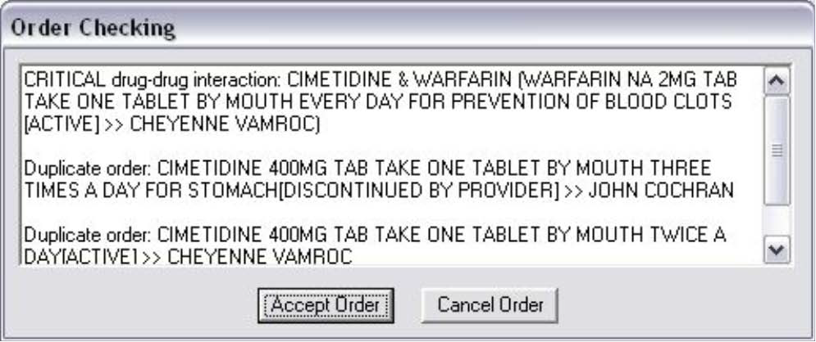
  - You should receive an order check window that indicates this order would constitute a duplicate drug or a duplicate drug class due to the existing prescription that is located at the remote facility.
This dialog should appear for a drug-drug interaction.

- Drug-Allergy Order Check against Remote Data

  - In CPRS, choose a patient that has an active drug allergy that was observed at another VA facility and not at your facility.
  - From the Orders tab, place an outpatient pharmacy order for the same drug to which the patient is allergic, and select Accept.
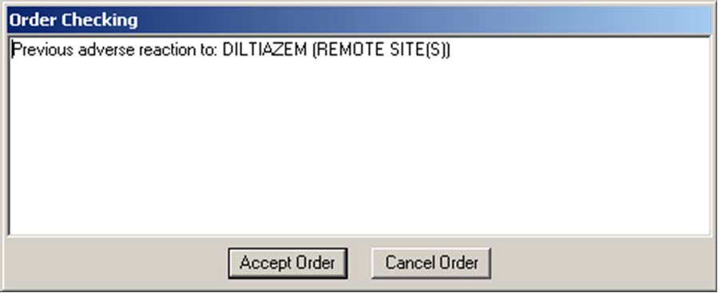
  - You should receive an order check window that indicates the patient has a “Previous Adverse Reaction” to the drug.
For the allergy check, this dialog appears with the (Remote Site(s)) designation.

Production Account: Test Medication Reconciliation Software

The Medication Reconciliation Software uses RDI to get a portion of the data it uses while processing. Thus, it is necessary to test the Medication Reconciliation functionality to ensure that nothing was broken by the change in retrieval mechanism of RDI that is implemented in this patch (OR*3.0*294.)

Validate Medication Reconciliation Functionality Is NOT Adversely Impacted by OR*3*294
  - Identify a patient with known remote data. Ideally, the patient would have the following characteristics:
    - Data on two remote systems
    - Medications on both of those systems
    - On each system, there are medications in a variety of statuses (Active, Active/Suspended, Hold, Expired, Discontinued)
    - On one system, there is allergy data
    - On the other system, there is no allergy data or NKA (just something to be different…this tests technical issues, not clinical relevance)

  - Given a patient with that setup, generate a health summary (could be done via Ad Hoc) for both of the remote components–RART and RDIM. RDIM might be labeled as HDRM on some systems, because of an issue with early Class III documentation.
  - Make the changes between the two systems as you are doing similarly for other tests.
  - Wait at least 2 hours so that the remote data can have time to expire and clear out.
  - Repeat the health summary generation on the new system.

  - Evaluate that both components generated all of the same data. You should get identical allergy information, and in both cases, just the active/suspended medications, not the hold, expired, discontinued medications.

NOTE
If you experience problems with the RDI software after the installation of OR*3.0*294, you can revert to the previous state by installing the backup of the routines you created before the install. By doing this, the RDI software will revert to using the HL7 method of communicating with HDR. However, the web service and web server entries will remain on the system, but will not be used until OR*3.0*294 is installed again.

