Electronic Wait List (EWL) for Scheduling and Primary Care Management Module (PCMM)

User Manual

November 2002

(Revised March 2016)

Department Of Veterans Affairs
Office of Enterprise Development
Management, Enrollment, Financial Systems

Revision History

Initiated on 12/27/2004

Date | Description (Patch # if applic.) | Project Manager | Technical Writer
12/27/2004 | Manual updated to comply with SOP 192-352 Displaying Sensitive Data | REDACTED | REDACTED
03/15/2006 | Manual updated to include enhancements made by Patch SD*5.3*420 - EWL Transmission Fields | REDACTED | REDACTED
09/28/2006 | Manual updated to include enhancements made by Patches SD*5.3*327 SD*5.3*394 SD*5.3*417 & SD*5.3*467 | REDACTED | REDACTED
11/07/2006 | Manual updated to include enhancements made by Patch SD*5.3*419 - EWL AD HOC Wait Time Report | REDACTED | REDACTED
06/19/2007 | Manual updated to include enhancements made by Patch SD*5.3*446 - Scheduling Beyond 120 Days | REDACTED | REDACTED
08/04/2008 | Manual updated to include corrections made by Patch SD*5.3*491 - EWL, PAIT and SCHEDULING Corrections | REDACTED | REDACTED
10/09/2008 | Patch SD*5.3*505 – Updated Wait List Statistic Report | REDACTED | REDACTED
10/22/2008 | Formatting Changes | REDACTED | REDACTED
06/25/2009 | Manual updated (p. 7) for change made by Patch SD*5.3*538 - ELECTRONIC WAIT LIST FIXES | REDACTED | REDACTED
06/19/2012 | Manual updated (p. 50, 70) for change made by Patch SD*5.3*539 - ELEC WAIT LIST, PAT APPT INFO TXN, PRIM CARE MGT MOD FIXES | REDACTED | REDACTED
03/19/2014 | Patch SD*5.3*594 updates. Page 6, enhancement allows scheduling more than 120 days from the “desired date”. Page 20, cancelling an appointment description clarified. | REDACTED | REDACTED
04/16/2016 | Patch SD*5.3*524 update. Page 33, add menu item for new report. Page 50, new report description. | REDACTED | REDACTED
03/15/2016 | Patch SD*5.3*638, DISABLE EWL TRANSMISSION OPTION, update. Removed contents of “Transmission to National Patient Care Database in Austin” section. | REDACTED | REDACTED

Table of Contents

Introduction 1
Sensitive Information 2
Related Manuals 2
Orientation 3
Overview of the Electronic Wait List (EWL) 3
Important Concepts 5
Inter-Facility Transfer 5
EWL Scheduling Beyond 120 Days 6
Disposition of Matching EWL Entries 7
Placing Patients on Multiple Wait Lists 9
When a Clinic Cancels an Appointment 9
Service Connected Appointment Type 10
How Priority Works 11
Report/Inquiry 13
Background Job 14
Business Rules Tables 16
Using the EWL Software 18
Electronic Wait List Standalone Menu 18
Wait List Parameter Enter/Edit (Sch/PCMM) 22
Inquire Wait List (Sch/PCMM) 25
Enter/Edit Wait List 27
Disposition Wait List (Sch/PCMM) Entry 31
Wait List (Sch/PCMM) Reports 33
SD Wait List Cleanup 51
Electronic Wait List via Scheduling Appointment Management Menu 52
PCE (Patient Care Encounter) and EWL 57
Electronic Wait List via PCMM GUI 58
PCMM GUI 58
Wait List Utilities Menu 61
Inter-facility Transfer Request 62
New Request 62
View Request Details 64
Remove Transfer Request 65
Display Inactive Entries 66
Inter-facility Transfer Request Acceptance 67
Request Summary 67
Request Details 67
Wait List Batch Clinic Change 69
Use the Wait List as a Scheduling Reminder 70
Open Closed EWL Entry 71
Using EWL When Team is Under Maximum Capacity 72
Wait List Import Tool 73
Transmission to National Patient Care Database in Austin 82
Glossary 83
Appendix A - Patch SD*5.3*420 - EWL Transmission Fields 87
Appendix B – 132 Column Sample Reports 89
Wait List Statistic Report 89
Enrollment Wait List Statistic Report 92
EWL Wait Time Statistics 94

Introduction

The user manual for Electronic Wait List (EWL) Version 1.0, for Scheduling and Primary Care Management Module (PCMM) provides instruction in the use of the Electronic Wait List (EWL). Access to the EWL is available in four separate applications.
- The EWL Stand-Alone program
- PCMM GUI
- PCMM VistA
- Scheduling Appointment Management Module

The EWL protocols, on the Appointment Management menu, may also be added to a Patient Care Encounter (PCE) List Manager menu if desired.

Recognizing a need to effectively track the demand for services at Department of Veterans Affairs (VA) hospitals and Community Based Outpatient Clinics (CBOCs) versus their ability to meet this demand, REDACTED, then Deputy Under Secretary of Health O & M, sent a memo to REDACTED, then Deputy CIO for Health, VHA, requesting the development of an electronic wait list. Here is an excerpt from the memo dated February 1, 2002.

As you are aware, clinic-waiting times has become a high visibility issue with the Secretary’s office. We report data monthly during the Deputy Secretary’s Performance briefings. Current waiting time measures reflect the experience of veterans already “in the system” and do not accurately portray waiting time experiences of new enrollees or patients without a scheduled appointment. Whether due to absence of appointments or other reasons, ad hoc “waiting lists” of new veteran enrollees to be entered into the scheduling system are known to exist, and waiting times for new enrollees seeking care are anecdotally reported to be long. We will attempt to formalize an “electronic waiting list” in VistA to more consistently and accurately reflect demand across VHA, and reduce the risk to enrollees lost to follow-up due to clerical error.

The EWL assists VA Medical Centers, Community Based Outpatient Clinics, and VHA Central Office in managing veterans’ access to outpatient health care. The EWL also assists clinics in identifying patients waiting for appointments and/or PCMM panel assignments.

Within the EWL stand-alone software program, a patient may be placed on a Wait List for a Primary Care team or position, a scheduling service/specialty, or a specific clinic. A patient can only be placed on a Wait List for a team or position if that team/position has met or exceeded capacity. To place a patient on a position Wait List, the patient must first be assigned a Primary Care team.
EWL software activates in the VistA Scheduling application through Appointment Management when an appointment for a clinic (set up in the Parameter file) is not available or cancelled. When utilizing the scheduling option, the user is notified prior to invoking the option if the patient is rated service connected 50% or greater. Within PCMM GUI, the EWL software activates when a Primary Care team or provider is not available to a patient. Specifically, this is when the panel is at or above capacity. Reports are available from the EWL Report option.

Sensitive Information

To avoid displaying sensitive information regarding our patients and staff, the examples in this manual contain pseudonyms or scrambled data instead of real names. Our patients and staff will be referred to as “EWLPATIENT, ONE”, “EWLPROVIDER, ONE”, or “EWLUSER, ONE.” Scrambled data is a series of random letters that replace a real name like “AAADY, JWHTRE”. Likewise real social security numbers (SSNs), real addresses and other personal identifiers are not used.

Related Manuals

The documentation for Electronic Wait List (EWL) Version 1.0 includes the following related manuals, located on the VistA Documentation Library (VDL) website. http://www.va.gov/vdl/application.asp?appid=131

- EWL Installation Guide
- EWL Release Notes

Orientation

This user manual assumes that readers have a working knowledge of the PCMM GUI and VistA, VistA Scheduling, and other VistA software applications. Screen displays may vary among different sites and you may not see the data on your monitor exactly as shown in this manual. Although screens are subject to modification, the major menu options, as they appear in this manual, are fixed and are not subject to modification (except by the package developer).

Overview of the Electronic Wait List (EWL)

In the outpatient setting, patients are assigned a primary care team and provider who are responsible for delivering essential health care, coordinating all health care services, and serving as the point of access for specialty care. This is accomplished through the Primary Care Management Module (PCMM) of the Veterans Health Information Systems and Technology Architecture (VistA). When a patient cannot be assigned to a primary care team or position, the PCMM software asks if the patient should be placed on the Electronic Wait List. PCMM Wait List reports assist in the management of patients awaiting a primary care team or provider assignment.

The purpose of EWL is to provide quicker or more convenient patient care by providing care by another team or location for the patient’s benefit. The EWL can be accessed through the PCMM GUI or by a Standalone Roll and Scroll application from the VistA Scheduling Appointment menu, as well as from the Scheduling Appointment Management Menu. The EWL standalone menu is accessible to users with the SDWL MENU security key.

The goal of the EWL is to provide care to the patient as quickly as possible. To facilitate this goal, patients may be placed on a Wait List for a different team or even at a different facility. The EWL keeps track of appointments, clinics, and providers associated with patients on the various Electronic Wait Lists. Patient eligibility information and service connected status is also recorded and updated. The EWL runs a background job to determine patient changes in the veteran’s service connected percentage, service connected priority as well as changes to appointment, clinics, and personnel that affect Wait List patients. EWL also sends messages to assigned mail groups to notify of such changes.

The Electronic Wait List can also produce reports on demand regarding EWL related activities.

Important Concepts

The following sections discuss important concepts and business rules that govern the use of the Electronic Wait List. A step-by-step view of the EWL Menus is discussed in the section Using the EWL Software.

Inter-Facility Transfer

The EWL Inquire option checks whether an EWL entry is the subject of an Inter-Facility Transfer. If so, this information is displayed. In the Enter/Edit Wait List (Sch/PCMM) option, at the point where a new EWL entry has been requested, a look-up is performed on the Inter-Facility Transfer file (#409.36). If the patient has a transfer pending, a new prompt appears asking if a new EWL entry should be created (transferring the patient from the requesting facility). In this way, an association is made with the newly created EWL entry and the EWL entry at the requesting facility. This association is maintained until EWL entry at the receiving facility is closed.

An EWL entry cannot be edited while it is the subject of an Inter-Facility Transfer. It should be stressed that it is not possible to simply reopen an EWL entry closed due to a transfer. First, the continuation EWL entry must be removed or the connection is broken.

When an EWL entry, which is the subject of an Inter-Facility Transfer, is closed, this normally concludes the transfer. An exception to this is if the disposition reason is ENTERED IN ERROR. In this case, the status of the transfer file at the facility returns to PENDING. Otherwise, a message is returned to the requesting facility and the associated EWL entry there is closed.

Special flags indicate and track the patient's primary care transfer, rejection, and multiple team assignments. These flags work in the background and shall provide information to the Austin Automation Center (AAC) in the near future.

- INTRA TRANSFER - identifies the patient's preferred location
- REJECTION - indicates that there are locations with available Primary Care teams while the patient opted to be put on the Wait List.
- MULTI TEAM - the requested location has more than one team, and one Wait List entry was created for each team.

See detailed information in section titled Inter-facility Transfer Request.

EWL Scheduling Beyond 120 Days

Make every effort to schedule appointments at most 120 days from the “desired date”. If an appointment is scheduled more than 120 days from the desired date, the system will prompt the user to create a Wait List entry. This entry will be created with the "120 Days" flag.

The ability to use the related clinic will be allowed even if it is not set up in the SD WL CLINIC LOCATION file (#409.32). That entry will be created during this process if applicable. If the user chooses to continue with the appointment entered by answering the EWL question ‘NO’, the system will continue with the appointment making process.

The date is more than 120 days beyond the Desired Date
Add to EWL? YES// NO

APPOINTMENT MADE

If a Wait List entry is created, a message is sent to the EWL Mail Group concerning the "120 Days" flags. When viewed through Wait List – Inquiry, an entry with the 120-day flag will display a comment as shown below.

Subj: EWL opened entry with a 120 days flag [#442794] 05/30/07@15:20 10 lines
From: POSTMASTER In 'IN' basket. Page 1 *New*
-------------------------------------------------------------------------------
An open Wait List entry was created with a 120 days flag, indicating that it
was not possible to schedule an appointment for the listed clinic within
120 days of the desired date.

An EWL Entry was created for the following patient,

PATIENT NAME SSN EWL
--------------------------------------------------------------------------
EWLPATIENT,TWO 000020246 CECELIA'S CARDIOLOGY

Enter message action (in IN basket): Ignore//

Disposition of Matching EWL Entries

When users make an appointment, VistA searches to see if the appointment has a matching stop code in open EWL entries of the SPECIFIC CLINIC or SERVICE/SPECIALTY EWL types. If the system finds a match, an on-screen message will appear, as shown below, as well as a list of matching EWL entries. If the user selects an EWL entry from the list it will be closed. VistA automatically assigns the matching entry with the (SA)REMOVED/SCHEDULED-ASSIGNED disposition type.

If you do not want to close a particular EWL entry, pressing the ‘Enter’ key allows you to keep the EWL entry opened but requires you to give a non-removal reason for not closing that entry.

==========================================================================
Open EWL entries matching appointment specialty
-----------------------------------------
EW List Type SC/P Waiting for Institution Orig Date By Des. Date Reopen
--------------------------------------------------------------------------------
1. CLINIC N/ DONNA'S CLINIC REDACTED 30 Oct 06 30 Oct 06
Comment: Follow-up needed
2. CLINIC N/F DONNA'S CLINIC REDACTED 20 Dec 06 PAT 15 Dec 06
Non-Removal Reason: Provider wants another appointment
Select one of the above open EWL entries to close with an appointment or press ‘Enter’ key to continue>: (1-2): 2

*** Patient has been removed from Wait List ***

If a matching EWL entry is not removed, the user is required to enter a non-removal reason for each matching appointment, if it has not already been entered. All open, matched entries will be displayed again when a new appointment entry occurs, including those with a previously entered non-removal reason. At this point, an EWL entry can be closed, left opened with an existing non-removal reason, or a new non-removal reason can be entered to keep the entry open.

==========================================================================
Open EWL entries matching appointment specialty
-----------------------------------------
EW List Type SC/P Waiting for Institution Orig Date By Des. Date Reopen
--------------------------------------------------------------------------------
1. CLINIC N/ DONNA'S CLINI REDACTED 30 Oct 06 30 Oct 06
Comment: Follow-up needed
2. CLINIC N/F DONNA'S CLINI REDACTED 20 Dec 06 PAT 15 Dec 06
Comment: > 120 days;
Non-Removal Reason: Provider wants another appointment

Select one of EWL entries to enter a non-removal reason or press 'Enter' key to
accept the current one: : (1-1): 1

Select one of the following:

1 APPOINTMENT CRITERIA NOT MET
2 PATIENT WANTS ANOTHER APPOINTMENT
3 PROVIDER WANTS ANOTHER APPOINTMENT
4 OTHER

Select one of the following reasons for #: 1:

NOTE: The same EWL Entry matching functionality exists when the user performs CHECK OUT on an existing appointment that was entered in the past.

Placing Patients on Multiple Wait Lists

When prompting a user for Wait List Type, the system displays all types of Wait Lists (i.e., PCMM team, PCMM position, Specific Clinic, Service/Specialty Clinic) regardless of current entries. The system displays the team associated with the PCMM position. This permits users to place patients on Wait Lists for multiple Primary Care Panels. Patients cannot be placed on the same TEAM multiple times nor can patients be assigned POSITIONS not defined to the specific TEAM. POSITION assignment can be made multiple times for the same TEAM, but the same POSITION can be assigned only one time. In addition, the display of POSITION(S) will include the TEAM associated with the POSITION for clarity.

It should also be noted that users may assign a patient to a Wait List for a specific position. However, that patient must be assigned to the appropriate TEAM prior to the position assignment.

When a Clinic Cancels an Appointment

EWL entries are synchronized with appointments by placing the patient back on the Wait List immediately whenever an appointment is cancelled by the decision of the clinic (denoted by appointment statuses C: CANCELLED BY CLINIC or A: CANCELLED BY CLINIC & AUTO-REBOOK), then interactively allowing the user to match an open Wait List entry with a rebooked appointment.

Service Connected Appointment Type

An appointment type called ‘SERVICE CONNECTED’ is used to flag and keep track of service-connected appointments. Service connected information is displayed when making an appointment. If the veteran’s service connection is 50 percent or greater, the display will look like this.

PATIENT'S SERVICE CONNECTION AND RATED DISABILITIES: SC Percent: 100% LEG, AMPUTATION: LOSS KNEE ACTION (SC - 100%)
Primary Eligibility Code: SERVICE CONNECTED 50% to 100%
APPOINTMENT TYPE: SERVICE CONNECTED//

Notice that if the patient’s service connection is 50% or greater the default prompt for appointment type may change to ‘SERVICE CONNECTED’.

Note: If the default appointment type for this Clinic is set to ‘REGULAR’, the appointment type default will change to ‘SERVICE CONNECTED’. If the default appointment type is not set to ‘REGULAR’ (e.g., C&P, Research, etc.), the default prompt will not change, but the Appointment Type can be manually overwritten.

Service connected information is displayed when making an appointment. If the veteran’s service connection is less than 50 percent, the display will look like this.

PATIENT'S SERVICE CONNECTION AND RATED DISABILITIES: SC Percent: 40% Primary Eligibility Code: SC LESS THAN 50% No Service Connected Disabilities Listed

If the veteran’s service connection is less than 50%, a prompt will ask if this appointment is for a service-connected condition as shown below. If you answer ‘Y’ or ‘YES’, the appointment type prompt may change to ‘SERVICE CONNECTED’.

Note: If the default appointment type for this Clinic is set to ‘REGULAR’, the appointment type default will change to ‘SERVICE CONNECTED’. If the default appointment type is not set to ‘REGULAR’ (e.g., C&P, Research, etc.), the default prompt will not change, but the Appointment Type can be manually overwritten.

IS THIS APPOINTMENT FOR A SERVICE CONNECTED CONDITION? (Y OR N): Y APPOINTMENT TYPE: SERVICE CONNECTED//

If at Check-out (Appointment Check-in/Check-out) the provider answers the question 'Is this appointment for an SC condition' different from the answer provided by the patient and entered by the user making the appointment, the provider’s answer will take precedence and set the APPOINTMENT TYPE.

How Priority Works

The Electronic Wait List is required to track the veteran’s service connected percentage of disability.

Patients with a service connected percentage of 50% or greater automatically receive a priority designation, while those patients with a service connected percentage less than 50% only receive a priority designation if their requested appointment is related to their service connected condition.
If a patient's service connected percentage changes, the following rule is applied to the patient's service connected priority: The Electronic Wait List is also required to track whether the appointment is related to a service connected disability.

In SD WAIT LIST file (# 409.3), the SERVICE CONNECTED PRIORITY field (#15) will be set to 'YES' if the SERVICE CONNECTED PERCENTAGE field (#.302) changes from less than 50% to 50% or greater. If the SERVICE CONNECTED PERCENTAGE field (#.302) changes and the SERVICE CONNECTED PRIORITY is updated, a MailMan bulletin with a subject line of "EWL SC Patient Update with SC Priority" will be sent to members of the mail group SD EWL BACKGROUND UPDATE, listing the patients' names.

Example of MailMan Bulletin

Subj: EWL SC Patient Update with SC Priority [#165697]
12/09/04@09:28 4 lines
From: POSTMASTER In 'IN' basket. Page 1 *New*
Patient Name SSN OLD-EWL/SC % NEW-EWL/SC % PRIORITY
------------------------------------------------------------------------ EWLPATIENT, THREE 9999 40 50 YES

A MailMan bulletin with a subject line of "EWL SC Patient Update with SC Percentage Change" will be sent to members of the mail group SD EWL BACKGROUND UPDATE if the SERVICE CONNECTED PERCENTAGE (#.302) changes from 50 % or greater to less than 50%. This bulletin will also be sent to the above mail group if the SERVICE CONNECTED PERCENTAGE (#.302) is initially less than 50% and changes to a different value that is also less than 50%, but less than its initial SERVICE CONNECTED PERCENTAGE field (#.302) value. The bulletin will list the patient(s) and include an additional note, "EWL SC PRIORITY MAY REQUIRE MANUAL UPDATE PLEASE REVIEW". Each site will determine whether the SERVICE CONNECTION PRIORITY (#15) needs updating and will need to change this field manually. The new option Service Connected Wait List (Sch/PCMM) Edit [SD WAIT LIST SC PRIORITY EDIT] was created to edit the new field SERVICE CONNECTED PRIORITY (#15). This new option is not attached to any menus. The EWL coordinator at each site should determine who will be assigned this option.
Example of MailMan Bulletin

Subj: EWL SC Patient Update with SC Percentage Change [#165699]
12/09/04@09:48 6 lines
From: POSTMASTER In 'IN' basket. Page 1 *New*
-------------------------------------------------------------------------------
Patient Name SSN OLD-EWL/SC % NEW-EWL/SC % MULTI-ENTRIES
-------------------------------------------------------------------------------
** NOTE: EWL SC PRIORITY MAY REQUIRE MANUAL UPDATE, PLEASE REVIEW **
EWLPATIENT, THREE 9999 30 40 YES

Report/Inquiry

The options Appointment (Sch/PCMM) Wait List Report [SD WAIT LIST APPT REPORT] (detailed report only) and Inquire Wait List (Sch/PCMM) [SD WAIT LIST INQUIRY] display the SERVICE CONNECTED PRIORITY field (#15). During installation, the SERVICE CONNECTED PRIORITY field (#15) in the SD WAIT LIST file will be set. This field will be set to NO for current patients in this file with eligibility of SC less than 50%. Some of these patients may be on the Wait List for service-connected disabilities. It is up to the site to determine if these entries should be changed to YES. A printout of the Appointment (Sch/PCMM) Wait List Report [SD WAIT LIST APPT REPORT] (detailed only) will list all patients and display the field SERVICE CONNECTED PRIORITY.

Example of Appointment (Sch/PCMM) Wait List Report (detailed report)

Institution: VAMC REDACTED
Clinic/Service: PRIMARY CARE
EWLPATIENT, ELEVEN 9999 Desired Date: MAY 19, 2005
Primary Eligibility: SC LESS THAN 50%
Service Connected Priority: YES
Comments: THIS IS A REGULAR COMMENT
Requested by: PATIENT
Telephone (Home): 555-555-5555
__________________________________________________________________________
Institution: VAMC REDACTED
Clinic/Service: CARDIOLOGY
EWLPATIENT , SIX 9494 Desired Date: MAY 05, 2005
Primary Eligibility: SERVICE CONNECTED 50% to 100%
Service Connected Priority: YES
Comments:
Requested by: PATIENT
Telephone (Home): 555-555-5555

Example of Inquire Wait List (Sch/PCMM) [SD WAIT LIST INQUIRY]

PATIENT: EWLPATIENT, SEVEN ORIGINATING DATE: MAY 18, 2005
INSTITUTION: REDACTED, NY VAMC WAIT LIST TYPE: PCMM TEAM ASSIGNMENT
WL SPECIFIC TEAM: TEAM 1 ORIGINATING USER: EWLSTAFF, ONE
CURRENT STATUS: OPEN COMMENTS: TEST
EWL ENROLLEE STATUS: PRIOR SERVICE CONNECTED PERCENTAGE: 50
SERVICE CONNECTED PRIORITY: YES

Background Job

SD EWL BACKGROUND JOB
The background job performs multiple operations. The routine SDWLQSC runs in the background as scheduled by the site to determine the following.

1) The SD EWL BACKGROUND JOB opens a closed EWL entry if the appointment cancellation was the clinic’s decision. The background job has been modified to remove the cancelled appointment data from the opened EWL entry to prevent that entry from being reopened if it is closed again with the same disposition code: SA: REMOVED/SCHEDULED-ASSIGNED.

A MailMan message is sent to recipients in the SD EWL BACKGROUND UPDATE mail group indicating that EWL entries were opened because of cancelled appointments with a listing of the patients, clinics, and date/times when the cancelled appointments had been scheduled. Each e-mail message may contain one or more appointments depending on the options and actions used to cancel appointments. Every cancelled appointment that results in opening an EWL entry will appear in a message, including EWL entries optionally closed by rebooking the appointment immediately after cancelling.

2) The SD EWL BACKGROUND JOB includes a search for potential matching appointments and/or encounters created for the same clinic or specialty as open EWL entries. The matching appointments/encounters would have to have their date/time not older than the Origination Date of the related open EWL entries. If the matching encounters are identified as described above, a message is sent to the mail group SD EWL BACKGROUND UPDATE, with a listing of those opened entries that should potentially be closed. These messages will include the patient’s SSN.

3) The SD EWL BACKGROUND JOB determines changes in the veteran’s service connected percentage and service connected priority. The business rules for this process are described in the Business Rules Tables for the SD EWL BACKGROUND UPDATE. Two messages have been created; Message 1 titled EWL SC Patient Update with SC Priority and Message 2 titled EWL SC Patient Update with SC Percentage Change. The appropriate message will then be sent to the user group. Message 1 will report that the SERVICE CONNECTED PRIORITY has been changed and both the old and new service connected percentage will be printed on the message. Message 2 will indicate that a manual review will be required and no updates to the EWL record will occur.
Example of messages

Message 1 (EWL SC Patient Update with SC Priority)

Subj: EWL SC Patient Update with SC Priority [#165697] 12/09/04@09:28 4 lines
From: POSTMASTER In 'IN' basket. Page 1 *New*
Patient Name SSN OLD-EWL/SC % NEW-EWL/SC % PRIORITY
---------------------------------------------------------------------------- EWLPATIENT, THREE 000-66-9999 40 50 YES

Message 2 (EWL SC Patient Update with SC Percentage Change)

Subj: EWL SC Patient Update with SC Percentage Change [#165699]
12/09/04@09:48 6 lines
From: POSTMASTER In 'IN' basket. Page 1 *New*
-------------------------------------------------------------------------------
Patient Name SSN OLD-EWL/SC % NEW-EWL/SC % MULTI-ENTRIES
-------------------------------------------------------------------------------
** NOTE: EWL SC PRIORITY MAY REQUIRE MANUAL UPDATE, PLEASE REVIEW **
EWLPATIENT, THREE 000-66-9999 30 40 YES

Business Rules Tables

The following tables document the business rules related to the changes included in patch SD*5.3*394.

SD EWL BACKGROUND JOB OPTION

PATIENT FILE SC | EWL SC | SC %  UPDATE | PRIORITY  UPDATE | MESSAGE TYPE
('<50) & (=) | (<50) & (=) | NO | NO | NONE
<50 | ('<50) | YES | NO | MESSAGE 2
>49 & (=) | >49 & (=) | YES | YES | NONE
<50 & (=) | <50 & (=) | NO | NO | NONE
>49 | <50 | YES | YES | MESSAGE 1
<50 & (=) | <50 & (=) | YES | NO | MESSAGE 2

MAKE APPOINTMENT SERVICE CONNECTED APPOINTMENT CRITERIA.

SERVICE CONNECTED | SC  PERCENTAGE | PRIMARY ELIG | RESULT
NO | >49% | SERVICE CONNECTED 50 - 100 | Error Message
NO | <50% | SERVICE CONNECTED 50 - 100 | Error Message
NO | NULL | SERVICE CONNECTED 50 - 100 | Error Message
NO | >49% | NULL | Error Message
NO | <50% | NULL | Error Message
NO | NULL | NULL | Error Message
NO | >49% | OTHER STATUS | Error Message
NO | <50% | OTHER STATUS | Error Message
NO | NULL | OTHER STATUS | No Message
NO | >49% | SC LESS THAN 50 | Error Message
NO | <50% | SC LESS THAN 50 | Error Message
NO | NULL | SC LESS THAN 50 | Error Message
NULL | >49% | SERVICE CONNECTED 50 - 100 | Error Message
NULL | <50% | SERVICE CONNECTED 50 - 100 | Error Message
NULL | NULL | NULL | Error Message
YES | NULL | SERVICE CONNECTED 50 - 100 | Error Message
YES | >49% | NULL | Error Message
YES | <50% | NULL | Error Message
YES | NULL | NULL | Error Message
YES | >49% | OTHER STATUS | Error Message
YES | <50% | OTHER STATUS | Error Message
YES | NULL | OTHER STATUS | Error Message
YES | >49% | SC LESS THAN 50 | Error Message
YES | <50% | SC LESS THAN 50 | No Message
YES | NULL | SC LESS THAN 50 | No Message
YES | >49% | SERVICE CONNECTED 50 - 100 | No Message
YES | <50% | SERVICE CONNECTED 50 - 100 | Error Message
YES | NULL | NULL | Error Message

Using the EWL Software

The following instructions and examples assume that the user is beginning at the Scheduling Appointment menu. All user actions appear in bold print. You must press <RETURN> after you have chosen each option.

Electronic Wait List Standalone Menu

The Electronic Wait List (EWL) menu option appears on the Scheduling Appointment menu. The EWL standalone menu is accessible to users with the SDWL MENU security key. If the Wait List options at your site are not functioning, they may be blocked locally. If this is the case, please contact your local ADPAC or IRM.
The SDWL Parameter security key provides for entering and editing Specific Clinics and Service/Specialties that use the EWL at each facility.

NOTE: All Clinics and Service/Specialties that will use EWL must be setup in the Scheduling application prior to use by EWL. Designate institutions for Service/Specialties PRIOR to utilizing the Import Tool.

Active clinic division/institution assignments can be reviewed by running the FileMan sort/print template provided below.

FileMan Sort & Print Templates:

Select OPTION: PRINT FILE ENTRIES

OUTPUT FROM WHAT FILE: HOSPITAL LOCATION//
SORT BY: NAME// TYPE="CLINIC"
WITHIN TYPE="CLINIC", SORT BY: INACTIVATE DATE=""
WITHIN INACTIVATE DATE="", SORT BY: NAME
START WITH NAME: FIRST//
WITHIN NAME, SORT BY:
STORE IN 'SORT' TEMPLATE:
FIRST PRINT FIELD: NAME
THEN PRINT FIELD: DIVISION
THEN PRINT FIELD: INSTITUTION
THEN PRINT FIELD:
Heading (S/C): HOSPITAL LOCATION LIST Replace
STORE PRINT LOGIC IN TEMPLATE:
START AT PAGE: 1// DEVICE: <select device>
HOSPITAL LOCATION LIST FEB 2,2007 11:21 PAGE 1
NAME DIVISION INSTITUTION
-------------------------------------------------------------------------------

OBSERVATION REDACTED VAMC REDACTED
OPC RADIOLOGY REDACTED VAMC REDACTED
ORTHO-CLINIC REDACTED VAMC REDACTED
OUTPATIENT LAB REDACTED VAMC REDACTED
PAT GM/SURG REDACTED VAMC REDACTED
PAT MH/NURS REDACTED (****missing institution****)

NOTE: If the institution field is blank, FileMan Enter/Edit must be utilized to enter the appropriate institution from the national institution file. Service/Specialties can be assigned an institution by utilizing the Wait List Parameter Enter/Edit option. The institution field points to the national institution file. If the site’s divisions are not entered in the national institution file, they need to be in order to be used with EWL.

FileMan Enter/Edit Example

Select OPTION: ENTER OR EDIT FILE ENTRIES
INPUT TO WHAT FILE: HOSPITAL LOCATION//

EDIT WHICH FIELD: ALL// INSTITUTION
THEN EDIT FIELD:

The SDWL keys DO NOT block the following three prompts in the Scheduling software. Each site must decide on use of the Wait List software at their site and implement the decision(s) through site-specific procedures and training. These decisions are particularly important to consider during the time of installation and local wait list cutover. These are the three prompts, within the Scheduling routines, that require site-specific procedures and training to implement successfully.
1. In the Make Appointment option, if a date and time are not entered for a clinic appointment the question is displayed, “Do you want to add this patient to the Wait List? NO//. No is the default answer. For users instructed not to use the EWL, a recommendation is to train them to always accept the “No” default. Only clinics set up in the Parameter file triggers this Wait List prompt. If a clinic appointment is made for a patient who is on the Wait List, the user is asked if they would like to remove the patient from the Wait List for that clinic. The default is yes but the response may be No and a reason given.

2. If an Unscheduled Visit is entered for a patient who is on the EWL for the same clinic, the user sees a prompt asking if the patient should be removed from the EWL for that clinic. Yes or No may be entered. Entering No requires entry of a reason code. The question only occurs for clinics set up in the EWL Parameter file.
3. When canceling an appointment for a patient, if there are entries for this patient on the Wait List for that clinic/service specialty, the user sees a message on the screen "There are Wait List entries waiting for an Appointment for this patient in (Name of) Clinic." This message could be used to prompt users to notify authorized staff about needed appointments. The prompt only occurs for clinics set up in the EWL Parameter file.

An institution must be entered for all Clinics and Service/Specialties that use EWL. Active clinic institution assignments can be verified by running a FileMan inquiry to the HOSPITAL LOCATION file (#44).

The EWL menu provides the following functionality.

1. Enter a patient on the EWL and assign the patient an EWL TYPE of the following.
Specific clinic
Scheduling service/specialty
Primary care team
Primary care position
2. Edit the EWL entry.
3. Inquire to a patient’s EWL entries.
4. Disposition the EWL entry
5. Produce reports in both summary and detail format.
6. Allow the setting of local parameters for clinics and service/specialties by institution.

For the purposes of this user manual, we explain each of the above options in the order that they appear to the user on the screen with the exception of the Wait List (Sch/PCMM) Parameter Enter/Edit option, which because of its importance is explained first. This is how the menu appears to the user. The Wait List (Sch/PCMM) Menu option is found within the Appointment Menu.
Select Scheduling Manager's Menu Option: Appointment Menu

AM Appointment Management
CK Appointment Check-in/Check-out
WL Wait List (Sch/PCMM) Menu ...
Add/Edit Stop Codes
Append Ancillary Test to Appt.
Cancel Appointment
Chart Request
Check-in/Unsched. Visit
Computer Generated Menu ...
Delete Ancillary Test for Appt.
Discharge from Clinic
Display Appointments
Edit Clinic Enrollment Data
Enrollment Review Date Entry
Find Next Available Appointment
Make Appointment
Multiple Appointment Booking
Multiple Clinic Display/Book
No-Shows
Select Appointment Menu Option: WL Wait List (Sch/PCMM) Menu

1 Inquire Wait List (Sch/PCMM)
2 Enter/Edit Wait List (Sch/PCMM)
3 Disposition Wait List (Sch/PCMM) Entry
4 Wait List (Sch/PCMM) Reports ...
5 Wait List (Sch/PCMM) Parameter Enter/Edit

Select Wait List (Sch/PCMM) Menu Option:

Wait List Parameter Enter/Edit (Sch/PCMM)

Users assigned the SDWL Parameter key are able to set the parameters for their Wait List functionality. By setting parameters, the user can determine which service/specialties and clinic locations by institution are available for Wait List entry.

NOTE: Specific Clinics and Service/Specialties must be set up for each Institution/Division before Importing Wait List entries with the Import Tool and/or using the EWL.

Select Wait List (Sch/PCMM) Menu Option: Wait List (Sch/PCMM) Parameter Enter/Edit

Wait List Parameter Enter/Edit
Select one of the following:
1. Wait List Service/Specialty (409.31)
2. Wait List Clinic Location (409.32)
When setting parameters for a service/specialty, the user chooses from a list of DSS identifiers from the CLINIC STOP file (#40.7).
Enter response: 1 Wait List Service/Specialty File

Select DSS ID: ?

Do you want the entire CLINIC STOP List? Y (Yes)

Choose from:
ACTIVE DUTY SEX TRAUMA 524
AMB SURGERY EVAL BY NON-MD 416
AMPUTATION CLINIC 418

Select DSS ID: 418 AMPUTATION CLINIC 418

Once the user has selected the DSS identifier, the user chooses from a list of institutions in file (#4) that are associated with that particular identifier. The user is asked for the institution for the particular service/specialty that is being activated.

Select INSTITUTION: ?
You may enter a new INSTITUTION, if you wish
Answer with INSTITUTION NAME, or STATUS, or STATION NUMBER, or
OFFICIAL VA NAME, or CURRENT LOCATION, or NAME (CHANGED FROM)
Do you want the entire 304-Entry INSTITUTION List? y (Yes)

ANN ARBOR, MI 506
ASHEVILLE, NC 637
BALTIMORE, MD 512
BALTIMORE MD - 313
BATAVIA, NY 513
BATH, NY 514
BATTLE CREEK, MI 515
BAY PINES, FL 516
ATLANTA, GA 508
ATLANTA- GA 316
AUGUSTA, GA 509
AUSTIN. TX 200

Select INSTITUTION: BAY PINES, FL 516
Are you adding 'BAY PINES, FL' as a new INSTITUTION (the 1ST for this SD WL SERVICE/SPECIALTY)? No// Y (Yes)

The user then chooses an activation date for the service/specialty.
DATE ACTIVATED: T (AUG 22, 2002)
The inactivation date is used when the service/specialty is no longer needed for Wait List purposes.
DATE INACTIVATED: RETURN
The clinics are set up in option SET UP A CLINIC with the Medical Center Division pointing to the Institution in the national Institution file. Periodically, the Chief Business Office sends out a directive and the sites are responsible for maintaining the Medical Center Division file. There is a one to one relationship between a Medical Center Division and an Institution. Each Institution should have the Station Number field (# 99) assigned.
Wait List Parameter Enter/Edit
Select one of the following:

1. Wait List Service/Specialty (409.31)
2. Wait List Clinic Location (409.32)

Enter response: 2 Wait List Clinic Location
Select Clinic: ?
Answer with HOSPITAL LOCATION NUMBER, or NAME, or ABBREVIATION, or TEAM
Do you want the entire HOSPITAL LOCATION List? y (Yes)
Choose from:

50 HAYNES UROLOGY -CHEYENNE VAMROC
51 OUTPT NURSE BLUE TEAM -CHEYENNE VAMROC
57 GIBBENS ENT -CHEYENNE VAMROC
66 MHC JOHNSON -CHEYENNE VAMROC
87 NUCLEAR MED -CHEYENNE VAMROC

Select Clinic: NUCLEAR MED -CHEYENNE VAMROC
DATE ACTIVATED: T (AUG 22, 2002)

The inactivation date is entered when the clinic is no longer needed for Wait List purposes.
Inactivation of a clinic is prevented if there are open EWL entries for that clinic in the SD WAIT LIST file (#409.3).

DATE INACTIVATED: <RETURN>

Inquire Wait List (Sch/PCMM)

The Inquire Wait List option allows a user to view Wait List entries for a patient. Once the user has entered the patient’s name, the user is asked if they want to view “only the open wait lists?” If the user accepts the prompt YES, only the Wait List entries that are open at that time are displayed. An open Wait List entry is one that has not had a disposition reason entered. If the user chooses “no” {meaning the user wants to see OPEN and CLOSED dispositioned entries} the user is asked for a date range. The Wait List entries for the noted time period are displayed. To best illustrate this option, choose to view only open Wait List entries and then all Wait List entries as shown below.
Select Wait List (Sch/PCMM) Menu Option:

1 Inquire Wait List (Sch/PCMM)
2 Enter/Edit Wait List(Sch/PCMM)
3 Disposition Wait List (Sch/PCMM) Entry
4 Wait List (Sch/PCMM) Reports ...
5 Wait List (Sch/PCMM) Parameter Enter/Edit

Select Wait List (Sch/PCMM) Menu: Inquire Wait List (Sch/PCMM)

Example of open Wait List entries for a patient
Wait List -Inquiry
Select PATIENT NAME: TEST, PATIENT A 1-1-44 CAUCASIAN 555551234
YES SC VETERAN GREEN TEAM

Do You Want to View Only 'OPEN' Wait Lists? Yes//

#1
Wait List -SPECIFIC CLINIC Date Entered -09/23/02
PRIMARY CARE GREEN CLINIC
Institution -VAMC REDACTED
Entered by –EWLSTAFF, ONE
Requested By -PATIENT Date Desired -09/23/02
Comments – Patient Requesting appt in Green clinic
*****
Example of all Wait List entries for a patient
Wait List -Inquiry
Select PATIENT NAME: EWLPatient, Five 10-26-38 666-10-2410 NO NSC VETERAN

Do You Want to View Only 'OPEN' Wait Lists? Yes// NO

Note: The “Date Entered” is the date the user placed the patient on the wait list.

Start with Date Entered: T (SEP 23, 2002)
End with Date Entered: T+90 (DEC 22, 2002)

#1

Wait List -SPECIFIC CLINIC Date Entered -09/23/02
AUDIOLOGY
Institution -VAMC REDACTED
Entered by –EWLstaff, Two
Requested By -PATIENT
Date Desired -10/23/02
*****

Wait List -Inquiry
EWLpatient, Five 666-10-2410

# | Wait List Type | P | Waiting For | Institution | Date Entered
1. | PCMM TEAM ASSI |  | RED TEAM | VAMC ALB | 092302

Wait List -SPECIFIC CLINIC Date Entered -09/23/02
AUDIOLOGY
Institution -VAMC REDACTED
Entered by - EWLSTAFF, TWO
Requested By -PROVIDER Date Desired -12/22/02
Provider –EWLPROVIDER, ONE
Comments – Consult request from Dr. Doctor.

Disposition -REMOVED/SCHEDULED-ASSIGNED Disposition Date -09/23/02
Dispositioned by - EWLSTAFF, ONE

NOTE: The closed or inactive EWL entries have the “Disposition,” “Disposition Date,” and the “Dispositioned by” fields displayed.

Enter/Edit Wait List

This option allows users to add patients to a PCMM Team or position, specific clinic or a Service/Section Wait List, or to edit their entries on a Wait List. If the patient is already on a Wait List, a listing of all the current Wait List entries for the patient is displayed. This listing contains the Wait List type, the Wait List modifier (waiting for field,) institution, and date the patient was entered on the Wait List. The user is then asked if they would like to put the patient on a new Wait List or to edit the existing Wait List information. Patients with a date of death are not allowed to have a Wait List entry assigned. The user receives a message that a date of death has been recorded for this patient.
If a clinic's DIVISION field (#3.5) is changed in the HOSPITAL LOCATION file (#44), the corresponding INSTITUTION fields (#2,#.02) in EWL files SD WL CLINIC LOCATION (#409.32) and SD WAIT LIST (#409.3) must be updated as described below.

The institution is determined from a clinic entry in the Hospital Location file (#44):
DIVISION field (#3.5) --> MEDICAL CENTER DIVISION file (#40.8) -->
INSTITUTION FILE POINTER field (#.07) --> INSTITUTION file (#4)

That path is not automatic and is primarily made necessary when a division is entered in the HOSPITAL LOCATION file (#44) in error. Each time a division correction takes place, the SD Wait List Cleanup [SD WAIT LIST CLEANUP] option must be run to update the SD WL CLINIC LOCATION file (#409.32) and the SD WAIT LIST file (#409.3).

Examples of PCMM Team Wait List entry

Select Appointment Menu Option: WL Wait List (Sch/PCMM) Menu
1 Inquire Wait List (Sch/PCMM)
2 Enter/Edit Wait List(Sch/PCMM)
3 Disposition Wait List (Sch/PCMM) Entry
4 Wait List (Sch/PCMM) Reports ...
5 Wait List (Sch/PCMM) Parameter Enter/Edit

Select Wait List (Sch/PCMM) Menu Option: Enter/Edit Wait List(Sch/PCMM)
Scheduling/PCMM Enter/Edit Wait List

If the selected patient is already on a wait list, VistA displays the entries as shown below.
Select PATIENT NAME: EWLPATIENT, FIVE 666-10-2410

Wait List Enter/Edit

EWLPATIENT, FIVE 666-10-2410

Patient Currently is on Waiting List for the Following
________________________________________________________________________________
# Wait List Type P Waiting Institution Date
For Entered

1. SPECIFIC CLINI F CECELIA'S OPHTHAL REDACTED 011607
2. SPECIFIC CLINI F DONNA'S CLINIC REDACTED 011607
3. SPECIFIC CLINI A PETER'S CLINIC REDACTED 011607

Select Wait List (1-3) or Enter 'N' for New or '^' to Quit ?

If the selected patient is not on a wait list, see below.

Select PATIENT NAME: EWLPATIENT, FIVE 666-10-2410
Patient is not on Waiting List. Do you wish to Add Patient? Yes//
Select Wait List Type:
1 PCMM TEAM ASSIGNMENT
2 SERVICE/SPECIALTY
3 SPECIFIC CLINIC

Select Institution: VAMC REDACTED
Select Team: ?
Answer with TEAM NUMBER, or NAME
Do you want the entire TEAM List? Y (Yes)
Choose from:
10 FORT COLLINS TEAM

Select Team: 10 FORT COLLINS TEAM
...OK? Yes// (Yes)

(Note: Only PCMM Teams that are at or above their panel capacity are displayed for selection in the Wait List. Therefore, if all Teams are below capacity, no teams are display in the Wait List. If teams are not at capacity, patients should not be placed on the Wait List for them.)
Comments: Patient is requesting assignment to PC team.
*** Patient has been added to Wait List ***
Examples of SERVICE/SPECIALTY Wait List entry where a patient is already on a Wait List
If the patient is being placed onto a Wait List for Service/Specialty or a Specific Clinic, the user needs to select an institution, then the service/specialty or clinic. S/he then selects the priority of the appointment choosing between Future and ASAP, for as soon as possible appointments. If the user chooses Future, a desired appointment date is requested. If the user chooses ASAP, the current date is logged into the "Desired Date" field. After either choice, the user chooses whether the provider or the patient made the request. If the user chooses provider, s/he selects a provider name. The user may provide comments. The patient is then be added to the Wait List.
Select Appointment Menu Option: WL Wait List (Sch/PCMM) Menu
1 Inquire Wait List (Sch/PCMM)
2 Enter/Edit Wait List(Sch/PCMM)
3 Disposition Wait List (Sch/PCMM) Entry
4 Wait List (Sch/PCMM) Reports ...
5 Wait List (Sch/PCMM) Parameter Enter/Edit
Select Wait List (Sch/PCMM) Menu Option: Enter/Edit Wait List(Sch/PCMM)
Scheduling/PCMM Enter/Edit Wait List
Select PATIENT NAME: EWLPATIENT, FIVE 666-10-2410

Patient Currently is on Waiting List for the Following

# Wait List Type P Waiting Institution Status Date For Entered

1. SPECIFIC CLINI F AUDIOLOGY VAMC ALB O 092302
2. SPECIFIC CLINI F AUDIOLOGY VAMC ALB O 092302
3. SERVICE/SPECIA A PRIMARY CARE/MEDICI VAMC ALB O 092302

Select Wait List (1) or Enter 'N' for New or '^' to Quit ? N (New)

Select Wait List Type:

1. PCMM TEAM ASSIGNMENT
2. SERVICE/SPECIALTY
3. SPECIFIC CLINIC

Enter response: 2 SERVICE/SPECIALTY
Select Institution: BAY PINES, FL 516
Select Service/Specialty: ALLERGY IMMUNOLOGY 302

Note: Service/Specialties must be added through the Wait List (Sch/PCMM) Parameter Enter/Edit option before user can select them in the EWL.
Priority
1. Future
2. ASAP

Enter response: 1 Future
Desired Date of Appointment: T+4 (AUG 27, 2002)

Requested By
1. Provider
2. Patient

Enter response: 2 Patient
Comments: Patient-requesting appt. with Audiology services.
*** Patient has been added to Wait List ***
Example of SPECIFIC CLINIC Wait List entry

Select PATIENT NAME: EWLPATIENT, FIVE 666-10-2410

Patient is not on Waiting List. Do you wish to Add Patient? Yes//

Select Wait List Type:

1. PCMM TEAM ASSIGNMENT
2. SERVICE/SPECIALTY
3. SPECIFIC CLINIC

Enter response: 3 SPECIFIC CLINIC
Select Institution: VAMC REDACTED
Select Clinic: AUDIOLOGY

Specific Clinics must be added through the Wait List (Sch/PCMM) Parameter Enter/Edit option before the user can select them in the EWL.

Priority
1. Future
2. ASAP

Enter response: 1 Future
Desired Date of Appointment: T+90 (DEC 05, 2002)
Request By

1. Provider
2. Patient

Enter response: 1 Provider
Provider Requesting Appointment: EWLPROVIDER, ONE

Comments: Dr. requests appt in Audiology clinic.

*** Patient has been added to Wait List ***

Disposition Wait List (Sch/PCMM) Entry

This option allows users to disposition or remove a patient from a Wait List. After selecting a patient, a list of the patient’s Wait List entries appears. Enter the number of the Wait List entry to be dispositioned.
Using the SD WAIT LIST DISPOSITION option allows a patient's Wait List entry for a Specific Clinic to be moved to a different clinic even if it involves a different Institution. The original entry is closed with the new disposition code of CL for Changed Clinic.

Note:
1. A patient’s EWL entries are automatically dispositioned with the disposition reason D –
DEATH when a date of death is entered.
2. Within the new EWL Scheduling routines, make appointment and unscheduled visit, EWL entries may be dispositioned.

Select Wait List (Sch/PCMM) Menu Option:

1 Inquire Wait List (Sch/PCMM)
2 Enter/Edit Wait List(Sch/PCMM)
3 Disposition Wait List (Sch/PCMM) Entry
4 Wait List (Sch/PCMM) Reports ...
5 Wait List (Sch/PCMM) Parameter Enter/Edit
Select Wait List (Sch/PCMM) Menu Option: Disposition Wait List (Sch/PCMM) Entry

Wait List -Disposition Patient
Select PATIENT NAME: EWLPATIENT, FIVE 10-10-38 666102410 NO NSC VETERAN

Patient Currently is on Waiting List for the Following

# Wait List Type P Waiting Institution Status Date For Entered

1. SPECIFIC CLINI F AUDIOLOGY VAMC ALB O 092302
2. SPECIFIC CLINI F AUDIOLOGY VAMC ALB O 092302
3. SERVICE/SPECIA A PRIMARY CARE/MEDICI VAMC ALB O 092302

Select Wait List (1-3) or '^' to Quit? 2
Disposition Reason:

D DEATH
NC REMOVED/NON-VA CARE
SA REMOVED/SCHEDULED-ASSIGNED
CC REMOVED/VA CONTRACT CARE
NN REMOVED/NO LONGER NECESSARY
CL CLINIC CHANGE
ER ENTERED IN ERROR

Enter response: SA REMOVED/SCHEDULED-ASSIGNED
*** Patient has been removed from Wait List. ***

The option SD WAIT LIST DISPOSITION ENTRY from the Appointment Management menu allows appointments matching the same specialty/stop code to be associated if the disposition code SA: REMOVED /SCHEDULED-ASSIGNED has been selected.

Wait List (Sch/PCMM) Reports

These Sample Reports were run on a test account with limited and spurious data.

Electronic Wait List allows the creation of several types of reports. These reports allow the customization of sort criteria (sort by institution, desired date range, Wait List assignment, and priority).
Select Wait List (Sch/PCMM) Reports Option: ?

1 Appointment (Sch/PCMM) Wait List Report
2 PCMM Team/Position Wait List (Sch/PCMM) Report
3 Overdue Appointment Wait List(Sch/PCMM) Report
4 Wait List (Sch/PCMM) Statistic Report
5 Enrollment Wait List (Sch/PCMM) Statistic Report
6 EWL Reopened Entries
7 EWL 30 Day Report
8 Print Transfer Requests
9 EWL Non-Removal Reason Report
10 EWL Wait Time Statistics
11 Ad Hoc Report V1
12 Ad Hoc Report V2
13 30, Over 30, Over 120 Day Report

Note: Reports print the 50-100% veterans FIRST by Wait List type.

Appointment (Sch/PCMM) Wait List Report

This report generates a list of patients on the Appointment Wait List (Specific Clinic/Service) printed from the desired date with the 50-100% SC Veterans printing first. This list can be used as a call list to schedule patients’ appointments.

Select Wait List (Sch/PCMM) Reports Option: Appointment (Sch/PCMM) Wait List Report

Appointment Wait List Report

Select Institution ALL //

*** Report Category Selection ***

1. Clinic
2. Service/Specialty

Enter response: 1 Clinic

Select Category for Report Output

Clinic: ALL// <choose one, many or all clinics>

Print Report for ALL dates? ? Yes// (Yes)

Do you want only 'OPEN' Wait List Entries ? Yes// (Yes)

Select One of the Following:
D Detailed
S Summary

Enter response: s Summary

*** Selected Report Parameters ***

Institution: ALL
Report Category: Clinic
ALL
Date Desired Range: ALL
Output Format: Summary
Printing 'OPEN' Entries Only.

Are these Parameters Correct ? Yes// (Yes)
DEVICE: HOME//
Detailed reports show (after the parameters entered)
1. Patient name
2. SSN (last four)
3. Primary eligibility
4. SC % (if applicable)
5. Who requested – patient/provider provider name
6. Comments
7. Phone number – residents
8. Disposition date – disposition reason if “Closed” entries are printed

Summary Reports only shows the number of Wait List entries for the selected criteria
1. Clinic Name
2. Number of wait list entries
3. Total wait list entries
4. Total # unique patients
PCMM Team/Position Wait List (Sch/PCMM) Report

This report generates a list of patients on the PCMM Wait List (Team/Position) printed from the date entered with the 50-100% SC Veterans printing first. This list can be used as a work list to assign patients to teams/positions.
Select Wait List (Sch/PCMM) Reports Option: 2 PCMM Team/Position Wait List (Sch/PCMM) Report

Primary Care Team/Position Assignment Wait List Report

Select Institution ALL //

*** Report Category Selection ***

1. Team
2. Position

Enter response: 1 Team

Select Category for Report Output

Team: ALL/

Do you want only 'OPEN' Wait List Entries ? Yes// (Yes)

Select One of the Following:
1. Detailed
2. Summary

Enter response: 2 Summary

*** Selected Report Parameters ***

Institution: REDACTED
Report Category: Team
ALL
Output Format: Summary
Printing 'OPEN' Entries Only.

Are these Parameters Correct ? Yes// (Yes)
DEVICE: HOME//
Detailed reports show (after the parameters or sort criteria)
1. Patient name
2. SSN (last four)
3. Primary eligibility
4. SC % (if applicable)
5. Current PC Team (if printing the Position WL)
6. Comments
7. Phone number – residents
8. Disposition date - disposition reason if “Closed” entries are printed

Summary Reports only shows the number of Wait List entries for the selected criteria
1. Team/Position Name
2. Number on wait list
3. Total wait list entries
4. Total # unique patients
Overdue Appointment Wait List (Sch/PCMM) Report

This report prints a list of all patients in “wait list priority” order where the desired date has passed.

Select Wait List (Sch/PCMM) Reports Option: 3 Overdue Appointment Wait List(Sch/PCMM) Report

Overdue Appointment Wait List Report

Select Institution ALL //

*** Report Category Selection ***

1. Clinic
2. Service/Specialty

Enter response: 1 Clinic

Select Category for Report Output

Clinic: ALL/

Select One of the Following:
D Detailed
S Summary

Enter response: s Summary

*** Selected Report Parameters ***

Institution: ALL
Report Category: Clinic
ALL
Output Format: Summary
DEVICE: HOME//

Detailed reports show (after sort criteria)
1. Patient name
2. SSN (last four)
3. Primary eligibility
4. SC % (if applicable)
5. Current PC Team (if printing the Position WL)
6. Comments
7. Phone number – residents
8. Disposition date - disposition reason if “Closed” entries are printed

Summary Reports only shows the number of Wait List entries for the selected criteria
1. Team/Position Name
2. Number on wait list
3. Total wait list entries
4. Total # unique patients
Wait List (Sch/PCMM) Statistic Report

This report generates a summary of Wait List activity for a specified time frame. Shows number of Wait List entries that were added and dispositioned along with a detailed breakout.

This is a 132-column report that is too wide for this page. See the sample report in Appendix B.

Enrollment Wait List (Sch/PCMM) Statistic Report

This report generates a summary of Wait List activity for a user specified time frame. Shows number of Wait List entries that were added and dispositioned along with a detailed breakout, sorted in EWL Enrollment Priority order.
This is a 132-column report that is too wide for this page. See the sample report in Appendix B.

EWL Reopened Entries Report

This report provides a list of patients whose Wait List entries were reopened and the reason they were reopened.

Select Wait List (Sch/PCMM) Reports Option: 6 EWL Reopened Entries
DEVICE: <ret> UCX/TELNET Right Margin: 80//

EWL REOPEN REASON APR 26, 2005 09:16 PAGE 1
-----------------------------------------------------------------------------

EWLPATIENT, SIX REOPEN REASON: CANCELED APPOINTMENT
EWL TYPE: SERVICE/SPECIALTY DESIRED DATE: AUG 21, 2003
APPT: PRIMARY CARE TEAM 1 MAY 6, 2005 09:00 Canceled by Clinic
REOPEN COMMENTS:

EWLPATIENT, SEVEN REOPEN REASON: OTHER
EWL TYPE: SPECIFIC CLINIC DESIRED DATE: DEC 10,2004
APPT:
REOPEN COMMENTS:

EWLPATIENT, ONE REOPEN REASON: CANCELED APPOINTMENT
EWL TYPE: SPECIFIC CLINIC DESIRED DATE: JAN 5,2005
APPT: STARTEST APR 27, 2005 13:00 Canceled by Clinic
REOPEN COMMENTS:

EWL 30 Day Report

This report shows all patients in the EWL file that have a DESIRED DATE within the next 30 days from the current date.

Select Wait List (Sch/PCMM) Reports Option: 8 EWL 30 Day Report
DEVICE: UCX/TELNET Right Margin: 80//

EWL 30 DAY REPORT SEP 25,2006 13:22 PAGE 1
DESIRED
NAME SSN DATE ORIG DATE
--------------------------------------------------------------------------------

INSTITUTION: REDACTED
EWLPATIENT,TWO 9380 OCT 8,2006 AUG 9,2006

Print Transfer Requests

This report prints any pending EWL Transfer Requests.

EWL Non-Removal Reason Report

This report provides a list of inactive patients who were not automatically removed from the Wait List and the reason they were not removed as scheduled.

Select Wait List (Sch/PCMM) Reports Option: 9 EWL Non-Removal Reason Report
* Previous selection: PATIENT from AA to ZZ
START WITH PATIENT: AA//
GO TO PATIENT: ZZ//
* Previous selection: ORIGINATING DATE from Nov 1,2003 to Jul 28,2006@24:00
START WITH ORIGINATING DATE: Nov 1,2003// (NOV 01, 2003)
GO TO ORIGINATING DATE: Jul 28,2006// (JUL 28, 2006)

DEVICE: HOME// TELNET PORT Right Margin: 80//

EWL NON-REMOVAL REASON REPORT SEP 25,2006 13:32 PAGE 1
PATIENT SSN ORIG DATE DON'T REMOVE DT
--------------------------------------------------------------------------------

EWLPATIENT, SIX 9999 JAN 4,2006 JAN 4,2006
NR REASON: Other
NR COMMENT:
ENTERING USER: EWLUSER, TEN STATUS: OPEN

EWLPATIENT, TWELVE 1414 JAN 4,2006 JAN 4,2006
NR REASON: Appointment Criteria Not Met
NR COMMENT:
ENTERING USER: EWLUSER, TEN STATUS: OPEN

EWLPATIENT, FOUR 0155 DEC 23,2005 MAY 27,2006
NR REASON: Other
NR COMMENT: TESTING
ENTERING USER: STATUS: OPEN

DO NOT REMOVE REASON
'A' FOR Appointment Criteria Not Met;
'P' FOR Patient wants another appointment;
'PR' FOR Provider wants another appointment;
'O' FOR Other;

EWL Wait Time Statistics

This report provides statistical information regarding Wait List times. Users may examine EWL Patient Wait Time by ‘SCHEDULED DATE OF APPT’.

This is a 132 column report that is too wide for this page. See the sample report in Appendix B.

Ad Hoc Report V1

AD HOC Custom Report Version 1 allows the user to build Print Templates which can be saved and reused. The user selects the print criteria and selects the fields that will be printed on the report. The user is required to have FileMan access to the SD Wait List file in order to use this report.

Select Wait List (Sch/PCMM) Reports Option: 11 Ad Hoc Report V1

Custom AD HOC Report - VERSION 1

SORT BY: NUMBER//
START WITH NUMBER: FIRST//
FIRST PRINT FIELD: ^

Select Wait List (Sch/PCMM) Reports Option: Ad Hoc Report V1

Custom AD HOC Report - VERSION 1

SORT BY: NUMBER//
START WITH NUMBER: FIRST// 1
GO TO NUMBER: LAST// 1000
WITHIN NUMBER, SORT BY: PROVIDER
START WITH PROVIDER: FIRST//
WITHIN PROVIDER, SORT BY:
FIRST PRINT FIELD: ?
Answer with FIELD NUMBER, or LABEL
Do you want the entire 43-Entry FIELD List? Y (Yes)
Choose from:
.01 PATIENT
1 ORIGINATING DATE
2 INSTITUTION
3 TRANSMISSION STATUS TO ACC
3.1 DATE OF TRANSMISSION (multiple)
4 WAIT LIST TYPE
5 WL SPECIFIC TEAM
6 WL SPECIFIC POSITION
7 WL SERVICE/SPECIALTY
8 WL SPECIFIC CLINIC
9 ORIGINATING USER
10 PRIORITY
11 REQUEST BY
12 PROVIDER
13 SCHEDULED DATE OF APPT
13.1 DATE APPT. MADE
13.2 APPT CLINIC
13.3 APPT INSTITUTION
13.4 APPT STOP CODE
13.5 APPT CREDIT STOP CODE
^
TYPE '&' IN FRONT OF FIELD NAME TO GET TOTAL FOR THAT FIELD,
'!' TO GET COUNT, '+' TO GET TOTAL & COUNT, '#' TO GET MAX & MIN,
']' TO FORCE SAVING PRINT TEMPLATE
TYPE '[TEMPLATE NAME]' IN BRACKETS TO USE AN EXISTING PRINT TEMPLATE
YOU CAN FOLLOW FIELD NAME WITH ';' AND FORMAT SPECIFICATION(S)
FIRST PRINT FIELD: 10 PRIORITY
THEN PRINT FIELD: 13 SCHEDULED DATE OF APPT
THEN PRINT FIELD:
DEVICE: UCX/TELNET Right Margin: 80//

EWL AD HOC REPORT - VERSION 1 SEP 25,2006 14:02 PAGE 1
SCHEDULED DATE OF
PRIORITY APPT
--------------------------------------------------------------------------------

NUMBER: 13
PROVIDER: EWLPROVIDER, SIX
ASAP OCT 5,2006

Ad Hoc Report V2

AD HOC Custom Report Version 2 is a basic FileMan Search, and allows users to create Sort Templates and Print Templates for reports which can be saved and reused. The user is required to have FileMan access to the SD Wait List file in order to use this report. The user can specify the Wait List Fields and conditions that apply to the search. Search logic can also be added using AD HOC Custom Report Version 2. The user will need to be familiar with FileMan to use all the features of this report The EWL information in SD WAIT LIST file (#409.3) as well as information in other files, such as patient demographics can be accessed.

Select Wait List (Sch/PCMM) Reports Option: 12 Ad Hoc Report V2

Custom AD HOC Report - VERSION 2

-A- SEARCH FOR SD WAIT LIST FIELD: PATIENT
-A- CONDITION: [ CONTAINS
-A- CONTAINS: EWL

-B- SEARCH FOR SD WAIT LIST FIELD: ORIGINATING DATE
-B- CONDITION: 6 GREATER THAN
-B- GREATER THAN DATE: 010144 (JAN 01, 1944)

-C- SEARCH FOR SD WAIT LIST FIELD:

IF: A&B PATIENT CONTAINS (case-insensitive) "EWL"
and ORIGINATING DATE GREATER THAN the entire day JAN 1,1944 (010144)
OR:

STORE RESULTS OF SEARCH IN TEMPLATE:

SORT BY: NUMBER//
START WITH NUMBER: FIRST//
FIRST PRINT FIELD: .01 PATIENT
THEN PRINT FIELD: ORIGINATING USER
THEN PRINT FIELD: ORIGINATING DATE
THEN PRINT FIELD: CURRENT STATUS
THEN PRINT FIELD:
Heading (S/C): SD WAIT LIST SEARCH//
DEVICE: UCX/TELNET Right Margin: 80//
SD WAIT LIST SEARCH SEP 25,2006 14:21 PAGE 1
ORIGINATING
PATIENT ORIGINATING USER DATE CURRENT STATUS
--------------------------------------------------------------------------------

NUMBER: 3
EWLPATIENT,THREE EWLUSER, TWELVE MAR 14,2006 CLOSED

NUMBER: 4
EWLPATIENT,THREE EWLUSER, TWELVE MAR 21,2006 OPEN

NUMBER: 6
EWLPATIENT,THREE EWLUSER, TWELVE MAR 27,2006 CLOSED

NUMBER: 9
EWLPATIENT,ONE EWLUSER, TWELVE MAY 9,2006 OPEN

NUMBER: 10
EWLPATIENT,ONE EWLUSER, TWELVE MAY 9,2006 OPEN

NUMBER: 12
EWLPATIENT,ONE EWLUSER, TWELVE JUN 20,2006 OPEN

NUMBER: 13
EWLPATIENT,TWO EWLUSER, TWELVE AUG 9,2006 CLOSED

NUMBER: 14
EWLPATIENT,TWO EWLUSER, TWELVE AUG 9,2006 OPEN

8 MATCHES FOUND.

Select Wait List (Sch/PCMM) Reports Option:

30, Over 30, Over 120 Day Report

This report prints a breakdown of the Wait List Specialties/Locations by totals of under 30 days, over 30 days and over 120 days from the Originating Date of the entry on the Electronic Wait List. The report will summarize the categories and provide subtotals of each type and a grand total of all types.

Select Wait List (Sch/PCMM) Reports Option: 13 30, Over 30, Over
120 Day Report

EWL Under 30/Over 30/120 Day Wait List Report

Institution: ALL//

Do you want only 'OPEN' Wait List Entries ? Yes// (Yes)

Print Report for ALL dates? ? Yes// (Yes)
DEVICE: HOME//

SD Wait List Cleanup

Only open EWL entries are evaluated by the SD Wait List Cleanup [SD WAIT LIST CLEANUP] option and the user is prompted for their correction if applicable.

This option allows users to update the INSTITUTION fields (#.02, #2) in the SD WL CLINIC LOCATION file (#409.32) and the SD WAIT LIST file (#409.3) if a clinic's DIVISION field (#3.5) is changed in the HOSPITAL LOCATION file (#44). Updating is done automatically where possible whenever the SD Wait List Cleanup is run. The option also generates lists of data problems and some editing features are built in.

SD Wait List Cleanup [WAIT LIST CLEANUP] must be run any time corrections are made to the Hospital Location file (#44) entry's DIVISION or to an INSTITUTION FILE POINTER in the MEDICAL CENTER DIVISION file (#40.8).

This option verifies that the entries in the files listed below are pointing to national institutions that are active treating facilities. If an entry in any of the files listed below has an institution that does not have a 'National' status or is not an active treating facility, then the entry will be available for interactive editing to replace a bad institution with a good one. The files verified are:

- TEAM (#404.51) – this file belongs to the PCMM application but contains data that affects EWL
- TEAM POSITION (#404.57) – this file belongs to the PCMM application but contains data that affects EWL
- SD WL SERVICE/SPECIALTY (#409.31)
- When evaluating EWL entries for the Wait List Key Field 'NULL' listing this report does not evaluate any incomplete entries without the CURRENT STATUS field (#23) of the SD WAIT LIST file (# 409.3) being populated. Those entries with 'NULL' in the CURRENT STATUS field are closed by this report with code ER: ENTERED IN ERROR filed in the DISPOSITION field (#21) if their ORIGINATING DATE field (#1) is before the current computer date. That condition was included not to interfere with any process of partial EWL entry on the same date when that report is generated. Those incomplete entries might have been created when there was a physical disconnection of the user's workstation during the EWL entry process.
- All closed EWL entries are eliminated from evaluation of any 'NULL' values in their required fields, and are not listed at all.

The SD WAIT LIST file (#409.3) is checked for null fields found in open EWL entries that must be manually corrected individually. The entries with missing data are displayed/printed and are available for editing. In some instances, if an entry, due to a missing field, is not available for editing in the Enter/Edit Wait List (Sch/PCMM) [SD WAIT LIST ENTER/EDIT] option, it would have to be corrected in FileMan.

Electronic Wait List via Scheduling Appointment Management Menu

Users can place patients on a Wait List during the make appointment process. This action can take place because a specific clinic or service/specialty does not have an open appointment or if a user chooses not to schedule an appointment. The user also has three additional list manager options for evoking the EWL functionality within the Appointment menu. The (WE) Wait List Entry option evokes the EWL Enter/Edit Wait List entry option (locked with SDWL MENU.) The (DL) Wait List Display option evokes the EWL Inquire Wait List option. The (WD) Wait List Disposition option evokes the EWL Disposition Wait List entry option (locked with SDWL MENU.) When choosing one of these options, the user goes through the same prompts, as they would in the EWL standalone menu. When these options are added to a local site’s Appointment Management menu, List Manager places the options where space is available. In some cases, options may not appear as they do in the examples found below or may not be immediately viewable. If changes are desired in the menu, the sites need to make those changes locally.

Note. If a user makes an appointment in a clinic for which the patient is waiting, a prompt displays asking if the EWL entry should be dispositioned.

Example of Clinic Wait List Entry via Make Appointment

Select Appointment Menu option: Appointment Management

Select Patient name or Clinic name: EWLpatient, Seven (5555)

Appt Mgt Module Oct 02, 2002@08:21:55 Page: 1 of 1 .
Patient: EWLPATIENT, SEVEN (0403) MT: REQ
Total Appointment Profile - New GAF Required 10/01/02 thru 02/02/03
Clinic Appt Date/Time Status .

Cecelia's Clinic 08/20/2003@08:00 Future

.
Enter ?? for more actions .
CI Check In CD Change Date Range DX Diagnosis Update
UN Unscheduled Visit EP Expand Entry DL Wait List Display
MA Make Appointment AE Add/Edit DE Delete Check Out
CA Cancel Appointment RT Record Tracking WD Wait List Disposition
NS No Show PD Patient Demographics CP Procedure Update
DC Discharge Clinic CO Check Out PC PC Assign or Unassign
AL Appointment Lists EC Edit Classification TI Display Team Information
PT Change Patient PR Provider Update
CL Change Clinic WE Wait List Entry
Select Action: Quit// MA Make Appointment
Select CLINIC: AUDIOLOGY
APPOINTMENT TYPE: REGULAR//
DISPLAY PENDING APPOINTMENTS:? No// (No)

IS THIS A 'NEXT AVAILABLE' APPOINTMENT REQUEST? Y YES

Calculating follow-up status
AUDIOLOGY
Aug 2002
TIME |8 |9 |10 |11 |12 |1 |2 |3 |4
DATE| | | | | | | | |
FR 23 [0000|0000|0000|0000|0000|0000|0000|0000|0 0]
MO 26 [0000|0000|0000|0000|0000]
FR 30 [0000|0000|0000|0000|0000|0000|0000|0000|0 0]
Sep 2002
MO 02 [0000|0000|0000|0000|0000]
FR 06 [0000|0000|0000|0000|0000|0000|0000|0000|0 0]
MO 09 [0000|0000|0000|0000|0000]
FR 13 [0000|0000|0000|0000|0000|0000|0000|0000|0 0]
MO 16 [0000|0000|0000|0000|0000]
FR 20 [0000|0000|0000|0000|0000|0000|0000|0000|0 0]
MO 23 [0000|0000|0000|0000|0000]
FR 27 [0000|0000|0000|0000|0000|0000|0000|0000|0 0]
MO 30 [0000|0000|0000|0000|0000]
15 MINUTE APPOINTMENTS (VARIABLE LENGTH)
DATE/TIME: <RETURN>
DO YOU WISH TO PLACE THIS PATIENT ON A WAITING LIST ? Yes// (Yes)

Select Wait List Type:
1 SERVICE/SPECIALTY
2 SPECIFIC CLINIC

Enter response: 2 SPECIFIC CLINIC

Select Institution: VAMC REDACTED NY VAMC 500
Select Clinic: AUDIOLOGY
Priority

1. Future
2. ASAP

Enter response: 2 ASAP SEP 18, 2002
Request By

1. Provider
2. Patient

Enter response: 2 Patient
Comments: Patient requesting Audiology Appt.

*** Patient has been added to Wait List ***
Example of a Wait List removal via Make Appointment

Select Patient name or Clinic name: TEST, PATIENT A

Appt Mgt Module Aug 20, 2002@14:28:24 Page:1 of 1 .

Patient: TEST, PATIENT A (1234) Outpatient
Total Appointment Profile * -New GAF Required 07/21/02 thru 05/15/05
Clinic Appt Date/Time Status .

Cecelia's Clinic 01/20/2003@08:00 Future

.
Enter ?? for more actions .
CI Check In CD Change Date Range DX Diagnosis Update
UN Unscheduled Visit EP Expand Entry DL Wait List Display
MA Make Appointment AE Add/Edit DE Delete Check Out
CA Cancel Appointment RT Record Tracking WD Wait List Disposition
NS No Show PD Patient Demographics CP Procedure Update
DC Discharge Clinic CO Check Out PC PC Assign or Unassign
AL Appointment Lists EC Edit Classification TI Display Team Information
PT Change Patient PR Provider Update
CL Change Clinic WE Wait List Entry
Select Action: Quit// MA Make Appointment

Patient: TEST, PATIENT A (1234)
Select CLINIC: CARDIOLOGY
APPOINTMENT TYPE: REGULAR//

DISPLAY PENDING APPOINTMENTS:? No// (No)
IS THIS A 'NEXT AVAILABLE' APPOINTMENT REQUEST? NO
Calculating follow-up status

Select one of the following:
'F' for First available following a specified date
Date (or date computation such as 'T+2M') for a desired date
Date/time to schedule a specific appointment
'?' for detailed help

ENTER THE DATE DESIRED FOR THIS APPOINTMENT: T (OCT 03, 2002)

CARDIOLOGY
Oct 2002
TIME |7 |8 |9 |10 |11 |12 |1 |2 |3
DATE | | | | | | | | |
TH 03 | [1111|1111|1111|1111|1111|1111]
TU 08 | [1111|1 111|1111|1111|1111|1111]
WE 09 | [1111|1111|1111|1111|1111]
TH 10 | [1111|1111|1111|1111|1111|1111]
TU 15 | [1111|1111|1111|1111|1111|1111]
WE 16 | [1111|1111|1111|1111|1111]
30 MINUTE APPOINTMENTS
DATE/TIME: T@1000 (OCT 03, 2002@10:00)
ISSUE REQUEST FOR RECORDS? NO//
30-MINUTE APPOINTMENT MADE
THIS APPOINTMENT IS MARKED AS 'NOT NEXT AVAILABLE', IS THIS CORRECT? YES//
THIS PATIENT IS CURRENTLY ON THE WAITING LIST FOR THIS CLINIC/SPECIALTY
SPECIFIC CLINIC F PODIATRY CHEYENNE 112202
DO YOU WISH TO REMOVE FROM LIST ? Yes// YES
WANT PATIENT NOTIFIED OF LAB, X-RAY, OR EKG STOPS? No// (No)
OTHER INFO:
Example of Do You Wish To Remove From List? Answered No

THIS PATIENT IS CURRENTLY ON THE WAITING LIST FOR THIS CLINIC/SPECIALTY
SPECIFIC CLINIC F PODIATRY CHEYENNE 112202
DO YOU WISH TO REMOVE FROM LIST ? Yes// N (No)
SELECT ONE OF THE FOLLOWING REASONS:
1. APPOINTMENT CRITERIA NOT MEET
2. PATIENT WANTS ANOTHER APPOINTMENT
3. PROVIDER WANTS ANOTHER APPOINTMENT
4. OTHER

Enter response: 2 PATIENT WANTS ANOTHER APPOINTMENT
WANT PATIENT NOTIFIED OF LAB, X-RAY, OR EKG STOPS? No// (No)
OTHER INFO:
Example of a Wait List notification via Cancel Appointment

Select Patient name or Clinic name: AUDIOLOGY

Appt Mgt Module Oct 02, 2002@08:21:55 Page: 1 of 1 .
Clinic: AUDIOLOGY
No Action Taken/Action Required * - New GAF Required 10/01/02 thru 02/02/03

Patient Appt Date/Time Status .

1234 Test, Patient A 10/02/2002@09:00 No Action Taken/Tod

.
Enter ?? for more actions .
CI Check In CD Change Date Range DX Diagnosis Update
UN Unscheduled Visit EP Expand Entry DL Wait List Display
MA Make Appointment AE Add/Edit DE Delete Check Out
CA Cancel Appointment RT Record Tracking WD Wait List Disposition
NS No Show PD Patient Demographics CP Procedure Update
DC Discharge Clinic CO Check Out PC PC Assign or Unassign
AL Appointment Lists EC Edit Classification TI Display Team Information
PT Change Patient PR Provider Update
CL Change Clinic WE Wait List Entry
Select Action: Quit// CA Cancel Appointment
Appointments cancelled by (P)atient or (C)clinic: Patient// PATIENT
Select CANCELLATION REASONS NAME: TRAVEL DIFFICULTY
CANCELLATION REMARKS: Per phone call.

1234 Test, Patient A 10/02/2002@09:00 No Action Taken/Tod
1 Appointment cancelled

DO YOU WISH TO REBOOK ANY APPOINTMENT(S) THAT YOU HAVE CANCELLED? No//
There are Patients on the Wait List waiting for an Appointment in this
Clinic.

Example of VistA Primary Care Position Wait List entry

Select Appointment Menu Option: Primary Care Team/Posn Assign or Unassign
Prior to using this option, PCMM's Graphical User Interface (GUI) must
be used to:
1) Setup active primary care team(s)
2) Setup active PC Practitioner position(s)
3) Setup any necessary preceptor/precepted relationships
4) Assign practitioner to position(s)
A patient can only have one PC team and one PC Position assignment on a given day. The patient must be assigned to a position's team to be assigned to the position.
Note: You must use the PCMM GUI if the patient was:
unassigned from PC assignment today or in the future
assigned to a future PC assignment.

Select PATIENT NAME: TEST, PATIENT A 10-1-43 332221212 YES
SC VETERAN BLUE TEAM

Checking PC Team and Position Status...
Primary Care Team: BLUE TEAM
Select one of the following:

1 POSITION ASSIGNMENT -BY PRACTITIONER NAME
2 POSITION ASSIGNMENT -BY POSITION NAME
3 TEAM UNASSIGNMENT

Enter response: 2 POSITION ASSIGNMENT -BY POSITION NAME
About to Assign TEST, PATIENT A to PC Position Assignment
Position’s Name: BLUE TEAM EWLPROVIDER, SIX 5TH FLOOR
Assignment date: TODAY// (SEP 23, 2002)
This assignment will reach or exceed the maximum set for this position.

Currently assigned: 3
Maximum set for position: 2 Do you wish to place the patient on the wait list (Yes/No)?? NO// YES ( If the user answers no to this question s/he are asked if they would like to continuing assigning the patient to a PCMM position. See example below.)
COMMENTS: Wants to be assigned to S. McDermott
Patient Placed on Wait List
Position Assignment NOT made.
Example of a user choosing to assign the patient in this prompt:
Do you wish to place the patient on the wait list (Yes/No)?? NO//
Do you wish to continue with the assignment (Yes/No)?? NO// YES
Sending NEW Patient-Team Assignment Message

PCE (Patient Care Encounter) and EWL

If “Make Appointment” and “Cancel Appointment” protocols/options are on the PCE ListManager menu at your site, these Scheduling options contain Wait List routines and display Wait List messages and questions. These messages and questions display for all users who make and cancel appointments regardless of whether they have the SDWL Menu key.
NOTE: Sites that use a PCE ListManager menu for scheduling may want to add the three Wait List protocols/options, from the Appointment Management Menu, to the PCE ListManager menu. The three protocols/options listed below limit access with the SDWL Menu key.
WE (Wait List Enter/Edit)
DL (Inquire/Display Wait List) – for a patient
WD (Wait List Disposition)
For information on how to add protocols to a ListManager menu, the following website in the VistA Document Library provides documentation.

ListManager Developer’s Guide http://vista.med.va.gov/listman/docs/hh/ (link left for historical purposes)

Each site needs to decide who will use the Wait List software at their site and implement their decision(s) through site-specific procedures and training.

Electronic Wait List via PCMM GUI

A user can place a patient on a Wait List for a primary care team or position if that team or position is at or beyond its allotted capacity. This option applies to the GUI software. A patient is automatically dispositioned when they are placed on a PCMM team or position.

PCMM GUI

Note: The PCMM GUI will only allow a patient to be placed on the EWL when the selected PCMM Team is over capacity.

    - Select patient.
    - Select a PC team or position.
    - If the team or position is at or beyond its allotted capacity, the user is given the number of patients that are allowed for that team or position and the number that are currently assigned to it. The user is then asked if they would like to put the patient on a Wait List. If the user chooses to put a patient on the Wait List, the prompts are the same as in the standalone Wait List program. If the user chooses not to put the patient on the Wait List, the user may proceed to assign the patient on a team or position.

Screen Images of the PCMM GUI

This is an illustration of the PCMM GUI displaying patient information. Clicking the Assign Team button opens a window displaying the Teams
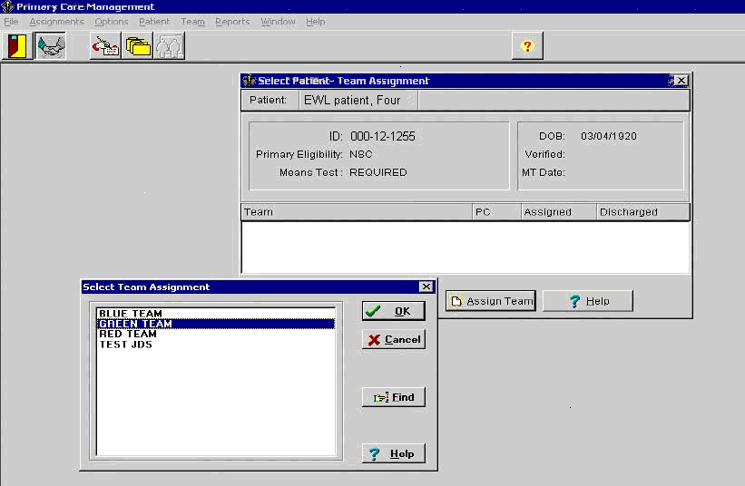

If the selected team is over the maximum capacity, the Waiting List window opens giving the user the opportunity to enter the patient on the wait list.

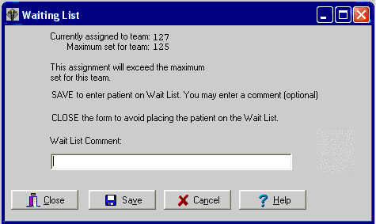
When a patient is assigned to a wait list the Team Assignment window will display the wait list assignment.

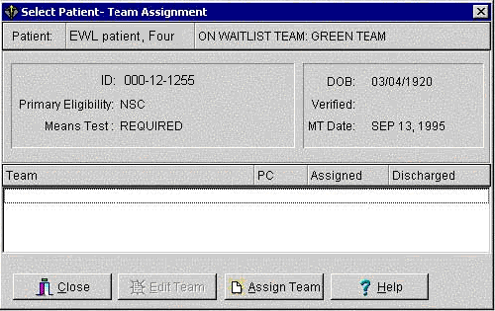

Wait List Utilities Menu

The Wait List (Sch/PCMM) Utilities menu allows users to:

- Request Inter-Facility Transfers
- Accept Inter-Facility Transfers
- Create new EWL entries for another clinic,
- Use the Wait List as a scheduling reminder
- Open closed EWL Entries

To access the Wait List (Sch/PCMM) Utilities menu, start with the Scheduling Manager's Menu and select Supervisor Menu.

Select Supervisor Menu Option: wait List (Sch/PCMM) Utilities

1 Inter-Facility Transfer Request
2 Inter-Facility Transfer Accept
3 Wait List Batch Clinic Change
4 Wait List Enter/Edit as a Scheduling Reminder
5 Open Closed EWL Entry

Select Wait List (Sch/PCMM) Utilities Option:

Inter-facility Transfer Request

To access the Wait List (Sch/PCMM) Utilities menu, start with the Scheduling Manager's Menu and select Supervisor Menu.

Select Supervisor Menu Option: wait List (Sch/PCMM) Utilities

1 Inter-Facility Transfer Request
2 Inter-Facility Transfer Accept
3 Wait List Batch Clinic Change
4 Wait List Enter/Edit as a Scheduling Reminder
5 Open Closed EWL Entry

Select Wait List (Sch/PCMM) Utilities Option:

New Request

The Inter-facility Transfer Request function is accessible from the Wait List (Sch/PCMM) Utilities menu option. The New Transfer (N) protocol is asking the user to make sure the patient is on an EWL list for a PCMM Team at their site before they enter a New Transfer for the patient.

INTER-FACILITY TRANSFFR REQUEST Jan 25, 2007@09:53:56 Page: 1 of 1
User: EWLUSER,ONE
Name SSN Transfer to Status .
1 EWLPTONE,RRRR PPPP 666-01-4321 DAYTON CANCELLED
CHEYENNE VAMC PCMM TEAM ASSIGNMENT : BLUE TEAM
2 EWLPTONE,RRRR PPPP 666-01-4321 DAYTON CANCELLED
CHEYENNE VAMC PCMM TEAM ASSIGNMENT : BLUE TEAM
3 EWLPTTWO,LLLLLL TTTT 666-02-8765 DAYTON RECEIVED
CHEYENNE VAMC PCMM TEAM ASSIGNMENT : GRAY TEAM
4 EWLPTTHREE,CCCCC D JR 666-66-7676 DAYTON TRANSMITTED
CHEYENNE VAMC PCMM TEAM ASSIGNMENT : GRAY TEAM
5 EWLPTFOUR,T J 666-05-5555 DAYTON TRANSMITTED
CHEYENNE VAMC PCMM TEAM ASSIGNMENT : BLUE TEAM
6 EWLPTFIVE,HHH L 666-44-0123 DAYTON RECEIVED
CHEYENNE VAMC PCMM TEAM ASSIGNMENT : GRAY TEAM

______________________________________________________________________________
Enter ?? for more actions___________________________________________
N New Transfer R Remove Transfer Request
D Display Inactive Entries V View Request Details
Select Action: Quit//

Select “N” at the action prompt.

Select Action: Quit// N New Transfer
Select SD WAIT LIST PATIENT:
Enter the name of the EWL patient.

If there is more than one match, the user is offered a list of patients to select from

Select SD WAIT LIST PATIENT: EWLPATIENT
1 EWLPATIENT,ONE 5-1-55 107050155P YES NSC VETERAN SMB SMB
2 EWLPATIENT,TWO 1-1-56 YES NSC VETERAN
3 EWLPATIENT,THREE 12-17-38 227121738P YES SC VETERAN
4 EWLPATIENT,FOUR 1-1-44 555551234 YES SC VETERAN
5 EWLPATIENT,FIVE 1-1-30 555927888 YES SC VETERAN

ENTER '^' TO STOP, OR
CHOOSE 1-5:

If the patient selected has more than one open EWL entry, these are displayed for selection

Select SD WAIT LIST PATIENT: EWLPATIENT
1 EWLPATIENT,ONE 5-1-55 000050155P YES NSC VETERAN SMB SMB
2 EWLPATIENT,TWO 1-1-56 000020246 YES NSC VETERAN
3 EWLPATIENT,THREE 12-17-38 000121738P YES SC VETERAN
4 EWLPATIENT,FOUR 1-1-44 000551234 YES SC VETERAN
5 EWLPATIENT,FIVE 1-1-30 000927888 YES SC VETERAN

ENTER '^' TO STOP, OR
CHOOSE 1-5:

When the EWL entry has been identified, the destination facility is entered

Select Institution to transfer to:

This is the institution code. Only national codes with a valid associated domain are accepted. The domain will be where the request is transmitted, e.g., CHEYENNE. REDACTED.

The last step is to enter optional comments to be transmitted with the request. There may be a need to add further details or some explanatory text in addition to the Wait List and Demographic data that is sent by default. Depending on your default user characteristics, the preferred text editor appears; the line editor
______________________________________________________________________
Transfer comments
1>
______________________________________________________________________________

or the full screen editor.
________________________________________________________________________
Transfer comments
==[ WRAP ]==[ INSERT ]==================< >=================[ <PF1>H=Help ]====

<=======T=======T=======T=======T=======T=======T=======T=======T=======T>======

Enter a blank line to exit the line editor or <CTRL>E to exit the full screen editor.
Once this is entered, the message will be transmitted to its recipient and the status will be set to TRANSMITTED.

INTER-FACILITY TRANSFER REQUEST Aug 02, 2005@13:34:48 Page: 1 of 1 .

User: EWLUSER,ONE

Name SSN Transfer to Status
1 EWLPATIENT,ONE 000-55-0555 BAY PINES VAMC TRANSMITTED
AKRON SPECIFIC CLINIC : PRIMARY CARE

.
Enter ?? for more actions .
N New Transfer R Remove Transfer Request
D Display Inactive Entries V View Request Details

Select Action: Quit//

When the message is received, an acknowledgement message is returned and the status will change to RECEIVED. N.B. This may take some time due to possible delays on mail servers.

View Request Details

To view the details of active requests that have been made, enter “V” at the action prompt of the Transfer Request function main summary screen.
.
Enter ?? for more actions .
N New Transfer R Remove Transfer Request
D Display Inactive Entries V View Request Details

Select Action: Quit//

If there is more than one entry to choose, prompt appears

Which entry?: (1-4):

When this is entered, the full details are shown.

INTER-FACILITY XFER DETAILS Aug 02, 2005@14:03:19 Page: 1 of 1 .
User: EWLUSER,ONE
.

Name: EWLPATIENT,ONE Status: RECEIVED
SSN: 107-05-0155P Date of birth: MAY 1,1955
Wait List Type: SPECIFIC CLINIC : PRIMARY CARE
Transfer to: BAY PINES VAMC
Comments:
.
Enter ?? for more actions .

Select Item(s): Quit//

Remove Transfer Request

To remove an active request, enter “R” at the action prompt of the Transfer Request function main summary screen.
The full details will be displayed in the same format as the View Details screen with a confirmation prompt

INTER-FACILITY XFER REMOVE Aug 02, 2005@14:27:23 Page: 1 of 1 .

User: EWLUSER,ONE
.

Name: EWLPATIENT,ONE Status: RECEIVED
SSN: 000-05-0155P Date of birth: MAY 1,1955
Wait List Type: SPECIFIC CLINIC :
Transfer to: BAY PINES VAMC
Comments:

.
Enter ?? for more actions .

R Remove
Select Item(s): R//

The way this is treated depends on the status of the transfer. If the status is TRANSMITTED, the acknowledgement has not been returned from the receiving site or the original message may have failed to arrive. In this case, the record of the request is simply removed. If the status of the request is RECEIVED, a corresponding record will be held at the receiving site and a message will have to be sent to request its removal. Once this is sent and until an acknowledgement message is received to indicate that the request has been removed, the status will stay as CANCELLED.
If a request is removed that has arrived at the receiving site but where the acknowledgement has been delayed for some reason, there is a mechanism to automatically send a removal message back when the acknowledgement is eventually returned. This will prevent a possible file mismatch at the two sites.

Display Inactive Entries

Inactive entries are those requests that have reached resolution through acceptance or rejection at the receiving site. They have a status of REFUSED or ACCEPTED and are not displayed on the main summary screen. A summary of these entries can be displayed by entering “D” at the action prompt of the Transfer Request function main summary screen.

INTER-FACILITY XFER INACTIVE Aug 02, 2005@14:40:34 Page: 1 of 1 .
User: EWLUSER,ONE
Name SSN Transfer to Status_______ .

1 EWLPATIENT,ONE 555-55-0555 BAY PINES VAMC REFUSED
AKRON SPECIFIC CLINIC : PRIMARY CARE
1 EWLPATIENT,TWO 555-55-0556 BAY PINES VAMC ACCEPTED
AKRON SPECIFIC CLINIC : PRIMARY CARE

Enter ?? for more actions______________________________________________ .
V View Request Details
Select Item(s): Quit//

The details of a request can be viewed by entering “V” at the action prompt. If there is more than one entry displayed, a further prompt will request the line to be viewed.

Inter-facility Transfer Request Acceptance

Request Summary

The Inter-facility Transfer Accept function is accessible from the Wait List (Sch/PCMM) Utilities menu option.

The main screen displays a summary of requests that have been received and await resolution.

INTER-FACILITY TRANSFER ACCEPT Aug 05, 2005@11:18:05 Page: 1 of 1 .
Name Transmission date Sending Institution .

1 EWLPATIENT,ONE AUG 02, 2005@13:31:16 VAMC REDACTED

.
Enter ?? for more actions____________________________________________ .
V View Details
Select Action: Quit//

To view the transfer request details, enter “V” at the action prompt. This brings up the details screen directly if there is only one request. Otherwise, a further prompt will request the entry to view before displaying the details.

Request Details

INTER-FACILITY XFER DETAILS Aug 05, 2005@11:21:04 Page: 1 of 1 .

Transmg. Inst: VAMC REDACTED Transmn. Date: AUG 02, 2005@13:31:16
Name: EWLPATIENT,ONE Sex: FEMALE DoB: MAY 01, 1955 SSN: 000050155P
Address: 212 NE 3
REDACTED
YOLO
TEXAS 75214
Service connected: YES Percentage: 50
Primary Eligibility: SERVICE CONNECTED 50% to 100%
Wait List Type: PCMM TEAM ASSIGNMENT : VASSER'S TEAM 1
Desired Date of Appt: Integration Control Number: 5000000167
Comments: .
Enter ?? for more actions .
A Accept P Print Coversheet R Reject
Select Item(s): Quit//

This is the screen from where all other actions take place on this request. The request may be rejected or accepted, or the print of a coversheet may be requested. The coversheet mush be requested before acceptance is made as the request entry is removed after that.
To reject the request, “R” is entered at the action prompt and the user is returned to the previous screen.
To print the coversheet, “P” is entered at the action prompt. The output device is entered at the next prompt and the coversheet is printed.

DEVICE: HOME//
To accept the transfer for this function, the details should be entered on the system as a new EWL entry or scheduled appointment and the details printed out to refer to. Having done that, “A” is entered at the action prompt for this screen. Following that a confirmation prompt appears to emphasize the need to enter the details before the record is removed.

Do you confirm that the appropriate action was taken to schedule this patient
for an appointment or she/he has EWL entry and the cover sheet has been printed?
? N//

When this statement is confirmed, the details are resolved and the user is returned to the previous screen.

Once a request has been either rejected or accepted, an acknowledgement message is returned to the requesting site which will trigger notification messages to the administration mail group there. If the result was accepted, the EWL entry at the requesting site will be closed with a disposition reason, new for this function, of TR – TRANSFERRED.

Wait List Batch Clinic Change

This option allows all the patients on one Clinic’s Wait list to be transferred to another Clinic’s Wait List. Provide the name or number of the Source Institution and Source Clinic as well as the name or number of the Destination Clinic and Destination Institution.

Select Supervisor Menu Option: wait List (Sch/PCMM) Utilities

1 Inter-Facility Transfer Request
2 Inter-Facility Transfer Accept
3 Wait List Batch Clinic Change
4 Wait List Enter/Edit as a Scheduling Reminder
5 Open Closed EWL Entry

Select Wait List (Sch/PCMM) Utilities Option:

Select Wait List (Sch/PCMM) Utilities Option: 3 Wait List Batch Clinic Change

Scheduling/PCMM Batch Change EWL Clinic

Select Source Institution: REDACTED, NY//
Answer with INSTITUTION NUMBER, or NAME, or STATUS, or STATION NUMBER, or
OFFICIAL VA NAME, or CURRENT LOCATION, or CODING SYSTEM/ID PAIR, or
NPI, or STATUS, or NAME (CHANGED FROM), or CODING SYSTEM

Select Source Clinic: CECELIA'S CARDIO REDACTED

Answer with SD WL CLINIC LOCATION, or NUMBER, or INSTITUTION, or
DATE INACTIVATED

Select Destination Institution: REDACTED// REDACTED

Select Destination Clinic: GENERAL CARDIO REDACTED

Use the Wait List as a Scheduling Reminder

This option allows the user to enter "tickler" or reminder type entries.

Select Wait List (Sch/PCMM) Utilities Option: 4 Wait List Enter/Edit as a Scheduling Reminder

Scheduling/PCMM Enter/Edit Wait List

Select PATIENT NAME: EWLPATIENT,ONE EWLPATIENT,ONE 10-30-60 000119999
YES ACTIVE DUTY
NO ENROLLMENT APPLICATION ON FILE

Patient is not on Waiting List. Do you wish to Add Patient? Yes//

Note: you are about to create an EWL entry to be used as a Scheduling Reminder.

Select Wait List Type:

1. PCMM TEAM ASSIGNMENT
2. SERVICE/SPECIALTY
3. SPECIFIC CLINIC

Enter response: 3 SPECIFIC CLINIC

Select Institution: REDACTED NY VAMC 500

Select Clinic: CECELIA'S CARDIOLOGY REDACTED

Priority

1. Future Date
2. ASAP

Enter response: 2 ASAP JUN 15, 2007

Request By

1. Provider
2. Patient

Enter response: 1 Provider

Provider Requesting Appointment: ADHVARYU,KALINDI KA

Comments:

*** Patient has been added to Wait List ***

Open Closed EWL Entry

The option Open Closed EWL Entry [SD WAIT LIST OPEN CLOSED ENTRY] will allow the user to manually open a closed EWL entry, with exception of closed EWL entries with code ER:ENTERED IN ERROR. This process enters the value 'O' – Other in the Reopen Reason field along with a required comment in the Reopen Comment field. This option is on the Wait List Utilities (Sch/PCMM) [SD WAIT LIST UTILITIES] menu as shown below.

Select Supervisor Menu Option: wait List (Sch/PCMM) Utilities

1 Inter-Facility Transfer Request
2 Inter-Facility Transfer Accept
3 Wait List Batch Clinic Change
4 Wait List Enter/Edit as a Scheduling Reminder
5 Open Closed EWL Entry

Select Wait List (Sch/PCMM) Utilities Option:

Using EWL When Team is Under Maximum Capacity

The user cannot put the patient on a Wait List for a PCMM Team (using the PCMM GUI) unless that PCMM Team is full (is over capacity). These are PCMM Business Rules. To place a patient on the EWL for a Team that is under capacity, the user must use the Enter/Edit Wait List (Sch/PCMM) option in the Wait List (Sch/PCMM) Menu.

Select Scheduling Menu Option: Appointment Menu

AM Appointment Management
CK Appointment Check-in/Check-out
WL Wait List (Sch/PCMM) Menu ...
Add/Edit Stop Codes
Append Ancillary Test to Appt.
Cancel Appointment
Chart Request
Check-in/Unsched. Visit
Computer Generated Menu ...
Delete Ancillary Test for Appt.
Discharge from Clinic
Display Appointments
Edit Clinic Enrollment Data
Enrollment Review Date Entry
Find Next Available Appointment
Make Appointment
Multiple Appointment Booking
Multiple Clinic Display/Book
No-Shows

Select Appointment Menu Option: WL Wait List (Sch/PCMM) Menu

1 Inquire Wait List (Sch/PCMM)
2 Enter/Edit Wait List (Sch/PCMM)
3 Disposition Wait List (Sch/PCMM) Entry
4 Wait List (Sch/PCMM) Reports ...
5 Wait List (Sch/PCMM) Parameter Enter/Edit

Select Wait List (Sch/PCMM) Menu Option: 2 Enter/Edit Wait List (Sch/PCMM)

Scheduling/PCMM Enter/Edit Wait List

Select PATIENT NAME: <Enter the patient’s name and continue the process for adding the patient to the Wait List.>

Wait List Import Tool

Sites that currently keep waiting lists are able to import their lists into the EWL via the Wait List Import Tool. This utility imports local Wait List entries into the EWL.
NOTE. Specific Clinics and Service/Specialties must be set up for each Institution/Division before Importing Wait List entries with the Import Tool.
Using the Wait List Import Tool

To use the Wait List Import Tool sites must convert their Wait List from its current format into a comma delimited text file (.txt). This is the excepted format for the tool. This file is called the Import file. The Import file can be created from Vista using FileMan’s DATA EXPORT TO FOREIGN FORMAT options or from Excel using the CSV format. This text file must contain four fields.
- Social security number (SSN) (Entered as xxxxxxxxx or xxx-xx-xxxx)
- Institution Name (The name of the Institution from file 4)
- Clinic Type {this numeric field is numbered 1-4, with 1 being file 404.51 (Team), 2 being file 404.57 (Team Position), 3 being file 409.31 (SD WL Service/Specialty), and 4 being file 409.32 (SD WL Clinic Location)}
- Clinic Type Modifier {a specific choice within one of the clinic types. For example, if clinic type 1 (Team) were chosen, the modifier would be a specific team.} \
- Desired Date (Entered as the FileMan acceptable date. This is date for which the appointment is being requested. Applies only to Clinic Types 3 and 4.) (Note: If the desired date is requested then the priority is set to future and a date is automatically plugged in. If there is no desired date than the priority is set to ASAP, and the date the file is imported is automatically entered.)

Note: If there is no value for a field then a null value is entered (""). One row of five fields defines a single record for entry into the Electronic Wait List.

Example #1
Values are submitted for all fields
FIELDS
1 2 3 4 5
"123456789","VA","1","CLINIC","01/12/2003"
Example #2
No value is submitted for field 5.
A null ("") is entered this field position.
FIELDS
1 2 3 4 5
"123456789","VA","1","CLINIC",""
1. Select a server or add a new IP address for the server. Log on to Vista.

2. Click on FILE, then OPEN or click the open folder icon on the toolbar.

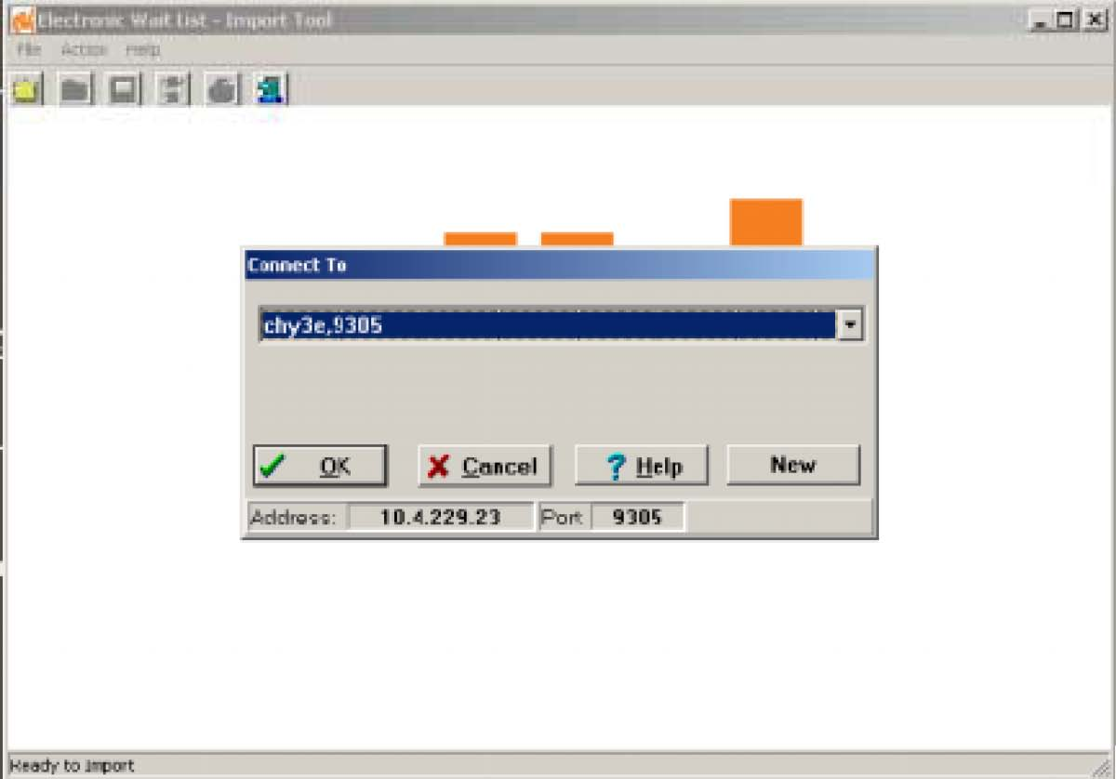
3. Log on to Vista.

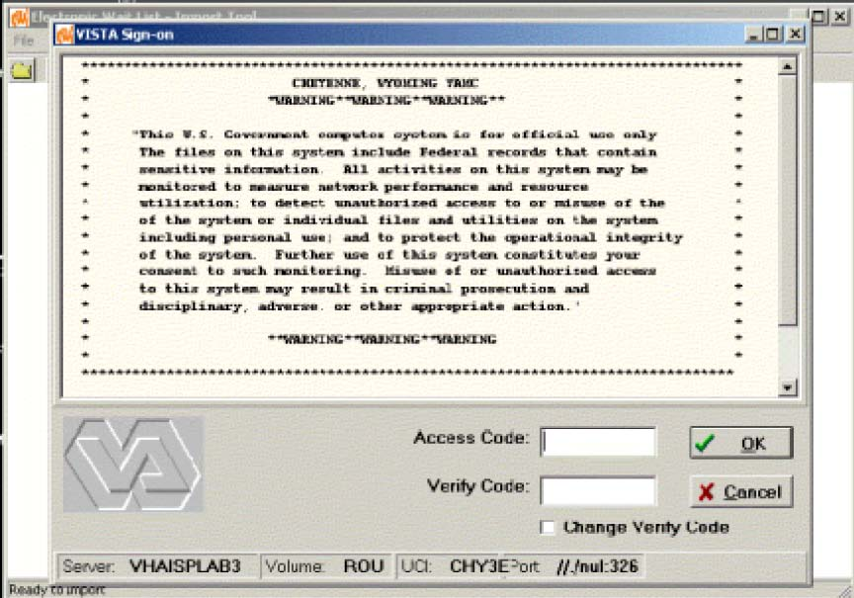
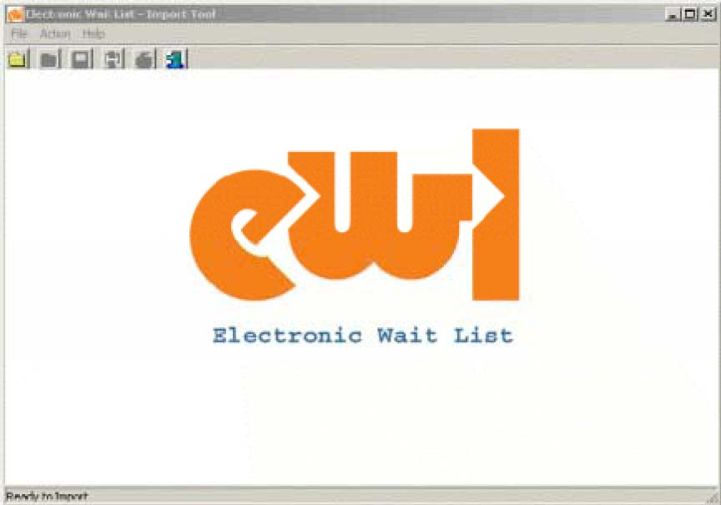
4. Click on FILE then OPEN or click the open folder icon on the toolbar.

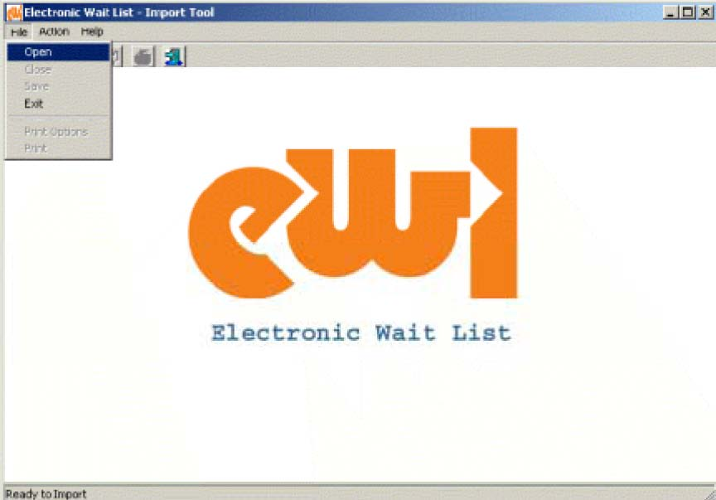

5. Select Import Options. Checking Pre-set Field Values pre-sets the Institution, Wait List Type, or Wait List Type Modifiers to the values the user selects and overwrites the values found for those fields in the IMPORT FILE. If the user leaves Pre-set Field Values unchecked, no changes are made to the IMPORT file. Click CONTINUE to accept the pre-set values or SKIP IT to cancel using pre-set values.
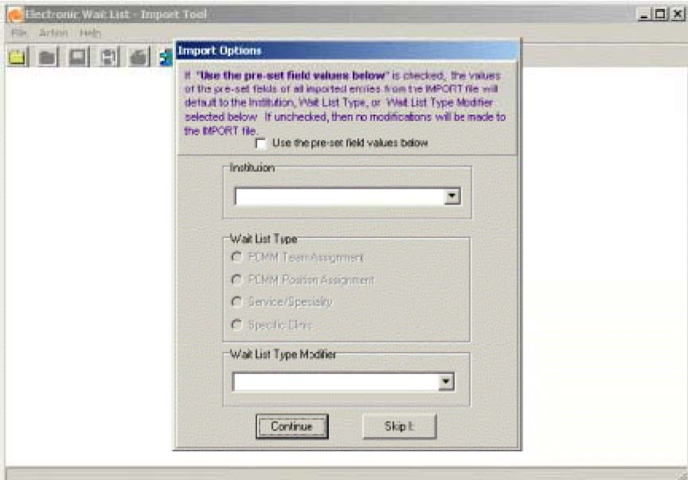

6. Select the IMPORT file.

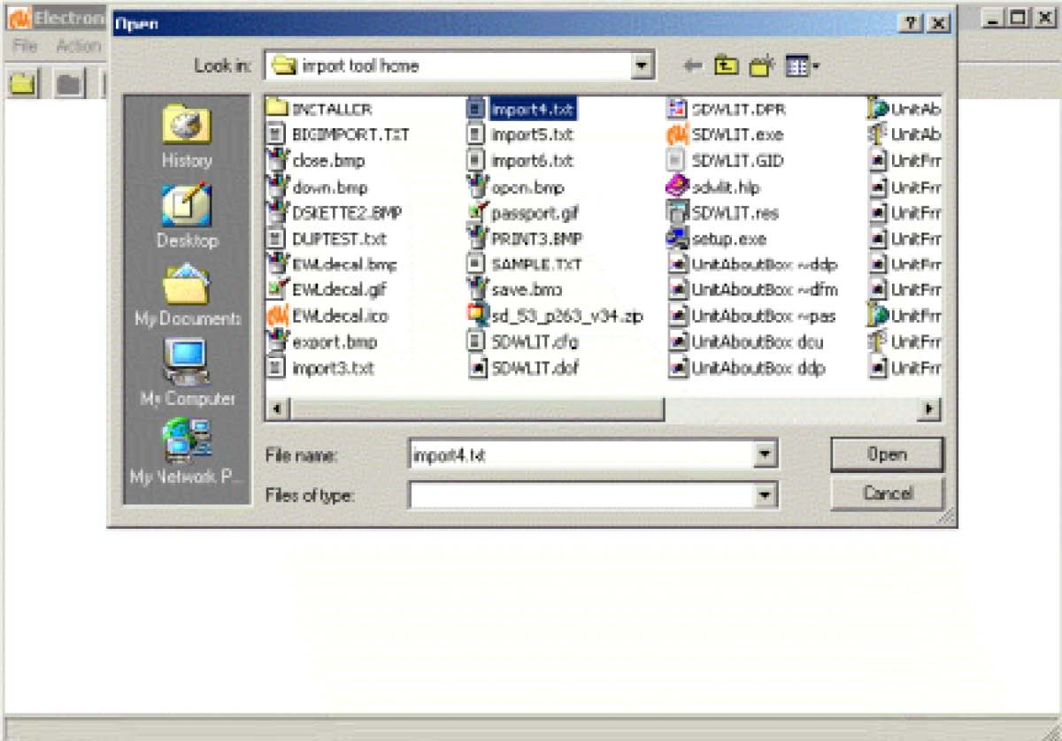

7. The IMPORT file displays in the grid. Entries can be reviewed or edited. To edit slowly, click twice in the field to be edited.

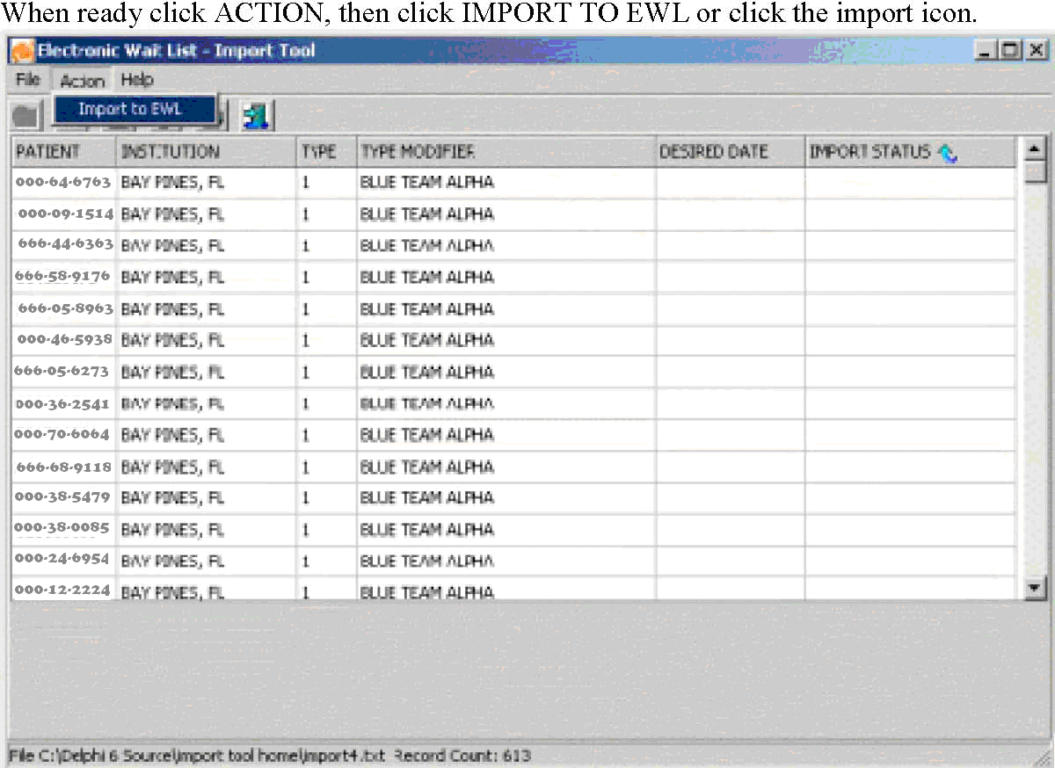

Each row of the grid is submitted to EWL as a new record. If the record is validated and accepted by EWL, the successful addition is noted at the bottom of the screen. If EWL cannot validate the record, the reason for the failure is noted in the IMPORT STATUS column of the grid, e.g., duplicate entry. To sort on a field, click on the column heading for that field, e.g., sort on Import Status.
The rows of failed imports can be reviewed and edited and the import action can be repeated.
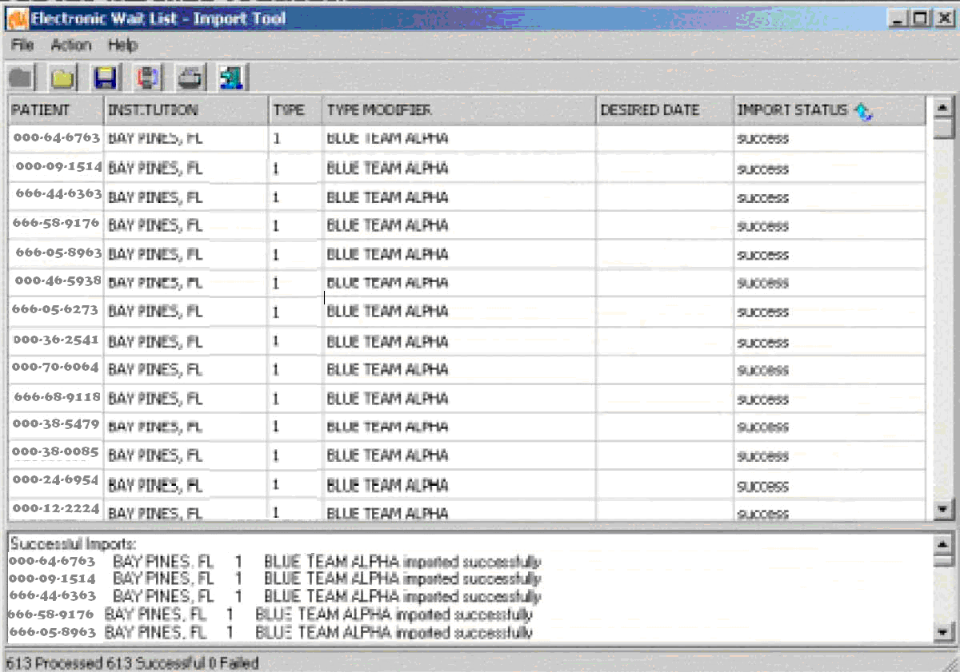

Transmission to National Patient Care Database in Austin

This functionality is now accomplished by CDW/VSSC. Patch SD*5.3*638, DISABLE EWL TRANSMISSION OPTION, update. Removed contents of “Transmission to National Patient Care Database in Austin” section. Data is now retrieved from the Corporate Data Warehouse (CDW) effective 10/1/2014.

Glossary

AAC | Austin Automation Center -The central repository for National Care Patient Care Database.
ADPAC | Automated Data Processing Applications Coordinator
Appointment | A meeting with a provider in a clinic; currently an appointment is entered for the clinic, and it may be scheduled in the future or entered in the past as already kept.
Austin Automation Center | The central repository for National Care Patient Care Database located in Austin, Texas.
Clerk | This person is a clerk who performs data entry.
Clinical Services | A service defined at the Medical Center level, for example, Medicine, Surgery, Primary Care
Closing | Another term for ‘inactivating’ a position or team.
Consults | When a patient is referred to a clinic on a one-time basis, he/she is not normally enrolled in that clinic.
Database | This refers to the information that is stored in your medical center’s computer program, e.g., patient information, service information, clinic information, etc.
Disposition/Close EWL Entry | Changing the Current Status field of EWL entry from ‘open’ to ‘closed’. There are several coded reasons, identified by the Disposition field of the SD WAIT LIST file.
DSS | Decision Support System
E-Mail Messages | These are the messages that are generated by a software event that delivers information to designated users via MailMan. E-mail messages in the PCMM module would include information about death notifications, inpatient movements; consult notifications, and team notifications or changes.
EWL | Electronic Wait List – VistA software package designed for recording, tracking and reporting veterans unable to acquire appropriate appointments within a specific VA medical center.  The EWL may be used as a tool to avoid pre-scheduling clinics until the appropriate return interval, for example to track return appointment times for Advanced Clinic Access
HL7 | Health Level 7 - ANSI standard for electronic data exchange in healthcare environments.
IRM | Information Resources Management
MAKE APPOINTMENT | A scheduling option which provides users the ability to schedule veterans for specific clinic appointments. This option also allows veterans to be placed on the Electronic Wait List if no appointment meets the veteran appointment criteria.

MD- PHYSICIAN-PRIMARY CARE | As a physician, incumbent's duties are to advise on, administer, supervise, or perform professional and scientific work in one or more fields of medicine. The degree of Doctor of Medicine or Doctor of Osteopathy is a fundamental requirement, along with a current license to practice medicine and surgery in a US State, territory or the District of Columbia. As a Primary Care practitioner, the incumbent provides the first point of assistance for a patient seeking care. Primary Care duties include: (1) Intake and initial needs assessment, (2) Health promotion and disease prevention, (3) Management of acute and chronic bio-psychosocial conditions, (4) Access to other components of health care, (5) Continuity, and (6) Patient and non-professional care giver education & training. (from IL 10-93-031, Under Secretary for Health's Letter) Can act as Primary Care Practitioner.
MODULE | A portion of a major software package, e.g. Primary Care functionality is considered a MODULE of the Scheduling package.
NPCD | National Patient Care Database - is maintained in Austin and receives selected demographic and encounter-based clinical, diagnostic data form VA medical centers. This data enables a detailed analysis of VHA inpatient and outpatient health care activity.
OTHER | A general classification for those team members who do not belong in any of the listed Standard Position entries.
PA | Physician’s Assistant
PANEL | A panel is a group of individual patients for which the Primary Care Provider has accepted primary care responsibility.
PATIENT PANEL | Group of individual patients assigned to Team/Position/  Practitioner. Can be either Primary Care or Non Primary Care patients; e.g., the Practitioner’s Patients Report includes both Primary Care and Non Primary Care patients assigned to the practitioner in the Patient Panel Count.
PC | Primary care is the provision of integrated, accessible health care services by clinicians that are accountable for addressing a large majority of personal health care needs.
PC Coordinator | Primary Care Coordinator
PCMM | Primary Care Management Module - is the application for VA facilities to use for implementing primary care teams. Teams are created, positions associated with the teams are created, staff members are assigned to positions, and patients are assigned to the teams and positions.

PCP | Primary Care Provider - In PCMM, the Primary Care Provider is the position determined to be responsible for the coordination of the patient’s primary care.
PHYSICIAN-PRIMARY CARE | As a physician, incumbent's duties are to advise on, administer, supervise, or perform professional and scientific work in one or more fields of medicine. The degree of Doctor of Medicine or Doctor of Osteopathy is a fundamental requirement, along with a current license to practice medicine and surgery in a US State, territory or the District of Columbia. As a Primary Care practitioner, the incumbent provides the first point of assistance for a patient seeking care. Primary Care duties include: (1) Intake and initial needs assessment, (2) Health promotion and disease prevention, (3) Management of acute and chronic biopsychosocial conditions, (4) Access to other components of health care, (5) Continuity, and (6) Patient and non-professional care giver education & training. (from IL 10-93-031, Under Secretary for Health's Letter) Can act as Primary Care Practitioner.
PIMS | Patient Information Management System
Position | Teams are comprised of one or more staff positions. Individual practitioners are assigned to a team position. A position is designated to serve certain roles in the overall primary care setting.
Preceptor | Physician responsible for providing the overall care for patients assigned to an Associate Provider or Medical Student. On Primary Care Teams the Preceptor must be able to provide Primary Care.
Primary Care. | Primary care is the provision of integrated, accessible health care services by clinicians that are accountable for addressing a large majority of personal health care needs.
Primary Care Management Module (PCMM) | Primary Care Management Module is the application for VA facilities to use for implementing primary care teams. Teams are created, positions associated with the teams are created, staff members are assigned to positions, and patients are assigned to the teams and positions.
Primary Care Provider (PCP) | In PCMM, the Primary Care Provider is the position determined to be responsible for the coordination of the patient’s primary care.
Role | A function or task of a staff member involved with the implementation, maintenance and continued success of primary care.
SA: Removed/Scheduled-Assigned | One of reasons for disposition of open EWL entry. If this reason is selected the field related to corresponding appointment are filed into the EWL entry.

SC | Service Connected
Service Connected | With respect to a condition or disability, the VA has determined that the condition or disability was incurred in or aggravated by military service.
SD | Refers to VistA’s Scheduling Package
SD EWL Background Update | EWL Mail Group used for different kinds of notifications.
SPECIALTY CLINICS | A set of clinics that are defined as SUBSETS of generalized Service clinics such as Cardiology (specialty of Medicine); Orthopedics (specialty of Surgery), etc.
STOP CODE | Treatment code used for reporting procedure performed during veterans visit.
TEAM | Teams are groups of staff members organized for a certain purpose (e.g., Primary Care).
TEAM PROFILE | This is a screen within PCMM that shows the various characteristics of a particular team, e.g., number of patients allowed for enrollment, name, positions assigned, etc.
UNIQUE PATIENT (UNIQUES) | For PCMM Primary Care, unique patients are defined as the individual veteran (patient) enrolled in VA health care that make up the primary care provider’s panel.
VA | Veterans Admission
VHA | Veterans Health Administration
VistA | Veterans Health Information Systems and Technology Architecture, formerly known as Decentralized Hospital Computer Program, encompasses the complete information environment at VA medical facilities.

Appendix A - Patch SD*5.3*420 - EWL Transmission Fields

This functionality is now accomplished by CDW/VSSC. Patch SD*5.3*638, DISABLE EWL TRANSMISSION OPTION, update. Removed contents of “Transmission to National Patient Care Database in Austin” section. Data is now retrieved from the Corporate Data Warehouse (CDW) effective 10/1/2014.

The following fields in file SD WAIT LIST (#409.3) were added to SD Wait List Trans to AAC [SD WAIT LIST TRANS TO AAC] option.

FIELD NUMBER FIELD NAME
----------------------------

13 SCHEDULED DATE OF APPT
13.1 DATE APPT. MADE
13.2 APPT CLINIC
13.3 APPT INSTITUTION
13.4 APPT STOP CODE
13.5 APPT CREDIT STOP CODE
13.6 APPT STATION NUMBER
13.7 APPT CLERK
13.8 APPT STATUS
14 SERVICE CONNECTED PERCENTAGE
15 SERVICE CONNECTED PRIORITY
29 REOPEN REASON
30 REOPEN COMMENT

PATCH SD*5.3*420 data types for new fields.

SCHEDULED DATE OF APPT - Date/time in FileMan format
DATE APPT. MADE - Date in FileMan format
APPT CLINIC – Pointer to file 44
APPT INSTITUTION - Pointer to file 4
APPT STOP CODE - Pointer to file 40.7
APPT CREDIT STOP CODE - Pointer to file 40.7
APPT STATION NUMBER - Free text 3-6 characters
APPT CLERK - Pointer to file 200
APPT STATUS - Set of codes
R = Scheduled/Kept
'I' = Inpatient
NS = No-Show
NSR = No-Show, Rescheduled
CP = Canceled by Patient
CPR = Canceled by Patient, Rescheduled
CC = Canceled by Clinic
CCR = Canceled by Clinic, Rescheduled
NT = No Action Taken
SERVICE CONNECTED PERCENTAGE - Number between 0 and 100
SERVICE CONNECTED PRIORITY - Set of codes
0 = NO
1 = YES
REOPEN REASON – Set of codes
CC = INACTIVATED CLINIC
CA = CANCELED APPOINTMENT
DE = DATE OF DEATH ERROR
O = OTHER
REOPEN COMMENT – Free text 3-72 characters.

This field is already transmitted; a new code was added to the set DISPOSITION – Set of codes.

D = DEATH
NC = REMOVED/NON-VA CARE
SA = REMOVED/SCHEDULED-ASSIGNED
CC = REMOVED/VA CONTRACT CARE
NN = REMOVED/NO LONGER NECESSARY
ER = ENTERED IN ERROR
TR = TRANSFERRED

Appendix B – 132 Column Sample Reports

Wait List Statistic Report

This Sample Report was run on a test account with limited and spurious data.

Wait List Stat Report

Select Institution ALL // REDACTED NY VAMC 500
Another Institution: CASTLE POINT NY VAMC 610
Another Institution:
Start Date: T-360 (JAN 22, 2007)
End Date: T (JAN 17, 2008)
Do you wish to exclude any Teams, Specialties or Specific Clinics where ALL
values are zero? YES//
DEVICE: HOME// ;132; UCX/TELNET

JAN 17, 2008@15:51:41 Wait List (Sch/PCMM) Stat Report Page: 1
STARTED Date: JAN 22, 2007
FINISHED Date: JAN 17, 2008
_____________________________________________________________________________________________________________
PREV # # # NOT
WAIT LIST TYPE REMN CLSD DTH NC SA CC NN ER CL TR ADD REMN REMVD

INSTITUTION: REDACTED

PCMM TEAM ASSIG
BLUETEAM 0 6 0 0 6 0 0 0 0 0 7 1 0
------ ------ ------ ------ ------ ------ ------ ------ ------ ------ ------ ------ -----
Sub-Totals: 0 6 0 0 6 0 0 0 0 0 7 1 0

Enter RETURN to continue or '^' to exit:
JAN 17, 2008@15:51:41 Wait List (Sch/PCMM) Stat Report Page: 2
STARTED Date: JAN 22, 2007
FINISHED Date: JAN 17, 2008
_____________________________________________________________________________________________________________
PREV # # # NOT
WAIT LIST TYPE REMN CLSD DTH NC SA CC NN ER CL TR ADD REMN REMVD

SPECIFIC CLINIC
DONNA'S CL ASAP 2 2 0 0 0 0 0 0 2 0 1 1 0
DONNA'S CL FUTUR 0 0 0 0 0 0 0 0 0 0 2 2 1
DONNA'S CL 0 1 0 0 0 0 0 0 1 0 2 1 1
------ ------ ------ ------ ------ ------ ------ ------ ------ ------ ------ ------ -----
Sub-Totals: 2 3 0 0 0 0 0 0 3 0 5 4 2

PETER'S CL ASAP 0 1 0 0 0 0 0 0 1 0 1 0 0
PETER'S CL 0 1 0 0 0 0 0 0 1 0 1 0 0
------ ------ ------ ------ ------ ------ ------ ------ ------ ------ ------ ------ -----
Sub-Totals: 0 2 0 0 0 0 0 0 2 0 2 0 0

Institution Totals: 2 11 0 0 6 0 0 0 5 0 14 5 2

Enter RETURN to continue or '^' to exit:

JAN 17, 2008@15:51:41 Wait List (Sch/PCMM) Stat Report Page: 3
STARTED Date: JAN 22, 2007
FINISHED Date: JAN 17, 2008
_____________________________________________________________________________________________________________
PREV # # # NOT
WAIT LIST TYPE REMN CLSD DTH NC SA CC NN ER CL TR ADD REMN REMVD

INSTITUTION: CASTLE POINT

PCMM TEAM ASSIG
GREEN TEAM 0 9 0 1 6 0 0 0 2 0 12 3 4
RED TEAM 0 2 0 0 1 0 0 0 1 0 2 0 0
------ ------ ------ ------ ------ ------ ------ ------ ------ ------ ------ ------ -----
Sub-Totals: 0 11 0 1 7 0 0 0 3 0 14 3 4

Institution Totals: 0 11 0 1 7 0 0 0 3 0 14 3 4

Grand Totals: 2 22 0 1 13 0 0 0 8 0 28 8 6
Abbreviations used in this report

PREV REMN Previously Remaining | CC Removed/VA Contract Care | #ADD Number Added
CLSD Closed | NN Removed/No Longer Necessary | #REMN Number Remaining
DTH Death | ER Entered in Error | # NOT REMVD Number Not Removed
NC Removed/Non-VA Care | CL Clinic Changed
SA Removed/Scheduled- Assigned | TR Transferred

Enrollment Wait List Statistic Report

This Sample Report was run on a test account with limited and spurious data.

Enrollment Wait List (Sch/PCMM) Statistic Report

Wait List Enrollment Status Report

Select Institution ALL // REDACTED NY VAMC 500

Another Institution:

Start Date: T-360 (JAN 22, 2006)
End Date: T (JAN 17, 2007)
DEVICE: HOME// ;132; UCX/TELNET

JAN 17, 2007@15:39 Wait List (Sch/PCMM) Enroll Status Report Page: 1
STARTED Date: JAN 22, 2006
FINISHED Date: JAN 17, 2007
_____________________________________________________________________________________________________________
PREV # # # NOT
WAIT LIST TYPE REMN CLSD DTH NC SA CC NN ER CL TR ADD REMN REMVD

INSTITUTION: REDACTED
ENROLLMENT PRIORITY: PRIOR
SPECIFIC CLINIC
DONNA'S CL ASAP 0 0 0 0 0 0 0 0 0 0 1 1 0
CECELIA'S ASAP 0 1 0 0 1 0 0 0 0 0 1 0 0
------ ------ ------ ------ ------ ------ ------ ------ ------ ------ ------ ------ ------
Sub-Totals: 0 1 0 0 1 0 0 0 0 0 2 1 0
ENROLLMENT PRIORITY: UNDETERMINED
PCMM TEAM ASSIG
FEYTEAM 0 6 0 0 6 0 0 0 0 0 7 1 0

JAN 17, 2007@15:39 Wait List (Sch/PCMM) Enroll Status Report Page: 2
STARTED Date: JAN 22, 2006
FINISHED Date: JAN 17, 2007
_____________________________________________________________________________________________________________
PREV # # # NOT
WAIT LIST TYPE REMN CLSD DTH NC SA CC NN ER CL TR ADD REMN REMVD
SERVICE/SPECIAL
500 ASAP 0 0 0 0 0 0 0 0 0 0 0 0 0
MEDICAL/SU ASAP 0 0 0 0 0 0 0 0 0 0 0 0 0
SPECIFIC CLINIC
DONNA'S CL ASAP 2 2 0 0 0 0 0 0 2 0 0 0 0
DONNA'S CL FUTURE 0 0 0 0 0 0 0 0 0 0 2 2 1
DONNA'S CL 0 1 0 0 0 0 0 0 1 0 2 1 1
PETER'S CL ASAP 0 1 0 0 0 0 0 0 1 0 1 0 0
PETER'S CL 0 1 0 0 0 0 0 0 1 0 1 0 0
CECELIA'S ASAP 0 8 0 1 5 0 0 0 2 0 11 3 4
CECELIA'S FUTURE 0 2 0 0 1 0 0 0 1 0 2 0 0
Enter RETURN to continue or '^' to exit:

JAN 17, 2007@15:39 Wait List (Sch/PCMM) Enroll Status Report Page: 3
STARTED Date: JAN 22, 2006
FINISHED Date: JAN 17, 2007
______________________________________________________________________________________________________________
PREV # # # NOT
WAIT LIST TYPE REMN CLSD DTH NC SA CC NN ER CL TR ADD REMN REMVD

ALLERGY 0 0 0 0 0 0 0 0 0 0 1 1 0
------ ------ ------ ------ ------ ------ ------ ------ ------ ------ ------ ------ ------
Sub-Totals: 2 21 0 1 12 0 0 0 8 0 27 8 6
Institution Totals: 2 22 0 14 0 0 0 0 8 0 29 9 6

Abbreviations used in this report

PREV REMN Previously Remaining CC Removed/Va Contract Care #ADD Number Added
CLSD Closed NN Removed/No Longer Necessary #REMN Number Remaining
DTH Death ER Entered in Error # NOT REMVD Number Not Removed
NC Removed/Non-VA Care CL Clinic Changed
SA Removed/Scheduled- Assigned TR Transferred
EWL Wait Time Statistics

This Sample Report was run on a test account with limited and spurious data.

EWL Wait Time Statistics
* Previous selection: ORIGINATING DATE from Jan 1,2006 to Jan 1,2007@24:00
START WITH ORIGINATING DATE: Jan 1,2006// (JAN 01, 2006)
GO TO ORIGINATING DATE: Jan 1,2007// (JAN 01, 2007)
DEVICE: ;132; UCX/TELNET

EWL Wait Time Statistics
The following fields from file SD WAIT LIST (#409.3) are included in this report.

Originating Date
Scheduling Date of Appt
Date Appt Made
Date of Disposition
Desired Date of Appointment

The following fields are computed calculations included in the report.
Refer to the following report key to translate field values:

a = Scheduled Date of Appt - Originating Date
b = Desired Date of Appointment - Originating Date
c = Desired Date of Appointment - Scheduled Date of Appt
d = Date of Disposition - Originating Date
e = Originating Date - Date Appt Made

EWL WAIT TIME STATISTICS REPORT JAN 17,2007 15:56 PAGE 1
SCHED DT DT APPT DESIRED DT
PATIENT SSN ORIG DATE APPT MADE APPT DISPOSITION DT
------------------------------------------------------------------------------------------------------------------------

EWLPATIENT,TEN 8888 OCT 24,2006 OCT 24,2006 08:00 OCT 24,2006 OCT 24,2006 OCT 24,2006
a. 0 b. 0 c. 0 d. 0 e. 0
EWLPATIENT,TWO 0246 OCT 24,2006 NOV 9,2006 11:00 DEC 19,2006 OCT 24,2006 DEC 19,2006
a. 16 b. 0 c. -16 d. 56 e. -56
EWLPATIENT,TWO 0246 OCT 24,2006 DEC 20,2006 12:00 DEC 20,2006 OCT 24,2006 DEC 20,2006
a. 57 b. 0 c. -57 d. 57 e. -57
EWLPATIENT,TWO 0246 OCT 25,2006 OCT 30,2006 08:00 OCT 25,2006 OCT 25,2006 OCT 25,2006
a. 5 b. 0 c. -5 d. 0 e. 0
EWLPATIENT,TWO 0246 OCT 25,2006 OCT 30,2006 08:00 OCT 25,2006 OCT 25,2006 OCT 25,2006
a. 5 b. 0 c. -5 d. 0 e. 0

