Department of Veterans Affairs

Emergency Department Integration Software (EDIS)

User Guide
VistA EDP*2.0*2
GUI EDIS Version 2.1.2
Revised November 2014
July 2013
Document Version 3.9
Office of Information and Technology (OI&T)
Product Development
Revision History

Date | Version | Description | Author
November 2014 | 3.9 | Patch EDP*2.0*2, EDIS GUI v2.1.2:  - Updated title page, headers, footers, and Index.  - Deleted two paragraphs from Section 1.5 Application Timeouts as ORWOR TIMEOUT CHART and ORWOR TIMEOUT COUNTDOWN are no longer used.  - Deleted Provider Report: Deleted mention of EDPR PROVIDER security key in Section 7, Reports View; Revised the Cross Reference Report paragraph in Section 7.1.2 to remove references to the Provider Report; Deleted Provider Report summary from p. 67; Deleted Figure 46 from Table of Figures and from p.68; Deleted reference to Provider Report from notation in Section 7.2.  - Made formatting changes (added automatic Table of Contents, corrected all page numbers in Table of Figures, made section 3.3.1 label Heading 3, deleted extra section break in section 7.2, linked last 3 section footers to previous footers to correct page numbers 95-97). | REDACTED
August 2014 | 3.8 | Patch EDP*2*2, GUI 2.1.1-ICD-10  - Updated Document Version  - Updated TOC  - Updated to reference ICD-10 diagnosis entries (pp. 10, 43, 92)  - Added information on new ICD-10 search function (p. 43)  - Updated column headings for Standard Reports (p. 54)  - Updated column headings for the Activity Report (p. 55)  - New Activity Report screenshot (p. 56)  - Updated column headings for the Delay Report (p. 57)  - New screenshot for Delay Report (p. 58)  - Updated column headings for ED Mental Health Patients Report (p. 59)  - New screenshot for ED Mental Health Report (p. 60)  - Updated ICD reference in Exposure Report (p. 60)  - New screenshot for Exposure Report (p. 61)  - Updated column headings for the VA Admissions Report (p. 65)  - New screenshot for VA Admissions Report (p. 66 ) | REDACTED
07/17/2013 | 3.7 | Update to change to HWS | ProdDev
06/20/2013 | 3.6 | Incorporate edits from Product Support | Product Development
06/20/2013 | 3.6 | Technical and Grammatical Review. Update of Index and TOC | REDACTED
06/17/2013 | 3.5 | Document review and addition of delay definitions | REDACTED
05/13/2013 | 3.4 | Final edits prior to submission | REDACTED
05/09/2013 | 3.4 | Review and edits | REDACTED
05/06/2013 | 3.4 | Document review, add content and update screen shots for EDIS v2.1.1 | REDACTED
02/19/2013 | 3.3 | Updated URLs | REDACTED
01/03/2013 | 3.1 | Addressed Product Support Feedback | EDIS Team
12/19/2012 | 3.0 | Added verbiage for 1.7 | REDACTED
12/19/2012 | 3.0 | Final review prior to submission | REDACTED
11/30/2012 | 2.9 | Final review prior to submission | REDACTED
11/29/2012 | 2.9 | Updated footer | REDACTED
10/22/2012 | 2.8 | Made updates (incorporated edits from [T.S.]) | REDACTED
10/14/2012 | 2.7 | Updated links within document | REDACTED
09/25/12 | 2.6 | Final review prior to submission | REDACTED
09/24/12 | 2.6 | Review and edits | REDACTED
09/21/12 | 2.6 | Document review and revision updates | REDACTED
09/06/12 | 2.5 | Final review prior to submission | REDACTED
09/04/12 | 2.5 | Document review and revision updates | REDACTED
09/04/12 | 2.5 | Review & Edits | REDACTED
08/22/12 | 2.4 | Document review, content and screenshot updates | REDACTED
08/06/12 | 2.3 | Peer review | REDACTED
06/28/12 | 2.2 | Document review, content and screenshot updates | REDACTED
06/10/12 | 2.1 | Document review and screenshot updates | REDACTED
05/17/12 | 2.0 | Final Review prior to submission | REDACTED
05/15/12 | 2.0 | Document revisions and Table of Contents updates | REDACTED
05/15/12 | 2.0 | Review | REDACTED
05/08/12 | 0.9 | Document revisions and history updates | REDACTED
02/29/12 | 0.8 | Document content and figure updates | REDACTED
01/12/12 | 0.7 | Final Review prior to submission | REDACTED
01/11/12 | 0.7 | Technical Edits | REDACTED
01/07/12 | 0.6 | Technical Review | REDACTED
01/06/12 | 0.6 | Document review and edits | REDACTED
12/07/11 | 0.5 | Document revisions | REDACTED
12/06/11 | 0.4 | New content added to the document | REDACTED
12/02/11 | 0.3 | Table updates and additional content added to the document | REDACTED
11/25/11 | 0.2 | Reference place holders added to the document | REDACTED
11/07/11 | 0.1 | Initial document review | REDACTED

Table of Contents
1. Product Description 1
1.1. About this Guide 1
1.2. Section 508 of the Rehabilitation Act of 1973 2
1.3. Role-based Access to Views 2
1.4. Document Conventions 2
1.4.1. JAWS Workstation Requirements 2
1.5. Application Timeouts 3
1.6. Preventing Accidental Application Sign-Outs 4
1.7. Reporting EDIS Issues/Problems 6
2. Getting Started 7
2.1. Launch EDIS 7
2.2. Log In 7
2.2.1. Changing Your Verify Code 8
2.3. EDIS Views 8
2.3.1. Select a View 11
2.4. Work with Data Grids 11
2.4.1. Arrange Columns 11
2.4.2. Resize Columns 11
2.4.3. Sort Information within Columns 12
2.5. Access Help Files 12
2.6. Understanding EDIS and CPRS Interactions 13
2.7. Using EDIS with Appointment Manager 13
2.7.1. Benefits of this Method 13
2.7.2. Drawbacks of this Method 13
2.7.3. Best Practice for Using EDIS with Appointment Manager 13
2.7.4. Unscheduled Appointments that cause Errors (in Appointment Manager) 14
2.8. Using EDIS with PCE 14
2.8.1. Benefits of this Method 14
2.8.2. Drawbacks of this Method 15
2.8.3. PCE is Best Used with EDIS 15
2.8.4. Why this Is Best Practice 16
2.8.5. Processes with PCE that Lead to Errors 16
3. Notifications 17
3.1. Patient-Selection Messages 17
3.2. Create a PCE encounter in CPRS 20
3.3. Add Patients to EDIS from the CPE View 21
3.3.1. Adding Patients Using the Search for Patient in VistA Selection 22
3.3.2. Adding Patients Using the Enter Name Selection 23
3.3.3. Adding Unidentified Patients 24
3.3.4. Adding Patients Using the Ambulance Is Arriving Selection 25
3.4. Update Patient Information from the Display Board 25
3.4.1. Updating a Room or Bed from the Display Board 26
3.4.2. View or Update Patient Demographic Information 27
3.5. Change the Patient Status 29
Change the ESI Acuity Level 30
3.5.1. Assign or Change a Provider 30
3.5.2. Add or Change a Nurse 31
3.5.3. Entering Patient Complaint 32
3.5.4. Entering Comments 32
3.5.5. Entering Disposition 32
3.5.6. Add or change a Resident 33
3.6. Visit or Assess Worksheet View 34
3.6.1. Visit Worksheet View 35
3.6.2. Assess Worksheet View 42
3.7. Enter ICD Diagnoses 43
3.8. Enter Free-Text Diagnoses 44
3.9. Remove Patients 45
3.10. Remove Patients Entered in Error 45
4. Edit Closed View 46
5. Display Board View 48
5.1. Viewing the Display Board 49
6. Assign Staff View 50
6.1. Add Providers, Residents, and Nurses 51
6.2. Remove Providers, Residents, and Nurses 51
6.3. Configure Colors for Providers, Residents, and Nurses 51
7. Reports View 53
7.1. Standard Reports 53
7.1.1. Column Headings 53
7.1.2. Standard Reports 55
7.2. Run and View Reports 68
7.3. Print Reports 70
7.3.1. Export Reports (locked with security key: EDPR EXPORT) 70
8. Configure View 71
8.1. Room and Area Configurations 71
8.1.1. Add, Configure, and Edit Rooms and Areas 72
8.2. Display Board Configurations 75
8.2.1. Add a New Display Board 75
8.2.2. Add Display Board Columns 77
8.2.3. Configure or Edit Display Board Columns 79
8.2.4. Specify the Order of Display Board Columns 79
8.2.5. Resize Display Board Columns 79
8.2.6. Remove Display Board Columns 80
8.2.7. Save Display Board Configuration Changes 80
8.3. Configure Colors 81
8.3.1. Configure Colors (General Instructions) 82
8.3.2. Configure Colors for Status and Acuity Values 82
8.3.3. Configure Colors for Urgency – Lab Values 83
8.3.4. Configure Colors for Urgency – Radiology Values 84
8.3.5. Configure Colors for Total Elapsed Minutes 85
8.3.6. Configure Colors for Minutes at Location 87
8.3.7. Configure Colors for Minutes for Lab Order 88
8.3.8. Configure Colors for Minutes for Imaging Order 89
8.3.9. Configure Colors for Minutes for Unverified Orders 90
8.4. Configure Parameters 91
8.4.1. Include Residents on Entry Form 92
8.4.2. Require a Diagnosis 92
8.4.3. Require ICD or Free Text Diagnoses 92
8.4.4. Require Disposition to Remove Patients 93
8.4.5. Require a Reason for Delay 93
8.4.6. Configure Shift Parameters 93
8.4.7. Set a Default Room or Area for Patients Arriving by Ambulance 93
8.4.8. Set a Default Room or Area 93
8.4.9. Save Parameter Selections 94
8.5. Add Choices to Selection Lists 94
8.5.1. Add Status, Disposition, Delay Reason, and Source Selections 96
9. Index 97

Table of Figures
Figure 1: The EDIS timeout warning and countdown. 4
Figure 2: The Internet Options Dialog, Advanced tab 5
Figure 3: Warning Message for No Default Room/Area 8
Figure 4: EDIS Home Page 9
Figure 5: The slider for resizing columns. 12
Figure 6: Sort information within columns by clicking on column headers. 12
Figure 7: Location of the Help Icon 12
Figure 8: Restricted Record warning (sensitive patient data) 17
Figure 9: The Active Flag window 18
Figure 10: Duplicate Selection 19
Figure 11: Adding provider assignments in EDIS creates PCE encounters in CPRS. 21
Figure 12: The New Patient button. 21
Figure 13: Search for Patient In VistA 23
Figure 14: The Enter Name, Patient Is Not in VistA button. 24
Figure 15: The Ambulance Is Arriving, Patient Name Is Unknown button. 25
Figure 16: CPE Display Board View 26
Figure 17: Change Room/Bed View 27
Figure 18: Patient Demographics View 28
Figure 19: Status View 29
Figure 20: ESI View 30
Figure 21: Change Provider View 31
Figure 22: Change Nurse View 31
Figure 23: Change Complaint 32
Figure 24: Change Comment 32
Figure 25: Change Disposition 33
Figure 26: Change Resident View 33
Figure 27: The Visit Worksheet view. 35
Figure 28: The Assess Worksheet view. 42
Figure 29: The Disposition view with free-text diagnoses enabled. 44
Figure 30: The Edit Closed View 46
Figure 31: The Display Board view. 48
Figure 32: The Assign Staff view. 50
Figure 33: The Reports view list of standard reports. 55
Figure 34: The Activity report 56
Figure 35: The Acuity report 57
Figure 36: The Delay Report 58
Figure 37: The Delay Summary Report 59
Figure 38: The ED Mental Health Patients Report 60
Figure 39: The Exposure Report 61
Figure 40: The Missed Opportunities Report 62
Figure 41: The Orders by Acuity Report 63
Figure 42: Patient Intake Report 64
Figure 43: The Shift Report Summary 65
Figure 44: The VA Admissions Report 66
Figure 45: The Patient XRef Report (Key req'd: EDPR XREF) 67
Figure 47: Report scroll bar 69
Figure 48: Exported Activity report 70
Figure 49: Configure View - Room/Area subview 72

Figure 50: Configure View - Display Board subview 75
Figure 51: Add Column List 78
Figure 52: Configure View - Colors subview (Status/Acuity) 81
Figure 53: Use Color checkbox 82
Figure 54: Colors for Urgency - Labs 83
Figure 55: Colors for Urgency - Imaging 84
Figure 56: Configure colors for Total Elapsed Time 85
Figure 57: Emins and Mins columns 86
Figure 58: Colors for Minutes at Location 87
Figure 59: Colors for Minutes for Lab Orders 88
Figure 60: Colors for Minutes for Imaging Orders 89
Figure 61: Colors for Minutes for Unverified orders 90
Figure 62: Configure View - Parameters subview 91
Figure 63: Configure View - Selections subview 94

Product Description

The fundamental mission of Department of Veterans Affairs (VA), Office of Information & Technology (OI&T), Emergency Department Integration Software (EDIS) Program Services is to provide Veterans the benefits they have earned throughout their military service to the United States. OI&T accomplishes its mission by delivering high-quality, client-centered, effective and efficient Information Technology (IT) services to those responsible for providing care to the Veterans at the point-of-care as well as throughout all the points of the Veterans’ health care in an effective, timely and compassionate manner. VA depends on Information Management/Information Technology (IM/IT) systems to meet mission goals.

The VHA Health Workflow System (HWS). (HWS) Initiative is a single initiative whose mission is to expand health care access for Veterans, including women and rural populations. Multiple programs and projects have been assigned as part of the HWS Initiative, including EDIS.

The system is an extension to Veterans Health Information Systems and Technology Architecture / Computerized Patient Record System (VistA/CPRS) for tracking and managing the delivery of care to patients in an Emergency Department (ED). The system provides - Recording and tracking Emergency Department patients during incidents of care - Display of the current state of care delivery - Reports and data extracts on the delivery of care. The system can be configured to specifics of different Veterans Health Administration (VHA) Emergency Departments.

About this Guide

This guide steps you through the process of performing the following tasks:

- Launch Emergency Department Integration Software (EDIS).
- Sign in patients to the emergency department (when you use the VistA Scheduling package (also known as Appointment Manager) to make appointments for—or check patients into—the emergency department, EDIS automatically adds the patients to its Active Patients view.
- Enter Emergency Severity Index (ESI) values for triaged patients.
- Create emergency-department encounters in the Computerized Patient Record System (CPRS) Patient Care Encounters (PCE) package (if not using Appointment Manager).
- Update patient information as patients progress through the emergency-care process
- View the display board.
- Enter patients’ dispositions in EDIS.
- Enter patients’ discharge diagnoses in EDIS and CPRS.
- Remove patients from the display board (this task incorporates disposing patients, which supports discharge and admit processes).
- Make site- and shift-relevant staff assignments.
- Edit visit-related information, including vital signs.
- Create reports.
- Configure the application using its graphical user interface (GUI) tools. All patient and provider information has been blocked with a blue window.

Section 508 of the Rehabilitation Act of 1973

The Portable Document File (PDF) version of this guide supports assistive reading devices such as Job Access with Speech (JAWS). Because the views that comprise EDIS provide graphical user interface (GUI) access to underlying functionality, the guide includes steps for accessing application functionality via mouse devices and keyboard actions (when keyboard actions are available).

Role-based Access to Views

EDIS provides role-based access to the specific functionality sets that are available through its views. If the application does not display in its main navigation page, one or more of the views this guide describes, your current role may not be compatible with functionality that the views include. Please contact your information resource management (IRM) or clinical application coordinator (CAC) staff if you have questions about your role. Please see Emergency Department Integration Software Technical Manual—M Server for information about configuring role -based access to application functionality.

Document Conventions

    - Bold type indicates application elements (views, panes, and links, buttons, and text boxes, for example) and key names.
    - Key names appear in angle brackets <>.
    - Italicized text indicates special emphasis.
    - The warning icon () indicates items of particular importance.
    - Within the confines of this user guide, the terms visit and encounter are synonymous.

1.4.1. JAWS Workstation Requirements

If you are a JAWS user, the IRM staff must download and install Adobe Flex accessibility scripts. To download JAWS scripts for Flex 3, go to http://www.adobe.com/macromedia/accessibility/features/flex/jaws.html. Click the executable file to install the scripts on your machine. These scripts work for JAWS 9 and 10; however, the EDIS project team recommends that you use JAWS 10 for the best results with EDIS.

Flex applications behave a bit differently than do regular Web applications —a result of the way Flash and Flex interact with browsers and JAWS screen readers. JAWS, Flex, and EDIS work together best with IE 7.0. Regardless of which browser you use, you can expect a slight learning curve.

Note: JAWS 10 users must turn off Autoforms mode (use the JAWS Verbosity settings).

Application Timeouts

EDIS uses parameter settings for application timeouts and timeout countdowns: namely, EDP APP TIMEOUT and EDP APP COUNTDOWN settings. IRM personnel enter values for these parameters at the site level. Emergency -department managers usually do not determine them. For many sites, EDIS is set to time out after 15 minutes of inactivity.
Routine EDPFAA was modified in EDIS version 2.1.1 to use two new EDIS parameters to determine the timeout and countdown values for the EDIS application.
In EDIS version 2.1.1, two new parameters were created in the PARAMETER DEFINITION (#8989.51) file. The two new parameters are:

NAME: EDP APP COUNTDOWN
DISPLAY TEXT: Countdown Seconds upon Timeout
VALUE TERM: Countdown Seconds VALUE DATA TYPE: numeric VALUE DOMAIN: 0:999
VALUE HELP: Enter the number of seconds (0 to 999) for the countdown before closing
EDIS.
DESCRIPTION: This value is the number of seconds used for the countdown when the timeout notification appears.
PRECEDENCE: 1 ENTITY FILE: USER PRECEDENCE: 5 ENTITY FILE: SYSTEM
PRECEDENCE: 9 ENTITY FILE:PACKAGE

NAME: EDP APP TIMEOUT
DISPLAY TEXT: Timeout for EDIS application
MULTIPLE VALUED: No VALUE TERM: Timeout (EDIS) VALUE DATA TYPE: numeric VALUE DOMAIN: 30:999999
VALUE HELP: Enter the number of seconds (30-999999) that should pass before EDIS times out.
DESCRIPTION: This value overrides the user's DTIME only in the
case of the EDIS application.
PRECEDENCE: 1 ENTITY FILE: USER
PRECEDENCE: 3 ENTITY FILE: DIVISION
PRECEDENCE: 5 ENTITY FILE: SYSTEM

EDIS displays its timeout message and countdown within the browser, at the bottom of the current EDIS view. Because JAWS cannot read this message, EDIS also sounds a chime as it begins its timeout countdown.

Figure 1: The EDIS timeout warning and countdown.

Note: If users are simultaneously running CPRS and EDIS, an active CPRS window can obscure the EDIS timeout warning and countdown. In high -use situations—in triage areas where several users share a single instance of CPRS and EDIS, for example—facilities may want to consider using separate screens for each application. This solution helps ensure that both applications are fully visible.

Preventing Accidental Application Sign-Outs

EDIS may automatically sign you out when you launch other Web applications while it is running. You can prevent this from happening by cancelling the selection of Internet Explorer’s Reuse windows for launching shortcuts setting. The following fix-it-yourself solution should be available to all users (administrative access is not required).

- Select Internet Options.
- Select the Advanced tab in the Internet Options dialog box.
- In the Browsing list, find the Reuse windows for launching shortcuts or (depending on the version of Internet Explorer you are using) Reuse windows for launching shortcuts (when tabbed browsing is off) setting.
- If this setting is selected, click the checkbox to cancel the selection.

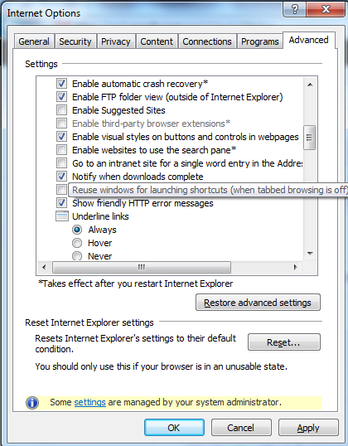Figure 2: The Internet Options Dialog, Advanced tab

Reporting EDIS Issues/Problems

All Emergency Department Integrated Software (EDIS) problems should be reported to your local site IT or regional IT department. The local IT or regional IT department will assess the problem to verify status of the network and VistA issues. If the problem cannot be resolved by the local or regional IT department, please contact the National Service Desk according to local policies.
The National Service Desk can be called REDACTED or e-mailed at REDACTED to request a Remedy Ticket be created.
NOTE: The site can also enter its own Remedy ticket through the Remedy application. The NSD will forward the Remedy Ticket to the appropriate EDIS support team for resolution. If the issue involves all VA facilities, an announcement will be forwarded via the EDIS User Alert Group. If the problem involves a Server issue, local or national, the ticket will be referred to the Austin Information Technology Center/Austin Automation Center (AITC) Service Desk. Once the AITC has resolved the issue/ticket, the National Support Specialist will update the site’s Remedy ticket.

Getting Started

Launch EDIS

If the IRM or CAC staff hasn’t provided a desktop shortcut or added an EDIS link to your CPRS Tools menu, you can access EDIS by pointing your browser to
https://vaww.edisprod2.med.va.gov/main—the application’s Uniform Resource Locater (URL).

If you want to access the application’s main electronic whiteboard (or big -board) display, use the following URL: https://vaww.edisprod2.med.va.gov/main/board.html. If you want to access a secondary big-board display, use this URL: https://vaww.edisprod2.med.va.gov/main/board.html?board=[boardname]. (Replace [boardname] with the name of the display board you want to view.)

When you access these URLs, the application's security system automatically redirects you to the login page. As it does this, the security system begins its authentication process.

Adding EDIS to your Internet Explorer Favorites
If you bookmark the EDIS login page, the link you initially create will bypass the application’s redirection-authentication process and the application’s security system will deny you access. You can remedy this situation by editing your bookmark link.

- In Internet Explorer, right-click the EDIS login bookmark and select

Properties.

- Edit the URL field to contain either https://vaww.edisprod2.med.va.gov/main or
https://vaww.edisprod2.med.va.gov/main/board.html.

- Click OK.

You can also create desktop shortcuts using these URLs.

Log In

When you launch EDIS, the application displays a login view that uses credentials stored in your local VistA system.

To log in:

- Type your VistA access and verify codes in the Access Code and Verify Code
boxes, respectively.
- Select your site in the Institution list. EDIS uses a persistent cookie to preselect your site upon subsequent logins, but only on the specific machine you used when you made this selection. You must select your site from the Institution list each time you use a new computer. (Your site may have configured a desktop shortcut that eliminates the need for this step by preselecting your institution.)

NOTE: Failure to select the correct institution is the most common cause of unsuccessful login attempts.

- Click Login or press the <Enter> key.

2.2.1. Changing Your Verify Code

For user authentication, EDIS relies on Kernel Authentication and Authorization for Java 2 Enterprise Edition (KAAJEE)—which is the only VA-approved login security package. KAAJEE limitations prevent EDIS from offering functionality that allows you to change your verify code within the EDIS application. When your VistA verify code expires, you can change it in CPRS or another VistA application. EDIS will then accept the change.

EDIS Views

Upon successfully logging in, the user will be presented with the EDIS Home Page (Fig. 4).

NOTE: In the event that a Default Waiting Room has not been assigned to EDIS, you will get the following warning popup message, indicating that new patients will be added to an area called EDIS_DEFAULT:

Figure 3: Warning Message for No Default Room/Area

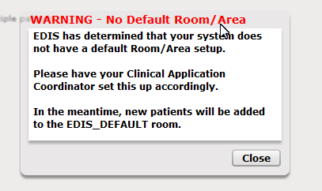

While you still will be able to log in and use EDIS normally, this situation should be resolved by asking your CAC to assign a default room in the Configure ->Parameters view within EDIS (see section 8.4.8).

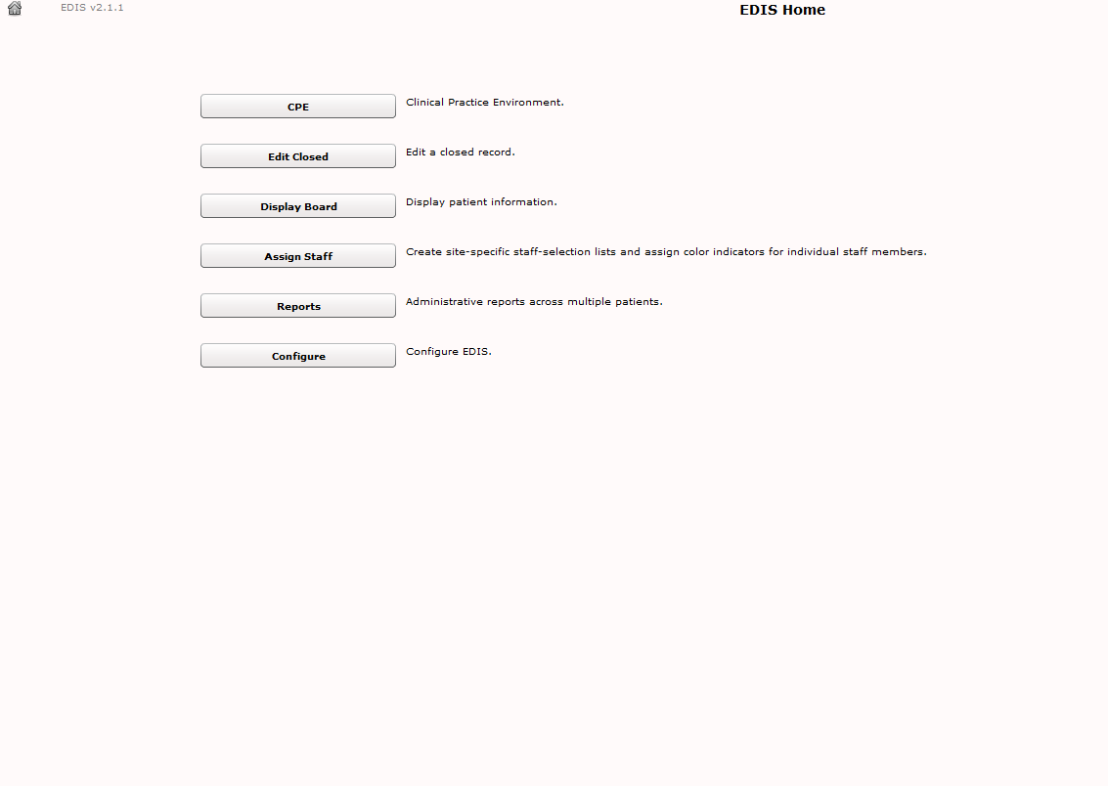Figure 4: EDIS Home Page

Following is a list and brief explanation of each view.

NOTE: Not all views are available to all users. EDIS offers site-configurable, role-based access to views. If you do not have access to a view that you need, speak with the IRM or CAC staff responsible for role-based access at your site.

CPE
The Clinical Practice Environment CPE view contains each window or a combination of these windows which enable you to perform the following functions:

Display Board (CPE Active Patients) Window

    - Add patients to the display board

    - Assign a room/bed to a patient

    - View visit status that lets the user know that an encounter has been created in PCE

    - View or update patient demographic information

    - Change the status of a patient

    - Change the ESI (Acuity Level)

    - Assign or change a Provider

    - Assign or change a Nurse

    - Assign or change a Resident

    - View labs and imaging tallies

    - Enter complaints in free-form text

    - Enter comments in free-form text

    - Assign or update patient disposition

    - View the total number of hours: minutes in the Emergency Department

    - View the number of hours: minutes a patient has been in his Room/Bed

    - View new orders

    - View the clinic where the patient is assigned

    - Access the Visit and Assess Worksheets by c licking on the Patient button or by clicking on the Pushpin to display the split screen worksheet views.

Visit Worksheet Window

    - View, add or change Complaint, Vitals, Status/Responsibility or Disposition

Assess Worksheet Window

    - View and print lab results

    - View and Print Active Problems

    - View and Print Active Medications

Edit Closed

The Edit Closed view enables you to edit patients’ information after their emergency-department visits have ended.

    - This view enables you to change a patient’s complaint, status/responsibility elements, and the patients’ dispositions and diagnoses. Diagnoses shall be entered in the form of either International Classification of Diseases, Ninth Revision, Clinical Modifications (ICD-9-CM) or International Classification of Diseases, Tenth Revision, Clinical Modifications (ICD-10-CM) after ICD-10 activation date; or free-text, if the EDIS parameter is set to allow free-text entries for diagnosis. If patients’ stays have exceeded the national emergency-department visit limit (currently six hours), the application may require you to select a reason for delay. If it does, this view will include a list of reasons from which you can choose. This view also allows restoring a patient to the board that has been removed in error.

Display Board
The Display Board view is a PC-based version of your site’s main electronic white-board—or big-board—display. You can configure multiple big-board displays for your site. However, you can view only your site’s main display board using the PC-based Display Board view.

Assign Staff
The Assign Staff view enables you to create site-specific staff-selection lists. You can also use this view to assign color indicators for individual staff members.

Reports
The Reports view enables you to select date ranges for, and run, standard reports. EDIS also includes two restricted reports requiring security-key access.

Configure
The Configure view enables you to localize the tracking application. It also allows you to assign color codes and locally meaningful color codes through available color maps (Select <Color> , then single Click on a map), populate pick lists with the names of your site’s treatment areas and set up display boards that contain only relevant information.

2.3.1. Select a View

On the EDIS Home page, click the button associated with the view you want to access. This menu is available from all application views. Keyboard shortcuts: use the <Tab> key to locate EDIS’s main navigation page button. Use the <Spacebar> or <Enter> key to navigate to the home page. On the EDIS home page, Use the
<Tab> key to navigate the view you want to select. Use the <Spacebar> key to select the view or push <Enter>.

Work with Data Grids

EDIS commonly displays information using a tabular —or grid—format. The application’s data grids allow you to personalize the following individual grids :

    - Arrange columns
    - Resize columns
    - Sort within columns

NOTE: The results of these actions are temporary. EDIS does not retain personalized data-grid changes.

Arrange Columns

Perform a drag-and-drop operation to move a column:

      - Point the mouse to a column header and hold down the left button.
      - Still holding down the left mouse button, move the column header to a new location.
      - Release the left mouse button.

Resize Columns

Use the computer mouse to resize columns:

      - Point your mouse to a column boarder in the header row. EDIS displays a column slider in place of the pointer.
      - Hold down the left mouse button and move the boarder to a new location.
      - Release the left mouse button.

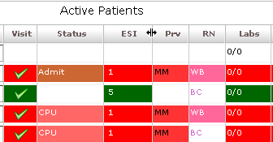Figure 5: The slider for resizing columns.

Column slider

Sort Information within Columns

You can sort the information within most columns.

- Click a column header to sort the information within the column in descending order.
- Click the column header again to sort the column’s contents in ascending order.

Figure 6: Sort information within columns by clicking on column headers.

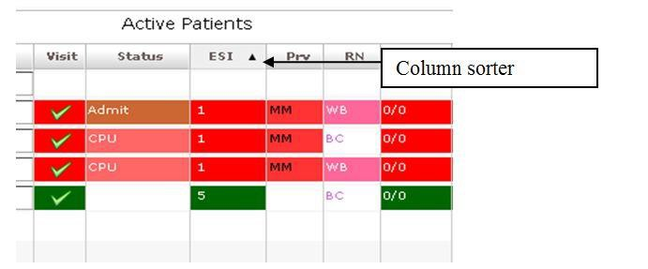

Access Help Files

Click the Help button to access the User Guide. Keyboard: use the <Tab> key to locate the Help button and use the <Spacebar> key to select the button.
Figure 7: Location of the Help Icon

Understanding EDIS and CPRS Interactions

You can successfully integrate CPRS with EDIS in one of two ways:

    - Create an unscheduled appointment in Appointment Manager; when you create an unscheduled appointment for a clinic location your site has specified in the EDPF LOCATION parameter, EDIS adds the patient to the EDIS Active Patients list.

NOTE: Depending on their EDPF SCHEDULING TRIGGER parameter setting (Either Make Appointment or CHECK IN) then the patient will appear.

- Create an encounter through EDIS, using Patient Care Encounter (PCE).

Each method has strengths and weaknesses. As is the case for any patient-scheduling system, less-than-optimal practices can lead to duplicated encounters . Sections 2.7 and 2.8 provide information that may help you choose the method that’s best for your location. Please read these two sections carefully.

Using EDIS with Appointment Manager

Benefits of this Method

Your site maintains the advantage of having a selectable list of triaged emergency-department patients available on the CPRS Patient Selection view.
This list of scheduled (that is, Appointment Manager-created) appointments is not
available via the PCE method.

Drawbacks of this Method

Successful CPRS and EDIS integration using this method requires intensive (recommended twenty-four-hours a day, seven days a week—or 24x7) secretarial and administrative support. For this method to work, your site must create an appointment for each emergency-department patient before doing anything else – which requires round-the-clock support of administrative staff who have access to Appointment Management.

Best Practice for Using EDIS with Appointment Manager

Add Patients to Appointment Management First:
When a patient presents to the emergency department for evaluation, a member of your site’s administrative staff immediately creates an appointment for the patient in Appointment Manager (depending on their EDPF SCHEDULING TRIGGER parameter setting (Either Make Appointment or CHECK IN) then the patient will appear). This creates a selectable visit in CPRS and adds the patient to EDIS. The triage nurse must subsequently add additional data to EDIS.

EXAMPLE:
      - Ms. Jones arrives at 11:30.
      - At 11:32, a member of the ED staff uses Appointment Manager to create an appointment for Ms. Jones.
      - EDIS automatically displays Ms. Jones on the Active Patients list.
      - The triage nurse sees Ms. Jones at 11:35 and completes her EDIS triage information; the nurse then opens CPRS and writes a triage note under the visit in
CPRS that corresponds to Ms. Jones’s emergency-department appointment.
      - The emergency-department provider selects this same encounter in CPRS when he or she writes notes or orders related to Ms. Jones’s emergency-department care.

Why This Is Best Practice

CPRS was created long before EDIS. It has not been changed to recognize that EDIS exists.

Unscheduled Appointments that cause Errors (in Appointment Manager)

NOTE: The following list contains things you should not do. We have included this section to help you troubleshoot problems that can occur when your site uses EDIS with unscheduled appointments in Appointment Manager.

- Creating unscheduled appoints just before the midnight hour: Appointments will disappear at midnight for patients who have unscheduled appointments for times that precede the midnight hour and for whom emergency-department personnel have completed neither documentation nor orders before midnight. When this occurs, your site must reenter the vanished appointments, thus creating both second appointments and duplicate PCE encounters. This problem is the result of CPRS business logic which exists outside of EDIS.

Failing to select the proper appointment when writing notes or ordering tests:
Providers and nurses create duplicate PCE encounters if they fail to select the
proper appointment in CPRS when writing notes or ordering tests.
- Writing notes or orders before creating unscheduled appointments: Providers and nurses create duplicate PCE encounters when they write orders or notes before ED staff have created unscheduled appointments for their patients.

Using EDIS with PCE

Benefits of this Method

Integrating EDIS with CPRS via the Patient Care Encounter (PCE) does not require intensive (recommended 24x7) support from personnel who have access to Appointment Manager. (The Appointment Manager method requires sites to create appointments for patients before doing anything else, which in turn requires
round-the-clock support from ED staff that have access to Appointment Management.)

Drawbacks of this Method

Sites that switch from using Appointment Manager to PCE, will impact their users, because they no longer have a list on their Patient Selection (initial) view of CPRS from which they can select patients who have emergency-department appointments. This list of scheduled (that is, Appointment Manager-created) appointments only appears when sites use the Appointment Manager method. As a result of not having this list, looking up patients who were discharged in the past (days or weeks ago) is a little more difficult in CPRS. However, authorized users can easily look up these patients in the EDIS Edit Closed view.

PCE is Best Used with EDIS

Place Patient on EDIS First with Provider Name:
When a patient is sent to the emergency department for evaluation, someone notifies the triage nurse and adds the patient to EDIS . The person who adds the patient to EDIS must also add a provider name. Assigning a provider in EDIS creates an unscheduled encounter in CPRS. Providers and nurses can subsequently write notes and orders under this encounter.

Although assigning a nurse in EDIS can also generate an encounter in CPRS, it doesn’t always. Nurse assignments generate selectable encounters in CPRS only if your hospital configures nurses with an active person class in VistA’s New Person file. Some sites do not allow this practice. In addition, using nursing assignments to create PCE encounters makes nurses primary providers in EDIS-generated encounters. Primary providers must change these placeholder assignments for encounters other than nursing-only encounters. To do this, primary providers should select Yes when CPRS prompts them to identify themselves as primary providers for encounters they are signing.

EXAMPLE #1:

      - At 11:31, a member of the administrative staff or a triage nurse adds Mr. Jones to EDIS and assigns Dr. Smith as Mr. Jones’s provider.
      - This creates an 11:31 encounter for Mr. Jones in CPRS.
      - The triage nurse opens CPRS, enters Mr. Jones’s chart, starts note, and selects the emergency-department encounter that already appears in CPRS.
      - The triage nurse writes and signs the note.
      - Mr. Jones’s provider writes a note or orders, also selecting the encounter that EDIS already created in CPRS.

In this example, if the initially assigned provider is not the primary provider for the encounter, the primary provider must select himself or herself when he or she signs the note. Someone (the provider, a clerk, or another emergency- department staff member) must also update EDIS to reflect the correct primary provider.

EXAMPLE #2:

      - At 11:31, an LPN adds Mr. Jones to EDIS.
      - Mr. Jones’s triage nurse has an active person class in VistA’s New Person file and opens a PCE encounter for Mr. Jones’s visit in CPRS as a provider.

      - A provider sees Mr. Jones; the provider (or a charge nurse or clerk) adds the provider’s name in EDIS.
      - When he is signing the encounter in CPRS, the provider identifies himself as the primary provider for the encounter.

If no primary provider had seen Mr. Jones (if he had left without being seen, for example) the triage nurse would close the encounter as a disposition of: "Nurse-only visit".

Why this Is Best Practice
CPRS was created long before EDIS and has not been updated to recognize EDIS. The PCE system is limited—it cannot create encounters unless users enter primary
providers or diagnoses for the encounters. If users add patients to EDIS without selecting their primary providers or diagnoses, EDIS cannot give to CPRS the
information that CPRS must supply to the PCE application, and PCE cannot create
the encounters. This is a limitation of the PCE application, not a limitation of EDIS. The best practice is to select a provider when you add a patient to EDIS
because diagnoses are rarely available early in the patient -care process.

NOTE: When patients present before midnight but providers do not treat them until after midnight, the providers must be certain to select the EDIS-created visit from the preceding day, as opposed to opening new (duplicate) visits.

Processes with PCE that Lead to Errors

NOTE: The following list contains things you should not do. We have included this section to help you troubleshoot problems that can occur when your site uses EDIS with the PCE system.

Failing to select a provider when adding a patient to EDIS:
When you fail to select a provider, EDIS cannot create an encounter in CPRS.

Failing to add a patient upon his or her arrival:
Duplicate encounters will result if users fail to add patients to EDIS (and select a provider) until after clinicians have started writing notes or orders.

Failing to select the EDIS-created visit when starting notes or writing orders:
Duplicate encounters will result if nurses and providers fail to select the
encounter EDIS creates when they start notes or create orders.

Continuing to use Appointment Manager for some patients:
Implementing two separate process flows can confuse staff and lead to errors.

Notifications

Patient-Selection Messages

When you select patients who are already registered in your local VistA system, EDIS may display one or more of the following messages:

Restricted Record Warning: This message appears when you select a patient whose records contain sensitive information. Only authorized users may view these records.

Figure 8: Restricted Record warning (sensitive patient data).

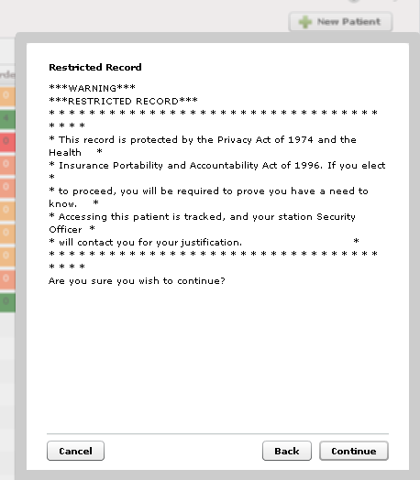

Patient Record Flags: EDIS displays advisory messages when you add patients whose records are flagged in VistA. You can view patient record flags after you’ve added patients by clicking the Flag button, which appears on the Patient Information bar when you select the CPE Visit or Assess Worksheets or Edit Closed view.

When you click the Flag button, EDIS displays important information to help you and other clinical staff better care for patients whose behavior or medical conditions

warrant special attention. The application displays patient-record flags in the Active Flag window.

Figure 9: The Active Flag window.

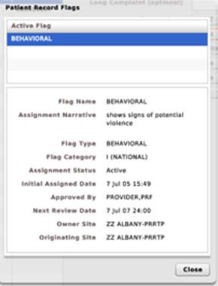

Duplicate Selection: EDIS displays an advisory when you attempt to add patients who are already active in the application.

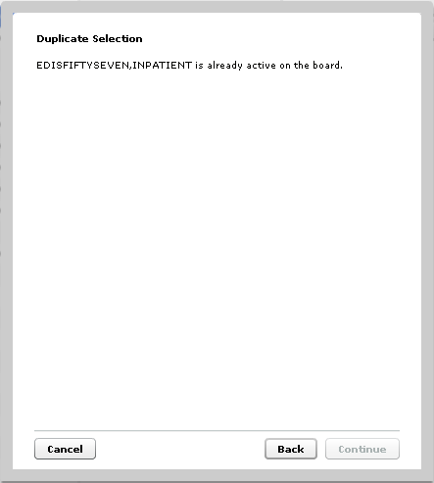Figure 10: Duplicate Selection

Multiple Patient icon: The application alerts you to the possibility of confusing patients’ identities by displaying an icon ( ) when two or more patients share the same last name or at least two consecutive ending digits of their social security numbers.

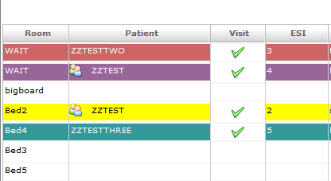CPE View
EDIS automatically adds patients when you use VistA’s Scheduling (Appointment
Manager) package to create an emergency department appointment for patients. Utilizing the Scheduler software is the preferred way to enter new patients into EDIS.

The EDPF LOCATION parameter, which holds your site’s emergency department location or locations, controls this functionality. Parameter settings ensure that only emergency-department check-ins and appointments add patients to EDIS.

From the CPE view, you can create an encounter in CPRS; add patients to the application from the Display Board, Worksheet (Visit or Assess) or combined Display Board and Worksheet views.

Create a PCE encounter in CPRS

Adding a provider (or a nurse who has an active person class in the New Person file) in EDIS automatically creates a PCE encounter in CPRS—unless EDIS has already created an encounter for this particular emergency-department episode of care (through Appointment Manager, for example) or the provider does not have an active person class in VistA’s New Person file. To reduce the possibility of creating duplicate PCE encounters in CPRS, EDIS checks back one hour for PCE encounter entries associated with the emergency department location your site’s IT staff has specified.

(EDPF LOCATION parameter settings and —if applicable—Clinic list selections determine the location EDIS uses to create encounters.)

The application creates only one PCE encounter in CPRS for each emergency- department episode of care (or encounter).You can avoid creating duplicate encounters for the same episode of care by selecting the encounter that EDIS creates when you complete patients’ emergency -department encounters in CPRS.

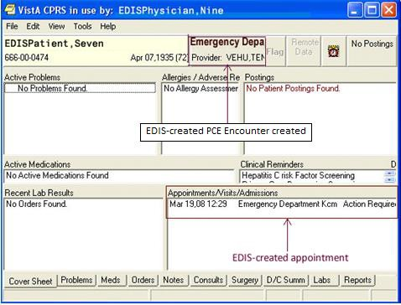

Add Patients to EDIS from the CPE View

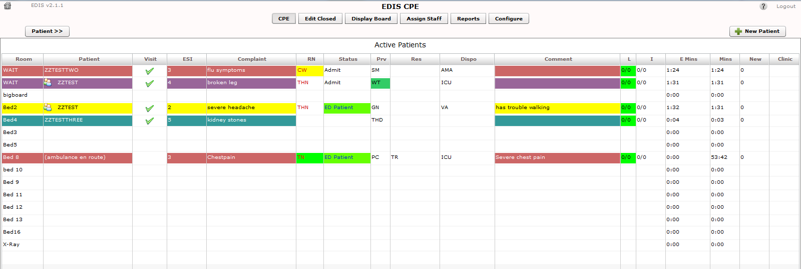Figure 12: The New Patient button.

    - Click New Patient in the upper right-hand corner of the CPE View. Keyboard: use the
<Tab> key to locate the New Patient button and press the <Spacebar> key to select it. The application displays the Add Patient dialog box, which offers the following three selections:

      - Search for Patient in VistA: Enables you to add patients who are already in your local VistA system
      - Ambulance Is Arriving, Patient Name Is Unknown: Enables you to add information for patients whose identities are unknown (EDIS does not create PCE encounters
for these patients until someone adds them using a VistA search)
      - Enter Name, Patient Is Not in VistA: Enables you to add patients who are not in your local VistA system (EDIS does not create PCE encounters for these patients until someone adds them using a VistA search)

Adding Patients Using the Search for Patient in VistA Selection

      - If necessary, select Search for Patient in VistA. (Search for Patient in VistA
is the application’s default selection; in most cases, you won’t need to manually select this button.) Keyboard: if the Search for Patient in VistA button isn’t already selected, use the <Tab> key to locate the selected button (Enter Name, Patient Is Not in VistA or Ambulance Is Arriving, Patient Name Is Unknown). Use the <Up Arrow> key to locate the Search for Patient in VistA button and use the <Spacebar> key to select it.
      - Type all or part of the patient’s name in the Find Patient box using this format: Surname, Firstname. For example, you can search using the patient’s
surname only, or the patient’s surname and the first initial of his or her first
name. You can also search using the initial letter of the patient’s surname concatenated with the last four digits of his or her Social Security number
(X9999 format), the patient’s entire Social Security number (SSN), or the last
four digits of his or her SSN.

Note: Use an underscore to denote space s in names. For example, if the patient’s name is O Hara, type O_Hara.

      - Click Search or press the <Enter> key.
      - The Add Patient dialog box lists possible matches. Select the correct patient and click Continue or press the <Enter> key. Keyboard: use the <Down
Arrow> and <Up Arrow> keys to locate the correct patient. Press the
<Enter> key to select the patient or use the <Tab> key to locate the Continue
button and then press the <Spacebar> key to select it.

The application displays the Patient Information pane.

Figure 13: Search for Patient In VistA.

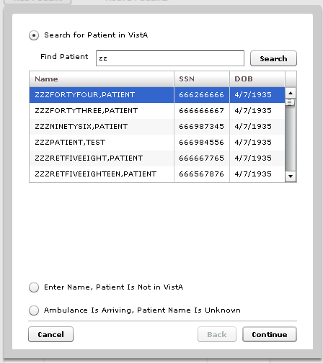

Adding Patients Using the Enter Name Selection

If the Find Patient search list does not contain a match, add the patient using the
Enter Name, Patient Is Not in VistA selection.

      - In the Add Patient dialog box, select Enter Name, Patient Is Not in VistA. Keyboard: use the <Tab> key to locate the currently selected button and use the <Down Arrow> or <Up Arrow> key to locate the Enter Name, Patient Is Not in VistA button. Press the <Spacebar> key to select this button.
      - EDIS automatically populates the Patient Name box with the name you typed to initiate the VistA search. If this name is incorrect or incomplete, type the
patient’s full name in the Patient Name box using this format: Lastname,
Firstname. Keyboard: use the <Tab> key to locate the Patient Name box.
      - Press the <Enter> key or click Continue.

The application displays the P atient Inf ormation pane.

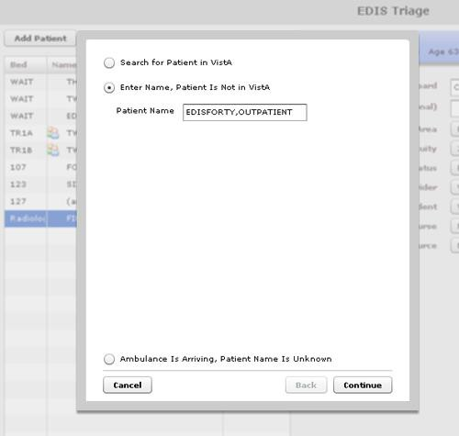Figure 14: The Enter Name, Patient Is Not in VistA button.

Adding Unidentified Patients

When you must add unresponsive patients whose identities you do not know, use the Enter Name, Patient Is Not in VistA selection and follow the naming protocol defined in section 12 of VHA Directive 2006 -036: Data Quality Requirements for Identity Management and Master Patient Index Functions . (Use the name UU-UNRESPONSIVE, PATIENT for the first such patient, UU- UNRESPONSIVE, PATIENT A for the second, UU-UNRESPONSIVE,
PATIENT B for the third, and so forth. You can find the full text of this directive at
http://www1.va. go v/ vha publications/ViewPublication.a sp?pub_ID=1434.)

Adding Patients Using the Ambulance Is Arriving Selection

EDIS enables you to add unknown patients who are arriving by ambulance or other types of emergency transportation, thereby allowing you to make room, provider, and nurse assignments before these patients arrive.

      - Select Ambulance Is Arriving, Patient Name Is Unknown. Keyboard: use the <Tab> key to locate the currently selected button, and use the <Down Arrow> key to locate the Ambulance Is Arriving, Patient Name Is Unknown button. Press the <Spacebar> key to select this button.
      - Click Continue. Keyboard: use the <Tab> key to locate the Continue button and use the <Spacebar> key to select it.

The application displays the P atient Inf ormation pane.

EDIS reports do not reflect the number of patients whom users add to the application via this method.

Also, EDIS creates its Time In timestamps when users identify patients in VistA or create unscheduled appointments for them in Appointment Management. As a result, sites must correct EDIS’s Time In values to reflect the times these patients actually arrived at the Emergency Department.

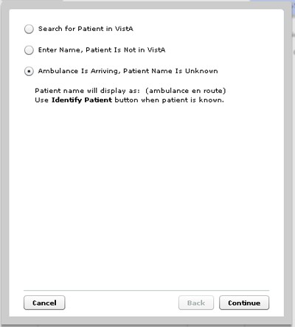Figure 15: The Ambulance Is Arriving, Patient Name Is Unknown button.

Update Patient Information from the Display Board

From the main Display Board, select from one of the following column headers, if available (columns are configurable and can be added/removed as desired) to perform the following functions:

    - Room – to update or add a room or bed

    - Patient – to view or update patient demographics information

    - Status – to change the status of a patient

    - ESI – to change the Acuity of a patient

    - PRV – to assign or change the provider

    - RN – to assign or change a nurse

    - Complaint – to view the complaint free-form text

    - Comments – to enter comments in free-form text

    - Dispo – to change the Disposition of a patient

    - Res – to assign or change the resident

Figure 16: CPE Display Board View

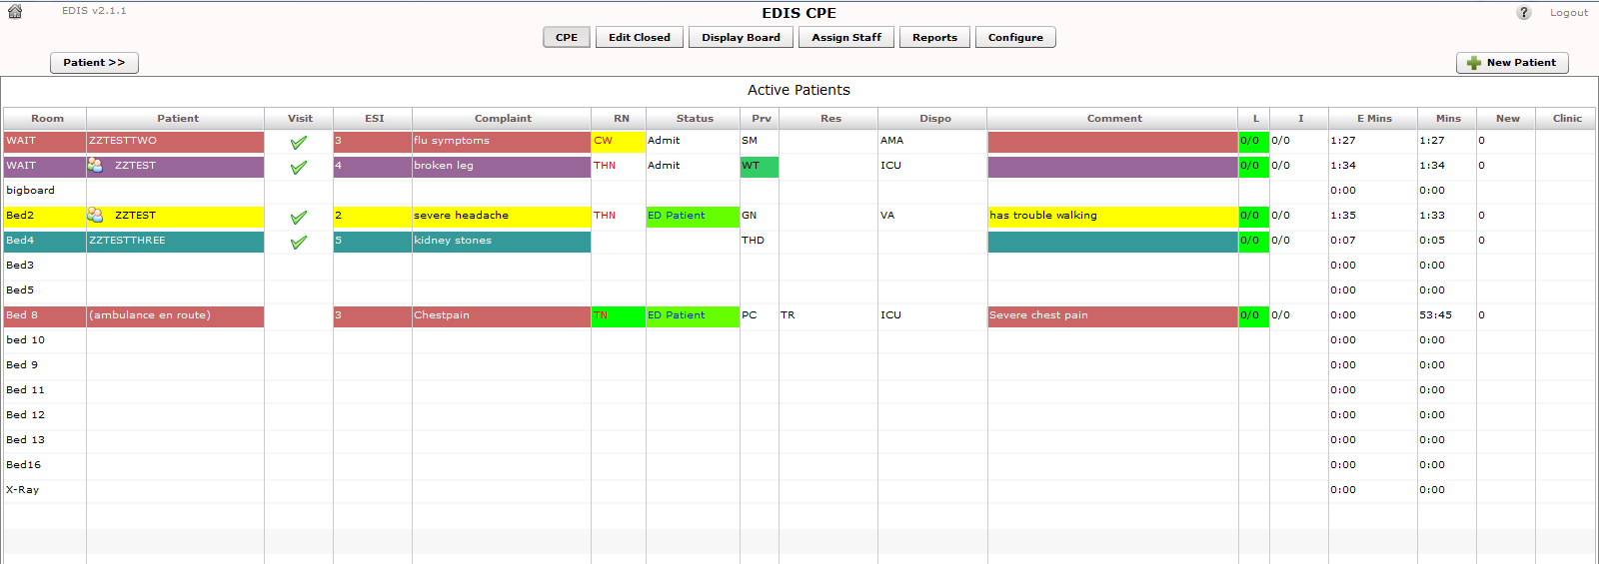

Updating a Room or Bed from the Display Board

In the Room column, select the patient whose information you want to view or edit. Use the <Down Arrow> key to enter the list, and use the < Down Arrow> and <Up Arrow> keys to select your Room.

Figure 17: Change Room/Bed View.

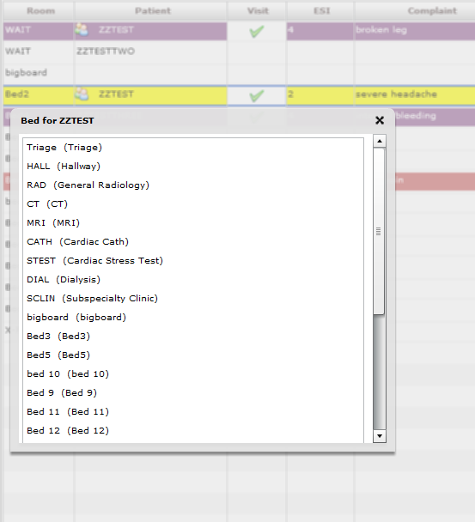

View or Update Patient Demographic Information

In the Patient column, select the patient whose information you want to view or edit. Select one of the fields to update the telephone number and click the OK button to accept your changes.

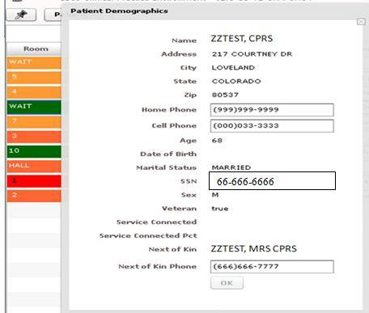Figure 18: Patient Demographics View

666-66-6666

Change the Patient Status

In the Status column, select the patient whose information you want to view or edit. Use the <Down Arrow> key to enter the list, and use the < Down Arrow> and <Up Arrow> keys to select your status.

Figure 19: Status View

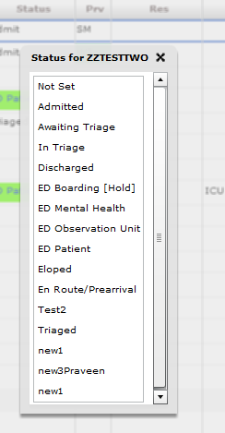

You may select the status that is appropriate for the patient from your site’s Status selection list.

Change the ESI Acuity Level

In the ESI column, select to view or edit patient information. Use the <Down Arrow> key to enter the list, and use the < Down Arrow> and <Up Arrow> keys to select your Acuity level.

Figure 20: ESI View

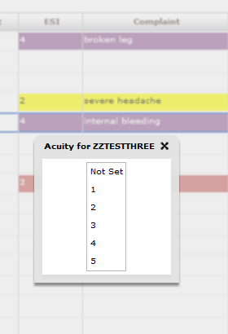

Assign or Change a Provider

In the PRV column, select the patient to view or edit patient information . Use the
<Down Arrow> key to enter the list, and use the < Down Arrow> and <Up Arrow> keys to select your Provider Name.

NOTE: Providers in this list, are defined in the Provider Configuration.

Figure 21: Change Provider View

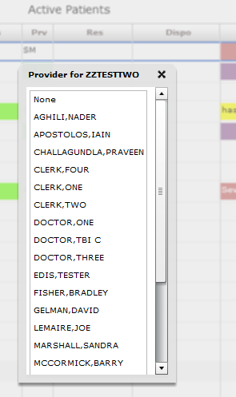

Add or Change a Nurse

In the Nurse column, select the patient whose information you want to view or edit. Use the <Down Arrow> key to enter the list, and use the < Down Arrow> and <Up Arrow> keys to select the name of the nurse triaging the patient. NOTE: the Nurse Selection is defined by the "Nurse Configuration" .

Figure 22: Change Nurse View

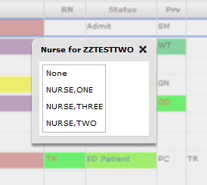

Entering Patient Complaint

In the Complaint column, select the patient whose information you want to view or edit. A popup appears to allow editing of the patient complaint.

Figure 23: Change Complaint

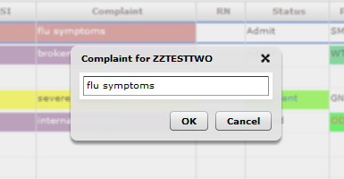

Entering Comments

In the Comments column, select the patient whose information you want to view or edit. A popup appears to allow editing of the comment.

Figure 24: Change Comment

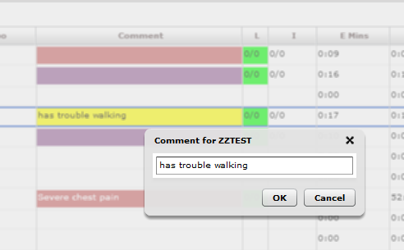

Entering Disposition

In the Dispo column, select the patient whose information you want to view or edit. A popup appears to allow selection of the disposition.

Figure 25: Change Disposition

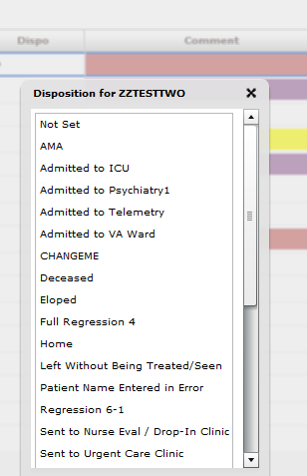

Add or change a Resident

In the Resident column, select the patient whose information you want to view or edit. Use the <Down Arrow> key to enter the list, and use the <Down Arrow> and <Up Arrow> keys to select the name of the resident attending the patient. NOTE: the Resident Selection is defined by the "Resident Configuration".

Figure 26: Change Resident View

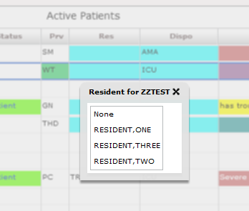

Visit or Assess Worksheet View

Use the Worksheet (Visit and Assess) or combined view to edit or update information that you gather as part of the patient care process. From this view, you can:

    - update the patient’s display-board complaint;

    - include additional, not-for-display information about their complaints (optional);

    - update their room or area assignments;

    - add information about their acuities;

    - make nursing, provider, and resident assignments;

    - update or add their sources (on-site clinics, nursing homes, and so forth);

    - specify a clinic location for the patient’s emergency -department visit.

    - add optional comments;

    - provide a disposition;

    - provide a Delay Reason, if applicable;

    - access vitals and active medications and problems

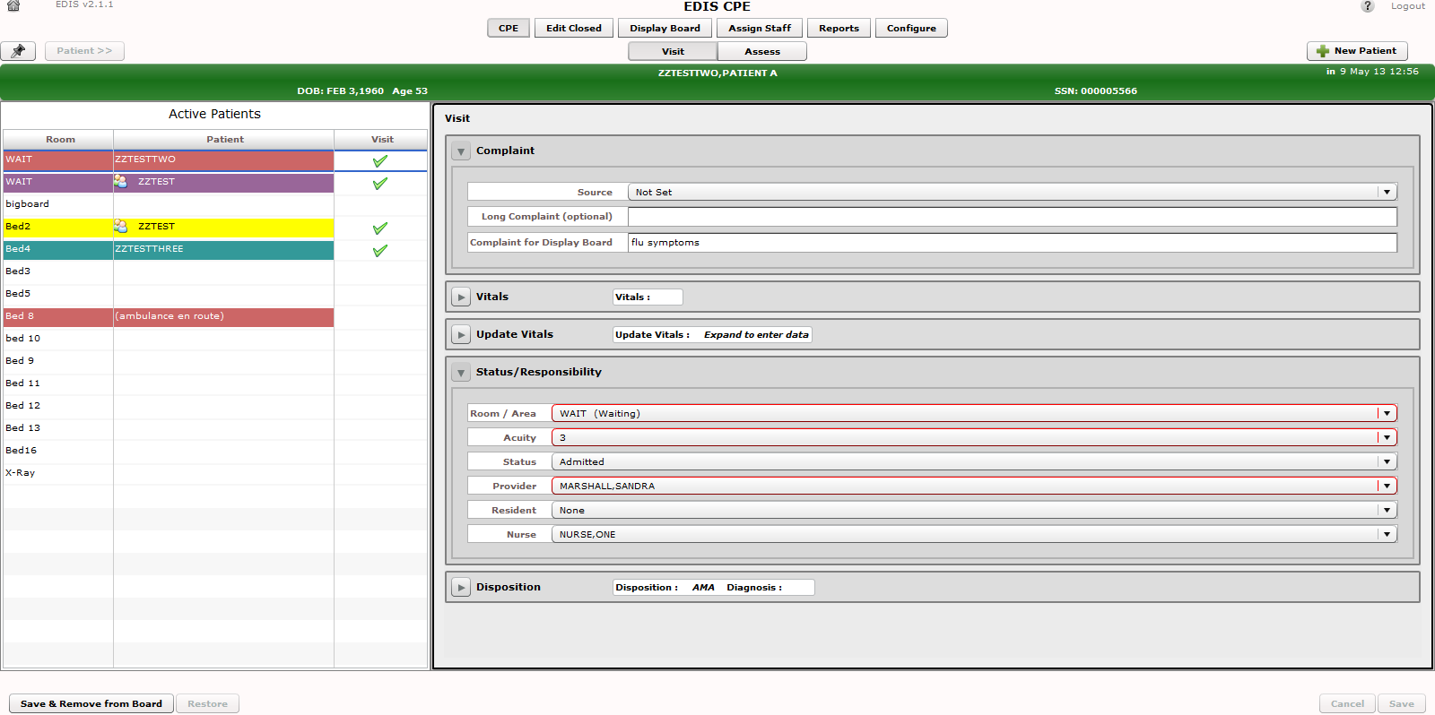
Figure 27: The Visit Worksheet view.

Visit Worksheet View

In the EDIS CPE/Active Patients view, select the patient whose information you want to enter. Keyboard: use the <Tab> key to locate the Active Patients list. Use the <Down Arrow> key to enter the list, and use the <Down Arrow> and <Up Arrow> keys to locate the patient you want to select. The Patient Information pane displays current information for the selected patient.

Complaint

If necessary, expand the Complaint section.

Enter the complaint in the Complaint for Display Board box. The application will not allow you to add the patient to EDIS if the Complaint for Display Board box is empty. In the Long Complaint (optional) box, you may type supplemental information about the patient’s condition.

If known, the patient’s arrival mode (Source) can also be selected.

Vitals

If necessary, expand the Vitals section and click the Load button. If the current patient has data, it will be displayed in the table, with an associated timestamp. The data can also be printed by clicking the Print button.

Update Vitals

If necessary, expand the UpdateVitals section.

      - Where applicable, update the vital fields BP – Blood Pressure, T (F) – Temperature, P- Pulse, RR – Respiratory Rate, Ht (in) – Height, Wt (lbs.) – Weights and Pain Severity. NOTE: Currently, EDIS does not support the metric system for vitals.
      - Save your changes by clicking Save or click Reset to zero out your changes.

Status/Responsibility

If necessary, expand the Status/Responsibility section.

- Select a room/area from the Room list (room or area selection is mandatory).
Keyboard: Use the <Down Arrow> and <Up Arrow> keys to select a room or area from the list.

- Click an acuity value from the Acuity list. Acuity information is mandatory for this view. If you do not select an acuity, the application will not allow you to save your updates or edits. Keyboard: Use the <Down Arrow> and <Up Arrow> keys to select an acuity from the list.

- EDIS supports the Emergency Severity Index (ESI) triage algorithm, which ranks patients’ acuities using the numbers 1 (most urgent) through 5 (least urgent). For more information, please visit the Agency for Healthcare Research and Quality ESI website: http://www.ahrq.gov/research/esi.
- From the Status list, select the patient’s status. Keyboard: Use the <Down Arrow>
and <Up Arrow> keys to select a Status from the list.
- Click a provider from the Provider list. Keyboard: Use the <Down Arrow> and
<Up Arrow> keys to select the patients’ provider assignment from the list. The
Provider list is also available on the Disposition view.
- Click a nurse from the Nurse list. Keyboard: use the <Tab> key to locate the Nurse list. Use the <Down Arrow> and <Up Arrow> keys to select the patients’ Nurse from the list.
- If applicable, click a resident from the Resident list. Keyboard: use the <Tab> key to locate the Resident list. Use the <Down Arrow> and <Up Arrow> keys to
select the patients’ Resident from the list.
- If applicable, click a clinic from the Clinic list. Keyboard: use the <Tab> key to locate the Clinic list. Use the <Down Arrow> and <Up Arrow> keys to select the
patients’ Clinic from the list.

When you make a provider assignment in EDIS, the application automatically creates a Patient Care Encounter (PCE) visit in CPRS —if it hasn’t already done so, or unless the provider does not have an active person class in VistA.

EDIS does not create encounters for patients you’ve added using the Enter Name, Patient Is Not in VistA and Ambulance Is Arriving, Patient Name Is Unknown selections. It does not create encounters when you

enter only resident or nurse assignments. However, EDIS does create
encounters if the nurse has an active person class in file 200.

NOTE: EDIS does not register patients.

Disposition

If necessary, expand the Disposition section.

- Enter an optional Comment.
- Click the Disposition list and select a disposition. Depending upon your site’s configuration, the application may require a disposition before allowing you to remove a patient from the display board. Keyboard: use the <Tab> key to locate the Disposition list. Use the <Down Arrow> and <Up Arrow> keys to select a disposition from the list.
- Click Save to save your changes or click Cancel to close the Patient Information pane without saving your changes. Keyboard: use the <Tab> key to locate the Save or Cancel button. Use the <Spacebar> key to select the button.

NOTE: The Save button is available only after you’ve added or updated information in the Disposition pane.

Definitions for National Dispositions

The EDIS Technical Work Group (TWG) offers the following definitions for nationally released dispositions:

Admitted to VA Ward—the patient was admitted to an inpatient location, not including an ICU, telemetry, or psychiatric unit.

AMA—the patient left against medical advice after signing a form; the patient may or may not have been medically evaluated before leaving.

Sent to Urgent Care Clinic—the patient was discharged from the emergency department and referred to another evaluation clinic at the same site; some degree of triage is necessary to make this judgment.

Deceased—the patient is dead.

Eloped—the patient left the emergency department and his or her disposition is unknown; a nurse or physician may have seen and evaluated the patient.

Patient Name Entered in Error—the patient’s name was entered in error; this disposition removes the patient from the board.

Home—the patient was discharged to his or her previous living arrangement.

Admitted to ICU—the patient was admitted to an inpatient critical care unit.

Left Without Being Treated/Seen—the patient left the emergency department before receiving treatment and before signing the form; this
is not the same as AMA, which assumes the patient signed a form before leaving.

Sent to Nurse Eval / Drop-in Clinic—the patient was discharged from the emergency department and referred to another on -campus same-day evaluation clinic; some degree of triage is necessary to make this judgment.

Admitted to Psychiatry—the patient was admitted to an inpatient psychiatric unit.

Admitted to Telemetry—the patient was admitted to an inpatient telemetry unit.

Transferred to a Non-VA Facility—the patient was discharged from the emergency department and sent to another, non -VA, facility.

Transferred to VA Facility—the patient was discharged from the emergency department and sent to another VA facility.

Sites can activate and inactivate these dispositions. The application allows your site to configure additional, site -specific dispositions.

To capture admission-delay times for reporting, you must change patients’ statuses to Admitted and then immediately select Admitted to VA Ward as their dispositions. Unless you intend to remove patients from the board, click Save. Do not click Save & Remove from Board, which will prematurely remove your patients from the EDIS tracking application.

Definitions for National Reason-for-Delay Sections

The EDIS TWG offers the following definitions for nationally released reason-for-delay selections. Your site is not required to include all selections in its pick list. EDIS test sites recommend limiting pick lists to reasons that are relevant at your site because over -long lists affect compliance.

Obtain Accepting Physician—the delay was caused by the inability to find an accepting physician to admit the patient. This selection includes the elapsed time between determining the patient’s need for admission and obtaining an accepting physician.

Admit Physician Writing Dispo—the delay resulted from the physician’s failure to write the patient’s admit or discharge order. This selection includes the elapsed time between when the patient was ready for his or her disposition and when the physician wrote the order to admit or discharge the patient.

Admitting Physician Evaluation—the delay was related to the admitting physician’s evaluation and confirmation of the patient’s disposition. For this selection, delay time begins when the physician sees the patient and ends when:

H&P is done

Ancillary studies that are necessary for disposing the patient are done and resulted

The patient is ready to be disposed

Patient Admitted to Observation—the delay resulted from the patient’s admission to observation. This selection includes the elapsed time between when the patient was ready to be disposed and the time the physician wrote an order to admit the patient to 23 hours of emergency department or floor observation.

Obtain Ambulance Services—the delay resulted from the time it too k to obtain ambulance services. This selection includes the elapsed time between when emergency department staff requested ambulance services and the time the ambulance arrived.

Obtain Consultant—the delay resulted from an ordered consultation’s lack of completion. This selection includes the elapsed time from when a physician ordered a consultation to the time the physician obtained the consultation.

ED to Hospital Bed—the delay represents the difference between the time the patient was assigned a hospital bed and the time the patient was transported from the emergency department; for example, this delay could represent the time emergency department staff spent waiting for an escort, for a bed to be cleaned, for a nursing report, or for staffing.

Obtain Escort—the delay resulted from the time it took to obtain an escort for the purpose of transporting the patient (not including transport to a hospital bed—use ED to Hospital Bed for this reason). This selection includes the time that elapsed between when the emergency department called an escort and the time the escort arrived to transport the patient to a clinic, radiology, or another ancillary department.

Patient Transport Home—the delay resulted from an inability to find transportation for a discharged patient or the time it took the identified source of transportation to arrive at the emergency department. This selection includes the elapsed time between when the patient was ready for discharge and the time the patient left the emergency department.

Obtain Imaging Results—the delay resulted from time spent waiting to obtain imaging results. This selection includes the elapsed time between when the imaging study was completed and the time the study was resulted.

Obtain Imaging Studies—the delay resulted from time spent waiting for imaging studies. This selection includes the elapsed time between when the physician ordered the imaging study and the time the study was done and ready for interpretation.

Obtain Inpatient Bed—the delay resulted from the time spent waiting for an impatient bed assignment. This selection includes the elapsed time between when the physician wrote the admission order and the time bed control or the house supervisor assigned the patient to a bed —the time an ICU patient waited for an ICU bed to open up, for example.

Interfacility Transfer—the delay was caused by an inability to transfer the patient to another facility in a timely manner.

Obtain Lab Results—the delay was caused by the lack of a timely turnaround for laboratory tests. This selection includes the elapsed time between when labs were drawn or obtained and the time the labs were resulted.

Obtain Lab Studies—the delay was caused by an inability to get labs drawn in a timely fashion. This select ion includes the elapsed time between when the physician wrote the lab order and the time the lab test was drawn.

On-call Staff—the delay was caused by an inability to contact on -call staff.

Overcrowding of ED—the delay resulted from waiting for an emergency department bed to become available (includes hallway beds and beds that were unavailable because of staffing issues); no beds were available for inbound ambulances, including hallway beds.

Obtain Drugs/Pharmacology—the delay was caused by an inability to get ordered drugs from the pharmacy. This selection includes the elapsed time between when the physician ordered the medications and the time the emergency department received the medications.

ED Physician Limits—the delay resulted from time the physician spent seeing patients. This selection includes the elapsed time between when the patient was placed in a bed and when the physician saw the patient. For example, this reason for delay might apply if five patients presented with chest pains, all within 10 minutes.

ED Staff Limits—the delay resulted from a failure to process the patient (see the patient or accomplish orders, for example) in a timely manner because of insufficient staffing. This selection includes the elapsed time between when the physician wrote an order (to splint a broken ankle, for example) and the time the order was accomplished.

Obtain Medical Supplies—the delay resulted from an inability to obtain medical supplies (splints, crutches, and c -line kits, for example) in a timely manner. This selection includes elapsed time from when emergency department personnel ordered the supplies (or identified the need for them) and the time the emergency department received the supplies.

Arrange Emergency Surgery—the delay resulted from the time it took to get the patient (who needed surgery) to the operating room.

Patient Transport Other—the delay resulted from the time it took to find transportation for the patient to a location other than home. This selection includes the elapsed time between when the patient was ready for transport and the time the patient left the emergency department.

- Click Save to save your edits and updates or click Cancel to close the Patient Information pane without saving your changes. The Save button is available only after you’ve added or updated information in the Patient Information pane.
- If the Delay Reason list is available, open it and select a reason for delay.
Depending upon your site’s configuration, the application may require a reason for delay when patients’ emergency-department visits have exceeded a specified number of minutes. Keyboard: use the <Tab> key to locate the Delay Reason list. Use the
<Down Arrow> and <Up Arrow> keys to select a delay reason from the list. The
Delay Reason list is available only under the following conditions:

  - Your site requires a delay reason and

  - The patient’s stay has exceeded the site-determined limit and

  - The patient is not in an observation ward

NOTE: If your site requires a reason for delay and the patient’s stay has exceeded the maximum number of minutes your site has specified, the application will require you to enter a delay reason before it allows you to remove the patient from the display board.

- Please refer to section 3.7 and 3.8 to see detailed explanations of how to enter information about Patient Diagnosis.

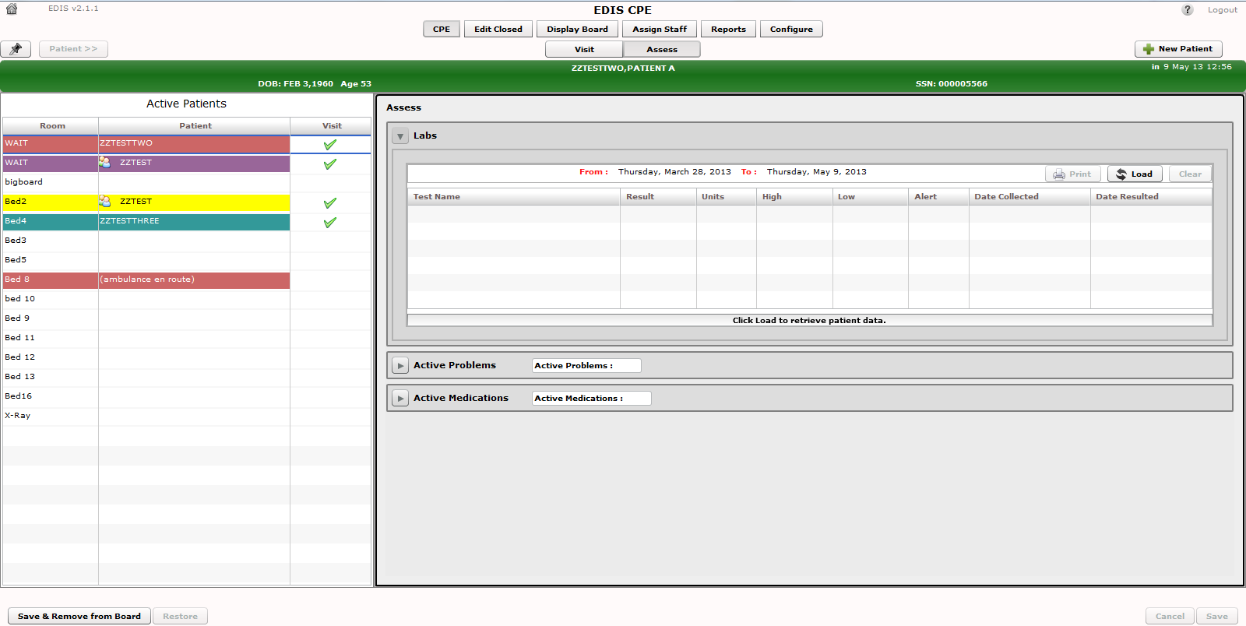
Figure 28: The Assess Worksheet view.

Assess Worksheet View

In the Active Patients view, click on the patient whose information you want to enter. Keyboard shortcut: use the <Tab> key to locate the Active Patients list. Use the <Down Arrow> key to enter the list, and use the <Down Arrow> and <Up Arrow> keys to locate the patient you want to select. The Patient Information pane displays current information for the selected patient.

Labs

If necessary, expand the Labs section. Click the Load button to view patient lab data. Not that the labs will be returned up to 6 weeks prior to the current date. Click the Print button to print the information in the table.

Active Problems

If necessary, expand the Active Problems section. Click the Load button to view patient data. Click the Print button to print the information in the table.

Active Medications

If necessary, expand the Active Medications section. Click the Load button to view patient data. Click the Print button to print the information in the table.

.

Enter ICD Diagnoses

- In the Visit Worksheet View (see section 3.6.1), expand the Disposition section.
- Type a diagnosis in the Diagnosis search box and click Search or press the <Enter> key. The application lists possible matches from VistA’s ICD-9-CM or ICD-10-CM (after ICD-10 activation date) code base. Keyboard: use the <Tab> key to locate the Diagnosis search box. Type a diagnosis in the box and press the <Enter> key.
- Click on an ICD-9-CM or ICD-10-CM (after ICD-10 activation date) diagnosis from the Diagnosis search result list and click Add or press the <Enter> key. The application adds this diagnosis to the Selected Diagnoses list. Keyboard: use the <Down Arrow> and <Up Arrow> keys to locate the diagnosis you want to select. Press the <Enter> key to select the diagnosis. To select another diagnosis from the same search list, use the
<Tab> key to reenter the list. Use the <Down Arrow> and <Up Arrow> keys
to locate the additional diagnosis, and press the <Enter> key to select this diagnosis. You can also select diagnoses by using the <Tab> key to locate the Add button, then pressing the <Spacebar> key to select the button.
- To remove a diagnosis from the Selected Diagnoses list, click the diagnosis and click Remove or press the <Delete> key. Keyboard: use the <Tab> key to locate the Selected Diagnoses list. Use the <Down Arrow> and <Up Arrow> keys to locate the diagnosis you want to remove. Press the <Delete> key to remove the diagnosis. You can also simultaneously press the <Shift> and
<Tab> keys to locate the Remove button, and then press the <Spacebar> key to remove the selected diagnosis.
- Repeat steps 1–3 as needed.
- In the Selected Diagnoses list, click a primary diagnosis and click Set as Primary Diagnosis. Keyboard: in the Selected Diagnoses list, use the <Down Arrow> and <Up Arrow> keys to locate the primary diagnosis. Use the
<Tab> key to locate the Set as Primary Diagnosis button, and use the <Spacebar> key to select this button.
- Click Save to save your changes or Cancel to close the Patient Information pane without saving your changes. Keyboard: use the <Tab> key to locate the
Save or Cancel button. Use the <Spacebar> key to select the button.
- For ICD-10 searches, the user can “drill down” through the categories and sub-categories to identify the single, valid ICD-10-CM code that best matches the patient diagnosis. Please refer to the ICD-10 Release Notes for more details and a screen example showing the tree view.

NOTE: Saving an ICD diagnosis in EDIS adds the diagnosis to the patient’s emergency-department encounter in CPRS. If EDIS hasn’t already created a PCE encounter for this patient, it will also create an encounter at this time. The application does not add free-text diagnoses to the patient’s visit in CPRS.

Enter Free-Text Diagnoses

You can type in free-text diagnoses only if your site has set the parameter that enables you to do so (Diagnosis must be coded as ICD is unchecked under Configure View, Parameters subview; see section 8.4).

- Type a diagnosis or procedure in the Diagnosis box and click Add or press the <Enter> key. Keyboard: Use the <Tab> key to locate the Diagnosis box. Type a diagnosis in the box and press the <Enter> key. You can also press the <Tab> key to locate the Add button and press the <Spacebar> key to select the button. The application displays your diagnosis or procedure in the Selected Diagnoses list.
- To remove an item from the Selected Diagnoses list, select the item and click Remove
or press the <Delete> key. Keyboard: Use the <Tab> key to locate the Selected Diagnoses list and use the <Down Arrow> and <Up Arrow> keys to locate and select the diagnosis you want to remove. Use the <Delete> key to remove the diagnosis. You can also remove the diagnosis by simultaneously pressing the <Shift> and <Tab> keys to locate the Remove button, then pressing the <Spacebar> key to select the button.
- Repeat steps 1–2 as needed.
- In the Selected Diagnoses list, choose a primary diagnosis, and then click Set as Primary Diagnosis. Keyboard: Use the <Tab> key to enter the Selected Diagnoses list
and the <Down Arrow> and <Up Arrow> keys to locate the primary diagnosis. Use the
<Tab> key to locate the Set as Primary Diagnosis button and use the <Spacebar> key to select it. NOTE: this diagnosis notes to save to the PCE Encounter in CPRS.
- Click Save to save your changes or click Cancel to close the Patient Information pane
without saving your changes. Keyboard: Use the <Tab> key to locate the Save or
Cancel button. Use the <Spacebar> key to select the button.

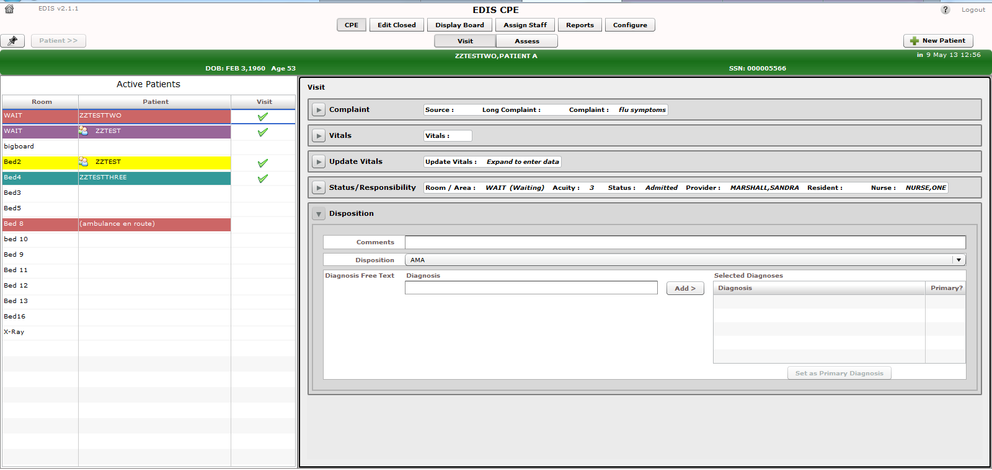Figure 29: The Disposition view with free-text diagnoses enabled.

Remove Patients

    - Click the Save & Remove from Board button to save changes and remove patients from the display board. Keyboard: use the <Tab> key to locate the Save & Remove from Board button. Use the <Spacebar> key to select the button.

This button is available only after users have entered all of the disposition information your site’s EDIS implementation requires. If you haven’t entered a provider or acuity, the application alerts you to do these things before it allows you to save your changes and remove your patient from the board—unless your patient’s disposition is Patient Name Entered in Error, Left Without Being Treated / Seen, or Sent to Nurse Eval / Drop In Clinic.

Clicking the Save & Remove from Board button removes patients from the display board and saves previously unsaved changes. While the application retains information about the visits of patients you’ve removed from the display board, only users who have access to the Edit Closed view will have direct access to this information. Users who have access to the Reports view will have indirect access to this information.

Remove Patients Entered in Error

- Open the Disposition list. Keyboard: Use the <Tab> key to locate the Disposition
list.
- Click Patient Name Entered in Error. Keyboard: Use the <Down Arrow> key to select Patient Name Entered in Error.

Click Save & Remove from Board. Keyboard: Use the <Tab> key to locate the
Save & Remove from Board button and press the <Spacebar> key to select it.

Edit Closed View

This view enables authorized users to edit the EDIS records of patients who are no longer on the display board. This view also allows a user to restore a patient to the board who was removed in error. EDIS logs all changes for subsequent reference (as it does with changes users make while patients are still signed in to the emergency department). If your site uses PCE instead of Appointment Management, the Edit Closed view provides a lookup tool; you can use this view to search for specific patients who visited your emergency department on a specific date.

NOTE: The following option is needed to access the Edit Closed View: (Option: [EDPF TRACKING VIEW EDIT CLOSED]).

Figure 30: The Edit Closed View

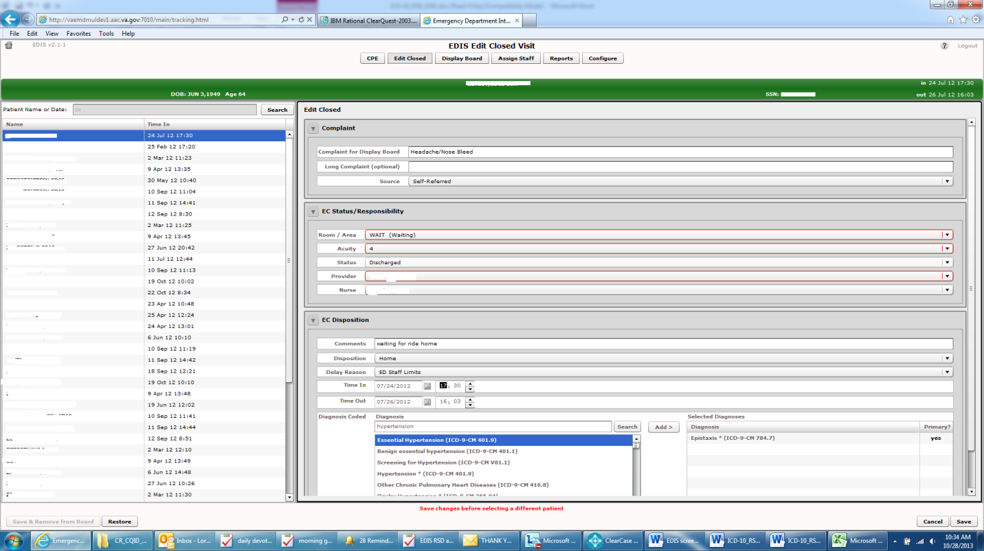

- Click Edit Closed on EDIS’s main navigation page.
- Type a date (mm/dd/yy format) or all or part of the patient’s name (Surname, First name format) in the Patient Name or Date box. For example, you can type the patient’s surname initial, entire surname, or surname and first-name initial. You can also type the patient’s full
SSN, the initial letter of the patient’s surname concatenated with the last four digits of his or her SSN (X9999 format), the word today (for a list of today’s visits), or t-n (where t represents today and n represents the number of days prior to today). Keyboard: use the
<Tab> key to locate the Patient Name or Date box.
- Click Search or press the <Enter> key. EDIS lists possible matches in the search-results list.

- Add or update other data-entry fields as necessary. You can add information to, or update the following fields: Complaint for Display Board, Long Complaint (optional), Room / Area, Acuity, Status/Responsibility, Room/Area, Acuity, Status, Provider, Nurse, Disposition, Status, Comments, Disposition, Delay Reason, Time In, Time Out and Diagnosis. (Click the Time In or Time Out spin-box arrows or use the <Up Arrow> and <Down Arrow> keys to edit the patient’s time in or time out.)
- Click Save to save your changes or click Cancel to discard them.
- If this was a patient who was removed from the board in error, click the Restore button to restore the patient’s record in EDIS and replace the patient’s name on the CPE Display Board.

NOTE: If you attempt to change the time out value (or other value) for a patient who left the emergency department before he or she was seen, EDIS will not allow you to save your change until you add a provider name.

NOTE: The Save button is available only after you’ve added or updated information in the Patient Information pane. The application allows you to save your changes only if all required data fields contain valid entries.

NOTE: If you attempt to edit the record of the only one patient returned from the query on the Edit Closed Visit page, EDIS will allow you to save the changes to the patient.

NOTE: If you attempt to edit the disposition of a Closed record that does not require a provider entry to another disposition which also does not require a provider entry then you will be able to save the record without entering a provider name.

Display Board View

Your site can configure one or more display boards, depending on its needs. The Display Board view offers a PC-or workstation-based preview of your site’s main electronic whiteboard display configuration. If you have access to this view, you can customize it as you would any other grid-based view:

  - Arrange columns
  - Resize columns
  - Sort within columns

See the “Work with Data Grids” section of this document for information about how to arrange, resize, and sort within columns.

NOTE: Sorting information within columns in the PC-based Display Board view does not cause EDIS to similarly sort information in large electronic (LCD) whiteboard display columns. EDIS sorts large display columns first in the order of the rooms and areas listed in the Room / Area configuration subview and then in the order of patients’ acuities.

You cannot save layout changes you make from within this view. Further, the changes you make appear only on your local machine (as opposed to the large display). To request permanent changes in the display-board view, please contact the person who configures EDIS for your site (usually an IRM or CAC staff member). NOTE : The following option is needed to access the Display Board View : (Option: [EDPF TRACKING VIEW BOARD])

Figure 31: The Display Board view.

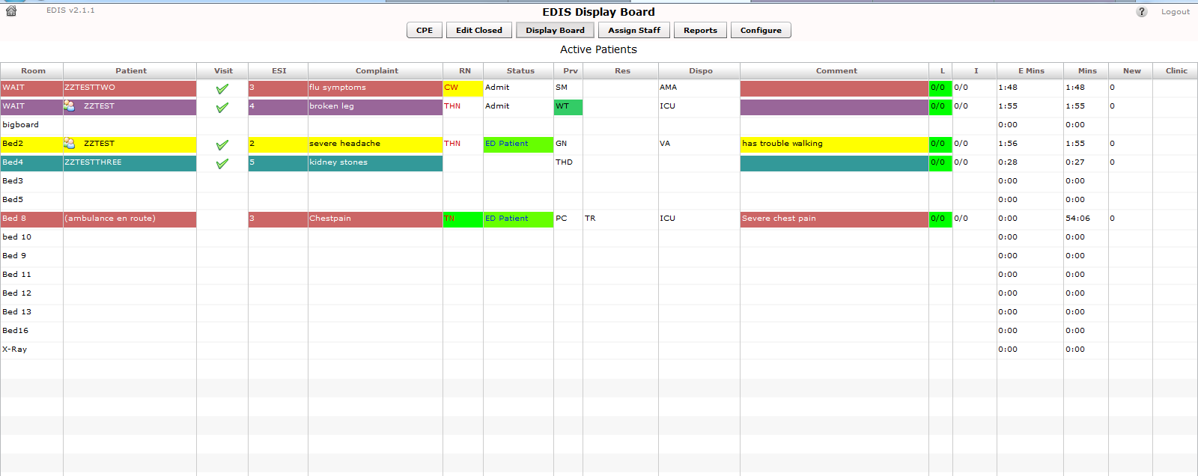

5.1. Viewing the Display Board

The PC-based Display Board view contains only the columns your site has selected for its main display board. Following is a list of the columns from which your site can choose:

Room / Bed: Patients’ locations

Patient Name: Patients’ display names

Complaint: Patients’ display-board complaints

Visit: A check mark lets the user know that a visit has been created in PCE

Status: Patients’ statuses

ESI: Patients’ acuities

Provider Initials: Providers’ initials Nurse Initials: Nurses’ initials Resident Initials: Residents’ initials
Lab Active/Complete: The total number of patients’ active laboratory orders relative to the total number of their completed laboratory orders

Imaging Active/Complete: The total number of patients’ active imaging orders relative to the total number of their completed imaging orders

New (Unverified) Orders: Patients’ unverified orders (values decrement when nurses verify the orders in CPRS and when ancillary services [lab and imaging] complete the orders)

Disposition: Patient disposition

Comment: Patient comments, if any

Elapsed Minutes: Total elapsed minutes patient has spent in the ED

Minutes at Location: The total number of minutes that patients have been in their present locations

Clinic: Patient’s currently-assigned clinic

NOTE: EDIS displays information only for laboratory, imaging, and new orders that are associated with patients’ current emergency-department visits.

Assign Staff View

This view allows authorized users to add staff names to —and remove them from—pick lists that are available in the Disposition, and Edit Closed views. You can also configure text and background colors for staff assignments.

Figure 32: The Assign Staff view.

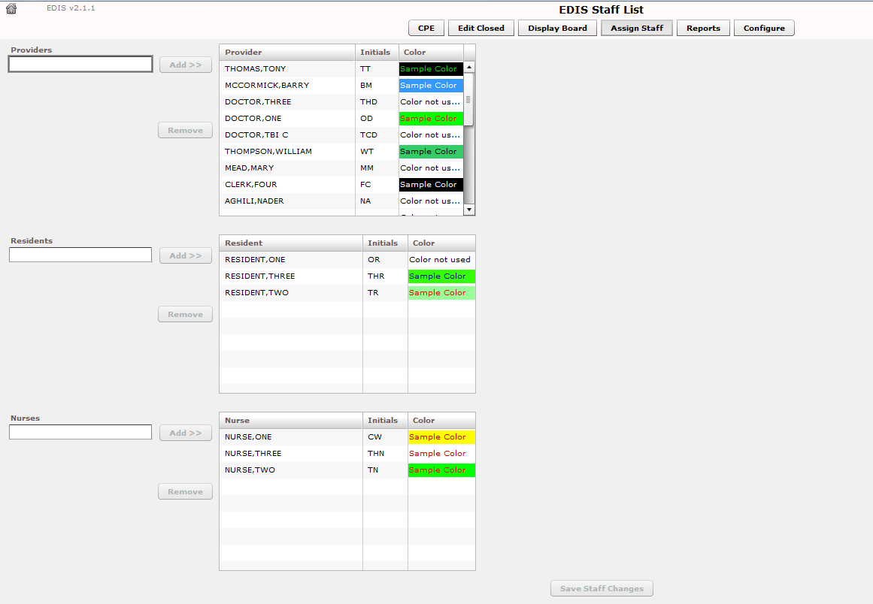

Add Providers, Residents, and Nurses

    - Type the name of a physician, resident, or nurse in the view’s Providers, Residents, or Nurses search box, respectively. EDIS displays a list of possible matches from your local VistA system. (Nurse search lists are based on your site’s EDPF NURSE STAFF SCREEN parameter setting.) Keyboard: Use the <Tab> key to locate the Providers, Residents, or Nurses search box.
    - Click on the name of the physician, resident, or nurse you want to add and click Add or press the <Enter> key. EDIS adds the name to the Provider, Resident, or Nurse list, respectively. Keyboard: Use the <Down Arrow> key to enter the search list. Use the <Down Arrow> and <Up Arrow> keys to locate the name of the physician, resident, or nurse you want to add. Press the <Enter> key to add this name.
    - Click Save Staff Changes to save your additions. Keyboard: Use the <Tab> key to locate Save Staff Changes and use the <Spacebar> key to select it.
NOTE: A nurse cannot be selected for both the Nurse Select and the Provider.

Remove Providers, Residents, and Nurses

    - In the Providers, Residents, or Nurses list, select the physician, resident, or nurse whose name you want to remove. Keyboard: Use the <Tab> key to locate the Providers, Residents, or Nurses list. Use the <Down Arrow> and <Up Arrow> keys to locate the name of the provider, resident, or nurse you want to remove.
- Click Remove or press the <Delete> key.
- Click Save Staff Changes to save your changes. Keyboard: Use the <Tab> key to locate the Save Staff Changes button and use the <Spacebar> key to select the
button.

Configure Colors for Providers, Residents, and Nurses

The application allows you to configure text and background colors for providers, residents, and nurses.

    - Select a physician, resident, or nurse in the Provider, Resident, or Nurse list. EDIS displays the Use Color check box. Keyboard: Use the <Tab> key to locate the Provider, Resident, or Nurse list. Use the <Down Arrow> and <Up Arrow> keys to select a name from the list.
    - Select the Use Color check box. Keyboard: Use the <Tab> key to locate the Use Color check box and use the <Spacebar> key to select it.
    - To configure a color for text, click the color-selection box labeled Text. EDIS
displays a color-selection grid ( 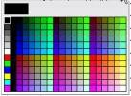 ). Click a color in the grid to select a text color. Keyboard actions are not available for this step.
    - To configure a background color, click the color-selection box labeled Back. EDIS displays a color-selection grid. Click a color in the grid to select a background color.
Keyboard actions are not available for this step.
    - Click Save Staff Changes to save your color selections. Keyboard: Use the <Tab>
key to locate the Save Staff Changes button and use the <Spacebar> key to select it.

NOTE: Colors you configure for staff assignments will not appear on the display board unless colors (in general) are enabled for staff assignments in the Configuration view’s Display Board subview.

Reports View

EDIS can control access to the Reports view in several ways. For example, the application can deny access (in which case you do not see the Reports selection on the application’s left-hand menu). It can also enable you to run and view standard reports, and allow you to print reports and export them for use in spreadsheet applications such as Microsoft Excel. (Sites control user access to EDIS’s export feature via the EDPR EXPORT security key. Sites also use security keys to control access to other restricted reports, such as EDPR XREF, which allows user to view and run the EDIS Cross Reference report.)

NOTE: The following reports may, under certain circumstances, give erroneous results; these reports should be used with caution:

Report | Possible Error
Activity | May display negative values for Wait, Triage, Admission  Delay, Admission Decision columns.
Acuity | May display negative values.
Delay | May display negative values for Admission Delay, Admission  Decision columns.
Missed Opportunity | May display negative values for Wait, Triage, Admission  Delay, Admission Decision columns.
Shift | Does not display correct values.
VA Admission  Report | May display negative values for Wait, Triage, Admission  Delay, Admission Decision columns.

Standard Reports

Column Headings

EDIS’s standard reports are data grids that include one or more of the following columns:

      - IEN: The EDIS internal entry number (FILE: ED LOG (#230))
      - Time In: the time at which an EDIS user identified and added the patient, or the time at which an Appointment Management user created an emergency-department appointment for the patient
      - Time Out: The time at which an EDIS user closed the patient’s emergency department visit
      - Complaint: The patient’s display-board complaint
      - MD: The initials of the patient’s physician
      - Acuity: The patient’s acuity level
      - Elapsed: Total elapsed time (from the patient’s time in to his or her time out, in minutes; asterisks indicate stays that have exceeded the current nationally recognized stay limit of 360 minutes)
      - Triage: The elapsed time between the patient’s time in and his or her initial acuity assessment

      - Wait: The elapsed time between the patient’s time in and his or her first assignment to a location other than the waiting room
      - Disposition (Dispo): The patient’s disposition
      - Admission Decision (Adm Dec): The elapsed time between the patient’s time in and the request for an inpatient bed (this value requires a disposition of Admitted to VA Ward or Admitted to ICU)
      - Admission Delay (Adm Delay): The elapsed time between the patient’s Time Out (the time the patient was removed from the board) and the time of the patient’s first admitting-disposition assignment
      - Diagnosis: The patient’s diagnosis
      - ICD: The patient’s ICD-9-CM or ICD-10-CM diagnosis codes
      - ICD Type: The ICD code set designation–i.e., “ICD-9-CM” or “ICD-10-CM” depending on what is in the ICD column

Disposition Abbreviations

The EDIS TWG provided the following abbreviations for nationally released dispositions; EDIS reports use these abbreviations when space is limited.

Abbreviation | Disposition
VA | Admitted to VA Ward
AMA | AMA
CL | Sent to Clinic
D | Deceased
E | Eloped
ERR | Patient Name Entered in Error
H | Home
ICU | Admitted to ICU
L | Left Without Being Treated/Seen
NEC | Sent to Evaluation / Same-Day Clinic
PSY | Admitted to Psychiatry
T | Admitted to Telemetry
NVA | Transferred to Non-VA Facility
O | Transferred to VA Facility

Standard Report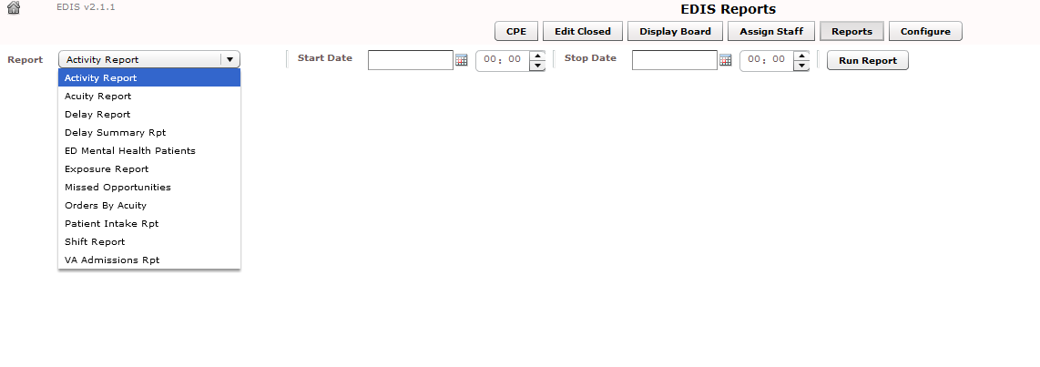s
Figure 33: The Reports view list of standard reports.

Activity Report: Displays patient’s activity from the timeframe specified from the date range. The Activity report lists the following information below:
- IEN
- Time In
- Time Out
- Complaint
- MD
- Acuity
- Elapsed
- Triage
- Wait
- Disposition (Dispo)
- Admission Decision (Adm Dec)
- Admission Delay (Adm Delay)
- Diagnosis
- ICD (the patient’s ICD-9-CM or ICD-10-CM diagnosis codes)
- ICD Type (the ICD code set designation–i.e., “ICD-9-CM” or “ICD-10-CM” depending on what is in the ICD column)

In addition, this report provides averages for several important time -based measurements (Admission Decision, Admission Delay, Elapsed, Wait, and Triage) in several patient categories:

      - All patients
      - All patients who were admitted
      - All patients who were not admitted
      - All patients in each of the following disposition categories: Deceased (D), Eloped (E), Patient Name Entered in Error (ERR), Home (H), Admitted to ICU (ICU), Left Without Being Treated/Seen (L), Sent to Nurse Eval / Drop In Clinic
(NEC), Transferred to non-VA Facility (NVA), Admitted to Psychiatry (PSY),
Admitted to Telemetry (T), and Admitted to VA Ward (VA).

Figure 34: The Activity report.

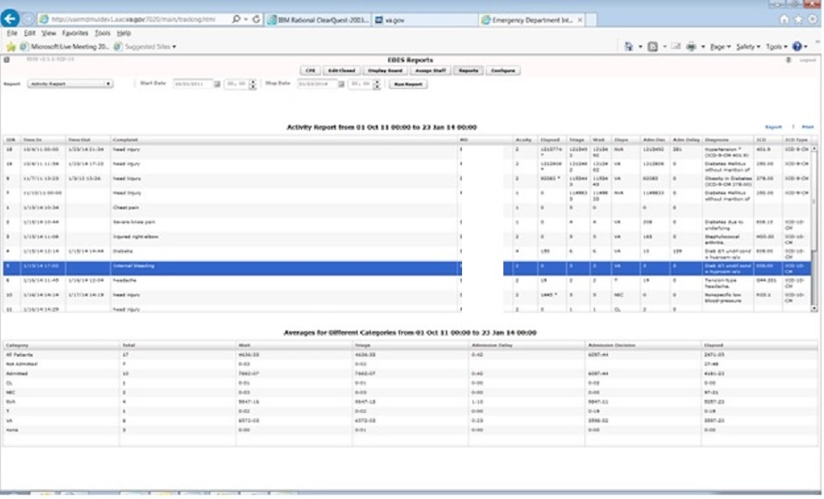

Acuity Report: This report displays statistics that measure patient workload for each acuity level. For the date-and-time range you select, statistics show the number of patients who fell into each acuity category, the number of patients in each category who were admitted, and the number of patients in each category who were admitted to a VA facility. The Acuity report also provides the following average times for patients in each acuity category:
      - Admission Decision (all facilities)
      - Admission Decision (VA facilities)
      - Admission Delay (VA facilities)
NOTE: Test sites found that this report times out for date ranges that cover a large number of visits (1,400 visits within a one-month range, for example). They recommend clicking Continue and toggling between the Display Board and Reports views to get data from extended time ranges.
Also, if your site’s process results in a number of patients whom you’ve removed from the board using the Patient Name Entered in Error selection, you should correct the report’s total number of patients by subtracting the number of patients who were entered in error.

Figure 35: The Acuity report.

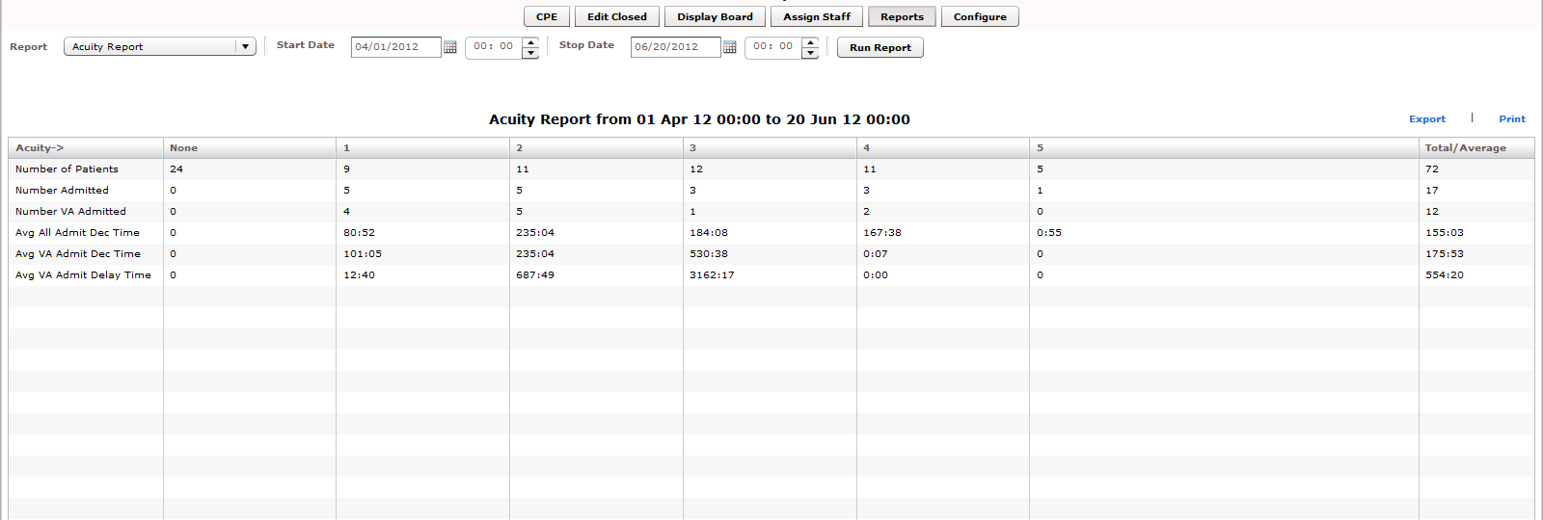

Delay Report: This report presents information about patients whose emergency department stays exceeded the nationally recognized limit (six hours or 360 minutes). For each patient whose stay exceeded this limit, the Delay report displays available information in the following columns:

- IEN
- Patient
- Time In
- Elapsed
- Disposition
- Delay Reason
- MD
- Admission Decision (Adm Dec)
- Admission Delay (Adm Delay)
- Acuity
- Diagnosis
- ICD (the patient’s ICD-9-CM or ICD-10-CM diagnosis codes)
- ICD Type (the ICD code set designation–i.e., “ICD-9-CM” or “ICD-10-CM” depending on what is in the ICD column)

Figure 36: The Delay Report.

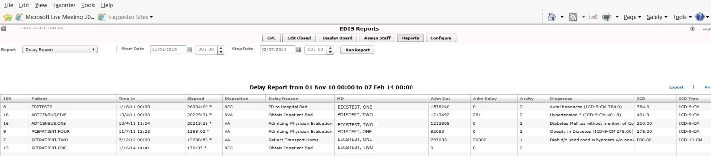

NOTE: EDIS does not include in its Delay and Delay Summary reports patients whose emergency-department visits are not yet closed—regardless of the number of hours their visits have consumed.

Delay Summary Report: This report presents average visit and decision -to-admit times (and other important information) for the following three visit categories:

  - All emergency department visits
  - All visits that resulted in VA-facility admissions
  - All visits that did not result in VA-facility admissions

This report also presents acuity-based tallies for each applicable reason for delay. Again, if your site’s process results in a number of patients whom you’ve removed
from the board using the Patient Name Entered in Error selection, you should subtract this number from the report’s total number of visits and from visits that didn’t result
in VA-facility admissions.

Figure 37: The Delay Summary Report.

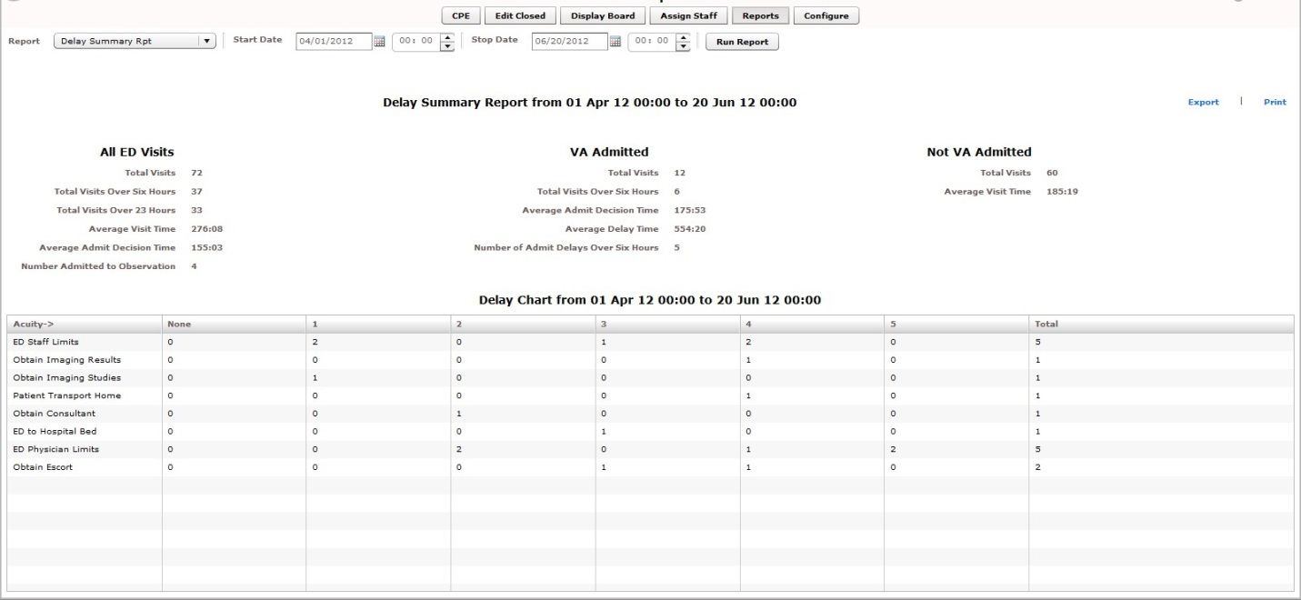

ED Mental Health Patients: The ED Mental Health Patients report captures the following information for behavioral -health patients:

- Time In
- Time Out
- Complaint
- MD
- Acuity
- Elapsed
- Triage
- Disposition
- Admission Decision (Adm Dec)
- Admission Delay (Adm Delay)
- Diagnosis
- ICD (the patient’s ICD-9-CM or ICD-10-CM diagnosis codes)
NOTE: ICD-9-CM codes for this report are greater than 290 and less than 316; ICD-10-CM codes for this report are F10 through F99, inclusive.
- ICD Type (the ICD code set designation–i.e., “ICD-9-CM” or “ICD-10-CM” depending on what is in the ICD column)

This report also provides service -related information such as whether or not the patient is a Vietnam veteran, has been exposed to Agent Orange, has a VA pension, and so forth.

Figure 38: The ED Mental Health Patients Report.

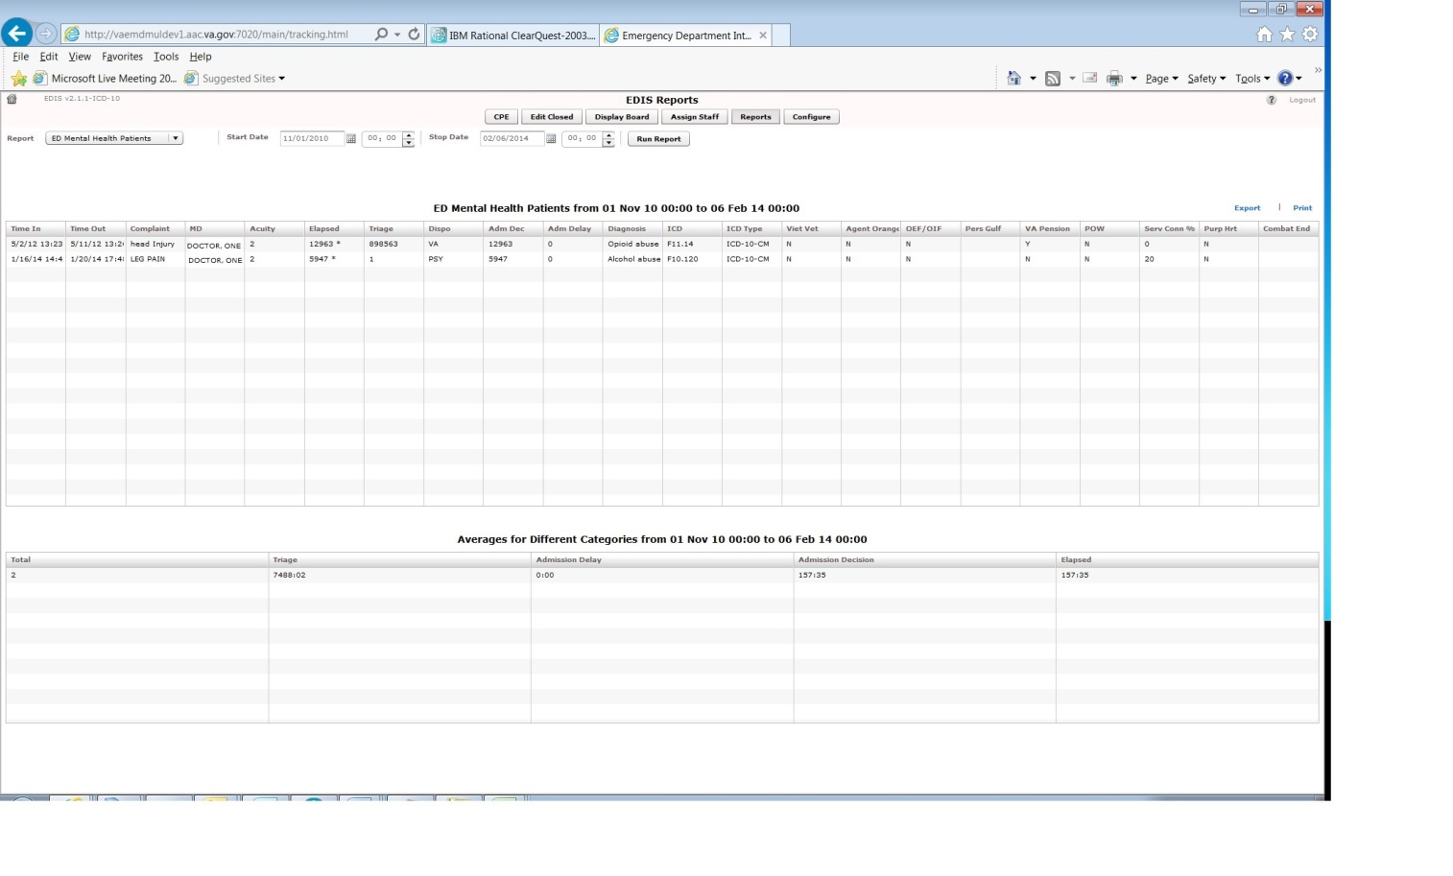

Exposure Report: This report identifies patients and staff who may have been in the emergency department when a contagious patient was present for treatment. To run the report, you enter the internal entry number (IEN) from the contagious patient’s Visit file (ED LOG file (#230)). EDIS then uses information in this file to compile lists of all patients and staff that were in the emergency department during the time of the contagious patient’s visit. ICD and ICD Type column headings have been added to this report.

Figure 39: The Exposure Report.

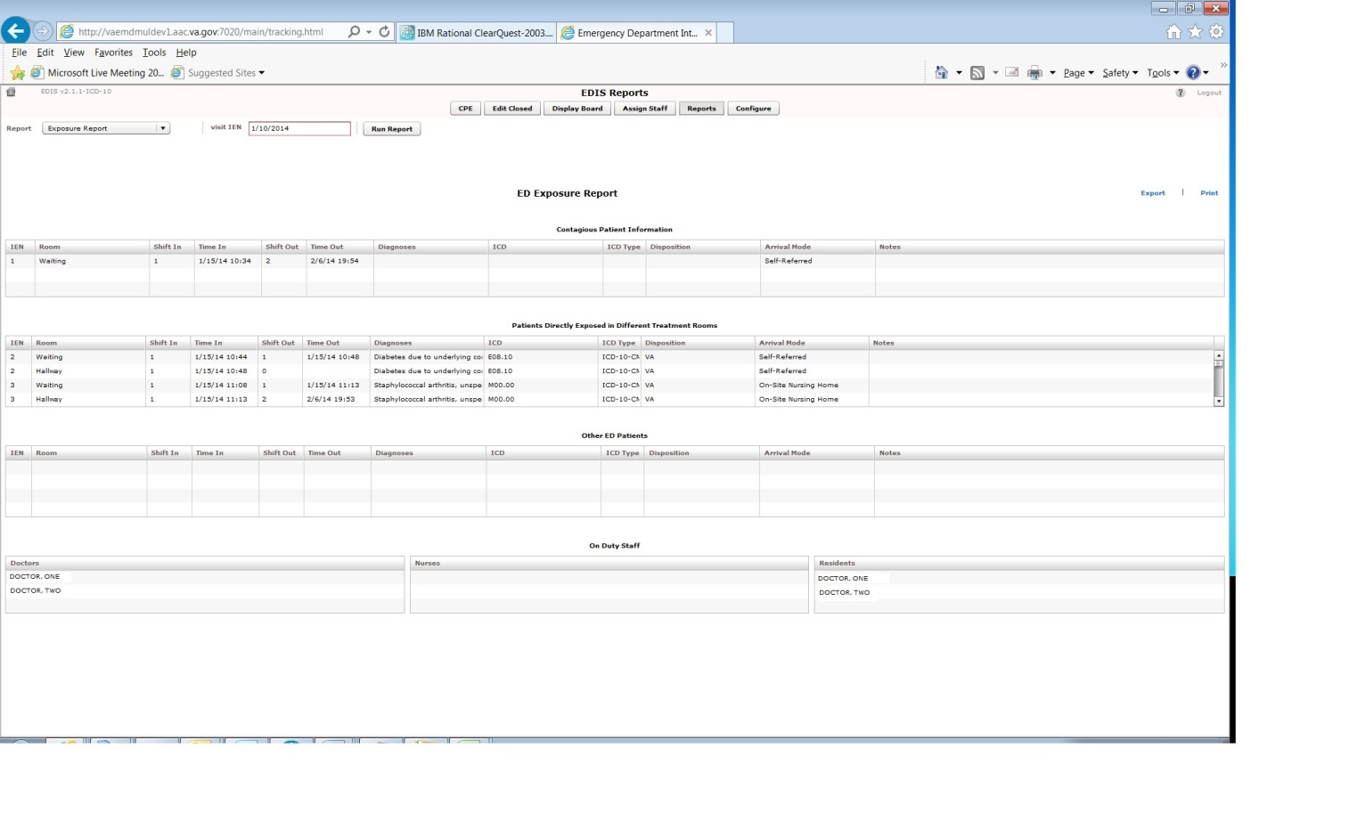

Missed Opportunities Report: This report displays the following information about patients whose dispositions are AMA (left against medical advice), L (left without being treated or seen), or E (eloped):

- IEN
- Time In
- Complaint
- MD
- Acuity
- Elapsed
- Triage
- Wait
- Disposition
- Admission Decision (Adm Dec)

If your site assigns a nurse to left -without-being-seen (LWBS) callbacks, the nurse must either have access to the Xref report or the application’s Edit Closed view (to search for LWBS patients by Time In values).

Figure 40: The Missed Opportunities Report.

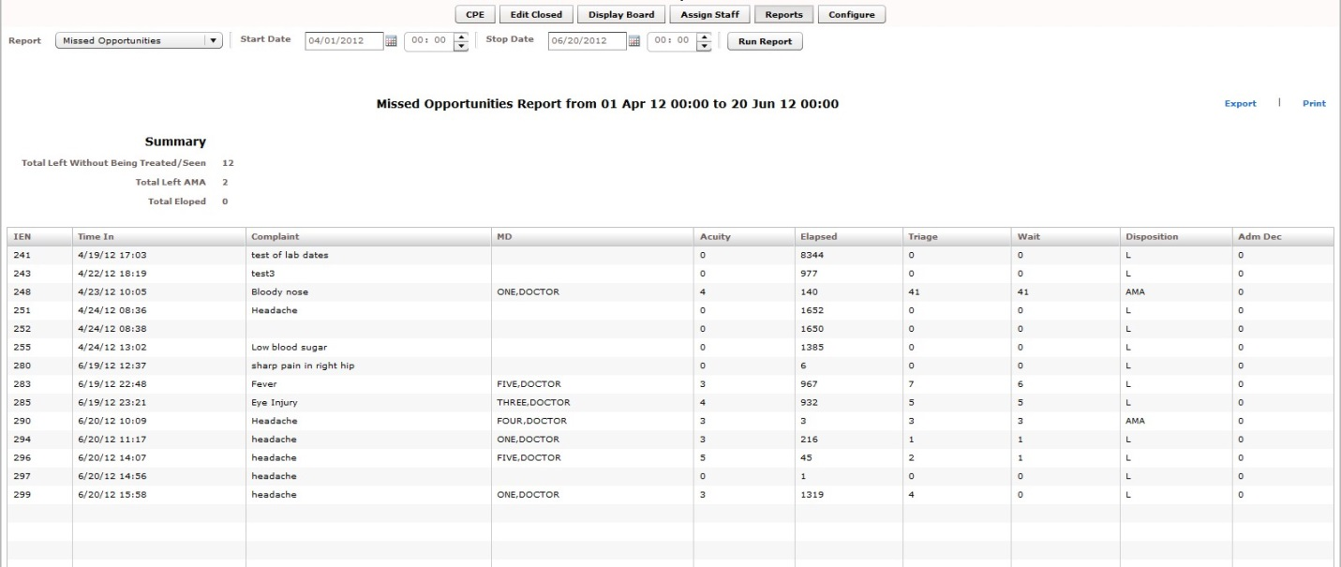

Orders by Acuity: For each acuity, this report tallies the number of medication, laboratory, imaging, consultation, and other orders emergency -department personnel placed during the date-and-time range you specify.

Figure 41: The Orders by Acuity Report.

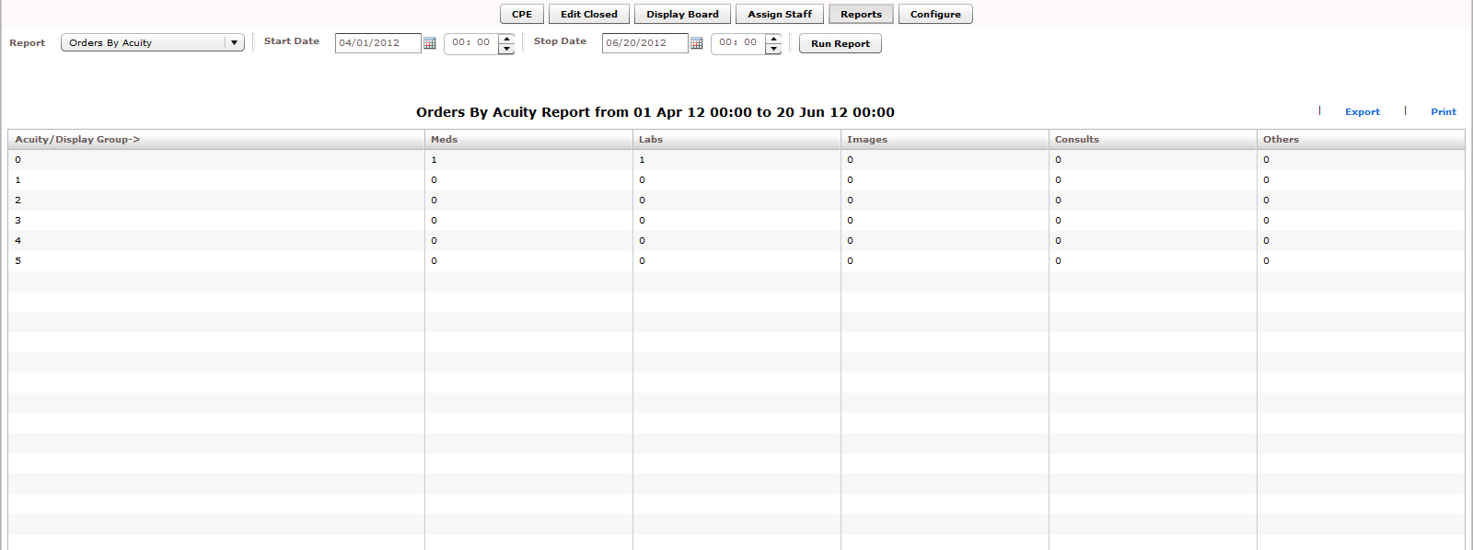

Patient Intake Report: The Patient Intake report provides time -of-day and day-of- week statistics regarding the number of patients who visited the emergency department during the date and time range you enter.

Columns contain day-of-week tallies cover the entire time -and-date range against which you run the report. For example, if the date range you enter includes two Tuesdays, the intersection of the Tue column and the 0700-0800 row displays the total number of patients who visited the emergency department on both Tuesdays between the hours of 7:00 a.m. and 8:00 a.m. The Total column contains a sum of all day-based totals across each time -based row. For example, in the 0700-0800 row, the Total column contains a sum of daily totals from the Sun through Sat columns.

For each time-based row, the Avg/Day column presents an average that is based on the figure in the Total column and the total number of days in the date range you select. For example, if your date range is January 1, 2009 through January 31, 2009, the total number of days (the denominator) will be 31.

The report’s Avg/Hour row contains an average that is based on the total number of visits in each day-based column divided by the total number of hours for each day in the search range you select. For example, in the Sun column, the application calculates the following average: the total number of Sunday visits (the value in the Total row, Sun column) divided by 24 (the number of hours in a day) multiplied by the number of Sundays in the date range you select.

NOTE: The Patient Intake report does not include maximum, minimum, and mean calculations.

Figure 42: Patient Intake Report

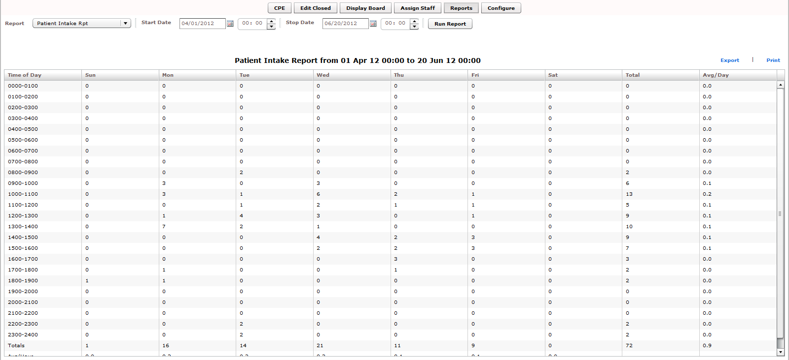

Shift Summary Report: This report is limited to one day of reporting and presents a shift-based calculation of the following data categories:

- Carried over at Report Start
- Number of New Patients
- Number of Patients Discharged
- Number Dec (Decision) to Admit to VA
- Number Dec (Decision) to Admit to Other
- Number over Six Hours
- Number Waiting for Triage
- Number of Occupied Beds
- Number of Missed Opportunities
- Number Deceased
- Number With No Disposition
- Carry over to Next Shift

Figure 43: The Shift Report Summary

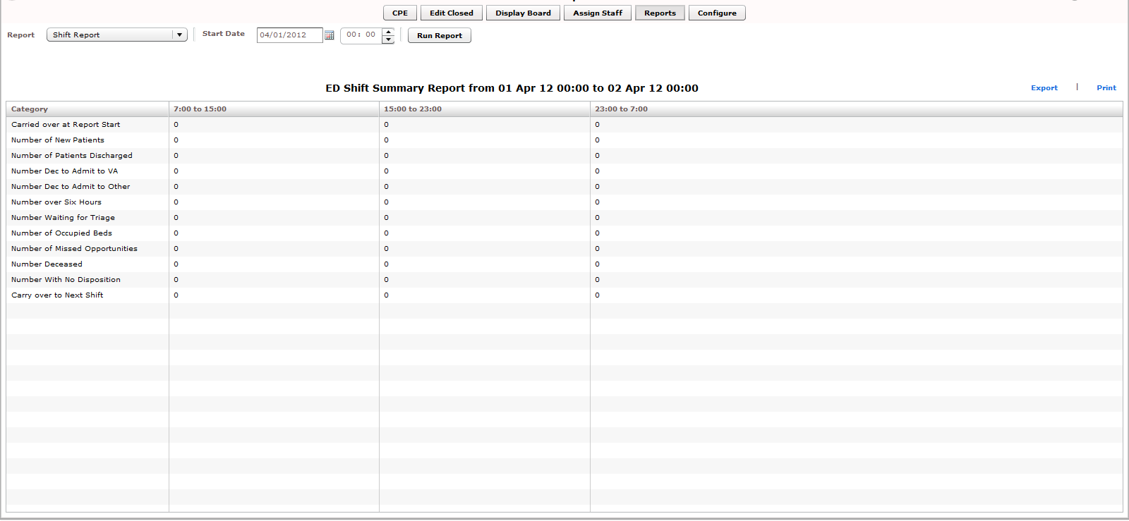

VA Admissions Report: This report uses Disposition selections to identify patients who were admitted to VA facilities (VA wards, intensive care units [ICUs], telemetry, and observation wards, for example) during the time -and-date range you specify.

The report contains available information in the following columns:

- IEN
- Time Out
- Complaint
- MD
- Acuity
- Disposition
- Adm Dec (Admission Decision)
- Adm (Admission) Delay
- Diagnoses
- ICD (the patient’s ICD-9-CM or ICD-10-CM diagnosis codes)
- ICD Type (the ICD code set designation–i.e., “ICD-9-CM” or “ICD-10-CM” depending on what is in the ICD column)

The report also provides averages for patients who fall into each applicable VA - admission category.

Figure 44: The VA Admissions Report
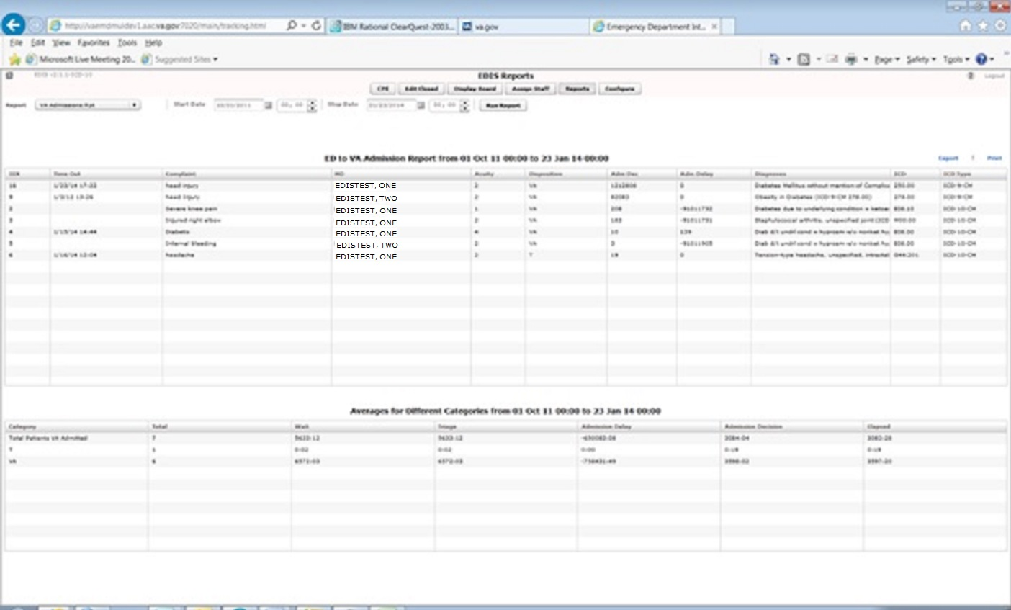

Cross Reference Reports:
EDIS also provides a restricted-access reports: the Patient XRef (Cross
Reference) report. Because this report contains personally identifying information, you need special security keys (in VistA) to access and
run it. The Key is: EDPR XREF - for the Cross Reference Report.

XREF: This report provides a cross reference between the EDIS IEN and patient identifiers (including patients’ surname initials concatenated with the last four digits of their SSNs).

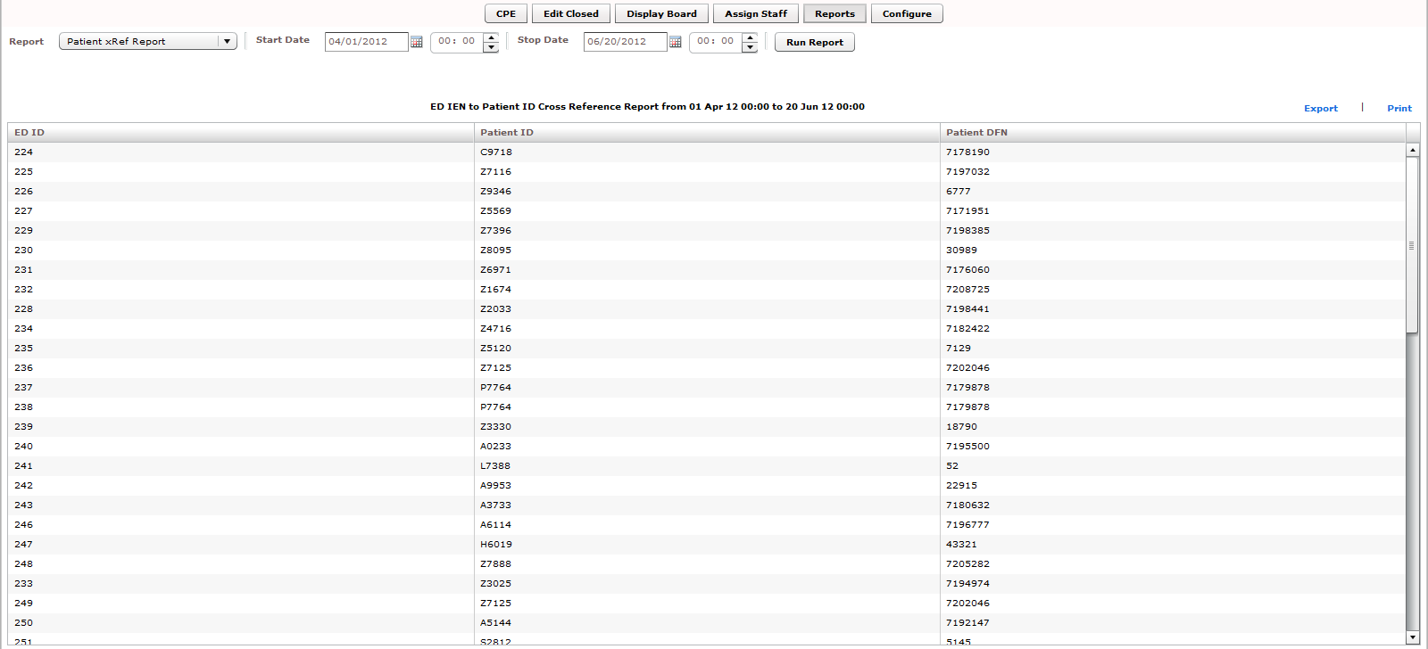

Run and View Reports

- Click on Reports on the application’s left-hand menu bar. Keyboard: use the <Tab> key to locate the left-hand menu bar. Use the <Up Arrow> or <Down Arrow> key to locate Reports. Use the <Spacebar> key to select Reports.
- Click a report from the Report list. Keyboard: use the <Tab> key to locate the Report list. Use the <Down Arrow> and <Up Arrow> keys to select a report from the list.
- Click the Calendar icon () and select a starting date for your report or type a starting date in the Start Date box using this format: mm/dd/yyyy. (The application automatically formats shorter dates. For example, if you type 8/8/09, the application reformats the date as 08/08/2009.) Keyboard: use the <Tab> key to locate the Start Date box.
- Click on a starting time in the Start Time box (). Keyboard: use the
<Tab> key to locate the hour selector in the Start Time box. Select a start-time hour using the <Down Arrow> and <Up Arrow> keys. Use the <Tab> key to locate the minutes selector in the Start Time box. Use the <Down Arrow> and <Up Arrow> keys to select start-time minutes.
- If you are running the Exposure report, type the contagious patient’s IEN in the visit IEN box. The Exposure report does not require a date range.
- Click the Calendar icon in the Stop Date area and select a stop date for your report or type a stop date in the Stop Date box. Keyboard: use the <Tab> key to locate the
Stop Date box. The Shift and Exposure reports do not require stop dates.
- Select a stop time in the Stop Time box. Keyboard: use the <Tab> key to locate the hour selector in the Stop Time box. Use the <Down Arrow> and <Up Arrow> keys
to select an hour. Use the <Tab> key to locate the minutes selector in the Stop Time
box. Use the <Down Arrow> and <Up Arrow> keys to select stop-time minutes.
- Click Run Report. Keyboard: use the <Tab> key to locate the Run Report button and use the <Spacebar> key to select the button.

NOTE: If your reports contain negative numbers, the problem could lie with logic that EDIS’s reports functionality inherited from the class-three Syracuse application. Syracuse reporting logic assumes that users will enter information in a certain sequence. For example, the application assumes that users will assign a provider before entering a patient’s disposition. To calculate the time that elapsed between a patient’s provider assignment and disposition, the application subtracts provider-entry time from disposition-entry time. If users assign providers after they’ve entered dispositions, reports will contain negative numbers.

Negative numbers can also be a result of not-so-careful data entry. For example, suppose a patient’s stay began on July 10 at 11:00 p.m. and ended on July 11 at 1:00 a.m. Further, suppose someone mistakenly removed this patient from the board at 11:55 p.m. When correcting this error, if the user corrects the patient’s time-out hour-and-minute value, but neglects to update the date value, the patient’s time-out value will be chronologically before his or her time-in value, and EDIS will calculate the patient’s stay at -22 hours.

When reports exceed your application window’s viewing capacity, the application includes a scroll bar, as it does in the following screen capture:

Figure 47: Report scroll bar

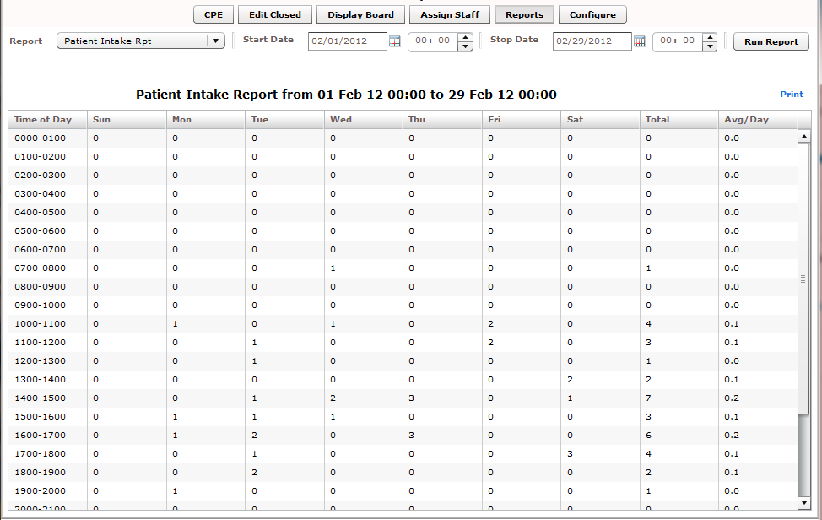

Print Reports

To print a report, click Print. The Print button is in the upper right -hand corner of the Reports view. Keyboard: Use the <Tab> key to locate the Print button and use the <Spacebar> key to select it. The application displays your operating system’s print dialog.

Export Reports (locked with security key: EDPR EXPORT)

- Click Export. If you are authorized by the KEY (EDPR EXPORT)to export reports, you’ll find this link in the upper right-hand corner of the Reports view. Keyboard: use the <Tab> key to locate Export and use the <Spacebar> key to select it.
- In the Select location for download by dialog box, select a location on the local PC for your exported report. Keyboard: use the <Tab> key to locate the Save in selector. Use the <Down Arrow> and <Up Arrow> keys to find a location on your local PC for your exported report. Press the <Enter> key to select the location.
- In the File name box, type a name for your exported report. Keyboard: use the
<Tab> key to locate the File name box. If you want to export the report as an Excel spreadsheet, append the .xls extension before saving.
- Click Save. Keyboard: Use the <Tab> key to locate the Save button and use the
<Spacebar> key to select it.
The application displays a message informing you that your download is complete.
Click Close to dismiss the message. Keyboard: use the <Spacebar> key to select the Close button.

Figure 48: Exported Activity report

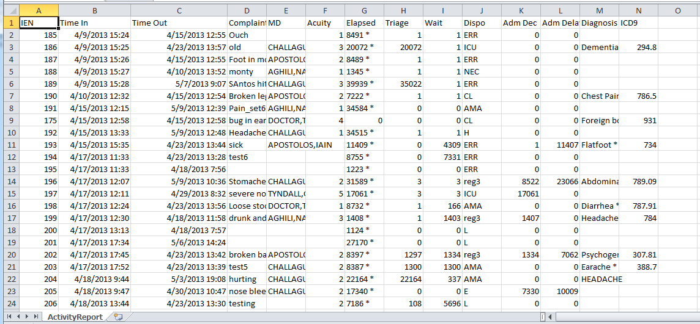

Configure View

This view allows authorized users to create customized big -board (usually large LED or plasma) displays and configure the application to include locally meaningful pick lists. Specifically, the view provides subviews that allow you to configure:

  - Room and area selections
  - Status, disposition, delay-reason, and source selections
  - Display-board options
  - Colors
  - Parameters

NOTE : Options Required : [EDPF TRACKING MENU ALL], OR [EDPF TRACKING VIEW CONFIGURE]

Room and Area Configurations

The Room / Area subview enables you to:

    - Add or configure rooms and areas
    - Specify display names for rooms and areas
    - Determine when the display board displays rooms and areas
    - Select a default status for patients who occupy specific rooms or areas
    - Mark rooms or areas inactive
    - Select the occupancy category into which rooms and areas fall (multiple patient, single patient, and so forth)
    - Indicate areas that contain two or more beds (for exposure reports)
    - Specify the electronic white-board display on which rooms and areas appear
    - Configure background and text colors for rooms and areas

Add, Configure, and Edit Rooms and Areas

Figure 49: Configure View - Room/Area subview

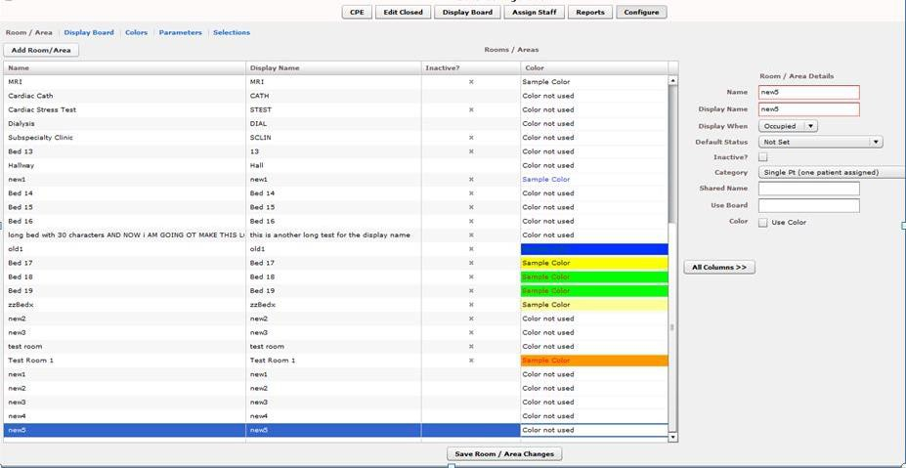

      - Click the Configure button and then the Room/Areasubview. Keyboard: Use the <Tab> key to locate the left-hand view-selection menu. Use the <Down Arrow> and <Up Arrow> keys to locate the Configure view. Use the
<Spacebar> key to select this view. Use the <Tab> key to locate the Room / Area subview and use the <Spacebar> or <Enter> key to select it.
      - To edit an existing room or area, click the room or area in the Rooms / Areas
grid. Keyboard: Use the <Tab> key to locate the Rooms / Areas grid. Use the
<Down Arrow> key to enter the grid, and use the <Down Arrow> and <Up Arrow> keys to select a room or area.
      - In the Name box (Edit pane), replace the application’s placeholder name (new1) with the name of the room you want to add. The application does not support duplicate room or area names. Keyboard: use the <Tab> key to locate
the Name box.
      - In the Display Name box, replace the placeholder name (new1) with the name you want EDIS to display. Keyboard: use the <Tab> key to locate the Display
Name box. The application does not support duplicate display names for
rooms and areas.
      - Click on one of the following three options from the Display When list:
Occupied, Always, or Never. Your selection determines when EDIS displays the room or area on the large electronic whiteboard display. Keyboard: use the
<Tab> key to locate the Display When list. Use the <Down Arrow> and <Up
Arrow> keys to select an option from this list.
      - To configure a default status for patients who are assigned to the new room (optional), select a status from the Default Status list. (Sites can configure
their own selections for this list.) Keyboard: use the <Tab> key to locate the
Default Status list. Use the <Down Arrow> and <Up Arrow> keys to select a default status from the list.
      - If the new room or area is currently inactive, select the Inactive? checkbox.
Keyboard: use the <Tab> key to locate the Inactive? checkbox. Use the
<Spacebar> key to select (or cancel the selection of) the Inactive? checkbox.
      - From the Category list, select the occupancy category into which the room or area falls. Keyboard: Use the <Tab> key to locate the Category list. Use the
<Down Arrow> and <Up Arrow> keys to select an occupancy category from
the list.
      - If a room or area contains two or more beds, type in the Shared Name box a name that associates the beds. For example, if area OBS contains two beds, OBS-1 and OBS-2, configure a room or area for each bed and type OBS in the Shared Name box for both OBS-1 and OBS-2. Keyboard: Use the <Tab> key to locate the Shared Name box.
      - If your site uses more than one large electronic whiteboard display, type in the Use Board box the name of the display board on which the room or area will appear. All patients appear on the application’s main electronic whiteboard display. Keyboard: Use the <Tab> key to locate the Use Board box.
      - Click on the Use Color check box to configure a text and/or background color for the room or area. (Optional. See section 13.1.1.1, “Configuring Color for Rooms and Areas.”)
      - To dismiss the Edit pane and view all columns in the Rooms / Areas grid, click All Columns. Keyboard: use the <Tab> key to locate the All Columns
button and use the <Spacebar> key to select it.

      - Click Save Room / Area Changes to save your changes. The application displays a message that tells you it has successfully saved your changes. Click Close to dismiss this message. Keyboard: use the <Tab> key to locate the Save Room / Area Changes button. Use the <Spacebar> key to select the Save Room / Area Changes button. Use the <Tab> key to locate the Close button, use the <Spacebar> key to select the Close button.

Configuring Colors for Rooms and Areas

The application allows you to configure text and background colors for rooms and areas.

- Click on the Use Color checkbox. Keyboard: use the <Tab> key to locate the Use Color check box. Use the <Spacebar> key to select (or cancel the selection of) this check box.

- To configure a color for text, click the color -selection box labeled Text.
EDIS displays a color-selection grid ( ). Click a color in the grid to select it as a text color. General keyboard actions are not available for this step; however, JAWS users can type hexadecimal color codes for text.

- To configure a background color, click the color -selection box labeled Back. EDIS displays a color-selection grid. Click a color in the grid to select it as a background color. General keyboard actions are not available for this step; however, JAWS users can type hexadecimal color codes for backgrounds.

- Click Save Room / Area Changes to save your color selections.
Keyboard: use the <Tab> key to locate the Save Room / Area Changes
button and use the <Spacebar> key to select it.

NOTE: Colors you configure for room and area assignments will not appear on the display board unless colors (in general) are enabled for room and area selections in the Configuration view’s Display Board subview.

Specifying the Order of Rooms and Areas

Use a drag and drop operation to change the order of rooms and areas in the Rooms / Areas grid. EDIS bases the order of its Room / Area selection lists on the order of rooms and areas in the Rooms / Areas grid. Keyboard actions are not available for drag-and-drop operations.

Display Board Configurations

Figure 50: Configure View - Display Board subview

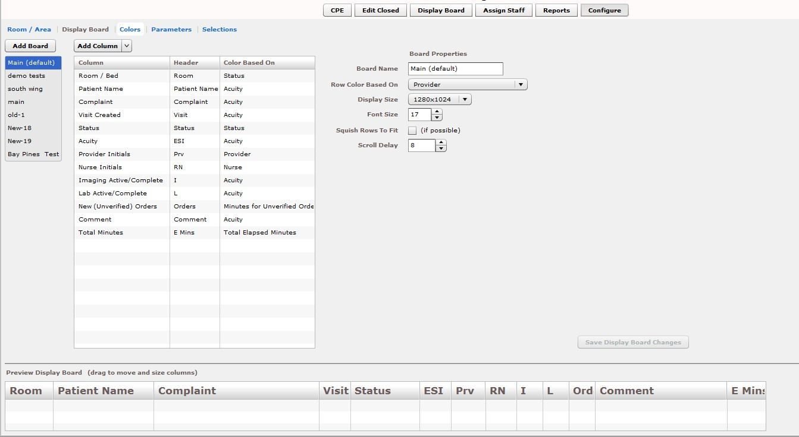

The Display Board subview enables you to:

    - Add a new large electronic whiteboard display
    - Add or remove display-board columns
    - Edit column headers
    - Identify information upon which you want to base cell colors in display-board columns
    - Identify information upon which you want to base colors in display-board rows
    - Reposition and resize display-board columns
    - Select optimal display sizes
    - Configure the display’s font size and scroll-delay time
    - Compress (squish) all data rows into a single, no-scroll view (if possible)

EDIS enables you to configure each display board separately. Simply select the board you want to configure in the Board Name list. The application displays editable information about the board in the Board Properties pane.

Add a New Display Board

EDIS enables you to create multiple large electronic whiteboard displays. However, be advised: you cannot delete display boards after you’ve saved them.

      - From the Configure Option, click Add Board. EDIS adds a placeholder name (new1) in the Board Name list and the Board Name box, which is located in the Board Properties pane. Keyboard: use the <Tab > key to locate the Add Board button and use the <Spacebar> key to select the button.
      - In the Board Name box, replace the placeholder name with the name you want to use for this new display board. Each display board must have a unique name. Keyboard: use the <Tab> key to locate the Board Name box.
      - (Optional) In the Row Color Based On list, select a display-board item upon which you want to base row colors. Keyboard: Use the <Tab> key to locate
the Row Color Based On list. Use the <Down Arrow> and <Up Arrow>
keys to select an item from the list.
      - In the Display Size list, select the screen size of your display board. Display sizes are site configurable. If the Display Size list does not contain your new
board’s screen size, ask your site’s CAC or IRM staff to add the size in VistA.
Keyboard: Use the <Tab> key to locate the Display Size list. Use the <Down Arrow> and <Up Arrow> keys to select a display size from the list.
      - In the Font Size spin box, type or select a font size for your new display board.
Available font sizes range from six to 36 points. The Preview Display Board
pane dynamically displays your font choices. Keyboard: Use the <Tab> key to locate the Font Size box. Type a font size, or use the <Down Arrow> and
<Up Arrow> keys to select a font size.
      - (Optional) Select the Squish Rows To Fit (if possible) check box. This selection allows EDIS to compress all data rows to completely fit within your site’s display screen, if this is possible. To ensure readability, the application compresses data only down to a row size of 18 points and a font size of nine points. If, after applying the maximum compression, your site’s data will still not fit within a single display view, the application applies scrolling functionality and restores the display board’s font size to the value in the Font Size spin box. Keyboard: Use the <Tab> key to locate the Squish (if possible) checkbox. Use the <Spacebar> key to select—or cancel the selection of—the checkbox.
      - In the Scroll Delay spin box, type or click on a scroll-delay time (in seconds).
The application automatically activates scrolling when the screen’s real estate is not sufficient to display all of the patients who are currently on the Active
Patients list. The delay-time setting determines how long screen contents remain stationary. For example, suppose your display can accommodate only
20 patients and 25 patients are currently on the list. Further, suppose that the EDIS scroll-delay time is set at five seconds. In this case, EDIS displays the first 20 patients for five seconds, then scrolls to display the remaining five
patients for five seconds, and so forth. Keyboard: use the <Tab> key to locate the Scroll Delay box. Type a delay time or use the <Up Arrow> and <Down
Arrow> keys to select a delay time.

NOTE: EDIS refreshes the display board every 30 seconds. Each refresh resets the display-board view. Set scroll-delay intervals that allow the application to display all patients within the span of a single refresh cycle. (JAWS users can disable automatic refresh functionality and manually refresh the display board by pressing the <F7> key. However, automatic refresh is disabled only when JAWS is running.)

Add Display Board Columns

Display boards can include any of the following columns:

- Room / Bed: The rooms, beds, and areas associated with the display board
- Patient Name: The patients’ surnames
- Visit Created: Checkmarks that indicate EDIS has created visits for the patients in CPRS or blank spaces that indicate EDIS has not created visits
- Complaint: The patients’ display-board complaints
- Comments: Comments users have entered via the CPE or Visit view
- Provider Initials: The initials of the providers users have selected via the CPE or Visit views
- Resident Initials: The initials of the residents users have selected via the CPE or Visit views
- Nurse Initials: The initials of the nurses users have selected via the CPE or Visit
views
- Acuity: The acuities users have entered via the CPE or Visit view
- Status: The statuses users have entered via the CPE or Visit views
- Lab Active/Complete: The number of active laboratory orders associated with the patients’ emergency-department visits over the number of completed laboratory orders
- Imaging Active/Complete: The number of active imaging orders associated with the patients’ emergency-department visits over the number of completed imaging
orders
- New (Unverified) Orders: The number of unverified orders associated with the patients’ emergency-department visits (for sites using CPRS 26, EDIS decrements this number when unverified orders are completed; for sites using CPRS 27, EDIS decrements this number when unverified orders are verified)
- Total Minutes: The number of minutes from patients’ time-in values (the times users added patients to—or identified them in—EDIS) to the present
- Minutes at Location: The number of minutes patients have been assigned to their present locations

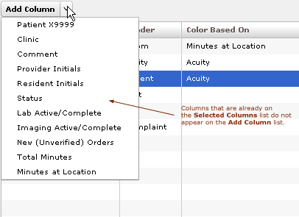Figure 51: Add Column List

      - Click to open the Add Column list. Keyboard: Use the <Tab> key to locate the Add Column list. Press the <Spacebar> key to open the list.
      - Click to select a column name from the Add Column list. The Preview Display Board pane dynamically displays columns as you add them. Keyboard: Use the <Down Arrow> and <Up Arrow> keys to locate the name
of the column you want to add. Use the <Spacebar> or <Enter> key to select the column.
      - Repeat steps 1 and 2 as necessary. Keyboard: The application maintains its focus on the Add Column list, so you won’t need to locate the Add Column list again with each new column addition. Simply press the <Spacebar> key to
reopen the list.

NOTE: After you add columns, you can specify their order using a drag-and-drop operation (see Section 8.2.4, “Specify the Order of Display Board Columns”). Keyboard operations are not available for post-addition column ordering. If you exclusively use keyboard actions, please add columns in the order in which you want them to appear on your large electronic whiteboard display.

Configure or Edit Display Board Columns

      - In the Selected Columns list, click the column whose properties you want to configure or edit. Keyboard: Use the <Tab> key to locate the Selected Columns list. Use the <Down Arrow> key to enter the list. Use the <Down Arrow> and <Up Arrow> keys to locate the column you want to configure.
      - In the Header box, which is located in the Column Properties pane, replace the application’s default or current header (optional). Keyboard: Use the
<Tab> key to locate the Header box.
      - Click on an item in the Color Based On list (optional). Your selection here determines the criteria the application uses to display color configurations in
big-board display columns. The application gives preference to colors you
configure for columns over colors you configure for rows. List items include:

Status / Acuity, Status, Acuity, Room / Bed, Provider, Resident, Nurse, Urgency – Lab, Urgency – Radiology, Total Elapsed Minutes, Minutes at Location, Minutes for Lab Order, Minutes for Imaging Order, and Minutes for Unverified Order.

NOTE: Although you configure color selections in the Assign Staff view and the Colors and Room / Area subviews, the Display Board subview of the Configuration view is where you determine which of these colors the board displays and where it displays them.

Your selection determines which color or colors appear on the display board for the column you’ve selected. For example, suppose you select the Status column. Then suppose you click this column’ s Color Based On list and select Acuity. In this case, the board will display in its Status column colors you have configured for acuity.

Specify the Order of Display Board Columns

You can specify the order of large electronic whiteboard display columns by using a drag-and-drop operation in either the Preview Display Board pane or the Selected Columns list.

To perform a drag-and-drop operation, click a column header and, without releasing your mouse button, move the header to its new location. Release the mouse button. Keyboard actions are not available for drag -and-drop operations. To reorder columns using your keyboard, remove columns in the Selected Columns list and re-add them in the order in which you want them to appear on the display.

Resize Display Board Columns

You resize columns in the Preview Display Board pane by using a drag-and-drop operation (keyboard actions are not available):

      - Point your mouse at the border of the column you want to resize.
      - When your mouse pointer becomes a slider ( ) hold down your right mouse button and drag the boarder to resize the column.
      - Release your mouse button.

Remove Display Board Columns

You can remove columns from the Selected Columns list in any of the following ways:

- Remove a single column: click an individual column in the Selected Columns list and press the <Delete> key. Keyboard: Use the <Tab> key to locate the Selected Columns list. Use the <Down Arrow> and <Up Arrow> keys to select the column you want to remove. Press the <Delete> key to remove the column.
- Remove a group of columns: select a group of columns in the Selected Columns
list by clicking the first column in the group, then pressing and holding down the
<Ctrl> key as you click the remaining columns. Release the <Ctrl> key and press the <Delete> key to remove the group. Keyboard: Use the <Tab> key to locate the
Selected Columns list. Use the <Down Arrow> and <Up Arrow> keys to select
the first column in the group. Press and hold down the <Ctrl> key while using the
<Down Arrow> and <Up Arrow> keys to locate additional columns in the group. Press the <Spacebar> key to select each of these columns. Release the <Ctrl> key
and press the <Delete> key to delete the group.
- Remove a range of columns: select a range of columns in the Selected Columns
list by clicking the first column in the range, then pressing and holding down the
<Shift> key as you click the last column. Release the <Shift> key and press the
<Delete> key to remove the range. Keyboard: Use the <Tab> key to locate the
Selected Columns list. Use the <Up Arrow> and <Down Arrow> keys to locate the first column in the range. Press and hold down the <Shift> key while using the
<Up Arrow> or <Down Arrow> key to select the remaining columns in the range.
Release the <Shift> key and press the <Delete> key to remove the range.

Save Display Board Configuration Changes

Click Save Display Board Changes. EDIS displays an Alert message to confirm that it has successfully saved your changes. Click Close to dismiss this message. Keyboard: Use the <Tab> key to locate the Save Display Board Changes button. Press the <Spacebar> key to select the button. Use the <Tab> key to locate the Close button, and use the <Spacebar> key to select it.

Configure Colors

Figure 52: Configure View - Colors subview (Status/Acuity)

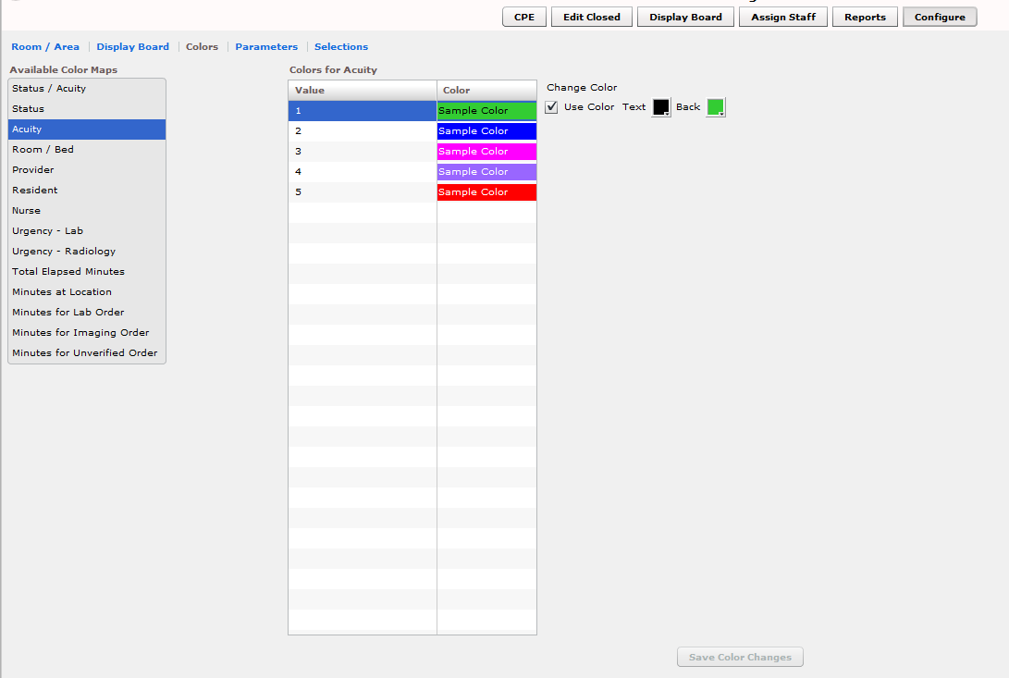

The Colors subview enables you to configure colors for the following items:

Status / Acuity

Status

Acuity

Urgency – Lab

Urgency – Radiology

Total Elapsed Minutes

Minutes at Location

Minutes for Lab Order

Minutes for Imaging Order

Minutes for Unverified Order

You can configure colors for rooms and areas on the EDIS Configuration/Configure/Room / Area subview. Configure colors for emergency - department staff on the EDIS Configuration/Assign Staff view.

Configure Colors (General Instructions)

Figure 53: Use Color checkbox

Use Color Check Box Selected
Use Color Check Box Not Selected

You can configure colors for any tracking item for which EDIS displays the Use Color check box:

      - Select the Use Color checkbox. The application displays the Text and Back color-selection boxes. Keyboard: use the <Tab> key to locate the Use Color check box. Use the <Spacebar> key to select it.
      - To configure a text color, click the Text box. The application displays the
color-selection grid (). Click a color within the grid to select it as the text color. Keyboard actions are not available for this step; however, JAWS users may type in a hexadecimal color code.
      - To configure a background color, click the Back box. EDIS displays the color- selection grid. Click a color within the grid to select it as the background color. Keyboard actions are not available for this step; however JAWS users may type in a hexadecimal color code.

Configure Colors for Status and Acuity Values

You can configure colors for all status values. The following initial values ship with the application:

Admitted

Awaiting Triage

ED Boarding [Hold]

ED Observation Unit

ED Patient

En Route/Prearrival

Discharged

You can also configure colors for the following acuity values. (The application supports Emergency Severity Index [ESI] acuity values.)

- 1 (most urgent)
- 2
- 3
- 4
- 5 (least urgent)

In addition, you can use the Status / Acuity selection to configure colors for the combined set of these status and acuity values.

NOTE: Color-map selections in the Colors subview must match at least one color selection in the Display Board subview. For example, if you configure colors for the Status / Acuity selection in the Colors subview, select Status / Acuity in the Colors Based On column or Row Color list in the Display Board subview. Also note: if you configure colors for the Status/Acuity selection and also for the Acuity and/or Status selections, the application will display the colors you configured for Status / Acuity.

      - In the Available Color Maps list, click on Status, Acuity, or Status / Acuity.
EDIS displays the Colors for Status, Colors for Acuity, or Colors for Status
/ Acuity grid, respectively. Keyboard: Use the <Tab> key to locate the Available Color Maps list. Use the <Down Arrow> or <Up Arrow> keys to select Status / Acuity, Status, or Acuity.
      - To configure colors for a value listed in the corresponding grid, click on the Value. Keyboard: Use the <Tab> key to locate the grid. Use the <Down
Arrow> and <Up Arrow> keys to select a Value within the grid.
      - Click the Use Color checkbox and follow the instructions in Section 8.3.1
“Configure Colors (General Instructions).” Keyboard: use the <Tab> key to locate the Use Color check box. Use the <Spacebar> key to select the check
box.
      - Repeat steps 1–3 to configure colors for additional values.
      - Click Save Color Changes to save your color configurations. The application displays an Alert message to inform you that it has saved your color
selections. Click Close to dismiss this message. Keyboard: Use the <Tab> key to locate Save Color Changes and use the <Spacebar> key to select it. Use
the <Tab> key to locate the Close button and use the <Spacebar> key to select it.

Configure Colors for Urgency – Lab Values

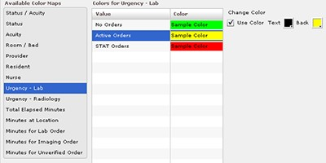Figure 54: Colors for Urgency - Labs

You can configure colors for the following values:

No Orders

Active Orders

STAT Orders

      - In the Available Color Maps list, click on Urgency - Lab. EDIS displays the Colors for Urgency - Lab grid. Keyboard: Use the <Tab> key to locate the Available Color Maps list. Use the <Down Arrow> key to enter the list, and use the <Down Arrow> or <Up Arrow> keys to locate Urgency – Lab.
      - To configure colors for a value listed in the grid, click on the Value, then select the Use Color check box. Keyboard: Use the <Tab> key to locate the
Urgency – Lab grid. Use the <Down Arrow> and <Up Arrow> keys to select a value in the grid. Use the <Tab> key to locate the Use Color
checkbox, and use the <Spacebar> key to select it.
      - Follow the steps in Section 8.3.1 “Configure Colors (General Instructions)” to configure colors for the value.
      - Repeat steps 1–3 to configure colors for additional values.
      - Click Save Color Changes to save your color configurations. The application displays an Alert message to inform you that it has saved your color
selections. Click Close to dismiss this message. Keyboard: Use the <Tab> key
to locate Save Color Changes and use the <Spacebar> key to select it. Use the <Tab> key to locate the Close button and use the <Spacebar> key to
select it.

Configure Colors for Urgency – Radiology Values

You can configure colors for the following values:

No Orders

Active Orders

STAT Orders

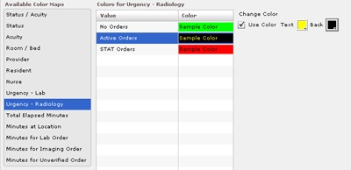Figure 55: Colors for Urgency - Imaging

      - In the Available Color Maps list, click on Urgency - Radiology. EDIS displays the Colors for Urgency – Radiology grid. Keyboard: Use the <Tab> key to locate the Available Color Maps list. Use the <Down Arrow> and
<Up Arrow> keys to select Urgency – Radiology.
      - To configure colors for a value listed in the Colors for Urgency – Radiology grid, click on the Value, then select the Use Color checkbox. Keyboard: Use the <Tab> key to locate the Colors for Urgency – Radiology grid. Use the
<Down Arrow> and <Up Arrow> keys to select a value. Use the <Tab> key to locate the Use Color checkbox and use the <Spacebar> key to select it.
      - Follow the steps in Section 8.3.1 “Configure Colors (General Instructions)” to configure colors for the value.
      - Repeat steps 1–3 to configure colors for additional values.
      - Click Save Color Changes to save your color configurations. The application displays an Alert message to inform you that it has saved your color selections. Click Close to dismiss this message. Keyboard: Use the <Tab> key to locate Save Color Changes and use the <Spacebar> key to select it. Use the <Tab> key to locate the Close button and use the <Spacebar> key to select it.

Configure Colors for Total Elapsed Minutes

The application measures total elapsed minutes from patients’ Time In values.

Figure 56: Configure colors for Total Elapsed Time

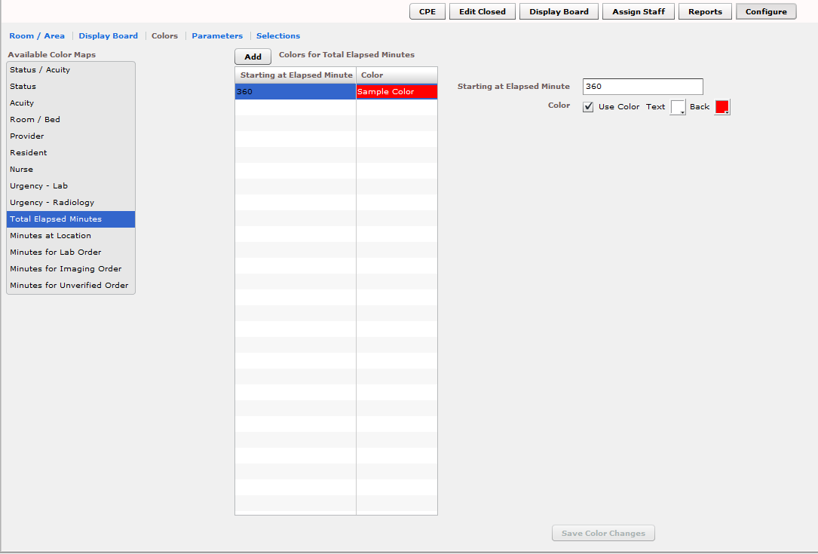

      - Click on Total Elapsed Minutes in the Available Color Maps list. The application displays the Colors for Total Elapsed Minutes grid. Keyboard: Use the <Tab> key to locate the Available Color Maps list. Use the <Down Arrow> and <Up Arrow> keys to select Total Elapsed Minutes in Hours: Minutes.
      - To add a time value to the Starting at Elapsed Minute column, click Add.
The application displays the Starting at Elapsed Minute box. Keyboard: Use the <Tab> key to locate the Add button and use the <Spacebar> key to select
it.
      - Type a starting value in the Starting at Elapsed Minute box. EDIS uses this value to determine when to display your color configuration. Keyboard: Use the <Tab> key to locate the Starting at Elapsed Minute box.
      - To associate a color with this value, click on the Use Color checkbox and follow the steps in Section 8.3.1 “Configure Colors (General Instructions).”
      - Repeat steps 1 through 4 to configure colors for additional Starting at…
Hours: minutes as necessary.
      - Click Save Color Changes to save your color configurations. The application displays an Alert message to inform you that it has saved your color selections. Click Close to dismiss this message. Keyboard: Use the <Tab> key to locate Save Color Changes and use the <Spacebar> key to select it. Use the <Tab> key to locate the Close button and use the <Spacebar> key to select it.

Note : The EMins and Mins column on the ‘CPE’ page displays the elapsed time in Hours: Minutes format.

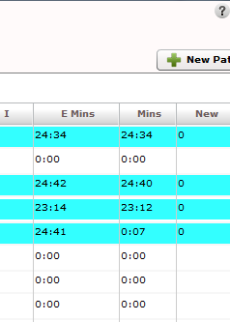Figure 57: Emins and Mins columns

Configure Colors for Minutes at Location

The application measures elapsed times from patients’ most recent room assignments.

Figure 58: Colors for Minutes at Location

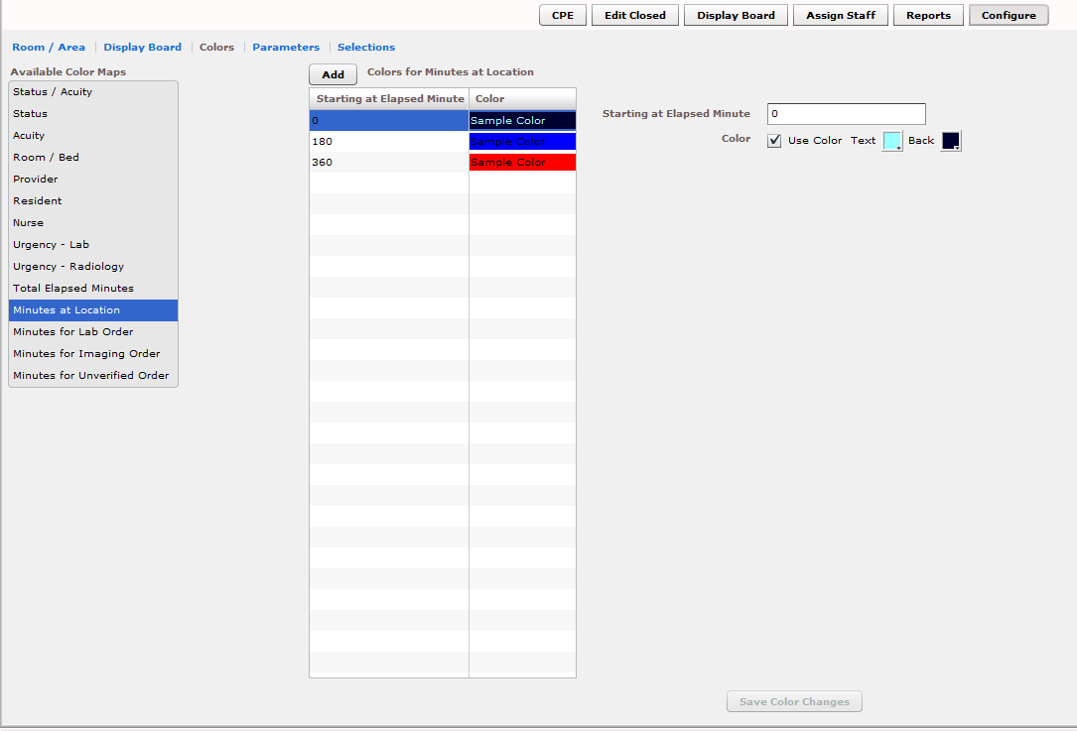

      - Click on Minutes at Location in the Available Color Maps list. The application displays the Colors for Minutes at Location grid. Keyboard: Use the <Tab> key to locate the Available Color Maps list. Use the <Down Arrow> and <Up Arrow> keys to select Minutes at Location.
      - To add a time value to the Starting at Elapsed Minute column, click Add.
The application displays the Starting at Elapsed Minute box. Keyboard: Use the <Tab> key to locate the Add button.
      - Type a starting value in the Starting at Elapsed Minute box. Keyboard: Use the <Tab> key to locate the Starting at Elapsed Minute box.
      - To associate a color with this value, click on the Use Color checkbox and follow the steps in Section 8.3.1 “Configure Colors (General Instructions).”
      - Repeat steps 1 through 4 to configure colors for additional Starting at…
values as necessary.
      - Click Save Color Changes to save your color configurations. The application displays an Alert message to inform you that it has saved your color
selections. Click Close to dismiss this message. Keyboard: Use the <Tab> key
to locate Save Color Changes and use the <Spacebar> key to select it. Use the <Tab> key to locate the Close button and use the <Spacebar> key to select it.

Configure Colors for Minutes for Lab Order

Values measure times from when orders were released to the laboratory.

Figure 59: Colors for Minutes for Lab Orders

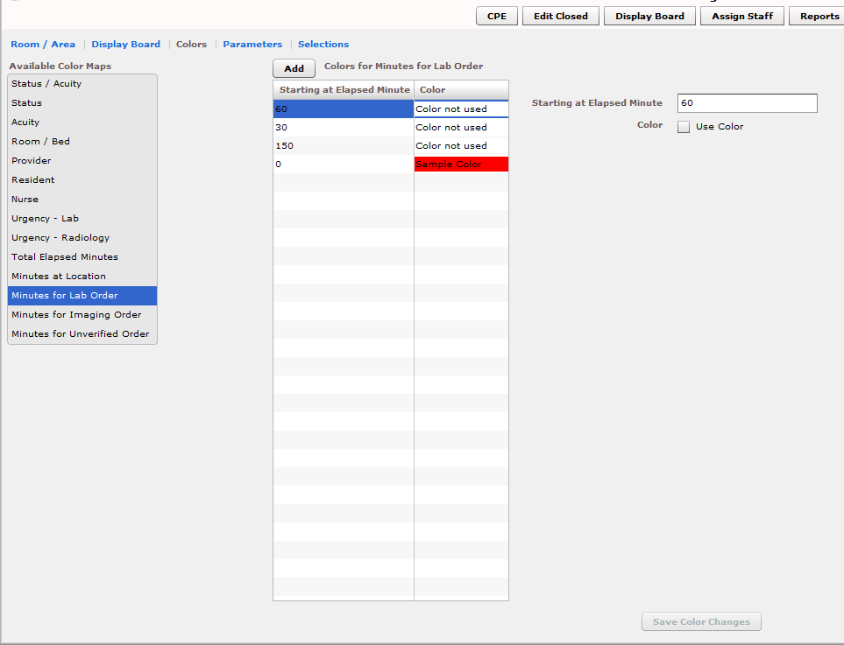

      - Click on Minutes for Lab Order in the Available Color Maps list. The application displays the Colors for Minutes for Lab Order grid. Keyboard: Use the <Tab> key to locate the Available Color Maps list. Use the <Down Arrow> and <Up Arrow> keys to select Minutes for Lab Order.
      - To add a time value to the Starting at Elapsed Minute column, click Add.
The application displays the Starting at Elapsed Minute box. Keyboard: Use the <Tab> key to locate the Add button.
      - Type a starting value in the Starting at Elapsed Minute box. Keyboard: use the <Tab> key to locate the Starting at Elapsed Minute box.
      - To associate a color with this value, click on the Use Color checkbox and follow the steps in Section 8.3.1 “Configure Colors (General Instructions).”
      - Repeat steps 1 through 4 to configure colors for additional starting-at minutes
as necessary.
      - Click Save Color Changes to save your color configurations. The application displays an Alert message to inform you that it has saved your color
selections. Click Close to dismiss this message. Keyboard: Use the <Tab> key
to locate Save Color Changes and use the <Spacebar> key to select it. Use the <Tab> key to locate the Close button and use the <Spacebar> key to select it.

Configure Colors for Minutes for Imaging Order

Values measure time from when orders are released to radiology.

Figure 60: Colors for Minutes for Imaging Orders

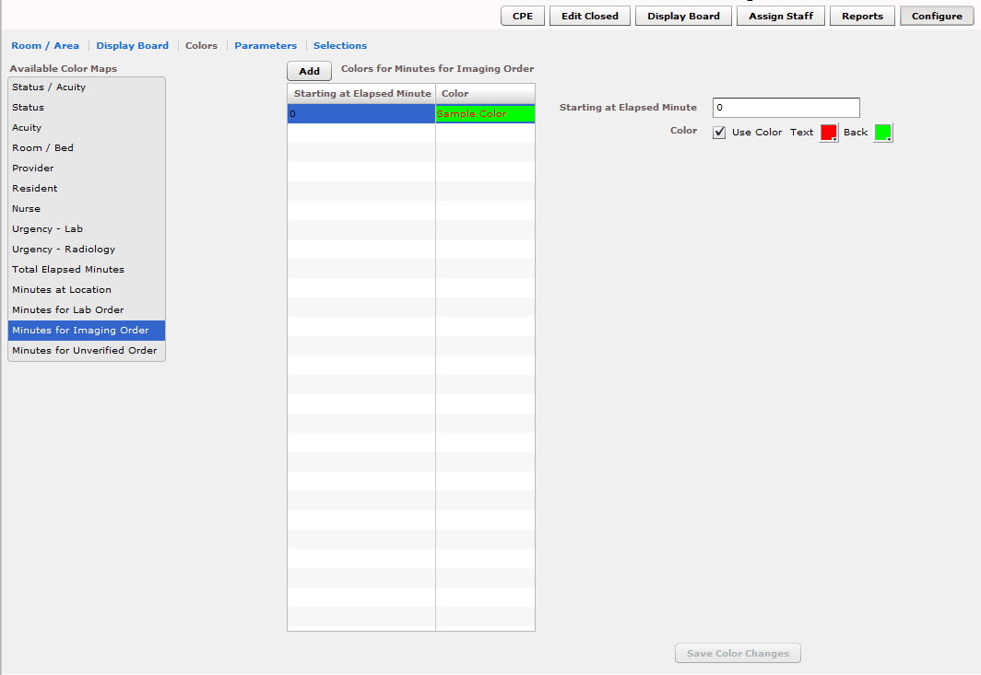

      - Click on Minutes for Imaging Order in the Available Color Maps list. The application displays the Colors for Minutes for Imaging Order grid. Keyboard: Use the <Tab> key to locate the Available Color Maps list. Use the <Down Arrow> and <Up Arrow> keys to select Minutes for Imaging Order.
      - To add a time value to the Starting at Elapsed Minute column, click Add.
The application displays the Starting at Elapsed Minute box. Keyboard: Use the <Tab> key to locate the Add button and use the <Spacebar> key to select
the button.
      - Type a starting value in the Starting at Elapsed Minute box. Keyboard: Use the <Tab> key to locate the Starting at Elapsed Minute box.
      - To associate a color with this value, click on the Use Color checkbox and
follow the steps in Section 8.3.1 “Configure Colors (General Instructions).”
      - Repeat steps 1 through 4 to configure colors for additional Starting at…
values as necessary.
      - Click Save Color Changes to save your color configurations. The application displays an Alert message to inform you that it has saved your color
selections. Click Close to dismiss this message. Keyboard: Use the <Tab> key
to locate Save Color Changes and use the <Spacebar> key to select it. Use the <Tab> key to locate the Close button and use the <Spacebar> key to
select it.

Configure Colors for Minutes for Unverified Orders

Values measure time from when orders are released.

Figure 61: Colors for Minutes for Unverified orders

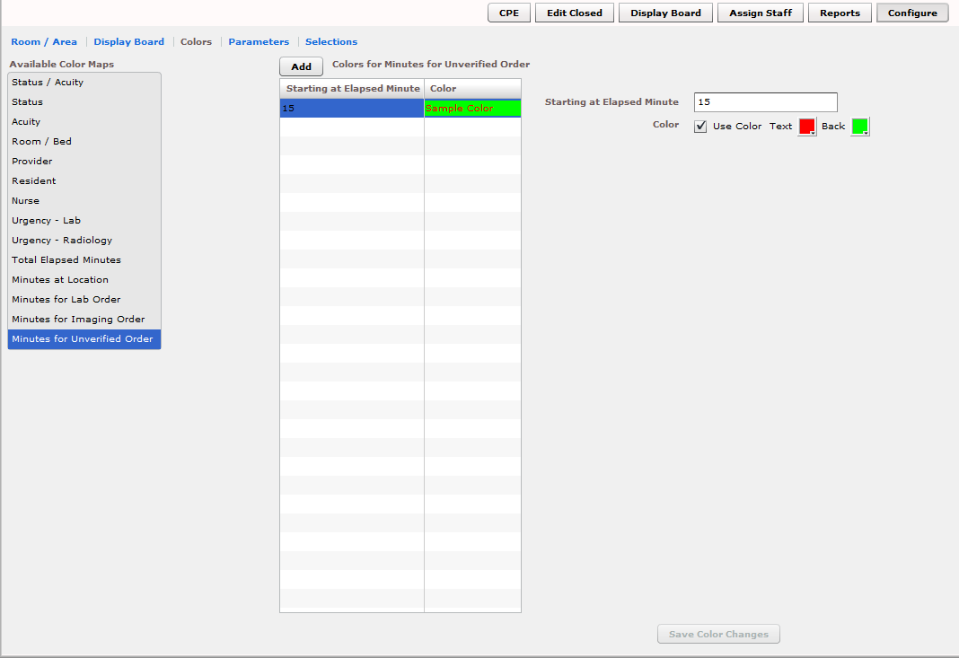

      - Click on Minutes for Unverified Order in the Available Color Maps list.
The application displays the Colors for Minutes for Unverified Orders grid. Keyboard: Use the <Tab> key to locate the Available Color Maps list. Use
the <Down Arrow> and <Up Arrow> keys to select Minutes for Unverified

Order.
      - To add a time value to the Starting at Elapsed Minute column, click Add.
The application displays the Starting at Elapsed Minute box. Keyboard: Use the <Tab> key to locate the Add button and press the <Spacebar> key to
select it.
      - Type a starting value in the Starting at Elapsed Minute box. Keyboard: Use the <Tab> key to locate the Starting at Elapsed Minute box.
      - To associate a color with this value, click on the Use Color checkbox and
follow the steps in Section 8.3.1 “Configure Colors (General Instructions).”
      - Repeat steps 1 through 4 to configure colors for additional Starting at…
values as necessary.
      - Click Save Color Changes to save your color configurations. The application displays an Alert message to inform you that it has saved your color
selections. Click Close to dismiss this message. Keyboard: Use the <Tab> key
to locate Save Color Changes and use the <Spacebar> key to select it. Use the <Tab> key to locate the Close button and use the <Spacebar> key to
select it.

Configure Parameters

Figure 62: Configure View - Parameters subview

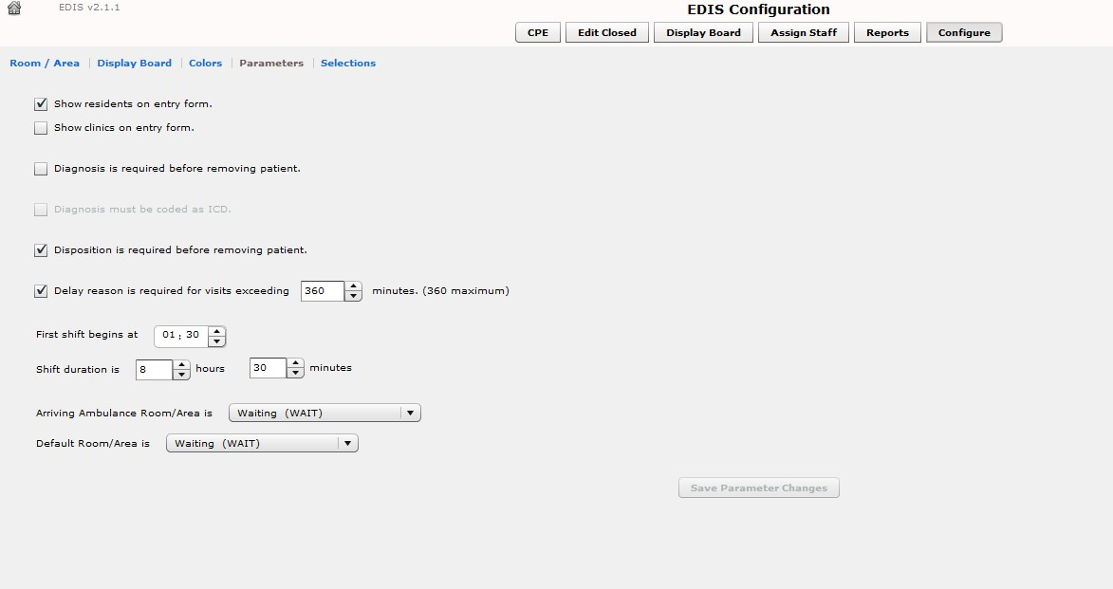

The Parameters subview allows you to set the following parameters :

    - Show residents on entry form—This parameter enables sites that have residents to include them on the application’s data entry form. Fields for making and editing resident selections are available in the Status/Responsibility section of the Visit view.

    - Show clinics on entry form—This parameter enables sites that have clinics specified to include them on the application’s data entry form. Fields for making and editing clinic selections are available in the Status/Responsibility section of the Visit view..
    - Diagnosis is required before removing a patient—When sites select this parameter, EDIS requires emergency-department personnel to enter diagnoses as a precondition to removing patients from the display board—unless the patient’s disposition is one of the following: Patient Name Entered in Error, Left Without Being Treated/Seen, or Sent to Nurse Eval / Drop In Clinic.
    - Diagnosis must be coded as ICD – When sites select this parameter, the application uses VistA’s ICD-9-CM or ICD-10-CM (after ICD-10 activation date) search for all diagnosis entries. When sites do not select this parameter, the application uses a free-text field to record diagnoses.
NOTE: Free Text Diagnosis does not pass to the PCE Encounter.
    - Disposition is required before removing patient—When sites select this parameter, the application requires emergency department personnel to enter dispositions before removing patients from the display board.
    - Delay reason is required for visits exceeding [site-specified] minutes—When sites select this parameter, the application does not allow users to remove patients whose stays have exceeded a specific number of minutes without first entering a reason for delay—except
when the patient’s disposition indicates that he or she has been assigned to an observation
ward.
    - Arriving Ambulance Room/Area is—This parameter enables sites to select a default room or area for patients who are arriving by ambulance or other emergency-transport
vehicles.
    - Default Room/Area is—This parameter enables sites to select a default room or area.

The Parameters subview also enables sites to specify shift start times and durations. The application uses this information to pull data for shift reports.

Include Residents on Entry Form

      - Click on the Show residents on entry form checkbox. Keyboard: Use the <Tab> key to locate the Show residents on entry form checkbox. Use the <Spacebar> key to select the checkbox.
      - Clear the checkbox to remove the resident-selection list from the entry form.
Keyboard: Use the <Spacebar> key to clear the checkbox.

Require a Diagnosis

      - Click on the Diagnosis is required before removing patient checkbox. Keyboard: Use the <Tab> key to locate the Diagnosis is required before removing patient checkbox. Use the <Spacebar> key to select the checkbox.
      - Clear the checkbox to remove the requirement. Keyboard: use the <Spacebar> key to clear the checkbox.

Require ICD or Free Text Diagnoses

      - To require ICD-9-CM or ICD-10-CM (after ICD-10 activation date) diagnoses, click on the Diagnosis must be coded as ICD checkbox. Keyboard: Use the <Tab> key to locate the Diagnosis must be coded as ICD checkbox. Use the <Spacebar> key to select the checkbox.
      - To require free-text diagnoses, do not click on —or clear the selection of—the Diagnosis must be coded as ICD checkbox. Keyboard: Use the <Spacebar> key to clear the selection of the checkbox.

Require Disposition to Remove Patients

      - Click on the Disposition is required before removing patient checkbox.
Keyboard: Use the <Tab> key to locate the Disposition is required before removing patient checkbox. Use the <Spacebar> key to select the checkbox.
      - To remove the requirement, clear the checkbox. Keyboard: Use the <Spacebar> key to clear the checkbox.

Require a Reason for Delay

      - Click on the Delay reason is required for visits exceeding …minutes checkbox.
In the minutes box, type or click on a number of minutes after which the application should require a reason for delay. Keyboard: Use the <Tab> key to locate the Delay reason is required for visits exceeding…minutes checkbox. Use the <Spacebar> key to select the checkbox. Use the <Tab> key to locate the minutes box. Type a number of minutes or use the <Up Arrow> or <Down Arrow> key to select a number of minutes.

NOTE: The national visit limit for emergency departments is currently six hours (360 minutes).

      - Clear the checkbox to remove the requirement. Keyboard: Use the <Spacebar> key to clear the checkbox.

Configure Shift Parameters

      - In the First shift begins at box, type the time (in hours and minutes—hh:mm) your site’s first shift begins. Keyboard: Use the <Tab> key to locate the First shift begins at box.
      - In the Shift duration is…hours and minutes boxes, type or click on the hours and minutes that mark the duration of your site’s shifts. Keyboard: Use the <Tab> key to locate the Shift duration is…hours and minutes boxes. Type hours and minutes or use the <Up Arrow> or <Down Arrow> key to select hours and minutes.

Set a Default Room or Area for Patients Arriving by Ambulance

Click on a room or area from the Arriving Ambulance Room/Area is list. Keyboard: Use the <Tab> key to locate the Arriving Ambulance Room/Area is list. Use the <Up Arrow> or <Down Arrow> key to select a default room or area from the list.

Set a Default Room or Area

Click on a room or area from the Default Room/Area is list. Keyboard: use the
<Tab> key to locate the Default Room/Area is list. Use the <Up Arrow> or
<Down Arrow> key to select a default room or area from the list.

NOTE: If a default room is not selected, EDIS will warn users upon log in that a default room needs to be set. Until a default room is selected, EDIS will place new patients in an area designated as EDIS_DEFAULT. This will ensure that new patients will function correctly within the EDIS application.

Save Parameter Selections

Click Save Parameter Changes. The application displays an Alert message to inform you that it has successfully saved your changes. Click Close to dismiss this message. Keyboard: Use the <Tab> key to locate the Save Parameter
Changes button. Use the <Spacebar> key to select the button. Use the <Tab> key to locate the Close button and use the <Spacebar> key to select it.

Some parameter settings require you to log out of the application and log back in. For example, if you select the Diagnosis must be coded as ICD checkbox, you must log out and log back in to see the change on the application’s Disposition view. Likewise, after selecting the Show residents on entry form checkbox, you must log out and log back in to see resident lists on the application’s Update view.

Add Choices to Selection Lists

Figure 63: Configure View - Selections subview

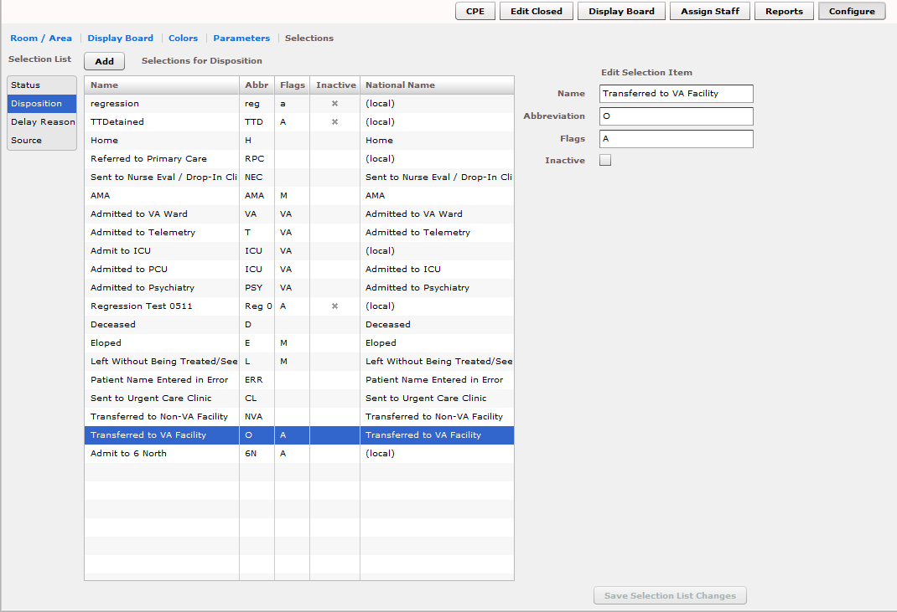

The Configure/Selections subview enables you to add locally meaningful choices to selection lists that ship with EDIS. Specifically, you can add selections to the following lists:

    - Status: The application ships with the following statuses:

Admitted

Awaiting Triage

Discharged

ED Boarding [Hold]

ED Observation Unit

ED Patient

En Route/Prearrival
    - Disposition: The application ships with the following dispositions:

Admitted to VA Ward o Admitted to Telemetry o Admitted to ICU

Admitted to Psychiatry

Home
      - AMA (left against medical advice)

Left Without Being Treated/Seen

Eloped

Transferred to VA Facility

Transferred to non-VA Facility

Deceased

Sent to Nurse Eval / Drop In Clinic

Sent to Urgent Care Clinic

Patient Name Entered in Error
    - Delay Reason: The application ships with the following reasons for delay:

Obtain Inpatient Bed

ED to Hospital Bed

Obtain Imaging Results

Obtain Imaging Studies

Obtain Drugs/Pharmacology

Obtain Lab Results

Obtain Lab Studies

Obtain Medical Supplies

Arrange Emergency Surgery

Obtain Consultant

On-call Staff

Patient Transport Home

Overcrowding of ED

Patient Transport Other

Obtain Accepting Physician

Obtain Escort

Admitting Physician Evaluation

Admit Physician Writing Dispo

Patient Admitted to Observation

ED Staff Limits

ED Physician Limits

Interfacility Transfer

Obtain Ambulance Services

    - Source: The application ships with the following sources:

Non-referred

On-site Clinic

On-site Nursing Home

VA Clinic, Off-site

VA Nursing Home, Off-site

Non-VA Clinic/Office

Non-VA Nursing Home

Transfer, Other
The EDIS technical working group (TWG) and technical advisory group (TAG) have vetted these default lists. When sites add selections, the application denotes them by displaying the word local in the subview’s National Name column.

Add Status, Disposition, Delay Reason, and Source Selections

      - Select Status, Disposition, Delay Reason, or Source in the Selection List.
The application displays the Selections for Status, Selections for Disposition, Selections for Delay Reason, or Selections for Source grid, respectively.
Keyboard: use the <Tab> key to locate the Selection List. Use the <Down
Arrow> and <Up Arrow> keys to select Status, Disposition, Delay Reason, or Source.
      - Click Add. The application displays the Edit Selection Item pane. Keyboard:
use the <Tab> key to locate the Add button and use the <Spacebar> key to select the button.
      - In the Name box (Edit Selection Item pane), type a name for the selection
you want to add. Keyboard: use the <Tab> key to locate the Name box.
      - In the Abbreviation box , type an abbreviation for the item you want to add.
EDIS uses this abbreviation for its large electronic whiteboard display. Keyboard: use the <Tab> key to locate the Abbreviation box.
      - (Optional) If you want to inactivate the new item, select the Inactive check box. The application does not include inactive items on its selection lists. Keyboard: use the <Tab> key to locate the Inactive check box and use the
<Spacebar> key to select it.
      - (Optional) Change the order in which EDIS displays list selections in its data views by using a drag-and-drop operation to reorder selections in the

Selections for Status, Selections for Disposition, Selections for Delay
Reason, or Selections for Source lists. Keyboard instructions are not available for this step.
      - Click Save Selection List Changes to save your additions (or edits). EDIS
displays an Alert message to tell you it successfully saved your changes. Click Close to dismiss this message. Keyboard: Use the <Tab> key to locate the Save Selection List Changes button and use the <Spacebar> key to select the button. Use the <Tab> key to locate the Close button and use the <Spacebar> key to select it.

9. Index

Activity report 55
Acuity Report 56
Add Patients to Appointment Management First:
.....................................................................13
Adding EDIS to your Internet Explorer Favorites 7
Application Timeouts 3
Assign Staff 11
Configure 11
CPE 9
Create a Visit in CPRS 13

Creating unscheduled appoints just before the midnight hour 14
Delay reason definitions
Admit Physician Writing Dispo 38
Admitting Physician Evaluation 38
Arrange Emergency Surgery 40
ED Physician Limits 40
ED Staff Limits 40
ED to Hospital Bed 39
Interfacility Transfer 39
Obtain Accepting Physician 38
Obtain Ambulance Services 39
Obtain Consultant 39
Obtain Drugs/Pharmacology 40
Obtain Escort 39
Obtain Imaging Results 39
Obtain Imaging Studies 39
Obtain Inpatient Bed 40
Obtain Lab Results 40
Obtain Lab Studies 40
Obtain Medical Supplies 40
On-call Staff 40
Overcrowding of ED 40
Patient Admitted to Observation 39
Patient Transport Home 39
Patient Transport Other 40
Display Board 10
Document Conventions 2

Duplicate Selection 18
Edit Closed 10

Failing to select the proper appointment when writing notes or ordering tests 14
JAWS Workstation Requirements 2
Launch EDIS 7
Log In 7
Missed Opportunities report 62

Multiple Patient icon 19

Patient Record Flags 17
Place Patient on EDIS First with Provider Name
..................................................................... 15
Preventing Accidental Application Sign-Outs. 4 Reports 11

Restricted Record Warning 17
Role-based Access to Views 2
Room / Area subview, Configure view 71
Section 508 of the Rehabilitation Act of 1973 .. 2

Writing notes or orders before creating unscheduled appointments 14

