Home Based Primary Care

HBH*1.0*32

Release Notes
August 2021
Department of Veterans Affairs
Table of Contents
Introduction 1
Purpose 1
Audience 1
Patch Information 1
Site Preparation 1
This Release 3
New Features and Functions Added 3
HBPCARE-15 - VistA environment provider number wheels 3
HBPCARE-18 - Identify unused provider numbers in the number wheel 3
HBPCARE-19 - Auto-assign the next available chronological provider number in the number wheel 3
HBPCARE-32 - Convert Provider File Data Entry in HBHC Edit Provider option from VistA Roll and Scroll to ListMan functionality 3
HBPCARE-35 - Provide additional details when adding new provider in HBHC Edit Provider Number 3
HBPCARE-36 - Alert user if provider has been previously defined 3
HBPCARE-53 - "PARENT SITE" prompt help text 3
HBPCARE-54 - Station Number AITC Record Transmission 3
HBPCARE-55 - Patient facility AITC error handling 3
HBPCARE-56 - Pad provider number with leading zeros in AITC Transmission 3
HBPCARE-57 - ListMan Print Functions 3
HBPCARE-61 - Notify Installer if HBH*1.0*32 patch install is halted 3
HBPCARE-62 - Inactive HBPC providers returning to the HBPC program at a facility 3
HBPCARE-63 - Inactive provider display in HBHC Edit Provider Number option 3
HBPCARE-64 - Max Number of Providers Reached Message 3
HBPCARE-66 - Check Transmission status upon edit of PARENT SITE prompt 3
HBPCARE-76 - Check for active providers sharing the same provider number 3
HBPCARE-77 - Check for the same user being assigned to more than one active HBPC provider number 3
HBPCARE-78 - Transmit correct transaction types if PARENT SITE prompt is edited but patient has NOT been discharged 3
HBPCARE-79 - Transmit correct transaction types if PARENT SITE prompt is edited on a patient with a complete episode of care. 3
HBPCARE-80 - Build local HBPC facility list 3
HBPCARE-81 - Use local HBPC facility list 3
HBPCARE-82 - Default HBPC Program Facility "PARENT SITE" 3
HBPCARE-83 - Make "PARENT SITE" a required prompt 4
HBPCARE-87 - SYSTEM PARAMETERS EDIT Select Parent Site Definition Help Statement 4
HBPCARE-88 - Add "PARENT SITE" prompt to DEMOGRAPHIC DATA ENTRY FOR MFH option 4
Enhancements and Modifications to Existing 4
HBPCARE-9 - Maintain 4-digit HBPC provider numbers 4
HBPCARE-11 - Update HBPC provider number logic from Edit Provider Number option 4
HBPCARE-12 - Update HBPC provider number logic on the Input Transform 4
HBPCARE-13 - Expand first and second provider number digits to allow 0 thru 9 4
HBPCARE-14 - Maintain existing provider number definitions 4
HBPCARE-16 - Update HBHC Edit Provider Number option to prompt for provider name first 4
HBPCARE-17 - Update message when Provider not found while in the HBHC Edit Provider Number option 4
HBPCARE-20 - Update Mailman logic to allow for HBPC test account transmissions 4
HBPCARE-27 - Transmission message type 3 admission facility ID update 4
HBPCARE-28 - Transmission message type 4 visit facility ID update 4
HBPCARE-29 - Transmission message type 5 discharge facility ID update 4
HBPCARE-30 - Transmission message type 6 correction facility ID update 4
HBPCARE-31 - Transmission message type 7 Medical Foster Home facility ID update 4
HBPCARE-33 - Remove ability to inactivate HBPC Providers 4
HBPCARE-34 - Discontinue VistA @ symbol deletion functionality in the HBHC Edit Provider option 4
HBPCARE-43 - Update Mailman logic to allow for HBPC test account RE-transmissions 4
HBPCARE-50 - New prompt addition to HBHC Evaluation/Admission Data Entry option 4
HBPCARE-65 - Update Data Dictionary info for deprecated fields in HBHC EDIT PROVIDER file #631.4 4
HBPCARE-67 - Disable the HBPC Provider File Report option from the Manager Menu 4
HBPCARE-69 - Review HBPC Management Reports for HBPC Provider data usage 4
HBPCARE-70 - Evaluation/Admission Data Report by Patient 4
HBPCARE-71 - Discharge Data by Patient 4
HBPCARE-72 - Form Errors Report 4
HBPCARE-75 - Update references from HBHC to HBPC for HBHC EDIT PROVIDER option 4
Known Issues 5
Product Documentation 5

Introduction
This patch includes the following enhancements:
- Modify the VistA-HBPC module to increase the number of providers that can be assigned unique Provider Number from the current limit of 2,999 to an upper limit of 9,999.
- Modify the VistA-HBPC module to add the site number with suffix-level granularity to patient-level HBPC data for each patient admission to an HBPC Program.

Purpose
These release notes cover the changes to Home Base Primary Care for the HBH*1.0*32 release.

Audience
This document targets users and administrators of Home Base Primary Care and applies to the changes made between this release and any previous release for this software.

Patch Information
HBH*1.0*32 includes specific pre-installation, post-installation, and prerequisite installation details that have been highlighted in the accompanying Deployment, Installation, Back-out, and Rollback Guide (DIBR). The list below contains the corresponding section number and title, within the DIBR, where the details can be found.
- 3.2.3 Site Preparation (which is also outlined in the next section, Site Preparation)
- 4.1 Pre-Installation and System Requirements
- 4.2 Platform Installation and Preparation
- 4.9.1 KIDS Verification

Site Preparation
Sites have been instructed to perform two FileMan searches. These searches will determine the presence of the following two conditions:
- If any providers are defined for more than one active HBHC provider number
- If an active HBHC provider number is defined for more than one provider.
A visual inspection is needed to determine if either of the two conditions are present. If the FileMan searches have not yet been performed, they are listed below:
- Search to determine if any provider is defined with more than one active HBPC provider number.
Note: Before inactivating one of the numbers, determine if these are different providers who have the same name.
Figure 1: Example search for providers with more than one active HBPC provider number
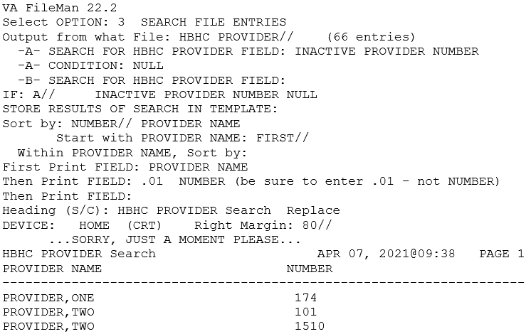
- FileMan search to determine if active HBHC provider numbers are defined for more than one provider.
Figure 2: Example search for active provider numbers defined for more than one provider
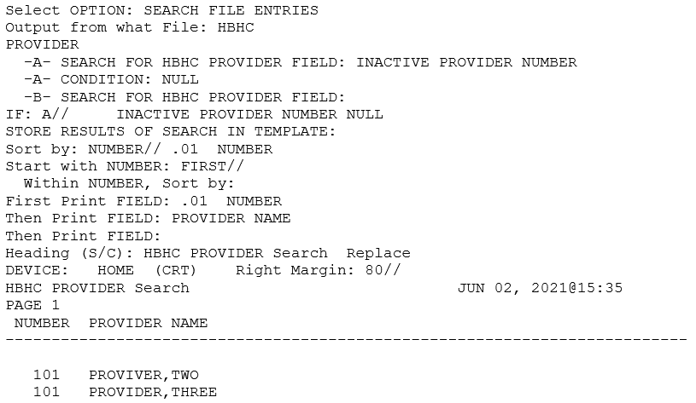

This Release
The following sections provide a summary of the new features and functions added, enhancements and modifications to the existing software, and any known issue for HBH*1.0*32.

New Features and Functions Added
The following are the new features and functions added to the HBH*1.0*32 release.

HBPCARE-15 - VistA environment provider number wheels

HBPCARE-18 - Identify unused provider numbers in the number wheel

HBPCARE-19 - Auto-assign the next available chronological provider number in the number wheel

HBPCARE-32 - Convert Provider File Data Entry in HBHC Edit Provider option from VistA Roll and Scroll to ListMan functionality

HBPCARE-35 - Provide additional details when adding new provider in HBHC Edit Provider Number

HBPCARE-36 - Alert user if provider has been previously defined

HBPCARE-53 - "PARENT SITE" prompt help text

HBPCARE-54 - Station Number AITC Record Transmission

HBPCARE-55 - Patient facility AITC error handling

HBPCARE-56 - Pad provider number with leading zeros in AITC Transmission

HBPCARE-57 - ListMan Print Functions

HBPCARE-61 - Notify Installer if HBH*1.0*32 patch install is halted

HBPCARE-62 - Inactive HBPC providers returning to the HBPC program at a facility

HBPCARE-63 - Inactive provider display in HBHC Edit Provider Number option

HBPCARE-64 - Max Number of Providers Reached Message

HBPCARE-66 - Check Transmission status upon edit of PARENT SITE prompt

HBPCARE-76 - Check for active providers sharing the same provider number

HBPCARE-77 - Check for the same user being assigned to more than one active HBPC provider number

HBPCARE-78 - Transmit correct transaction types if PARENT SITE prompt is edited but patient has NOT been discharged

HBPCARE-79 - Transmit correct transaction types if PARENT SITE prompt is edited on a patient with a complete episode of care.

HBPCARE-80 - Build local HBPC facility list

HBPCARE-81 - Use local HBPC facility list

HBPCARE-82 - Default HBPC Program Facility "PARENT SITE"

HBPCARE-83 - Make "PARENT SITE" a required prompt

HBPCARE-87 - SYSTEM PARAMETERS EDIT Select Parent Site Definition Help Statement

HBPCARE-88 - Add "PARENT SITE" prompt to DEMOGRAPHIC DATA ENTRY FOR MFH option

Enhancements and Modifications to Existing
The following are the enhancements and modifications to the HBH*1.0*32 release.

HBPCARE-9 - Maintain 4-digit HBPC provider numbers

HBPCARE-11 - Update HBPC provider number logic from Edit Provider Number option

HBPCARE-12 - Update HBPC provider number logic on the Input Transform

HBPCARE-13 - Expand first and second provider number digits to allow 0 thru 9

HBPCARE-14 - Maintain existing provider number definitions

HBPCARE-16 - Update HBHC Edit Provider Number option to prompt for provider name first

HBPCARE-17 - Update message when Provider not found while in the HBHC Edit Provider Number option

HBPCARE-20 - Update Mailman logic to allow for HBPC test account transmissions

HBPCARE-27 - Transmission message type 3 admission facility ID update

HBPCARE-28 - Transmission message type 4 visit facility ID update

HBPCARE-29 - Transmission message type 5 discharge facility ID update

HBPCARE-30 - Transmission message type 6 correction facility ID update

HBPCARE-31 - Transmission message type 7 Medical Foster Home facility ID update

HBPCARE-33 - Remove ability to inactivate HBPC Providers

HBPCARE-34 - Discontinue VistA @ symbol deletion functionality in the HBHC Edit Provider option

HBPCARE-43 - Update Mailman logic to allow for HBPC test account RE-transmissions

HBPCARE-50 - New prompt addition to HBHC Evaluation/Admission Data Entry option

HBPCARE-65 - Update Data Dictionary info for deprecated fields in HBHC EDIT PROVIDER file #631.4

HBPCARE-67 - Disable the HBPC Provider File Report option from the Manager Menu

HBPCARE-69 - Review HBPC Management Reports for HBPC Provider data usage

HBPCARE-70 - Evaluation/Admission Data Report by Patient

HBPCARE-71 - Discharge Data by Patient

HBPCARE-72 - Form Errors Report

HBPCARE-75 - Update references from HBHC to HBPC for HBHC EDIT PROVIDER option

Known Issues
No known issues.

Product Documentation
The following documents apply to this release:
- Installation Guide
- Security Guide
- Technical Manual
- User Manual
All release documentation will be housed in the vista-home-based-primary-care-product repository of GitHub EC, the SOFTWARE library, and the Veterans Document Library (VDL).

