Joint Longitudinal Viewer (JLV) 3.4.0.0

Veterans Affairs Enterprise Cloud

Production Operations Manual (POM)



May 2023

Version 0.1

Department of Veterans Affairs

Revision History

|  |  |  |  |
| --- | --- | --- | --- |
| Date | Version | Description | Author |
| 04/05/2023 | 0.1 | Initial draft of document from last approved | Booz Allen Hamilton |
| 04/24/2023 | 0.2 | All Comments Addressed | Booz Allen Hamilton |
| 04/26/2023 | 1.0 | Submitting Document for Approval | Booz Allen Hamilton |

Table of Contents

1. Introduction 1

2. Routine Operations 2

2.1. Administrative Procedures 2

2.1.1. System Startup 3

2.1.1.1. System Startup from Emergency Shutdown 4

2.1.2. System Shutdown 5

2.1.2.1. The Amazon Command Line Interface (CLI) Emergency System Shutdown 5

2.1.3. Backup and Restore 5

2.1.3.1. Backup Procedures 5

2.1.3.2. Restore Procedures 6

2.1.3.3. Storage and Rotation 6

2.2. Security/Identity Management 7

2.2.1. Identity Management 8

2.2.2. Access Control 8

2.3. User Notifications 8

2.3.1. User Notification Points of Contact 8

2.3.2. JLV QoS Mail Groups 10

2.3.3. Scheduled Downtime Notifications 11

2.3.3.1. Service Now (SNOW) Process 13

2.3.3.2. Patch Release Notification E-mail (Example) 14

2.3.4. Unscheduled Outage Notifications 14

2.3.4.1. Initial Response to Issues Within 30 Minutes of Alert 14

2.3.4.1.1. Initial Outage Response Notification E-Mail (Example) 15

2.3.4.2. Outage Escalation to External Teams 15

2.3.4.2.1. Outage Escalation to External Teams E-Mail (Example) 15

2.3.4.2.2. Outage Update E-Mail (Example) 16

2.3.5. Announcement Banners 17

2.3.5.1. Placing Announcement Banners 19

2.3.5.2. Removing Announcement Banners 20

2.3.5.2.1. Manual Removal 20

2.3.5.2.2. Automatic Expiration 20

2.3.5.3. Announcement Banner Extensions 20

2.4. System Monitoring, Reporting, and Tools 21

2.4.1. Dataflow Diagram 21

2.4.2. Availability Monitoring 21

2.4.2.1. Domain-Level Availability Monitoring 23

2.4.3. Performance/Capacity Monitoring 24

2.4.4. Critical Metrics 24

2.4.5. RDS Production Monitoring and Notification 25

2.5. Routine Updates, Extracts, and Purges 25

2.5.1. Routine Updates 25

2.5.2. Extracts 26

2.5.3. Purges 26

2.6. Scheduled Maintenance 26

2.7. Unscheduled Outage Triage Process 27

2.7.1. Outage Triage Timeline 28

2.7.2. Escalation 28

2.7.3. Issue Resolution and After Action 29

2.8. Capacity Planning 29

2.8.1. Initial Capacity Plan 29

3. Exception Handling 29

3.1. Routine Errors 30

3.1.1. Security Errors 30

3.1.2. Timeouts 30

3.1.2.1. Application Timeout 30

3.1.2.2. Connection Errors 31

3.1.3. Concurrency 32

3.2. Significant Errors 32

3.2.1. Application Error Logs 32

3.2.2. Application Error Codes and Descriptions 33

3.2.3. Services Infrastructure Errors 34

3.2.3.1. DB 34

3.2.3.2. Web Server 35

3.2.3.3. Application Server 35

3.2.3.4. Network 36

3.2.3.5. Authentication and Authorization (A&A) 36

3.2.3.6. Logical and Physical Descriptions 36

3.3. Dependent System(s) and Services 36

3.4. Troubleshooting 37

3.5. System Recovery 37

3.5.1. Restart After an Unscheduled System Interruption 37

3.5.2. Restart after DB Restore 37

3.5.3. Backout Procedures 37

3.5.4. Rollback Procedures 37

4. Operations and Maintenance Responsibilities 38

Appendix A. Approval Signatures 40

Appendix B. Acronyms and Abbreviations 41

Statement on Auditing Standards-70 43

Table of Figures

Figure 1: The JLV Patient Data and Widgets Page 1

Figure 2: The Database Details Window 6

Figure 3: Mockup of Regularly Scheduled Downtimes 11

Figure 4: Scheduled Downtime Notification Process 13

Figure 5: Service Now (SNOW) Process 14

Figure 6: User-facing Banner on the JLV Login Page 19

Figure 7: System Status Check Sequence 22

Figure 8: System Status Message on the JLV Login Page 23

Figure 9: System Status on the JLV Toolbar 23

Figure 10: Connection Status Details 24

Figure 11: Patching Process for VA and DOD Components 26

Figure 12: Scheduled Downtime and Unscheduled Outage Overview 27

Figure 13: Outage Event Activities and Timeline 28

Figure 14: Session Timeout Notification 30

Figure 15: Session Timeout (SSOi) 31

Figure 16: Connection Error 31

Figure 17: jMeadows Log Output 33

Figure 18: JLV Architecture and Components 34

Figure 19: Audit Log 35

Table of Tables

Table 1: User Authentication and Login Overview 7

Table 2: Access Control Design 8

Table 3: JLV Scheduled Downtime Notification List (VA Stakeholders) 8

Table 4: Announcement Banner Content for Maintenance Events Impacting End Users 18

Table 5: Database Table Entry Prior to Manual Removal 20

Table 6: Database Table Entry After Manual Removal 20

Table 7: Database Table Entry for a Planned Maintenance Announcement Banner 20

Table 8: Database Table Entry as Initially Posted 21

Table 9: Database Table Entry After a Date Extension Update 21

Table 10: Services Monitored by QoS 21

Table 11: Response Time Log Location 32

Table 12: JLV Dependent Systems and Services 36

Table 13: Operations and Maintenance Responsibility Matrix 38

Table 14: Acronyms and Abbreviations 41

# Introduction

Born from a joint Department of Defense (DOD)–Department of Veterans Affairs (VA) venture called JANUS, Joint Longitudinal Viewer (JLV) was directed by the Secretary of the VA and the Secretary of Defense in early 2013 to further support interoperability between the two departments. JLV is a centrally hosted, Java-based web application managed as two similar but distinct products - one tailored for DoD use and another tailored for VA use. Each JLV product is deployed to its respective DoD and VA hosting environments. Although separately hosted, the respective applications use several shared data services. The browser-based Graphical User Interface (GUI) provides an integrated, read-only view of Electronic Health Record (EHR) data from the VA, DOD, and community partners within a single application.

JLV eliminates the need for VA and DOD clinicians to access disparate viewers. The GUI retrieves clinical data from several native data sources and systems, then presents it to the user via widgets, each corresponding to a clinical data domain.

Users can create and personalize tabs, drag, and drop widgets onto tabs, sort data within a widget’s columns, set date filters, and expand a widget for a detailed view of patient information. Within each widget, a blue circle indicates VA data; an orange square indicates DOD data; a purple hexagon indicates community partner data; and a green triangle indicates Cerner Millennium Federal Electronic Health Record (FEHR) data.

Figure 1 depicts the main application window, comprised of the Patient Data and Widgets page (details displayed) and widgets. The widgets retrieve clinical data from sources in real time, displaying them in a unified, chronological view.

Figure 1: The JLV Patient Data and Widgets Page

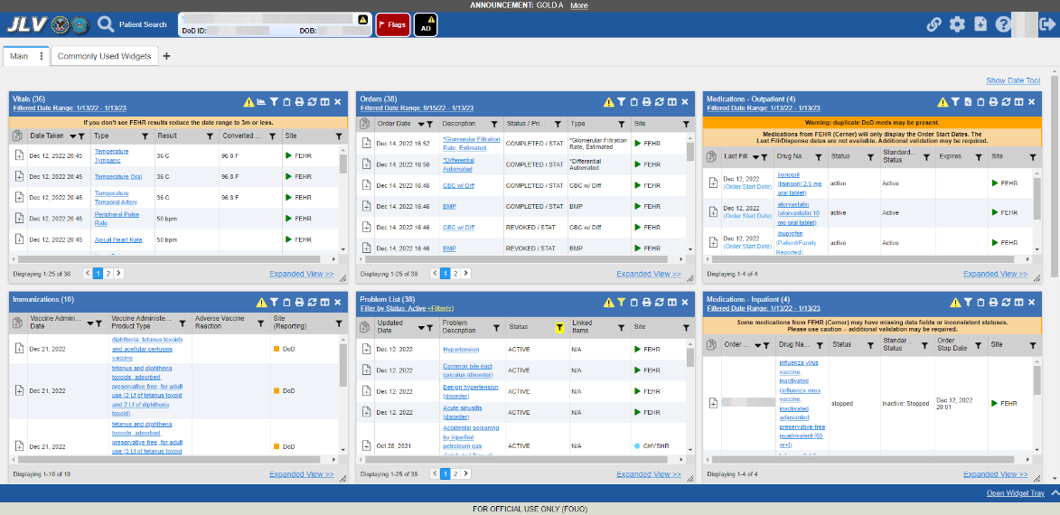

JLV is deployed to and operates within the Veterans Affairs Enterprise Cloud (VAEC) using Amazon Elastic Container Service (ECS). The Elastic Container Registry stores and manages the container images.

Docker technology is used to create file images. Docker is a set of Platforms as a Service (PaaS) products that use OS-level virtualization to deliver software in packages called containers.

When a docker file is built, the configuration instructions are executed, and the artifacts are installed into the image. This activity creates the container.

Docker files are packaged up and sent to Amazon Web Services (AWS) Elastic Container Registry (ECR). When changes are made to individual containers, a new docker file is created. The new file is sent to ECR, where a new container is created to replace the outdated container.

* JLV ECS Cluster is a logical grouping of containers which together form the JLV application.
  + A cluster setting describes the number of containers needed at any one time.
  + If a container crashes, this ECS service automatically creates a new container to ensure the desired number of containers is maintained.
* Each container is described by the task definition associated with each specific container.
* The JLV Cluster definition is stored in the ECR.
* The ECR stores and manage container images.

The JLV database has migrated to VAEC and uses Amazon Relational Database Service (RDS) in conjunction with Microsoft SQL Server Enterprise Edition. RDS provides automated administration tasks such as hardware provisioning, database setup, patching and backups.

# Routine Operations

The JLV Operations Team (JLV Ops) performs routine operations to maintain the configuration, upkeep, and reliable operation of computer systems. System administrators also ensure that the performance, uptime, resources, and security of the systems meet the needs of the end users.

## Administrative Procedures

JLV is installed within the JLV VAEC Virtual Private Clouds (VPC) using the ECS managed service. JLV services are stored as container images in ECR.

Docker technology is used to create file images. Docker is a set of Platforms as a Service (PaaS) product that use OS-level virtualization to deliver software in packages called containers.

When a docker file is built, the configuration instructions are executed, and the artifacts are installed into the image. This activity creates the container image.

Docker images are packaged and sent to ECR. When changes are made to individual services, a new docker image is created, and the new image is sent to ECR, where a new container is created to replace the outdated container.

A detailed list of the services referenced throughout this POM can be found in the VA JLV Product Repository on GitHub[1]. Please contact the GitHub Administrator to gain access if necessary.

### System Startup

ECS requires a task definition that specifies launch parameters required to run/start a single or multiple containers for a given service within the JLV application stack. When ECS starts the task for a given JLV service, the container is configured to initiate the docker run command to start the application (i.e. Apache Tomcat). ECS will auto start containers based on the desired number of tasks stated.

1. Start the JLV RDS database (DB) instance.
   1. The DB instances processes are configured to run as system services and are automatically started with the DB instances.
   2. Validation:
      1. Startup is validated through the successful smoke test of the application; loading the JLV Login page and logging in to the application confirms that the DB instances are up and operational.
2. Start the Veterans Information Systems and Technology Architecture (VistA) Data Service (VDS) container.
   1. The Tomcat service is configured to run as a system service and is automatically started within the VDS container.
   2. Validation:
      1. Startup is validated through the successful smoke test of the application; loading the JLV Login page and logging in to the application confirms that the VDS instances are up and operational.
      2. Review each of the Tomcat-managed VDS server application logs for connection and/or application errors.
3. Start the JLV jMeadows container.
   1. The Tomcat service is configured to run as a system service and is automatically started within the task.
   2. Validation:
      1. Startup is validated through the successful smoke test of the application; loading the JLV Login page and logging into the application confirms that the jMeadows containers are up and operational.
      2. Review each of the Tomcat-managed jMeadows container application logs for connection and/or application errors.
4. Start the Report Builder container
   1. The Tomcat service is configured to run as a system service and is automatically started within the instances.
   2. Validation:
      1. Startup is validated through the successful smoke test of the application; loading a document into Report Builder and testing the print feature confirms that the Report Builder servers are up and operational
      2. Review each of the Tomcat-managed Report Builder instance application logs for connection and/or application errors
5. Start the JLV front-end web container and the Apache Single Sign-On Internal (SSOi) container
   1. The Tomcat service is configured to run as a system service and is automatically started within the instances
   2. Validation:
      1. Startup is validated through the successful smoke test of the application; loading the JLV Login page and logging in to the application confirms that the dependent backend JLV systems are up and operational
      2. Review each Apache-managed web server for connection and/or application errors
   3. Access and launch the JLV Universal Resource Locator (URL), [[REDACTED](https://jlv.med.va.gov/JLV)] in a web browser. This URL is currently pointing to the Application Load Balancer (ALB) [REDACTED].
   4. Log in as a Veterans Health Administration (VHA) user with a VHA test account:
      1. Verify that the JLV Login page displays as expected and that the system status indicates services are online and connected
   5. Log in as a Veterans Benefits Administration (VBA) Compensation and Pension Record Interchange (CAPRI)-Claims user with a VBA test account:
      1. Verify that the JLV Login page displays as expected and that the system status indicates services are online and connected

#### System Startup from Emergency Shutdown

The VAEC infrastructure is hosted by AWS GovCloud, a cloud service provider. The AWS GovCloud platform is used to provide a variety of hosting environments to suit a variety of needs. AWS GovCloud can support applications categorized up to High as rated in accordance with Federal Information Processing Standard (FIPS) 199. VA applications available to the public are hosted in AWS GovCloud.

A dedicated private data link (AWS Direct Connect) provides all connectivity for VA resources communicating to the environment. VPCs wrap the applications within AWS GovCloud to encapsulate network access. Access from the applications to VA internal resources such as Identity, Credential, and Access Management (ICAM) and Active Directory (AD) Services are conducted over the encrypted private data link to the VA Network.

AWS operates in two regions with three Availability Zones in each region designed to allow U.S. government agencies, contractors, and customers to move sensitive workloads into the cloud for addressing specific regulatory and compliance requirements. JLV currently operates in a single region (GovCloud West) and utilizes two Availability Zones (A and B). AWS GovCloud does not manage logical access controls within the VAEC system boundary. VAEC offers the same level of security as other VA physical technology centers and supports existing VA security controls and certification requirements such as FISMA, Health Insurance Portability and Accountability Act of 1996 (HIPAA), HITECH, SAS-70, ISO 27001, FIPS 140-2 compliant end points, and PCI DS

* JLV ECS Cluster is a logical grouping of containers which together form the JLV application.
  + A cluster setting describes the number of containers needed at any one time.
  + If a container becomes degraded, the ECS service will automatically create a new container to ensure the desired number of containers is maintained.
* Each container is described by the task definition associated with each specific container.
* The JLV Cluster definition is stored in the Elastic Container Registry (ECR)

### System Shutdown

The application is shut down by stopping the running instances of the JLV containers and stopping the RDS JLV instance.

#### The Amazon Command Line Interface (CLI) Emergency System Shutdown

In an emergency, services can be stopped by connecting to the project-jlv-aws-cli-instance and running the following command:

aws ecs update-service --service <service name> --desired-count 0

### Backup and Restore

JLV Operations maintains the database instances running within Amazon Relational Database Service (RDS). JLV uses the MS SQL service engine within RDS. The system is configured to perform daily snapshots of each database instance nightly and allows the JLV operation team to easily perform snapshot restore in the event of data loss / corruption. The JLV services do not require backup/restore procedures since each service in stored in ECR as a container with version control enabled.

#### Backup Procedures

The Production VAEC RDS Database is automatically backed up daily and stored in AWS-managed S3. These backups have a seven-day retention, meaning that they are kept for seven days until deleted.

A detailed list of the services referenced throughout this POM can be found in the VA JLV Product Repository on GitHub.

Using the AWS console or Command Line Interface (CLI), the VAEC RDS production database instance can be restored to any specific time during the backup retention period.

If the database instance does not have automated backups enabled, it can be enabled by setting the backup retention period to a positive nonzero value. Once the automated backup is enabled, the RDS instance and database is taken offline, and a backup is immediately created.

To enable automated backups immediately:

1. Sign into the AWS Management Console and open the Amazon RDS Console: [REDACTED]
2. Choose Databases, then choose the JLV database instance to modify.
3. Choose Modify. The Modify DB instance page opens.
4. Choose a positive nonzero value for the backup retention period, for example 7 days.
5. Choose Continue, apply immediately and on the confirmation page, choose Modify DB instance to save changes made and enable the automated backups.

#### Restore Procedures

When restoring the VAEC RDS DB instance:

1. Choose the default VPC security group or apply a custom VPC security group to the VAEC RDS DB instance.
2. Choose Automated backups in the Amazon RDS console to see the latest restorable time for the VAEC RDS DB instance.
3. Choose Restore Snapshot and select the latest restorable time.

Figure 2: The Database Details Window

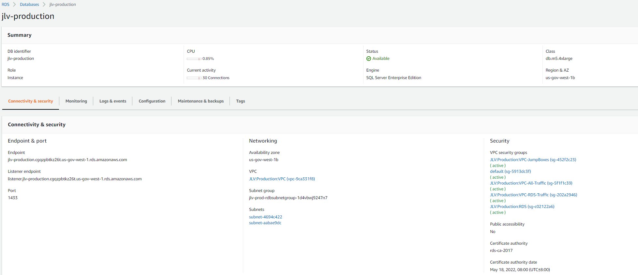Backup Testing

Backups of the Production VAEC DBs are done on the AWS RDS console. Backups are automatically taken daily with a seven-day retention.

#### Storage and Rotation

The RDS database instances use General Purpose Solid-State Drives (SSD) volumes as a cost-effective storage. These volumes deliver single-digit millisecond latencies and the ability to burst to 3,000 IOPS for extended periods of time.

Amazon RDS creates and saves automated backups of the JLV DB instance during the backup window of the DB instance. RDS creates a storage volume snapshot of the JLV DB instance, backing up the entire DB instance, and not just individual databases. RDS saves the automated backups of the DB instance according to the 2-week backup retention period.

The first snapshot of a JLV DB instance contains the data for the full DB instance. Subsequent snapshots of the same DB instance are incremental, which means only the data that has changed after the most recent snapshot is saved.

The JLV team also creates manual DB snapshots monthly, which are not subject to the AWS backup retention period.

## Security/Identity Management

JLV restricts access to the GUI to authorized users within the VA. Users access JLV via a URL.

Users are authenticated through the SSOi system, which allows them to link their Personal Identity Verification (PIV) card to their VistA account using their Access and Verify codes. Once linked, users may log in directly to the Patient Portal, with just their PIV and Personal Identification Number (PIN) and without their Access and Verify codes. When authenticating users with SSOi, JLV attempts to retrieve agency and site profile information from the SSOi system. When enabled, users are authenticated through SSOi (default).

VA users at Cerner Millennium sites are also able to access JLV via SmartLaunch within PowerChart, if the users are authorized to use PowerChart. VA VBA/Benefit’s users are also able to launch JLV via CAPRI using their CAPRI credentials.

JLV requires that VA users provide the following credentials at the Login page:

* **VHA/Clinical Users:** The user’s local existing VistA Access and Verify codes
* **VBA/Benefits Users:** The user’s existing National Claims VistA Access and Verify codes

Access control and authentication takes place before JLV displays any data. The user is authenticated to their host EHR system, granting them access to the presentation layer. jMeadows retrieves the user’s profile information from the JLV DB based on their credentials. The user’s default host location, custom widget layout, and other user data are returned. See Access Control for more information. Table 1 provides a user authentication and login overview.

Table 1: User Authentication and Login Overview

| User | Context Root | Authentication Overview |
| --- | --- | --- |
| VBA/ CAPRI-Claims | /JLV | * The user is prompted to enter their PIV and PIN * CAPRI-Claims users are authenticated through SSOi * If the user's PIV is not linked to Claims (e.g., first time login), the user is prompted to identify their home site and will be asked to provide their Access/Verify login credentials on the Login page * If the user has linked their PIV to their home site (e.g., subsequent logins), JLV validates their credentials against their local VA Claims system |
| VHA | /JLV | * VHA users are authenticated through SSOi using their PIV and PIN * IAM authenticates VHA users and users proceed to the JLV Provider Portal |

### Identity Management

Users with a valid VA PIV card and PIN can access JLV.

### Access Control

JLV access control for VA users consists of IAM validating the user’s PIV card and PIN (SSOi) or if the user provides an invalid PIN or access and verify codes an error message is presented above the Access/Verify code fields on the Login page. Table 2 summarizes the JLV system components and the settings utilized for access control.

Table 2: Access Control Design

| Component | Description |
| --- | --- |
| Configuration settings | A configuration setting within the appconfig-production.properties file that enables access control:   * Enable VA Access Control, On/Off; This setting enables access control for VA users |

## User Notifications

JLV is comprised of hardware and software, interfaces to the dependent partner systems, such as Patient Discovery Web Service (PDWS) and Master Person Index (MPI), as well as other infrastructure necessary to deliver the JLV application. Each of the individual components may undergo scheduled downtime for maintenance on a periodic basis. JLV Support follows a notification process to alert VA stakeholders of pending downtime in advance of each known event.

 **NOTE:** The VHA JLV team is responsible for notifying end users.

### User Notification Points of Contact

Table 3 details the current notification list for alerting for VA stakeholders of JLV scheduled downtime. The list is maintained by JLV Support.

Table 3: JLV Scheduled Downtime Notification List (VA Stakeholders)

| Name | Organization | Email Address |
| --- | --- | --- |
| REDACTED | VA-Government | REDACTED |
| REDACTED | VA-Government | REDACTED |
| REDACTED | VA-Government | REDACTED |
| REDACTED | VA-Government | REDACTED |
| REDACTED | VA-Government | REDACTED |
| REDACTED | VA-Government | REDACTED |
| REDACTED | VA-Government | REDACTED |
| REDACTED | VA-Government | REDACTED |
| REDACTED | VA-Government | REDACTED |
| REDACTED | VA-Government | REDACTED |
| REDACTED | Booz Allen | REDACTED |
| REDACTED | Booz Allen | REDACTED |
| REDACTED | Booz Allen | REDACTED |
| REDACTED | Booz Allen | REDACTED |
| REDACTED | Booz Allen | REDACTED |
| REDACTED | Booz Allen | REDACTED |
| REDACTED | Booz Allen | REDACTED |
| REDACTED | Booz Allen | REDACTED |
| REDACTED | Booz Allen | REDACTED |
| REDACTED | Booz Allen | REDACTED |
| REDACTED | Booz Allen | REDACTED |
| REDACTED | SMS | REDACTED |
| REDACTED | Government CIO | REDACTED |
| REDACTED | Government CIO | REDACTED |

### JLV QoS Mail Groups

**VA:**

* REDACTED
* REDACTED
* REDACTED
* REDACTED
* REDACTED
* REDACTED
* REDACTED
* REDACTED
* REDACTED
* REDACTED
* REDACTED
* REDACTED

**DOD:**

* REDACTED
* REDACTED
* REDACTED
* REDACTED
* REDACTED
* REDACTED
* REDACTED
* REDACTED
* REDACTED
* REDACTED
* REDACTED
* REDACTED
* REDACTED
* REDACTED
* REDACTED

**Booz Allen Team:**

* REDACTED
* REDACTED
* REDACTED
* REDACTED
* REDACTED
* REDACTED
* REDACTED
* REDACTED
* REDACTED
* REDACTED
* REDACTED
* REDACTED
* REDACTED
* REDACTED
* REDACTED
* REDACTED
* REDACTED
* REDACTED
* REDACTED
* REDACTED
* REDACTED
* REDACTED

### Scheduled Downtime Notifications

JLV Support monitors the maintenance schedules of systems that provide notification of planned outages, then communicates the upcoming downtime to VA stakeholders.

 **NOTE:** JLV Support depends on the receipt of timely information from dependent systems and infrastructure. Not all systems and/or infrastructure teams provide downtime notices to JLV Support. Detailed information, such as organization, frequency of planned downtime, and points of contact (POCs), is available in Appendices A, B, and C for each of the dependent systems and other infrastructure.

Figure 3 shows a typical calendar of regularly scheduled downtimes for JLV and external systems. Refer to the detailed list following the calendar mockup for a complete list of planned downtimes.

Figure 3: Mockup of Regularly Scheduled Downtimes

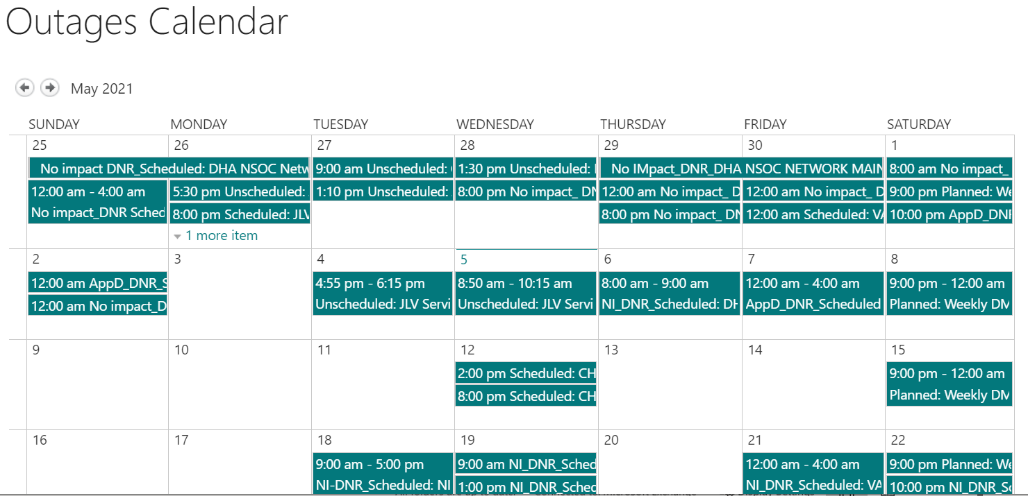

**The following list details the maintenance notices currently known to JLV Support.**

* **MPI (VA and DOD)**
  + Organization: VA
  + Frequency: As needed
  + Time Frame: Varies, typically the 3rd weekend and from 3:00 pm to 9:00 pm
  + Email Subject: VAAFI Data center flip Miami to Culpeper
  + VA POC: [REDACTED], [REDACTED]
  + DOD POC: [REDACTED]
* **VA/DOD Gateway**
  + Organization: Joint DOD/VA
  + Frequency: As needed
  + Time Frame: Varies
  + POC: [REDACTED]
  + Data Exchange Service (DES) (includes data from the Clinical Data Repository [CDR], Composite Health Care System [CHCS], Federal Electronic Health Record [FEHR], and Community Partners):

 **NOTE:** JLV Support does not receive a distribution notice for all DOD downstream data sources (Theater Medical Data Store [TMDS], Essentris, SHARE, Bidirectional Health Information Exchange (BHIE) Framework, Joint Health Information Exchange (HIE)[2], Community Partners)

* + Organization: DOD
  + Frequency: TBD
  + Time Frame: TBD
  + Email Subject: DMIX Integration Alert
  + POC: [REDACTED]
* **Military Health System (MHS) Enterprise Services Operations Center (MESOC) / Defense Information Systems Administration (DISA)**
  + Organization: DOD
  + Frequency: Monthly, 3rd weekend of every month
  + Time Frame: Varies
  + Email Subject: DMIX Integration Alert
  + POC: [REDACTED]
* **PDWS / Defense Manpower Data Center (DMDC)**
  + Organization: DOD
  + Frequency: Weekly (actual downtime plan verified with the PDWS team)
  + Email Subject: DMIX Integration Alert
  + Time Frame: 9:00 pm ET Saturday to 6:00 am ET Sunday
* **CAPRI:** JLV Support does not currently receive a distribution notice
  + Organization: VA
* **VistA:** JLV Support does not currently receive a distribution notice
  + Organization: VA

The JLV Support team actively monitors all relevant systems maintenance schedules, and the team follows the scheduled downtime notification process for JLV code-driven patch releases:

* VA notifies JLV users of pending system downtime, when JLV is unavailable, and when the system is restored
* The JLV Support team notifies the VA stakeholders (see Table 3) when the JLV system is restored to service

The process flow shown in Figure 4 was designed primarily for JLV code-driven patch releases and is used as a guide for scheduled downtime notifications. However, not all steps may apply for JLV downtimes triggered by scheduled maintenance or outages on external components that are outside the control of the JLV application.

Figure 4: Scheduled Downtime Notification Process

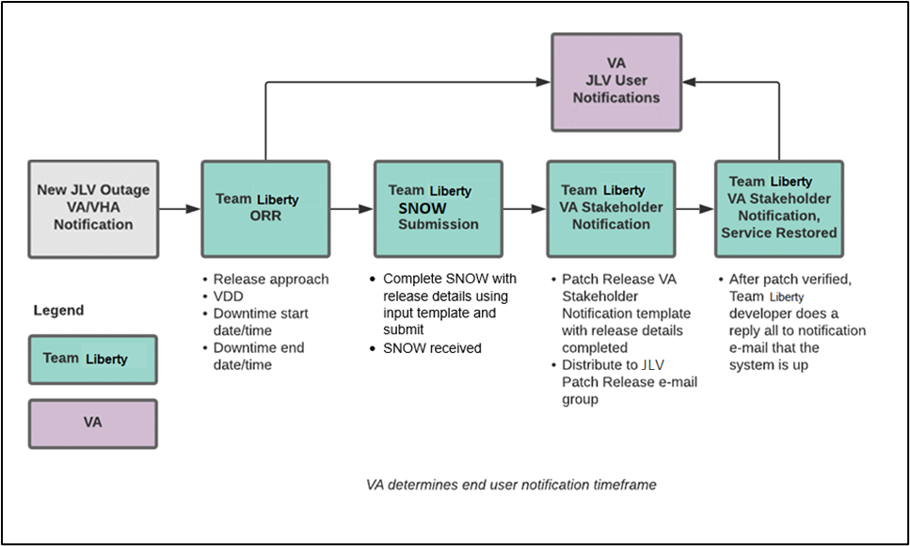

While all JLV scheduled downtime, communications follow a similar format, each is tailored to the specific activity and system/service affected.

#### Service Now (SNOW) Process

2.3.3.1.1. Creating a new Release

Once the team has decided to develop and make available a group of changes as a Release, a team member will enter a new Release into Service Now.

For detailed instructions on how to add a new Release to SNOW, please consult the following work instruction:  [[REDACTED].](https://dvagov.sharepoint.com/sites/OITECRCM/ECM%20Public%20Documents/Forms/AllItems.aspx?id=%2Fsites%2FOITECRCM%2FECM%20Public%20Documents%2FWI%20%2D%20How%20to%20Create%20a%20Release%20Request%2Epdf&parent=%2Fsites%2FOITECRCM%2FECM%20Public%20Documents)

Figure 5: Service Now (SNOW) Process

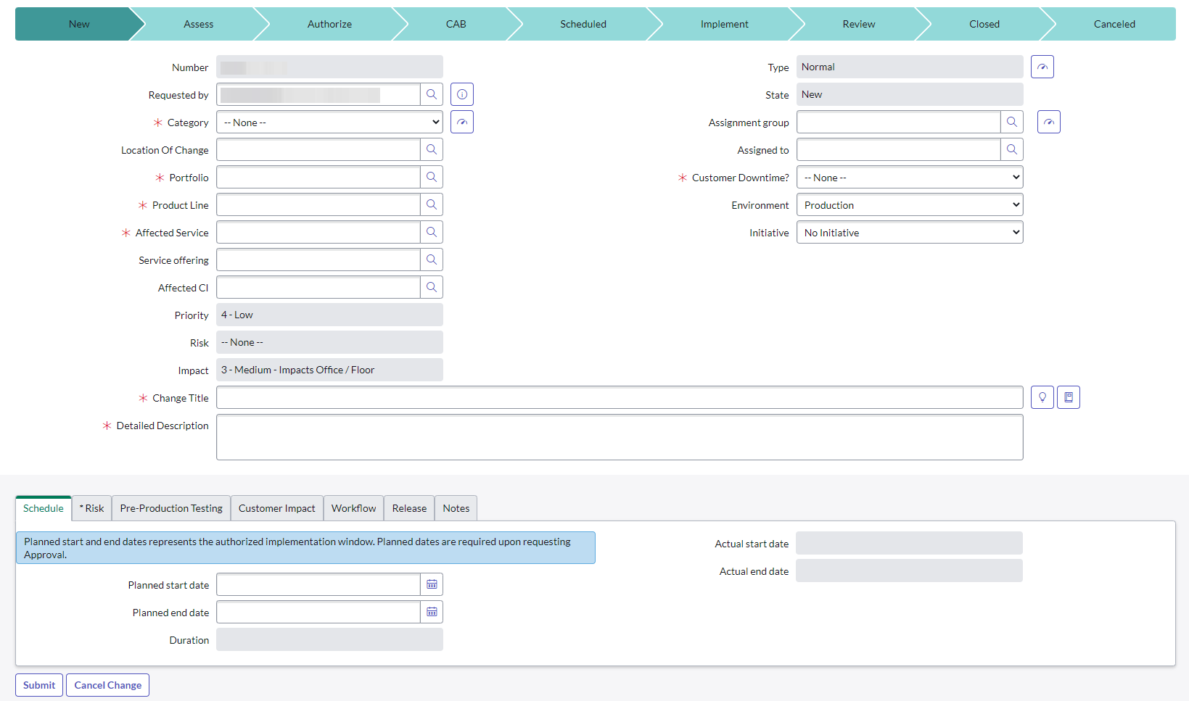

#### Patch Release Notification E-mail (Example)

All,

This is to notify you of the upcoming Production release of the JLV Enterprise Patch x.x.x.x.x.

* The CHG number is **CHGxxxxx**
* The ServiceNow Ticket number is **INCxxxxxxx**
* JLV Enterprise Patch version x.x.x.x.x will be released to DOD and VA Production environments on <Day>, <Month> <Day>, <Year> starting at <Time 24-hour clock> (Time am/pm) ET. Patching is expected to be completed by <Time 24-hour clock> (Time am/pm) ET, <Day>, <Month> <Day>, <Year>. JLV-Enterprise will be unavailable during this time.

### Unscheduled Outage Notifications

#### Initial Response to Issues Within 30 Minutes of Alert

The following steps represent the response to a reported issue, to occur within 30 minutes of the initial alert:

1. If a QoS e-mail is received and errors have **not** been cleared within 30 minutes of receipt of the initial error alert, proceed to Step 2
2. Within 30 minutes of the initial error e-mail, JLV Support (Table 13) sends an e-mail to the JLV stakeholders (Table 3), stating that the Support team is investigating the issue
   1. Using the e-mail example below, tailored to the specific activity and the system(s)/service(s) that are affected

##### Initial Outage Response Notification E-Mail (Example)

Subject: JLV Outage Notification

All,

JLV is currently experiencing an error in the <Environment Name> environment.

The error detail is: <Error from QoS>

This error impacts <service impacted> (choose one from list below)

* PDWS: the users’ ability to perform a patient search
* MPI: the users’ ability to retrieve VA records
* VDS: the users’ ability for VA users to log in and retrieve VA records
* VistA Host: the ability for JLV to retrieve records for the specified host
* BHIE Relay Service (BRS): the users’ ability to retrieve DOD records
* Database: the ability for the application to check the authorized users list, retrieve a user's profile, generate a site list for the log in, and the ability for JLV to log auditing records
* jMeadows: the application’s ability to connect to external sources; users will not be able to log in to JLV until service is restored
* CAPRI: the ability for JLV to authenticate VBA users

Please stand by as we further investigate the error. You will be notified by e-mail as soon as the issue is rectified. If the issue persists longer than 90 minutes from now, you will be notified of the error status and resolution progress in another e-mail.

Thank you.

#### Outage Escalation to External Teams

The following information details the escalation process to external teams in the case of an issue caused by a service outside JLV Support’s purview. A status update is requested within 2 hours of the initial alert.

1. Send an e-mail to the applicable external service group as specified in Table 13
2. Request the status of the issue within 2 hours of the initial alert
   1. Copy JLV Support (Table 13)
   2. Use the e-mail example(s) below, tailored to the specific activity and system(s)/service(s) that are affected

##### Outage Escalation to External Teams E-Mail (Example)

Subject: JLV Service Verification Request

All,

JLV is currently experiencing an error in the <Environment Name> environment.

The error detail is: **<Error from QoS>**

This error impacts <**service impacted> (choose one from list below)**

* PDWS: the users’ ability to perform a patient search
* MPI: the users’ ability to retrieve VA records
* VDS: the VA users’ ability to authenticate and to retrieve VA records
* VistA Host: the ability for JLV to retrieve records for the specified VistA host
* CAPRI: the ability for JLV to authenticate VBA users
* BRS/DES: the users’ ability to retrieve DOD, FEHR, and Community Partner records
* jMeadows: the application’s ability to connect to external sources; users will not be able to log in to JLV until service is restored

JLV Support would like to verify that <application/service> is up, running, and not experiencing any errors.

**Optional:** JLV Support has verified that network connectivity is not the issue. Please verify and respond to JLV Support with your findings.

Thank you for your assistance in troubleshooting this issue.

1. Generate a trouble ticket (VA or DOD) and assign it to the appropriate application team
2. Send a notification to the JLV stakeholders (Table 3) with all pertinent information
   1. Use the e-mail example(s) below, tailored to the specific activity and system(s)/service(s) that are affected

##### Outage Update E-Mail (Example)

Subject ALERT: JLV Service Degradation - (Affected Service) errors - (insert error start time YYYYMMDD 24:00 ET)

All,

JLV is currently experiencing an error in the <Environment Name> environment.

The error detail is: **<Error from QoS>**

* PDWS: the users’ ability to perform a patient search
* MPI: the users’ ability to retrieve VA records
* VDS: the VA users’ ability to authenticate and to retrieve VA records
* VistA Host: the ability for JLV to retrieve records for the specified VistA host
* CAPRI: the ability for JLV to authenticate VBA users
* BRS/DES: the users’ ability to retrieve DOD, FEHR, and Community Partner records
* jMeadows: the application’s ability to connect to external sources; users will not be able to log in to JLV until service is restored

The JLV Engineering team has determined the following:

* Severity: Severity Level ONE
* Impact: <**List impacted users (VA, DOD, or VA and DOD), and state which services are impacted, and the functionality lost>**
* Fault is isolated to: <**Where the error resides (local JLV containers, local JLV DB, network (provide details if possible) or external application>**
* Estimated Time of Service Restoration: <**Estimated time frame of restoration>**
* CHG Number: <**CHG number, only if applicable and approved by VA JLV PM or VHA JLV Team>**
* Ticket Number: <**Ticket number submitted to the VA or DOD service desks, only if issue is with the network or external application>**

The JLV Engineering team will continue to monitor and troubleshoot the issue. Updates will be provided every 2 hours until the issue is resolved.

Thank you.

1. Continue monitoring the issue
2. Provide updates every **2 hours** to the JLV stakeholders (Table 3) until issue is resolved:
   1. Booz Allen Emergency Contact: [REDACTED]
   2. Booz Allen Alternate Contact: [REDACTED]
   3. Booz Allen Alternate Contact: [REDACTED]
   4. Booz Allen Alternate Contact: [REDACTED]

JLV Support Hours: 24x7x365

### Announcement Banners

Announcement banners are provided for the end users’ benefit and information. They appear in the Announcements section of the JLV Login page, and within the JLV application in the form of banners.

The primary goal of announcement banners is to inform end users of important information about their use of JLV. The use of acronyms and IT jargon within announcement banners is minimized to clearly communicate any temporary limitations of JLV.

It is important to note that the system maintenance notices shared among technical groups are different from the application-level announcement banners as they are not appropriate for end users.

Announcement banners are posted no more than 24 hours prior to a planned event and removed immediately upon completion of the planned event.

Announcement banners for an unplanned outage are posted immediately after the confirmation of the outage and are removed immediately upon resolution of the outage.

The following announcement banners are prioritized:

1. Patient Safety
2. Newly discovered defects/issues with broad impact
3. Unplanned outages or unexpected loss of data lasting more than 2 hours that are not already communicated by System Status notifications
4. Planned maintenance/outages with expected impact or disruption
   1. Maintenance events of no or inconsequential impact should not be posted

End users can become desensitized to the important information in announcement banners when too many alerts are posted too often. The plan to minimize alert fatigue is as follows:

1. Display announcement banners by severity
   1. Add a prefix category (Patient Safety, Issue, Outage, Maintenance, etc.) to the announcement banner titles and content to further differentiate context and priority
2. Post only those alerts that impact end users
   1. Informational announcement banners for maintenance events where there is no expected or an inconsequential impact should not be posted
3. Set an expiration date for announcement banners, and remove them as soon as possible after the event has completed or the issue has been corrected

The following groups have the responsibility and authority to enable certain types of announcement banners:

* JLV Project Support Team: Maintenance-related notifications that impact end users
* VHA JLV Team: Notifications regarding patient safety and other critical issues that impact end users

Table 4 lists the announcement banner content for maintenance events with expected user impact and for special events and issues.

Table 4: Announcement Banner Content for Maintenance Events Impacting End Users

| Maintenance Event Titles (50-character limit) | “More” Hyperlink Expanded Content (255-character limit) |
| --- | --- |
| **MAINTENANCE** DOD Patient Identity System-5/17-5/18 More | **Maintenance window:** 05/17/18 9pm ET–05/18/18 12pm ET  **Impact:** JLV will be available for use, but users may experience problems with patient lookups/patient search using DOD EDIPI or issues viewing DOD patient demographics. |
| **MAINTENANCE** VA Patient Identity System -5/17 More | **Maintenance window:** 05/17/18 9pm ET–05/18/18 12pm ET  **Impact:** Users may experience problems with patient search: CPRS via CCOW may display VA data only; DOD EDIPI or recently viewed list may display DOD data only; SSN[3] searches may display no data. |
| **MAINTENANCE** DOD Theater Records System– 5/21-5/22 More | **Maintenance window:** 05/21/18 9pm ET–05/22/18 12pm ET  **Impact:** Records from DOD theater systems may be unavailable. These include records from an area where military events were occurring at the time of care delivery (e.g., wartime). |
| **MAINTENANCE** Community Partner System—6/29 More | **Maintenance window:** 06/29/18 8pm ET–06/29/18 11 pm ET  **Impact:** JLV will be available for use, but the Community Health Summaries & Documents widget may not retrieve records. If you experience this problem, please try again later. |
| **ISSUE** Please Check Federal EHR/MHS GENESIS Widget Date Filter | An error caused Federal EHR/MHS GENESIS widgets added to workspaces before 6/28/18 to display only the past 4 months instead of 1/1/17-present. To correct this, click the funnel-shaped filter icon and manually adjust the dates or close/re-add the widget. |
| **PATIENT SAFETY** Contrast Allergies | JLV is currently not displaying VA allergies for Contrast media entered through the Radiology option “Update Patient Record” [RA PTEDIT]. Until further notice, please use CPRS RDV to check for Contrast allergies from other VA sites. |
| **ISSUE** Imaging not available to Claims/CAPRI users | VA images are not currently being displayed in JLV. The issue is being analyzed and a patch to resolve the issue will be deployed as soon as possible. Please use a standalone Advanced Web Image Viewer (AWIV) for VA imaging access.  **NOTE:** Affects VBA (Claims) Only |
| **OUTAGE** Community Partner Records | VA is currently unable to retrieve records from community partners. Engineers are working to restore connections as quickly as possible. (Add details on anticipated resolution, etc. if available). |

#### Placing Announcement Banners

When there is a major system outage, service degradation, scheduled downtime, or patient safety issue, an announcement banner will be placed on the Login page for the affected environment at the T+30 time frame. The announcement banner placement in any environment is accomplished via the DB associated with that environment.

 **NOTE:** Current functionality does not allow for a specific time frame, like 2:00 pm to 8:00 pm, to be provided. At present, the system only allows for an expiration date, formatted as Month/Day/Year.

An example of the script used to place an announcement banner is as follows:

execute dbo.createNotification

@startDate='10/17/2018'

,@endDate='10/30/2018'

,@announcement='Lab Results'

,@userGroup='ALL'

,@description='Temporarily, some laboratory test results may not appear when a panel test is selected from the Lab Results widget.'

The resulting announcement banner, as viewed on the application Login page, is shown in Figure 6.

Figure 6: User-facing Banner on the JLV Login Page

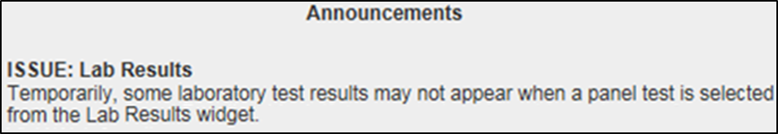

#### Removing Announcement Banners

There are two methods used to remove a banner from the application Login page: manual and automatic expiration.

##### Manual Removal

The manual removal method is used when a system degradation has been resolved or the planned outage has been completed prior to the designated end date.

Manual removal is accomplished by accessing the DB tables and manually changing the end date (shown in red text below) to match the start date associated with the announcement banner to be removed. Database entries demonstrating the announcement banner prior to (Table 5) and after (Table 6) manual removal follow.

Table 5: Database Table Entry Prior to Manual Removal

| Start Date | End Date | Title | Announcement Banner Text |
| --- | --- | --- | --- |
| 2018-10-17 | 2018-10-30 | ISSUE: Lab Results | Temporarily, some laboratory test results may not appear when a panel test is selected from the Lab Results widget. |

Table 6: Database Table Entry After Manual Removal

| Start Date | End Date | Title | Announcement Banner Text |
| --- | --- | --- | --- |
| 2018-10-17 | 2018-10-17 | ISSUE: Lab Results | Temporarily, some laboratory test results may not appear when a panel test is selected from the Lab Results widget. |

##### Automatic Expiration

Automatic expiration of an announcement banner occurs when the designated end date (shown in red text below) of the announcement banner has been reached. Expiration dates are set based on when the issue can be resolved by an authorized member of JLV Support. A DB entry demonstrating a planned maintenance announcement banner is shown in Table 7.

Table 7: Database Table Entry for a Planned Maintenance Announcement Banner

| Start Date | End Date | Title | Announcement Banner Text |
| --- | --- | --- | --- |
| 2018-10-26 | 2018-10-27 | ISSUE: System performance upgrades | System may temporarily be down for system performance upgrades between 8pm ET, 26 October 2018–12am ET, 27 October 2018. |

#### Announcement Banner Extensions

If a service degradation or other event will exceed the planned end date (shown in red text below) of an existing announcement banner, JLV Support can manually extend the duration of the announcement banner by changing the end date (shown in red text below) to a date in the future. Database entries demonstrating the announcement banner prior to (Table 8) and after a date extension (Table 9) follow.

Table 8: Database Table Entry as Initially Posted

| Start Date | End Date | Title | Announcement Banner Text |
| --- | --- | --- | --- |
| 2018-10-26 | 2018-10-27 | ISSUE: System performance upgrades | System may temporarily be down for system performance upgrades between 8pm ET, 26 October 2018–12am ET, 27 October 2018. |

Table 9: Database Table Entry After a Date Extension Update

| Start Date | End Date | Title | Announcement Banner Text |
| --- | --- | --- | --- |
| 2018-10-26 | 2018-10-29 | ISSUE: System performance upgrades | System may temporarily be down for system performance upgrades between 8pm ET, 26 October 2018–12am ET, 29 October 2018. |

## System Monitoring, Reporting, and Tools

JLV traces and audits actions that a user executes within the application. JLV audits are provided through audit trails and audit logs that offer a backend view of system use, in addition to storing user views of patient data. Audit trails and logs record key activities (date and time of event, patient identifiers, user identifiers, type of action, and access location) to show system threads of access and the views of patient records. Refer to Application Error Logs for more information about audit and server logs.

The JLV QoS service monitors the availability of data sources. Refer to Availability Monitoring for more information.

JLV in VAEC will make use of AppDynamics, AWS CloudWatch, and ScienceLogic for monitoring services and health status of the application. AWS CloudTrail is used for auditing and analyzing application behavior analysis.

### Dataflow Diagram

The data retrieval sequence is detailed in the JLV 3.4.0.0 System Design Document (SDD). Once approved, all project documentation is available on the VA JLV Product Repository on GitHub.

### Availability Monitoring

QoS monitors the health of JLV and checks for the availability or disruption of dependent services within the systems in DOD and/or VA environments (Table 10: Services Monitored by QoS).

Table 10: Services Monitored by QoS

| Service | Description |
| --- | --- |
| DMDC PDWS | Patient look up |
| MPI (VA) | Retrieves VA patient ID |
| BRS (DES) | Connects to DES and DOD VLER |
| JLV RDS Instance | MS SQL Server Enterprise DB instance |
| jMeadows Data Service | Connects to MPI, PDWS, DB, BRS, EHRM Service, and Report Builder |
| VDS | VA Log in/Data |
| EHRM Service | Connects to jMeadows, Joint HIE via Fast Healthcare Interoperability Resources (FHIR), and Cerner Millennium via Cerner FHIR Application Programming Interface (API) |

Figure 7: System Status Check Sequence

This figure displays the JLV System Status Check Sequence.

System status checks (Figure 7) are performed as follows:

1. The Health Monitor pings the monitored services every 5 minutes
2. The Health Monitor receives a system status from each monitored service and reports the status of JLV systems to JLV Support via e-mail
3. System status events are written to the QOS_LOGS table within the JLV DB
4. The Health Monitor sends an automated e-mail notification every 6 hours, unless a status change is detected
   1. Detection of a status change immediately triggers an e-mail notification, and the 6-hour timer is reset
   2. The next e-mail is generated after 6 hours if no further system status changes are detected
   3. When all errors are cleared, an e-mail is sent stating that no errors are detected
5. The jMeadows Data Service pings the JLV DB every 2 minutes for status checks
6. The jMeadows Data Service stores the data returned from the JLV DB in an internal cache, the jMeadows Data Service cache
7. When a user accesses the JLV **Login** page, JLV requests and receives system status data from the QoS Health Monitor application
8. During active user sessions, JLV requests system status data from the QoS Health Monitor application every 5 minutes
   1. Current system status is retrieved from the QoS Health Monitor application, which queries the JLV Database, and is sent to the JLV GUI

Figure 8 depicts a system status message displayed on the JLV **Login** page.

Figure 8: System Status Message on the JLV Login Page

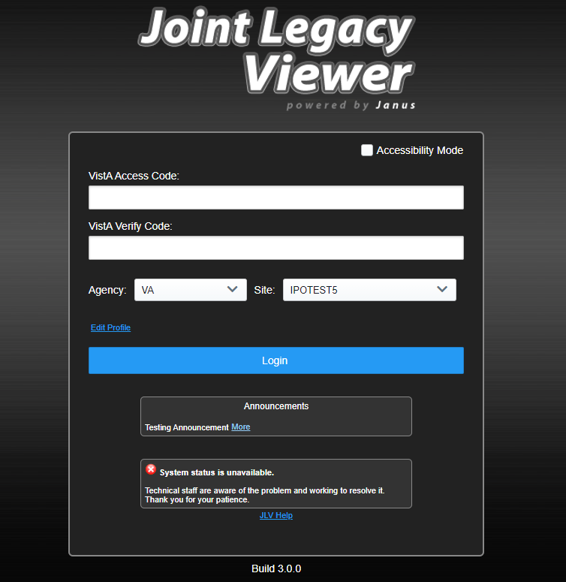

Figure 9 shows a system status icon displayed on the JLV **Toolbar**, which presents only if the system status is yellow or red. If the system does not detect a service connection error, no notice displays.

Figure 9: System Status on the JLV Toolbar

Screenshot of the system status icon on the JLV toolbar.

#### Domain-Level Availability Monitoring

JLV displays interface status icons on the toolbars of multiple widgets to communicate the status of the data source for the widget’s clinical domain. There are two conditions:

* The information icon Image of the information icon, a black circle with a white, lower case i in the center indicates that all sources are available
* The warning icon Image of the warning icon, a yellow triangle with a black exclamation point in the center indicates one or more data sources are unavailable

Both icons are used to provide status for VA, DOD, and community partner data sources. Clicking the status icon opens interface status details in a separate window, as shown in Figure 10.

Figure 10: Connection Status Details

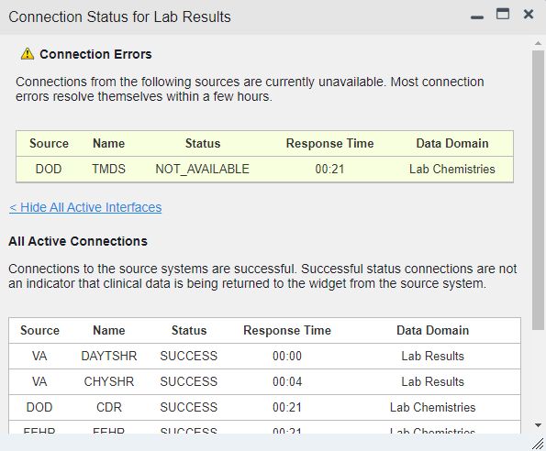

### Performance/Capacity Monitoring

Query times for each web service call in to the Relay Service, jMeadows, EHRM Service, and VDS are recorded to CloudWatch and the VAEC's Central Logging Solution (CLS) logs. AppDynamics is used for monitoring connections and performance.

### Critical Metrics

**VA providers, VHA users, or VBA users accessing a DOD-only patient (i.e., no VA identifiers for a patient):** JLV records each access of Protected Health Information (PHI) through JLV. This includes the identification of the individual whose PHI was accessed, the identification of the user who accessed the information, and identification of the specific PHI accessed.

**User access to sensitive DOD data:** DOD and VA users are audited each time a sensitive DOD record (domains: sensitive notes, outpatient encounters, and labs) is viewed, regardless of how many times the user has previously viewed it, including multiple views in the same user session. When a user opens and closes a sensitive record, then reopens the same record and views it a second time, the user is asked to agree to be audited again.

The following information is captured for each attempt to access DOD sensitive data, whether successful or unsuccessful:

* Organization (i.e., VHA, VBA, DOD)
* Username
* User SSN
* User PIV, if known, for VA users
* User location
* Patient last name, first name, middle initial (MI), SSN, MPI, date of birth (DOB)
* Sensitive data accessed
* Date/time of access
* Reason for access (emergent care, clinical care, or authorized administrative use)

### RDS Production Monitoring and Notification

Monitoring of the JLV Database is available via the AWS Relational Database Service (RDS).

Notifications are created using AWS SNS service which helps in sending email notifictations to the subscribers on these alerts. The AWS SNS uses the topic “JLV-RDS-Prod-Alerts”.

The following metrics and their thresholds are in place to ensure optimal performance of the Production DB:

* RDS_Prod_DBconnectionCount –Number of active connections. This is set for greater than 10000 for 1 datapoint within 3 minutes.
* RDS_Prod_CPUutlization – Alarm triggers when CPU utilizations reaches to 90% for 1 datapoint within 5 minutes.
* RDS_Prod_ReadWriteIOPS – Alarm triggers when the sum of average of read and write IOPS for a given time period reaches above 2900 for 1 datapoint within 3 minutes.
* RDS_Prod_ReadWriteThroughput – Alarm triggers when the sum of average of read and write throughput for a given time period reaches above 250M for 2 datapoints within 3 minutes of each other.

## Routine Updates, Extracts, and Purges

### Routine Updates

Patches and other routine updates follow the JLV patching process, shown in Figure 11.

Figure 11: Patching Process for VA and DOD Components

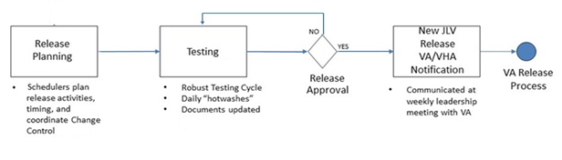

### Extracts

Extracts of the JLV audit logs and server logs are available by request only, on an as-needed basis. The VA Project Manager (PM) must approve requests for extracts. Approvals are dependent on the type of request and the organization of the requester. Once a request is approved, an authorized system administrator extracts the requested data and sends it to the requestor via an encrypted method. Refer to Application Error Logs for more information on audit and server logs.

### Purges

Neither data nor audit log entries, from the JLV DB or other system components, are purged.

## Scheduled Maintenance

Scheduled downtime typically occurs after 08:00 pm ET, and service is restored by 8:00 am ET. Any planned downtimes, (within VA control), outside of these hours requires justification and approval by the VHA JLV Team and the Office of Information and Technology (OIT) PM.

Figure 12 depicts the JLV process for monitoring, analyzing, and initiating the notification for an outage.



Figure 12: Scheduled Downtime and Unscheduled Outage Overview

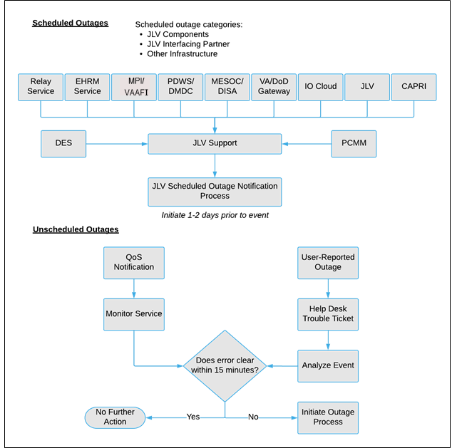

## Unscheduled Outage Triage Process

An unscheduled outage typically occurs when there is a major, unexpected Production issue. As such, the processes in the following sections are triggered (i.e., when the entire JLV application is down and/or a significant number of end users are impacted).

 **NOTE:** The QoS tool is the primary means of monitoring the JLV application. The processes described in the following sections are specific to the QoS tool and its related incident responses. The VHA JLV team is responsible for notifying end users.

### Outage Triage Timeline

The JLV outage triage process is executed by JLV Support in coordination with the VA JLV interface systems teams (e.g., MPI), as necessary.

The following steps represent routine system monitoring:

1. Monitor e-mail to see if the JLV application corrects itself
   1. Wait 15 minutes to see if a QoS e-mail arrives indicating that there are no errors (e.g., *Cloud—JLVQoS Report: NO ERRORS DETECTED)*
   2. Check junk e-mail folder for QoS alerts
2. If a QoS e-mail is received indicating “*NO ERRORS DETECTED,”* the system is connected and executing properly

Figure 13: Outage Event Activities and Timeline

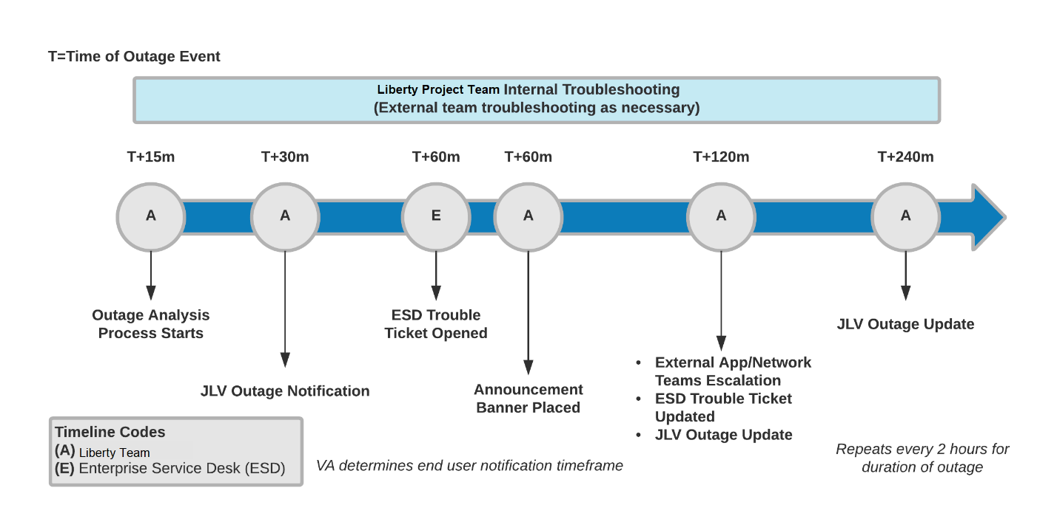

### Escalation

The escalation process typically follows this progression:

1. The problem is reported
   1. QoS reports a problem that remains unresolved for over 30 minutes (See Availability Monitoring)

**-OR-**

* 1. A JLV user calls the ESD and opens a trouble ticket

 **NOTE:** There are instances when the user may bypass the ESD and go directly to the VA PM or other program contact. Should this occur, direct the user to the ESD to complete an official trouble ticket.

1. JLV Support analyzes the problem and determines whether to initiate the triage process
2. Once the triage process is initiated, JLV Support follows the analysis and notification timeline and escalation (as necessary) processes, and includes external systems teams (Figure 13)

 **NOTE:** Discoveries made regarding the root cause of an issue and the service restoration time frame are communicated via e-mail to the stakeholders as soon as they come to light.

### Issue Resolution and After Action

The following steps are taken after the issue is resolved:

1. After the issue is resolved, determine if the root cause was *internal* to the JLV application
   1. If the problem was with an *external system/service*, obtain the root cause from the applicable team (Table 13)
2. Send an e-mail to the JLV stakeholders (Table 3) stating that JLV is back online and available for use
   1. Include the root cause of the issue and details of the fix required to resolve the issue, if available

## Capacity Planning

JLV does not have any configuration settings that limit the amount of concurrent user sessions. Instead, JLV will scale up and down automatically to accommodate user load. Concurrent user sessions are defined as all JLV users who are logged into the JLV application and active at a given time. JLV uses auto-scaling and automatic failover techniques. Data collected from AWS CloudWatch will help inform the team of the potential need for capacity adjustments.

Additionally, JLV monitors the application performance, user onboarding, and user behaviors on a weekly basis. Container resources and JLV application data are collected by the enterprise monitoring group, using the AppDynamics monitoring tool, Computer Associates Application Performance Management (CA APM). CA APM monitors and stores data and sends alerts to notify members of an e-mail distribution group when any metric exceeds its upper or lower boundary.

### Initial Capacity Plan

Processing capacity forecasts and workload modeling are conducted in an ad hoc manner. These forecasts are used to project server capacity based on Production data, JLV requirements, and JLV application changes planned for future releases. AWS provides the capability for automatically scaling (autoscaling) to adjust to changing capacity needs.

# Exception Handling

Like most systems, JLV may generate a small set of errors that may be considered routine, in the sense that they have minimal impact on users and do not compromise the operational state of the system. Most errors are transient in nature and are resolved by the user trying to execute an operation again. The following subsections describe these errors, their causes, and what, if any, response an operator should take.

## Routine Errors

While the occasional occurrence of errors may be routine, encountering many individual errors over a short period of time is an indication of a more serious problem. In that case, the error must be treated as a significant error. Refer to Significant Errors for more information.

### Security Errors

One possible security error an end user may encounter is an invalid login error. Causes of such an error include the user attempting to access JLV before they are authorized to do so (Access denied. You are not an authorized user.) or mistyping their Access and/or Verify code (Invalid Access/Verify Codes). A user’s login credentials will be locked by the VistA service to which JLV connects after five incorrect login attempts (Device/Internet Protocol (IP) address is locked due to too many invalid sign-on attempts.). If this occurs, the user contacts the ESD and opens a service request ticket. The user’s local VistA administrator can unlock their account.

### Timeouts

Each subsection describes a possible timeout error.

#### Application Timeout

JLV has a timeout feature that is set to 60 minutes of inactivity. If users leave the JLV application idle for 55 minutes, they receive the Session Timeout Notification (Figure 14). If the user would like to extend the session, they can click the OK button to continue using JLV.

Figure 14: Session Timeout Notification

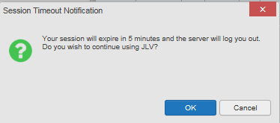

If the user does not interact with the Session Timeout Notification message within the 60-minute time limit, the JLV session times out (Figure 15). The user must then close the browser, reopen the browser, and log back in to JLV.

Figure 15: Session Timeout (SSOi)

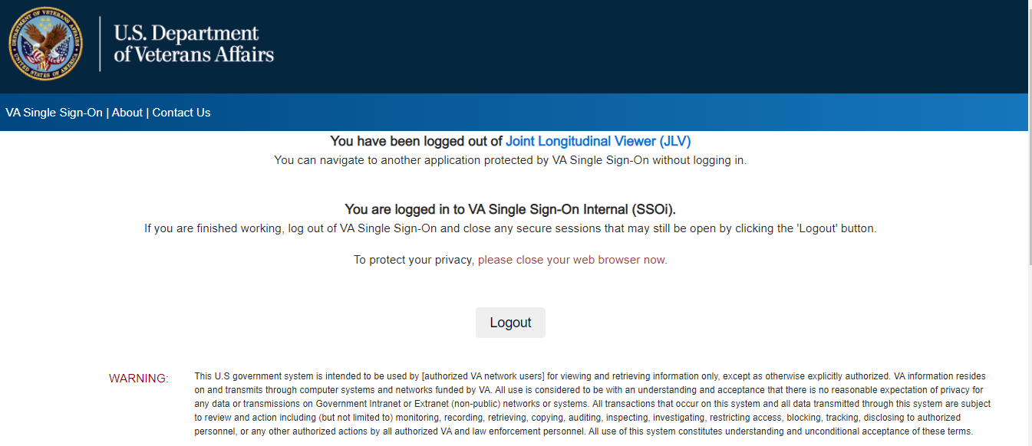

#### Connection Errors

If users encounter a web browser timeout error or the browser displays, “This page can’t be displayed,” when accessing the correct URL, it indicates that JLV application services are either not running or there is a network outage.

In the event the JLV team needs “break-glass” access to a container (i.e., verify Tomcat is running or debug high-severity issues encountered), they can leverage AWS Systems Manager to create a secure channel between the JLV AWS CLI instance and the target container to initiate exec command.

JLV may also report timeouts to external systems within widgets by displaying a message that one or more data sources could not be connected (Figure 16).

Figure 16: Connection Error

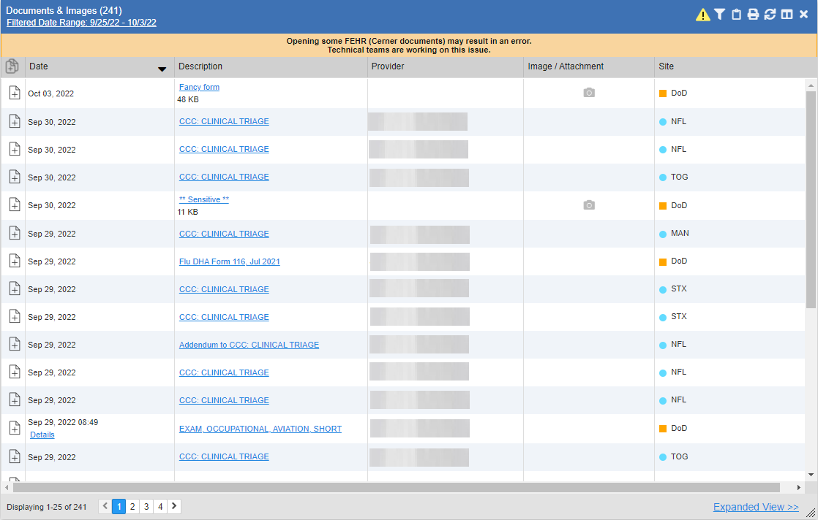

 **NOTE:** Connection errors that persist for more than 5 minutes must be investigated by Tier 3 support.

### Concurrency

Resolution of concurrent EHR access is handled by the underlying system of record that is being queried. The JLV Engineering team optimizes the stored procedures for user profiles in the DB to avoid concurrency contention, based on application and system metrics, degradation, and user load. Remediation depends on the identified root cause.

## Significant Errors

Significant errors are defined as errors or conditions that affect system stability, availability, performance, or otherwise make the system unavailable to its user base. The following subsections contain information to aid administrators, operators, and other support personnel in the resolution of significant errors, conditions, or other issues.

### Application Error Logs

jMeadows retains user actions within JLV. Specific events regarding user transactions are also audited (captured in log files), including but not limited to user identification, date and time of the event, type of event, success or failure of the event, successful logins, and the identity of the information system component where the event occurred.

Each time an attempt is made to interface with jMeadows, whether it is a service communication or a user searching for a patient, the activity is logged and stored in the JLV DB. The purpose of retention is for traceability; specifically, to show what calls/actions were made, where, by whom, and when they terminated. Each query for data is audited and each has the user ID linked to it. Only one audit log is produced that contains both VA and DOD user IDs and usernames.

Query times for each web service call in to the Relay Service, jMeadows, and VDS are recorded in CloudWatch and the VAEC's Central Logging Solution (CLS).

Table 11: Response Time Log Location

| Data Service | Log File CloudWatch Location |
| --- | --- |
| jMeadows Data Service | [REDACTED] |
| Relay Service | [REDACTED] |
| VDS | [REDACTED] |

Figure 17: jMeadows Log Output

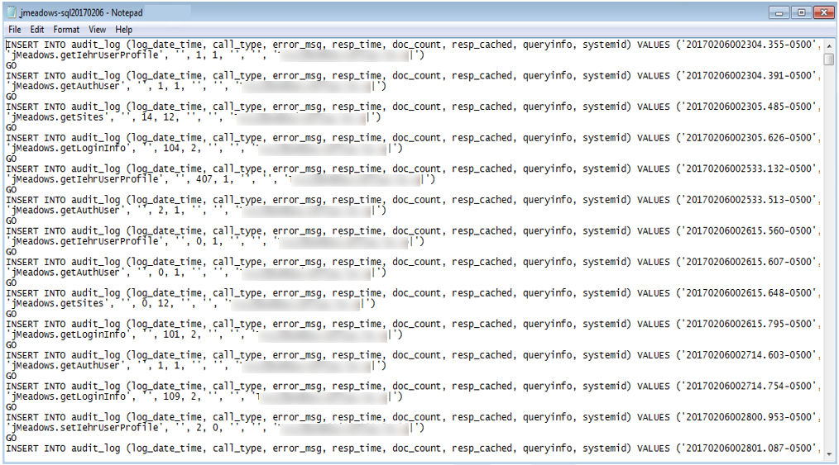

The QoS service deployed with JLV monitors the availability of the services that connect to JLV data sources and other outside systems. Connection errors within the JLV environment are written to the QOS_LOGS table within the JLV DB and are displayed in JLV.

Service interruptions detected by the QoS service are reported to JLV Support via e‑mail. An automated e-mail notification is sent every 6 hours, unless a status change is detected. Detection of a status change immediately triggers an e-mail notification, and the 6-hour timer is reset. The next e-mail is generated after 6 hours if no further system status changes are detected. The QoS service does not send service interruption notices to external systems or services.

For detailed information on service interruption notifications and sample e-mail messages, please see the system design specifications and diagrams that can be found in the VA JLV Product Repository on GitHub.

### Application Error Codes and Descriptions

The JLV Support team utilizes system notifications generated from the QoS service to diagnose service interruptions and troubleshoot potential issues.

Standard SQL Server, Tomcat, Apache httpd, Java, and Hypertext Markup Language (HTML) error codes—generated by the system and recorded in the application logs—are used to identify, triage, and resolve complex issues that may arise during system operation.

### Services Infrastructure Errors

#### DB

The JLV DB is a relational DB used to store user profile information and audit data. It also stores VA and DOD terminology mappings (both local terminology and national standards). The DB does NOT store, neither long term nor temporarily, patient or provider EHRs from VA, DOD, or community partner data through the Joint HIE.

The JLV DB is an Amazon-managed RDS instance running Microsoft SQL Enterprise Edition 14.00.3049.1.v1.

(Figure 18). Only the JLV application and components of the JLV system, including the jMeadows Data Service, connect to and utilize the JLV DB.

Figure 18: JLV Architecture and Components[4]

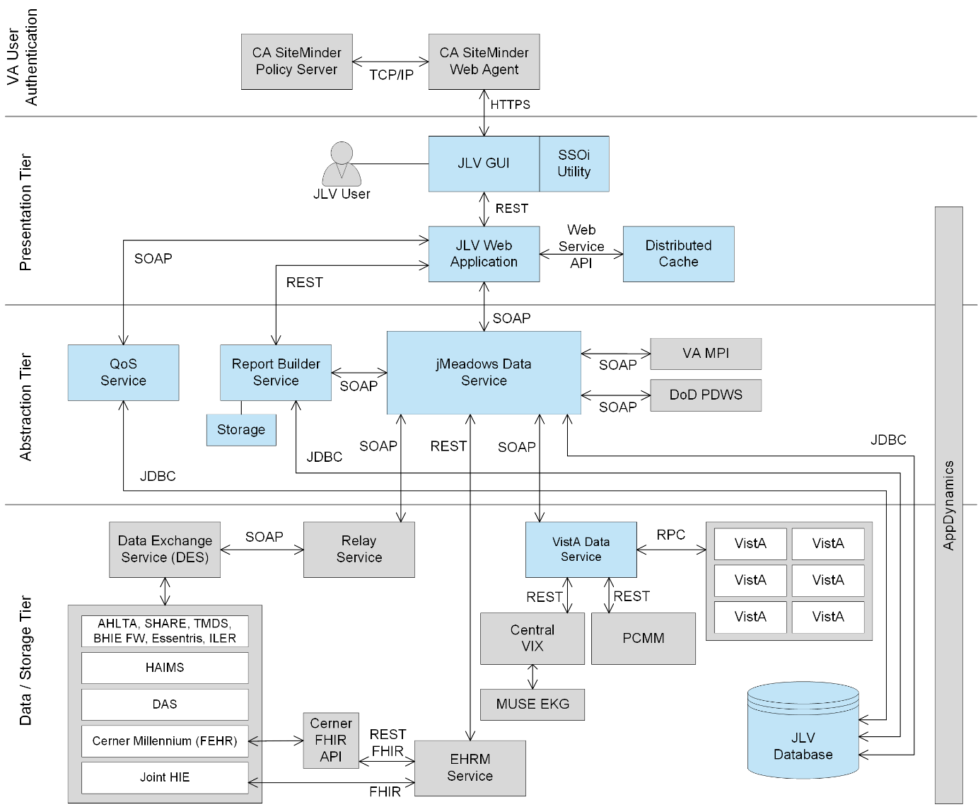

For detailed information about errors and events for the SQL Server DB Engine, please see the website [REDACTED].

The JLV DB has a table to audit user actions within the application within the AUDIT DB table. This table collects system usage data and provides the JLV Support team the ability to create reports and extract pertinent information from the DB, as needed. A sample of the Audit log can be seen in Figure 19.

Figure 19: Audit Log

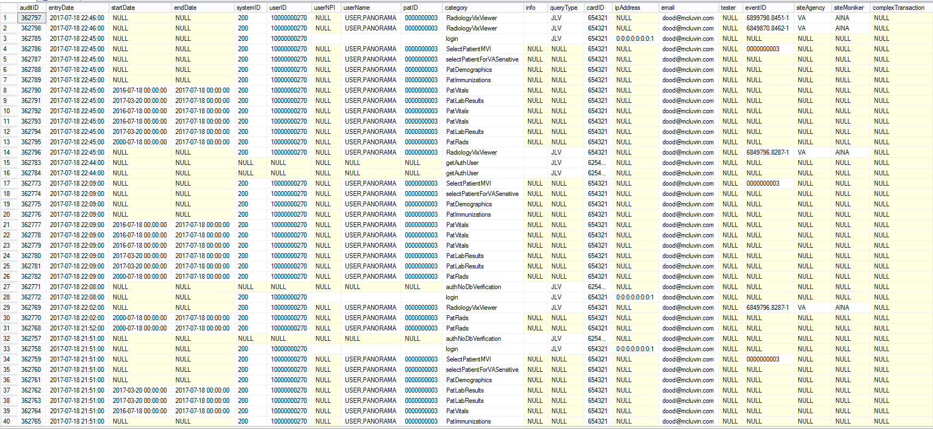

#### Web Server

JLV uses Apache Tomcat as its web server in the VA environment. JLV does not implement any custom Tomcat error handling or reporting. Please refer to the [REDACTED][5] for more information.

#### Application Server

JLV uses Apache Tomcat as its application server in the VA environment. JLV does not implement any custom Tomcat for error handling or reporting. Please refer to the [Apache](https://docs.oracle.com/middleware/11119/wls/WLMCT/RMI.html) Tomcat Troubleshooting and Diagnostics guide for more information. See Web Server for the link to the resource.

#### Network

JLV utilizes the network infrastructure provided by VAEC. Any network errors that arise are corrected by the VAEC team.

#### Authentication and Authorization (A&A)

Users must provide their PIV and PIN to log in via SSOi. If credentials are not found the message, “*Not a valid Access Code/Verify Code pair*” displays.

A&A error messages are:

* Smart Card Required: The user has not inserted their PIV card into the card reader
* ActivClient: The user’s PIV PIN was entered incorrectly
* Missing Code: The user has not entered their Access/Verify code(s)
* Invalid Access Code: The user has entered an incorrect Access/Verify code

A detailed overview of the login process from the user’s perspective is provided in the JLV 3.4User Guide. Once approved, all project documentation is available on the VA JLV Product Repository on GitHub. Refer to Security/Identity Management for detailed information.

#### Logical and Physical Descriptions

System design specifications and diagrams can be found in the VA JLV Product Repository on GitHub.

## Dependent System(s) and Services

Table 12: JLV Dependent Systems and Services lists the other VA systems upon which JLV depends. It also includes the errors related to each dependent system and remedies available to system administrators. Tier 3 system engineers follow a triage process to determine the root cause of the error and coordinate with the Point of Contact (POC) for the external systems, as needed.

Table 12: JLV Dependent Systems and Services

| Other VA System | Related Error(s) |
| --- | --- |
| BRS | **DOD, Federal EHR, and Community Partner data in widgets is currently unavailable**. The source connection is down and DOD, Cerner, and community partner records of all types from all sites may not display. |
| Cerner FHIR API | **Federal EHR (Cerner) is currently unavailable.** The source connection is down, and some Federal EHR data may not display. |
| CVIX | If the CVIX service is not available, a message states, “There was an issue retrieving the CVIX URL.” |
| EHRM Service | If the EHRM Service is unavailable, the user's ability to retrieve data through the JLV FHIR for clinical data residing in the CERNER systems will be degraded. |
|  |  |
| MPI | The JLV QoS Service monitors MPI availability. When MPI is unavailable, the message, “MPI Service may be offline or unavailable,” is shown in System Status. Refer to Domain-Level Availability Monitoring. |
| Patient Centered Management Module (PCMM) | If PCMM is unavailable, JLV displays the error message: “**The connection to PCMM is unavailable.** The patient’s assigned clinical teams may not display.” |
| Site VistA instances | VistA connection errors are reported through interface status notifications for each clinical domain. Refer to Domain-Level Availability Monitoring. |
| SSOi | If this service is enabled and the SSOi Policy Server is not available, VA users cannot gain access to JLV. |

## Troubleshooting

Tier 1 troubleshooting contact information can be found in CA SNow by searching for JLV in the **Knowledge** tab. Tier 1 troubleshooting support is handled through the ESD at 855-673-4357. Refer to Table 13 for additional contact information.

Tier 2 issues are handled by Health Product Support (HPS).

Tier 3 support and troubleshooting is handled directly by JLV Support.

## System Recovery

The following subsections define the processes and procedures necessary to restore the system to a fully operational state after a service interruption. Each of the subsections starts at a specific system state and ends with a fully operational system.

### Restart After an Unscheduled System Interruption

The simplest way to bring the system back to normal operations is to redeploy all containers for all JLV tiers. See System Startup from Emergency Shutdown for guidance.

### Restart after DB Restore

Refer to System Startup for the system startup procedures.

### Backout Procedures

Backout procedures vary depending on the specific release. Please see the JLV *Deployment, Installation, Backout, and Rollback* Guide(DIBRG) specific to the version to be backed out for more information. Once approved, all project documentation is available on the VA JLV Product Repository on GitHub.

### Rollback Procedures

Rollback procedures are dependent on each specific release. Please see the JLV DIBRG specific to the version to be rolled back for more information. Once approved, all project documentation is available on the VA JLV Product Repository on GitHub.

# Operations and Maintenance Responsibilities

Operations and maintenance roles and responsibilities for JLV are summarized in Table 13.

Table 13: Operations and Maintenance Responsibility Matrix

| Name/Organization | Role/Responsibility | Phone Number | E-mail Address |
| --- | --- | --- | --- |
| VA ESD | Tier 1 support for VA Users | [REDACTED] | [REDACTED] |
| DOD MHS Service Desk | Tier 1 support for DOD Users | [REDACTED] | [REDACTED] |
| **VA JLV Project Office** | **VA OIT and VHA Stakeholders** |  |  |
| [REDACTED] | JLV PgM | [REDACTED] | [REDACTED] |
| [REDACTED] | Program Specialist | [REDACTED] | [REDACTED] |
| [REDACTED] | Senior JLV Analyst | [REDACTED] | [REDACTED] |
| [REDACTED] | Program Analyst | [REDACTED] | [REDACTED] |
| [REDACTED] | Senior Clinical Subject Matter Expert |  | [REDACTED] |
| [REDACTED] | CLIN 3 |  | [REDACTED] |
| **DOD JLV Project Office** | **DMIX Stakeholders** |  |  |
| [REDACTED] |  | [REDACTED] | [REDACTED] |
| [REDACTED] | DOD JLV PM | [REDACTED] | [REDACTED] |
| **Booz Allen Team** | **JLV Support** |  |  |
| [REDACTED] | Contract Program Manager (PgM) | [REDACTED] | [REDACTED] |
| [REDACTED] | Contract PM | [REDACTED] | [REDACTED] |
| [REDACTED] | JLV Product Owner | [REDACTED] | [REDACTED] |
| [REDACTED] | JLV Operations Lead | [REDACTED] | [REDACTED] |
| [REDACTED] | JLV DevOps Lead | [REDACTED] | [REDACTED] |
| [REDACTED] | JLV Cloud Lead | [REDACTED] | [REDACTED] |
| [REDACTED] | JLV DevOps | [REDACTED] | [REDACTED] |
| [REDACTED] | JLV DevOps | [REDACTED] | [REDACTED] |
| **DMDC** | **PDWS Technical Issues and Support Contacts** | [REDACTED] |  |
| [REDACTED] |  | [REDACTED] | [REDACTED] |
| [REDACTED] |  | [REDACTED] | [REDACTED] |
| [REDACTED] |  | [REDACTED] | [REDACTED] |
| [REDACTED] |  | [REDACTED] | [REDACTED] |
| **DES** | **DOD Adapter Technical Issues and Support Contacts** |  |  |
| [REDACTED] |  | [REDACTED] | [REDACTED] |
| [REDACTED] |  | [REDACTED] | [REDACTED] |
| [REDACTED] |  | [REDACTED] | [REDACTED] |
| **DOD DISA** | **Technical Issues and Support Contacts** |  |  |
| [REDACTED] |  | [REDACTED] | [REDACTED] |
| [REDACTED] |  | [REDACTED] | [REDACTED] |
| **MPI (VA)** | **Technical Issues/ Support Contacts** | **N/A** | For MPI, contact the Enterprise Service Desk or open a Service Now incident: [REDACTED] (Select: Ask for IT Help). |
| [REDACTED] | Lead Developer/ Architect | [REDACTED] | [REDACTED] |
| [REDACTED] | MPI point of contact | [REDACTED] | [REDACTED] |
| [REDACTED] | MPI point of contact | [REDACTED] | [REDACTED] |
| [REDACTED] |  | [REDACTED] | [REDACTED] |
| [REDACTED] | VistA Imaging |  | [REDACTED] |
| **VA Network—NSOC** | **Technical Issues/Support Contacts** | [REDACTED] | **In VA Remedy:** **VA NSOC Business Partner Extranet (BPE) Operations**  **-OR-**  **Network Support Center (NSC) BPE Operations** [REDACTED] |
| [REDACTED] | Triple-I/VA-NSOC | [REDACTED] | [REDACTED] |
| **DOD Network Space & Naval Warfare Systems (SPAWAR) Virtual Private Network (VPN)** | **Technical Issues and Support Contacts** |  | **In VA Remedy: SPAWARVPN** |
| [REDACTED] |  |  | [REDACTED] |
| **DOD NSOC** | **Technical Issues and Support Contacts** | [REDACTED] |  |
| [REDACTED] |  |  | [REDACTED] |

1. Approval Signatures

Signed:_______________________________________________________________________

[REDACTED], Project Manager/Receiving Organization

Signed:_______________________________________________________________________

[REDACTED], Product Owner

1. Acronyms and Abbreviations

Table 14 lists the acronyms and abbreviations used throughout this document and their descriptions.

Table 14: Acronyms and Abbreviations

| Acronym | Description |
| --- | --- |
| A&A | Authentication and Authorization |
| AD | Active Directory |
| API | Application Program Interface |
| APM | Application Performance Management |
| AWIV | Advanced Web Image Viewer |
| AWS | Amazon Web Services |
| BHIE Relay Service (BRS) | Bidirectional Health Information Exchange |
| BPE | Business Partner Extranet |
| BRS | BHIE Relay Service |
| CA | Computer Associates |
| CAC | Common Access Card |
| CAPRI | Compensation and Pension Records Interchange |
| CCOW | Clinical Context Management Specification |
| CDR | Clinical Data Repository |
| CHCS | Composite Health Care System |
| CLI | Command Line interface |
| CLS | Central Logging Solution (VAEC) |
| CHG | Change Order |
| CPRS | Computerized Patient Record System |
| CVIX | Central VistA Imaging Exchange |
| DAS | Data Access Service |
| DB | Database |
| DES | Data Exchange Service |
| DIBRG | Deployment, Installation, Backout, and Rollback Guide |
| DISA | Defense Information Systems Administration |
| DMDC | Defense Manpower Data Center |
| DMIX | Defense Medical Information Exchange |
| DOB | Date of Birth |
| DOD | Department of Defense |
| ECR | Elastic Container Registry |
| ECS | Elastic Container Service |
| EDIPI | Electronic Data Interchange Personal Identifier |
| EHR | Electronic Health Record |
| EHRM | Electronic Health Records Modernization |
| ESD | Enterprise Service Desk |
| FEHR | Federal Electronic Health Record |
| FHIR | Fast Healthcare Interoperability Resources |
| FIPS | Federal Information Processing Standard |
| FISMA | Federal Information Security Modernization Act |
| GitHub | GitHub is a web-based hosting service for software development projects that us the Git revision control system |
| GUI | Graphical User Interface |
| GTM | Global Traffic Manager |
| HAIMS | Healthcare Artifact and Image Management Solution |
| HIE | Health Information Exchange |
| HIPAA | Health Insurance Portability and Accountability Act of 1996 |
| HITECH | Health Information Technology for Economic and Clinical Health |
| HPS | Health Product Support |
| HTML | Hypertext Markup Language |
| HTTPD | Apache HyperText Transfer Protocol (HTTP) |
| HTTPS | HyperText Transfer Protocol Secure |
| ICAM | Identity, Credential, and Access Management |
| IAM | Identity and Access Management |
| ID | Identification |
| IP | Internet Protocol |
| ISO | Information Security Officer |
| IT | Information Technology |
| JDBC | Java Database Connectivity |
| Joint HIE, JHIE | Joint Health Information Exchange |
| JLV | Joint Longitudinal Viewer |
| LDAP | Lightweight Directory Access Protocol |
| MedCOI | Medical Community of Interest |
| MESOC | MHS Enterprise Services Operations Center |
| MHS | Military Health System |
| MI | Middle Initial |
| MS | Microsoft |
| MS SQL | Microsoft Structured Query Language |
| MPI | Master Person Index |
| NSC | Network Support Center |
| NSOC | Network Security Operations Center |
| OIT | Office of Information Technology |
| ORR | Outage Readiness Review |
| OS | Operating System |
| PAAS | Platform as a service |
| PCMM | Patient Centered Management Module |
| PDWS | Patient Discovery Web Service |
| PHI | Protected Health Information |
| PIN | Personal Identification Number |
| PIV | Personal Identity Verification |
| PM | Project Manager |
| POC | Point of Contact |
| POM | Production Operations Manual |
| QoS | Quality of Service |
| RDS | Amazon Relational Database Service |
| REST | Representational State Transfer |
| RPC | Remote Procedure Call |
| SAS | Statement on Auditing Standards-70 |
| SDD | System Design Document |
| SNOW | Service Now |
| SOAP | Simple Object Access Protocol |
| SPAWAR | Space and Naval Warfare Systems |
| SQL | MS Structured Query Language |
| SSD | Solid-State Drives |
| SSMS | SQL Server Management Studio |
| SSN | Social Security Number |
| SSOi | Single Sign on Internal |
| TBD | To be determined |
| TCP | Transmission Control Protocol |
| TMDS | Theater Medical Data Store |
| URL | Universal Resource Locator |
| VA | Department of Veterans Affairs |
| VAAFI | VA Authentication Federation Infrastructure |
| VAEC | VA Enterprise Cloud |
| VBA | Veterans Benefits Administration |
| VDD | Version |
| VDS | VistA Data Service |
| VHA | Veterans Health Administration |
| VistA | Veterans Information Systems and Technology Architecture |
| VM | Virtual Machine |
| VPS, VPC’s | Virtual Private Cloud(s) |
| VPN | Virtual Private Network |

1. **NOTE:** Access to the VA JLV Product Repository on GitHub is restricted and must be requested.
2. DES to Joint HIE switch is a configuration change and requires a redeployment
3. Social Security Number (SSN)
4. Active Directory (AD), Computer Associates (CA), Central VistA Imaging Exchange (CVIX), Data Access Service (DAS), Enterprise Common Access Card (CAC) Electronic Health Record Modernization (EHRM), Healthcare Artifact and Image Management Solution (HAIMS), HyperText Transfer Protocol Secure (HTTPS), Java DB Connectivity (JDBC), Lightweight Directory Access Protocol (LDAP), Military Health System (MHS), Remote Procedure Calls (RPCs), Representational State Transfer (REST), Simple Object Access Protocol (SOAP), Transmission Control Protocol (TCP)
5. [REDACTED]