Joint Longitudinal Viewer (JLV) 3.5.0.0

User Guide
July 2023
Version 1.0
Department of Veterans Affairs
Office of Information and Technology (OIT)

Revision History
Date | Version | Document | Author
07/21/2023 | 1.0 | Submitting the document for approval | Booz Allen Hamilton
07/20/2023 | 0.2 | Comments addressed | Booz Allen Hamilton
07/10/2023 | 0.1 | Initial draft of document from last approved | Booz Allen Hamilton

Artifact Rationale
Per the Veteran-focused Integrated Process (VIP) Guide, the user guide is required to be completed prior to Critical Decision Point #2 (CD2), with the expectation that it is updated as needed. A user guide is a technical communication document intended to give assistance to people using a system, such as Veterans Health Information Systems and Technology Architecture (VistA) end users. It is usually written by a technical writer, although it can also be written by programmers, product or project managers, or other technical staff. Most user guides contain both a written guide and the associated images. It is usual to include screenshots of the human-machine interfaces, and hardware manuals often include clear, simplified diagrams. The language used is matched to the intended audience, with jargon kept to a minimum or explained thoroughly. The user guide is a mandatory, build-level document, and should be updated to reflect the contents of the most recently deployed build. The sections documented herein are required if applicable to your product.
Table of Contents
1. Introduction 1
1.1. Purpose of the Guide 1
1.1.1. Guide Conventions 2
1.1.2. Terminology 2
1.2. Assumptions 2
1.3. System Requirements 2
1.4. Getting Help 2
2. Logging Into JLV 3
2.1. VHA User Login 3
2.1.1. Link Your PIV Card and VistA Account 5
2.2. CAPRI-Claims User Login 6
2.2.1. Editing Your User Profile at Login 9
2.3. Logging Out of the Current JLV Session 10
3. The Elements and Functionality of JLV 10
3.1. The Patient Data and Widgets Page 10
3.1.1. Default View 10
3.1.2. System Menu 11
3.1.3. Viewing System Status 12
3.1.4. Patient Context Management 14
3.1.4.1. Suspending Context 15
3.1.4.2. Establishing Context 15
3.1.4.3. Unable to Communicate with Vault 16
3.1.4.4. Context Synchronization Failure 16
3.2. Customizing JLV 17
3.2.1. About Data Display Settings 19
3.2.2. About UI Themes 20
3.2.3. Using the Accessible Theme’s Functionality 23
3.2.3.1. Keyboard Focus and Navigation 23
3.2.3.2. Accessible Theme Navigation 25
3.2.3.3. Table Functionality 26
3.2.3.4. Widget Move 27
3.2.3.5. Widget Resize 28
3.3. User-Restricted Access to Patient Data 29
3.3.1. VHA Users Viewing DOD-only Patient Data 29
3.3.2. CAPRI-Claims Users Viewing Patients with DOD Data 30
3.3.2.1. Patient Registered in MPI 30
3.3.2.2. Patient Not Registered in MPI 30
3.3.3. Access to DOD Sensitive Records 31
3.4. Patient Searches 32
3.4.1. PDWS Search Rules and Supported Searches 32
3.4.2. MPI Search Guidelines 33
3.4.3. Patient Search Using DOD ID 33
3.4.3.1. Invalid and Maximum Characters 34
3.4.4. Patient Search Using SSN 36
3.4.5. Advanced Patient Search Options 38
3.4.6. Family Member Search 39
3.4.7. Recently Viewed Patients List 41
4. Widgets 42
4.1. Accessing and Opening Widgets 43
4.2. Widget Navigation and Display Options 43
4.3. Widget Toolbars 44
4.4. Minimized vs. Expanded Widget View 45
4.5. Sort and Filter Options 46
4.5.1. Widget Date Range Filters 48
4.5.1.1. Quick Date Range Filter 49
4.5.1.2. Start and End Date Filter 50
4.5.1.3. Tab Date and Text Filter Tool 51
4.5.2. Text Filter 52
4.6. Viewing Connection Status 54
4.7. Displaying Widgets on Custom Tabs 57
4.7.1. Exporting Tabs 58
4.7.2. Importing Tabs 59
4.8. Refreshing Data in a Widget 61
4.9. Terminology Normalization 61
4.10. Image Support 62
4.11. Using Report Builder 63
4.11.1. Adding One Record 65
4.11.2. Removing One Record Directly from a Widget 65
4.11.3. Adding Multiple Records with EZ Select 66
4.11.4. Adding Details from Multiple Dates 67
4.11.5. Adding Sensitive Records 68
4.11.6. Adding Only Record Details or Notes 68
4.11.7. Adding Patient Demographics 69
4.11.8. Generating a Report 70
4.11.9. Opening a Report 71
4.11.10. Delete a Report 72
4.11.11. Downloading and Printing a Report 72
4.12. Printing 75
5. Widget Functionality 75
5.1. Patient Demographics Widget 75
5.1.1. Patient Flags 77
5.1.2. Advance Directives 78
5.1.3. Viewing Third-Party Insurance Information 79
5.1.4. Viewing Military Service Data 80
5.1.5. Viewing Eligibility and Enrollment Data 81
5.2. Cardiology Studies - –FEHR and VA MUSE Only Widget 82
5.2.1. Cardiology Studies - –FEHR and VA MUSE Only Widget Data 82
5.3. Community Health Summaries and Documents 82
5.3.1. Community Health Summaries and Documents Widget Data 83
5.3.2. Viewing VA Community Health Summary Documents 84
5.4. Imaging Widget 85
5.4.1. Imaging Widget Data 86
5.4.2. Viewing Images 86
5.5. Documents & Images Widget 89
5.5.1. Documents & Images Widget Data 89
5.5.2. Viewing Documents & Images 91
5.6. Federal EHRH Military Health System (MHS) GENESIS Widget 91
5.6.1. Federal EHR/MHS GENESIS Widget Data 92
5.6.2. Viewing Federal EHR/MHS GENESIS Documents 92
5.7. Health Summaries and Reports—VistA Only Widget 93
5.7.1. Health Summaries and Reports—VistA Only Widget Data 93
5.7.2. Viewing Health Summaries 95
5.8. Lab Results Widget 96
5.8.1. Lab Results Widget Data 96
5.8.2. Viewing Lab Results Details 98
5.8.3. Viewing Lab Panel Results Details 98
5.8.4. Viewing Abnormal Results in the Lab Results Widget 99
5.8.5. Viewing Results and Interpretations in the Lab Results Widget 100
5.8.6. Graph/Table View from the Lab Results Widget 101
6. Troubleshooting 102
6.1. Special Instructions for Error Correction 103
6.1.1. Login Page Error Messages 104
6.1.2. System Error Messages 106
A. Acronyms and Abbreviations 108
B. Patient Data and Widgets page Widgets, Columns, and Supported Views 110

Table of Figures
Figure 1: SSOi Page for VA Users 4
Figure 2: Home VistA Site Dialog for VHA Users 4
Figure 3: JLV Link My Account Page 5
Figure 4: IAM Provisioning Services Link VistA User Page 6
Figure 5: Home VistA Site Dialog for CAPRI-Claims 7
Figure 6: The JLV Login Page 8
Figure 7: User Profile Data Source and User Interface Option Fields 9
Figure 8: JLV Logout Icon 10
Figure 9: Default View 11
Figure 10: JLV Tools on the Patient Data and Widgets Page 12
Figure 11: More JLV Functionality 12
Figure 12: System Status on the JLV Login Page 14
Figure 13: System Status on the JLV Toolbar 14
Figure 14: Context Indicator 15
Figure 15: Suspending Context 15
Figure 16: CCOW Warning Message 16
Figure 17: CCOW Error Message 16
Figure 18: Context Synchronization Failure 17
Figure 19: JLV Settings Dialog Box 18
Figure 20: VHA JLV User Management Settings Tab 19
Figure 21: Blue (Default) UI Theme 21
Figure 22: Green UI Theme 21
Figure 23: Dark Gray UI Theme 22
Figure 24: Gray UI Theme 22
Figure 25: Accessible (Section 508-Compliant) UI Theme 23
Figure 26: Navigation Using Elements with Keyboard Focus 25
Figure 27: Document Details with Keyboard Focus 26
Figure 28:Table Column Header 26
Figure 29: Widget Column Select Dropdown 27
Figure 30: Widget Move Icon 27
Figure 31: Widget Move Dropdown 28
Figure 32: Widget Resize Icon 28
Figure 33: Widget Resize Dropdown 29
Figure 34: VA User Restricted Access Dialog 29
Figure 35: CAPRI-Claims User Audit Notification 30
Figure 36: Restricted Access Notification 31
Figure 37: DOD Sensitive Record and Audit Dialog Box 32
Figure 38: DOD ID (EDIPI) Search 34
Figure 39: Invalid Character Entry 35
Figure 40: Maximum Characters Reached 36
Figure 41: SSN Search 37
Figure 42: Additional Identifiers Needed 37
Figure 43: Advanced Search Options 38
Figure 44: Sponsor SSN Search 40
Figure 45: Family Members Dialog Box 41
Figure 46: Recently Viewed Patients List 42
Figure 47: Widget Tray 43
Figure 48: Dynamically Expanded Filter Dropdown in the Documents & Images Widget 48
Figure 49: Date Range Filters Applied 49
Figure 50: Quick Date Range Filter Options 50
Figure 51: Start and End Date Display Filter 51
Figure 52: Tab Date and Text Filter Tool 52
Figure 53: Documents & Images Widget Text Filter 53
Figure 54: Demographics Widget, PCMM Connection Status Unavailable 55
Figure 55: Connection Status Indicator 55
Figure 56: Connection Status Details 56
Figure 57: Connection Status Window 57
Figure 58: Add Custom Tab Icon 57
Figure 59: Add Tab Dialog Box 58
Figure 60: Export Tabs 59
Figure 61: Import Tabs 60
Figure 62: Import Successful 60
Figure 63: Import Failed 61
Figure 64: Camera Icon in the Image Column 62
Figure 65: Thumbnail and Link in Details View of the Documents & Images Widget 63
Figure 66: Report Builder Icon 63
Figure 67: Report Builder Header Icons 63
Figure 68: New Report Tab 64
Figure 69: Saved Reports Tab 65
Figure 70: Report Builder EZ Select 66
Figure 71: Records Added to Report Builder 67
Figure 72: Adding Date-Flexible Details to Report Builder, Medicine Full Report 68
Figure 73: Report Builder Options 69
Figure 74: Demographics Widget Add to Report Builder Icon 69
Figure 75: Name Report Dialog Box 70
Figure 76: Saved Reports Tab Report Ready and Delete Option 71
Figure 77: Report Ready Message and Indicator 71
Figure 78: Report Contents Window 72
Figure 79: Delete Reports Dialog Box 72
Figure 80: Report Hyperlink 73
Figure 81: Printing the Downloaded Report 73
Figure 82: Download Selected Option 74
Figure 83: Opening the PDF 74
Figure 84: Print Icon on the PDF 75
Figure 85: Patient Demographics Widget in the JLV Toolbar 76
Figure 86: Patient Demographics Widget Site Tabs 76
Figure 87: Patient Flags Indicator 77
Figure 88: Patient Flags Details 78
Figure 89: Advanced Directives Dialog 79
Figure 90: Insurance Information 80
Figure 91: Military Service Window 81
Figure 92: Eligibility and Enrollment Window 81
Figure 93: Cardiology Studies - –FEHR and VA MUSE Only Widget 82
Figure 94: Community Health Summaries and Documents, Minimized View 83
Figure 95: Community Health Summaries and Documents, Expanded View 84
Figure 96: Community Health Document 85
Figure 97: Imaging Widget, Minimized View 86
Figure 98: Imaging Widget 87
Figure 99: View of an Image 88
Figure 100: View of a PDF-formatted Document 89
Figure 101: Documents & Images Widget, Minimized View 90
Figure 102: Documents & Images Widget, Expanded View 91
Figure 103: Details View of a Document 91
Figure 104: Federal EHR/MHS GENESIS Widget 92
Figure 105: C-CDA Document 93
Figure 106: Health Summaries and Reports—VistA Only Widget, Minimized View 94
Figure 107: Health Summaries and Reports—VistA Only Widget, Expanded View 95
Figure 108: Health Summary from a Single, Local Site 95
Figure 109: National Health Summary, Multiple Sites 96
Figure 110: Lab Results Widget, Expanded View 97
Figure 111: Lab Results Details 98
Figure 112: Lab Panel Results Detail 99
Figure 113: Lab Results Widget, Abnormal Results in Expanded View 99
Figure 114: Lab Results Widget, Expanded View, Interpretations Available 100
Figure 115: Lab Results Interpretation Details 100
Figure 116: Lab Results Graph/Table View 101
Figure 117: Lab Results Graph Table View, Select a Lab Test 102
Figure 118: Login Error—CAPRI Patient Selection Restrictions 104

Table of Tables
Table 1: JLV User Profiles 1
Table 2: System Status Notices by Service 13
Table 3: Data Sources 20
Table 4: Accessible Theme Keyboard Shortcuts – Patient Data& Widget Navigation 23
Table 5: Accessible Theme Keyboard Shortcuts - Tabs 24
Table 6: Accessible Theme Keyboard Shortcuts – Windows or Dialog Boxes 24
Table 7: Accessible Theme Keyboard Shortcuts – Adding Widgets to the Patient Data and Widgets Page 24
Table 8: Navigation Icons and Actions 44
Table 9: Widget Toolbar Icons 44
Table 10: Available Widget Filters 47
Table 11: Terminology Specific to Widgets 61
Table 12: Gender ID (SIGI) Code Values 76
Table 13: Error Messages and Resolution Steps 104
Table 14: System Error Messages 106
Table 15: Acronyms and Abbreviations 108
Table 16: Widget Details 110

Introduction
Born from a joint Department of Defense (DOD)–Department of Veterans Affairs (VA) venture called JANUS, Joint Longitudinal Viewer (JLV) was directed by the Secretary of the VA and the Secretary of Defense in early 2013 to further support interoperability between the two departments. JLV is a centrally hosted, Java-based web application managed as a single code baseline and deployed in separate DOD and VA environments. Its browser-based, graphical user interface (GUI) provides an integrated, read-only view of Electronic Health Record (EHR) data from the VA, DOD, and community partners within a single application.
JLV eliminates the need for VA and DOD clinicians to access disparate viewers. The GUI retrieves clinical data from several native data sources and systems, then presents it to the user via widgets, each corresponding to a clinical data domain. Users can create and personalize tabs, drag, and drop widgets onto tabs, sort data within a widget’s columns, set date filters, and expand a widget for a detailed view of patient information.
This document is intended for VA JLV users supporting the:
- Veterans Health Administration (VHA)
- Veterans Benefits Administration (VBA)
Table 1 describes authorized JLV users and their responsibilities.
Table 1: JLV User Profiles
User | Description and Responsibilities
Compensation and Pension Record Interchange (CAPRI)-Claims | VA administrative staff who access patient EHRs to assist in VBA processes
VHA | VA clinicians and administrative staff who access patient EHRs to assist in providing health care services
DOD Clinician | DOD clinicians who access patient EHRs

Purpose of the Guide
The purpose of the user guide is to familiarize VA users with the important features and navigational elements of JLV.
The major features of the JLV GUI include:
- Access to patient data (through widgets)
- Patient context management
- User-restricted access (Break the Glass)
- Use of the Report Builder
- Option to use the accessible (Section 508-compliant) interface

Guide Conventions
This document is designed for both online and hardcopy consumption.
- Cross References are indicated by blue, underlined text and provide a hyperlink to figures, tables, and other sections within this guide.
- Emphasis is expressed by bold and italicized text.
- The information symbol calls the reader’s attention to additional information.

Terminology
The following standard terms are used throughout this guide:
- Patient Data and Widgets: The page that displays patient data through widgets.
- Tab: A component of the JLV interface that displays patient data and user-customized views of widgets.
- Widget: A component of the JLV interface that enables a user to view information or perform a function.
- Widget Tray: An expandable and collapsible tray on the Patient Data and Widgets page that provides access to all widgets available for placement on the Patient Data and Widgets page.

Assumptions
The user guide is written from the perspective of VA users, assuming the following:
- You can open, navigate, and use a web browser.
- You can use web-based applications, their menu options, and navigation tools.
- You have the Uniform Resource Locator (URL) for the JLV Login page, a system username, and the required Access and Verify codes.
- You are using the functionality of JLV to support VHA and/or VBA workflows.

System Requirements
JLV is optimized for use with the VA standard browsers, Microsoft Edge, Chrome, Internet Explorer (IE) version 11 and Safari. Other web browsers may function but are not certified for support. It is recommended that you view JLV using:
- A monitor set to a minimum screen resolution of 1024 x 768.
- An approved browser, with the browser’s zoom percentage set to 100%.
It is also recommended that Adobe Reader be installed on your system.

Getting Help
Please see online help for how-to information within JLV. Please visit REDACTED for access to JLV training videos and additional JLV training materials.
Prior to contacting the Enterprise Service Desk (ESD) for support, please refer to Logging Into JLV for detailed information about how to access JLV and to Troubleshooting for suggested resolution steps and troubleshooting information.
If you are an authorized user having trouble logging into JLV or experiencing other application issues, please contact the ESD via telephone or by using the YourIT self-service portal for assistance.
IT Enterprise Service Desk
Phone: REDACTED
YourIT Self-Service Portal: REDACTED
If you are unable to retrieve community partner documents for a patient, please contact your local Veterans Health Information Exchange (VHIE) Coordinator. If you need assistance locating your local contact, please e-mail REDACTED.

Logging Into JLV
Users who have access to the Computerized Patient Record System (CPRS), CAPRI, and Cerner PowerChart are automatically authorized to use JLV.
NOTE: There is no functionality available to change a user identification (ID) and password in JLV. See Troubleshooting for information about login errors, Access code errors, or Verify code errors.

VHA User Login
To log into JLV through SSOi, you must first link your Personal Identity Verification (PIV) card to your VistA account (see Link Your PIV Card and VistA Account). If you can log into CPRS or JLV without entering your Access and Verify code, you are already linked.
- Enter the JLV URL (REDACTED) into the address bar of your Internet browser, select the JLV button CPRS if available, or select the JLV button in PowerChart.
  - You are redirected to the VA Single Sign-On Internal (SSOi) page (Figure 1).
Figure 1: SSOi Page for VA Users
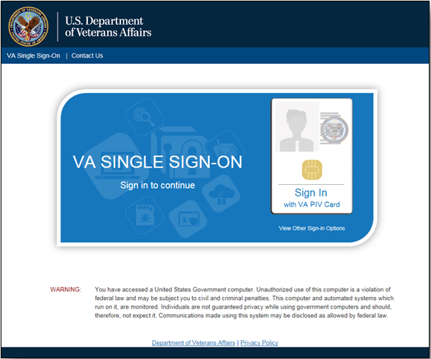
- Click the Sign in with VA PIV Card button.
- Select the current authentication certificate Veterans Affairs User CA B1, and click OK.
- Enter your Personal Identification Number (PIN), and click OK.
  - If the Home VistA Site dialog appears (Figure 2), select your site, and click Save.
Figure 2: Home VistA Site Dialog for VHA Users
  - If your PIV card is properly linked to the home VistA site you selected, the Government Information System Acknowledgement displays.
  - If your PIV is not properly linked to the home VistA site you selected, the Link My Account page displays (Figure 3, Link Your PIV Card and VistA Account).
- Read the important user consent information regarding access to a Government information system, and click I Accept.
  - You are redirected to JLV (Figure 9).

Link Your PIV Card and VistA Account
You need your Access and Verify codes for your VistA account and a PIV card PIN to link your PIV credentials to your VistA account. If you do not remember your PIN or experience any other issue related to your PIV card, visit your local PIV office.
- Complete steps 1–4 listed in VHA User Login.
  - Link My Account page displays (Figure 3).
Figure 3: JLV Link My Account Page
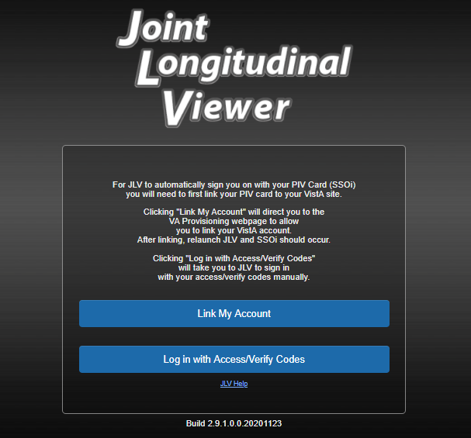
- Select the Link My Account button.
  - JLV redirects the user to the Identity Access Management (IAM) Provisioning Services page (Figure 4).
Figure 4: IAM Provisioning Services Link VistA User Page
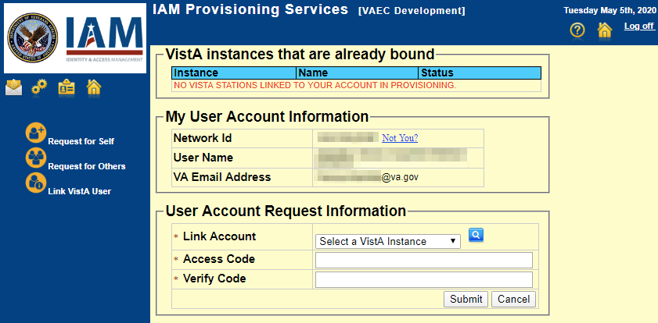
NOTE: Close all other open applications and browser windows. You may experience a failure to link your account(s) if you are logged into CPRS and your VistA application. If this occurs, you should log out and not log back into CPRS until you receive an email stating your account is linked.
- Click the Link Vista User link (Figure 4)
NOTE: Ignore the “No VistA stations linked to your account in provisioning” message that displays.
- Select the appropriate instance of VistA from the Link Account dropdown.
NOTE: The VistA instance list is sorted by station number. If your station is a divisional site of the main PARENT VA site, select the parent site from the list. Example: if your divisional site is Albany, select the parent site 528 Upstate New York HCS from the list.
- Enter your Access and Verify codes for the selected VistA instance.
- Click Submit.

CAPRI-Claims User Login
The following instructions apply to CAPRI-Claims users accessing JLV.
NOTE: Users with any CAPRI patient selection restrictions must use the Joint Longitudinal Viewer tab in CAPRI to access JLV.
- Enter the URL into the address bar of your Internet browser (REDACTED), or select the Joint Longitudinal Viewer tab in CAPRI.
  - You are redirected to the VA SSOi page (Figure 1).
- Click the Sign in with VA PIV Card button.
- Select the authentication certificate Veterans Affairs User CA B1, and click OK.
- Enter your PIN, and click OK.
  - If the Home VistA Site dialog appears (Figure 5), select CAPRI-Claims or All VBA, and click Save. All VBA will be the first entry in the drop-down list.
Figure 5: Home VistA Site Dialog for CAPRI-Claims
NOTE: When CAPRI/Claims is stored as a user's JLV Login site and the user's PIV card is linked to the Claims system in IAM, the user is only prompted for PIV Cert and PIN to authenticate to JLV.
  - You are redirected to the JLV Login page (Figure 6).
Figure 6: The JLV Login Page
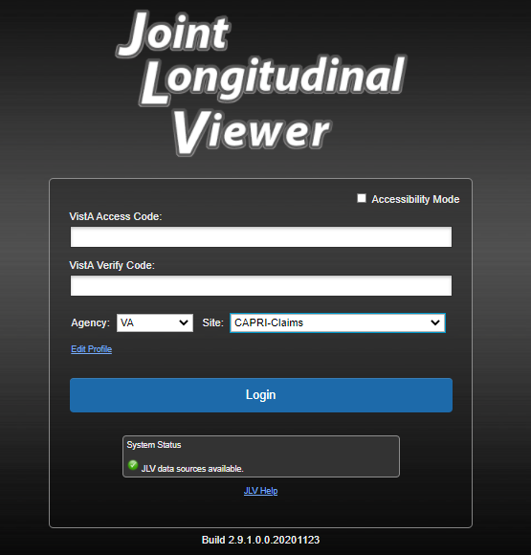
- Read the important user consent information regarding access to a Government information system, and click I Accept.
- If desired, check the Accessibility Mode option.
  - If selected, JLV opens and displays the application in the Section 508-compliant Accessible UI theme (See Using the Accessible Theme’s Functionality for detailed information).
- Enter your login credentials:
  - Enter your CAPRI Access code.
  - Enter your CAPRI Verify code.
  - Select VA from the Agency field.
  - Select CAPRI-Claims or All VBA from the Site dropdown list.
- Click Login.
  - You are redirected to JLV (Figure 9).

Editing Your User Profile at Login
One method of setting application configuration options (i.e., customizing) is by using the Edit Profile link (Figure 6) to access the user profile fields through the JLV Login page (Figure 7). User profile options can also be set within JLV. See Customizing JLV.
NOTE: Only CAPRI-Claims users and those who haven’t yet linked their VistA accounts to their PIV can load the Login page and access the Edit Profile link.
NOTE: The selected options are saved to your user profile by clicking Save and Login and remain set for all subsequent JLV sessions until you change them.
Figure 7: User Profile Data Source and User Interface Option Fields
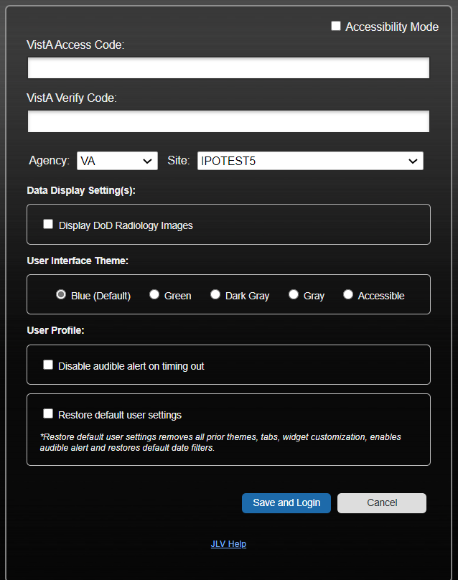

Logging Out of the Current JLV Session
Click (highlighted in Figure 8) at any time to end the current session and exit JLV.
Figure 8: JLV Logout Icon

A JLV session ends automatically after 60 minutes of inactivity. Actions in JLV that are considered activity are changing patients, refreshing widgets, opening, or closing widgets, adding, or removing widgets from the Patient Data and Widgets page, and adjusting date ranges. You receive an audible and visual warning that the current session is about to terminate after 55 minutes of inactivity. Automatic termination of a session logs you out of the application, closes all JLV tabs and windows, and displays the Logout page. Close and reopen the browser and return to the JLV Login page to initiate a new JLV session. If SSOi is enabled, you are redirected to the VA Single Single-On Logout page.
NOTE: The audible alert can be disabled by selecting Disable audible alert on time out in the Settings panel.

The Elements and Functionality of JLV

The Patient Data and Widgets Page
After a successful log in, your username displays on the JLV toolbar, and the Patient Data and Widgets page is displayed.

Default View
Upon log in, you see the Patient Search dialog box by default.
NOTE: CPRS users who select a patient within CPRS, then launch JLV are taken directly to the Patient Data and Widgets page, where the records for the patient selected in CPRS are displayed.
Figure 9: Default View
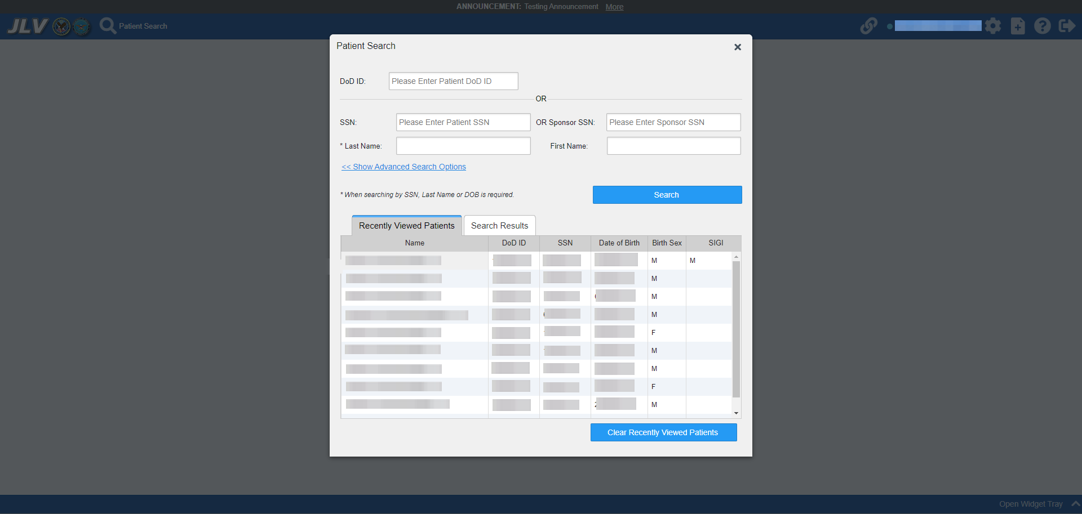

Clicking a patient name in the Patient Search window displays the selected patient's clinical records and other patient-centric information.
Note: The Patient Flags window opens and displays by default when the Patient Data and Widgets page opens if there are warnings associated with the selected patient. For more information, see Patient Flags and Alerts.

New JLV users see a preconfigured, default widget layout on the Patient Data and Widgets page when a patient is selected. The default layout includes the Allergies, Problem List, Documents & Images, Medications - Outpatient, and Lab Results widgets, as well as the Patient Flags widget if applicable.
NOTE: You can configure the layout of widgets on the Patient Data and Widgets page and create multiple widget tabs, as described in Customizing JLV and in Accessing and Opening Widgets. Customizations are saved to your user profile and remain until manually changed.

System Menu
Each Patient Data and Widgets page has a toolbar (highlighted in Figure 10) that enables quick access to the following features:
- View Context Management status .
- Settings: Click to set user preferences, including the UI theme (Refer to Customizing JLV).
- Report Builder: Click to create custom reports (Refer to Using Report Builder).
- Online Help: Click to open online help.
- Logout: Click to log out and close the current JLV session (Refer to Logging Out of the Current JLV Session).
Figure 10: JLV Tools on the Patient Data and Widgets Page

The following functions can be completed from the Patient Data and Widgets pages (highlighted in Figure 11):
- Perform a Patient Search.
- View the system status .
- Open the widget tray using the Open Widget Tray ^ link on the Patient Data and Widgets page (as shown in Accessing and Opening Widgets, Figure 47).
Figure 11: More JLV Functionality

Viewing System Status
The system status reports the condition of the JLV application. Hovering over System Status provides additional information.
NOTE: The System Status reports the overall condition of the JLV application, while the Connection Status reports the condition of the connection between JLV and its external resources. See Viewing Connection Status for more information.
JLV displays the system status on the Login page and on the Patient Data and Widgets toolbar.
- When all monitored systems and services are online and connected, appears with the status message, “JLV data sources are available”.
- When one or more of the monitored systems or services is offline or unavailable, appears with the status message, “Services are not available to JLV”.
- When JLV is unavailable, appears with the message, “System status is unavailable”.
  - You may not be able to log into JLV or view patient data until the connection is restored.
These warnings may be accompanied by one or more of the notices listed in Table 2, depending on which services are unavailable. Figure 12 shows a system status message on the Login page, and Figure 13 shows the System Status hover text on the Patient Data and Widgets toolbar.
Table 2: System Status Notices by Service
Service | Notice
jMeadows | “The service that gathers patient data and prepares it for display in JLV is unavailable. JLV is available for login but may not function otherwise.”
Master Person Index (MPI) | “VA Patient Identity Service is unavailable. Patient search may not be available, and VA and community partner data may not display.”
Patient Discovery Web Service (PDWS) | “DOD Patient Identity Service is unavailable. Patient search may not be available and DOD data may not display.”
Relay Service | “All DOD, Federal EHR, and Community Partner data in widgets is currently unavailable. The source connection is down and DOD, Federal EHR, and Community Partner data of all types from all sites may not display.”
VistA Data Service (VDS) | “The connection to VA sites is unavailable. VA patient records of all types from all sites may not display.”
Data Exchange Service (DES) | “Some Federal EHR, DOD, and Community Partner data are currently unavailable. The source connection is down and some DOD and Community Partner, and some FEHR data of all types from all sites may not display in widgets.
Electronic Health Record Modernization (EHRM) | “Federal EHR (Cerner) is currently unavailable. The source connection is down and some Federal EHR data may not display.”
Figure 12: System Status on the JLV Login Page
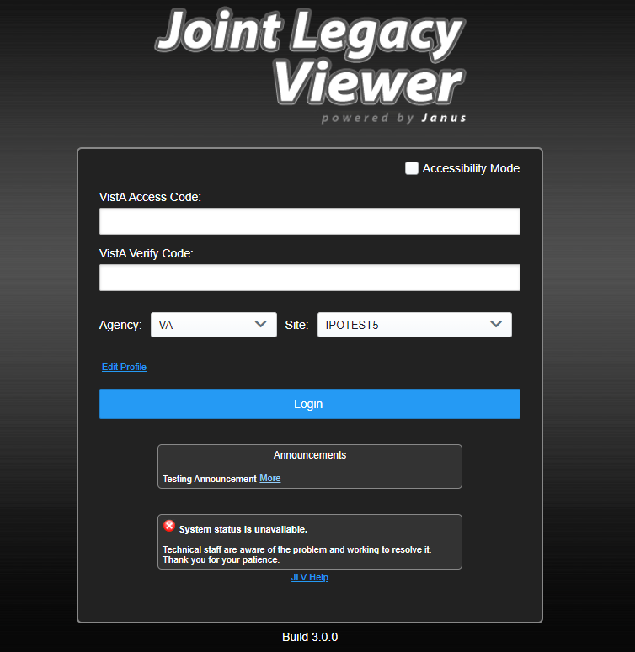

Figure 13: System Status on the JLV Toolbar
A System Status icon appears in the JLV Navigation Bar to indicate the status.

Patient Context Management
Clinical Context Management (CCOW) is a way for applications to synchronize the display of clinical context, based on the Health Level 7 (HL7) CCOW standard. If CCOW-compliant applications are sharing context and one of the applications changes the data display to a different patient, the other applications switch to display that same patient.
JLV is context management enabled. When context is enabled, a patient change made in one context-enabled application (i.e., CPRS) triggers the same change in JLV. The same effect is shown vice versa; that is, when a patient is selected in JLV, it triggers a patient change in other context-enabled applications.
Context management is enabled by default, and JLV attempts to connect to the context vault upon a valid login. The context status appears on the Patient Data and Widgets toolbar. When context is established, is shown. When context is suspended, is shown.
Figure 14 shows the context indicator location on a JLV page. Context is established in this example.
Figure 14: Context Indicator

Suspending Context
Context can be manually suspended.
- Click .
- The CCOW warning message, “Are you sure you want to break patient link?” appears (Figure 15).
- Click Yes to continue.
Once context is suspended, displays on the Patient Data and Widgets page. When context is suspended, patient changes are not reflected in either JLV or other CCOW-enabled applications.
Figure 15: Suspending Context
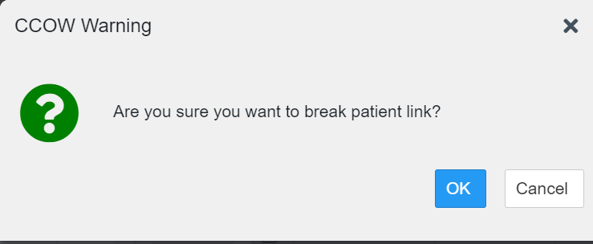

Establishing Context
When context is suspended, it can be reestablished manually.
- Click .
- The CCOW warning message, “Are you sure you want to rejoin patient link?” appears (Figure 16).
- Click Yes.
Once context is established, displays on the Patient Data and Widgets page.
Figure 16: CCOW Warning Message
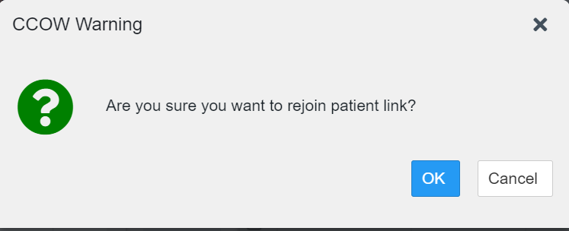

Unable to Communicate with Vault
If JLV is unable to initiate context management upon log in, you see the CCOW Error message (Figure 17). Click OK to continue. displays on the Patient Data and Widgets page. If the CCOW error persists, contact your local service desk for assistance.
Figure 17: CCOW Error Message
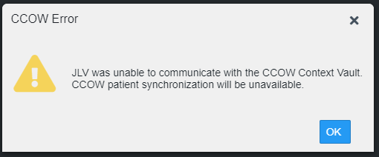

NOTE: This error message automatically displays if you have more than one active JLV session open.

Context Synchronization Failure
A CCOW error message is presented if JLV is unable to reestablish context (Figure 18). This indicates context is suspended. Click OK to continue. displays on the Patient Data and Widgets page. CAPRI-Claims users may encounter this error message at each log in, as there are usually no CCOW system components installed on their computers.
Figure 18: Context Synchronization Failure
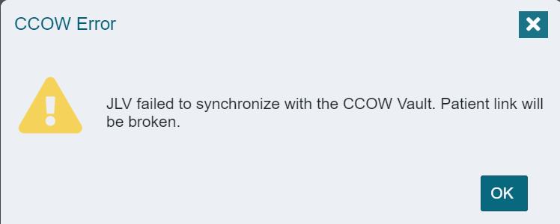

Customizing JLV
Configuration options can be set in the JLV Settings dialog (Figure 19). These settings are saved to your user profile and persist.
1. Click the link on the Patient Data and Widgets page (Figure 10).
  - The JLV Settings dialog box opens (all selections are optional).
- Select the data display setting checkbox for DOD Radiology Images to display within the Radiology Reports Widget.
- Select the radio button to change the color theme.
- To disable audible alert on timing out, select the check box.
- To restore your user profile default settings, click the checkbox.
- You can view your JLV Login Site
- To export or import custom tabs, click the Export Tabs or Import Tabs buttons.
- Click Save to apply the selected data display setting and/or theme OR
- Click Cancel to exit the dialog box and restore the previous data display and/or theme configuration.
Additional information on each of these selections is contained in the following sections.
Figure 19: JLV Settings Dialog Box
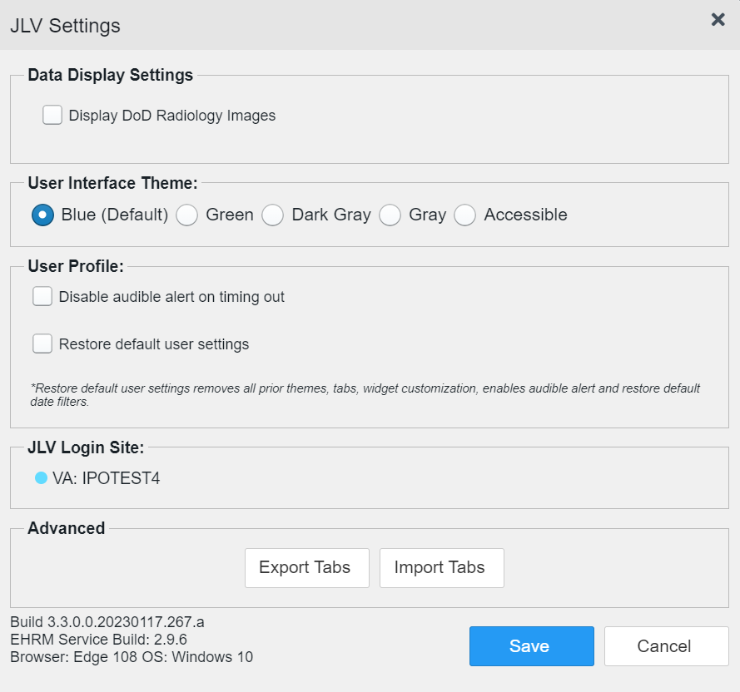
NOTE: Users logging into JLV with a PIV card will have the option of changing their site location. Users should only select sites linked to their PIV card. The new selection will not take effect until the next login and will remain the user’s default site until updated or reset.
You may reset your user profile to JLV defaults by selecting the Restore Default User Settings checkbox and then the Save button in the JLV Settings dialog. This feature resets the theme and data display to default; enables the audible alert; removes any custom tabs; and resets all widgets to their default configurations, which removes any custom sort or filter settings.
Figure 20: VHA JLV User Management Settings Tab
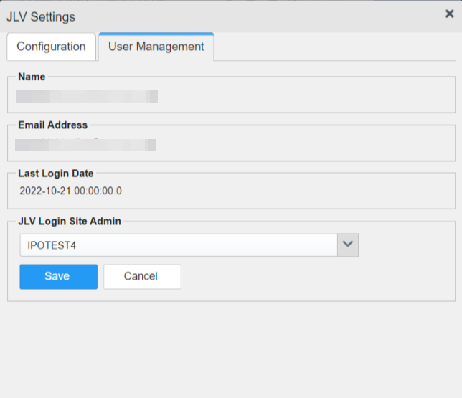
JLV users that have privileges to edit login sites for end users will have the additional User Management tab. Users will be prompted to enter an email address to search for the associated current entry in the JLV user table. If there is no associated email address, a popup will appear, “User not found”.
If the search locates a current entry in the JLV user table, the user’s email, username, and last login date will appear in a read only mode as in Figure 20. A login site will appear prepopulated with the selected end user’s login site from the user table and allow selection of any site in the JLV site drop-down list. Clicking the save button will update the login site for the user.

About Data Display Settings
The data display setting is part of your user profile. The data display setting enables you to specify whether to include DOD radiology images. This option is disabled by default.
JLV displays data source indicators in the Site columns of individual widgets (Figure 21). A blue circle indicates VA data; an orange square indicates DOD data; a purple hexagon indicates community partner data (if enabled); and a green triangle indicates Cerner Millennium Federal Electronic Health Record (FEHR) data (Table 3). Hovering over individual data source indicators provides more specific information about the data source.
Table 3: Data Sources
Icon | Sources | Hover information | Data Supplied
XXX  XXX = the three-letter VistA site abbreviation | CPRS/VistA system data | VA: location  Examples:  - VA: Walla Walla, WA  - VA: Central Texas HCS | Supplies all records from CPRS/VistA for all sites. These records will remain available even after a site transitions to VA EHRM (Cerner).
 | CHCS (CDR), AHLTA, Essentris, TMDS, various clinical applications | DOD source system : Full name of DOD Medical Treatment Facility  Examples:  - CDR: Fairchild AFB  - AHLTA: JB San Antonio | Supplies all records from all sites from all DOD facilities for all legacy applications. These records will remain available even after a site transitions to MHS GENESIS (Cerner).
 | DOD MHS GENESIS (Cerner) and VA EHRM (Cerner) records stored in Cerner Millennium | FEHR: VA or DOD facility name/location  Examples:  - FEHR: Spokane, WA  - FEHR: Madigan AMC | Supplies records from VA and DOD facilities that have migrated to the new Federal EHR, called MHS GENESIS in DOD and VA EHRM (Cerner) in VA.
Name  Name = Community Partner name | All DOD and VA Community Partners (VHIE/VLER), Sequoia Project and DOD Health Information Exchange) | Federal HIE: Community Partner Organization Name  Examples:  - Federal HIE: UC San Diego  - Federal HIE: Mayo Clinic | Supplies continuity of care documents, care summaries, and notes when provided by partners. Partner capabilities and responses vary.

About UI Themes
The UI theme setting is also part of your user profile. Choosing a UI theme sets the font, foreground, and background colors of the widgets, toolbars, and dialog boxes. Once selected, the UI theme is stored in your user profile and remains set until you change it. The available UI themes are Blue (Default), Green, Dark Gray, Gray, and Accessible (Section 508-compliant).
Figure 21: Blue (Default) UI Theme
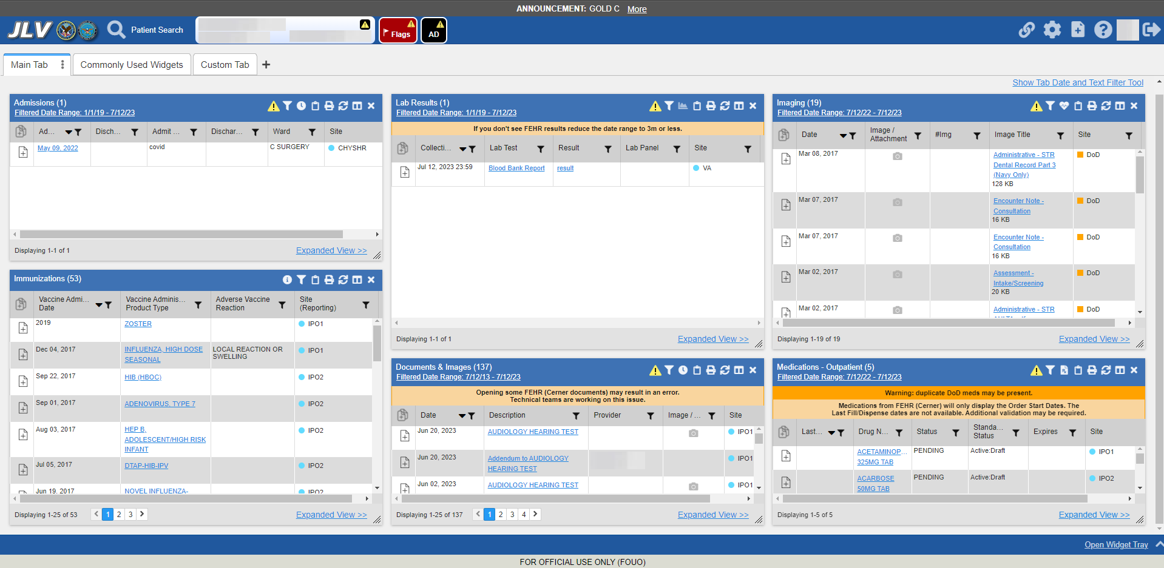

Figure 22: Green UI Theme
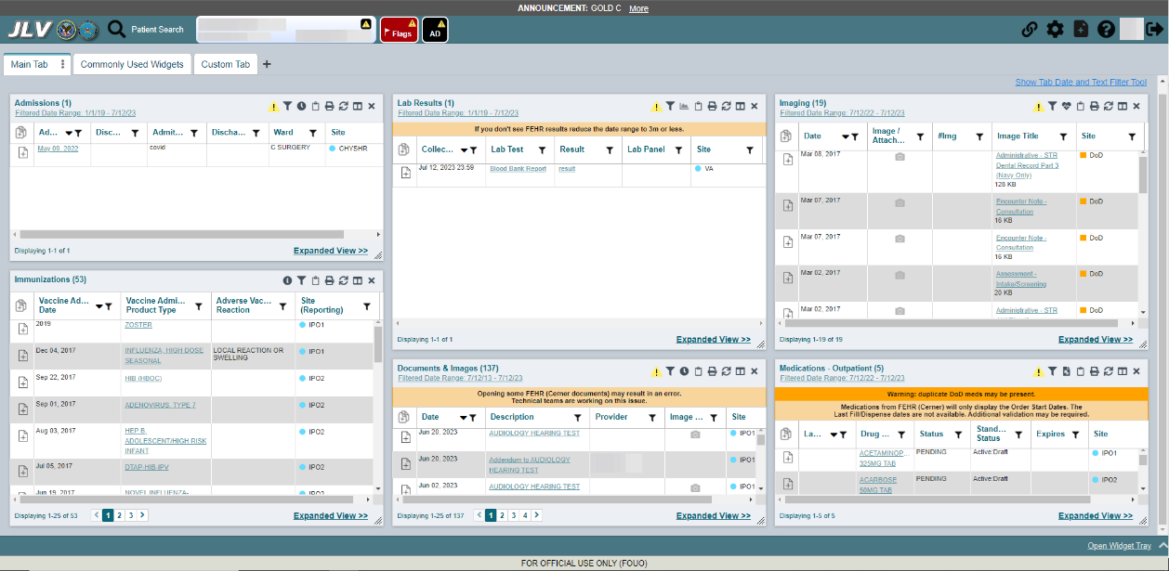

Figure 23: Dark Gray UI Theme
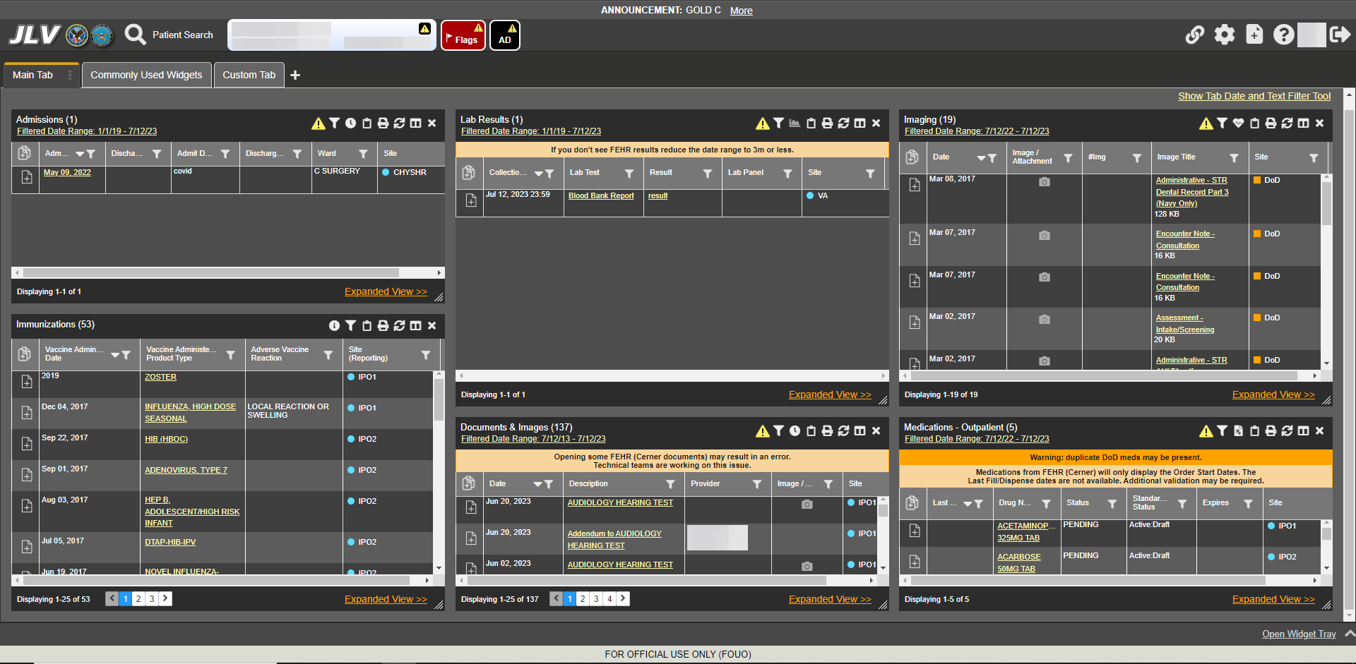

Figure 24: Gray UI Theme
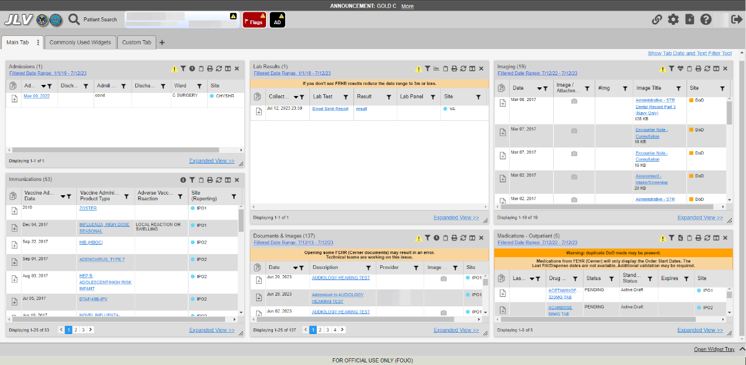

Figure 25: Accessible (Section 508-Compliant) UI Theme
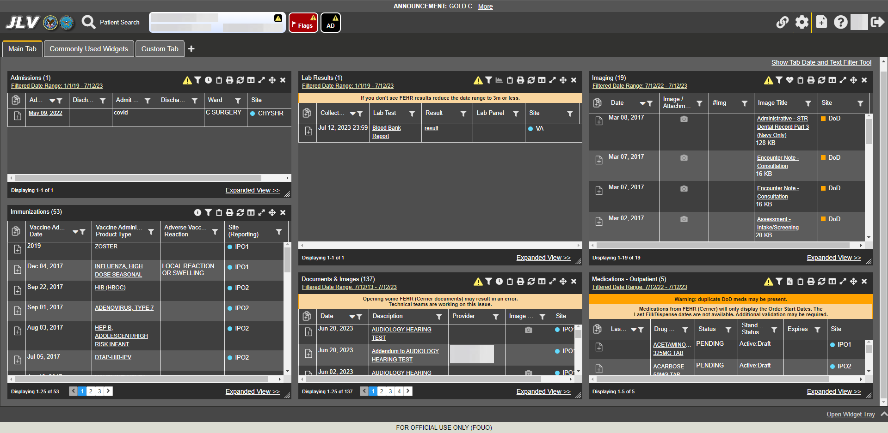

Using the Accessible Theme’s Functionality
The Accessible theme includes larger fonts, enhanced tab and keystroke functionality, and screen reader compatibility in compliance with Federal accessibility requirements and Section 508 standards.
NOTE: The Accessible theme is available for users who have adaptive technologies installed on their computers.

Keyboard Focus and Navigation
Keyboard focus is the highlighting of an element, field, or control that enables interaction with, and navigation of, JLV using the keyboard and keystrokes. When navigating interactable elements with the Tab key, the item in focus is outlined in gold as a visual indicator.
JLV uses standard accessibility software key commands for navigation and interaction.
Pressing Enter or the Spacebar when an element that provides action is in keyboard focus performs the associated action; for example, pressing Enter or the Spacebar when the is in focus opens the JLV Settings dialog box. Using the arrow keys or the Tab key moves between keyboard focus items to navigate through screen elements.
The following tables provide a complete list of accessible keystrokes.
Table 4: Accessible Theme Keyboard Shortcuts – Patient Data& Widget Navigation
Keystroke | Description
ALT + W | Press to enter widget body.
ENTER | Press to initiate the action associated with the item in focus.
TAB | Press to transfer keyboard focus to other user interface items.
ESC | Press to return keyboard focus to the panel containing the user interface item with keyboard focus or to exit a window, widget, or tab, and close dropdowns.
SPACEBAR | Press to activate any user interface item (for example, click a button).
Arrow Keys | When focused on a dropdown list, press the down arrow key to view list contents.
Table 5: Accessible Theme Keyboard Shortcuts - Tabs
Keystroke | Description
Arrow Keys | Use the left and right arrow keys to change tab panels.
TAB | - Press Tab until is in focus  - Press Enter  - The new tab dialog box opens and prompts you to enter a name for the new tab  - Tab to the Add button to confirm the new tab name or tab to the Cancel button to discard the new tab
ENTER | Press to initiate data load of tab.
1 | On custom tabs, press 1 to rename the tab.
DELETE | On custom tabs, press DELETE to remove the tab.

Table 6: Accessible Theme Keyboard Shortcuts – Windows or Dialog Boxes
Keystroke | Description
TAB | Press to transfer keyboard focus to other user interface items within the window or dialog box.
Table 7: Accessible Theme Keyboard Shortcuts – Adding Widgets to the Patient Data and Widgets Page
Keystroke | Description
= | Press to load a dialogue box with options to place a widget.

Accessible Theme Navigation
An element with keyboard focus is the starting point for navigation. Pressing the ALT+W keys when a widget is in focus, will take you to the first interactable element in the widget.
Figure 26 depicts the Documents & Images widget with keyboard focus. Focus can be changed by pressing the Tab key. Pressing the Tab or Shift Tab key, in this example, shifts the keyboard focus from one interactable element to the next. Press the escape key to return focus to the widget body.
Figure 26: Navigation Using Elements with Keyboard Focus
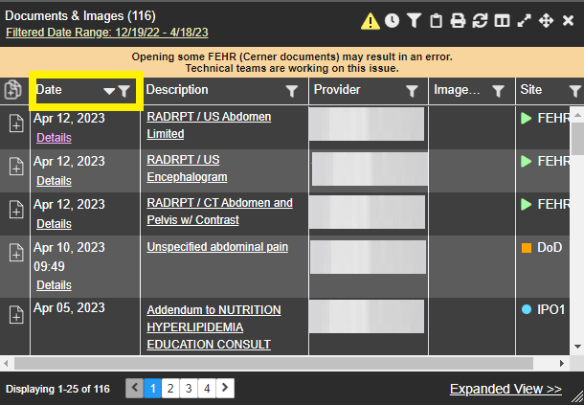
The Document details window has keyboard focus in Figure 27. Move through the toolbar buttons by using the arrow keys, or by pressing Tab. Move to and press Enter to close the details window. After closing the window, keyboard focus returns to the last element that had keyboard focus prior to opening the window.
Figure 27: Document Details with Keyboard Focus
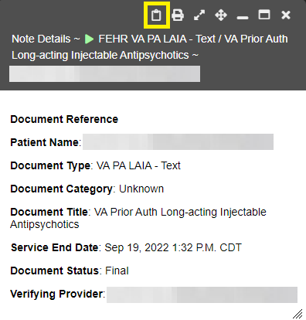

Table Functionality
Table Column Headers (Figure 28) can be sorted by selecting the column header and pressing the space bar or enter key to sort the column. Upon a sort, (Figure 29) a user will have to leave the table and reenter for JAWS to receive the updated Table Data.
Figure 28:Table Column Header
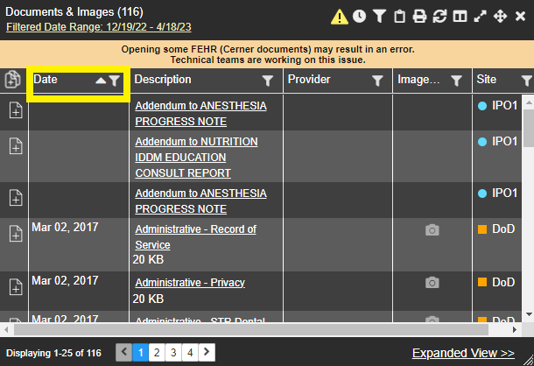

Figure 29: Widget Column Select Dropdown
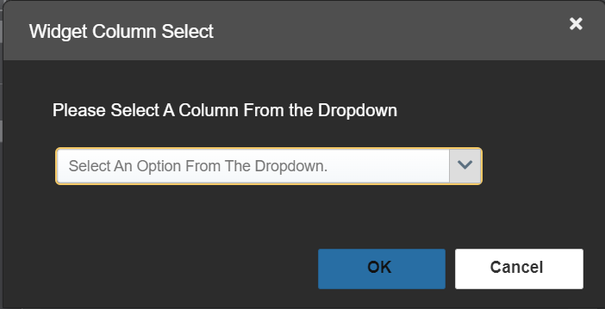
NOTE: Not all table columns are sortable. EZ Select All Column Header and Report Builder Selected Items Column Header are not sortable.

Widget Move
In the widget tools menu, pressing the four-arrow icon or move widget button (Figure 30) will open a dialogue with options to move the widget on the screen or inside the Patient Data and Widgets page (Figure 31). This function is available in both the minimized and expanded view.
Figure 30: Widget Move Icon
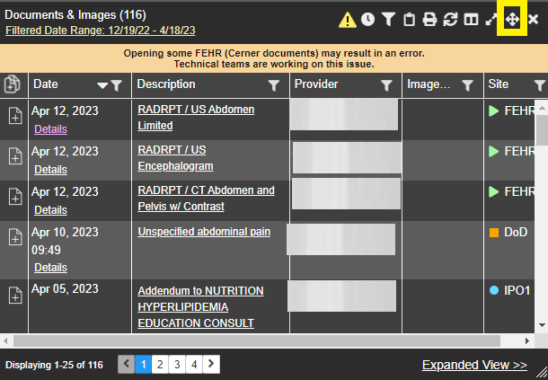
Figure 31: Widget Move Dropdown
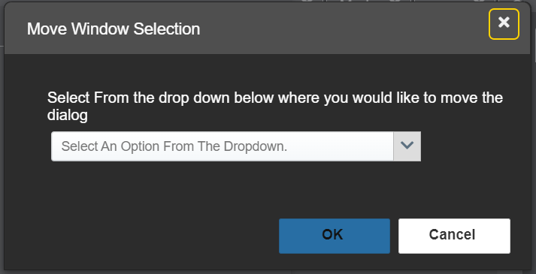

Widget Resize
In the widget tools menu, pressing the two-arrow icon or resize widget button (Figure 32) will open a dialogue with options to resize the widget on the screen or inside the Patient Data and Widgets page (Figure 33). This function is available in both the minimized and expanded view.
Figure 32: Widget Resize Icon
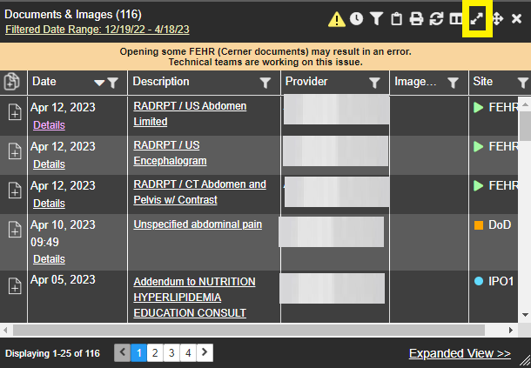
Figure 33: Widget Resize Dropdown
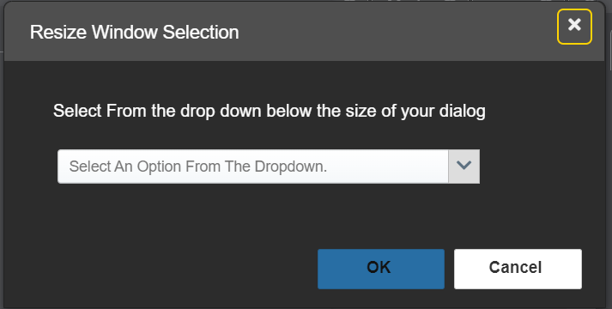

User-Restricted Access to Patient Data

VHA Users Viewing DOD-only Patient Data
VHA users can view the records of DOD-only patients, meaning they are not registered in MPI, but VA requires that these actions be audited. If an attempt is made to access DOD-only patient records, the VHA user is asked to specify the purpose for access. The purpose options presented to the user are: Emergent Care, Clinical Care, or Authorized Administrative Use (Figure 34).
Once the purpose for access is selected, clicking Agree to be Audited & Access this Patient Record (Figure 34), displays the requested data, and audits the action. The access purpose, organization of the VA provider, date, username, IP address, user’s Internal Entry Number (IEN), host system’s ID, and patient’s Electronic Data Interchange Personal Identifier (EDIPI) are captured in the audit record.
Figure 34: VA User Restricted Access Dialog
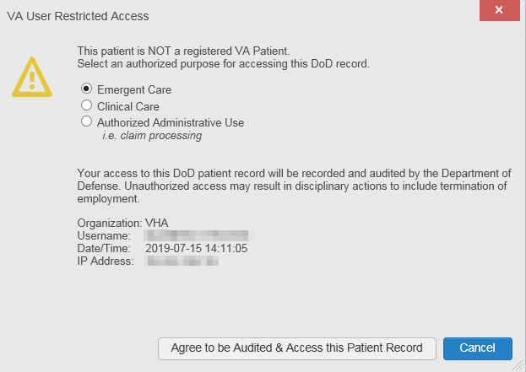

CAPRI-Claims Users Viewing Patients with DOD Data
CAPRI-Claims users may see one of two different dialog boxes, depending on whether the patient is registered for care in the VA. If the patient is registered for care in the VA, they are in MPI.

Patient Registered in MPI
CAPRI-Claims users are permitted to view the records of a patient who is registered in MPI, but the VA requires that these actions be audited. After performing a patient search and selecting a patient from the search results, a CAPRI-Claims user sees the audit notification (Figure 35) if the patient they selected is registered in MPI. After agreeing to the audit, the CAPRI-Claims user can access the patient’s record.
Figure 35: CAPRI-Claims User Audit Notification
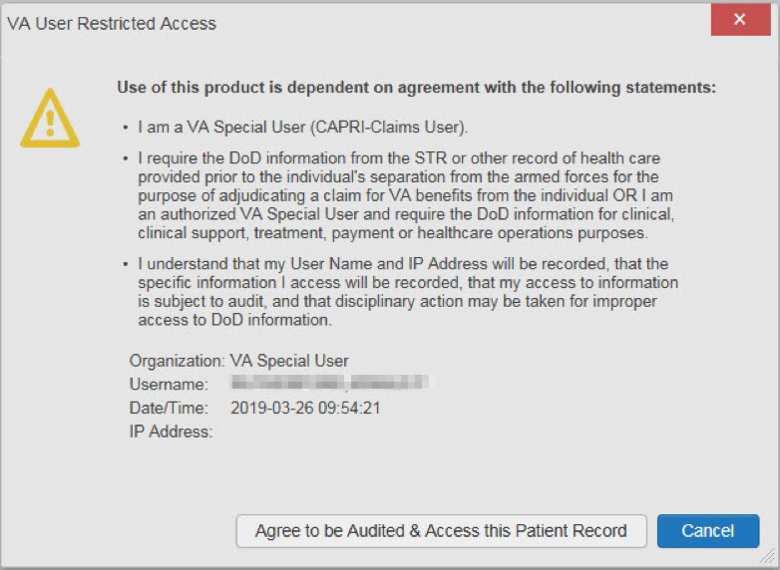

Patient Not Registered in MPI
CAPRI-Claims users are not permitted to access the records of a patient who is not registered in MPI. After performing a patient search and selecting a patient from the search results, a CAPRI-Claims user sees the restricted access notification (Figure 36) if the selected patient is not registered in MPI. Clicking Cancel returns the user to the previous screen.
Figure 36: Restricted Access Notification
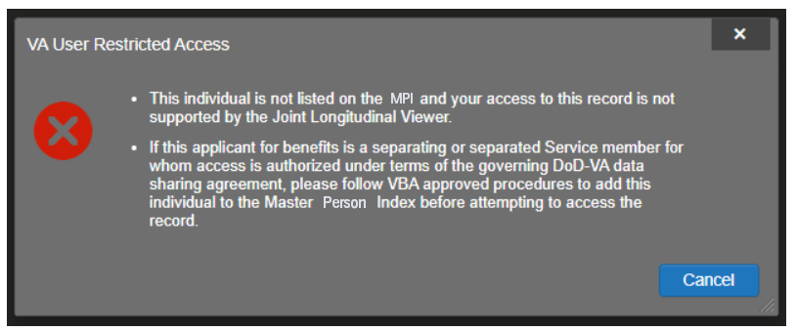

Access to DOD Sensitive Records
All JLV users are audited each time a sensitive DOD record is accessed. Auditing applies to sensitive documents, lab results, outpatient encounters, or progress notes records. JLV records the user’s name, organization, SSN/EDIPI (for DOD users), PIV (for VA users), location, patient identifiers (patient last name, first name, middle initial [MI], SSN/EDIPI [DOD only], MPI [VA only], and date of birth [DOB]), data accessed, date and time, and reason for access for each attempt to access sensitive data.
JLV notifies you before you are audited. The message is triggered the first time you click a masked record that is marked ** Sensitive**. Your acknowledgement of the audit notification covers all subsequent DOD sensitive records in any widget during the remainder of the session, and it only expires when you switch patients or log off. An example of a masked record audit notification is depicted in Figure 37.
After you select the purpose for viewing the record and agree to be audited, the sensitive data displays in the Details view of the widget.
Figure 37: DOD Sensitive Record and Audit Dialog Box
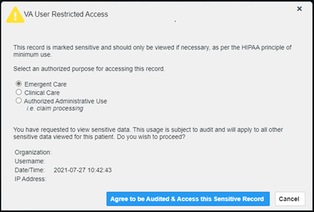

Patient Searches
The core function of JLV is to display patient information on the Patient Data and Widgets page. Use the Patient Search feature to perform a patient search, perform a family search, or use the advanced search options.
JLV determines which enterprise service to use for a patient search, based upon the search criteria:
- If the EDIPI or Sponsor SSN is entered, JLV utilizes PDWS for the search (See PDWS Search Rules and Supported Searches for details).
- If the EDIPI or Sponsor SSN fields are empty, JLV utilizes MPI for the search (See MPI Search Guidelines for details).

PDWS Search Rules and Supported Searches
When JLV utilizes PDWS for patient search, the applicable rules and rule sets required for the PDWS interface must be used:
- Rule Set 1: When searching by SSN, the full nine-digit SSN must be entered, and the Last Name or DOB must also be supplied.
  - This is true for search by patient SSN as well as Sponsor SSN.
- Rule Set 2: If you do not have the patient’s SSN, you must supply ALL the following identifiers: Last Name, First Name, DOB, and Birth Sex.
  - Blanks in any of these four required fields generates an error
- A 10-digit string is required for telephone number.
The following search combinations are supported when PDWS is utilized:
- DOD ID, also referred to as the EDIPI
- Patient SSN and Last Name
- Patient SSN and DOB
- Sponsor SSN and Last Name
- Sponsor SSN and DOB
- Last Name, First Name, DOB, and Birth Sex (ALL identifiers must be entered)

MPI Search Guidelines
JLV utilizes MPI for a patient search when the search parameters include the patient’s name and SSN. MPI requires the full last name is entered when the patient’s SSN is entered. MPI may also require entering the patient’s first name and DOB to increase the efficiency of the search, and the likelihood of locating the patient. An example would be searching for a patient with a common last name, such as Smith or Jones.

Patient Search Using DOD ID
- Click Patient Search.
  - The Patient Search dialog opens.
- Enter the 10-digit patient DOD ID (EDIPI) in the DOD ID field (Figure 38).
Figure 38: DOD ID (EDIPI) Search
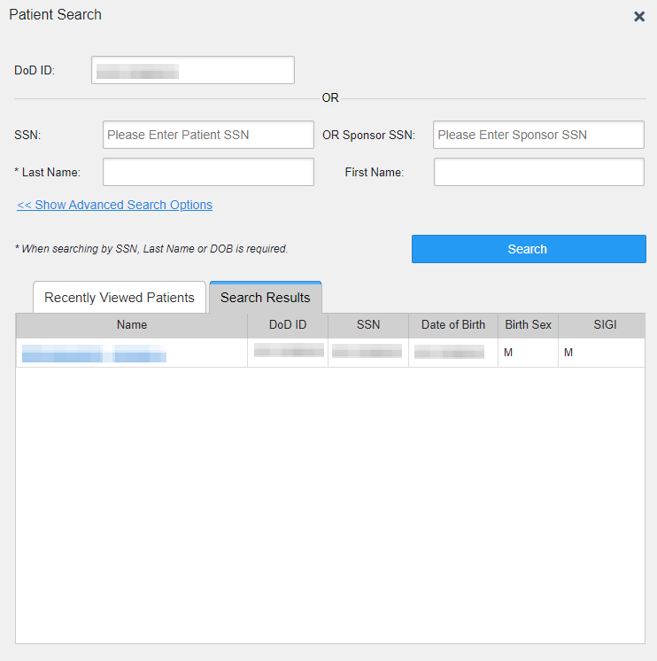
- Click Search.
  - The search results display on the Search Results tab.
- Click a patient’s name in the search results list to open the associated record.
  - The Name, SSN, DOB, Birth Sex, and SIGI columns in the results list provide information to assist with patient identification.
- After selecting a patient, the Patient Data and Widgets page opens and displays the selected patient’s data.

Invalid and Maximum Characters
Text Fields on Patient Search will alert the user if an invalid key is entered into the text box (Figure 39).Text fields will inform the user when they have reached the maximum character length for entry (Figure 40).
Figure 39: Invalid Character Entry
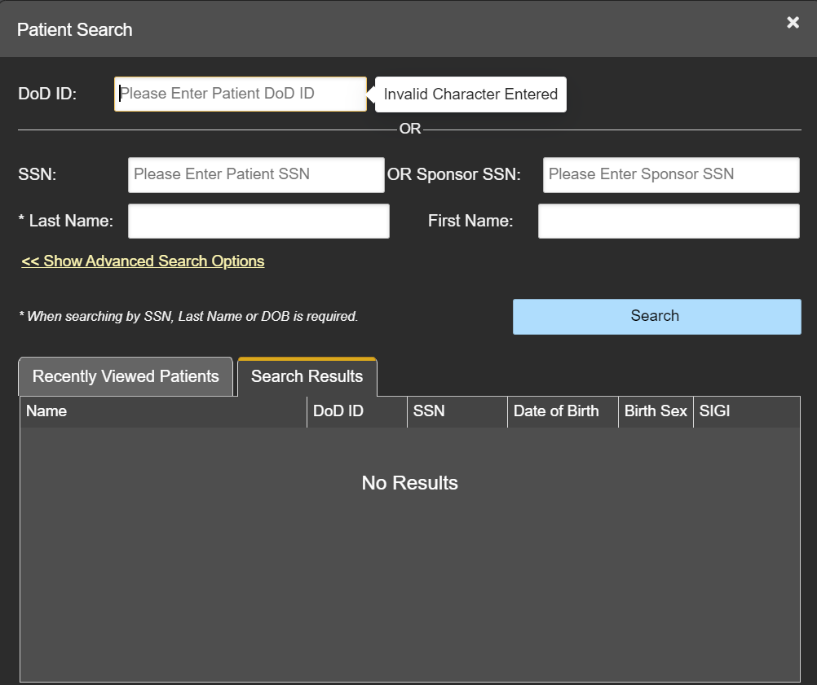

Figure 40: Maximum Characters Reached
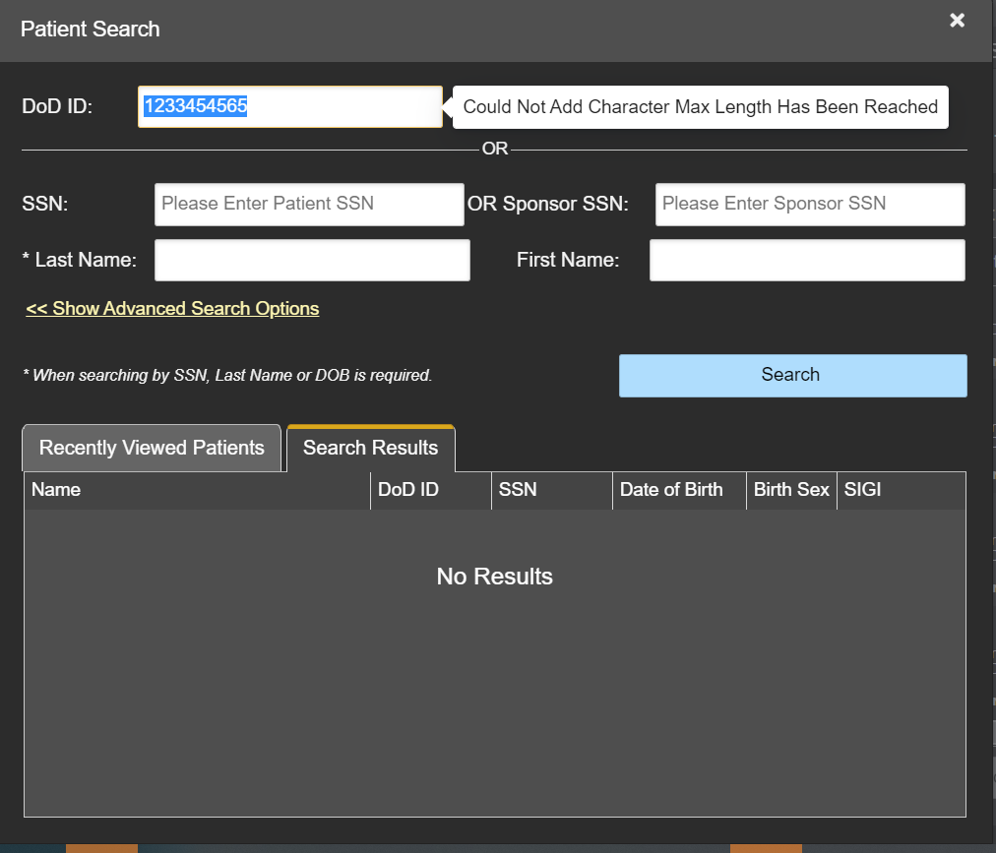

Patient Search Using SSN
- Click Patient Search.
  - The Patient Search dialog box opens.
- Enter the patient’s full, nine-digit SSN in the SSN field (Figure 41).
  - When searching by SSN, either the last name or the DOB must be entered to perform the search.
Figure 41: SSN Search
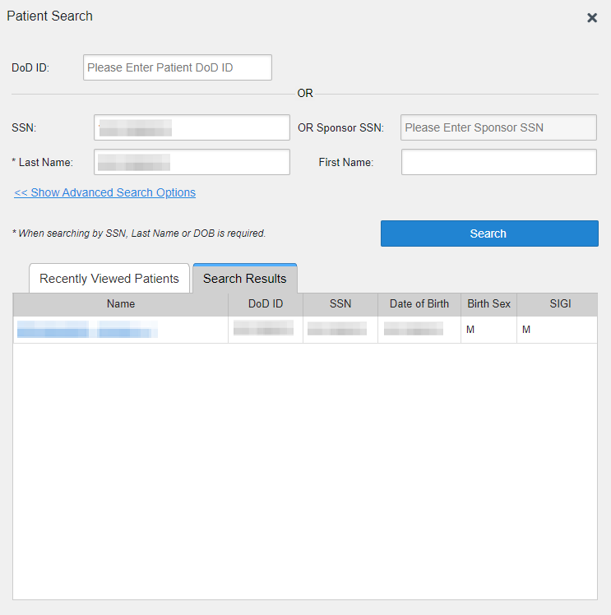

- Click Search
  - If the required patient identifiers are not provided, hover text appears, indicating the information necessary to complete the patient search.
  - If a match of patient names cannot be made, enter additional identifiers (first name, DOB) to refine the search (Figure 42).
Figure 42: Additional Identifiers Needed

- The search results display on the Search Results tab.
- Click a patient’s name in the search results list to open the associated record.
  - The Name, SSN, DOB, Birth Sex, and SIGI columns in the results list provide information to assist with patient identification.
- After selecting a patient, the Patient Data and Widgets page opens and displays the selected patient’s data.

Advanced Patient Search Options
Advanced patient search options in the Patient Search dialog box allow for the use of additional patient identifiers when performing a patient search.
- Click Patient Search.
  - The Patient Search dialog box opens.
- Click the <<Show Advanced Search Options link under the *Last Name field (seen in Figure 41).
- Enter the patient identifiers in the appropriate search fields, as desired.
  - Advanced search option fields include *DOB, MI, Birth Sex, Address, State, City, Zip, and Telephone (seen in Figure 43).
Figure 43: Advanced Search Options
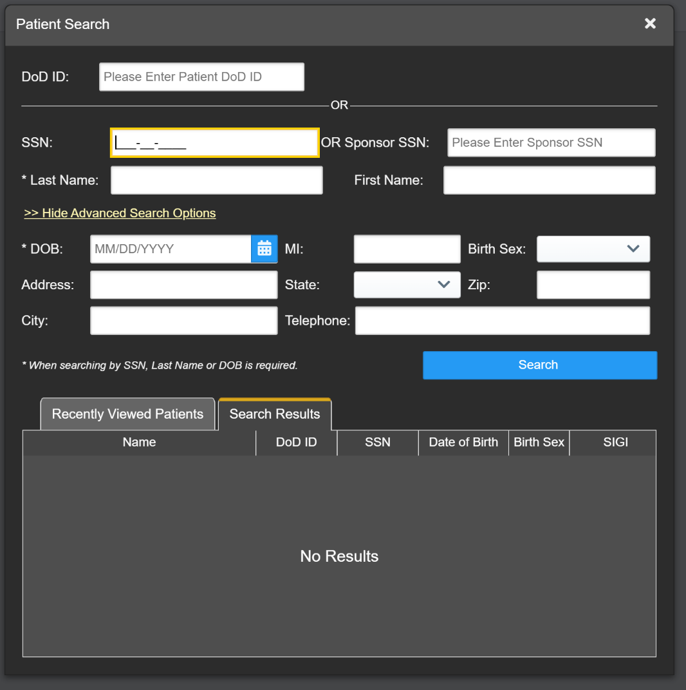

- Click Search
  - If the required patient identifiers are not provided, hover text appears, indicating the information necessary to complete the patient search.
  - The search results display on the Search Results tab.
- Click a patient’s name in the search results list to open the associated record.
  - The Name, SSN, DOB, Birth Sex, and SIGI columns in the results list provide information to assist with patient identification.
- After selecting a patient, the Patient Data and Widgets page opens and displays the selected patient’s data.

Family Member Search
A family member search can be performed using the Sponsor SSN field in the Patient Search dialog box.
- Click Patient Search.
  - The Patient Search dialog box opens.
- Enter the SSN in the Sponsor SSN field.
  - The Last Name or DOB of the patient must also be entered in the appropriate fields (Figure 44).
- Click Search.
  - If the required patient identifiers are not provided, hover text appears indicating the information necessary to complete the patient search.
  - The search results display on the Search Results tab (Figure 44).
Figure 44: Sponsor SSN Search
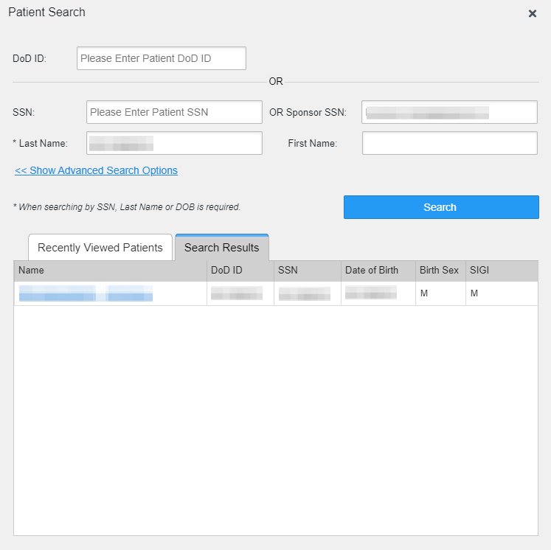

- Click a name in the Search Results list.
  - The Family Members dialog opens (Figure 45).
  - The sponsor’s identifiers and a list of dependents display in the dialog.
- Click a name in the list of family members to open the associated record.
- After selecting a patient, the Patient Data and Widgets page opens and displays the selected patient’s data.
Figure 45: Family Members Dialog Box
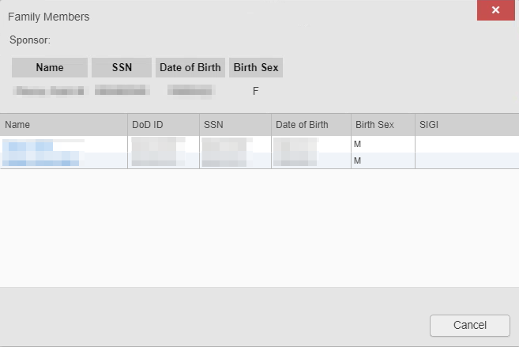

Recently Viewed Patients List
Users who have previously logged into JLV, searched for a patient, and viewed that patient’s records can see and access a list of recently viewed patients. A recent patient is defined as a patient whose record has been viewed (opened) by the user.
NOTE: The Recently Viewed Patients list does not include search history or recent search results, only a list of patients whose data was accessed and viewed. The list is limited to 10 patients. You can clear this list by selecting the Clear Recently Viewed Patients button.
- Click Patient Search.
  - The Patient Search dialog box opens.
- Click the Recently Viewed Patients tab in the Patient Search dialog box.
  - A list of recently viewed patients displays (Figure 46).
  - The Name, DOD ID, SSN, DOB, Birth Sex, and SIGI columns in the results list provide information to assist with patient identification.
- Click a patient’s name in the Recently Viewed Patients list to open the associated record.
- After selecting a patient, the Patient Data and Widgets page opens and displays the selected patient’s data.
Figure 46: Recently Viewed Patients List
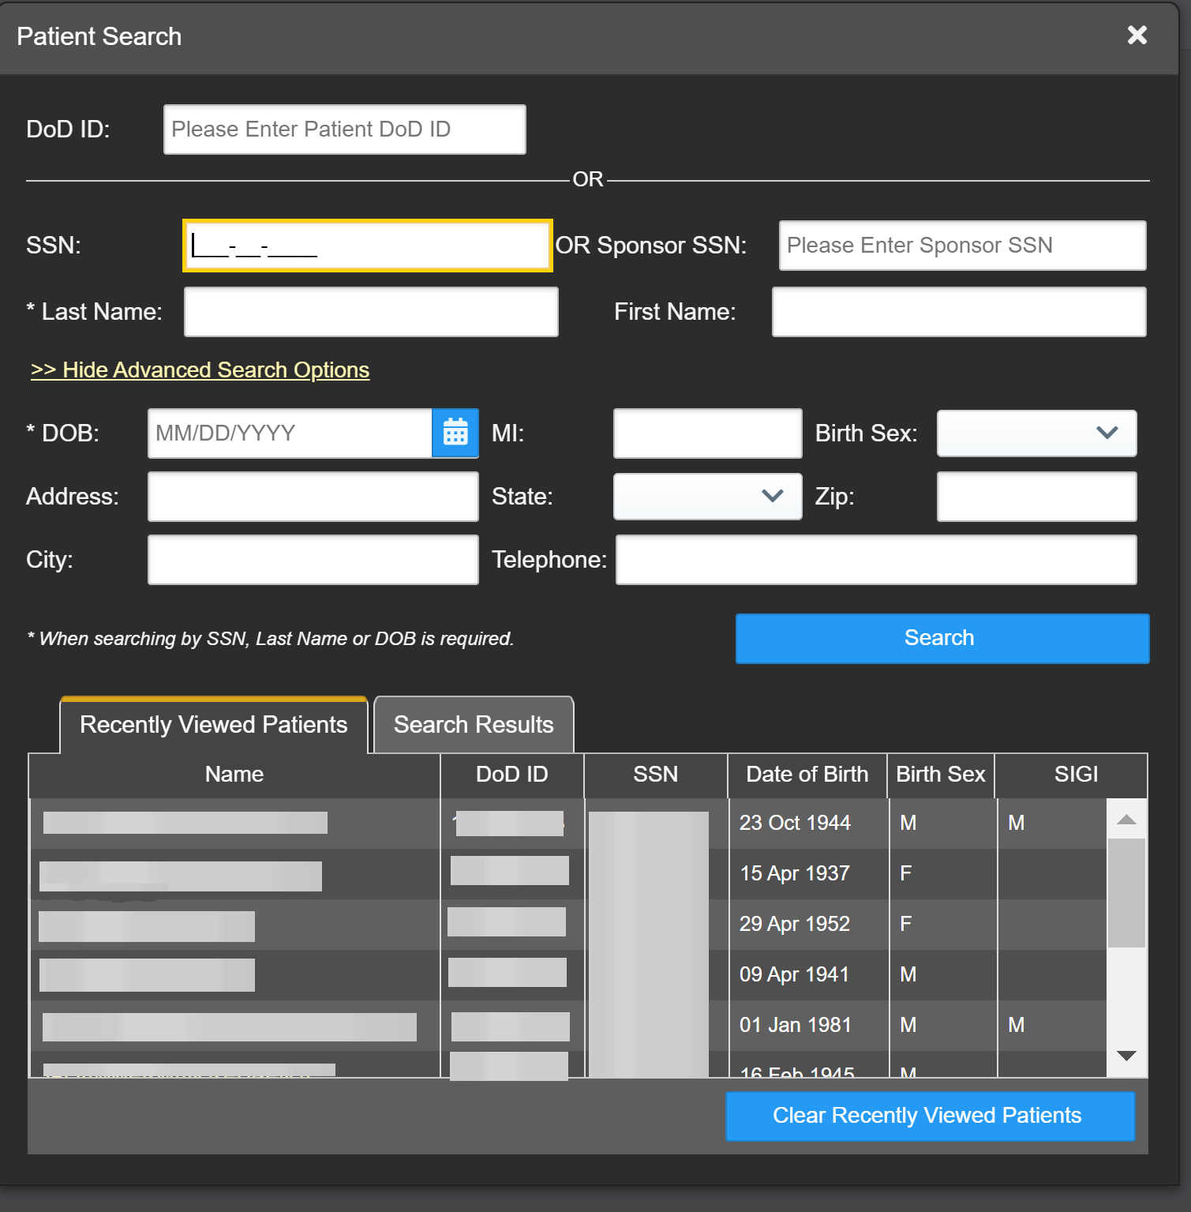

Widgets
Widgets are elements on the JLV Patient Data and Widgets page that display data specific to a clinical domain. By default, widgets are displayed in minimized view on the Patient Data and Widgets page (Figure 21), but they can be expanded to view additional details. Available widgets are listed in and launched from the widget tray.
NOTE: Widgets may take anywhere between 10 seconds to 90 seconds to load, depending on the date range settings.

Accessing and Opening Widgets
All available widgets display in the widget tray (Figure 47). Hover over a widget icon to view a description of the widget. Widgets can be opened, rearranged, and closed. JLV can display up to 12 widgets per tab.
Figure 47: Widget Tray
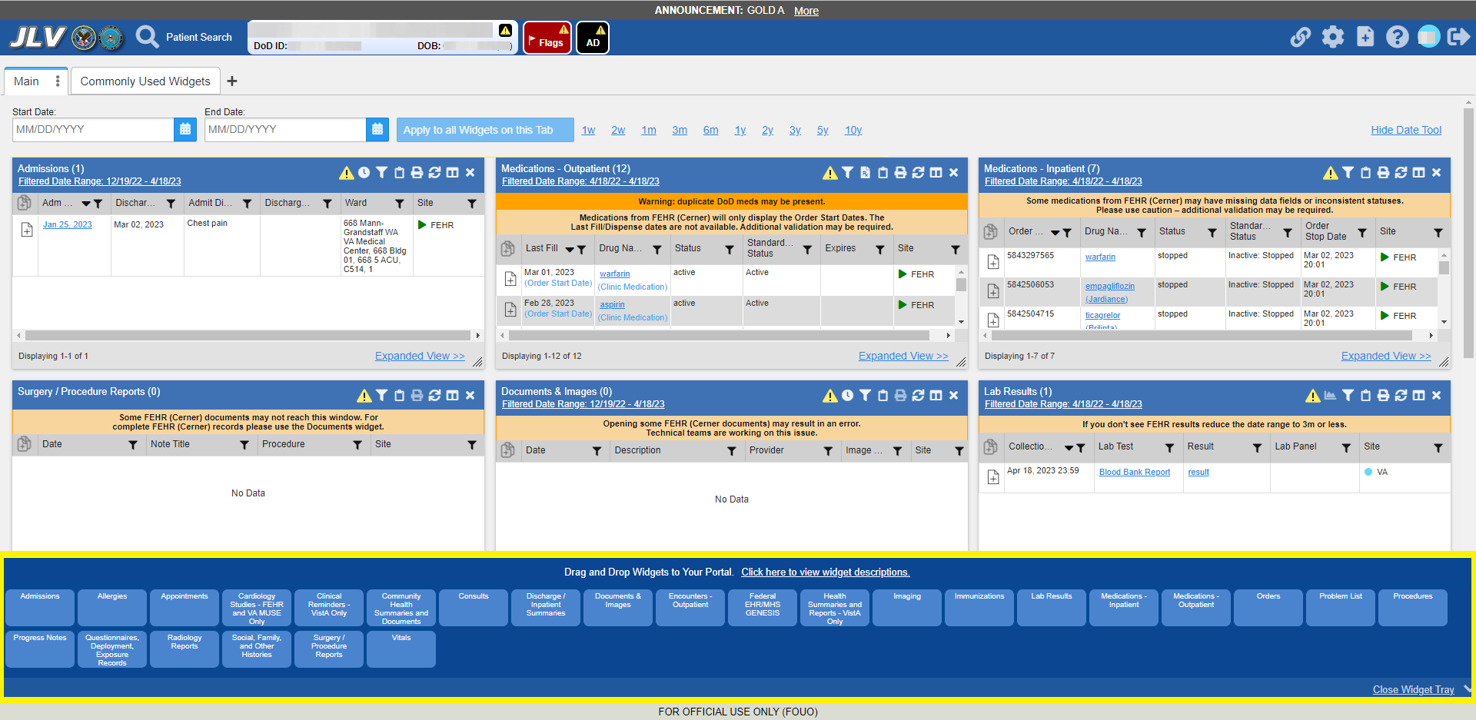

- Open the widget tray by clicking the Open Widget Tray link. You can also click the ⁝ symbol located on the selected tab, then select the Open Widget Tray link.
- Use the scroll bar arrows < > at either end of the tray to see all widget choices, or click the More Widgets >> link to scroll through the list of widgets.
- Click and hold a widget icon in the tray, drag it to the Patient Data and Widgets page, and drop it in the desired location.
  - The widget is docked on the page and opens in minimized view.
- Close the widget tray by clicking the Close Widget Tray link.
NOTE: JLV displays a Duplicate Widget notice if you attempt to add another instance of a widget to a tab.
Widgets can be closed (removed from the Patient Data and Widgets page) by clicking . Rearrange the widgets displayed on the page by dragging and dropping them.

Widget Navigation and Display Options
Each widget has tools and display options available to navigate through, and change, the display of data. The vertical scroll bar allows you to move through, and view, the widget’s data. Navigation icons and actions are detailed in Table 8.
Table 8: Navigation Icons and Actions
Navigation Icon | Action | Description
 | Changes the focus of the widget to the previous group or page of records within the results display. | Go to Previous Page
 | Changes the focus of the widget to the page number selected. | Jump to Page
 | Changes the focus of the widget to the next group or page of records within the results display. | Go to Next Page
Expanded View >> | Available in minimized views only. Opens the expanded view of the widget in a secondary window. | Go to Expanded View
1-25 of 55 | Indicates the number of records displayed in that widget page out of the total number of results for that widget. | Record Display Indicator
Show All/  Show Paged | Click Show All to open all records for a given widget in a scrollable window.  Click Show Paged to return to the display of records grouped by pages. | Display Setting
When there are more than 25 records available in a widget, they are grouped in Show Paged view. Records 1 through 25 can be viewed by using the widget’s vertical scroll bar. Records 26+ can be viewed by using or to view to subsequent pages. The expanded view of a widget contains a Show All link, which opens all records for that widget, in a scrollable window. Click Show Paged to return to the display of records grouped by pages.

Widget Toolbars
There is a toolbar on both the minimized and expanded views of each widget and most dialog boxes. Toolbar buttons vary by widget, dialog box, and window. Table 9 describes the functionality of each toolbar button.
Table 9: Widget Toolbar Icons
Icon | Name | Function
 | Add to Report Builder | Adds the information displayed in the widget to the Report Builder, including any Details or Notes.
 | Clinical Reminders | Opens the Clinical Reminders widget.  NOTE: This icon only appears on the Admissions, Appointments, Encounters-Outpatient, and the Documents & Images widgets.
 | Close | Removes the widget from the Patient Data and Widgets screen or closes a dialog box.
 | Column Settings | Configures the columns within the widget. Turn the columns on or off by checking the column names that appear in the pop-up box and clicking Apply.  NOTE: Column widths and window sizes are auto saved to user profiles for both the minimized and expanded views.
 | Configure Filter | Filters on specific record types or other elements within the widget, including a date filter. If a date range filter is applied in an open widget, the date range is displayed in the widget header.  NOTE: After setting a filter, the Close Filter option is enabled in the widget. Clicking Close Filter restores the full display of records within the widget.
 | Copy to Clipboard | Copies the selected content of the open window to the clipboard for pasting into another application. Copy to Clipboard is disabled in the widget toolbar after clicking Show All within a widget. The clipboard is cleared after closing a patient record, selecting a new patient record, and logging off JLV. Once a user chooses the column selections for Copy to Clipboard, the new selections for that widget will be retained even when switching to a new patient, unless restore default settings is executed.
 | Connection Status | Both icons provide a status indicator for DOD and VA data sources. indicates all sources are available. indicates one or more data sources are unavailable. Clicking either status icon opens the connection status details in a separate window.
 | Print | Prints the selected contents of the open window. Print is disabled in the widget toolbar after clicking Show All within a widget. Once a user chooses the column selections for Print, the new selections for that widget will be retained even when switching to a new patient, unless restore default settings is executed.  NOTE: It is recommended that you have the latest Adobe Reader installed for the Report Builder and other printing features.
 | Graph | Opens a dialog to configure the display of multiple data of the same type in a graph.
 | Refresh | Refreshes the widget or window display. Only the data within that widget’s dataset is updated.
 | Copy Active Rx to Clipboard | Converts the medication data within the widget to text and copies the text to the user’s clipboard. This option is available from the Medications - Outpatient widget. NOTE: Copy Active Rx is disabled when a date range filter is set to less than 120 days.
 | Widget Move | Opens a dialogue box with options to move the widget on the screen or inside the portal. NOTE: This is only available in the accessible theme.
 | Widget Resize | Opens a dialogue box with options to resize the widget on the screen or inside the portal. NOTE: This is only available in the accessible theme.

Minimized vs. Expanded Widget View
Each widget can be displayed in either a minimized (default) or an expanded view. Minimized view displays a simple list of the available patient data for a clinical domain, arranged in reverse chronological order by default. Expanded view provides a detailed list of similarly arranged patient data. When the expanded view of a widget is launched, it opens in a new, separate window that displays more attributes of the records in the widget, including additional, sortable columns of data.
NOTE: The Cardiology Studies - FEHR and VA MUSE Only, Community Health Summaries and Documents, and Federal EHR/MHS GENESIS widgets do not have an expanded view. Instead, a record opened from the minimized view of the widget is displayed in a new, separate window.
Click the Expanded View >>link in minimized view to launch expanded view and see the additional display and functionality options.

Sort and Filter Options
Widgets have a variety of methods to sort and filter data.
The Filter Indicator () in the widget header shows that column or text filters have been applied.
In general, you can:
- Click a column title to sort records according to data in that column.
  - If you sort a column that appears in both minimized and expanded views of the widget, the sort saves in your user profile and persists. Data views persist from minimized to expanded views and expanded to minimized views.
  - If you sort a column that is only in the expanded view of the widget, your next session restores the default widget sort, or the last sort saved to your user profile.
  - If you sort a Date column that has some partial or missing date values, understand:
    - Dates that have month and year, but lack a day are treated as though the day were “00” (e.g., July 2018 sorts between June 30, 2018 and July 01, 2018).
    - Dates that have a year only are treated as though the month is January and the day is “00” (e.g., 2018 sorts between December 31, 2017 and January 01, 2018.
- Click on the widget toolbar to show or hide columns within the widget.
  - Check/uncheck the column names that appear in the pop-up dialog box, then click Close.
- If a widget’s column data contains blanks, the column Filter popup will move all blanks to the bottom of the list. If there are no blanks in the widget, the Filter will not be available as a selection in the column.
Sort and filter capabilities are specific to the data presented in each widget and may vary between the minimized and expanded views of an individual widget or between widgets. Table 10 lists available filters and their corresponding widgets.
Table 10: Available Widget Filters
Filter By | Widgets
Site | Admissions, Allergies, Appointments, Consults, Documents & Images, Health Summaries and Reports, Medications - Inpatient, Discharge/Inpatient Summaries, Lab Results, Orders, Encounters - Outpatient, Medications - Outpatient, Problem List, Procedures, Progress Notes, Questionnaires, Deployment, Exposure Records, Radiology Reports, Social, Family, and Other Histories, Surgery/Procedure Reports, Vitals
Site (Reporting) | Immunizations
Provider | Discharge/Inpatient Summaries, Progress Notes, Surgery/Procedure Reports
Provider Specialty | Appointments, Consults, Documents & Images, Discharge/Inpatient Summaries, Orders, Encounters - Outpatient, Procedures, Progress Notes
Clinic | Appointments, Encounters - Outpatient
VA Health Factors | Admissions, Appointments, Documents & Images, Encounters - Outpatient
Consult Order | Consults
Description | Documents & Images
Problem Description | Problem List
Standardized Description | Documents & Images, Problem List
Location | Admissions, Allergies, Appointments, Assessments, Consults, Documents & Images, Discharge/Inpatient Summaries, Encounters – Outpatient, Federal HER MHS GENESIS, Imaging, Lab Results, Medications - Inpatient, Medications – Outpatient, Orders, Problem List, Procedures, Progress Notes, Questionnaires, Deployment, Exposure Records, Radiology Reports, Social, Family, and Other Histories, Surgery/Procedure Reports, Vitals
Source System | Documents & Images
Vaccine Administered Product Type | Immunizations
Standardized Vaccine Product Type | Immunizations
Drug Name | Medications - Inpatient, Medications - Outpatient
Standardized Drug Name | Medications -Inpatient, Medications -Outpatient
Ordering Health Care Provider (HCP) Specialty | Medications - Inpatient, Medications - Outpatient
Note Type | Discharge/Inpatient Summaries
Lab Test | Lab Results
Type | Lab Results; Orders; Problem List; Procedures; Social, Family, and Other Histories; Vitals
Standardized Type | Orders, Vitals
Status | Problem List
Document Type/Title | Progress Notes
Standardized Document Type | Progress Notes
Exam | Radiology Reports
Standardized Radiology Exam | Radiology Reports
Standardized Finding | Social, Family, and Other Histories
Note Title | Surgery/Procedure Reports
Procedure | Surgery/Procedure Reports
Filter dropdowns dynamically expand and sometimes have a horizontal scroll bar to display long lines of data by which records can be filtered (Figure 48).
Figure 48: Dynamically Expanded Filter Dropdown in the Documents & Images Widget
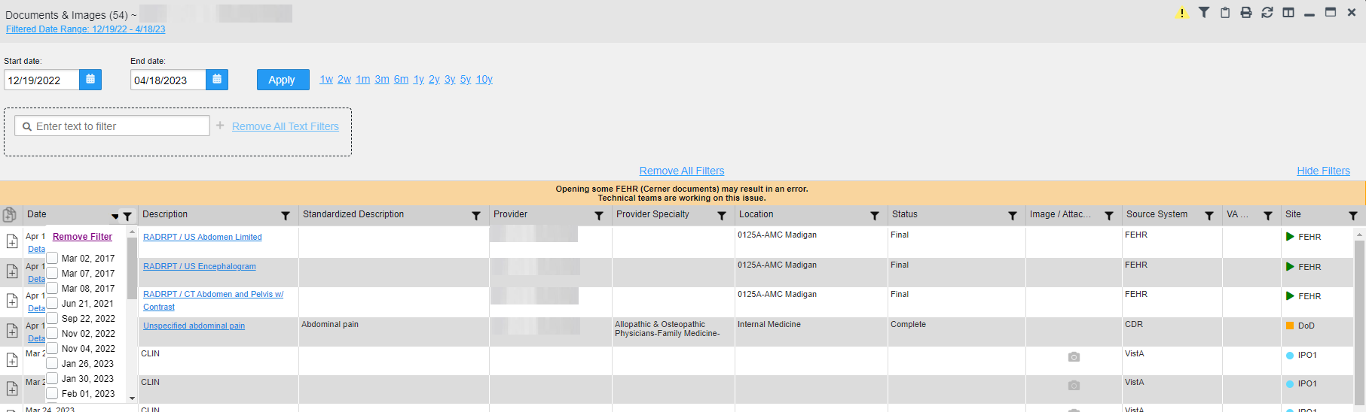

Some widgets also have the capability to configure data to display multiple records of the same type in a graph or table view.

Widget Date Range Filters
Patient data displayed within a widget can be filtered by date range. If a date range filter is applied, the selected range is indicated in the widget header. Click or the Filtered Date Range link on the widget toolbar to change the date range of the data displayed (Figure 49).
Figure 49: Date Range Filters Applied
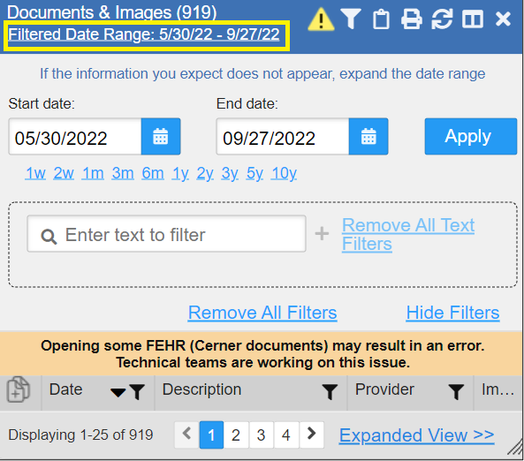

The two ways to filter the date range of data displayed in a widget are the Quick Date Range filter and the Start and End Date filter. If the expected information does not appear in the widget display, use the date filter options to change the date range.
- NOTE: Changes made to the date range in a widget persist from minimized to expanded view, expanded to minimized view, patient to patient, and session to session, until the widget is either removed or the date range is changed.
- NOTE: When looking for Essentris information associated with a specific admission in the Discharge/Inpatient Summaries widget, expand your search date ranges to include additional days before and after the admission. This includes preadmission notes as well as notes signed after the patient was discharged in the filtered widget display.

Quick Date Range Filter
Use the preset, Quick Date Range filter to set or limit the display of patient records within a widget. This option is available by clicking the Filtered Date Range link or by clicking in a widget on the Patient Data and Widgets page.
Clicking a Quick Date Range filter refreshes the data displayed to show only the records for the selected range. Selecting Cancel, which is the Apply button while the data refresh is running, stops the query. The options represent time counting back from the present day (for example, selecting 2y displays only records within the last 2 years). Examples of preset date ranges include 1w (last 7 days), 6m (last 6 months), and 3y (last 3 years).
NOTE: The Quick Date Range filter is contextual. If today is February 2, 2021, the preset filter counts backwards using that date. If today is April 16, 2021, the preset filter counts backwards using that date.
Figure 50 highlights the Quick Date Range filter options in the expanded view of the Documents & Images widget.
Figure 50: Quick Date Range Filter Options
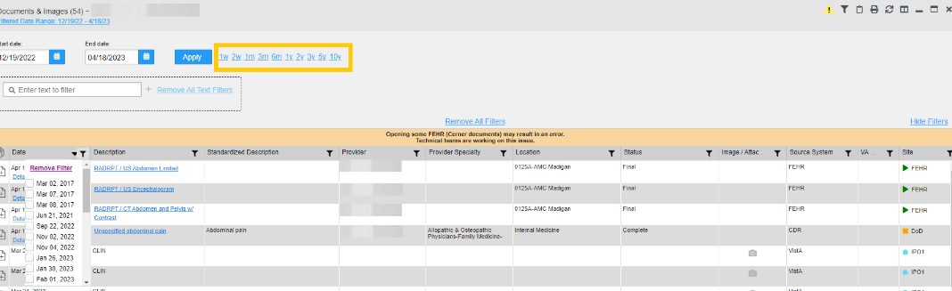

Start and End Date Filter
Use the Start Date and End Date filter to display data for a specific time range. Click the Filtered Date Range link or .
NOTE: The Start and End Date filter is static. If the start date is set to June 2, 2016 and the end date is set to June 2, 2017, the data in that date range displays, no matter what today’s date is.
Figure 51 provides an example of the start and end date filter fields in the expanded view of the Admissions widget.
Figure 51: Start and End Date Display Filter
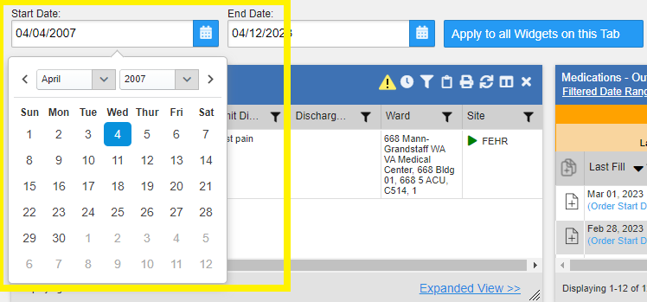

- Click next to Start Date.
- Select a month, day, and year start date for the display filter.
- Click next to End Date.
- Select the month, day, and year end date for the display filter.
- When both a start and end date have been chosen, click Apply.
- (Optional) Click Cancel to stop the query.
NOTE: Prior day selections persist if you change only the month or year. If you change the month or year and the prior day value does not exist, the calendar will default to the last day of the new month. For example, changing only the month value of an existing August 31, 2018 entry to February would set the date to February 28, 2018 because there are less days in February. Similarly, if you had February 29, 2016 selected, a day which only exists in a leap year, switching the year to 2015 would set the date to February 28, 2015, the last day of the month in a standard year.
The widget refreshes and displays only the records that fall within the custom date range. The date range in use is displayed in the widget header.

Tab Date and Text Filter Tool
All tabs in the Patient Data and Widgets page have a Tab Date and Text Filter tool that you can use to filter all widgets on a single tab by the same date range or text. The Tab Date and Text Filter tool has the same Start and End Date and Quick Date Range filters available on most individual widgets, but it applies the date filter to all widgets on an individual tab.
- Select the Show Tab Date and Text Filter Tool hyperlink, or the ⁝ button and then select the Show Tab Date and Text Filter Tool hyperlink.
- Enter dates in the Start Date and End Date fields or select a Quick Date Range value, select the applicable widgets, then select the Apply to Selected Widgets on This Tab button. To reset the date ranges of widgets, select Restore Default Date Ranges, select the applicable widgets, then select Restore Default Date Range for Selected Widgets. OR
- Enter text in the Text Filter section and select the Apply button. Select the widgets you want to apply the text filter to, then select Apply Text Filter to Selected Widgets on this Tab. If the widgets are grayed out, check if you have already applied this filter. You can Lock, Unlock, Remove, or Unlock and Remove text filters once it is applied.

The Tab Date and Text Filter tool (Figure 52) is hidden by default. After you apply a date range or text filter, the tool remains open unless closed manually.
Figure 52: Tab Date and Text Filter Tool
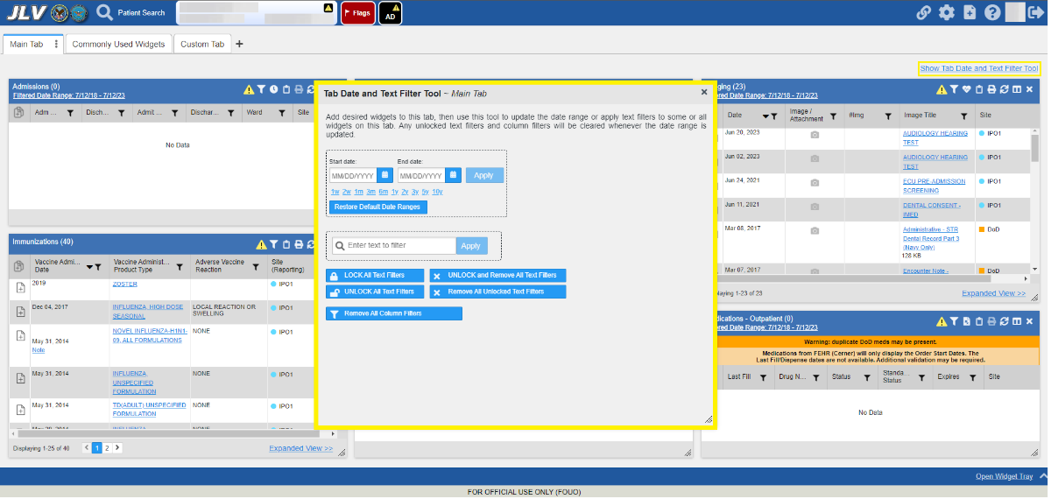
The Tab Date and Text Filter tool only filters widgets currently displayed on the active tab that support date range filtering. Widgets that display all data, without a date range, will continue to do so. Filtering only applies to widgets on the tab at the time you apply the Tab Date and Text Filter tool and will not affect new widgets added to the tab. You may still apply widget-level date and text filters to individual widgets even after using the Tab Date and Text Filter tool. All your widget date and text settings will save to your profile regardless of whether they were set with the Tab Date and Text Filter tool or widget-level date or text filters.

Text Filter
Widgets provide a text filter option (Figure 53), allowing you to quickly locate relevant patient data using keywords or characters by applying multiple text filters. Text filters are performed on the information displayed in all columns within a widget, including hidden columns. Filters are not performed on notes, attachments, or details associated with patient records.
Figure 53: Documents & Images Widget Text Filter
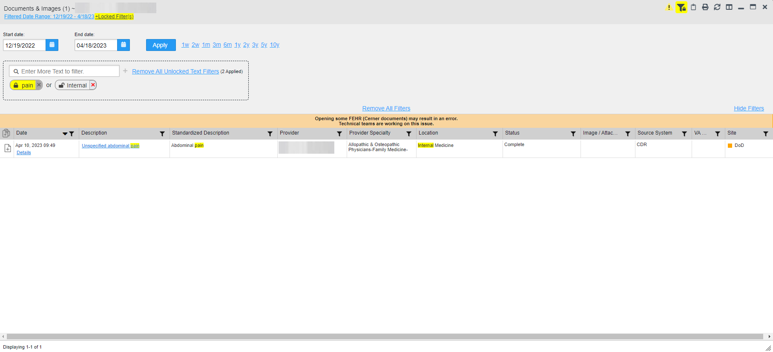

Click in the minimized view of a widget to display the Enter text to filter field. If the filter options are not displayed in the expanded view of the widget, clicking also opens the filter options.
- A text filter box is displayed in the widget filter section. When text is entered, a pop-up box displays with “Press Enter or the + button to apply to filter.”
- The applied search term is displayed below the text filter box with a red “X” next to it which allows a user to remove it and updates the search results accordingly.
- The funnel shaped icon and the +Filters displays with a yellow highlighted color to indicate that a filter has been applied in the widget.
- If another search term is typed in the Text Filter Box and the user clicks “enter” or “+”, a second text filter is applied against the ORIGINAL DATA SET. Filtered results from a second text filter search are displayed in addition to the results from the first text filter search.
- If a third text filter is applied against the ORIGINAL DATA SET, filtered results from the first and second text filter searches are displayed in addition to the results from the third text filter search.
- The text filter box is disabled after a total of 10 text filters search terms are applied. Each search term can be up to 20 characters. The Text Filter Box remains disabled until one (or all) search terms are removed. A message displays with instructions that the maximum number of search terms have been applied, and to remove one or all terms to apply a different search term.
- The word "or" will appear between the search bubbles when multiple text filters are used.
- Text filtering applies only within the widget being searched.
- Text is filtered within the subset of filtered data if a date range filter or other dropdown filters are applied within the widget.
- Text filters are performed on data within all columns. Some widgets have columns that are not shown by default in either the minimized or expanded view.
- Text filters entered in the minimized view of a widget persist when you open the widget in expanded view, except for the Vitals and Lab Results widgets.
- On widgets with site tabs, text filters entered on one site tab persist when you select other site tabs.
- All records across the widget pages are filtered if the widget has multiple page views.
- The Enter text to filter field is not case sensitive and allows up to 25 characters, including numeric and special characters.
- JLV begins to filter when you pause while typing the term in the Enter text to filter field.
- Text filtering is not available in the Demographics widget.
- If a column is hidden, all filters are removed from that column in minimized and expanded views.
- Filtered text is highlighted.
- Users can lock and persist multiple text filters in a widget. This allows automatic application of key search terms to any patient chart.
- If a text filter is locked, the word will be highlighted in yellow with the locked icon closed and the “X” in gray. This text filter will not be able to be removed until unlocked.

Viewing Connection Status
JLV widgets display the status of their connection to VA and DOD data sources. Connection status information is available for each widget.
NOTE: The Connection Status reports the condition of the connection between JLV and its external resources, while System Status reports the overall condition of the JLV application. See Viewing System Status for more information.
The Connection Status indicator icon on a widget toolbar indicates the state of the connection to VA and DOD data sources. There are two status conditions:
- All sources are connected (available).
- One or more sources are not connected (unavailable).
Figure 54 shows in the Demographics widget. When the Primary Care Management Module (PCMM) service is unavailable, the primary care fields in the Demographics widget display this error message: “Team assignment system is currently unavailable.”
Figure 54: Demographics Widget, PCMM Connection Status Unavailable
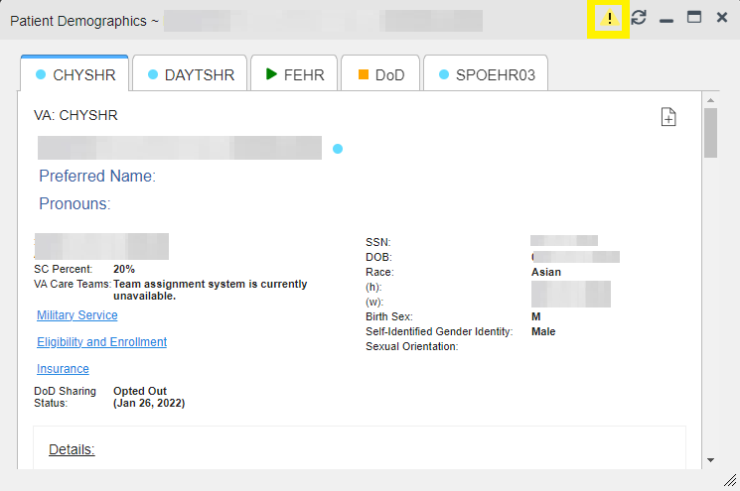
Figure 55 shows a connection status indicator icon displayed on the Patient Flags widget toolbar.
Figure 55: Connection Status Indicator
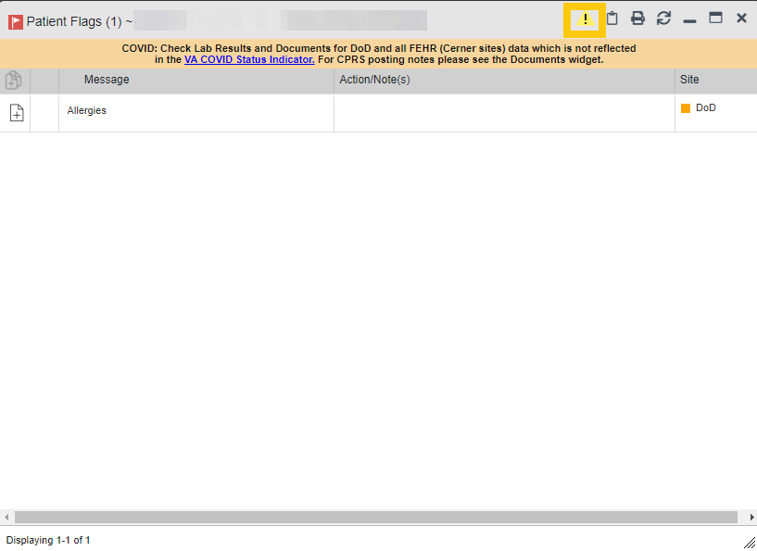

Clicking a Connection Status indicator icon (Figure 55) opens a standalone window with information about the connection to data sources. Clicking the < Hide All Active Interfaces link (Figure 56) in the Connection Status window hides the detailed All Active Connections view and displays only the connection errors and connection time out errors.
Figure 56: Connection Status Details
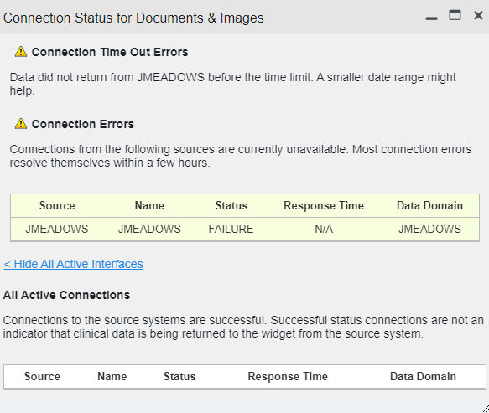

Clicking the > Show All Active Interfaces link in the Connection Status window (Figure 57) opens a Connection Status Details view (Figure 56).
Figure 57: Connection Status Window
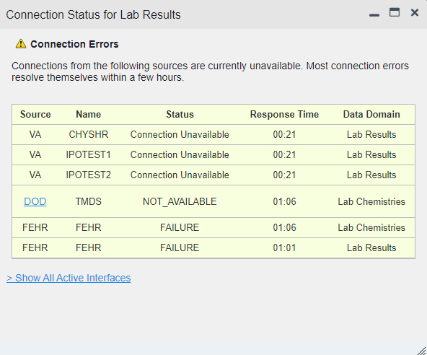

Displaying Widgets on Custom Tabs
You can use the custom tabs feature to create additional widget configurations for ease of use and quick reference. Changes made to the Patient Data and Widgets page layouts (widget layouts and custom tabs) are saved to your user profile and displayed in future sessions.
- Click beside the existing tabs on the Patient Data and Widgets page (Figure 58).
  - The Add Tab dialog box opens (Figure 59).
Figure 58: Add Custom Tab Icon
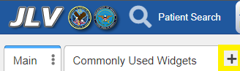
Figure 59: Add Tab Dialog Box
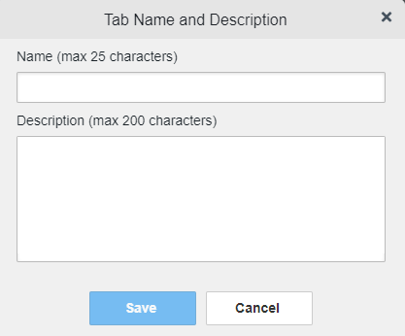

- Type the name of the new tab in the Add Tab dialog box, along with a description, and click Save. A message will display if there are any duplicate Tab names, or if max character limits have been reached for the name or description for the custom tab.
  - The custom tab opens with a blank workspace, with instructions on how to add widgets and an open widget tray.
  - After the tab has been created, hovering on the tab name will display the tab description.
- Click, hold, and drag each of the desired widgets to the screen (max 12).
- Click between tabs at any time, without losing each tab’s configuration. Click, hold, and drag the tabs into any order, when there is more than a single tab.
  - Tab layouts persist, even when a patient change is made.
- Hovering over the Tab Menu area of the selected tab, the options to Edit Name and Description, Create a Copy, and Delete will become available.
  - When creating a copy of a tab, a copy of the tab name will be created with all the settings from the copied widgets, filters, etc.
  - Once the copy has been created, the two tabs will be independent of each other.
NOTE: Tab configurations remain set until you manually change them or restore your profile to default in the JLV Settings dialog, which will remove all custom tabs.

Exporting Tabs
Users can export one or more tabs using the Export Tabs option, located under Settings. Upon clicking Export Tabs, a scrollable list of tabs will be available to export in the same order as in the user’s JLV application, with a tab description available as a hover hint.
Figure 60: Export Tabs
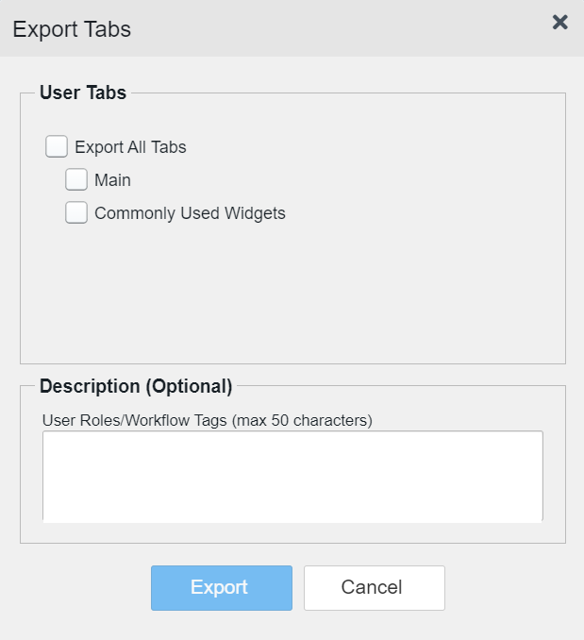
By default, no tabs are preselected within the list, but users may choose one, multiple, or all tabs as seen in (Figure 60). The Export button will become highlighted when one or more Tabs are selected. An optional description may be added with up to 50 characters that will be included in the Export.
After clicking Export, a Save As dialogue box will appear with a default export file name, <userLastNameFirstName>_JLV_tab_config. Users will be able to edit the name of the exported tab however, the extension will be fixed to .JSON and is not changeable. Users can then save the exported config to a local or shared drive.

Importing Tabs
JLV users will be able to import one or more tabs using the Import Tabs option (Figure 61), located under Settings. When this option is selected, the user sees a dialogue box where .JSON files will be displayed, any available tab descriptions will be displayed as a hover hint on the tab name. After the user clicks Import, the user’s current configuration is saved and JLV starts the tab import.
Figure 61: Import Tabs
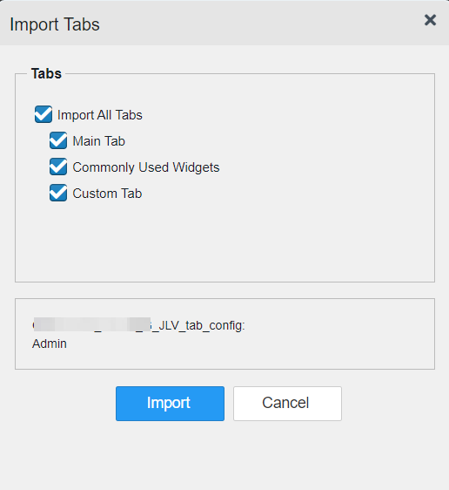
The imported tab will display to the right of the last tab. If the tab is imported and it does not exist only the <tabname> will appear. If a tab with the same name already exists in the user’s JLV workspace, the tab being imported will be named <tabname>*, and on subsequent duplicates, the imported tabs will be named with added asterisk, <tabname>**.
An information dialogue popup will be displayed that the import was successful (Figure 62). When the user logs out and logs back in, the imported tabs will still be displayed.
Figure 62: Import Successful
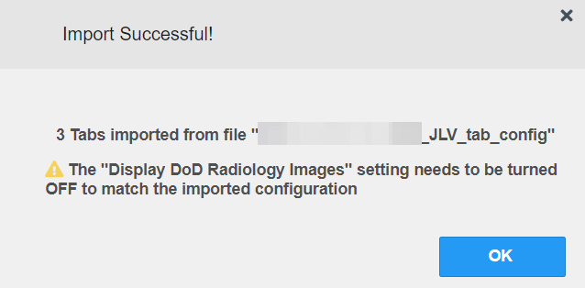
If the import is unsuccessful due to an incorrect file type, an alternate popup will appear (Figure 63).
Figure 63: Import Failed
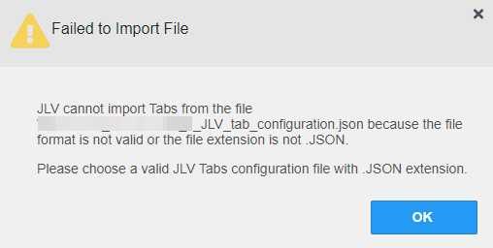

Refreshing Data in a Widget
The data displayed in a widget can be refreshed by clicking . This action retrieves data from VA and DOD sources and refreshes the individual widget’s display.

Terminology Normalization
Table 11: Terminology Specific to Widgets
Normalization  Standard | Description | Widgets
Centers for Disease Control (CDC) Race Standard | Code set based on the current Federal standards to classify race and ethnicity | Patient Demographics
Current Procedural Terminology (CPT) Standard | Uniform code to describe medical, surgical, and diagnostic services | Procedures, Radiology Reports
Vaccine Administered (CVX) Standard | Numeric string that identifies the type of vaccine product used | Immunizations
Logical Observation Identifiers Names and Codes (LOINC) Standard | Universal standard for identifying health measurements, observations, and documents | Discharge/Inpatient Summaries, Documents & Images, Lab Results, Orders, Progress Notes, Questionnaires, Deployment, Exposure Records, Assessments, Radiology Reports, Vitals
National Uniform Claim Committee (NUCC) Taxonomy Standard | Unique, 10-character alphanumeric code that identifies a provider grouping, classification, and area of specialization | Admissions, Appointments, Consults, Documents & Images, Medications - Inpatient, Discharge/Inpatient Summaries, Orders, Encounters - Outpatient, Medications - –Outpatient, Procedures, Progress Notes
RxNorm Standard | Standard names given to allergens, clinical drugs, and drug delivery devices in the United States | Allergies, Medications - –Inpatient, Orders, Medications - –Outpatient
SNOMED CT Standard | Core, general terminology used in electronic health records | Admissions, Encounters - –Outpatient, Problem List
X12 Health Insurance Type Standard | Defines electronic data interchange standards for health care insurance | Patient Demographics

Image Support
JLV integrates access to the VistA Imaging Viewer and MUSE, allowing you access to VA imaging artifacts for supported clinical domains (widgets). Please see the REDACTED for more information regarding the VistA Imaging Viewer.
You can open one or more images associated with a record by selecting the displayed in the Image column (Figure 64) of the Advanced Directives, Cardiology Studies - FEHR and VA MUSE Only, Documents & Images, Imaging, Procedures, Progress Notes, Radiology Reports, and Surgery/Procedure Reports widgets. Clicking from the Image column opens the image(s) in a standalone window. Like a hyperlink, changes color after you launch an image so you can track which images you’ve viewed in the minimized or expanded widget view of the current session. Changing between minimized and expanded view resets the color.
Figure 64: Camera Icon in the Image Column
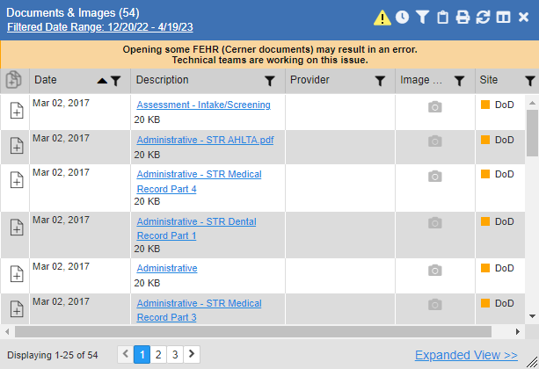

If a record has one or more images associated with it, the Details view of the record includes a thumbnail with a Click image to open viewer link (Figure 65). Clicking either the thumbnail or the link opens the VistA Imaging Viewer and displays the associated image(s).
Figure 65: Thumbnail and Link in Details View of the Documents & Images Widget
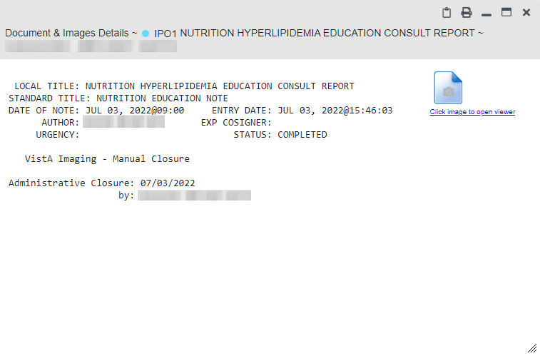

Using Report Builder
The Report Builder feature is used to create custom PDF reports using patient data and records displayed in JLV widgets. Content for reports can be selected from either the minimized or expanded view of a supported widget. You can launch Report Builder from the toolbar on the Patient Data and Widgets page (highlighted in Figure 66).
Figure 66: Report Builder Icon

The Report Builder pane is comprised of the New Report tab (Figure 68) and the Saved Reports tab (Figure 69). When open, the Report Builder appears docked on the left side of the Patient Data and Widgets page. It can be moved and docked anywhere on the page. JLV will save the location the user selects for the RB window, but will be reset with the option to restore user settings.
Figure 67: Report Builder Header Icons
Click the show () or hide icon () to display or hide the Report Builder.
Click the Pin icon () to pin or unpin the Report Builder to a location in the interface. When unpinned, users are able to resize the Report Builder window horizontally from both the left and right edges, and vertically from the lower edge. The unpinned Report Builder will not be able to be positioned where it could hide the tab name or the top JLV banner. The bottom edge will always be clearly visible so it can be resized without moving it. The unpinned size will be saved for the current and subsequent JLV sessions.
Click the Close icon () to close the Report Builder. Any report configurations in progress are saved when collapsing or closing the Report Builder and restored when the Report Builder is displayed again.
If Report Builder is hidden or out of focus, clicking on the Report Builder icon or on any visible part of the Report Builder popup will bring it back into focus.
The New Report tab (Figure 68) is used to build the custom report. The patient data and/or records are listed here as you select and add them. The print linked artifacts in the report box will be checked automatically, with all attachments that are unable to be printed denoted by **. The option to Clear All records after Build will need to be manually checked if the functionality is desired. The records can be arranged in the desired order for the final report. The total number of New Reports will appear on the tab. Once a record is selected, users may use the to clear a record. If the selected record is no longer visible after scrolling the user will be unable to take any actions on the selected record until it is visible again. Users will be able to unselect the already selected record by clicking on the record again, If Report Builder is closed, the record will be automatically unselected.
Figure 68: New Report Tab
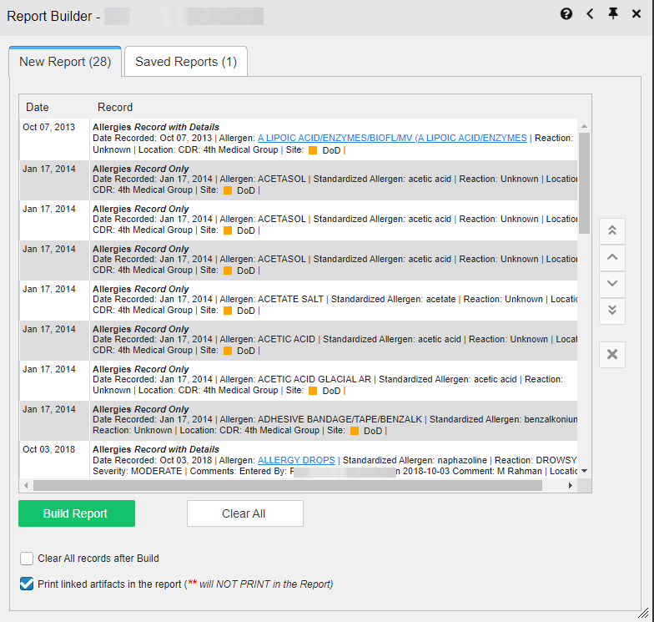

The Saved Reports tab (Figure 69) presents a list of all completed reports with the option to select one or all of the reports for action, the status of the report generation progress, the date the report expires which is seven days, the report size, and a hyperlink to the contents of the completed report. If one or more is selected, Saved Reports can be deleted or downloaded using the buttons.
Figure 69: Saved Reports Tab
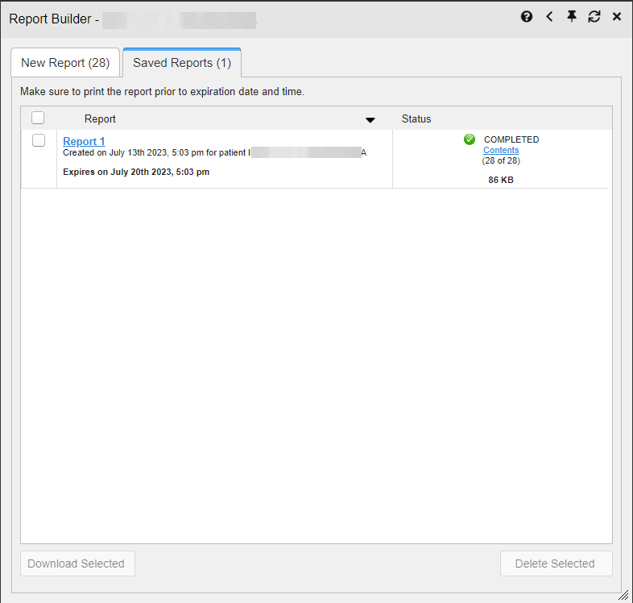

You can perform actions within widgets to add patient data when the Report Builder is open or closed. JLV enforces a maximum number of 200 records per report, where no more than 100 of these records have attachments. A message appears when this limit is reached.

Adding One Record
Click next to a record in a widget to add data from that record to the Report Builder, including the details and notes associated with the record. in the row changes to 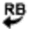 to confirm the record has been added to the Report Builder (Figure 71). This applies to both minimized and expanded widget views and the Patient Flags dialog box.
- NOTE: A single site report can now be added to the Report Builder from the Blood Bank Report in the Lab Results widget.

Removing One Record Directly from a Widget
Click to remove a singular record from Report Builder directly from a widget. The record will be removed from Report Builder and will no longer display in the Report Builder selected records. The icon will change back to.

Adding Multiple Records with EZ Select
EZ Select allows you to add all records displayed on a single page of a single widget to the Report Builder with one click. Click (Figure 70) to add data from all records shown in the widget's page display to the Report Builder, including the details and notes associated with the record. EZ Select is available from the minimized and expanded views as well as the Patient Flags dialog box.
NOTE: Sensitive records and Medication Administration History (MAH) / Medication Administration Log (MAL) reports accessed from the Medications - Inpatient widget cannot be added using EZ Select. You must add them to a report one at a time, and you can only add MAH/MAL to reports from Detail view in the Medications - Inpatient widget. However, you can use EZ Select to add MAH/MAL reports to Report Builder from the Health Summaries and Reports widget.
Figure 70: Report Builder EZ Select
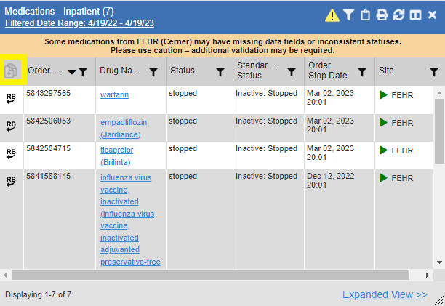
in each row changes to to confirm the record has been added (Figure 71).
Figure 71: Records Added to Report Builder
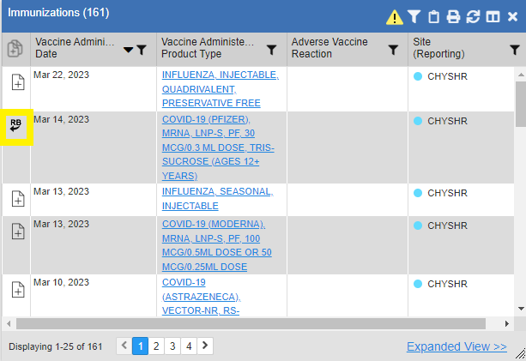
NOTE: Records previously added to a report remain in the Report Builder after a widget refresh. Clicking in the widget refreshes the clinical data, refreshes the widget data display, and resets to , even if the record has been added to the Report Builder. Records previously added to a report prior to the refresh remain in the Report Builder after a widget refresh.

Adding Details from Multiple Dates
When the Details view of a record has a date filter (Figure 72)—as in the Health Summaries and Reports, Medications - –Inpatient, and Procedures widgets—resets to each time you change the date range, allowing you to build date-flexible reports using records from multiple date ranges.
Figure 72: Adding Date-Flexible Details to Report Builder, Medicine Full Report
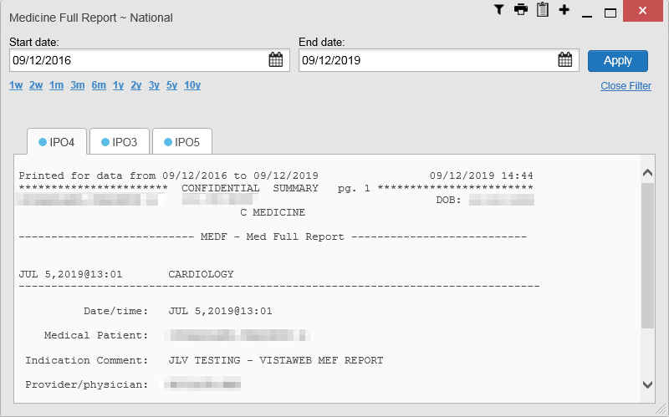

Adding Sensitive Records
Sensitive records can be added to the Report Builder by for a sensitive record in the widget. When prompted, click Agree to be Audited & Access This Sensitive Record to continue. in the row changes to to confirm the record has been added (Figure 71). Sensitive records must be added to the Report Builder individually; therefore, repeat as necessary for additional sensitive items.

Adding Only Record Details or Notes
When adding records to a report using or in the widget, JLV by default adds the data displayed in the widget as well as any details and notes associated with the record. This applies to both minimized and expanded widget views and the Patient Flags dialog box. If you would like to add just the details and notes or the record row data:
- Select and hold to access these options (Figure 73).
- Select Add Detail or Add Note to add the details and/or notes associated with the record as well as the record row data to the Report Builder.
- Select the Add Record Row option to add only the data displayed in the widget display for that record and not the information provided in the details and/or notes.
Figure 73: Report Builder Options
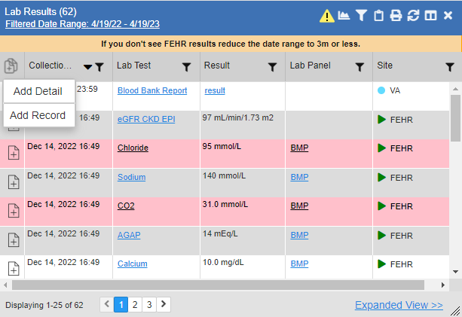

NOTE: Once you add a record to Report Builder using either the , Add Detail/Note, or Add Record Row option, you cannot change the record data included in the report without first clearing the record from the report and adding it again.

Adding Patient Demographics
Clicking in the Demographics widget (Figure 74) adds the patient's demographics details for that site to the Report Builder. changes to to confirm the demographics data has been added. Click additional site tabs within the Demographics widget and repeat as desired to add demographics details from other sites within the patient's health record.
Figure 74: Demographics Widget Add to Report Builder Icon
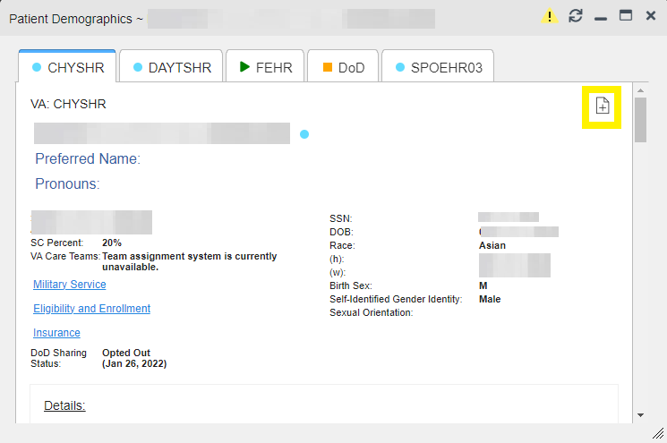

Generating a Report
The selected records appear in the Report Builder pane (Figure 68).
- Use the navigation arrows to arrange the records in the desired order in the generated report. When a record is selected for the report, the complete record will be visible including all the columns in the widget view, hyperlinks for details and attachments in the Record column of the Report Builder pane. The Record column will be sortable.
- Click Build Report to validate the selected records and prepare the report. If a record is added to the report without an error, a Ready notation displays next to it in the Status column. If a record cannot be added to the report, an Error notation appears next to the record. Users will have the option to Clear All of the records after the report starts to build. If the user cancels the build, the records will not be cleared.
- Name the report when prompted, and click OK (Figure 75)
Figure 75: Name Report Dialog Box
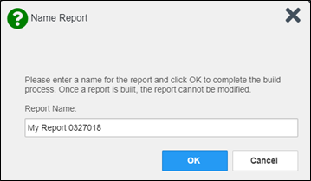

- The Saved Reports tab opens and displays a report processing indicator in the Status column.
- When processing is complete, the Status column displays either COMPLETED or ERROR (Figure 76).
  - An ERROR in the Status column does not indicate the report failed to build, it is an indicator that one or more records could not be included in the generated report.
  - Both the COMPLETED and ERROR entries include a Contents link (Figure 76), which provides a list of the records that appear in the generated report.
Figure 76: Saved Reports Tab Report Ready and Delete Option
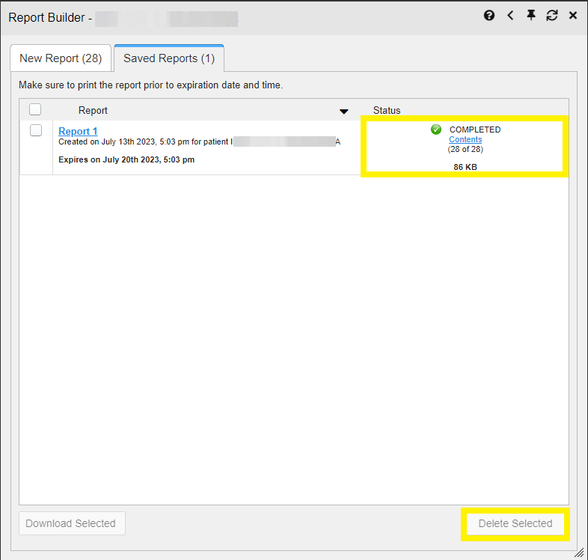

  - A report ready message appears for 6 seconds on the Patient Data and Widgets page when the report has been built and is ready to be printed (Figure 77).
Figure 77: Report Ready Message and Indicator

NOTE: Once a report is created, it is available on the Saved Reports tab for seven days. After seven days, the report expires, is removed from the Saved Reports tab, and can no longer be accessed.

Opening a Report
- Click the report name in the Report column of the Saved Reports tab (Figure 76) OR -
- Click the Contents link in the Status column of the Saved Reports tab to open a list of the records included in the report in the Report Contents window (Figure 76) OR -
- Click the blue, hyperlinked report name in the Report Contents window (Figure 78).
Figure 78: Report Contents Window
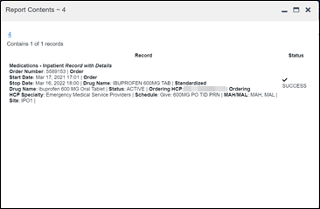
NOTE: The Report Builder prints the report content to a file in PDF format. It is recommended that you have the latest Adobe Reader installed on the system from which you access JLV to utilize the Report Builder and other JLV features.

Delete a Report
- Select the checkbox for the report name on the Saved Reports tab (Figure 76).
- Click the Delete Selected button.
- Click OK to confirm deletion (Figure 79).
Figure 79: Delete Reports Dialog Box
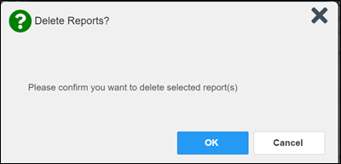

Downloading and Printing a Report
There are two ways to download a report.
Option1: Once a new report has been created, click on the hyperlink to open the report (Figure 80).
.
Figure 80: Report Hyperlink
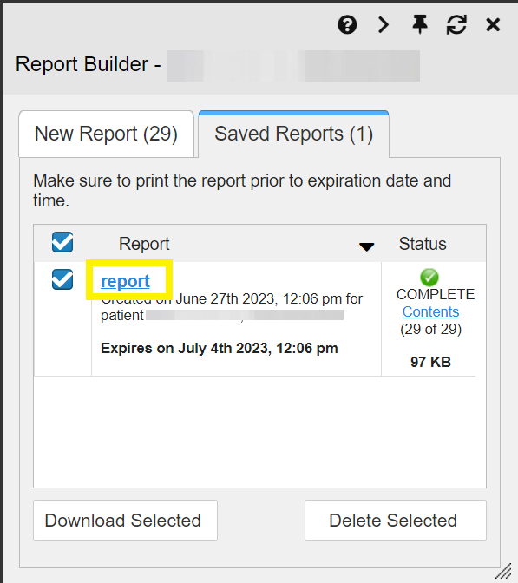
Click the . . . option (Figure 81) within the report window to download an Adobe PDF report created in Report Builder. A printing option will be visible within this view.
Figure 81: Printing the Downloaded Report
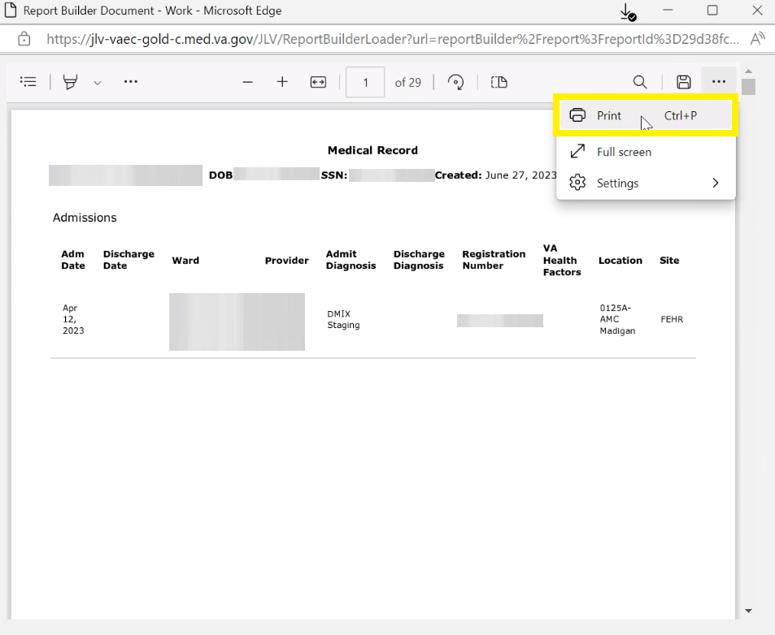
Option 2: After a report has been built, select the check box next to the report name. Then, click on the Download Selected button (Figure 82).
Figure 82: Download Selected Option
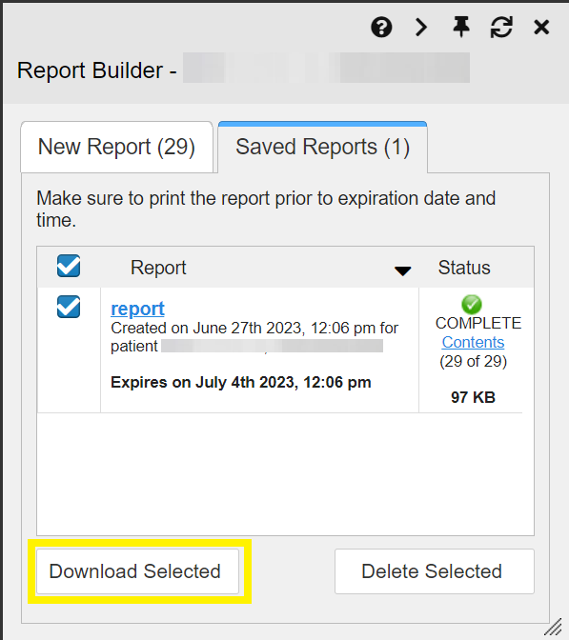
Once the file is finished downloading, select Open (Figure 83).
Figure 83: Opening the PDF
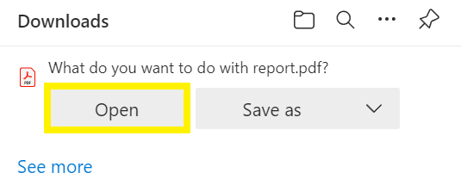
To Print the report, click on the print icon in the toolbar (Figure 84).
Figure 84: Print Icon on the PDF
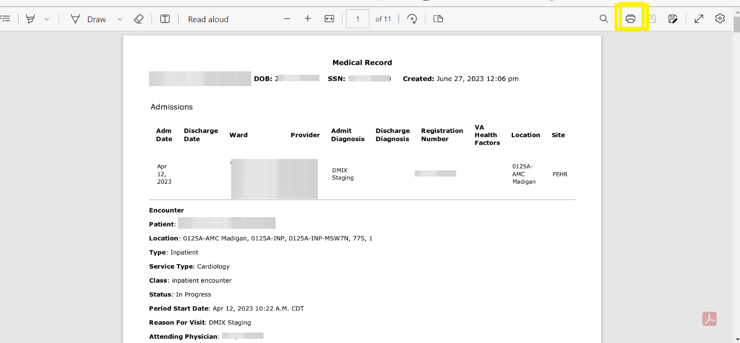

Printing
The data list of a widget in either minimized or expanded view, the details window of a widget, and reports created in Report Builder can be printed.
- Click on the desired widget’s toolbar to print the data list of a widget in either minimized or expanded view.
- Click on the details window’s toolbar to print the details window of a widget.
- Click the (PDF) Print icon within the report window to print a report created in Report Builder.
The columns currently displayed in the widget will be checked by default in the column popup box. The print selections for the widget will remain, even when switching patients, unless restore default settings is executed.
NOTE: Each report generated using Report Builder includes this disclaimer: “The information contained in this transmission may contain privileged and confidential information, including patient information protected by federal and state privacy laws.”

Widget Functionality
The following subsections detail the functionality in a sampling of the widgets available in JLV.

Patient Demographics Widget
The Patient Demographics widget displays a summary of the patient’s nonclinical, personal data on the primary JLV toolbar (Figure 85). Clicking the Patient Demographics widget will open the expanded view of the widget (Figure 86).
Figure 85: Patient Demographics Widget in the JLV Toolbar
The site tabs provide a demographics summary for each site (VA, FEHR, or DOD) the patient has visited.
Figure 86: Patient Demographics Widget Site Tabs
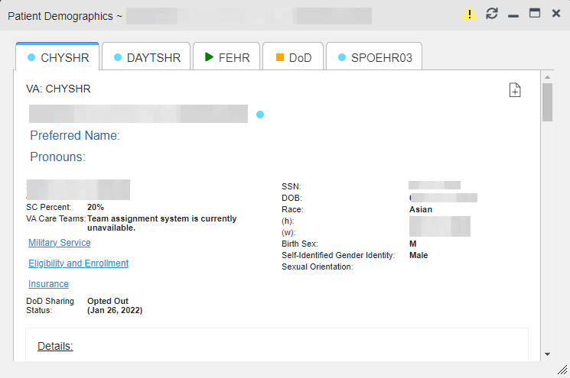

Nonclinical, personal data displayed for the patient varies by site and could include site name, patient name, address, SSN, DOB with the age in parenthesis, race, phone numbers, birth sex, and gender ID (SIGI). SIGI code values are listed in Table 12. If the patient is deceased, a DECEASED label will be displayed along with the date of death and age at death in parenthesis next to it in red. The deceased patient’s age will not be displayed next to the DOB.
Table 12: Gender ID (SIGI) Code Values
Code | Description
M | Male
F | Female
TM | Transmale/Transman/Female-to-Male
TF | Transfemale/Transwoman/Male-to-Female
O | Other
NB | Nonbinary
Any Other Code | Unknown

The Patient Demographics widget provides additional functionality:
- Clicking Patient Demographics opens details in a standalone window, including inpatient providers.
- Clicking or opens the connection status details in a separate window.
- Clicking opens clinical flag details in a new window.
- Clicking opens the Advance Directives dialog in a new window.
- Clicking refreshes Patient Demographics and Patient Flags simultaneously.
If displays on one or more tabs within the Demographics widget, it is an indication that the patient is not registered at that VA site or DOD facility.

Patient Flags
If the patient has one or more clinical warnings, alerts, or flags in their record from VA and DOD sites, displays next to the Demographics widget banner on the Patient Data and Widgets page (Figure 87). A spinner will appear on the Flags icon while data is being retrieved. If the patient does not have flags, the Flags icon will appear greyed out in the toolbar and will not be clickable . A hover hint for the greyed-out icon will appear, “Patient does not have any Flags”.
The Patient Flags window opens and displays by default when the patient data appears, if there are warnings associated with the selected patient. If there are any connection errors in Flags, the yellow connection error icon will be visible on the Flags icon .
Figure 87: Patient Flags Indicator
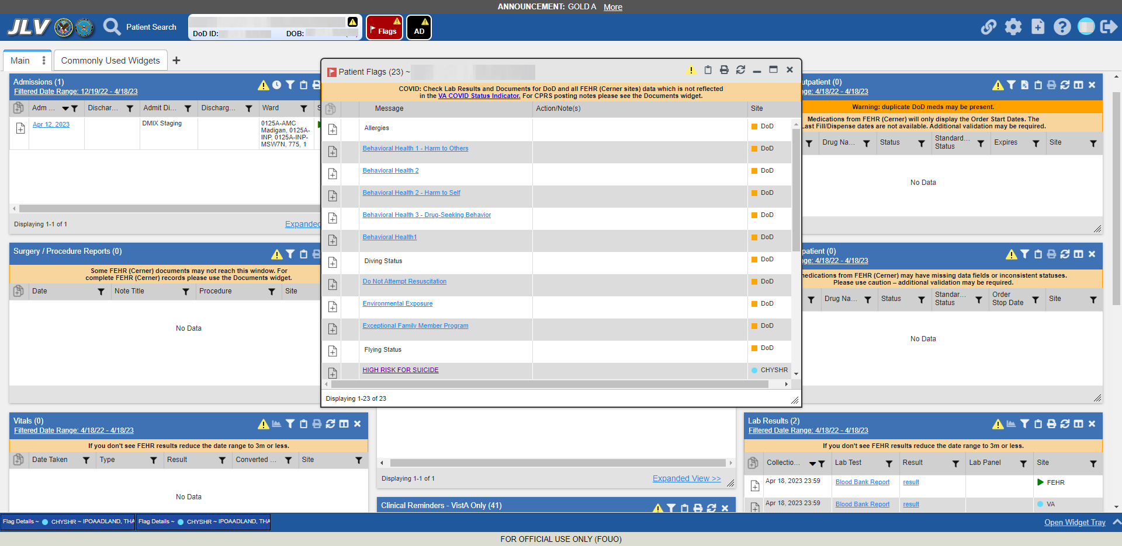

Click to open the Patient Flags window (Figure 87). The window displays a list of alerts and flags within the patient’s record. Selecting the hyperlinked message for each patient alert opens the Flag Details window (Figure 88). Selecting the Action/Note(s) link (Figure 87) will open documents pertaining to placement of the flag. Category I Patient flags that are present at multiple sites will be grouped under the owner site.
Figure 88: Patient Flags Details
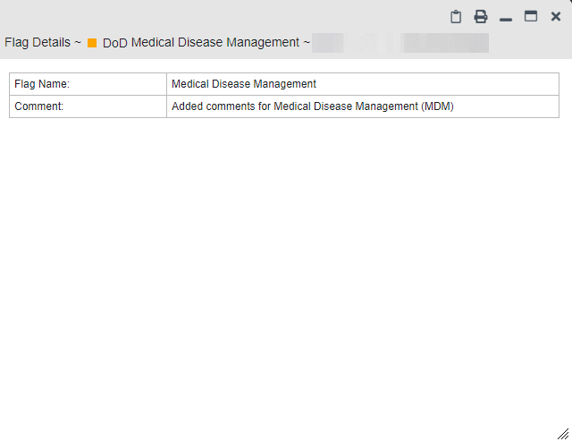

Advance Directives
You can view Advance Directives (Figure 89) by selecting on Demographics widget. Advance Directives are pulled from DOD, VA, and Cerner data sources. A spinner will appear on the Advanced Directives icon while data is being retrieved and remains greyed out and unclickable if Advance Directives were not found for the patient. A hover hint will appear, “Patient does not have any Advanced Directives”. If there are any connection errors, the yellow connection error icon will be visible on the AD icon 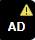.
Figure 89: Advanced Directives Dialog
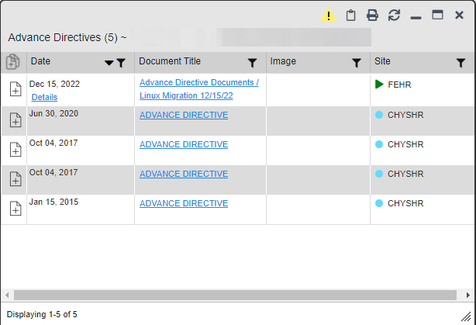

Viewing Third-Party Insurance Information
Third-party payers and insurance information is available from the Patient Demographics widget. Click the Insurance link in the Demographics widget.
A new window opens with the following insurance information, some of which is displayed in (Figure 90):
- Health Plan Type
- Health Plan Name
- Standardized Insurance Type (See Terminology Normalization for more information.)
- Plan Effective Date
- Plan Expiration Date
- Site
- Group Number
- Member ID
- Subscriber ID
- RxBIN
- RxPCN
- Notes
- Comments
- Subscriber Date of Birth
- Subscriber’s Relationship to Insurer
- Health Plan Mailing Address
- Health Plan Contact Information
Figure 90: Insurance Information
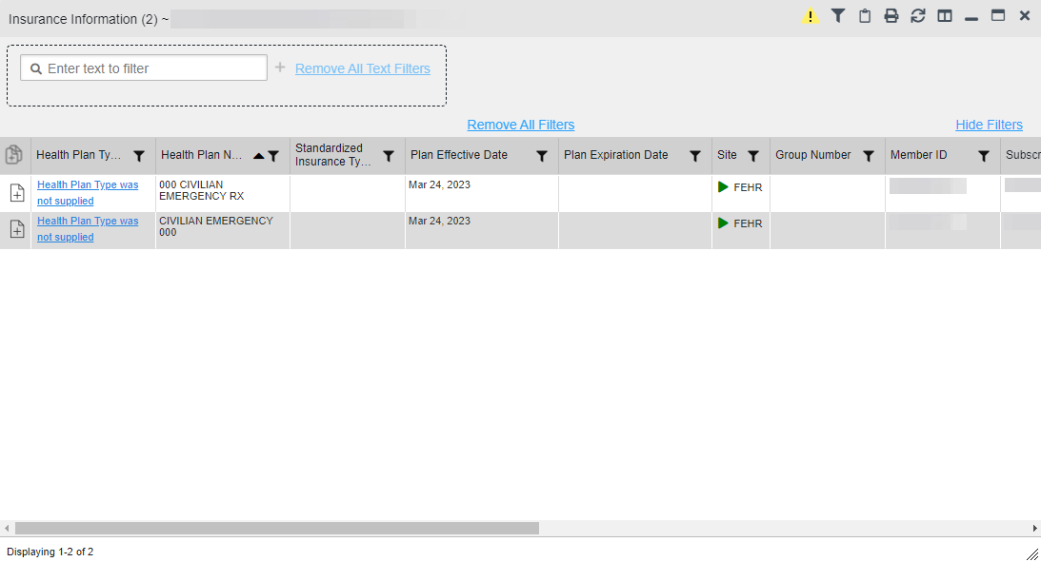

Use the horizontal scroll bar in the window to view the columns not seen within the default window size.

Viewing Military Service Data
Military service data (Figure 91) are available from the Patient Demographics widget. Click the Military Service link in the Demographics widget.
Figure 91: Military Service Window
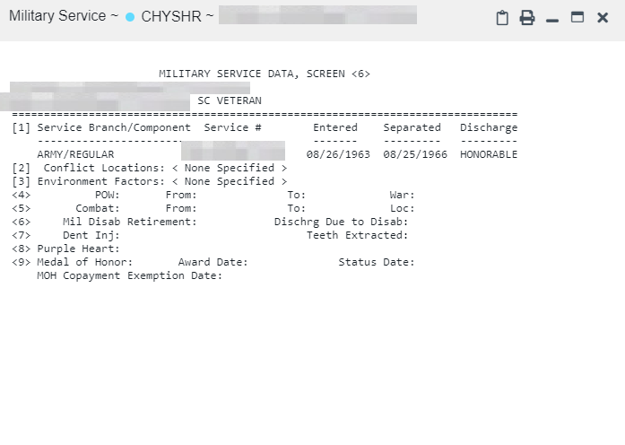

Viewing Eligibility and Enrollment Data
Eligibility and enrollment data (Figure 92) are available from the Patient Demographics widget. Click the Eligibility & Enrollment link in the Demographics widget.
Figure 92: Eligibility and Enrollment Window
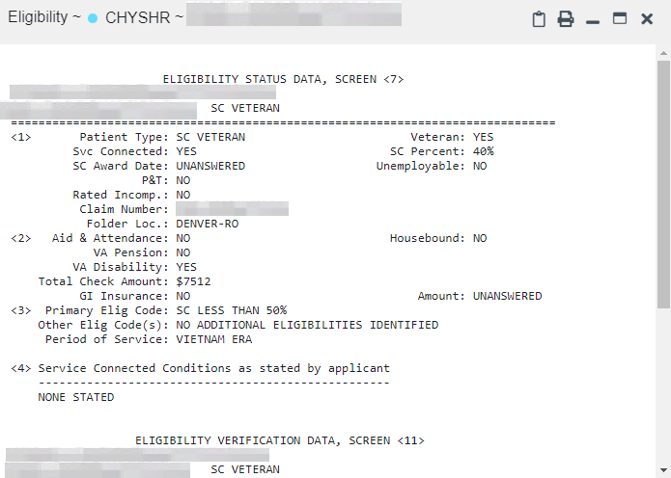

Cardiology Studies - –FEHR and VA MUSE Only Widget
The Cardiology Studies - –FEHR and VA MUSE Only widget (Figure 93) displays electrocardiograms (EKGs) and cardiology studies with related images from all FEHR and VA MUSE sites and systems. The information displays in reverse chronological order by date with one tab for each site where the patient is registered.
Clicking from the Image column opens the image(s) in a standalone window.
Report Builder functionality is not available for this widget.

Cardiology Studies - –FEHR and VA MUSE Only Widget Data
The information in the Cardiology Studies - –FEHR and VA MUSE Only widget includes:
- Date
- Description (Test Type)
- Status
- Image
- Site
There is no expanded view for this widget.
Figure 93: Cardiology Studies - –FEHR and VA MUSE Only Widget
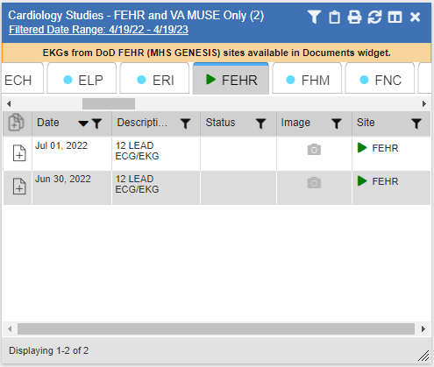

Community Health Summaries and Documents
The Community Health Summaries and Documents widget (Figure 94) displays the patient’s community partner information, including Continuity of Care Documents (CCDs) in C32 and C62 formats and HL7 Consolidated-Clinical Document Architecture (C-CDA) structured documents available for the patient. The information in this widget is sorted by the title of the entry listed in the Document Type/Title column.
NOTE: By default, CAPRI-Claims users cannot see the Community Health Summaries and Documents widget. To enable access to this widget, CAPRI-Claims users must be assigned the security key, "DVBA ALLOW JLV COMM DATA".

Community Health Summaries and Documents Widget Data
Data displayed within the Community Health Summaries and Documents widget (Figure 94) in the minimized view includes:
- Date
- Document Type/Title
- Site
The purple hexagon beside entries in the Site column denotes the source of the data is outside the VA.
Figure 94: Community Health Summaries and Documents, Minimized View
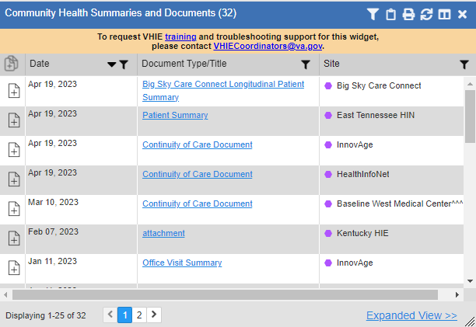

Click Expanded View >> in the minimized view of the Documents & Images widget to open the expanded view (Figure 95). Information in expanded view includes:
- Date
- Document Type/Title
- Site
Figure 95: Community Health Summaries and Documents, Expanded View
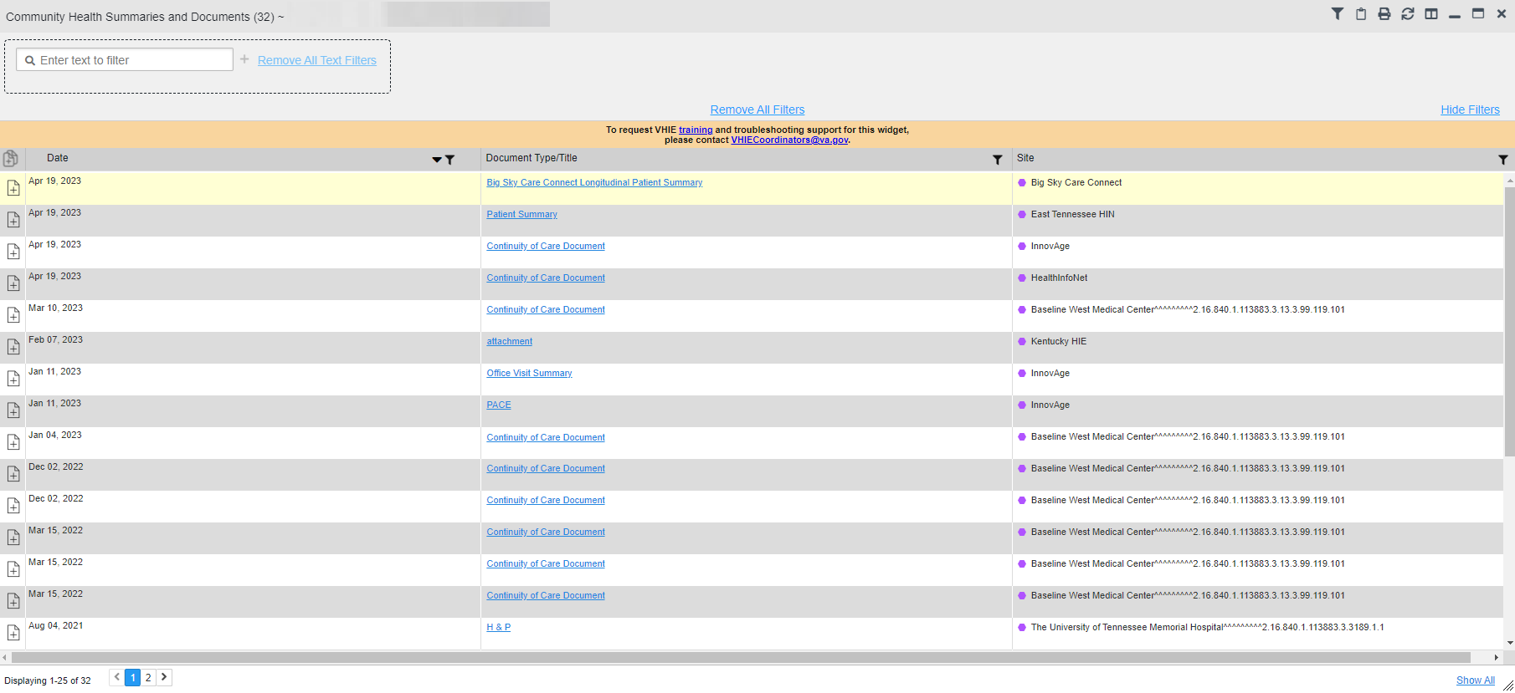

Viewing VA Community Health Summary Documents
Click on the hyperlinked entries in the Document Type/Title column within the Community Health Summaries and Documents widget, to open the documents in a new browser window. (Figure 96).
NOTE: Multiple documents can be opened in separate browser tabs for simultaneous viewing and printing.
Figure 96: Community Health Document
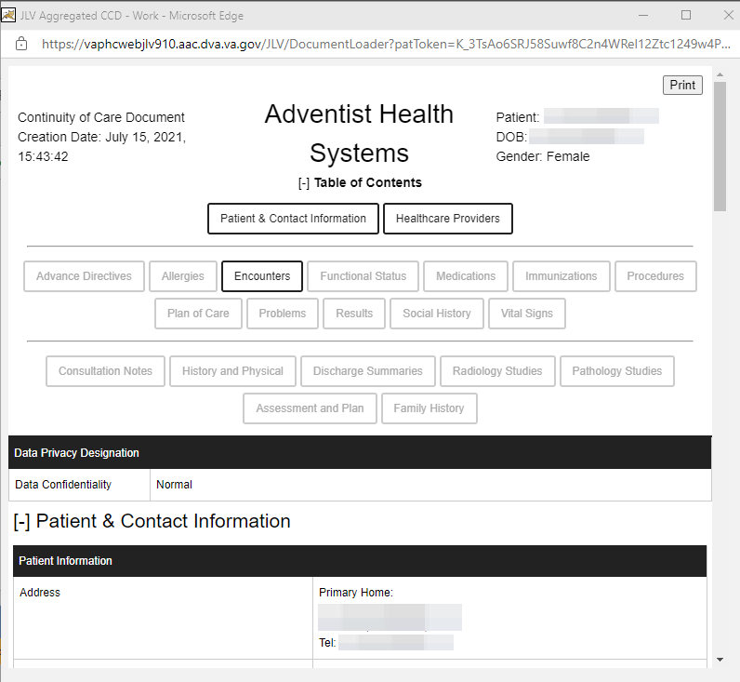

Imaging Widget
The Imaging widget (Figure 97) displays images from multiple sources, including all Vista Imaging, Cerner imaging, DOD Radiology, and HAIMS artifacts. When the widget is displayed, data is sorted by date.

Record data can be added to Report Builder, although images cannot be added.
- NOTE: The Imaging widget is only available to VA JLV users. DoD JLV users do not have access to the widget and do not see it in the Patient Data and Widgets widget tray.
Figure 97: Imaging Widget, Minimized View
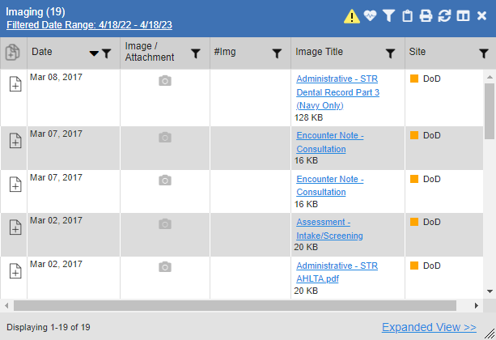

Imaging Widget Data
The minimized view of the Imaging widget displays the following information:
- Date
- Image/Attachment (See Image Support)
- #Img
- Image Title
- Site
Clicking the icon in the toolbar displays the Cardiology Studies - –FEHR and VA MUSE Only Widget which has electrocardiograms (EKGs) and cardiology studies, and related images from all FEHR and VA MUSE sites and systems.

Viewing Images
Click Expanded View >> in the minimized view of the Imaging widget to open the expanded view (Figure 98). Information in expanded view includes:
- Date
- Image/Attachment (See Image Support)
- #Img
- Image Title
- Standardized Description
- Description
- Procedure
- Origin
- Specialty
- Event
- Type
- Capture Date
- Source System
- Location
- Site
Figure 98: Imaging Widget
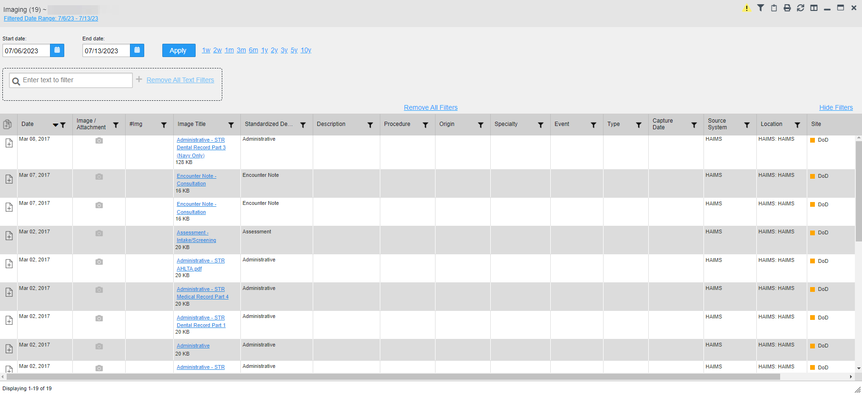

Click a hyperlinked entry in the Image/Attachment or the Image Title column in either the minimized or expanded view of the Imaging widget to access additional information for a listed record in text, PDF, graphic, or document format. The additional information will open in a separate browser window when the image source is VistA Imaging. Figure 99 and Figure 100 display two types of data accessed through the Imaging widget.
Figure 99: View of an Image
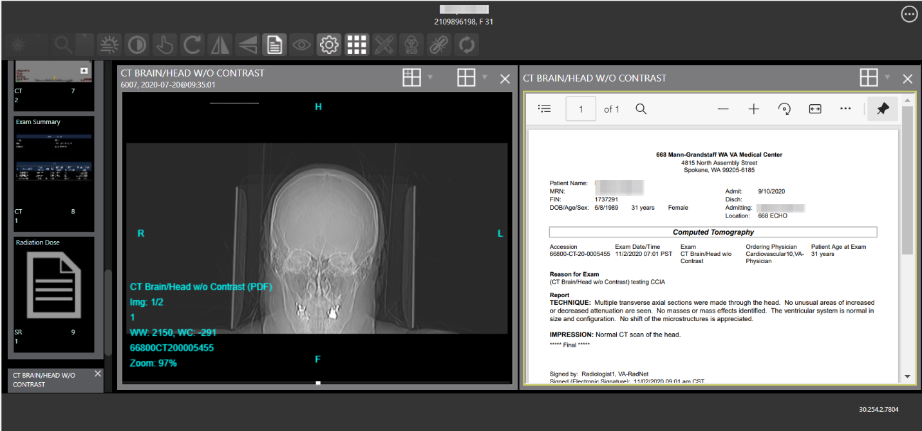

Figure 100: View of a PDF-formatted Document
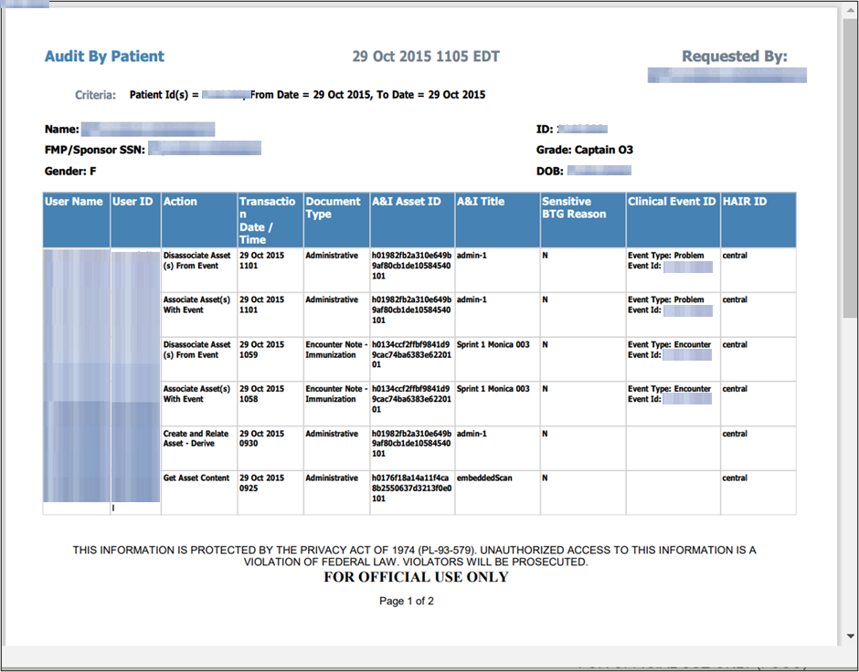

Documents & Images Widget
The Documents & Images widget (Figure 101) includes documents from multiple clinical domains, including radiology reports (exams), progress notes, outpatient encounters, consults, discharge summaries (inpatient notes), questionnaires, and HAIMS records, displayed in reverse chronological order by the document date. HAIMS records retrieved by JLV include scanned paper records, imported paper records, advance directives, scanned non-radiology images, and imported non-radiology images.

Documents & Images Widget Data
The minimized view of the Documents & Images widget displays the following information:
- Date
- Description
- Provider
- Image/Attachment (See Image Support)
- Site
Figure 101: Documents & Images Widget, Minimized View

Outpatient encounter records displayed in the Documents & Images widget may have a Details link enabled in the Date column. Where available, click the link to open a Details window for records of this type.
Click Expanded View >>in the minimized view of the Documents & Images widget to open the expanded view (Figure 102). Information in expanded view includes:
- Date
- Description
- Standardized Description
- Provider
- Provider Specialty
- Location
- Status
- Image/Attachment
- Source System
- VA Health Factors
- Site
Figure 102: Documents & Images Widget, Expanded View
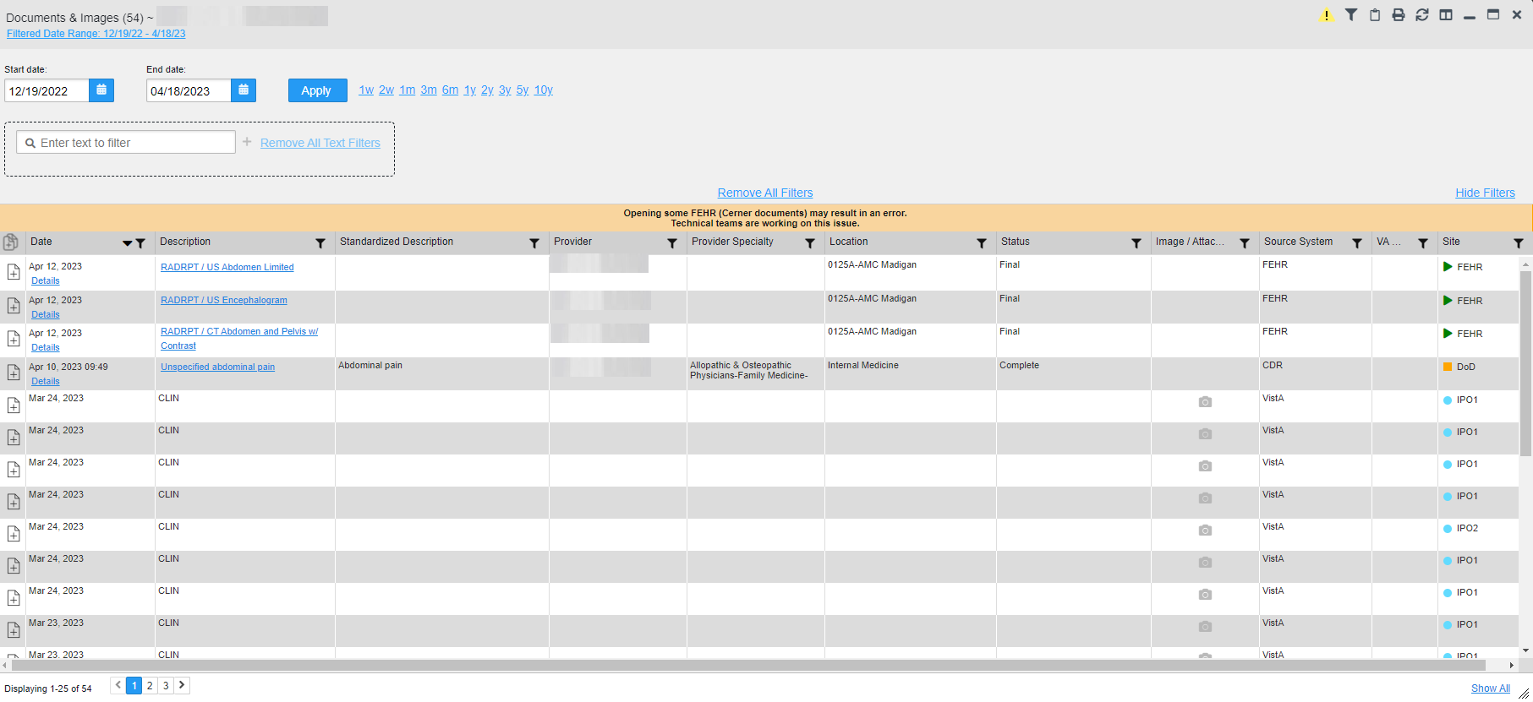

Viewing Documents & Images
Click a hyperlinked entry in the Description column in either the minimized or expanded view of the Documents & Images widget to access additional information for a listed record. Depending on the record type, the additional information may open in either a Details window or a separate browser window. Figure 103 displays outpatient encounters details, accessed through the Documents & Images widget.
Figure 103: Details View of a Document
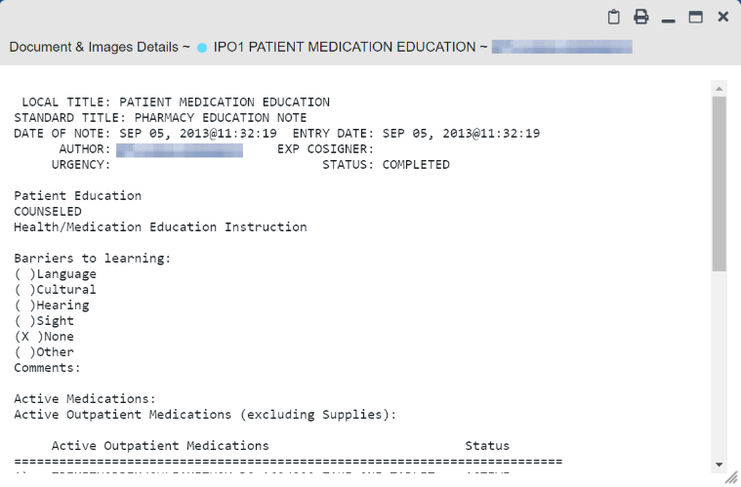

Federal EHRH Military Health System (MHS) GENESIS Widget
The Federal EHR/MHS GENESIS widget displays DOD patient documents and dental summaries from DOD’s MHS GENESIS system and VA’s Cerner PowerChart. The information is displayed in reverse chronological order by date.

Federal EHR/MHS GENESIS Widget Data
The minimized view of the Federal EHR/MHS GENESIS widget includes the following information:
- Date
- Document Title
- Document Type
- Site
Figure 104 highlights the Federal EHR/MHS GENESIS widget in minimized view. There is no expanded view for the widget; instead, the C-CDA document selected opens in a new browser window (Figure 105).
NOTE: The Medications - Outpatient widget displays an orange banner with a warning that reads, “Duplicate DOD meds may be present” due to the migration of data into FEHR/MHS GENESIS (Cerner.)
Medical CCDs, Dental CCDs, and aggregate CCDs with blank entries in the Date column for the record appear first in the widget by default.
Figure 104: Federal EHR/MHS GENESIS Widget
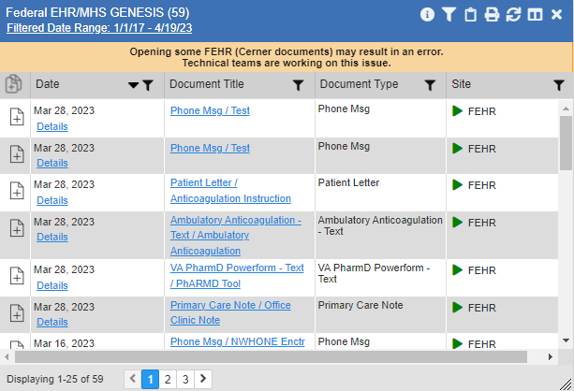

Viewing Federal EHR/MHS GENESIS Documents
Click a hyperlink in the Document Title column in either view of the Federal EHR/MHS GENESIS widget to display a document (Figure 105) in a new browser window.
Figure 105: C-CDA Document
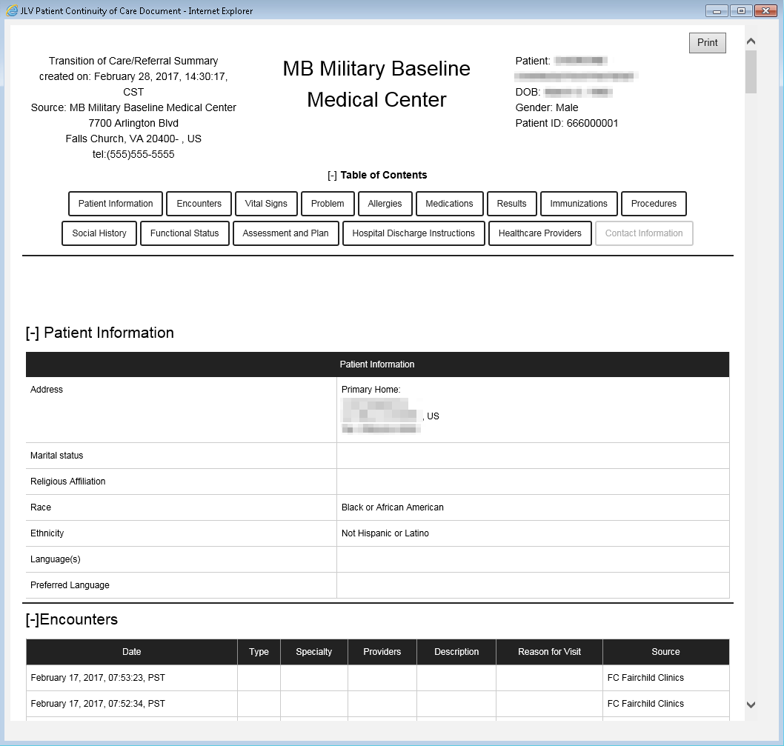

Health Summaries and Reports—VistA Only Widget

Health Summaries and Reports—VistA Only Widget Data
The Health Summaries and Reports—VistA Only widget displays the patient's national and local health summaries from VistA sites where the patient has been registered, including the Autopsy, Blood Bank, Cytopathology, Lab Summary—Cumulative, MAH, MAL, Medicine Full, Surgical Pathology, Transfers, and Unit Dose reports. This widget is available to VA users only.
JLV sorts records by Site by default. If a patient has national health summaries, JLV sorts to display National records first. National records are named in the Site column in the minimized view and in the Type and Site columns in the expanded view.
The Description column displays the document title, where available. Click a hyperlinked entry in the Description column in either the minimized or expanded views of the widget to open the document.
Information in the minimized view of the Health Summaries and Reports—VistA Only widget (Figure 106) includes:
- Description
- Site
Figure 106: Health Summaries and Reports—VistA Only Widget, Minimized View
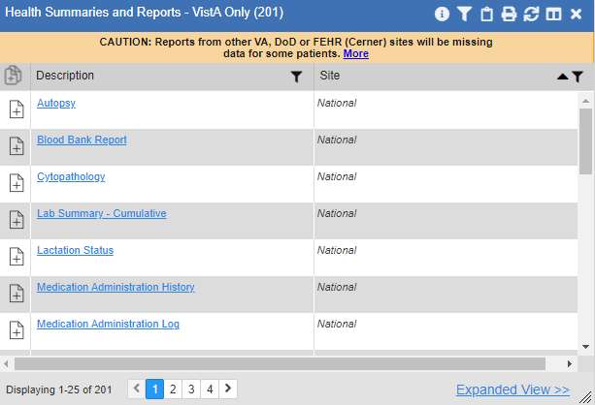

Click Expanded View >>from the minimized view of the Health Summaries and Reports—VistA Only widget to open an expanded view of the widget. Information in the expanded view (Figure 107) includes:
- Description
- Type
- Site
Figure 107: Health Summaries and Reports—VistA Only Widget, Expanded View
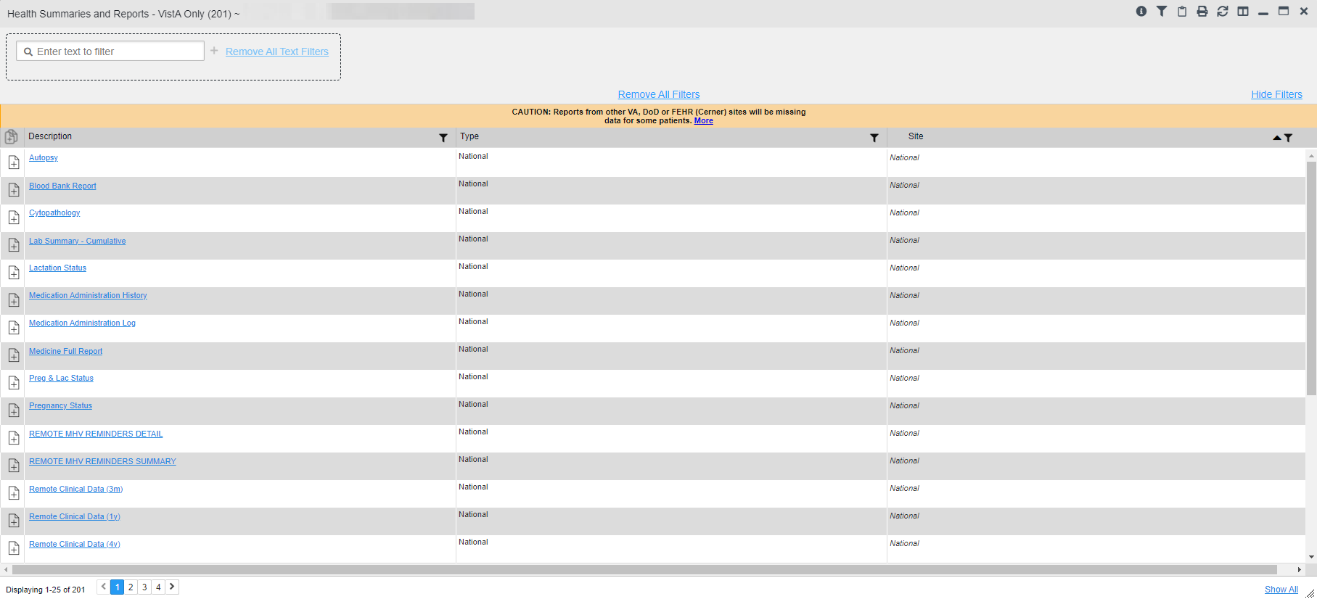

Viewing Health Summaries
Click a hyperlinked entry in the Description column of either the minimized or expanded view of the Health Summaries and Reports—VistA Only widget to view additional information for the record. This widget is available to VA users only.
Figure 108 displays a health summary record from a single, local site.
Figure 108: Health Summary from a Single, Local Site
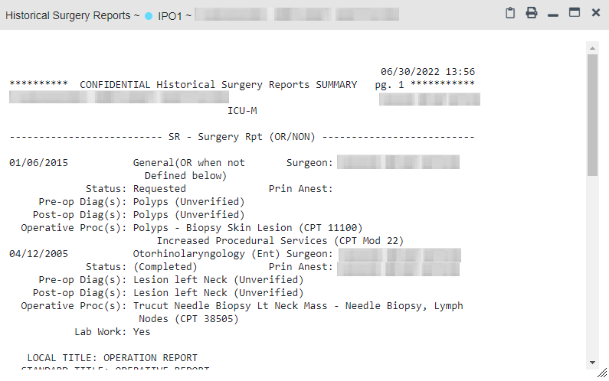

Figure 109 is an example of JLV's display of a national health summary. Within the window, tabs represent the VistA sites where the patient is registered. Click each tab to view patient records for that site.
Figure 109: National Health Summary, Multiple Sites
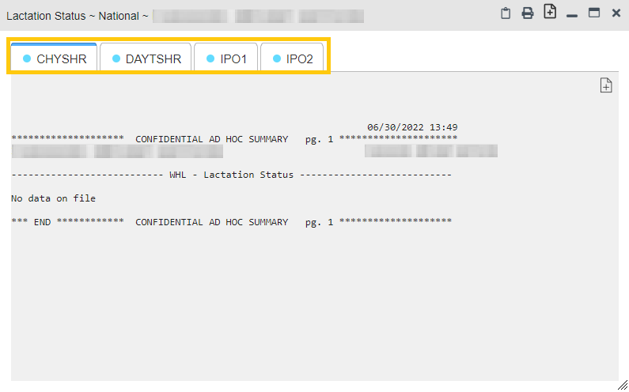

Lab Results Widget

Lab Results Widget Data
The Lab Results widget displays the patient’s lab results information, as well as skin test data and blood transfusion history when available in the patient’s record. The information is displayed in reverse chronological order by collection date. Lab data received by DOD sources that include a sensitive flag are masked in the widget views and access to this data is subject to auditing. Additional data may be available in the Community Health Summaries and Documents widget.
The information in the minimized view of the Lab Results widget includes:
- Collection Date
- Lab Test
- Result
- Lab Panel
- Site
Click Expanded View >>from the minimized view of the Lab Results widget to open the expanded view (Figure 110). The lab results information in the expanded view includes:
- Collection Date
- Specimen Source
- Lab Test
- Result
- Interpretation
- Units
- Ref Range
- Lab Panel
- Type
- Order Number
- Ordering HCP
- Status
- Location
- Site
NOTE: While the Standardized Lab Test and Ordering HCP Specialty columns are not listed by default, you may add them to the expanded view by selecting their corresponding checkboxes in .
Figure 110: Lab Results Widget, Expanded View
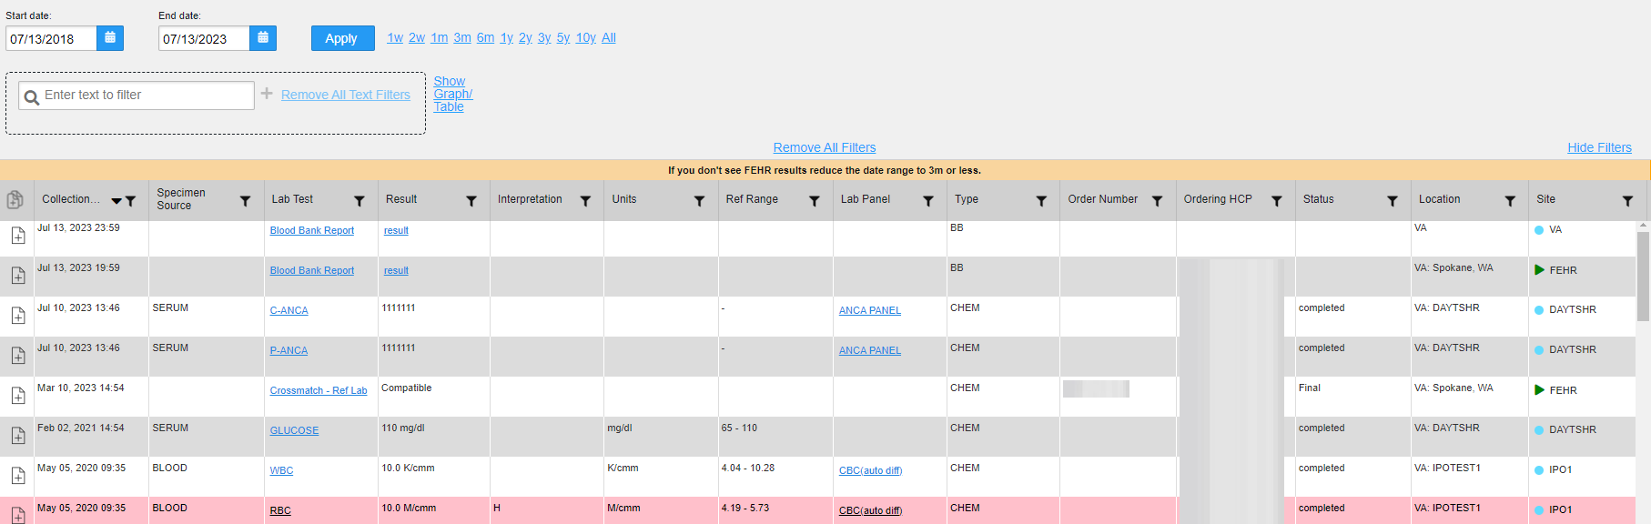

The following lab test abbreviations are used in the Type column of the expanded view. Hovering over an entry in the Type column displays the full lab type name.
- CHEM for CH, COAG, HEM, HE, TOX, RIA, SER, and SEND
- MICRO for MI, MICROBIOLOGY, and BACT
- AP for ANATOMIC PATHOLOGY
- EM for ELECTRON MICROSCOPY
- SP for SURGICAL PATHOLOGY
- ST for SKIN or SKIN TEST
- CY for CYTOLOGY
- AU for AUTOPSY
- BB for BLOOD BANK
- H.I.V for HIV

Viewing Lab Results Details
Clicking a hyperlinked entry in the Lab Test column of the Lab Results widget opens a separate window containing a report of the record (Figure 111).
Figure 111: Lab Results Details
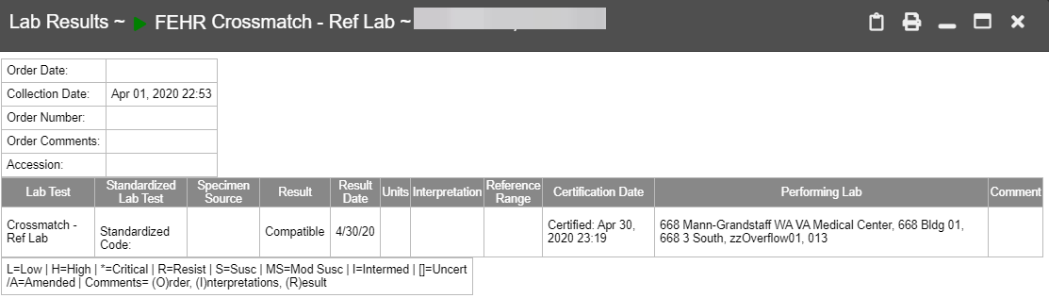

NOTE: A single site report can now be added to the Report Builder from the Blood Bank Report in the Lab Results widget.

Viewing Lab Panel Results Details
Clicking a hyperlinked entry in the Lab Panel column of the Lab Results widget opens a separate window containing a detailed lab panel report (Figure 112).
Figure 112: Lab Panel Results Detail
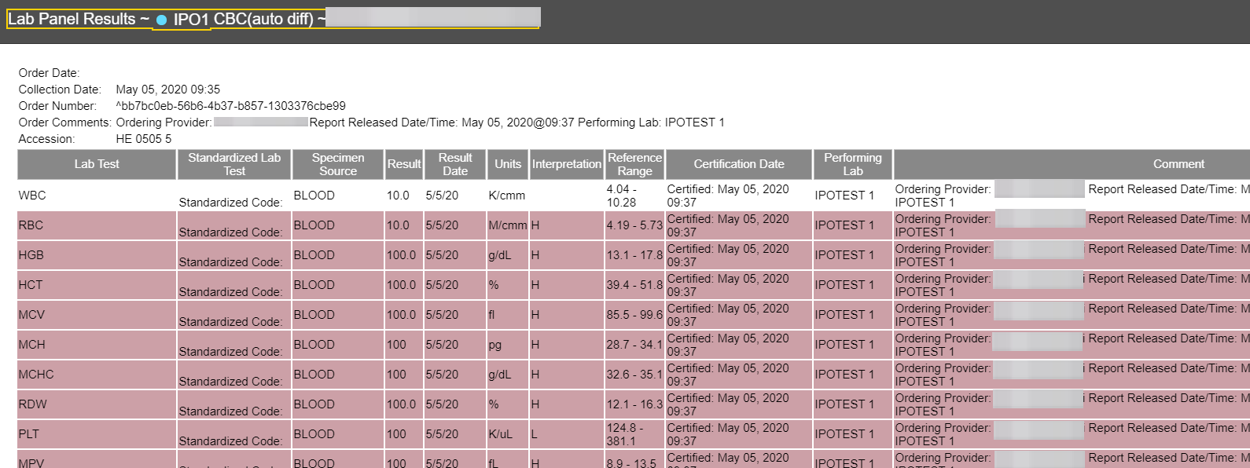

Viewing Abnormal Results in the Lab Results Widget
JLV highlights the row for that record in the minimized and expanded views of the widget for records in the Lab Results widget where result values fall within a calculated reference range for abnormal.
Pink highlighting represents an abnormal result (i.e., high (H) or low (L)). Red highlighting represents that the abnormal indicator has an asterisk (i.e., H* or L*) or the result is critical.
Examples of records with abnormal results are shown in the expanded view of the Lab Results widget in Figure 113.
Figure 113: Lab Results Widget, Abnormal Results in Expanded View
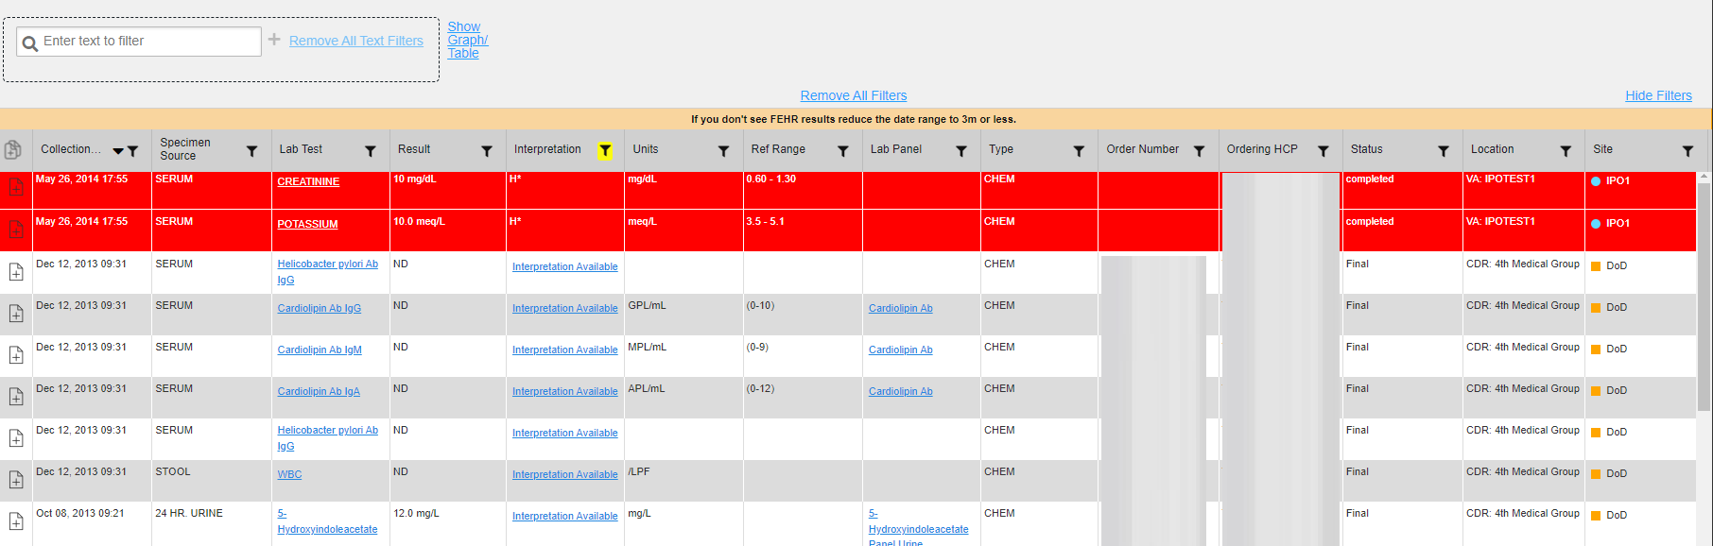

Viewing Results and Interpretations in the Lab Results Widget
JLV displays links in the Result and Interpretation columns in the expanded views of the widget to indicate additional information is available for records in the Lab Results widget where result values and interpretation are available in a record. Figure 114 highlights multiple result and interpretation links within the widget.
Figure 114: Lab Results Widget, Expanded View, Interpretations Available
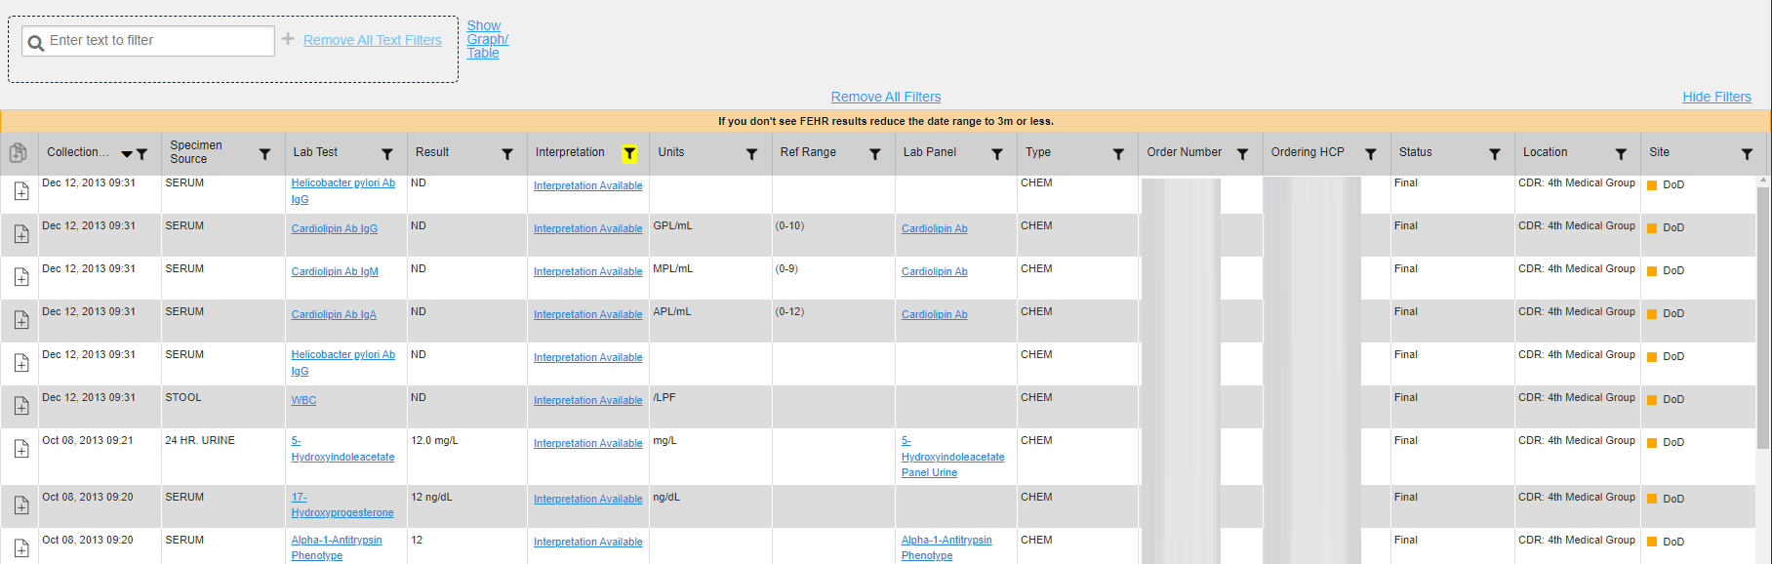

Figure 115 displays an example lab interpretation accessed by clicking a link in the Interpretation column. The contents of the window may vary depending on the lab type and what is contained in the patient record.
Figure 115: Lab Results Interpretation Details
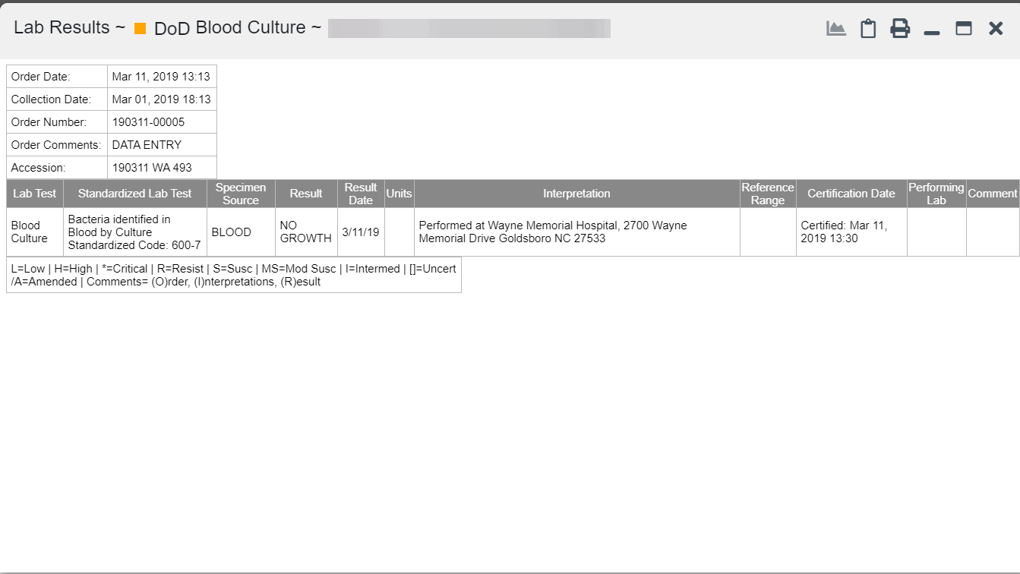

Graph/Table View from the Lab Results Widget
The Lab Results widget provides the option to display multiple results for the same lab test in a graph and table.
- Select from the widget toolbar in either minimized or expanded view OR -
- Click Expanded View >> from the minimized view of the Lab Results widget to open an expanded view of the widget, then select the Show Graph/Table link.
- Select a value from the Select a Lab Test dropdown in the Lab Results Graph/Table dialog.
  - The graph displays with corresponding table values beneath.
- Select the Show Labels checkbox to toggle graph data labels on or off.
- Select to exit Graph/Table view and return to the minimized or expanded view of the Lab Results widget.
Figure 116 displays an example Graph/Table view of the lab test results.
Figure 116: Lab Results Graph/Table View
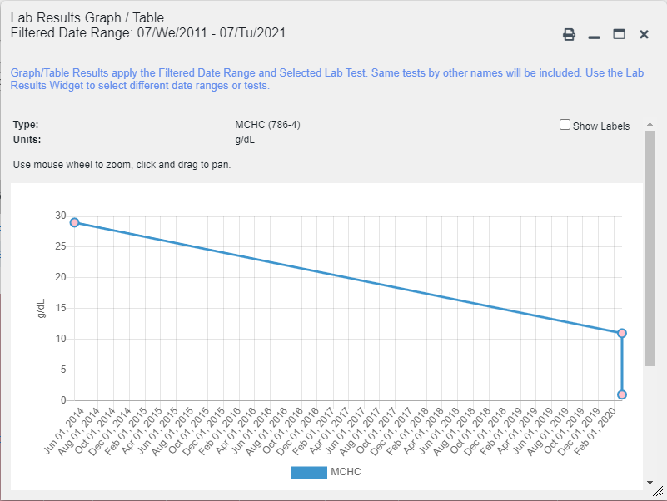

In the expanded view of the Lab Results widget, selecting one or more values in the Filter by Lab Test dropdown will disable all other filter dropdowns until the filtered selections are removed. The lab test values in the Filter by Lab Test dropdown dynamically increase or decrease depending on the date filter criteria you apply. Tests with the same LOINC code (shown in parentheses following the lab test name) as those selected will be automatically included in the filtered results displayed in the widget.
You may only use the graph/table feature for a single lab test LOINC value. All lab tests with the same LOINC will be graphed even if the lab test names differ. While you can select multiple lab test values in the Filter by Lab Test dropdown, you will be forced to select a single lab test value from the Select a Lab Test dropdown in the Lab Results Graph/Table dialog (Figure 117) once you select either or the Show Graph/Table link. The lab test values in the Select a Lab Test dropdown also dynamically increase or decrease depending on the filter criteria applied in the Lab Results Widget.
Figure 117: Lab Results Graph Table View, Select a Lab Test
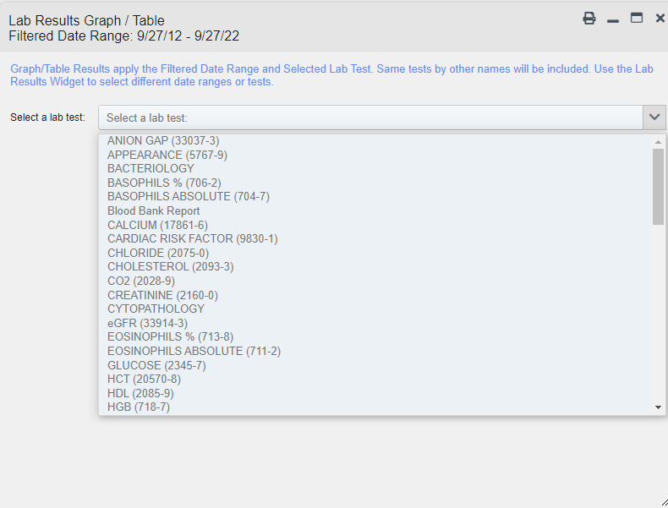
You may also generate a graph for all lab tests with the same LOINC code by selecting from the Lab Results Details view (Figure 111).

Troubleshooting
The following subsections provide information about troubleshooting common errors in JLV.
Please see online help for how-to information within JLV. Please visit REDACTED to see JLV training videos and access additional JLV training materials.

Special Instructions for Error Correction
JLV utilizes access control and authentication services to limit access to registered, authorized users. When enabled, JLV validates you against information retrieved from your Smart Card. If you are having trouble logging into JLV, and have used the correct URL for your agency, please review the following before contacting the ESD:
VHA users:
- Have accessed JLV using the JLV URL (REDACTED) or the JLV button in CPRS if available
- Have entered their existing CPRS Access and Verify codes correctly in the fields on the JLV Login page
- Have selected a site from the Site dropdown list on the JLV Login page (Most users must specify the individual facility name or their parent healthcare system name)
CAPRI-Claims users:
- Have accessed JLV using the JLV URL (REDACTED) or the Joint Longitudinal Viewer tab in CAPRI
- Have entered their existing CAPRI Access and Verify codes correctly in the fields on the JLV Login page
- Have selected CAPRI-Claims from the Site dropdown list
- Have connected PIV card to the Claims system in IAM.
- Do not have any CAPRI patient selection restrictions
Users with any CAPRI patient selection restrictions (restricted users) must use the Joint Longitudinal Viewer tab in CAPRI to access JLV. Restricted users will see the message shown in Figure 118 on the JLV Login page if attempting to access JLV via the JLV URL.
Figure 118: Login Error—CAPRI Patient Selection Restrictions
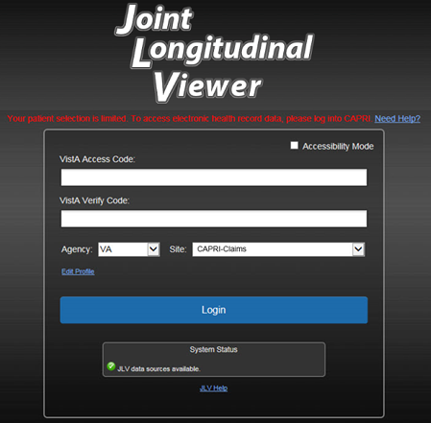

Login Page Error Messages
Troubleshooting steps for error messages received at the Login page are provided in Table 13.
Table 13: Error Messages and Resolution Steps
Error Message/Behavior | Description/Resolution Steps
No access allowed for this user. | WHY? You have not signed into CAPRI or CPRS for 90 days and your account is inactive.  FIX IT: Contact the ESD and tell them that either your access to CAPRI or CPRS (whichever you use) has been deactivated.
Access denied. You are not an authorized user. | WHY? There is a PIV card processing problem, you selected an invalid security certificate, you may not have the OR CPRS GUI Chart VistA option enabled (VHA), or there may be an issue with your single sign-on account.  FIX IT:  Reinsert PIV and Choose a Valid Authentication Certificate  - Close your browser window  Reinsert your PIV card and relaunch JLV  Select a certificate that is not expired and specifies: “Issuer: Veterans Affairs User CA B1”  Confirm Your VistA Account is Linked  - Go to the REDACTED website  Select a certificate that is not expired and specifies: “Issuer: Veterans Affairs User CA B1”  Select Link VistA User  Select the VA Medical Center to link  Enter your Access/Verify codes  Click Submit  If neither of these methods resolve the error, contact the ESD.
Could not save User Profile. | WHY? The error occurred during PIV authentication. It is either a PIV card processing problem, or you chose the wrong security certificate.  FIX IT:  - Close your browser window  Reinsert your PIV card and relaunch JLV  Select a certificate that is not expired and specifies: “Issuer: Veterans Affairs User CA B1”  If unsuccessful, close all open browser windows/tabs, then open the browser and try JLV again
Not a valid ACCESS/VERIFY CODE pair. | WHY? JLV could not match your Access and Verify codes to the site selected in the dropdown, or you entered username and password instead of Access/Verify codes.  FIX IT:  - VHA users must select the parent VistA host site for their facility  Reenter your Access and Verify codes (CAPRI codes for CAPRI-Claims users, CPRS codes for VHA users)
Page cannot be displayed. | WHY? The JLV URL requires certain IE settings.  FIX IT:  - Click the Tools menu (press ALT+X) in IE  Select Internet Options  When the dialog box opens, click the Advanced tab  Scroll down in the list until you see the Secure Sockets Layer (SSL) 2.0 setting, and ensure it is NOT checked  Ensure that the Transport Layer Security (TLS) 1.0, 1.1 and 1.2 settings ARE checked  Click OK to close the dialog box, then relaunch JLV (The page should load)
Smart Card required. | WHY? Your Smart Card was not read by Windows Security and JLV before opening the JLV URL.  FIX IT:  - Close all browser sessions and browser-based applications  Reinsert your PIV card, and relaunch the JLV URL  If unsuccessful, close all open IE windows/tabs, then open IE and try JLV again
VERIFY CODE must be changed before continued use. | WHY? Your CPRS or CAPRI Verify code has expired.  FIX IT:  - Open CPRS, VistA, or CAPRI (CAPRI-Claims users)  - If prompted for a PIV card certificate by CPRS, click Cancel  You are prompted to create a new Verify code  Once your Verify code has been changed for CPRS or CAPRI, relaunch JLV, which recognizes the new code immediately

System Error Messages
Table 14 summarizes system messages that may be presented to JLV users.
Table 14: System Error Messages
Error Message/Behavior | Description/Resolution Steps
No message displays but behavior occurs: The browser window does not allow the user to scroll to widgets or access the JLV icons on the Patient Data and Widgets page. | WHY? You may be using an unsupported browser, or your screen resolution settings do not match the recommended configuration.  FIX IT:  - Access JLV using IE 11 or Chrome  Use a monitor with a minimum screen resolution of 1024 x 768  Set the browser zoom feature to 100%  If browser display issues continue, log out of JLV, close the browser window, open a new browser window, and log into JLV again
Warning: An error occurred while attempting to retrieve VistA Imaging Viewer URL. | WHY? JLV is unable to retrieve the necessary data object to launch a VistA Imaging Viewer instance.  FIX IT: Try again later; either VDS or CVIX is offline.
MPI Error: Your query yields too many results. Please modify your search parameters to narrow the search. | WHY? JLV adheres to VA guidelines and blocks search results when a search request yields more than 10 patients.  FIX IT: Modify the information in the Patient Search dialog box using additional patient identifiers to reduce the number of results.
MPI Error: There are no patients found using the current parameters. | WHY? No patient records were found using the information entered in the Patient Search dialog box.  FIX IT:  - Verify the accuracy of the information  Reenter patient identifiers in the Patient Search dialog box fields
MPI Error: Application Reject. There was an error attempting to process your query. Please modify your search parameters and try again. | WHY? There may be one or more errors in the Patient Search dialog fields.  FIX IT:  - Validate the patient identifiers, and try the search again  If problems persist, there may be an error between MPI and the Defense Enrollment Eligibility Reporting System (DEERS)
MPI Error: Patient not found with search elements entered, please provide additional patient identifying information and search again. | WHY? No unique patient is found with the identifiers used in the search.  FIX IT:  - Click OK to return to the Patient Search dialog  Provide additional patient identifiers, like the full first name or DOB
You do not have authorization to view this record. Security regulations prohibit computer access to your own medical record. | WHY? VA security regulations prevent you from accessing your own medical records.
You do not have authorization to view this record. Your SSN is missing from the NEW PERSON file. Contact your ADP Coordinator. | WHY? Per VA policy, JLV does not allow access to patient records if the JLV user’s SSN is not in their VistA profile.  FIX IT: Contact your Automated Data Processing Application Coordinator (ADPAC).
An error occurred while attempting to retrieve the document. | WHY? This error occurs when something goes wrong when JLV tries to retrieve a selected document.  FIX IT:  - Try again  If the error persists, contact local support or the ESD
An error occurred while attempting to display the document. | WHY? This error occurs when JLV tries to retrieve a document but has trouble converting the document to a viewable format.  FIX IT:  - Try again  If the error persists, contact local support or the ESD
Your patient selection is limited. To access electronic health record data, please log into CAPRI. | WHY? Some CAPRI-Claims users have patient or site restrictions attached to their profile.  FIX IT: Log into CAPRI and select the Joint Longitudinal Viewer tab to view patient records.
- Acronyms and Abbreviations
Table 15 lists the acronyms and abbreviations used throughout this document and their descriptions.
Table 15: Acronyms and Abbreviations
Acronym | Description
ADPAC | Automated Data Processing Application Coordinator
AFB | Air Force Base
AHLTA | Armed Forces Health Longitudinal Technology Application
AMC | Army Medical Center
BMI | Body Mass Index
BP | Blood Pressure
BSA | Body Surface Area
CAPRI | Compensation and Pension Record Interchange
CCD | Continuity of Care Document
C-CDA | Consolidated Clinical Document Architecture
CCOW | Clinical Context Object Workgroup
CD2 | Critical Decision Point #2
CDC | Centers for Disease Control
CDR | Clinical Data Repository
CHCS | Composite Health Care System
CPRS | Computerized Patient Record System
CPT | Current Procedural Terminology
CVX | Vaccine Administered
DES | Data Exchange Service
DEERS | Defense Enrollment Eligibility Reporting System
DOB | Date of Birth
DOD | Department of Defense
EDIPI | Electronic Data Interchange PeInal Identifier
EHR | Electronic Health Record
EHRM | Electronic Health Record Modernization
EKG | Electrocardiogram
ESD | Enterprise Service Desk
FEHR | Federal Electronic Health Record
GUI | Graphical User Interface
HAIMS | Healthcare Artifact and Image Management Solution
HCP | Health Care Provider
HCS | Health Care System
HIE | Health Information Exchange
HL7 | Health Level Seven International
IAM | Identity Access Management
ID | Identification
IE | Internet Explorer
IEN | Internal Entry Number
IP | Internet Protocol
JB | Joint Base
JLV | Joint Longitudinal Viewer
LOINC | Logical Observation Identifiers Names and Codes
MAH | Medication Administration History
MAL | Medication Administration Log
MHS | Military Health System
MI | Middle Initial
MPI | Master Person Index
NUCC | National Uniform Claim Committee
OIT | Office of Information and Technology
PACT | Patient-Aligned Care Team
PCMM | Primary Care Management Module
PCP | Primary Care Provider
PDWS | Patient Discovery Web Service
PIN | Personal Identification Number
PIV | Personal Identity Verification
SIGI | Self-Identified Gender Identity
SSL | Secure Sockets Layer
SSN | Social Security Number
SSOi | Single Sign-On Internal
TLS | Transport Layer Security
TMDS | Theater Medical Data Store
UC | University of California
UI | User Interface
URL | Uniform Resource Locator
VA | Department of Veterans Affairs
VBA | Veterans Benefits Administration
VDS | VistA Data Service
VHIE | Veterans Health Information Exchange
VIP | Veteran-Focused Integrated Process
VLER | Virtual Lifetime Electronic Record
VHA | Veterans Health Administration
VistA | Veterans Health Information Systems and Technology Architecture

- Patient Data and Widgets page Widgets, Columns, and Supported Views
Table 16 details each data column within the minimized and expanded views of each widget. Data columns available in each view are ordered from left to right.
- An asterisk (*) next to a column title in the table indicates the data for that record is available in “detail view” from within the widget; clicking a link opens the contents of that record in a standalone window.
- A dagger (†) next to a column title in the table indicates the data in that column is normalized (mapped to standards).
- A double dagger (‡) next to a column title in the table indicates the column is hidden by default and must be added from .
Table 16: Widget Details
Widget | Description | Minimized View | Expanded View
Admissions | Displays the patient’s inpatient admissions information including VA expanded admission discharge transfer history and detailed discharge diagnosis data | Adm Date* | Discharge Date | Admit Diagnosis† | Discharge Diagnosis | Ward | Site | Adm Date* | Discharge Date | Ward | Provider† | Diagnosis† | Discharge Diagnosis† | Registration Number | VA Health Factors | Location | Site
Allergies | Displays the patient’s allergy information | Date Recorded | Allergen*† | Standardized Allergen† | Site | Date Recorded | Allergen*† | Standardized Allergen† | Reaction | Severity |Comments | Location | Site
Appointments | Displays the patient’s past and future appointments information | Scheduled Date/Time* | Clinic | Provider† | Site | Scheduled Date/Time* | Clinic | Provider†¹⁸ | Provider Specialty†¹⁸| Appointment Status | Type | Reason | VA Health Factors | Location | Site
Cardiology Studies - FEHR and VA MUSE Only | Displays EKGs and cardiology studies with related images from all FEHR and VA MUSE sites and systems | Date | Description (Test Type) | Status | Image | N/A
Clinical Reminders—VistA Only | Displays the patient’s clinical reminders information from all VistA sites | Reminder | Site* | Reminder | Site*¹⁹
Community Health Summaries | Displays the patient’s community health documents from VHIE partners including any CCDs, in C32 and C62 formats, and HL7 C-CDA structured documents | Date | Document* | Source | N/A
Consults | Displays the patient’s outpatient consult information | Date | Consult Order* | Status | Site | Date | Consult Order* | Provider† | Provider Specialty† | Status | Location | Site
Demographics | Displays the patient’s non-clinical or personal data including Patient Inquiry, Demographics, Disabilities, Primary Care assignments, Insurance, Military Service, and Enrollment and Eligibility | The site tabs provide a summary from the site (VA or DOD) where the patient is registered | Click the demographics tab to see patient demographic details (VistA patient inquiry for each VA site and DOD DEERS), as well as inpatient and attending providers
Discharge/Inpatient Summaries | Displays the patient’s discharge summaries, history, the LOINC Standardized Name, and physical summaries | Date | Note Type/Title* | Site | Date | Note Type/Title* | Standardized Note Type / Title | Provider† | Provider Specialty† | Location | Visit/Adm Date | Status | Site
Documents & Images | Displays documents from multiple clinical domains including radiology reports (exams), progress notes, encounters - outpatient, consults, discharge summaries, inpatient notes, questionnaires, and HAIMS and MHS GENESIS records | Date (Note[s]*) | Description*† | Provider† | Image | Site | Date (Note[s]*) | Description*† | Standardized Description† | Provider† | Provider Specialty† | Location | Status | Image/Attachment | Source System | VA Health Factors | Site
Encounters—Outpatient | Displays records of the patient’s outpatient encounters | Encounter Date (Details* | Note*) | Clinic | Provider† | Diagnosis† | Attachment | Site | Encounter Date (Details* | Note*) | Clinic | Status | Type | Provider† | Provider Specialty† | Reason | Diagnosis† | Standardized Diagnosis† | Attachment | VA Health Factors | Location | Site
Federal EHR/MHS GENESIS | Displays patient documents and dental summaries from the MHS GENESIS system | Date | Document Title* | Document Type | Location | Site | N/A
Health Summaries and Reports—VistA Only | Displays the patient’s national and local health summaries and reports from VistA sites where the patient has been registered | Description* | Site | Description* | Type | Site
Imaging | Displays images from multiple sources, including all Vista Imaging, Cerner imaging, DOD Radiology, and HAIMS artifacts. | Date | Image/Attachment | #image | Image Title | Site | Date | Image/Attachment | #image | Image Title | Description | Class | Package | Procedure | Origin | Status | Specialty | Event Type | Capture Date | Source System | Location | Site
Immunizations | Displays the patient’s immunization history, including skin test data (where available) in the patient’s record | Vaccine Administered Date (Note[s]*) | Vaccine Administered Product Type*† | Adverse Vaccine Reaction | Site (Reporting) | Vaccine Administered Date (Note[s]*) | Vaccine Administered Product Type*† | Standardized Vaccine Product Type† | Series | Immunization Result | Adverse Vaccine Reaction | Exemption/Refusal Reason | Exemption/Refusal Date | Site of Admin | Location | Site (Reporting)
Lab Results | Displays the patient’s lab results information by individual lab test for all test types (i.e., Microbiology, Anatomical Pathology, Cytopathology, and Surgical Pathology) as well as skin test data and blood bank (blood type testing and transfusion) history, when available in the patient’s record | Collection Date | Lab Test*† | Result* | Lab Panel* | Site | Collection Date | Specimen Source | Lab Test*† | Standardized Lab Test†‡ | Result* | Interpretation* | Units | Ref Range | Lab Panel* | Type | Order Number | Ordering HCP† | Ordering HCP Specialty†‡ | Status | Location | Site
Medications—Inpatient | Displays a patient’s inpatient medications information including inpatient infusions | Order Number | Drug Name*† | Status | Standardized Status † | Order Stop Date | Site | Order Number | Order Start Date | Order Stop Date | Drug Name*† | Standardized Drug Name† | Status | Standardized Status † | Ordering HCP† | Ordering HCP Specialty† | Schedule | MAH/MAL | Quantity | Location | Site
Medications—Outpatient | Displays the patient’s outpatient medications information, including those discontinued or expired within the past 120 days | Last Fill | Drug Name*† | Status | Standardized Status † | Expires | Site | Last Fill | Drug Name*† | Standardized Drug Name† | Prescription Number | Sig | Indication | Quantity | Days’ Supply | Refills Left* | Status | Standardized Status † | Ordering HCP† | Ordering HCP Specialty† | Expires | Location | Site
Orders | Displays the patient’s medication, consult, radiology, and lab orders | Order Date | Description*† | Status/Priority | Type | Site | Order Date | Order Number | Description*† | Standardized Description† | Status/Priority | Start Date | Stop Date | Type | Provider† | Provider Specialty† | Location | Site
Problem List | Displays the patient’s problem list information | Updated Date | Problem Description*† | Status | Linked Items | Site | Updated Date | Onset | Problem Description*† | Standardized Description† | ICD Code | ICD Description | Severity | Type | Status | Linked Items²¹ | Location | Site
Procedures | Displays the patient’s procedures for all Current Procedural Terminology (CPT) codes | Procedure Date (Medicine Full Reports* | Note[s]*) | Location | Provider† | Procedure Description† | Image | Site | Procedure Date (Medicine Full Reports* | Note[s])* | Location²² | Provider† | Provider Specialty† | CPT Code | Procedure Description† | Standardized Procedure Description† | Image | Type | Site²³
Progress Notes | Displays the patient’s progress notes information as well as advance directives, clinical warnings, and crisis notes | Date | Document Type/Title*† | Provider† | Image | Site | Date | Document Type/Title*† | Standardized Document Type† | Provider† | Provider Specialty† | Clinic | Image | Location | Site
Questionnaires, Deployment, Exposure Records (AHLTA Only) | Displays the patient’s history of questionnaires and DOD pre- and post-deployment assessments | Date | Document Title*†| Site | Date | Entered By | Document Title*†| Standardized Document Title† | Location | Site
Radiology Reports | Displays the patient’s radiology exams information | Date | Exam*†| Image | Site | Date | Exam Number | Exam*†| Standardized Radiology Exam† | CPT Description† | Status | Results | Image | Location | Site
Social, Family, and Other Histories | Displays the patient’s history records from DOD only | Date Reported | Type | Findings | Status | Site | Date Reported | Type | Findings | Standardized Findings | Comments | Status | Site
Surgery/Procedure Reports | Displays surgical and operative reports for all dates | Date | Note Title | Procedure | Site | Date | Note Title | Standardized Title | Procedure | Provider | Image | Location | Site
Vitals | Displays the patient’s vital signs information from inpatient or outpatient settings | Date Taken | Type*† | Result | Converted Result | Site | Date Taken | Type*† | Standardized Type† Standardized Group| Result²⁵ | Converted Result²⁶ | Location | Site

Health Care System
Composite Health Care System
Clinical Data Repository
Armed Forces Health Longitudinal Technology Application
Theater Medical Data Store
Air Force Base
Joint Base
Army Medical Center
Virtual Lifetime Electronic Record
Health Information Exchange
University of California
Primary Care Provider (PCP), Patient-Aligned Care Team (PACT), Social Security Number (SSN), Date of Birth (DOB)
Self-Identified Gender Identity (SIGI)
Filter applies to DOD data only
If LOINC mappings are not available for an entry in the Radiology Reports widget, JLV looks for CPT mappings and displays CPT normalization for standardized type and standardized code, if found.
Limited to any 7-day period
Limited to any 14-day period
Column hover display includes provider address and phone number.
Lists a sortable, filterable reminder column for each site to which the patient is registered. A maximum of three site columns display in minimized view. All site columns display in expanded view.
The Immunizations widget differentiates between the reporting site and the site of administration of a vaccine.
Linked Items contains DOD data only
Location represents a ward or clinic within a given DOD or VA facility where the procedure took place.
Site represents the source of procedure (i.e., VA or DOD). Site is different from Location or Facility.
CPT Code is limited to clinically relevant medical or administrative procedure types.
Result displays all results received natively as metric, received as imperial and converted to metric, and those values that are neither metric nor imperial.
Converted Result displays all results received natively as imperial and all imperial conversions of metric results with the applicable, concatenated unit (height, weight, temperature, etc.), but remains blank for all numeric or text results that are neither metric or imperial and metric results that have no imperial equivalent/conversion (e.g., blood pressure [BP], body mass index [BMI], body surface area [BSA]).

