Joint Legacy Viewer (JLV) 2.6 User Guide

September 2017

Version 1.1 Department of Veterans Affairs

Office of Information and Technology (OI&T)

Revision History

Date | Revision | Description | Author
09/14/2017 | 1.1 | Submitted for PM approval | AbleVets
09/06/2017 | 1.0 | Draft submitted for review one | AbleVets
08/14/2017 | 0.1 | Initial draft of artifact | AbleVets

Artifact Rationale
Per the Veteran-focused Integrated Process (VIP) Guide, the User’s Guide is required to be completed prior to Critical Decision Point #2 (CD2), with the expectation that it will be updated as needed. A User Guide is a technical communication document intended to give assistance to people using a particular system, such as VistA end users. It is usually written by a technical writer, although it can also be written by programmers, product or project managers, or other technical staff. Most user guides contain both a written guide and the associated images. In the case of computer applications, it is usual to include screenshots of the human-machine interfaces, and hardware manuals often include clear, simplified diagrams. The language used is matched to the intended audience, with jargon kept to a minimum or explained thoroughly. The User Guide is a mandatory, build-level document, and should be updated to reflect the contents of the most recently deployed build. The sections documented herein are required if applicable to your product.

Table of Contents

- Introduction 1
  - Purpose of the Guide 1
    - Guide Conventions 2
    - Terminology 2
  - Assumptions 2
  - System Requirements 2
  - Getting Help 3
- Logging in to JLV 4
  - VHA User Log In 4
  - VBA User Log In 6
  - Editing Your User Profile at Log In 6
    - Selecting a UI Theme 7
    - Community Data Display 7
  - Logging Out of the Current JLV Session 8
- The Elements and Functionality of JLV 9
  - The JLV Portal Pages 9
    - Default View 9
    - System Menu 10
    - Viewing System Status 11
    - Context Management 12
      - Establishing Context 13
      - Suspending Context 13
      - Unable to Communicate with Vault 14
      - Context Synchronization Failure 14
    - VistA Imaging Viewer 15
  - Customizing JLV 16
    - Setting the UI Theme 16
    - Using the Accessible Theme’s Functionality 19
      - Keyboard Focus and Screen Navigation 19
      - Accessible Theme Screen Navigation 20
  - User-Restricted Access to Patient Data 22
    - VHA Users Viewing DoD-only Patients 22
    - VBA Users Viewing Patients with DoD Data 22
    - Access to DoD Sensitive Records 23
  - Patient Searches 24
    - PDWS Search Rules and Supported Searches 25
    - MVI Search Guidelines 25
    - Patient Search Using DoD ID 25
    - Patient Search Using SSN 26
    - Advanced Patient Search Options 27
    - Family Member Search 29
    - Recently Viewed Patients List 30
- Widgets 32
  - Accessing and Opening Widgets 32
  - Widget Navigation and Display Options 33
  - Widget Toolbars 34
  - Minimized vs. Expanded Widget View 35
    - Date Range Filters 36
      - Quick Date Range Filter 36
      - Start and End Date Filter 37
  - Viewing Interface Status 38
  - Displaying Widgets on Custom Tabs 38
  - Refreshing Data in a Widget 39
  - Using Report Builder 40
  - Printing 44
- Widget Functionality 45
  - Patient Demographics Widget 45
    - Patient Flags and Alerts 45
    - Race Data Terminology Normalization 46
    - Demographics from Community Partners 47
    - Viewing Third-Party Insurance Information 47
  - Documents Widget 48
    - Documents Widget Data 49
    - Viewing Documents 50
    - Viewing DoD Sensitive Data 51
    - Display and Filter Options 51
    - Terminology Normalization 51
  - Community Health Summaries and Documents – VA 52
    - Community Health Summaries and Documents – VA Widget Data 52
    - Viewing VA Community Health Summary Documents 53
  - Military Health System (MHS) GENESIS Widget 54
    - MHS GENESIS Widget Data 54
    - Viewing MHS GENESIS Documents 55
- Troubleshooting 56
  - Special Instructions for Error Correction 56
    - Log in Page Error Messages 56
    - System Error Messages 58
    - VA VLER Server Error Message 59
- Acronyms and Abbreviations 60

Table of Figures

Figure 1: Single Sign-On Page for VA Users 5
Figure 2: Edit Profile Link on the JLV Login Page 7
Figure 3: Community Data Display Option 8
Figure 4: JLV Log Out Icon 8
Figure 5: References Widget 9
Figure 6: JLV Tools on the Portal Pages 10
Figure 7: More JLV Functionality 10
Figure 8: System Status Details 11
Figure 9: System Status on the JLV Login Page 12
Figure 10: Context Indicator 12
Figure 11: CCOW Warning Message 13
Figure 12: Suspending Context 14
Figure 13: CCOW Error Message 14
Figure 14: Context Synchronization Failure 15
Figure 15: Camera Icon in the Image Column 15
Figure 16: Thumbnail and Link in Details View 16
Figure 17: Blue (Default) UI Theme 17
Figure 18: Green UI Theme 17
Figure 19: Dark Gray UI Theme 18
Figure 20: Gray UI Theme 18
Figure 21: Accessible (508 Compliant) UI Theme 19
Figure 22: Navigation Using Elements with Keyboard Focus 21
Figure 23: Document Details with Keyboard Focus 21
Figure 24: VA User Restricted Access Dialog 22
Figure 25: VBA User Audit Notification 23
Figure 26: Restricted Access Notification 23
Figure 27: DoD Sensitive Record and Audit Dialog Box 24
Figure 28: DoD ID (EDIPI) Search 26
Figure 29: SSN Search 27
Figure 30: Advanced Search Options 28
Figure 31: Sponsor SSN Search 29
Figure 32: Family Members Dialog Box 30
Figure 33: Recently Viewed Patients List 31
Figure 34: Widgets on the Patient Portal 32
Figure 35: Widget Tray 32
Figure 36: Date Range Filters Applied 35
Figure 37: Quick Date Range Filter Options 36
Figure 38: Start and End Date Display Filter 37
Figure 39: Interface Status Banner 38
Figure 40: Add Custom Tab Icon 39
Figure 41: Report Builder Icon 40
Figure 42: Report Builder Pane and Add Record to Report Option 41
Figure 43: Document Ready Dialog Box 41
Figure 44: Report Builder Tools 42
Figure 45 Preview of Record in Report Builder Pane 43
Figure 46: Patient Demographics Widget 45

Figure 47: Patient Flags Indicator 46
Figure 48: Patient Flags and Postings Details 46
Figure 49: Standardized Race Data 47
Figure 50: Insurance Information 48
Figure 51: Documents Widget, Minimized View 49
Figure 52: Documents Widget, Expanded View 50
Figure 53: Details View of a Document 50
Figure 54: Standardized Name and Code – Documents Widget 52
Figure 55: Community Health Summaries and Documents – VA, Minimized View 53
Figure 56: Community Health Document 54
Figure 57: MHS GENESIS Widget 55
Figure 58: CCDA Document 55

Table of Tables
Table 1: JLV User Profiles 1
Table 2: ESD Contact Information 3
Table 3: Accessible Theme Keyboard Shortcuts 20
Table 4: Navigation Icons and Actions 33
Table 5: Widget Toolbar Icons 34
Table 6: Error Messages and Resolution Steps 56
Table 7: System Error Messages 58
Table 8: Community Health Summaries and Documents – VA Widget Error Message 59
Table 9: Acronyms and Abbreviations 60

Introduction
Born from a joint Department of Defense (DoD)-Department of Veterans Affairs (VA) venture called JANUS, Joint Legacy Viewer (JLV) was directed by the Secretary of the VA and the Secretary of Defense in early 2013 to further support interoperability between the two departments. JLV is a centrally hosted, java-based web application managed as a single code baseline, and deployed in separate DoD and VA environments. Its browser-based, graphical user interface (GUI) provides an integrated, read-only view of Electronic Health Record (EHR) data from the VA, DoD, and Virtual Lifetime Electronic Record (VLER) eHealth Exchange (eHX) partners, within a single application.
JLV eliminates the need for VA and DoD clinicians to access disparate viewers. The GUI retrieves clinical data from a number of native data sources and systems, then presents it to the user via widgets, each corresponding to a clinical data domain.
Users can create and personalize tabs, drag and drop widgets onto tabs, sort data within a
widget’s columns, set date filters, and expand a widget for a detailed view of patient information. Within each widget, a circular, blue icon indicates the data retrieved is from a VA source; a square, orange icon indicates that the data retrieved is from a DoD source; and a hexagonal, purple icon indicates data that the data retrieved is from VA VLER partners.
This document is intended for VA JLV users supporting the:
  - Veterans Health Administration (VHA)
  - Veterans Benefits Administration (VBA)
Table 1 describes authorized JLV users and their responsibilities.

Table 1: JLV User Profiles

User | Description and Responsibilities
DoD Clinician | DoD clinicians access the patient EHRs.
VHA | VA clinicians and administrative staff who access the patient EHRs to assist in providing health care services.
VBA | VA administrative staff who access patient EHRs to assist in Veterans benefits administration processes.

Purpose of the Guide
The purpose of the User Guide is to familiarize VA users with the important features and navigational elements of JLV.
The major features of the JLV GUI include:
- Access to patient data (through widgets)
- Context management
- User-restricted access (Break the Glass)
- Use of the Report Builder
- Option to use the accessible (508 compliant) interface

Guide Conventions
This document is designed for both online and hardcopy consumption.
      - Cross References are indicated by blue, underlined text, and provide a hyperlink to figures, tables, and other sections within this guide
      - Emphasis is expressed by bold and italicized text
      - The information symbol calls the reader’s attention to additional information

Terminology
The following standard terms are used throughout this guide:
      - Patient Portal: The page that displays patient data through widgets
      - Provider Portal: The landing page, or default view, of JLV that appears after logging in to the application. The portal page displays widgets and the tools that enable quick access to basic features
      - Widget: A component of the JLV interface that enables a user to view information or perform a function
      - Widget Tray: An expandable and collapsible tray at the bottom of the portal pages that provides access to all widgets available for placement on the portal pages

Assumptions
The User Guide is written from the perspective of VA JLV users, assuming the following:
- You can open, navigate, and use a web browser
- You can use web-based applications, their menu options, and navigation tools
- You have the Uniform Resource Locator (URL) for the JLV log in page, a system user name, and Access/Verify codes required for launching JLV
- You are using the functionality of JLV to support VHA and/or VBA workflows

System Requirements
JLV is optimized for use with the VA standard browser, Internet Explorer (IE), currently version
- To ensure proper viewing of patient data and other application elements, it is recommended that JLV is viewed using:
  - A monitor set to a minimum screen resolution of 1024 x 768
  - The approved browser, with the browser’s zoom percentage set to 100
It is required that JLV is accessed through IE versions 9 and above. Other web browsers may function, but are not certified for support. It is also recommended that the Adobe Reader should be installed on the user’s system.

Getting Help
Prior to contacting the Enterprise Service Desk (ESD) for support (Table 2), please refer to Section 2, Logging in to JLV, for detailed information about how to access JLV, and to Section 6, Troubleshooting, for suggested resolution steps and troubleshooting information.
REDACTED

Logging in to JLV
Authorized, registered users within the VA and DoD are provided access information to log in to JLV. VHA users who have access to the Computerized Patient Record System (CPRS) are automatically authorized to use JLV. VBA users must contact the ESD for access.
Refer to Section 6, Troubleshooting, for more tips on logging in to JLV.

Users who are not authorized to access JLV will see an Access denied message. If you believe you received the message in error, please contact the ESD

The JLV log in page displays the last successful and unsuccessful log in attempts in the lower left corner, along with the date, local time, and the Internet Protocol (IP) address from which access was made, or attempted access failed.
PLEASE NOTE: There is no functionality available for changing a user identification (ID) and password in JLV. For information about log in errors, Access code errors, or Verify code errors, see Section 6, Troubleshooting.

VHA User Log In
The log in steps detailed below apply to VHA users accessing JLV through a URL. To log in to JLV:
    - Enter VHA's URL for JLV into the address bar of your Internet browser. REDACTED
    - All VA users will be redirected to the VA Single Sign-On page (Figure 1). VA users must sign in to, and be authenticated by, the Single Sign-On system in order to access JLV.

Users with a Personal Identity Verification (PIV) exemption may select any of the alternate authentication options available through the VA Single Sign-On log in page
for access to JLV. PIV exemptions, if required, can be obtained from the ESD.

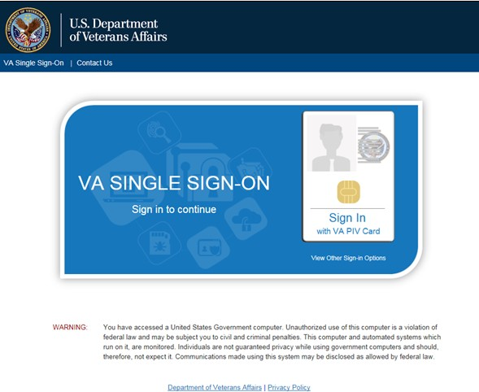
Figure 1: Single Sign-On Page for VA Users

    - Once authenticated by the Single Sign-On system, you are redirected to JLV
    - Read the important user consent information regarding access to a Government information system, and click I Accept
    - If desired, check the Accessibility Mode option in the top right corner, above the JLV log in page fields. If selected, JLV opens and displays the application in the 508- compliant Accessible User Interface (UI) theme. See Section 3.2.2, Using the Accessible Theme's Functionality, for detailed information
    - Enter your VA log in credentials:
      - Enter your CPRS Veterans Health Information Systems and Technology Architecture (VistA) Access Code
      - Enter your CPRS (VistA) Verify Code
      - Select VA from the Agency field
      - Select your VA Medical Center or regional Health Care System from the Site field
    - Click Login

VBA User Log In
The following instructions apply to VBA users accessing JLV through a URL only. To log in to JLV:
    - Enter the VBA's URL for JLV into the address bar of your Internet browser. REDACTED
    - All VA users will be redirected to the VA Single Sign-On page (Figure 1). VA users must sign in to, and be authenticated by, the Single Sign-On system in order to access JLV

Users may select any of the authentication options available through the VA Single Sign-On log in page for access to JLV.

    - Once authenticated by the Single Sign-On system, you are redirected to JLV
    - Read the important user consent information regarding access to a Government information system and click I Accept
    - If desired, check the Accessibility Mode option in the top right corner, above the JLV log in page fields. If selected, JLV opens and displays the application in the 508- compliant Accessible UI theme. See Section 3.2.2, Using the Accessible Theme's Functionality, for detailed information
    - Enter your log in credentials:
      - Enter your Compensation and Pension Record Interchange (CAPRI) Access Code
      - Enter your CAPRI Verify Code
    - Click Login

Editing Your User Profile at Log In
One method of setting application configuration options (customizing) is by using the Edit Profile link (highlighted in Figure 2) to access the user profile fields through the JLV Login page.
The subsections below discuss the options to set the UI theme, and to enable/disable the Include Community Data function via the Edit Profile link.

User profile options can be set within JLV. See Section 3.2, Customizing JLV.

The selected options are saved to the user profile by clicking Save and Login, and remain set for all subsequent JLV sessions, until changed by the user.

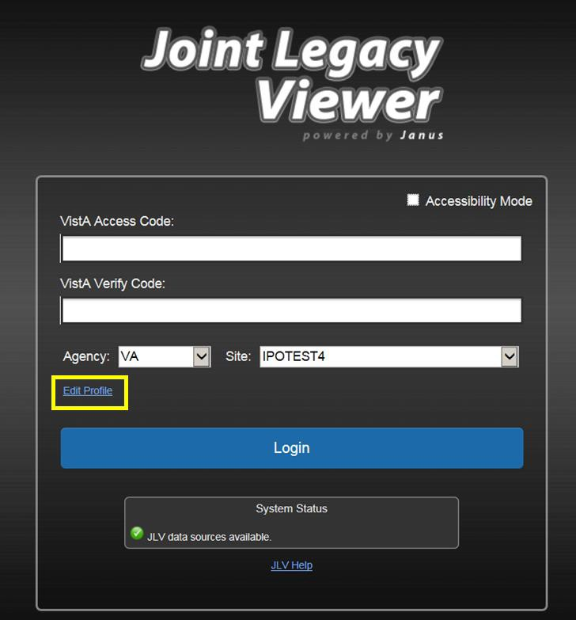
Figure 2: Edit Profile Link on the JLV Login Page

Selecting a UI Theme
Selecting a UI theme sets the font color and foreground/background colors of the JLV GUI for the widgets, toolbars, and dialog boxes. Theme color options are Blue (Default), Green, Dark Gray, Gray, and Accessible (508 compliant). The UI theme choices appear below the Agency and Site fields, as seen in Figure 3.

The Accessible theme provides larger fonts, enhanced tab and keystroke functionality, and screen reader compatibility, compliant with Federal accessibility requirements and Section 508 standards. Refer to Section 3.2.2, Using the Accessible Theme's Functionality, for more information.

Community Data Display
In a future release, checking (enabling) the Include Community Data option will tell JLV to query for, receive, and integrate patient data from external VA VLER community partner data

sources. The community data setting is in the bottom half of the Edit Profile dialog, seen in Figure 3.

VHA users can see the Include Community Data option, but it is not yet active.
VBA users do not have access to community data, and will not see the Include Community Data option.

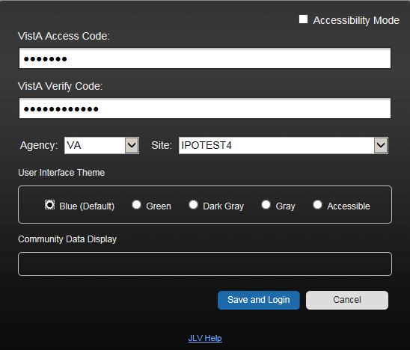
Figure 3: Community Data Display Option

Logging Out of the Current JLV Session
To end the current session and exit JLV, click the Log Out icon (highlighted in Figure 4) at any time.

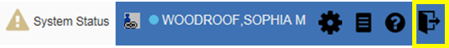
Figure 4: JLV Log Out Icon

A JLV session will end automatically after thirty minutes of inactivity. Automatic termination of a session does not clear the last screen in use and display the Login page, but connectivity to, and the functionality of JLV is terminated. To re-open a JLV session, log in to JLV again.

Actions in JLV that are considered activity are changing patients, refreshing widgets, opening or closing widgets, adding or removing widgets from the portal pages, and adjusting date ranges.

The Elements and Functionality of JLV

The JLV Portal Pages
After a successful log in, your user name is shown in the upper right corner of the application, and the JLV portal pages are displayed. The JLV portal pages are:
- The Patient Portal
- The Provider Portal

Default View
Upon log in, users will see the Provider Portal . The portal displays the Search dialog box and the References widget by default.
The References widget (Figure 5) is shown by default on the Provider Portal . The References widget displays hyperlinked references to online clinical medicine resources. Click a reference link to access the associated website. Click the Add icon + to add a new reference link.
Delete a reference by right-clicking the link and selecting Delete URL. Users will not be able to delete reference links included in the default widget configuration.

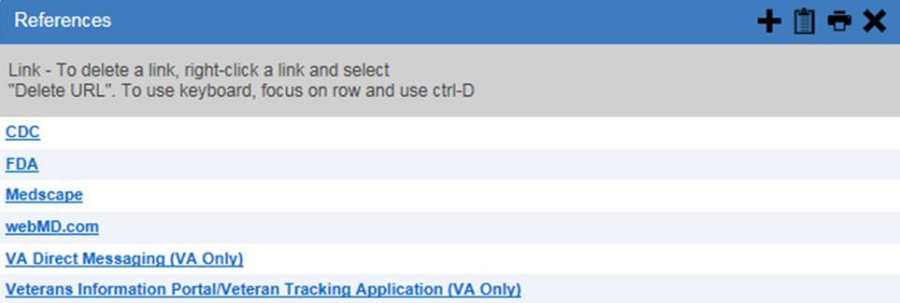
Figure 5: References Widget

The Patient Portal displays a selected patient's clinical records and other patient-centric information.
New JLV users will see a pre-configured, default widget layout on the Patient Portal when JLV opens. The default layout includes the Patient Demographics, Allergies, Problem List, Documents, Outpatient Medications, and Lab Results widgets.

Users can configure the layout of widgets on the Patient Portal and create multiple widget

tabs, as described in Section 3.2, Customizing JLV after Log In, and in Section 4.1, Accessing and Opening Widgets. Customizations are saved to the user profile as set, and remain until manually changed.

System Menu
Each portal page has a toolbar (highlighted in Figure 6) that enables quick access to the following features:
      - Configuration Options: Click the cog wheel icon in the top right corner of either portal page to set user preferences, including the UI theme. Refer to Section 3.2, Customizing JLV
      - Report Builder: Click the Report Builder icon in the top right corner of either portal page to create custom reports. Refer to Section 4.8, Using Report Builder
      - Access Online Help: Click the Help icon in the top right corner of either portal page to open online help
      - Log Out of JLV: Click the Log Out icon to log out and close the current JLV session. Refer to Section 2.4, Logging Out of the Current JLV Session

Figure 6: JLV Tools on the Portal Pages

The following functions can be completed from the portal pages (highlighted in Figure 7):
      - Perform a Patient Search
      - Switch between the Patient Portal and the Provider Portal
      - View the system status
      - View Context Management status
      - Open the widget tray Open Widget Tray ^ (bottom of the portal pages)

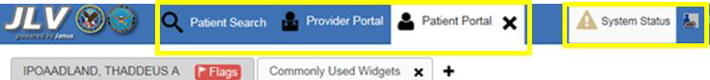
Figure 7: More JLV Functionality

The system status is displayed to the left of the user name. Hovering over System Status will provide additional information, as seen in Figure 8.

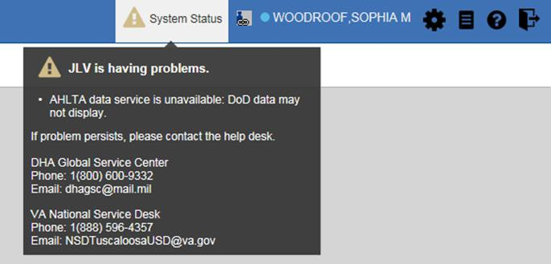
Figure 8: System Status Details

Viewing System Status
System status updates are received from JLV’s Quality of Service (QoS) Monitor, also called the Health Monitor. QoS monitors the status of services that JLV uses to connect to VA and DoD data sources, which include: Master Veteran Index (MVI), Patient Discovery Web Service (PDWS), Relay Service, VistA Data Service (VDS), and jMeadows Data Service.
JLV displays the system status on the Login page, below the user credential fields (highlighted in Figure 9), and at the top of the Portal Pages (Figure 8).
      - When all monitored systems and services are online and connected, a green icon appears next to the status message JLV data sources are available on the JLV Login page.
      - When one or more of the monitored systems or services is offline or unavailable, a yellow warning icon appears next to the status message JLV is having problems. Notification of unavailable systems persisting longer than ten (10) minutes should be reported to the VA Enterprise Service Desk (Section 1.4, Getting Help).
      - When the jMeadows Data Service is unavailable, a red icon appears next to the message, JLV is having problems. jMeadows Data Service is unavailable. JLV may not function properly. Users may not be able to log in to JLV, or view patient data, until the jMeadows connection is restored.

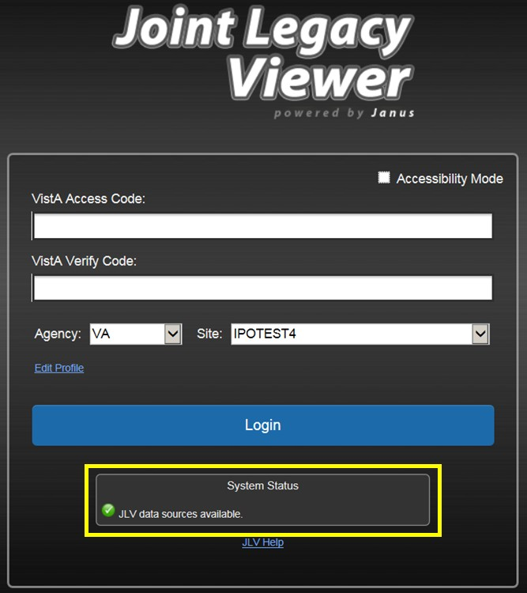
Figure 9: System Status on the JLV Login Page

Context Management
Clinical Context Management (CCOW) is a way for applications to synchronize the display of clinical context, based on the Health Level 7 (HL7) CCOW standard. If CCOW-compliant applications are sharing context and one of the applications changes the data display to a different patient, the other applications will switch to display that same patient.
JLV is context management-enabled. When context is enabled, a patient change made in one context-enabled application (i.e., CPRS) will trigger the same change in JLV. The same effect is shown vice versa; that is, when a patient is selected in JLV, it triggers a patient change in other context-enabled applications.
Context management is enabled by default, and JLV will attempt to connect to the context vault upon a valid login. The context status appears in the top right corner of the portal pages. When context is established, the Context On icon is shown. When context is suspended, the Context Suspended icon is shown.
Figure 10 shows the context indicator location on a JLV portal pages. In this example, context is suspended.

Figure 10: Context Indicator

Establishing Context
When context is suspended, it can be re-established manually. To establish or re-establish context:
        - Click the Context Suspended icon
        - The CCOW warning message, Are you sure you want to rejoin patient link? appears (Figure 11)
        - Click Yes
Once context is established, the Context On icon is displayed on the portal pages.

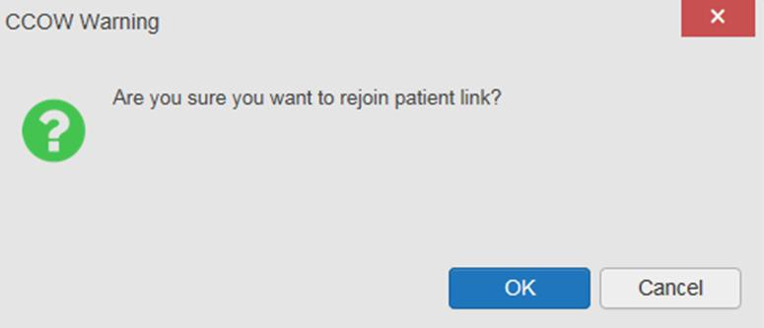
Figure 11: CCOW Warning Message

      - Suspending Context Context can be manually suspended. To manually suspend context:
        - Click the Context On icon
        - The CCOW warning message, Are you sure you want to break patient link? appears (Figure 12)
        - Click Yes to continue
Once context is suspended, the Context Suspended icon is displayed on the portal pages.

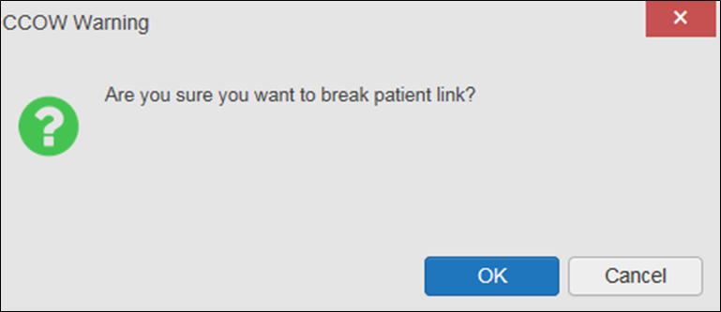
Figure 12: Suspending Context

Unable to Communicate with Vault
If JLV is unable to initiate context management upon log in, the user will see the CCOW Error message (Figure 13). Click OK to continue. The Context Suspended icon is displayed on the portal pages.

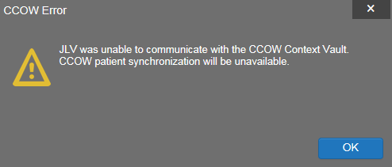
Figure 13: CCOW Error Message

Context Synchronization Failure
In the event that JLV is unable to re-establish context, a CCOW Error message is presented (Figure 14). This indicates context is suspended. Click OK to continue. The Context Suspended icon is displayed on the portal pages.

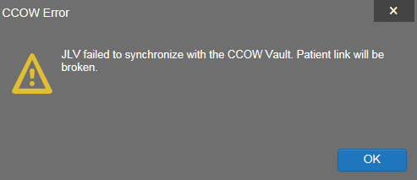
Figure 14: Context Synchronization Failure

VistA Imaging Viewer
JLV integrates access to the VistA Imaging Viewer (an external application), allowing VA users access to VA imaging artifacts for supported clinical domains (widgets). Users can open an instance of the VistA Imaging Viewer through JLV. For more information regarding the VistA Imaging Viewer, please see the VistA Imaging SharePoint site.

A camera icon displayed in the Image column (Figure 15) of the Documents, Outpatient Encounters, Procedures, Progress Notes, and Radiology Reports widgets indicates that one or more images are associated with that record. Clicking the camera icon within the widget opens the VistA Imaging Viewer in a standalone window, and displays the associated image.

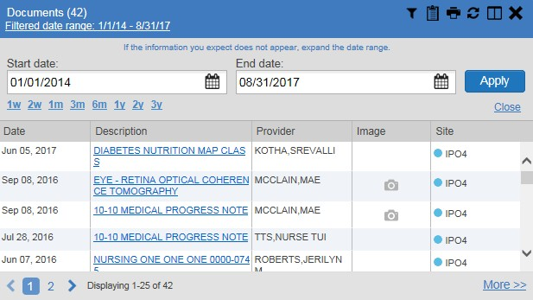
Figure 15: Camera Icon in the Image Column

If a record has one or more images associated with it, the Details view of the widget includes a display of a thumbnail in the top right corner of the window (Figure 16). Below the thumbnail, a

link that reads, Click image to open viewer, is also displayed. Clicking either the thumbnail or the link opens the VistA Imaging Viewer, and displays the associated image(s).

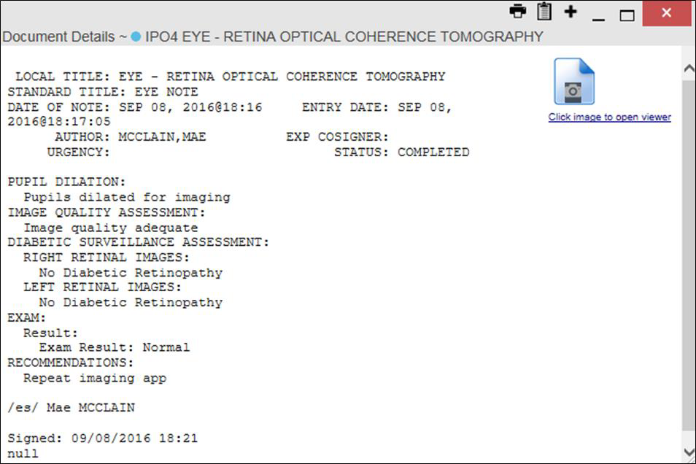
Figure 16: Thumbnail and Link in Details View

Customizing JLV
Configuration options can be set within JLV by clicking the cog wheel icon.

Setting the UI Theme
The UI theme setting is a part of the user profile. Choosing a UI theme sets the font, foreground, and background colors of the widgets, toolbars, and dialog boxes. Once selected, the UI theme is stored in the user profile, and remains set until changed. The available UI themes are Blue (Default), Green, Dark Gray, Gray, and Accessible (508 compliant).

To set the UI theme within JLV:
      - Click the cog wheel icon in the upper right corner of the portal pages (Figure 6)
      - The User Configuration dialog box opens
      - Select the desired theme and click Save
      - After clicking Save, click Yes to reload the application and apply your theme choice
      - Alternatively, click Cancel to exit the dialog box and restore the previous theme

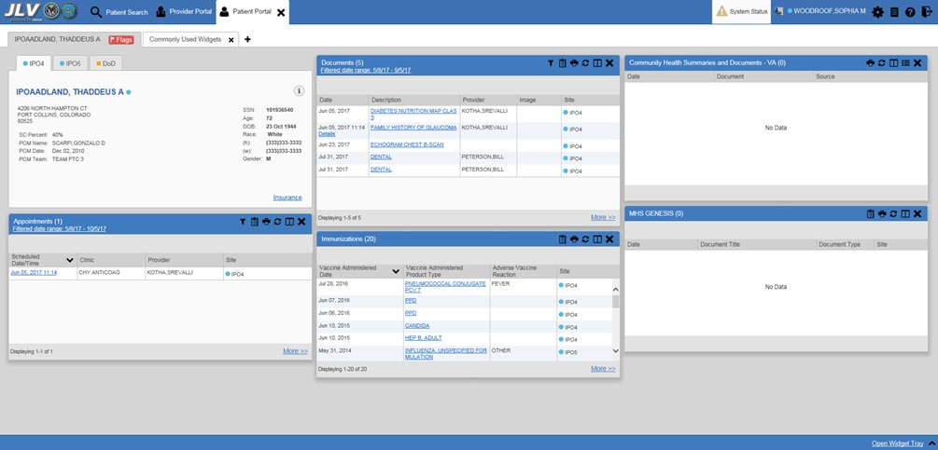
Figure 17: Blue (Default) UI Theme

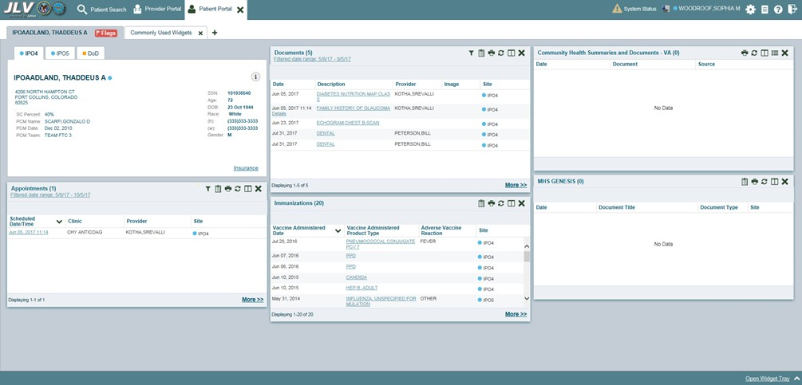
Figure 18: Green UI Theme

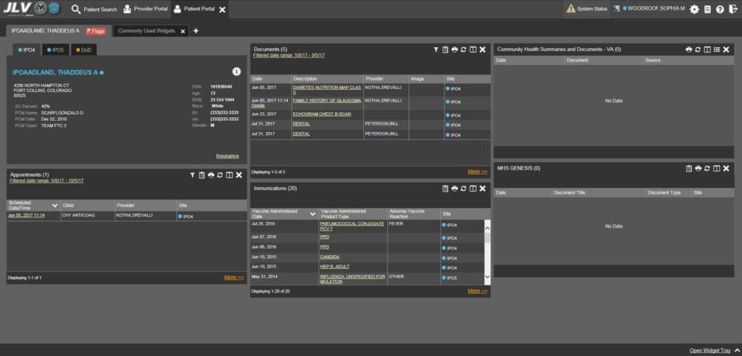
Figure 19: Dark Gray UI Theme

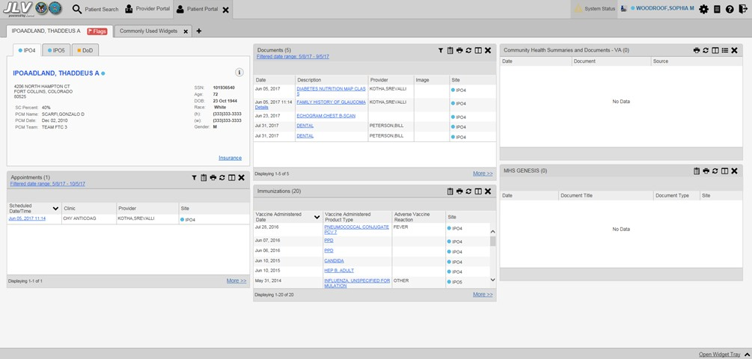
Figure 20: Gray UI Theme

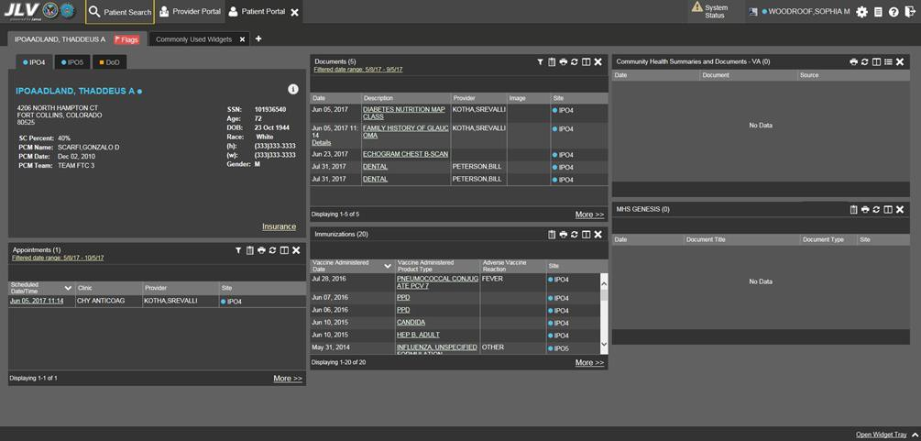
Figure 21: Accessible (508 Compliant) UI Theme

Using the Accessible Theme’s Functionality
The Accessible theme includes larger fonts, enhanced tab and keystroke functionality, and screen reader compatibility to support Federal accessibility requirements and Section 508 compliance.

The Accessible theme is available for users who have adaptive technologies installed on their computers.

Keyboard Focus and Screen Navigation
Keyboard focus is the highlighting of screen elements that enables interaction with, and navigation of, JLV through the keyboard and keystrokes. The on-screen item in focus is outlined. JLV uses a gold outline as a visual indicator of the element with keyboard focus.
JLV uses common Windows keystrokes (Tab, Shift + Tab, arrow keys, Enter), and keyboard shortcuts to move the focus to all menus, and activate all functions on the menus. All user interface items are accessible via the keyboard under the Accessible theme.
Pressing Enter or the Spacebar when an element that provides action is in keyboard focus performs the associated action. For example, pressing Enter or the Spacebar when the Cog Wheel icon is in focus opens the User Configuration dialog box. Using the arrow keys or the Tab key moves between keyboard focus items to navigate through screen elements. A complete list of accessible keystrokes is provided in Table 3.

Table 3: Accessible Theme Keyboard Shortcuts

Keystroke | Description
Application & Portal Navigation
ENTER | Press to transfer keyboard focus to the highlighted widget
TAB | Press to transfer keyboard focus to other user interface items
ESC | Press to return keyboard focus to the panel containing the user interface item with keyboard focus, or to exit a window or widget
SPACEBAR | Press to activate any user interface item (for example, click a button)
Arrow Keys | When focused on a widget, press the arrow keys to change page viewing in a widget's data table  When focused on a dropdown list, press the down arrow key to view list contents
Ctrl + P | Press to bring focus to the first tab in the active portal
Ctrl + R | When working with Report Builder, place keyboard focus on a record in a widget and press Ctrl + R to add the record to the Report Builder pane
Tab Panels
Arrow Keys | Use the left and right arrow keys to change tab panels  To add a tab panel, press the right arrow key until the last tab (labeled with a plus sign) is selected. A dialog box will prompt for the new tab name.  To close a tab, focus on the tab panel and press Ctrl + X
Windows or Dialog Boxes
TAB | Press to transfer keyboard focus to other user interface items within the window or dialog box
Adding Widgets to a Portal Page
SHIFT +  (Number position) | To add a widget from the widget tray using keystrokes:  - Determine which column (1, 2, or 3) in which to place the widget  - Focus the desired widget icon in the widget tray and press the SHIFT key, along with the 1, 2, or 3 key, depending on the column chosen

Accessible Theme Screen Navigation
An element with keyboard focus is the starting point for screen navigation. Pressing the Enter
key when a screen element or icon has keyboard focus mimics a mouse click.
Figure 22 depicts the Documents widget with keyboard focus. Focus can be changed by pressing the Tab key. In this example, pressing the Tab key shifts the keyboard focus from the Documents widget to the widget immediately below the Documents widget. Pressing the Tab key again shifts the keyboard focus to the widget at the top of the next column.

To view hover text where available, focus on the element within the widget that has hover text. After a small delay, the text will appear as if the user hovered over the element with a
mouse cursor.

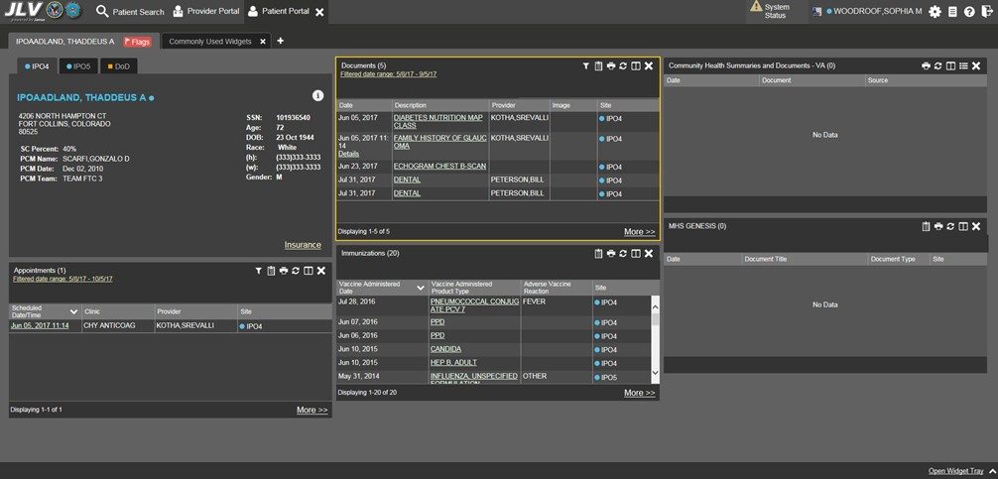
Figure 22: Navigation Using Elements with Keyboard Focus

In Figure 23, the Document details window has keyboard focus. Move through the toolbar buttons by using the arrow keys, or by pressing Tab. Move to Close (X) and press Enter to close the details window. After closing the window, keyboard focus returns to the last element that had keyboard focus prior to opening the window.

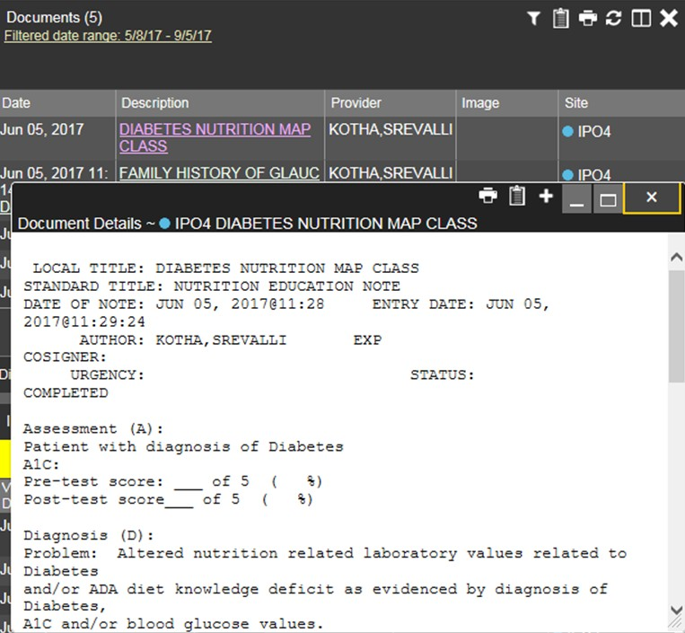
Figure 23: Document Details with Keyboard Focus

User-Restricted Access to Patient Data

VHA Users Viewing DoD-only Patients
VHA users are permitted to view the records of patients considered DoD-only, meaning they either have no VA identifiers, or are not registered in MVI. The VA requires that these actions be audited. If an attempt is made to access DoD-only patient records, the VHA user is asked to specify the purpose for access. The purpose options presented to the user are: Emergent Care, Clinical Care, or Authorized Administrative Use (Figure 24).
Once the purpose for access is selected, clicking Agree to be Audited & Access this Patient Record (Figure 24), displays the requested data, and audits the action. The access purpose, organization of the VA provider, date, user name, IP address, user’s Internal Entry Number (IEN), host system’s ID, and patient’s Electronic Data Interchange Personal Identifier (EDIPI) are captured in the audit record.

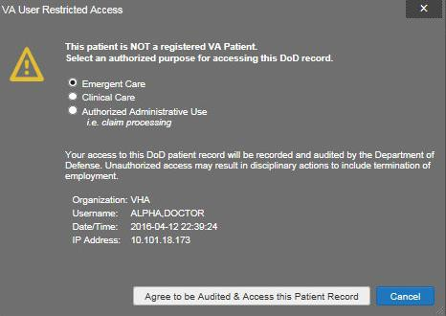
Figure 24: VA User Restricted Access Dialog

VBA Users Viewing Patients with DoD Data
VBA users may see one of two different dialog boxes, depending on whether or not the patient is registered for care in the VA. If the patient is registered for care in the VA, they are in MVI.
      - Patient registered in MVI: VBA users are permitted to view the records of a patient who is registered in MVI, but the VA requires that these actions be audited. After performing a patient search and selecting a patient from the search results, a VBA user will see the audit notification (Figure 25) if the patient they selected is registered in MVI. After agreeing to the audit, the VBA user can access the patient’s record.

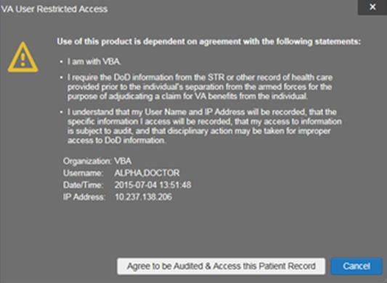
Figure 25: VBA User Audit Notification

      - Patient not registered in MVI: VBA users are not permitted to access the records of a patient who is not registered in MVI. After performing a patient search and selecting a patient from the search results, a VBA user will see the restricted access notification (Figure 26) if the selected patient is not registered in MVI. Clicking Cancel returns the user to the previous screen.

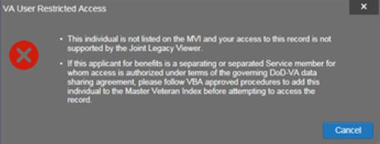
Figure 26: Restricted Access Notification

Access to DoD Sensitive Records
All JLV users are audited each time a sensitive DoD record is accessed. Auditing applies to sensitive outpatient encounters, progress notes, or labs results records. For each attempt to access sensitive data, JLV records the user’s name, organization, Social Security Number (SSN)/EDIPI (for DoD users), PIV (for VA users), location, patient identifiers (patient last name, first name, middle initial (MI), SSN/EDIPI (DoD only), MVI (VA only), and date of birth (DOB)), data accessed, date and time, and reason for access.

The audit prompt is seen each time access to a sensitive record is attempted, even if the user has been previously audited for the same record.

JLV notifies users before they are audited. The message is triggered when the user clicks a masked record that is marked ** Sensitive **. An example of a masked record displayed in a widget and the audit notification are depicted in Figure 27.

After the user selects the purpose for viewing the record and agrees to be audited, the sensitive data is displayed in the Details view of the widget.

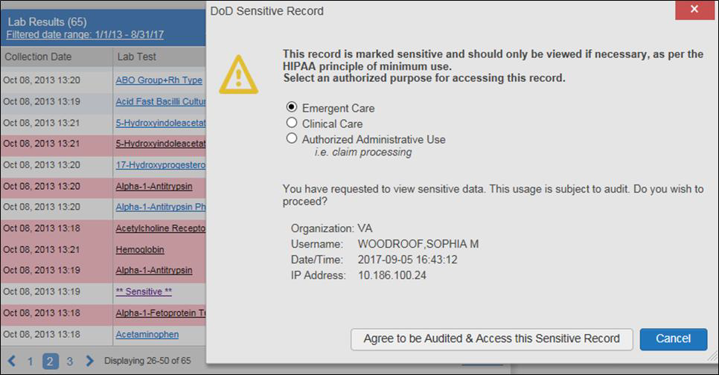
Figure 27: DoD Sensitive Record and Audit Dialog Box

Patient Searches
The core function of JLV is to display patient information on the Patient Portal . Use the Patient Search feature to perform a patient search, perform a family search, or use the advanced search options.

JLV determines which enterprise service to use for a patient search, based upon the search criteria:
- If the EDIPI or Sponsor SSN is entered, JLV utilizes PDWS for the search. See Section 3.4.1, PDWS Search Rules and Supported Searches, for details
- If the EDIPI or Sponsor SSN fields are empty, JLV utilizes MVI for the search. See Section 3.4.2, MVI Search Guidelines, for details

PDWS Search Rules and Supported Searches
When JLV utilizes PDWS for patient search, the applicable rules and rule sets required for the PDWS interface must be used:
      - Rule Set 1: When searching by SSN, the full nine-digit SSN must be entered, and the Last Name or DOB must also be supplied. This is true for search by patient SSN, as well as Sponsor SSN
      - Rule Set 2: If you do not have the patient’s SSN, you must supply ALL of the following identifiers: last name, first name, DOB, and gender. Blanks in any of these four required fields will generate an error
      - A ten-digit string is required for telephone number
The following search combinations are supported when PDWS is utilized:
      - DoD ID, also referred to as the EDIPI
      - Patient SSN and Last Name
      - Patient SSN and DOB
      - Sponsor SSN and Last Name
      - Sponsor SSN and DOB
      - Last Name, First Name, DOB, and Gender (ALL identifiers must be entered)

MVI Search Guidelines
JLV utilizes MVI for a patient search when the search parameters include the patient’s name and SSN. MVI requires the full last name is entered when the patient’s SSN is entered. MVI may
also require entering the patient’s first name and DOB to increase the efficiency of the search, and the likelihood of locating the patient. An example would be searching for a patient with a common last name, such as Smith or Jones.

Patient Search Using DoD ID
To perform a patient search using the DoD ID (Figure 28):
- Click the Patient Search icon at the top of the portal pages. The Patient Search
dialog opens
- Enter the ten-digit patient DoD ID (EDIPI) in the DoD ID field

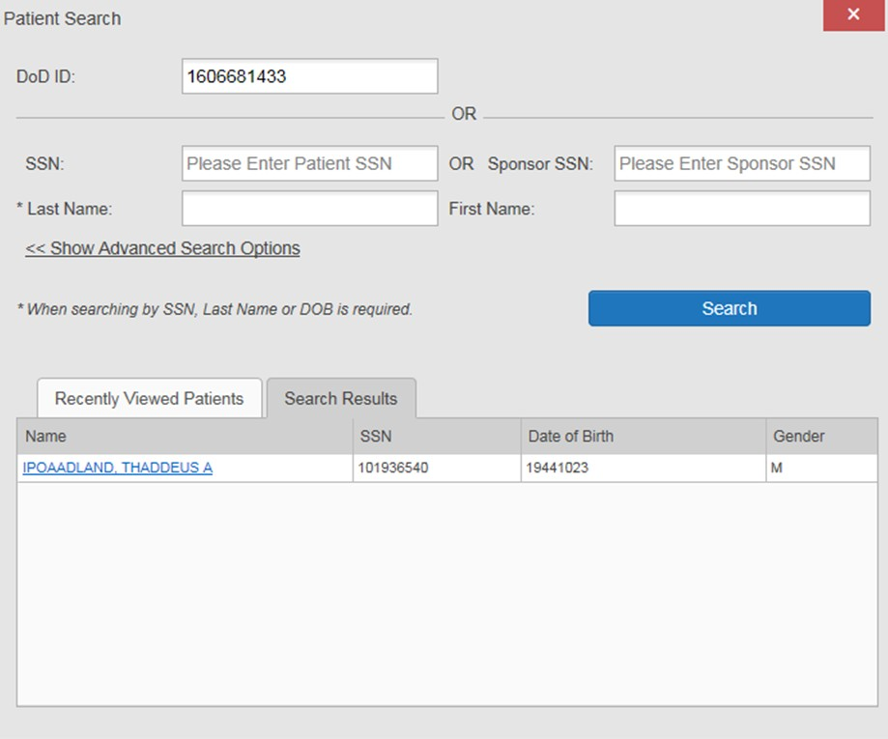
Figure 28: DoD ID (EDIPI) Search

- Click Search. The search results are displayed in the lower third of the dialog box, under the Search Results tab
- Click a patient’s name in the search results list to open the associated record. The Name, SSN, DOB, and Gender columns in the results list provide information to assist with patient identification
- After selecting a patient, the Patient Portal opens and displays the selected patient’s data

Patient Search Using SSN
To perform a patient search using the patient’s SSN:
- Click the Patient Search icon at the top of the portal pages. The Patient Search
dialog box opens
- Enter the patient’s full, nine-digit SSN in the SSN field (Figure 29)

NOTE: When searching by SSN, either the last name or the DOB must be entered to perform the search.

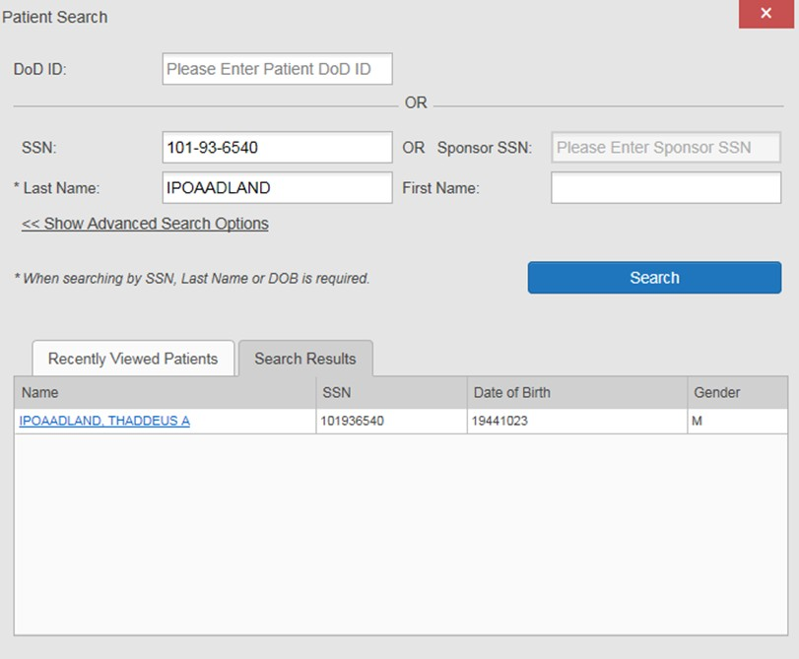
Figure 29: SSN Search

- Click Search. If the required patient identifiers are not provided, hover text appears, indicating the information necessary to complete the patient search. If a match of patient names cannot be made, enter additional identifiers to refine the search
- The search results are displayed in the lower third of the dialog box, under the Search Results tab
- Click a patient’s name in the search results list to open the associated record. The Name, SSN, DOB, and Gender columns in the results list provide information to assist with patient identification
- After selecting a patient, the Patient Portal opens and displays the selected patient’s data

Advanced Patient Search Options
Advanced patient search options in the Patient Search dialog box allow for the use of additional patient identifiers when performing a patient search.
To search using advanced patient search options:
- Click the Patient Search icon at the top of the portal pages. The Patient Search
dialog box opens

- Click the <<Show Advanced Search Options link under the *Last Name field (seen in Figure 29)
- Enter the patient identifiers in the appropriate search fields, as desired. Advanced search option fields include *DOB, MI, Gender, Address, State, City, Zip, and Telephone

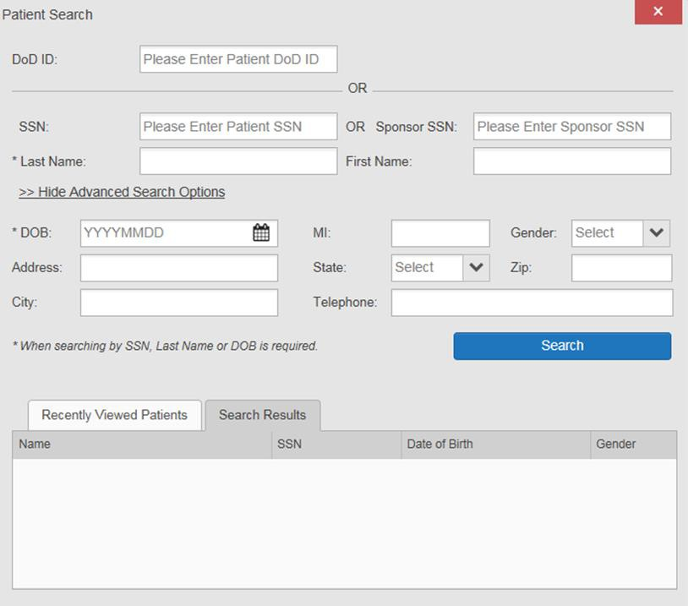
Figure 30: Advanced Search Options

- Click Search. If the required patient identifiers are not provided, hover text appears, indicating the information necessary to complete the patient search
- The search results are displayed in the lower third of the dialog box, under the Search Results tab
- Click a patient’s name in the search results list to open the associated record. The Name, SSN, DOB, and Gender columns in the results list provide information to assist with patient identification
- After selecting a patient, the Patient Portal opens and displays the selected patient’s data

Family Member Search
A family member search can be performed using the Sponsor SSN field in the Patient Search
dialog box.
To perform a family member search:
- Click the Patient Search icon at the top of the portal pages. The Patient Search
dialog box opens
- Enter the SSN in the Sponsor SSN field. The Last Name or DOB of the patient must also be entered in the appropriate fields (Figure 31)
- Click Search. If the required patient identifiers are not provided, hover text appears indicating the information necessary to complete the patient search
- The search results are displayed in the lower third of the dialog box, under the Search Results tab (Figure 31)

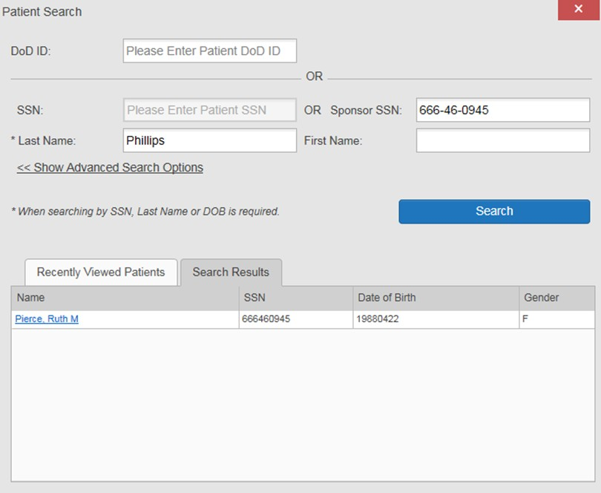
Figure 31: Sponsor SSN Search

- Click a name in the Search Results list. The Family Members dialog opens (Figure 32). The sponsor’s identifiers and a list of dependents are displayed in the dialog
- Click a name in the list of family members to open the associated record

- After selecting a patient, the Patient Portal opens and displays the selected patient’s data

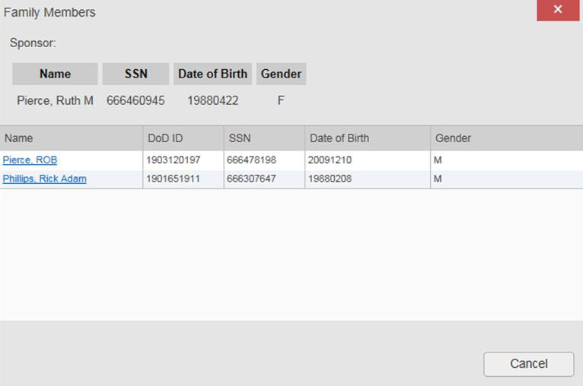
Figure 32: Family Members Dialog Box

Recently Viewed Patients List
Users who have previously logged into JLV, searched for a patient, and viewed that patient’s records, can see and access a list of recently viewed patients. A recent patient is defined as a patient whose record has been viewed (opened) by the user.

NOTE: The Recently Viewed Patients list does not include search history or recent search results, only a list of patients whose data was accessed and viewed. The list is limited to ten
(10) patients.

To open the list of recently viewed patients:
1. Click the Patient Search icon at the top of the portal pages. The Patient Search
dialog box opens
- Click the Recently Viewed Patients tab in the lower third of the Patient Search dialog box
- A list of recently viewed patients is displayed (Figure 33). The Name, DoD ID, SSN, DOB, and Gender columns in the results list provide information to assist with patient identification
- Click a patient’s name in the Recently Viewed Patients list to open the associated record
- After selecting a patient, the Patient Portal opens and displays the selected patient’s data

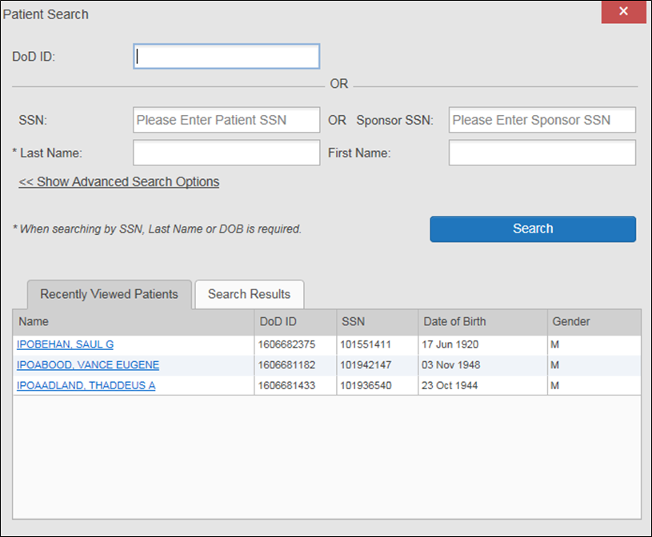
Figure 33: Recently Viewed Patients List

Widgets
Widgets are elements on the JLV portal pages that display data specific to a clinical domain. By default, widgets are displayed in minimized view on the portal pages (Figure 34), but can be expanded to view additional details. The list of available widgets is provided in a horizontal tray at the bottom of the page.
Widgets may take anywhere between 3 seconds to 10 seconds to load.

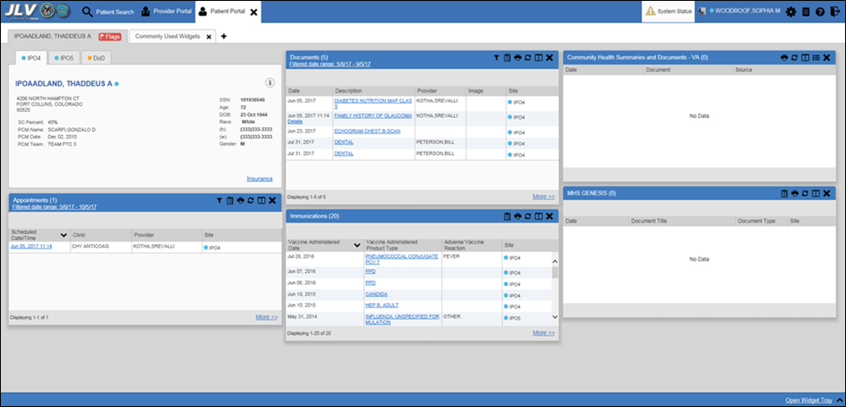
Figure 34: Widgets on the Patient Portal

Accessing and Opening Widgets
Widgets can be opened, rearranged, and closed. All available widgets are displayed in the widget tray, at the bottom of the portal pages (Figure 35).

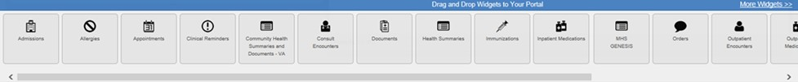
Figure 35: Widget Tray

To place a widget on the Patient Portal:
    - Open the widget tray by clicking the Open Widget Tray link
    - Use the scroll bar arrows < > at either end of the tray to see all widget choices

-OR-
    - Click the More Widgets >> link to scroll through the list of widgets

    - Click and hold a widget in the tray, then drag it to the portal page and drop it in the desired location
    - The widget is docked on the portal page, and opens in minimized view
    - Close the widget tray by clicking the Close Widget Tray link

Widgets can be closed (removed from the portal page) by clicking the Close icon in the top right corner of the widget. Rearrange the widgets displayed on the portal page by dragging and dropping them.

Widget Navigation and Display Options
Each widget has tools and display options available to navigate through, and change, the display of data. The vertical scroll bar allows the user to move through, and view, the widget’s data. The options at the bottom of a widget provide various ways to see all the records loaded for the widget’s clinical domain.
Navigation icons and actions are detailed in Table 4.

Table 4: Navigation Icons and Actions

Navigation Icon/Action |  | Description
 | Go to Previous Page | Changes the focus of the widget to the previous group or page of records within the results display.
 | Jump to Page | Changes the focus of the widget to the page number selected.
 | Go to Next Page | Changes the focus of the widget to the next group or page of records within the results display.
More >> | Go to Expanded View | Available in minimized views only. Opens the expanded view of the widget in a secondary window.
1-25 of 55 | Record Display Indicator | Indicates the number of records displayed in that widget page out of the total number of results for that widget.
Show All/ Show Paged | Display Setting | Click Show All to open all records for a given widget in a scrollable window.  Click Show Paged to return to the display of records grouped by pages.

When there are more than 25 records available in a widget, they are grouped in Show Paged view. Records 1 through 25 can be viewed by using the widget’s vertical scroll bar. Records 26+ can be viewed by using the page navigation options in the lower left corner of the widget, to jump to subsequent pages. The expanded view of a widget contains a Show All link, which opens all records for that widget, in a scrollable window. Click Show Paged to return to the display of records grouped by pages.

Widget Toolbars
There is a toolbar in the upper right corner of both the minimized and expanded views of each widget, and most dialog boxes. Toolbar icons vary by widget, open dialog box, and window. Table 5 describes the functionality of each toolbar icon.

Table 5: Widget Toolbar Icons

Icon | Name | Function
 | Add to Report Builder | Adds the information displayed in the window to the Report Builder. This icon is available for supported domains when a record has a Details or Notes view that displays in a standalone window
 | Close | Removes the widget from the portal screen or closes a dialog box
 | Column Settings | Used to configure the columns within the widget. Turn on or off the columns displayed by checking the column names that appear in the pop-up box and checking Apply
 | Configure Filter | Used to filter on specific record types or other elements within the widget, including a date filter. If a date range filter is applied in an open widget, the date range is displayed in the widget header  Note: After setting a filter, the Close Filter option is enabled in the widget. Clicking  Close Filter will restore the full display of records within the widget
 | Copy to Clipboard | Copies the content of the open window to the clipboard for pasting into another application
 | Interface Status | Both icons provide a status indicator for DoD, VA, and community partner data sources. The circle with the lowercase “i" indicates all sources are available. The yellow triangle warning indicates one or more data sources are unavailable.  Clicking either status icon will open the interface status details in a separate window  Note: Interface status updates are not available from the Clinical Reminders widget
 | Print | Prints the contents of the open window. Printing is disabled in the widget toolbar after clicking Show All within a widget.  Note: It is recommended that JLV users have the latest Adobe Reader installed for the Report Builder and other printing features
 | Refresh | Refreshes the widget or window display. Only the data within that widget’s dataset is updated
 | Rx | Converts the medication data within the widget to text, and opens the text in a pop-up window. Available from the Outpatient Medications widget
 | Site List | Opens a list of community sites where the patient has been seen (only available from the Community Health Summaries and Documents – VA widget)
 | VLER  Refresh | Refreshes VLER-enabled widgets with the community partner data stored in the VLER cache, in addition to refreshing DoD and VA data  NOTE: The VLER Refresh icon is shown in VLER-enabled widgets only when

Icon | Name | Function
 |  | Include Community Data is enabled. (The Community Data option will be available in a future release.)

Minimized vs. Expanded Widget View
Each widget can be displayed in either a minimized (default) or an expanded view. Minimized view displays a short list of the available patient data for a clinical domain, arranged in reverse chronological order. Expanded view provides a longer list of similarly arranged patient data.
When the expanded view of a widget is launched, it opens in a new, separate window.

The Community Health Summaries and Documents - VA widget does not have an expanded view. Instead, a document opened from the minimized view of the widget is
displayed in a new, separate window.

Click the More >> link at the bottom of a widget to launch the expanded view, and see the additional display and functionality options.
Patient data displayed within a widget can be filtered by date range. If a date range filter is applied, the selected range is indicated in the widget header, below the title. Click the Configure Filter icon or the Filtered Date Range link on the widget toolbar to change the date range of the data displayed (Figure 36).

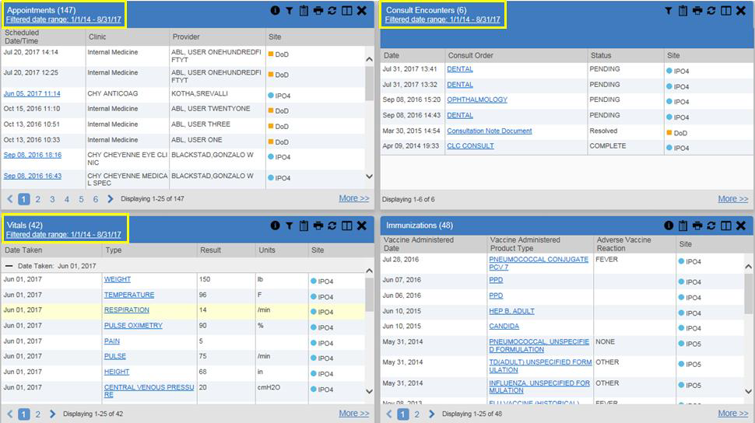
Figure 36: Date Range Filters Applied

Date Range Filters
There are two ways to filter the date range of data displayed in a widget; the Quick Date Range filter, and the Start and End Date filter. If the expected information does not appear in the widget display, use the date filter options to change the date range.

Changes made to the date range in a widget persist from patient to patient, and session to session, until the widget is either removed, or the date range is changed.

Quick Date Range Filter
Use the preset, Quick Date Range filter to set or limit the display of patient records within a particular widget. This option is available in multiple widgets on the Patient Portal.
Clicking a date range refreshes the data displayed to show only the records for the selected range. The options represent time counting back from the present day (for example, selecting 2y will display only records within the last two years). Examples of preset date ranges include 1w (last 7 days), 6m (last 6 months), and 3y (last 3 years).

The Quick Date Range filter is contextual. If today is January 2, 2017, the preset filters will count backwards using that date. If today is April 16, 2017, the preset filter will count
backwards using that date.

Figure 37 highlights the Quick Date Range filter options in the expanded view of the
Documents widget.

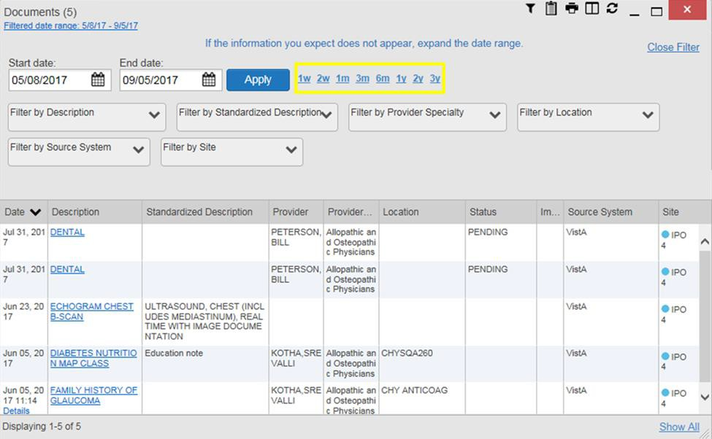
Figure 37: Quick Date Range Filter Options

Start and End Date Filter
Use the Start Date and End Date filter to display data for a specific time range. The start and end date fields are available at the top of multiple widgets in expanded view, or by clicking the Configure Filter icon in minimized view.

The Start and End Date filter is static. If the start date is set to June 2, 2016 and the end date is set to June 2, 2017, the data in that date range will display, no matter what today’s
date is.

Figure 38 provides an example of the start and end date filter fields in the expanded view of the
Radiology Reports widget.

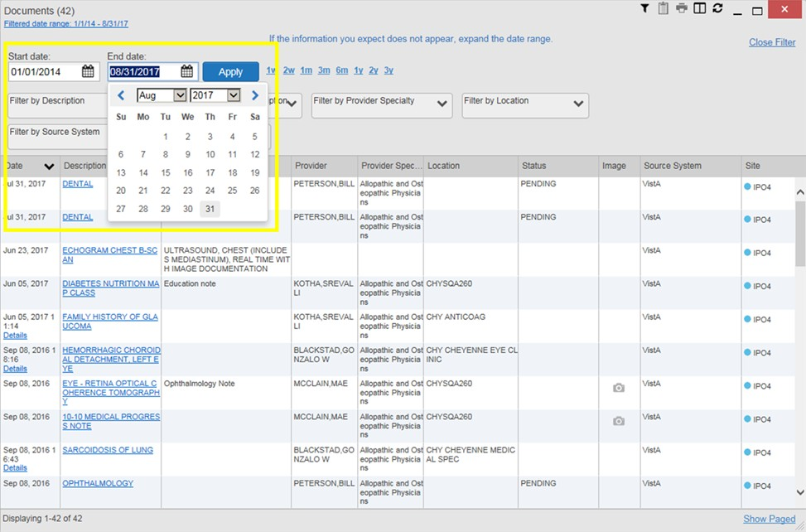
Figure 38: Start and End Date Display Filter

To set a custom date range:
        - Click the Calendar icon next to Start Date
        - Choose a start date for the display filter
        - Click the Calendar icon next to End Date
        - Select the end date for the display filter
        - When both a start and end date have been chosen, click Apply

The widget refreshes and displays only the records that fall within the custom date range. The date range in use is displayed in the widget header.

Viewing Interface Status
Interface status updates for clinical domains are not the same as System Status messages displayed in the top right corner of the portal pages. See Section 3.1.3, Viewing System Status, for more information.

Interface status updates are available for each widget except Clinical Reminders, and can be accessed through the widget's toolbar. An icon on the toolbar provides a status indicator for VA, DoD, and community partner data sources. There are two status conditions: all sources are connected (available), or one or more sources are not connected/unavailable. Clicking either icon opens the interface status for VA, DoD, and community partner sources in a standalone window. Entries for the status of DoD sources are derived from responses received from Data Exchange Services (DES). Interface status notifications accessed from the widget show connection status at the domain level.

Figure 39 shows a status message banner displayed in the Documents widget. The banner can be closed by clicking the Close icon X to the right of the status message. This action hides the banner during the current JLV session, until the widget is closed. Re-opening the widget restores the banner display, if the problem persists.

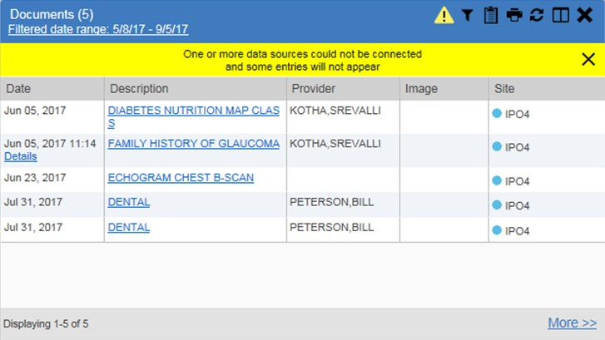
Figure 39: Interface Status Banner

Displaying Widgets on Custom Tabs
You can use the custom tabs feature to create additional widget configurations for ease of use and quick reference. Changes made to portal page layouts (widget layouts and custom tabs) are saved to the user profile, and are displayed in future sessions.
To create a custom tab:

    - Click the plus sign + beside the existing tabs on the portal page (Figure 40). The Add Tab dialog box opens
    - Type the name of the new tab in the Add Tab dialog box and click OK

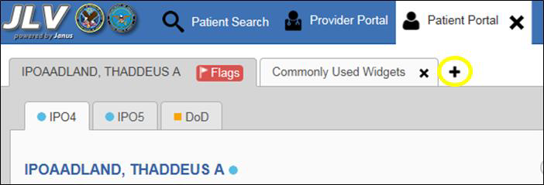
Figure 40: Add Custom Tab Icon

    - Click the Open Widget Tray link within the new tab space to display all available widgets
    - Click, hold, and drag each of the desired widgets to the screen

Tab configurations remain as set, until manually changed.
    - Click between tabs at any time, without losing each tab’s configuration. Tab layouts persist, even when a patient change is made

Refreshing Data in a Widget
The data displayed in a widget can be refreshed by clicking the Refresh icon . This action refreshes the widget’s display.

When the option to Include Community Data is enabled, clicking the Refresh icon also triggers a refresh of the VA VLER-enabled widgets’ data.

A widget will display the VLER Refresh icon if the widget supports community partner data, and the Include Community Data option is enabled. Clicking the VLER Refresh icon triggers two refresh actions: JLV sends a new query to VLER sources for community partner data, then refreshes DoD and VA data in open widgets with data JLV has stored in a cache. Clicking VLER Refresh in one widget refreshes all other open, VLER-enabled widgets.

If the option to Include Community Data is disabled, the VLER Refresh icon will not be displayed in any of the widgets that support the display of community data.

Please Note: VHA users can see the Include Community Data option, but it is not yet active. It will be enabled in a future release.

Using Report Builder
Report Builder provides the ability to build custom reports by selecting patient records, or a combination of supported documents and record details. The information selected for the custom report is exported to a printable file in Portable Document Format (PDF).

As noted in Section 1.3, System Requirements, it is recommended that the latest version of the Adobe Reader be installed on the system used to access JLV.

Reports can be built using patient records, and/or documents from either the minimized or expanded view of a supported widget. The Report Builder feature can be accessed from the toolbar at the top right corner of the Patient Portal.
To create a custom report:
    - Click the Report Builder icon (Figure 41). The Report Builder pane opens on the
Patient Portal (Figure 42)

Figure 41: Report Builder Icon

    - Select records to add to the report:
      - Any record or demographics data within a widget can be added by right-clicking the entry in an open widget and selecting Add Record to Report (Figure 42)
      - Click Add to Report within any Demographics tab to add demographics data. Demographics information will appear at the top of the report by default
      - If the desired record has a Details or Notes view, click the Add Record icon on the toolbar of the open Details or Notes window to add the additional record information
        - Some DoD documents can only be added to Report Builder by opening the
Details or Notes view of the document
        - Some DoD documents do not have a Details or Notes view, but clicking on their name in the list of documents will present the dialog box seen in Figure 43
        - Some DoD notes cannot be added to Report Builder. If a note cannot be added, there will not be an option to add the record to the report on a right-click

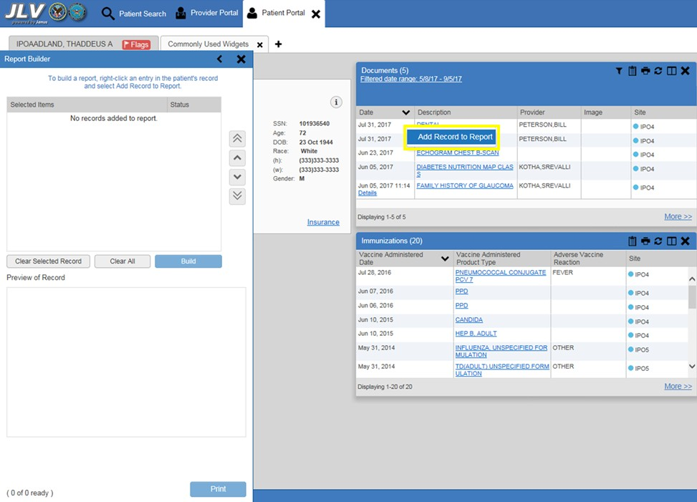
Figure 42: Report Builder Pane and Add Record to Report Option

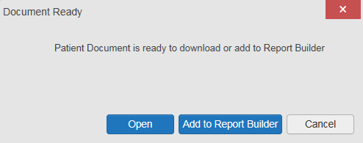
Figure 43: Document Ready Dialog Box

    - The selected records appear in the Report Builder window
    - Use the navigation arrows to the right of the listed records (Figure 44) to arrange the records in the desired order in the generated report. Records can be removed by clicking Clear Selected Record or Clear All

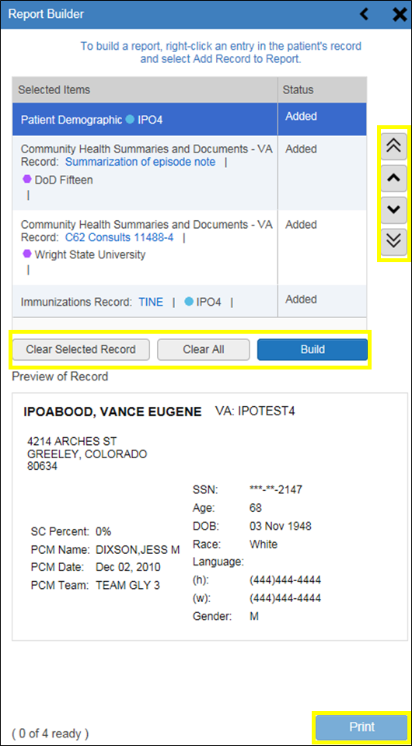
Figure 44: Report Builder Tools

    - When a record is selected for the report, it appears in the Preview of Record area of the
Report Builder pane (Figure 45)
    - Click Build to validate and prepare the records selected for the report. If a record can be added to the report with no errors, there will be a Ready notation next to it; if a record cannot be added to the report, an Error notation will appear next to the record
    - Click Print to generate the report, built only with those records that have a Ready status

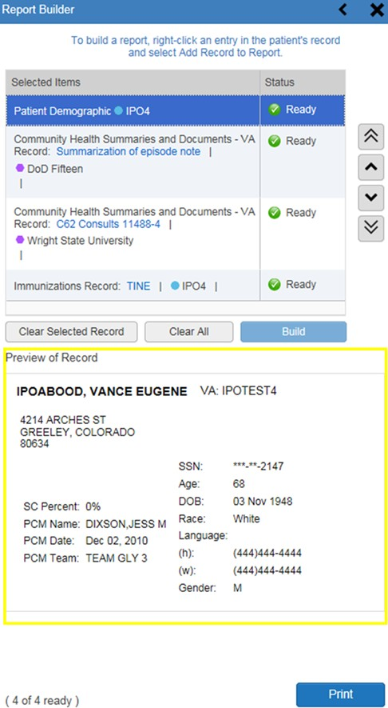
Figure 45 Preview of Record in Report Builder Pane

    - The generated report opens in a new tab within the browser window. Save the report to your local system, if desired

Each report generated using the Report Builder feature includes this disclaimer:
The information contained in this transmission may contain privileged and confidential information, including patient information protected by federal and state privacy laws. It is intended only for the use of the person(s) named above. If you are not the intended recipient, you are hereby notified that any review, dissemination, distribution, or duplication of this communication is strictly prohibited. If you are not the intended recipient, please contact the sender by reply e-mail, and destroy all copies of the original message.

Printing
The data list of a widget in either minimized or expanded view, the details window of a widget, and reports created in Report Builder can be printed from JLV.
To print the data list of a widget in either minimized or expanded view click the Print icon on the desired widget’s toolbar.
To print the details window of a widget, click the Print icon on the details window’s toolbar. To print a report created in Report Builder, click the Print button.

Widget Functionality
The following subsections detail the functionality in a sampling of the widgets available in JLV.

Patient Demographics Widget
The Patient Demographics widget displays a summary of the patient’s non-clinical, personal data. The widget appears in the upper left section of the Patient Portal (Figure 46). The tabs above the patient’s name provide a demographics summary for each site (VA, DoD, or VLER) the patient has visited.

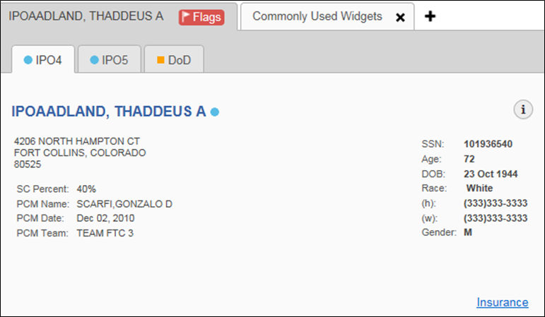
Figure 46: Patient Demographics Widget

The Patient Demographics widget provides additional functionality and displays:
- Clicking the patient's name opens details in a standalone window
- Clicking an Interface Status icon opens the interface status details in a separate window
- Clicking the Flags icon above the tabs in the widget opens clinical flag details in a new window

Patient Flags and Alerts
If the patient has one or more clinical warnings, alerts, or flags in their record from VA and DoD sites, the Flags icon is displayed next to the Patient Name tab, above the Demographics widget, on the Patient Portal (Figure 47).
The Patient Flags and Alerts details window opens and displays by default when the Patient Portal opens, if there are warnings associated with the selected patient.

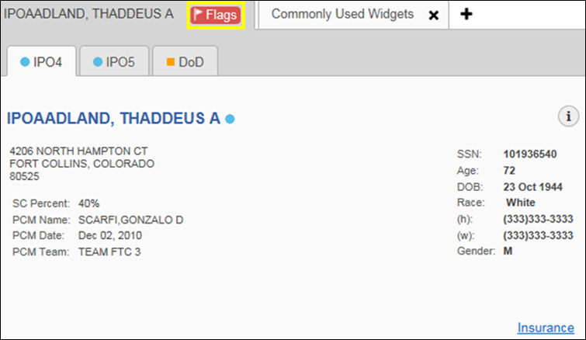
Figure 47: Patient Flags Indicator

Click the Flags icon to open the Patient Flags and Postings details window (Figure 48). The window displays a list of alerts and flags within the patient’s record. If the patient’s record does not contain any clinical warnings, the Flags icon is not displayed.

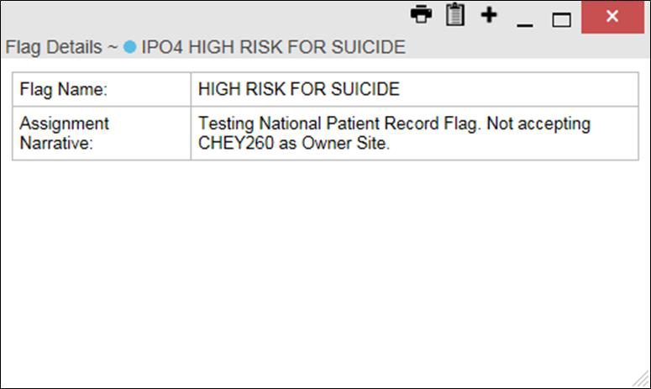
Figure 48: Patient Flags and Postings Details

Race Data Terminology Normalization
Race data from VA and DoD sources in the Patient Demographics widget is normalized. Hovering over the Race information displays the standardized name and code for the race classification, normalized to the Centers for Disease Control (CDC) standard (Figure 49).

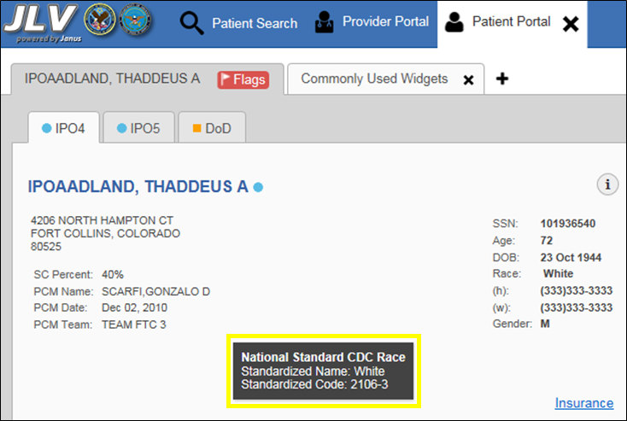
Figure 49: Standardized Race Data

Demographics from Community Partners
When users enable the Include Community Data setting and VLER patient data is displayed, the Patient Demographics widget displays color-coded information.
      - The blue circle represents data retrieved from a VA system
      - The orange square represents data retrieved from a DoD system
      - The purple hexagon represents data retrieved from VLER sources
Please Note: VHA users can see the Include Community Data option, but it is not yet active. It will be enabled in a future release.

Viewing Third-Party Insurance Information
Third-party payers and insurance information is available from the Patient Demographics widget. Click the Insurance link in the Demographics widget. A new window (Figure 50) opens with the following insurance information:

- Health Plan Type | - Member ID
- Health Plan Name | - Subscriber ID
- Standardized Insurance Type | - Subscriber Date of Birth
- Plan Effective Date | - Subscriber’s Relationship to Insurer
- Plan Expiration Date | - Health Plan Mailing Address
- Site | - Health Plan Contact Information
- Group Number

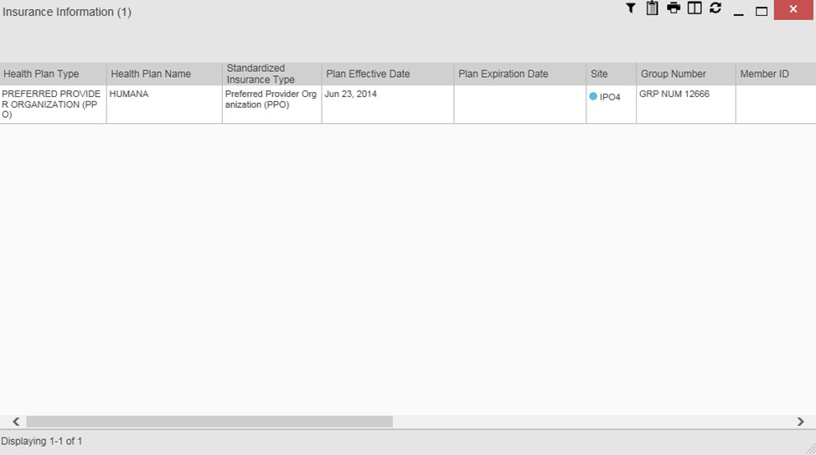
Figure 50: Insurance Information

Use the scroll bar in the window to view the columns not seen within the default window size.
The data in the Standardized Insurance Type column is normalized to the X12 Health Insurance Type standard. Hovering over entries in this column display the standardized name and code for the insurance type.

Documents Widget
The Documents widget (Figure 51) includes documents from multiple clinical domains, including radiology reports (exams), progress notes, outpatient encounters, consult encounters, discharge summaries (inpatient notes), questionnaires, and Health Artifact and Image Management Solution (HAIMS) records. HAIMS records retrieved by JLV include scanned paper records, imported paper records, scanned non-radiology images, and imported non- radiology images, displayed in chronological order by the document date.

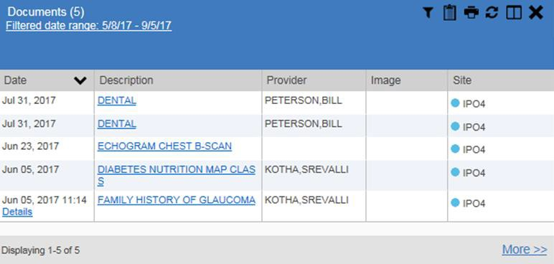
Figure 51: Documents Widget, Minimized View

Documents Widget Data
The minimized view of the Documents widget displays the following information:
      - Date
      - Description
      - Provider
      - Image
      - Site
Outpatient encounter records displayed in the Documents widget may have a Details link enabled in the Date column. Where available, click the link to open a Details window for records of this type.
The Description column displays the document title, where available. Click a hyperlinked entry in the Description column in either the minimized or expanded view of the widget to open the document.
A camera icon in the Image column of the Documents widget indicates that one or more images are associated with that record. Clicking the camera icon opens the VistA Imaging Viewer in a standalone window, and displays the associated image(s).
Click More >> in the minimized view of the Documents widget to open the expanded view (Figure 52). Information in expanded view includes:

- Date  - Description  - Standardized Description  - Provider | - Provider Specialty  - Location  - Status  - Site

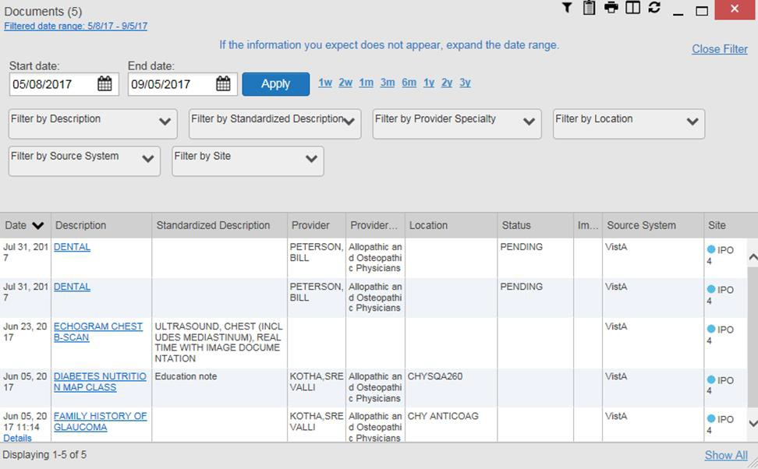
Figure 52: Documents Widget, Expanded View

Viewing Documents
Click a hyperlinked entry in the Description column in either the minimized or expanded view of the Documents widget to access additional information for a listed record. Depending on the record type, the additional information may open in either a details window or a separate browser window. Figure 53 displays outpatient encounters details, accessed through the Documents widget.

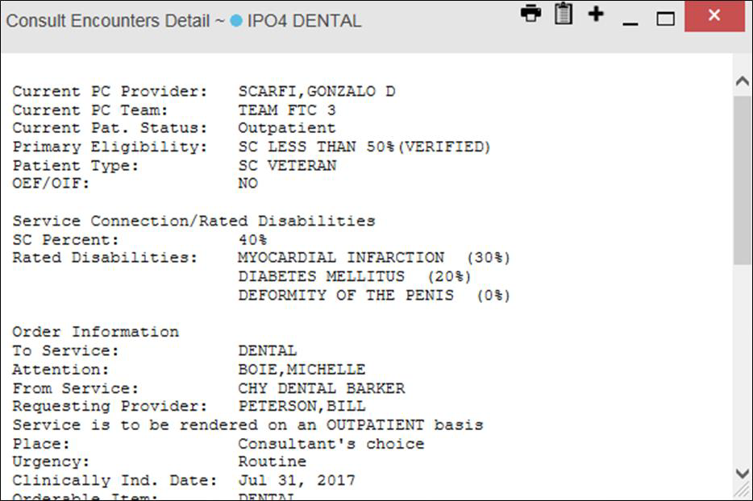
Figure 53: Details View of a Document

Viewing DoD Sensitive Data
JLV masks the display of sensitive records in the Documents widget. The record is masked with the tag **Sensitive**. A user may view the data, but the action is audited each time the sensitive DoD record is viewed.
After clicking the hyperlink in the Description column for a sensitive record, JLV notifies the user that they will be audited. This message is triggered each time a user clicks a sensitive record. After the user selects the purpose of viewing the record and agrees to be audited, the sensitive data appears in Details view, but the record remains masked in the minimized and expanded views of the widget.

Display and Filter Options
Display and filter options within the Documents widget include:
      - Click a column title to sort records by that column. If a user sorts on a column that appears in both minimized and expanded views of the widget, the sort is saved to the user profile, and appears in subsequent JLV sessions. If a user sorts on a column that is only available in the expanded view of the widget, subsequent JLV sessions display the default widget sort, or the last sort saved to the user profile.
      - Use the Quick Date Range Selector, or the Start Date and End Date calendars, to specify the date range of records to be displayed within the widget. If the information you expect does not appear in the widget display, use the Start Date and End Date filter options to expand the date range. When a date range filter is applied in an open widget, the date range is displayed in the widget header. Open or close the filter options by clicking the date range in the header.
      - Click the Column Settings icon on the widget toolbar to show or hide columns within the widget. Check/uncheck the column names that appear in the pop-up dialog box, then click Apply.
      - Use the Filter by Description dropdown to re-draw the widget and show only the records for the selected description(s). Only available in expanded view.
      - Use the Filter by Standardized Description dropdown to re-draw the widget and show only the records for the selected description(s). Only available in expanded view.
      - Use the Filter by Provider Specialty dropdown to re-draw the widget and show only the records for the selected provider type(s). Only available in expanded view.
      - Use the Filter by Location dropdown to re-draw the widget and show only the records for the selected location(s). Only available in expanded view.

Terminology Normalization
Terminology normalization in the Documents widget is provided through the following columns:
      - The Description column displays the name of a note or document in the patient record. Hovering over an entry in this column displays the standard used for terminology normalization for the clinical domain (Logical Observation Identifiers Names and Codes (LOINC)), and the standardized LOINC name and code for that document.

      - The Standardized Description column displays the standardized name for the corresponding entry in the Description column, mapped to the LOINC standard. In addition to the standardized name, hovering over an entry in this column displays the standard used for terminology normalization for the clinical domain (LOINC), and the standardized code for that document.
      - The data in the Provider and Provider Specialty columns, in both the minimized and expanded views of the widget, is normalized to the National Uniform Claim Committee Taxonomy (NUCC) standard. Hovering over entries in these columns displays the standardized name and code for the provider.
Figure 54 highlights a document mapped to the LOINC standard. The standardized name and code are displayed in the hover text over the record in the Description column.

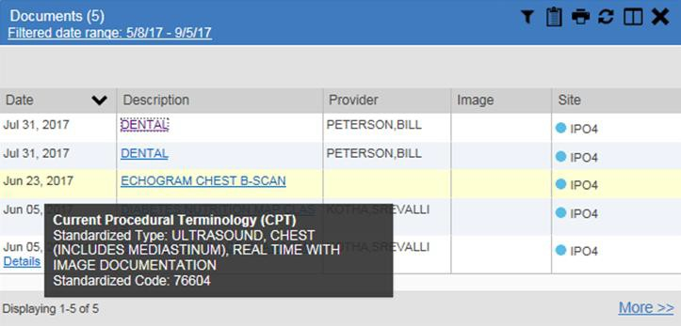
Figure 54: Standardized Name and Code – Documents Widget

Community Health Summaries and Documents – VA
The Community Health Summaries and Documents – VA widget displays the patient’s VA VLER community partner information, including Continuity of Care Documents (CCDs) in C32 and C62 formats, and HL7 Consolidated-Clinical Document (C-CDA) structured documents available for the patient. The information in this widget is sorted by the title of the entry listed in the Document column.

Community Health Summaries and Documents – VA Widget Data
Data displayed within the Community Health Summaries and Documents – VA widget includes:
      - Date
      - Document
      - Source
The purple hexagon beside entries in the Source column denotes the source of the data is outside the VA.

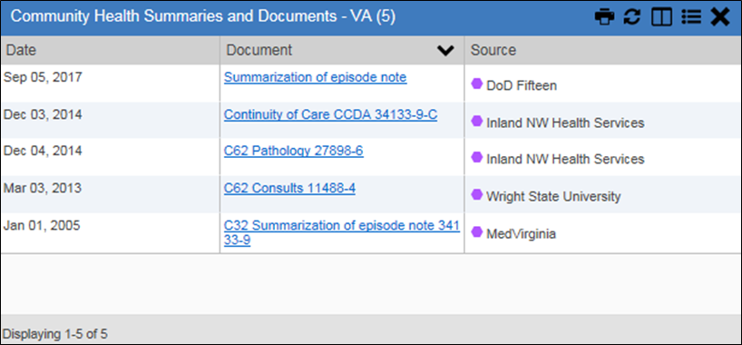
Figure 55: Community Health Summaries and Documents – VA, Minimized View

The Site List icon on the toolbar in the Community Health Summaries and Documents - VA widget (Figure 55) generates a list of community sites where the patient has been seen.
Click the Site List icon to open the full list of community sites where the patient has been seen. The site list contents are gathered from the widget's Source column and the sites where the patient was seen, but no document was generated. Click Close Site List to remove the full site list from the widget display.

Viewing VA Community Health Summary Documents
Figure 55 shows health summary records available from the Document column in the Community Health Summaries and Documents - VA widget. Clicking a hyperlinked entry in the Document column opens the document in a separate browser tab (Figure 56).

Multiple documents can be opened in separate browser tabs for simultaneous viewing and printing.

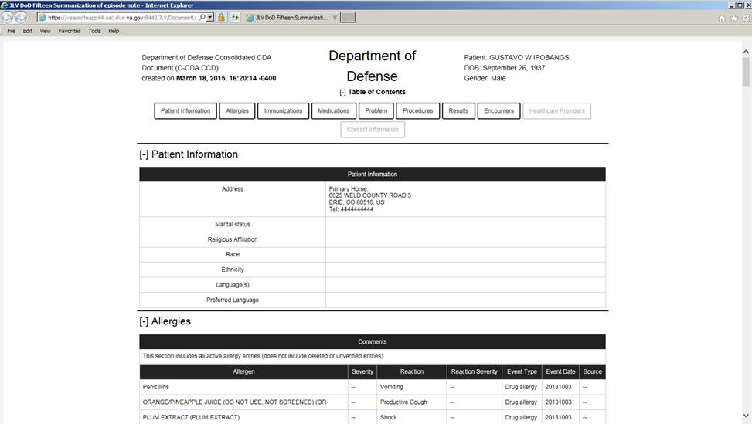
Figure 56: Community Health Document

Military Health System (MHS) GENESIS Widget
The MHS GENESIS widget displays the documents in patient records from MHS GENESIS. The information is displayed in reverse chronological order, by date.

MHS GENESIS Widget Data
The minimized view of the MHS GENESIS widget includes the following orders information:
      - Date
      - Document Title
      - Document Type
      - Site
Figure 57 highlights the MHS GENESIS widget in minimized view.
Medical CCDs, Dental CCDs, and aggregate CCDs with blank entries in the Date column for the record appear first in the widget, by default.

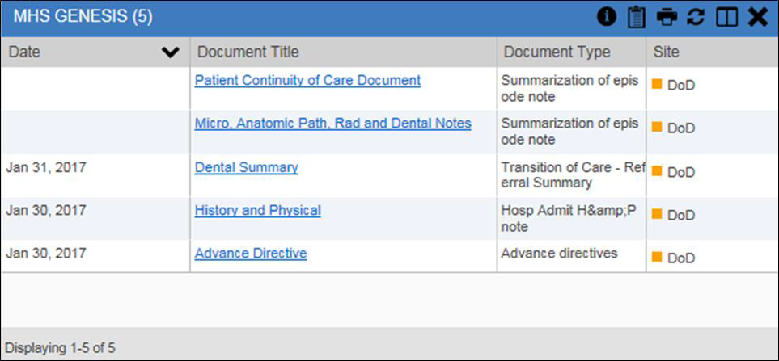
Figure 57: MHS GENESIS Widget

Viewing MHS GENESIS Documents
Click a hyperlink in the Document column in either view of the MHS GENESIS widget to display a Consolidated Clinical Document Architecture (CCDA) document (Figure 58) in a new browser window.

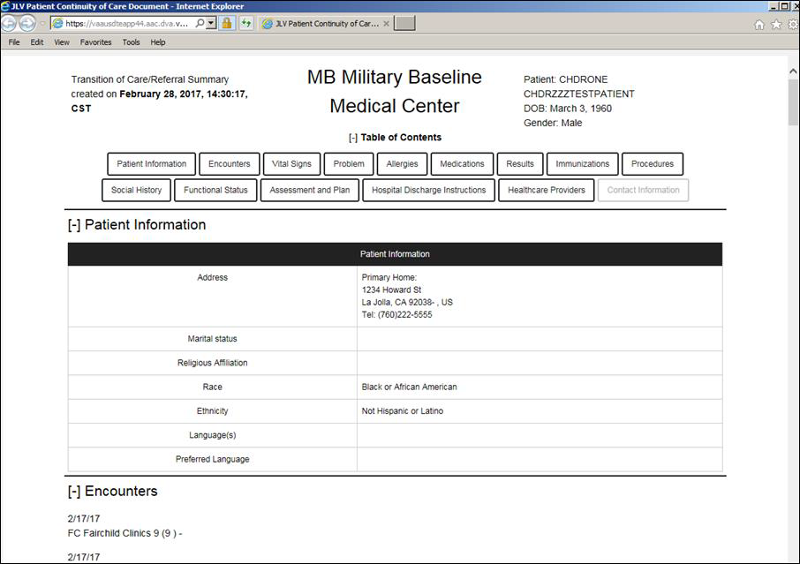
Figure 58: CCDA Document

Troubleshooting
The following subsections provide information about troubleshooting common errors in JLV.

Special Instructions for Error Correction
JLV utilizes access control and authentication services to limit access to registered, authorized users. When enabled, JLV validates a user against information retrieved from their Smart Card. If you are having trouble logging in to JLV, and have used the correct URL for your agency, please review the following before contacting the ESD:
VHA users:
- Have accessed JLV using the VHA URL REDACTED)
- Have entered their existing CPRS Access and Verify codes correctly in the fields on the JLV log in page
- Have selected a site from the Site dropdown list on the JLV log in page. Most users must specify the individual facility name, or their parent healthcare system name
VBA users:
- Have accessed JLV using the VBA URL (REDACTED)
- Have entered their existing CAPRI Access and Verify codes correctly in the fields on the JLV log in page
- Have selected Veterans Benefits Admin from the Site dropdown list

Log in Page Error Messages
Troubleshooting steps for error messages received at the log in page are provided in Table 6.

Table 6: Error Messages and Resolution Steps

Error Message | Resolution Steps
Access denied. You are not an authorized user | WHAT? You see the error message Access Denied. You are not an authorized User.  WHY? Possible causes are: a PIV card processing problem; selection of the wrong security certificate; you are not an authorized user.  FIX IT:  - Close your browser window  - Re-insert your PIV card and relaunch JLV  - Select a certificate that is not expired, and specifies Issued by: Veterans Affairs CA B1  - If unsuccessful, contact the ESD

Error Message | Resolution Steps
Could not save User Profile | WHAT? You receive the error message Could not save User Profile.  WHY? The error occurred during PIV authentication. It is typically a PIV card processing problem, or the wrong security certificate is chosen.  FIX IT:  - Close your browser window  - Re-insert your PIV card and relaunch JLV  - Select a certificate that is not expired, and specifies Issued by: Veterans Affairs CA B1  4.) If unsuccessful, close all open IE windows/tabs. Open IE and try JLV again
Not a valid ACCESS/VERIFY  CODE pair | WHAT? You see the error message Not a valid ACCESS CODE/VERIFY CODE pair error at the log in screen.  WHY? 1) JLV could not match your Access and Verify codes to the site selected in the dropdown, or 2) A user name and password were entered instead of Access/Verify codes.  FIX IT:  - Select the parent VistA host site for your facility (VHA users) Example: Wichita uses Kansas City, MO  - Re-enter your Access and Verify codes (CAPRI codes for VBA users, CPRS codes for VHA users)
Page cannot be displayed | WHAT? You receive a Page cannot be displayed error when launching JLV.  WHY? The JLV URL requires certain IE settings  FIX IT:  - Click the Tools menu (press ALT-X) in IE  - Select Internet Options  - When the dialog opens, click the Advanced tab  - Scroll down in the list until you see the Secure Sockets Layer (SSL) 2.0 setting. Ensure it is NOT checked  - Ensure that the Transport Layer Security (TLS) 1.0, 1.1 and 1.2 settings ARE checked  5) Click OK to close the dialog, then relaunch JLV. The page should load
Smart Card required | WHAT? You see the error message Smart Card Required.  WHY? Your Smart card was not read by Windows Security and JLV before opening the JLV URL.  FIX IT:  - Close all browser sessions and browser-based applications  - Re-insert your PIV card and reopen the JLV URL  - If unsuccessful, close all open IE windows/tabs. Open IE and try JLV again

Error Message | Resolution Steps
VERIFY CODE must  be changed before continued use | WHAT? You receive the message VERIFY CODE must be changed before continued use at the log in screen.  WHY? Your CPRS or CAPRI VERIFY CODE has expired.  FIX IT:  - Open CPRS, VistA, or CAPRI (VBA users)  - Select the Change Verify Code checkbox on the sign-on dialog before clicking OK  - You will be prompted to create a new Verify code  - Once your Verify code is changed for CPRS or CAPRI, relaunch JLV and the new code will be recognized immediately

System Error Messages
Table 7 summarizes system messages that may be presented to JLV users.

Table 7: System Error Messages

Message | Description
No Message displays, but behavior occurs: The browser window does not allow the user to scroll to widgets, or access the JLV icons on the portal pages. | The issue can be resolved by:  Accessing JLV using IE 11  Using a monitor with a minimum screen resolution of 1024 x 768  Setting the browser zoom feature to 100%  If browser display issues continue, log out of JLV, close the browser window, open a new browser window, and log in to JLV again.
Warning: An error occurred while attempting to retrieve VistA Imaging Viewer URL. | Either VistA Data Service or VistA Imaging Exchange is offline, and JLV is unable to retrieve the necessary data object to launch a VistA Imaging Viewer instance within JLV.
MVI Message: There are no patients found using the current parameters. | No patient records were found using the information entered in the Patient Search dialog box. Re-enter patient identifiers in the Patient Search dialog box fields after verifying the accuracy of the information
MVI Error: Patient not found with search elements entered, please provide additional patient identifying information and search again. | No unique patient is found with the identifiers used in the search. Click OK to return to the Patient Search window and provide additional patient identifiers, like the full first name or DOB.
MVI Error: Your query yields too many results. Please modify your search parameters to narrow the search. | JLV adheres to VA guidelines and blocks search results when a search request yields more than 10 patients.  Modify the information in the Patient Search dialog box using additional patient identifiers to reduce the number of results.
MVI Error: Application Reject. There was an error attempting to process your query.  Please modify your search parameters and try again. | There may be one or more errors in the Patient Search dialog fields. Validate the patient identifiers and try the search again. If problems persist, there may be an error between MVI and DEERS.

Message | Description
You do not have authorization to view this record. Security regulations prohibit computer access to your own medical record. | VA security regulations prevent a user to access their own medical records.
You do not have authorization to view this record. Your SSN is missing from the NEW PERSON file. Contact your ACP Coordinator. | Per VA policy, JLV does not allow access to patient records if the JLV user’s SSN is not in their VistA profile.
An error occurred while attempting to retrieve the document. | Occurs when something goes wrong when JLV tries to retrieve a selected document.
An error occurred while attempting to display the document. | Occurs when JLV tries to receive a document, but has trouble converting the document to a viewable format.

VA VLER Server Error Message
Table 8 details an error that may be presented to JLV users, related to the display of VA VLER data.

Table 8: Community Health Summaries and Documents – VA Widget Error Message

Message | Description
Error displayed in widget: Something went wrong: Internal Server Error (500) | This message appears in the Community Health Summaries and Documents – VA widget when the VA VLER service is not available. If the message persists after 5 minutes, contact the ESD to report the connection error.

Acronyms and Abbreviations
Table 9 lists the acronyms and abbreviations used throughout this document, and their descriptions.

Table 9: Acronyms and Abbreviations

Acronym | Description
CAPRI | Compensation and Pension Record Interchange
CCD | Continuity of Care Document
CCDA | Consolidated Clinical Document Architecture
CCOW | Clinical Context Object Workgroup
CDC | Centers for Disease Control
CPRS | Computerized Patient Record System
DES | Data Exchange Services
DOB | Date of Birth
DoD | Department of Defense
EDIPI | Electronic Data Interchange Personal Identifier
EHR | Electronic Health Records
eHX | eHealth Exchange
ESD | Enterprise Service Desk
GUI | Graphical User Interface
HAIMS | Healthcare Artifact and Image Management Solution
HL7 | Health Level 7
ID | Identification
IE | Internet Explorer
IEN | Internal Entry Number
IP | Internet Protocol
JLV | Joint Legacy Viewer
LOINC | Logical Observation Identifiers Names and Codes
MHS | Military Health System
MI | Middle Initial
MVI | Master Veteran Index
NUCC | National Uniform Claim Committee
OI&T | Office of Information and Technology
PDF | Portable Document Format
PDWS | Patient Discovery Web Service
PIV | Personal Identity Verification
QoS | Quality of Service
SSL | Secure Sockets Layer
SSN | Social Security Number

Acronym | Description
TLS | Transport Layer Security
UI | User Interface
URL | Uniform Resource Locator
VA | Department of Veterans Affairs
VBA | Veterans Benefits Administration
VDS | VistA Data Service
VHA | Veterans Health Administration
VistA | Veterans Health Information Systems and Technology Architecture
VLER | Virtual Lifetime Electronic Record

