Joint Legacy Viewer (JLV) 2.5.2 User Guide

April 2017

Version 1.3 Department of Veterans Affairs
Office of Information and Technology (OI&T)

Revision History

Date | Revision | Description | Author
04/13/2017 | 1.3 | Client comments addressed. Document approved | AbleVets
04/12/2017 | 1.2 | Submitted for final review, all comments addressed | AbleVets
03/24/2017 | 1.1 | Comments addressed with client, tentative approval | AbleVets
03/13/2017 | 1.0 | Draft submitted for review | AbleVets
01/15/2017 | 0.1 | Initial draft of artifact | AbleVets

Artifact Rationale
Per the Veteran-focused Integrated Process (VIP) Guide, the User’s Guide is required to be completed prior to Critical Decision Point #2 (CD2), with the expectation that it will be updated as needed. A User Guide is a technical communication document intended to give assistance to people using a particular system, such as VistA end users. It is usually written by a technical writer, although it can also be written by programmers, product or project managers, or other technical staff. Most user guides contain both a written guide and the associated images. In the case of computer applications, it is usual to include screenshots of the human-machine interfaces, and hardware manuals often include clear, simplified diagrams. The language used is matched to the intended audience, with jargon kept to a minimum or explained thoroughly. The User Guide is a mandatory, build-level document, and should be updated to reflect the contents of the most recently deployed build. The sections documented herein are required if applicable to your product.

Table of Contents

- Introduction 1
  - Purpose 1
  - Document Orientation 1
    - Organization of the Manual 1
      - Intended Audience 2
    - Assumptions 2
    - Coordination 2
    - Disclaimers 2
      - Software Disclaimer 2
      - Documentation Disclaimer 3
    - Documentation Conventions 3
    - References and Resources 3
  - Enterprise Service Desk and Organizational Contacts 3
- System Summary 4
  - System Configuration 4
  - Data Flows 4
  - User Access Levels 5
  - Continuity of Operations 6
- Getting Started 6
  - Logging On 6
    - VHA User Log In 7
    - VBA User Log In 8
    - Log In Page Messages 9
      - System Status Messages 9
    - Configuration Options 10
      - User Interface Theme 11
      - Community Data Display 11
  - System Menu 11
  - Changing User Identification (ID) and Password 13
  - Exit System 13
  - Caveats and Exceptions 13
- Using the Software 14
  - Default JLV Layout 14
    - References Widget 14
    - Patient Portal Data Displays 14
      - Interface Status 15
      - Patient Flags and Alerts 15
  - Customizing JLV 17
    - Setting the UI Theme 17
    - Working with the Accessible Theme 19
    - Keyboard Focus and Screen Navigation 20
      - Keyboard Shortcuts 20
      - Accessible Theme Screen Navigation 21
    - Creating Custom Tabs 23
  - Working with Widgets 24
    - Opening and Closing Widgets 24
    - Minimized and Expanded Views 25
    - Widget Toolbars 26
    - Refreshing Data in a Widget 27
    - Widget Navigation and Display Options 27
    - Date Range Filters 29
      - Quick Date Range Filter 29
      - Start and End Date Filter 30
    - Context Management 31
      - Unable to Communicate with Vault 32
      - Establishing Context 32
      - Context Synchronization Failure 33
      - Suspending Context 33
    - User-Restricted Access to Patient Data 34
      - VHA Users Viewing DoD-only Patients 34
      - VBA Users Viewing DoD-only Patients 35
      - Access to DoD Sensitive Records 35
    - Using Report Builder 37
      - Creating Reports 37
    - VistA Imaging Viewer 40
  - Patient Searches 42
    - PDWS Search Rules and Supported Searches 43
    - MVI Search Guidelines 43
    - Patient Search Using DoD ID 43
    - Patient Search Using SSN 44
    - Advanced Patient Search Options 45
    - Family Member Search 46
    - Recently Viewed Patients List 48
  - Widget Functionality 49
    - Patient Demographics 49
      - Race Data Terminology Normalization 50
      - Demographics from Community Partners 51
      - Viewing Third-Party Insurance Information 51
    - Allergies 52
      - Allergies Widget Data 53
      - Viewing Allergy Details 54
      - Terminology Normalization 55
    - Community Health Summaries and Documents – VA 55
      - Community Health Summaries and Documents – VA Widget Data 55
      - Viewing VA Community Health Summary Documents 56
    - Documents 57
      - Documents Widget Data 58
      - Viewing Documents 59
      - Viewing DoD Sensitive Data 60
      - Display and Filter Options 60
      - Terminology Normalization 60
    - Military Health System (MHS) GENESIS 61
      - MHS GENESIS Widget Data 61
      - Viewing MHS GENESIS Documents 62
    - Outpatient Encounters 63
      - Outpatient Encounters Widget Data 63
      - Viewing Outpatient Encounter Details 64
      - Viewing Outpatient Encounter Notes 65
      - Viewing Sensitive Data in the Outpatient Encounters Widget 66
      - Display and Filter Options 66
      - Terminology Normalization 67
- Troubleshooting 68
  - Special Instructions for Error Correction 68
    - Log In Page Error Messages 68
    - VistA Imaging Viewer Integration Error 69
    - ‘Cannot View Patients’ Error 70
    - System Error Messages 70
    - VA VLER Server Error Message 71
    - eHX Error Message 71
- Acronyms and Abbreviations 72

Table of Figures

Figure 1: JLV Components and Tiers 5
Figure 2: Scheduled Downtime and Non-Scheduled Outage Workflows 6
Figure 3: Single Sign-On Page for VA Users 7
Figure 4: System Status on the JLV Login Page 9
Figure 5: Edit Profile Link (JLV Login Page) 10
Figure 6: Include Community Data Option (JLV Login Page) 11
Figure 7: JLV Tools on the Portal Pages 12
Figure 8: More JLV Functionality 12
Figure 9: System Status Details 13
Figure 10: JLV Log Out Icon 13
Figure 11: References Widget 14
Figure 12: Unavailable Interface Message Banner 15
Figure 13: Patient Flags Indicator 16
Figure 14: Patient Flags and Postings Window 16
Figure 15: Default UI Theme 17
Figure 16: Green UI Theme 18
Figure 17: Blue UI Theme 18
Figure 18: Gray UI Theme 19
Figure 19: Accessible UI Theme 19
Figure 20: Navigation Using Elements with Keyboard Focus 22
Figure 21: IPO3 Tab with Keyboard Focus 22
Figure 22: Close Button with Keyboard Focus 23
Figure 23: Add New Tab 23
Figure 24: Widgets on the Patient Portal 24
Figure 25: Widget Tray on the Patient Portal 25
Figure 26: Minimized Widgets with Date Range Filter Applied 26
Figure 27: Widget Navigation Tools 29
Figure 28: Quick Date Range Filter Options 30
Figure 29: Start and End Date Display Filter 31
Figure 30: Context Indicator on the JLV Portal Pages 32
Figure 31: CCOW Error Message 32
Figure 32: CCOW Warning Message 33
Figure 33: Context Synchronization Failure 33
Figure 34: Suspending Context 34
Figure 35: VA User Restricted Access Dialog 34
Figure 36: VBA User Audit Notification 35
Figure 37: Restricted Access Notification 35
Figure 38: DoD Sensitive Record and Audit Dialog 36
Figure 39: Report Builder Icon on the Portal Toolbar 37
Figure 40: Report Builder Window & Add Record to Report Option 38
Figure 41: Report Builder Tools 39
Figure 42 Preview of Record in Report Builder Window 40
Figure 43: Camera Icon in the Image Column 41
Figure 44: Thumbnail and Link in Details View 42
Figure 45: Patient Search Using DoD ID 44
Figure 46: Patient Search Using Patient’s SSN 45
Figure 47: Advanced Patient Search Options 46
Figure 48: Patient Search Using Sponsor SSN 47

Figure 49: Family Members Dialog 48
Figure 50: Recently Viewed Patients List 49
Figure 51: Patient Demographics on the Patient Portal 50
Figure 52: Standardized Race Data in the Demographics Widget 50
Figure 53: Insurance Information 52
Figure 54: Allergies Widget 53
Figure 55: Allergies Widget, Minimized View 54
Figure 56: Allergy Details View 54
Figure 57: Terminology Normalization – Allergies Widget 55
Figure 58: Community Health Summaries and Documents – VA, Minimized View 56
Figure 59: Community Health Document 57
Figure 60: Documents Widget, Minimized View 58
Figure 61: Documents Widget, Expanded View 59
Figure 62: Details of a Document Record 59
Figure 63: Terminology Normalization – Documents Widget 61
Figure 64: MHS GENESIS Widget, Minimized View 62
Figure 65: CCDA Document Display 63
Figure 66: Outpatient Encounters Widget, Expanded View 64
Figure 67: Outpatient Encounters, Details View 65
Figure 68: Outpatient Encounters, Encounter Note Link 65
Figure 69: Outpatient Encounters Widget, Sensitive Record 66
Figure 70: Terminology Normalization – Outpatient Encounters 67
Figure 71: eHX Error Message 71

Table of Tables

Table 1: Major Sections and Descriptions 1
Table 2: Reference Documents 3
Table 3: ESD Contact Information 4
Table 4: JLV User Profiles 5
Table 5: Accessible Theme Keyboard Shortcuts 20
Table 6: Widget Toolbar Icons 26
Table 7: Navigation Icons and Actions 28
Table 8: Error Messages and Resolution Steps 68
Table 9: System Error Messages 70
Table 10: Community Health Summaries and Documents – VA Widget Error Message 71
Table 11: Acronyms and Abbreviations 72

Introduction
JLV is a centrally hosted, java-based web application that is managed as a single code baseline, and deployed in separate Department of Defense (DoD) and Department of Veteran Affairs (VA) environments. JLV is a browser-based, graphical user interface (GUI) that provides an integrated, read-only view of Electronic Health Record (EHR) data from the DoD, VA, and Virtual Lifetime Electronic Record (VLER) eHealth Exchange (eHX) partners, within a single application.
The JLV GUI retrieves and displays clinical data from a number of native data sources and systems. The data is then presented to the user in a simple to use, web-based interface, through widgets. Each widget corresponds to a clinical data domain. JLV eliminates the need for VA and DoD clinicians to access separate, disparate viewers. Born from a joint DoD-VA venture called JANUS, JLV was directed by the Secretary of Defense and Secretary of Veterans Affairs in early 2013 to further support interoperability between the two departments.
JLV users can create and personalize tabs, drag and drop widgets onto tabs, sort data within a widget’s columns, set date filters, and expand a widget for a detailed view of patient information. Within each widget, a circular, blue icon indicates the data retrieved is from a VA source; a square orange icon indicates that the data retrieved is from a DoD source; and a hexagonal, purple icon indicates data that the data retrieved is from VA VLER partners.

Purpose
The purpose of the User Guide is to familiarize VA users with the important features and navigational elements of the JLV GUI.

Document Orientation

Organization of the Manual
Table 1 briefly describes the major sections of the JLV User Guide.

Table 1: Major Sections and Descriptions

Major Section Name | Description
System Summary | Provides a general description of the system, and the purpose for which it is intended.
Getting Started | Describes VA user log on to the JLV User Interface (UI), JLV user profile information and configuration settings, UI theme settings, and exiting JLV.

Major Section Name | Description
Using the Software | Details functionality, and provides example figures of the JLV UI, such as:  - Accessing Patient Data  - Using Widgets  - Context Management  - User Restricted Access (break-the-glass)  - Using the Report Builder  - Working with the Accessible Interface  - Patient Portal Data Domains
Troubleshooting | Provides error message examples, troubleshooting information, and suggested resolution steps for JLV users.

Intended Audience
This document is intended for the VA JLV users supporting the:
        - Veterans Health Administration (VHA)
        - Veterans Benefits Administration (VBA)
Please refer to Section 2.3, User Access Levels, for more information regarding user types and access.

Assumptions
This guide was written assuming that the intended audience has authorization to access JLV, possesses the appropriate VA credentials necessary to log in to JLV, and will utilize the functionality of JLV to support VHA and/or VBA workflows.

Coordination
JLV is a read only view of EHR, coordinated with the DoD. Its purpose is to provide health care and benefits professionals an integrated view of participating government sources of Veteran and active duty military health information.
JLV is a centralized enterprise application, and does not require deployments to any local facilities. Deployment of JLV occurs at the Austin Information Technology Center (AITC) and Philadelphia Information Technology Center (PITC), and requires no site preparation for deployment.
Post-deployment hardware, software, and system support roles and responsibilities are defined in the JLV Production Operations Manual (POM), and the JLV System Design Document (SDD).

Disclaimers

Software Disclaimer
This software was developed at the VA by employees of the Federal Government in the course of their official duties. Pursuant to Title 17, Section 105 of the United States Code, this software

is not subject to copyright protection, and is in the public domain. VA assumes no responsibility whatsoever for its use by other parties, and makes no guarantees, expressed or implied, about its quality, reliability, or any other characteristic. We would appreciate acknowledgement if the software is used. This software can be redistributed and/or modified freely, if any derivative works bear some notice that they are derived from it, and any modified versions bear some notice that they have been modified.

Documentation Disclaimer
The appearance of external hyperlink references in this manual does not constitute endorsement by the VA of the linked website(s), or the information, products, or services contained therein. The VA does not exercise any editorial control over the information you may find at these locations. All links are provided with the intent of meeting the mission of VA web sites.

Documentation Conventions
This document is designed for both online and hardcopy consumption.
- Cross References are indicated by blue, underlined text, and provide a hyperlink to figures, tables, and other sections within this guide
- The conventions used in this document for emphasis are bold and italicized text
- The information symbol is used to inform the reader of additional, general information

References and Resources
The documents used as references to prepare this User Guide are listed in Table 2. Once approved, all documents referenced throughout this User Guide are available on the Technical Services Project Repository (TSPR)¹.

Table 2: Reference Documents

Document Name | Document Link | Date
JLV 2.5.2 SDD | CLIN 0003AA JLV 2.5.2 System Design Document | March, 2017
JLV 2.5.1 SDD | CLIN 0003AA JLV 2.5.1 System Design Document | November 2016

Enterprise Service Desk and Organizational Contacts
Prior to contacting the Enterprise Service Desk (ESD) for support (Table 3), please refer to Section 3, Getting Started, for detailed information about how to access JLV, and to Section 5, Troubleshooting, for suggested resolution steps and troubleshooting information.

¹ NOTE: Access to TSPR is restricted, and must be requested.

If you are an authorized user, are having trouble logging in to JLV, or are experiencing other application issues, please use contact the ESD via the telephone number unique to your agency for assistance.
NOTE: Unregistered users should contact support to request access to JLV.
Table 3: ESD Contact Information REDACTED

System Summary
JLV is a patient-centric presentation system that pulls information from disparate health care systems in real time, for viewing in a web browser. The web application provides the ability to view specific clinical data within patients’ longitudinal health records, stored in EHR systems available to the VA and the DoD.
JLV is optimized for use with the VA standard browser, Internet Explorer (IE), currently version
- It is required that JLV is accessed through IE versions 9 and above. Other web browsers may function, but are not certified for support. It is also recommended that the Adobe Reader should be installed on the user’s system.
The major JLV GUI functions include:
  - Access to patient data
  - Use of widgets
  - Context management
  - User-restricted access (Break the Glass)
  - Use of the Report Builder feature
  - Option to use the accessible interface
  - Patient Portal data domains

System Configuration
JLV is a read only web application with no clinical data input or output to other EHR applications within VA or DoD.
Refer to the JLV 2.5.2 Deployment, Installation, Backout, and Rollback Guide (DIBR) for a complete overview of JLV components, and the production environments in which the components reside. Once approved, all referenced documentation for JLV 2.5.2 will be available on the TSPR.

Data Flows
Figure 1 depicts the data flows in the JLV system. All patient data flows are read only from their corresponding sources.

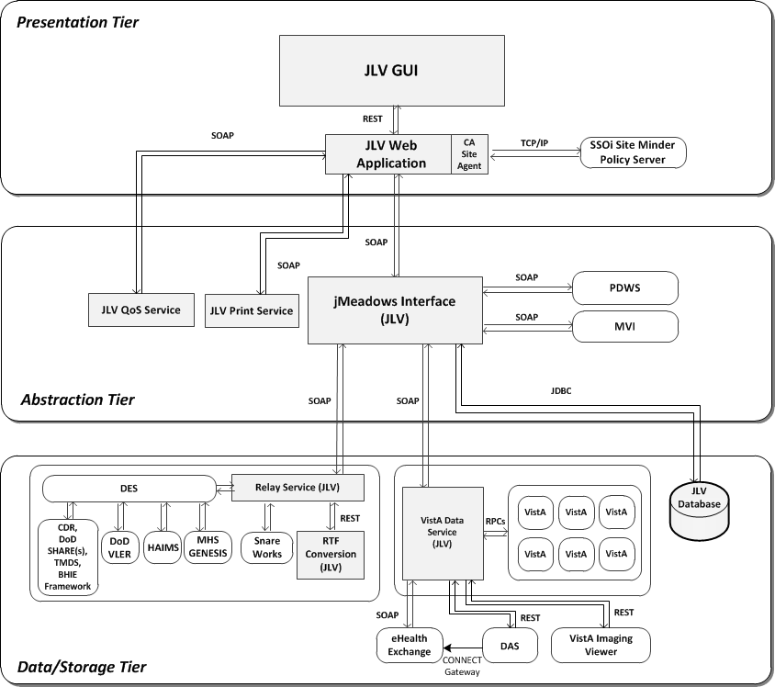
Figure 1: JLV Components and Tiers

User Access Levels
Table 4 describes the authorized JLV users and their responsibilities.

Table 4: JLV User Profiles

User | Description and Responsibilities
DoD Clinician | DoD clinicians access the patient EHRs.
VHA | VA clinicians and administrative staff who access the patient EHRs to assist in providing health care services.
VBA | VA administrative staff who access patient EHRs to assist in Veterans benefits administration processes.

Please refer to Section 3.1, Logging On, for a description of the VA users and their access to JLV data. Also, refer to Section 4.3.8, User Restricted Access to Patient Data, for a description of VHA and VBA user access levels to DoD-only patient data and/or DoD sensitive patient data.

Continuity of Operations
The operation of JLV components hosted in VA environments is administered as a service by the VA AITC and PITC data centers. These organizations maintain Continuity of Operations (COOP) team linkage and documentation.
Refer to the JLV 2.5.2 POM for specific information about possible service interruptions, system errors, support operations, and scheduled maintenance.
Figure 2 depicts the workflows for scheduled downtime and non-scheduled outages.

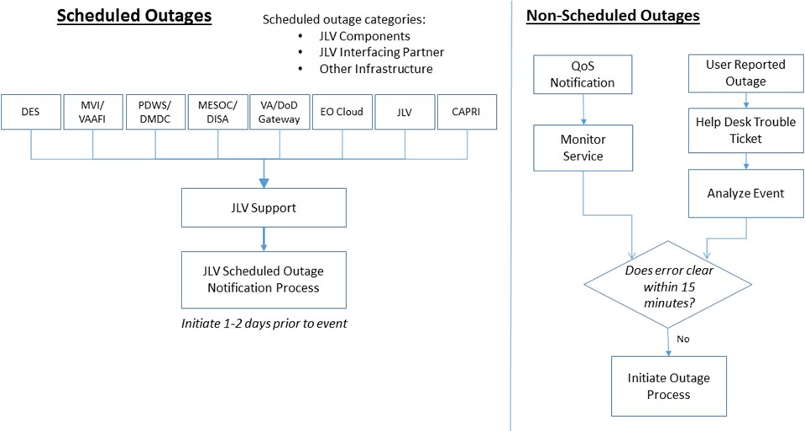
Figure 2: Scheduled Downtime and Non-Scheduled Outage Workflows

Getting Started
The subsections below provide information for logging in to JLV, setting options via the JLV Login page, and the display of system status messages.

Logging On
Authorized, registered users within the VA and DoD are provided access information to log in to JLV. VHA users who have access to the Computerized Patient Record System (CPRS) are automatically authorized to use JLV. VBA users must contact the ESD for access.
Refer to Section 5, Troubleshooting, for more tips on logging in to JLV.

Users who are not authorized to access JLV will see an Access denied message. If you believe you have received the message in error, please contact the VA ESD

During future log in attempts, the last successful and unsuccessful log in attempts are displayed in the lower left corner of the JLV log in page, along with the date, local time, and the Internet Protocol (IP) address from which access was made, or attempted access failed.

VHA User Log In
The log in steps detailed below apply to VHA users accessing JLV through a Uniform Resource Locator (URL).
To log in to JLV:
      - Enter the VHA's URL for the JLV web application into the address bar of your Internet browser. (REDACTED)
      - All VA users will be redirected to the VA Single Sign-On page (Figure 3). VA users must sign in to, and be authenticated by, the Single Sign-On system in order to access JLV.

Users with a Personal Identity Verification (PIV) exemption may select any of the alternate authentication options available through the VA Single Sign-On log in page for access to JLV. PIV exemptions, if required, can be obtained from the ESD.

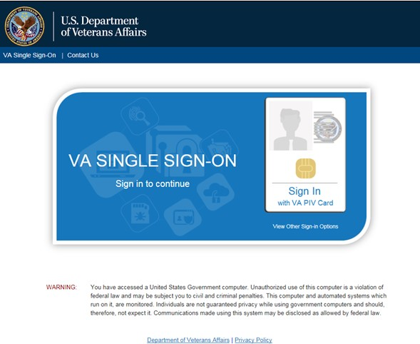
Figure 3: Single Sign-On Page for VA Users

      - Once authenticated by the Single Sign-On system, you are redirected to JLV
      - Read the important user consent information regarding access to a Government information system, and click I Accept
      - If desired, check the Accessibility Mode option in the top right corner, above the JLV log in page fields. If selected, JLV opens and displays the application in the Accessible UI theme. See Section 4.2.2, Working with the Accessible Theme, for detailed information
      - Enter your VA log in credentials:
        - Enter your CPRS Veterans Health Information Systems and Technology Architecture (VistA) Access Code
        - Enter your CPRS (VistA) Verify Code
        - Select VA from the Agency field
        - From the Site field, Select your VA Medical Center or regional Health Care System from the Site field
      - Click Login

VBA User Log In
The following instructions apply to VBA users accessing JLV through a URL only. To log in to JLV:
      - Enter the VBA's URL for the JLV web application into the address bar of your Internet browser. (REDACTED)
      - All VA users will be redirected to the VA Single Sign-On page (Figure 3). VA users must sign in to, and be authenticated by, the Single Sign-On system in order to access JLV

Users may select any of the authentication options available through the VA Single Sign-On log in page for access to JLV.

      - Once authenticated by the Single Sign-On system, you are redirected to JLV
      - Read the important user consent information regarding access to a Government information system and click I Accept
      - If desired, check the Accessibility Mode option in the top right corner, above the JLV log in page fields. If selected, JLV opens and displays the application in the Accessible UI theme. See Section 4.2.2, Working with the Accessible Theme, for detailed information
      - Enter your log in credentials:
        - Enter your Compensation and Pension Record Interchange (CAPRI) Access Code
        - Enter your CAPRI Verify Code
      - Click Login

Log In Page Messages

System Status Messages
System status updates are received from JLV’s Quality of Service (QoS) Monitor, also called the Health Monitor. QoS monitors the status of services that JLV uses to connect to DoD and VA data sources, which include: Master Veteran Index (MVI), Patient Discovery Web Service (PDWS), Relay Service, VistA Data Service (VDS), and jMeadows Data Service.
JLV displays the system status on the Log in page, below the user credential fields (Figure 4), and at the top of the Portal Pages (Figure 9).

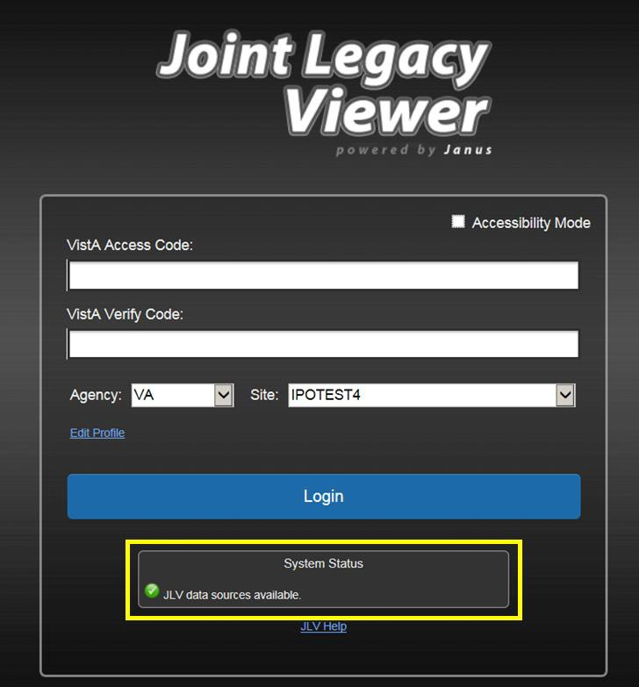
Figure 4: System Status on the JLV Login Page

        - When all monitored systems and services are online and connected, a green icon appears next to the status message JLV data sources are available.
        - When one or more monitored systems or services are offline or unavailable, a yellow warning icon appears next to the status message JLV is having problems. Notification of unavailable systems persisting longer than ten (10) minutes should be reported to the

VA Enterprise Service Desk (Section 1.3, Enterprise Service Desk and Organizational Contacts).
        - When the jMeadows Data Service is unavailable, a red icon appears next to the message, JLV is having problems. jMeadows Data Service is unavailable. JLV may not function properly. Users may not be able to log in to JLV, or view patient data, until the jMeadows connection is restored.

Configuration Options
One method of setting configuration options is by using the Edit Profile link (Figure 5) to access the user profile fields through the JLV Login page.
The subsections below detail the processes for enabling/disabling the option to Include Community Data, and setting the UI theme via the Edit Profile link.

Options selected here are saved to the user profile by clicking Save and Login, and remain set for all subsequent JLV sessions, until changed by the user.

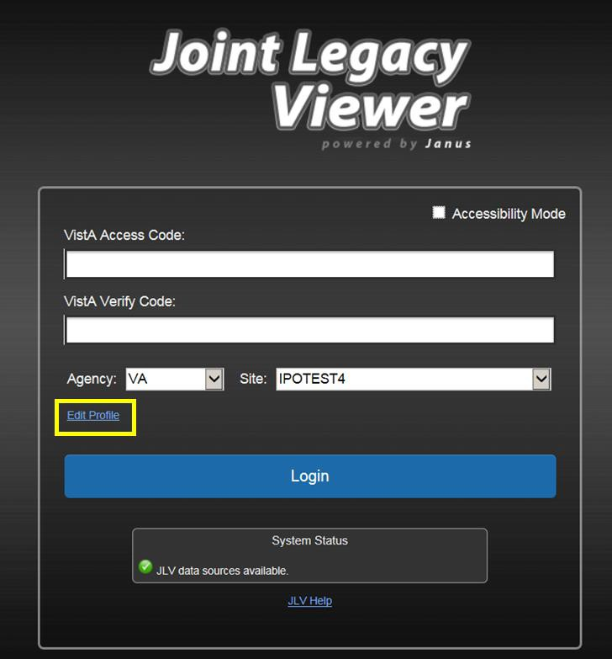
Figure 5: Edit Profile Link (JLV Login Page)

User Interface Theme
Selecting a UI theme sets the font color and foreground/background colors of the JLV GUI, including the widgets, toolbars, and dialog boxes. Theme color selections are Default, Green, Blue, Gray, and Accessible. The UI theme choices appear above the community data option, as seen in Figure 6.

The Accessible theme provides larger fonts, enhanced tab and keystroke functionality, and screen reader compatibility, compliant with Federal accessibility requirements and Section 508 standards. Refer to Section 4.2.2, Working with the Accessible Theme, for more information.

Community Data Display
Checking (enabling) the Include Community Data option tells JLV to query for, receive, and integrate patient data from external VA VLER community partner data sources. The community data setting is in the bottom half of the Edit Profile dialog, seen in Figure 6.

VBA users do not have access to community data, and will not see the Include Community Data feature.

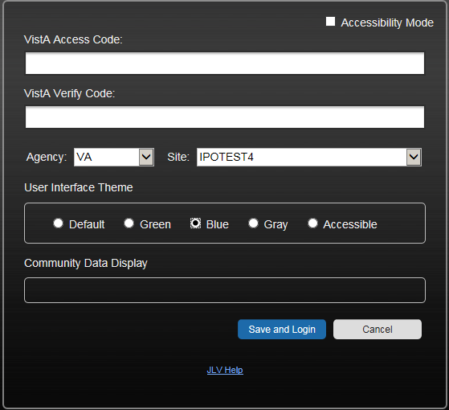
Figure 6: Include Community Data Option (JLV Login Page)

System Menu
After a successful log in your user name is shown in the upper right corner of the application, and the JLV portal pages are displayed. The JLV portal pages are:

- The Patient Portal
- The Provider Portal .
Each portal page has a toolbar (highlighted in Figure 7) that enables quick access to the following features:
- Configuration Options: Click the cog wheel icon in the top right corner of either portal page to set user preferences, including the UI theme. Refer to Section 4.2, Customizing JLV.
- Report Builder: Click the Report Builder icon in the top right corner of either portal page to create custom reports. Refer to Section 4.3.9, Using Report Builder.
- Access Online Help: Click the Help icon in the top right corner of either portal page to open online help.
- Log Out of JLV: Click the Log Out icon to log out and close the current JLV session. Refer to Section 3.4, Exit the System.

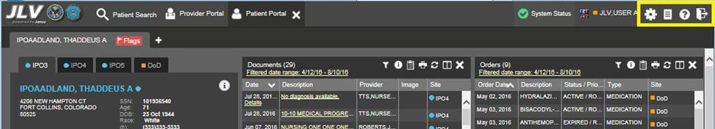
Figure 7: JLV Tools on the Portal Pages

The following functions can also be performed from the portal pages (highlighted in Figure 8):
- Perform a Patient Search
- Switch between the Patient Portal and the Provider Portal
- View the system status (Hover over System Status)
- View Context Management status
- Open the widget tray Open Widget Tray ^ (bottom of the portal pages)

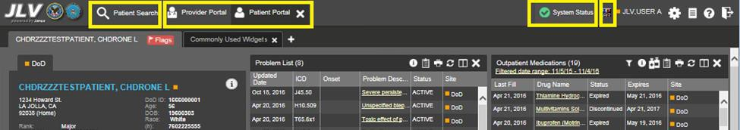
Figure 8: More JLV Functionality

The system status is displayed to the left of the user name. Hovering over System Status will provide additional information, as seen in Figure 9.

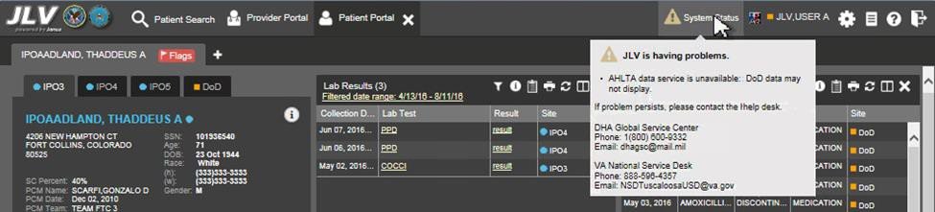
Figure 9: System Status Details

Changing User Identification (ID) and Password
No functionality is available for changing a user ID and password in JLV.
For information about log in errors, access code errors, or verify code errors, see Section 5, Troubleshooting.

Exit System
To end the current session and exit JLV, click the Log Out icon (highlighted in Figure 10) at any time.

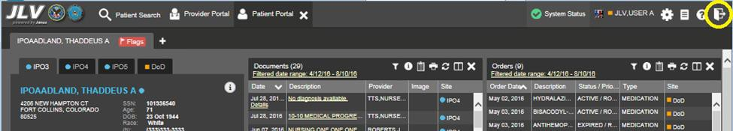
Figure 10: JLV Log Out Icon

A JLV session will end automatically after five minutes of inactivity. Automatic termination of a session does not clear the last screen in use and display the Login page, but connectivity to, and the functionality of, JLV is terminated. To re-open a JLV session, log in to JLV again.

Caveats and Exceptions
JLV audits user access to restricted patient records when VHA or VBA users view DoD-only patients. JLV also blocks access to designated patient records by particular users. See Section 4.3.8, User-Restricted Access to Patient Data, for detailed information.

Using the Software

Default JLV Layout
New JLV users will see a pre-configured, default widget layout on the Patient Portal when JLV opens. The default layout includes the Allergies, Problem List, Documents, Outpatient Medications, and Lab Results widgets.
In this release, only the References widget is available to JLV users on the Provider Portal .

References Widget
The References is shown by default on the Provider Portal . The References widget displays hyperlinked references for providers to online clinical medicine resources. Click a reference link to access the associated website. To add a new reference link, click Add.
Delete a reference by right-clicking the link and selecting Delete URL. Users will not be able to delete references included in the default widget configuration.

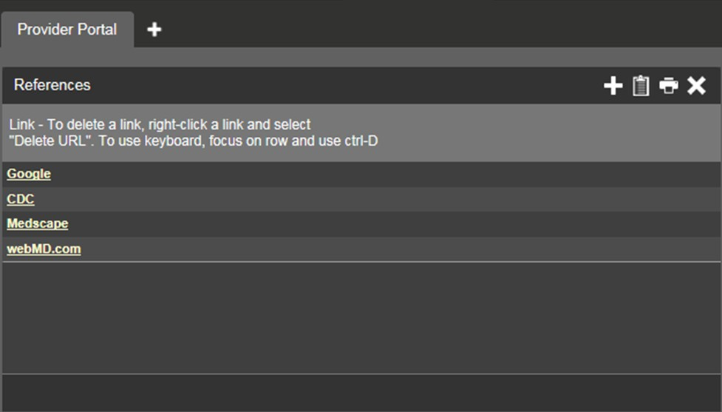
Figure 11: References Widget

Patient Portal Data Displays
The Patient Portal displays a selected patient's clinical records and other patient-centric information.

Users can configure the layout of widgets on the Patient Portal and create multiple widget tabs, as described in Section 4.2, Customizing JLV, and in Section 4.3.1, Opening and Closing Widgets. Customizations are saved to the User Profile as set, and remain until manually changed.

Interface Status
Interface status updates are available for each clinical domain (widget) except Clinical Reminders, and can be accessed through a widget's toolbar. An icon on the toolbar provides a status indicator for DoD, VA, and community partner data sources. There are two status conditions: all sources are connected (available), or one or more sources are not connected (unavailable). Clicking either icon opens the interface status for DoD, VA, and community partner sources in a standalone window. For the status of DoD sources, the entries are derived from responses received from Data Exchange Services (DES). Interface status notifications accessed from the widget show connection status at the domain level.

Interface status updates for clinical domains are not the same as system status messages displayed in the top right corner of the portal. See Section 3.1.3.1, System Status
Messages.

Figure 12 shows the status message banner displayed in a widget. The banner can be closed by clicking the X to the right of the status message. This action hides the banner during the current JLV session until the widget is closed. Re-opening the widget at a later time will restore the banner display if the problem persists.

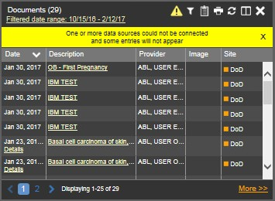
Figure 12: Unavailable Interface Message Banner

Patient Flags and Alerts
If the patient has one or more clinical warnings, alerts, or flags in their record from VA and DoD sites, a Flag icon will display next to the Patient Name tab, above the Demographics widget, on the Patient Portal (Figure 13).

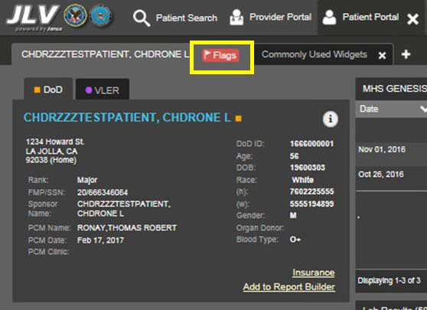
Figure 13: Patient Flags Indicator

Click Flags to open the Patient Flags and Postings window (Figure 14). The window displays a list of alerts and flags within the patient’s record. If the patient’s record does not contain any clinical warnings, the button is not displayed.

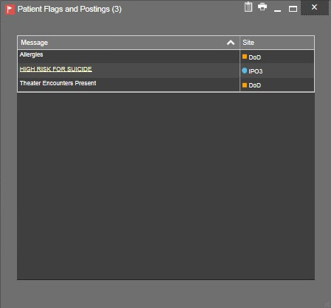
Figure 14: Patient Flags and Postings Window

Customizing JLV
Configuration options can be set at the log in page level, using the Edit Profile link (see Section 3.1.4, Configuration Options), or within the JLV application. To access the user configuration settings within JLV, click the cog wheel icon.

Setting the UI Theme
The UI theme preference is a part of the user profile. Choosing a UI theme sets the font, foreground, and background colors of the widgets, toolbars, and dialog boxes. Once selected, the UI theme is stored in the user profile, and remains set until changed.
The available UI themes can be seen in the figures below.

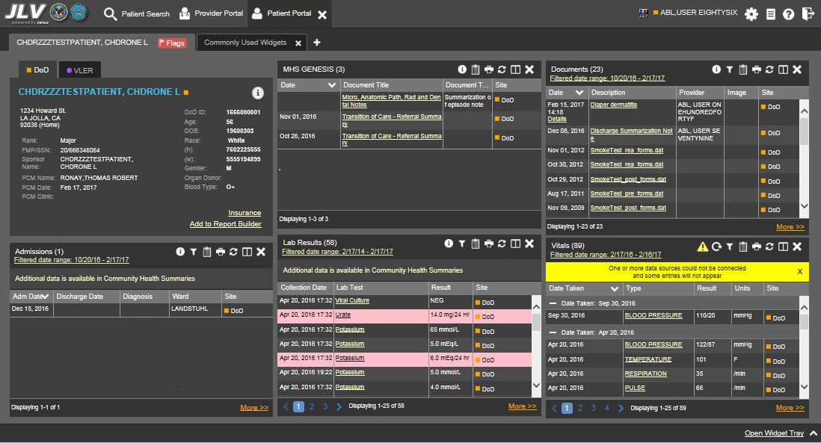
Figure 15: Default UI Theme

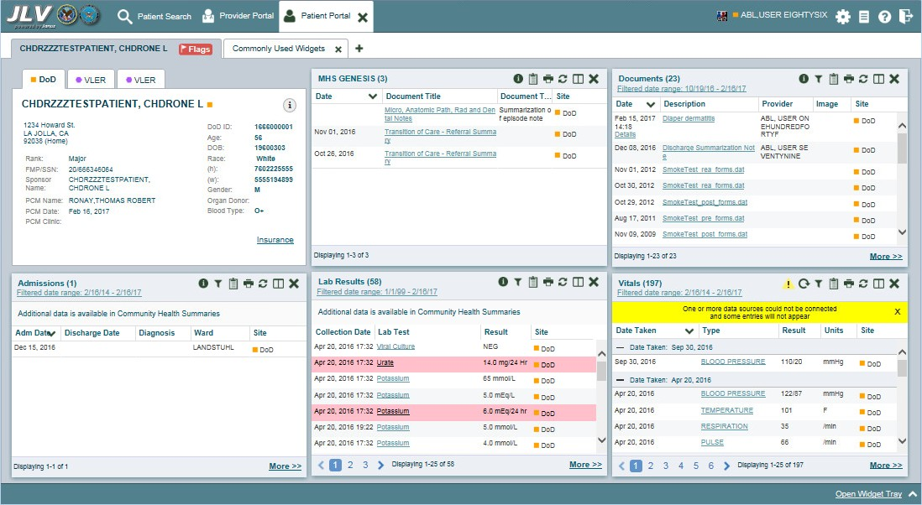
Figure 16: Green UI Theme

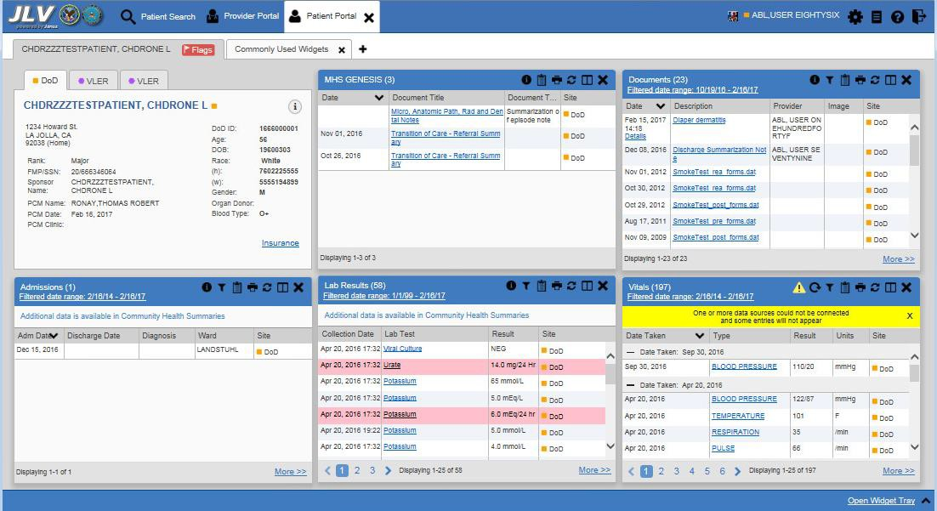
Figure 17: Blue UI Theme

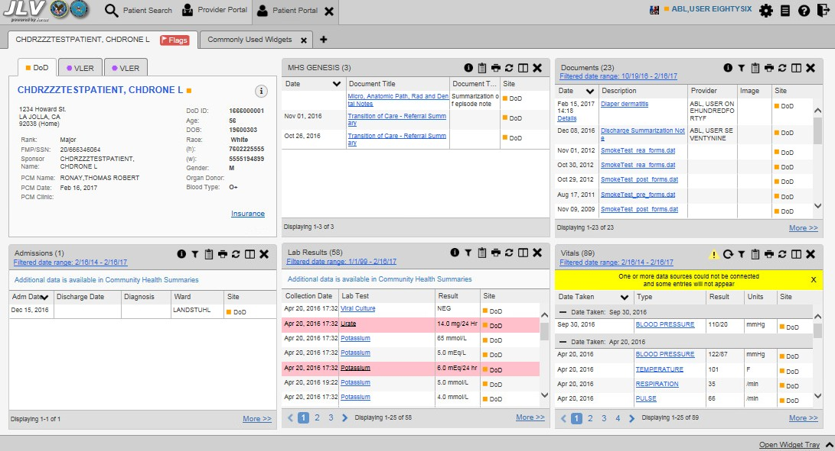
Figure 18: Gray UI Theme

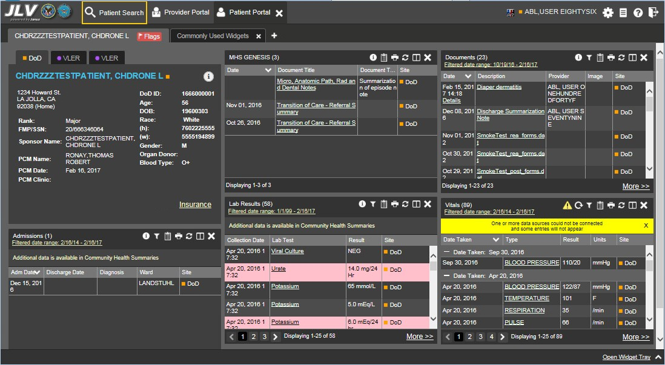
Figure 19: Accessible UI Theme

Working with the Accessible Theme
Users who need to utilize the accessibility features of JLV can select the Accessible UI theme from the log in page, or within JLV.

The Accessible theme includes larger fonts, enhanced tab and keystroke functionality, and screen reader compatibility for users needing accommodation to support Federal accessibility requirements and Section 508 compliance. The Accessible theme is available for users who have adaptive technologies installed on their computers.

To set the Accessible theme after logging in:
      - Click the cog wheel icon in the upper right corner of the JLV portal pages (Figure 7)
      - The User Configuration dialog box opens
      - Select Accessible and click Save
      - After clicking Save, click Yes to reload the application and to apply the settings.
      - Alternatively, click Cancel to exit the dialog box and restore the UI to the previous theme

Keyboard Focus and Screen Navigation
Keyboard focus is the highlighting of screen elements that enables interaction with and navigation of the web application through the keyboard and keystrokes. The GUI element that has keyboard focus is outlined. JLV uses a gold border or outline as a visual indicator of which element has current keyboard focus.

Keyboard Shortcuts
JLV uses Windows keyboard shortcuts (i.e., Tab, Shift + Tab, arrow keys, Enter, etc.) and other keystrokes to move the focus to, and activate, all menus and functions (Table 5).
Pressing Enter, when an element that provides action is in keyboard focus, executes the associated action. For example, pressing Enter when the cog wheel icon is in keyboard focus opens the User Configuration dialog box. Use the arrow keys or the Tab key to move between keyboard focus and navigate through the elements on the screen.

Table 5: Accessible Theme Keyboard Shortcuts

Keystroke | Description
Application & Portal Navigation
ENTER | Press to transfer keyboard focus to the highlighted widget.
TAB | Press to transfer keyboard focus to other user interface items.
ESC | Press to return keyboard focus to the panel containing the user interface item with keyboard focus or to exit a window or widget.
SPACEBAR | Press to activate any user interface item (for example, click a button).
Arrow Keys | When focused on a widget, press the arrow keys to change page viewing in a widget's data table.  When keyboard focus is on a drop-down list, press the down arrow to view the contents.
Ctrl + p | Press to bring focus to the first tab in the active portal (either provider or patient).

Keystroke | Description
Ctrl + r | When working with the Report Builder, place keyboard focus on a record in a widget and then press Ctrl + r to add the record to the Report Builder tool.
Tab Panels
Arrow Keys | Use the left and right key buttons to change tab panels.  To add a tab panel, press the right key until the last tab (labeled with a plus sign) is selected. A dialog will prompt for the tab name. To close a tab, focus on the tab panel and press Ctrl + x.
Windows or Dialog Boxes
TAB | Press the TAB key to move the keyboard focus to other user interface items within the window.
Adding Widgets to the Onscreen Portal
SHIFT +  (Number position) | To add a widget from the widget tray using keystrokes:  - First determine which column (1, 2, or 3) to place the widget onscreen.  - Focus the desired widget icon from the widget tray and press the SHIFT key along with the 1, 2, or 3 key, depending on the column chosen.

Accessible Theme Screen Navigation
An element with keyboard focus is the starting point for screen navigation. Pressing the Enter
key when a screen element or icon has keyboard focus mimics a mouse click.
In Figure 20, the Documents widget has keyboard focus. Focus can be changed by pressing the Tab key. In this example, pressing the Tab key shifts the keyboard focus from the Documents widget to the Procedures widget (below the Documents widget in the figure). Pressing the Tab key again shifts the keyboard focus to the Radiology Reports widget, as in this sample configuration, there are no widgets below the Procedures widget.

To view hover text where available in the JLV interface, focus on the element within the widget that has hover text. After a small delay, the text will appear as if the user hovered
over the element with a mouse cursor.

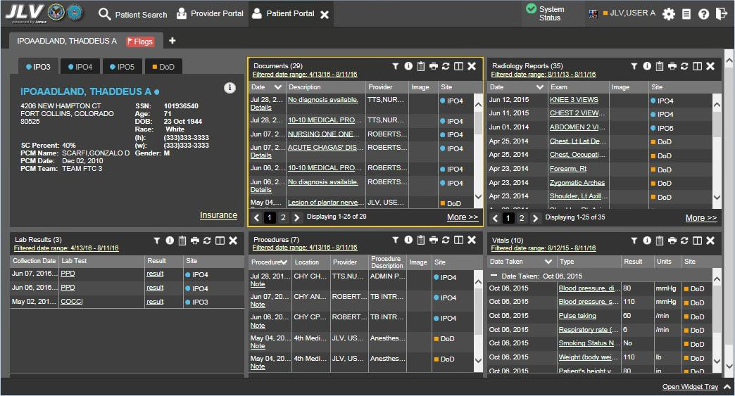
Figure 20: Navigation Using Elements with Keyboard Focus

In Figure 21, the IPO3 tab of the Patient Demographics details window has keyboard focus. Move through the tabs (IPO4, IPO5, or DoD) by using the arrow keys, or by pressing Tab. Move to the patient name and press Enter to open the details view of patient demographics.
When the patient’s name has keyboard focus, press the up and down arrow keys to scroll through the contents of the window.

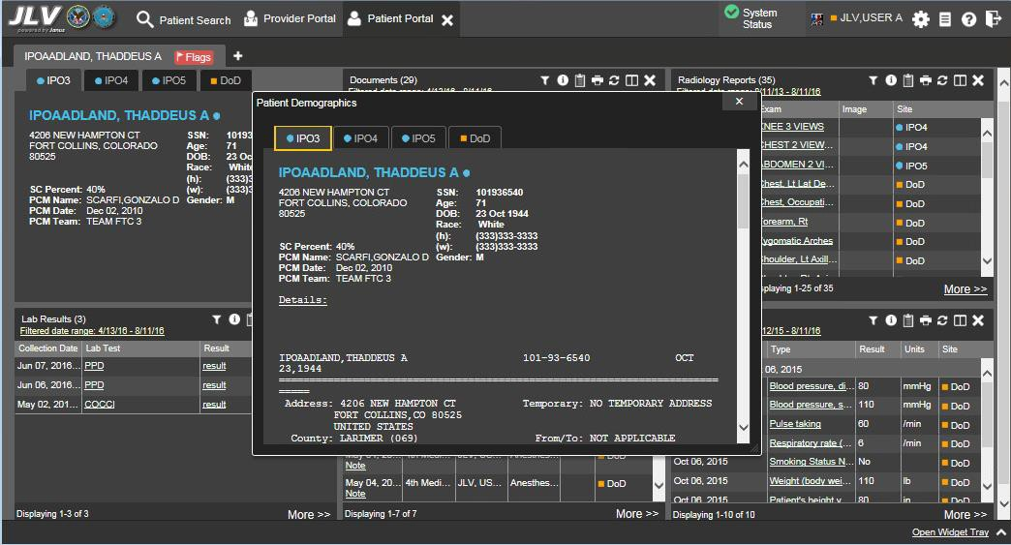
Figure 21: IPO3 Tab with Keyboard Focus

When keyboard focus is on the Close X button in a widget or window (Figure 22), press Enter to close that widget or window. After closing the window, keyboard focus returns to the last element that had keyboard focus prior to opening the window.

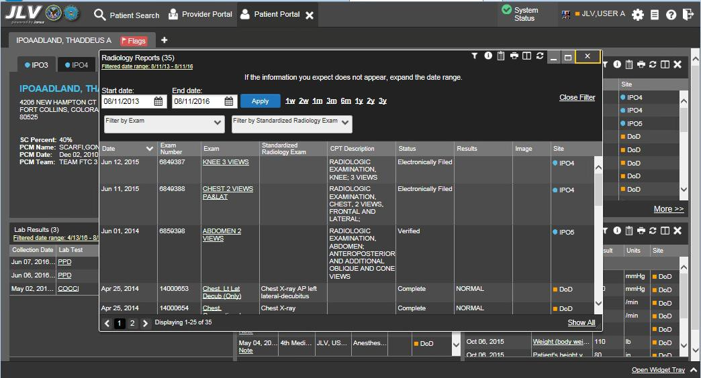
Figure 22: Close Button with Keyboard Focus

Creating Custom Tabs
For ease of use and quick reference, use the Tabs feature to create custom widget configurations on the portal.
To create a custom tab:
      - Click the plus sign + next to the existing tabs in the upper left corner of the portal page (Figure 23). The Add Tab dialog opens
      - Type the name of the new tab in the Add Tab dialog and click OK

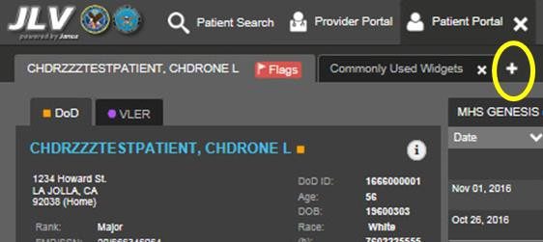
Figure 23: Add New Tab

      - Use the Open Widget Tray link to display available widgets
      - Click and drag the desired widgets to the portal page

Tab configurations remain as set throughout the current, and subsequent, JLV sessions,
until manually changed.

      - To switch between portal tabs, click the name of the tab you want to display

Working with Widgets
Widgets are elements on the JLV portal pages that display data specific to a clinical domain. By default, widgets are displayed in minimized view on the portal pages, but can be expanded to view additional details. The list of available widgets is provided in a horizontal tray at the bottom of the page (Figure 24).

Widgets may take anywhere between 3 seconds to 10 seconds to load.

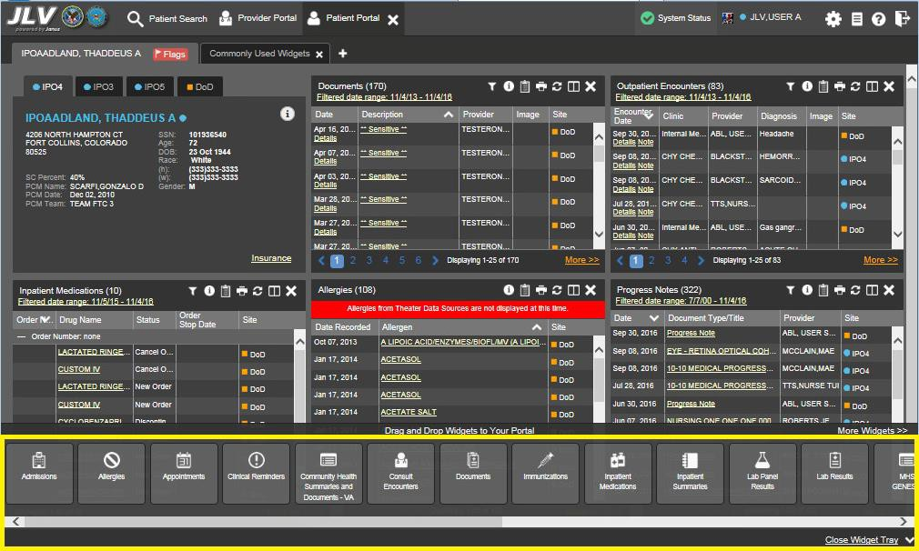
Figure 24: Widgets on the Patient Portal

Opening and Closing Widgets
Widgets can be opened, closed, and rearranged on the portal pages. Available widgets are located in the widget tray, at the bottom of the portal pages (Figure 25).

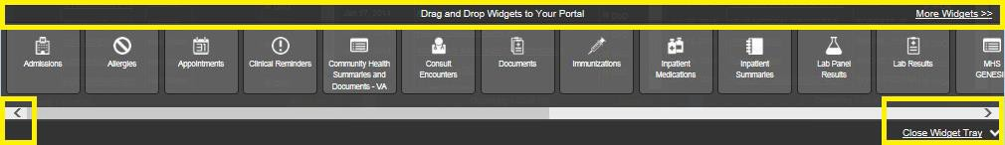
Figure 25: Widget Tray on the Patient Portal

To place a widget on the Patient Portal:
      - Open the widget tray by clicking the Open Widget Tray link, or clicking the Expand ^
icon
      - Use the scroll bar arrows < > to see all widget choices
-OR-
      - Click the More Widgets link to scroll through the list of widgets
      - Drag and drop the widget from the tray onto the portal page
      - The widget is docked on the portal page, and opens in minimized view
      - Close the widget tray by clicking the Close Widget Tray link

Widgets can be removed by clicking the Close icon in the top right corner, and re-arranged on the portal page, as desired, using drag and drop actions.

Minimized and Expanded Views
Each widget can be displayed in either a minimized (default) or an expanded view. Minimized view displays a short list of the available patient data for a clinical domain, arranged in reverse chronological order. Expanded view provides a longer list of similarly arranged patient data.
When the expanded view of a widget is launched, it opens in a new, separate window.

The Community Health Summaries and Documents - VA widget does not have an
expanded view. Instead, a list of the documents available for viewing is displayed in a new, separate window.

Click the More >> link at the bottom of a widget to launch the expanded view, and see additional display and functionality options.
The patient data displayed within a widget can be filtered by date range. If a date range filter is applied, the selected range is indicated in the widget header, below the title. Click the Configure Filter icon, or the Filtered Date Range link on the widget toolbar to change the date range of the data displayed (Figure 26).

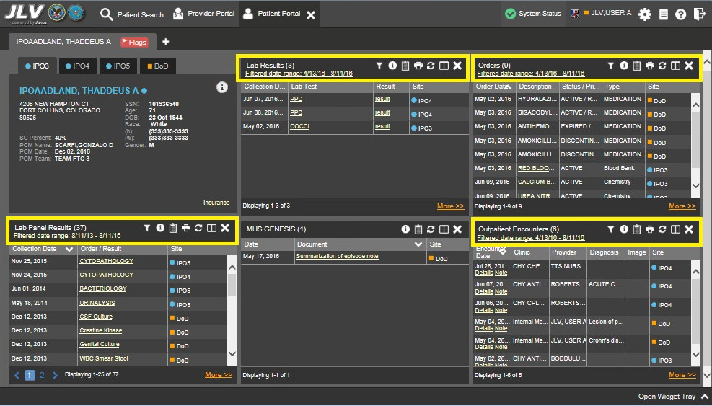
Figure 26: Minimized Widgets with Date Range Filter Applied

Widget Toolbars
Toolbars are provided in the upper right corner of both the minimized and expanded views of each widget, and most dialog boxes. Toolbar icons vary by widget, open dialog box, and window. Table 6 describes the functionality of each toolbar icon.

Table 6: Widget Toolbar Icons

Icon | Name | Function
 | Add to Report Builder | Adds the information displayed in the window to the Report Builder. This icon is available for supported domains when a record has a Details or Notes view that displays in a standalone window.
 | Close | Removes the widget from the portal screen or closes a dialog box.
 | Column Settings | Used to configure the columns within the widget. Turn on or off the columns displayed by checking the column names that appear in the pop-up box and checking Apply.
 | Configure Filter | Used to filter on specific record types or other elements within the widget, including a date filter. If a date range filter is applied in an open widget, the date range is displayed in the widget header.  Note: After setting a filter, the Close Filter option is enabled in the widget. Clicking  Close Filter will restore the full display of records within the widget.
 | Copy to Clipboard | Copies the content of the open window to the clipboard for pasting into another application.

Icon | Name | Function
 | Interface Status | Both icons provide a status indicator for DoD, VA, and community partner data sources. The circle with the lowercase “i" indicates all sources are available. The yellow triangle warning indicates one or more data sources are unavailable. Clicking either status icon will open the interface status details in a separate window.  Note: Interface status updates are not available from the Clinical Reminders  widget.
 | Print | Prints the contents of the open window. Printing is disabled in the widget toolbar after clicking Show All within a widget.  Note: It is recommended that JLV users have the latest Adobe Reader installed for the Report Builder and other printing features..
 | Refresh | Refreshes the widget or window display. Only the data within that widget’s dataset is updated.
 | Rx | Converts the medication data within the widget to text, and opens the text in a pop- up window. Available from the Outpatient Medications widget.
 | Site List | Opens a list of community sites where the patient has been seen (only available from the Community Health Summaries and Documents – VA widget).
 | VLER  Refresh | Refreshes VLER-enabled widgets with the community partner data stored in the VLER cache, in addition to refreshing DoD and VA data.  NOTE: The VLER Refresh icon is shown in VLER-enabled widgets only when  Include Community Data is enabled.

Refreshing Data in a Widget
Data displayed in a widget can be refreshed by clicking the Refresh icon. This action will refresh the widget’s VA/DoD data display. When the option to Include Community Data is enabled, clicking the Refresh icon also triggers a refresh of the VA VLER-enabled widgets’ data.
A widget will display the VLER Refresh icon if the widget supports community partner data, and the Include Community Data option is enabled. Clicking the VLER Refresh icon triggers two refresh actions: JLV sends a new query to VLER sources for community partner data, then refreshes DoD and VA data in open widgets with data JLV has stored in a cache. Clicking VLER Refresh in one widget refreshes all other open, VLER-enabled widgets.

If the option to Include Community Data is disabled, the VLER Refresh icon will not be
displayed in any of the widgets that support the display of community data.

Widget Navigation and Display Options
There are tools and display options available within each widget. Their functionality allows the user to navigate through and change the display of data results available in the widget’s minimized and expanded views. A vertical scroll bar allows the user to scroll through, and view,

the data. Options at the bottom of the widget allow for navigation through all records loaded for the widget’s clinical domain.
The functionality for the navigation tools shown in the following sample widget is further explained in Table 7.

Table 7: Navigation Icons and Actions

Navigation Icon/Action |  | Description
 | Go to Previous Page | Changes the focus of the widget to the previous group or page of records within the results display.
 | Jump to Page | Changes the focus of the widget to the page number selected.
 | Go to Next Page | Changes the focus of the widget to the next group or page of records within the results display.
More >> | Go to Expanded View | Available in minimized views only. Opens the expanded view of the widget in a secondary window.
1-25 of 55 | Record Display Indicator | Indicates the number of records displayed in that widget page out of the total number of results for that widget.
Show All/ Show Paged | Display Setting | Click Show All to open all records for a given widget in a scrollable window.  Click Show Paged to return to the display of records grouped by pages.

In Figure 27, there are 55 total records available in the Lab Panel Results widget, grouped in the Show Paged view. Records 1 through 25 can be viewed by using the widget’s vertical scroll bar. Records 26 - 55 can be viewed by using the page navigation options in the lower left corner of the widget, to jump to subsequent pages. A widget open in expanded view contains a Show All link, which opens all records for a given widget in a scrollable window. Click Show Paged to return to the display of records grouped by pages.

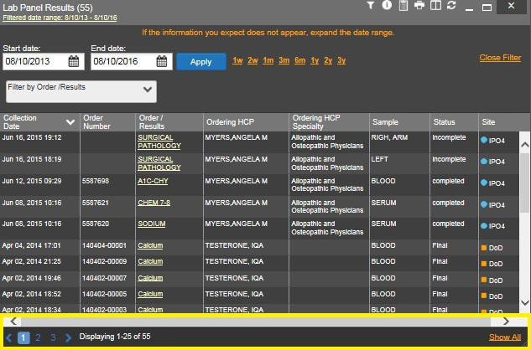
Figure 27: Widget Navigation Tools

Date Range Filters
There are two ways to filter the date range of data displayed in JLV; the Quick Date Range filter, and the Start and End Date filter. If the expected information does not appear in the widget display, use the date filter options to change the date range.

Changes made to the date range in a widget persist from patient to patient, and session to
session, until the widget is either removed, or the date range is changed.

Quick Date Range Filter
Use the preset, Quick Date Range filter to set or limit the display of patient records within a particular widget. This option is available in multiple widgets on the Patient Portal.
Clicking a date range will refresh the display to show only the records for the selected range. The options represent time counting back from the present day (for example, selecting 2y will display only records within the last two years). Examples of preset date ranges include 1w (last 7 days), 6m (last 6 months), and 3y (last 3 years).

The Quick Date Range filter is contextual. If today is January 2, 2017, the preset filters
will count backwards using that date. If today is April 16, 2017, the preset filter will count backwards using that date.

Figure 28 highlights the Quick Date Range filter options in the expanded view of the Orders
widget.

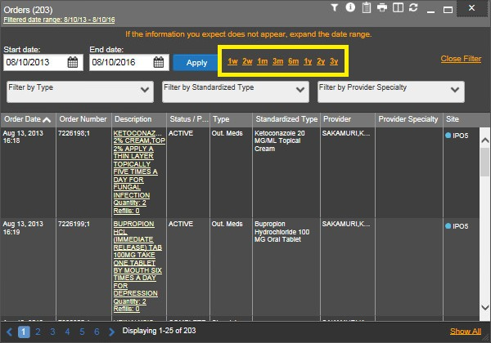
Figure 28: Quick Date Range Filter Options

Start and End Date Filter
Use the Start Date and End Date filter to display data for a specific time range. These start and end date fields are available at the top of multiple widgets in expanded view, or by clicking the Configure Filter icon in minimized view.

The Start and End Date filter is static. If the start date is set to June 2, 2016 and the end date is set to June 2, 2017, the data in that date range will display, no matter what today’s
date is.

Figure 29 provides an example of the start and end date filter fields in the expanded view of the
Radiology Reports widget.

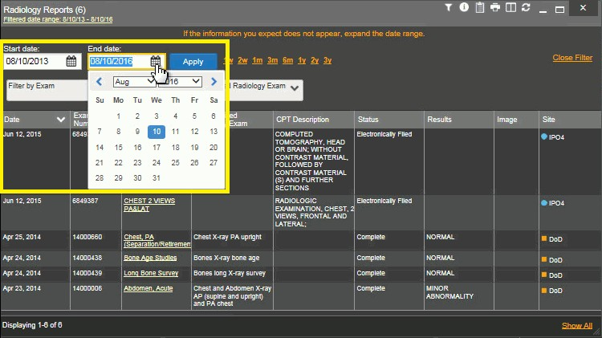
Figure 29: Start and End Date Display Filter

To set a custom date range:
        - Click the Calendar icon next to Start Date
        - Choose a start date for the display filter
        - Click the Calendar icon next to End Date
        - Select the end date for the display filter
        - When both a start and end date have been chosen, click Apply
The widget refreshes and displays only the records that fall within the custom date range. The date range in use is displayed in the widget header.

Context Management
Clinical Context Management (also referred to as CCOW) is a way for applications to synchronize the display of clinical context based on the Health Level 7 CCOW standard. If CCOW-compliant applications are sharing context and one of the applications changes the data display to a different patient, the other applications will switch to display that same patient.
JLV is context management-enabled. When context is enabled, a patient change triggered in one context-enabled application (i.e., CPRS) will cause the same change in JLV. The same effect is shown vice versa; that is, when a patient is selected in JLV, it triggers a patient change in other context-enabled applications.
Context management is enabled by default, and JLV will attempt to connect to the context vault upon a valid login. The context status appears in the top right corner of all JLV screens. When context is established, the Context On icon is shown. When context is suspended, the Context Suspended icon is shown.

Figure 30 shows the context indicator location on a JLV portal page. In this example, context is suspended.

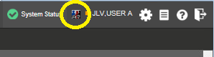
Figure 30: Context Indicator on the JLV Portal Pages

Unable to Communicate with Vault
If JLV is unable to initiate context management upon log in, the user will see the CCOW Error message in Figure 31. Click OK to continue. The Context Suspended icon is displayed on the JLV portal pages.

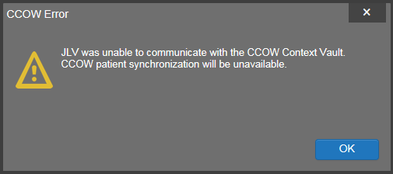
Figure 31: CCOW Error Message

Establishing Context
When context is suspended, it can be re-established manually. To establish or re-establish context:
        - Click the Context Suspended icon
        - The CCOW warning message, Are you sure you want to rejoin patient link? appears (Figure 32)
        - Click Yes
Once context is established, the Context On icon is displayed on the JLV portal pages.

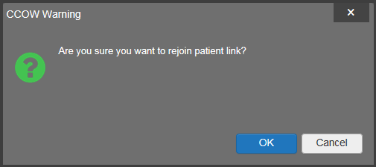
Figure 32: CCOW Warning Message

Context Synchronization Failure
In the event that JLV is unable to re-establish context, the user is presented with a CCOW Error message seen in Figure 33. This indicates context is suspended. Click OK to continue. The Context Suspended icon is displayed on the JLV portal pages.

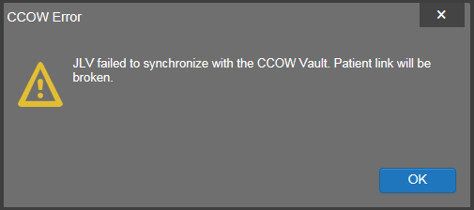
Figure 33: Context Synchronization Failure

      - Suspending Context Context can be manually suspended. To manually suspend context:
        - Click the Context On icon
        - The CCOW warning message, Are you sure you want to break patient link? appears (Figure 34)
        - Click Yes to continue
Once context is suspended, the Context Suspended icon is displayed.

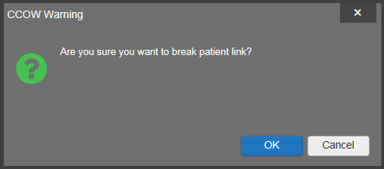
Figure 34: Suspending Context

User-Restricted Access to Patient Data

VHA Users Viewing DoD-only Patients
VHA users are permitted to view the records of DoD-only patients (i.e., there are no VA identifiers, or the patient is not registered in MVI), but the VA requires that these actions be audited. If an attempt is made to access DoD-only patient records, the VHA user is asked to specify the purpose for access. The purpose options presented to the user are: Emergent Care, Clinical Care, or Authorized Administrative Use (Figure 35).
After selecting the purpose for access, and clicking Agree to be Audited & Access this Patient Record (Figure 35), the requested data is displayed, and an audit is performed. The access purpose, organization of the VA provider, date, user name, IP address, user’s Internal Entry Number (IEN), host system’s ID, and patient’s Electronic Data Interchange Personal Identifier (EDIPI) are audited.

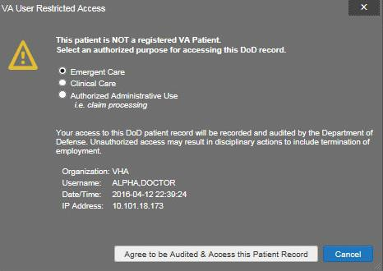
Figure 35: VA User Restricted Access Dialog

VBA Users Viewing DoD-only Patients
VBA users may see two different dialog boxes, depending on whether or not the patient is registered in MVI.
        - Patient registered in MVI: VBA users are permitted to view the records of a patient who is registered in MVI, but the VA requires that these actions be audited. After performing a patient search and selecting a patient from the search results, a VBA user will see the audit notification (Figure 36) if the patient they selected is registered in MVI. After agreeing to the audit, the VBA user can access the patient’s record.

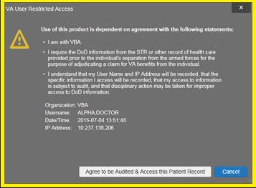
Figure 36: VBA User Audit Notification

        - Patient not registered in MVI: VBA users are not permitted to access the records of a patient who is not registered in MVI. After performing a patient search and selecting a patient from the search results, a VBA user will see the restricted access notification (Figure 37) if the patient selected is not registered in MVI. Clicking Cancel returns the user to the previous screen.

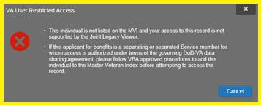
Figure 37: Restricted Access Notification

Access to DoD Sensitive Records
All JLV users are audited each time a sensitive DoD record is accessed. Auditing applies to sensitive outpatient encounters, progress notes, or labs results records. For each attempt to access

sensitive data, JLV records the user’s organization, user name, user Social Security Number (SSN)/EDIPI (for DoD users), user PIV (for VA users), user location, patient identifiers (patient last name, first name, middle initial (MI), SSN/EDIPI (DoD only), MVI (VA only), and date of birth (DOB)), data accessed, date and time, and reason for access. Information is sent to, and stored in, the JLV database for use by System Administrators to create audit reports.

The audit prompt is seen each time access to a sensitive record is attempted, even if the
user has been previously audited for the same record.

JLV notifies users before they are audited. The message is triggered when the user clicks a masked record that is marked ** Sensitive **. An example of a masked record displayed in a widget and the audit notification are depicted in Figure 38.
After the user selects the purpose for viewing the record and agrees to be audited, the sensitive data is displayed in the Details view of the widget.

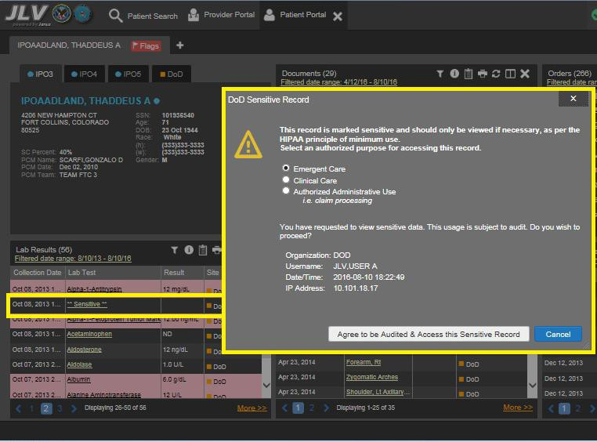
Figure 38: DoD Sensitive Record and Audit Dialog

Using Report Builder
The Report Builder feature provides the ability to build custom reports by selecting patient records, or combination of supported documents and record details. The information selected for the custom report is exported to a printable file in Portable Document Format (PDF).

As noted in Section 2, System Summary, it is recommended that the latest version of the
Adobe Reader be installed on the system used to access JLV.

Creating Reports
Reports can be built using patient records, and/or documents from the minimized or expanded view of a supported widget. The Report Builder feature can be accessed from the toolbar at the top right corner of the Patient Portal.
To create a report:
        - Click the Report Builder icon (Figure 39). The Report Builder window opens on the Patient Portal (Figure 40)

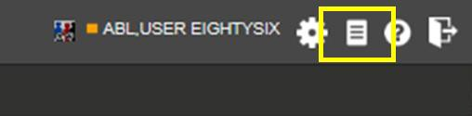
Figure 39: Report Builder Icon on the Portal Toolbar

        - Select records to add to the report:
          - Any record or demographics data within a widget can be added by right-clicking the entry in an open widget and selecting Add Record to Report (Figure 40)
          - Click Add to Report within any Demographics tab to add demographics data. Demographics information will appear at the top of the report by default
          - If the desired record has a Details or Notes view, click the Add Record icon on the toolbar of the open Details or Notes window to add the additional record information
            - Some DoD notes cannot be added to Report Builder. If a note cannot be added, there will not be an option on a right-click to add the record to the report

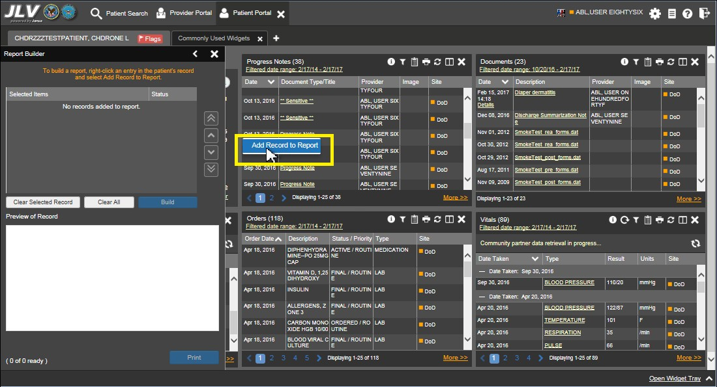
Figure 40: Report Builder Window & Add Record to Report Option

        - The selected records appear in the Report Builder window
        - Use the navigation arrows to the right of the listed records (Figure 41) to arrange the records in the desired order in the generated report. Records can be removed by clicking Clear Selected Record or Clear All

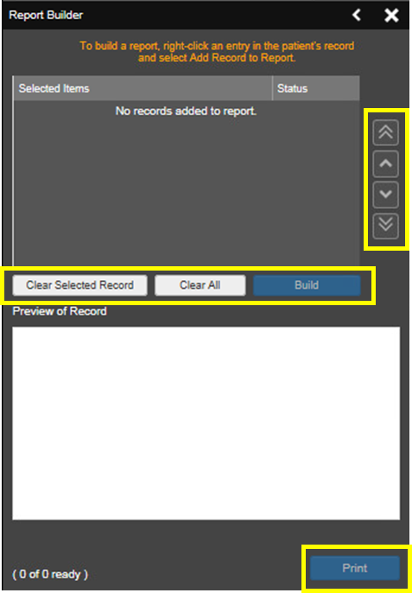
Figure 41: Report Builder Tools

        - When a record is selected for the report, it appears in the Preview of Record are of the
Report Builder window (Figure 42)
        - Click Build to validate and prepare the records selected for the report printing. If a record can be added to the report with no errors, there will be a Ready notation next to it; if a record cannot be added to the report, there will be an Error notation next to the it
        - Click Print to generate the report, built only with those records that have a Ready status

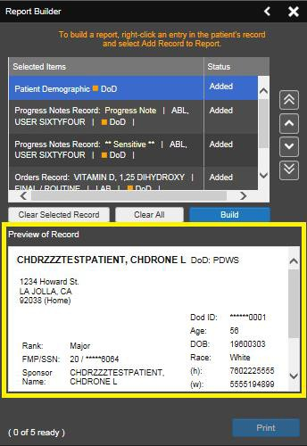
Figure 42 Preview of Record in Report Builder Window

        - The generated report opens in a new tab within the browser window. Save the report to your local system, if desired

Each report generated using the Report Builder feature includes this disclaimer:
The information contained in this transmission may contain privileged and confidential information, including patient information protected by federal and state privacy laws. It is intended only for the use of the person(s) named above. If you are not the intended recipient, you are hereby notified that any review, dissemination, distribution, or duplication of this communication is strictly prohibited. If you are not the intended recipient, please contact the sender by reply e-mail, and destroy all copies of the original
message.

VistA Imaging Viewer
JLV integrates access to the VistA Imaging Viewer (an external application), allowing VA users access to VA imaging artifacts for supported clinical domains (widgets), and DoD radiology exam images. Users can open an instance of the VistA Imaging Viewer through JLV. For more information regarding the VistA Imaging Viewer, please reference the information posted on the VistA Imaging SharePoint site.

In the Documents widget, images not mapped to Text Integration Utility (TIU) documents are displayed as standalone records. Images may be accessed from the Image column, but
details for the records are not available.

A camera icon displayed in the Image column (Figure 43) of the Documents, Outpatient Encounters, Procedures, Progress Notes, and Radiology Reports widgets indicates that one or more images are associated with that record. Clicking the camera icon within the JLV widget opens the VistA Imaging Viewer in a standalone window, and displays the associated image(s).

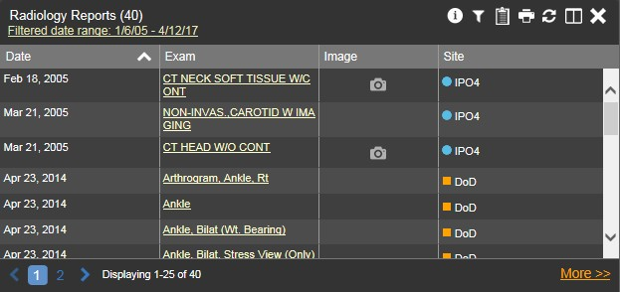
Figure 43: Camera Icon in the Image Column

If a record has one or more images associated with it, the Details view of the widget includes a display of a thumbnail in the top right corner of the window (Figure 44). Below the thumbnail, a link that reads Click image to open viewer is also displayed. Clicking either the thumbnail or the link opens the VistA Imaging Viewer, and display the associated image(s).

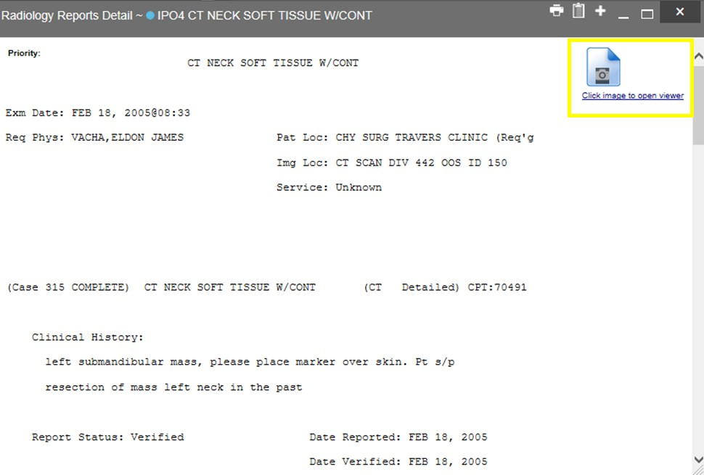
Figure 44: Thumbnail and Link in Details View

Patient Searches
The core function of JLV is to display patient information on the Patient Portal . Use the Patient Search feature to search for a patient using DoD ID, SSN, perform a family search, or use advanced search options.

Some users will be restricted to a specific list of patients, and will be unable to use the Search feature. See Section 4.3.8, User-Restricted Access to Patient Data, for more
information.

JLV determines which enterprise service to use for a patient search, based upon the search criteria:
- If the EDIPI or Sponsor SSN is entered, JLV utilized PDWS for the search. See Section 4.4.1, PDWS Search Rules and Supported Searches, for details
- If the EDIPI or Sponsor SSN fields are empty, JLV utilizes MVI for the search. See Section 4.4.2, MVI Search Guidelines, for details

PDWS Search Rules and Supported Searches
When PDWS is utilized for patient search, users must adhere to the applicable rules and rule sets required for the PDWS interface:
- Rule Set 1: When searching by SSN, the full nine-digit SSN must be entered, and the Last Name or DOB must also be supplied. This is true for search by patient SSN, as well as Sponsor SSN
- Rule Set 2: If you do not have the SSN, you must supply ALL of the following identifiers: last name, first name, DOB, and gender. Blanks in any of these four required fields will generate an error
- A ten-digit string is required for telephone number
The following search combinations are supported in JLV when PDWS is utilized:
- DoD ID, also referred to as the EDIPI
- Patient SSN and Last Name
- Patient SSN and Date of Birth (DOB)
- Sponsor SSN and Last Name
- Sponsor SSN and DOB
- Last Name, First Name, DOB, and Gender (ALL identifiers must be entered)

MVI Search Guidelines
When a VA user searches for patient records using a patient’s SSN and name, JLV utilizes MVI for the search. MVI requires the full last name when the patient’s SSN is entered. The MVI may also require entering the patient’s first name and DOB to increase the efficiency of the search and the likelihood of locating the patient. An example would be searching for a patient with a common last name, such as Smith or Jones.

Patient Search Using DoD ID
To perform a patient search using the DoD ID (Figure 45):
      - Click the Patient Search icon at the top of the portal page. The Patient Search dialog opens
      - Enter the eleven-digit patient DoD ID (EDIPI) in the DoD ID field

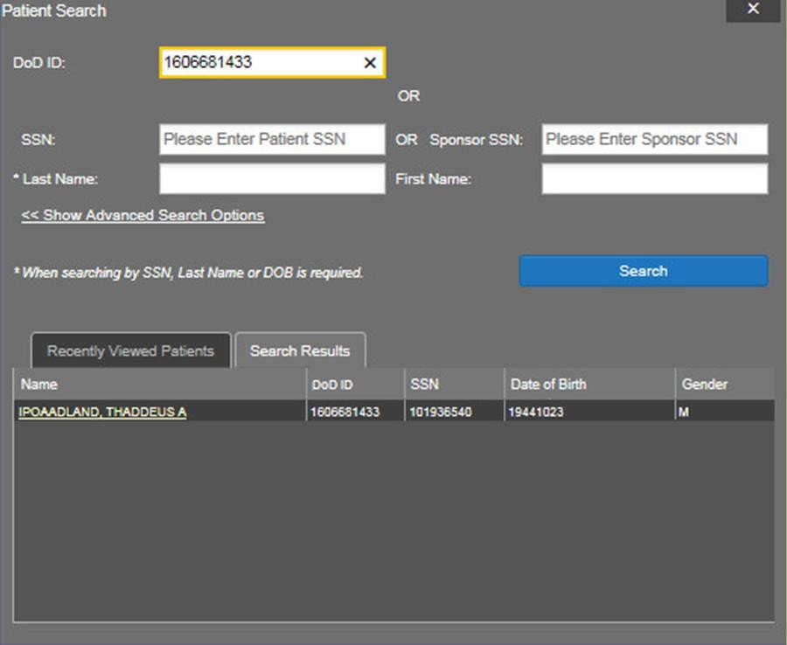
Figure 45: Patient Search Using DoD ID

      - Click Search. The search results are displayed in the lower third of the dialog box, under the Search Results tab
      - Click a patient’s name in the search results list to open the associated record. The Name, SSN, DOB, and Gender columns in the results list provide information to assist with patient identification
      - After selecting a patient, the Patient Portal displays the selected patient’s data

Patient Search Using SSN
To perform a patient search using the patient’s SSN:
      - Click the Patient Search icon at the top of the portal page. The Patient Search dialog box opens
      - Enter the patient’s full, nine-digit SSN in the SSN field (Figure 46)

NOTE: When searching by SSN, either the last name or the DOB must be entered to
perform the search.

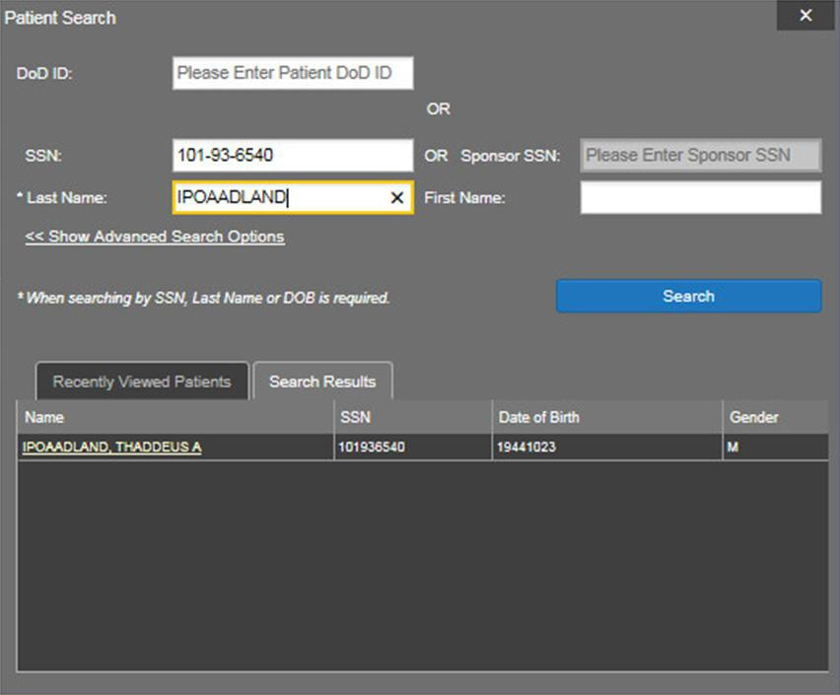
Figure 46: Patient Search Using Patient’s SSN

      - Click Search. If the required patient identifiers are not provided, hover text appears indicating the information necessary to complete the patient search. If a match of patient names cannot be made, enter more identifiers to refine the search
      - The search results are displayed in the lower third of the dialog box, under the Search Results tab
      - Click a patient’s name in the Search Results list to open the associated record. The Name, SSN, DOB, and Gender columns in the results list provide information to assist with patient identification
      - After selecting a patient, the Patient Portal displays the selected patient’s data

Advanced Patient Search Options
Advanced patient search options in the Patient Search dialog box allow for the use of additional patient identifiers when searching for a patient.
To perform a patient search using advanced options:
      - Click the Patient Search icon at the top of the portal page. The Patient Search dialog box opens
      - Click the <<Show Advanced Search Options link under the *Last Name field (Figure 47)
      - Enter the patient identifiers in the appropriate search fields, as desired. Advanced search option fields include *DOB, Middle Initial (MI), Gender, Address, State, City, Zip, and Telephone

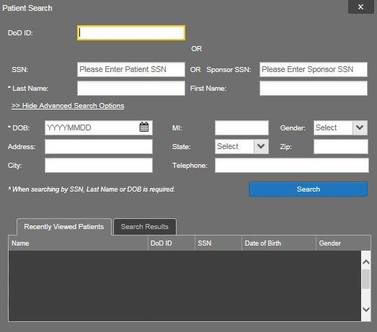
Figure 47: Advanced Patient Search Options

      - Click Search. If the required patient identifiers are not provided, hover text appears indicating the information necessary to complete the patient search
      - The search results are displayed in the lower third of the dialog box, under the Search Results tab
      - Click a patient’s name in the Search Results list to open the associated record. The Name, SSN, DOB, and Gender columns in the results list provide information to assist with patient identification
      - After selecting a patient, the Patient Portal displays the selected patient’s data

Family Member Search
JLV’s functionality allows a user to perform a family member search using the Sponsor SSN
field in the Patient Search dialog box. To perform a family member search:
      - Click the Patient Search icon at the top of the portal page. The Patient Search dialog box opens
      - Enter the SSN in the Sponsor SSN field. The Last Name or DOB of the patient must also be entered in the appropriate fields (Figure 48)
      - Click Search. If the required patient identifiers are not provided, hover text appears indicating the information necessary to complete the patient search

      - The search results are displayed in the lower third of the dialog box, under the Search Results tab (Figure 48)

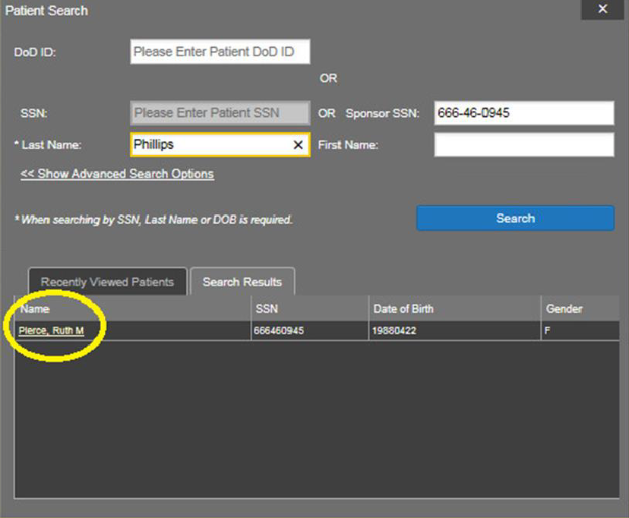
Figure 48: Patient Search Using Sponsor SSN

      - Click a name in the Search Results list. The Family Members dialog opens (Figure 49). The sponsor’s identifiers and a list of dependents are displayed in the dialog
      - Click a name in the list of family members to open the associated record
      - After selecting a patient, the Patient Portal displays the selected patient’s data

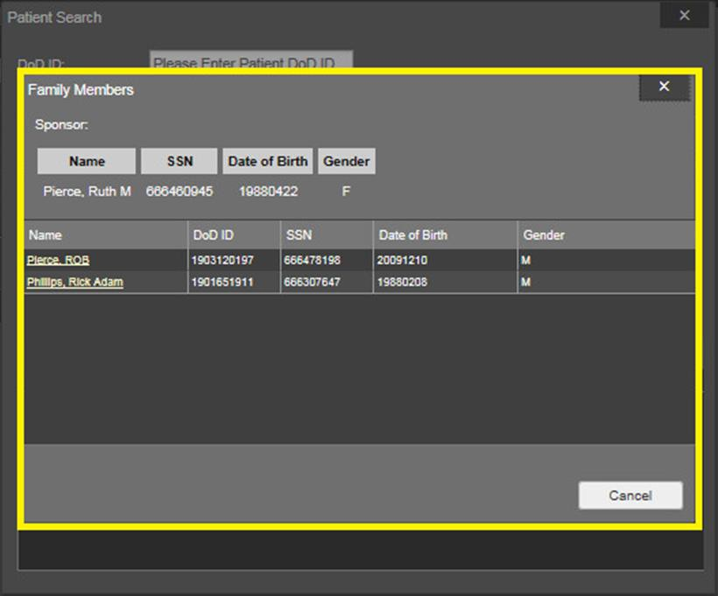
Figure 49: Family Members Dialog

Recently Viewed Patients List
Users who have previously logged into JLV, searched for a patient, and viewed that patient’s records, can see and access a list of recently viewed patients. A recent patient is defined as a patient whose record has been viewed (opened) by the user.

NOTE: The Recently Viewed Patients list does not include search history or recent search results, only a list of patients whose data was accessed/viewed. The list is limited to ten (10)
patients.

To open the list of recently viewed patients:
      - Click the Patient Search icon at the top of the portal page. The Patient Search dialog opens
      - Click the Recently Viewed Patients tab in the lower third of the Patient Search dialog
      - A list of recently viewed patients is displayed (Figure 50). The Name, DoD ID, SSN, DOB, and Gender columns in the results list provide information to assist with patient identification
      - Click a patient’s name in the Recently Viewed Patients list to open the associated record
      - After selecting a patient, the Patient Portal displays the selected patient’s data

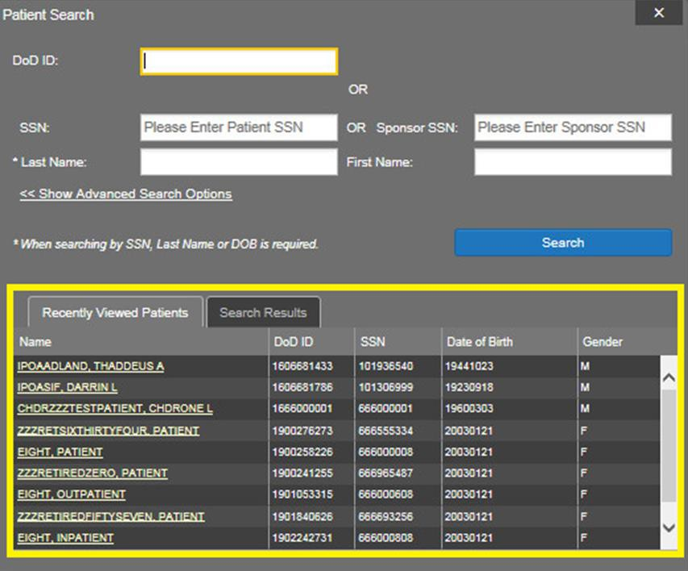
Figure 50: Recently Viewed Patients List

Widget Functionality
The following subsections detail the functionality in a sampling of the widgets available in JLV.

Patient Demographics
The Patient Demographics widget displays a summary of the patient’s non-clinical or personal data. The widget appears in the upper left section of the Patient Portal (Figure 51). The tabs above the patient’s name provide the patient’s demographics summary for each site (VA, DoD, or VLER) the patient has visited.

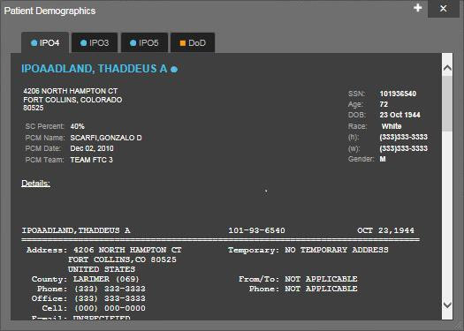
Figure 51: Patient Demographics on the Patient Portal

The Demographics widget provides additional functionality and displays:
- Clicking the patient's name opens patient demographics details in a separate window
- Clicking an Interface Status icon opens the interface status details in a separate window
- Clicking the Flags icon above the tabs in the widget opens clinical flag details in a separate window

Race Data Terminology Normalization
Race data from DoD and VA sources appearing in the Demographics widget is normalized. Hovering over the Race field will display the standardized name and code for the race classification, normalized to the Centers for Disease Control (CDC) standard.

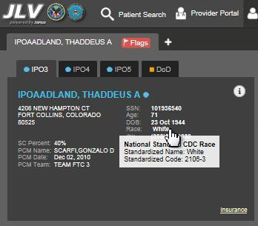
Figure 52: Standardized Race Data in the Demographics Widget

Demographics from Community Partners
When users enable the Include Community Data setting and VLER patient data is returned to JLV, the Demographics widget displays color-coded information.
        - The blue circle represents data retrieved from a VA system
        - The orange square represents data retrieved from a DoD system
        - The purple hexagon represents data retrieved from VLER sources

When insurance data is provided by a community partner, an Insurance link for that
partner is provided in the patient demographics window. The link opens a new window with insurance information.

Viewing Third-Party Insurance Information
Third-party payers and additional insurance information are available from the Demographics widget. Click Insurance in the Demographics widget. A new window (Figure 53) opens with the following insurance information:
        - Health Plan Type
        - Health Plan Name
        - Standardized Insurance Type
        - Plan Effective Date
        - Plan Expiration Date
        - Site
        - Group Number
        - Member ID
        - Subscriber ID
        - Subscriber Date of Birth
        - Subscriber’s Relationship to Insurer
        - Health Plan Mailing Address
        - Health Plan Contact Information

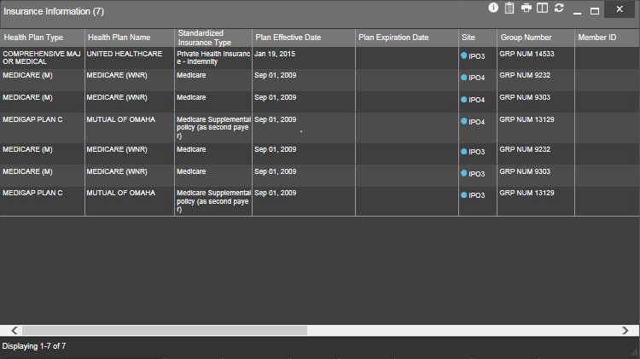
Figure 53: Insurance Information

Use the scroll bar in the window to view additional columns not seen within the default window size.
The data in the Standardized Insurance Type column is normalized to the X12 Health Insurance Type standard. Hovering over entries in this column display the standardized name and code for the insurance type.

Allergies
The Allergies widget displays a patient’s allergy information (Figure 54). There is no allergy information available from TMDS at this time, as seen in the red banner display across the widget.

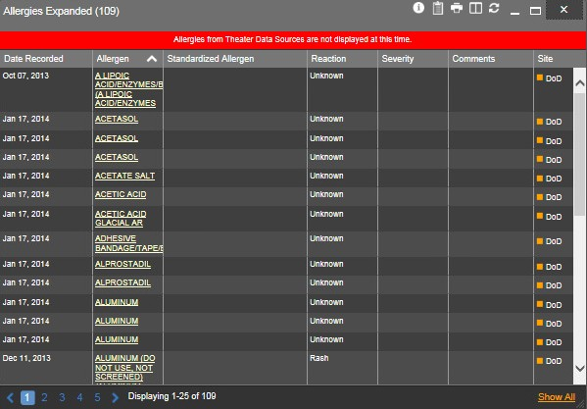
Figure 54: Allergies Widget

Allergies Widget Data
Information in the minimized view of the Allergies widget (Figure 55) includes:
        - Date Recorded
        - Allergen
        - Site
Click a column title to sort records by that column. If sorting is used on a column that appears in both the minimized and expanded views of the widget, the sort will be saved in the user profile and will be seen in the next JLV session. If sorting is used on a column that is only available in the expanded view of the widget, the next JLV session will restore the default widget sort, unless or the last sort saved to the user profile.

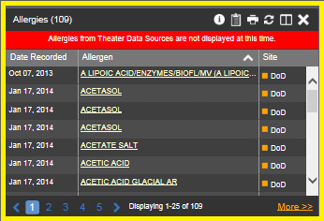
Figure 55: Allergies Widget, Minimized View

Click More >> in the minimized view of the Allergies widget to open the expanded view. Information in the expanded view includes:
        - Date Recorded
        - Allergen
        - Standardized Allergen
        - Reaction
        - Severity
        - Comments
        - Site

Viewing Allergy Details
Clicking a hyperlinked entry in the Allergen column in either the minimized or expanded view of the Allergies widget opens a separate window that displays the details of the allergy record. The presentation of data within the secondary window differs slightly, depending on whether the record is a VA or DoD record.
Figure 56 presents the details view for a DoD record.

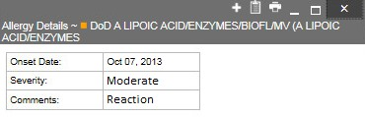
Figure 56: Allergy Details View

Terminology Normalization
Terminology normalization is provided in the Allergies widget through the following GUI elements:
The Allergen column displays allergy information contained in the patient's record. Hovering over an entry in this column displays the terminology normalization for the clinical domain (RxNorm), the standardized allergen name, and the standardized RxNorm code for that allergen.
The Standardized Allergen column displays the standardized name for the corresponding entry in the Allergen column, mapped to the RxNorm standard. In addition to the standardized name, hovering over an entry in this column displays the terminology normalization for the clinical domain (RxNorm), and the RxNorm code for that allergen.
Figure 57 highlights an allergen mapped to the RxNorm standard. The standardized name and standardized code are displayed in the hover text over the record in the Standardized Allergen column.

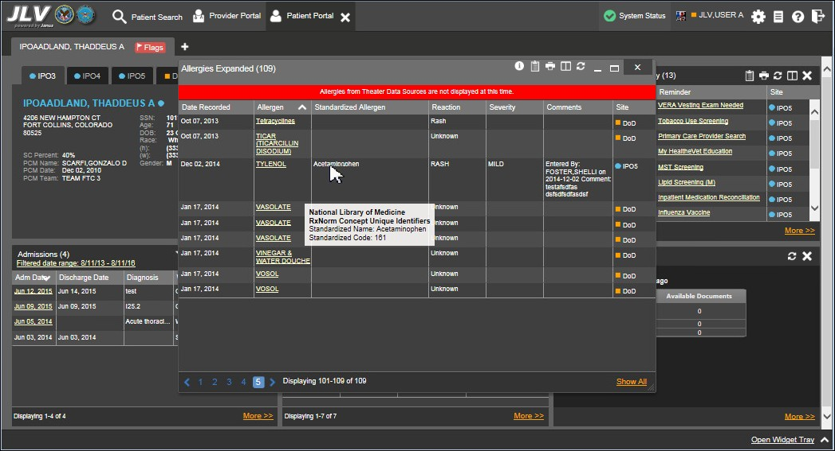
Figure 57: Terminology Normalization – Allergies Widget

Community Health Summaries and Documents – VA
The Community Health Summaries and Documents - VA widget displays the patient’s VA VLER community partner information, including Continuity of Care Documents (CCDs) in C32 and C62 formats, and Health Level 7 (HL7) Consolidated-Clinical Document (C-CDA) structured documents that are available for the patient. The information in this widget is sorted by the title of the entry listed in the Document column.

Community Health Summaries and Documents – VA Widget Data
Data displayed within the Community Health Summaries and Documents – VA widget includes:

        - Date
        - Document
        - Source
The purple hexagon beside entries in the Source column denotes the source of that data is outside the VA.

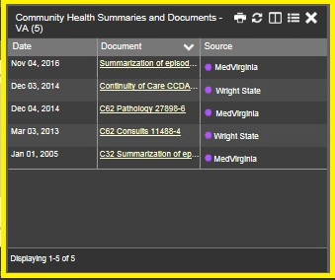
Figure 58: Community Health Summaries and Documents – VA, Minimized View

The Site List icon on the toolbar in the Community Health Summaries and Documents - VA widget (Figure 58) is used to view only the list of community sites where the patient has been seen.
After clicking the Site List icon, the widget refreshes and displays the full list of community sites where the patient was seen, gathered from the Source column. Community sites listed in the record where the patient was seen, but no document was generated for the visit, will also be displayed. Click Close Site List to remove the full site list from the widget display.

Viewing VA Community Health Summary Documents
Figure 58 shows health summary records available from the Document column in the Community Health Summaries and Documents - VA widget. Clicking a hyperlinked entry in the Document column opens the document in a separate browser tab (Figure 59).

Multiple documents can be opened in separate browser tabs for viewing simultaneously.

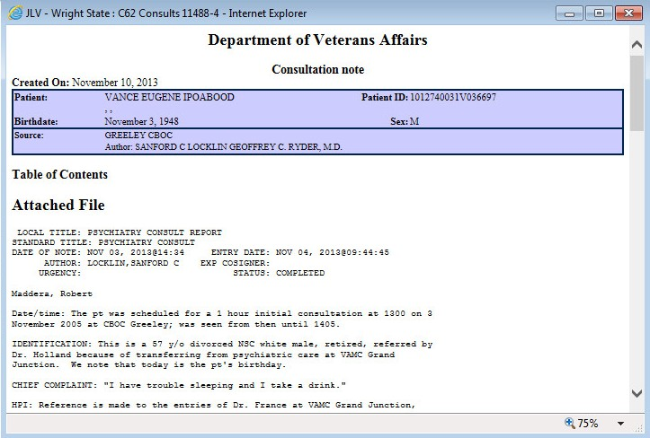
Figure 59: Community Health Document

Documents
The Documents widget (Figure 60) includes documents from multiple clinical domains, including radiology reports (exams), progress notes, outpatient encounters, consult encounters, discharge summaries (inpatient notes), questionnaires, and Health Artifact and Image Management Solution (HAIMS) records. HAIMS records retrieved by JLV include scanned paper records, imported paper records, scanned non-radiology images, and imported non- radiology images, displayed in chronological order by the document date.

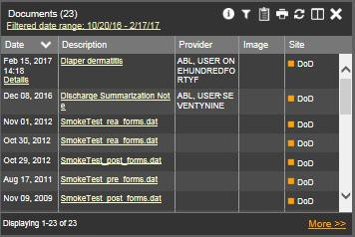
Figure 60: Documents Widget, Minimized View

Documents Widget Data
The minimized view of the Documents widget provides the following information:
        - Date
        - Description
        - Provider
        - Image
        - Site
Outpatient encounter records displayed in the Documents widget may have a Details link enabled in the Date column. Where available, click the link to open a Details window for records of this type.
The Description column displays the document title, where available. Click a hyperlinked entry in the Description column in either the minimized or expanded view of the widget to open the document.
A camera icon in the Image column of the Documents widget indicates that one or more images are associated with that record. Clicking the camera icon opens the VistA Imaging Viewer in a standalone window, and displays the associated image(s).
Click More >> in the minimized view of the Documents widget to open the expanded view (Figure 61). Information in expanded view includes:

- Date  - Description  - Standardized Description  - Provider | - Provider Specialty  - Location  - Status  - Site

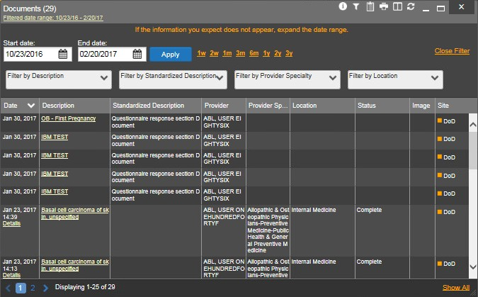
Figure 61: Documents Widget, Expanded View

Viewing Documents
Click a hyperlinked entry in the Description column in either the minimized or expanded views of the Documents widget to access additional information for a listed record. Depending on the record type, the additional information may open in either a details window or a separate browser window. Figure 62 displays outpatient encounters details, accessed through the Documents widget.

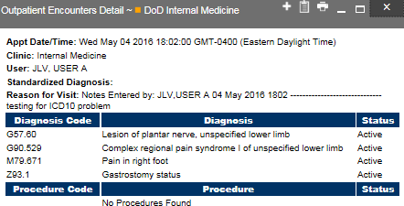
Figure 62: Details of a Document Record

Viewing DoD Sensitive Data
JLV masks the display of sensitive records in the Documents widget. The record is masked with the tag ** Sensitive**. A user may view the data, but the action is audited (recorded) each time a sensitive DoD record is viewed.
After clicking the hyperlink in the Description column for a sensitive record, JLV notifies the user that they will be audited (Figure 35). This message is triggered each time a user clicks a sensitive record. After the user selects the purpose of viewing the record and agrees to be audited, the sensitive data appears in the Details view, but the record remains masked in the minimized and expanded views of the widget.

Display and Filter Options
Display and filter options within the Documents widget include:
        - Click a column title to sort records by that column. If a user sorts on a column that appears in both minimized and expanded views of the widget, the sort will be saved in the user profile and will appear in the next JLV session. If a user sorts on a column that is only in the expanded view of the widget, the next JLV session will restore the default widget sort, or the last sort saved to the user profile.
        - Use the Quick Date Range Selector, or the Start Date and End Date calendars to specify the date range of records to be displayed within the widget. If the information you expect does not appear in the widget display, use the Start Date and End Date filter options to expand the date range. When a date range filter is applied in an open widget, the date range is displayed in the widget header. Open or close the filter options by clicking the date range in the header.
        - Click the Column Settings icon in the widget toolbar to show or hide the columns within the widget. Check/uncheck the column names that appear in the pop-up dialog, then click Apply.
        - Use the Filter by Description dropdown to re-draw the widget to show only the records for the selected description(s). Only available in expanded view.
        - Use the Filter by Standardized Description dropdown to re-draw the widget to show only the records for the selected description(s). Only available in expanded view.
        - Use the Filter by Provider Specialty dropdown to re-draw the widget to show only the records for the selected provider type(s). Only available in expanded view.
        - Use the Filter by Location dropdown to re-draw the widget to show only the records for the selected location(s). Only available in expanded view.

Terminology Normalization
Terminology normalization is provided in the Documents widget through the following GUI elements:
        - The Description column displays the name of a note or document within the patient's record. Hovering over an entry in this column displays the standard used for terminology normalization for the clinical domain (Logical Observation Identifiers Names and Codes (LOINC)), and the standardized LOINC name and code for that document.

        - The Standardized Description column displays the standardized name for the corresponding entry in the Description column, mapped to the LOINC standard. In addition to the standardized name, hovering over an entry in this column displays the standard used for terminology normalization for the clinical domain (LOINC), and the standardized code for that document.
        - The data in the Provider and Provider Specialty columns, in both the minimized and expanded views of the widget, are normalized to the National Uniform Claim Committee Taxonomy (NUCC) standard. Hovering over entries in these columns displays the standardized name and code for the provider.
Figure 63 highlights a document mapped to the LOINC standard. The standardized name and code are displayed in the hover text over the record in the Description column.

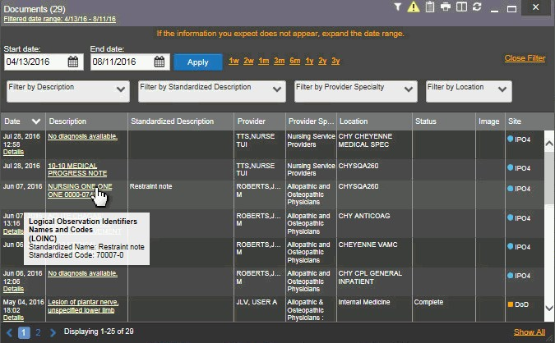
Figure 63: Terminology Normalization – Documents Widget

Military Health System (MHS) GENESIS
The MHS GENESIS widget displays documents within the patient’s record from MHS GENESIS. The information is displayed in reverse chronological order by date.

MHS GENESIS Widget Data
In the minimized view of the MHS GENESIS widget, the orders information includes:
        - Date
        - Document Title

        - Document Type
        - Site
Figure 64 highlights the MHS GENESIS widget in minimized view.
Medical Continuity of Care documents (CCD), Dental CCD, and Aggregate CCDs with blank entries in the Date column for the record appear first in the widget by default.

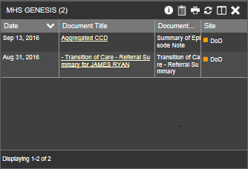
Figure 64: MHS GENESIS Widget, Minimized View

Viewing MHS GENESIS Documents
Click a hyperlink in the Document column in either view of the MHS GENESIS widget to open a separate window that displays a Consolidated Clinical Document Architecture (CCDA) document (Figure 65).

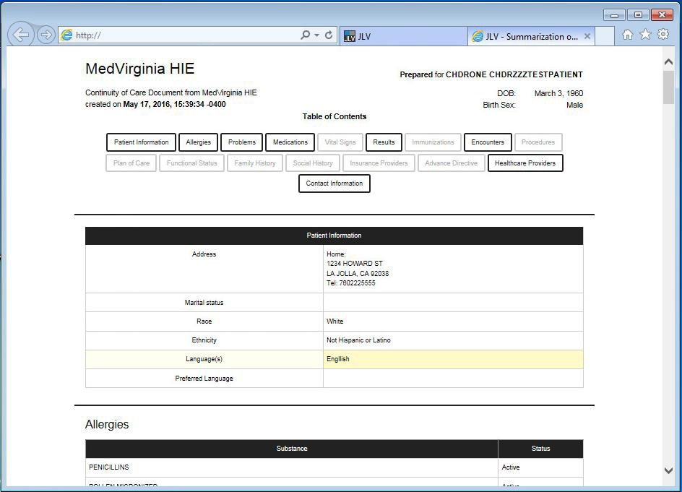
Figure 65: CCDA Document Display

Outpatient Encounters
The Outpatient Encounters widget (Figure 66) includes clinical data for outpatient encounters.

Outpatient Encounters Widget Data
Information in the minimized view of the Outpatient Encounters widget includes:
        - Encounter Date
        - Clinic
        - Provider
        - Diagnosis
        - Image
        - Site
Click More >> in the minimized view of the Outpatient Encounters widget to open the expanded view of the widget. In the expanded view, the outpatient encounter information includes:

- Encounter Date  - Clinic  - Status  - Type  - Provider  - Provider Specialty | - Reason  - Diagnosis  - Standardized Diagnosis  - Image  - Site

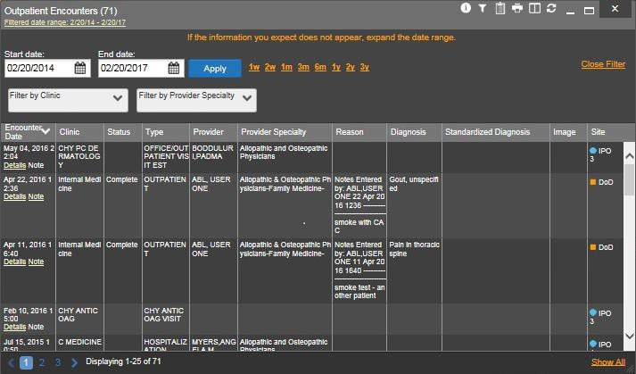
Figure 66: Outpatient Encounters Widget, Expanded View

Viewing Outpatient Encounter Details
Click the Details hyperlink, where available, in the Encounter Date column of either view of the Outpatient Encounters widget. A separate window opens, displaying the details of the encounter (Figure 67).
When a record contains one or more images, the Details view accessed from the widget displays a thumbnail in the top right corner of the window.

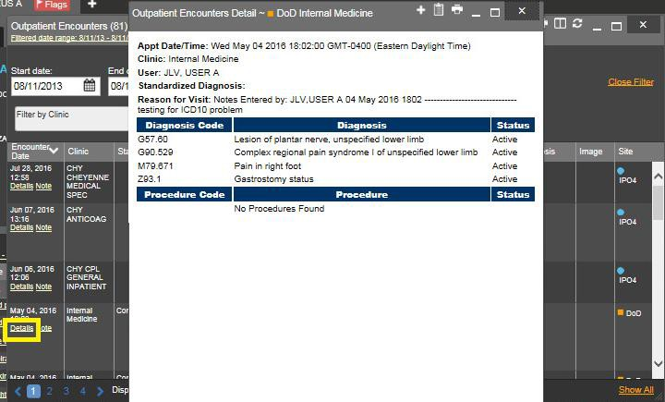
Figure 67: Outpatient Encounters, Details View

Viewing Outpatient Encounter Notes
Where available, click a Note hyperlink in the Encounter Date column of either view of the
Outpatient Encounters widget to view the note from the encounter (Figure 68).

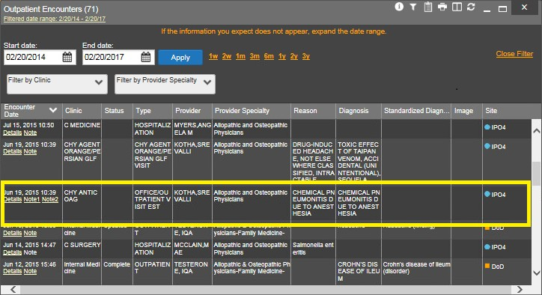
Figure 68: Outpatient Encounters, Encounter Note Link

Viewing Sensitive Data in the Outpatient Encounters Widget
Records marked **Sensitive** in the Outpatient Encounters widget (Figure 69) can be viewed, but the action will be recorded each time the sensitive record is clicked.
After clicking a Details or Note hyperlink in the Encounter Date column for a sensitive record, JLV notifies the user that they will be audited (Figure 35). This message is triggered each time a user clicks a sensitive record. After the user selects the purpose of viewing the record and agrees to be audited, sensitive data appears in the additional view, but the record remains masked in both the minimized and expanded views of the widget.

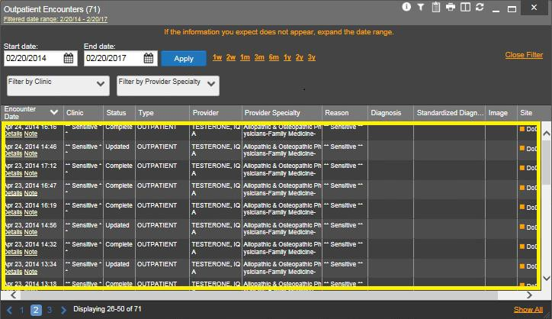
Figure 69: Outpatient Encounters Widget, Sensitive Record

Display and Filter Options
Display and filter options within the Outpatient Encounters widget include:
        - Click a column title to sort records by that column. If a user sorts by a column that appears in both the minimized and expanded views of the widget, the sort will be saved in the user profile, and will appear in the next JLV session. If a user sorts on a column that is only in the expanded view of the widget, the next JLV session will restore the default widget sort, or the last sort saved to the user profile.
        - Click the Column Settings icon on the widget toolbar to show or hide the columns within the widget. Check/uncheck the column names that appear in the pop-up box, then click Apply.
        - Specify the date range of the displayed records by using the Quick Date Range Selector or the Start Date and End Date calendars. If the expected information does not appear, use the Start Date and End Date filter options to expand the date range. When a date

range filter is applied, the date range is displayed in the widget header. Open or close the filter options by clicking the date range in the header.
        - Use the Filter by Clinic dropdown to re-draw the widget to show only the records for the selected clinic(s). Only available in expanded view.
        - Use the Filter by Provider Specialty dropdown box to re-draw the widget to show only the records for the selected provider type(s). Only available in expanded view.

Terminology Normalization
Terminology normalization is provided in the Outpatient Encounters widget through the following GUI elements:
        - The data in the Provider and Provider Specialty columns, in both the minimized and expanded views of the widget, are normalized to the NUCC standard. Hovering over entries in these columns displays the standardized name and code for the provider.
        - The data in the Diagnosis and Standardized Diagnosis columns, in both the minimized and expanded views of the widget, are normalized to the Systematized Nomenclature of Medicine – Clinical Terms (SNOMED CT) standard. Hovering over entries in these columns displays the standardized name and code for the diagnosis.
Figure 70 highlights a diagnosis mapped to the SNOMED CT standard. The standardized name and code are displayed in the hover text over the record in the Diagnosis column.

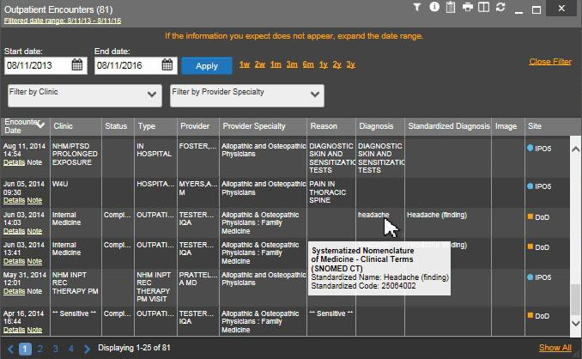
Figure 70: Terminology Normalization – Outpatient Encounters

Troubleshooting
The following subsections provide information about troubleshooting the JLV system.

Special Instructions for Error Correction
JLV utilizes access control and authentication services to limit access to registered, authorized users. When enabled, JLV validates a user against information retrieved from that user’s SmartCard. If you are experiencing trouble logging in to JLV, and have used the correct URL for your agency, please review the following before contacting the ESD:
VHA users:
- Have accessed JLV using the VHA URL
- Have entered their existing CPRS access and verify codes correctly in the fields on the JLV Log in page
- Have selected a site from the Site dropdown list on the JLV Log in page. Most users must specify the individual facility name, or their parent healthcare system name
VBA users:
- Have accessed JLV using the VBA URL
- Have entered their existing CAPRI access and verify codes correctly in the fields on the JLV Log in page
- Have selected VBA from the Site dropdown list

Log In Page Error Messages
Additional troubleshooting is provided in Table 8.

Table 8: Error Messages and Resolution Steps

Error Message | Resolution Steps
Access denied. You are not an authorized user | WHAT? Error message indicating Access Denied. You are not an authorized User.  WHY? PIV card processing problem or invalid security certificate chosen; no access to JLV because user is not authorized.  FIX IT:  - Close browser window.  - Re-insert PIV card and re-launch JLV link.  - Select a certificate that is not expired and specifies Issued by: Veterans Affairs CA B1.  If this is unsuccessful, contact the ESD.
Could not save User Profile | WHAT? Error message indicating Could not save User Profile.  WHY? Error occurred during PIV authentication for VA users - typically a PIV card processing problem or an invalid security certificate chosen.  FIX IT:  - Close your browser window.  - Re-insert PIV card and re-launch the JLV link.

Error Message | Resolution Steps
(3) Select a certificate that is not expired and specifies Issued by: Veterans Affairs CA B1.
If this is unsuccessful, close all open IE windows/tabs. Open IE and try JLV again.
Not a valid ACCESS/VERIFY  CODE pair | WHAT? Not a valid ACCESS CODE/VERIFY CODE pair error at login screen. WHY? 1) JLV could not match your access and verify codes to the Site selected in the dropdown, or 2) Username and password were entered instead  of access/verify codes.  FIX IT:  - VHA users must select the parent VistA host site for their facility (e.g., Wichita uses Kansas City, MO).  - Re-enter correct Access and Verify codes (CAPRI codes for VBA users, CPRS codes for VHA users).
Page cannot be displayed | WHAT? You receive a Page cannot be displayed error when launching JLV.  WHY? The JLV URL requires certain internet explorer settings  FIX IT:  - With Internet Explorer open, click the Tools menu or press ALT-X.  - Select Internet Options.  - When the dialog opens, select the Advanced tab.  - Scroll down in the list until you see SSL 2.0 setting and ensure is NOT checked, and that Transport Layer Security (TLS) 1.0, 1.1 and 1.2 are checked.  - Click OK, then relaunch JLV and the page should load.
SmartCard required | WHAT? Error Message Smart Card Required.  WHY? Smart card not read by Windows Security and JLV before launching JLV link.  FIX IT:  - Close all browser sessions/browser-based applications.  - Re-insert PIV card and re-launch JLV link.  If this is unsuccessful, close all open IE windows/tabs. Open IE and try JLV again.
VERIFY CODE must  be changed before continued use | WHAT? Receive VERIFY CODE must be changed before continued use error at login screen.  WHY? CPRS or CAPRI VERIFY CODE has expired.  FIX IT:  - Open CPRS, VistA, or CAPRI (VBA users).  - Select the Change Verify Code checkbox on the sign-on dialog before clicking OK.  - You will be prompted to create a new verify code.  - Once your verify code is changed for CPRS or CAPRI, relaunch JLV and the new code will be recognized immediately.

VistA Imaging Viewer Integration Error
When VistA Data Service or VistA Imaging Exchange interfaces are stopped or offline, JLV is unable to retrieve a context URL, and displays the following message: Warning: An error occurred while attempting to retrieve VistA Imaging Viewer URL.

When this message appears, JLV is unable to retrieve the necessary data object to launch a VistA Imaging Viewer instance from within JLV. This could indicate that either VistA Data Service or VistA Imaging Exchange is offline.

‘Cannot View Patients’ Error
When access to patients is restricted for a VHA VA user, JLV will display a list of restricted patients in the Patient List window, immediately upon login. VHA users will only be able to select a patient from the list of pre-populated patients in the Patient List window. The pre- populated list represents the only patients the user is authorized to view. JLV will also replace the Patient Search link on the portal with a link to the restricted patient list.

System Error Messages
Table 9 summarizes system messages that may be presented to JLV users.

Table 9: System Error Messages

Message | Description
Warning: An error occurred while attempting to retrieve VistA Imaging Viewer URL. | JLV will display this message when either VistA Data Service or VistA Imaging Exchange is offline and JLV is unable to retrieve the necessary data object to launch a VistA Imaging Viewer instance from within JLV.
MVI Message: There are no patients found using the current parameters. | No patient records were found using the information entered in the Patient Search dialog box. Re-enter patient identifiers in the Patient Search dialog box fields.
MVI Error: Patient not found with search elements entered, please provide additional patient identifying information and search again. | This message is presented to the user when a patient search is performed and the patient is not found with the identifiers used. Click OK in the dialog box presented to return to the Patient Search window and search for the patient again using additional search criteria or other patient identifiers.
MVI Error: Your query yields too many results. Please modify your search parameters to narrow the search. | JLV adheres to VA guidelines and blocks the search results when the search request yields more than 10 patients. Modify the information entered into the Patient Search dialog box to reduce the number of results by using additional search criteria, or other patient identifiers.
MVI Error: Application Reject. There was an error attempting to process your query.  Please modify your search parameters and try again. | There may be one or more errors in the information entered into the Patient Search dialog fields. Please validate your patient identifiers and try the search again. If problems persist, there may be an error in the query from MVI to DEERS (external process to JLV) or an error occurred between MVI and DEERS.
You do not have authorization to view this record. Security regulations prohibit computer access to your own medical record. | Following VA security regulations, JLV does not allow access to a user’s own medical records.

Message | Description
You do not have authorization to view this record. Your SSN is missing from the NEW PERSON file. Contact your ACP Coordinator. | Following VA policy, JLV does not allow access to  patient records if the JLV user’s SSN is not in the user’s VistA profile.

VA VLER Server Error Message
Table 10 summarizes an error that may be presented to JLV users, related to the display of VA VLER data.

Table 10: Community Health Summaries and Documents – VA Widget Error Message

Message | Description
Error displayed in widget: Something went wrong: Internal Server Error (500) | This message will appear in the Community Health Summaries and Documents – VA widget when the VA VLER service is not available. If this message persists after 5 minutes, contact the ESD to report the connection error.

eHX Error Message
Figure 71 will appear in a new browser tab when eHX does not return a document to JLV when a user tries to access/print a VLER record through the Report Builder, or tries to access a document in the Community Health Summaries – VA widget.

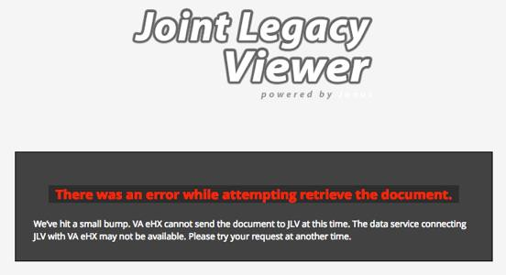
Figure 71: eHX Error Message

Acronyms and Abbreviations
Table 11 lists the acronyms and abbreviations used throughout this document, and their descriptions.

Table 11: Acronyms and Abbreviations

Acronym | Description
AITC | Austin Information Technology Center
CAPRI | Compensation and Pension Record Interchange
CCD | Continuity of Care Document
CCDA | Consolidated Clinical Document Architecture
CCOW | Clinical Context Object Workgroup
CDC | Centers for Disease Control
COOP | Continuity of Operations
CPRS | Computerized Patient Record System
DES | Data Exchange Services
DIBR | Deployment, Installation, Backout and Rollback
DOB | Date of Birth
DoD | Department of Defense
EDIPI | Electronic Data Interchange Personal Identifier
EHR | Electronic Health Records
eHX | eHealth Exchange
ESD | Enterprise Service Desk
GUI | Graphical User Interface
HAIMS | Healthcare Artifact and Image Management Solution
HL7 | Health Level 7
ID | Identification
IE | Internet Explorer
IEN | Internal Entry Number
IP | Internet Protocol
JLV | Joint Legacy Viewer
LOINC | Logical Observation Identifiers Names and Codes
MHS | Military Health System
MI | Middle Initial
MVI | Master Veteran Index
NUCC | National Uniform Claim Committee
OI&T | Office of Information and Technology
PDF | Portable Document Format
PDWS | Patient Discovery Web Service
PITC | Philadelphia Information Technology Center
PIV | Personal Identity Verification

Acronym | Description
POM | Production Operations Manual
QoS | Quality of Service
SDD | System Design Document
SNOMED CT | Systematized Nomenclature of Medicine - Clinical Terms
SSL | Secure Socket Layer
SSN | Social Security Number
TIU | Text Integration Utility
TLS | Transport Layer Security
TSPR | Technical Services Project Repository
UI | User Interface
URL | Uniform Resource Locator
VA | Department of Veterans Affairs
VBA | Veterans Benefits Administration
VDS | VistA Data Service
VHA | Veterans Health Administration
VistA | Veterans Health Information Systems and Technology Architecture
VLER | Virtual Lifetime Electronic Record

