Joint Legacy Viewer (JLV) 2.8.1 User Guide

November 2019 Version 1.1
Department of Veterans Affairs

Office of Information and Technology (OIT)

Revision History

Date | Version | Description | Author
10/29/2019 | 1.1 | Received PM Approval | AbleVets
10/24/2019 | 1.1 | Submitted for PM Approval | AbleVets
10/10/2019 | 1.0 | User Guide Delivered for Review | AbleVets
09/25/2019 | 0.1 | Initial draft of artifact from last approved | AbleVets

Artifact Rationale
Per the Veteran-focused Integrated Process (VIP) Guide, the user guide is required to be completed prior to Critical Decision Point #2 (CD2), with the expectation that it is updated as needed. A user guide is a technical communication document intended to give assistance to people using a system, such as Veterans Health Information Systems and Technology Architecture (VistA) end users. It is usually written by a technical writer, although it can also be written by programmers, product or project managers, or other technical staff. Most user guides contain both a written guide and the associated images. It is usual to include screenshots of the human-machine interfaces, and hardware manuals often include clear, simplified diagrams. The language used is matched to the intended audience, with jargon kept to a minimum or explained thoroughly. The user guide is a mandatory, build-level document, and should be updated to reflect the contents of the most recently deployed build. The sections documented herein are required if applicable to your product.

Table of Contents

- Introduction 1
  - Purpose of the Guide 1
    - Guide Conventions 2
    - Terminology 2
  - Assumptions 2
  - System Requirements 2
  - Getting Help 3
- Logging in to JLV 3
  - Editing Your User Profile at Login 5
  - Logging Out of the Current JLV Session 6
- The Elements and Functionality of JLV 7
  - The JLV Portal Pages 7
    - Default View 7
    - System Menu 8
    - References Widget 9
    - Viewing System Status 9
    - Patient Context Management 12
      - Suspending Context 12
      - Establishing Context 13
      - Unable to Communicate with Vault 13
      - Context Synchronization Failure 14
  - Customizing JLV 15
    - About Data Sources 16
    - About UI Themes 16
    - Using the Accessible Theme’s Functionality 18
      - Keyboard Focus and Screen Navigation 19
      - Accessible Theme Portal Navigation 20
  - User-Restricted Access to Patient Data 21
    - VHA Users Viewing DoD-only Patient Data 21
    - CAPRI-Claims Users Viewing Patients with DoD Data 22
      - Patient Registered in MVI 22
      - Patient Not Registered in MVI 23
    - Access to DoD Sensitive Records 23
  - Patient Searches 24
    - PDWS Search Rules and Supported Searches 24
    - MVI Search Guidelines 25
    - Patient Search Using DoD ID 25
    - Patient Search Using SSN 26
    - Advanced Patient Search Options 27
    - Family Member Search 28
    - Recently Viewed Patients List 30
- Widgets 31
  - Accessing and Opening Widgets 31
  - Widget Navigation and Display Options 32
  - Widget Toolbars 33
  - Minimized vs. Expanded Widget View 34
  - Sort and Filter Options 34
    - Widget Date Range Filters 37
      - Quick Date Range Filter 38
      - Start and End Date Filter 39
      - Tab Date Range Tool 40
    - Text Filter 41
  - Viewing Connection Status 43
  - Displaying Widgets on Custom Tabs 45
  - Refreshing Data in a Widget 46
  - Terminology Normalization 46
  - VistA Imaging Viewer 47
  - Using Report Builder 48
    - Adding One Record 50
    - Adding Multiple Records with EZ Select 51
    - Adding Details from Multiple Dates 52
    - Adding Sensitive Records 53
    - Adding Only Record Details or Notes 53
    - Adding Patient Demographics 54
    - Generating a Report 55
    - Opening a Report 57
    - Delete a Report 58
  - Printing 58
- Widget Functionality 58
  - Patient Demographics Widget 58
    - Patient Flags and Alerts 59
    - Advance Directives 60
    - Viewing Third-Party Insurance Information 61
  - Documents Widget 62
    - Documents Widget Data 63
    - Viewing Documents 64
  - Community Health Summaries and Documents - VA 65
    - Community Health Summaries and Documents - VA Widget Data 65
    - Viewing VA Community Health Summary Documents 66
  - Health Summaries and Reports – VA Only Widget 66
    - Health Summaries and Reports – VA Only Widget Data 66
    - Viewing Health Summaries 68
  - Lab Results Widget 70
    - Lab Results Widget Data 70
    - Viewing Lab Results Details 71
    - Viewing Lab Panel Results Details 72
    - Viewing Abnormal Results in the Lab Results Widget 72
    - Viewing Results and Interpretations in the Lab Results Widget 73
    - Graph/Table View from the Lab Results Widget 74
  - Military Health System (MHS) GENESIS Widget 76
    - MHS GENESIS Widget Data 76
    - Viewing MHS GENESIS Documents 77
- Troubleshooting 78
  - Special Instructions for Error Correction 78
    - Login Page Error Messages 79
    - System Error Messages 81
- Acronyms and Abbreviations 84
- Patient Portal Widgets, Columns, and Supported Views 86

Table of Figures
Figure 1: SSOi Page for VA Users 4
Figure 2: Edit Profile Link on the JLV Login Page 5
Figure 3: User Profile Data Source and User Interface Option Fields 6
Figure 4: JLV Log Out Icon 6
Figure 5: Default View 7
Figure 6: JLV Tools on the Portal Pages 8
Figure 7: More JLV Functionality 9
Figure 8: References Widget 9
Figure 9: System Status on the JLV Login Page 11
Figure 10: System Status on the JLV Toolbar 11
Figure 11: Context Indicator 12
Figure 12: Suspending Context 13
Figure 13: CCOW Warning Message 13
Figure 14: CCOW Error Message 14
Figure 15: Context Synchronization Failure 14

Figure 16: JLV Settings Dialog Box 15
Figure 17: Blue (Default) UI Theme, DoD Data Disabled 16
Figure 18: Dark Gray UI Theme, DoD Data Disabled 17
Figure 19: Green UI Theme, DoD Data Disabled 17
Figure 20: Gray UI Theme, DoD Data Disabled 18
Figure 21: Accessible (508-Compliant) UI Theme, DoD Data Disabled 18
Figure 22: Navigation Using Elements with Keyboard Focus 20
Figure 23: Document Details with Keyboard Focus 21
Figure 24: VA User Restricted Access Dialog 22
Figure 25: CAPRI-Claims User Audit Notification 22
Figure 26: Restricted Access Notification 23
Figure 27: DoD Sensitive Record and Audit Dialog Box 24
Figure 28: DoD ID (EDIPI) Search 25
Figure 29: SSN Search 26
Figure 30: Additional Identifiers Needed 27
Figure 31: Advanced Search Options 28
Figure 32: Sponsor SSN Search 29
Figure 33: Family Members Dialog Box 30
Figure 34: Recently Viewed Patients List 31
Figure 35: Widget Tray 32
Figure 36: Dynamically Expanded Filter Dropdown in the Documents Widget 37
Figure 37: Date Range Filters Applied 38
Figure 38: Quick Date Range Filter Options 39
Figure 39: Start and End Date Display Filter 40
Figure 40: Tab Date Tool 41
Figure 41: Vitals Widget Text Filter 42
Figure 42: Connection Status Indicator 43
Figure 43: Connection Status Details 44
Figure 44: Connection Status Window 44
Figure 45: Example of a Connection Error Message 45
Figure 46: Add Custom Tab Icon 45
Figure 47: Add Tab Dialog Box 46
Figure 48: Terminology Specific to Widgets 46
Figure 49: Camera Icon in the Image Column 48
Figure 50: Thumbnail and Link in Details View of the Documents Widget 48
Figure 51: Report Builder Icon 49
Figure 52: Current Report Tab 49
Figure 53: Patient Reports Tab 50
Figure 54: Report Builder EZ Select 51
Figure 55: Records Added to Report Builder 52
Figure 56: Adding Date-Flexible Details to Report Builder, Medicine Full Report 53
Figure 57: Report Builder Options 54
Figure 58: Demographics Widget Add to Report Builder Icon 55
Figure 59: Name Report Dialog Box 55

Figure 60: Patient Reports Tab Report Ready and Delete Option 56
Figure 61: Report Ready Message and Indicator 57
Figure 62: Report Contents Window 57
Figure 63: Delete Reports Dialog Box 58
Figure 64: Patient Demographics Widget 59
Figure 65: Patient Flags Indicator 60
Figure 66: Patient Flags and Postings Details 60
Figure 67: Advanced Directives Dialog 61
Figure 68: Insurance Information 62
Figure 69: Documents Widget, Minimized View 62
Figure 70: Documents Widget, Expanded View 64
Figure 71: Details View of a Document 64
Figure 72: Community Health Summaries and Documents - VA, Minimized View 65
Figure 73: Community Health Document 66
Figure 74: Health Summaries and Reports - VA Only Widget, Minimized View 67
Figure 75: Health Summaries and Reports - VA Only Widget, Expanded View 68
Figure 76: Health Summary from a Single, Local Site 69
Figure 77: National Health Summary, Multiple Sites 69
Figure 78: Lab Results Widget, Expanded View 71
Figure 79: Lab Results Details 72
Figure 80: Lab Panel Results Detail 72
Figure 81: Lab Results Widget, Abnormal Results in Expanded View 73
Figure 82: Lab Results Widget, Expanded View, Interpretations Available 74
Figure 83: Lab Results Interpretation Details 74
Figure 84: Lab Results Graph/Table View 75
Figure 85: Lab Results Graph Table View, Select a Lab Test 76
Figure 86: MHS GENESIS Widget 77
Figure 87: CCDA Document 78
Figure 88: Login Error - CAPRI Patient Selection Restrictions 79

Table of Tables
Table 1: JLV User Profiles 1
Table 2: System Status Notices by Service 10
Table 3: Accessible Theme Keyboard Shortcuts 19
Table 4: Navigation Icons and Actions 33
Table 5: Widget Toolbar Icons 33
Table 6: Available Widget Filters 35
Table 7: Error Messages and Resolution Steps 80
Table 8: System Error Messages 81
Table 9: Acronyms and Abbreviations 84
Table 10: Widget Details 86

Introduction
Born from a joint Department of Defense (DoD)–Department of Veterans Affairs (VA) venture called JANUS, Joint Legacy Viewer (JLV) was directed by the Secretary of the VA and the Secretary of Defense in early 2013 to further support interoperability between the two departments. JLV is a centrally hosted, Java-based web application managed as a single code baseline and deployed in separate DoD and VA environments. Its browser-based, graphical user interface (GUI) provides an integrated, read-only view of Electronic Health Record (EHR) data from the VA, DoD, and Veterans Health Information Exchange (VHIE) community partners, within a single application.
JLV eliminates the need for VA and DoD clinicians to access disparate viewers. The GUI retrieves clinical data from several native data sources and systems, then presents it to the user via widgets, each corresponding to a clinical data domain. Users can create and personalize tabs, drag and drop widgets onto tabs, sort data within a widget’s columns, set date filters, and expand a widget for a detailed view of patient information.
This document is intended for VA JLV users supporting the:
- Veterans Health Administration (VHA)
- Veterans Benefits Administration (VBA)
Table 1 describes authorized JLV users and their responsibilities.

Table 1: JLV User Profiles

User | Description and Responsibilities
Compensation and Pension Record Interchange (CAPRI)-Claims | VA administrative staff who access patient EHRs to assist in VBA processes
VHA | VA clinicians and administrative staff who access patient EHRs to assist in providing health care services
DoD Clinician | DoD clinicians who access patient EHRs

Purpose of the Guide
The purpose of the user guide is to familiarize VA users with the important features and navigational elements of JLV.
The major features of the JLV GUI include:
- Access to patient data (through widgets)
- Patient context management
- User-restricted access (Break the Glass)
- Use of the Report Builder
- Option to use the accessible (508-compliant) interface

Guide Conventions
This document is designed for both online and hardcopy consumption.
- Cross References are indicated by blue, underlined text and provide a hyperlink to figures, tables, and other sections within this guide
- Emphasis is expressed by bold and italicized text
- The information symbol calls the reader’s attention to additional information

Terminology
The following standard terms are used throughout this guide:
- Patient Portal: The page that displays patient data through widgets
- Provider Portal: The landing page, or default view, of JLV that appears after logging in to the application that displays widgets and the tools that enable quick access to basic features
- Tab: A component of the JLV interface that displays the Patient and Provider portals and presents user-customized views of widgets
- Widget: A component of the JLV interface that enables a user to view information or perform a function
- Widget Tray: An expandable and collapsible tray at the bottom of the portal pages that provides access to all widgets available for placement on the portal pages

Assumptions
The user guide is written from the perspective of VA users, assuming the following:
- You can open, navigate, and use a web browser
- You can use web-based applications, their menu options, and navigation tools
- You have the Uniform Resource Locator (URL) for the JLV Login page, a system username, and the required Access and Verify codes
- You are using the functionality of JLV to support VHA and/or VBA workflows

System Requirements
JLV is optimized for use with the VA standard browser, Internet Explorer (IE) version 11. It is recommended that JLV is viewed using:
- A monitor set to a minimum screen resolution of 1024 x 768
- The approved browser, with the browser’s zoom percentage set to 100%
JLV must be accessed through IE. Other web browsers may function but are not certified for support. It is also recommended that Adobe Reader be installed on your system.

Getting Help
Please see online help for how-to information within JLV. Please visit JLV Resources for access to JLV training videos and additional JLV training materials.
Prior to contacting the Enterprise Service Desk (ESD) for support, please refer to Logging in to JLV for detailed information about how to access JLV and to Troubleshooting for suggested resolution steps and troubleshooting information.
If you are an authorized user having trouble logging in to JLV or experiencing other application issues, please contact the ESD via telephone or by using the YourIT self-service portal for assistance.
Redacted
If you are unable to retrieve community partner documents for a patient, please contact your local VHIE Coordinator. If you need assistance identifying your local contact, please e-mail redacted.

Logging in to JLV
Users who have access to the Computerized Patient Record System (CPRS) or CAPRI are automatically authorized to use JLV.

NOTE: There is no functionality available to change a user identification (ID) and password in JLV. See Troubleshooting for information about login errors, Access code errors, or Verify code errors.
- Enter the JLV URL (redacted) into the address bar of your Internet browser, select the JLV button CPRS if available, or select the Joint Legacy Viewer tab in CAPRI
- All users are redirected to the VA Single Sign-On Internal (SSOi) page (Figure 1)
  - Click the Sign in with VA Personal Identity Verification (PIV) Card graphic
  - Select the CA B1 certificate, and click OK
  - Enter your Personal Identification Number (PIN), and click OK

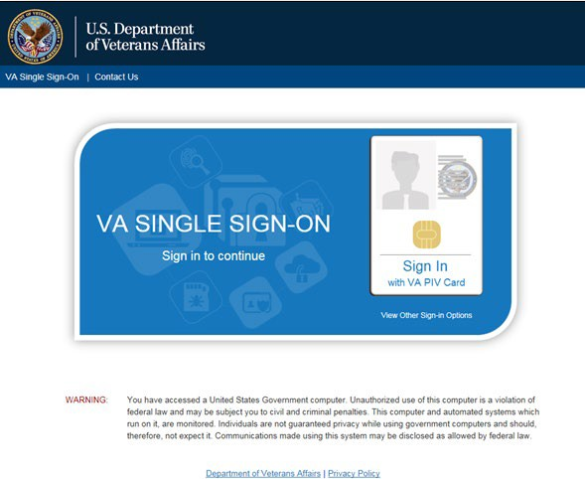
Figure 1: SSOi Page for VA Users

- Once authenticated by the SSOi system, you are redirected to JLV
- Read the important user consent information regarding access to a government information system, and click I Accept
- If you have adaptive technology installed, you can check the Accessibility Mode option on the JLV Login page
  - If selected, JLV opens and displays the application in the 508-compliant Accessible User Interface (UI) theme (See Using the Accessible Theme’s Functionality for detailed information)
- Enter your VA login credentials:
  - Enter your Access Code
  - Enter your Verify Code
  - Select VA from the Agency field
  - Select your VA Medical Center or regional health care system, if you are a CPRS user, or CAPRI-Claims, if you are a CAPRI user, from the Site field
- Click Login

NOTE: Users with any CAPRI patient selection restrictions must use the
Joint Legacy Viewer tab in CAPRI to access JLV.

Editing Your User Profile at Login
One method of setting application configuration options (i.e., customizing) is by using the Edit Profile link (Figure 2) to access the user profile fields through the JLV Login page (Figure 3). User profile options can also be set within JLV. See Customizing JLV.

NOTE: The selected options are saved to your user profile by clicking Save and Login and remain set for all subsequent JLV sessions until you change them.

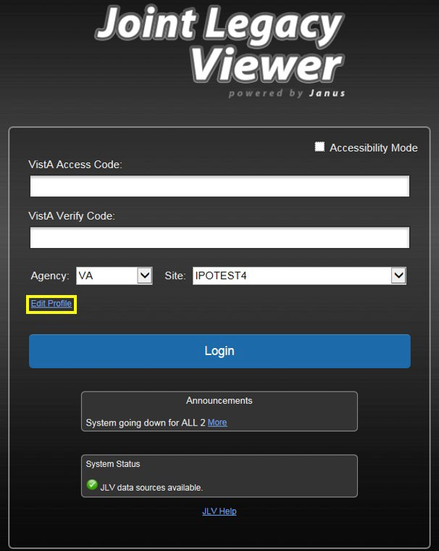
Figure 2: Edit Profile Link on the JLV Login Page

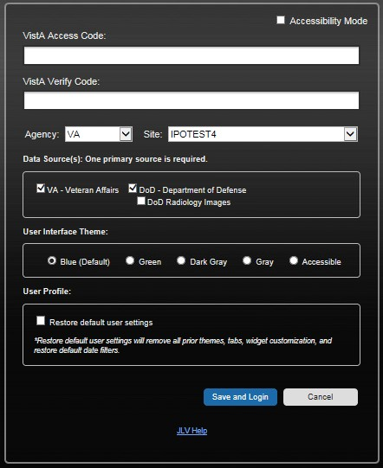
Figure 3: User Profile Data Source and User Interface Option Fields

Logging Out of the Current JLV Session
Click the Log Out icon (highlighted in Figure 4) at any time to end the current session and exit JLV.

Figure 4: JLV Log Out Icon

A JLV session ends automatically after 30 minutes of inactivity. Actions in JLV that are considered activity are changing patients, refreshing widgets, opening or closing widgets, adding

or removing widgets from the portal pages, and adjusting date ranges. You receive an audible and visual warning that the current session is about to terminate after 25 minutes of inactivity. Automatic termination of a session logs you out of the application, closes all JLV tabs and windows, and displays the Logout page. Close and reopen the browser and return to the JLV Login page to initiate a new JLV session.
If SSOi is enabled, you are redirected to the VA Single Single-On Logout page.

The Elements and Functionality of JLV

The JLV Portal Pages
After a successful log in, your username is shown in the upper right corner of the application, and the JLV portal pages are displayed. The JLV portal pages are:
- The Patient Portal
- The Provider Portal
    - Default View
Upon log in, you see the Provider Portal . The portal displays the Patient Search dialog box by default.

NOTE: CPRS users who select a patient within CPRS, then launch JLV are taken directly to the JLV Patient Portal , where the records for the patient selected in CPRS are displayed.

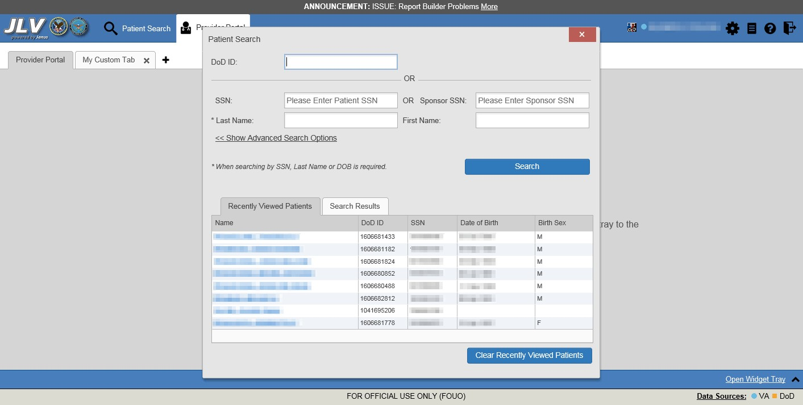
Figure 5: Default View

The Patient Portal displays a selected patient's clinical records and other patient-centric information.
New JLV users see a preconfigured, default widget layout on the Patient Portal when a patient is selected. The default layout includes the Allergies, Problem List, Documents, Outpatient Medications, and Lab Results widgets, as well as the Patient Flags and Postings widget if applicable.

NOTE: You can configure the layout of widgets on the Patient Portal and create multiple widget tabs, as described in Customizing JLV and in Accessing and Opening Widgets. Customizations are saved to your user profile and remain until manually changed.

System Menu
Each portal page has a toolbar in the top-right corner of either portal page (highlighted in Figure 6) that enables quick access to the following features:
- Configuration Options: Click the Settings icon to set user preferences, including the UI theme (Refer to Customizing JLV)
- Report Builder: Click the Report Builder icon to create custom reports (Refer to Using Report Builder)
- Access Online Help: Click the Help icon to open online help
- Log Out of JLV: Click the Log Out icon to log out and close the current JLV session (Refer to Logging Out of the Current JLV Session)

Figure 6: JLV Tools on the Portal Pages

The following functions can be completed from the portal pages (highlighted in Figure 7):
- Perform a Patient Search
- Switch between the Patient Portal and the Provider Portal
- View the system status
- View Context Management status
- Open the widget tray using the Open Widget Tray ^ link in the lower right corner of the portal pages (as shown in Accessing and Opening Widgets, Figure 35)

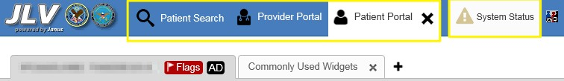
Figure 7: More JLV Functionality

Switching from the Patient Portal to the Provider Portal closes all associated patient tabs and windows to prevent confusion between patient records.

References Widget
The References widget (Figure 8) displays hyperlinked references to online resources. Click the Open Widget Tray link (or click the up arrow) in the lower right corner of the Provider Portal to view the widget tray. Click and drag the References widget from the tray up to the portal and position where desired. Click a reference link to access the associated website. Click to add a new reference link.
Only the reference links you add can be deleted. Right-click the link and select Delete URL to delete a reference link. You cannot delete reference links included in the default widget configuration.

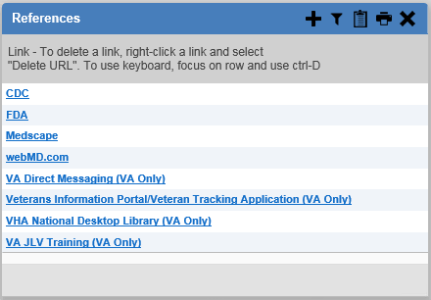
Figure 8: References Widget

Viewing System Status
The system status reports the condition of the JLV application. If there is a system status alert, the warning icon is displayed to the left of your username. Hovering over System Status provides additional information.

NOTE: The System Status reports the overall condition of the JLV application, while the Connection Status reports the condition of the connection between JLV and its external resources. See Viewing Connection Status for more information.

JLV displays the system status below the user credential fields on the Login page, as well as at the top of the portal pages.
- When all monitored systems and services are online and connected, a green icon appears next to the status message, “JLV data sources are available”
- When one or more of the monitored systems or services is offline or unavailable, a yellow warning icon appears next to the status message, “Services are not available to JLV”
- When JLV is unavailable, a red icon appears next to the message, “System status is unavailable”
  - You may not be able to log in to JLV or view patient data until the connection is restored
These warnings may be accompanied by one or more of the notices listed in Table 2, depending on which services are unavailable.

Table 2: System Status Notices by Service
Service | Notice
jMeadows | “The service that gathers patient data and prepares it for display in JLV is unavailable. JLV is available for login but may not function otherwise.”
Master Veteran Index (MVI) | “VA Patient Identity Service is unavailable. Patient search may not be available, and VA and community partner data may not display.”
Patient Discovery Web Service (PDWS) | “DoD Patient Identity Service is unavailable. Patient search may not be available and DoD data may not display.”
Relay Service | “The connection to DoD is unavailable. DoD patient records of all types from all sites may not display.”
VistA Data Service (VDS) | “The connection to VA sites is unavailable. VA patient records of all types from all sites may not display.”
Figure 9 shows a system status message on the Login page, and Figure 10 shows the System Status hover text on the toolbar in the upper right corner of the application.

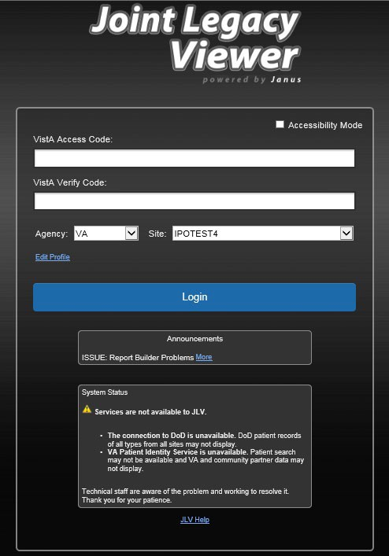
Figure 9: System Status on the JLV Login Page

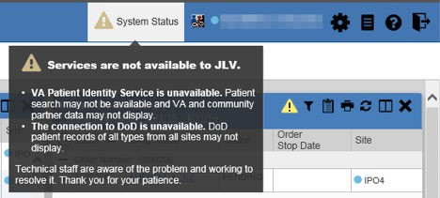
Figure 10: System Status on the JLV Toolbar

Patient Context Management
Clinical Context Management (CCOW) is a way for applications to synchronize the display of clinical context, based on the Health Level 7 (HL7) CCOW standard. If CCOW-compliant applications are sharing context and one of the applications changes the data display to a different patient, the other applications switch to display that same patient.
JLV is context management-enabled. When context is enabled, a patient change made in one context-enabled application (i.e., CPRS) triggers the same change in JLV. The same effect is shown vice versa; that is, when a patient is selected in JLV, it triggers a patient change in other context-enabled applications.
Context management is enabled by default, and JLV attempts to connect to the context vault upon a valid login. The context status appears in the top-right corner of the portal pages. When context is established, the Context On icon is shown. When context is suspended, the Context Suspended icon is shown.
Figure 11 shows the context indicator location on a JLV portal page. Context is suspended in this example.

Figure 11: Context Indicator

Suspending Context
Context can be manually suspended.
- Click the Context On icon
- The CCOW warning message, “Are you sure you want to break patient link?” appears (Figure 12)
- Click Yes to continue
Once context is suspended, the Context Suspended icon is displayed on the portal pages. When context is suspended, patient changes are not reflected in either JLV or other CCOW- enabled applications.

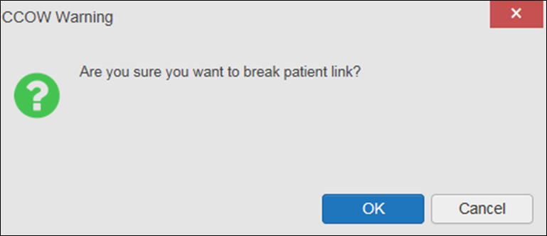
Figure 12: Suspending Context

Establishing Context
When context is suspended, it can be reestablished manually.
- Click the Context Suspended icon
- The CCOW warning message, “Are you sure you want to rejoin patient link?” appears (Figure 13)
- Click Yes
Once context is established, the Context On icon is displayed on the portal pages.

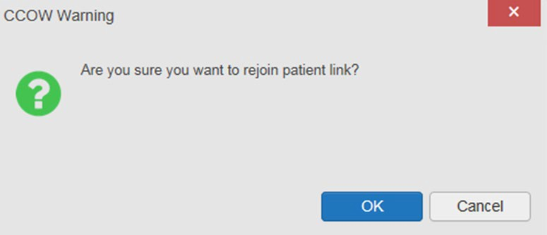
Figure 13: CCOW Warning Message

Unable to Communicate with Vault
If JLV is unable to initiate context management upon log in, you see the CCOW Error message (Figure 14). Click OK to continue. The Context Suspended icon is displayed on the portal pages. If the CCOW error persists, contact your local service desk for assistance.

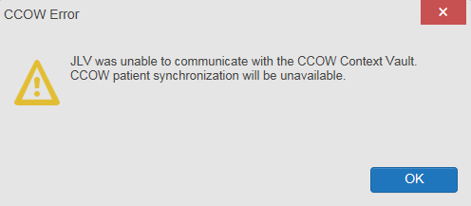
Figure 14: CCOW Error Message

NOTE: This error message will automatically display if you have more than one active JLV session open.

Context Synchronization Failure
A CCOW error message is presented if JLV is unable to reestablish context (Figure 15). This indicates context is suspended. Click OK to continue. The Context Suspended icon is displayed on the portal pages.
CAPRI-Claims users may encounter the error message (Figure 15) at each log in, as there are usually no CCOW system components installed on their computers.

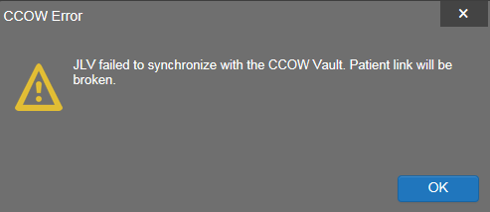
Figure 15: Context Synchronization Failure

Customizing JLV
Configuration options, such as data sources and UI theme, can be set in the JLV Settings dialog (Figure 16). These settings are saved to your user profile and persist.
- Click the Edit Profile link on the Login page (Figure 2), the Settings icon on the portal pages (Figure 6), or the Data Sources link on the portal pages (see the figures in About UI Theme)
  - The JLV Settings dialog box opens
- Select the desired data source checkbox
  - (Optional) Enable the DoD Radiology Images option if desired when enabling DoD data
- Select the radio button next to the desired theme
- Click Save to apply the selected data source and/or theme OR
- Click Cancel to exit the dialog box and restore the previous data source and/or theme configuration

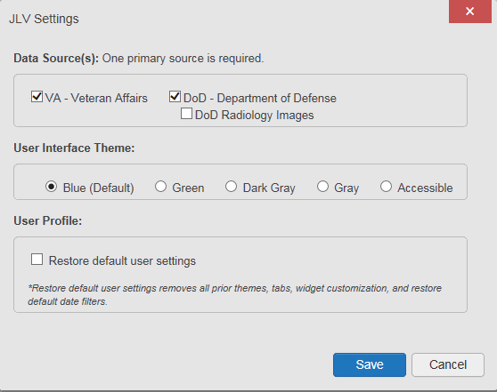
Figure 16: JLV Settings Dialog Box

NOTE: Changing the data sources or UI theme will require you to reselect and reload the current patient.

You may reset your user profile to JLV defaults by selecting the Restore Default User Settings
checkbox and then the Save button in the JLV Settings dialog. This feature resets the theme and

data source options to default; removes any custom tabs; and resets all widgets to their default configurations, which removes any custom sort or filter settings.

About Data Sources
The data source setting is part of your user profile. The data source setting enables you to specify the agency or agencies JLV queries for patient data. DoD and VA are considered primary data sources. One primary data source is required. Both VA and DoD are selected by default for new users. With both agencies selected, JLV retrieves patient data from DoD and VA sources and populates the widgets in the Patient Portal with data from DoD and VA sites. Selecting one primary source displays only data from that agency in the widgets.
JLV displays data source indicators in the Data Sources pane in the lower right corner of the portal pages, depending on which data sources are enabled. A circular, blue icon indicates that VA data is enabled; a square, orange icon indicates that DoD data is enabled; and a circular, gray icon indicates either VA or DoD data is disabled (Figure 17).
The DoD data source also has an option to enable DoD Radiology images. This option is not enabled by default.

About UI Themes
The UI theme setting is also part of your user profile. Choosing a UI theme sets the font, foreground, and background colors of the widgets, toolbars, and dialog boxes. Once selected, the UI theme is stored in your user profile and remains set until you change it. The available UI themes are Blue (Default), Green, Dark Gray, Gray, and Accessible (508-compliant).

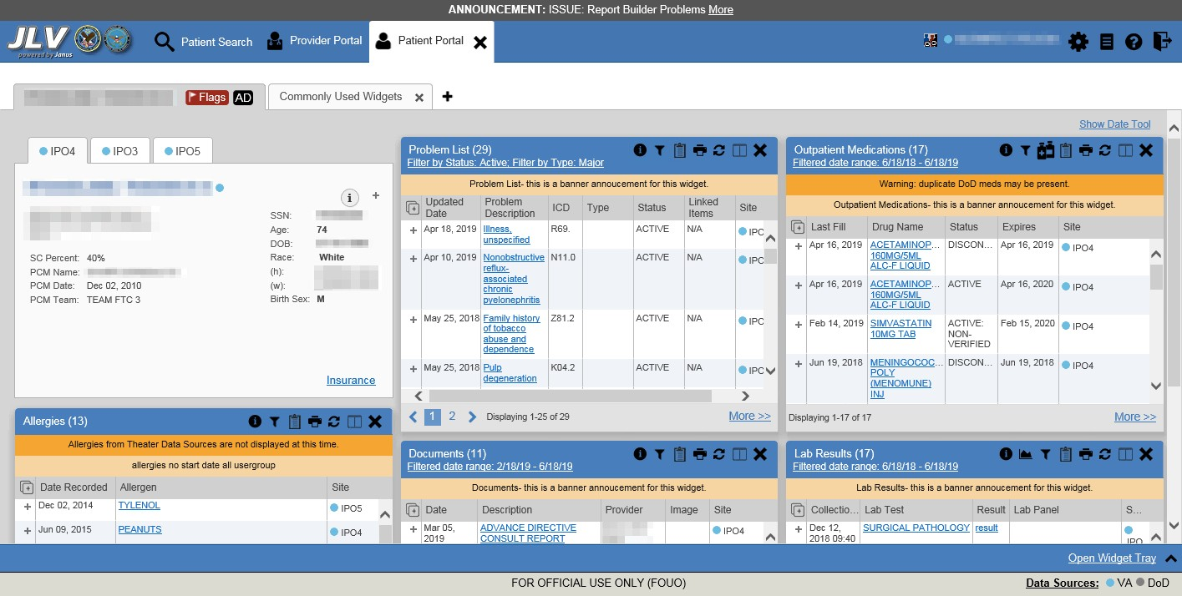
Figure 17: Blue (Default) UI Theme, DoD Data Disabled¹

¹ Primary Care Management (PCM), Social Security Number (SSN), Date of Birth (DOB)

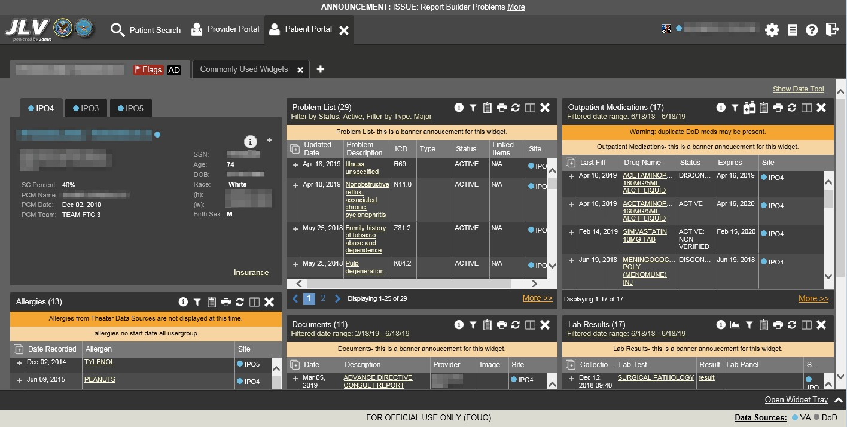
Figure 18: Dark Gray UI Theme, DoD Data Disabled

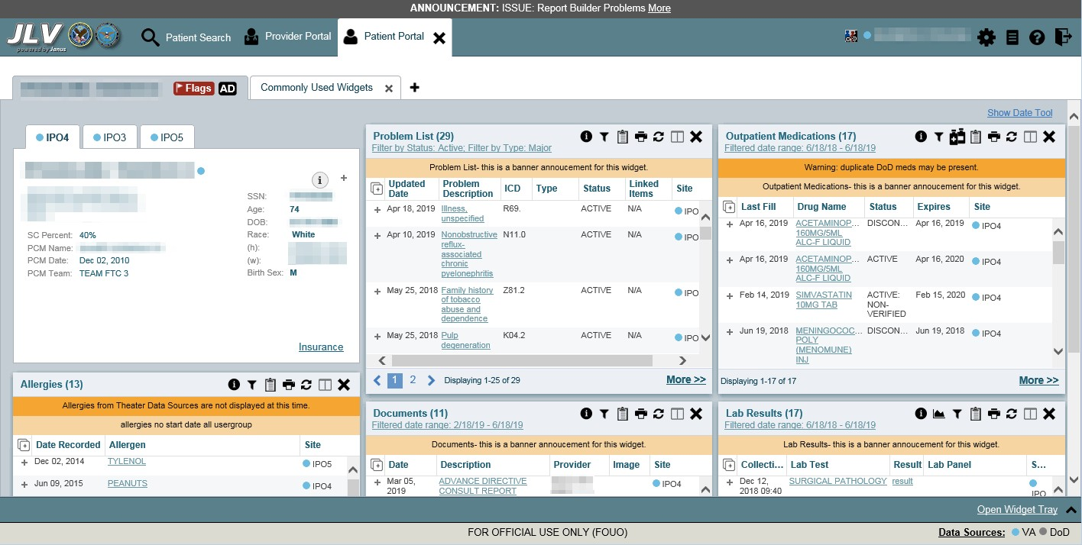
Figure 19: Green UI Theme, DoD Data Disabled

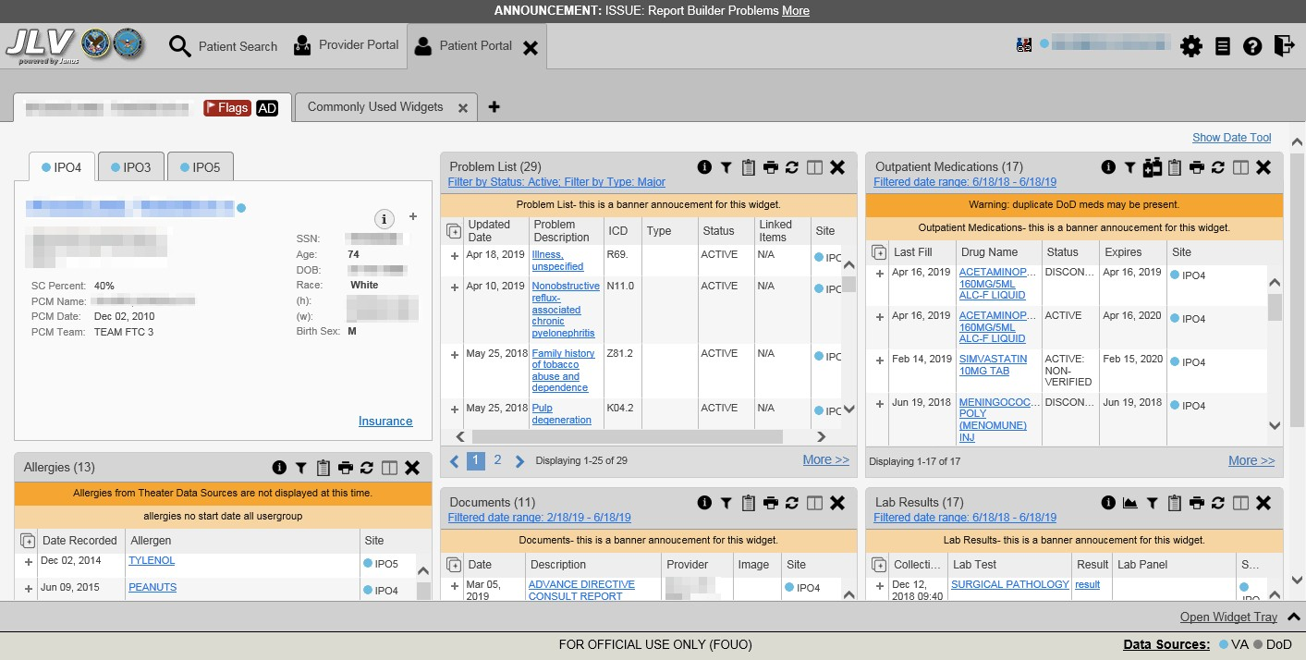
Figure 20: Gray UI Theme, DoD Data Disabled

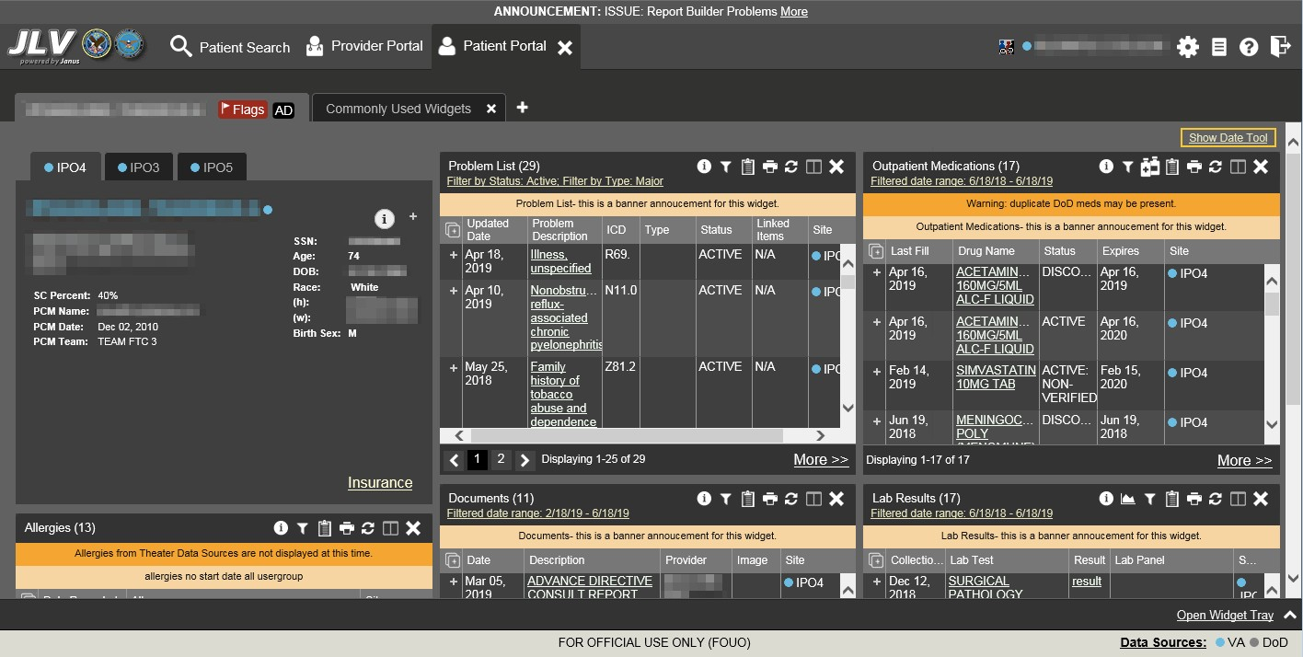
Figure 21: Accessible (508-Compliant) UI Theme, DoD Data Disabled

Using the Accessible Theme’s Functionality
The Accessible theme includes larger fonts, enhanced tab and keystroke functionality, and screen reader compatibility to support Federal accessibility requirements and Section 508 compliance.

NOTE: The Accessible theme is available for users who have adaptive technologies installed on their computers.

Keyboard Focus and Screen Navigation
Keyboard focus is the highlighting of a screen element, field, or control that enables interaction with, and navigation of, JLV using the keyboard and keystrokes. The item in focus is outlined in gold as a visual indicator of the element, field, or control with keyboard focus that receives information typed on the keyboard.
JLV uses common Windows keystrokes (Tab, Shift + Tab, arrow keys, Enter), and keyboard shortcuts to move the focus to all menus, and activate all functions on the menus. All user interface items are accessible via the keyboard under the Accessible theme.
Pressing Enter or the Spacebar when an element that provides action is in keyboard focus performs the associated action; for example, pressing Enter or the Spacebar when the Settings icon is in focus opens the JLV Settings dialog box. Using the arrow keys or the Tab key moves between keyboard focus items to navigate through screen elements. Table 3 provides a complete list of accessible keystrokes.

Table 3: Accessible Theme Keyboard Shortcuts

Keystroke | Description
Application & Portal Navigation
ALT + 4 | Press to transfer keyboard focus to the main or top screen element  - Focus transfers to Patient Search or the patient tab in the Demographics widget on a portal page  - Focus transfers to the More>> link in a widget  - Focus transfers to the dialog box’s Close button in a dialog box
ENTER | Press to initiate the action associated with the item in focus
TAB | Press to transfer keyboard focus to other user interface items
ESC | Press to return keyboard focus to the panel containing the user interface item with keyboard focus or to exit a window, widget, or tab
SPACEBAR | Press to activate any user interface item (for example, click an icon)
Arrow Keys | When focused on a widget, press the arrow keys to change page viewing in a widget's data table  When focused on a dropdown list, press the down arrow key to view list contents
Ctrl + d | Place keyboard focus on a reference or row within the References widget on the Provider portal and press Ctrl + d to remove the reference URL  Removing a default reference is not allowed
Tab Panels
Arrow Keys | Use the left and right arrow keys to change tabs
TAB | Press one or more times when focus is on a portal tab to place in keyboard focus. Add a Tab:  - Press Tab until is in focus  - Press Enter  - The new tab dialog box opens and prompts you to enter a name for the new tab  - Tab to the Add button to confirm the new tab name or tab to the Cancel button to discard the new tab

Keystroke | Description
Windows or Dialog Boxes
TAB | Press to transfer keyboard focus to other user interface items within the window or dialog box
Adding Widgets to a Portal Page
Number position | Add a widget from the widget tray using keystrokes:  - Determine in which column (1, 2, or 3) to place the widget  - Focus on the desired widget icon in the widget tray, and press the Alt key and the 1, 2, or 3 key, depending on the column chosen

Accessible Theme Portal Navigation
An element with keyboard focus is the starting point for portal navigation. Pressing the Enter or
Spacebar keys when a screen element or icon has keyboard focus mimics a mouse click.
Figure 22 depicts the Documents widget with keyboard focus. Focus can be changed by pressing the Tab key. Pressing the Tab key in this example shifts the keyboard focus from the Documents widget to the widget immediately below the Documents widget. Pressing the Tab key again shifts the keyboard focus to the widget at the top of the next column.

NOTE: Focus on the element within the widget that has hover text. After a small delay, the text appears as if you hovered over the element with your mouse cursor.

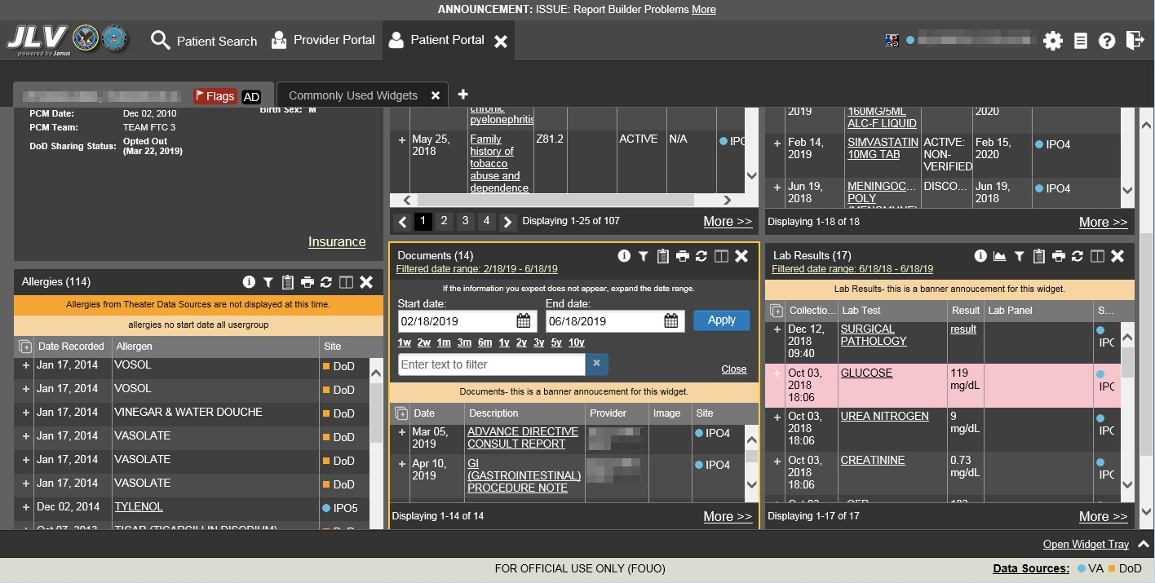
Figure 22: Navigation Using Elements with Keyboard Focus

The Document details window has keyboard focus in Figure 23. Move through the toolbar buttons by using the arrow keys, or by pressing Tab. Move to Close (X) and press Enter to close

the details window. After closing the window, keyboard focus returns to the last element that had keyboard focus prior to opening the window.

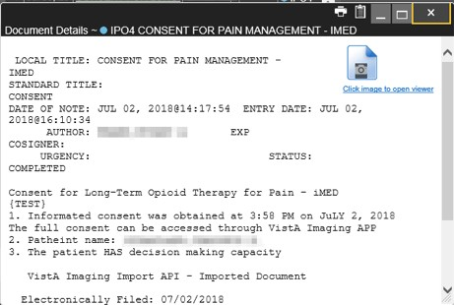
Figure 23: Document Details with Keyboard Focus

User-Restricted Access to Patient Data

VHA Users Viewing DoD-only Patient Data
VHA users can view the records of DoD-only patients, meaning they either have no VA identifiers or are not registered in MVI, but VA requires that these actions be audited. If an attempt is made to access DoD-only patient records, the VHA user is asked to specify the purpose for access. The purpose options presented to the user are: Emergent Care, Clinical Care, or Authorized Administrative Use (Figure 24).
Once the purpose for access is selected, clicking Agree to be Audited & Access this Patient Record (Figure 24), displays the requested data, and audits the action. The access purpose, organization of the VA provider, date, username, IP address, user’s Internal Entry Number (IEN), host system’s ID, and patient’s Electronic Data Interchange Personal Identifier (EDIPI) are captured in the audit record.

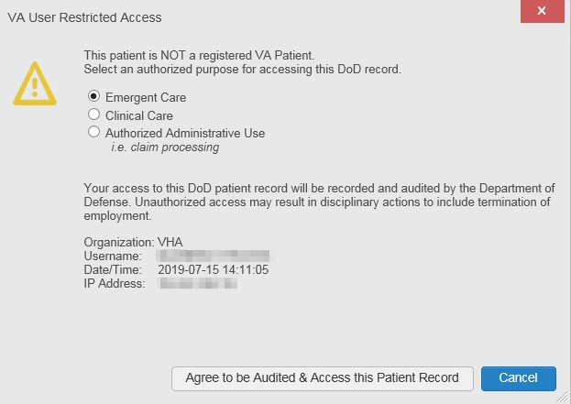
Figure 24: VA User Restricted Access Dialog

CAPRI-Claims Users Viewing Patients with DoD Data
CAPRI-Claims users may see one of two different dialog boxes, depending on whether the patient is registered for care in the VA. If the patient is registered for care in the VA, they are in MVI.

Patient Registered in MVI
CAPRI-Claims users are permitted to view the records of a patient who is registered in MVI, but the VA requires that these actions be audited. After performing a patient search and selecting a patient from the search results, a CAPRI-Claims user sees the audit notification (Figure 25) if the patient they selected is registered in MVI. After agreeing to the audit, the CAPRI-Claims user can access the patient’s record.

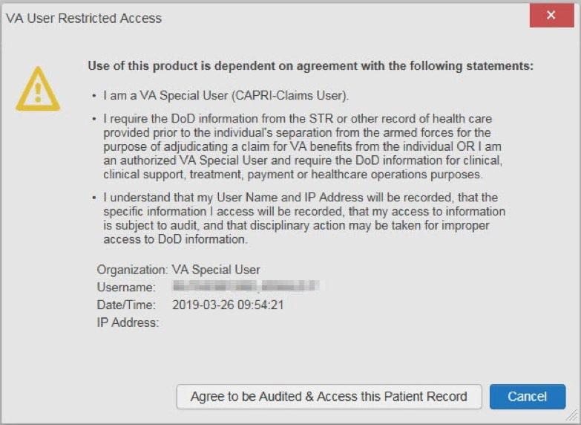
Figure 25: CAPRI-Claims User Audit Notification

Patient Not Registered in MVI
CAPRI-Claims users are not permitted to access the records of a patient who is not registered in MVI. After performing a patient search and selecting a patient from the search results, a CAPRI- Claims user sees the restricted access notification (Figure 26) if the selected patient is not registered in MVI. Clicking Cancel returns the user to the previous screen.

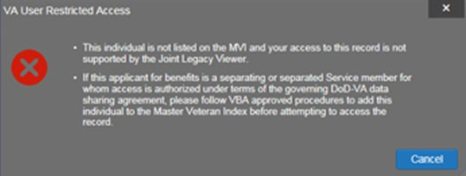
Figure 26: Restricted Access Notification

Access to DoD Sensitive Records
All JLV users are audited each time a sensitive DoD record is accessed. Auditing applies to sensitive documents, lab panel results, outpatient encounters, or progress notes records. JLV records the user’s name, organization, SSN/EDIPI (for DoD users), PIV (for VA users), location, patient identifiers (patient last name, first name, middle initial [MI], SSN/EDIPI [DoD only], MVI [VA only], and date of birth [DOB]), data accessed, date and time, and reason for access for each attempt to access sensitive data.
JLV notifies you before you are audited. The message is triggered the first time you click a masked record that is marked ** Sensitive**. Your acknowledgement of the audit notification covers all subsequent DoD sensitive records in any widget during the remainder of the session, and it only expires when you switch patients or log off. An example of a masked record audit notification is depicted in Figure 27.
After you select the purpose for viewing the record and agree to be audited, the sensitive data displays in the Details view of the widget.

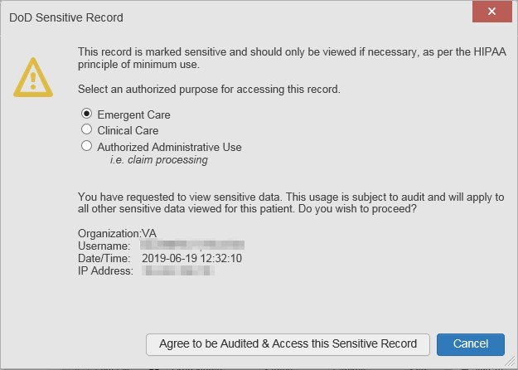
Figure 27: DoD Sensitive Record and Audit Dialog Box

Patient Searches
The core function of JLV is to display patient information on the Patient Portal . Use the Patient Search feature to perform a patient search, perform a family search, or use the advanced search options.
JLV determines which enterprise service to use for a patient search, based upon the search criteria:
- If the EDIPI or Sponsor SSN is entered, JLV utilizes PDWS for the search (See PDWS Search Rules and Supported Searches for details)
- If the EDIPI or Sponsor SSN fields are empty, JLV utilizes MVI for the search (See MVI Search Guidelines for details)

PDWS Search Rules and Supported Searches
When JLV utilizes PDWS for patient search, the applicable rules and rule sets required for the PDWS interface must be used:
- Rule Set 1: When searching by SSN, the full nine-digit SSN must be entered, and the Last Name or DOB must also be supplied
  - This is true for search by patient SSN as well as Sponsor SSN
- Rule Set 2: If you do not have the patient’s SSN, you must supply ALL the following identifiers: Last Name, First Name, DOB, and Birth Sex
  - Blanks in any of these four required fields generates an error
- A 10-digit string is required for telephone number
The following search combinations are supported when PDWS is utilized:
- DoD ID, also referred to as the EDIPI
- Patient SSN and Last Name

- Patient SSN and DOB
- Sponsor SSN and Last Name
- Sponsor SSN and DOB
- Last Name, First Name, DOB, and Birth Sex (ALL identifiers must be entered)

MVI Search Guidelines
JLV utilizes MVI for a patient search when the search parameters include the patient’s name and SSN. MVI requires the full last name is entered when the patient’s SSN is entered. MVI may also require entering the patient’s first name and DOB to increase the efficiency of the search, and the likelihood of locating the patient. An example would be searching for a patient with a common last name, such as Smith or Jones.

Patient Search Using DoD ID
- Click the Patient Search icon at the top of the portal pages
  - The Patient Search dialog opens
- Enter the 10-digit patient DoD ID (EDIPI) in the DoD ID field (Figure 28)

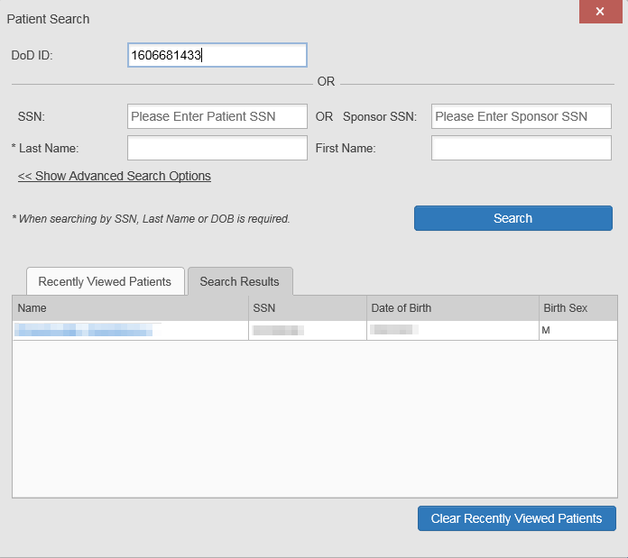
Figure 28: DoD ID (EDIPI) Search

- Click Search
  - The search results are displayed in the lower third of the dialog box, under the Search Results tab
- Click a patient’s name in the search results list to open the associated record

  - The Name, SSN, DOB, and Birth Sex columns in the results list provide information to assist with patient identification
- After selecting a patient, the Patient Portal opens and displays the selected patient’s data

Patient Search Using SSN
- Click the Patient Search icon at the top of the portal pages
  - The Patient Search dialog box opens
- Enter the patient’s full, nine-digit SSN in the SSN field (Figure 29)
  - When searching by SSN, either the last name or the DOB must be entered to perform the search

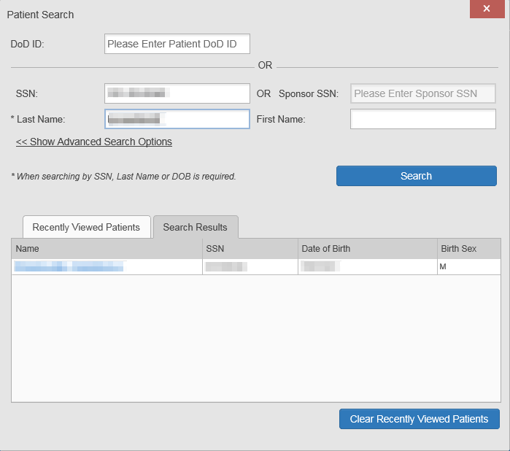
Figure 29: SSN Search

- Click Search
  - If the required patient identifiers are not provided, hover text appears, indicating the information necessary to complete the patient search
  - If a match of patient names cannot be made, enter additional identifiers (first name, DOB) to refine the search (Figure 30)

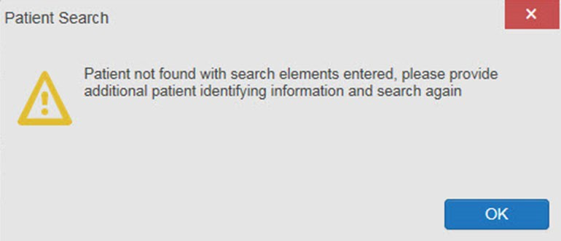
Figure 30: Additional Identifiers Needed

- The search results are displayed in the lower third of the dialog box, under the Search Results tab
- Click a patient’s name in the search results list to open the associated record
  - The Name, SSN, DOB, and Birth Sex columns in the results list provide information to assist with patient identification
- After selecting a patient, the Patient Portal opens and displays the selected patient’s data

Advanced Patient Search Options
Advanced patient search options in the Patient Search dialog box allow for the use of additional patient identifiers when performing a patient search.
- Click the Patient Search icon at the top of the portal pages
  - The Patient Search dialog box opens
- Click the <<Show Advanced Search Options link under the *Last Name field (seen in Figure 29)
- Enter the patient identifiers in the appropriate search fields, as desired
  - Advanced search option fields include *DOB, MI, Birth Sex, Address, State, City, Zip, and Telephone (seen in Figure 31)

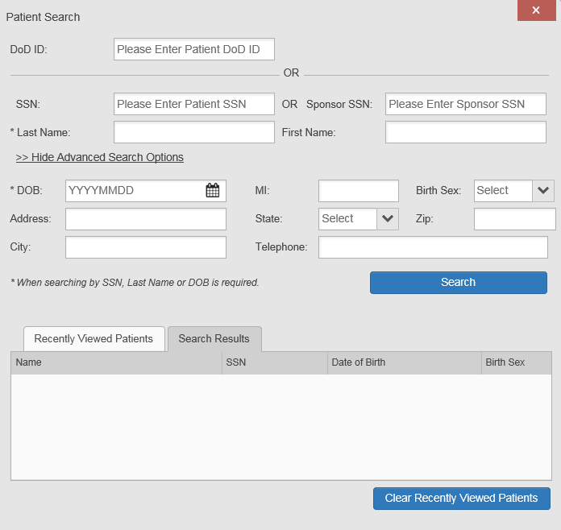
Figure 31: Advanced Search Options

- Click Search
  - If the required patient identifiers are not provided, hover text appears, indicating the information necessary to complete the patient search
- The search results are displayed in the lower third of the dialog box, under the Search Results tab
- Click a patient’s name in the search results list to open the associated record
  - The Name, SSN, DOB, and Birth Sex columns in the results list provide information to assist with patient identification
- After selecting a patient, the Patient Portal opens and displays the selected patient’s data

Family Member Search
A family member search can be performed using the Sponsor SSN field in the Patient Search
dialog box.
- Click the Patient Search icon at the top of the portal pages
  - The Patient Search dialog box opens

- Enter the SSN in the Sponsor SSN field
  - The Last Name or DOB of the patient must also be entered in the appropriate fields (Figure 32)
- Click Search
  - If the required patient identifiers are not provided, hover text appears indicating the information necessary to complete the patient search
- The search results are displayed in the lower third of the dialog box, under the Search Results tab (Figure 32)

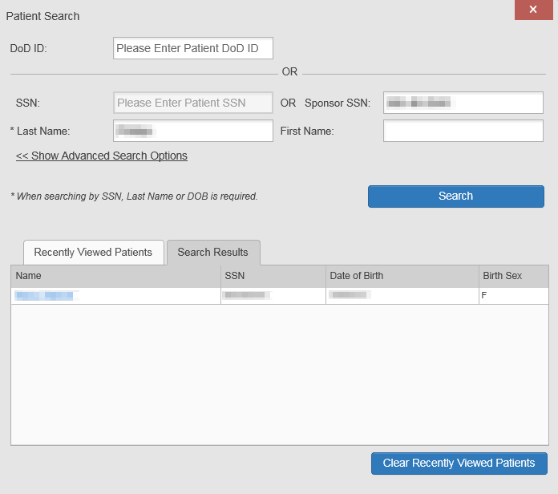
Figure 32: Sponsor SSN Search

- Click a name in the Search Results list
  - The Family Members dialog opens (Figure 33)
  - The sponsor’s identifiers and a list of dependents are displayed in the dialog
- Click a name in the list of family members to open the associated record
- After selecting a patient, the Patient Portal opens and displays the selected patient’s data

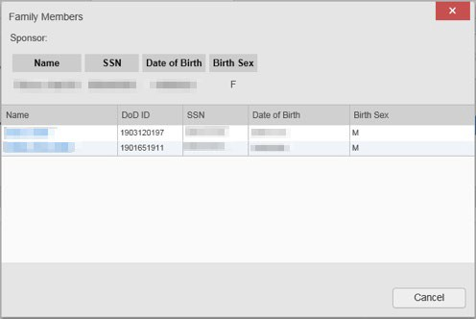
Figure 33: Family Members Dialog Box

Recently Viewed Patients List
Users who have previously logged in to JLV, searched for a patient, and viewed that patient’s records can see and access a list of recently viewed patients. A recent patient is defined as a patient whose record has been viewed (opened) by the user.

NOTE: The Recently Viewed Patients list does not include search history or recent search results, only a list of patients whose data was accessed and viewed. The list is limited to 10 patients. You can clear this list by selecting the Clear Recently Viewed Patients button.

- Click the Patient Search icon at the top of the portal pages
  - The Patient Search dialog box opens
- Click the Recently Viewed Patients tab in the lower third of the Patient Search dialog box
- A list of recently viewed patients is displayed (Figure 34)
  - The Name, DoD ID, SSN, DOB, and Birth Sex columns in the results list provide information to assist with patient identification
- Click a patient’s name in the Recently Viewed Patients list to open the associated record
- After selecting a patient, the Patient Portal opens and displays the selected patient’s data

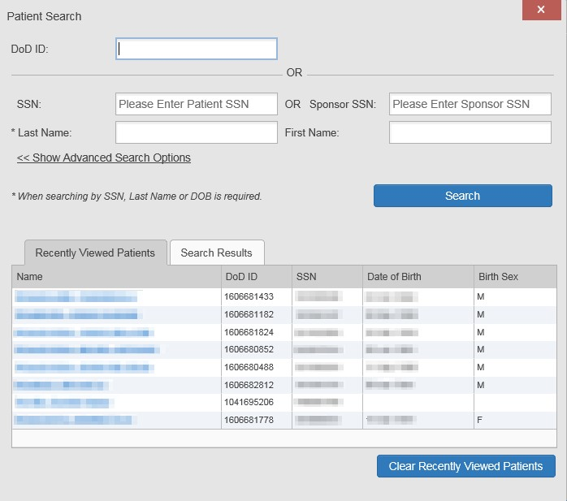
Figure 34: Recently Viewed Patients List

Widgets
Widgets are elements on the JLV portal pages that display data specific to a clinical domain. By default, widgets are displayed in minimized view on the portal pages (Figure 17), but they can be expanded to view additional details. The list of available widgets is provided in a horizontal tray at the bottom of the page.

NOTE: Widgets may take anywhere between 10 seconds to 90 seconds to load, depending on the date range settings.

Accessing and Opening Widgets
All available widgets are displayed in the widget tray, at the bottom of the portal page (Figure 35). Hover over a widget icon to view a description of the widget. Widgets can be opened, rearranged, and closed. JLV can display up to 12 widgets per tab.

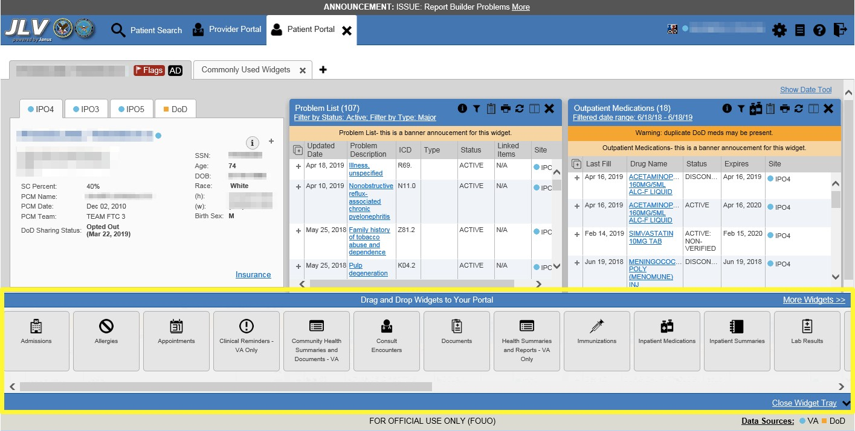
Figure 35: Widget Tray

- Open the widget tray by clicking the Open Widget Tray link in the lower right corner of the portal page
- Use the scroll bar arrows < > at either end of the tray to see all widget choices OR
- Click the More Widgets >> link to scroll through the list of widgets
- Click and hold a widget icon in the tray, drag it to the portal page, and drop it in the desired location
- The widget is docked on the portal page, and opens in minimized view
- Close the widget tray by clicking the Close Widget Tray link

NOTE: JLV displays a Duplicate Widget notice if you attempt to add another instance of a widget to a tab.

Widgets can be closed (removed from the portal page) by clicking the Close icon in the top- right corner of the widget. Rearrange the widgets displayed on the portal page by dragging and dropping them.

Widget Navigation and Display Options
Each widget has tools and display options available to navigate through, and change, the display of data. The vertical scroll bar allows you to move through, and view, the widget’s data. The options at the bottom of a widget provide various ways to see all the records loaded for the widget’s clinical domain.
Navigation icons and actions are detailed in Table 4.

Table 4: Navigation Icons and Actions

Navigation Icon | Action | Description
 | Changes the focus of the widget to the previous group or page of records within the results display. | Go to Previous Page
 | Changes the focus of the widget to the page number selected. | Jump to Page
 | Changes the focus of the widget to the next group or page of records within the results display. | Go to Next Page
More >> | Available in minimized views only. Opens the expanded view of the widget in a secondary window. | Go to Expanded View
1-25 of 55 | Indicates the number of records displayed in that widget page out of the total number of results for that widget. | Record Display Indicator
Show All/ Show Paged | Click Show All to open all records for a given widget in a scrollable window.  Click Show Paged to return to the display of records grouped by pages. | Display Setting
When there are more than 25 records available in a widget, they are grouped in Show Paged view. Records 1 through 25 can be viewed by using the widget’s vertical scroll bar. Records 26+ can be viewed by using the page navigation options, in the lower left corner of the widget, to jump to subsequent pages. The expanded view of a widget contains a Show All link, which opens all records for that widget, in a scrollable window. Click Show Paged to return to the display of records grouped by pages.

Widget Toolbars
There is a toolbar in the upper right corner of both the minimized and expanded views of each widget, and most dialog boxes. Toolbar icons vary by widget, dialog box, and window. Table 5 describes the functionality of each toolbar icon.

Table 5: Widget Toolbar Icons

Icon | Name | Function
 | Add to Report Builder | Adds the information displayed in the widget to the Report Builder, including any  Details or Notes.
 | Close | Removes the widget from the portal screen or closes a dialog box.
 | Column Settings | Configures the columns within the widget. Turn the columns on or off by checking the column names that appear in the pop-up box and clicking Apply.

Icon | Name | Function
 | Configure Filter | Filters on specific record types or other elements within the widget, including a date filter. If a date range filter is applied in an open widget, the date range is displayed in the widget header.  Note: After setting a filter, the Close Filter option is enabled in the widget. Clicking Close Filter restores the full display of records within the widget.
 | Copy to Clipboard | Copies the content of the open window to the clipboard for pasting into another application. Copy to Clipboard is disabled in the widget toolbar after clicking Show All within a widget.
 | Connection Status | Both icons provide a status indicator for DoD and VA data sources. The circle with the lowercase “i" indicates all sources are available. The yellow triangle warning indicates one or more data sources are unavailable. Clicking either status icon opens the connection status details in a separate window.
 | Print | Prints the contents of the open window. Print is disabled in the widget toolbar after clicking Show All within a widget.  Note: It is recommended that you have the latest Adobe Reader installed for the Report Builder and other printing features.
 | Graph | Some widgets have the capability to configure data to display multiple records of the same type in a graph.
 | Refresh | Refreshes the widget or window display. Only the data within that widget’s dataset is updated.
 | Rx | Converts the medication data within the widget to text and opens the text in a pop-up window. Available from the Outpatient Medications widget.
 | Site List | Opens a list of community sites where the patient has been seen (only available from the Community Health Summaries and Documents - VA widget).

Minimized vs. Expanded Widget View
Each widget can be displayed in either a minimized (default) or an expanded view. Minimized view displays a simple list of the available patient data for a clinical domain, arranged in reverse chronological order by default. Expanded view provides a detailed list of similarly arranged patient data. When the expanded view of a widget is launched, it opens in a new, separate window that displays more attributes of the records in the widget, including additional, sortable columns of data.

NOTE: The Community Health Summaries and Documents - VA widget does not have an expanded view. Instead, a document opened from the minimized view of the widget is displayed in a new, separate window.

Click the More >> link at the bottom of a widget to launch the expanded view and see the additional display and functionality options.

Sort and Filter Options
Widgets have a variety of methods to sort and filter data. In general, you can:

- Click a column title to sort records according to data in that column
  - If you sort a column that appears in both minimized and expanded views of the widget, the sort saves in your user profile and persists
  - If you sort a column that is only in the expanded view of the widget, your next session restores the default widget sort, or the last sort saved to your user profile
  - If you sort a Date column that has some partial or missing date values, understand:
    - Dates that have month and year but lack a day are treated as though the day were “00” (e.g., July 2018 sorts between June 30, 2018 and July 01, 2018)
    - Dates that have a year only are treated as though the month is January and the day is “00” (e.g., 2018 sorts between December 31, 2017 and January 01, 2018
- Click the Column Settings icon on the widget toolbar to show or hide columns within the widget
  - Check/uncheck the column names that appear in the pop-up dialog box, then click Apply
Sort and filter capabilities are specific to the data presented in each widget and may vary between the minimized and expanded views of an individual widget or between widgets. Table 1 lists available filters and their corresponding widgets.

Table 6: Available Widget Filters

Filter By | Widgets
Site | Admissions, Allergies, Appointments, Consult Encounters, Documents, Health Summaries and Reports, Inpatient Medications, Inpatient Summaries, Lab Results, Orders, Outpatient Encounters, Outpatient Medications, Problem List, Procedures, Progress Notes, Questionnaires and Deployment Forms, Radiology Reports, Surgery/Procedure Reports, Vitals
Site (Reporting) | Immunizations
Provider | Inpatient Summaries, Progress Notes, Surgery/Procedure Reports
Provider Specialty | Appointments, Consult Encounters, Documents, Inpatient Summaries, Orders, Outpatient Encounters, Procedures, Progress Notes
Clinic | Appointments, Outpatient Encounters
Consult Order | Consult Encounters
Description | Documents
Problem Description | Problem List
Standardized Description | Documents, Problem List
Location | Documents2, Inpatient Summaries
Source System | Documents
Vaccine Administered Product Type | Immunizations
Standardized Vaccine Product Type | Immunizations
Drug Name | Inpatient Medications, Outpatient Medications

² Only available in expanded view

Filter By | Widgets
Standardized Drug Name | Inpatient Medications, Outpatient Medications
Ordering Health Care Provider (HCP) Specialty | Inpatient Medications, Outpatient Medications
Note Type | Inpatient Summaries
Lab Test | Lab Results
Type | Lab Results; Orders; Problem List3; Procedures; Social, Family, and other Past Histories; Vitals
Standardized Type | Orders, Vitals
Status | Problem List
Document Type/Title | Progress Notes
Standardized Document Type | Progress Notes
Exam | Radiology Reports
Standardized Radiology Exam | Radiology Reports
Standardized Finding | Social, Family, and other Past Histories
Note Title | Surgery/Procedure Reports
Procedure | Surgery/Procedure Reports
Filter dropdowns dynamically expand and sometimes have a horizontal scroll bar to display long lines of data by which records can be filtered (Figure 36).

³ Filter applies to DoD data only

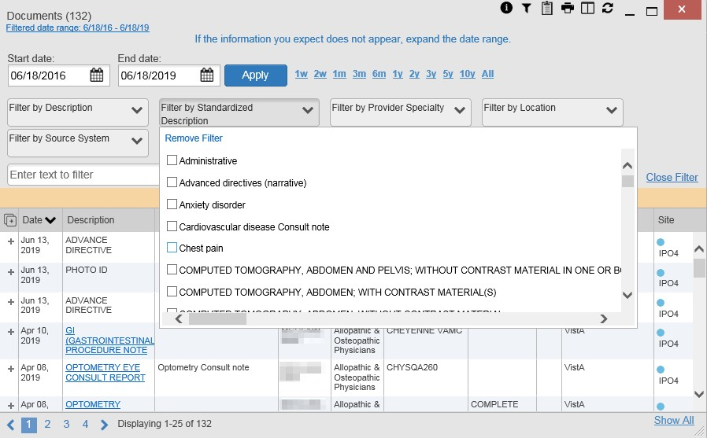
Figure 36: Dynamically Expanded Filter Dropdown in the Documents Widget

Some widgets also have the capability to configure data to display multiple records of the same type in a graph or table view.

Widget Date Range Filters
Patient data displayed within a widget can be filtered by date range. If a date range filter is applied, the selected range is indicated in the widget header, below the title. Click the Configure Filter icon or the Filtered Date Range link on the widget toolbar to change the date range of the data displayed (Figure 37).

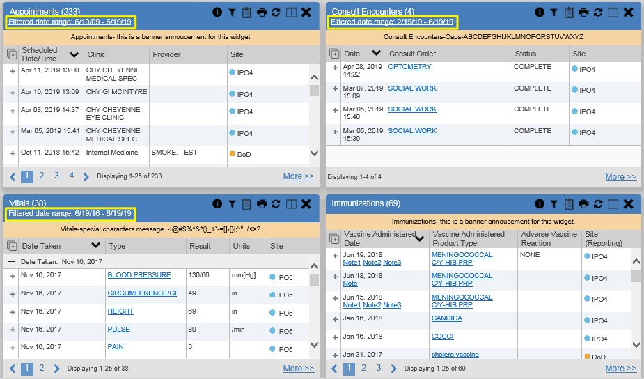
Figure 37: Date Range Filters Applied

The two ways to filter the date range of data displayed in a widget are the Quick Date Range filter and the Start and End Date filter. If the expected information does not appear in the widget display, use the date filter options to change the date range.

NOTE: Changes made to the date range in a widget persist from minimized to expanded view, patient to patient, and session to session, until the widget is either removed or the date range is changed.

NOTE: When looking for Essentris information associated with a specific admission in the Inpatient Summaries widget, expand your search date ranges to include additional days before and after the admission. This includes pre-admission notes as well as notes signed after the patient was discharged in the filtered widget display.

Quick Date Range Filter
Use the preset, Quick Date Range filter to set or limit the display of patient records within a widget. This option is available by clicking the Filtered Date Range link or by clicking the Configure Filter icon in a widget on the Patient Portal.
Clicking a Quick Date Range filter refreshes the data displayed to show only the records for the selected range. Selecting Cancel, which is the Apply button while the data refresh is running, stops the query. The options represent time counting back from the present day (for example,

selecting 2y displays only records within the last 2 years). Examples of preset date ranges include 1w (last 7 days), 6m (last 6 months), and 3y (last 3 years).

NOTE: The Quick Date Range filter is contextual. If today is February 2, 2017, the preset filter counts backwards using that date. If today is April 16, 2017, the preset filter counts backwards using that date.

Figure 38 highlights the Quick Date Range filter options in the expanded view of the
Documents widget.

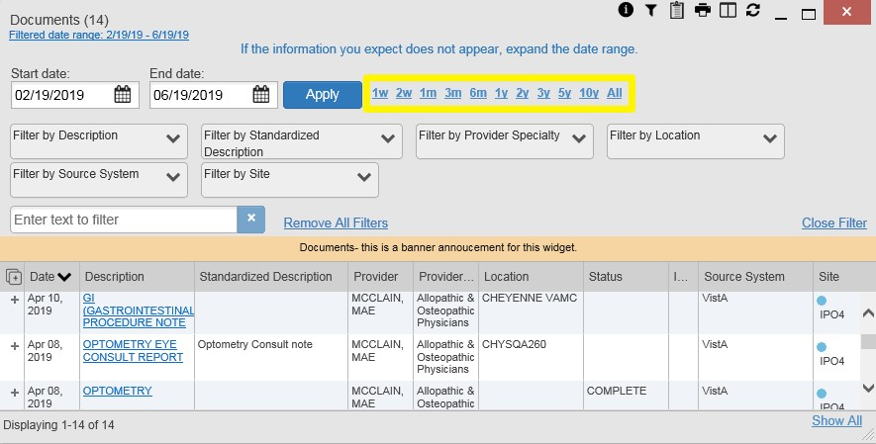
Figure 38: Quick Date Range Filter Options

Start and End Date Filter
Use the Start Date and End Date filter to display data for a specific time range. The start and end date fields are available at the top of multiple widgets by clicking the Filtered Date Range link or the Configure Filter icon .

NOTE: The Start and End Date filter is static. If the start date is set to June 2, 2016 and the end date is set to June 2, 2017, the data in that date range displays, no matter what today’s date is.

Figure 39 provides an example of the start and end date filter fields in the expanded view of the
Radiology Reports widget.

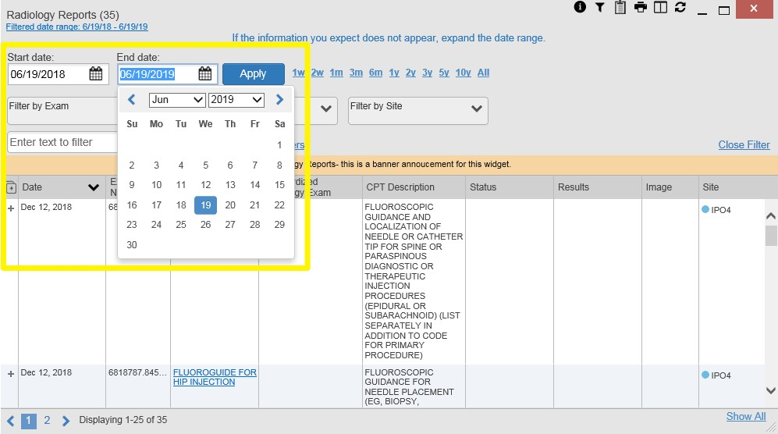
Figure 39: Start and End Date Display Filter

- Click the Calendar icon next to Start Date
- Select a month, day, and year start date for the display filter

NOTE: Prior day selections persist if you change only the month or year. If you change the month or year and the prior day value does not exist, the calendar will default to the last day of the new month. For example, changing only the month value of an existing August 31, 2018 entry to February would set the date to February 28, 2018 because there are less days in February. Similarly, if you had February 29, 2016 selected, a day which only exists in a leap year, switching the year to 2015 would set the date to February 28, 2015, the last day of the month in a standard year.

- Click the Calendar icon next to End Date
- Select the month, day, and year end date for the display filter
- When both a start and end date have been chosen, click Apply
- Click Cancel to stop the query
The widget refreshes and displays only the records that fall within the custom date range. The date range in use is displayed in the widget header.

Tab Date Range Tool
All tabs in the Patient Portal have a Tab Date tool that you can use to filter all widgets on a single tab by the same date range. The Tab Date tool has the same Start and End Date and

Quick Date Range filters available on most individual widgets, but it applies the date filter to all widgets on an individual tab.
- Select the Show Date Tool hyperlink in the upper right corner of a new or existing tab
- Enter dates in the Start Date and End Date fields, and select the Apply to All Widgets on This Tab button OR
- Select a Quick Date Range value in the Tab Date tool
The Tab Date tool (Figure 40) is hidden by default, and it hides again automatically after you apply a date filter to the tab. Should you decide not to apply a date filter to the tab, select the Hide Date Tool hyperlink to hide the tab-level date filters.

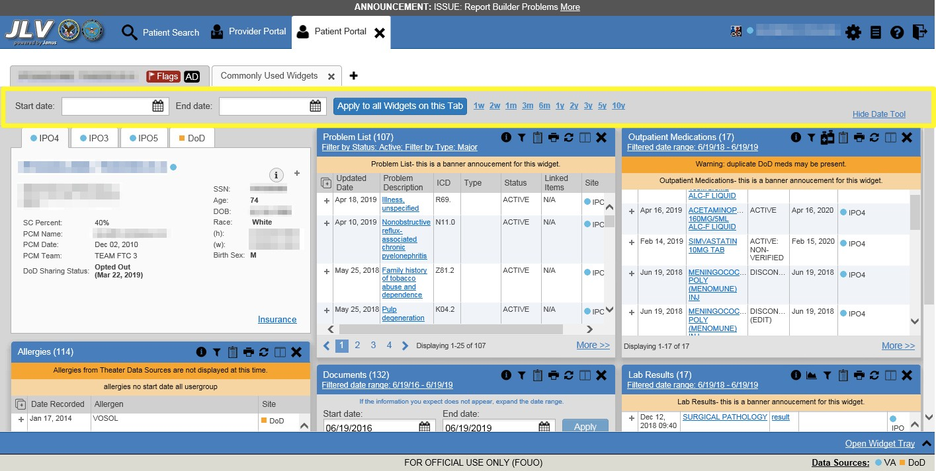
Figure 40: Tab Date Tool

The Tab Date tool only filters widgets currently displayed on the active tab that support date range filtering. Widgets that display all data, without a date range, will continue to do so.
Filtering only applies to widgets on the tab at the time you apply the Tab Date tool and will not affect new widgets added to the tab. You may still apply widget-level date filters to individual widgets after using the Tab Date tool. All your widget date settings will save to your profile regardless of whether they were set with the Tab Date tool or widget-level date filters.

Text Filter
Clinical data widgets on the Patient portal and the Patient Flags and Postings dialog box provide a text filter option (Figure 41), allowing you to quickly locate relevant patient data using keywords or characters. Text filters are performed on the information displayed in all columns within a widget, including hidden columns. Filters are not performed on notes, attachments, or details associated with patient records.

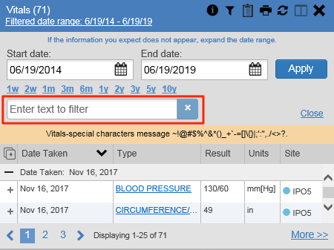
Figure 41: Vitals Widget Text Filter

Click the Configure Filter icon in the minimized view of a widget to display the Enter text to filter field. If the filter options are not displayed in the expanded view of the widget, clicking the Configure Filter icon also opens the filter options. Keep in mind:
- Text filtering applies only to one widget
- Text is filtered within the subset of filtered data if a date range filter or other dropdown filters are applied within the widget
- Text filters are performed on data within all columns shown in the expanded view of the widget even if the term is entered in the text filter field of the minimized view
- Text filters entered in the minimized view of a widget persist when you open the widget in expanded view
- On widgets with site tabs, text filters entered on one site tab persist when you select other site tabs
- All records across the widget pages are filtered if the widget has multiple page views
- The Enter text to filter field is not case sensitive and allows up to 25 characters, including numeric and special characters
- JLV begins to filter when you pause while typing the term in the Enter text to filter field
- Text filtering is not available in the Demographics widget

Viewing Connection Status
JLV widgets display the status of their connection to VA and DoD data sources. Connection status information is available for each widget.

NOTE: The Connection Status reports the condition of the connection between JLV and its external resources, while System Status reports the overall condition of the JLV application. See Viewing System Status for more information.

The Connection Status icon on a widget toolbar indicates the state of the connection to VA and DoD data sources. There are two status conditions:
• all sources are connected (available)
• one or more sources are not connected (unavailable)
Figure 42 shows a connection status indicator icon displayed on the Documents widget toolbar.

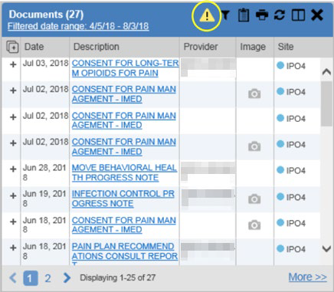
Figure 42: Connection Status Indicator

Clicking a Connection Status icon (Figure 42) opens a standalone window with information about the connection to data sources. Clicking the >Hide All Active Interfaces link (Figure 43) in the Connection Status window hides the detailed All Active Connections view and displays only the connection errors.

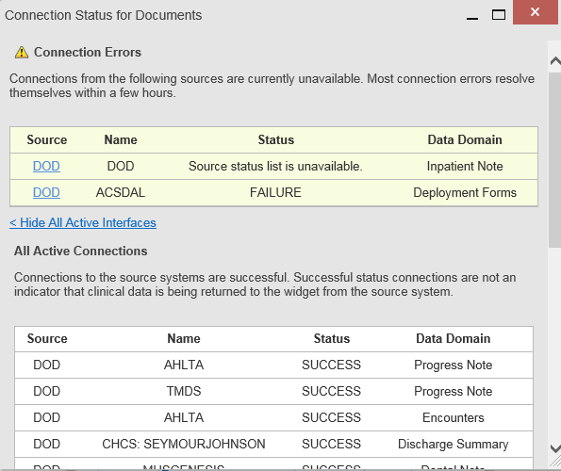
Figure 43: Connection Status Details

Clicking the >Show All Active Interfaces link in the Connection Status window (Figure 44) opens a Connection Status Details view (Figure 43).

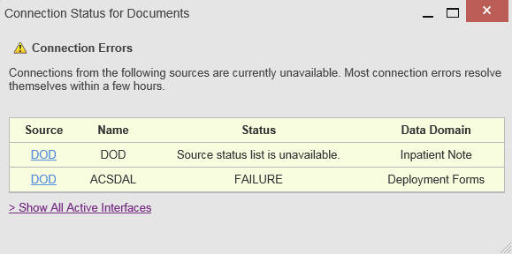
Figure 44: Connection Status Window

This message may display when you select the hyperlinked Source value in the Community Health Summaries and Documents - VA widget.

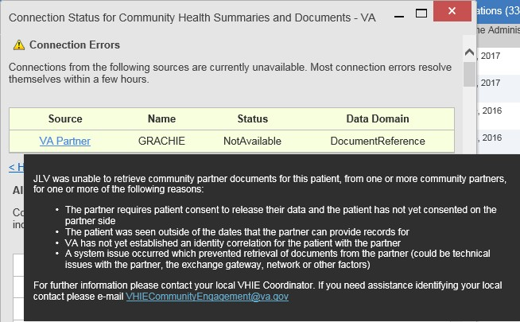
Figure 45: Example of a Connection Error Message

Displaying Widgets on Custom Tabs
You can use the custom tabs feature to create additional widget configurations for ease of use and quick reference. Changes made to portal page layouts (widget layouts and custom tabs) are saved to your user profile and displayed in future sessions.
- Click beside the existing tabs on the portal page (Figure 46)
  - The Add Tab dialog box opens (Figure 47)

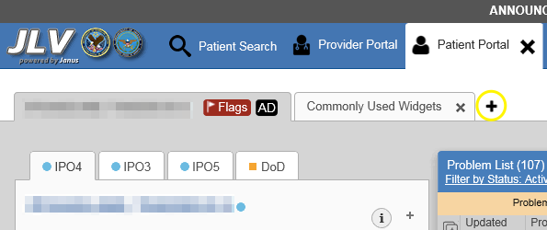
Figure 46: Add Custom Tab Icon

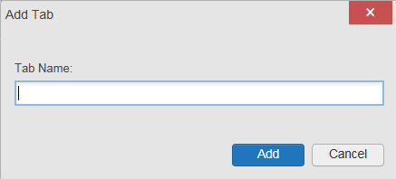
Figure 47: Add Tab Dialog Box

- Type the name of the new tab in the Add Tab dialog box, and click Add
  - The new tab opens with a blank workspace, with instructions on how to add widgets, and an open widget tray
- Click, hold, and drag each of the desired widgets to the screen (max 12)
- Click between tabs at any time, without losing each tab’s configuration
  - Tab layouts persist, even when a patient change is made
  - Custom tabs can be renamed by double-clicking the tab name

NOTE: Tab configurations remain set until you manually change them or restore your profile to default in the JLV Settings dialog, which will remove all custom tabs.

Refreshing Data in a Widget
The data displayed in a widget can be refreshed by clicking the Refresh icon . This action retrieves data from VA and DoD sources and refreshes the individual widget’s display.

Terminology Normalization

Figure 48: Terminology Specific to Widgets
Normalization Standard | Description | Widgets
Centers for Disease Control (CDC) Race Standard | Code set based on the current Federal standards to classify race and ethnicity | Patient Demographics
Current Procedural Terminology (CPT) Standard | Uniform code to describe medical, surgical, and diagnostic services | Procedures, Radiology Reports4
Vaccine Administered (CVX) Standard | Numeric string that identifies the type of vaccine product used | Immunizations

⁴ If LOINC mappings are not available for an entry in the Radiology Reports widget, JLV looks for CPT mappings and displays CPT normalization for standardized type and standardized code, if found.

Normalization Standard | Description | Widgets
Logical Observation Identifiers Names and Codes (LOINC) Standard | Universal standard for identifying health measurements, observations, and documents | Documents, Lab Results, Orders, Progress Notes, Questionnaires and Deployment Assessments, Radiology Reports, Vitals
National Uniform Claim Committee (NUCC) Taxonomy Standard | Unique, 10-character alphanumeric code that identifies a provider grouping, classification, and area of specialization | Admissions, Appointments, Consult Encounters, Documents, Inpatient Medications, Inpatient Summaries, Orders, Outpatient Encounters, Outpatient Medications, Procedures, Progress Notes
RxNorm Standard | Standard names given to allergens, clinical drugs, and drug delivery devices in the United States | Allergies, Inpatient Medications, Orders, Outpatient Medications
SNOMED CT  Standard | Core, general terminology used in electronic health records | Admissions, Outpatient Encounters, Problem List
X12 Health Insurance Type Standard | Defines electronic data interchange standards for health care insurance | Patient Demographics

VistA Imaging Viewer
JLV integrates access to the VistA Imaging Viewer (an external application), allowing you access to VA imaging artifacts for supported clinical domains (widgets). You can open an instance of the VistA Imaging Viewer through JLV. Please see the VistA Imaging SharePoint site for more information regarding the VistA Imaging Viewer.
A Camera icon displayed in the Image column (Figure 49) of the Documents, Outpatient Encounters, Procedures, Progress Notes, Radiology Reports, and Surgery/Procedure Reports widgets indicates that one or more images are associated with that record. Clicking the Camera icon within the widget opens the VistA Imaging Viewer in a standalone window and displays the associated image.

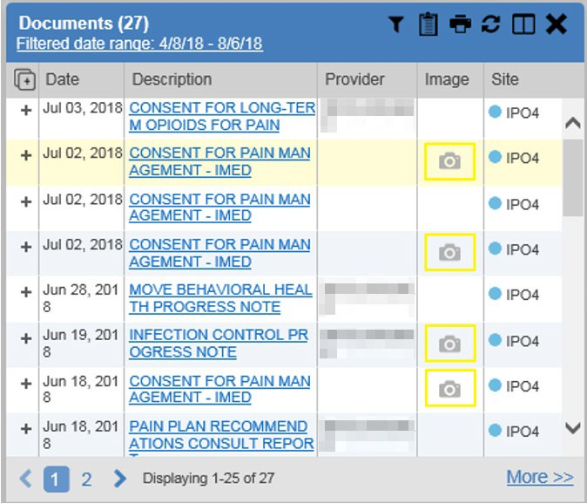
Figure 49: Camera Icon in the Image Column

If a record has one or more images associated with it, the Details view of the record includes a display of a thumbnail in the top-right corner of the window (Figure 50). Below the thumbnail, the Click image to open viewer link is also displayed. Clicking either the thumbnail or the link opens the VistA Imaging Viewer and displays the associated image(s).

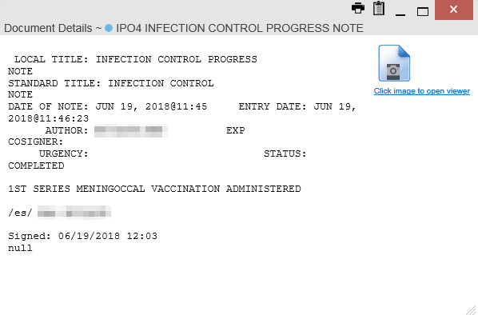
Figure 50: Thumbnail and Link in Details View of the Documents Widget

Using Report Builder
The Report Builder feature is used to create custom PDF reports using patient data and records displayed in JLV widgets. Content for reports can be selected from either the minimized or

expanded view of a supported widget. Report Builder is accessed from the toolbar in the upper right corner of the Patient Portal (highlighted in Figure 51).

Figure 51: Report Builder Icon

The Report Builder pane is comprised of the Current Report tab (Figure 52) and the Patient Reports tab (Figure 53). When open, the Report Builder appears over the left side of the JLV portal window. Click the left (collapse) or right (expand) arrow buttons to collapse or expand the Report Builder. Any report configurations in progress are saved when collapsing or closing the Report Builder and restored when the Report Builder is displayed again.
The Current Report tab (Figure 52) is used to build the custom report. The patient data and/or records are listed here as you select and add them. The records can be previewed and can be arranged in the desired order for the final report.

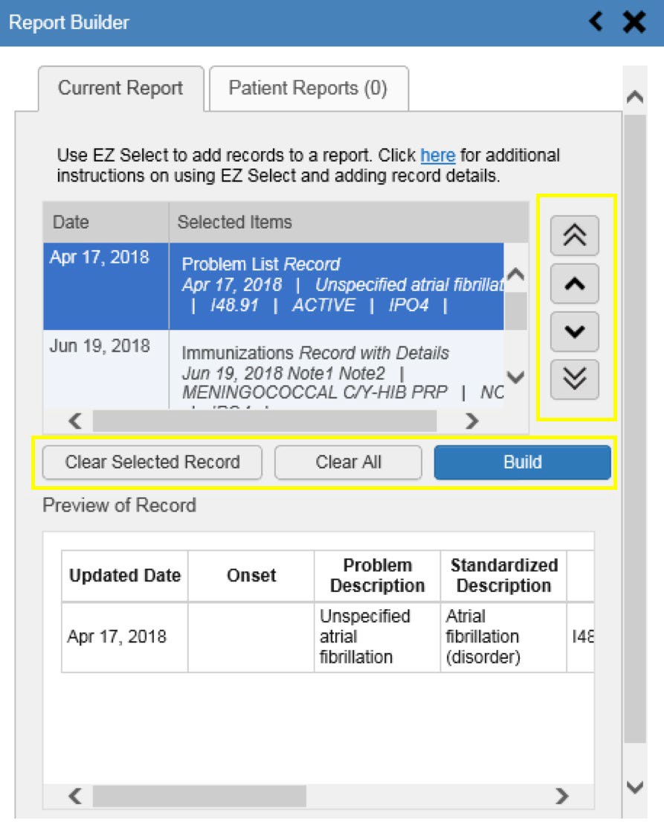
Figure 52: Current Report Tab

The Patient Reports tab (Figure 53) presents a list of all completed reports, the status of the report generation progress, the date the report expires, and a hyperlink to the contents of the completed report.

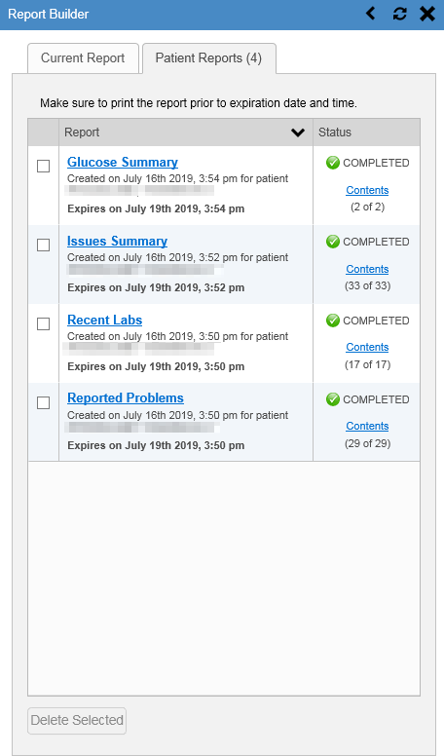
Figure 53: Patient Reports Tab

You can perform actions within widgets to add patient data when the Report Builder is open or closed. JLV enforces a maximum number of 50 records per report. A message appears when this limit is reached.

Adding One Record
Click the Add to Report Builder icon next to a record in a widget to add data from that record to the Report Builder, including the details and notes associated with the record. The Add to Report Builder icon in the row changes to the Added to Report Builder icon to

confirm the record has been added to the Report Builder (Figure 55). This applies to both minimized and expanded widget views and the Patient Flags and Postings dialog box.

Adding Multiple Records with EZ Select
EZ Select allows you to add all records displayed on a single page of a single widget to the Report Builder with one click. Click the Select All icon at the top of the left column (Figure 54) to add data from all records shown in the widget's page display to the Report Builder, including the details and notes associated with the record. EZ Select is available from the minimized and expanded views as well as the Patient Flags and Postings dialog box.

NOTE: Sensitive records and Medication Administration History (MAH)
/ Medication Administration Log (MAL) reports accessed from the Inpatient Medications widget cannot be added using EZ Select. You must add them to a report one at a time, and you can only add MAH/MAL to reports from Detail view in the Inpatient Medications widget.
However, you can use EZ Select to add MAH/MAL reports to Report Builder from the Health Summaries and Reports widget.

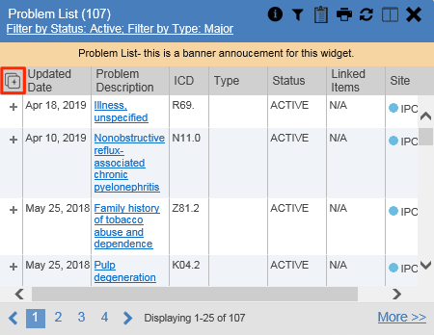
Figure 54: Report Builder EZ Select

The Add to Report Builder icon in each row changes to the Added to Report Builder
icon to confirm the record has been added (Figure 55).

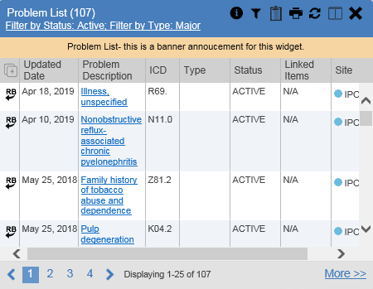
Figure 55: Records Added to Report Builder

NOTE: Records previously added to a report remain in the Report Builder after a widget refresh. Clicking Refresh in the widget re-pulls clinical data, refreshes the widget data display, and resets the state of the icon in the left column to the Add to Report Builder icon, even if the record has been added to the Report Builder.

Adding Details from Multiple Dates
When the Details view of a record has a date filter (Figure 56)—as in the Health Summaries and Reports, Inpatient Medications, and Procedures widgets—the state of the Added to Report Builder icon resets to the Add to Report Builder icon each time you change the date range, allowing you to build date-flexible reports using records from multiple date ranges.

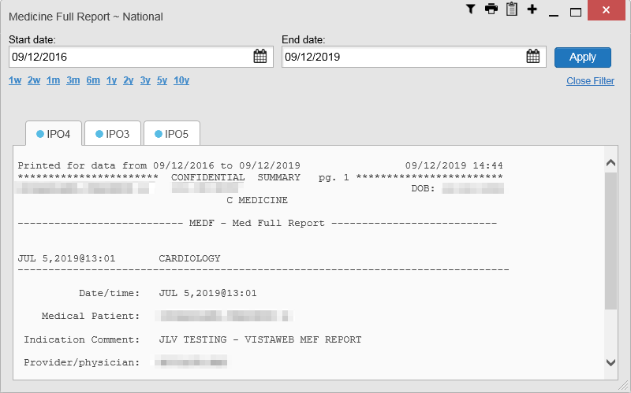
Figure 56: Adding Date-Flexible Details to Report Builder, Medicine Full Report

Adding Sensitive Records
Sensitive records can be added to the Report Builder by clicking the Add to Report Builder icon next to the item in the widget. When prompted, click Agree to be Audited & Access This Sensitive Record to continue. The Add to Report Builder icon in the row changes to the Added to Report Builder icon to confirm the record has been added (Figure 55). Sensitive records must be added to the Report Builder individually; therefore, repeat as necessary for additional sensitive items.

Adding Only Record Details or Notes
When adding records to a report using the Select All icon or the Add to Report Builder icon in the widget, JLV by default adds the data displayed in the widget as well as any details and notes associated with the record. This applies to both minimized and expanded widget views and the Patient Flags and Postings dialog box. If you would like to add just the details and notes or the record row data:
- Select and hold the Add to Report Builder icon to access these options (Figure 57)
- Select Add Detail or Add Note to add the details and/or notes associated with the record as well as the record row data to the Report Builder
- Select the Add Record Row option to add only the data displayed in the widget display for that record and not the information provided in the details and/or notes

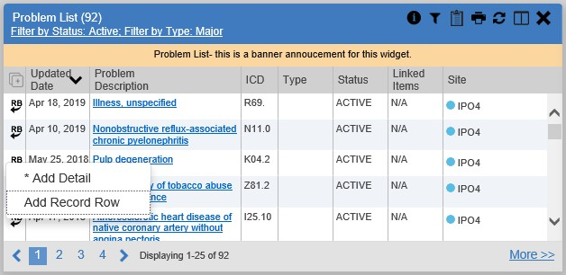
Figure 57: Report Builder Options

NOTE: Once you add a record to Report Builder using either the Add to Report Builder icon, Add Detail/Note, or Add Record Row option, you cannot change the record data included in the report without first clearing the record from the report and adding it again.

Adding Patient Demographics
Clicking the Add to Report Builder icon in the top-right corner of the Demographics widget (Figure 58) adds the patient's demographics details for that site to the Report Builder. The Add to Report Builder icon changes to the Added to Report Builder icon to confirm the demographics data has been added. Click additional site tabs within the Demographics widget and repeat as desired to add demographics details from other sites within the patient's health record.

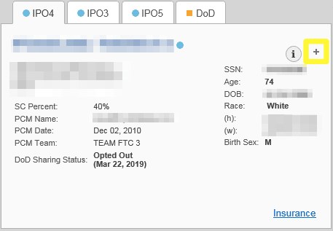
Figure 58: Demographics Widget Add to Report Builder Icon

Generating a Report
The selected records appear in the Report Builder pane (Figure 52).
- Use the navigation arrows to the right of the listed records to arrange the records in the desired order in the generated report
  - Records can be removed by clicking Clear Selected Record or Clear All
- When a record is selected for the report, it appears in the Preview of Record area of the
Report Builder pane
- Click Build to validate the selected records and prepare the report
  - If a record is added to the report without an error, a Ready notation displays next to it in the Status column
  - If a record cannot be added to the report, an Error notation appears next to the record
- Name the report when prompted and click OK (Figure 59)

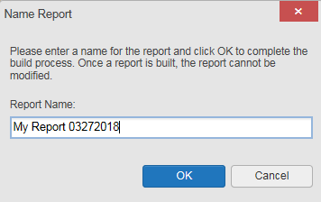
Figure 59: Name Report Dialog Box

- The Patient Reports tab opens and displays a report processing indicator in the Status
column
- When processing is complete, the Status column displays either COMPLETED or ERROR
(Figure 60)
  - An ERROR in the Status column does not indicate the report failed to build, it is an indicator that one or more records could not be included in the generated report
  - Both the COMPLETED and ERROR entries include a Contents link (Figure 60), which provides a list of the records that appear in the generated report

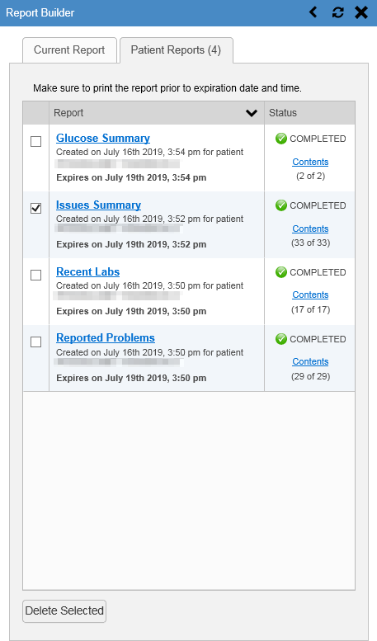
Figure 60: Patient Reports Tab Report Ready and Delete Option

  - A report ready message appears for 6 seconds on the portal page when the report has been built and is ready to be printed (Figure 61)

  - A red icon (Figure 61) appears over the Report Builder icon when report builder is closed to indicate that a report is ready to be printed

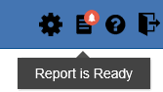
Figure 61: Report Ready Message and Indicator

NOTE: Once a report is created, it is available on the Patient Reports tab for 72 hours. After 72 hours, the report expires, is removed from the Patient Reports tab, and can no longer be accessed.

Opening a Report
- Click the report name in the Report column of the Patient Reports tab (Figure 60) OR
- Click the Contents link in the Status column of the Patient Reports tab to open a list of the records included in the report in the Report Contents window (Figure 60) OR
- Click the blue, hyperlinked report name in the Report Contents window (Figure 62)

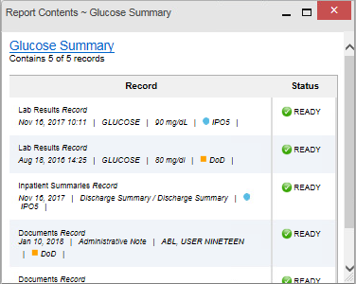
Figure 62: Report Contents Window

NOTE: The Report Builder prints the report content to a file in PDF format. It is recommended that you have the latest Adobe Reader installed on the system from which you access JLV to utilize the Report Builder and other JLV features.

Delete a Report
- Select the checkbox to the left of the report name on the Patient Reports tab (Figure 60)
- Click the Delete Selected button
- Click OK to confirm deletion (Figure 63)

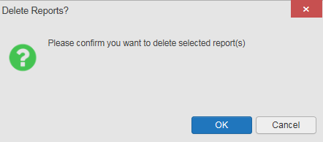
Figure 63: Delete Reports Dialog Box

Printing
The data list of a widget in either minimized or expanded view, the details window of a widget, and reports created in Report Builder can be printed.
- Click the Print icon on the desired widget’s toolbar to print the data list of a widget in either minimized or expanded view
- Click the Print icon on the details window’s toolbar to print the details window of a widget
- Click the (PDF) Print icon within the report window to print a report created in Report Builder

NOTE: Each report generated using Report Builder includes this disclaimer: “The information contained in this transmission may contain privileged and confidential information, including patient information protected by federal and state privacy laws.”

Widget Functionality
The following subsections detail the functionality in a sampling of the widgets available in JLV.

Patient Demographics Widget
The Patient Demographics widget displays a summary of the patient’s non-clinical, personal data. The widget appears in the upper left section of the Patient Portal (Figure 64). The tabs above the patient’s name provide a demographics summary for each site (VA or DoD) the patient has visited.

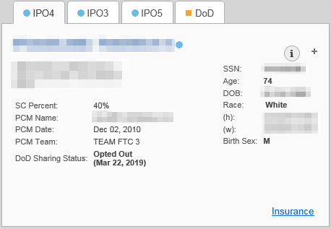
Figure 64: Patient Demographics Widget

The Patient Demographics widget provides additional functionality:
- Clicking the patient's name opens details in a standalone window
- Clicking a Connection Status icon opens the connection status details in a separate window
- Clicking the Flags icon above the tabs in the widget opens clinical flag details in a new window
- Clicking the icon above the tabs in the widget opens the Advance Directives dialog in a new window
A Warning icon that displays on one or more tabs within the Demographics widget is an indication that the patient is not registered at that VA site or DoD facility.

Patient Flags and Alerts
If the patient has one or more clinical warnings, alerts, or flags in their record from VA and DoD sites, the Flags icon is displayed next to the Patient Name tab, above the Demographics widget, on the Patient Portal (Figure 65).
The Patient Flags and Postings window opens and displays by default when the Patient Portal
opens if there are warnings associated with the selected patient.

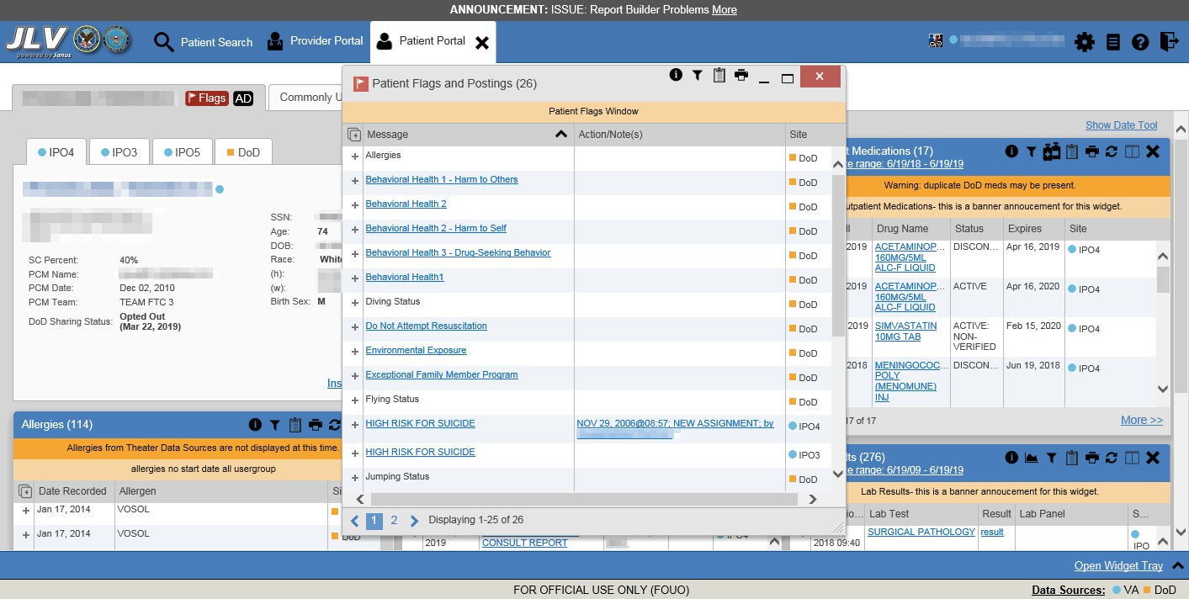
Figure 65: Patient Flags Indicator

Click the Flags icon to open the Patient Flags and Postings window (Figure 65). The window displays a list of alerts and flags within the patient’s record. Selecting the hyperlinked message for each patient alert opens the Flag Details window (Figure 66). Selecting the Note link (Figure 65) will open documents pertaining to placement of the flag. If the patient’s record does not contain any clinical warnings, the Flags icon is not displayed.

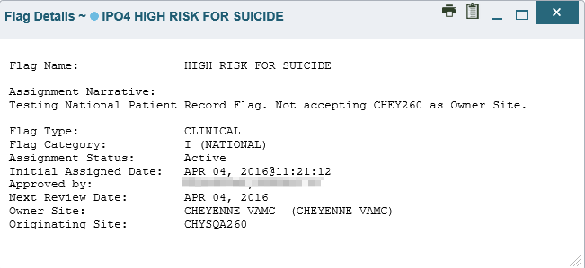
Figure 66: Patient Flags and Postings Details

Advance Directives
You can view Advance Directives (Figure 67) by selecting the icon on Demographics
widget. Advance Directives are pulled from DoD and VA data sources. The icon changes if

it is loading or may be greyed out if no Advance Directives were found for the patient.

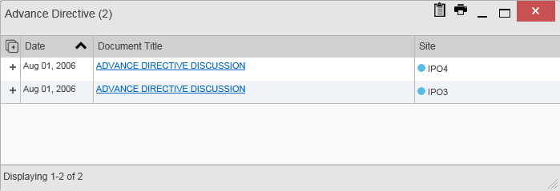
Figure 67: Advanced Directives Dialog

Viewing Third-Party Insurance Information
Third-party payers and insurance information is available from the Patient Demographics widget. Click the Insurance link in the Demographics widget. A new window opens with the following insurance information, some of which is displayed in Figure 68:
- Health Plan Type
- Health Plan Name
- Standardized Insurance Type (See Terminology Normalization for more information.)
- Plan Effective Date
- Plan Expiration Date
- Site
- Group Number
- Member ID
- Subscriber ID
- RxBIN
- RxPCN
- Notes
- Comments
- Subscriber Date of Birth
- Subscriber’s Relationship to Insurer
- Health Plan Mailing Address
- Health Plan Contact Information

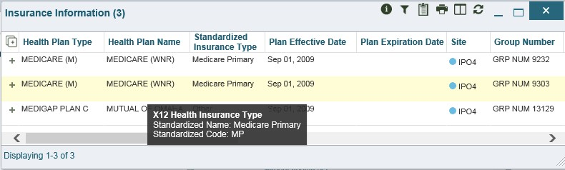
Figure 68: Insurance Information

Use the horizontal scroll bar in the window to view the columns not seen within the default window size.

Documents Widget
The Documents widget (Figure 69) includes documents from multiple clinical domains, including radiology reports (exams), progress notes, outpatient encounters, consult encounters, discharge summaries (inpatient notes), questionnaires, and Health Artifact and Image Management Solution (HAIMS) records. HAIMS records retrieved by JLV include scanned paper records, imported paper records, scanned non-radiology images, and imported non- radiology images, displayed in reverse chronological order by the document date.

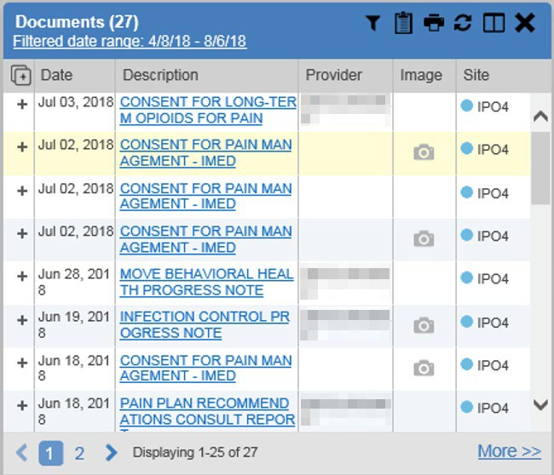
Figure 69: Documents Widget, Minimized View

Documents Widget Data
The minimized view of the Documents widget displays the following information:
- Date
- Description
- Provider
- Image (See VistA Imaging Viewer)
- Site
Outpatient encounter records displayed in the Documents widget may have a Details link enabled in the Date column. Where available, click the link to open a Details window for records of this type.
Click More >> in the minimized view of the Documents widget to open the expanded view (Figure 70). Information in expanded view includes:
- Date
- Description
- Standardized Description
- Provider
- Provider Specialty
- Location
- Status
- Image
- Source System
- Site

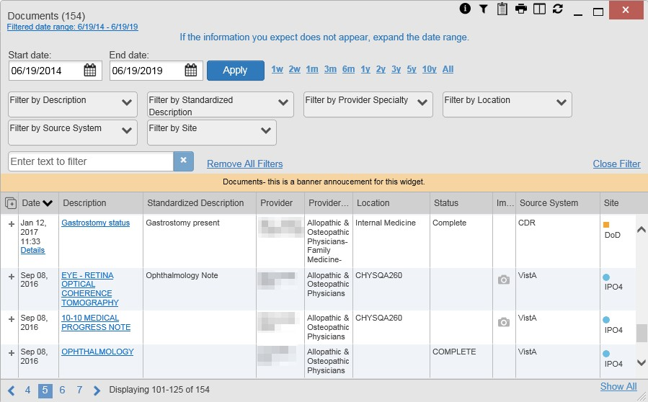
Figure 70: Documents Widget, Expanded View

Viewing Documents
Click a hyperlinked entry in the Description column in either the minimized or expanded view of the Documents widget to access additional information for a listed record. Depending on the record type, the additional information may open in either a Details window or a separate browser window. Figure 71 displays outpatient encounters details, accessed through the Documents widget.

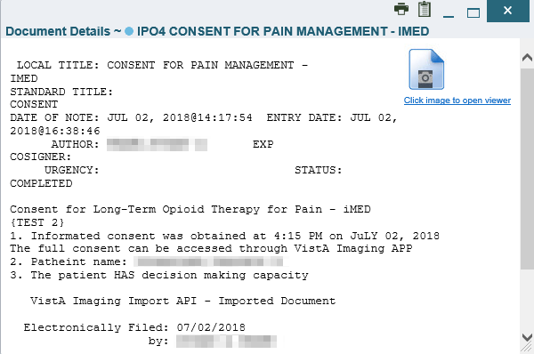
Figure 71: Details View of a Document

Community Health Summaries and Documents - VA
The Community Health Summaries and Documents - VA widget displays the patient’s VA VHIE community partner information, including Continuity of Care Documents (CCDs) in C32 and C62 formats and HL7 Consolidated-Clinical Document Architecture (CCDA) structured documents available for the patient. The information in this widget is sorted by the title of the entry listed in the Document column.

NOTE: CAPRI-Claims users cannot see the Community Health Summaries and Documents - VA widget.

Community Health Summaries and Documents - VA Widget Data
Data displayed within the Community Health Summaries and Documents - VA widget includes:
- Date
- Document
- Source
The purple hexagon beside entries in the Source column denotes the source of the data is outside the VA. The widget displays all data available 150 years into the past and 1 year into the future.

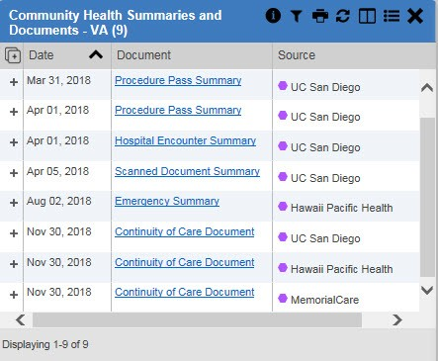
Figure 72: Community Health Summaries and Documents - VA, Minimized View

The Site List icon on the toolbar in the Community Health Summaries and Documents - VA widget (Figure 72) generates a list of community sites where the patient has been seen.

Click the Site List icon to open the full list of community sites where the patient has been seen. The site list content is gathered from the widget's Source column and the sites where the patient was seen but no document was generated. Click Close Site List to remove the full site list from the widget display.

Viewing VA Community Health Summary Documents
The Community and Health Summaries and Documents - VA widget is rendered only in minimized view. Instead of an expanded view, the selected document opens in a new browser window (Figure 73).
Figure 72 shows health summary records available from the Document column in the Community Health Summaries and Documents - VA widget. Clicking a hyperlinked entry in the Document column opens the document in a separate browser tab (Figure 73).

NOTE: Multiple documents can be opened in separate browser tabs for simultaneous viewing and printing.

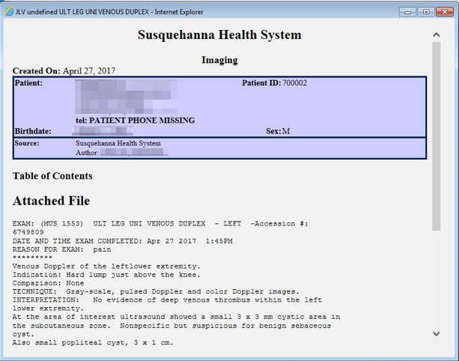
Figure 73: Community Health Document

Health Summaries and Reports – VA Only Widget

Health Summaries and Reports – VA Only Widget Data
The Health Summaries and Reports – VA Only widget displays the patient's national and local health summaries from VA sites where the patient has been registered, including the

Autopsy, Blood Bank, Cytopathology, Lab Summary—Cumulative, MAH⁵, MAL⁶, Medicine Full, Surgical Pathology, Transfers, and Unit Dose reports. This widget is available to VA users only. Click the Health Summaries and Reports – VA Only icon from the widget tray that appears at the bottom of the Patient Portal, drag the icon to the screen, and drop it where desired on the portal to open the widget.
JLV sorts records by Site by default. If a patient has national health summaries, JLV displays records of National type at the top of the widget. National records are named in the Site column in the minimized view and in the Type and Site columns in the expanded view. The widget also presents report data within last 14 days by default, but you can adjust the date range.
The Description column displays the document title, where available. Click a hyperlinked entry in the Description column in either the minimized or expanded views of the widget to open the document.
Information in the minimized view of the Health Summaries and Reports – VA Only widget (Figure 74) includes:
- Description
- Site

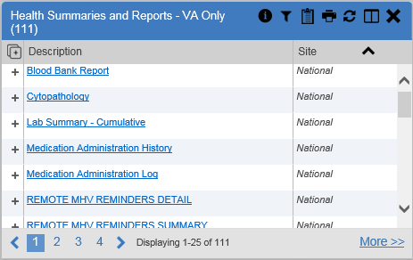
Figure 74: Health Summaries and Reports - VA Only Widget, Minimized View

Click More >> from the minimized view of the Health Summaries and Reports – VA Only widget to open an expanded view of the widget. Information in the expanded view (Figure 75) includes:
- Description
- Type

⁵ Limited to any 7-day period
⁶ Limited to any 14-day period

- Site

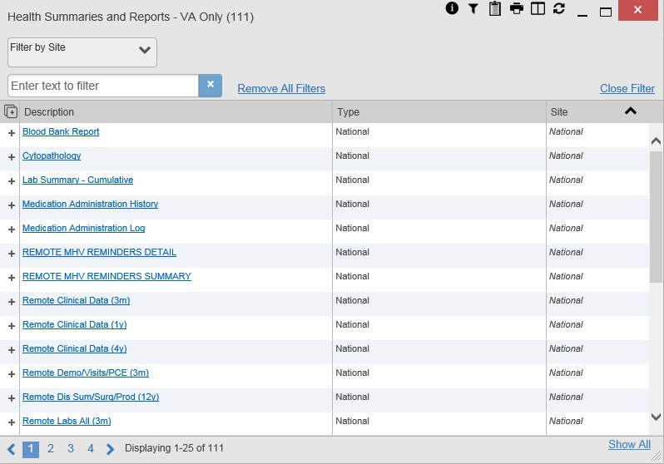
Figure 75: Health Summaries and Reports - VA Only Widget, Expanded View

Viewing Health Summaries
Click a hyperlinked entry in the Description column of either the minimized or expanded view of the Health Summaries and Reports – VA Only widget to view additional information for the record. This widget is available to VA users only.
Figure 76 displays a health summary record exported from a single, local site.

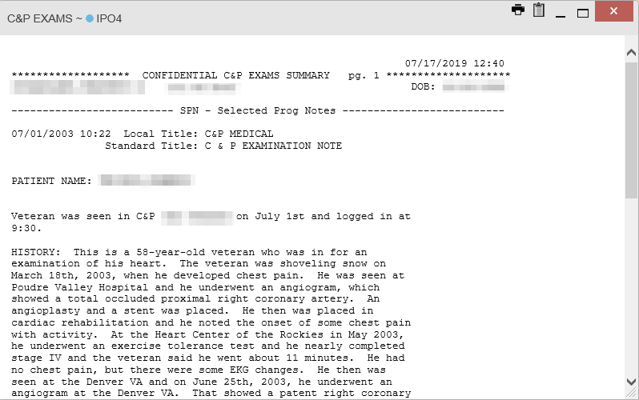
Figure 76: Health Summary from a Single, Local Site

Figure 77 is an example of JLV's display of a national health summary. Within the window, tabs represent the VistA sites where the patient is registered. Click each tab to view patient records for that site.

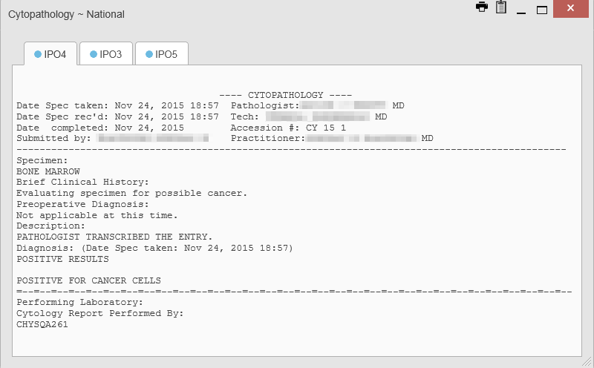
Figure 77: National Health Summary, Multiple Sites

Lab Results Widget

Lab Results Widget Data
The Lab Results widget displays the patient’s lab results information, as well as skin test data and blood transfusion history where available in the patient’s record. The information is displayed in reverse chronological order by collection date. Labs data received by DoD sources that include a sensitive flag are masked in the widget views and access to this data is subject to auditing.
The lab results information in the minimized view of the Lab Results widget includes:
- Collection Date
- Lab Test
- Result
- Lab Panel
- Site
Click More >> from the minimized view of the Lab Results widget to open the expanded view (Figure 78). The lab results information in the expanded view includes:
- Collection Date
- Specimen Source
- Lab Test
- Result
- Interpretation
- Units
- Ref Range
- Lab Panel
- Type
- Order Number
- Ordering HCP
- Status
- Site

NOTE: While the Standardized Lab Test and Ordering HCP Specialty columns are not listed by default, you may add them to the expanded view by selecting their corresponding checkboxes in the Column Settings.

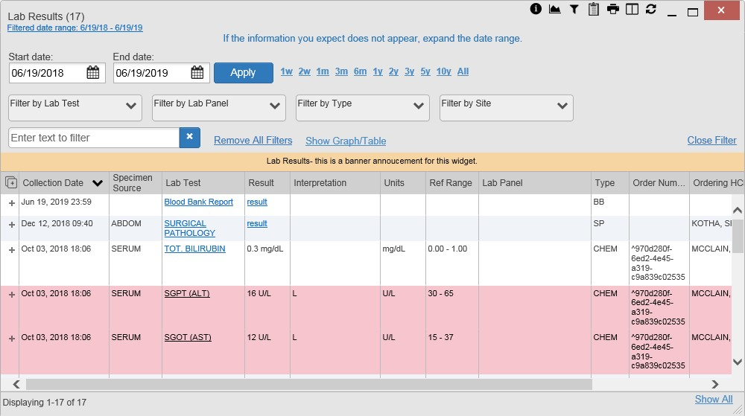
Figure 78: Lab Results Widget, Expanded View

The following lab test abbreviations are used in the Type column of the expanded view. Hovering over an entry in the Type column displays the full lab type name.
- CHEM for CH, COAG, HEM, HE, TOX, RIA, SER, and SEND
- MICRO for MI, MICROBIOLOGY, and BACT
- AP for ANATOMIC PATHOLOGY
- EM for ELECTRON MICROSCOPY
- SP for SURGICAL PATHOLOGY
- ST for SKIN or SKIN TEST
- CY for CYTOLOGY
- AU for AUTOPSY
- BB for BLOOD BANK
- H.I.V for HIV

Viewing Lab Results Details
Clicking a hyperlinked entry in the Lab Test column of the Lab Results widget opens a separate window containing a report of the record (Figure 79).

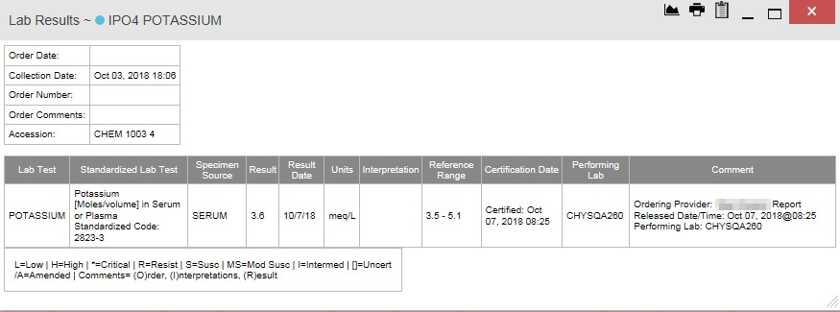
Figure 79: Lab Results Details

Viewing Lab Panel Results Details
Clicking a hyperlinked entry in the Lab Panel column of the Lab Results widget opens a separate window containing a detailed lab panel report (Figure 80).

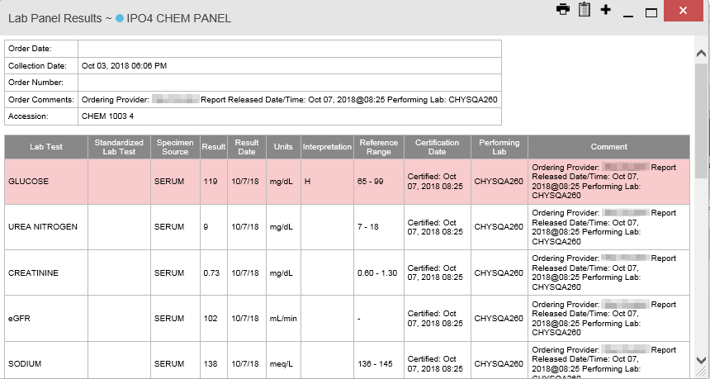
Figure 80: Lab Panel Results Detail

Viewing Abnormal Results in the Lab Results Widget
JLV highlights the row for that record in the minimized and expanded views of the widget for records in the Lab Results widget where result values fall within a calculated reference range for abnormal.

Pink highlighting represents an abnormal result (i.e., high (H) or low (L)). Red highlighting represents that the abnormal indicator has an asterisk (i.e., H* or L*) or the result is critical.
Examples of records with abnormal results are shown in the expanded view of the Lab Results
widget in Figure 81.

Figure 81: Lab Results Widget, Abnormal Results in Expanded View

Viewing Results and Interpretations in the Lab Results Widget
JLV displays links in the Result and Interpretation columns in the expanded views of the widget to indicate additional information is available for records in the Lab Results widget where result values and interpretation are available in a record. Figure 82 highlights multiple result and interpretation links within the widget.

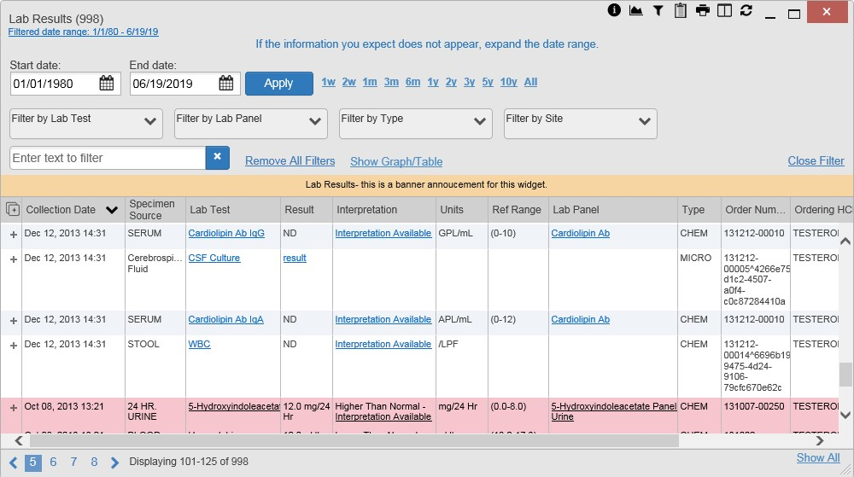
Figure 82: Lab Results Widget, Expanded View, Interpretations Available
Figure 83 displays an example lab interpretation accessed by clicking a link in the Interpretation column. The contents of the window may vary depending on the lab type and what is contained in the patient record.

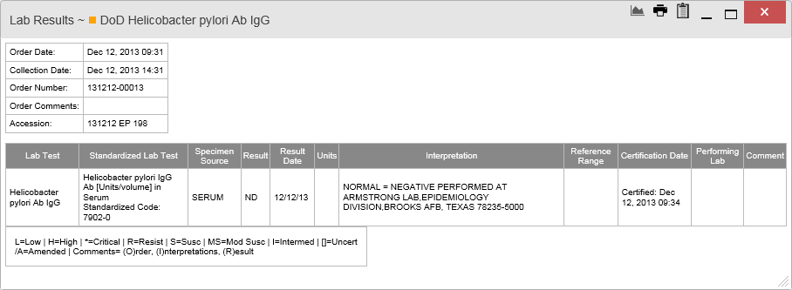
Figure 83: Lab Results Interpretation Details

Graph/Table View from the Lab Results Widget
The Lab Results widget provides the option to display multiple results for the same lab test in a graph and table.
- Select the Graph icon from the widget toolbar in either minimized or expanded view

OR

- Click More >> from the minimized view of the Lab Results widget to open an expanded view of the widget, then select the Show Graph/Table link
- Select a value from the Select a Lab Test dropdown in the Lab Results Graph/Table dialog
  - The graph displays with corresponding table values beneath
- Select the Show Labels checkbox to toggle data labels on or off in the graph
- Select the Close button to exit Graph/Table view and return to the minimized or expanded view of the Lab Results widget
Figure 84 displays an example Graph/Table view of the lab test results.

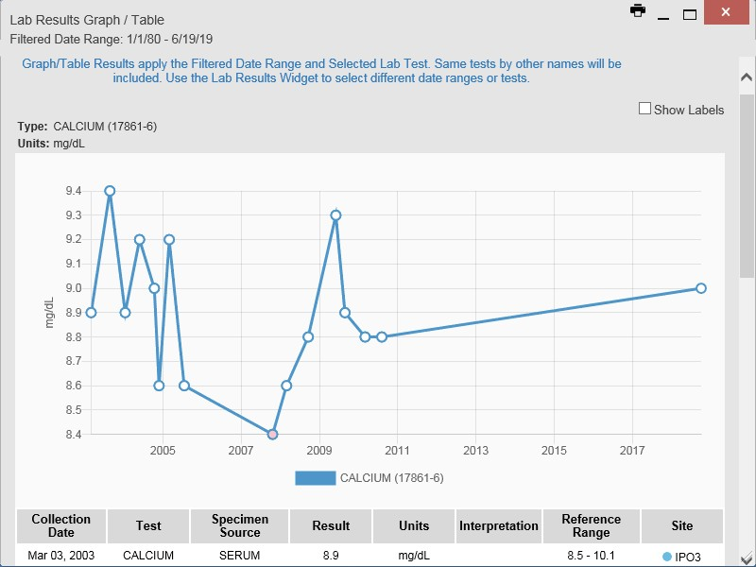
Figure 84: Lab Results Graph/Table View

In the expanded view of the Lab Results Widget, selecting one or more values in the Filter by Lab Test dropdown will disable all other filter dropdowns until the filtered selections are removed. The lab test values in the Filter by Lab Test dropdown dynamically increase or decrease depending on the date filter criteria you apply. Tests with the same LOINC code (shown in parentheses following the lab test name) as the ones selected will be automatically included in the filtered results displayed in the widget.

You may only use the graph/table feature for a single lab test LOINC value. All lab tests with the same LOINC will be graphed even if the lab test names differ. While you can select multiple lab test values in the Filter by Lab Test dropdown, you will be forced to select a single lab test value from the Select a Lab Test dropdown in the Lab Results Graph/Table dialog (Figure 85) once you select either the Graph icon or the Show Graph/Table link. The lab test values in the Select a Lab Test dropdown also dynamically increase or decrease depending on the filter criteria applied in the Lab Results Widget.

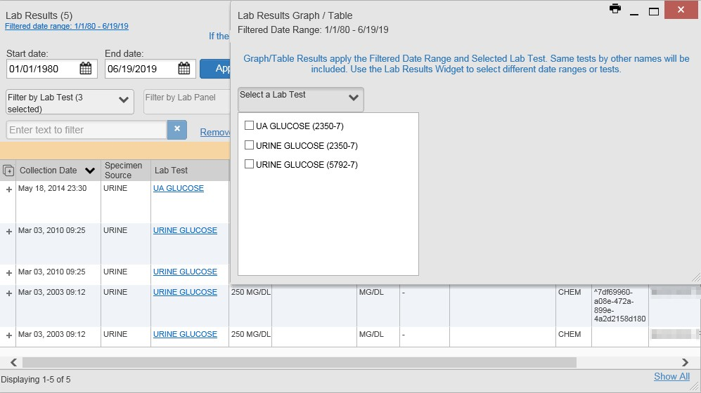
Figure 85: Lab Results Graph Table View, Select a Lab Test

You may also generate a graph for all lab tests with the same LOINC code by selecting the
Graph icon from the Lab Results Details view (Figure 79).

Military Health System (MHS) GENESIS Widget
The MHS GENESIS widget displays DoD patient documents and dental summaries from the DoD’s MHS GENESIS system. The information is displayed in reverse chronological order by date.

NOTE: MHS GENESIS is a DoD data source. You must enable DoD data sources to view data in this widget. If you opt to view only VA data sources, MHS GENESIS data is suppressed.

MHS GENESIS Widget Data
The minimized view of the MHS GENESIS widget includes the following information:
- Date

- Document Title
- Document Type
- Site
Figure 86 highlights the MHS GENESIS widget in minimized view. There is no expanded view for the widget; instead, the CCDA document selected opens in a new browser window (Figure 87).

NOTE: The Outpatient Medications widget displays an orange banner with a warning that reads, “Duplicate DoD meds may be present” due to the integration of data from MHS GENESIS.

Medical CCDs, Dental CCDs, and aggregate CCDs with blank entries in the Date column for the record appear first in the widget by default.

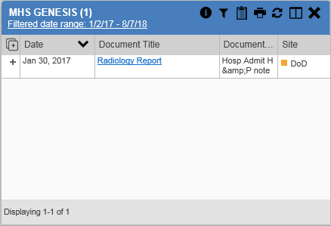
Figure 86: MHS GENESIS Widget

Viewing MHS GENESIS Documents
Click a hyperlink in the Document column in either view of the MHS GENESIS widget to display a CCDA document (Figure 87) in a new browser window.

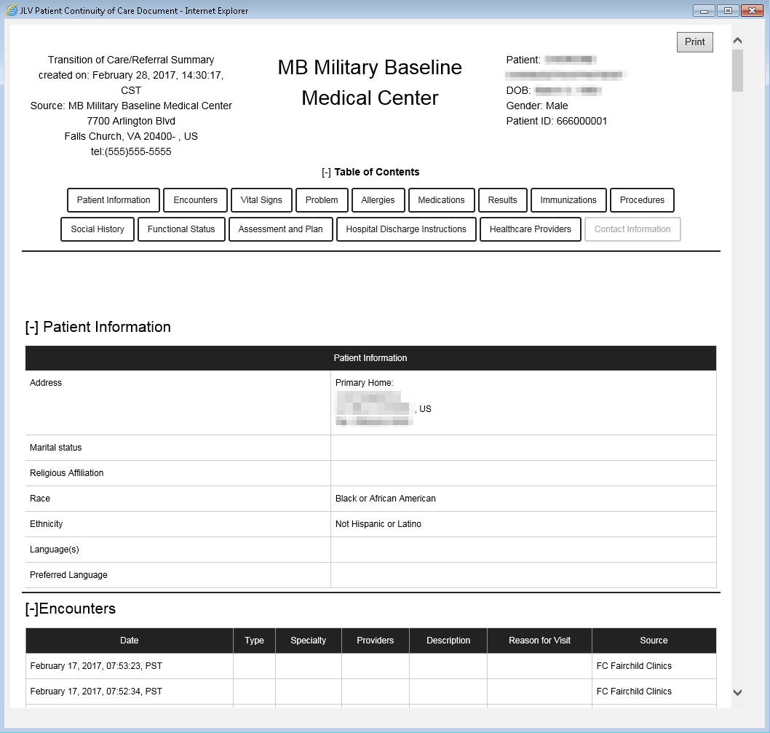
Figure 87: CCDA Document

Troubleshooting
The following subsections provide information about troubleshooting common errors in JLV.
Please see online help for how-to information within JLV. Please visit JLV Resources to see JLV training videos and access additional JLV training materials.

Special Instructions for Error Correction
JLV utilizes access control and authentication services to limit access to registered, authorized users. When enabled, JLV validates you against information retrieved from your Smart Card. If you are having trouble logging in to JLV, and have used the correct URL for your agency, please review the following before contacting the ESD:
VHA users:
- Have accessed JLV using the JLV URL (redacted) or the JLV button in CPRS if available
- Have entered their existing CPRS Access and Verify codes correctly in the fields on the JLV
Login page

- Have selected a site from the Site dropdown list on the JLV Login page (Most users must specify the individual facility name or their parent healthcare system name)
CAPRI-Claims users:
- Have accessed JLV using the JLV URL(redacted) or the Joint Legacy Viewer tab in CAPRI
- Have entered their existing CAPRI Access and Verify codes correctly in the fields on the JLV Login page
- Have selected CAPRI-Claims from the Site dropdown list
- Do not have any CAPRI patient selection restrictions
Users with any CAPRI patient selection restrictions (restricted users) must use the Joint Legacy Viewer tab in CAPRI to access JLV. Restricted users will see the message shown in Figure 88 on the JLV Login page if attempting to access JLV via the JLV URL.

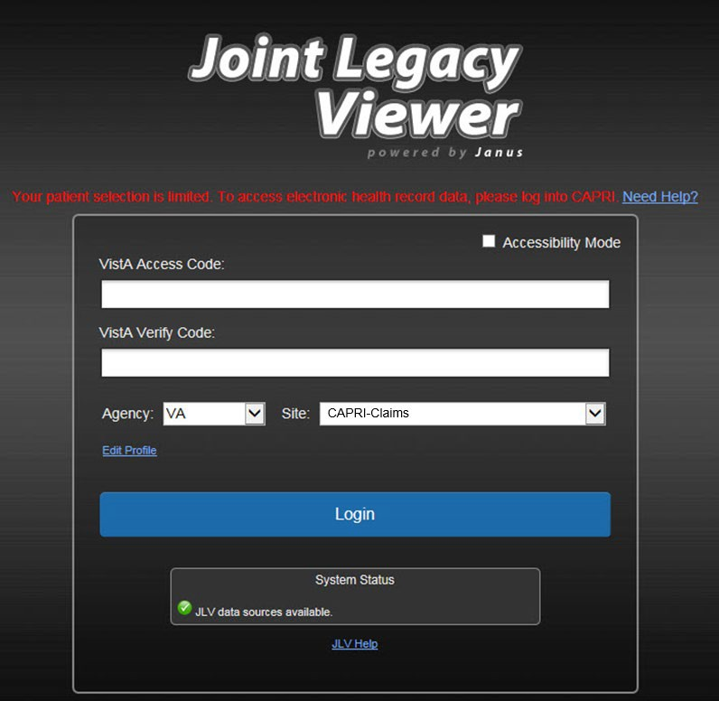
Figure 88: Login Error - CAPRI Patient Selection Restrictions

Login Page Error Messages
Troubleshooting steps for error messages received at the Login page are provided in Table 7.

Table 7: Error Messages and Resolution Steps

Error Message/Behavior | Description/Resolution Steps
No access allowed for this user | WHY? You have not signed onto CAPRI or CPRS for too long and your account is inactive.  FIX IT: Contact the ESD and tell them that either your access to CAPRI or CPRS (whichever you use) has been deactivated.
Access denied. You are not an authorized user. | WHY? There may be an issue with your Single Sign-on account.  FIX IT:  - Go to the Link My Account website  - Select a certificate that is not expired, and specifies: “Issuer: Veterans Affairs User CA B1”  - Select Link VistA User from the left side of the page  - Select the VA Medical Center to link to  - Enter your Access/Verify codes  - Click Submit  - If unsuccessful, contact the ESD
Could not save User Profile | WHY? The error occurred during PIV authentication. It is either a PIV card processing problem, or you chose the wrong security certificate.  FIX IT:  - Close your browser window  - Reinsert your PIV card and relaunch JLV  - Select a certificate that is not expired and specifies: “Issuer: Veterans Affairs User CA B1”  - If unsuccessful, close all open IE windows/tabs, then open IE and try JLV again
Not a valid ACCESS/VERIFY  CODE pair | WHY? JLV could not match your Access and Verify codes to the site selected in the dropdown, or you entered username and password instead of Access/Verify codes.  FIX IT:  - VHA users must select the parent VistA host site for their facility  - Reenter your Access and Verify codes (CAPRI codes for CAPRI-Claims users, CPRS codes for VHA users)
Page cannot be displayed | WHY? The JLV URL requires certain IE settings.  FIX IT:  - Click the Tools menu (press ALT+X) in IE  - Select Internet Options  - When the dialog box opens, click the Advanced tab  - Scroll down in the list until you see the Secure Sockets Layer (SSL) 2.0 setting, and ensure it is NOT checked  - Ensure that the Transport Layer Security (TLS) 1.0, 1.1 and 1.2 settings ARE checked  - Click OK to close the dialog box, then relaunch JLV (The page should load)

Error Message/Behavior | Description/Resolution Steps
Smart Card required | WHY? Your Smart Card was not read by Windows Security and JLV before opening the JLV URL.  FIX IT:  - Close all browser sessions and browser-based applications  - Reinsert your PIV card, and relaunch the JLV URL  - If unsuccessful, close all open IE windows/tabs, then open IE and try JLV again
VERIFY CODE must  be changed before continued use | WHY? Your CPRS or CAPRI Verify code has expired.  FIX IT:  - Open CPRS, VistA, or CAPRI (CAPRI-Claims users)  - If prompted for a PIV card certificate by CPRS, click Cancel  - You are prompted to create a new Verify code  - Once your Verify code has been changed for CPRS or CAPRI, relaunch JLV, which recognizes the new code immediately
No message displays but behavior occurs: Clicking the JLV button in CPRS does not open JLV | WHY? You are likely using Google Chrome as your default browser.  FIX IT:  - Click Start menu, then select Default Programs in the right pane  - Click Set your default programs  - Click Internet Explorer in the list, then click Set this program as default

System Error Messages
Table 8 summarizes system messages that may be presented to JLV users.

Table 8: System Error Messages

Error Message/Behavior | Description/Resolution Steps
No message displays but behavior occurs: The browser window does not allow the user to scroll to widgets or access the JLV icons on the portal pages. | WHY? You may be using an unsupported browser, or your screen resolutions settings do not match the recommended configuration.  FIX IT:  - Access JLV using IE 11  - Use a monitor with a minimum screen resolution of 1024 x 768  - Set the browser zoom feature to 100%  - If browser display issues continue, log out of JLV, close the browser window, open a new browser window, and log in to JLV again
Warning: An error occurred while attempting to retrieve VistA Imaging Viewer URL. | WHY? JLV is unable to retrieve the necessary data object to launch a VistA Imaging Viewer instance.  FIX IT: Try again later; either VDS or CVIX is offline.
MVI Error: Your query yields too many results. Please modify your search parameters to narrow the search. | WHY? JLV adheres to VA guidelines and blocks search results when a search request yields more than 10 patients.  FIX IT: Modify the information in the Patient Search dialog box using additional patient identifiers to reduce the number of results.

Error Message/Behavior | Description/Resolution Steps
MVI Error: There are no patients found using the current parameters. | WHY? No patient records were found using the information entered in the Patient Search dialog box. FIX IT:  - Verify the accuracy of the information  - Reenter patient identifiers in the Patient Search  dialog box fields
MVI Error: Application Reject. There was an error attempting to process your query. Please modify your search parameters and try again. | WHY? There may be one or more errors in the Patient Search dialog fields.  FIX IT:  - Validate the patient identifiers, and try the search again  - If problems persist, there may be an error between MVI and the Defense Enrollment Eligibility Reporting System (DEERS)
MVI Error: Patient not found with search elements entered, please provide additional patient identifying information and search again. | WHY? No unique patient is found with the identifiers used in the search.  FIX IT:  - Click OK to return to the Patient Search dialog  - Provide additional patient identifiers, like the full first name or DOB
You do not have authorization to view this record. Security regulations prohibit computer access to your own medical record. | WHY? VA security regulations prevent you from accessing your own medical records.
You do not have authorization to view this record. Your SSN is missing from the NEW PERSON file. Contact your ADP Coordinator. | WHY? Per VA policy, JLV does not allow access to patient records if the JLV user’s SSN is not in their VistA profile.  FIX IT: Contact your Automated Data Processing Application Coordinator (ADPAC).
An error occurred while attempting to retrieve the document. | WHY? This error occurs when something goes wrong when JLV tries to retrieve a selected document.  FIX IT:  - Try again  - If the error persists, contact local support or the ESD
An error occurred while attempting to display the document. | WHY? This error occurs when JLV tries to retrieve a document but has trouble converting the document to a viewable format.  FIX IT:  - Try again  - If the error persists, contact local support or the ESD
Your patient selection is limited. To access electronic health record data, please log in to CAPRI. | WHY? Some CAPRI-Claims users have patient or site restrictions attached to their profile.  FIX IT: Log in to CAPRI and select the Joint Legacy Viewer tab to view patient records.

Error Message/Behavior | Description/Resolution Steps
Connection Status alert or error displayed in the Community Health Summaries and Documents - VA widget:  One or more data sources could not be connected; some entries will not appear. or  Error: DAS Query failure. HTTP error. | WHY? These messages appear when the VA VHIE service is not available.  FIX IT: If either message persists for more than 5 minutes, contact support. If you are unable to retrieve community partner documents for a patient, please contact your local VHIE Coordinator. If you need assistance identifying your local contact, please e-mail redacted.
Error displayed in Community Health Summaries and Documents - VA widget: Connection Error – No Data | WHY? JLV was unable to retrieve data from eHealth Exchange (eHX).  FIX IT:  - Try again  - If the error persists, contact local support or the ESD

Acronyms and Abbreviations
Table 9 lists the acronyms and abbreviations used throughout this document and their descriptions.

Table 9: Acronyms and Abbreviations

Acronym | Description
ADPAC | Automated Data Processing Application Coordinator
CAPRI | Compensation and Pension Record Interchange
CCD | Continuity of Care Document
CCDA | Consolidated Clinical Document Architecture
CCOW | Clinical Context Object Workgroup
CD2 | Critical Decision Point #2
CDC | Centers for Disease Control
CPRS | Computerized Patient Record System
CPT | Current Procedural Terminology
CVX | Vaccine Administered
DEERS | Defense Enrollment Eligibility Reporting System
DOB | Date of Birth
DoD | Department of Defense
EDIPI | Electronic Data Interchange Personal Identifier
EHR | Electronic Health Record
eHX | eHealth Exchange
ESD | Enterprise Service Desk
GUI | Graphical User Interface
HAIMS | Healthcare Artifact and Image Management Solution
HCP | Health Care Provider
HL7 | Health Level Seven International
ID | Identification
IE | Internet Explorer
IEN | Internal Entry Number
IP | Internet Protocol
JLV | Joint Legacy Viewer
LOINC | Logical Observation Identifiers Names and Codes
MAH | Medication Administration History
MAL | Medication Administration Log
MHS | Military Health System
MI | Middle Initial
MVI | Master Veteran Index
NUCC | National Uniform Claim Committee
OIT | Office of Information and Technology

Acronym | Description
PCM | Primary Care Management
PDWS | Patient Discovery Web Service
PIN | Personal Identification Number
PIV | Personal Identity Verification
SSL | Secure Sockets Layer
SSN | Social Security Number
SSOi | Single Sign-On Internal
TLS | Transport Layer Security
UI | User Interface
URL | Uniform Resource Locator
VA | Department of Veterans Affairs
VBA | Veterans Benefits Administration
VDS | VistA Data Service
VIP | Veteran-Focused Integrated Process
VHA | Veterans Health Administration
VistA | Veterans Health Information Systems and Technology Architecture
VHIE | Veterans Health Information Exchange

Patient Portal Widgets, Columns, and Supported Views
Table 10 details each data column within the minimized and expanded views of each widget. Data columns available in each view are ordered from left to right.
- An asterisk (*) next to a column title in the table indicates the data for that record is available in “detail view” from within the widget; clicking a link opens the contents of that record in a standalone window
- A dagger (†) next to a column title in the table indicates the data in that column is normalized (mapped to standards)
- A double dagger (‡) next to a column title in the table indicates the column is hidden by default and must be added from the Column Settings

Table 10: Widget Details

Widget | Description | Minimized View | Expanded View
Admissions | Displays the patient’s inpatient admissions information including VA expanded admission discharge transfer history and detailed discharge diagnosis data | Adm Date* | Discharge Date  | Diagnosis† | Ward | Site | Adm Date* | Discharge Date | Ward | Provider† | Diagnosis† | Standardized Diagnosis† | Registration Number | Site
Allergies | Displays the patient’s allergy information | Date Recorded | Allergen*† | Site | Date Recorded | Allergen*† | Standardized Allergen† | Reaction | Severity |Comments | Site
Appointments | Displays the patient’s past and future appointments information | Scheduled Date/Time* | Clinic | Provider†7 | Site | Scheduled Date/Time* | Clinic | Provider†7 | Provider Specialty†7| Appointment Status | Type | Reason | Site
Clinical Reminders - VA Only | Displays the patient’s clinical reminders information from all VA sites | Reminder | Site*8 | Reminder | Site*8
Community Health Summaries - VA | Displays the patient’s community health documents from VHIE partners including any CCDs, in C32 and C62 formats, and HL7 C- CDA structured documents | Date | Document* | Source | N/A

⁷ Column hover display includes provider address and phone number.
⁸ Lists a sortable, filterable reminder column for each site to which the patient is registered. A maximum of three site columns display in minimized view. All site columns display in expanded view.

Widget | Description | Minimized View | Expanded View
Consult Encounters | Displays the patient’s outpatient consult information | Date | Consult Order* | Status | Site | Date | Consult Order* | Provider† | Provider Specialty† | Status | Site
Demographics | Displays the patient’s non-clinical or personal data including Patient Inquiry, Demographics, Insurance, Disabilities, and Primary Care assignments | The tabs above the patient’s name provide a summary at site (VA or DoD) where the patient is registered | Click the patient name to open a separate window that provides patient demographic details (VistA patient inquiry for each VA site and DoD DEERS)
Documents | Displays documents from multiple clinical domains including radiology reports (exams), progress notes, outpatient encounters, consult encounters, discharge summaries, inpatient notes, questionnaires, and HAIMS and MHS GENESIS records | Date (Note[s]*) | Description*† | Provider† | Image | Site | Date (Note[s]*) | Description*† | Standardized Description† | Provider†  | Provider Specialty† | Location | Status | Image | Source System | Site
Health Summaries and Reports - VA Only | Displays the patient’s national and local health summaries and reports from VA sites where the patient has been registered | Description* | Site | Description* | Type | Site
Immunizations | Displays the patient’s immunization history, including skin test data (where available) in the patient’s record | Vaccine Administered Date (Note[s]*) | Vaccine Administered Product Type*† | Adverse Vaccine Reaction | Site (Reporting) | Vaccine Administered Date (Note[s]*) | Vaccine Administered Product Type*†  | Standardized Vaccine Product Type†  | Series | Immunization Result | Adverse Vaccine Reaction | Exemption/Refusal Reason | Exemption/Refusal Date | Site of Admin | Site (Reporting)9
Inpatient Medications | Displays a patient’s inpatient medications information including inpatient infusions | Order Number | Drug Name*† | Status | Order Stop Date | Site | Order Number | Order Start Date | Order Stop Date | Drug Name*† | Standardized Drug Name† | Status | Ordering HCP† | Ordering HCP Specialty† | Schedule | MAH/MAL | Quantity | Site
Inpatient Summaries | Displays the patient’s discharge summaries, history, and physical summaries | Date | Note Type/Title* | Site | Date | Note Type/Title* | Provider† | Provider Specialty†10 | Location | Visit/Adm Date | Status | Site

⁹ The Immunizations widget differentiates between the reporting site and the site of administration of a vaccine.
¹⁰ The Provider Specialty column is populated with VA data only.

Widget | Description | Minimized View | Expanded View
Lab Results | Displays the patient’s lab results information by individual lab test for all test types (i.e., Microbiology, Cytopathology, and Surgical Pathology) as well as skin test data and blood bank (blood type testing and transfusion) history, when available in the patient’s record | Collection Date | Lab Test*†  | Result* | Lab Panel* | Site | Collection Date | Specimen Source | Lab Test*† | Standardized Lab Test†‡  | Result* | Interpretation* | Units | Ref Range | Lab Panel* | Type | Order Number | Ordering HCP† | Ordering HCP Specialty†‡ | Status | Site
MHS GENESIS | Displays patient documents and dental summaries from the MHS GENESIS system | Date | Document Title* | Document Type | Site | N/A
Orders | Displays the patient’s medication, consult, radiology, and lab orders | Order Date | Description*† | Status/Priority | Type | Site | Order Date | Order Number | Description*† | Status/Priority | Start Date | Stop Date | Type | Standardized Type† | Provider† | Provider Specialty† | Site
Outpatient Encounters | Displays records of the patient’s outpatient encounters | Encounter Date (Details* | Note*) | Clinic | Provider† | Diagnosis† | Image | Site | Encounter Date (Details* | Note*) | Clinic | Status11 | Type | Provider† | Provider Specialty† | Reason | Diagnosis† | Standardized Diagnosis†  | Image | Site
Outpatient Medications | Displays the patient’s outpatient medications information, including those discontinued or expired within the past 120 days | Last Fill | Drug Name*† | Status | Expires | Site | Last Fill | Drug Name*† | Standardized Drug Name† | Prescription Number | Sig | Quantity | Days’ Supply | Refills Left* | Status | Ordering HCP† | Ordering HCP Specialty† | Expires | Site
Problem List | Displays the patient’s problem list information | Updated Date | Problem Description*† | ICD | Type | Status | Linked Items12 | Site | Updated Date | Onset | Problem Description*† | Standardized Description† | ICD | Severity | Type | Status | Linked Items12 | Site

¹¹ Data in the Status column is populated with DoD data only.
¹² Linked Items contains DoD data only

Widget | Description | Minimized View | Expanded View
Procedures | Displays the patient’s procedures for all Current Procedural Terminology (CPT) codes | Procedure Date (Medicine Full Reports* | Note[s]*) | Location13 | Provider† | Procedure Description† | Image | Site14 | Procedure Date (Medicine Full Reports* | Note[s])* | Location13 | Provider† | Provider Specialty† | CPT Code15 | Procedure Description† | Standardized Procedure Description† | Image | Type | Site14
Progress Notes | Displays the patient’s progress notes information as well as advance directives, clinical warnings, and crisis notes | Date | Document Type/Title*† | Provider† | Image | Site | Date | Document Type/Title*† | Standardized Document Type† | Provider† | Provider Specialty† | Clinic  | Image | Site
Questionnaires and Deployment Assessments (AHLTA Only) | Displays the patient’s history of questionnaires and DoD pre- and post- deployment assessments | Date | Document Title*†| Site | Date | Entered By | Document Title*†| Standardized Document Title† | Site
Radiology Reports | Displays the patient’s radiology exams information | Date | Exam*†| Image | Site | Date | Exam Number | Exam*†| Standardized Radiology Exam† | CPT Description† | Status | Results | Image  | Site
Social, Family, and Other Past Histories | Displays the patient’s history records from DoD only | Date Reported | Type | Findings | Status | Site | Date Reported | Type | Findings | Standardized Findings | Comments | Status | Site
Surgery/Procedure Reports - VA Only | Displays surgical and operative reports for all dates | Date | Note Title | Provider | Site | Date | Note Title | Procedure | Provider  | Image | Site
Vitals | Displays the patient’s vital signs information from inpatient or outpatient settings | Date Taken | Type*† | Result | Units | Site | Date Taken | Type*† | Standardized Type† | Result | Units | Site

¹³ Location represents a ward or clinic within a given DoD or VA facility where the procedure took place.
¹⁴ Site represents the source of procedure (i.e., VA or DoD). Site is different from Location or Facility.

