Joint Legacy Viewer (JLV) 2.8 User Guide



## August 2019

**Version 1.2**

## Department of Veterans Affairs Office of Information and Technology (OIT)

**Revision History**

|  |  |  |  |
| --- | --- | --- | --- |
| **Date** | **Version** | **Description** | **Author** |
| 08/19/2019 | 1.2 | Received VA PM approval | AbleVets |
| 08/15/2019 | 1.2 | Submitted for approval | AbleVets |
| 08/15/2019 | 1.2 | Implemented client feedback | AbleVets |
| 08/05/2019 | 1.1 | Implemented client feedback | AbleVets |
| 07/26/2019 | 1.0 | Submitted for review | AbleVets |
| 04/04/2019 | 0.1 | Initial draft of artifact from last approved | AbleVets |

## Artifact Rationale

Per the Veteran-focused Integrated Process (VIP) Guide, the user guide is required to be completed prior to Critical Decision Point #2 (CD2), with the expectation that it is updated as needed. A user guide is a technical communication document intended to give assistance to people using a system, such as Veterans Health Information Systems and Technology Architecture (VistA) end users. It is usually written by a technical writer, although it can also be written by programmers, product or project managers, or other technical staff. Most user guides contain both a written guide and the associated images. It is usual to include screenshots of the human-machine interfaces, and hardware manuals often include clear, simplified diagrams. The language used is matched to the intended audience, with jargon kept to a minimum or explained thoroughly. The user guide is a mandatory, build-level document, and should be updated to reflect the contents of the most recently deployed build. The sections documented herein are required if applicable to your product.

## Table of Contents

1. Introduction 1
   1. Purpose of the Guide 1
      1. Guide Conventions 2
      2. Terminology 2
   2. Assumptions 2
   3. System Requirements 2
   4. Getting Help 3
2. Logging in to JLV 3
   1. Editing Your User Profile at Login 5
   2. Logging Out of the Current JLV Session 7
3. The Elements and Functionality of JLV 7
   1. The JLV Portal Pages 7
      1. Default View 7
      2. System Menu 8
      3. References Widget 9
      4. Viewing System Status 10
      5. Patient Context Management 12
         1. Suspending Context 12
         2. Establishing Context 13
         3. Unable to Communicate with Vault 14
         4. Context Synchronization Failure 14
   2. Customizing JLV 15
      1. Setting the Data Source 15
      2. Setting the UI Theme 16
      3. Using the Accessible Theme’s Functionality 18
         1. Keyboard Focus and Screen Navigation 19
         2. Accessible Theme Portal Navigation 20
   3. User-Restricted Access to Patient Data 21
      1. VHA Users Viewing DoD-only Patient Data 21
      2. CAPRI-Claims Users Viewing Patients with DoD Data 22
         1. Patient Registered in MVI 22
         2. Patient Not Registered in MVI 23
      3. Access to DoD Sensitive Records 23
   4. Patient Searches 24
      1. PDWS Search Rules and Supported Searches 24
      2. MVI Search Guidelines 25
      3. Patient Search Using DoD ID 25
      4. Patient Search Using SSN 26
      5. Advanced Patient Search Options 27
      6. Family Member Search 28
      7. Recently Viewed Patients List 30
4. Widgets 31
   1. Accessing and Opening Widgets 31
   2. Widget Navigation and Display Options 32
   3. Widget Toolbars 33
   4. Minimized vs. Expanded Widget View 34
   5. Sort and Filter Options 34
      1. Widget Date Range Filters 37
         1. Quick Date Range Filter 38
         2. Start and End Date Filter 39
         3. Tab Date Range Tool 40
      2. Text Filter 41
   6. Viewing Connection Status 43
   7. Displaying Widgets on Custom Tabs 45
   8. Refreshing Data in a Widget 46
   9. Terminology Normalization 46
   10. VistA Imaging Viewer 47
   11. Using Report Builder 48
       1. Adding Multiple Records with EZ Select 50
       2. Adding Sensitive Records 52
       3. Adding One Record 52
       4. Adding Only Record Details or Notes 53
       5. Adding Patient Demographics 53
       6. Generating a Report 54
       7. Opening a Report 56
       8. Delete a Report 57
   12. Printing 57
5. Widget Functionality 57
   1. Patient Demographics Widget 57
      1. Patient Flags and Alerts 58
      2. Advance Directives 59
      3. Viewing Third-Party Insurance Information 60
   2. Documents Widget 61
      1. Documents Widget Data 62
      2. Viewing Documents 63
   3. Community Health Summaries and Documents - VA 64
      1. Community Health Summaries and Documents - VA Widget Data 64
      2. Viewing VA Community Health Summary Documents 65
   4. Health Summaries and Reports – VA Only Widget 65
      1. Health Summaries and Reports – VA Only Widget Data 65
      2. Viewing Health Summaries 67
   5. Lab Results Widget 69
      1. Lab Results Widget Data 69
      2. Viewing Lab Results Details 70
      3. Viewing Lab Panel Results Details 71
      4. Viewing Abnormal Results in the Lab Results Widget 71
      5. Viewing Results and Interpretations in the Lab Results Widget 72
      6. Graph/Table View from the Lab Results Widget 73
   6. Military Health System (MHS) GENESIS Widget 75
      1. MHS GENESIS Widget Data 75
      2. Viewing MHS GENESIS Documents 76
6. Troubleshooting 77
   1. Special Instructions for Error Correction 77
      1. Login Page Error Messages 78
      2. System Error Messages 80
7. Acronyms and Abbreviations 83
8. Patient Portal Widgets, Columns, and Supported Views 85

**Table of Figures**

Figure 1: SSOi Page for VA Users 4

Figure 2: Edit Profile Link on the JLV Login Page 5

Figure 3: User Profile Data Source and User Interface Option Fields 6

Figure 4: JLV Log Out Icon 7

Figure 5: Default View 8

Figure 6: JLV Tools on the Portal Pages 9

Figure 7: More JLV Functionality 9

Figure 8: References Widget 10

Figure 9: System Status on the JLV Login Page 11

Figure 10: System Status on the JLV Toolbar 12

Figure 11: Context Indicator 12

Figure 12: Suspending Context 13

Figure 13: CCOW Warning Message 13

Figure 14: CCOW Error Message 14

Figure 15: Context Synchronization Failure 14

Figure 16: JLV Settings Dialog Box 15

Figure 17: Blue (Default) UI Theme, DoD Data Disabled 16

Figure 18: Dark Gray UI Theme, DoD Data Disabled 17

Figure 19: Green UI Theme, DoD Data Disabled 17

Figure 20: Gray UI Theme, DoD Data Disabled 18

Figure 21: Accessible (508-Compliant) UI Theme, DoD Data Disabled 18

Figure 22: Navigation Using Elements with Keyboard Focus 20

Figure 23: Document Details with Keyboard Focus 21

Figure 24: VA User Restricted Access Dialog 22

Figure 25: CAPRI-Claims User Audit Notification 22

Figure 26: Restricted Access Notification 23

Figure 27: DoD Sensitive Record and Audit Dialog Box 24

Figure 28: DoD ID (EDIPI) Search 25

Figure 29: SSN Search 26

Figure 30: Additional Identifiers Needed 27

Figure 31: Advanced Search Options 28

Figure 32: Sponsor SSN Search 29

Figure 33: Family Members Dialog Box 30

Figure 34: Recently Viewed Patients List 31

Figure 35: Widget Tray 32

Figure 36: Dynamically Expanded Filter Dropdown in the Documents Widget 37

Figure 37: Date Range Filters Applied 38

Figure 38: Quick Date Range Filter Options 39

Figure 39: Start and End Date Display Filter 40

Figure 40: Tab Date Tool 41

Figure 41: Vitals Widget Text Filter 42

Figure 42: Connection Status Indicator 43

Figure 43: Connection Status Details 44

Figure 44: Connection Status Window 44

Figure 45: Example of a Connection Error Message 45

Figure 46: Add Custom Tab Icon 45

Figure 47: Add Tab Dialog Box 46

Figure 48: Terminology Specific to Widgets 46

Figure 49: Camera Icon in the Image Column 48

Figure 50: Thumbnail and Link in Details View of the Documents Widget 48

Figure 51: Report Builder Icon 49

Figure 52: Current Report Tab 49

Figure 53: Patient Reports Tab 50

Figure 54: Report Builder EZ Select 51

Figure 55: Records Added to Report Builder 52

Figure 56: Report Builder Options 53

Figure 57: Demographics Widget Add to Report Builder Icon 54

Figure 58: Name Report Dialog Box 54

Figure 59: Patient Reports Tab Report Ready and Delete Option 55

Figure 60: Report Ready Message and Indicator 56

Figure 61: Report Contents Window 56

Figure 62: Delete Reports Dialog Box 57

Figure 63: Patient Demographics Widget 58

Figure 64: Patient Flags Indicator 59

Figure 65: Patient Flags and Postings Details 59

Figure 66: Advanced Directives Dialog 60

Figure 67: Insurance Information 61

Figure 68: Documents Widget, Minimized View 61

Figure 69: Documents Widget, Expanded View 63

Figure 70: Details View of a Document 63

Figure 71: Community Health Summaries and Documents - VA, Minimized View 64

Figure 72: Community Health Document 65

Figure 73: Health Summaries and Reports - VA Only Widget, Minimized View 66

Figure 74: Health Summaries and Reports - VA Only Widget, Expanded View 67

Figure 75: Health Summary from a Single, Local Site 68

Figure 76: National Health Summary, Multiple Sites 68

Figure 77: Lab Results Widget, Expanded View 70

Figure 78: Lab Results Details 71

Figure 79: Lab Panel Results Detail 71

Figure 80: Lab Results Widget, Abnormal Results in Expanded View 72

Figure 81: Lab Results Widget, Expanded View, Interpretations Available 73

Figure 82: Lab Results Interpretation Details 73

Figure 83: Lab Results Graph/Table View 74

Figure 84: Lab Results Graph Table View, Select a Lab Test 75

Figure 85: MHS GENESIS Widget 76

Figure 86: CCDA Document 77

Figure 87: Login Error - CAPRI Patient Selection Restrictions 78

## Table of Tables

Table 1: JLV User Profiles 1

Table 2: System Status Notices by Service 11

Table 3: Accessible Theme Keyboard Shortcuts 19

Table 4: Navigation Icons and Actions 33

Table 5: Widget Toolbar Icons 33

Table 6: Available Widget Filters 35

Table 7: Error Messages and Resolution Steps 79

Table 8: System Error Messages 80

Table 9: Acronyms and Abbreviations 83

Table 10: Widget Details 85

# Introduction

Born from a joint Department of Defense (DoD)–Department of Veterans Affairs (VA) venture called JANUS, Joint Legacy Viewer (JLV) was directed by the Secretary of the VA and the Secretary of Defense in early 2013 to further support interoperability between the two departments. JLV is a centrally hosted, Java-based web application managed as a single code baseline and deployed in separate DoD and VA environments. Its browser-based, graphical user interface (GUI) provides an integrated, read-only view of Electronic Health Record (EHR) data from the VA, DoD, and Veterans Health Information Exchange (VHIE) community partners, within a single application.

JLV eliminates the need for VA and DoD clinicians to access disparate viewers. The GUI retrieves clinical data from several native data sources and systems, then presents it to the user via widgets, each corresponding to a clinical data domain. Users can create and personalize tabs, drag and drop widgets onto tabs, sort data within a widget’s columns, set date filters, and expand a widget for a detailed view of patient information.

This document is intended for VA JLV users supporting the:

* Veterans Health Administration (VHA)
* Veterans Benefits Administration (VBA)

Table 1 describes authorized JLV users and their responsibilities.

**Table 1: JLV User Profiles**

|  |  |
| --- | --- |
| **User** | **Description and Responsibilities** |
| **Compensation and Pension Record Interchange (CAPRI)-Claims** | VA administrative staff who access patient EHRs to assist in VBA processes |
| **VHA** | VA clinicians and administrative staff who access patient EHRs to assist in providing health care services |
| **DoD Clinician** | DoD clinicians who access patient EHRs |

## Purpose of the Guide

The purpose of the user guide is to familiarize VA users with the important features and navigational elements of JLV.

The major features of the JLV GUI include:

* Access to patient data (through widgets)
* Patient context management
* User-restricted access (Break the Glass)
* Use of the Report Builder
* Option to use the accessible (508-compliant) interface

### Guide Conventions

This document is designed for both online and hardcopy consumption.

* Cross References are indicated by blue, underlined text and provide a hyperlink to figures, tables, and other sections within this guide
* Emphasis is expressed by **bold** and *italicized* text
* The information symbol Symbol for additional information - lowercase, white letter "i" inside a blue circle. calls the reader’s attention to additional information

### Terminology

The following standard terms are used throughout this guide:

* **Patient Portal:** The page that displays patient data through widgets
* **Provider Portal:** The landing page, or default view, of JLV that appears after logging in to the application that displays widgets and the tools that enable quick access to basic features
* **Tab:** A component of the JLV interface that displays the **Patient** and **Provider** portals and presents user-customized views of widgets
* **Widget:** A component of the JLV interface that enables a user to view information or perform a function
* **Widget Tray:** An expandable and collapsible tray at the bottom of the portal pages that provides access to all widgets available for placement on the portal pages

## Assumptions

The user guide is written from the perspective of VA users, assuming the following:

* You can open, navigate, and use a web browser
* You can use web-based applications, their menu options, and navigation tools
* You have the Uniform Resource Locator (URL) for the JLV **Login** page, a system username, and the required Access and Verify codes
* You are using the functionality of JLV to support VHA and/or VBA workflows

## System Requirements

JLV is optimized for use with the VA standard browser, Internet Explorer (IE) version 11. It is recommended that JLV is viewed using:

* A monitor set to a minimum screen resolution of 1024 x 768
* The approved browser, with the browser’s zoom percentage set to 100%

JLV must be accessed through IE. Other web browsers may function but are not certified for support. It is also recommended that Adobe Reader be installed on your system.

## Getting Help

Please see online help for how-to information within JLV. Please visit [JLV Resources](https://dvagov.sharepoint.com/sites/VACOVE2/JLV/Resources) for access to JLV training videos and additional JLV training materials.

Prior to contacting the Enterprise Service Desk (ESD) for support, please refer to Logging in to JLV for detailed information about how to access JLV and to Troubleshooting for suggested resolution steps and troubleshooting information.

If you are an authorized user having trouble logging in to JLV or experiencing other application issues, please contact the ESD via telephone or by using the YourIT self-service portal for assistance.

Redacted

If you are unable to retrieve community partner documents for a patient, please contact your local VHIE Coordinator. If you need assistance identifying your local contact, please e-mail redacted

# Logging in to JLV

Users who have access to the Computerized Patient Record System (CPRS) or CAPRI are automatically authorized to use JLV.

Image of the information icon. **NOTE:** There is no functionality available to change a user identification (ID) and password in JLV. See Troubleshooting for information about login errors, Access code errors, or Verify code errors.

1. Enter the JLV URL (redacted) into the address bar of your Internet browser, select the **JLV** button CPRS if available, or select the **Joint Legacy Viewer** tab in CAPRI
2. All users are redirected to the **VA Single Sign-On Internal (SSOi)** page (Figure 1)
   1. Click the **Sign in with VA Personal Identity Verification (PIV) Card** graphic
   2. Select the CA B1 certificate, and click **OK**
   3. Enter your Personal Identification Number (PIN), and click **OK**

**Figure 1: SSOi Page for VA Users**

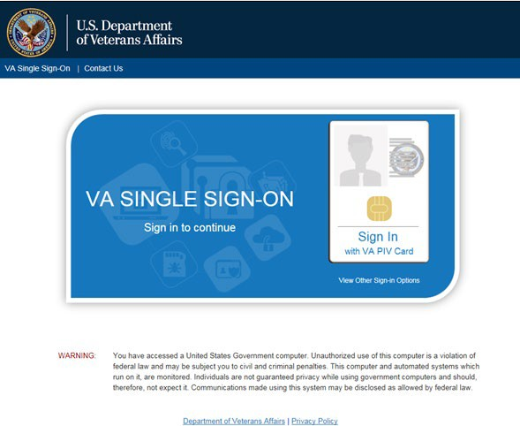

1. Once authenticated by the SSOi system, you are redirected to JLV
2. Read the important user consent information regarding access to a government information system, and click **I Accept**
3. If you have adaptive technology installed, you can check the **Accessibility Mode** option in the top-right corner, above the JLV **Login** page fields
   1. If selected, JLV opens and displays the application in the 508-compliant Accessible User Interface (UI) theme (See Using the Accessible Theme’s Functionality for detailed information)
4. Enter your VA login credentials:
   1. Enter your Access Code
   2. Enter your Verify Code
   3. Select VA from the **Agency** field
   4. Select your VA Medical Center or regional health care system, if you are a CPRS user, or CAPRI-Claims, if you are a CAPRI user, from the **Site** field
5. Click **Login**

Image of the information icon. **NOTE:** Users with any CAPRI patient selection restrictions must use the

**Joint Legacy Viewer** tab in CAPRI to access JLV.

## Editing Your User Profile at Login

One method of setting application configuration options (i.e., customizing) is by using the **Edit Profile** link (Figure 2) to access the user profile fields through the JLV **Login** page (Figure 3). User profile options can also be set within JLV. See Customizing JLV.

Image of the information icon. **NOTE:** The selected options are saved to your user profile by clicking **Save and Login** and remain set for all subsequent JLV sessions until you change them.

**Figure 2: Edit Profile Link on the JLV Login Page**

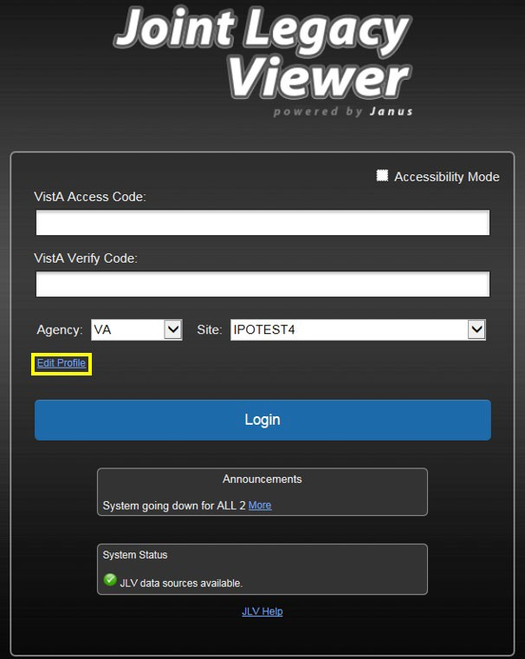

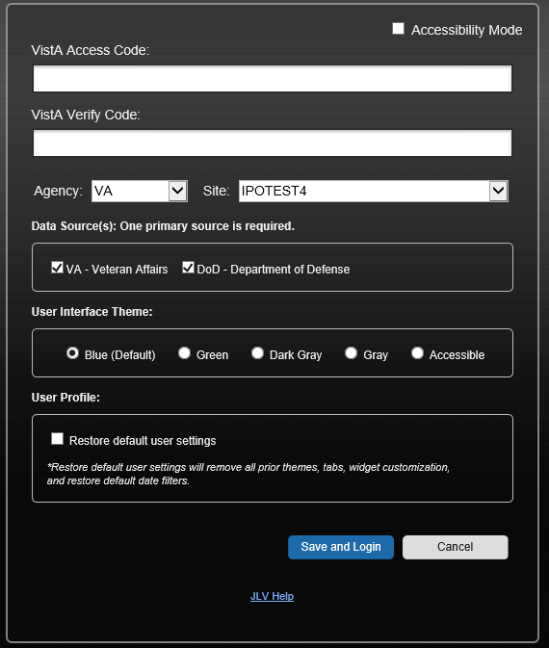**Figure 3: User Profile Data Source and User Interface Option Fields**

Selecting a data source allows you to configure whether you see VA data, DoD data, or both. One primary data source is required. The **Data Source** choices appear below the **Agency** and **Site** fields, as seen in Figure 3. Refer to Setting the Data Source for more information.

Selecting a UI theme sets the font color and foreground/background colors of the JLV GUI for the widgets, toolbars, and dialog boxes. Theme color options are Blue (Default), Green, Dark Gray, Gray, and Accessible (508-compliant). The UI theme choices appear below **Data Source** choices, as seen in Figure 3. Refer to Setting the UI Theme for more information.

Title: Information Icon - Description: Image of the information icon. **NOTE:** The **Accessible** theme provides larger fonts, enhanced tab and keystroke functionality, and screen reader compatibility, compliant with Federal accessibility requirements and Section 508 standards. Refer to Using the Accessible Theme’s Functionality for more information.

## Logging Out of the Current JLV Session

Click the **Log Out** icon Image of the Log Out icon (highlighted in Figure 4) at any time to end the current session and exit JLV.

**Figure 4: JLV Log Out Icon**

A JLV session ends automatically after 30 minutes of inactivity. Actions in JLV that are considered activity are changing patients, refreshing widgets, opening or closing widgets, adding or removing widgets from the portal pages, and adjusting date ranges. You receive an audible and visual warning that the current session is about to terminate after 25 minutes of inactivity.

Automatic termination of a session logs you out of the application, closes all JLV tabs and windows, and displays the **Logout** page. Close and reopen the browser and return to the JLV **Login** page to initiate a new JLV session.

If SSOi is enabled, you are redirected to the **VA Single Single-On Logout** page.

# The Elements and Functionality of JLV

## The JLV Portal Pages

After a successful log in, your username is shown in the upper right corner of the application, and the JLV portal pages are displayed. The JLV portal pages are:

* The **Patient Portal Image of the Patient Portal icon**
* The **Provider Portal Image of the Provider Portal icon**
  + 1. **Default View**

Upon log in, you see the **Provider Portal Image of the Provider Portal icon**. The portal displays the **Patient Search** dialog box by default.

Image of the information icon. **NOTE:** CPRS users who select a patient within CPRS, then launch JLV are taken directly to the JLV **Patient Portal Image of the Patient Portal icon**, where the records for the patient selected in CPRS are displayed.

**Figure 5: Default View**

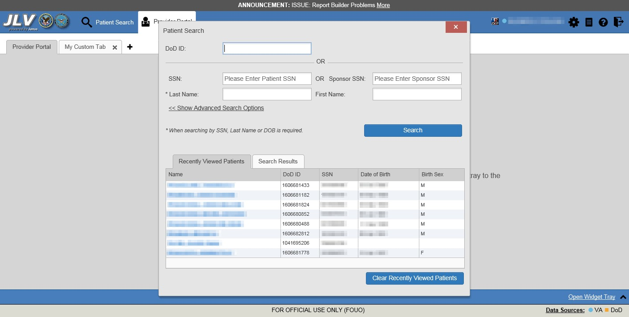

The **Patient Portal** displays a selected patient's clinical records and other patient-centric information.

New JLV users see a preconfigured, default widget layout on the **Patient Portal Image of the Patient Portal icon** when a patient is selected. The default layout includes the **Allergies**, **Problem List**, **Documents**, **Outpatient Medications**, and **Lab Results** widgets, as well as the **Patient Flags and Postings** widget if applicable.

Image of the information icon. **NOTE:** You can configure the layout of widgets on the **Patient Portal** and create multiple widget tabs, as described in Customizing JLV and in Accessing and Opening Widgets. Customizations are saved to your user profile and remain until manually changed.

### System Menu

Each portal page has a toolbar in the top-right corner of either portal page (highlighted in Figure 6) that enables quick access to the following features:

* **Configuration Options:** Click the **Settings** icon Image of settings icon to set user preferences, including the UI theme (Refer to Customizing JLV)
* **Report Builder:** Click the **Report Builder** icon Image of the Report Builder icon to create custom reports (Refer to Using Report Builder)
* **Access Online Help:** Click the **Help** icon Image of the Help icon to open online help
* **Log Out of JLV:** Click the **Log Out** icon Image of the Log Out icon to log out and close the current JLV session (Refer to Logging Out of the Current JLV Session)

**Figure 6: JLV Tools on the Portal Pages**



The following functions can be completed from the portal pages (highlighted in Figure 7):

* Perform a **Patient Search Image of the Patient Search icon**
* Switch between the **Patient Portal Image of the Patient Portal icon** and the **Provider Portal Image of the Provider Portal icon**
* View the system status Image of yellow triangle with an exclamation point in the center, indicating that JLV is having problems.



* View Context Management status
* Open the widget tray using the **Open Widget Tray ^** link in the lower right corner of the portal pages (as shown in Accessing and Opening Widgets, Figure 35)

**Figure 7: More JLV Functionality**

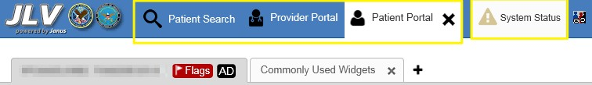

Switching from the **Patient Portal Image of the Patient Portal icon** to the **Provider Portal Image of the Provider Portal icon** closes all associated patient tabs and windows to prevent confusion between patient records.

### References Widget

The **References** widget (Figure 8) displays hyperlinked references to online resources. Click the **Open Widget Tray** link (or click the up arrow) in the lower right corner of the **Provider Portal Image of the Provider Portal icon** to view the widget tray. Click and drag the **References** widget from the tray up to the portal and position where desired. Click a reference link to access the associated website. Click the **Add** icon + to add a new reference link.

Only the reference links you add can be deleted. Right-click the link and select **Delete URL** to delete a reference link. You cannot delete reference links included in the default widget configuration.

**Figure 8: References Widget**

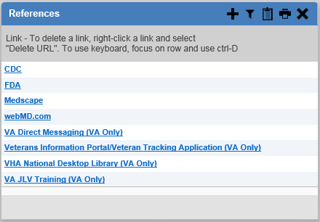

### Viewing System Status

The system status reports the condition of the JLV application. If there is a system status alert, the warning icon Image of yellow triangle with an exclamation point in the center, indicating that JLV is having problems. is displayed to the left of your username. Hovering over **System Status** provides additional information.

Image of the information icon. **NOTE:** The System Status reports the overall condition of the JLV application, while the Connection Status reports the condition of the connection between JLV and its external resources. See Viewing Connection Status for more information.

JLV displays the system status below the user credential fields on the **Login** page, as well as at the top of the portal pages.

* When all monitored systems and services are online and connected, a green icon Image of the green circle with a white check mark, indicating all systems and services are online and connected appears next to the status message, “*JLV data sources are available”*
* When one or more of the monitored systems or services is offline or unavailable, a yellow warning icon Image of yellow triangle with an exclamation point in the center, indicating that JLV is having problems. appears next to the status message, “*Services are not available to JLV”*
* When JLV is unavailable, a red icon Image of a red hexagon with an X in the center, indicating that jMeadows Data Service is unavailable. appears next to the message, “*System status is unavailable”*
  + You may not be able to log in to JLV or view patient data until the connection is restored

These warnings may be accompanied by one or more of the notices listed in Table 2, depending on which services are unavailable.

**Table 2: System Status Notices by Service**

|  |  |
| --- | --- |
| **Service** | **Notice** |
| **jMeadows** | *“****The service that gathers patient data and prepares it for display in JLV is unavailable.*** *JLV is available for login but may not function otherwise.”* |
| **Master Veteran Index (MVI)** | *“****VA Patient Identity Service is unavailable.*** *Patient search may not be available, and VA and community partner data may not display.”* |
| **Patient Discovery Web Service (PDWS)** | *“****DoD Patient Identity Service is unavailable.*** *Patient search may not be available and DoD data may not display.”* |
| **Relay Service** | *“****The connection to DoD is unavailable****. DoD patient records of all types from all sites may not display.”* |
| **VistA Data Service (VDS)** | *“****The connection to VA sites is unavailable.*** *VA patient records of all types from all sites may not display.”* |

Figure 9 shows a system status message on the **Login** page, and Figure 10 shows the **System Status** hover text on the toolbar in the upper right corner of the application.

**Figure 9: System Status on the JLV Login Page**

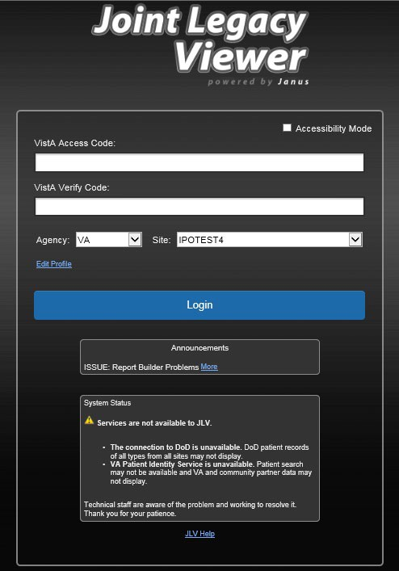

**Figure 10: System Status on the JLV Toolbar**

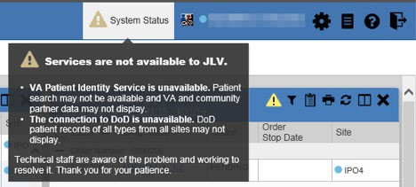

### Patient Context Management

Clinical Context Management (CCOW) is a way for applications to synchronize the display of clinical context, based on the Health Level 7 (HL7) CCOW standard. If CCOW-compliant applications are sharing context and one of the applications changes the data display to a different patient, the other applications switch to display that same patient.

JLV is context management-enabled. When context is enabled, a patient change made in one context-enabled application (i.e., CPRS) triggers the same change in JLV. The same effect is shown vice versa; that is, when a patient is selected in JLV, it triggers a patient change in other context-enabled applications.

Context management is enabled by default, and JLV attempts to connect to the context vault upon a valid login. The context status appears in the top-right corner of the portal pages. When context is established, the **Context On** icon Image of the Context On icon. is shown. When context is suspended, the **Context Suspended** icon Image of the Context Suspended icon. is shown.

Figure 11 shows the context indicator location on a JLV portal page. Context is suspended in this example.

**Figure 11: Context Indicator**

#### Suspending Context

Context can be manually suspended.

1. Click the **Context On** icon Image of the Context On icon.
2. The CCOW warning message, “*Are you sure you want to break patient link?”* appears (Figure 12)
3. Click **Yes** to continue

Once context is suspended, the **Context Suspended** icon Image of the Context Suspended icon. is displayed on the portal pages. When context is suspended, patient changes are not reflected in either JLV or other CCOW- enabled applications.

**Figure 12: Suspending Context**

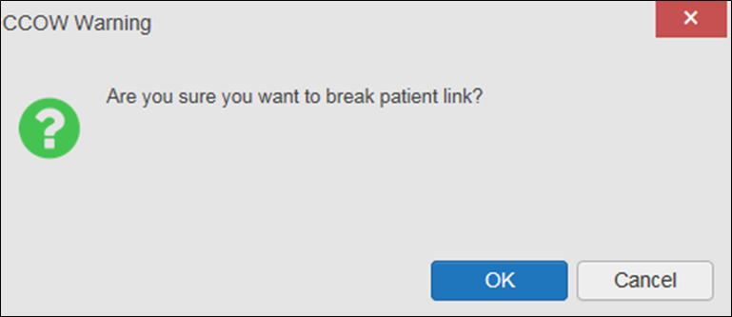

#### Establishing Context

When context is suspended, it can be reestablished manually.

1. Click the **Context Suspended** icon Image of the Context Suspended icon.
2. The CCOW warning message, “*Are you sure you want to rejoin patient link?”* appears (Figure 13)
3. Click **Yes**

Once context is established, the **Context On** icon Image of the Context On icon. is displayed on the portal pages.

**Figure 13: CCOW Warning Message**

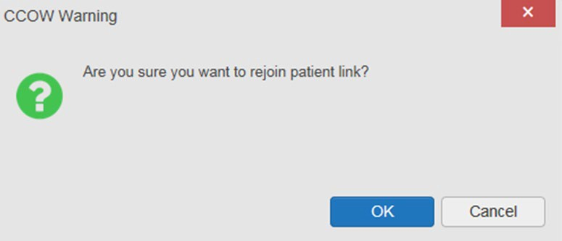

#### Unable to Communicate with Vault

If JLV is unable to initiate context management upon log in, you see the CCOW Error message (Figure 14). Click **OK** to continue. The **Context Suspended** icon Image of the Context Suspended icon. is displayed on the portal pages. If the CCOW error persists, contact your local service desk for assistance.

**Figure 14: CCOW Error Message**

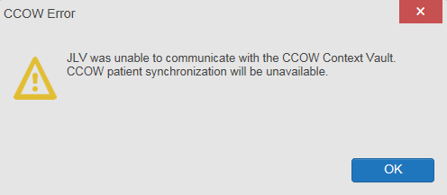

Image of the information icon. **NOTE:** This error message will automatically display if you have more than one active JLV session open.

#### Context Synchronization Failure

A CCOW error message is presented if JLV is unable to reestablish context (Figure 15). This indicates context is suspended. Click **OK** to continue. The **Context Suspended Image of the Context Suspended icon.** icon is displayed on the portal pages.

CAPRI-Claims users may encounter the error message (Figure 15) at each log in, as there are usually no CCOW system components installed on their computers.

**Figure 15: Context Synchronization Failure**

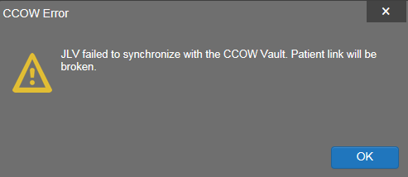

## Customizing JLV

Configuration options (Figure 16) can be set within JLV by clicking the **Settings Image of the settings icon.** icon.

**Figure 16: JLV Settings Dialog Box**

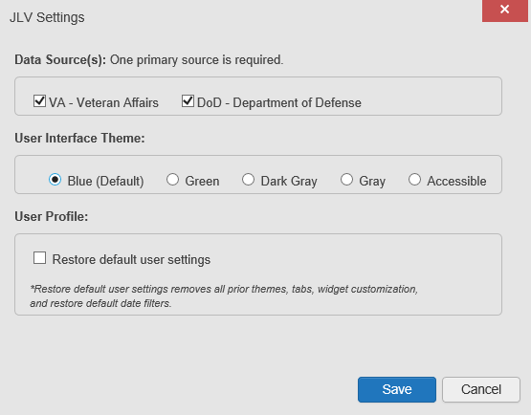

Image of the information icon. **NOTE:** Changing the data sources or UI theme will require you to reselect and reload the current patient.

### Setting the Data Source

The data source setting is part of your user profile. Choosing a data source allows you to configure whether you see VA data, DoD data, or both. A circular, blue icon in the **Data Sources** pane indicates that VA data is enabled; a square, orange icon indicates that DoD data is enabled; and a circular, gray icon indicates either VA or DoD data is disabled (Figure 17). One primary data source is required. Once selected, the data source selection is stored in your user profile and remains set until changed.

1. Access **JLV Settings** dialog box (Figure 16) by selecting:
   1. **Edit Profile** on the **Login** page -OR-
   2. **Settings Screenshot of the Settings icon**on either the **Provider** or **Patient Portals** (Figure 6)-OR-
   3. The **Data Sources** link in the lower right corner of either the **Provider** or **Patient Portals** (see the figures in Setting the UI Theme)
2. Select the desired data source
3. Click **Save** to apply the selected data source **-**OR-
4. Click **Cancel** to exit the dialog box and restore the previous data source configuration

### Setting the UI Theme

The UI theme setting is a part of your user profile. Choosing a UI theme sets the font, foreground, and background colors of the widgets, toolbars, and dialog boxes. Once selected, the UI theme is stored in your user profile and remains set until you change it. The available UI themes are Blue (Default), Green, Dark Gray, Gray, and Accessible (508-compliant).

1. Access **JLV Settings** dialog box (Figure 16) by selecting:
   1. **Edit Profile** on the **Login** page -OR-
   2. **Settings Screenshot of the Settings icon**on either the **Provider** or **Patient Portals** (Figure 6)-OR-
   3. The **Data Sources** link in the lower right corner of either the **Provider** or **Patient Portals** (see the figures in Setting the UI Theme)
2. Select the desired theme
3. Click **Save** to apply the selected UI theme -OR-
4. Click **Cancel** to exit the dialog box and restore the previous theme configuration

**Figure 17: Blue (Default) UI Theme, DoD Data Disabled****1**

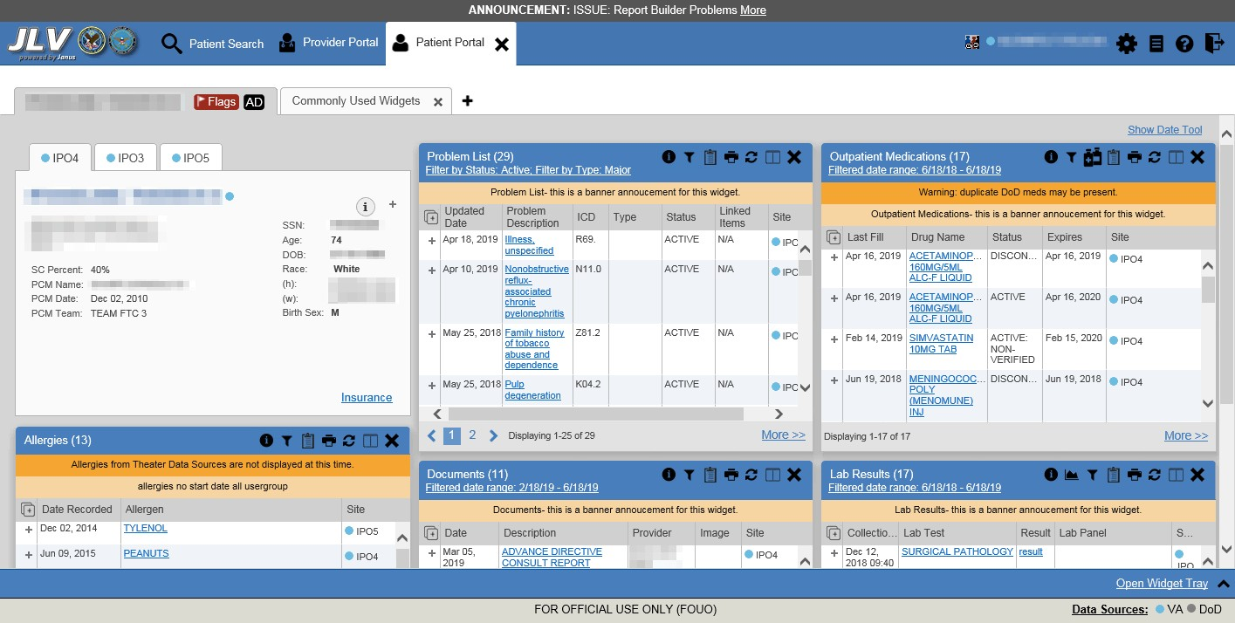

1 Primary Care Management (PCM), Social Security Number (SSN), Date of Birth (DOB)

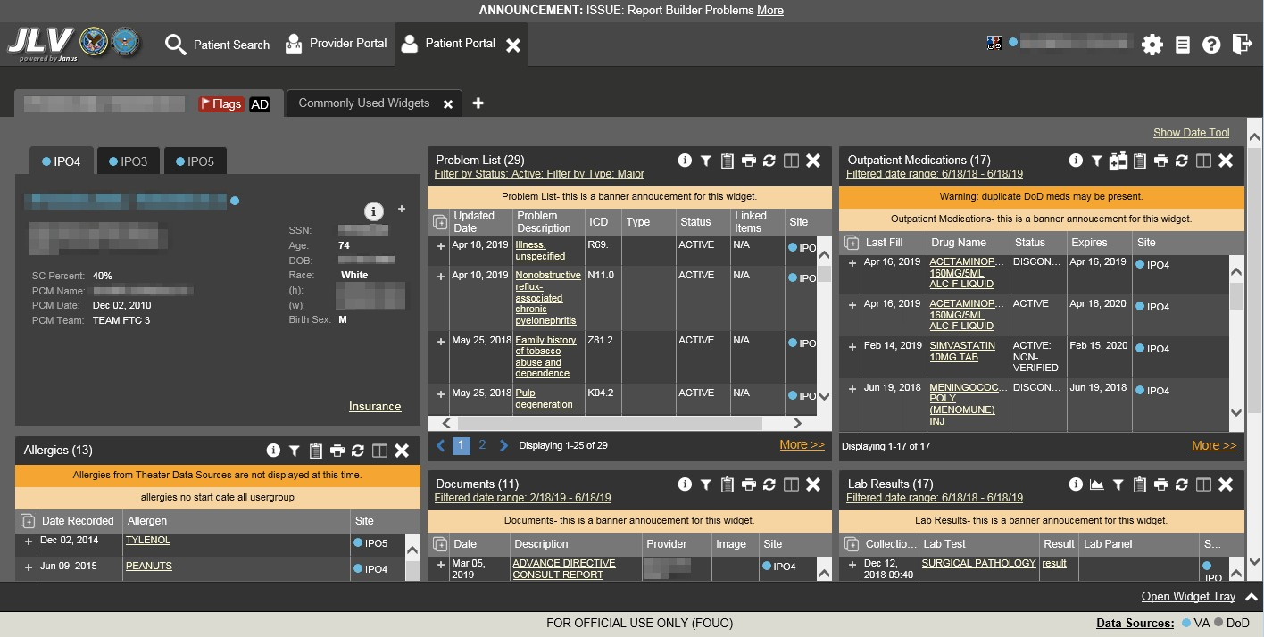**Figure 18: Dark Gray UI Theme, DoD Data Disabled**

**Figure 19: Green UI Theme, DoD Data Disabled**

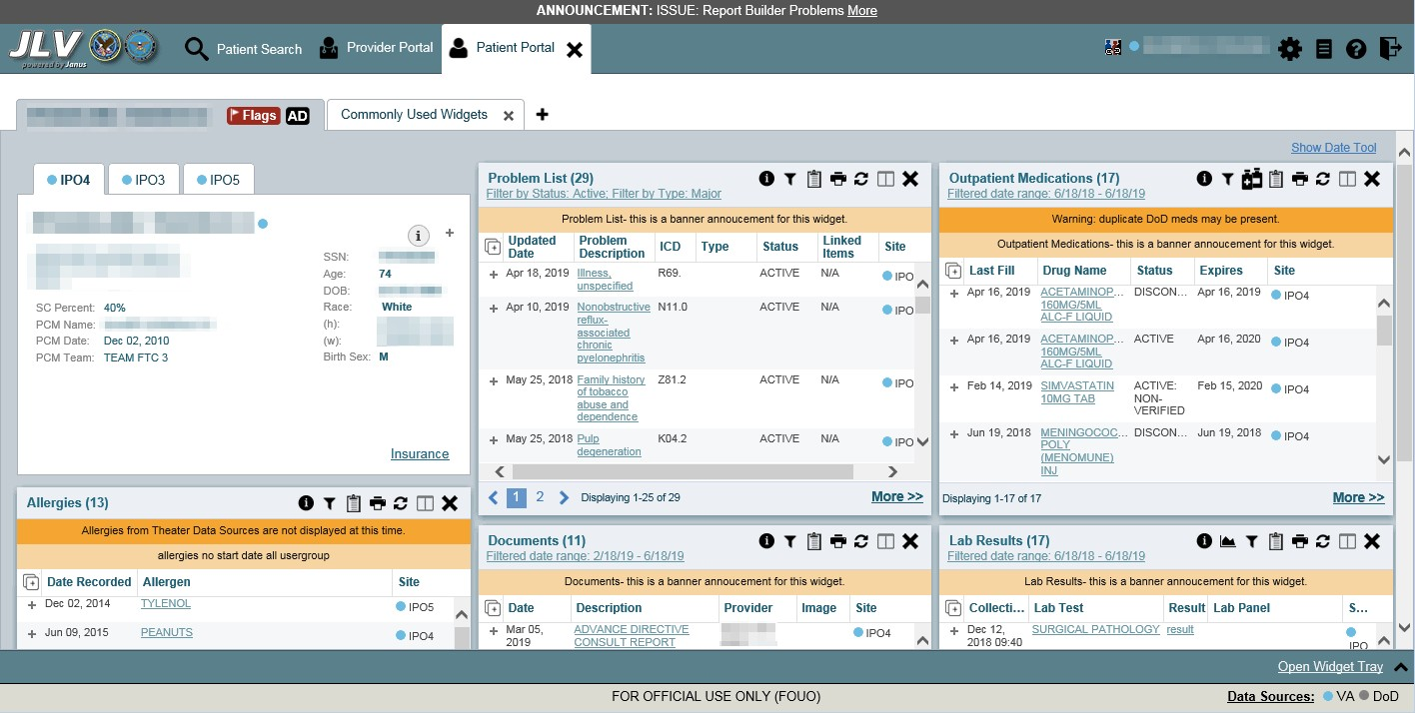

**Figure 20: Gray UI Theme, DoD Data Disabled**

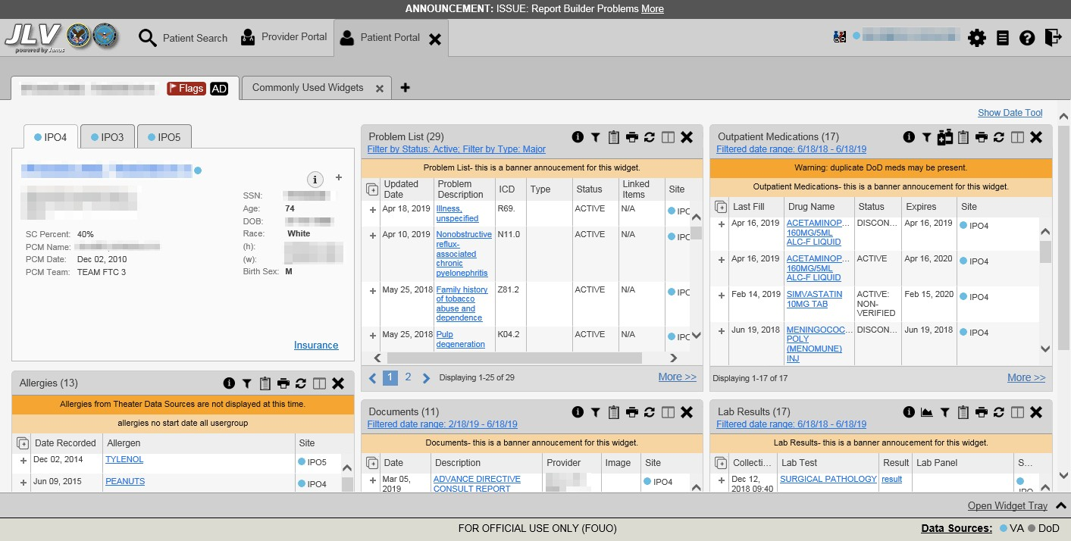

**Figure 21: Accessible (508-Compliant) UI Theme, DoD Data Disabled**

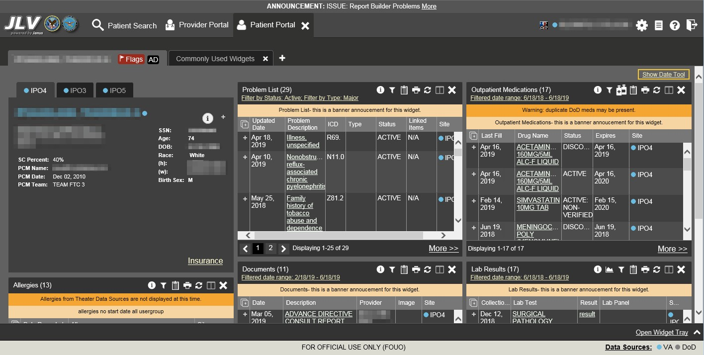

### Using the Accessible Theme’s Functionality

The Accessible theme includes larger fonts, enhanced tab and keystroke functionality, and screen reader compatibility to support Federal accessibility requirements and Section 508 compliance.

Image of the information icon. **NOTE:** The Accessible theme is available for users who have adaptive technologies installed on their computers.

#### Keyboard Focus and Screen Navigation

Keyboard focus is the highlighting of a screen element, field, or control that enables interaction with, and navigation of, JLV using the keyboard and keystrokes. The item in focus is outlined in gold as a visual indicator of the element, field, or control with keyboard focus that receives information typed on the keyboard.

JLV uses common Windows keystrokes (Tab, Shift + Tab, arrow keys, Enter), and keyboard shortcuts to move the focus to all menus, and activate all functions on the menus. All user interface items are accessible via the keyboard under the **Accessible** theme.

Pressing **Enter** or the **Spacebar** when an element that provides action is in keyboard focus performs the associated action; for example, pressing **Enter** or the **Spacebar** when the **Settings Image of the settings icon.** icon is in focus opens the **JLV Settings** dialog box. Using the arrow keys or the **Tab** key moves between keyboard focus items to navigate through screen elements. Table 3 provides a complete list of accessible keystrokes.

**Table 3: Accessible Theme Keyboard Shortcuts**

|  |  |
| --- | --- |
| **Keystroke** | **Description** |
| **Application & Portal Navigation** | |
| **ALT + 4** | Press to transfer keyboard focus to the main or top screen element   1. Focus transfers to **Patient Search** or the patient tab in the **Demographics** widget on a portal page 2. Focus transfers to the **More>>** link in a widget 3. Focus transfers to the dialog box’s **Close** button in a dialog box |
| **ENTER** | Press to initiate the action associated with the item in focus |
| **TAB** | Press to transfer keyboard focus to other user interface items |
| **ESC** | Press to return keyboard focus to the panel containing the user interface item with keyboard focus or to exit a window, widget, or tab |
| **SPACEBAR** | Press to activate any user interface item (for example, click an icon) |
| **Arrow Keys** | When focused on a widget, press the arrow keys to change page viewing in a widget's data table  When focused on a dropdown list, press the down arrow key to view list contents |
| **Ctrl + d** | Place keyboard focus on a reference or row within the **References** widget on the Provider portal and press **Ctrl + d** to remove the reference URL  Removing a default reference is not allowed |
| **Tab Panels** | |
| **Arrow Keys** | Use the left and right arrow keys to change tabs |
| **TAB** | Press one or more times when focus is on a portal tab to place **Add Tab (+)** in keyboard focus.  Add a Tab:   1. Press **Tab** until **Add Tab (+)** is in focus 2. Press **Enter** 3. The new tab dialog box opens and prompts you to enter a name for the new tab 4. Tab to the **Add** button to confirm the new tab name or tab to the **Cancel** button to discard the new tab |

|  |  |
| --- | --- |
| **Keystroke** | **Description** |
| **Windows or Dialog Boxes** | |
| **TAB** | Press to transfer keyboard focus to other user interface items within the window or dialog box |
| **Adding Widgets to a Portal Page** | |
| **Number position** | Add a widget from the widget tray using keystrokes:   1. Determine in which column (1, 2, or 3) to place the widget 2. Focus on the desired widget icon in the widget tray, and press the Alt key and the 1, 2, or 3 key, depending on the column chosen |

#### Accessible Theme Portal Navigation

An element with keyboard focus is the starting point for portal navigation. Pressing the **Enter** or

**Spacebar** keys when a screen element or icon has keyboard focus mimics a mouse click.

Figure 22 depicts the **Documents** widget with keyboard focus. Focus can be changed by pressing the **Tab** key. Pressing the **Tab** key in this example shifts the keyboard focus from the **Documents** widget to the widget immediately below the **Documents** widget. Pressing the **Tab** key again shifts the keyboard focus to the widget at the top of the next column.

Image of the information icon. **NOTE:** Focus on the element within the widget that has hover text. After a small delay, the text appears as if you hovered over the element with your mouse cursor.

**Figure 22: Navigation Using Elements with Keyboard Focus**

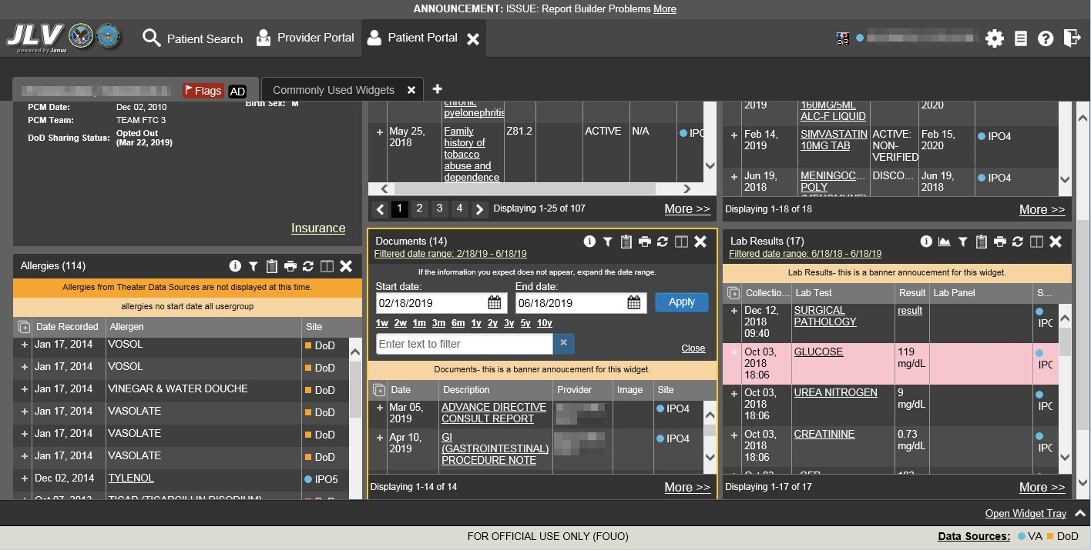

The **Document** details window has keyboard focus in Figure 23. Move through the toolbar buttons by using the arrow keys, or by pressing **Tab**. Move to **Close (X)** and press **Enter** to close

the details window. After closing the window, keyboard focus returns to the last element that had keyboard focus prior to opening the window.

**Figure 23: Document Details with Keyboard Focus**

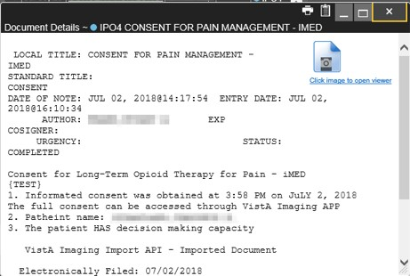

## User-Restricted Access to Patient Data

### VHA Users Viewing DoD-only Patient Data

VHA users can view the records of DoD-only patients, meaning they either have no VA identifiers or are not registered in MVI, but VA requires that these actions be audited. If an attempt is made to access DoD-only patient records, the VHA user is asked to specify the purpose for access. The purpose options presented to the user are: Emergent Care, Clinical Care, or Authorized Administrative Use (Figure 24).

Once the purpose for access is selected, clicking **Agree to be Audited & Access this Patient Record** (Figure 24), displays the requested data, and audits the action. The access purpose, organization of the VA provider, date, username, IP address, user’s Internal Entry Number (IEN), host system’s ID, and patient’s Electronic Data Interchange Personal Identifier (EDIPI) are captured in the audit record.

**Figure 24: VA User Restricted Access Dialog**

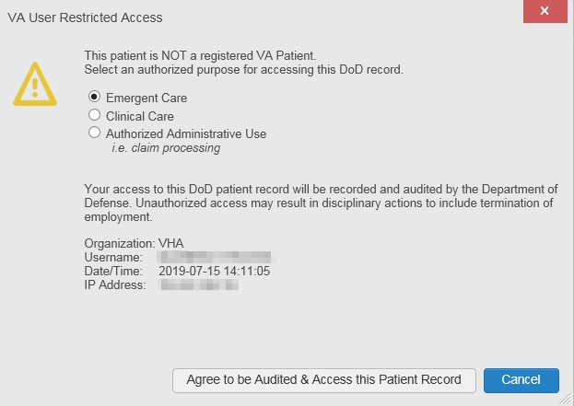

### CAPRI-Claims Users Viewing Patients with DoD Data

CAPRI-Claims users may see one of two different dialog boxes, depending on whether the patient is registered for care in the VA. If the patient is registered for care in the VA, they are in MVI.

#### Patient Registered in MVI

CAPRI-Claims users are permitted to view the records of a patient who is registered in MVI, but the VA requires that these actions be audited. After performing a patient search and selecting a patient from the search results, a CAPRI-Claims user sees the audit notification (Figure 25) if the patient they selected is registered in MVI. After agreeing to the audit, the CAPRI-Claims user can access the patient’s record.

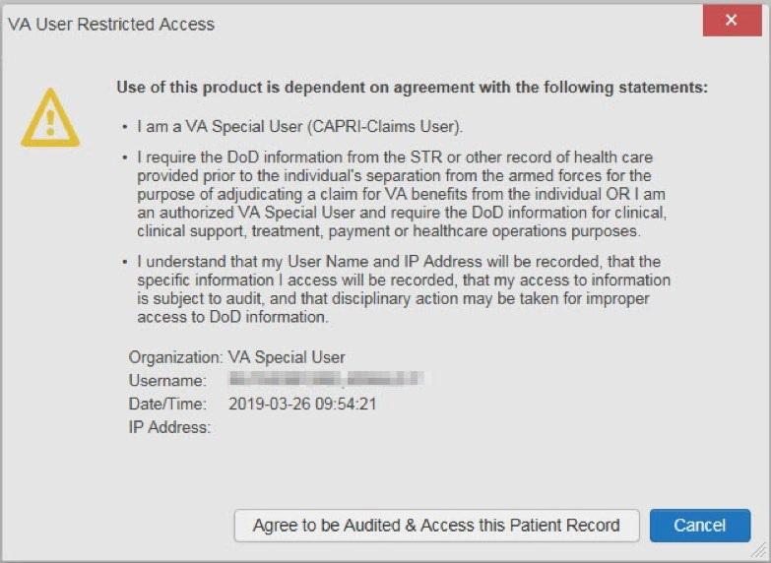**Figure 25: CAPRI-Claims User Audit Notification**

#### Patient Not Registered in MVI

CAPRI-Claims users are not permitted to access the records of a patient who is not registered in MVI. After performing a patient search and selecting a patient from the search results, a CAPRI- Claims user sees the restricted access notification (Figure 26) if the selected patient is not registered in MVI. Clicking **Cancel** returns the user to the previous screen.

**Figure 26: Restricted Access Notification**

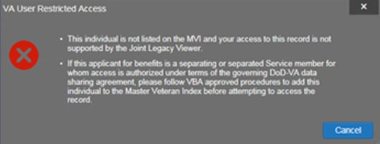

### Access to DoD Sensitive Records

All JLV users are audited each time a sensitive DoD record is accessed. Auditing applies to sensitive documents, lab panel results, outpatient encounters, or progress notes records. JLV records the user’s name, organization, SSN/EDIPI (for DoD users), PIV (for VA users), location, patient identifiers (patient last name, first name, middle initial [MI], SSN/EDIPI [DoD only], MVI [VA only], and date of birth [DOB]), data accessed, date and time, and reason for access for each attempt to access sensitive data.

JLV notifies you before you are audited. The message is triggered the first time you click a masked record that is marked **\*\* Sensitive\*\***. Your acknowledgement of the audit notification covers all subsequent DoD sensitive records in any widget during the remainder of the session, and it only expires when you switch patients or log off. An example of a masked record audit notification is depicted in Figure 27.

After you select the purpose for viewing the record and agree to be audited, the sensitive data displays in the **Details** view of the widget.

**Figure 27: DoD Sensitive Record and Audit Dialog Box**

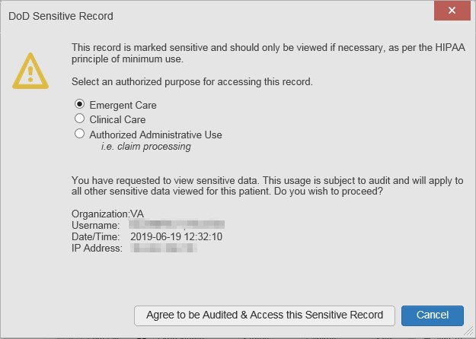

## Patient Searches

The core function of JLV is to display patient information on the **Patient Portal Image of the patient portal icon**. Use the **Patient Search Image of the patient search icon** feature to perform a patient search, perform a family search, or use the advanced search options.

JLV determines which enterprise service to use for a patient search, based upon the search criteria:

* If the EDIPI or Sponsor SSN is entered, JLV utilizes PDWS for the search (See PDWS Search Rules and Supported Searches for details)
* If the EDIPI or Sponsor SSN fields are empty, JLV utilizes MVI for the search (See MVI Search Guidelines for details)

### PDWS Search Rules and Supported Searches

When JLV utilizes PDWS for patient search, the applicable rules and rule sets required for the PDWS interface must be used:

* **Rule Set 1:** When searching by SSN, the full nine-digit SSN must be entered, and the Last Name or DOB must also be supplied
  + This is true for search by patient SSN as well as Sponsor SSN
* **Rule Set 2**: If you do not have the patient’s SSN, you must supply ALL the following identifiers: Last Name, First Name, DOB, and Birth Sex
  + Blanks in any of these four required fields generates an error
* A 10-digit string is required for telephone number

The following search combinations are supported when PDWS is utilized:

* DoD ID, also referred to as the EDIPI
* Patient SSN and Last Name
* Patient SSN and DOB
* Sponsor SSN and Last Name
* Sponsor SSN and DOB
* Last Name, First Name, DOB, and Birth Sex (ALL identifiers must be entered)

### MVI Search Guidelines

JLV utilizes MVI for a patient search when the search parameters include the patient’s name and SSN. MVI requires the full last name is entered when the patient’s SSN is entered. MVI may also require entering the patient’s first name and DOB to increase the efficiency of the search, and the likelihood of locating the patient. An example would be searching for a patient with a common last name, such as Smith or Jones.

### Patient Search Using DoD ID

1. Click the **Patient Search** icon Image of the patient search icon at the top of the portal pages
   1. The **Patient Search** dialog opens
2. Enter the 10-digit patient DoD ID (EDIPI) in the **DoD ID** field (Figure 28)

**Figure 28: DoD ID (EDIPI) Search**

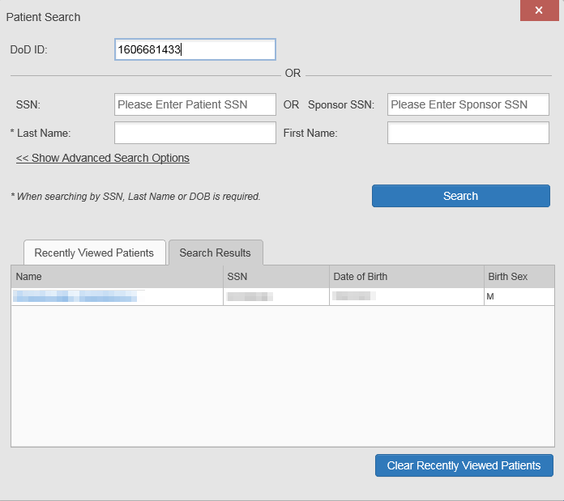

1. Click **Search**
   1. The search results are displayed in the lower third of the dialog box, under the **Search Results** tab
2. Click a patient’s name in the search results list to open the associated record
   1. The **Name**, **SSN**, **DOB**, and **Birth Sex** columns in the results list provide information to assist with patient identification
3. After selecting a patient, the **Patient Portal Image of the patient portal icon** opens and displays the selected patient’s data

### Patient Search Using SSN

1. Click the **Patient Search** icon Image of the patient search icon at the top of the portal pages
   1. The **Patient Search** dialog box opens
2. Enter the patient’s full, nine-digit SSN in the **SSN** field (Figure 29)
   1. When searching by SSN, either the last name or the DOB *must* be entered to perform the search

**Figure 29: SSN Search**

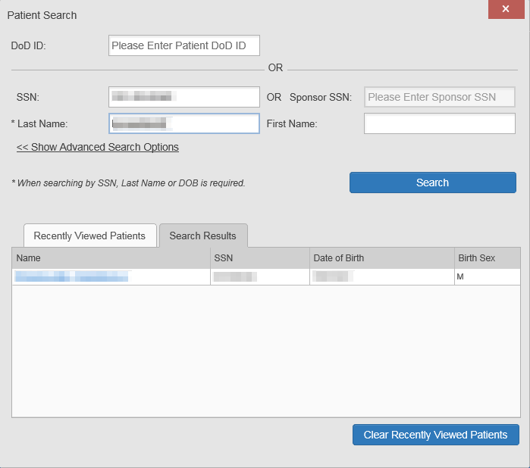

1. Click **Search**
   1. If the required patient identifiers are not provided, hover text appears, indicating the information necessary to complete the patient search
   2. If a match of patient names cannot be made, enter additional identifiers (first name, DOB) to refine the search (Figure 30)

**Figure 30: Additional Identifiers Needed**

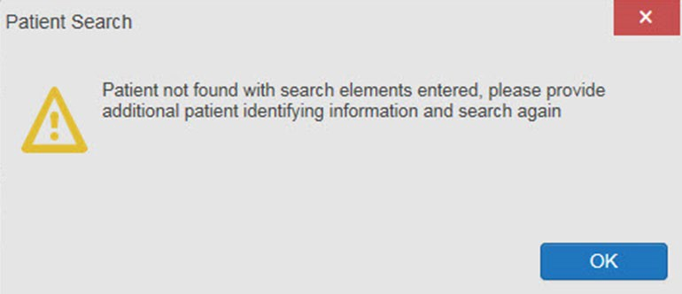

1. The search results are displayed in the lower third of the dialog box, under the **Search Results** tab
2. Click a patient’s name in the search results list to open the associated record
   1. The **Name**, **SSN**, **DOB**, and **Birth Sex** columns in the results list provide information to assist with patient identification
3. After selecting a patient, the **Patient Portal Image of the patient portal icon** opens and displays the selected patient’s data

### Advanced Patient Search Options

Advanced patient search options in the **Patient Search** dialog box allow for the use of additional patient identifiers when performing a patient search.

1. Click the **Patient Search** icon Image of the patient search icon at the top of the portal pages
   1. The **Patient Search** dialog box opens
2. Click the **<<Show Advanced Search Options** link under the **\*Last Name** field (seen in Figure 29)
3. Enter the patient identifiers in the appropriate search fields, as desired
   1. Advanced search option fields include **\*DOB**, **MI**, **Birth Sex**, **Address**, **State**, **City**, **Zip**, and **Telephone** (seen in Figure 31**)**

**Figure 31: Advanced Search Options**

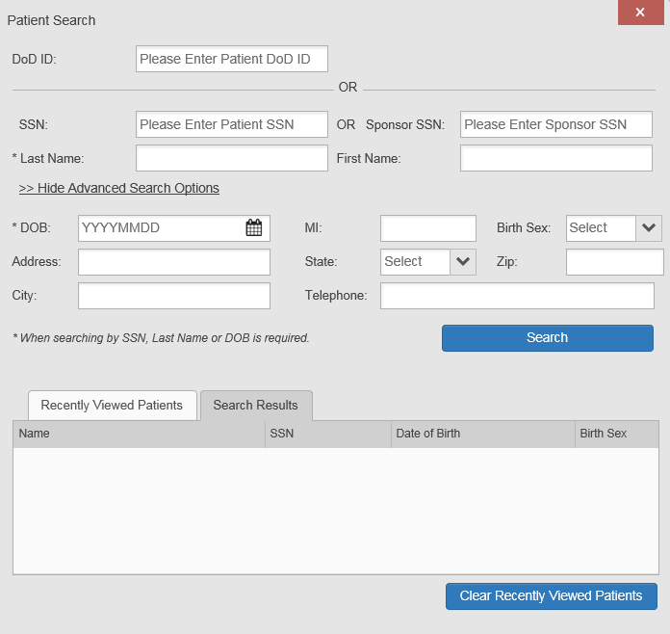

1. Click **Search**
   1. If the required patient identifiers are not provided, hover text appears, indicating the information necessary to complete the patient search
2. The search results are displayed in the lower third of the dialog box, under the **Search Results** tab
3. Click a patient’s name in the search results list to open the associated record
   1. The **Name**, **SSN**, **DOB**, and **Birth Sex** columns in the results list provide information to assist with patient identification
4. After selecting a patient, the **Patient Portal Image of the patient portal icon** opens and displays the selected patient’s data

### Family Member Search

A family member search can be performed using the **Sponsor SSN** field in the **Patient Search**

dialog box.

1. Click the **Patient Search** icon Image of the patient search icon at the top of the portal pages
   1. The **Patient Search** dialog box opens
2. Enter the SSN in the **Sponsor SSN** field
   1. The **Last Name** or **DOB** of the patient must also be entered in the appropriate fields (Figure 32)
3. Click **Search**
   1. If the required patient identifiers are not provided, hover text appears indicating the information necessary to complete the patient search
4. The search results are displayed in the lower third of the dialog box, under the **Search Results** tab (Figure 32)

**Figure 32: Sponsor SSN Search**

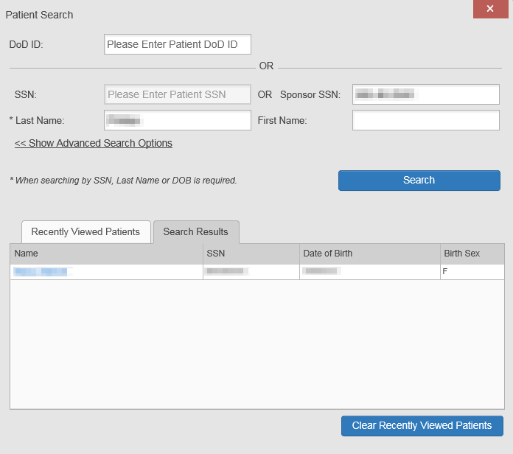

1. Click a name in the **Search Results** list
   1. The **Family Members** dialog opens (Figure 33)
   2. The sponsor’s identifiers and a list of dependents are displayed in the dialog
2. Click a name in the list of family members to open the associated record
3. After selecting a patient, the **Patient Portal Image of the patient portal icon** opens and displays the selected patient’s data

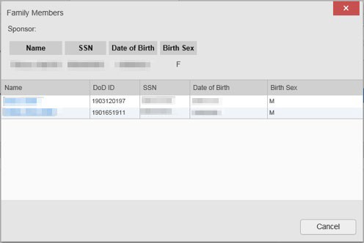**Figure 33: Family Members Dialog Box**

### Recently Viewed Patients List

Users who have previously logged in to JLV, searched for a patient, and viewed that patient’s records can see and access a list of recently viewed patients. A recent patient is defined as a patient whose record has been viewed (opened) by the user.

Image of the information icon. **NOTE:** The **Recently Viewed Patients** list does not include search history or recent search results, only a list of patients whose data was accessed and viewed. The list is limited to 10 patients. You can clear this list by selecting the **Clear Recently Viewed Patients** button.

1. Click the **Patient Search** icon Image of the patient search icon at the top of the portal pages
   1. The **Patient Search** dialog box opens
2. Click the **Recently Viewed Patients** tab in the lower third of the **Patient Search** dialog box
3. A list of recently viewed patients is displayed (Figure 34)
   1. The **Name**, **DoD ID**, **SSN**, **DOB**, and **Birth Sex** columns in the results list provide information to assist with patient identification
4. Click a patient’s name in the **Recently Viewed Patients** list to open the associated record
5. After selecting a patient, the **Patient Portal Image of the patient portal icon** opens and displays the selected patient’s data

**Figure 34: Recently Viewed Patients List**

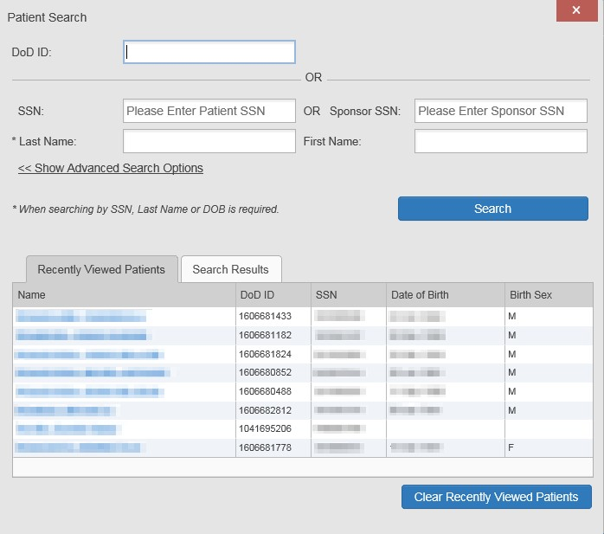

# Widgets

Widgets are elements on the JLV portal pages that display data specific to a clinical domain. By default, widgets are displayed in minimized view on the portal pages (Figure 17), but they can be expanded to view additional details. The list of available widgets is provided in a horizontal tray at the bottom of the page.

Image of the information icon. **NOTE:** Widgets may take anywhere between 10 seconds to 90 seconds to load, depending on the date range settings.

## Accessing and Opening Widgets

All available widgets are displayed in the widget tray, at the bottom of the portal page (Figure 35). Widgets can be opened, rearranged, and closed.

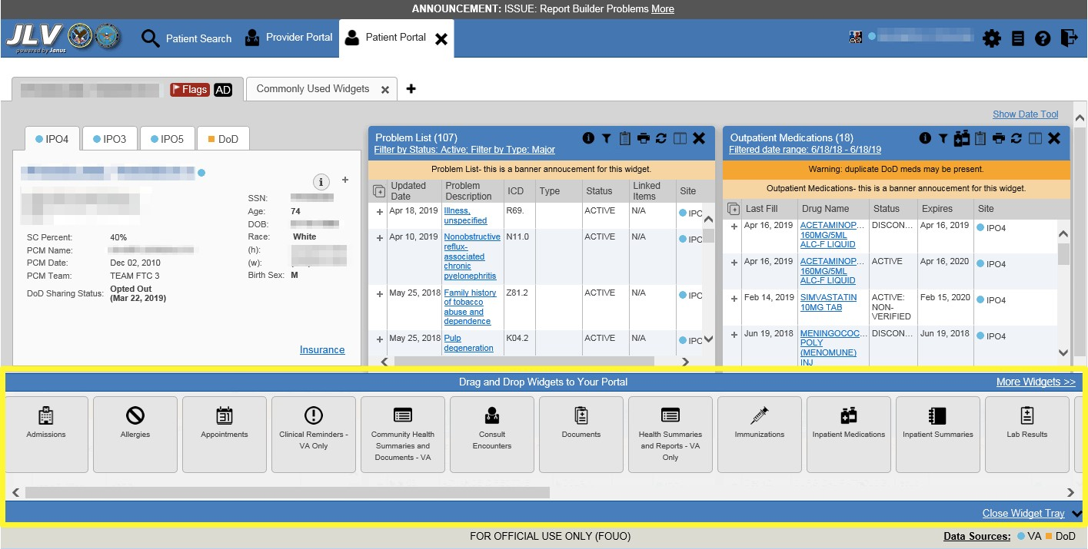**Figure 35: Widget Tray**

1. Open the widget tray by clicking the **Open Widget Tray** link in the lower right corner of the portal page
2. Use the scroll bar arrows < > at either end of the tray to see all widget choices -OR-
3. Click the **More Widgets >>** link to scroll through the list of widgets
4. Click and hold a widget icon in the tray, drag it to the portal page, and drop it in the desired location
5. The widget is docked on the portal page, and opens in minimized view
6. Close the widget tray by clicking the **Close Widget Tray** link

Image of the information icon. **NOTE:** JLV displays a **Duplicate Widget** notice if you attempt to add another instance of a widget to a tab.

Widgets can be closed (removed from the portal page) by clicking the **Close** icon Image of the Close icon. in the top- right corner of the widget. Rearrange the widgets displayed on the portal page by dragging and dropping them.

## Widget Navigation and Display Options

Each widget has tools and display options available to navigate through, and change, the display of data. The vertical scroll bar allows you to move through, and view, the widget’s data. The options at the bottom of a widget provide various ways to see all the records loaded for the widget’s clinical domain.

Navigation icons and actions are detailed in Table 4.

**Table 4: Navigation Icons and Actions**

|  |  |  |
| --- | --- | --- |
| **Navigation Icon** | **Action** | **Description** |
| Image of the previous page navigation icon. | Changes the focus of the widget to the previous group or page of records within the results display. | Go to Previous Page |
| Image of the go to page icon. | Changes the focus of the widget to the page number selected. | Jump to Page |
| Image of the go to next page navigation icon. | Changes the focus of the widget to the next group or page of records within the results display. | Go to Next Page |
| **More >>** | Available in minimized views only. Opens the expanded view of the widget in a secondary window. | Go to Expanded View |
| **1-25 of 55** | Indicates the number of records displayed in that widget page out of the total number of results for that widget. | Record Display Indicator |
| **Show All/ Show Paged** | Click **Show All** to open all records for a given widget in a scrollable window.  Click **Show Paged** to return to the display of records grouped by pages. | Display Setting |

When there are more than 25 records available in a widget, they are grouped in **Show Paged** view. Records 1 through 25 can be viewed by using the widget’s vertical scroll bar. Records 26+ can be viewed by using the page navigation options, in the lower left corner of the widget, to jump to subsequent pages. The expanded view of a widget contains a **Show All** link, which opens all records for that widget, in a scrollable window. Click **Show Paged** to return to the display of records grouped by pages.

## Widget Toolbars

There is a toolbar in the upper right corner of both the minimized and expanded views of each widget, and most dialog boxes. Toolbar icons vary by widget, dialog box, and window. Table 5 describes the functionality of each toolbar icon.

**Table 5: Widget Toolbar Icons**

|  |  |  |
| --- | --- | --- |
| **Icon** | **Name** | **Function** |
| Image of the Add to Report Builder icon. | Add to Report Builder | Adds the information displayed in the widget to the Report Builder, including any  **Details** or **Notes**. |
| Image of the Close icon. | Close | Removes the widget from the portal screen or closes a dialog box. |
| Image of the Column Settings icon. | Column Settings | Configures the columns within the widget. Turn the columns on or off by checking the column names that appear in the pop-up box and clicking **Apply**. |

|  |  |  |
| --- | --- | --- |
| **Icon** | **Name** | **Function** |
| Image of the Configure Filter icon. | Configure Filter | Filters on specific record types or other elements within the widget, including a date filter. If a date range filter is applied in an open widget, the date range is displayed in the widget header.  **Note:** After setting a filter, the **Close Filter** option is enabled in the widget. Clicking **Close Filter** restores the full display of records within the widget. |
| Image of the Copy to Clipboard icon. | Copy to Clipboard | Copies the content of the open window to the clipboard for pasting into another application. **Copy to Clipboard** is disabled in the widget toolbar after clicking **Show All** within a widget. |
|  | Connection Status | Both icons provide a status indicator for DoD and VA data sources. The circle with the lowercase “i" Image of the Sources Available icon, a black circle with a white, lower case "i" in the center. indicates all sources are available. The yellow triangle warning Image of the Warning icon, a yellow triangle with a black exclamation point in the center. indicates one or more data sources are unavailable. Clicking either status icon opens the connection status details in a separate window. |
| Image of the Print icon. | Print | Prints the contents of the open window. **Print** is disabled in the widget toolbar after clicking **Show All** within a widget.  **Note:** It is recommended that you have the latest Adobe Reader installed for the Report Builder and other printing features. |
| Image of the Refresh icon. | Refresh | Refreshes the widget or window display. Only the data within that widget’s dataset is updated. |
| Image of the Rx icon. | Rx | Converts the medication data within the widget to text and opens the text in a pop-up window. Available from the **Outpatient Medications** widget. |
| Image of the Site List icon. | Site List | Opens a list of community sites where the patient has been seen (only available from the **Community Health Summaries and Documents - VA** widget). |

## Minimized vs. Expanded Widget View

Each widget can be displayed in either a minimized (default) or an expanded view. Minimized view displays a simple list of the available patient data for a clinical domain, arranged in reverse chronological order by default. Expanded view provides a detailed list of similarly arranged patient data. When the expanded view of a widget is launched, it opens in a new, separate window that displays more attributes of the records in the widget, including additional, sortable columns of data.

Title: Information Icon - Description: Image of the information icon. **NOTE:** The **Community Health Summaries and Documents - VA** widget does not have an expanded view. Instead, a document opened from the minimized view of the widget is displayed in a new, separate window.

Click the **More >>** link at the bottom of a widget to launch the expanded view and see the additional display and functionality options.

## Sort and Filter Options

Widgets have a variety of methods to sort and filter data. In general, you can:

* Click a column title to sort records according to data in that column
  + If you sort a column that appears in both minimized and expanded views of the widget, the sort saves in your user profile and persists
  + If you sort a column that is only in the expanded view of the widget, your next session restores the default widget sort, or the last sort saved to your user profile
  + If you sort a **Date** column that has some partial or missing date values, understand:
    - Dates that have month and year but lack a day are treated as though the day were “00” (e.g., July 2018 sorts between June 30, 2018 and July 01, 2018)
    - Dates that have a year only are treated as though the month is January and the day is “00” (e.g., 2018 sorts between December 31, 2017 and January 01, 2018
* Click the **Column Settings** icon Image of the Column Settings icon. on the widget toolbar to show or hide columns within the widget
  + Check/uncheck the column names that appear in the pop-up dialog box, then click **Apply**

Sort and filter capabilities are specific to the data presented in each widget and may vary between the minimized and expanded views of an individual widget or between widgets. Table 1 lists available filters and their corresponding widgets.

**Table 6: Available Widget Filters**

|  |  |
| --- | --- |
| **Filter By** | **Widgets** |
| **Site** | Admissions, Allergies, Appointments, Consult Encounters, Documents, Health Summaries and Reports, Inpatient Medications, Inpatient Summaries, Lab Results, Orders, Outpatient Encounters, Outpatient Medications, Problem List, Procedures, Progress Notes, Questionnaires and Deployment Forms, Radiology Reports, Surgery/Procedure Reports, Vitals |
| **Site (Reporting)** | Immunizations |
| **Provider** | Inpatient Summaries, Progress Notes, Surgery/Procedure Reports |
| **Provider Specialty** | Appointments, Consult Encounters, Documents, Inpatient Summaries, Orders, Outpatient Encounters, Procedures, Progress Notes |
| **Clinic** | Appointments, Outpatient Encounters |
| **Consult Order** | Consult Encounters |
| **Description** | Documents |
| **Problem Description** | Problem List |
| **Standardized Description** | Documents, Problem List |
| **Location** | Documents2, Inpatient Summaries |
| **Source System** | Documents |
| **Vaccine Administered Product Type** | Immunizations |
| **Standardized Vaccine Product Type** | Immunizations |
| **Drug Name** | Inpatient Medications, Outpatient Medications |

2 Only available in expanded view

|  |  |
| --- | --- |
| **Filter By** | **Widgets** |
| **Standardized Drug Name** | Inpatient Medications, Outpatient Medications |
| **Ordering Health Care Provider (HCP) Specialty** | Inpatient Medications, Outpatient Medications |
| **Note Type** | Inpatient Summaries |
| **Lab Test** | Lab Results |
| **Type** | Lab Results; Orders; Problem List3; Procedures3; Social, Family, and other Past Histories; Vitals |
| **Standardized Type** | Orders, Vitals |
| **Status** | Problem List |
| **Document Type/Title** | Progress Notes |
| **Standardized Document Type** | Progress Notes |
| **Exam** | Radiology Reports |
| **Standardized Radiology Exam** | Radiology Reports |
| **Standardized Finding** | Social, Family, and other Past Histories |
| **Note Title** | Surgery/Procedure Reports |
| **Procedure** | Surgery/Procedure Reports |

Filter dropdowns dynamically expand and sometimes have a horizontal scroll bar to display long lines of data by which records can be filtered (Figure 36).

3 Filter applies to DoD data only

**Figure 36: Dynamically Expanded Filter Dropdown in the Documents Widget**

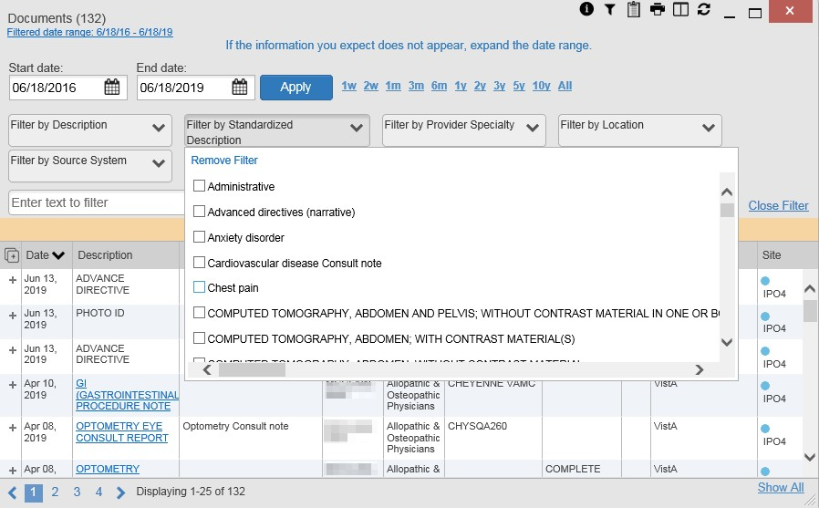

Some widgets also have the capability to configure data to display multiple records of the same type in a graph or table view.

### Widget Date Range Filters

Patient data displayed within a widget can be filtered by date range. If a date range filter is applied, the selected range is indicated in the widget header, below the title. Click the **Configure Filter** icon or the **Filtered Date Range** link on the widget toolbar to change the date range of the data displayed (Figure 37).

**Figure 37: Date Range Filters Applied**

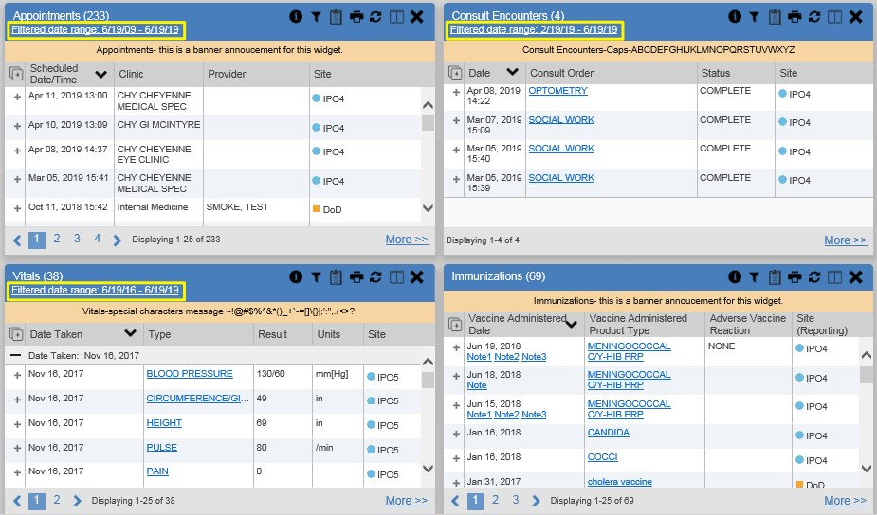

The two ways to filter the date range of data displayed in a widget are the **Quick Date Range** filter and the **Start and End Date** filter. If the expected information does not appear in the widget display, use the date filter options to change the date range.

Title: Information Icon - Description: Image of the information icon. **NOTE:** Changes made to the date range in a widget persist from minimized to expanded view, patient to patient, and session to session, until the widget is either removed or the date range is changed.

Image of the information icon. **NOTE:** When looking for Essentris information associated with a specific admission in the **Inpatient Summaries** widget, expand your search date ranges to include additional days before and after the admission. This includes pre-admission notes as well as notes signed after the patient was discharged in the filtered widget display.

#### Quick Date Range Filter

Use the preset, **Quick Date Range** filter to set or limit the display of patient records within a widget. This option is available by clicking the **Filtered Date Range** link or by clicking the **Configure Filter** icon Image of the Configure Filter icon. in a widget on the **Patient Portal**.

Clicking a **Quick Date Range** filter refreshes the data displayed to show only the records for the selected range. Selecting **Cancel**, which is the **Apply** button while the data refresh is running, stops the query. The options represent time counting back from the present day (for example,

selecting 2y displays only records within the last 2 years). Examples of preset date ranges include 1w (last 7 days), 6m (last 6 months), and 3y (last 3 years).

Image of the information icon. **NOTE:** The **Quick Date Range** filter is contextual. If today is February 2, 2017, the preset filter counts backwards using that date. If today is April 16, 2017, the preset filter counts backwards using that date.

Figure 38 highlights the **Quick Date Range** filter options in the expanded view of the

**Documents** widget.

**Figure 38: Quick Date Range Filter Options**

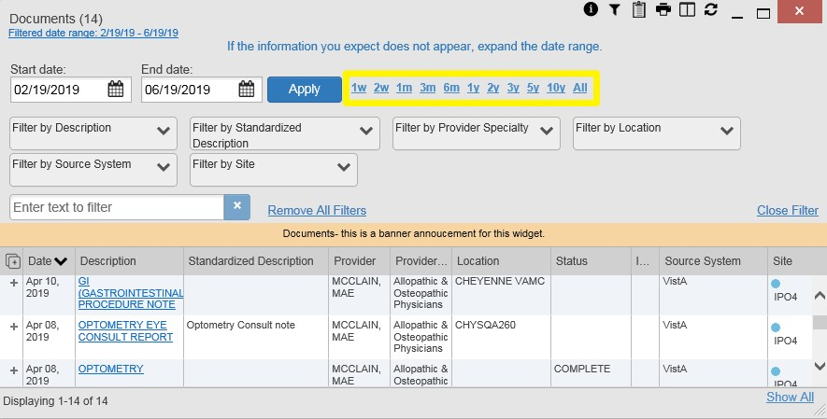

#### Start and End Date Filter

Use the **Start Date and End Date** filter to display data for a specific time range. The start and end date fields are available at the top of multiple widgets by clicking the **Filtered Date Range** link or the **Configure Filter** icon Image of the Configure Filter icon..

Image of the information icon. **NOTE:** The **Start and End Date** filter is static. If the start date is set to June 2, 2016 and the end date is set to June 2, 2017, the data in that date range displays, no matter what today’s date is.

Figure 39 provides an example of the start and end date filter fields in the expanded view of the

**Radiology Reports** widget.

**Figure 39: Start and End Date Display Filter**

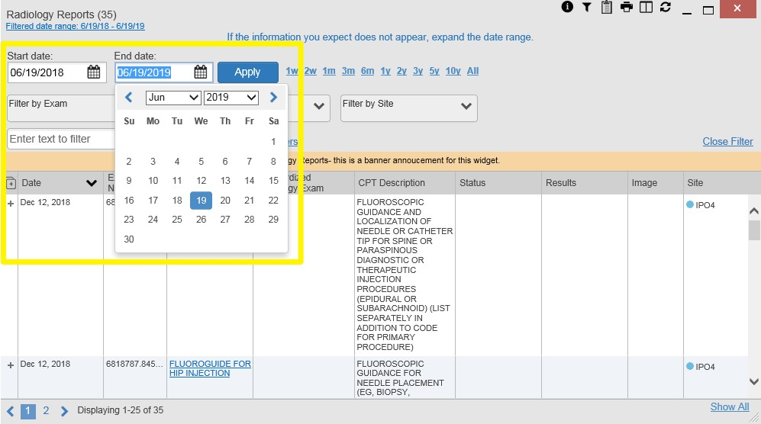

1. Click the **Calendar** icon Image of the calendar icon. next to **Start Date**
2. Select a month, day, and year start date for the display filter

Image of the information icon. **NOTE:** Prior day selections persist if you change only the month or year. If you change the month or year and the prior day value does not exist, the calendar will default to the last day of the new month. For example, changing only the month value of an existing August 31, 2018 entry to February would set the date to February 28, 2018 because there are less days in February. Similarly, if you had February 29, 2016 selected, a day which only exists in a leap year, switching the year to 2015 would set the date to February 28, 2015, the last day of the month in a standard year.

1. Click the **Calendar** icon Image of the calendar icon. next to **End Date**
2. Select the month, day, and year end date for the display filter
3. When both a start and end date have been chosen, click **Apply**
4. Click **Cancel** to stop the query

The widget refreshes and displays only the records that fall within the custom date range. The date range in use is displayed in the widget header.

#### Tab Date Range Tool

All tabs in the Screenshot of the Patient Portal icon **Patient Portal** have a **Tab Date** tool that you can use to filter all widgets on a single tab by the same date range. The **Tab Date** tool has the same **Start and End Date** and

**Quick Date Range** filters available on most individual widgets, but it applies the date filter to all widgets on an individual tab.

1. Select the **Show Date Tool** hyperlink in the upper right corner of a new or existing tab
2. Enter dates in the **Start Date** and **End Date** fields, and select the **Apply to All Widgets on This Tab** button -OR-
3. Select a **Quick Date Range** value in the **Tab Date** tool

The **Tab Date** tool (Figure 40) is hidden by default, and it hides again automatically after you apply a date filter to the tab. Should you decide not to apply a date filter to the tab, select the **Hide Date Tool** hyperlink to hide the tab-level date filters.

**Figure 40: Tab Date Tool**

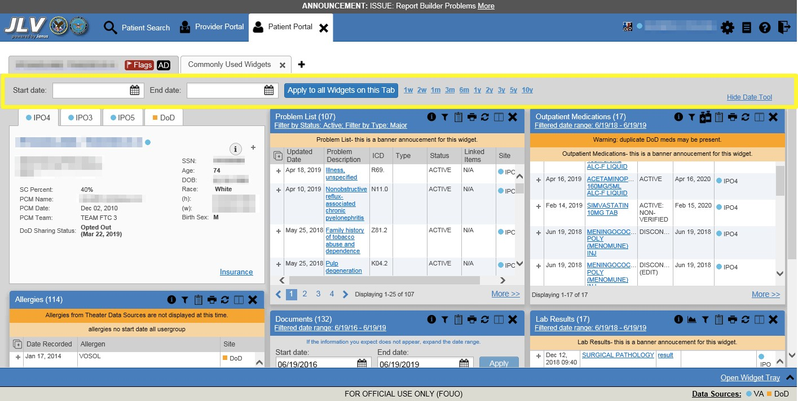

The **Tab Date** tool only filters widgets currently displayed on the active tab that support date range filtering. Widgets that display all data, without a date range, will continue to do so.

Filtering only applies to widgets on the tab at the time you apply the **Tab Date** tool and will not affect new widgets added to the tab. You may still apply widget-level date filters to individual widgets after using the **Tab Date** tool. All your widget date settings will save to your profile regardless of whether they were set with the **Tab Date** tool or widget-level date filters.

### Text Filter

Clinical data widgets on the **Patient** portal and the **Patient Flags and Postings** dialog box provide a text filter option (Figure 41), allowing you to quickly locate relevant patient data using keywords or characters. Text filters are performed on the information displayed in all columns within a widget, including hidden columns. Filters are not performed on notes, attachments, or details associated with patient records.

**Figure 41: Vitals Widget Text Filter**

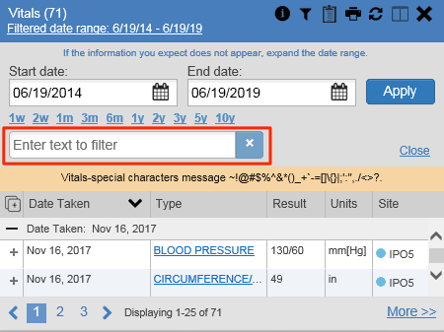

Click the **Configure Filter Image of the Configure Filter icon.** icon in the minimized view of a widget to display the **Enter text to filter** field. If the filter options are not displayed in the expanded view of the widget, clicking the **Configure Filter Image of the Configure Filter icon.** icon also opens the filter options. Keep in mind:

* Text filtering applies only to one widget
* Text is filtered within the subset of filtered data if a date range filter or other dropdown filters are applied within the widget
* Text filters are performed on data within all columns shown in the expanded view of the widget even if the term is entered in the text filter field of the minimized view
* Text filters entered in the minimized view of a widget persist when you open the widget in expanded view
* On widgets with site tabs, text filters entered on one site tab persist when you select other site tabs
* All records across the widget pages are filtered if the widget has multiple page views
* The **Enter text to filter** field is not case sensitive and allows up to 25 characters, including numeric and special characters
* JLV begins to filter when you pause while typing the term in the **Enter text to filter** field
* Text filtering is not available in the **Demographics** widget

## Viewing Connection Status

JLV widgets display the status of their connection to VA and DoD data sources. Connection status information is available for each widget.

Image of the information icon. **NOTE:** The Connection Status reports the condition of the connection between JLV and its external resources, while System Status reports the overall condition of the JLV application. See Viewing System Status for more information.

The **Connection Status** icon on a widget toolbar indicates the state of the connection to VA and DoD data sources. There are two status conditions:

• Title: All Sources Available Icon - Description: Image of the All Sources Available icon, a black circle with a white, lower case "i" in the center. all sources are connected (available)

• Title: One or More Sources Unavailable Icon - Description: Image of the One or More Sources Unavailable icon, a yellow triangle with a black excalamtion point in the center. one or more sources are not connected (unavailable)

Figure 42 shows a connection status indicator icon displayed on the **Documents** widget toolbar.

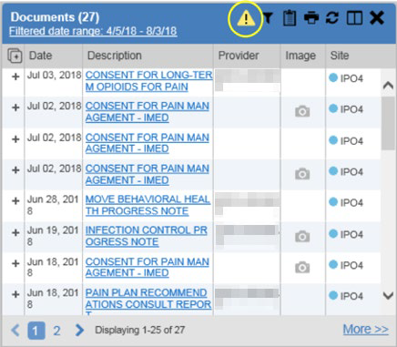**Figure 42: Connection Status Indicator**

Clicking a **Connection Status** icon (Figure 42) opens a standalone window with information about the connection to data sources. Clicking the **>Hide All Active Interfaces** link (Figure 43) in the **Connection Status** window hides the detailed **All Active Connections** view and displays only the connection errors.

**Figure 43: Connection Status Details**

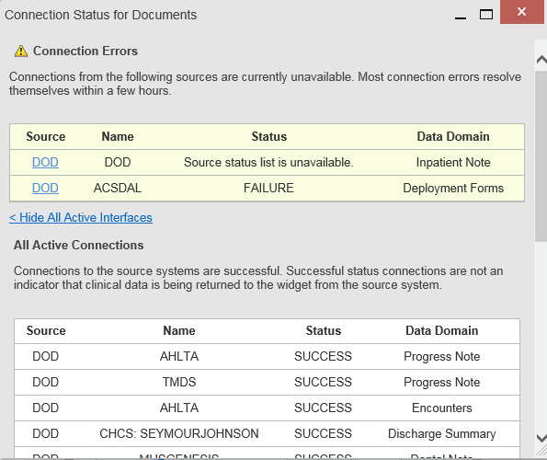

Clicking the **>Show All Active Interfaces** link in the **Connection Status** window (Figure 44) opens a **Connection Status Details** view (Figure 43).

**Figure 44: Connection Status Window**

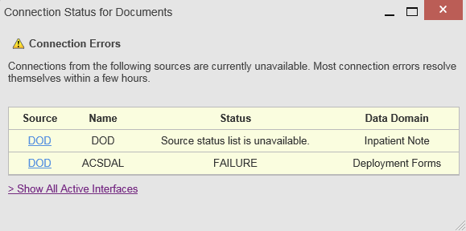

This message may display when you select the hyperlinked **Source** value in the **Community Health Summaries and Documents - VA** widget.

**Figure 45: Example of a Connection Error Message**

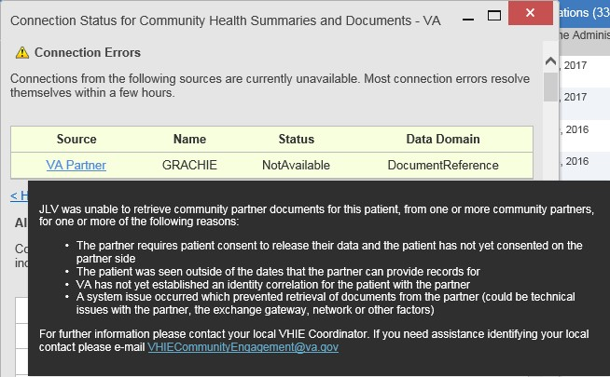

## Displaying Widgets on Custom Tabs

You can use the *custom tabs* feature to create additional widget configurations for ease of use and quick reference. Changes made to portal page layouts (widget layouts and custom tabs) are saved to your user profile and displayed in future sessions.

1. Click the plus sign + beside the existing tabs on the portal page (Figure 46)
   1. The **Add Tab** dialog box opens (Figure 47)

**Figure 46: Add Custom Tab Icon**

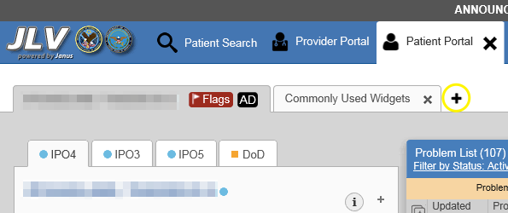

**Figure 47: Add Tab Dialog Box**

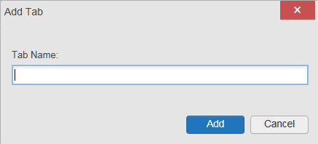

1. Type the name of the new tab in the **Add Tab** dialog box, and click **Add**
   1. The new tab opens with a blank workspace, with instructions on how to add widgets, and an open widget tray
2. Click, hold, and drag each of the desired widgets to the screen

Image of the information icon. **NOTE:** Tab configurations remain set until you manually change them or restore your profile to default in the **JLV Settings** dialog, which will remove all custom tabs.

1. Click between tabs at any time, without losing each tab’s configuration
   1. Tab layouts persist, even when a patient change is made
   2. Custom tabs can be renamed by double-clicking the tab name

## Refreshing Data in a Widget

The data displayed in a widget can be refreshed by clicking the **Refresh** icon Image of the Refresh icon.. This action retrieves data from VA and DoD sources and refreshes the individual widget’s display.

## Terminology Normalization

**Figure 48: Terminology Specific to Widgets**

|  |  |  |
| --- | --- | --- |
| **Normalization Standard** | **Description** | **Widgets** |
| **Centers for Disease Control (CDC) Race Standard** | Code set based on the current Federal standards to classify race and ethnicity | Patient Demographics |
| **Current Procedural Terminology (CPT) Standard** | Uniform code to describe medical, surgical, and diagnostic services | Procedures, Radiology Reports4 |

4 If LOINC mappings are not available for an entry in the Radiology Reports widget, JLV looks for CPT mappings and displays CPT normalization for standardized type and standardized code, if found.

|  |  |  |
| --- | --- | --- |
| **Normalization Standard** | **Description** | **Widgets** |
| **Vaccine Administered (CVX) Standard** | Numeric string that identifies the type of vaccine product used | Immunizations |
| **Logical Observation Identifiers Names and Codes (LOINC) Standard** | Universal standard for identifying health measurements, observations, and documents | Documents, Lab Results, Orders, Progress Notes, Questionnaires and Deployment Assessments, Radiology Reports, Vitals |
| **National Uniform Claim Committee (NUCC) Taxonomy Standard** | Unique, 10-character alphanumeric code that identifies a provider grouping, classification, and area of specialization | Admissions, Appointments, Consult Encounters, Documents, Inpatient Medications, Inpatient Summaries, Orders, Outpatient Encounters, Outpatient Medications, Procedures, Progress Notes |
| **RxNorm Standard** | Standard names given to allergens, clinical drugs, and drug delivery devices in the United States | Allergies, Inpatient Medications, Orders, Outpatient Medications |
| **SNOMED CT**  **Standard** | Core, general terminology used in electronic health records | Admissions, Outpatient Encounters, Problem List |
| **X12 Health Insurance Type Standard** | Defines electronic data interchange standards for health care insurance | Patient Demographics |

## VistA Imaging Viewer

JLV integrates access to the VistA Imaging Viewer (an external application), allowing you access to VA imaging artifacts for supported clinical domains (widgets). You can open an instance of the VistA Imaging Viewer through JLV. Please see the [VistA Imaging SharePoint](http://vaww.oed.portal.va.gov/applications/VistAImaging/default.aspx) [site](http://vaww.oed.portal.va.gov/applications/VistAImaging/default.aspx) for more information regarding the VistA Imaging Viewer.

A **Camera** icon Image of the camera icon. displayed in the **Image** column (Figure 49) of the **Documents**, **Outpatient Encounters**, **Procedures**, **Progress Notes**, **Radiology Reports**, and **Surgery/Procedure Reports** widgets indicates that one or more images are associated with that record. Clicking the **Camera** icon Image of the camera icon. within the widget opens the VistA Imaging Viewer in a standalone window and displays the associated image.

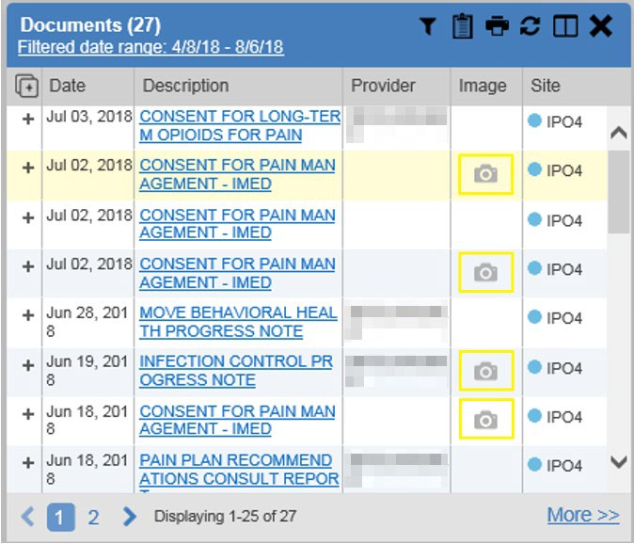**Figure 49: Camera Icon in the Image Column**

If a record has one or more images associated with it, the **Details** view of the record includes a display of a thumbnail in the top-right corner of the window (Figure 50). Below the thumbnail, the **Click image to open viewer** link is also displayed. Clicking either the thumbnail or the link opens the VistA Imaging Viewer and displays the associated image(s).

**Figure 50: Thumbnail and Link in Details View of the Documents Widget**

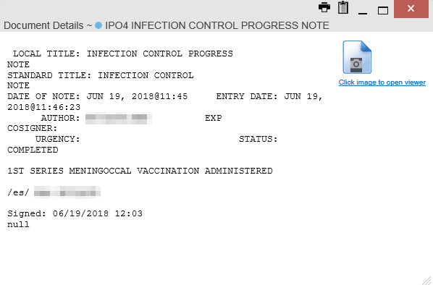

## Using Report Builder

The **Report Builder** feature is used to create custom PDF reports using patient data and records displayed in JLV widgets. Content for reports can be selected from either the minimized or

expanded view of a supported widget. **Report Builder** is accessed from the toolbar in the upper right corner of the **Patient Portal** (highlighted in Figure 51).

**Figure 51: Report Builder Icon**



The **Report Builder** pane is comprised of the **Current Report** tab (Figure 52) and the **Patient Reports** tab (Figure 53). When open, the **Report Builder** appears over the left side of the JLV portal window. Click the left (collapse) Image of the previous page navigation icon. or right (expand) Image of the go to next page navigation icon. arrow buttons to collapse or expand the **Report Builder**. Any report configurations in progress are saved when collapsing or closing the Report Builder and restored when the Report Builder is displayed again.

The **Current Report** tab (Figure 52) is used to build the custom report. The patient data and/or records are listed here as you select and add them. The records can be previewed and can be arranged in the desired order for the final report.

**Figure 52: Current Report Tab**

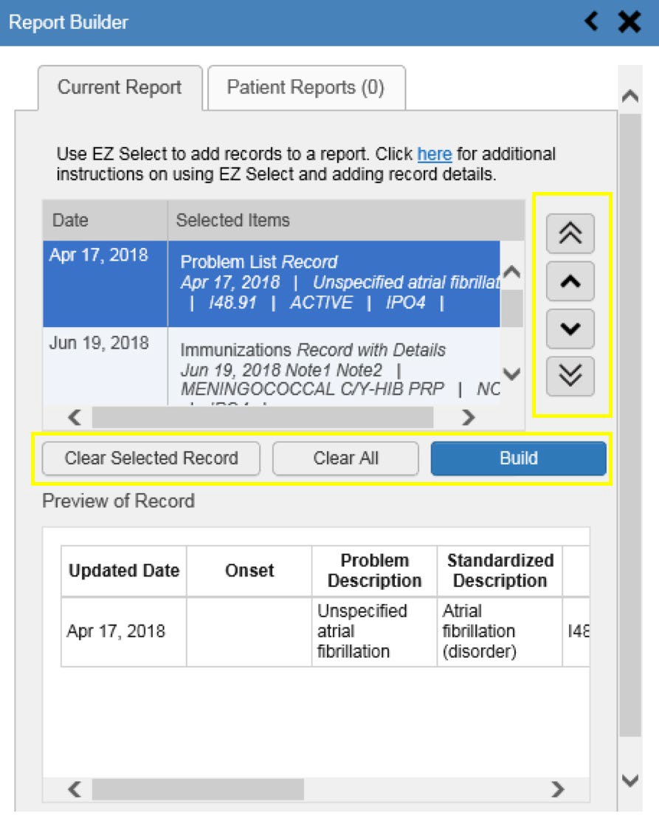

The **Patient Reports** tab (Figure 53) presents a list of all completed reports, the status of the report generation progress, the date the report expires, and a hyperlink to the contents of the completed report.

**Figure 53: Patient Reports Tab**

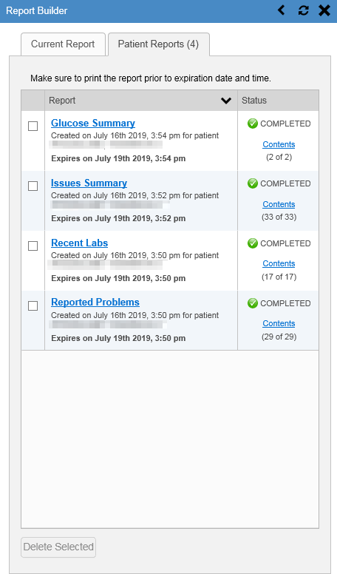

You can perform actions within widgets to add patient data when the Report Builder is open or closed. JLV enforces a maximum number of 50 records per report. A message appears when this limit is reached.

### Adding Multiple Records with EZ Select

EZ Select allows you to add all records displayed on a single page of a single widget to the Report Builder with one click. Click the **Select All Image of Report Builder's Select All icon** icon at the top of the left column (Figure 54) to add data from all records shown in the widget's page display to the Report Builder,

including the details and notes associated with the record. EZ Select is available from the minimized and expanded views as well as the **Patient Flags and Postings** dialog box.

Image of the information icon. **NOTE:** Sensitive records cannot be added using EZ Select and must be added one at a time.

**Figure 54: Report Builder EZ Select**

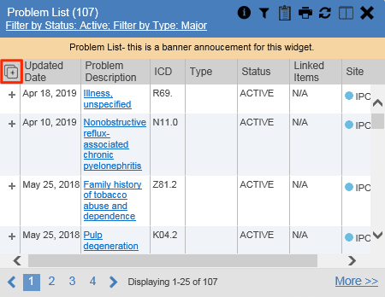

The **Add to Report Builder** icon in each row changes to the **Added to Report Builder Image of the Added to Report Builder icon**

icon to confirm the record has been added (Figure 55).

**Figure 55: Records Added to Report Builder**

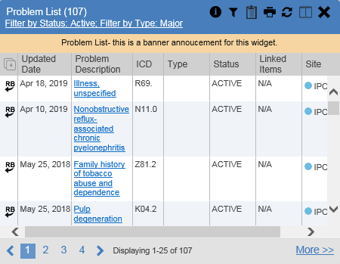

Image of the information icon. **NOTE:** Records previously added to a report remain in the Report Builder after a widget refresh. Clicking **Refresh Image of the Refresh icon** in the widget re-pulls clinical data, refreshes the widget data display, and resets the state of the Image of the Added to Report Builder icon icon in the left column to the **Add to Report Builder Image of the Add Record icon.** icon, even if the record has been added to the Report Builder.

### Adding Sensitive Records

Sensitive records can be added to the Report Builder by clicking the **Add to Report Builder** icon next to the item in the widget. When prompted, click **Agree to be Audited & Access This Sensitive Record** to continue. The **Add to Report Builder** icon in the row changes to the **Added to Report Builder Image of the Added to Report Builder icon** icon to confirm the record has been added (Figure 55). Sensitive records must be added to the Report Builder individually; therefore, repeat as necessary for additional sensitive items.

### Adding One Record

Click the **Add to Report Builder** icon next to a record in a widget to add data from that record to the Report Builder, including the details and notes associated with the record. The **Add to Report Builder** icon in the row changes to the **Added to Report Builder Image of the Added to Report Builder icon** icon to confirm the record has been added to the Report Builder (Figure 55). This applies to both minimized and expanded widget views and the **Patient Flags and Postings** dialog box.

### Adding Only Record Details or Notes

When adding records to a report using the EZ Select **Select All Image of Report Builder's Select All icon** icon or the **Add to Report Builder** icon in the widget, JLV by default adds the data displayed in the widget as well as any details and notes associated with the record. This applies to both minimized and expanded widget views and the **Patient Flags and Postings** dialog box. If you would like to add just the details and notes or the record row data:

1. Select and hold the **Add to Report Builder** icon to access these options (Figure 56)
2. Select **Add Detail** or **Add Note** to add the details and/or notes associated with the record as well as the record row data to the Report Builder
3. Select the **Add Record Row** option to add only the data displayed in the widget display for that record and not the information provided in the details and/or notes

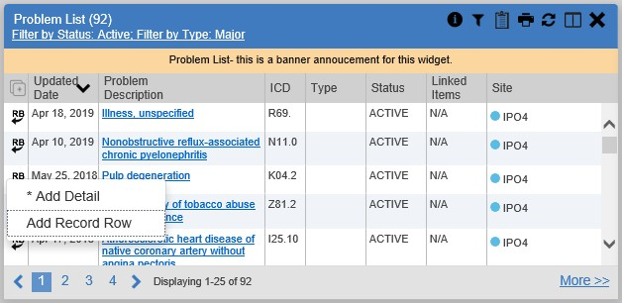**Figure 56: Report Builder Options**

Image of the information icon. **NOTE:** Once you add a record to Report Builder using either the **Add to Report Builder** icon, **Add Detail/Note,** or **Add Record Row** option, you cannot change the record data included in the report without first clearing the record from the report and adding it again.

### Adding Patient Demographics

Clicking the **Add to Report Builder** icon in the top-right corner of the **Demographics** widget (Figure 57) adds the patient's demographics details for that site to the Report Builder. The **Add to Report Builder** icon changes to the **Added to Report Builder Image of the Added to Report Builder icon** icon to confirm the demographics data has been added. Click additional site tabs within the **Demographics** widget and repeat as desired to add demographics details from other sites within the patient's health record.

**Figure 57: Demographics Widget Add to Report Builder Icon**

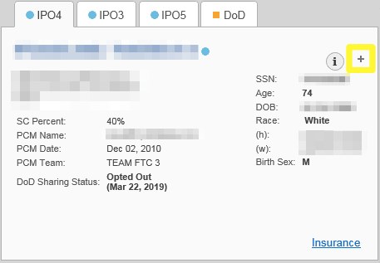

### Generating a Report

The selected records appear in the **Report Builder** pane (Figure 52).

1. Use the navigation arrows to the right of the listed records to arrange the records in the desired order in the generated report
   1. Records can be removed by clicking **Clear Selected Record** or **Clear All**
2. When a record is selected for the report, it appears in the **Preview of Record** area of the

**Report Builder** pane

1. Click **Build** to validate the selected records and prepare the report
   1. If a record is added to the report without an error, a **Ready** notation displays next to it in the **Status** column
   2. If a record cannot be added to the report, an **Error** notation appears next to the record
2. Name the report when prompted and click **OK** (Figure 58)

**Figure 58: Name Report Dialog Box**

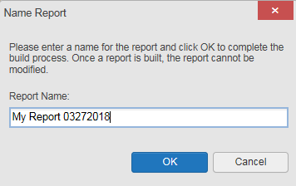

1. The **Patient Reports** tab opens and displays a report processing indicator in the **Status**

column

1. When processing is complete, the **Status** column displays either *COMPLETED* or *ERROR*

(Figure 59)

* 1. An *ERROR* in the **Status** column does not indicate the report failed to build, it is an indicator that one or more records could not be included in the generated report
  2. Both the *COMPLETED* and *ERROR* entries include a **Contents** link (Figure 59), which provides a list of the records that appear in the generated report

**Figure 59: Patient Reports Tab Report Ready and Delete Option**

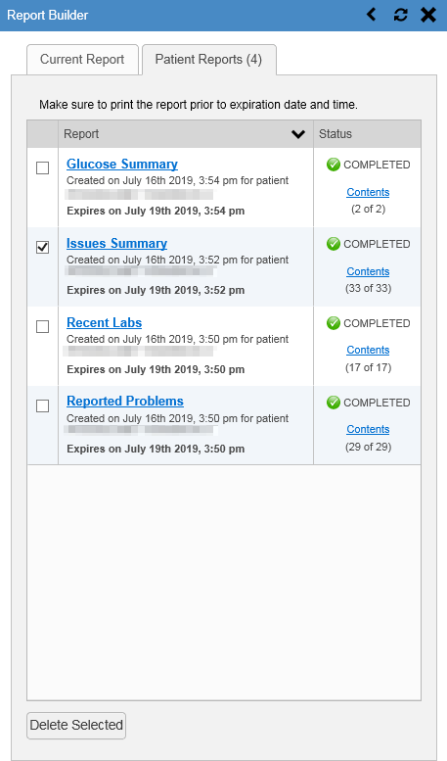

* 1. A report ready message appears for 6 seconds on the portal page when the report has been built and is ready to be printed (Figure 60)
  2. A red icon (Figure 60) appears over the **Report Builder** icon when report builder is closed to indicate that a report is ready to be printed

**Figure 60: Report Ready Message and Indicator**

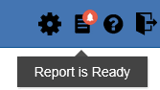

Image of the information icon. **NOTE:** Once a report is created, it is available on the Patient Reports tab for 72 hours. After 72 hours, the report expires, is removed from the Patient Reports tab, and can no longer be accessed.

### Opening a Report

1. Click the report name in the **Report** column of the **Patient Reports** tab (Figure 59) -OR-
2. Click the **Contents** link in the **Status** column of the **Patient Reports** tab to open a list of the records included in the report in the **Report Contents** window (Figure 59) -OR-
3. Click the blue, hyperlinked report name in the **Report Contents** window (Figure 61)

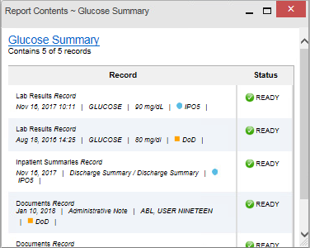**Figure 61: Report Contents Window**

Image of the information icon. **NOTE:** The Report Builder prints the report content to a file in PDF format. It is recommended that you have the latest Adobe Reader installed on the system from which you access JLV to utilize the Report Builder and other JLV features.

### Delete a Report

1. Select the checkbox to the left of the report name on the **Patient Reports** tab (Figure 59)
2. Click the **Delete Selected** button
3. Click **OK** to confirm deletion (Figure 62)

**Figure 62: Delete Reports Dialog Box**

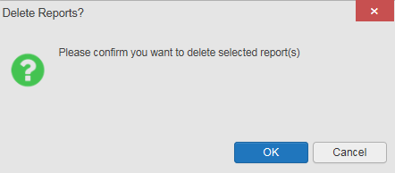

## Printing

The data list of a widget in either minimized or expanded view, the details window of a widget, and reports created in **Report Builder** can be printed.

* Click the **Print** icon Image of the Print icon. on the desired widget’s toolbar to print the data list of a widget in either minimized or expanded view
* Click the **Print** icon Image of the Print icon. on the details window’s toolbar to print the details window of a widget
* Click the (PDF) **Print** icon within the report window to print a report created in **Report Builder**

Image of the information icon. **NOTE:** Each report generated using **Report Builder** includes this disclaimer: “*The information contained in this transmission may contain privileged and confidential information, including patient information protected by federal and state privacy laws.”*

# Widget Functionality

The following subsections detail the functionality in a sampling of the widgets available in JLV.

## Patient Demographics Widget

The **Patient Demographics** widget displays a summary of the patient’s non-clinical, personal data. The widget appears in the upper left section of the **Patient Portal** (Figure 63). The tabs above the patient’s name provide a demographics summary for each site (VA or DoD) the patient has visited.

**Figure 63: Patient Demographics Widget**

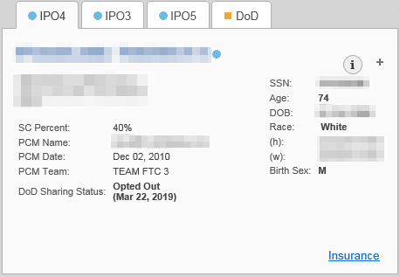

The **Patient Demographics** widget provides additional functionality:

* Clicking the patient's name opens details in a standalone window
* Clicking a **Connection Status** icon Image of the Sources Available icon, a black circle with a white, lower case "i" in the center. Image of the Warning icon, a yellow triangle with a black exclamation point in the center. opens the connection status details in a separate window
* Clicking the **Flags** icon above the tabs in the widget opens clinical flag details in a new window
* Clicking the Image of the Advanced Directives icon icon above the tabs in the widget opens the **Advance Directives** dialog in a new window

A **Warning** icon Image of the Warning icon, a yellow triangle with a black exclamation point in the center. that displays on one or more tabs within the **Demographics** widget is an indication that the patient is not registered at that VA site or DoD facility.

### Patient Flags and Alerts

If the patient has one or more clinical warnings, alerts, or flags in their record from VA and DoD sites, the **Flags** icon is displayed next to the **Patient Name** tab, above the **Demographics** widget, on the **Patient Portal** (Figure 64).

The **Patient Flags and Postings** window opens and displays by default when the **Patient Portal**

opens if there are warnings associated with the selected patient.

**Figure 64: Patient Flags Indicator**

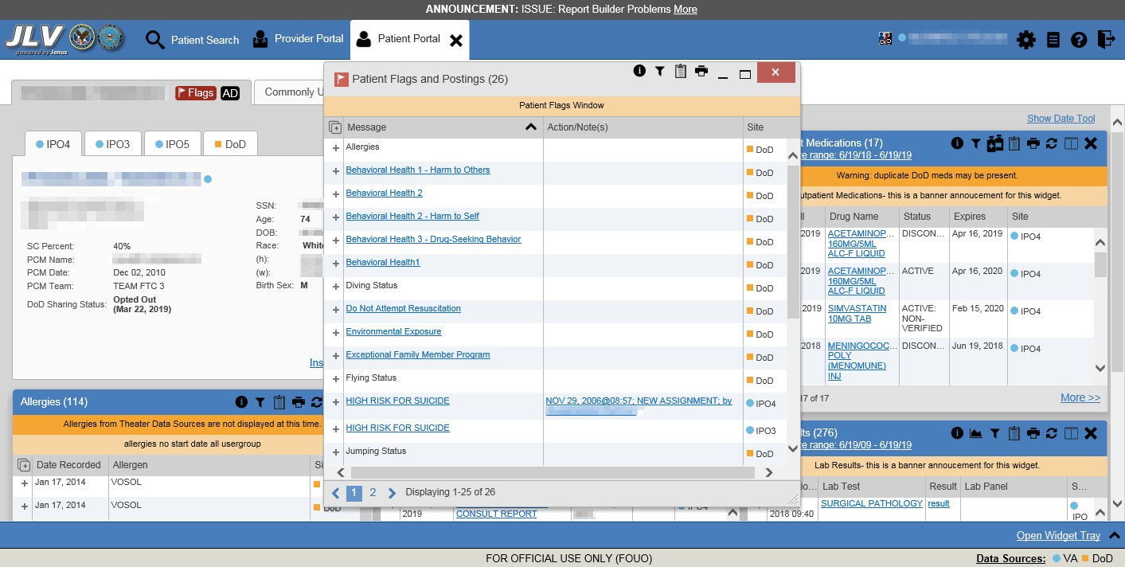

Click the **Flags** icon to open the **Patient Flags and Postings** window (Figure 64). The window displays a list of alerts and flags within the patient’s record. Selecting the hyperlinked message for each patient alert opens the Flag Details window (Figure 65). Selecting the **Note** link (Figure 64) will open documents pertaining to placement of the flag. If the patient’s record does not contain any clinical warnings, the **Flags** icon is not displayed.

**Figure 65: Patient Flags and Postings Details**

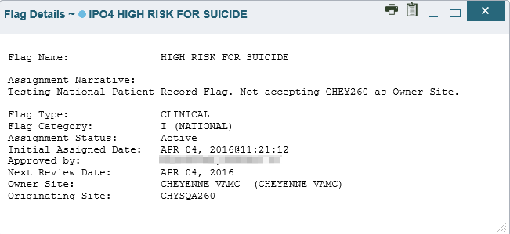

### Advance Directives

You can view Advance Directives (Figure 66) by selecting the Image of the Advanced Directives icon icon on **Demographics**

widget. Advance Directives are pulled from DoD and VA data sources. The Image of the Advanced Directives icon icon changes if

it is loading Screen shot of the Advance Directives Loading icon or may be greyed out Screen shot of the Advance Directives icon, greyed out, indicating that there are no Advance Directives for the patient. if no Advance Directives were found for the patient.

**Figure 66: Advanced Directives Dialog**

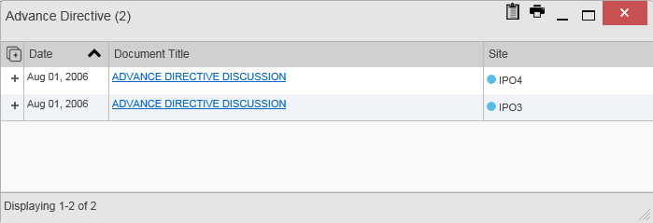

### Viewing Third-Party Insurance Information

Third-party payers and insurance information is available from the **Patient Demographics** widget. Click the **Insurance** link in the **Demographics** widget. A new window opens with the following insurance information, some of which is displayed in Figure 67:

* Health Plan Type
* Health Plan Name
* Standardized Insurance Type (See Terminology Normalization for more information.)
* Plan Effective Date
* Plan Expiration Date
* Site
* Group Number
* Member ID
* Subscriber ID
* RxBIN
* RxPCN
* Notes
* Comments
* Subscriber Date of Birth
* Subscriber’s Relationship to Insurer
* Health Plan Mailing Address
* Health Plan Contact Information

**Figure 67: Insurance Information**

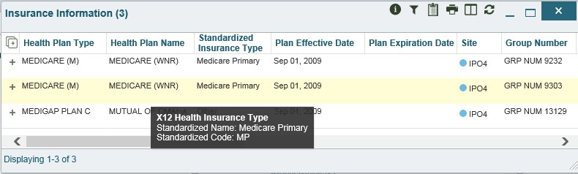

Use the horizontal scroll bar in the window to view the columns not seen within the default window size.

## Documents Widget

The Image of the icon representing the Documents widget. **Documents** widget (Figure 68) includes documents from multiple clinical domains, including radiology reports (exams), progress notes, outpatient encounters, consult encounters, discharge summaries (inpatient notes), questionnaires, and Health Artifact and Image Management Solution (HAIMS) records. HAIMS records retrieved by JLV include scanned paper records, imported paper records, scanned non-radiology images, and imported non- radiology images, displayed in reverse chronological order by the document date.

**Figure 68: Documents Widget, Minimized View**

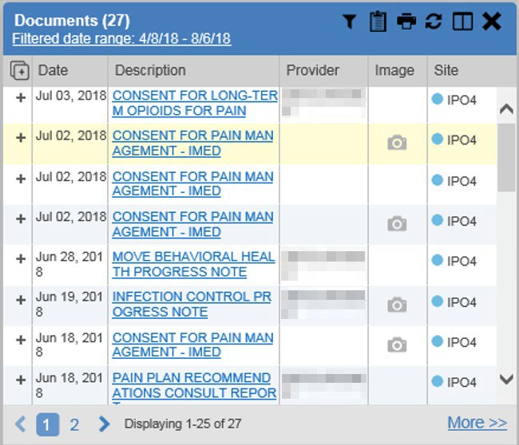

### Documents Widget Data

The minimized view of the **Documents** widget displays the following information:

* Date
* Description
* Provider
* Image (See VistA Imaging Viewer)
* Site

Outpatient encounter records displayed in the **Documents** widget may have a **Details** link enabled in the **Date** column. Where available, click the link to open a **Details** window for records of this type.

Click **More >>** in the minimized view of the **Documents** widget to open the expanded view (Figure 69). Information in expanded view includes:

* Date
* Description
* Standardized Description
* Provider
* Provider Specialty
* Location
* Status
* Image
* Source System
* Site

**Figure 69: Documents Widget, Expanded View**

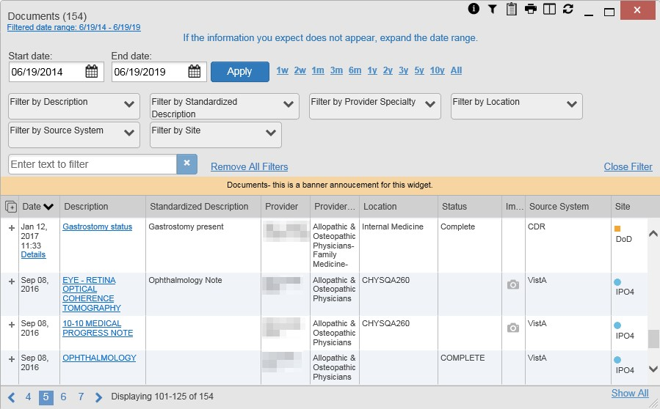

### Viewing Documents

Click a hyperlinked entry in the **Description** column in either the minimized or expanded view of the **Documents** widget to access additional information for a listed record. Depending on the record type, the additional information may open in either a **Details** window or a separate browser window. Figure 70 displays outpatient encounters details, accessed through the **Documents** widget.

**Figure 70: Details View of a Document**

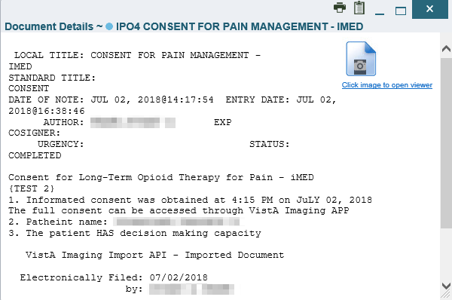

## Community Health Summaries and Documents - VA

The Image of the icon representing the Community Health Summaries and Documents - VA widget. **Community Health Summaries and Documents - VA** widget displays the patient’s VA VHIE community partner information, including Continuity of Care Documents (CCDs) in C32 and C62 formats and HL7 Consolidated-Clinical Document Architecture (CCDA) structured documents available for the patient. The information in this widget is sorted by the title of the entry listed in the **Document** column.

Image of the information icon. **NOTE:** CAPRI-Claims users cannot see the **Community Health Summaries and Documents - VA** widget.

### Community Health Summaries and Documents - VA Widget Data

Data displayed within the **Community Health Summaries and Documents - VA** widget includes:

* Date
* Document
* Source

The purple hexagon beside entries in the **Source** column denotes the source of the data is outside the VA. The widget displays all data available 150 years into the past and 1 year into the future.

**Figure 71: Community Health Summaries and Documents - VA, Minimized View**

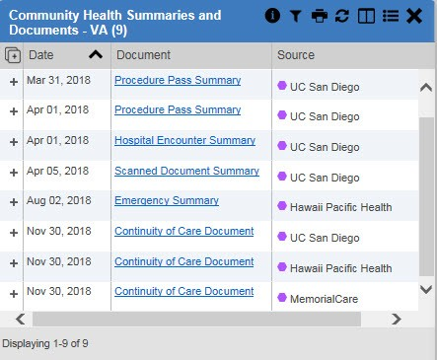

The **Site List** icon Image of the Site List icon. on the toolbar in the **Community Health Summaries and Documents - VA** widget (Figure 71) generates a list of community sites where the patient has been seen.

Click the **Site List** icon Image of the Site List icon. to open the full list of community sites where the patient has been seen. The site list content is gathered from the widget's **Source** column and the sites where the patient was seen but no document was generated. Click **Close Site List** to remove the full site list from the widget display.

### Viewing VA Community Health Summary Documents

The **Community and Health Summaries and Documents - VA** widget is rendered only in minimized view. Instead of an expanded view, the selected document opens in a new browser window (Figure 72).

Figure 71 shows health summary records available from the **Document** column in the **Community Health Summaries and Documents - VA** widget. Clicking a hyperlinked entry in the **Document** column opens the document in a separate browser tab (Figure 72).

Image of the information icon. **NOTE:** Multiple documents can be opened in separate browser tabs for simultaneous viewing and printing.

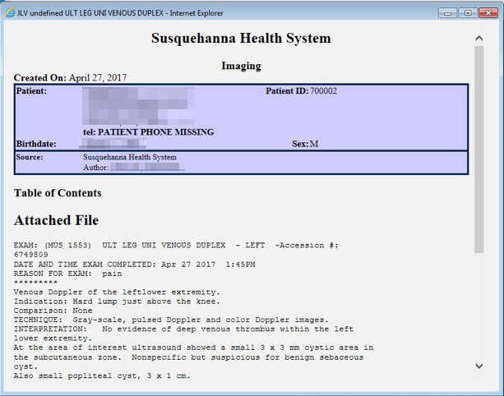**Figure 72: Community Health Document**

## Health Summaries and Reports – VA Only Widget

### Health Summaries and Reports – VA Only Widget Data

The Image of the Health Summaries and Reports - VA Only icon **Health Summaries and Reports – VA Only** widget displays the patient's national and local health summaries from VA sites where the patient has been registered, including the Medication Administration History (MAH), Medication Administration Log (MAL),

Cytopathology, Surgical Pathology, Lab Summary—Cumulative, and Blood Bank reports. This widget is available to VA users only. Click the **Health Summaries and Reports – VA Only** icon from the widget tray that appears at the bottom of the Patient Portal, drag the icon to the screen, and drop it where desired on the portal to open the widget.

JLV sorts records by **Site** by default. If a patient has national health summaries, JLV displays records of National type at the top of the widget. National records are named in the **Site** column in the minimized view and in the **Type** and **Site** columns in the expanded view. The widget also presents report data within last 14 days by default, but you can adjust the date range.

The **Description** column displays the document title, where available. Click a hyperlinked entry in the **Description** column in either the minimized or expanded views of the widget to open the document.

Information in the minimized view of the **Health Summaries and Reports – VA Only** widget (Figure 73) includes:

* Description
* Site

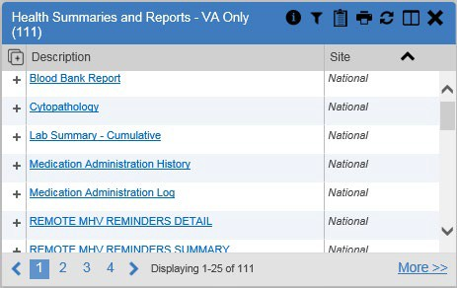**Figure 73: Health Summaries and Reports - VA Only Widget, Minimized View**

Click **More >>** from the minimized view of the **Health Summaries and Reports – VA Only** widget to open an expanded view of the widget. Information in the expanded view (Figure 74) includes:

* Description
* Type
* Site

**Figure 74: Health Summaries and Reports - VA Only Widget, Expanded View**

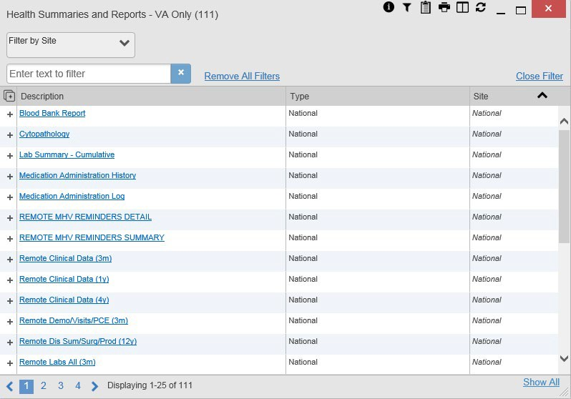

### Viewing Health Summaries

Click a hyperlinked entry in the **Description** column of either the minimized or expanded view of the **Health Summaries and Reports – VA Only** widget to view additional information for the record. This widget is available to VA users only.

The following example displays a health summary record exported from a single, local site.

**Figure 75: Health Summary from a Single, Local Site**

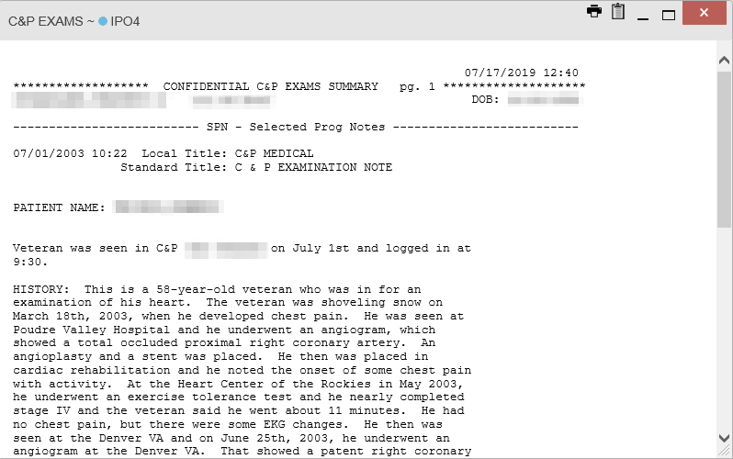

The following is an example of JLV's display of a national health summary. Within the window, tabs represent the VistA sites where the patient is registered. Click each tab to view patient records for that site.

**Figure 76: National Health Summary, Multiple Sites**

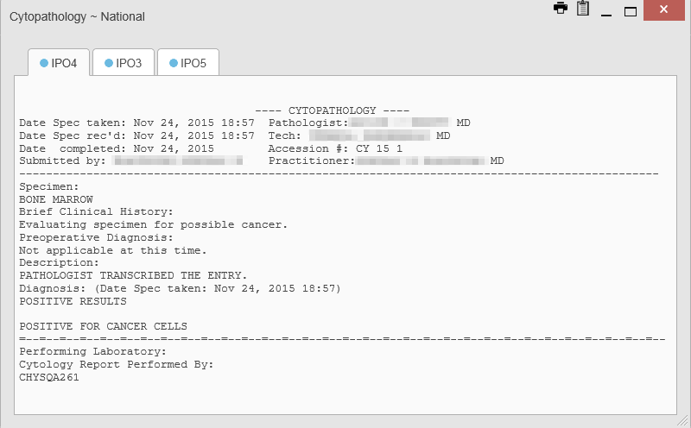

## Lab Results Widget

### Lab Results Widget Data

The Screenshot of the Lab Results widget icon **Lab Results** widget displays the patient’s lab results information, as well as skin test data and blood transfusion history where available in the patient’s record. The information is displayed in reverse chronological order by collection date. Labs data received by DoD sources that include a sensitive flag are masked in the widget views and access to this data is subject to auditing.

The lab results information in the minimized view of the **Lab Results** widget includes:

* Collection Date
* Lab Test
* Result
* Lab Panel
* Site

Click **More >>** from the minimized view of the **Lab Results** widget to open the expanded view (Figure 77). The lab results information in the expanded view includes:

* Collection Date
* Specimen Source
* Lab Test
* Result
* Interpretation
* Units
* Ref Range
* Lab Panel
* Type
* Order Number
* Ordering HCP
* Status
* Site

Image of the information icon. **NOTE:** While the **Standardized Lab Test** and **Ordering HCP Specialty** columns are not listed by default, you may add them to the expanded view by selecting their corresponding checkboxes in the Screenshot of the Column Settings icon **Column Settings**.

**Figure 77: Lab Results Widget, Expanded View**

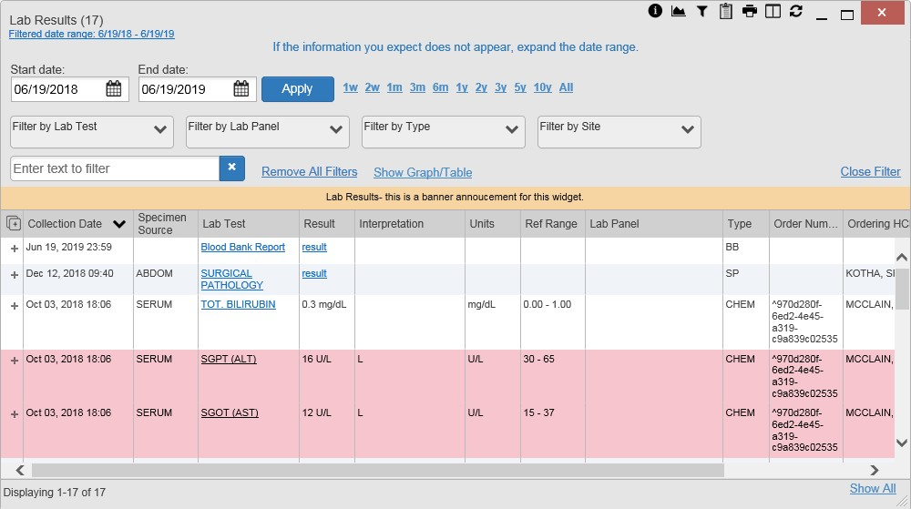

The following lab test abbreviations are used in the **Type** column of the expanded view. Hovering over an entry in the **Type** column displays the full lab type name.

* CHEM for CH, COAG, HEM, HE, TOX, RIA, SER, and SEND
* MICRO for MI, MICROBIOLOGY, and BACT
* AP for ANATOMIC PATHOLOGY
* EM for ELECTRON MICROSCOPY
* SP for SURGICAL PATHOLOGY
* ST for SKIN or SKIN TEST
* CY for CYTOLOGY
* AU for AUTOPSY
* BB for BLOOD BANK
* H.I.V for HIV

### Viewing Lab Results Details

Clicking a hyperlinked entry in the **Lab Test** column of the **Lab Results** widget opens a separate window containing a report of the record (Figure 78).

**Figure 78: Lab Results Details**

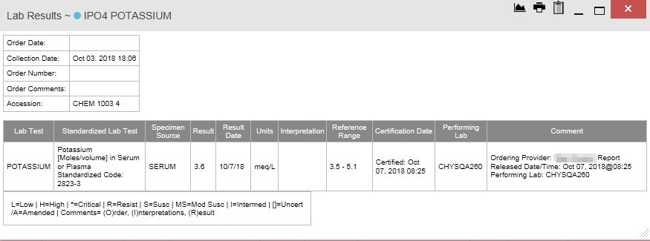

### Viewing Lab Panel Results Details

Clicking a hyperlinked entry in the **Lab Panel** column of the **Lab Results** widget opens a separate window containing a detailed lab panel report (Figure 79).

**Figure 79: Lab Panel Results Detail**

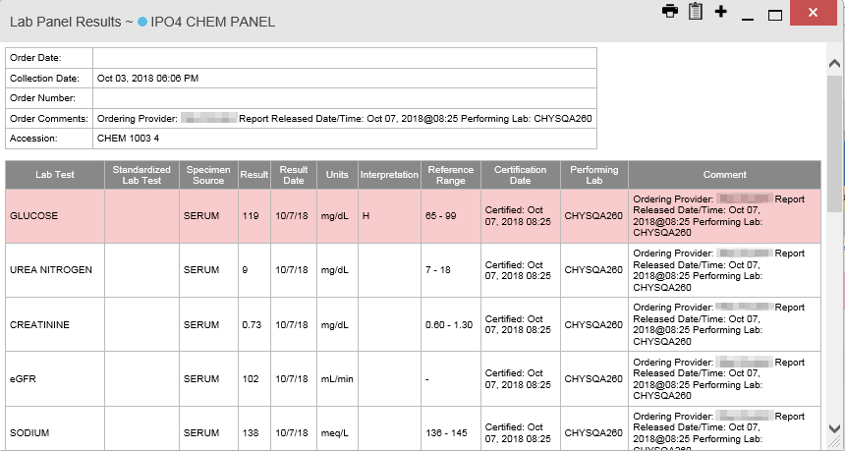

### Viewing Abnormal Results in the Lab Results Widget

JLV highlights the row for that record in the minimized and expanded views of the widget for records in the **Lab Results** widget where result values fall within a calculated reference range for abnormal.

Pink highlighting represents an abnormal result (i.e., high (H) or low (L)). Red highlighting represents that the abnormal indicator has an asterisk (i.e., H* or L*) or the result is critical.

Examples of records with abnormal results are shown in the expanded view of the **Lab Results**

widget in Figure 80.

**Figure 80: Lab Results Widget, Abnormal Results in Expanded View**



### Viewing Results and Interpretations in the Lab Results Widget

JLV displays links in the **Result** and **Interpretation** columns in the expanded views of the widget to indicate additional information is available for records in the **Lab Results** widget where result values and interpretation are available in a record. Figure 81 highlights multiple result and interpretation links within the widget.

**Figure 81: Lab Results Widget, Expanded View, Interpretations Available**

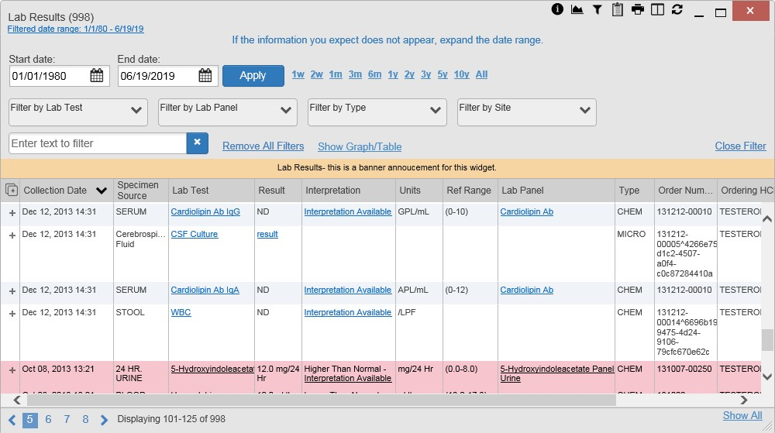

Figure 82 displays an example lab interpretation accessed by clicking a link in the **Interpretation** column. The contents of the window may vary depending on the lab type and what is contained in the patient record.

**Figure 82: Lab Results Interpretation Details**

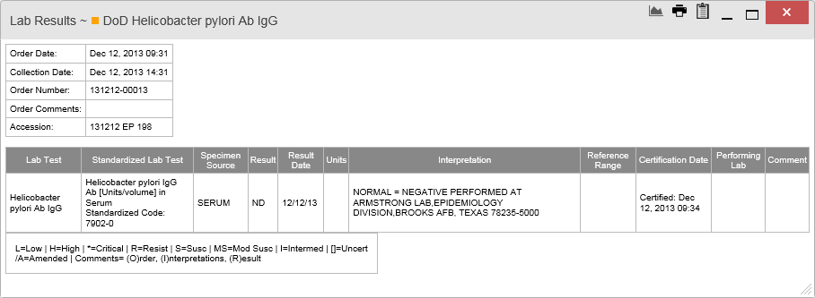

### Graph/Table View from the Lab Results Widget

The **Lab Results** widget provides the option to display multiple results for the same lab test in a graph and table.

1. Select the Screenshot of the Graph icon **Graph** icon from the widget toolbar in either minimized or expanded view **-OR-**
2. Click **More >>** from the minimized view of the **Lab Results** widget to open an expanded view of the widget, then select the **Show Graph/Table** link
3. Select a value from the **Select a Lab Test** dropdown in the **Lab Results Graph/Table** dialog
   1. The graph displays with corresponding table values beneath
4. Select the **Show Labels** checkbox to toggle data labels on or off in the graph
5. Select the **Close** button to exit **Graph/Table** view and return to the minimized or expanded view of the **Lab Results** widget

Figure 83 displays an example **Graph/Table** view of the lab test results.

**Figure 83: Lab Results Graph/Table View**

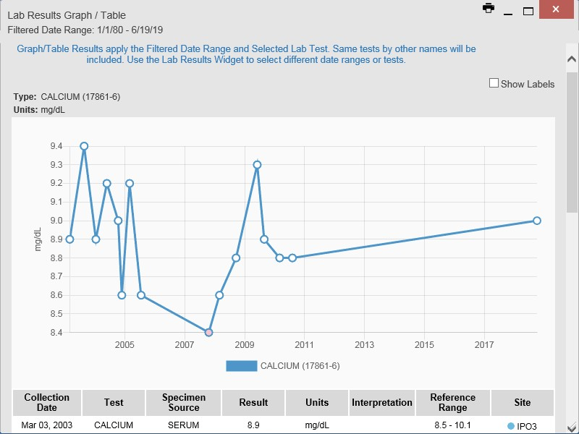

In the expanded view of the Lab Results Widget, selecting one or more values in the **Filter by Lab Test** dropdown will disable all other filter dropdowns until the filtered selections are removed. The lab test values in the **Filter by Lab Test** dropdown dynamically increase or decrease depending on the date filter criteria you apply. Tests with the same LOINC code (shown in parentheses following the lab test name) as the ones selected will be automatically included in the filtered results displayed in the widget.

You may only use the graph/table feature for a single lab test LOINC value. All lab tests with the same LOINC will be graphed even if the lab test names differ. While you can select multiple lab test values in the **Filter by Lab Test** dropdown, you will be forced to select a single lab test value from the **Select a Lab Test** dropdown in the **Lab Results Graph/Table** dialog (Figure 84) once you select either the **Graph** icon or the **Show Graph/Table** link. The lab test values in the **Select a Lab Test** dropdown also dynamically increase or decrease depending on the filter criteria applied in the **Lab Results Widget**.

**Figure 84: Lab Results Graph Table View, Select a Lab Test**

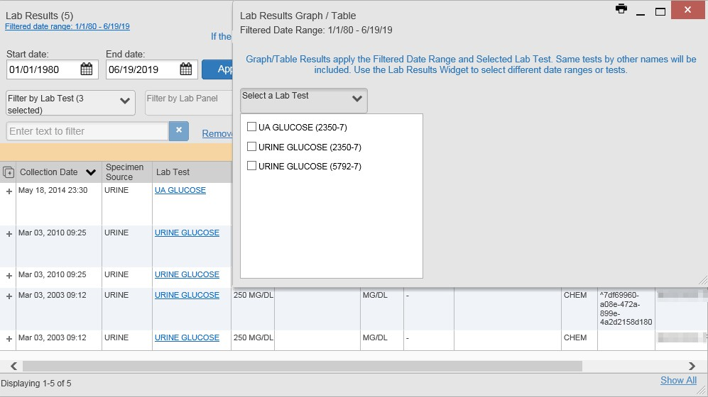

You may also generate a graph for all lab tests with the same LOINC code by selecting the

Screenshot of the Graph icon **Graph** icon from the **Lab Results Details** view (Figure 78).

## Military Health System (MHS) GENESIS Widget

The **MHS GENESIS** widget Image of the icon representing the MHS GENESIS widget. displays DoD patient documents and dental summaries from the DoD’s MHS GENESIS system. The information is displayed in reverse chronological order by date.

Image of the information icon. **NOTE:** MHS GENESIS is a DoD data source. You must enable DoD data sources to view data in this widget. If you opt to view only VA data sources, MHS GENESIS data is suppressed.

### MHS GENESIS Widget Data

The minimized view of the **MHS GENESIS** widget includes the following information:

* Date
* Document Title
* Document Type
* Site

Figure 85 highlights the **MHS GENESIS** widget in minimized view. There is no expanded view for the widget; instead, the CCDA document selected opens in a new browser window (Figure 86).

Image of the information icon. **NOTE:** The **Outpatient Medications** widget displays an orange banner with a warning that reads, *“Duplicate DoD meds may be present”* due to the integration of data from MHS GENESIS.

Medical CCDs, Dental CCDs, and aggregate CCDs with blank entries in the **Date** column for the record appear first in the widget by default.

**Figure 85: MHS GENESIS Widget**

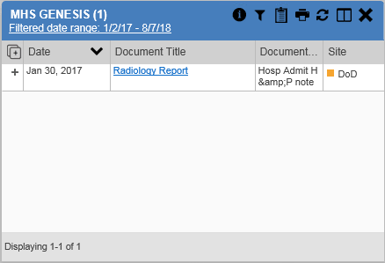

### Viewing MHS GENESIS Documents

Click a hyperlink in the **Document** column in either view of the **MHS GENESIS** widget to display a CCDA document (Figure 86) in a new browser window.

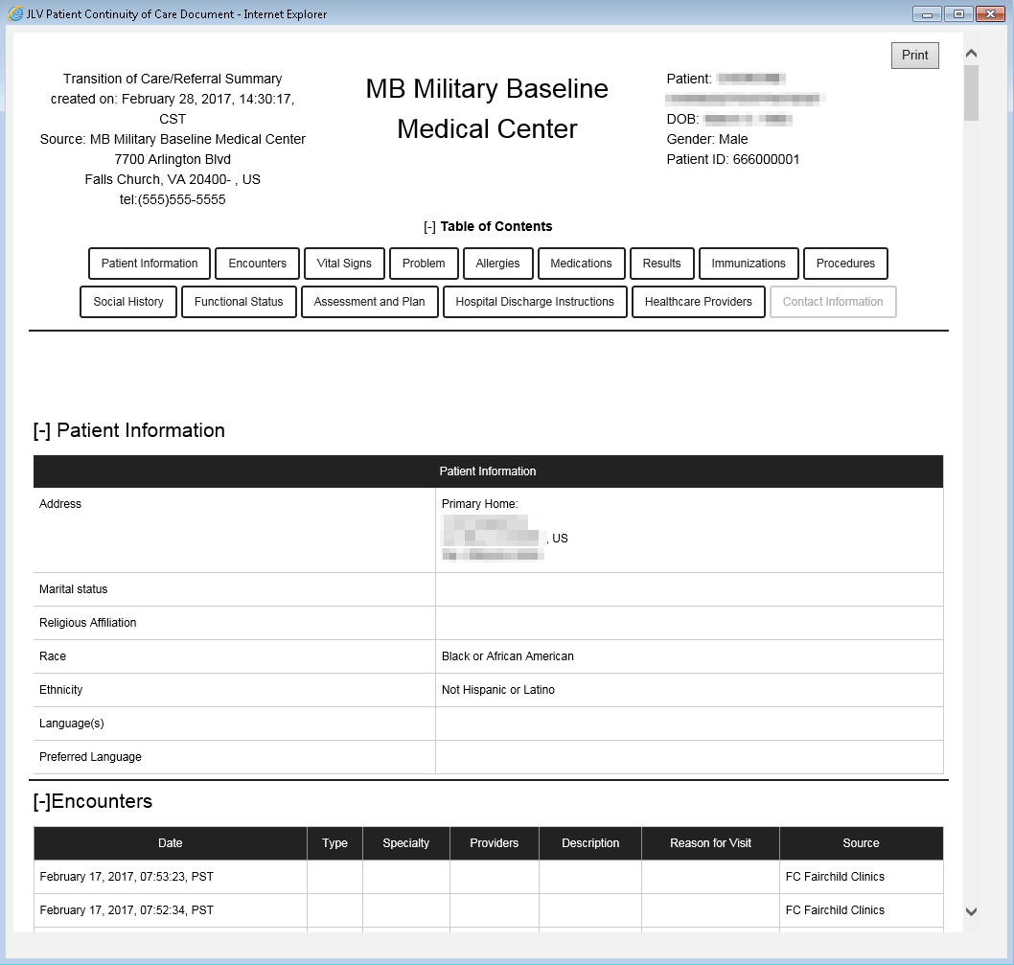**Figure 86: CCDA Document**

# Troubleshooting

The following subsections provide information about troubleshooting common errors in JLV.

Please see online help for how-to information within JLV. Please visit [JLV Resources](http://vaww.oed.portal.va.gov/pm/iehr/vista_evolution/JLV/Resources/Forms/AllItems.aspx) to see JLV training videos and access additional JLV training materials.

## Special Instructions for Error Correction

JLV utilizes access control and authentication services to limit access to registered, authorized users. When enabled, JLV validates you against information retrieved from your Smart Card. If you are having trouble logging in to JLV, and have used the correct URL for your agency, please review the following before contacting the ESD:

VHA users:

* Have accessed JLV using the JLV URL (redacted) or the **JLV** button in CPRS if available
* Have entered their existing CPRS Access and Verify codes correctly in the fields on the JLV

**Login** page

* Have selected a site from the **Site** dropdown list on the JLV **Login** page (Most users must specify the individual facility name or their parent healthcare system name)

CAPRI-Claims users:

* Have accessed JLV using the JLV URL(redacted) or the **Joint Legacy Viewer** tab in CAPRI
* Have entered their existing CAPRI Access and Verify codes correctly in the fields on the JLV **Login** page
* Have selected CAPRI-Claims from the **Site** dropdown list
* Do not have any CAPRI patient selection restrictions

Users with any CAPRI patient selection restrictions (restricted users) must use the **Joint Legacy Viewer** tab in CAPRI to access JLV. Restricted users will see the message shown in Figure 87 on the JLV **Login** page if attempting to access JLV via the JLV URL.

**Figure 87: Login Error - CAPRI Patient Selection Restrictions**

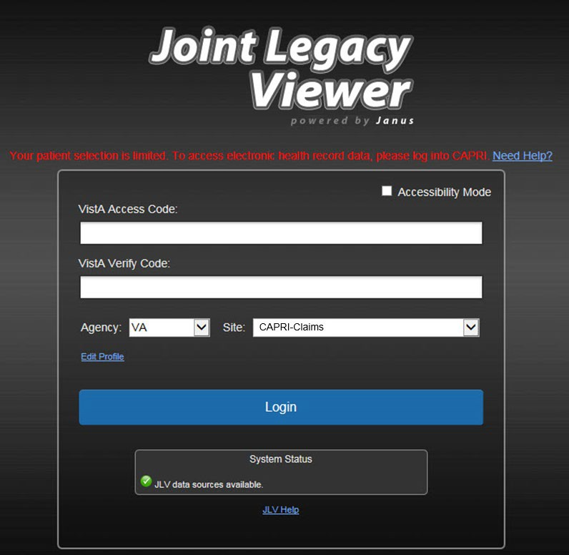

### Login Page Error Messages

Troubleshooting steps for error messages received at the **Login** page are provided in Table 7.

**Table 7: Error Messages and Resolution Steps**

|  |  |
| --- | --- |
| **Error Message/Behavior** | **Description/Resolution Steps** |
| **No access allowed for this user** | ***WHY?*** You have not signed onto CAPRI or CPRS for too long and your account is inactive.  ***FIX IT:*** Contact the ESD and tell them that either your access to CAPRI or CPRS (whichever you use) has been deactivated. |
| **Access denied. You are not an authorized user.** | ***WHY?*** There may be an issue with your Single Sign-on account.  ***FIX IT:***   1. Go to the [Link My Account](https://mvitkssoi-prod.aac.va.gov/imdquiWeb/login.do) website 2. Select a certificate that is not expired, and specifies: *“Issuer: Veterans Affairs User CA B1”* 3. Select *Link VistA User* from the left side of the page 4. Select the VA Medical Center to link to 5. Enter your Access/Verify codes 6. Click **Submit** 7. If unsuccessful, contact the ESD |
| **Could not save User Profile** | ***WHY?*** The error occurred during PIV authentication. It is either a PIV card processing problem, or you chose the wrong security certificate.  ***FIX IT:***   1. Close your browser window 2. Reinsert your PIV card and relaunch JLV 3. Select a certificate that is not expired and specifies: *“Issuer: Veterans Affairs User CA B1”* 4. If unsuccessful, close all open IE windows/tabs, then open IE and try JLV again |
| **Not a valid ACCESS/VERIFY**  **CODE pair** | ***WHY?*** JLV could not match your Access and Verify codes to the site selected in the dropdown, or you entered username and password instead of Access/Verify codes.  ***FIX IT:***   1. VHA users must select the parent VistA host site for their facility 2. Reenter your Access and Verify codes (CAPRI codes for CAPRI-Claims users, CPRS codes for VHA users) |
| **Page cannot be displayed** | ***WHY?*** The JLV URL requires certain IE settings.  ***FIX IT:***   1. Click the **Tools** menu (press ALT+X) in IE 2. Select **Internet Options** 3. When the dialog box opens, click the **Advanced** tab 4. Scroll down in the list until you see the Secure Sockets Layer (SSL) 2.0 setting, and ensure it is NOT checked 5. Ensure that the Transport Layer Security (TLS) 1.0, 1.1 and 1.2 settings ARE checked 6. Click **OK** to close the dialog box, then relaunch JLV (The page should load) |

|  |  |
| --- | --- |
| **Error Message/Behavior** | **Description/Resolution Steps** |
| **Smart Card required** | ***WHY?*** Your Smart Card was not read by Windows Security and JLV before opening the JLV URL.  ***FIX IT:***   1. Close all browser sessions and browser-based applications 2. Reinsert your PIV card, and relaunch the JLV URL 3. If unsuccessful, close all open IE windows/tabs, then open IE and try JLV again |
| **VERIFY CODE must**  **be changed before continued use** | ***WHY?*** Your CPRS or CAPRI Verify code has expired.  ***FIX IT:***   1. Open CPRS, VistA, or CAPRI (CAPRI-Claims users)    1. If prompted for a PIV card certificate by CPRS, click **Cancel** 2. You are prompted to create a new Verify code 3. Once your Verify code has been changed for CPRS or CAPRI, relaunch JLV, which recognizes the new code immediately |
| ***No message displays but behavior occurs*: Clicking the JLV button in CPRS does not open JLV** | ***WHY?*** You are likely using Google Chrome as your default browser.  ***FIX IT:***   1. Click **Start** menu, then select **Default Programs** in the right pane 2. Click **Set your default programs** 3. Click **Internet Explorer** in the list, then click **Set this program as default** |

### System Error Messages

Table 8 summarizes system messages that may be presented to JLV users.

**Table 8: System Error Messages**

|  |  |
| --- | --- |
| **Error Message/Behavior** | **Description/Resolution Steps** |
| ***No message displays but behavior occurs*: The browser window does not allow the user to scroll to widgets or access the JLV icons on the portal pages.** | ***WHY?*** You may be using an unsupported browser, or your screen resolutions settings do not match the recommended configuration.  ***FIX IT:***   1. Access JLV using IE 11 2. Use a monitor with a minimum screen resolution of 1024 x 768 3. Set the browser zoom feature to 100% 4. If browser display issues continue, log out of JLV, close the browser window, open a new browser window, and log in to JLV again |
| **Warning: An error occurred while attempting to retrieve VistA Imaging Viewer URL.** | ***WHY?*** JLV is unable to retrieve the necessary data object to launch a VistA Imaging Viewer instance.  ***FIX IT:*** Try again later; either VDS or CVIX is offline. |
| **MVI Error: Your query yields too many results. Please modify your search parameters to narrow the search.** | ***WHY?*** JLV adheres to VA guidelines and blocks search results when a search request yields more than 10 patients.  ***FIX IT:*** Modify the information in the **Patient Search** dialog box using additional patient identifiers to reduce the number of results. |

|  |  |
| --- | --- |
| **Error Message/Behavior** | **Description/Resolution Steps** |
| **MVI Error: There are no patients found using the current parameters.** | ***WHY?*** No patient records were found using the information entered in the **Patient Search** dialog box. ***FIX IT:***   1. Verify the accuracy of the information 2. Reenter patient identifiers in the **Patient Search**   dialog box fields |
| **MVI Error: Application Reject. There was an error attempting to process your query. Please modify your search parameters and try again.** | ***WHY?*** There may be one or more errors in the **Patient Search** dialog fields.  ***FIX IT:***   1. Validate the patient identifiers, and try the search again 2. If problems persist, there may be an error between MVI and the Defense Enrollment Eligibility Reporting System (DEERS) |
| **MVI Error: Patient not found with search elements entered, please provide additional patient identifying information and search again.** | ***WHY?*** No unique patient is found with the identifiers used in the search.  ***FIX IT:***   1. Click **OK** to return to the **Patient Search** dialog 2. Provide additional patient identifiers, like the full first name or DOB |
| **You do not have authorization to view this record. Security regulations prohibit computer access to your own medical record.** | ***WHY?*** VA security regulations prevent you from accessing your own medical records. |
| **You do not have authorization to view this record. Your SSN is missing from the NEW PERSON file. Contact your ADP Coordinator.** | ***WHY?*** Per VA policy, JLV does not allow access to patient records if the JLV user’s SSN is not in their VistA profile.  ***FIX IT:*** Contact your Automated Data Processing Application Coordinator (ADPAC). |
| **An error occurred while attempting to retrieve the document.** | ***WHY?*** This error occurs when something goes wrong when JLV tries to retrieve a selected document.  ***FIX IT:***   1. Try again 2. If the error persists, contact local support or the ESD |
| **An error occurred while attempting to display the document.** | ***WHY?*** This error occurs when JLV tries to retrieve a document but has trouble converting the document to a viewable format.  ***FIX IT:***   1. Try again 2. If the error persists, contact local support or the ESD |
| **Your patient selection is limited. To access electronic health record data, please log in to CAPRI.** | ***WHY?*** Some CAPRI-Claims users have patient or site restrictions attached to their profile.  ***FIX IT:*** Log in to CAPRI and select the **Joint Legacy Viewer** tab to view patient records. |

|  |  |
| --- | --- |
| **Error Message/Behavior** | **Description/Resolution Steps** |
| **Connection Status alert or error displayed in the** Community Health Summaries and Documents - VA **widget:**  **One or more data sources could not be connected; some entries will not appear. or**  **Error: DAS Query failure. HTTP error.** | ***WHY?*** These messages appear when the VA VHIE service is not available.  ***FIX IT:*** If either message persists for more than 5 minutes, contact support. If you are unable to retrieve community partner documents for a patient, please contact your local VHIE Coordinator. If you need assistance identifying your local contact, please e-mail [redacted.](mailto:VHIECommunityEngagement@va.gov) |
| **Error displayed in Community Health Summaries and Documents - VA widget: Connection Error – No Data** | ***WHY?*** JLV was unable to retrieve data from eHealth Exchange (eHX).  ***FIX IT:***   1. Try again 2. If the error persists, contact local support or the ESD |

# Acronyms and Abbreviations

Table 9 lists the acronyms and abbreviations used throughout this document and their descriptions.

**Table 9: Acronyms and Abbreviations**

|  |  |
| --- | --- |
| **Acronym** | **Description** |
| **ADPAC** | Automated Data Processing Application Coordinator |
| **CAPRI** | Compensation and Pension Record Interchange |
| **CCD** | Continuity of Care Document |
| **CCDA** | Consolidated Clinical Document Architecture |
| **CCOW** | Clinical Context Object Workgroup |
| **CD2** | Critical Decision Point #2 |
| **CDC** | Centers for Disease Control |
| **CPRS** | Computerized Patient Record System |
| **CPT** | Current Procedural Terminology |
| **CVX** | Vaccine Administered |
| **DEERS** | Defense Enrollment Eligibility Reporting System |
| **DOB** | Date of Birth |
| **DoD** | Department of Defense |
| **EDIPI** | Electronic Data Interchange Personal Identifier |
| **EHR** | Electronic Health Record |
| **eHX** | eHealth Exchange |
| **ESD** | Enterprise Service Desk |
| **GUI** | Graphical User Interface |
| **HAIMS** | Healthcare Artifact and Image Management Solution |
| **HCP** | Health Care Provider |
| **HL7** | Health Level 7 |
| **ID** | Identification |
| **IE** | Internet Explorer |
| **IEN** | Internal Entry Number |
| **IP** | Internet Protocol |
| **JLV** | Joint Legacy Viewer |
| **LOINC** | Logical Observation Identifiers Names and Codes |
| **MAH** | Medication Administration History |
| **MAL** | Medication Administration Log |
| **MHS** | Military Health System |
| **MI** | Middle Initial |
| **MVI** | Master Veteran Index |
| **NUCC** | National Uniform Claim Committee |
| **OIT** | Office of Information and Technology |

|  |  |
| --- | --- |
| **Acronym** | **Description** |
| **PCM** | Primary Care Management |
| **PDWS** | Patient Discovery Web Service |
| **PIN** | Personal Identification Number |
| **PIV** | Personal Identity Verification |
| **SSL** | Secure Sockets Layer |
| **SSN** | Social Security Number |
| **SSOi** | Single Sign-On Internal |
| **TLS** | Transport Layer Security |
| **UI** | User Interface |
| **URL** | Uniform Resource Locator |
| **VA** | Department of Veterans Affairs |
| **VBA** | Veterans Benefits Administration |
| **VDS** | VistA Data Service |
| **VIP** | Veteran-Focused Integrated Process |
| **VHA** | Veterans Health Administration |
| **VistA** | Veterans Health Information Systems and Technology Architecture |
| **VHIE** | Veterans Health Information Exchange |

# Patient Portal Widgets, Columns, and Supported Views

Table 10 details each data column within the minimized and expanded views of each widget. Data columns available in each view are ordered from left to right.

* An asterisk (*) next to a column title in the table indicates the data for that record is available in “detail view” from within the widget; clicking a link opens the contents of that record in a standalone window
* A dagger (†) next to a column title in the table indicates the data in that column is normalized (mapped to standards)
* A double dagger (‡) next to a column title in the table indicates the column is hidden by default and must be added from the Screenshot of the Column Settings icon Column Settings

**Table 10: Widget Details**

|  |  |  |  |
| --- | --- | --- | --- |
| **Widget** | **Description** | **Minimized View** | **Expanded View** |
| **Admissions** | Displays the patient’s inpatient admissions information including VA expanded admission discharge transfer history and detailed discharge diagnosis data | Adm Date* | Discharge Date  | Diagnosis† | Ward | Site | Adm Date* | Discharge Date | Ward | Provider† | Diagnosis† | Standardized Diagnosis† | Registration Number | Site |
| **Allergies** | Displays the patient’s allergy information | Date Recorded | Allergen*† | Site | Date Recorded | Allergen*† | Standardized Allergen† | Reaction | Severity |Comments | Site |
| **Appointments** | Displays the patient’s past and future appointments information | Scheduled Date/Time* | Clinic | Provider†5 | Site | Scheduled Date/Time* | Clinic | Provider†5 | Provider Specialty†5| Appointment Status | Type | Reason | Site |
| **Clinical Reminders - VA Only** | Displays the patient’s clinical reminders information from all VA sites | Reminder | Site*6 | Reminder | Site*6 |
| **Community Health Summaries - VA** | Displays the patient’s community health documents from VHIE partners including any CCDs, in C32 and C62 formats, and HL7 C- CDA structured documents | Date | Document* | Source | N/A |

5 Column hover display includes provider address and phone number.

6 Lists a sortable, filterable reminder column for each site to which the patient is registered. A maximum of three site columns display in minimized view. All site columns display in expanded view.

|  |  |  |  |
| --- | --- | --- | --- |
| **Widget** | **Description** | **Minimized View** | **Expanded View** |
| **Consult Encounters** | Displays the patient’s outpatient consult information | Date | Consult Order* | Status | Site | Date | Consult Order* | Provider† | Provider Specialty† | Status | Site |
| **Demographics** | Displays the patient’s non-clinical or personal data including Patient Inquiry, Demographics, Insurance, Disabilities, and Primary Care assignments | The tabs above the patient’s name provide a summary at site (VA or DoD) where the patient is registered | Click the patient name to open a separate window that provides patient demographic details (VistA patient inquiry for each VA site and DoD DEERS) |
| **Documents** | Displays documents from multiple clinical domains including radiology reports (exams), progress notes, outpatient encounters, consult encounters, discharge summaries, inpatient notes, questionnaires, and HAIMS and MHS GENESIS records | Date (Note[s]*) | Description*† | Provider† | Image | Site | Date (Note[s]*) | Description*† | Standardized Description† | Provider†  | Provider Specialty† | Location | Status | Image | Source System | Site |
| **Health Summaries and Reports - VA Only** | Displays the patient’s national and local health summaries and reports from VA sites where the patient has been registered | Description* | Site | Description* | Type | Site |
| **Immunizations** | Displays the patient’s immunization history, including skin test data (where available) in the patient’s record | Vaccine Administered Date (Note[s]*) | Vaccine Administered Product Type*† | Adverse Vaccine Reaction | Site (Reporting) | Vaccine Administered Date (Note[s]*) | Vaccine Administered Product Type*†  | Standardized Vaccine Product Type†  | Series | Immunization Result | Adverse Vaccine Reaction | Exemption/Refusal Reason | Exemption/Refusal Date | Site of Admin | Site (Reporting)7 |
| **Inpatient Medications** | Displays a patient’s inpatient medications information including inpatient infusions | Order Number | Drug Name*† | Status | Order Stop Date | Site | Order Number | Order Start Date | Order Stop Date | Drug Name*† | Standardized Drug Name† | Status | Ordering HCP† | Ordering HCP Specialty† | Schedule | MAH/MAL | Quantity | Site |
| **Inpatient Summaries** | Displays the patient’s discharge summaries, history, and physical summaries | Date | Note Type/Title* | Site | Date | Note Type/Title* | Provider† | Provider Specialty†8 | Location | Visit/Adm Date | Status | Site |

7 The **Immunizations** widget differentiates between the reporting site and the site of administration of a vaccine.

8 The **Provider Specialty** column is populated with VA data only.

|  |  |  |  |
| --- | --- | --- | --- |
| **Widget** | **Description** | **Minimized View** | **Expanded View** |
| **Lab Results** | Displays the patient’s lab results information by individual lab test for all test types (i.e., Microbiology, Cytopathology, and Surgical Pathology) as well as skin test data and blood bank (blood type testing and transfusion) history, when available in the patient’s record | Collection Date | Lab Test*†  | Result* | Lab Panel* | Site | Collection Date | Specimen Source | Lab Test*† | Standardized Lab Test†‡  | Result* | Interpretation* | Units | Ref Range | Lab Panel* | Type | Order Number | Ordering HCP† | Ordering HCP Specialty†‡ | Status | Site |
| **MHS GENESIS** | Displays patient documents and dental summaries from the MHS GENESIS system | Date | Document Title* | Document Type | Site | N/A |
| **Orders** | Displays the patient’s medication, consult, radiology, and lab orders | Order Date | Description*† | Status/Priority | Type | Site | Order Date | Order Number | Description*† | Status/Priority | Start Date | Stop Date | Type | Standardized Type† | Provider† | Provider Specialty† | Site |
| **Outpatient Encounters** | Displays records of the patient’s outpatient encounters | Encounter Date (Details* | Note*) | Clinic | Provider† | Diagnosis† | Image | Site | Encounter Date (Details* | Note*) | Clinic | Status9 | Type | Provider† | Provider Specialty† | Reason | Diagnosis† | Standardized Diagnosis†  | Image | Site |
| **Outpatient Medications** | Displays the patient’s outpatient medications information, including those discontinued or expired within the past 120 days | Last Fill | Drug Name*† | Status | Expires | Site | Last Fill | Drug Name*† | Standardized Drug Name† | Prescription Number | Sig | Quantity | Days’ Supply | Refills Left* | Status | Ordering HCP† | Ordering HCP Specialty† | Expires | Site |
| **Problem List** | Displays the patient’s problem list information | Updated Date | Problem Description*† | ICD | Type | Status | Linked Items10 | Site | Updated Date | Onset | Problem Description*† | Standardized Description† | ICD | Severity | Type | Status | Linked Items10 | Site |

9 Data in the **Status** column is populated with DoD data only.

|  |  |  |  |
| --- | --- | --- | --- |
| **Widget** | **Description** | **Minimized View** | **Expanded View** |
| **Procedures** | Displays the patient’s procedures for all Current Procedural Terminology (CPT) codes | Procedure Date (Medicine Full Reports* | Note[s]*) | Location11 | Provider† | Procedure Description† | Image | Site12 | Procedure Date (Medicine Full Reports* | Note[s])* | Location11 | Provider† | Provider Specialty† | CPT Code | Procedure Description† | Standardized Procedure Description† | Image | Type | Site12 |
| **Progress Notes** | Displays the patient’s progress notes information as well as advance directives, clinical warnings, and crisis notes | Date | Document Type/Title*† | Provider† | Image | Site | Date | Document Type/Title*† | Standardized Document Type† | Provider† | Provider Specialty† | Clinic  | Image | Site |
| **Questionnaires and Deployment Assessments (AHLTA Only)** | Displays the patient’s history of questionnaires and DoD pre- and post- deployment assessments | Date | Document Title*†| Site | Date | Entered By | Document Title*†| Standardized Document Title† | Site |
| **Radiology Reports** | Displays the patient’s radiology exams information | Date | Exam*†| Image | Site | Date | Exam Number | Exam*†| Standardized Radiology Exam† | CPT Description† | Status | Results | Image  | Site |
| **Social, Family, and Other Past Histories** | Displays the patient’s history records from DoD only | Date Reported | Type | Findings | Status | Site | Date Reported | Type | Findings | Standardized Findings | Comments | Status | Site |
| **Surgery/Procedure Reports - VA Only** | Displays surgical and operative reports for all dates | Date | Note Title | Provider | Site | Date | Note Title | Procedure | Provider  | Image | Site |
| **Vitals** | Displays the patient’s vital signs information from inpatient or outpatient settings | Date Taken | Type*† | Result | Units | Site | Date Taken | Type*† | Standardized Type† | Result | Units | Site |

11 **Location** represents a ward or clinic within a given DoD or VA facility where the procedure took place.