Howdy Computerized Phlebotomy Login Process

C3-C1 Conversion Project

Reference Manual for Local IT Staff

Laboratory Patch LR*5.2*417

June 2013

Department of Veterans Affairs

Revision History Date | Revision | Description | Author
November 2011 | 1.0 | Compiled Howdy reference material | REDACTED
December 2011 | 1.1 | Prepped for national release | REDACTED
January 2012 | 1.2 | Changed dates to January 2012 | REDACTED
June 2013 | 1.3 | Change link to software for formatting MagTek card reader (page 5) per Patch 417. | REDACTED
Table of Contents
Introduction 1
Howdy Setup for the VistA User Account 2
Howdy Hardware 3
How to Set Up the Howdy PC 4
Howdy Network Service Account 4
VIC Card Readers/Magnetic Card Swipe 5
Troubleshooting Card Swipe Issues 7
Reflections File (.r2w) 8
Secure Shell Connection for Reflection 8
Creating Macros in New KEA 16
Thin Client for Howdy 22

Introduction
Patch LR*5.2*405 introduces the Howdy Computerized Phlebotomy Login Process as an automated laboratory check-in application which can be used within the Veterans Health Information Systems and Technology Architecture (VistA) Laboratory module. This software performs the following functions:

- Howdy automates laboratory check-in, accessioning of orders, and printing of specimen labels
- Howdy captures collection process times and provides the information required to create phlebotomy performance reports
- Howdy eliminates the need for a hand-written log book for sign-in where the patient's name and SSN can be compromised
- Howdy can utilize bar code technology to assist in the process of patient and specimen identification

Howdy Setup for the VistA User Account
Dedicated PCs are being used for the Howdy software. For multi-divisional sites an account is setup for each division. Each site will name the accounts as deemed appropriate indicated in the example below.
- HOWDY, Division 1
- HOWDY, Division 2
- HOWDY, Division 3
- HOWDY, Division 4

Each account will have one and ONLY one menu option of. This will depend upon which HOWDY your site chooses to utilize.
- SCAN PATIENT CARD [LRHY PATIENT CARD SCAN]
- SCAN PATIENT CARD (PPOC) [LRHY PATIENT CARD SCAN (PPOC)]

The password/verify codes require changing every 90 days.
Each account must have the division set as such to assure accurate order accessioning and printing for the division:
HOWDY, Division 1 in the user account set the division to Division 1 and the default to yes.
HOWDY, Division 2 in the user account set the division to Division 2 and the default to yes.
HOWDY, Division 3 in the user account set the division to Division 3 and the default to yes.
HOWDY, Division 4 in the user account set the division to Division 4 and the default to yes.

Of course you must take into consideration how each division is being utilized for example as a draw station only or with a small lab and limited testing to full testing capabilities.

Howdy Hardware
Traditional Howdy: Allows scanning of the patient VIC (Veterans Identification Card) card.
- 1 Dedicated PC (Howdy) with monitor, keyboard and mouse is required for each blood drawing area/room. Multi-divisional sites with draw stations require one for each site.
- 1 Magnetic card reader is required for each PC to read the VIC (Veterans Identification Card) card.
- 1 Barcode label printer (Zebra or Intermec s are currently being used at most sites for bar-coded lab test labels) for each blood drawing area/room.

Howdy PPOC: Allows scanning of the patient VIC and in addition captures tracking times for turn-around times.
- 1 Dedicated PC (HOWDY) with monitor, keyboard and mouse is required for each blood drawing area/room. Multi-divisional sites with draw stations require one for each site.
- 1 Magnetic card reader is required for each PC to read the VIC (Veterans Identification Card) card.
- 1 Hand held scanner (can be wireless if wireless available) to scan blood tubes for each blood drawing area/room/PC. If you have general workstation PCs located at individual draw chairs then a hand held scanner could be provided for each of these allowing the phlebotomist to scan utilizing the appropriate

Howdy PPOC option in a closer proximity of the draw area: the user must be logged onto the PC with the option opened. However, it is not required and local policies can be applied to accommodate this option. The scanning of the lab tubes allows for the tracking of the specimens to assist with turn-around times.
Local procedures/policies should be established to standardize the workflow for each blood drawing area/room.

How to Set Up the Howdy PC
- Setup standard PC with all updates
- Create a service account (For SBY it is VHASBYHowdy) and is created already
- Log in with this account to create the profile
- Copy ssh_config AND reflection.ini files to C:\document and settings\all users\application data\attachmate\reflection folder using your admin account
- Put Sby-Vista (ss) short-cut into vhasbyhowdy startup folder (Do not use all users!)
- The user will need the Howdy Access and Verify Codes for the specific Howdy PC
- If this is a replacement PC, ask users in that location for Howdy Access and Verify Codes. If this is a new Howdy install, obtain the create Access and Verify Codes from VistA Support staff
- The user must log in using VHASBYHowdy. A reflections session with VistA will automatically be launched. Do not put the VistA shortcut on the Vhasbyhowdy desktop. This is a dedicated PC. VHASBYHowdy is a service account and is not a member of any user groups, so there will be no icons on the desktop.
- Install the Magnetic Card Reader using the install information provided and stored on your shared drive
- Test the reader

Howdy Network Service Account
- Create a new Howdy NT service account with a password that does not expire or need changing. One account can be used for all divisions if multi-divisional.
- This account will use the local domain for logging in and not to the local machine.
- Assign a VistA menu to the account.

This account will then be used for logging into the Howdy units.
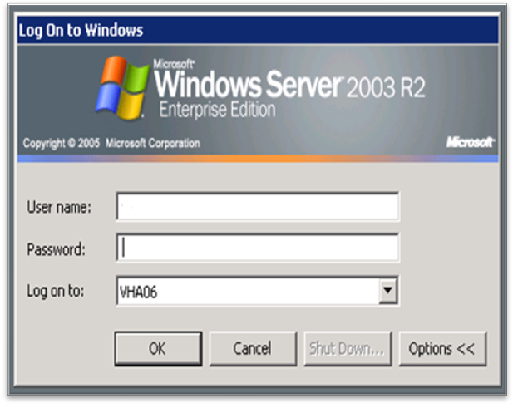
Windows Server 2003 R2 log on window

VIC Card Readers/Magnetic Card Swipe
A lot of the magnetic card swipes used with the Howdy systems are from MagTek and have a USB connection. If the device does not have a USB connector, then it is not from MagTek and is not covered in this document. I would suggest replacing it with a MagTek if there is a problem. These card swipes have 2 setups, HID and Keyboard. To be used with VistA, the swipe must be programmed to the Keyboard interface. All MagTek swipes come in and/or default to the HID interface.

To program the magnetic card swipe to be used as a keyboard interface follow these easy steps.

- Connect the USB device to a PC. (This should be done at any PC but should be done prior to installation at the user location if the user has a Thin Client).
- Go to http://www.magtek.com/support/software/demo_programs/usb_swipe_insert.asp .
Do the Download which will allow for the installation of USBMSR.exe that formats the MagTek card reader.
- The following window will appear (ensure that the “Send Commands” tab is selected).
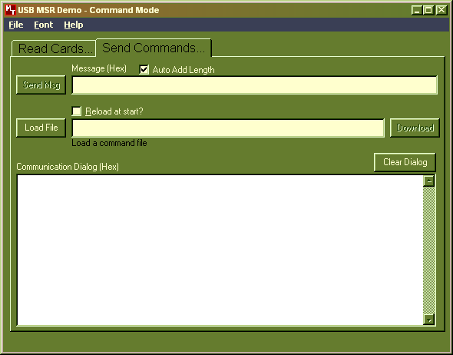
- Click on the Load File button and the open window appears.
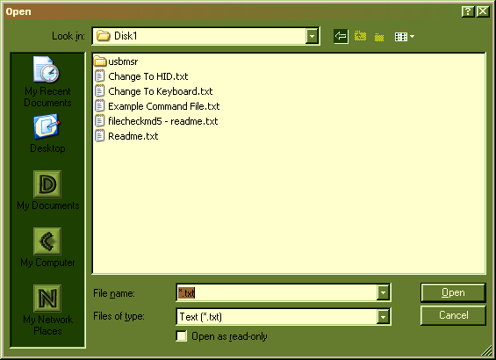
- Select the Change to Keyboard.txt file and click on Open.
- The following information will appear in the window of the Send Commands tab.
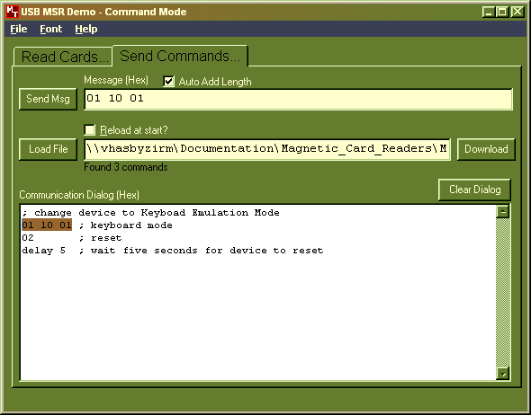
- Enter the highlighted information into the Message (Hex) box: 01 10 01
- Click on the Send Msg button.

The Magnetic card swipe is now setup to be a Keyboard interface. You can remove it from your PC and install on any other machine to be used.

Troubleshooting Card Swipe Issues
As of this writing, I know of only 2 issues related to the magnetic card swipes.
- Card swipe is attached and has a green ready light, but nothing appears on the screen when a card is swiped.
- Card swipe is attached and there is no green light.

To be able to trouble shoot the card swipe, you first have to know what the normal operation is. Normal operation is (after programmed above) connect the device to a pc and after a few seconds the light on the top of the device should turn green. Now at a VistA patient entry prompt (either Howdy or appointment management) swipe the card and the veterans name and social security number will populate the entry. The entry will automatically bring up the patient information as dictated by the prompt.
- If the light is green, but when a card is swiped, nothing happens. This usually occurs if the card swipe has lost its programming or has not been programmed. If this is a standard PC workstation, go through the steps above and program the reader as a Keyboard entry device. If this is a Thin Client PC, take the device to a standard PC and go through the steps above and then replace on the Thin Client.
- Usually, if there is no green light on the card swipe, unplugging it from the pc and then plugging it back into the PC is the only thing needed to clear this problem. If not, replace it with a new device.

Reflections File (.r2w)

Secure Shell Connection for Reflection
REDACTED

First and foremost all Howdy workstations log into themselves and present to the end user a single icon on the desktop. The icon is the Howdy Reflection icon. Once the logon process is finished, Howdy Reflection executes by :
- Starting Reflection
- Running a Macro that logs Howdy into VistA
- Macro stops after the printer has been selected
- Howdy workstation ready for Patient use

For sites that do not have their workstations logging into themselves automatically and then running the VistA connection, the steps will change to reflect how you want the Macro to run. I haven’t played with the Reflection session I make enough to properly remove any unwanted features from the Menu Bar, but then that is the next step.

When the VA went to the Reflection software, the reason given was that the VA needed a Secure connection to the VistA instance. The following steps create a connection to VistA using the Secure Shell feature in Reflections.
- From the Start button navigate to the Attachmate Reflection/Host - UNIX and OpenVMS:
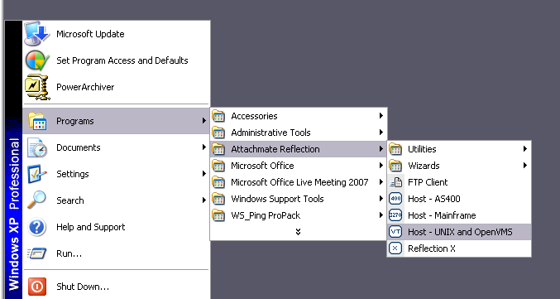
- Once you select the Host – UNIX and OpenVMS the following display appears.

On my system this display is a small window, so I maximize the windows before I save the r2w.

- Next set the display color using the Setup dropdown and selecting Display
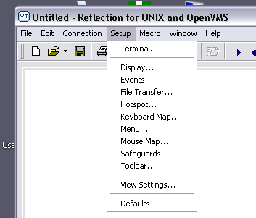
- When the following panel displays, select the colors you want and click OK.
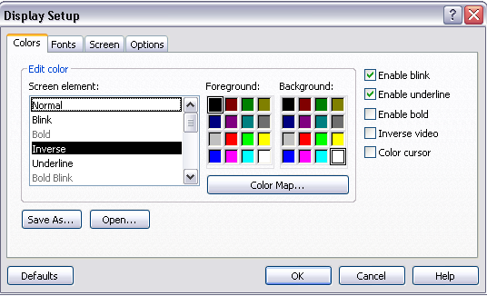
- The display changes to the colors you have selected.
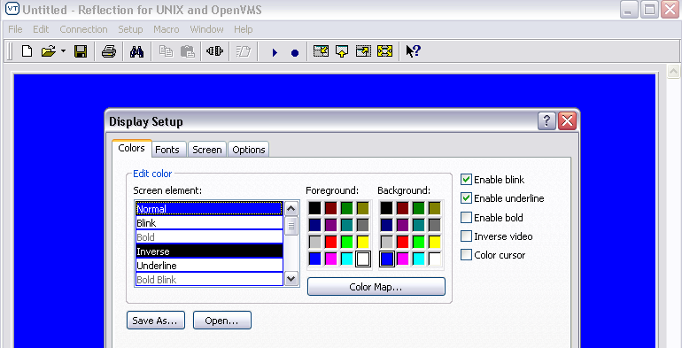
- Select the OK button and you are ready to now make your connection.
- Select Connection on the Menu Bar and from the drop down select Connection Setup.
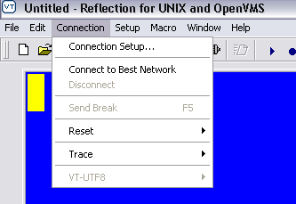
- Once you select the Connection Setup the following panel displays
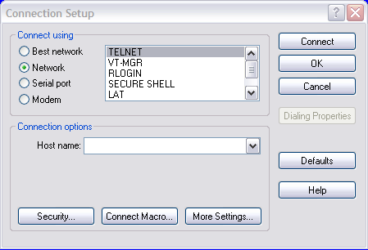
- Select SECURE SHELL, the display will change to the following
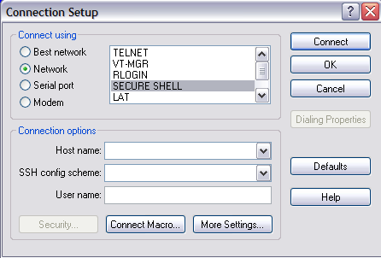
- Fill in the blanks with the appropriate information. The top line refers to your sites VistA instance. The second line you want to select the BlankPassword choice and for the last line you want to enter your site’s access/users name for VistA.
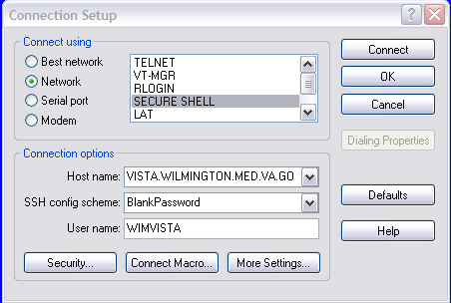
- Select the Security button to see the following display.
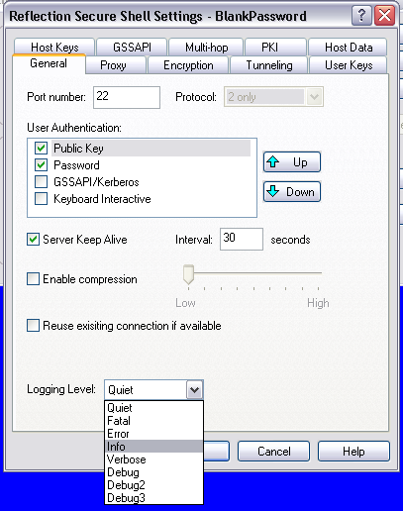
- Select Quiet and then click on the Connect button.
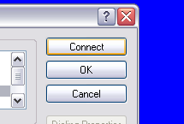
Your system will connect to your VistA instance and in the lower right-hand corner it will display the information about a secure shell connection.
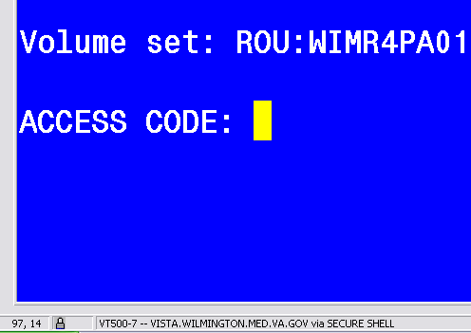
- Now you should save the work done so far. And then you can write your Macro specifically for this system. I usually save the file to the C:\Program Files\Attachmate\Reflection folder, because this will be used for a Howdy box, which logs into itself.
- Select the Save As from the File Menu drop down
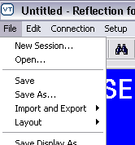
- Give it a name and save it. I use the C:\Program Files\Attachmate\Reflection folder.
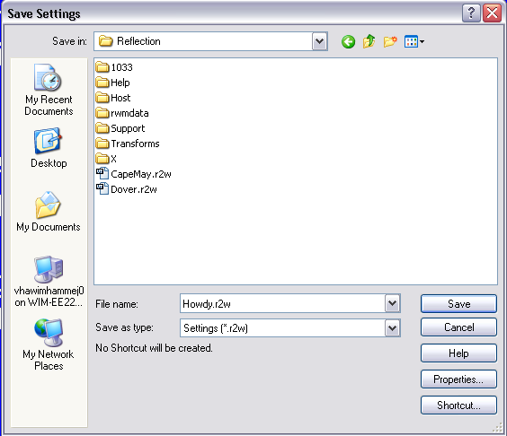
- Select the Shortcut Button in the lower right-hand corner of the panel shown above.
- Check the box in the upper left-hand corner and the radio button as shown in the display below. This will put a shortcut on the Start Menu that can be copied wherever you want to put it. Click OK and return to the display in Step 15-b and click OK again. You have saved your new Session connection.
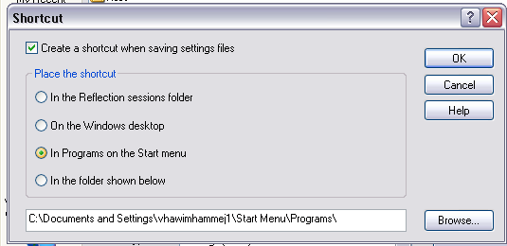
- To Write the Macro after you have saved the initial connection do the following.
- After saving your new Session connection, close it, and then re-open it using the Shortcut you have just made.
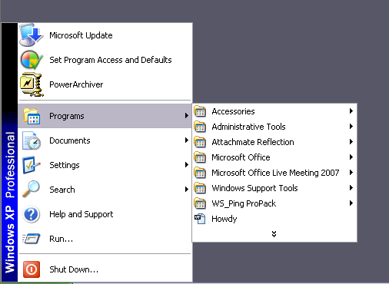
- Once your session opens, select Macro from the Menu Bar and the select Start Recording
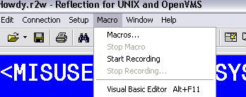
- Enter the information you want to have in the Macro and then select Stop Recording from the Macro drop down on the Menu Bar
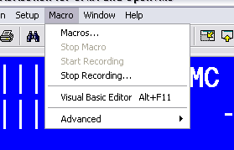
- A pop-up will display and the Macro should be named as Login. The Make this the connection Macro box should be checked.
- Next select File from the Menu bar and the Save Howdy.r2w.
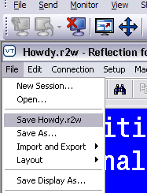
- If everything was done right, you can close out the session and restart it using your shortcut.

Creating Macros in New KEA
- Select the macro drop-down menu.
- Select the Macro Recording Wizard.
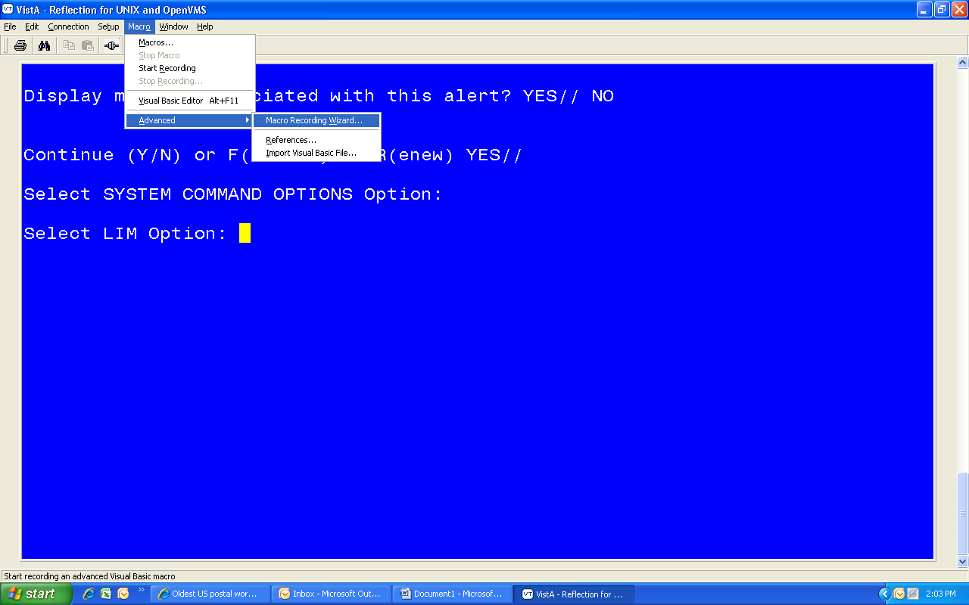
- Record your macro and then click the stop recording button.
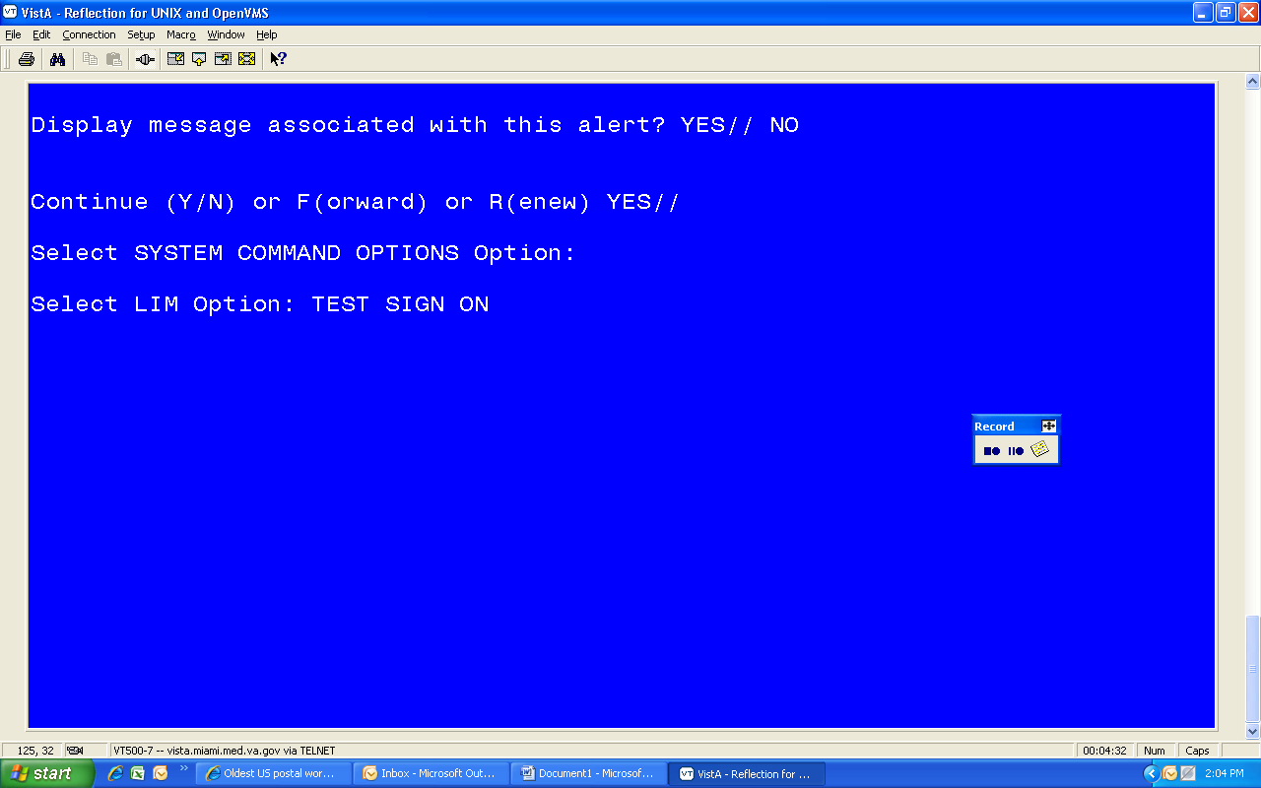
- Give the macro a name. Make sure create a button is checked.
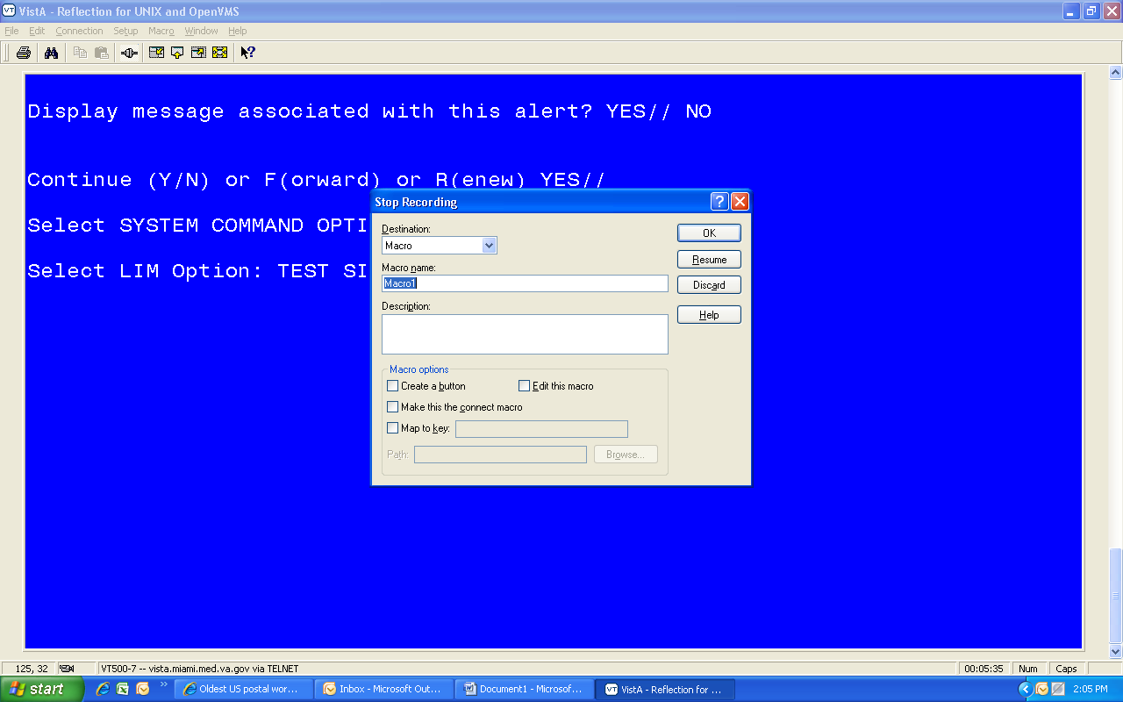

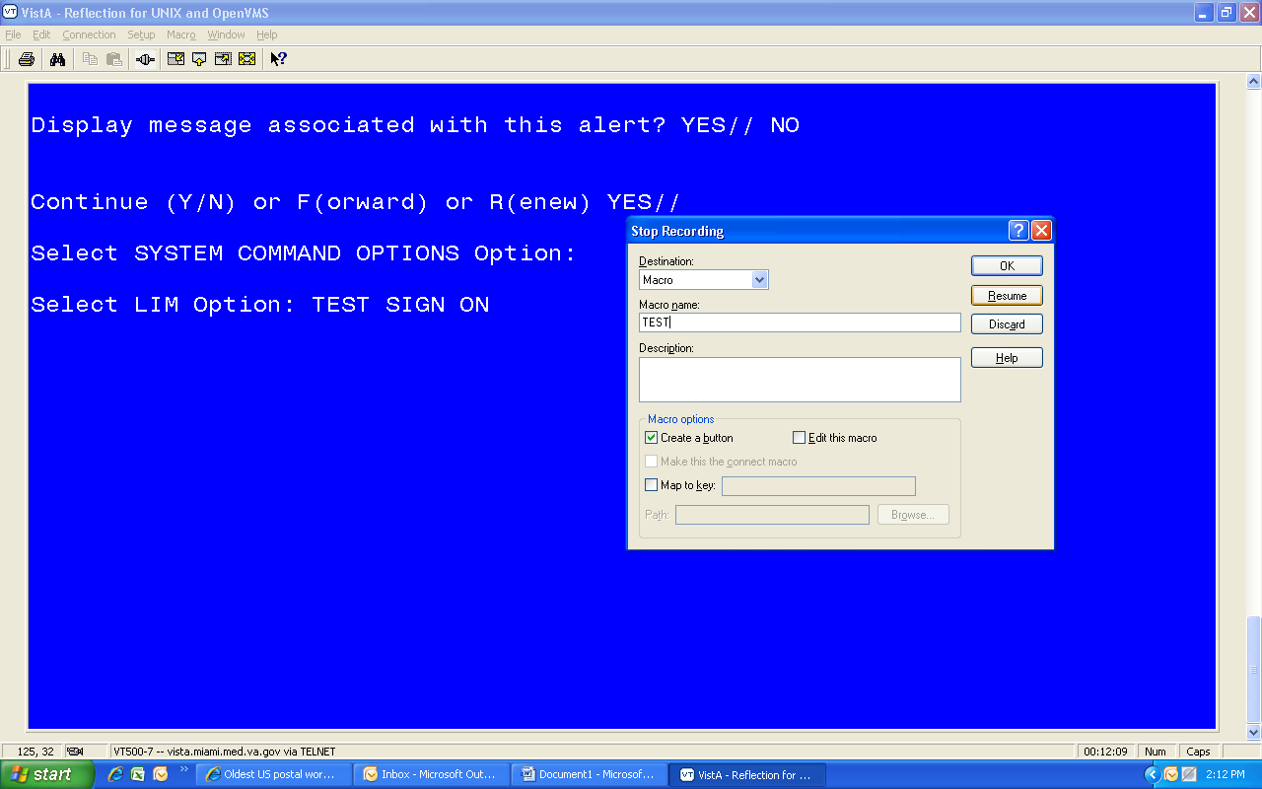
- Uncheck this box. Then click OK.
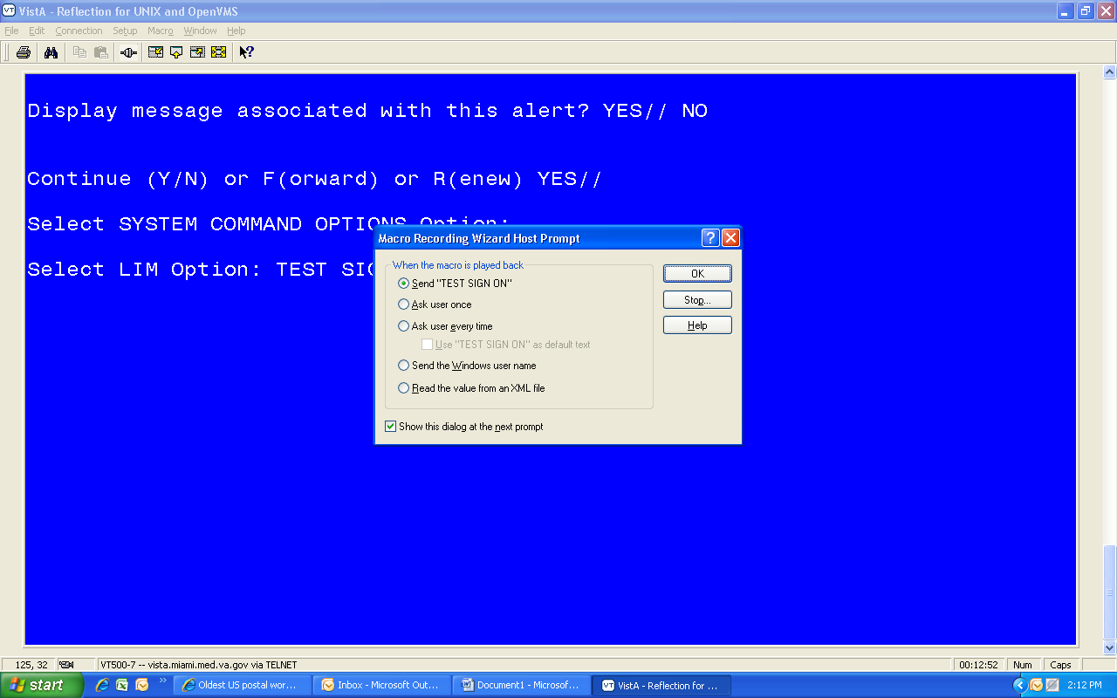
The button is created here.
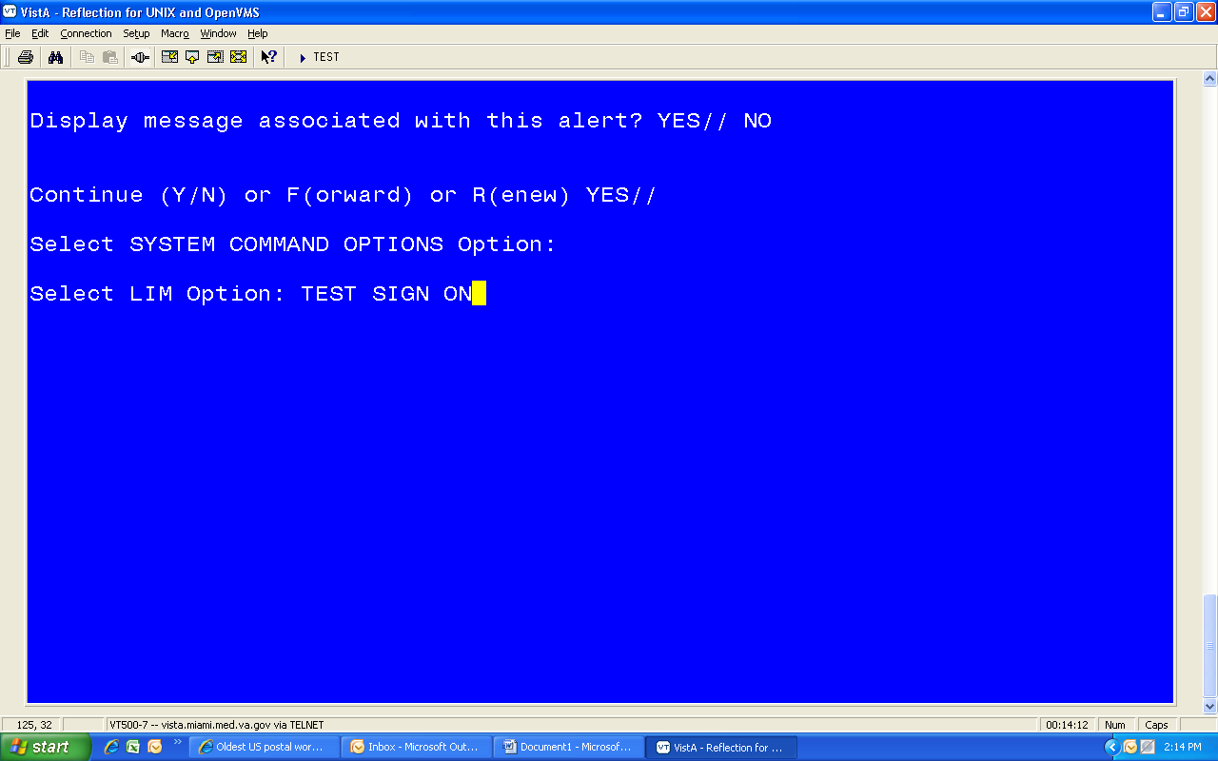
- Test the macro by clicking the button.
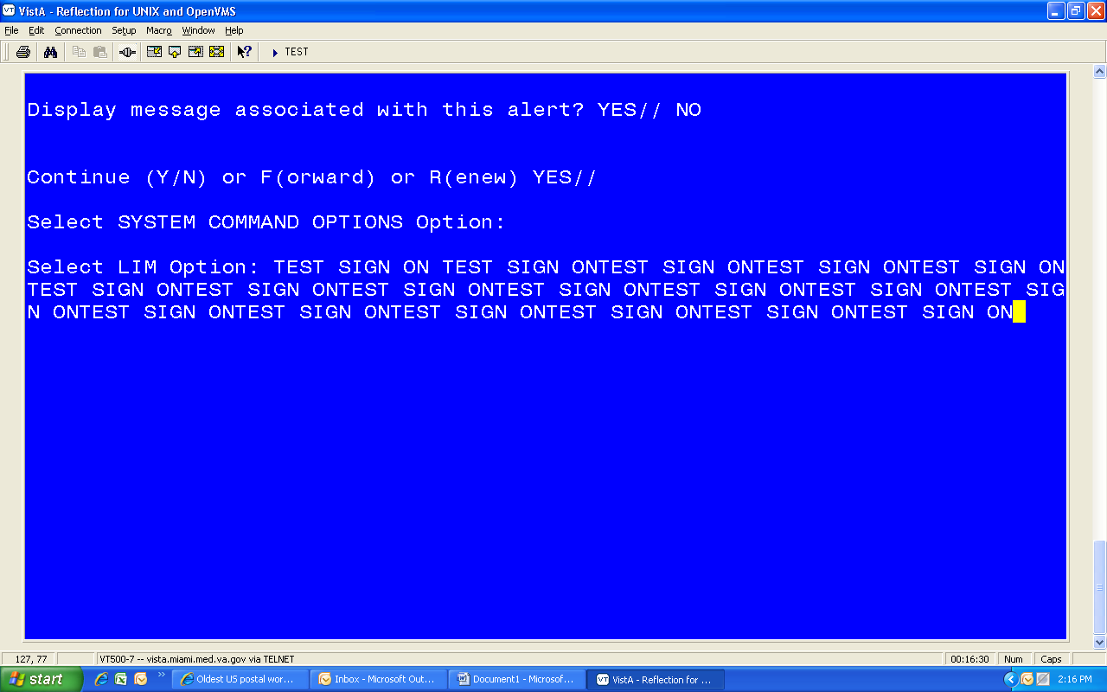
- Go to File and Save as.
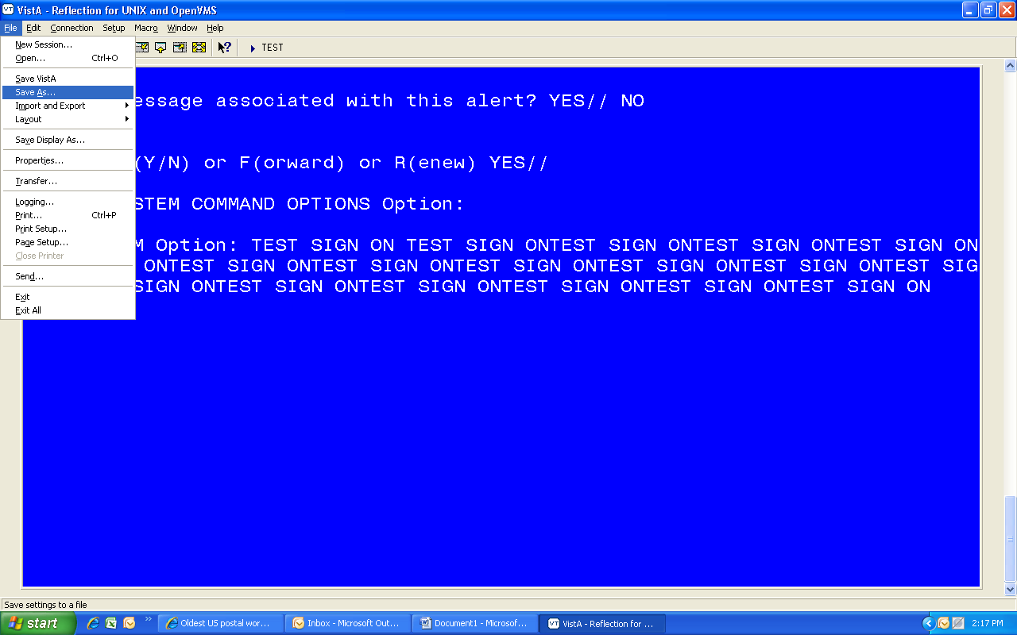
- Give the file a name, and change the location.
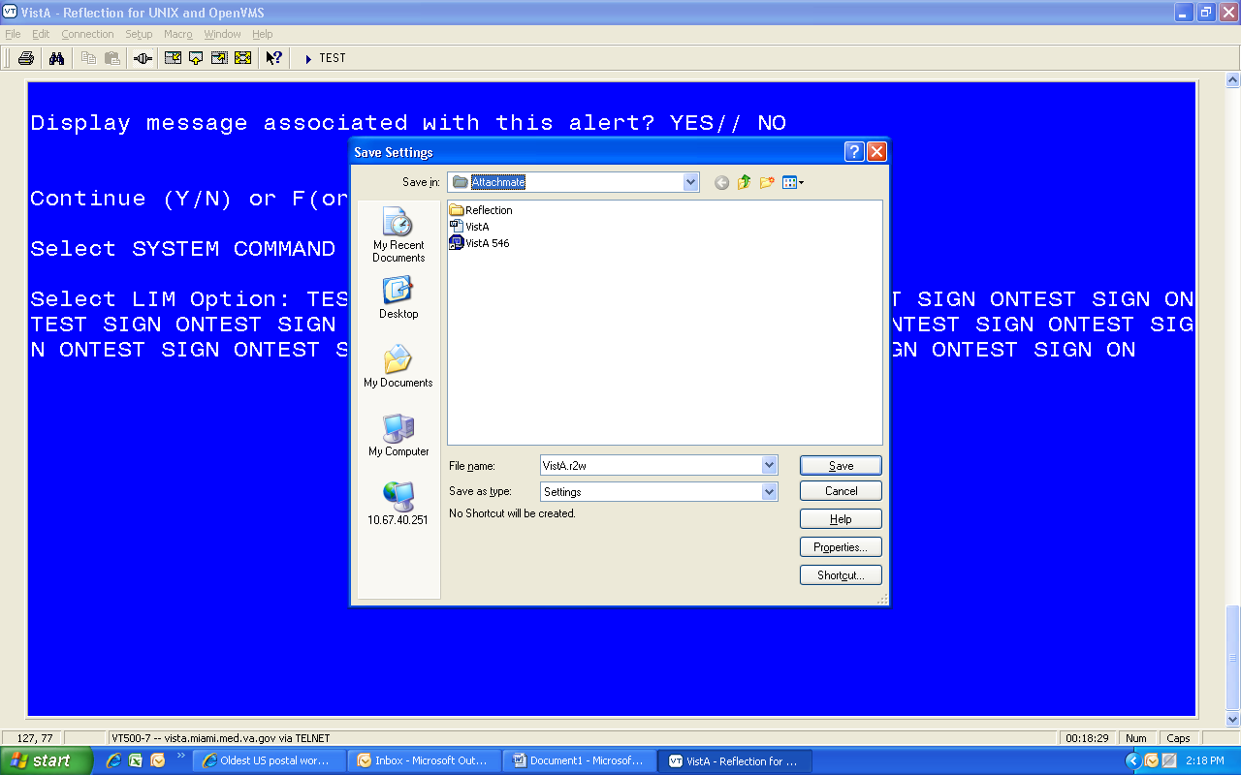

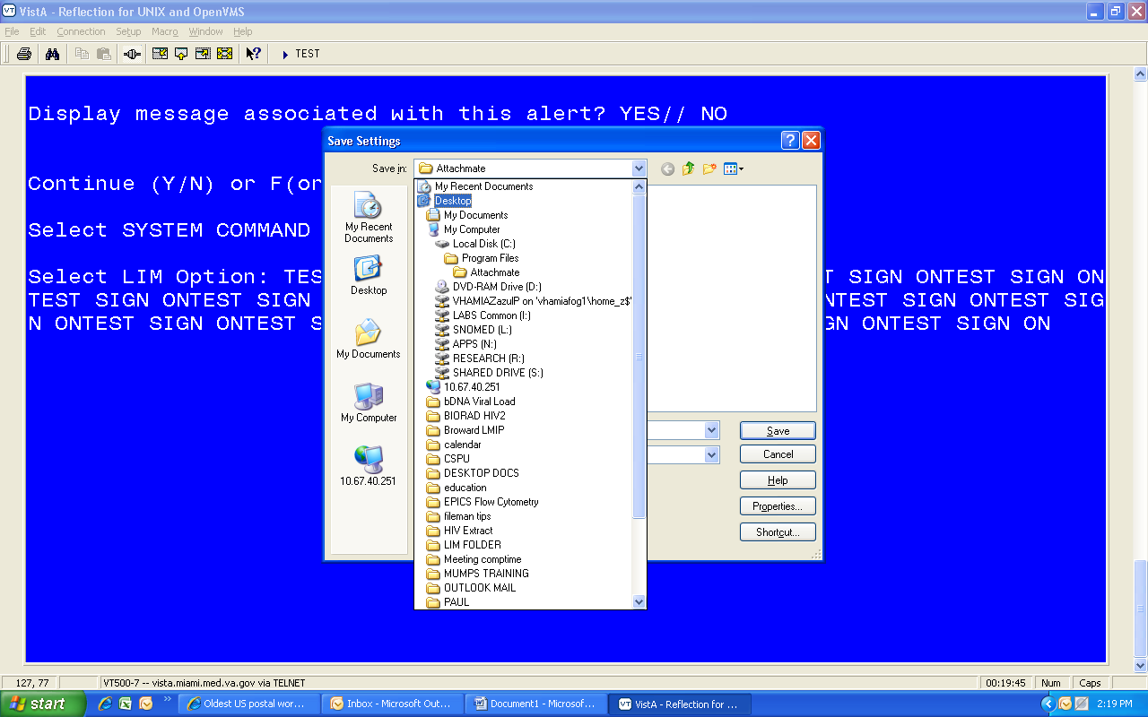
- Click Save.
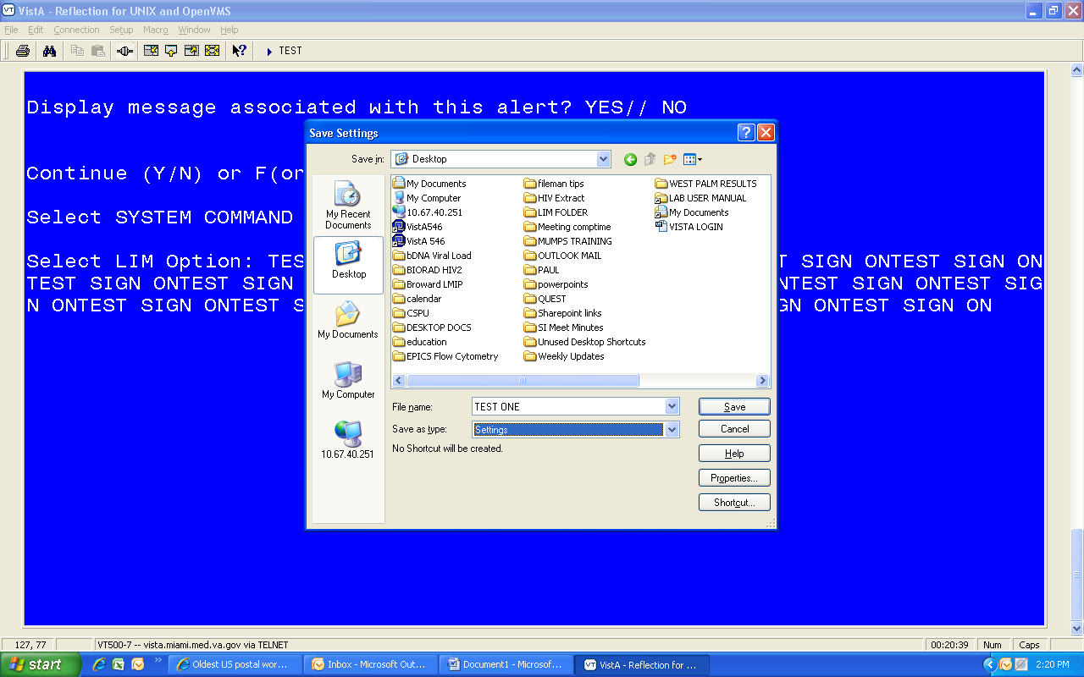
- Shortcut on desktop. When you click this, it will open the session with your saved macro and any others you have created.
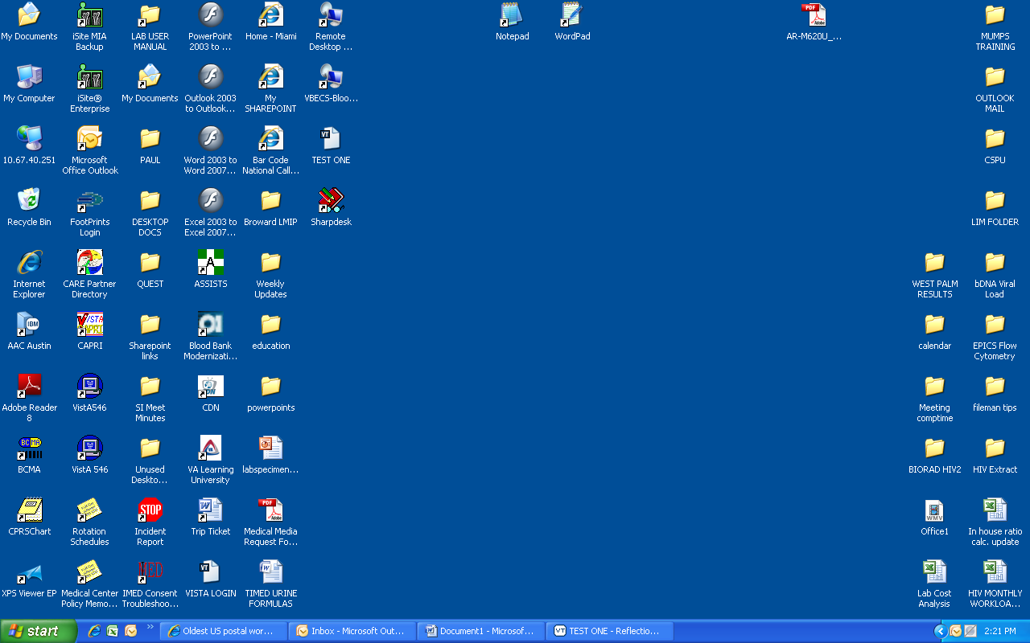

Thin Client for Howdy
- Logon as Administrator (press ALT+F4 during countdown).
- Add a menu option for Telnet session.

- Configure the connection (use screen shots for setting examples).
- Name your connection – other settings are default.

- Enter your site host name.
- Enter Username: in the text box.
- Respond with vista and press Enter.
- Click Add to complete the script.

Default settings are:
No changes here, yet…

Default settings are:
You are finished.

- Test the connection and tweak the telnet session settings.
- Log into VistA, so that you can edit the session settings without timing out.
- While performing the steps below, I recommend selecting File / Save Session between the different setups.

Terminal Settings are:
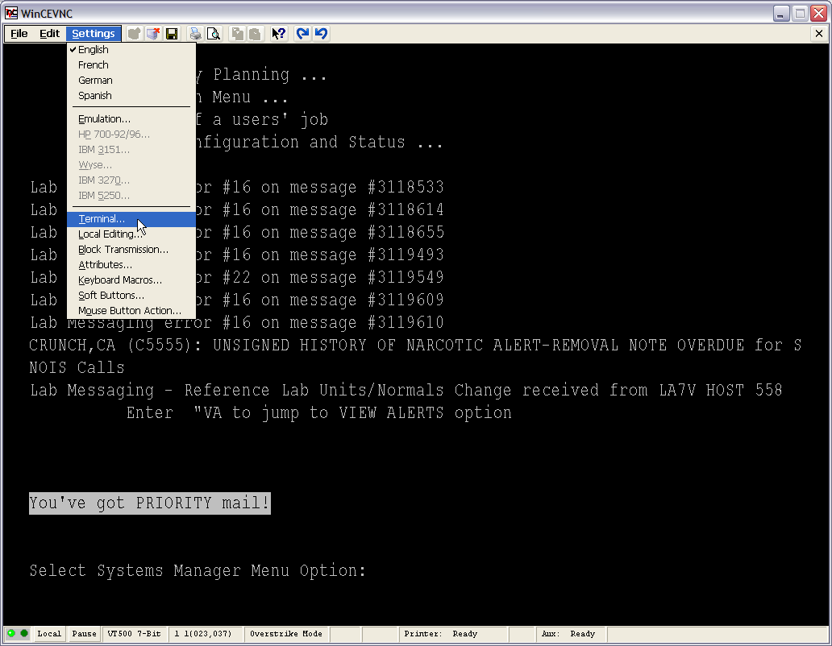

- Under Terminal Settings / Preferences I added Backspace = DEL
- Click OK and go back into Settings / Attributes.
- Scroll through the Screen Elements and assign preferences to the elements that you wish to change. You will have to experiment – there are a lot of little settings you can play with to make the screens look nice. This example shows where I set the font to bold.

Part of my screen after playing with the settings.
- Click OK to finish. Next we go into Settings / Keyboard Macros.
- Place your cursor in the Program Key block and press your F1 key. Then use the drop down under Predefined Macros and choose VT_PF1. Click Apply (which fills in the With block. Then click the Add button.
- Clicking Add places the info into the right hand window and clears the left side out so that you can add the next macro.
- Repeat with F2, etc. and click OK when finished.
- At this point you want to save your session! File / Save Session.
- Log out of VistA, exit the session, and Access the Control Panel.
- This is where you will change the Connection Manager menu that the vauser account sees.
- Choose the Security option from the Control Panel.
- Highlight the vauser account and Modify User.
- Assign the Telnet (VistA) menu and Unassign the Citrix Web Portal connections.

- Click OK to close this window and OK again to close out the Security window. When you close the Winterm Control Panel, the system will need to restart for the settings to take effect.
- Let the system come back up and auto-logon so that you see what the Howdy user sees. At this point, Settings menus and status bar are still visible. If you are happy with keyboard macros and all other settings, you can go back to your Administrator login and remove the menu bar and status bar.
- Go back into the application Edit settings and click through the screens until you come to this one:
- Disable Elements - pick individual items to remove, or you can just disable the whole menu bar.

- This is also the place to disable the status bar and decide how you want the program to act if VistA times out or the user closes the application.

