VistA Blood Establishment Computer Software (VBECS) Version 2.3.0

Administrator User Guide

September 2018

Department of Veterans Affairs
Enterprise Project Management Office
This page intentionally left blank.

Revision History

Date | Revision | Description | Author
6/19/18 | 1.0 | Initial Version. | BBM team
9/12/18 | 2.0 | Global: Revised screen captures and captions where applicable. | BBM team

This page intentionally left blank.

Table of Contents
Revision History 3
Introduction vii
VBECS Version Numbers vii
Related Manuals and Reference Materials ix
How this Administrator User Guide is Organized 11
Terms 11
Figures 11
Screen Shots 11
Customer Support 13
VBECS Maintenance Operations 15
Prerequisites 15
Outcome 16
Limitations and Restrictions 16
Additional Information 16
Log into VBECS Administrator 16
VBECS Administrator Operations 21
Edit System Interfaces 21
Assumptions 21
Limitations and Restrictions 21
Additional Information 21
Edit Divisions 31
Assumptions 31
Limitations and Restrictions 31
Additional Information 31
Add and Maintain Divisions 31
Edit Users 36
Assumptions 36
Limitations and Restrictions 36
Additional Information 36
Edit VBECS Users 36
Index 41

This page intentionally left blank.

Introduction
VBECS is a Blood Bank application that facilitates ongoing compliance with Food and Drug Administration (FDA) standards for medical devices and enhances the VA’s ability to produce high-quality blood products and services to veterans. The system follows blood bank standards, standards of national accrediting agencies, FDA regulations, and VA policies.
The main purpose of the VistA Blood Establishment Computer Software (VBECS) is to automate the daily processing of blood inventory and patient transfusions in a hospital transfusion service.
Unauthorized access or misuse of this system and/or its data is a federal crime. Use of all data, printed or electronic, must be in accordance with VA policy on security and privacy.

Do not change the system! The U.S. Food and Drug Administration classifies this software as a medical device. Unauthorized modifications will render this device an adulterated medical device under Section 501 of the Medical Device Amendments to the Federal Food, Drug, and Cosmetic Act. Acquiring and implementing this software through the Freedom of Information Act require the implementer to assume total responsibility for the software and become a registered manufacturer of a medical device, subject to FDA regulations. Adding to or updating VBECS software without permission is prohibited.

VBECS Version Numbers
In previous VBECS patch releases, the user documentation referred to the VBECS version in a 4-digit format (e.g., 2.1.0.2 – where 2.1.0 represents the patch version and the last digit (2) is the patch build number).
The VBECS version (Figure 1) is now represented with only the first three digits (e.g., 2.1.0) and appears that way in all user documentation to simplify readability
The revision letter tracks database-only updates (e.g., blood product table updates, canned comments updates). The revision letter is normally a single alpha character (e.g., C), but can be two characters (e.g., AA, AB, AC) in the unlikely event that more than 25 database updates are made before a code change is implemented. The revision letter starts at A with each new code change and is incremented to B when the first database-only update is made. The revision letter is then updated by one character in the alphabet for every successive database-only update until a new code change is implemented, at which time the revision letter reverts back to A. The version submitted for system testing is revision A, but the version customers receive can be revision A, B or a higher revision letter.

Figure 1: Example of VBECS Administrator About Screen
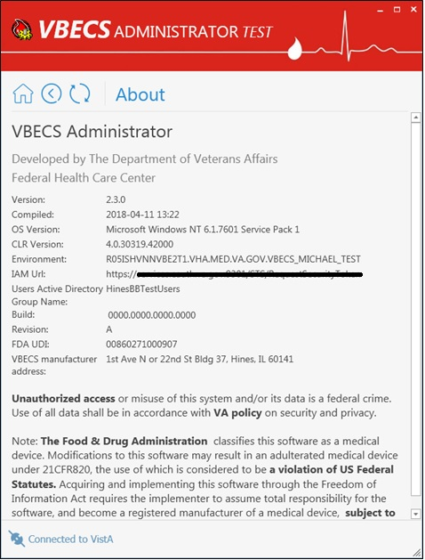

The VBECS Administrator and VBECS applications, when started, will verify that the application code (binary build number) matches the SQL Server code (database build number) in order to ensure that application servers and SQL servers are patched and remain in sync with each other. In the rare event that they fall out of sync, the applications will present the following error message (Figure 2) and close until both the code and the database are in sync.
Figure 2: Example of System Error
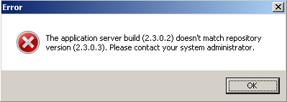

Related Manuals and Reference Materials
HL7 V2.3.1 Implementation Guide
CPRS-VBECS Interface (OR*3.0*212) Release Notes April 2009
PIMS V. 5.3 Technical Manual
Duplicate Record Merge: Patient Merge Technical Manual Version 7.3 April 1998 Revised December 2010
Kernel Systems Manual Version 8.0, Chapter 1: Sign-On Security/User Interface, pp. 13–20
Manage Open Sessions and Files in Windows 2008 R2
Health Product Support Release of Products and Patches Guide V2.3 Updated: February 2014
VistA Blood Establishment Computer Software (VBECS) 2.3.0 User Guide
VistA Blood Establishment Computer Software (VBECS) 2.3.0 Technical Manual-Security Guide
VistA Blood Establishment Computer Software (VBECS) 2.2.0 Automated Instrument and Instrument Manager for <instrument> Setup Guide
VistALink Version 1.5 Developer-System Manager Manual, Chapter 6: Security Management, pp. 34–35
Windows Server 2008R2 Security Guide, Microsoft Corporation
This page intentionally left blank.

How this Administrator User Guide is Organized
Outlined text is used throughout this guide to highlight warnings, limitations, and cautions:
Warnings, limitations, cautions

Terms
For consistency and space considerations, the pronouns “he,” “him,” and “his” are used as pronouns of indeterminate gender equally applicable to males and females.
In many instances, a user may scan a barcode or enter data manually (by typing). The term “enter” is used throughout this guide to mean “enter manually.”

Figures
If you refer to figures from the VBECS Administrator User Guide in your local policy and procedure documents, you may wish to use their titles only, without figure or table numbers: as the administrator user guide is updated, those numbers may change.

Screen Shots
Because VBECS is a medical device, screen shots must be captured at various points throughout the administrator user guide to meet FDA requirements for objective evidence and documentation.
This page intentionally left blank.

Customer Support
Contact your Local Information Resource Management (IRM) or Laboratory Automated Data Processing Application Coordinator (ADPAC) if you encounter VistA or CPRS connection problems and for training support before contacting the VA Service Desk (SD).

Please ensure local VistA Support contact information is available at all times. National Support will engage Enterprise Operations (EO) personnel as needed.

Problems with connectivity to VistA and CPRS may require personnel from EO with VBECS server administrator access and VistA IT support access.

If you experience an FDA reportable adverse event (patient death or serious injury) that VBECS may have caused or contributed to, contact the Enterprise Service Desk directly to enter a ticket for Blood Bank software support.

If the problem remains unresolved after local VistA triage, contact the national Information Technology (IT) support service or request a region ticket to be reassigned to:

Enterprise VA Service Desk Contact
See Customer Support section of the VBECS n.n.n Release Notes (where n.n.n is the version of the release notes associated with this release).

Enterprise VA Service Desk Alternate Contacts
See Customer Support section of the VBECS n.n.n Release Notes (where n.n.n is the version of the release notes associated with this release).
This page intentionally left blank.

VBECS Maintenance Operations

These maintenance operations are performed, using the VBECS Administrator software.

Do not change the system! The U.S. Food and Drug Administration classifies this software as a medical device. Unauthorized modifications will render this device an adulterated medical device under Section 501 of the Medical Device Amendments to the Federal Food, Drug, and Cosmetic Act. Acquiring and implementing this software through the Freedom of Information Act require the implementer to assume total responsibility for the software and become a registered manufacturer of a medical device, subject to FDA regulations. Adding to or updating VBECS software without permission is prohibited.

VistA data is treated as a master record for Divisions. VistA data and Active Directory are treated as a master record for Users. If a discrepancy is found between VBECS data and VistA or Active Directory, such records will be displayed as invalid and will require user intervention to correct.

VBECS data is cross referenced with VistA data, so it is very important to make sure that the VBECS Administrator is connected to the correct VistA account (see Figure 14: Example of Edit System Interfaces – VistALink). This is why before connecting to VistA, the user is presented with a VistA account confirmation message that contains all VistA account information (Figure 6 or Figure 7). If the VistA account is incorrect, the user must cancel the connection and specify the correct VistA account in VistALink External Interface settings. (See Figure 16 for instructions on obtaining a valid VistA Broker IP/Port.)

Prerequisites
- VistALink is installed and running on the associated VistA system.
- The VistA Outbound logical links have been set up and started.
- The VBECS VistALink and VBECS HL7 windows services are installed and running on the application server.
- The user is defined in VistA, has a DUZ and connectivity to VistA can be established.
- The user has a valid Windows account and is defined as a member of the VBECS Administrator Active Directory (AD) domain group.
- The VBECS database is operational and up-to-date.
- If using an Automated Instrument interface in VBECS, the supporting Middleware system with applicable drivers should be set up and running.

Outcome
- The VBECS Internal and External interfaces (Figure 9) have been set up and started.
- VBECS users and divisions are defined and users are able to access/use VBECS per its divisional access.
- Changes to verified data are captured for inclusion in the Audit Trail Report.

Limitations and Restrictions
- Only one instance of the VBECS Administrator can run at a time.
- Edit System Interfaces and Edit Divisions options cannot run when VBECS is operational. VBECS cannot run when a dialog in these options is operational.

Additional Information
- Refer to the completed Appendix B from the Configuration Worksheet in VBECS Application Interfacing Support Software Installation and User Configuration Guide for required information when performing maintenance operations.

Log into VBECS Administrator

User Action | VBECS Administrator
- Open a Remote Desktop Connection. | Displays the Remote Desktop Connection screen.
- Enter or select the name of the VBECS Application Server on the Remote Desktop Connection (Figure 3) screen and click Connect. | Displays Windows Security window for credentials.
- Select appropriate PIV, enter PIN, and click OK to enter the Remote Desktop Connection (Figure 4 and Figure 5). | Remote Desktop Connection establishes connection to target server. Target server displays Warning screen.
- Click OK on the Security Warning screen.  If another message is displayed (about the last time the user logged in), click OK. | Displays VBECS server desktop with VBECS Admin Prod and VBECS Admin Test icons.
- Double-click the VBECS Admin Prod icon. | Opens VBECS Administrator.
- Select appropriate PIV, enter PIN if requested to connect to VistA (Figure 4, Figure 5 and Figure 6) when VBECS Administrator starts up or at the invocation of any option that uses VistALink when VistALink is not connected. | VistA account confirmation message is displayed.
- Verify that correct VistA account is displayed.  - If the VistA account is correct, enter the VistA Access and Verify Codes if requested (Figure 6) and click Connect.  - If the VistA account is incorrect, click Cancel. Specify the correct VistA account in VistALink External Interface settings (Figure 14). Click OK to restart application. Go to step 5. | Displays the main VBECS Administrator screen.  NOTES  The user may skip logging into VistALink or continue and log on as needed.
Figure 3: Remote Desktop Connection Options
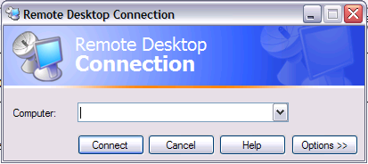
Figure 4: IAM – PIV Certificate
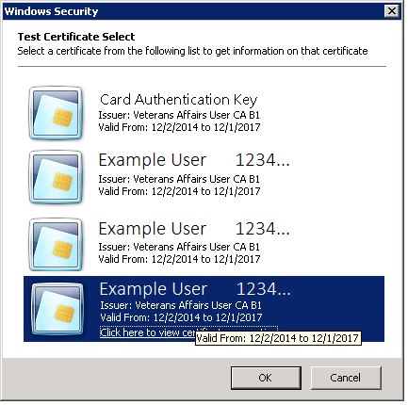
Figure 5: ActivClient Login
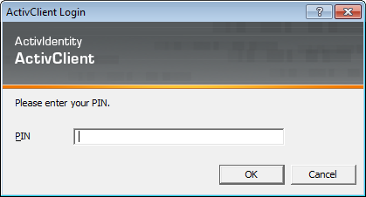

Figure 6: Example of VistA Logon with PIV
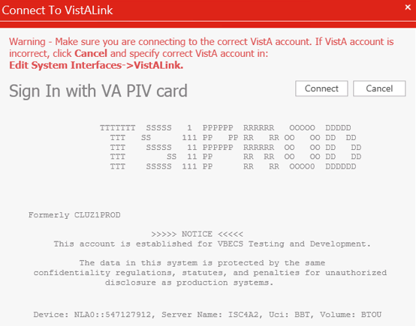
Figure 7: Example of VistA Logon with Access/Verify Codes
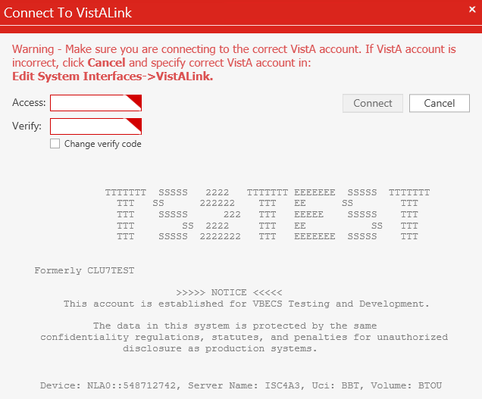

Figure 8: Example of VBECS Administrator
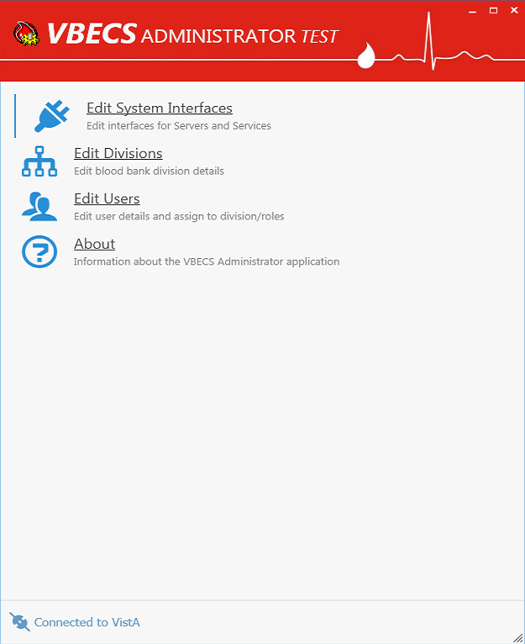

VBECS Administrator Operations

Edit System Interfaces
The VBECS Administrator will set up the parameters required for connection to VistA (VistALink and HL7 interfaces) and Data Innovations Middleware (Automated Instrument interface) enabling VBECS to send or receive data from multiple systems where applicable.

Interfaces are divided in two groups (Figure 9):
- Internal interfaces (marked with label) are VBECS services that listen for incoming messages from external applications (such as CPRS, VistALink). Each internal interface corresponds with windows service running on the VBECS application service:
  - VBECS VistALink Service corresponds with “VBECS Prod VistALink Listener”
  - VBECS HL7 Service corresponds with “VBECS Prod HL7 Listener”
- External interfaces (marked with label) are all other interfaces that VBECS communicates with.

Assumptions
None

Limitations and Restrictions
It is recommended to restart the VBECS HL7 Service (i.e., “VBECS Prod HL7 Listener” windows service) and the VBECS VistALink Service (i.e., “VBECS Prod VistALink Listener” windows service) on the application server if its properties are changed. VBECS Administrator will also try to automatically restart services in certain scenarios and will notify the user if the attempt fails (usually due to insufficient user privileges). If you receive the service restart failure message, file a support ticket. See the Customer Support section of VBECS 2.3.0 Release Notes.

Additional Information
None
Edit System Interface Parameters
User Action | VBECS Administrator
- Select Edit System Interfaces option (Figure 9). | System displays the available interfaces for configuration and their connection status:  Internal VBECS Services:  - VBECS VistALink Service (See Figure 10). Corresponds with “VBECS Prod VistALink Listener” windows service.  - VBECS HL7 Service (See Figure 12). Corresponds with “VBECS Prod HL7 Listener” windows service.  External Interfaces:  - VistALink (See Figure 14)  - CPRS HL7 OERR (See  Figure 17)  - BCE COTS (See Figure 19)  - Automated Instrument (See Figure 20)  NOTES  All enabled interfaces that have Connection Options are tested for connectivity and the interface status is displayed to the user.
- Select an interface for configuration. | System allows the following attributes to be configured or executed where applicable:  - Email alerts: must be a valid e-mail address  - Local/External Connection  - TCP/IP address or server name  - TCP/IP Port Number: integer defined in range 1024-65535  - External Facility: 1 through 20-character identifier for the remote side of the CPRS HL7 OERR and BCE COTS interfaces.  - Ack Timeout: is the number of seconds to wait for an acknowledgement from the receiving server and can be defined with a value from 1 through 999 seconds.  - Re-transmit Attempts: is the number of retransmit attempts for failed messages and can be defined with a value from 1 through 99.  - Activate/Deactivate interface switch: when Off, communication ends and no updates are queued.
- Apply the changes to the interface parameters. | System saves the changed parameters.  NOTES  If changes are made to the VBECS VistALink Service or the VBECS HL7 Service connection parameters, these services will be restarted automatically.  User may cancel changes or leave screen or application without applying changes. VBECS warns user that it will not save the data.  All changes to previously verified data, captured for an audit trail report, include:  - Category or transaction  - Data:  - Name of tech entering data  - Division  - Date/time originally saved  - Newly entered data:  - Name of tech entering data  - Division  - Date/time the new value is saved
- Repeat Steps 2 and 3 to configure additional interfaces as applicable.
Figure 9: Example of Edit System Interfaces
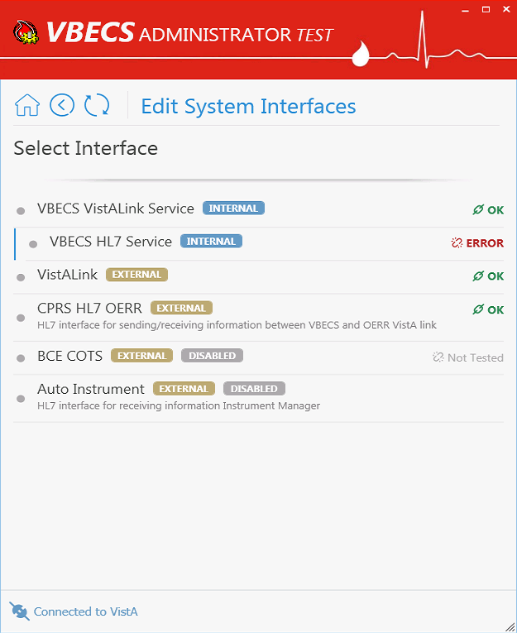
Figure 10: Example of Edit System Interfaces – VBECS VistALink Service
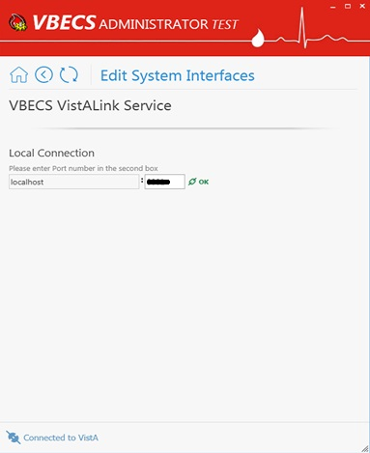
The IP Address and Port are defined in VistA in the PARAMETERS (#8989.5) file.

For example:
ENTITY (PKG) = VBECS
PARAMETER =VBECS VistALink LISTENER

INSTANCE =LISTENER PORT NUMBER
VALUE = 21992 for PROD, 21991 for TEST

INSTANCE = LISTENER IP ADDRESS
VALUE = The IP address of the VBECS server.
Note, that VBECS Server IP is always “localhost” in VBECS Administrator (as the “VBECS Prod VistALink Listener” windows service is always running directly on VBECS application server). Check with your local or regional support personnel if you are unable to determine the VBECS IP address.
VBECS VistALink Service corresponds with “VBECS Prod VistALink Listener” windows service and specifies which port number windows service is listening for incoming messages.

Figure 11: VBECS VistALink Service: Old to New Mapping
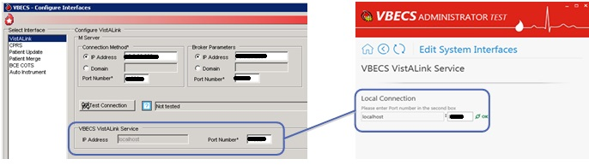
Figure 12: Example of Edit System Interfaces – VBECS HL7 Service
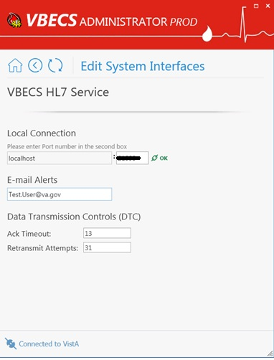
This is the port defined in the OERR-VBECS logical link in VistA. The VBECS Application server IP address will be the same as the listings for the connection in the other VistA HL7 listing for the VBECSPTU and VBECSPTM links.
Note, that VBECS Server IP is always “localhost” in VBECS Administrator (as the “VBECS Prod HL7 Listener” windows service is always running directly on VBECS application server). Check with your local or regional support personnel if you are unable to determine the VBECS IP address.
The current settings for all VBECS related links can be found using the HL EDIT LOGICAL LINKS option in VistA.

Note: standard port for PROD system is 21994 and for TEST system is 21993
VBECS HL7 Service corresponds with “VBECS Prod HL7 Listener” windows service and specifies which port number windows service is listening for incoming messages.

Figure 13: VBECS HL7 Service: Old to New Mapping
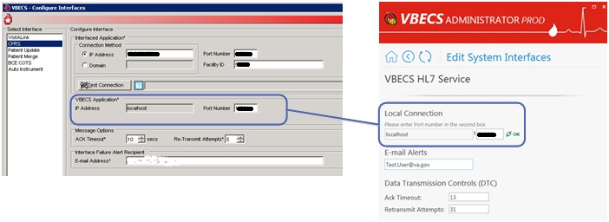
Figure 14: Example of Edit System Interfaces – VistALink
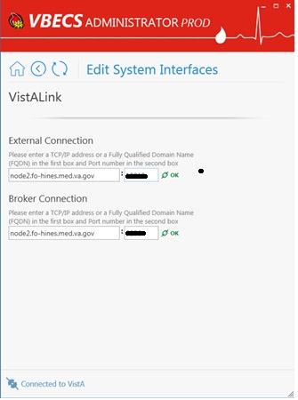
Specifies the TCP IP address and port number used by the VistALink listener (VLINK) in VistA. Check with your local or regional support personnel if you are unable to determine the IP address and Port for the local instance of VistALink.

Note: port number, e.g., 19818 (where 18 is the site’s magic number)
Used only for user authentication purposes and specifies which TCP IP address and port number CPRS Broker connection is running on VistA (see Figure 16 for instructions on obtaining a valid CPRS Broker IP/Port).
Note, IP address usually is the same as for VistALink listener (VLINK) (see above).

Figure 15: VistALink Interface: Old to New Mapping
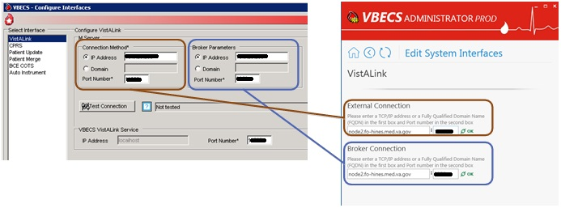
Figure 16: Example of Collecting VistA Broker Values from a CPRS Shortcut
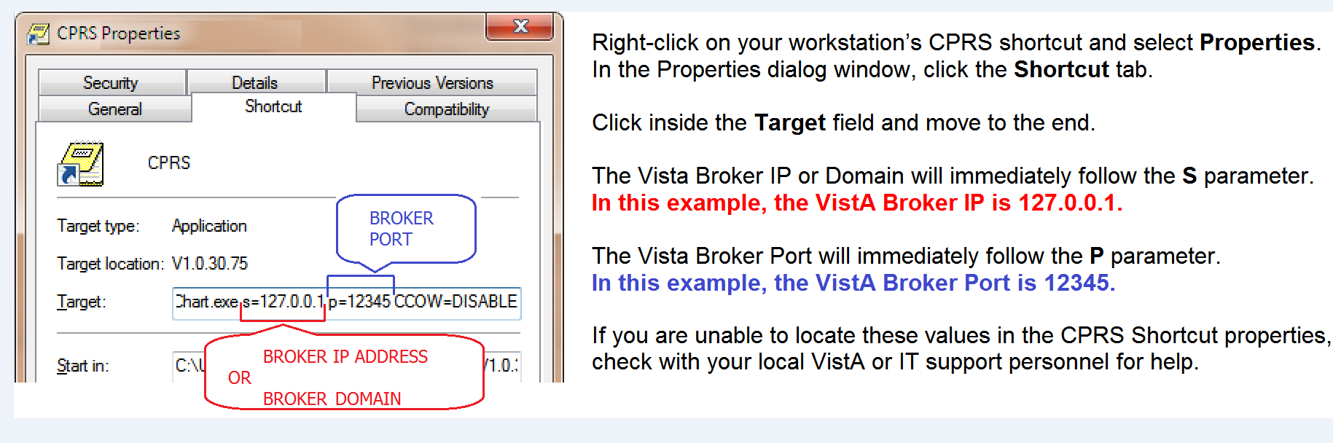

Figure 17: Example of Edit System Interfaces – CPRS HL7 OERR
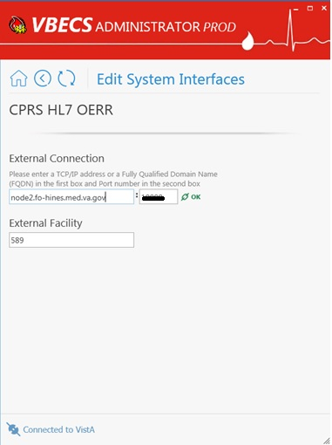
TCP IP address and port number defined in VBECS-OERR logical link in VistA.
Check with your local or regional support personnel if you are unable to determine the IP address and Port for the local link in VistA.

Note: port number, e.g., 19998 (where 99 is the site’s magic number)

Figure 18: CPRS HL7 OERR Interface: Old to New Mapping
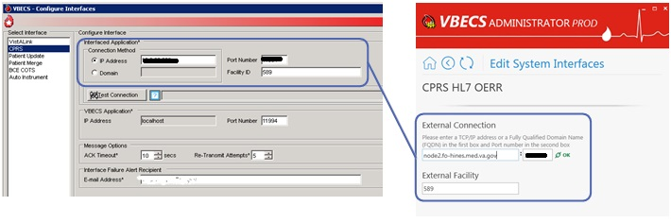
Figure 19: Example of Edit System Interfaces – BCE COTS
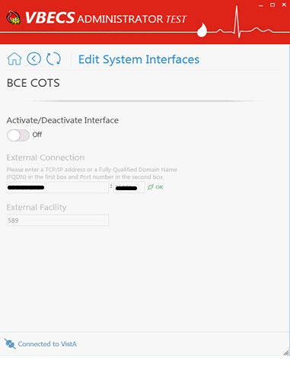
All VA facilities have this interface disabled until further notice from VA about BCE interfacing support.

Figure 20: Example of Edit System Interfaces – Automated Instrument
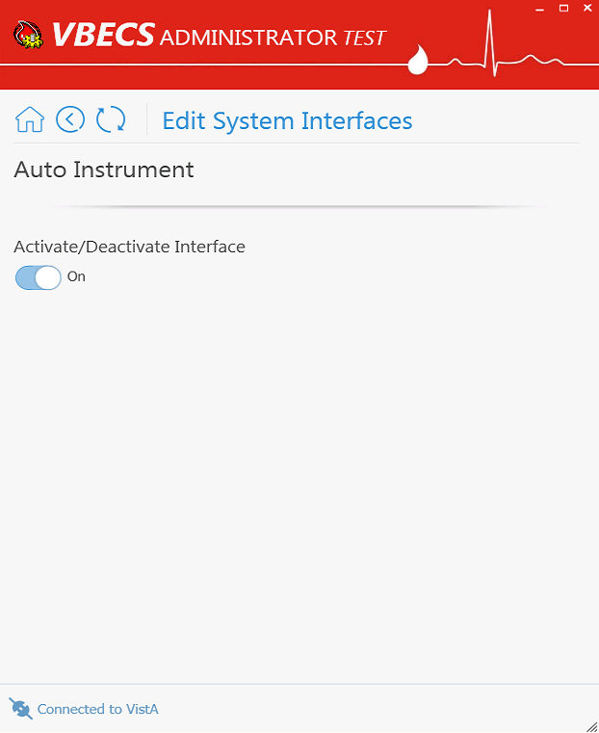

Edit Divisions
The VBECS Administrator configures VBECS as a single division or as multidivisional. One or more divisions may be defined in VBECS as local facilities (marked with label) or may be mapped (marked with label) to a defined VBECS division (see Figure 21). Mapped divisions (also known as CBOC) specify order delivery mapping: if blood is issued to a mapped division, all activities in VBECS associated with that order will be related to the mapped-to defined division.
Defined or Mapped divisions may be undefined in VBECS. All undefined divisions are marked with label; this means that they exist only in a VistA account and are available for future defining or mapping in VBECS.

Assumptions
- The VistALink external interface (see Figure 14) is configured and valid.
- VistA Logon has been executed successfully.

Limitations and Restrictions
- VBECS orders can only be mapped to divisions defined in VBECS.
- When the division changes from full-service to transfusion-only or from transfusion-only to full-service, blood units and orders must be in a final state and eXM must be disabled.
- Divisions defined in VBECS must have at least one Level 6 (Administrator/Supervisor) user assigned in order to have access to the Supervisor menu options in VBECS.
When orders mapping is changed, VBECS HL7 Service (i.e., “VBECS Prod HL7 Listener” windows service) should be restarted in order to accept these changes. If user does not have the necessary permissions to do this, they will need to file a ticket with customer support.

Additional Information
Changes in the mapping orders do not affect delivered orders. Orders delivered to a VBECS division must be completed, rejected, or canceled in that division. Resubmit orders after mapping is completed to send an order to another VBECS division.

Add and Maintain Divisions
User Action | VBECS Administrator
- Select Edit Divisions (Figure 21). | System displays each available VistA division with its status in VBECS.  NOTES  System checks to see whether a connection to VistALink is established. When there is not a connection to VistALink, the option is not available.  If a previously defined or mapped VBECS division is not found in VistA, the corresponding record will be marked as Invalid. If invalid records are found, the list will be pre-filtered to invalid records only.  If user chooses to clear an invalid division which was previously defined, it will be cleared together with all user divisional roles assigned to that division and all order mapping to that division (mapped divisions).  The Division Name in VBECS is silently synced with the Division Name in VistA if a discrepancy is detected.
- Select a division from the presented list view to configure it in VBECS (Figure 22). | For an undefined division, the system allows the user to define or map the division (map its orders) to the other defined division.  For a mapped division, the system allows the user to un-map the division (remove order mapping) from the other defined division. After un-mapping the division, the user will get the undefined status.  For a defined division, the system allows the user to undefine the division in VBECS as well as configuring the following parameters:  - Full Service Division switch: when on, division is Full Service; when off, division is Transfusion only (when a division is transfusion-only, VBECS disables electronic crossmatch).  - Associated FDA Registered Facility  - Orders Mapping (CBOC). See Figure 23 for how to assign orders mapping from remote facilities.  - Accession Area  - Lock Timeout: lock inactivity timeout in VBECS (range 5-15)  - Label Printing (optional)  - TCP/IP address or server name  - TCP/IP Port Number: integer defined in range 1024-65535. Must match the port number defined in the printer software.  - Report Printer: Required selection from all report printers installed on the VBECS server. VBECS will warn the user if the defined division does not have the correct report printer selected.  - Time Zone  - Observing DST  NOTES  When undefining a division, VBECS will warn the user if the division has any user division roles assigned, and requires user confirmation before continuing. After positive confirmation, the system must remove all assigned user roles as a part of the Un-Defining command.  VBECS will warn the user if the defined division does not have a Level 6 user.  Undefined VistA divisions are available for defining a new VBECS division or order mapping. One defined VBECS division may have many VistA divisions mapped to it, but a VistA division may be associated with only one defined VBECS division (i.e., one-to-many relation). An already mapped VistA division cannot be used for defining a new VBECS division.  Orders mapping relates to the physical testing facilities, not where orders are generated or where blood is sent for transfusion (See Figure 23 for how to assign orders mapping from remote facilities).
- Apply the changes to the division parameters. | System saves the changed parameters.  NOTES  User may cancel changes or leave the screen or application without applying changes. VBECS warns the user that it will not save the data.  All changes to previously verified data, captured for an audit trail report, include:  - Category or transaction  - Data:  - Name of tech entering data  - Division  - Date/time originally saved  - Newly entered data:  - Name of tech entering data  - Division  - Date/time the new value is saved
- Repeat Steps 2 and 3 for each division, as applicable.
Figure 21: Example of Select VistA Division
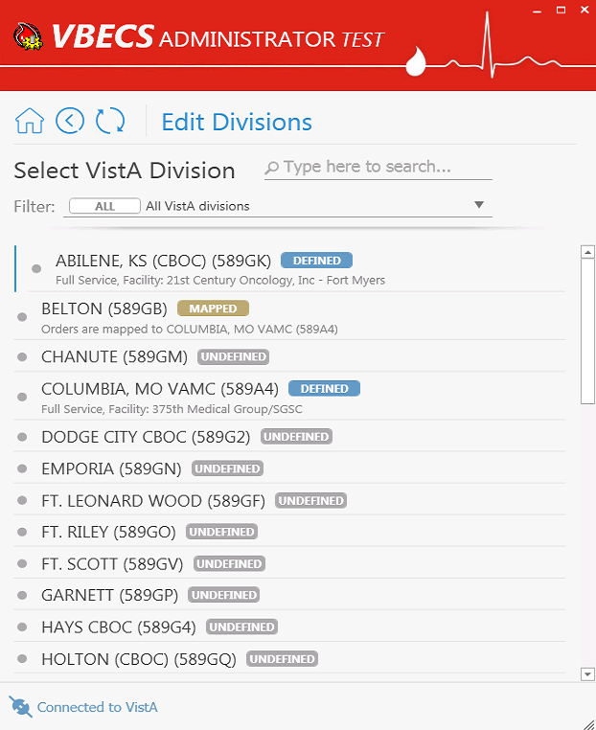

Figure 22: Example of Edit Division
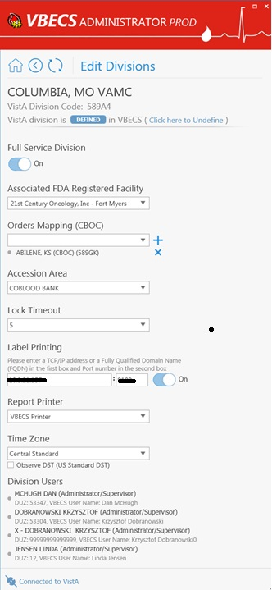
Figure 23: Example of Edit Division: Assign new orders mapping
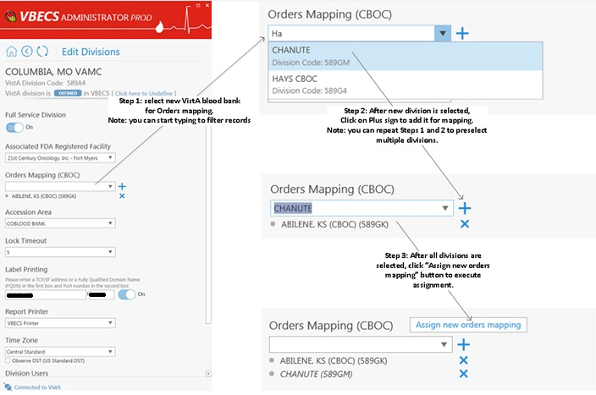
Note: When orders mapping is changed, VBECS HL7 Service (i.e., “VBECS Prod HL7 Listener” windows service) should be restarted in order to accept these changes.

Edit Users
The VBECS Administrator configures VBECS users. One or more users may be defined in VBECS (marked with label) or may be undefined (marked with label) (see Figure 24). Defined users can use VBECS per the user’s divisional access settings. Users may have different security levels for each assigned division; users may be restricted to use the division as well.
Undefined users exist only in VistA account and Active Directory group and are available for future defining in VBECS.

Assumptions
- The VistALink external interface (see Figure 14) is configured and valid.
- VistA Logon has been executed successfully.
- Users to be configured have been assigned the appropriate VistA Division in the NEW PERSON file (#200) DIVISION multiple.
- Users to be configured have been defined as VistA Blood Bank users in VistA account and assigned to the correct Active Directory group (see Figure 1). Contact a local system administrator to add or remove VBECS users from your VBECS Active Directory groups.

Limitations and Restrictions
- VBECS Administrator caches data collected from the Active Directory at startup. In order to refresh it, the application must be restarted.
Each VBECS user must have a unique Windows login ID. If a Windows login ID becomes inactive and is eligible for re-use in Active Directory, do not re-use it for VBECS: it may result in corrupted data in VBECS.
It is not recommended to change a user’s Windows login ID. If it does change, the current user record will be invalidated in VBECS Administrator.

Additional Information
- Each defined VBECS user must have a unique DUZ.
- The VBECS User ID stored in VBECS is the user’s NT Logon ID.
- A VBECS Administrator/Supervisor can further configure VBECS users in VBECS but an initial role must be defined for each VBECS user in VBECS Administrator. The option should be used primarily to define and undefine the user in VBECS.
- A user’s role may be changed while they are logged into VBECS; the change takes effect the next time the user logs into VBECS.

Edit VBECS Users
User Action | VBECS Administrator
- Select Edit Users (Figure 24). | System displays each available VistA Blood Bank user (who are also defined in the appropriate Active Directory group) with its status in VBECS. System displays user name and DUZ as it is defined in VistA.  The list is searchable by:  - VistA user name and DUZ  - User’s NT Logon ID  - Active Directory user name  NOTES  System checks whether a connection to VistALink is established. When there is no a connection to VistALink, the option is not available.  If a previously defined VBECS user is not found in VistA or Active Directory Group, the corresponding record will be marked as Invalid. If invalid records are found, the list will be pre-filtered to invalid records only.  If user chooses to clear an invalid user which was previously defined, it will be cleared together with all divisional roles.  The user name and e-mail in VBECS are silently synced with the user’s data from Active Directory if a discrepancy is detected.
- Select a user for configuration (Figure 25). | For an undefined user record, the system allows the user to define the user in VBECS.  For a defined user, the system allows the user to undefine the user in VBECS as well as configure the following parameters:  - Mapped Windows User: allows the user to map the current user record to a different Windows Account from the Active Directory group. There is a one-to-one correspondence between Windows users and VistA users. A VistA DUZ may only be associated with one NT Logon ID and vice versa.  - Initials: A unique user initial is required which may be 2-5 characters (alphanumeric) in length.  - Divisional Access: matches divisional access in VistA for each user. Allows the user to assign divisional access for all defined divisions in VBECS.  NOTES  An invalid record might hold a DUZ; clear invalid record to re-use released DUZ for defining a new VBECS user.  Invalid record might hold NT Logon ID, clear the invalid record to re-use released NT Logon ID for defining a new VBECS user or mapping existing defined user to this NT Logon ID.  A user may not remove the last level 6 (Administrator/ Supervisor) user from a defined division. An error message will appear when the last level 6 is being updated to a level 5 or lower.
- Apply the changes to the user parameters. | System saves the changes parameters.  NOTES  User may cancel changes or leave screen or application without applying changes. VBECS warns the user that it will not save the data.  VBECS associates the technologist ID, date, time, and division with each process for retrieval by division.  All changes to previously verified data, captured for an audit trail report, include:  - Category or transaction  - Data:  - Name of tech entering data  - Division  - Date/time originally saved  - Newly entered data:  - Name of tech entering data  - Division  - Date/time the new value is saved
- Repeat Steps 2 and 3 for each user, as applicable.

Figure 24: Example of Select VistA User
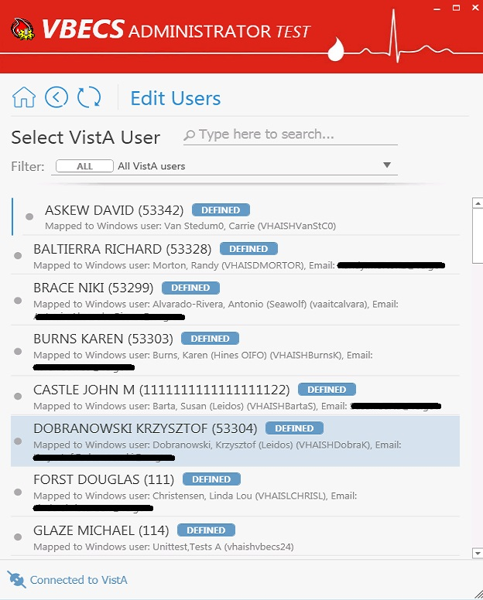

Figure 25: Example of Edit User
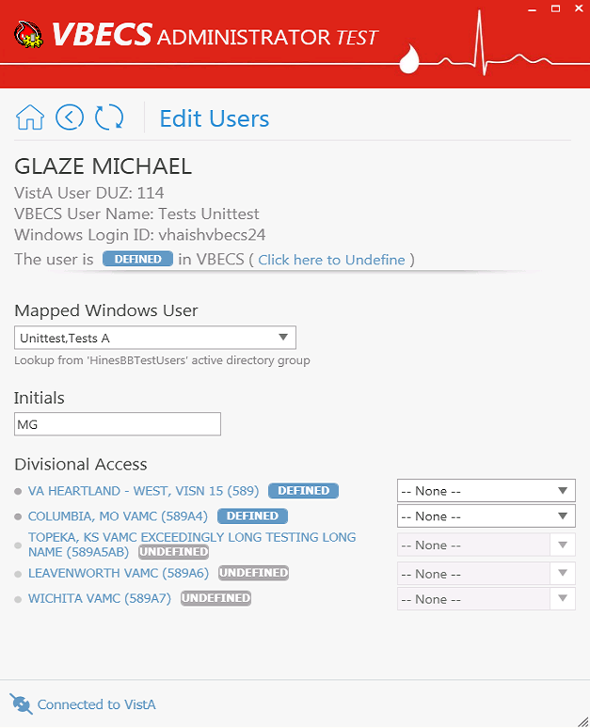
This page intentionally left blank.

Index

C
Customer Support 13
H
How This Technical Manual-Security Guide Is Organized 11
I
Introduction vii
M
Maintenance Operations 15
R
Related Manuals and Reference Materials ix
S
Screen Shots 11
V
VA Service Desk 13

This is the last page of the VistA Blood Establishment Computer Software (VBECS) 2.3.0 Administrator User Guide.

