

VistA Blood Establishment Computer Software (VBECS) Version 2.3.2

Technical Manual-Security Guide Version 2.0

July 2020

Department of Veterans Affairs
Enterprise Project Management Office

This page intentionally left blank.

Table of Contents

Introduction 1
VBECS Version Numbers 1
Related Manuals and Reference Materials 3
How This Technical Manual-Security Guide Is Organized 5
Terms 5
Figures and Tables 5
Screen Shots 5
Data Center Tasks 5
Appendices 5
Remote Desktop Configuration (Windows) 7
Server Name and Screen Resolution 7
Sound 10
Keyboard 11
Connection Speed 12
Save Settings 13
Create a Remote Desktop Connection Shortcut for VBECS 14
Server Hardware and System Configuration 15
Required Peripherals 17
Printers 17
Report Printer 17
Label Printer (Zebra ZM400, Z4Mplus and ZT410) 23
Scanners 24
Workstation Configuration 25
Report Share 25
Implementation and Maintenance (Data Center Only) 27
Periodic System Maintenance 27
SQL Maintenance Jobs 28
SQL Maintenance Job Alerts 28
SQL Database Backups 29
Applying Windows Updates 30
Applying Updates to VBECS SQL Server System 32
ePolicy and Virus Definitions 43
VistA Maintenance Operations 45
Set Up VBECS Outbound Logical Links 45
Set Up the VBECS Inbound Logical Link 47
Start VistA HL7 Logical Links 48
Monitor VBECS HL7 Logical Links 49
Configure VBECS VistALink Links 50
VBECS Maintenance Operations 51
Record Workload Data 51
External Interfaces 55
VistALink Remote Procedure Calls 55
VBECS Windows Services 57
Troubleshooting 59
Remote Desktop Session Issues 59
Remote Desktop Services Licensing Issues 60
Stopping and Starting VBECS Services 62
VBECS Auditing 62
VBECS Exception Logging 63
VBECS Application Interfaces 63
Zebra Printer Problems 72
Scanner Problems 74
Archiving and Recovery (Data Center Only) 77
Restore the Databases 77
Failover 79
Performance 81
Locking 81
Security 83
Access Request Process 83
Active Directory 83
Group Policy 83
System Center Operations Manager 83
Application-Wide Exceptions 84
Configuring the App Server and Lab Workstations 87
Server Tasks (Data Center Only) 87
Grant User Permissions 87
Configure the Report Share 89
Workstation Tasks 94
Update the RDP Shortcut 94
Configure a Shortcut to the Report Share 96
Glossary 99
Appendices 101
Appendix A: Data Center Instructions (Data Center Only) 101
Purpose 101
Server Configuration 101
Initial Setup Tasks 102
Ongoing Tasks 104
Appendix B: Auditing on VBECS Servers 105
Appendix C: Set Up VBECS Protocol Definitions 107
Set Up VBECS Protocol Definitions 107
Patient Update Events 108
Patient Merge Events 115
Order Update Events 118
Order Update Events (continued) 121
Appendix D: Laboratory Test File (#60) 125
Appendix E: Other Configuration Items 129
Assign the B Type Option to Blood Bank Users 129
Assign Security Keys to Blood Bank Users 129
Index 131
Revision History 133

This page intentionally left blank.

Introduction
The main purpose of the VistA Blood Establishment Computer Software (VBECS) is to automate the daily processing of blood inventory and patient transfusions in a hospital transfusion service.
Unauthorized access or misuse of this system and/or its data is a federal crime. Use of all data, printed or electronic, must be in accordance with VA policy on security and privacy.

Do not change the system! The U.S. Food and Drug Administration classifies this software as a medical device. Unauthorized modifications will render this device an adulterated medical device under Section 501 of the Medical Device Amendments to the Federal Food, Drug, and Cosmetic Act. Acquiring and implementing this software through the Freedom of Information Act require the implementer to assume total responsibility for the software and become a registered manufacturer of a medical device, subject to FDA regulations. Adding to or updating VBECS software without permission is prohibited.

VBECS Version Numbers
In previous VBECS patch releases, the user documentation referred to the VBECS version in a 4-digit format (e.g., 2.1.0.2 – where 2.1.0 represents the patch version and the last digit (2) is the patch build number).
The VBECS version (Figure 1) is now represented with only the first three digits (e.g., 2.1.0) and appears that way in all user documentation to simplify readability
The revision letter tracks database-only updates (e.g., blood product table updates, canned comments updates). The revision letter is normally a single alpha character (e.g., C), but can be two characters (e.g., AA, AB, AC) in the unlikely event that more than 25 database updates are made before a code change is implemented. The revision letter starts at A with each new code change and is incremented to B when the first database-only update is made. The revision letter is then updated by one character in the alphabet for every successive database-only update until a new code change is implemented, at which time the revision letter reverts back to A. The version submitted for system testing is revision A, but the version customers receive can be revision A, B or a higher revision letter.

Figure 1: Example of Help, About VBECS
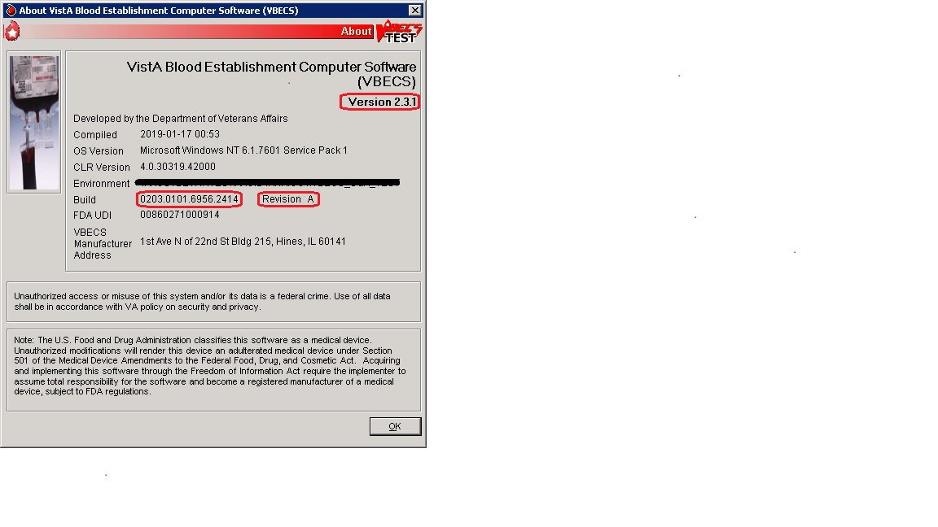

The VBECS Administrator and VBECS applications, when started, will verify that the application code (binary build number) matches the SQL Server code (database build number) in order to ensure that application servers and SQL servers are patched and remain in sync with each other. In the rare event that they fall out of sync, the applications will present the following error message (Figure 2) and close until both the code and the database are in sync.
Figure 2: Example of System Error
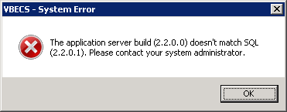

Related Manuals and Reference Materials
HL7 V2.3.1 Implementation Guide
CPRS-VBECS Interface (OR*3.0*212) Release Notes April 2009
PIMS V. 5.3 Technical Manual
Duplicate Record Merge: Patient Merge Technical Manual Version 7.3 April 1998 Revised December 2010
Kernel Systems Manual Version 8.0, Chapter 1: Sign-On Security/User Interface, pp. 13–20
Manage Open Sessions and Files in Windows 2008 R2
Health Product Support Release of Products and Patches Guide V2.3 Updated: February 2014
VistA Blood Establishment Computer Software (VBECS) 2.3.2 User Guide
VistA Blood Establishment Computer Software (VBECS) 2.3.2 Administrator User Guide
VistA Blood Establishment Computer Software (VBECS) – <instrument> Configuration and Setup Guide
VistALink Version 1.5 Developer-System Manager Manual, Chapter 6: Security Management, pp. 34–35
Windows Server 2008R2 Security Guide, Microsoft Corporation
This page intentionally left blank.

How This Technical Manual-Security Guide Is Organized
Outlined text is used throughout this guide to highlight warnings, limitations, and cautions:
Warnings, limitations, cautions

Terms
For consistency and space considerations, the pronouns “he,” “him,” and “his” are used as pronouns of indeterminate gender equally applicable to males and females.
In many instances, a user may scan a barcode or enter data manually (by typing). The term “enter” is used throughout this guide to mean “enter manually.”
See the Glossary for definitions of other terms and acronyms used in this guide.

Figures and Tables
If you refer to figures and tables from the Technical Manual-Security Guide in your local policy and procedure documents, you may wish to use their titles only, without figure or table numbers: as the technical manual-security guide is updated, those numbers may change.

Screen Shots
Because VBECS is a medical device, screen shots must be captured at various points throughout the technical manual-security guide to meet FDA requirements for objective evidence and documentation. A (camera) at the beginning of each step that requires a screen capture will identify these points.

Data Center Tasks
Some of the tasks in this guide are executed by members of Data Center (DC) affiliated with the data center where VBECS Servers are hosted. These tasks are differentiated by the text in the headings with (Data Center Only) noted in the heading.

Appendices
The appendices contain reference materials.
While pressing the Ctrl button, left-click on a section name or page number in the table of contents to move to that section or page. The index does not incorporate this feature.
.
This page intentionally left blank.

Remote Desktop Configuration (Windows)
Configure the screen resolution, sound, and connection speed, and create a Remote Desktop Connection shortcut on each VBECS workstation.

Server Name and Screen Resolution
To set the screen resolution:
- Double-click  (the Remote Desktop Connection icon).
- Click Show Options (Figure 3).
Figure 3: Example of Remote Desktop Connection Options
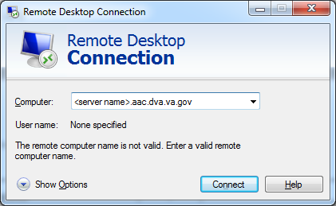
- Click the General tab (Figure 4).
- Enter the VBECS application server’s fully qualified domain name (FQDN) in the Computer field. The name will always be your server name followed by .aac.dva.va.gov
Figure 4: Example of General Tab Computer and Domain
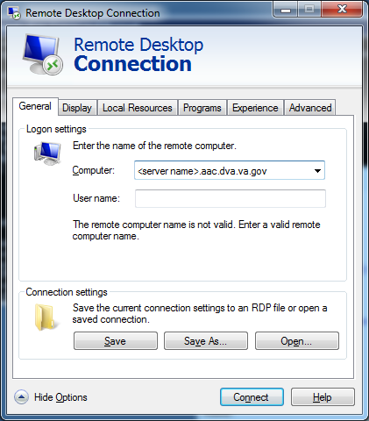
- Click the Display tab (Figure 5).
- Click, hold, and slide the pointer to a screen resolution of Full Screen.
Figure 5: Example of Display Tab
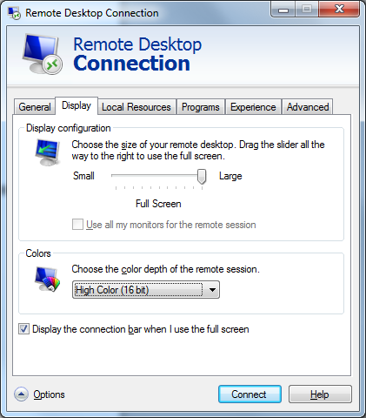

Sound
To enable sound:
- Click the Local Resources tab (Figure 6).
- Click the Settings button.
Failure to properly configure the sound disables audible alerts throughout VBECS.
Figure 6: Example of Remote Computer Sound
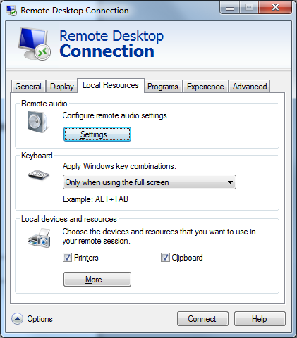
- Select Play on this computer (Figure 7) from the Remote audio playback section.
- Click the OK button.
Figure 7: Remote audio playback selection
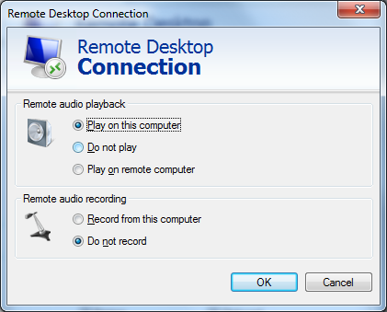

Keyboard
To configure keyboard settings:
- Click the Local Resources tab (Figure 8).
- Select On this computer from the Keyboard drop-down list.
Figure 8: Example of Remote Computer Keyboard
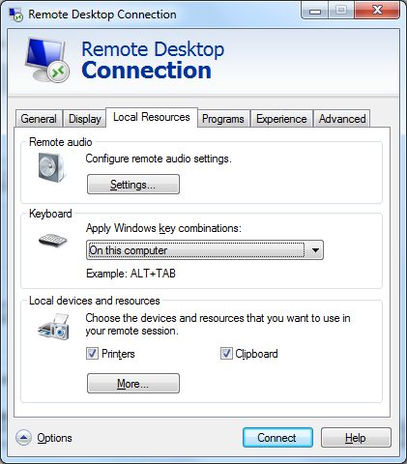

Connection Speed
To set the connection speed:
- Click the Experience tab (Figure 9).
- Select LAN (10 Mbps or higher) from the Choose your connection speed to optimize performance drop-down list. Deselect Font smoothing.
Figure 9: Example of Connection Speed
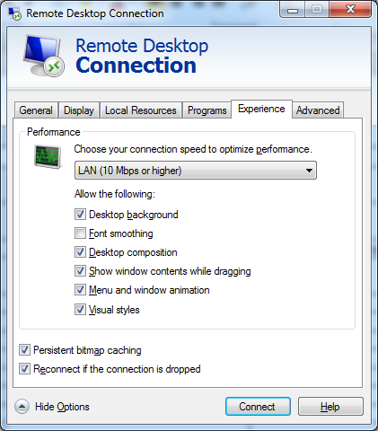

Save Settings
To save the settings:
- Click the General tab (Figure 10).
- Click Save As.
Figure 10: Example of General Tab Save As

Create a Remote Desktop Connection Shortcut for VBECS
- To create a Remote Desktop Connection shortcut for VBECS (Figure 11), save the file as VBECS.rdp in the C:\Users\Public\Public Desktop folder.
Figure 11: Example of Remote Desktop Connection Shortcut for VBECS
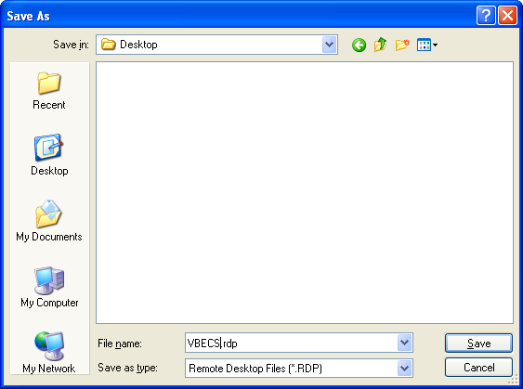
- Double-click the shortcut to launch the Remote Desktop Connection to VBECS. The Windows start-up sound confirms that the sound functions.

Server Hardware and System Configuration
The VBECS application requires hardware and system software to service the requirements of a user population of five users in a standard configuration and up to twenty-five users in an integrated Veterans Integrated Service Network (VISN) environment.

VBECS is installed in a virtualized environment using vSphere® as the virtualization platform. This section focuses on the configuration of the virtual machines. Table 15 and Table 16 contain the virtual machine specifications for the Application and SQL Servers respectively. The System Schematic diagram (Figure 12) describes the major system components:

- Application Server (App Server): This is a Windows 2008 Server Enterprise Edition R2 (x64) server and is the execution environment for the VBECS application (both Test and Production). It also functions as a Remote Desktop Protocol (RDP) Server. Each VBECS instance (single or multidivisional) has a unique App Server.
The App Server also communicates with and exchanges information with VistA applications and other HL7 interfaces through messages formatted using Extensible Markup Language (XML) and Health Level 7 (HL7) over Transmission Control Protocol/Internet Protocol (TCP/IP) networking.
- SQL Server: This is a Windows 2008 Server Enterprise Edition R2 (x64) server that runs SQL Server 2012. It hosts the VBECS’ databases for each single or multidivisional instance. Up to 15 sites share a single SQL Server.
SQL Servers exist in an AlwaysOn cluster, which consists of three nodes. The Primary and High Availability servers reside at the primary site while a Disaster Recovery server resides at an alternate location:
  - Primary SQL Server: This server fields all requests. Its data are replicated to the High Availability and Disaster Recovery servers.
  - High Availability (HA) SQL Server: This server provides database backup services through synchronous replication. Its data are guaranteed to be consistent with the Primary. It becomes the Primary should the original Primary server fail or become unreachable. Failover to this server is automatic.
  - Disaster Recovery (DR) SQL Server: This server resides at a remote site and provides database backup services through asynchronous replication. It becomes the Primary server should both the Primary and HA server fail or become unreachable. Failover to this server is a manual process.
- Windows Workstations: Users continue to access the VBECS application using Remote Desktop Services.

Figure 12: System Schematic
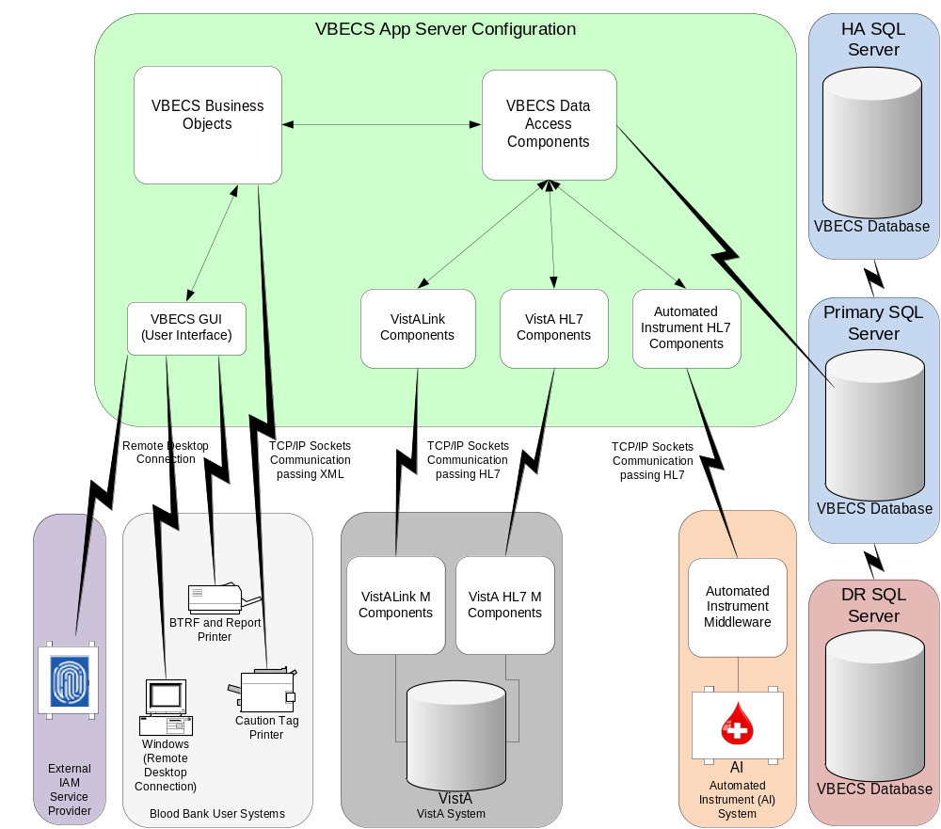

Required Peripherals
Table 1 describes additional required hardware.
Table 1: Additional Required Hardware
Additional Required Hardware
Barcode Scanner | Hand-Held Model 4600 (This is the model distributed with the original VBECS deployment and is now discontinued. The successor is the Honeywell Xenon 1900.)
Report Printer | HP LaserJet 9040dn (sites may elect to use a different report printer)
Label Printer | Zebra ZM400, Z4MPlus or ZT410; Must print at 300 DPI and have Ethernet connectivity.

Printers

Report Printer
A laser printer capable of printing 8.5" x 11" sheets may be used. VBECS supports duplex printing, but not all printers are duplex capable. Consult the printer documentation to determine if it has this capability.
Note: A division’s printer name cannot exceed 50 characters in length.

Installing a Printer (Server Administrators Only)
To install a printer, execute the following instructions:
- Copy the printer driver to the C:\temp directory on the app server.
- Log into the app server with administrative privileges.
- Click Start, Devices and Printers. The Device and Printers window is displayed (Figure 13). Click the Add a printer button.
Figure 13: Example of Devices and Printers, Add a printer
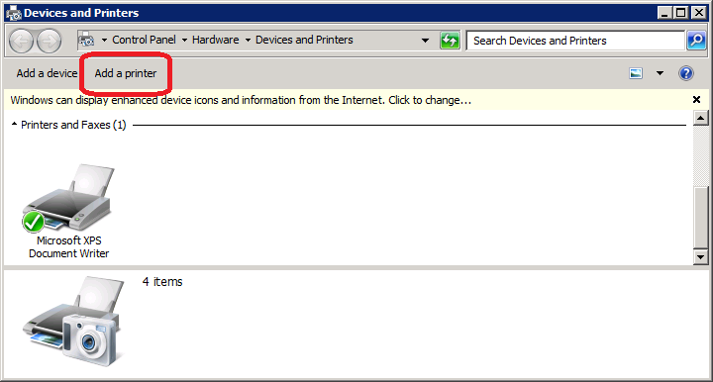
- In the Add Printer Wizard screen, select the Add a local printer button (Figure 14).
Figure 14: Example of Add Printer Wizard
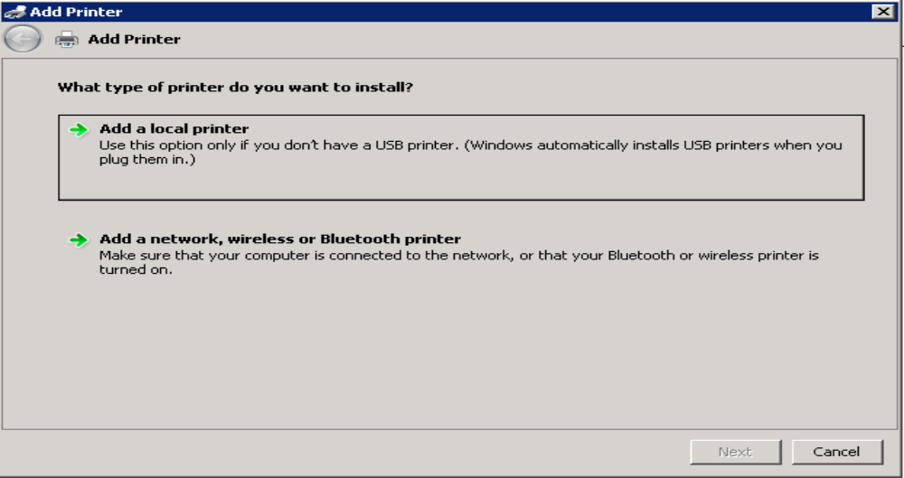
- On the Choose a printer port window, select Create a new port radio button. From the Type of port: drop-down, select Standard TCP/IP Port. Click Next (Figure 15).
Figure 15: Example of Add Printer Wizard
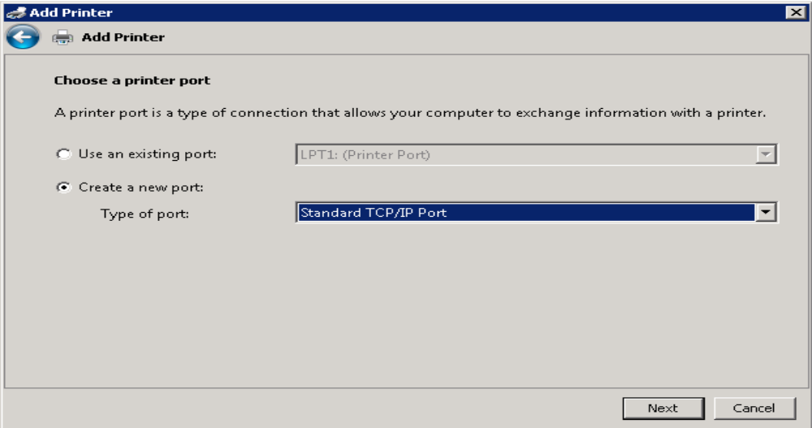
- Enter the IP address of the printer in the Hostname or IP address field (the Port Name field will populate automatically). Click Next (Figure 16).
Figure 16: Example of TCP/IP Settings
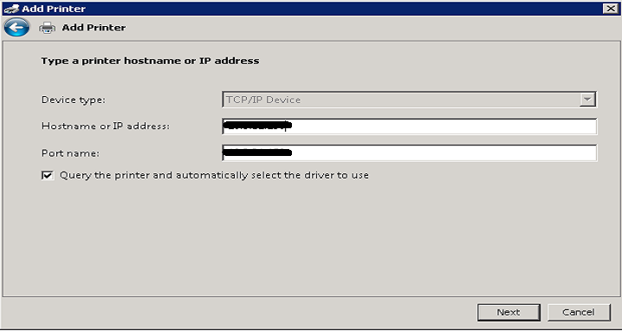
- Click Finish (Figure 17).
Figure 17: Example of Review Settings
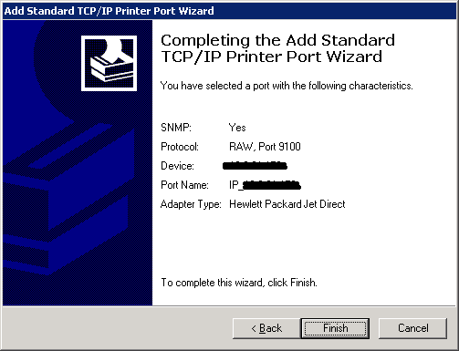
- To select a driver, click Have Disk (Figure 18).
Figure 18: Example of Add Printer Wizard
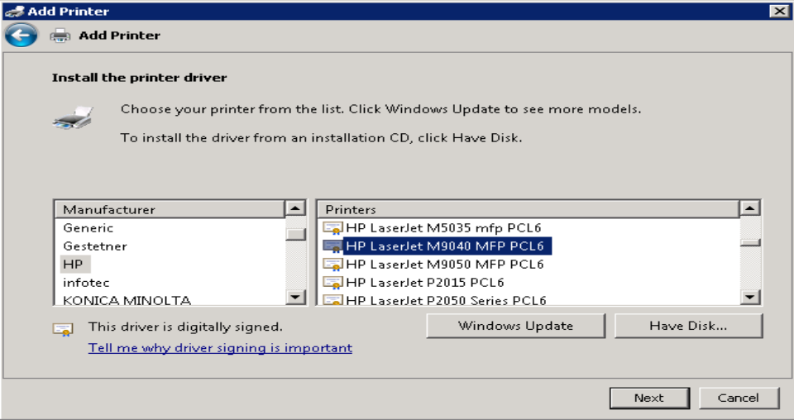
- Click Browse (Figure 19). Navigate to the driver that you copied to C:\temp\ in Step 1. Click Open (Figure 20).
Figure 19: Example of Install from Disk
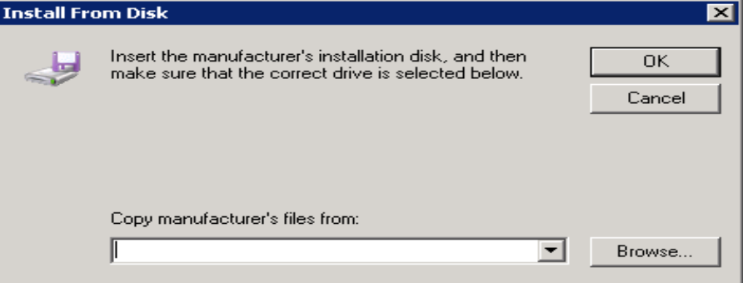
Figure 20: Example of Select Driver
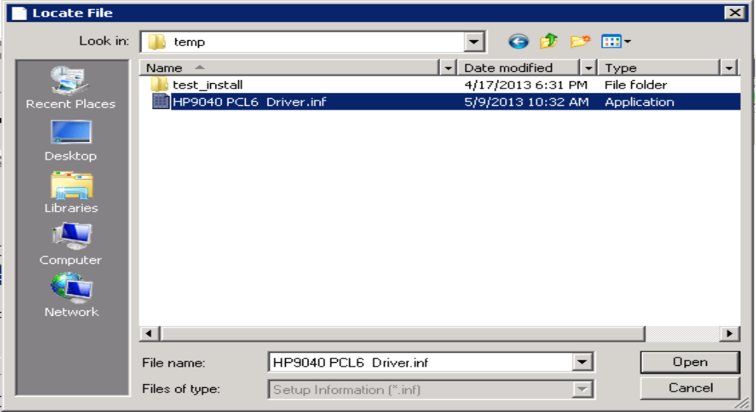
- Click OK (Figure 19).
- For a single-division site, enter VBECS Printer as the printer name. For a multidivisional site, enter VBECS Printer and the site name (e.g., VBECS Printer Hines). Click Next (Figure 21)
Figure 21: Example of Add Printer Wizard
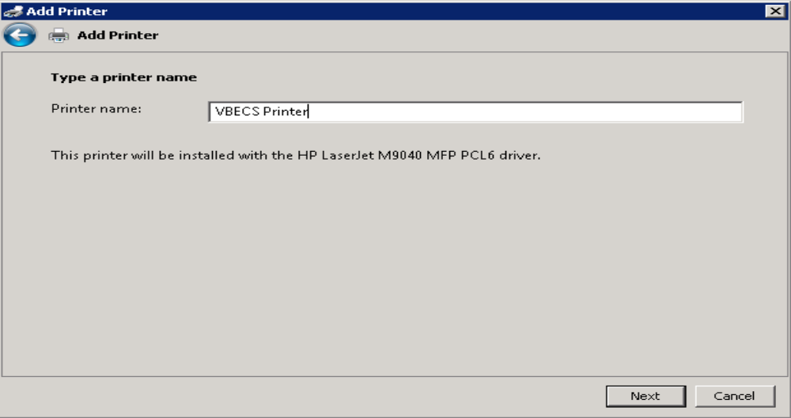
- Click the Do not share this printer radio button. Click Next (Figure 22).
Figure 22: Example of Add Printer Wizard
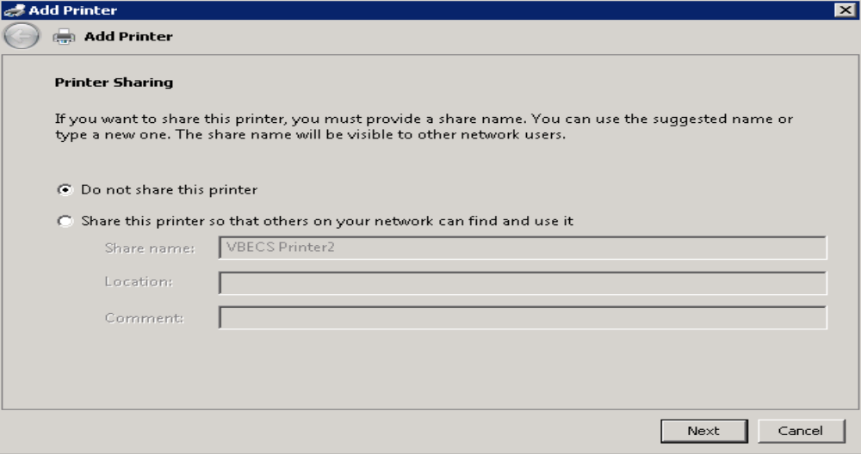
- Click Next (Figure 23).
Figure 23: Example of Add Printer Wizard
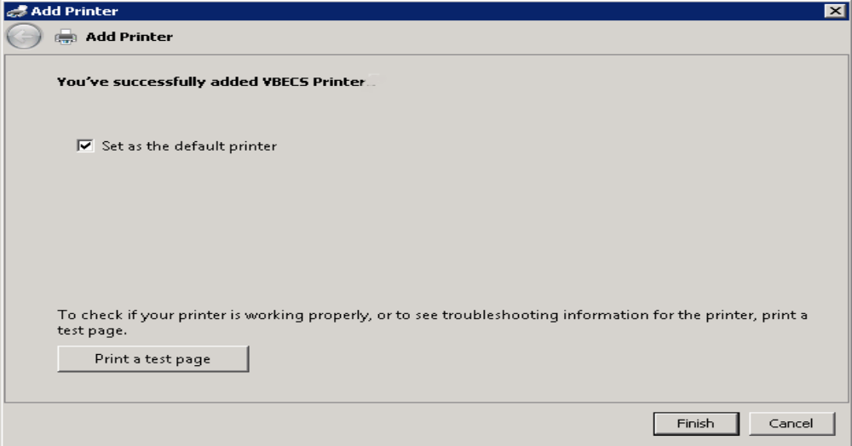

Label Printer (Zebra ZM400, Z4Mplus and ZT410)
Do not install the label printer on the VBECS Server. Connectivity is configured in VBECS Administrator (See the VBECS Administrator User Guide).
VBECS is configured to work only with Zebra printers: VBECS uses Zebra Programming Language to communicate with the printer. Other requirements:
- Ethernet connectivity: the label printer must have an Ethernet card
- Must print on 4" x 4" label stock
- Must print at 300DPI

Prior to configuring the label printer, load the ribbon and label stock and ensure that the printer is on. If the printer does not display PRINTER READY, there is a problem that must be resolved before proceeding. Refer to the Zebra user guide or printer CD for more information.

Scanners
Scanners used with VBECS must be able to scan Codabar, ISBT 128, and PDF-417 barcodes. To configure a scanner. VBECS no longer supports entry of new Codabar units into the system.
- Connect the scanner to the workstation.
  - To configure a Hand-Held 4600 scanner, scan the barcode in Figure 24.
Figure 24: Configuration Barcode for a Hand-Held 4600


  - The configuration barcodes below only apply to the Honeywell Xenon 1900 series scanner. Do not try to configure any other scanners with these barcodes. To configure a Honeywell Xenon 1900 scanner, scan the Standard Product Defaults barcode in Figure 25 followed by the VBECS Default barcode in Figure 26.
Figure 25: Xenon 1900: Restore Defaults

Figure 26: Xenon 1900: VBECS Settings


To test the scanner, open Notepad. Print and scan the barcodes in Figure 27, Figure 28 and Figure 29. The Codabar and ISBT barcodes must scan as “~123456789”; the PDF 417 must scan as “~Testing.”
Save and print the Notepad file for validation records.
Figure 27: Codabar (Code39)


Figure 28: ISBT 128


Figure 29: PDF 417


Workstation Configuration
Specifications are as follows:
- Memory: 2GB
- Display: 17”
- Video: video card with 16-bit color and 1024 x 768 resolution
- Operating System: Microsoft Windows
- Input Devices: U.S. 101-key keyboard, mouse
- Audio: Sound card and speakers
- Personal Identity Verification (PIV) card reader: required for PIV card access

Report Share
The VBECS system provides a share for users to access reports from their workstations (see Configure a Shortcut to the Report Share). While VBECS administrators have the ability to create and delete files and folders, users have read-only access to the share.
This page intentionally left blank.
Implementation and Maintenance (Data Center Only)
The U.S. Food and Drug Administration classifies this software as a medical device. Unauthorized modifications will render this device an adulterated medical device under Section 501 of the Medical Device Amendments to the Federal Food, Drug, and Cosmetic Act. Acquiring and implementing this software through the Freedom of Information Act require the implementer to assume total responsibility for the software and become a registered manufacturer of a medical device, subject to FDA regulations.

Periodic System Maintenance
The VBECS SQL Maintenance jobs run nightly from 10:00 PM to 1:00 AM (CST). Do not reboot the server during this time interval. Doing so may cause consistency and allocation errors.
The system will fail to function as intended when maintenance checks are not performed or are not performed correctly (Table 2).
Table 2: Periodic System Maintenance
Action | Frequency | Description
System Center Operations Manager (SCOM) Alerts | Daily | SCOM emails alert messages to a Server Administrators mail group. Investigate all alerts to completion.
Review Database Integrity Reports | Daily | Take action only upon receipt of a job failure email. See the  SQL Maintenance Jobs section for more details.
Apply Windows Updates | Wednesday, two weeks after 2nd Tuesday of the month | See  Applying Windows Updates.
VBECS Reports folder cleanup | As needed | Users are able to export reports to the division subfolder located within D:\VBECSReports folder on the App Server. The D drive is 10 GB in size and logs are also stored there.  Whenever the drive is over 90% full, old reports must be deleted. This activity may be performed by a blood bank supervisor or by a server administrator in coordination with blood bank personnel. For multidivisional sites, each division’s subfolder should be maintained by its respective personnel.

SQL Maintenance Jobs
The VBECS databases are contained within Microsoft SQL Server and require regular maintenance jobs to backup, validate integrity, and improve performance. The jobs are automated and configured to run according to the specifications shown in Table 3, Table 4 and Table 5.

System Level Jobs: Each system level job executes against all databases found on the SQL system not contained in an Availability Group. Email alerts are sent to REDACTED.
Table 3: System Level Jobs
Databases Affected | Job Name | Start Time
All databases not in an Availability Group | System_IntegrityCheck | 10:00pm
All databases not in an Availability Group (except TempDB) | System_FullBackups | 11:00pm
n/a | System_ResetServerLog | Every Saturday at 12:00am

Availability Group Level Jobs: Each Availability Group level job executes against all VBECS databases found within the Availability Group indicated by the job name (Table 4). Email alerts are sent to the recipients defined in the targeted database’s CPRS interface (see SQL Maintenance Job Alerts section).
Table 4: Availability Group Level Jobs
Databases Affected | Job Name | Start Time
All VBECS databases in the Availability Group AGVISNXX (XX is equal to the VISN number) | AGVISNXX_DifferentialBackups | Every 6 hours between 3:00am and 10:00pm
 | AGVISNXX_TransactionalLogBackups | Every 2 hours between 2:00am and 11:00pm
 | AGVISNXX_ReIndexTables | 10:00pm
 | AGVISNXX_UpdateStats | 10:30pm
 | AGVISNXX_IntegrityCheck | 11:30pm
 | AGVISNXX_FullBackups | 12:15am

VBECS Level Jobs: Each VBECS level job targets a single VBECS database indicated in the job name (Table 5). These jobs affect user data by expiring Component and Test Orders and marking units Presumed Transfused. Email alerts are sent to the recipients defined in the targeted database’s CPRS interface (see SQL Maintenance Job Alerts section).
Table 5: VBECS Level Jobs
Databases Affected | Job Name | Start Time
(Test SQL Server)  VBECS_SSS_TEST (SSS is equal to the Site Code) | AGVISNXX_VBECS_SSS_TEST_Background_Jobs | 12:01am
(Production SQL Server) VBECS_SSS_PROD | AGVISNXX_VBECS_SSS_PROD_Background_Jobs | 12:01am

SQL Maintenance Job Alerts
Email alert messages are sent only when a SQL maintenance job fails. System Level job alerts are sent to REDACTED and REDACTED. Refer to the VistA Blood Establishment Computer Software (VBECS) Admin User Guide.

SQL maintenance job alerts are marked with High Importance and must be acted upon immediately. The email will contain details of the failure and instructions for contacting the Service Desk Primary Contact. When a SQL integrity job fails, a report will be included as an attachment with the alert – include this with any support ticket (Service Desk Primary Contact) or communication (Figure 30).
Figure 30: Example of a SQL Maintenance Job Failure Email
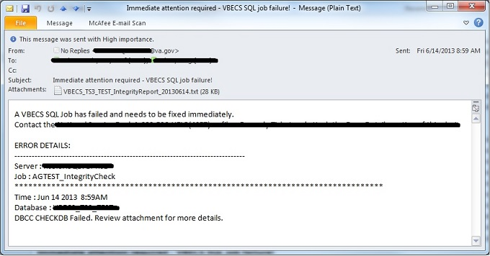

SQL Database Backups
To assist recovery and support options, database backup files and integrity reports are retained for 7 days for each SQL database and can be found on the SQL Server at H:\Program Files\Microsoft SQL Server\MSSQL11.MSSQLSERVER\MSSQL\Backup. If tape or offsite backups are desired, locate and backup the folders associated with the 3-character site code (SSS). For example, on a production SQL server, Hines (“HIN” site code) would backup the VBECS_HIN_PROD and VBECS_HIN_PROD_MIRROR folders.

Applying Windows Updates
App server updates require downtime, which is detailed in Table 6 and Table 7. SQL server updates require no downtime.

The VistA Blood Establishment Computer Software (VBECS) systems are updated with Microsoft Windows Security patches by Austin Information Technology Center (AITC) staff during defined maintenance periods (Table 6 and Table 7).
Microsoft typically releases Windows updates on the second Tuesday of the month, commonly referred to as Patch Tuesday (PT). The monthly updates are analyzed by the AITC Infrastructure Team and a patch offering is created in IBM’s BigFix software. The BigFix software analyzes each server to determine which updates are needed.

All Windows updates are tested before being released to customer VBECS servers:
- AITC staff installs Windows updates to VBECS development test servers.
- VBECS maintenance team tests the updated pre-production servers and proves that the updates do no harm to VBECS.
- After the VBECS maintenance team approves the updates, AITC staff creates change orders for applying the approved Windows Updates to the remaining VBECS servers.
BigFix Patch Windows
- Patch Offer: On-demand (pull) method. Patches are downloaded and installed manually by AITC staff.
- PreProd - TUE 0000 Manual: Patches are pushed out to servers and installed @00:00AM on Tuesday (PT + 7 days).
- Prod - Second Saturday 0500 Manual: Patches are pushed out to servers and installed @5:00AM on Saturday (PT + 11 days).
Table 6: Customer System Patch Schedule
Patch Day | Environment | Affected Servers | VBECS Downtime | Server Reboot | BigFix Patch Window
Tuesday  PT + 14 days | Customer | SQL Servers (Test) | NO | 08:00 AM CST | Patch Offer
Wednesday  PT + 15 days | Customer | App Servers | YES | 10:00 AM local | Prod - Second Saturday 0500 Manual
Wednesday  PT + 15 days | Customer | SQL Servers (Production) | NO | 08:00 AM CST | Patch Offer
Wednesday  PT + 15 days | Customer | Qurorum Server | NO | 10:00 AM CST | Prod - Second Saturday 0500 Manual

Table 7: Development System Patch Schedule
Patch Day | Environment | Affected Servers | VBECS Downtime | Server Reboot | BigFix Patch Window
Monday  PT + 6 days | Development | SQC 700s | NO | 09:30 AM CST | Patch Offer
Tuesday  PT + 7 days | Development | APP7AUS  QOR600 | YES | 08:00 AM CST | PreProd - TUE 0000 Manual
Tuesday  PT + 14 days | Development | APP750  APP751  SQC 750s | NO | 10:00 AM CST | Prod - Second Saturday 0500 Manual
Tuesday  PT + 14 days | Product Support | PRD200  PRD201 | YES | 10:00 AM CST | Prod - Second Saturday 0500 Manual

On the designated patch day, VBECS App servers will notify any user connected to the server before the server is restarted. At 9:45AM (local time), users will see a message similar to the message displayed in Figure 31. Unless the users log off, they will receive additional messages at 9:50, 9:55, 9:56, 9:57, 9:58 and 9:59AM local time.
Figure 31: Example of Server Restart Warning
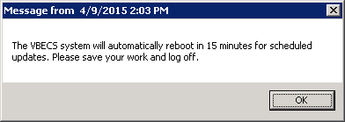

How long will VBECS be down?
Windows updates are unpredictable and can take up to 90 minutes to finish installing. During this time, the VBECS App server will not be available. Patching speed can be affected by increased patch size or quantity as well as datacenter load. As a result, patching times may vary month-to-month. We recommend trying to reconnect every 10-15 minutes.

REDACTED

Applying Updates to VBECS SQL Server System
Each VBECS SQL Server system is comprised of three servers that are setup for redundancy with the use of Windows Failover Clustering and the Microsoft SQL AlwaysOn technology:
- Server 1: referred to as the Primary server
- Server 2: local secondary server, referred to as the High Availability (HA) server
- Server 3: remote secondary server, referred to as the Disaster Recovery (DR) server
Replica is another name for a server within a SQL Server AlwaysOn configuration.
The names of the VBECS SQL servers can be found on the Data Center Worksheet.

Failure to adhere to these instructions could result in data loss and/or system failure. Always apply updates to Server 3 first and the Primary Replica last.

When updating a VBECS SQL Server system, refer to the flowchart in Figure 32 for the proper execution order.
Figure 32: Updating a VBECS SQL Server System Process Flow
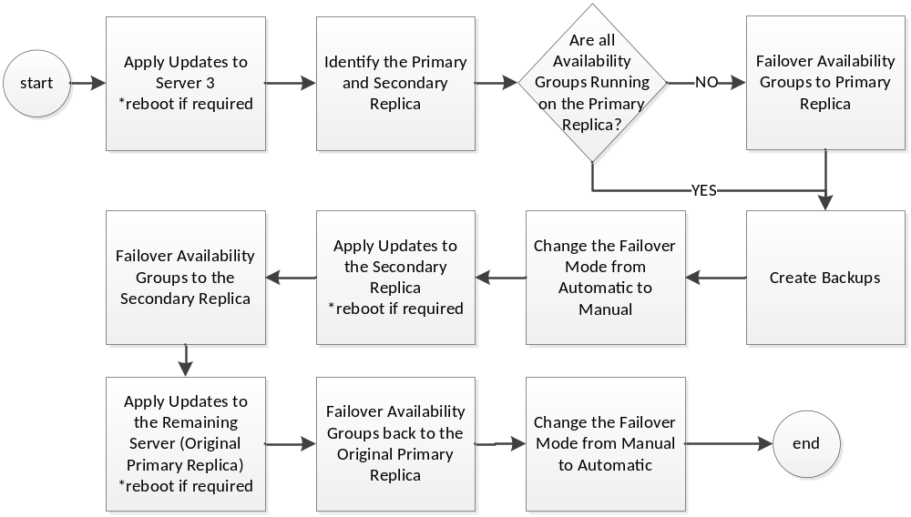
Failover is a term used to describe the process of changing which server in a SQL AlwaysOn configuration is designated as the Primary Replica. Never use the following instructions to failover to Server 3 (DR Server). Instructions for forcing a failover to Server 3 are provided in the VBECS Disaster and Recovery guide.

A Server Administrator should only initiate manual failover when client usage of the system is minimal. Users may briefly lose VBECS database connectivity depending on how long the failover takes.
Apply Updates to Server 3
- Open a remote desktop connection to Server 3 of the VBECS SQL Server system.
- Apply the Windows/Software Updates using the supplied instructions for the updates (reboot Server 3 only if instructed).

Identify the Primary and Secondary Replica
- Open a remote desktop connection to Server 1 of the VBECS SQL Server system. On the Start menu, click All Programs, Microsoft SQL Server 2012, SQL Server Management Studio.
- When prompted to connect to a server, enter the name of Server 1 in the Server Name field and click Connect. Note 1: VBECS Test system SQL Servers are named differently than production SQL servers. Note 2: If you have issues connecting, use the fully qualified domain name.
- On the left side of the SQL Server Management Studio (SSMS) screen is the Object Explorer pane. Within the Object Explorer pane, right-click on the AlwaysOn High Availability folder and select Show Dashboard (Figure 33).
Figure 33: Example of Launching the SQL Dashboard
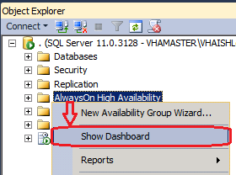
- A Dashboard tab (Figure 34) displays the Primary Instance and Failover Mode of the VBECS SQL Availability Groups (AG). Each AG has one of the following status indicator icons:
: your SSMS is connected to the AG’s Primary Instance server (i.e., the Primary Replica)
: your SSMS is not connected to the AG's Primary Instance server
: there is a severe issue with the AG
Figure 34: Example of the SQL Server Dashboard
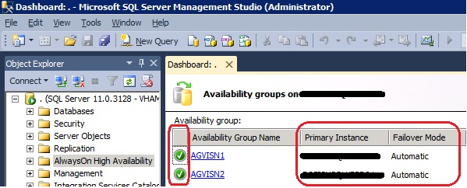

If any Availability Group status indicators are or if there are a mix of and indicators, VBECS is down and the problem must be resolved immediately.
- If all of the indicators are , close SSMS. Restart at Step 3 connecting to the server listed in the Primary Instance column.
- Make a note of the Primary and Secondary Replicas (i.e., if Server 1 is the Primary Replica, then Server 2 is the Secondary Replica and visa-versa).

Create Backups
- Now that all of the AGs are running under the Primary Replica, navigate to and expand the SQL Server Agent, Jobs folder in the Object Explorer pane.
- Double-click on Job Activity Monitor.
- In the Job Activity window, click the button (Figure 35).
Figure 35: Example of Job Activity Monitor
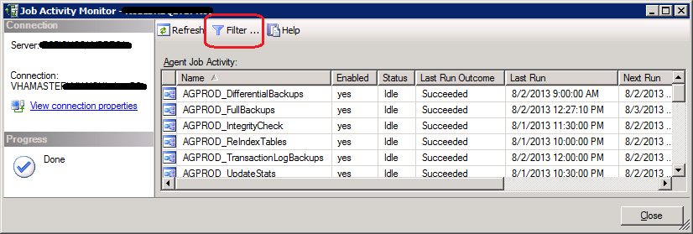
- In the Filter Settings window, enter full in the Name field, check the Apply filter box and click OK (Figure 36).
Figure 36: Filter Settings
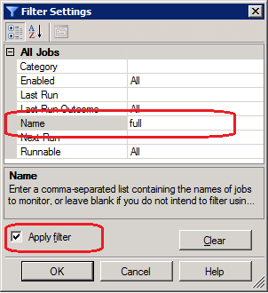
- Right-click the first job in the filtered list and select Start Job at Step… (Figure 37).
Figure 37: Example Starting a SQL Job
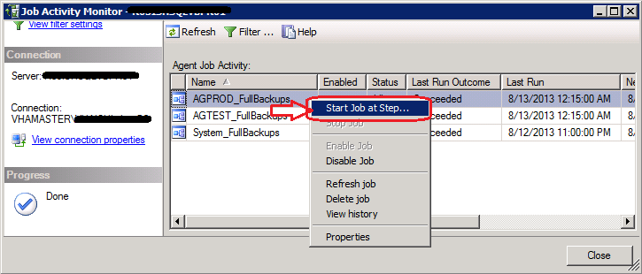
- Wait for the job to finish (Figure 38). Verify the status indicator is Success before clicking Close.
Figure 38: Example Job Completion Message
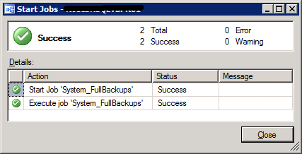
- Repeat Steps 13 and 14 for each job in the list.
REDACTED
- Click Close on the Job Activity Monitor window.

Change the Failover Mode from Automatic to Manual
- In the Object Explorer pane, navigate to and expand the AlwaysOn High Availability, Availability Groups folder.
- Right-click on the first AG and select Properties; the Availability Group Properties window opens.
- Locate the two servers with an Availability Mode of Synchronous commit (Figure 39). Change both Failover Mode cells from Automatic to Manual and click OK. If the fields are greyed-out, you are not connected to the Primary Replica: close SSMS, logoff the server and restart at Step 3.
Figure 39: Example of the Availability Group Properties
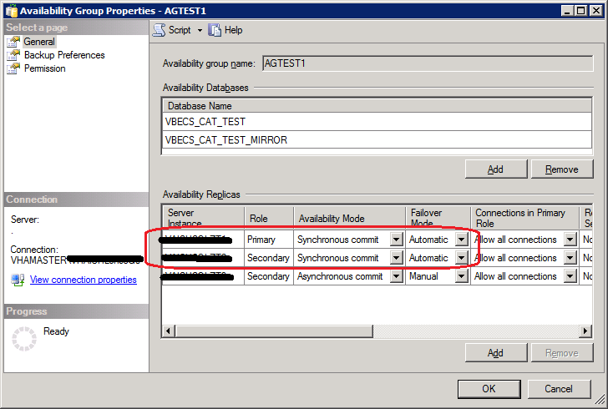
- Repeat Steps 18 and 19 for each AG on the server until each has their Failover Mode set to Manual.
- Close SSMS.
To prevent an unintentional automatic failover during the upgrade process, the Failover Mode must be set to Manual on each replica before performing a Manual Failover of the Availability Groups.
Apply Updates to the Secondary Replica
- Open a remote desktop connection to the Secondary Replica identified in Step 8 of the VBECS SQL Server system.
- Apply the Windows/Software Updates using the supplied instructions for the updates (reboot the server only if instructed).

Failover the Availability Groups to the Secondary Replica
- Open SSMS and connect to the Secondary Replica noted in Step 8.
- Inside the Object Explorer pane, navigate to and expand the AlwaysOn High Availability, Availability Groups folder.
- Right-click on the first AG and select Failover…; an Availability Group Failover wizard starts.
- Click Next (Figure 40).
Figure 40: Example of the Availability Group Failover Wizard
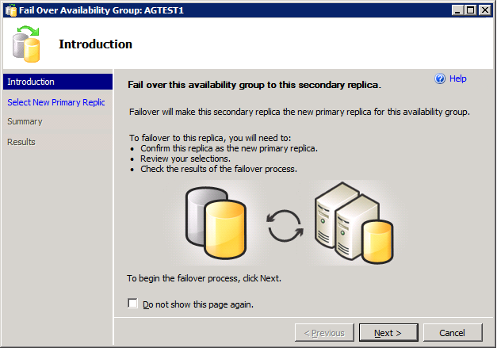
- Verify the Failover Mode is Manual and Failover Readiness is No data loss. Click Next (Figure 41). Note: If two servers appear in the list, then you are connected to the Primary Replica. Click Cancel and close SSMS. Restart at Step 24.
Figure 41: Example of Selecting the New Primary Replica
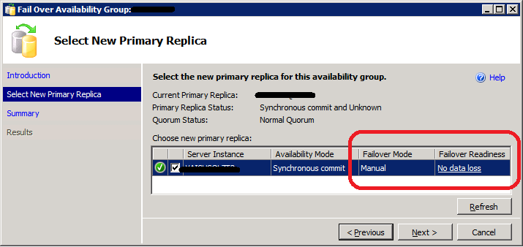

If the Failover Readiness field is not in a state of No data loss, notify SQL Server support personnel immediately by contacting the Service Desk Primary Contact.
- A Summary window is displayed (Figure 42). If any of the field values are incorrect (Failover Actions must be No data loss), click Cancel and close SSMS. Restart at Step 24.
Figure 42: Example of Availability Group Failover Wizard Summary
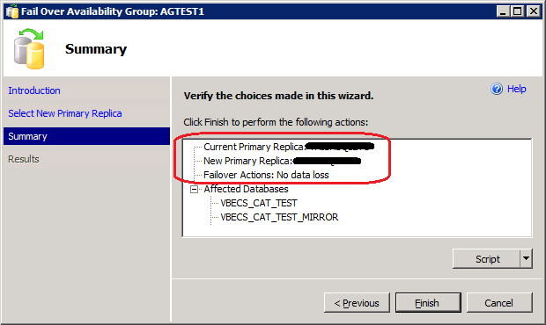
- Click Finish to initiate the failover.
- A failover may take several minutes to complete. Click Close (Figure 43).
Figure 43: Example of Successful Failover Wizard
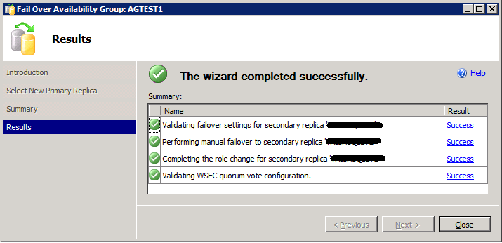

If any of the Results indicate Error, Warning or Failure, contact SQL Server support personnel by contacting the Service Desk Primary Contact. Databases contained in the problem Availability Group will not be available for use until the problem is resolved.
- Repeat Steps 26 through 31 for each AG on the server.
- Close SSMS.

Apply Updates to the Remaining Server (Original Primary Replica)
- Open a remote desktop connection to the Original Primary Replica (identified in Step 8) of the VBECS SQL Server system.
- Apply the Windows/Software Updates using the supplied instructions for the updates (reboot the server only if instructed).

Failover the Availability Groups Back to the Original Primary Replica
- Open SSMS and connect to the Primary Replica noted in Step 8.
- Inside the Object Explorer pane, navigate to and expand the AlwaysOn High Availability, Availability Groups folder.
- Right-click on the first AG and select Failover…; an Availability Group Failover wizard starts. Click Next (Figure 40).
- Verify the Failover Mode is Manual and Failover Readiness is No data loss. Click Next (Figure 41). If two servers appear in the list, then you are connected to the Secondary Replica. Click Cancel and close SSMS. Restart at Step 36.
If the Failover Readiness field is anything other than No data loss, contact SQL Server support personnel (contact the Service Desk Primary Contact).
- A Summary window is displayed (Figure 42). If any of the field values are incorrect (Failover Actions must be No data loss), click Cancel and close SSMS. Restart at Step 36.
- Click Finish to initiate the failover.
- The failover may take several minutes to complete. Click Close (Figure 43).
If any of the Results indicate Error, Warning or Failure. Databases contained in the problem, contact SQL Server support personnel (contact the Service Desk Primary Contact). Availability Group will not be available for use until the problem is resolved.
- Repeat Steps 28 through 42 for each AG on the server.

Change the Failover Mode from Manual to Automatic
- Right-click on the first AG and select Properties; the Availability Group Properties window open.
- Locate the two servers with an Availability Mode of Synchronous commit (Figure 44). Change both Failover Mode cells from Manual to Automatic and click OK.
Figure 44: Example of the Availability Group Properties
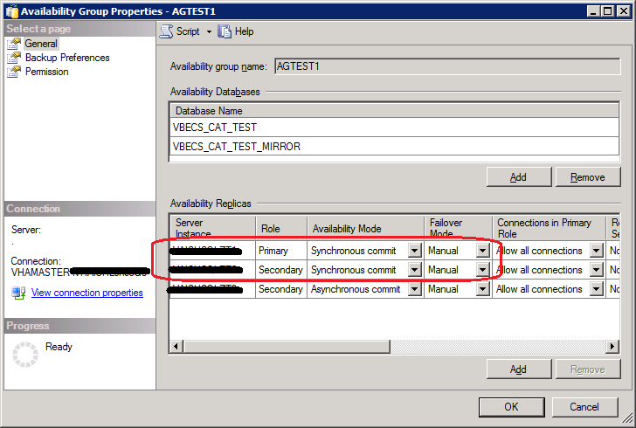
- Repeat Steps 44 and 45 for each AG on the server until each has their Failover Mode set to Automatic.
- Close SSMS and log off the server.

ePolicy and Virus Definitions
Virus definitions are automatically updated on the VBECS system. The VBECS maintenance team monitors the releases.
Do not change the system! The U.S. Food and Drug Administration classifies this software as a medical device. Unauthorized modifications will render this device an adulterated medical device under Section 501 of the Medical Device Amendments to the Federal Food, Drug, and Cosmetic Act. Acquiring and implementing this software through the Freedom of Information Act require the implementer to assume total responsibility for the software and become a registered manufacturer of a medical device, subject to FDA regulations. Adding to or updating VBECS software without permission is prohibited.
This page intentionally left blank.

VistA Maintenance Operations

Four HL7 Logical Links and one VistALink connection must be established and configured to establish proper communication with VBECS. The HL7 links are OERR-VBECS, VBECS-OERR, VBECSPTU, and VBECSPTM. The VistALink connection configuration is the data that VistA will use to transmit data in XML format to VBECS. The following set of instructions will aid in the proper configuration of these links and ensure reliable communication between VistA and VBECS. These links must be configured during the initial installation of VBECS, and after any changes to the HL7 or VistALink configuration on VBECS. The settings should also be updated after the VistA Test account has been remirrored.

Set Up VBECS Outbound Logical Links
- At the “Select HL7 Main Menu Option:” prompt, enter Filer.
- Shut down the logical link.
- At the “Select Filer and Link Management Options Option:” prompt, enter Link Edit.
- At the “Select HL LOGICAL LINK NODE:” prompt, enter OERR-VBECS (Figure 45).
Figure 45: HL7 Logical Link Edit Menu Navigation
HL7 Main Menu
Event monitoring menu ...
Systems Link Monitor
Filer and Link Management Options ...
Message Management Options ...
Interface Developer Options ...
Site Parameter Edit

Select HL7 Main Menu Option: FILER

SM Systems Link Monitor
FM Monitor, Start, Stop Filers
LM TCP Link Manager Start/Stop
SA Stop All Messaging Background Processes
RA Restart/Start All Links and Filers
DF Default Filers Startup
SL Start/Stop Links
PI Ping (TCP Only)
ED Link Edit
ER Link Errors ...

Select Filer and Link Management Options Option: ED

Select HL LOGICAL LINK NODE: OERR-VBECS

- Enter Enabled in the AUTOSTART field (Figure 46).
- Move the cursor to the LLP TYPE field and press Enter (Figure 46).
Figure 46: HL7 Logical Link
HL7 LOGICAL LINK
-----------------------------------------------------------------------------
NODE: OERR-VBECS
INSTITUTION:
DOMAIN:
AUTOSTART: ENABLED
QUEUE SIZE: 10
LLP TYPE: TCP
______________________________________________________________________________
COMMAND: Press <PF1>H for help Insert
- No “TCP/IP ADDRESS” should be entered. Change the value of the “TCP/IP PORT” parameter to the port number of the VistA HL7 Listener at your site. Regional support should be contacted for the correct (unique) port numbers. Unique port numbers are in the format 1mn93 for Test and 1mn94 for Prod, where “mn” is the site specific “magic number”. Standard port numbers of 21993 for Test and 21994 for Prod can be used if unique ports have not been assigned.
- Move the cursor to the “COMMAND:” prompt.
- Enter Close to return to the previous screen.
- At the “COMMAND:” prompt, enter Save.
- Enter Exit.
Figure 47: TCP Lower Level Parameters: OERR-VBECS
HL7 LOGICAL LINK
-----------------------------------------------------------------------------
TCP LOWER LEVEL PARAMETERS
OERR-VBECS

TCP/IP SERVICE TYPE: CLIENT (SENDER)
TCP/IP ADDRESS: <IP address of VBECS application server>
TCP/IP PORT: <Port number of VBECS application server>

ACK TIMEOUT: 30 RE-TRANSMISION ATTEMPTS:
READ TIMEOUT: 30 EXCEED RE-TRANSMIT ACTION: restart
BLOCK SIZE: SAY HELO:

STARTUP NODE: PERSISTENT: NO
RETENTION: 15 UNI-DIRECTIONAL WAIT:
____________________________________________________________________________
COMMAND: Press <PF1>H for help Insert
- Repeat Steps 3 through 11 substituting “VBECSPTM” and “VBECSPTU” for “OERR-VBECS” when prompted for the logical link name to change the IP address and port numbers for the VBECSPTM and VBECSPTU logical links.

Set Up the VBECS Inbound Logical Link
- At the “Select HL7 Main Menu Option:” prompt, enter Filer.
- At the “Select Filer and Link Management Options Option:” prompt, enter Link Edit.
- At the “Select HL LOGICAL LINK NODE:” prompt, enter VBECS-OERR (as shown for OERR-VBECS in Figure 45).
- Enter Enabled in the AUTOSTART field (Figure 48).
- Move the cursor to the LLP TYPE field and press Enter (Figure 48).
Figure 48: HL7 Logical Link
HL7 LOGICAL LINK
-----------------------------------------------------------------------------
NODE: VBECS-OERR
INSTITUTION:
DOMAIN:
AUTOSTART: ENABLED
QUEUE SIZE: 10
LLP TYPE: TCP
_____________________________________________________________________________
COMMAND: Press <PF1>H for help Insert
- No “TCP/IP ADDRESS” should be entered. Change the value of the “TCP/IP PORT” parameter to the port number of the VistA HL7 Listener at your site. Regional support should be contacted for the correct port numbers. Standard port numbers of 21993 for Test and 21994 for Prod can be used if unique ports have not been assigned.
- Move the cursor to the “COMMAND:” prompt.
- Enter Close to return to the previous screen.
- At the “COMMAND:” prompt, enter Save.
- Enter Exit.
Figure 49: TCP Lower Level Parameters: VBECS-OERR
HL7 LOGICAL LINK
-----------------------------------------------------------------------------
TCP LOWER LEVEL PARAMETERS
VBECS-OERR

TCP/IP SERVICE TYPE: SINGLE LISTENER
TCP/IP ADDRESS:
TCP/IP PORT: <VistA HL7 Listener Port>

ACK TIMEOUT: 30 RE-TRANSMISION ATTEMPTS:
READ TIMEOUT: 30 EXCEED RE-TRANSMIT ACTION:
BLOCK SIZE: SAY HELO:

STARTUP NODE: PERSISTENT: NO
RETENTION: UNI-DIRECTIONAL WAIT:
____________________________________________________________________________
COMMAND: Press <PF1>H for help Insert

Start VistA HL7 Logical Links
- Before data can be transmitted over the VBECS logical links, edit the link definitions as described above.
- To turn on the new VBECS logical links, select Start/Stop Links [HL START].
- Start the “OERR-VBECS” logical link.
- Start the “VBECS-OERR” logical link.
- Start the “VBECSPTM” logical link.
- Start the “VBECSPTU” logical link.
- Ensure that the VistA HL7 Link Manager is running; VBECS messaging cannot occur without it.
- To check the status of the Link Manager (and, if necessary, restart it), access the HL START/STOP LINK MANAGER menu option.

Monitor VBECS HL7 Logical Links
Once two-way communication has been established, you can monitor the links.

- Use the “System Link Monitor” to view the status of the VBECS Logical Links.
- From the “HL7 Main Menu”, select System Link Monitor (Figure 50).
Figure 50: HL7 System Link Monitor Menu Navigation
HL7 Main Menu
Event monitoring menu ...
Systems Link Monitor
Filer and Link Management Options ...
Message Management Options ...
Interface Developer Options ...
Site Parameter Edit

Select HL7 Main Menu Option: System Link Monitor
- When a list of VistA HL7 links defined at your site appears, press V at the “Select a Command:” prompt (Figure 51).
- At the “Select LINK MONITOR VIEWS:” prompt, enter VBECS (Figure 51).
Figure 51: System Link Monitor
SYSTEM LINK MONITOR for <your site name>

MESSAGES MESSAGES MESSAGES MESSAGES DEVICE
NODE RECEIVED PROCESSED TO SEND SENT TYPE STATE

LA7V 657 4 4 MM Halting
LL15VISN 105 105 394 105 NC Shutdown
MPIVA 0 0 322 0 NC Shutdown
NPTF 0 0 25 0 MM Halting
OERR-VBE 34 34 1019 1018 NC Idle
PSOTPBAA 28 28 52 28 NC Shutdown
VABAC 0 0 1 0 NC Shutdown
VAFAV 0 0 2 0 NC Shutdown
VAFHM 0 0 3 0 NC Shutdown
VAFRE 0 0 4 0 NC Shutdown

Incoming filers running => 1 TaskMan running
Outgoing filers running => 1 Link Manager running
Monitor OVERDUE
Select a Command:
(N)EXT (B)ACKUP (A)LL LINKS (S)CREENED (V)IEWS (Q)UIT (?) HELP: V

Select LINK MONITOR VIEWS: VBECS
- A screen similar to Figure 52 appears.
Figure 52: System Link Monitor
SYSTEM LINK MONITOR for <your site name>

MESSAGES MESSAGES MESSAGES MESSAGES DEVICE
NODE RECEIVED PROCESSED TO SEND SENT TYPE STATE

OERR-VBECS 0 0 0 0 NC Idle
VBECS-OERR 0 0 0 0 SS Idle
VBECSPTM 0 0 0 0 NC Enabled
VBECSPTU 0 0 0 0 NC Enabled

Incoming filers running => 1 TaskMan running
Outgoing filers running => 1 Link Manager Running
Monitor OVERDUE
Select a Command:
(N)EXT (B)ACKUP (A)LL LINKS (S)CREENED (V)IEWS (Q)UIT (?) HELP:
- To exit the “System Link Monitor”, at the “Select a Command:” prompt, enter q to quit.
- Refer to Appendix C: Set Up VBECS Protocol Definitions if errors are noted and the configuration of the HL7 links is in question.

The volume of HL7 traffic over these links depends on the number of daily CPRS Blood Bank orders and updates to the VistA clinical information at your site. These can be significant at large sites. Monitor the links closely the first few days after the installation and purge the HL7 log data (as appropriate) in accordance with your standard HL7 monitoring and purging procedures.

Configure VBECS VistALink Links
- Use the “Edit Parameter Values” option on the “GENERAL PARAMETER TOOLS” menu to edit the values for the VistALink connection to VBECS.
- At the “Select Instance:” prompt, enter LISTENER IP ADDRESS.
- At the “Value:” prompt, enter the VBECS application server IP address.
- At the “Select Instance:” prompt, enter LISTENER PORT NUMBER.
- At the “Value:” prompt, enter the VBECS VistALink listener port number. This is typically 21991 for Test and 21992 for Prod.
- Press Enter to exit the option.
Figure 53: VistALink Configuration
Select OPTION NAME: GENERAL PARAMETER TOOLS XPAR MENU TOOLS General Parameter Tools

LV List Values for a Selected Parameter
LE List Values for a Selected Entity
LP List Values for a Selected Package
LT List Values for a Selected Template
EP Edit Parameter Values
ET Edit Parameter Values with Template
EK Edit Parameter Definition Keyword

Select General Parameter Tools Option: EP Edit Parameter Values
--- Edit Parameter Values

Select PARAMETER DEFINITION NAME: VBECS VISTALINK

---------------- Setting VBECS VISTALINK for Package: VBECS
Select Instance: LISTENER IP ADDRESS

Instance: LISTENER IP ADDRESS// LISTENER IP ADDRESS
Value: <IP address>// Enter the VBECS application server IP address here.
Select Instance: LISTENER PORT NUMBER

Instance: LISTENER PORT NUMBER Replace LISTENER PORT NUMBER
Value: 8000// Enter the VBECS VistALink listener port here.
Select Instance:

VBECS Maintenance Operations
Refer to the VistA Blood Establishment Computer Software (VBECS) Admin User Guide. VBECS Administrator does not allow VistALink access through e-token.

Record Workload Data
VBECS workload data is recorded in VBECS when records that qualify as Workload Events are saved in VBECS. This data is transmitted to the VistA Laboratory workload recording system for national and local workload reporting.

Assumptions
- Workload codes were assigned to VBECS processes using Workload Codes.
- A record was saved or inactivated immediately preceding workload data collection.
- The connection to VistA is active.
- LRTASK NIGHTY is running as a scheduled option.

Outcome
- Information was transmitted to VistA for inclusion in appropriate reports.

Limitations and Restrictions
None

Additional Information
- Workload Event data must include information required for Decision Support System (DSS), Patient Care Encounter (PCE), and Billing Awareness. Once in VistA, existing VistA functionality will handle required reporting.
- Billing Awareness is being developed concurrently and related requirements are anticipated based on initial contact with the Billing Awareness team.
- The system accumulates and periodically transmits workload information to the VistA Lab workload recording process. The data is transmitted from VBECS to VistA by the VBECS Workload Capture Remote Procedure called by a nightly Lab background process.
- Workload multipliers for all blood bank activities in VistA File #64 must be set to one (1) to avoid excessive Laboratory Management Index Program (LMIP) counts. This allows the workload multiplier set in VBECS to be correctly reflected on VistA reports.

User Roles with Access to This Option
All users

Transmit Workload Data
These steps are associated with the “Save” function within any class that performs a Workload Event such as recording a blood test result or interpretation for a unit or a patient, modifying a unit, and pooling units. VBECS must know which classes perform Workload Events and how to classify the work accomplished for reporting. When the database is updated, the VistA technologist ID of the updater, the division, and the date and time of the update are recorded. In some instances, a mechanism to capture LMIP workload information exists. In addition, for certain events that involve patient processing, the patient location, treating specialty, service, etc., are captured to satisfy PCE or DSS reporting requirements.
These steps address the initial recording of these events.
User Action | VBECS
- Click Save to save a record from an option. | Creates a Workload Event for every process record saved.  Recognizes the activity as a new Workload Event.  Checks for required reporting properties based on the type of record being saved.  Determines the proper workload codes and other related information to be included.  NOTES  One or more workload codes can be collected with each Workload Event saved. A workload code may be multiplied for certain Workload Events.
- Exit.

Inactivate a Workload Event
VBECS updates VistA to inactivate the associated workload information (for a patient or a unit) so that PCE and Billing Awareness can be updated to reflect that the transaction is not valid.
User Action | VBECS
- Inactivate a saved record. | Recognizes the activity performed as an inactivation of an existing Workload Event record.  NOTES
- Complete the update and choose to save. | Prompts to confirm the save. Saves workload data.  NOTES  When a previously saved workload-generating event is invalidated (such as in Remove Final Status, Invalidate Test Results, or invalidating previously logged-in units through Edit Unit Information or Invalidate Shipment), VBECS must create and transmit the same Workload Event information to VistA as a negative number.
- Confirm the save. | Saves workload data.  NOTES  When a saved Workload Event is associated with a patient, VBECS needs to link the Workload Event to the patient for future reports.
- The option ends when the record is saved.

This page intentionally left blank.
External Interfaces

VistALink Remote Procedure Calls
Remote Procedure Calls (RPCs) provide a method of data exchange through VistALink for VBECS. The VBECS software provides data to or receives data from the VBECS Application Interfacing Support Software (VAISS) located in the VistA M environment through RPCs. This data exchange is controlled through Database Integration Agreements (DBIAs) between the blood bank medical device software and the VAISS VistA M software.
The VAISS software provides a set of M Application Programmer Interfaces (APIs) that call VBECS RPCs through the VBECS VistALink Listener Windows Service and return blood bank data to other VistA applications. The VAISS software also provides a set of VistA RPCs under the VBECS namespace in the Remote Procedure File (#8994) that are called by the VistA VistALink Listener client-server software. These calls are not public utilities and may be subject to change.
Table 8: Remote Procedure Calls
RPC Name | Database Integration  Agreement (DBIA) | This RPC:
VBECS Order Entry | 4619 | Supports order entry of blood bank requests from the blood bank order entry dialog in CPRS
VBECS Patient Available Units | 4620 | Provides a list of assigned, crossmatched, autologous and directed blood units that are available for a patient
VBECS Patient Transfusion History | 4621 | Provides a list of past transfusions performed for a patient
VBECS Blood Products | 4622 | Provides a list of orderable blood products, or component classes, to the VistA Surgery package
VBECS Patient Report | 4623 | Provides patient specimen testing results, component requests, and available blood units for a patient to be displayed in CPRS
VBECS Patient ABO_RH | 4624 | Provides the most current ABO Group and Rh Type identified for a patient
VBECS Patient ABID | 4625 | Provides a list of antibodies identified for a patient
VBECS Patient TRRX | 4626 | Provides a list of transfusion reactions for a patient
VBECS Workload Capture | 4627 | Provides blood bank workload data to the VistA Laboratory Service package for workload reporting to national and local entities
VBECS Workload Update Event | 4628 | Updates completed workload-related data into the VBECS database after the VistA Laboratory Services package has completed workload-reporting transactions. Upon completion of the update, the RPC returns an XML response to the VAISS that initiated the communication indicating a successful or unsuccessful transaction.
VBECS Accession Area Lookup | 4607 | Provides a list of all Laboratory Blood Bank Accession Areas in VistA and their associated divisions to VBECS for workload reporting purposes
VBECS Blood Bank User Lookup | 4608 | Returns a list of all blood bank users identified in the VistA system to VBECS. Blood bank users are identified by the Security Keys of either LRBLOODBANK or LRBLSUPER.
VBECS Division Lookup | 4609 | Returns a list of all VAMC divisions associated with a VistA system
VBECS HCPCS Codes Lookup | 4610 | Returns a list of blood bank related HCPCS codes to be associated with processes, or procedures, performed in VBECS
VBECS Laboratory Test Lookup | 4611 | Returns a list of VistA Laboratory tests to be associated with blood components in VBECS
VBECS Lab Test Results Lookup | 4612 | Returns a list of VistA Laboratory test results for a patient
VBECS Medication Profile Lookup | 4613 | Returns a list of medications for a patient from the VistA Pharmacy package
VBECS Lab Accession UID Lookup | 4614 | Returns data from the VistA Laboratory Services package based on a Lab order number. The data is used to validate a VBECS specimen test request for a patient and specimen received in the blood bank for that test.
VBECS Workload Codes Lookup | 4615 | Returns a list of blood bank related workload related data that is associated with processes in VBECS
VBECS Patient Lookup | 4616 | Provides a patient lookup function using standard VistA patient lookup criteria. A list of matching patients found in the lookup is returned to VBECS along with required patient identifiers and demographics.
VBECS Provider Lookup | 4617 | Provides a lookup of VistA users that hold the PROVIDER security key
VBECS Hospital Location Lookup | 4618 | Returns a list of hospital locations associated with a division in VistA
VBECS Lab Order Lookup by UID | 4633 | Returns a list of Laboratory Services data related to an order based on a specimen UID
VBECS Dss Extract | 4956 | Provides BloodBank post-transfusion related data to the VistA DSS Blood Bank Extract application for DSS reporting
TCPConnect | N/A | The purpose of this RPC is to establish a Broker TCP IP connection. This RPC initiates the initial connection between VBECS and the Broker. This is not yet using the token; this is an initial connection to the required Broker endpoint.
XUS SIGNON SETUP | N/A | The purpose of this RPC is to authenticate user with a Client Agent token during each application’s session. This is the IAM Sign on and Setup steps needed prior to validation.
XUS ESSO VALIDATE | N/A | The purpose of this RPC is to validate a user's token for each session. This is the IAM token validation that occurs inside VistA.
XUS GET TOKEN | N/A | The purpose of this RPC is to return a handle to a token that will sign-on a new process for subsequent RPC calls.

VBECS Windows Services
VBECS uses Microsoft Windows Services (services) to provide minimal downtime and minimal user interaction. These services are installed on each VBECS application server. For details on stopping and starting VBECS services, see the Stopping VBECS Services and Starting VBECS Services sections. All VBECS services start with the VBECS namespace prefix. There are duplicate services for production and test accounts that provide functionality for their respective databases. See Figure 54 for a complete listing of VBECS services.
Figure 54: Example of VBECS Services
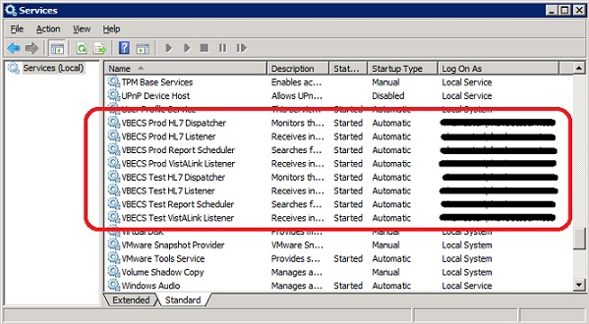
Table 9: VBECS Windows Services
Windows Service Name | Description
VBECS Prod HL7 Dispatcher | The startup type is set to automatic. It polls the VBECS Production database for HL7 messages to be sent to CPRS in the VistA Production account.
VBECS Prod HL7 Listener | The startup type is set to automatic. This is the default HL7 listener service for all Production HL7 interfaces
VBECS Prod Report Scheduler | The startup type is set to automatic. It runs scheduled VBECS reports for the Production database.
VBECS Prod VistALink Listener | The startup type is set to automatic. It provides a client-server TCP/IP listener service for VistALink RPC XML messages from the VAISS APIs. It calls VBECS RPCs to provide blood bank data from the VBECS Production database to VistA Production account applications.
VBECS Test HL7 Dispatcher | The startup type is set to automatic. It polls the VBECS Test database for HL7 messages to be sent to CPRS in the VistA Test account.
VBECS Test HL7 Listener | The startup type is set to automatic. This is the default HL7 listener service for all Test HL7 interfaces.
VBECS Test Report Scheduler | The startup type is set to automatic. It runs scheduled VBECS reports for the Test database.
VBECS Test VistALink Listener | The startup type is set to automatic. It provides a client-server TCP/IP listener service for VistALink RPC XML messages from the VAISS APIs. It calls VBECS RPCs to provide blood bank data from the VBECS Test database to VistA Test account applications.

Troubleshooting
Remote Desktop Session Issues
Occasionally remote desktop sessions require disconnection by a server administrator. Sessions may become unresponsive and require disconnection. Additionally, if you need to apply a patch such as a window update but sessions remain on the server you may need to force a session to disconnect. To disconnect a remote session, navigate to the application or SQL server and click Start, Administrative Tools, Remote Desktop Services, Remote Desktop Services Manager. Locate the session(s) that require disconnection. Right-click on the session and select Disconnect (Figure 55).
Figure 55: Example of Remote Desktop Services Manager
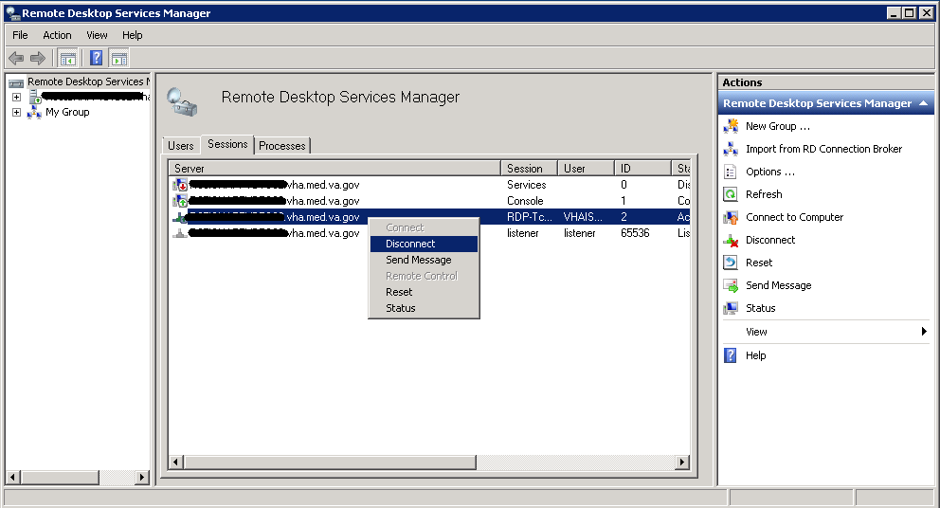
Remote Desktop Services Licensing Issues
In order to connect to VBECS, a workstation must have a valid license from an active Remote Desktop Services licensing server. A problem may occur when this license has expired on the workstation; the user receives an error message when trying to establish a Remote Desktop Connection (Figure 56). Deleting the Remote Desktop Services license information from the registry will cause the workstation to refresh its license information and restore the ability to connect using remote desktop.
Figure 56: Example of Expired Remote Desktop License
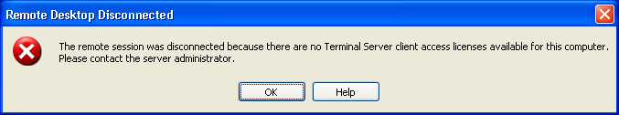

Deleting the Remote Desktop Services Licensing Information on a VBECS Workstation
Administrative rights on the workstation are required to perform the following steps.
- Log into the workstation that is receiving the error (Figure 56) and click Start, Run…
- In the Run window, type regedit and click Enter.
- In the Registry Editor window, expand the folders to the following location: Computer, HKEY_LOCAL_MACHINE, SOFTWARE, Microsoft.
- Locate and right-click the MSLicensing folder; select Delete (Figure 57).
Figure 57: Deleting the MSLicensing Registry Key
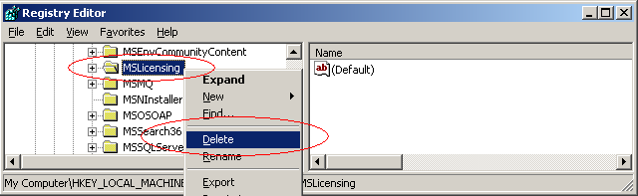
- Make sure you are at the correct path and click Yes to confirm the deletion.
- Close the Registry Editor.

Identity Verification Warning
Occasionally, a warning may appear when initiating an RDP session that states that the identity of the remote computer could not authenticated (Figure 58). This is due to an archived certificate and is not dangerous. Select Don’t ask me again… and click Yes.
Figure 58: Example of Identity Warning
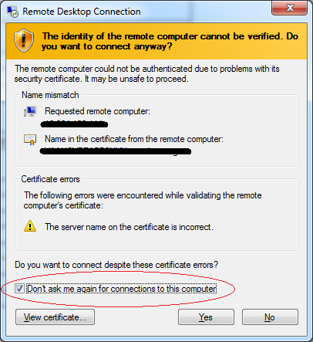
Stopping and Starting VBECS Services

Stopping VBECS Services
- Click Start, Administrative Tools, Services (Figure 59).
- Right-click on the service you would like to stop and click Stop.
Figure 59: Example of Stopping a VBECS Service
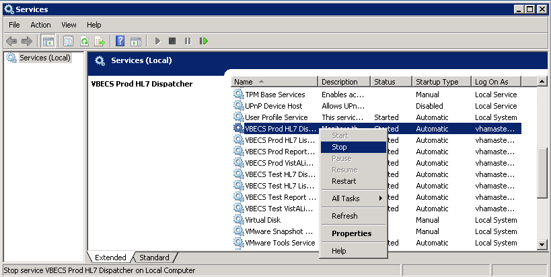

Starting VBECS Services
- Click Start, Administrative Tools, Services (Figure 60).
- Right-click on the service you would like to start and click Start
Figure 60: Example of Starting a VBECS Service
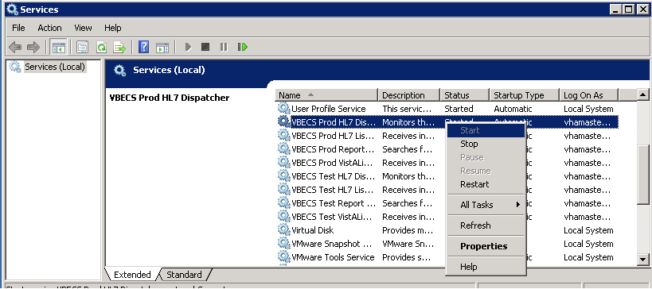

VBECS Auditing
For a complete list of audited server events, please see: Appendix B: Auditing on VBECS Servers.

VBECS Exception Logging
VBECS logs all errors that occur in the system in the Application log of Event Viewer on the application server. A user defined as an administrator on the application server can connect to the server through Remote Desktop Connection to view these errors.
- Click Start, Control Panel, Administrative Tools.
- Open the Event Viewer and open the Windows logs folder, then select Application to view the errors that VBECS logs.
- In the list view on the right side of the screen, click the date column header to sort the errors by date.
- Evaluate “Error” and warning errors that were logged at the same time a VBECS user reported an error. Ignore informational messages. If you require assistance from the VBECS maintenance team, file a support ticket (Service Desk Primary Contact).

VBECS Application Interfaces
When the HL7 Listener service encounters an error parsing an HL7 message it generates an event description like the following:
VBECS Patient Update HL7 Parser: Error processing HL7 message:
Missing or invalid content in HL7 message:
ERR^MSH~1~12~203~
Upon troubleshooting an email message regarding an HL7 message, file a ticket with the Service Desk Primary Contact and include the contents of the email for a description so that Health Product Support can assist in identifying the patient associated with the failed HL7 message. Due to PII and HIPAA constraints, patient information will not be sent over email. Product support will have access to the event viewer and be able to identify the appropriate patient information. Table 10 describes the ERR codes (e.g., 203 like in the above example) descriptions.

Table 10: Troubleshooting Rejected VBECS HL7 Messages
Error Code | Description of Problem
100 | Segment Sequence Error
101 | Required Field Missing
102 | Data Type Error
103 | Table Value Not Found
200 | Unsupported Message Type
201 | Unsupported Event Code
202 | Unsupported Processing ID
203 | Unsupported Version Id  See Table 11: VBECS HL7 Versions.
204 | Unknown Key Identifier
205 | Duplicate Key Identifier
206 | Application Record Locked
207 | Application Internal Error
208 | Conflicting Processing Id
Table 11: VBECS HL7 Versions
HL7 Interface | HL7 Version
VistA CPRS- Order Update – CPRS OERR | 2.4
VistA PIMS Patient ADT Update – VAFC ADT | 2.3
VistA MPI/PD PatientMerge – MPI TRIGGER | 2.4
Automated Instrument | 2.4

Table 12: Troubleshooting VBECS Application Interfaces
Source | Description of Problem | Possible Cause | Solution
VBECS: Order Alerts and Pending Order List | New orders or cancellations of existing orders in CPRS are not showing up in VBECS. | The OERR-VBECS Logical Link is not running on the VistA system. | Start the OERR-VBECS Logical Link.
VBECS: Order Alerts and Pending Order List |  | The VBECS <Prod or Test> HL7 Listener Windows Service is not running or is locked on the application server. | Start or restart the VBECS <Prod or Test> HL7 Listener Windows Service.
VBECS: Order Alerts and Pending Order List |  | Network connectivity issue | Contact local system support.
VBECS: Order Alerts and Pending Order List |  | The HL7 message is missing patient name or one or more name components length(s) exceed(s) the VBECS maximum supported value. | VBECS responds to the new order request with an application reject (AR) acknowledgement message indicating Patient Name(s) not found in HL7 Message or Patient's Name(s) field size(s) exceed(s) VBECS maximum supported value. Rejected patient order messages due to invalid patient name message content are recorded on the Windows Event Log (Finding Application Log Entries from Email Alerts) and an email message containing the MSH segment of the rejected HL7 message.
VBECS Admin: Edit Division | New orders are not showing up in VBECS. | Order mappings to institutions within a division’s configuration were changed. | Stop and restart the VBECS <Prod or Test> HL7 Listener Service.
VBECS: Patient Update Alerts | VistA patient updates are not showing up in VBECS. | The patient being updated in VistA is not in the VBECS Patient table and is, therefore, not a blood bank patient. | No action is required.
VBECS: Patient Update Alerts | VistA patient updates are not showing up in VBECS. | The fields that were updated in VistA are not stored in VBECS; therefore, no data will be updated. | No action is required.
VBECS: Patient Update Alerts | VistA patient updates are not showing up in VBECS. | The Taskman scheduled option VAFC BATCH UPDATE is not scheduled to run or has not reached the time limit in the schedule. | Schedule the VAFC BATCH UPDATE option to run at the desired frequency (the recommended frequency is every 10 minutes) or use the option “One-time Option Queue” in the Taskman Management Options to start the task.
VBECS: Patient Update Alerts | VistA patient updates are not showing up in VBECS. | The VBECSPTU Logical Link is not running on the VistA system. | Start the VBECSPTU Logical Link.
VBECS: Patient Update Alerts | VistA patient updates are not showing up in VBECS. | The VBECS <Prod or Test> HL7 Listener Windows Service is not running or is locked on the application server. | Start or restart the VBECS <Prod or Test> HL7 Listener Windows Service.
VBECS: Patient Update Alerts | VistA patient updates are not showing up in VBECS. | Network connectivity issue | Contact local system support.
VBECS: Patient Update Alerts | VistA patient updates are not showing up in VBECS. | The HL7 message is missing patient name or one or more name components length(s) exceed(s) the VBECS maximum supported value. | VBECS responds to the patient update request with an application reject (AR) acknowledgement message indicating Patient Name(s) not found in HL7 Message or Patient's Name(s) field size(s) exceed(s) VBECS maximum supported value. Rejected patient update messages due to invalid patient name message content are recorded on the Windows Event Log (Finding Application Log Entries from Email Alerts)  and an email message containing the MSH segment of the rejected HL7 message as a means to identify the message in the server event log is sent to the interface failure alert recipient set in VBECS Administrator for immediate action.
VBECS: Patient Merge Alerts | VistA Patient Merge events are not showing up in VBECS. | The two patient identifiers in the merge do not exist in VBECS and, therefore, cannot be merged. | No action is required.
VBECS: Patient Merge Alerts | VistA Patient Merge events are not showing up in VBECS. | The VBECPTM Logical Link is not running on the VistA system. | Start the VBECSPTM Logical Link.
VBECS: Patient Merge Alerts | VistA Patient Merge events are not showing up in VBECS. | The VBECS <Prod or Test> HL7 Listener Windows Service is not running or is locked on the application server. | Start or restart the VBECS <Prod or Test> HL7 Listener Windows Service.
VBECS: Patient Merge Alerts | VistA Patient Merge events are not showing up in VBECS. | Network connectivity issue | Contact local system support.
VBECS: Patient Merge Alerts | VistA Patient Merge events are not showing up in VBECS. | The HL7 message is missing patient name or one or more name components length(s) exceed(s) the VBECS maximum supported value. | Failed patient merge messages due to invalid patient name message content are recorded on the Windows Event Log and an email message containing the MSH segment of the rejected HL7 message as a means to identify the message in the server event log is sent to the interface failure alert recipient set in VBECS Administrator for immediate action.
VistA: HL7 System Link Monitor | The VistA HL7 System Link Monitor shows more MESSAGES TO SEND than MESSAGES SENT for the OERR-VBECS Logical Link and is hung in an “Open” state. | The VBECS <Prod or Test> HL7 Listener Windows Service is not running or is locked on the VBECS Application server. | Start or restart the VBECS <Prod or Test> HL7 Listener Windows Service.
VistA: HL7 System Link Monitor |  | Network connectivity issue | Contact local system support.
VistA: HL7 System Link Monitor | The VistA HL7 System Link Monitor shows more MESSAGES TO SEND than MESSAGES SENT for the VBECSPTU Logical Link and is hung in an “Open” state. | The VBECS <Prod or Test> HL7 Listener Windows Service is not running or is locked on the VBECS Application server. | Start or restart the VBECS <Prod or Test> HL7 Listener Windows Service.
VistA: HL7 System Link Monitor |  | Network connectivity issue. | Contact local system support.
VistA: HL7 System Link Monitor | The VistA HL7 System Link Monitor shows more MESSAGES TO SEND than MESSAGES SENT for the VBECSPTM Logical Link and is hung in an “Open” state. | The VBECS <Prod or Test> HL7 Listener Windows Service is not running or is locked on the application server. | Start or restart the VBECS <Prod or Test> HL7 Listener Windows Service.
VistA: HL7 System Link Monitor |  | Network connectivity issue. | Contact local system support.
CPRS: Orders Tab | CPRS does not display the correct status of a blood bank order after it was updated in VBECS. | The VBECS <Prod or Test> HL7 Dispatcher Windows Service is not running or is locked on the application server. | Start or restart the VBECS <Prod or Test> HL7 Dispatcher Windows Service.
CPRS: Orders Tab |  | The VBECS-OERR Logical Link is not running. | Start the VBECS-OERR Logical Link.
CPRS: Orders Tab |  | Network connectivity issue | Contact local system support.
CPRS: Blood Bank Order Dialog | CPRS displays “Not able to open port” message in Patient Information screen in Blood Bank Order Dialog. | The VBECS <Prod or Test> VistALink Listener Service is not running or is locked on the VBECS Application server. | Start or restart the VBECS <Prod or Test> VistALink Listener Service.
CPRS: Blood Bank Order Dialog |  | Network connectivity issue | Contact local system support.
CPRS: Reports Tab, Blood Bank Report | CPRS displays “---- BLOOD BANK REPORT IS UNAVAILABLE----“ | The VBECS <Prod or Test> VistALink Listener is not running or is locked on the VBECS Application server. | Start or restart the VBECS <Prod or Test> VistALink Listener Service.
CPRS: Reports Tab, Blood Bank Report | CPRS displays “---- BLOOD BANK REPORT IS UNAVAILABLE----“ | Network connectivity issue. | Contact local system support.
CPRS: Reports Tab, Blood Bank Report | CPRS displays “---- BLOOD BANK REPORT IS UNAVAILABLE----“ | Incorrect parameters file | Verify settings are pointing to the correct VBECS application server and port.
CPRS: Blood Bank Order Dialog: Signing an Order | CPRS displays an “Error Saving Order” dialog screen with the text “The error, One or more orders to the VBECS system failed and are queued for later delivery.” | An error occurred in the VBECS <Prod or Test> HL7 Listener Windows Service, which caused a failure to respond to CPRS with acceptance. | Log onto the application server and review the System Application Event Log for error details.
CPRS: Blood Bank Order Dialog: Signing an Order |  | Network connectivity issue. | Contact local system support.
VBECS Application Server Application Event Log: Source is VBECS SimpleListener | An application error has been logged to the Event Log where the Message under Exception Information is “Could not access ‘CDO.Message’ object.” | The VBECS <Prod or Test> HL7 Listener Windows Service has encountered an error trying to send an email message to the Interface Administrator. | Disable port 25 blocking in McAfee. Open the VirusScan Console and select Access Protection. Click the Task menu option, the Properties. Uncheck Prevent mass mailing worms from sending mail, port 25 under Ports to block.
 | An application warning was logged in the Event Log with the description stating, “An unsupported HL7 message was received from IP Address [IP address].”  The IP address in the description of the error will indicate where the message is coming from. | If the IP address is associated with the local VistA system, the HL7 Application Parameters in VistA were not set up correctly for the supported protocols. | Refer to the VBECS Application Interfacing Support Software Installation and User Configuration Guide for HL7 setup procedures in VistA.
 |  | If the IP address is not from the local VistA system, a rogue HL7 system is sending messages to the VBECS server. | Contact IRM to identify the location of the server with which the IP address is associated. Notify the site that the message is coming from the problem so that the messages can be routed to the correct location.
VBECS Application Server Application Event Log: Source is VBECS HL7 MailServer | An application error was logged in the Event Log with the source of VBECS HL7 MailServer where the Message under Exception Information is, “Could not access ‘CDO.Message’ object.” | The VBECS <Prod or Test> HL7 Listener Windows Service encountered an error trying to send an email message to the Interface Administrator. | Disable port 25 blocking in McAfee. Open the VirusScan Console and select Access Protection. Click the Task menu option, Properties. Uncheck Prevent mass mailing worms from sending mail, port 25 under Ports to block.
VBECS Application Server Application Event Log: Source is CPRS HL7 Parser | An HL7 message sent from CPRS to VBECS was rejected. The description in the Event Log is “Exception message:  Division [division] is not supported by this instance of VBECS.” | An invalid or unsupported division associated with the Patient Location was selected in CPRS when the order was created. | The order must be created in CPRS again with a valid Patient Location associated with a VBECS-supported division.
 | An HL7 message sent from CPRS to VBECS was rejected. The description in the Event Log is “Exception message:  Unable to find valid Associated Institutions information. Please check configuration in VBECS Admin.” | Clinician logs into VistA with a division that is not mapped to VBECS. | The order must be created in CPRS again with a division that is mapped to VBECS.
- Automated Instrument | Messages not being received from the instrument. | The VBECS <Prod or Test> HL7 Listener Windows Service is not running or is locked on the VBECS Application server. | Start or restart the VBECS <Prod or Test> HL7 Listener Windows Service.

Finding Application Log Entries from Email Alerts
When HL7 message patient last or first name components length(s) exceed(s) the VBECS maximum supported value of 40, an email will be received (Figure 61).
Figure 61: Example of Error in VBECS HL7 Listener for CPRS
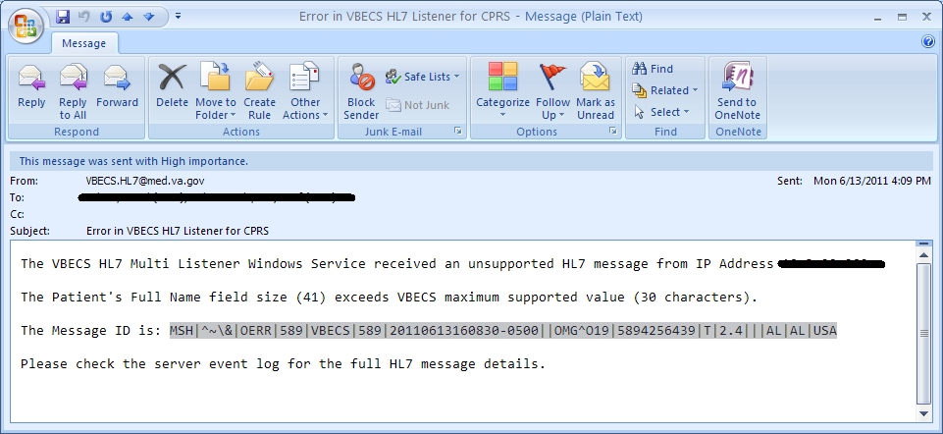
- On the Application Server, click Start, Administrative Tools, Event Viewer.
- On the Event Viewer Window, expand the Windows Logs and click on Application in the left-hand tree; click the top event in the log table, then click Find on the right side of the window (Figure 62).
Figure 62: Example of Event Viewer
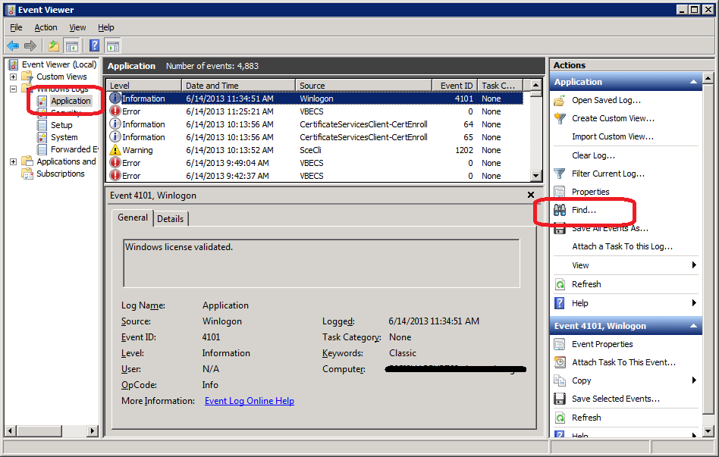
- Paste the MessageID highlighted in the email received (Figure 61) in the Find What text box. Click Find Next (Figure 63).
Figure 63: Example of Find in Local Application
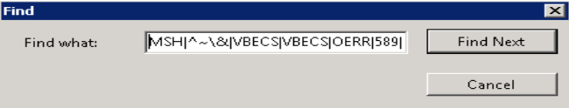
- When the event record has been found, the row will be highlighted (Figure 64).
Figure 64: Example of Message ID Located in Event Log
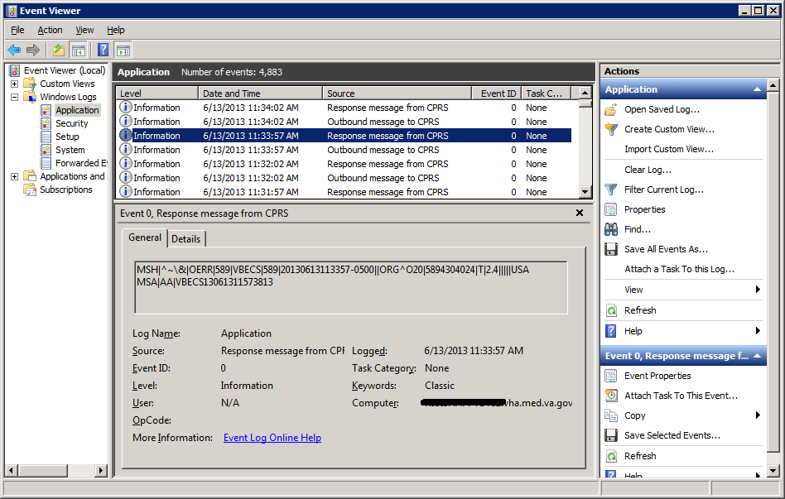
- Click Cancel to close the Find window (Figure 63).

- Double-click on the highlighted row (Figure 65).
Figure 65: Example of Event Properties
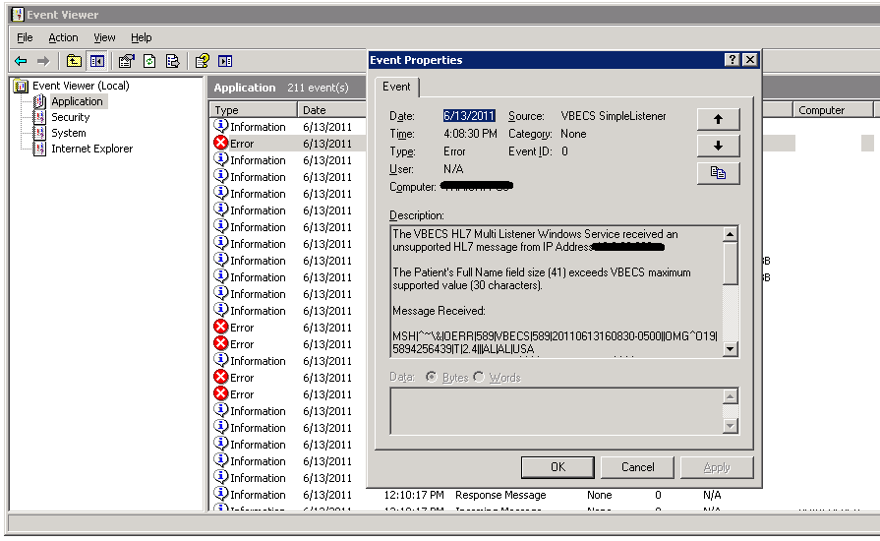
- If the Message ID in the email is part of the Message Receive information in the Event Properties, analyze the detail message to identify the Patient Information causing the error (Figure 66).
Figure 66: Example of Analyzing Event Properties
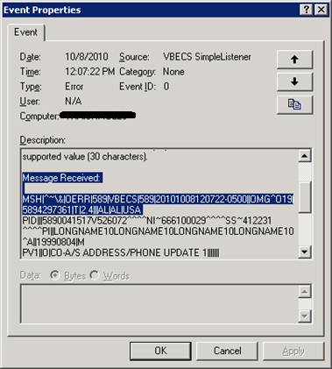
- If the Message ID in the email is not found in the Message Received, proceed to the next error by repeating Steps 3 through 7.

Zebra Printer Problems
Problem: The printer prints, but there is no text on the label or text is too light.

Probable Cause: The printer is out of ribbon or the DARKNESS setting is too light (Figure 67).

Solution: Increase the DARKNESS setting after verifying printer has ribbon.
Figure 67: Example Zebra Printer Settings
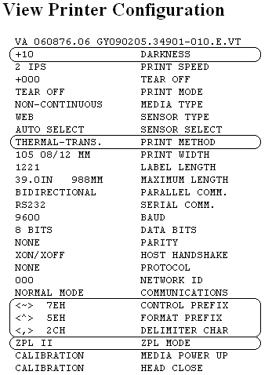

Problem: The printer does not print. It also cannot be pinged or be seen in a web browser (Figure 68).

Probable Cause: Network settings are not correct on the printer

Solution: Correct the printer’s network settings. All printer manuals may be found on the VBECS SharePoint.
Figure 68: Example of Zebra Printer Web Console
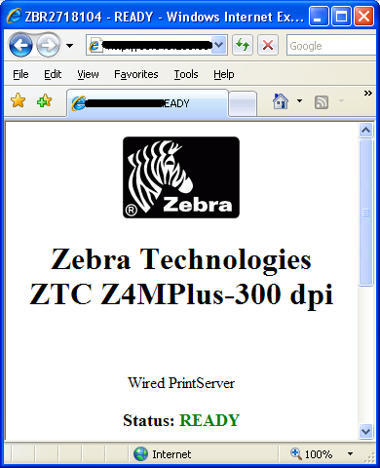
Problem: The printer does not print and network settings have been verified (see previous).

Probable Cause: One or more settings are incorrect.

Solution: Verify that the PRINT METHOD, CONTROL PREFIX, FORMAT PREFIX, DELIMITER CHAR and ZPL MODE match the settings in Figure 67.

Problem: The printer is online and network settings have been verified (see previous), but the printer fails to print.

Probable Cause: The network is blocking the printer, most likely due to a firewall. Test with Telnet PowerShell script. You may find it on D:\VBECS-Tools\ (App Server) (Figure 69). Read the accompanying readme file for instructions.

Solution: Open the firewall to the printer on port 9100.
Figure 69: Example of Telnet test setup
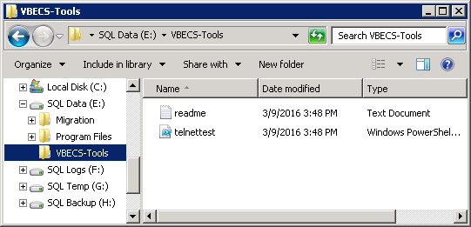

Scanner Problems

Problem: When scanning, a ` character appears at the start of the scan.

Probable Cause: The Caps Lock is on.

Solution: Turn the Caps Lock off.

Problem: When scanning, characters appear in the field that do not match the label being scanned. Often, the bad characters are not alphanumeric.

Probable Causes: Remote Desktop setting or network latency causes data to become corrupted.

Solution #1: First, try adjusting the keyboard settings in Remote Desktop Connection. Change the Keyboard setting to On the local computer (Figure 8). If this does not work, try solution #2.

Solution #2: The lab supervisor will program an inter-character delay into the scanner to fix the issue. This puts a small time-delay between each character as it is sent over the network, which results in slightly slower scan speeds.

Figure 70 through Figure 77 are configuration barcodes arranged from a 10-millisecond inter-character delay all the way up to an 80-millisecond delay respectively. We suggest that you start with the 10-millisecond delay. If that does not resolve the problem, proceed with larger delays until the problem is corrected.

Note that these barcodes include all of the configuration information for the scanners. There is no need to scan any additional barcodes to configure the scanner.

Figure 70: 10 milliseconds

Figure 71: 20 milliseconds

Figure 72: 30 milliseconds

Figure 73: 40 milliseconds

Figure 74: 50 milliseconds

Figure 75: 60 milliseconds

Figure 76: 70 milliseconds

Figure 77: 80 milliseconds


Archiving and Recovery (Data Center Only)
The VBECS database will be backed up once daily and the backup to tape can be taken any time after 1:00 AM (CST).

Assumptions
- The SQL Server job that backs up the database is running correctly.
- Replacement hardware will have a tape drive that is compatible with the one lost in the disaster.

Outcome
VBECS data is successfully recovered.

Limitations and Restrictions
None

Additional Information
None

Restore the Databases
If you find the need to perform a database restore and require assistance, file a support ticket (Service Desk Primary Contact) for the VBECS Maintenance Team.

Service Desk Primary Contact
See Customer Support section of VBECS 2.3.2 Release Notes.
This page intentionally left blank.

Failover
VBECS does not have a seamless failover mechanism. If an application server fails, the user will receive a message that the remote connection was lost. VBECS will lose information entered since the last save. The user must reopen a Remote Desktop Connection session. The user will have to reenter all information that was lost since the last save.

The connection between VBECS and VistA can be lost for a number of reasons:
An application server can fail, or the VistA server can fail. When this connection is lost, no messages can be exchanged. When the connection between VBECS and VistA is lost due to a failure of VBECS, the messages are queued on the VistA side. Orders placed during this downtime will remain in the queue. Once the VBECS system recovers and a connection is reestablished with VistA, the messages come across. The order alerts icon located in the VBECS status bar will display the orders that were in the queue at the time of failure.
An application server can fail because of a vSphere failure. If the underlying physical host that VBECS resides on fails, the VBECS servers will fail too. vSphere clustering will restore the server on another host.
If a user’s client workstation fails in the middle of a VBECS session, the session remains active on the server for a period set by the server administrator. The standard session time-out is 15 minutes. If the user resolves the issues with the client workstation and reconnects to the VBECS server through Remote Desktop Connection before the session times out, the session will remain as it was when the client failed.
VBECS uses a feature within Microsoft SQL Server 2012 called AlwaysOn. SQL Server AlwaysOn provides both High Availability (HA) and Disaster Recovery for VBECS databases. HA is implemented within one datacenter through synchronous replication. If a primary SQL server should fail, the VBECS application is automatically directed to use the databases on the HA SQL server. This is a seamless failover and occurs automatically with no intervention needed. The previously defined HA server becomes the new primary server and when the original primary server recovers, it becomes the new HA server. This will occur during normal maintenance of the servers during Windows update deployment on a monthly basis as those servers are rebooted. Using the same AlwaysOn technology, disaster recovery is implemented through asynchronous replication between the primary data center and a disaster recovery data center. Unlike the HA configuration, activating a disaster recovery server requires manual intervention.
If the VBECS user is in the process of performing a query at the exact second a synchronous failover takes place, they are presented with the message shown in Figure 78:
Figure 78: Synchronous Failover Message
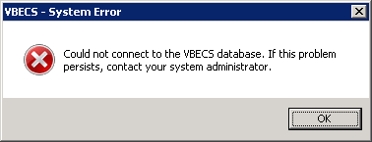

Once the VBECS user clicks OK, any open child dialogs automatically close to preserve data integrity. They may proceed to use VBECS and will not see this message again. This message could present itself in the event of a disaster recovery failover as well. In that case, the system will not recover automatically and the VBECS user continues to see this message every time they try to query the database. Manual failover recovery to the disaster recovery server takes place through written instructions defined in the Disaster Recovery Plan and requires the intervention and expertise of the datacenter and VBECS maintenance teams.

Performance
VBECS may delay a critical function such as patient transfusion if the network suffers latency issues. File a support ticket (Service Desk Primary Contact) per local procedures when latency issues arise.
VBECS was re-factored after performance testing results showed latency issues for VistA queries. As a result, many queries are cached in the VBECS database. Due to the criticality of having correct and current patient data, patient lookups cannot be cached.

Locking
VBECS is designed with pessimistic locking controlled within the application code: if one user selects a record for edit, the record is locked by that user. If another user tries to edit that record, a message will tell him that the record is locked and who has the record. The second user is not granted access to the record.
Locks have a timeout period defined in the edit divisions portion of the VBECS Administrator application (refer to the VistA Blood Establishment Computer Software (VBECS) Admin User Guide). When a lock times out or is released by a user completing his edit, another user can edit that record.
If the application code fails due to a logic bug, optimistic locking is in place to prevent data corruption. When a record is retrieved, a row version is also retrieved. When a record is saved, the row in the database gets an updated row version; before the save takes place, the save routine checks that the row version supplied matches the row version in the table. If it does not match, the routine notifies the caller that another user changed the data. The save does not complete; the user must retrieve the updated record and start his edits again.
If VBECS had an application error resulting in the application terminating, locks may have to be manually deleted. Contact the Service Desk Primary Contact.
This page intentionally left blank.

Security
VBECS contains sensitive data and performs a critical function, so it is critical to secure the system. It is important to secure the server from both users and malicious attacks from an individual who is trying to gain access to the system.

Access Request Process
To gain access to the VBECS server, reference the VBECS SharePoint site:
(https://dvagov.sharepoint.com/sites/oitepmovbecs/default.aspx).

A NMEA must be used at all times to access a VBECS server with administrator access.

Active Directory
Access to the VBECS servers is controlled through AD. Each VBECS site will have two groups set up in AD, one for normal VBECS users and one for VBECS Administrators (this is not a server administrator). Unless the user is a server administrator, he must be a member of one of these two groups to gain access to the server.
These groups also play a role in application level security. Even if a user were able to access the server, he would not be able to access VBECS.

Group Policy
Group policy controls the user experience (what the user sees and has access to on the VBECS server). To configure this correctly, the recommendations in “Windows Server 2008 R2 Security Guide” (Microsoft Web site) were followed to establish a baseline for group policy.
Group policy can be applied to user accounts or to the servers directly. In the case of VBECS, group policy is applied to the servers (it is easier to manage). It is also undesirable to have group policy associated with the user, which may inhibit his use of other systems. Enabling loopback processing applies the policy to any user that logs into the server.
In some cases, group policy also enables VBECS to perform actions on the Windows operating system. For example, there is a group policy setting that allows the VBECS services to be restarted after a configuration change in VBECS Administrator.

System Center Operations Manager
SCOM is a proactive monitoring tool. SCOM will constantly monitor each server for system abnormalities. If SCOM detects a problem, an email will be sent to the system administrator defined during the SCOM installation process. SCOM will monitor these high-level categories:
- Windows Server 2008 R2 Operating System
- CPU health and usage
- Network interface cards
- SQL Server (SQL Clustering and SQL AlwaysOn)
- Memory usage
- Hard-disk health and usage
- VBECS files and services
- Windows Services

Application-Wide Exceptions
Table 13 explains system exceptions to aid VA Health Product Support in determining the cause and resolving system issues.
Table 13: Application-Wide Exceptions
System Exceptions | Description
ArgumentException | Base class for all argument exceptions
ArgumentNullException | Thrown by methods that do not allow an argument to be null
ArgumentOutOfRangeException | Thrown by methods that verify that arguments are in a given range
ComException | Exception encapsulating COM HRESULT information
Exception | Base class for all exceptions
ExternalException | Base class for exceptions that occur or are targeted at environments outside the runtime
IndexOutOfRangeException | Thrown by the runtime only when an array is indexed improperly
InvalidOperationException | Thrown by methods when in an invalid state
NullReferenceException | Thrown by the runtime only when a null object is referenced.
SEHException | Exception encapsulating Win32 structured exception handling information
System.ArithmeticException | A base class for exceptions that occur during arithmetic operations, such as System.DivideByZeroException and System.OverflowException
System.ArrayTypeMismatchException | Thrown when a store into an array fails because the actual type of the stored element is incompatible with the actual type of the array
System.DivideByZeroException | Thrown when an attempt to divide an integral value by zero occurs
System.IndexOutOfRangeException | Thrown when an attempt to index an array via an index that is less than zero or outside the bounds of the array
System.InvalidCastException | Thrown when an explicit conversion from a base type or interface to a derived type fails at run time
System.NullReferenceException | Thrown when a null reference is used in a way that causes the referenced object to be required
System.OutOfMemoryException | Thrown when an attempt to allocate memory (via new) fails
System.OverflowException | Thrown when an arithmetic operation in a checked context overflows
System.StackOverflowException | Thrown when the execution stack is exhausted by having too many pending method calls; typically indicative of very deep or unbounded recursion
System.TypeInitializationException | Thrown when a static constructor throws an exception, and no catch clauses exist to catch it
SystemException | Base class for all runtime-generated errors

Table 14 explains the event sources that VBECS uses to write to the Application log in Event Viewer (Finding Application Log Entries from Email Alerts).
Table 14: Event Sources
Event Source | Description
VBECS Exception | A VBECS system crash
VBECS Prod | VBECS Production
VBECS Test | VBECS Test
VBECS Admin Prod | VBECS Administrator Production
VBECS Admin Test | VBECS Administrator Test
HL7Dispatcher Prod | VBECS Services
HL7Dispatcher Test | VBECS Services
HL7Service Prod | VBECS Services
HL7Service Test | VBECS Services
ReportScheduler Prod | VBECS Services
ReportScheduler Test | VBECS Services
VistaLinkService Prod | VBECS Services
VistaLinkService Test | VBECS Services

This page intentionally left blank.
Configuring the App Server and Lab Workstations
After the App Server is deployed, additional configuration will need to be performed on it and on the lab workstations. On the server, install the printer, configure permissions and create the Report share. On the workstation, create a shortcut to the report share.

Server Tasks (Data Center Only)
Perform the following tasks on the App Server only.

Grant User Permissions
- Open a remote desktop connection to the VBECS App Server and login with server administrator privileges.
- Click Start, Administrative Tools, Computer Management. Expand Local Users and Groups. Select Groups and double-click Remote Desktop Users (Figure 79).
Figure 79: Computer Management
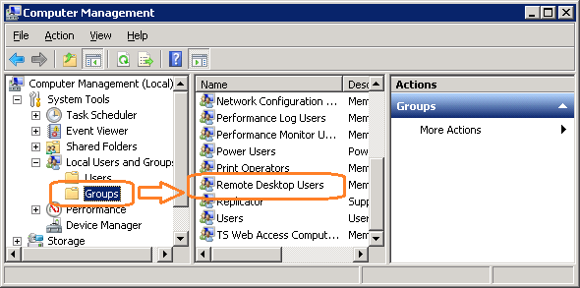
- Click Add (Figure 80).
Figure 80: Remote Desktop Users Properties
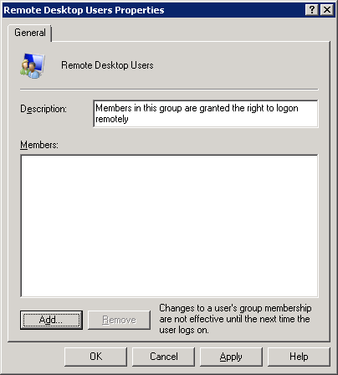
- Specify the VBECS Users and VBECS Administrators group (Figure 81). Note that groups typically follow this naming convention (substitute the 3-letter site code for sss):
  - VBECS Users: VHAsssVbecsUsers
  - VBECS Administrators: VHAsssVbecsAdministrators
Click OK to close the window. Click OK again to close the Properties window.
Figure 81: Example of Select Users, Computers...
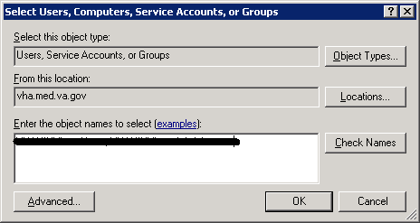

Configure the Report Share
- Open a remote desktop connection to the VBECS App Server and login with server administrator privileges.
- Open Windows Explorer and navigate to the D drive.
- Right-click on VBECSReports and click Properties. Select the Security tab and click Edit (Figure 82).
Figure 82: Example of VBECSReports Properties
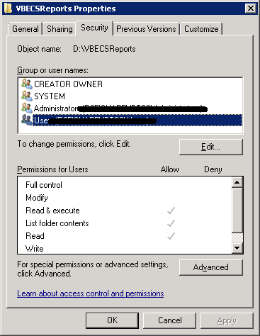
- Click Add (Figure 83).
Figure 83: Example of Permissions
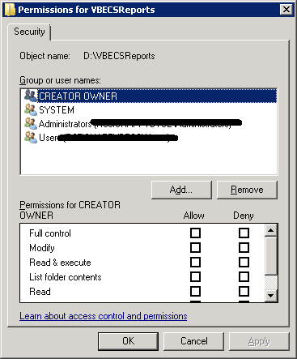
- Specify the VBECS Users and VBECS Administrators group (Figure 84). Note that groups typically follow this naming convention (substitute the 3-letter site code for sss):
  - VBECS Users: VHAsssVbecsUsers
  - VBECS Administrators: VHAsssVbecsAdministrators
Click OK to close the window.
Figure 84: Example of Select Users, Computers...
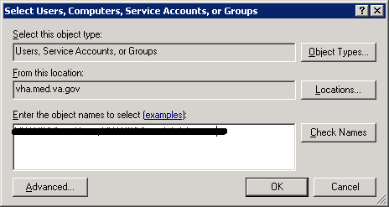
- In the Permissions window, assign Write access to both groups in addition to the rights granted by default. Click OK (Figure 85).
Figure 85: Example of Permissions
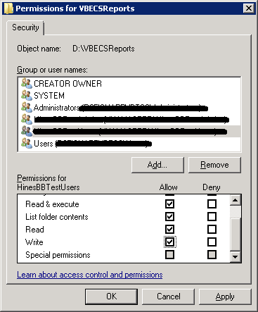
- Select the Sharing tab and click Advanced Sharing (Figure 86).
Figure 86: VBECSReports Properties
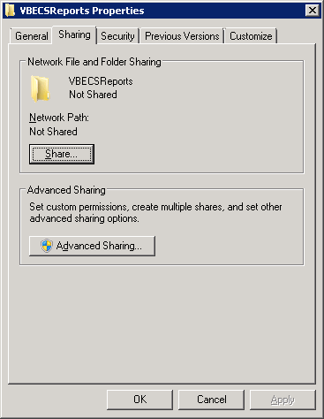
- Click Share this folder and then Permissions (Figure 87).
Figure 87: Advanced Sharing
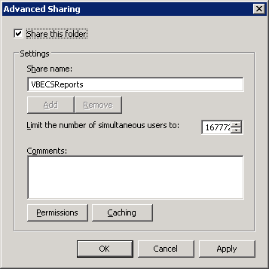
- Click Add (Figure 88).
Figure 88: Permissions
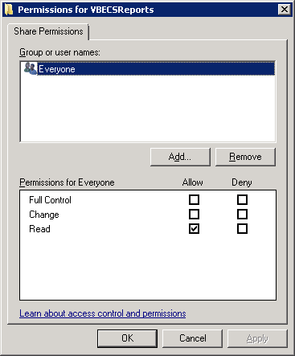
- Specify the VBECS Users and VBECS Administrators group (Figure 89). Note that groups typically follow this naming convention (substitute the 3-letter site code for sss):
  - VBECS Users: VHAsssVbecsUsers
  - VBECS Administrators: VHAsssVbecsAdministrators
Click OK.
Figure 89: Example of Select Users...
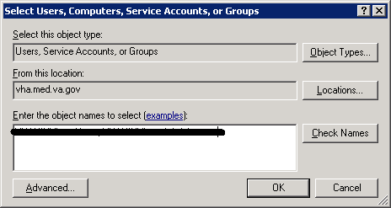
- Select the VBECS Administrators group and select Full Control. Leave the default permissions for the VBECS Users group and click OK (Figure 90).
Figure 90: Permissions for VBECSReports
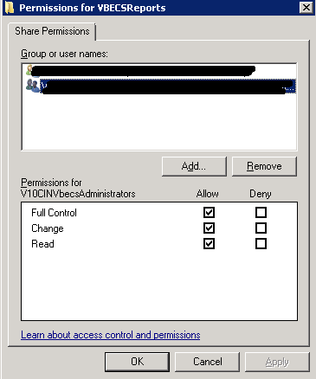

Workstation Tasks
Update the RDP shortcut and create a link to the report share on each lab workstation.

Update the RDP Shortcut
- Log into the lab workstation with administrator privileges.
- Right-click on the VBECs remote desktop shortcut and click Edit (Figure 91).
Figure 91: Edit shortcut
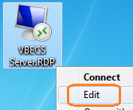
- In the Computer field, the VBECS application server’s fully qualified domain name. The name will always be your server name followed by aac.dva.va.gov (Figure 92). Click Save.
Figure 92: Remote Desktop Connection

Configure a Shortcut to the Report Share
The report share section (Configure the Report Share) must have been executed before proceeding with this section. The report share contains patient identifiable information, so the shortcut must only be accessible by authorized laboratory personnel. If the workstation will only be used by laboratory personnel, the shortcut may be placed in the Public Desktop folder. Otherwise, create it separately in each user’s folder.
- Log into the lab workstation with administrator privileges. Navigate to the user’s desktop folder (C:\Users\Public\Public Desktop), right-click on the Desktop folder and select New, Shortcut (Figure 93). Note: If you cannot see the Public Desktop folder in the tree view type C:\Users\Public\Public Desktop in the address bar and hit enter.
Figure 93: Example of New Shortcut
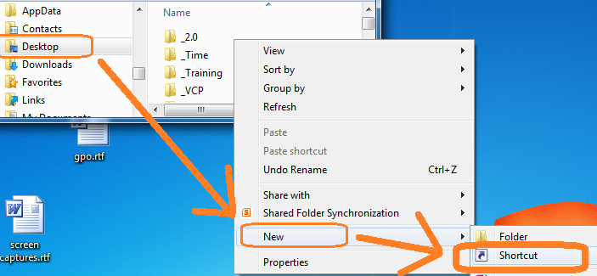
- Enter the share name (\\<VBECS application server fully qualified domain name >\VBECSReports\Division Code) and click Next (Figure 94). Division Code is the folder labeled with the site’s station number. For all sites, reports are saved in subfolders named after the site’s Division Code (Station Number).
Figure 94: Example of Report Share (if 518 is the Site’s Station #)
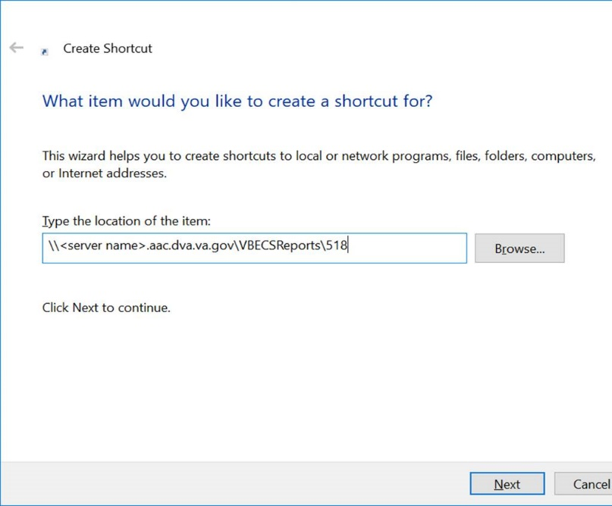
- Name the shortcut VBECSReports. Click Finish (Figure 95).
Figure 95: Create Shortcut
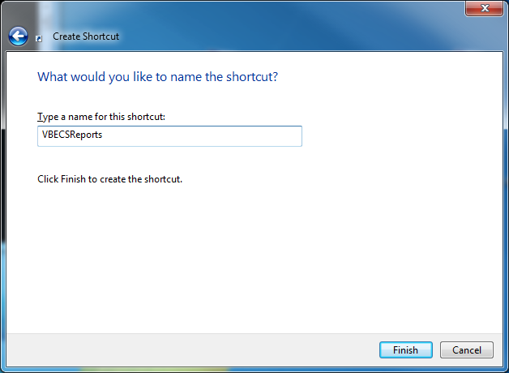
This page intentionally left blank.

Glossary
Acronym, Term | Definition
Access Code | A field in the VistA New Person file used to uniquely identify a user on the VistA system.
Active Directory (AD) | A hierarchical directory service built on the Internet's Domain Naming System (DNS).
AG | Availability Group.
API | Application Programmer Interface.
AITC | Austin Information Technology Center.
CPRS | Computerized Patient Record System.
DBIA  DC | Database Integration Agreement.  Data Center.
DR | Disaster Recovery.
DSS | Decision Support System.
FQDN | Fully Qualified Domain Name.
HA | High Availability.
HCPCS | Healthcare Common Procedure Coding System.
HL7 | Health Level Seven.
LAN | Local Area Network.
LLP | Lower Layer Protocol.
LMIP | Laboratory Management Index Program.
PCE | Patient Care Encounter.
PIV | Personal Identification Verification.
RDP | Remote Desktop Protocol.
RPC | Remote Procedure Call.
SQL | Structured Query Language.
SSMS | SQL Server Management Studio.
SCOM | System Center Operations Manager.
TCP/IP | Transmission Control Protocol/Internet Protocol.
VAISS | VBECS Application Interfacing Support Software.
VBECS | VistA Blood Establishment Computer Software.
VDL | VA Software Document Library.
Verify Code | A field in the VistA New Person file used to verify the identity of a user associated with an Access Code.
VISN | Veterans Integrated Service Network.
XML | Extensible Markup Language.
This page intentionally left blank.

Appendices

Appendix A: Data Center Instructions (Data Center Only)

Purpose
This appendix describes the server configuration as well as the tasks that must be completed by the data center for a successful VBECS installation:
- Initial Setup Tasks: These tasks must be completed prior to installation of any VBECS systems.
- Ongoing Tasks: These are continual maintenance tasks.

Server Configuration
The U.S. Food and Drug Administration classifies this software as a medical device. Unauthorized modifications will render this device an adulterated medical device under Section 501 of the Medical Device Amendments to the Federal Food, Drug, and Cosmetic Act. Acquiring and implementing this software through the Freedom of Information Act require the implementer to assume total responsibility for the software and become a registered manufacturer of a medical device, subject to FDA regulations.

VBECS is a medical device; all updates and changes to it must be tested and documented. This will be centrally managed. The VBECS servers must be added to site exclusion lists so they are not part of local update mechanisms. Ensure that login scripts do not run on VBECS servers as they may attempt to install unauthorized software. Do not install the ePolicy agent on the VBECS systems: exclude them from Systems Management Server (SMS) updates. Install Windows updates only after approval is granted.

App and Database Server Virtual Machine Configurations
Table 15 and Table 16 describe the configurations of the App and Database Server virtual machines respectively.
These configurations are designed to promote 24/7 availability and use of the application. At an App Server level, replication provides high availability. At the Database Server level, AlwaysOn cluster configuration provides near immediate failover in case the primary server fails.
Table 15: App Server Virtual Machine Configuration
App Server Specifications
Processor | 2 virtual CPUs (vCPUs) with a speed of 2.67GHz
Memory | 6 gigabyte (GB) main storage (RAM)
Storage | 80GB system drive (C) with a 10GB (D) drive to host configuration and reports
Operating System | Microsoft Windows Server 2008 Server Enterprise Edition R2 (x64)
Network Controller | Two 10/100 network cards; one for network configuration and another for backups.
Backup | Servers are replicated at the disaster recovery site.
Table 16: Database Server Virtual Machine Configuration
Database Server Specifications
Processor | 4 vCPUs: Xeon(R) X5650 @ 2.67GHz
Memory | 32GB main storage (RAM)
Storage | Server: 80GB system drive (C)  Shared storage: 4 x 980GB drives*: E (Data), F (Logs), G (TempDB) and H (Backup)
Operating System | Microsoft Windows Server 2008 Server Enterprise Edition R2 (x64)
Network Controller | Two 10/100 network cards; one for network configuration and another for backups.
Backup | Data is replicated to the disaster recovery site via SQL AlwaysOn.
*The drives used in the test servers will be scaled down.

Physical Host Configurations
Table 17 describes the requirements of the hosting hardware. Input/Output Operations per Second (IOPS) is a storage benchmark. The Storage Totals row describes the total amount of storage that each region must provide.
Table 17: App Server Virtual Machine Configuration
Specification |  | R01 | R02 | R03 | R04
IOPS | Read (Avg/ Max) | 654/ 5,265  2,435/ 10,435 | 658/ 5,326  2,445/ 10,543 | 985/ 7,959  3,663/ 15,761 | 646/ 5,143  2,418/ 10,220
IOPS | Write (Avg/ Max)
Storage Totals |  | 31.16 TB | 31.32 TB | 46.9 TB | 30.84 TB

Initial Setup Tasks
Execute the tasks in this section prior to installation.

Group Policy
For Group Policy purposes, VBECS servers will reside in their own OU, which will contain only VBECS servers. You may also create OUs under the main OU for organizational purposes. For more information, see Group Policy section.
Import the VHA VBECS Terminal Server Policy from the VHAMASTER domain. Place the group policy in the top-level server OU. For more information about OUs and server organization, see Active Directory section.
Configure the policy so that it is not applied to the VBECS Server Admins Active Directory group. See the example in Figure 96.
Figure 96: Example of a Group Policy Not Applied to VBECSAdministrators Group
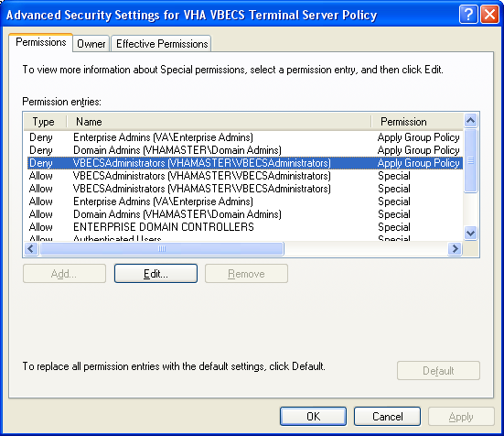

RDP Server
VBECS is an RDP Server application and requires a license. Specify the license server in the group policy at the following location:

- Computer Configuration, Policies, Administrative Templates, Windows Components, Remote Desktop Services, Remote Desktop Session Host, Licensing, Use the specified Remote Desktop license servers (Enabled), License servers to use: <specify the VA’s license server with the server’s fully qualified domain name>
Remote desktop is critical to VBECS. Failure to connect to a license server will result in widespread outages. If you see errors related to Terminal Server licensing, contact the Enterprise Engineering group immediately: VAITEngineeringCISIDM@va.gov.

Ongoing Tasks
Execute the tasks in this section continually.

Back Up the VBECS Database
Back up the VBECS databases nightly (1am CST):
  - Back up all folders and files in the <Primary Server> H:\Program Files\Microsoft SQL Server\MSSQL11.MSSQLSERVER\MSSQL\Backup and <Secondary (HA) Server> H:\Program Files\Microsoft SQL Server\MSSQL11.MSSQLSERVER\MSSQL\Backup directories.
  - Database backups are maintained for at least seven days on the Active Replica servers.

VBECS Updates
When the VBECS maintenance team releases a VBECS patch, install the patch in accordance with instructions supplied by the VBECS maintenance team.

Windows Updates
The VBECS maintenance team tests every Microsoft Windows update. Once the VBECS maintenance team certifies the Microsoft Windows update, DC staff at the AITC install the updates during the monthly maintenance periods defined for the test and production servers. Refer to Applying Windows Updates section for details.

Appendix B: Auditing on VBECS Servers
The following events are audited on VBECS servers. These events may be viewed in Event Viewer logs (under Administrative Tools):
- Account logon events (Success, Failure)
- Account management (Success, Failure)
- Directory service access (Success, Failure)
- Logon events (Success, Failure)
- Object access (Success, Failure)
- Policy Change (Success, Failure)
- System events (Success, Failure)
This page intentionally left blank.

Appendix C: Set Up VBECS Protocol Definitions
This section should be referenced whenever it is suspected that the HL7 configuration may have become corrupt.

Set Up VBECS Protocol Definitions
- From the ‘HL7 Main” Menu, select Interface Developer Options.
- Select Protocol Edit.
Figure 97: HL7 Protocol Menu Navigation
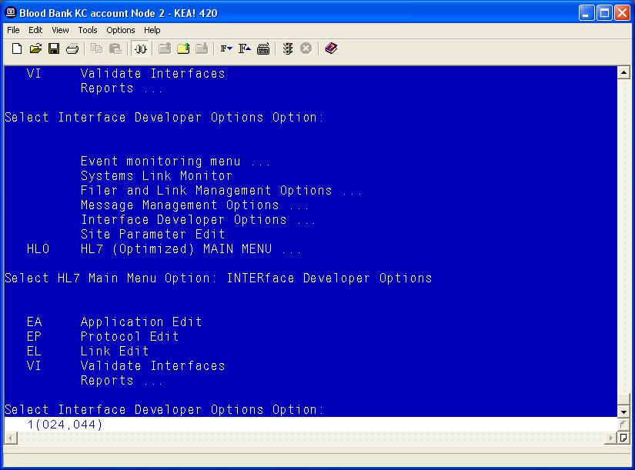

Patient Update Events

Edit VAFC ADT-A08 SERVER Protocol
- Select Edit Protocol and enter VAFC ADT-A08 SERVER.
- Move the cursor to the “TYPE” field and press Enter.
Figure 98: HL7 Interface Setup
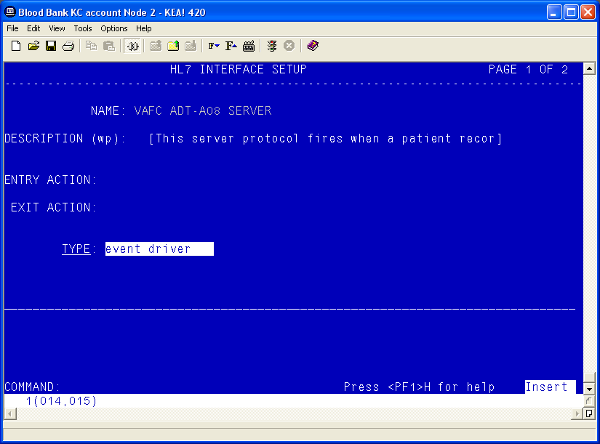
- Move the cursor to below the last entry in the “SUBSCRIBERS” section.
- Enter VBECS ADT-A08 ROUTER and press Enter.
Figure 99: HL7 Event Driver
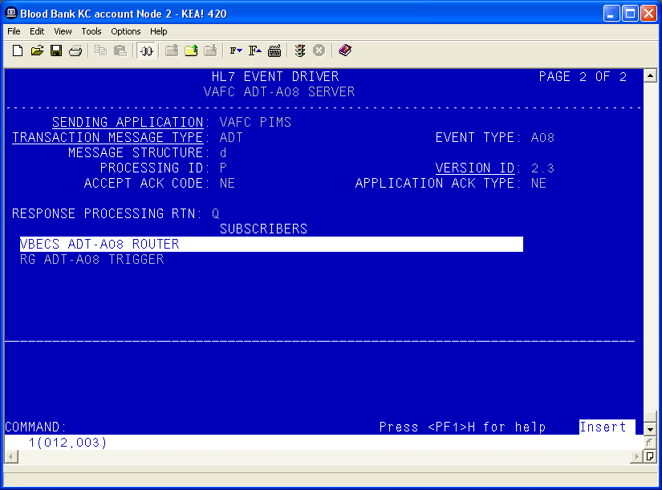
- Accept the default settings in the sub-window.
- Move the cursor to the “RECEIVING APPLICATION” prompt and verify that the entry is “VBECS ADT”.
- Press Enter.
Figure 100: HL7 Subscriber: VBECS ADT-A08 Router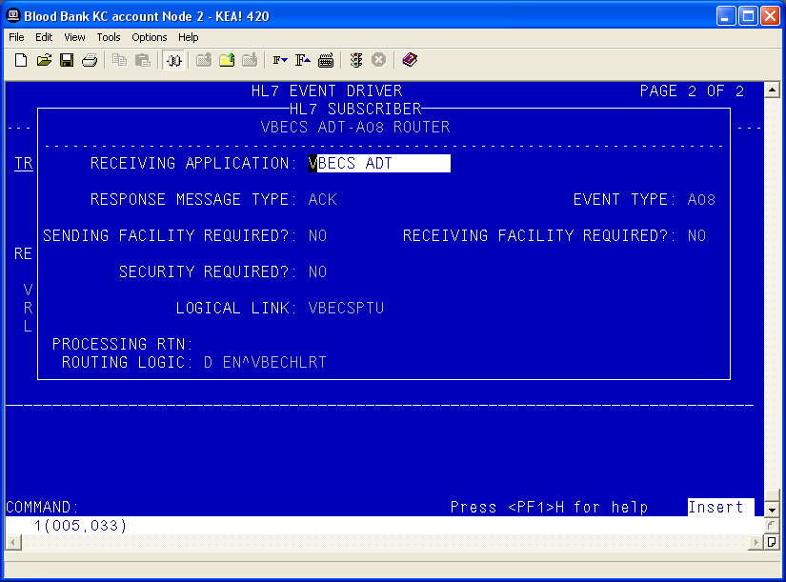
- Move the cursor to the “FACILITY NAME” prompt and enter the station number of the primary division of the site.
- Move the cursor to the “COMMAND” prompt.
- Enter Close and press Enter.
Figure 101: HL7 Subscriber: VBECS ADT-A08 Router
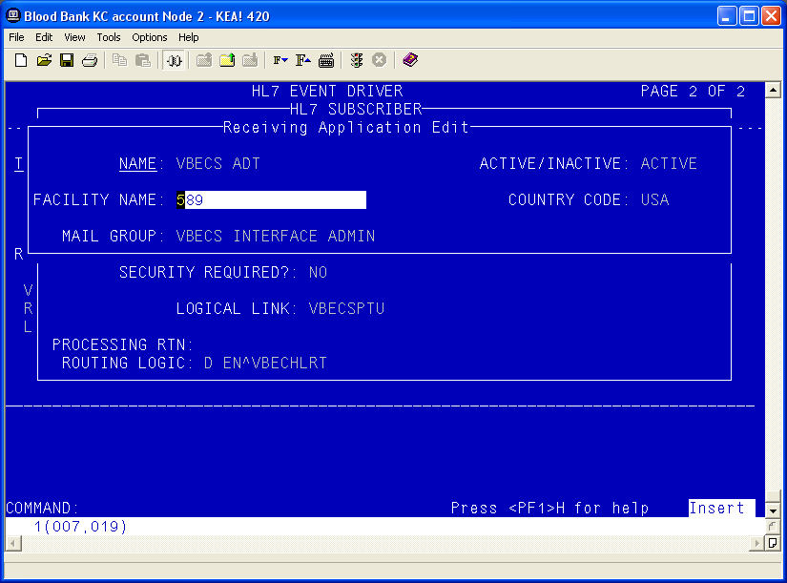
- You will return to the previous screen (Figure 14). Move the cursor to the “COMMAND” prompt.
- Enter Save and press Enter.
- Enter Exit and press Enter.

VBECS ADT-A08 CLIENT
- Select VBECS ADT-A08 CLIENT.
- Move the cursor to the “TYPE” field and press Enter.
Figure 102: HL7 Interface Setup
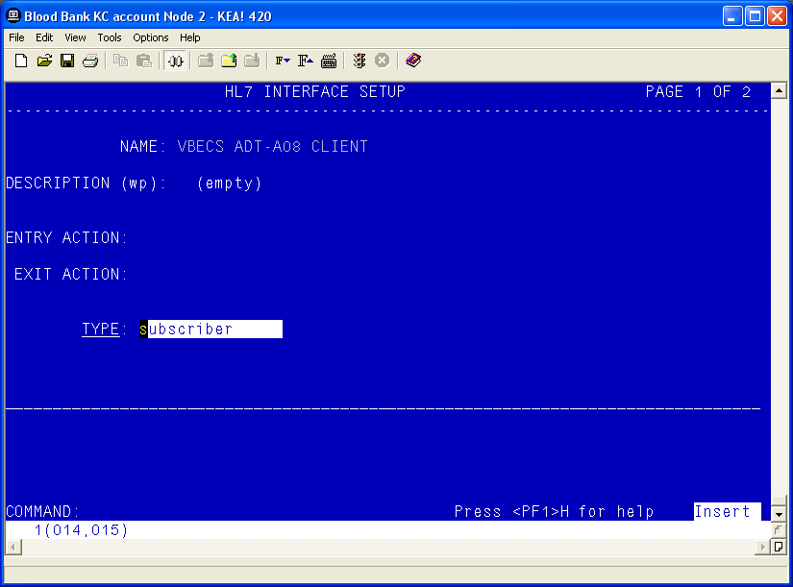
- Move the cursor to the “RECEIVING APPLICATION” prompt and verify that the entry is “VBECS ADT”.
- Press Enter.
Figure 103: HL7 Subscriber: VBECS ADT-A08 Client
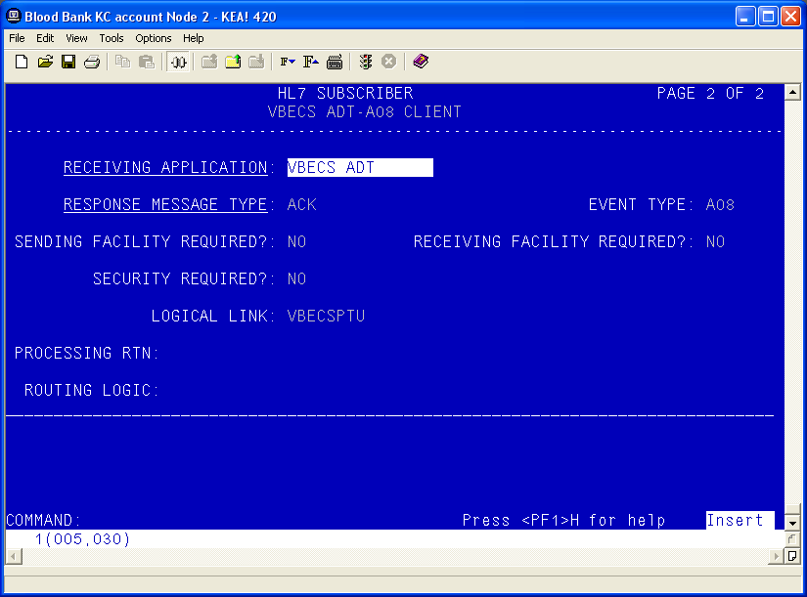
- Move the cursor to the “FACILITY NAME” prompt and enter the station number of the primary division of the site.
- Move the cursor to the “COMMAND” prompt.
- Enter Close and press Enter.
Figure 104: Receiving Application Edit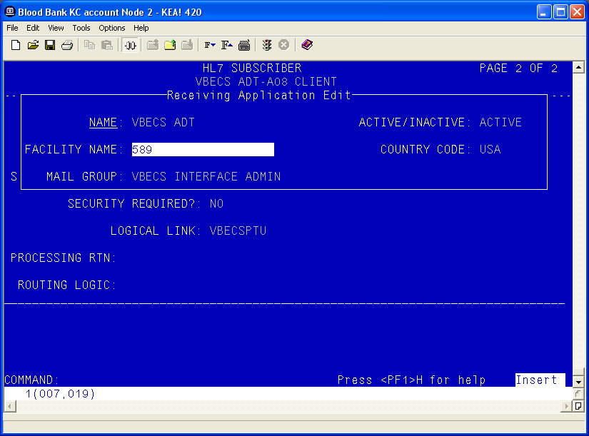
- You will return to the previous screen (Figure 17). Move the cursor to the “COMMAND” prompt.
- Enter Save and press Enter.
- Enter Exit and press Enter.

Patient Merge Events
- Select MPIF ADT-A40 SERVER.
- Move the cursor to the “TYPE” field and press Enter.
Figure 105: HL7 Interface Setup
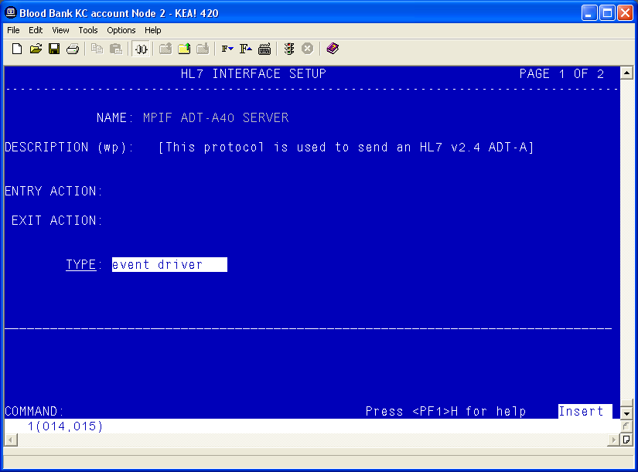
- Move the cursor to below the last entry in the “SUBSCRIBERS” section.
- Enter VBECS ADT-A40 CLIENT and press Enter.
Figure 106: HL7 Event Driver: MPIF ADT-A40 Server
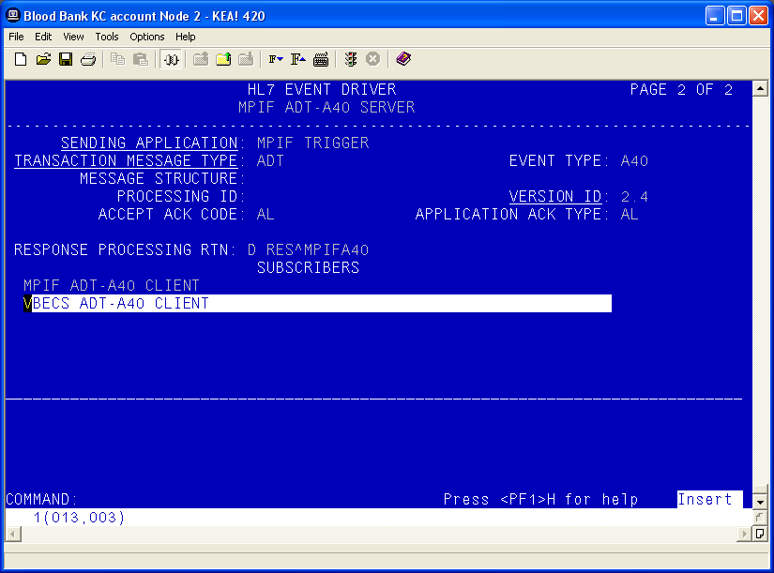
- Accept the default settings in the sub-window.
- Move the cursor to the “COMMAND” prompt.
- Enter Close and press Enter.
- You will return to the previous screen. Move the cursor to the “COMMAND” prompt.
Figure 107: HL7 Subscriber: VBECS ADT-A40 Client
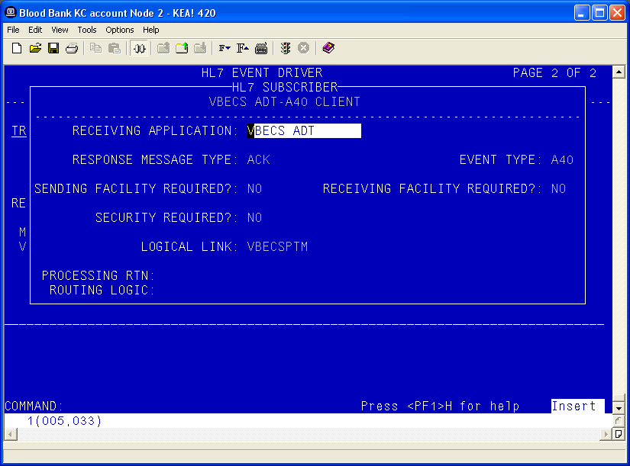
- Enter Save and press Enter.
- Enter Exit and press Enter.

Order Update Events
- Select VBECS OMG SERVER.
- Move the cursor to the “TYPE” field and press Enter.
Figure 108: HL7 Order Update Setup
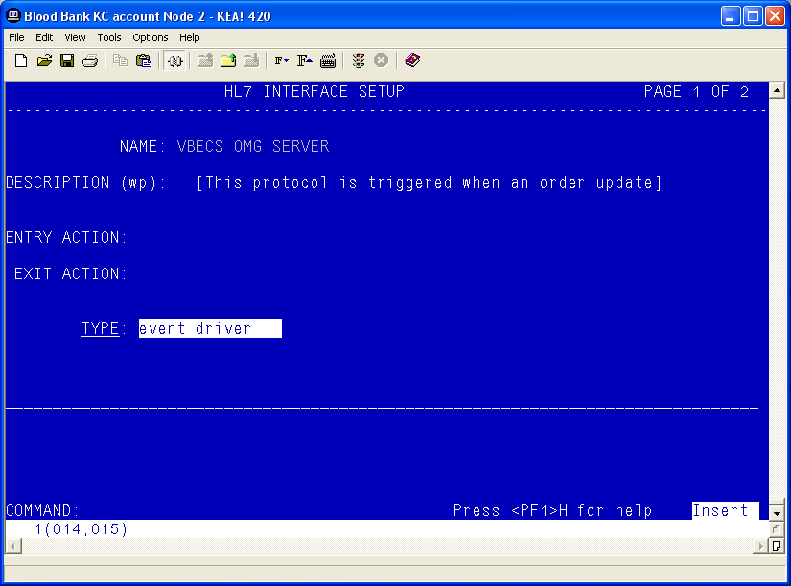
- Move the cursor to below the last entry in the “SUBSCRIBERS” section.
- Enter VBECS OMG CLIENT and press Enter.
Figure 109: HL7 Event Driver: VBECS OMG Server
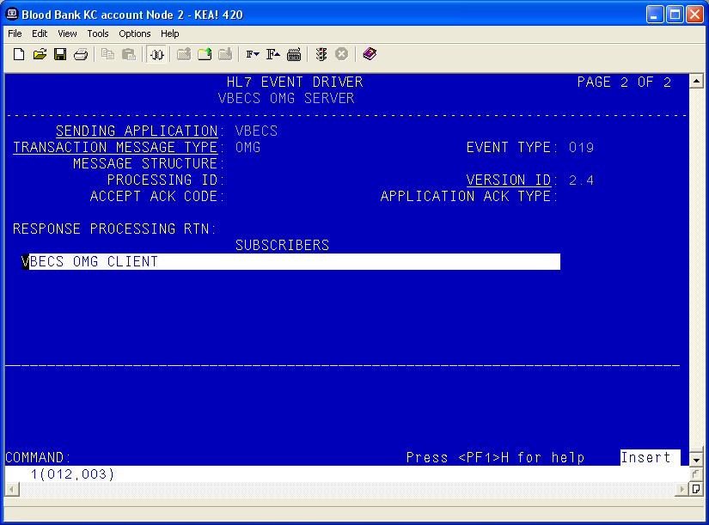
- Verify that the Receiving Application is OERR.
Figure 110: HL7 Event Driver: VBECS OMG Server
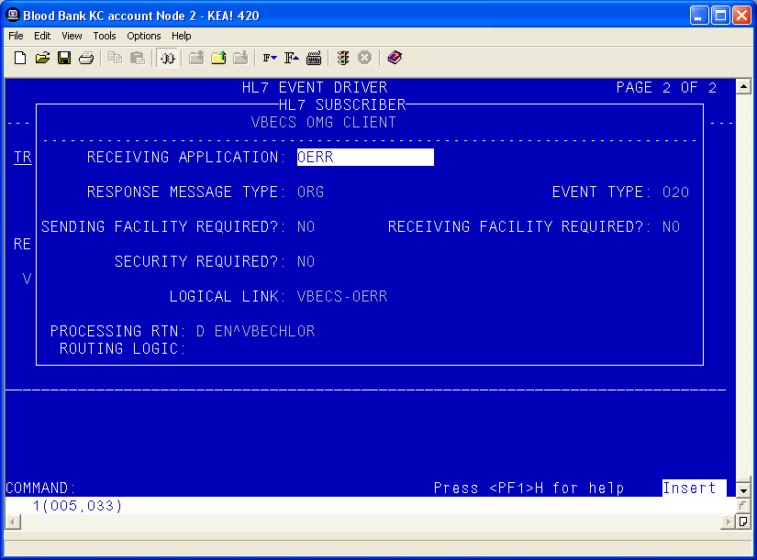
- Move the cursor to the “COMMAND” prompt.
- Enter Close and press Enter.
- Move the cursor to the “COMMAND” prompt.
- Enter Save and press Enter.
- Enter Exit and press Enter.

Order Update Events (continued)
- Select VBECS OMG CLIENT.
- Move the cursor to the “TYPE” field and press Enter.
Figure 111: HL7 Interface Setup
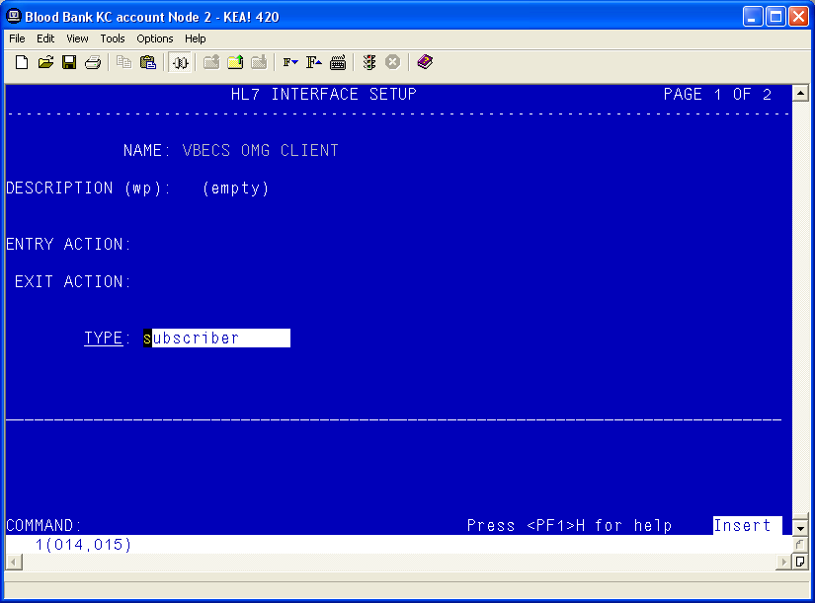
- Verify that the Receiving Application is OERR and press Enter.
Figure 112: HL7 Event Driver: VBECS OMG Client
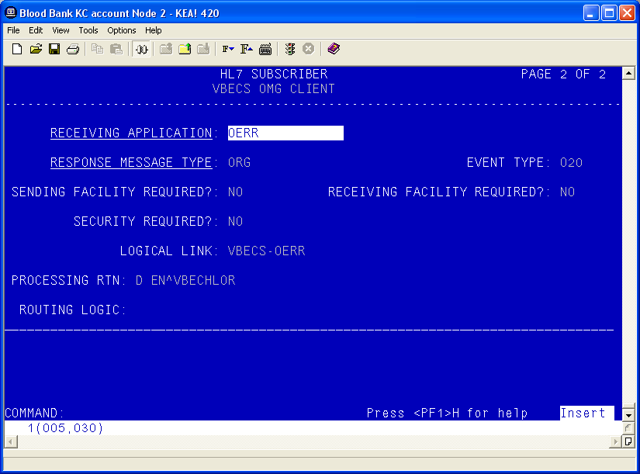
- Enter the correct Facility Name
Figure 113: HL7 Subscriber: VBECS ADT-A40 Client
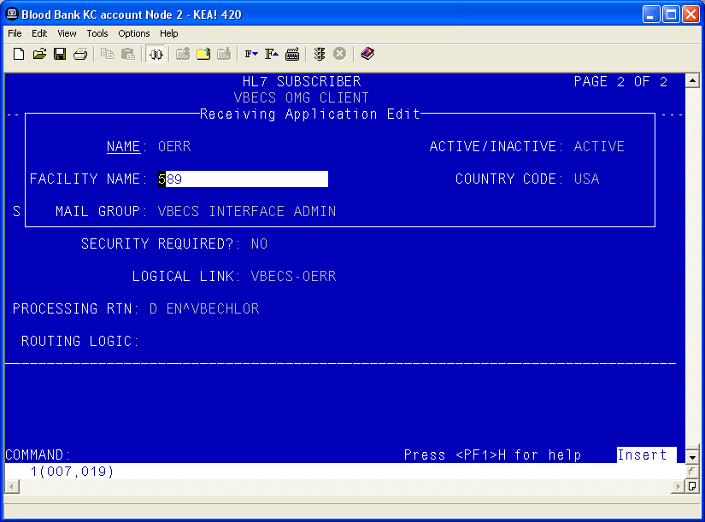
- Move the cursor to the “COMMAND” prompt.
- Enter Close and press Enter.
- Move the cursor to the “COMMAND” prompt.
- Enter Save and press Enter.
- Enter Exit and press Enter.
This page intentionally left blank.

Appendix D: Laboratory Test File (#60)
The Laboratory tests added must be configured for your site. The appropriate INSTITUTION and ACCESSION AREA must be added using the “Edit cosmic tests” (LRDIECOSMIC) option. The TYPE field in Existing Blood Bank tests should be set to OUTPUT to prevent these tests from being ordered after VBECS has been installed.
Any of the diagnostic tests that will be ordered for Lab Collect (LC) must also have a LAB COLLECTION SAMPLE defined in addition to the COLLECTION SAMPLE. The LAB COLLECTION SAMPLE can be edited with the EDIT COSMIC TESTS (LRDIECOSMIC) option.

LABORATORY TEST File (#60)
NAME: ABO/RH - LAB TYPE: OUTPUT (CAN BE DISPLAYED)
SUBSCRIPT: BLOOD BANK UNIQUE COLLECTION SAMPLE: YES
HIGHEST URGENCY ALLOWED: STAT PRINT NAME: ABO RH
COLLECTION SAMPLE: BLOOD
INSTITUTION: VA HEARTLAND - WEST, VISN 15
ACCESSION AREA: BLOOD BANK
INSTITUTION: COLUMBIA, MO VAMC ACCESSION AREA: COBLOOD BANK
INSTITUTION: LEAVENWORTH VAMC ACCESSION AREA: LEBLOOD BANK
INSTITUTION: TOPEKA, KS VAMC ACCESSION AREA: TOBLOOD BANK
INSTITUTION: WICHITA VAMC ACCESSION AREA: WIBLOOD BANK
NAME: ANTIBODY SCREEN - LAB TYPE: OUTPUT (CAN BE DISPLAYED)
SUBSCRIPT: BLOOD BANK UNIQUE COLLECTION SAMPLE: YES
HIGHEST URGENCY ALLOWED: STAT PRINT NAME: AB SCRN
COLLECTION SAMPLE: BLOOD
INSTITUTION: VA HEARTLAND - WEST, VISN 15
ACCESSION AREA: BLOOD BANK
INSTITUTION: COLUMBIA, MO VAMC ACCESSION AREA: COBLOOD BANK
INSTITUTION: LEAVENWORTH VAMC ACCESSION AREA: LEBLOOD BANK
INSTITUTION: TOPEKA, KS VAMC ACCESSION AREA: TOBLOOD BANK
INSTITUTION: WICHITA VAMC ACCESSION AREA: WIBLOOD BANK
NAME: CRYOPRECIPITATE - LAB TYPE: OUTPUT (CAN BE DISPLAYED)
SUBSCRIPT: BLOOD BANK UNIQUE COLLECTION SAMPLE: YES
HIGHEST URGENCY ALLOWED: STAT PRINT NAME: CRYOPRE
COLLECTION SAMPLE: VBECS - NO SPECIMEN REQUIRED
INSTITUTION: VA HEARTLAND - WEST, VISN 15
ACCESSION AREA: BLOOD BANK
INSTITUTION: COLUMBIA, MO VAMC ACCESSION AREA: COBLOOD BANK
INSTITUTION: LEAVENWORTH VAMC ACCESSION AREA: LEBLOOD BANK
INSTITUTION: TOPEKA, KS VAMC ACCESSION AREA: TOBLOOD BANK
INSTITUTION: WICHITA VAMC ACCESSION AREA: WIBLOOD BANK
NAME: DIRECT ANTIGLOBULIN TEST - LAB TYPE: OUTPUT (CAN BE DISPLAYED)
SUBSCRIPT: BLOOD BANK UNIQUE COLLECTION SAMPLE: YES
HIGHEST URGENCY ALLOWED: STAT PRINT NAME: DAT
COLLECTION SAMPLE: BLOOD
INSTITUTION: VA HEARTLAND - WEST, VISN 15
ACCESSION AREA: BLOOD BANK
INSTITUTION: COLUMBIA, MO VAMC ACCESSION AREA: COBLOOD BANK
INSTITUTION: LEAVENWORTH VAMC ACCESSION AREA: LEBLOOD BANK
INSTITUTION: TOPEKA, KS VAMC ACCESSION AREA: TOBLOOD BANK
INSTITUTION: WICHITA VAMC ACCESSION AREA: WIBLOOD BANK
NAME: FRESH FROZEN PLASMA - LAB TYPE: OUTPUT (CAN BE DISPLAYED)
SUBSCRIPT: BLOOD BANK UNIQUE COLLECTION SAMPLE: YES
HIGHEST URGENCY ALLOWED: STAT PRINT NAME: FFP
COLLECTION SAMPLE: VBECS - NO SPECIMEN REQUIRED
INSTITUTION: VA HEARTLAND - WEST, VISN 15
ACCESSION AREA: BLOOD BANK
INSTITUTION: COLUMBIA, MO VAMC ACCESSION AREA: COBLOOD BANK
INSTITUTION: LEAVENWORTH VAMC ACCESSION AREA: LEBLOOD BANK
INSTITUTION: TOPEKA, KS VAMC ACCESSION AREA: TOBLOOD BANK
INSTITUTION: WICHITA VAMC ACCESSION AREA: WIBLOOD BANK
NAME: OTHER - LAB TYPE: OUTPUT (CAN BE DISPLAYED)
SUBSCRIPT: BLOOD BANK UNIQUE COLLECTION SAMPLE: YES
HIGHEST URGENCY ALLOWED: STAT PRINT NAME: VBOTHER
COLLECTION SAMPLE: VBECS - NO SPECIMEN REQUIRED
INSTITUTION: VA HEARTLAND - WEST, VISN 15
ACCESSION AREA: BLOOD BANK
INSTITUTION: COLUMBIA, MO VAMC ACCESSION AREA: COBLOOD BANK
INSTITUTION: LEAVENWORTH VAMC ACCESSION AREA: LEBLOOD BANK
INSTITUTION: TOPEKA, KS VAMC ACCESSION AREA: TOBLOOD BANK
INSTITUTION: WICHITA VAMC ACCESSION AREA: WIBLOOD BANK
NAME: PLATELETS - LAB TYPE: OUTPUT (CAN BE DISPLAYED)
SUBSCRIPT: BLOOD BANK UNIQUE COLLECTION SAMPLE: YES
HIGHEST URGENCY ALLOWED: STAT PRINT NAME: PLTLTS
COLLECTION SAMPLE: VBECS - NO SPECIMEN REQUIRED
INSTITUTION: VA HEARTLAND - WEST, VISN 15
ACCESSION AREA: BLOOD BANK
INSTITUTION: COLUMBIA, MO VAMC ACCESSION AREA: COBLOOD BANK
INSTITUTION: LEAVENWORTH VAMC ACCESSION AREA: LEBLOOD BANK
INSTITUTION: TOPEKA, KS VAMC ACCESSION AREA: TOBLOOD BANK
INSTITUTION: WICHITA VAMC ACCESSION AREA: WIBLOOD BANK
NAME: RED BLOOD CELLS - LAB TYPE: OUTPUT (CAN BE DISPLAYED)
SUBSCRIPT: BLOOD BANK UNIQUE COLLECTION SAMPLE: YES
HIGHEST URGENCY ALLOWED: STAT PRINT NAME: RED BLD
COLLECTION SAMPLE: VBECS - NO SPECIMEN REQUIRED
INSTITUTION: VA HEARTLAND - WEST, VISN 15
ACCESSION AREA: BLOOD BANK
INSTITUTION: COLUMBIA, MO VAMC ACCESSION AREA: COBLOOD BANK
INSTITUTION: LEAVENWORTH VAMC ACCESSION AREA: LEBLOOD BANK
INSTITUTION: TOPEKA, KS VAMC ACCESSION AREA: TOBLOOD BANK
INSTITUTION: WICHITA VAMC ACCESSION AREA: WIBLOOD BANK
NAME: TRANSFUSION REACTION WORKUP - LAB
TYPE: OUTPUT (CAN BE DISPLAYED) SUBSCRIPT: BLOOD BANK
UNIQUE COLLECTION SAMPLE: YES HIGHEST URGENCY ALLOWED: STAT
PRINT NAME: TRW
COLLECTION SAMPLE: BLOOD
INSTITUTION: VA HEARTLAND - WEST, VISN 15
ACCESSION AREA: BLOOD BANK
INSTITUTION: COLUMBIA, MO VAMC ACCESSION AREA: COBLOOD BANK
INSTITUTION: LEAVENWORTH VAMC ACCESSION AREA: LEBLOOD BANK
INSTITUTION: TOPEKA, KS VAMC ACCESSION AREA: TOBLOOD BANK
INSTITUTION: WICHITA VAMC ACCESSION AREA: WIBLOOD BANK
NAME: TYPE & SCREEN - LAB TYPE: OUTPUT (CAN BE DISPLAYED)
SUBSCRIPT: BLOOD BANK UNIQUE COLLECTION SAMPLE: YES
HIGHEST URGENCY ALLOWED: STAT PRINT NAME: T&S
COLLECTION SAMPLE: BLOOD
INSTITUTION: VA HEARTLAND - WEST, VISN 15
ACCESSION AREA: BLOOD BANK
INSTITUTION: COLUMBIA, MO VAMC ACCESSION AREA: COBLOOD BANK
INSTITUTION: LEAVENWORTH VAMC ACCESSION AREA: LEBLOOD BANK
INSTITUTION: TOPEKA, KS VAMC ACCESSION AREA: TOBLOOD BANK
INSTITUTION: WICHITA VAMC ACCESSION AREA: WIBLOOD BANK
NAME: WHOLE BLOOD - LAB TYPE: OUTPUT (CAN BE DISPLAYED)
SUBSCRIPT: BLOOD BANK UNIQUE COLLECTION SAMPLE: YES
HIGHEST URGENCY ALLOWED: STAT PRINT NAME: WB
COLLECTION SAMPLE: VBECS - NO SPECIMEN REQUIRED
INSTITUTION: VA HEARTLAND - WEST, VISN 15
ACCESSION AREA: BLOOD BANK
INSTITUTION: COLUMBIA, MO VAMC ACCESSION AREA: COBLOOD BANK
INSTITUTION: LEAVENWORTH VAMC ACCESSION AREA: LEBLOOD BANK
INSTITUTION: TOPEKA, KS VAMC ACCESSION AREA: TOBLOOD BANK
INSTITUTION: WICHITA VAMC ACCESSION AREA: WIBLOOD BANK

This page intentionally left blank.

Appendix E: Other Configuration Items

Assign the B Type Option to Blood Bank Users
The VBECS BUNDLE 1.0 KIDS build installed one new (B)roker Type menu option in the OPTION file (#19). VistALink uses the VBECS VISTALINK CONTEXT option to provide user context sign-on security to VistA. All users of the Blood Bank medical device software must be assigned the VBECS VISTALINK CONTEXT option as a secondary option. Refer to the KERNEL SYSTEMS MANUAL Version 8.0 for more information on assigning secondary options to users.

Assign Security Keys to Blood Bank Users
The Laboratory ADPAC or Information Resource Management (IRM) must confirm that the LRBLSUPER and/or LRBLOODBANK security keys were assigned to all Blood Bank users in the “NEW PERSON” file (#200).

This page intentionally left blank.

Index

A
Active Directory 83
Appendices 101
Application-Wide Exceptions 84
Archiving and Recovery 77
Assign Security Keys to Blood Bank Users 129
B
Back Up the VBECS Database 104
C
Configuring the App Server and Lab Workstations 87
Connection Speed 12
Create a Remote Desktop Connection Shortcut for VBECS 14
D
Data Center Instructions 101
Database Conversion Updates 105
E
ePolicy and Virus Definitions 43
External Interfaces 55
G
Glossary 99
Group Policy 83, 102
H
Hardware and System Configuration 15
Hardware Specifications and Settings 7
How This Technical Manual-Security Guide Is Organized 5
I
Implementation and Maintenance 27
Introduction 1
L
Locking 81
M
Maintenance Operations 51
Monitor VBECS HL7 Logical Links 49, 50
O
Ongoing Tasks 102, 104
Order Update Events 118
Order Update Events Continued 121
P
Patient Merge Events 115
Patient Update Events 108
Performance 81
Printers 17
Purpose 101
R
Related Manuals and Reference Materials 3
Remote Desktop Configuration 7
S
Save Settings 13
Scanners 24
Screen Resolution 7
Screen Shots 5
Security 83
Server Configuration 101
Set Up the VBECS Inbound Logical Link 47
Set Up VBECS Outbound Logical Links 45
Set Up VBECS Protocol Definitions 107
Sound 10
Start VistA HL7 Logical Links 48
System Center Operations Manager 83
T
Terminal Server License Server 103
Transmit Workload Data 51
V
VBECS Updates 104
VBECS Windows Services 57
VistALink Remote Procedure Calls 55
W
Windows Updates 104

Revision History

Date | Revision | Description | Author
8/29/19 | 1.0 | Modified VistA Blood Establishment Computer Software (VBECS) 2.3.1 Technical Manual-Security Guide, Version 1.0 to create the VistA Blood Establishment Computer Software (VBECS) 2.3.2 Technical Manual-Security Guide, Version 1.0.  Figure 12 System Schematic: Revised to remove BCE.  Printers, Report Printer section: Added a note pertaining to the 50 character limit of the division report printer name.  Figure 25: Revised to only show bar code for clarity.  Figure 26: Updated Xenon 1900 configuration barcode.  Figure 27: Added “(Code39) to figure caption.  How long will VBECS be down? Section: Revised to read “can take up to 90 minutes”.  Record Workload Data section, Assumptions: Removed bullet pertaining to HCPCS. Added new bullet pertaining to LRTASK NIGHTY.  Figure 96: Revised to show “\518” in the report location.  Glossary: Removed ABO, ADPAC, ANR and DUZ.  Appendix A: Removed and renumbered the subsequent appendices.  Group Policy section: Revised sentence before the figure to “Configure the policy so that it is not applied to the VBECS Server Admins Active Directory group”. | BBM team
7/7/20 | 2.0 | Appendices C, D and E were added for the configuration and setup information from the VBECS Application Interfacing Support Software Installation and User Configuration Guide. | BBM team
This is the last page of the VistA Blood Establishment Computer Software (VBECS) 2.3.2 Technical Manual-Security Guide.

