VistA Blood Establishment Computer Software (VBECS) Version 2.3.3

Admin User Guide Version 1.0

September 2021

Department of Veterans Affairs
Enterprise Project Management Office

Table of Contents
Introduction 3
Related Manuals and Reference Materials 3
Customer Support 4
VBECS Maintenance Operations 4
Prerequisites 5
Outcome 5
Limitations and Restrictions 5
Additional Information 5
Log into VBECS Administrator 5
VBECS Administrator Operations 10
Common Controls 10
Edit System Interfaces 12
Assumptions 12
Limitations and Restrictions 12
Additional Information 12
Edit System Interfaces Steps Description 12
Edit Divisions 21
Assumptions 21
Limitations and Restrictions 21
Additional Information 21
Edit Divisions Steps Description 21
Edit Users 31
Assumptions 31
Limitations and Restrictions 31
Additional Information 31
Edit Users Steps Description 32
Edit Printers 40
Assumptions 44
Limitations and Restrictions 44
Additional Information 44
Index 45
Revision History 46

Introduction
VBECS is a Blood Bank application that facilitates ongoing compliance with Food and Drug Administration (FDA) standards for medical devices and enhances the VA’s ability to produce high-quality blood products and services to Veterans. The system follows blood bank standards, standards of national accrediting agencies, FDA regulations, and VA policies.
The main purpose of the VistA Blood Establishment Computer Software (VBECS) is to automate the daily processing of blood inventory and patient transfusions in a hospital transfusion service.
Unauthorized access or misuse of this system and/or its data is a federal crime. Use of all data, printed or electronic, must be in accordance with VA policy on security and privacy.

Do not change the system! The U.S. Food and Drug Administration classifies this software as a medical device. Unauthorized modifications will render this device an adulterated medical device under Section 501 of the Medical Device Amendments to the Federal Food, Drug, and Cosmetic Act. Acquiring and implementing this software through the Freedom of Information Act requires the implementer to assume total responsibility for the software and become a registered manufacturer of a medical device, subject to FDA regulations. Adding to or updating VBECS software without permission is prohibited.
Outlined text is used throughout this guide to highlight warnings, limitations, and cautions:
Warnings, limitations, cautions

Related Manuals and Reference Materials
• HL7 V2.3.1 Implementation Guide
• CPRS-VBECS Interface (OR*3.0*212) Release Notes April 2009
• PIMS V. 5.3 Technical Manual
• Duplicate Record Merge: Patient Merge Technical Manual Version 7.3 April 1998 Revised December 2010
• Kernel Systems Manual Version 8.0, Chapter 1: Sign-On Security/User Interface, pp. 13–20
• Health Product Support Release of Products and Patches Guide V2.3 Updated: February 2014
• VBECS 2.3.3 User Guide
• VBECS 2.3.3 Technical Manual-Security Guide
• VBECS 2.3.3 Release Notes
• Automated Instrument Setup Guides are located on the VDL (https://www.va.gov/vdl/application.asp?appid=182)
• VistALink Version 1.5 Developer-System Manager Manual, Chapter 6: Security Management, pp. 34–35

Customer Support
Contact your Local/Regional Office of Information Technology (OIT) or Laboratory Information Manager (LIM) if you encounter VistA or CPRS connection problems and for training support before contacting the Service Desk (SD).
Please ensure local/regional VistA Support contact information is available at all times.
If you experience an FDA reportable adverse event (patient death or serious injury) that VBECS may have caused or contributed to, contact the Service Desk directly to enter a ticket for Blood Bank software support.
If the problem remains unresolved after local VistA triage, call the Service Desk (below) and specify the Enterprise Application be set as VBECS (VistA Blood Establishment Computer Software)
Service Desk Contact
For Information Technology (IT) support, call the Service Desk REDACTED.
For troubleshooting error messages in VBECS that read "Contact Your System Administrator", contact the Service Desk for VBECS Server support.

VBECS Maintenance Operations
These maintenance operations are performed, using the VBECS Administrator software.
Do not change the system! The U.S. Food and Drug Administration classifies this software as a medical device. Unauthorized modifications will render this device an adulterated medical device under Section 501 of the Medical Device Amendments to the Federal Food, Drug, and Cosmetic Act. Acquiring and implementing this software through the Freedom of Information Act requires the implementer to assume total responsibility for the software and become a registered manufacturer of a medical device, subject to FDA regulations. Adding to or updating VBECS software without permission is prohibited.

VistA data is treated as a master record for Divisions. VistA data and Active Directory are treated as a master record for Users. If a discrepancy is found between VBECS data and VistA or Active Directory, such records will be displayed as invalid and will require user intervention to correct.

VBECS data is cross referenced with VistA data, so it is very important to make sure that the VBECS Administrator is connected to the correct VistA account. This is why before connecting to VistA, the user is presented with a VistA account confirmation message that contains all VistA account information (Figure 4 or Figure 5). If the VistA account is incorrect, the user must cancel the connection and specify the correct VistA account in VistALink External Interface settings. (see Maintain VistALink)

Prerequisites
- VistALink is installed and running on the associated VistA system.
- The VistA Outbound logical links have been set up and started.
- The VBECS VistALink and VBECS HL7 windows services are installed and running on the application server.
- The user is defined in VistA, has a DUZ and connectivity to VistA can be established.
- The user has a valid Windows account and is defined as a member of the VBECS Administrator Active Directory (AD) domain group.
- The VBECS database is operational and up-to-date.
- If using an Automated Instrument interface in VBECS, the supporting Middleware system with applicable drivers should be set up and running.

Outcome
- The VBECS Internal and External interfaces have been set up and started.
- VBECS users and divisions are defined and users can access/use VBECS per its divisional access.
- Changes to verified data are captured for inclusion in the Audit Trail Report.

Limitations and Restrictions
- Only one instance of the VBECS Administrator can run at a time.
- Edit System Interfaces and Edit Divisions options cannot run when VBECS is operational. VBECS cannot run when a dialog in these options is operational.

Additional Information
- None

Log into VBECS Administrator

User Action | VBECS Administrator
1. Open a Remote Desktop Connection. | Displays the Remote Desktop Connection screen.
2. Enter or select the name of the VBECS Application Server on the Remote Desktop Connection (Figure 1) screen and click Connect. | Displays Windows Security window for credentials.
3. If necessary, select current authentication PIV credential (to do that click “More choices” button) and enter PIN, and click OK to enter the Remote Desktop Connection (Figure 2). | Remote Desktop Connection establishes connection to target server. Target server displays Warning screen.
4. Click OK on the Security Warning screen.  If another message is displayed (about the last time the user logged in), click OK (Figure 3). | Displays VBECS server desktop with VBECS Admin Prod and VBECS Admin Test icons.
5. Double-click the VBECS Admin Prod icon. | Opens VBECS Administrator.
6. Select current authentication PIV credential, enter PIN if requested to connect to VistA (Figure 4, Figure 5 and Figure 6) when VBECS Administrator starts up or at the invocation of any option that uses VistALink when VistALink is not connected. | VistA account confirmation message is displayed.
7. Verify that the correct VistA account is displayed.  • If the VistA account is correct, enter the VistA Access and Verify Codes if requested (Figure 5) and click Connect.  • If the VistA account is incorrect, click Cancel. Specify the correct VistA account in VistALink External Interface settings (see Maintain VistALink). Click OK to restart application. Go to Step 5. | Displays the main VBECS Administrator screen.  NOTES  The user may skip logging into VistALink or continue and log on as needed.
Figure 1: Remote Desktop Connection Options
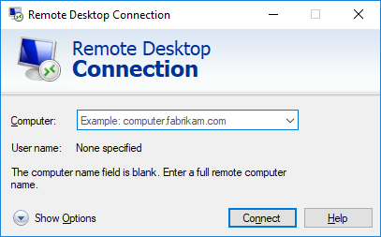
Figure 2: User Account and PIN
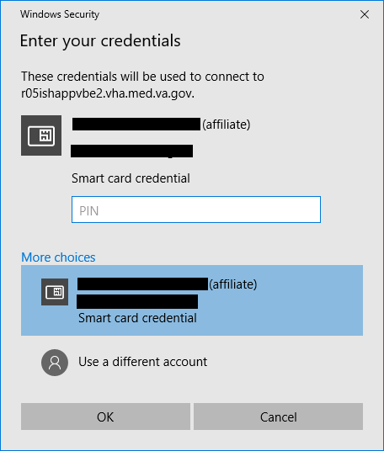
Figure 3: Security Warning Confirmation
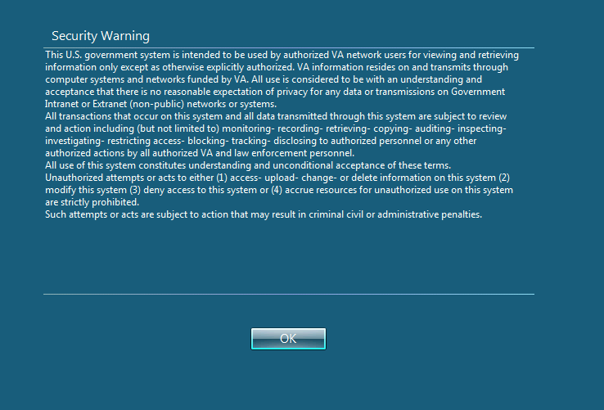
Figure 4: Example of VistA Logon with PIV
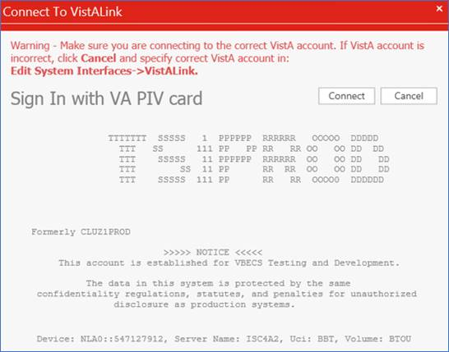
Figure 5: Example of VistA Logon with Access/Verify Codes
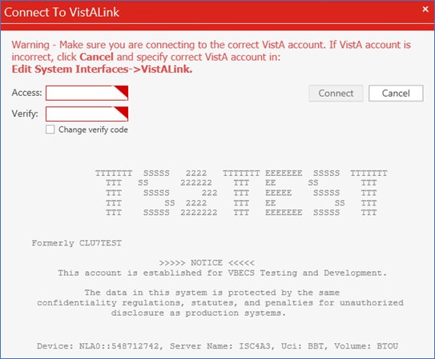
Figure 6: Example of VBECS Administrator
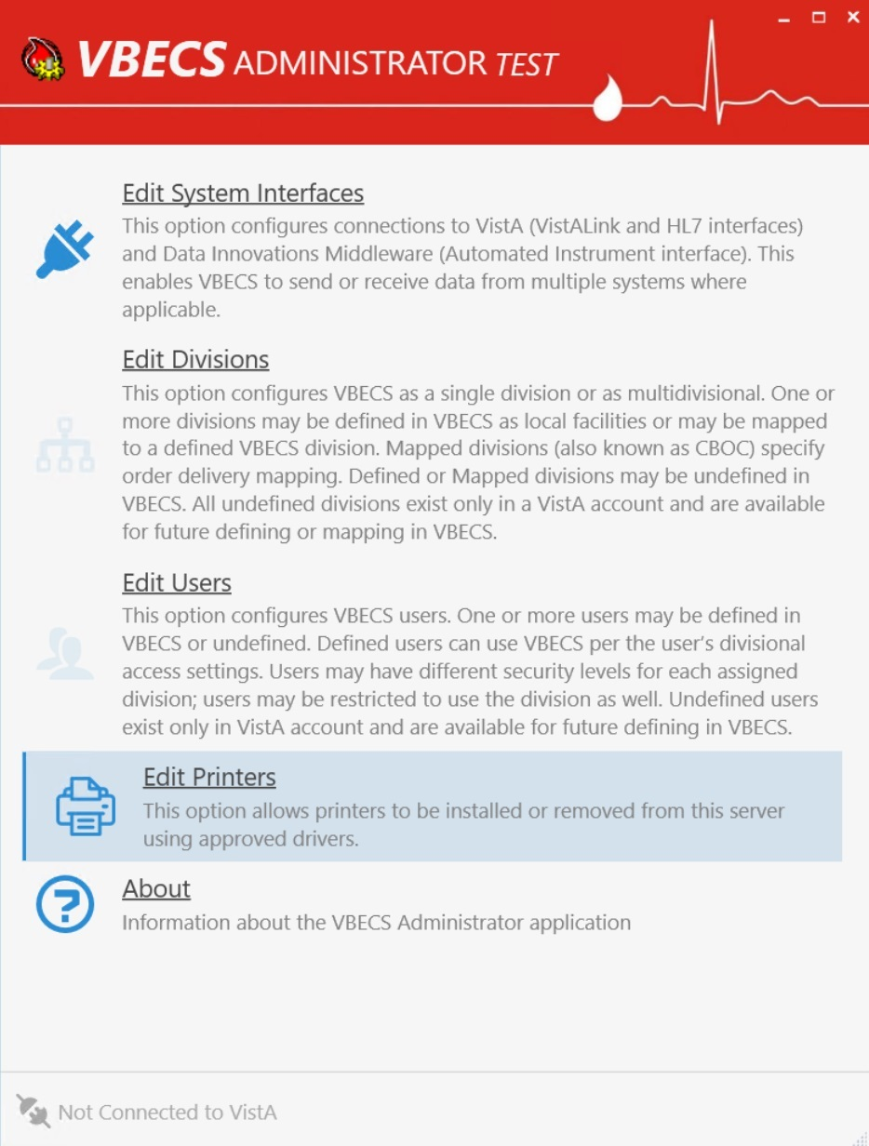

VBECS Administrator Operations

Common Controls

“F1” hotkey to open user guide
After the application starts, the “Vbecs Help” notification popup is displayed to inform the user that this user guide can be displayed by pressing the “F1” key. The “F1” key can be pressed anytime and on any screen in the application.
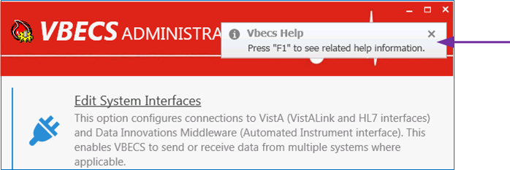

Navigation
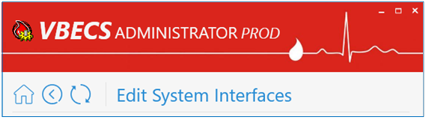
There are three navigation buttons available at the top of the screen on all pages except the main screen (home page). These buttons act like regular web browser navigation buttons:
The Home button takes the user to the main screen.
The Back button takes the user back to the previous screen.
The Refresh button refreshes the current screen.
If there are any changes that have not been saved, a message box is displayed confirming whether the user would like to abandon their changes before performing a navigation action. If the user agrees to abandon changes, all the changes will be canceled and the user will be navigated according to the button chosen.

Notification Popups
Notification messages pop up at the top-right corner of the main screen. There are four different types of notifications: Success, Warning, Info and Error. Success messages close automatically after five seconds. Also, all notifications are cleared by the Back, Refresh and Home buttons.
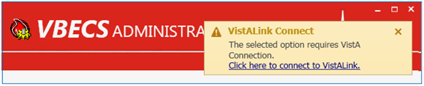

User Input Validation
If a user input error is detected in a particular control (for example if the port number is outside of the allowed range), an input error message popup is displayed next to the control and the control is surrounded by a red border.
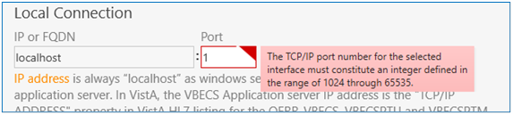

Command Buttons
Configuration controls are controls that allow the user to change or configure settings. Configuration controls are divided by sections. A section is represented by a tile and followed by one or more configuration controls. Command operations are performed per section. If the section content is changed, a command button appears allowing the option to save the change. Other sections get disabled to help the user focus on one task at a time. The text shown on the button describes the action that will be completed by clicking on it.
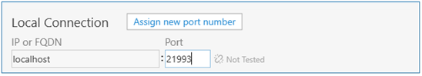

Edit System Interfaces
The VBECS Administrator sets up the parameters required for connection to VistA (VistALink and HL7 interfaces) and Data Innovations Middleware (Automated Instrument interface) enabling VBECS to send or receive data from multiple systems where applicable.

Interfaces are divided in two groups:
- Internal interfaces (marked with label) are VBECS services that listen for incoming messages from external applications. Each internal interface corresponds with the windows service running on the VBECS application service:
o VBECS VistALink Service corresponds with “VBECS Prod VistALink Listener”
o VBECS HL7 Service corresponds with “VBECS Prod HL7 Listener”
- External interfaces (marked with label) are all the other interfaces that VBECS communicates with.

Assumptions
This guide supports blood bank hospitals with VBECS previously installed and configured. If a new installation is necessary, file a Service Desk ticket (see the Customer Support section).

Limitations and Restrictions
- It is recommended to restart the VBECS HL7 Service (i.e., “VBECS Prod HL7 Listener” windows service) and the VBECS VistALink Service (i.e., “VBECS Prod VistALink Listener” windows service) on the application server if its properties are changed. VBECS Administrator will also try to automatically restart services in certain scenarios and will notify the user if the attempt fails (usually due to insufficient user privileges). If you receive a service restart failure message, file a Service Desk ticket (see the Customer Support section).
- This option is not allowed if someone is using VBECS at the same time.

Additional Information
None

Edit System Interfaces Steps Description

Maintain VBECS VistALink Service
Corresponds with “VBECS Prod/Test VistALink Listener” windows service and specifies which port number windows service is listening for incoming messages from the VistALink sender in VistA.

1) Log into VBECS Administrator.
2) Select the Edit System Interfaces menu option.
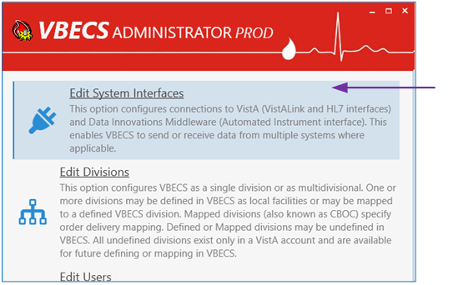
3) A new window populates with all available system interfaces and their status. Every interface that has connection properties shows its status on the right side. If the status is ERROR, it means that the interface is not functioning correctly and needs attention. Click the refresh button to retest all interfaces.
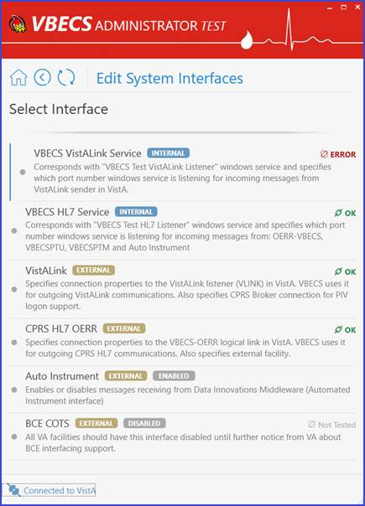
4) Select VBECS VistALink Service. A new window populates. The window contains detailed descriptions for all available configurations.
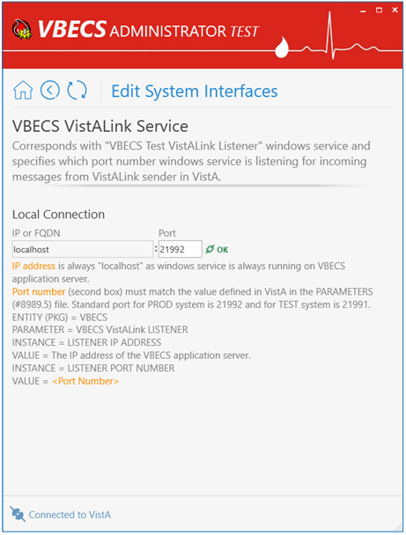
5) To specify a new Port number, enter the new value in the Port text box field under the Local Connection section and click Assign new port number button (displayed after the new value is entered) to save the change.
Note: If a service restart failure notification pops up, file a Service Desk ticket (see the Customer Support section). A restart failure usually happens if the user does not have administrative privileges to the application server.

Maintain VBECS HL7 Service
Corresponds with “VBECS Prod/Test HL7 Listener” windows service and specifies which port number the windows service is listening for incoming messages from: OERR-VBECS, VBECSPTU, VBECSPTM and Auto Instrument.

(Refer to the screen captures in the previous steps for a visual if needed.)
1) Log into VBECS Administrator.
2) Select the Edit System Interfaces menu option.
3) Select VBECS HL7 Service. A new window populates. The window contains detailed descriptions for all available configurations.
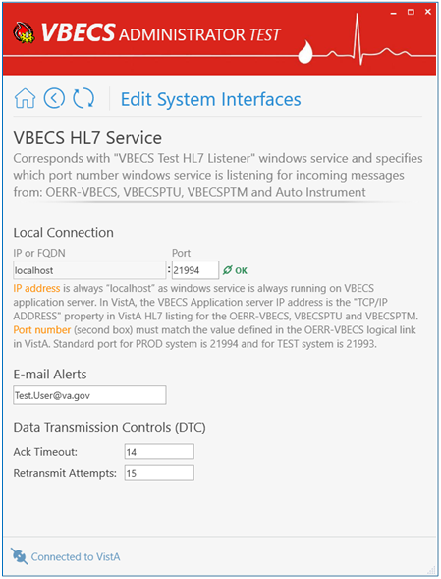
4) To specify a new Port number, enter the new value in the Port text box field under the Local Connection section and click Assign new port number button (displayed after the new value is entered) to save the change.
Note: If a service restart failure notification pops up, file a Service Desk ticket (see the Customer Support section). A restart failure usually happens if the user does not have administrative privileges to the application server.
5) To specify a new E-mail for alerts, enter the new value in the text box field and click Assign new E-mail for alerts button (displayed after the new value is entered) to save the change.
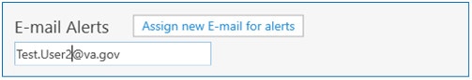
6) To specify a new Ack Timeout or Retransmit Attempts, enter the new values in the text box fields under the Data Transmission Controls (DTC) section and click Assign new DTC button (displayed after new values are entered) to save the change.
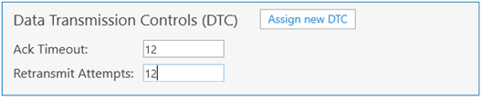

Maintain VistALink
Specifies connection properties to the VistALink listener (VLINK) in VistA. VBECS uses it for outgoing VistALink communications. It also specifies the CPRS Broker connection for PIV logon support.

(Refer to the screen captures in the previous steps for a visual if needed.)
1) Log into VBECS Administrator.
2) Select the Edit System Interfaces menu option.
3) Select VistALink. A new window populates. The window contains detailed descriptions for all available configurations.
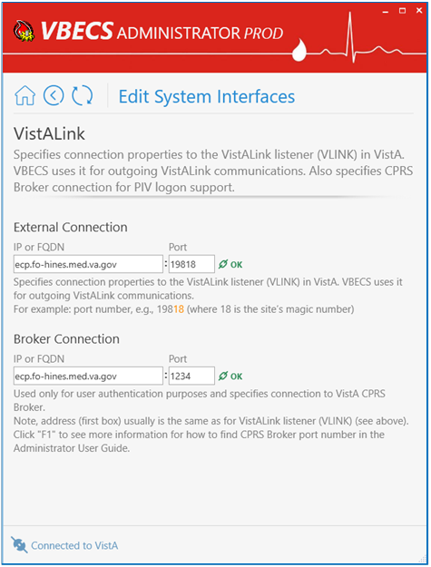
4) Specify a new VistALink listener (VLINK) in VistA connection properties.
VBECS data is cross referenced with VistA data, so it is very important to make sure that the VBECS Administrator is connected to the correct VistA account. This is why before connecting to VistA, the user is presented with a VistA account confirmation message that contains all VistA account information (Figure 6 or Figure 7). If the VistA account is incorrect, the user must cancel the connection and specify the correct VistA account in VistALink External Interface settings. (see Maintain VistALink)
5) Enter new IP or FQDN and Port number values under the External Connection section and click the Test and Change External Connection button (displayed after new values are entered).
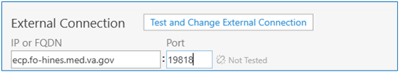
Note: VBECS Administrator checks the connection to the VistALink listener first and if there is no connection found on the other end, an error message will be displayed.
5.1. You selected a different VistA account warning message is displayed. Click OK to confirm application restart.
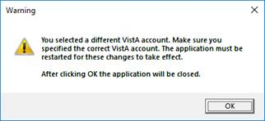
5.2. VBECS Administrator closes. The next time you start VBECS Administrator, it will be connected to the new VistALink listener (VLINK) in VistA.
6) To specify new CPRS Broker connection properties, enter new IP or FQDN and Port number values under the Broker Connection section and click the Test and Change Broker Connection button (displayed after new values are entered).
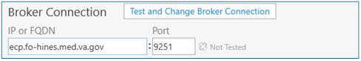
Notes:
• VBECS Administrator checks the connection to the CPRS Broker first and if there is no connection found on the other end, an error message will be displayed.
• Example of Collecting VistA Broker Values from a CPRS Shortcut.
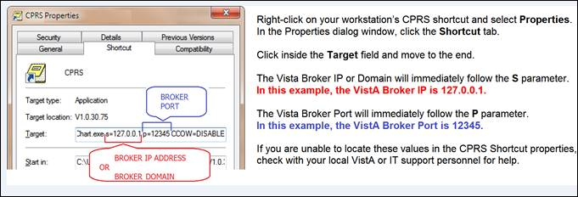

Maintain CPRS HL7 OERR
Specifies connection properties to the VBECS-OERR logical link in VistA. VBECS uses it for outgoing CPRS HL7 communications. It also specifies the external facility.

(Refer to the screen captures in the previous steps for a visual if needed.)
1) Log into VBECS Administrator.
2) Select the Edit System Interfaces menu option.
3) Select CPRS HL7 OERR. A new window populates. The window contains detailed descriptions for all available configurations.
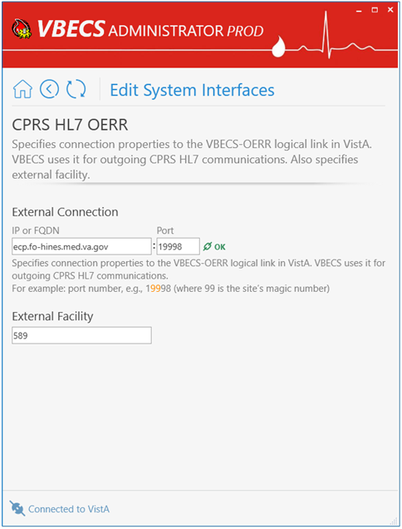
4) To specify new VBECS-OERR logical link in VistA connection properties, enter new IP or FQDN and Port number values under the External Connection section and click the Test and Change External Connection button (displayed after new values are entered).
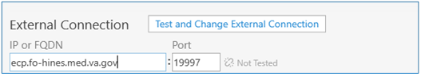
Note: VBECS Administrator checks the connection to the VBECS-OERR logical link first and if there is no connection found on the other end, an error message will be displayed.
5) To specify a new External Facility, enter a new value in the text field and click the Assign new facility button (displayed after the new value is entered).
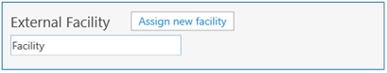

Maintain Auto Instrument
Enables or disables messages receiving from Data Innovations Middleware (Automated Instrument interface)

(Refer to the screen captures in the previous steps for a visual if needed.)
1) Log into VBECS Administrator.
2) Select the Edit System Interfaces menu option.
3) Select Auto Instrument. A new window populates.
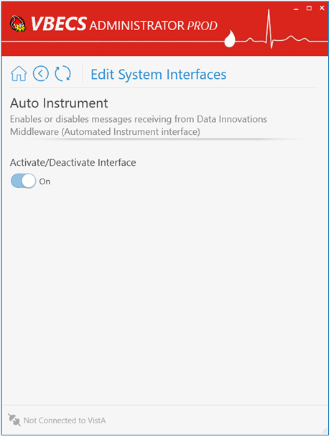
4) To disable messages receiving from Data Innovations Middleware, turn the switch Off and click the Deactivate Interface button (displayed after the switch is changed).
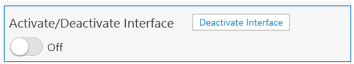
5) To enable messages receiving from Data Innovations Middleware, turn the switch On and click Activate Interface button (displayed after the switch is changed).
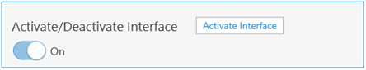

Maintain BCE COTS
All VA facilities should have the BCE COTS interface disabled until further notice from VA about BCE interfacing support.
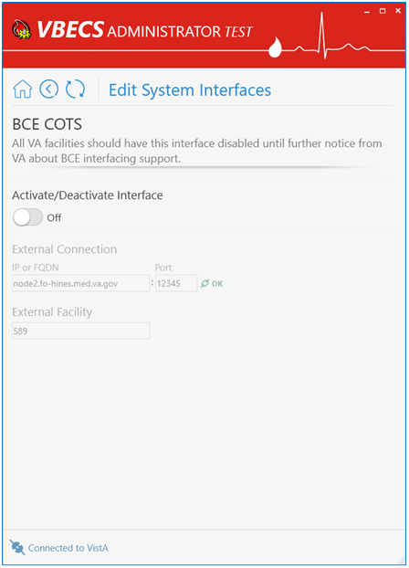

Edit Divisions
The VBECS Administrator configures VBECS as a single division or as multidivisional. One or more divisions may be defined in VBECS as local facilities (marked with label) or may be mapped (marked with label) to a defined VBECS division. Mapped divisions (also known as CBOC) specify order delivery mapping: if blood is issued to a mapped division, all activities in VBECS associated with that order will be related to the mapped-to defined division.
Defined or Mapped divisions may be undefined in VBECS. All undefined divisions are marked with label; this means that they only exist in a VistA account and are available for future defining or mapping in VBECS.

Assumptions
- The VistALink external interface (see Maintain VistALink) is configured and valid.
- VistA Logon has been executed successfully.

Limitations and Restrictions
- This option is not allowed if someone is using VBECS at the same time.
- VBECS orders can only be mapped to divisions defined in VBECS.
- When the division changes from full-service to transfusion-only or from transfusion-only to full-service, blood units and orders must be in a final state and eXM must be disabled (refer to FAQ The Differences Between Transfusion Only and Full Service Facility Types).
- Divisions defined in VBECS must have at least one Level 6 (Administrator/Supervisor) user assigned in order to have access to the Supervisor menu options in VBECS.
When orders mapping is changed, VBECS HL7 Service (i.e., “VBECS Prod HL7 Listener” windows service) should be restarted in order to accept these changes. If the user does not have the necessary permissions to do this, they will need to file a Service Desk ticket.

Additional Information
Changes in the mapping orders do not affect delivered orders. Orders delivered to a VBECS division must be completed, rejected, or canceled in that division. Resubmit orders after mapping is completed to send an order to another VBECS division.

Edit Divisions Steps Description

Define a New VBECS Division
When access to VBECS has been granted in both Production and Test accounts, proceed to define the division in VBECS. (The steps are the same for Production and Test accounts, but each must be configured individually).
1) Acquire the division name and code.
2) Log into VBECS Administrator.
3) Select the Edit Divisions menu option. The option is only enabled if it is connected to VistALink.
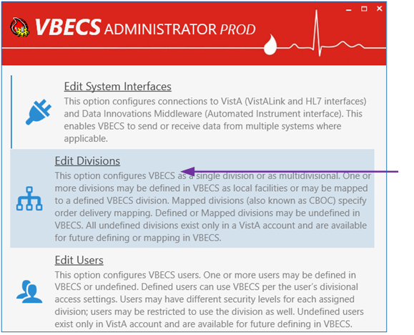
4) Make sure the Filter drop-down menu is selected to show all or undefined divisions. You can further filter the list by typing the division’s name or code in “Type here to search…” search text box.
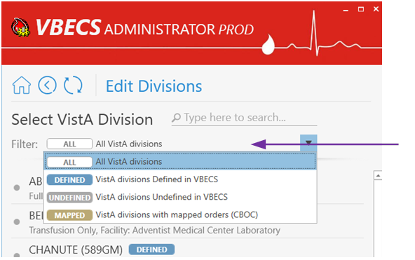
5) Locate the undefined division’s record from the list provided and click on it.
6) Once the undefined division is chosen, the user has the option to define the VistA division in VBECS as a local facility or specify orders mapping (also known as CBOC).
6.1. Define the VistA Division in VBECS as a Local Facility
6.1.1. Click “Click here to Define” to start defining the VistA division in VBECS as a local facility
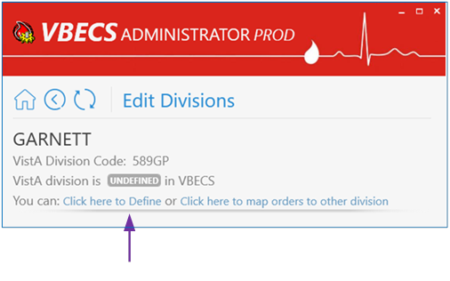
6.1.2. Select values for Associated FDA Registered Facility, Accession Area, Time Zone, Report Printer, Lock Timeout and specify if this is a full-service division or not by using the toggle button at the bottom.
Note: You can narrow down records by typing in the top text field of the drop-down boxes.
6.1.3. After all values are specified, the Define VistA Division in VBECS button is displayed. Click this button to save the new division settings.
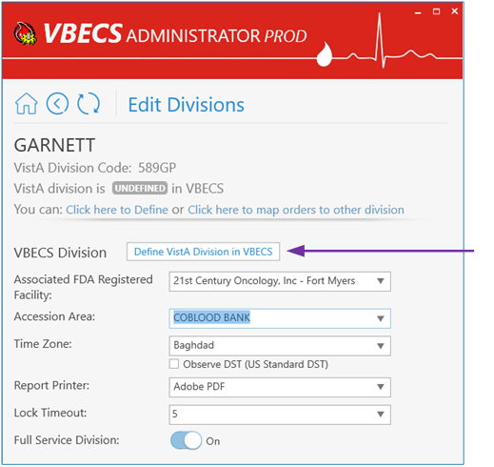
6.1.4. A new window populates the screen. Initially the division does not have any users assigned. Click the Edit Users link in the warning popup or manually navigate to the Edit Users screen to assign users to the division [see Define a New VBECS User and Maintain an Existing (Defined) VBECS User].
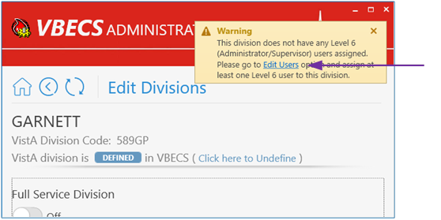
6.2. Map Orders to Other Division (CBOC)
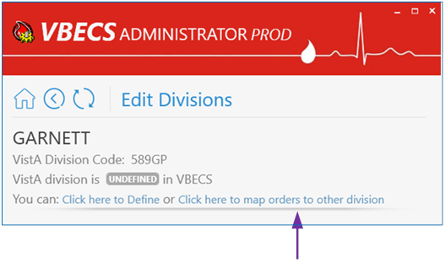
6.2.1. Click “Click here to map orders to other division” to specify the orders mapping for a selected VistA division (such divisions are also known as CBOC).
6.2.2. Select the VBCES Division in the drop-down box to specify where orders should be mapped.
6.2.3. After a division is selected, the Assign orders mapping button is displayed. Click on this button.
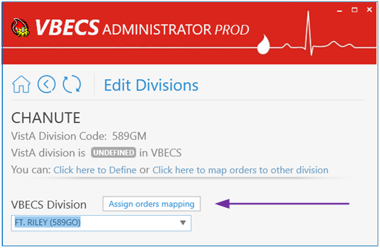
6.2.4. A new window populates the screen. A mapped division does not have any configurations besides the Click here to Un-map orders link button to remove orders mapping.
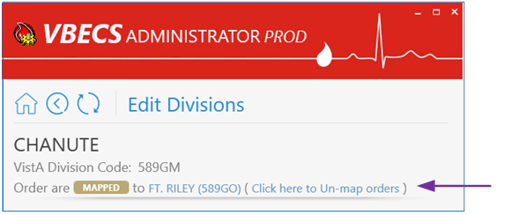

Maintain Existing (defined) VBECS Division
(Refer to the screen captures in the previous steps for a visual if needed.)
1) Log into VBECS Administrator.
2) Select the Edit Divisions menu option. This option is only enabled if the Administrator application is connected to VistALink.
3) Make sure the Filter drop-down menu is selected to show all or defined divisions. You can further filter the list by typing the division’s name or code in the “Type here to search…” search text box.
4) Locate the defined division’s record from the list provided and click on it. A new window populates with all available configurations for the division (use window scrolling if necessary).
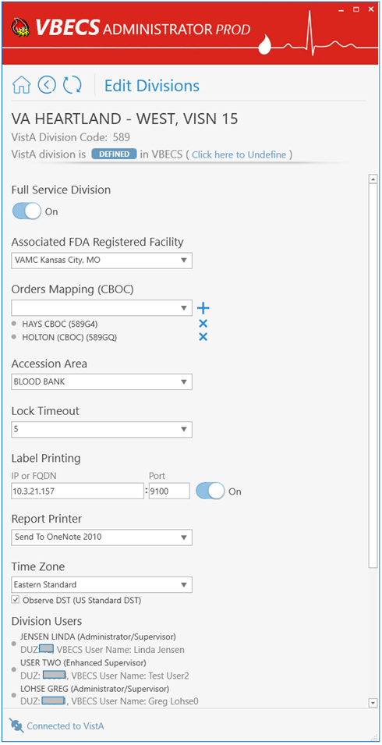
4.1. Mark the Division as Transfusion-Only or Full-Service:
When the division changes from full-service to transfusion-only or from transfusion-only to full-service, blood units and orders must be in a final state and eXM must be disabled.
4.1.1. If selected division is transfusion-only, the Full Service Division switch is in the Off position. Click on it to turn it On and click on the Mark as Full Service button (displayed after the switch is changed) to mark the division as full-service.
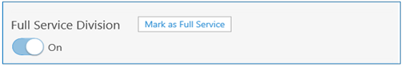
4.1.2. If the selected division is full-service, the Full Service Division switch is in On position. Click on it to turn it Off and click on the Mark as Transfusion Only button (displayed after the switch is changed) to mark the division as transfusion-only.
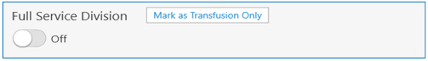
4.2. To change Associated FDA Registered Facility: select a new facility from the Associated FDA Registered Facility drop-down box (narrow down records by typing in the top text field of the drop-down boxes) and click on the Associate new facility button (displayed after the new value is selected).
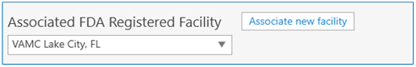
4.3. Change Orders Mapping (CBOC). Current orders mapping (i.e., CBOC facilities) is listed under the Orders Mapping (CBOC) section.
4.3.1. To cancel orders mapping, select the division orders mapping that should be canceled by clicking on the button next to this divisions (CBOCs).
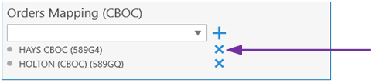
4.3.2. To assign orders mapping from another division, select a new division in the Orders Mapping (CBOC) drop-down box (narrow down records by typing division name or code in the top text field of the drop-down boxes) and click the button next to the drop-down box.
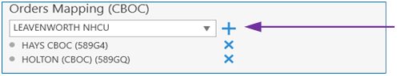
Note: You can repeat this step to select multiple divisions. Newly selected divisions are displayed in the list under the drop-down box (meaning these division are pre-selected but changes are not applied yet; see the next step to apply the changes).
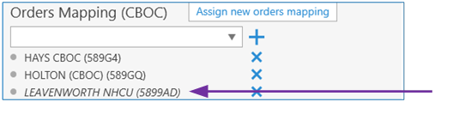
4.3.3. To apply the change, click on the Assign new orders mapping button (displayed after at least one division is added or removed).
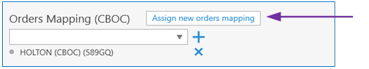
4.4. To change Accession Area: select a new accession area in the Accession Area drop-down box and click on the Assign new accession area button (displayed after the new value is selected).
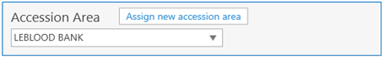
4.5. To change Lock Timeout: select a new lock timeout in the Lock Timeout drop-down box and click on the Assign new lock timeout button (displayed after the new value is selected).
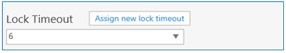
4.6. To change Label Printing: specify new IP or FQDN and Port number values under the Label Printing section. The user can also enable or disable label printing by using the toggle button on the right. Click on the Assign new label printing button (displayed after new values are entered) to apply the change.
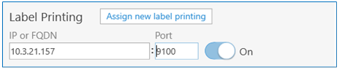
4.7. To change Report Printer: select a new report printer from the Report Printer drop-down box and click on the Assign new report printer button (displayed after the new value is selected).
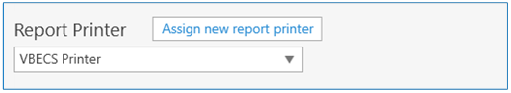
4.8. To change Time Zone: select a new time zone from the Time Zone drop-down box, specify if day light savings time should be observed and click on the Assign new time settings button (displayed after new values are selected).
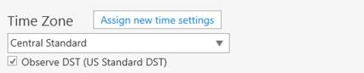
4.9. Review division users: A list of all current division users is located at the bottom of window. It is for information-only; use the Edit Users option to manage users (see Edit Users for more information).

Undefine VBECS Division
(Refer to the screen captures in the previous steps for a visual if needed.)
1) Log into VBECS Administrator.
2) Select the Edit Divisions menu option. This option is only enabled if the Administrator application is connected to VistALink.
3) Make sure the Filter drop-down menu is selected to show all, defined or mapped divisions. You can further filter the list by typing the division’s name or code in “Type here to search…” search text box.
4) Locate the defined or mapped division’s record from the list provided and click on it.
4.1. If defined (i.e., local VBECS facility) the VistA division was chosen.
4.1.1. Click the “Click here to Undefine” link button at the top portion of the screen.
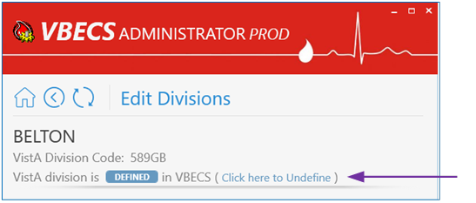
4.1.2. Are you sure you would like to Undefine the current division? confirmation window is displayed. If there are users currently assigned to this division, they will be displayed in the confirmation dialog for the information. Click OK to confirm.
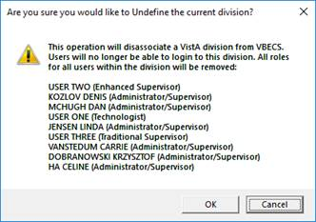
4.1.3. The VistA division has been successfully undefined in VBECS. The screen returns back to the Select VistA Division list. The VistA division’s new state in the list is undefined.
4.2. If mapped (i.e., CBOC), the VistA division was chosen.
4.2.1. Click the Click here to Un-map orders link button at the top portion of the screen.
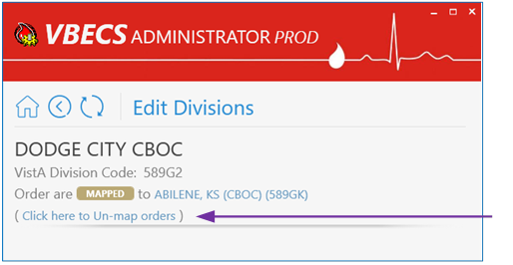
4.2.2. Are you sure you would like to Un-map orders from current division? confirmation window is displayed. Click OK to confirm.
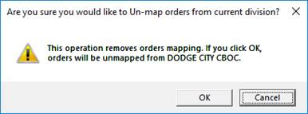
4.2.3. The orders were successfully un-mapped from the VistA division. The screen returns back to the Select VistA Division list. The VistA division’s new state in the list is undefined.

Handle Invalid VBECS Divisions
If a previously defined VBECS division is not found in VistA, the corresponding record will be marked as invalid. This situation is highly unlikely; however, it could happen if it is connected to the wrong VistA environment for example. It is recommended to contact the Service Desk to resolve this type of situation.

Edit Users
The VBECS Administrator configures VBECS users. One or more users may be defined in VBECS (marked with label) or may be undefined (marked with label). Defined users can use VBECS per the user’s divisional access settings. Users may have different security levels for each assigned division; users may be restricted to use the division as well.
Undefined users only exist in the VistA account and Active Directory group and are available for future defining in VBECS.

Assumptions
• The VistALink external interface (see Maintain VistALink) is configured and valid.
• Users have successfully logged in to VistA.
• Users have been assigned the appropriate VBECS Division in the NEW PERSON file (#200) DIVISION multiple.
• Users have been assigned the LRBLOODBANK and/or LRBLSUPER security key(s) in VistA.
• Users have been assigned the VBECS VISTALINK CONTEXT option as a secondary menu option in VistA.
• Users have been assigned to the correct Active Directory group [see Figure 1 (User’s Active Directory Group Name)]. Contact a local system administrator to add or remove VBECS users from your VBECS Active Directory groups.

Limitations and Restrictions
• VBECS Administrator caches data collected from Active Directory at startup. In order to refresh it, the application must be restarted.
Each VBECS user must have a unique Windows login ID. If a Windows login ID becomes inactive and is eligible for re-use in Active Directory, do not re-use it for VBECS: this may result in corrupted data in VBECS.
It is not recommended to change a user’s Windows login ID. If it does change, the current user record will be invalidated in VBECS Administrator.

Additional Information
• Each defined VBECS user must have a unique DUZ.
• The VBECS User ID stored in VBECS is the user’s NT Logon ID.
• A VBECS Administrator/Supervisor can further configure VBECS users in VBECS, but an initial role must be defined for each VBECS user in VBECS Administrator. The option should be used primarily to define and undefine the user in VBECS.
• A user’s role may be changed while they are logged into VBECS; the change takes effect the next time the user logs into VBECS.
• The user name and e-mail in VBECS are silently synced with the user’s data from Active Directory if a discrepancy is detected.

Edit Users Steps Description

Define a New VBECS User
When access to VBECS has been granted in both Production and Test accounts, proceed to define the user in VBECS. (These steps are the same for Production and Test accounts, but each must be configured individually).
1) Acquire the user’s full name and VA email address (Outlook/GAL).
2) Log into VBECS Administrator.
3) Select the Edit Users menu option. This option is only enabled if the Administrator application is connected to VistALink.
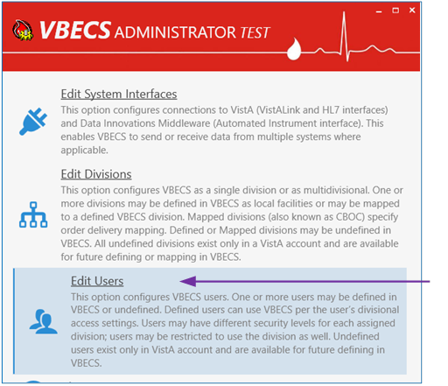
4) Make sure the Filter drop-down menu is selected to show all or undefined users. You can further filter the list by typing the user’s name or DUZ in “Type here to search…” search text box
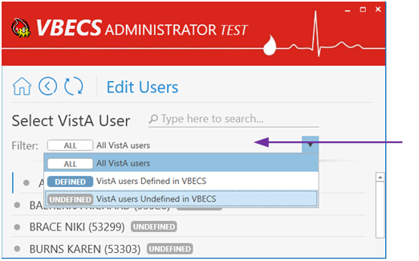
5) Locate the new user’s record from the list provided and click on it.
6) Once the new user is chosen, expand the Windows User drop-down box to review the new user’s record. Ensure that the user’s name, e-mail and login ID are correct.
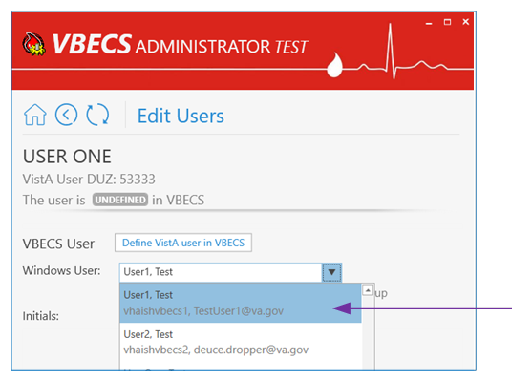
Note: If the Windows User drop-down box is initially blank and has a red border, it means that no automatic match was possible by the user name. In this case, manually select the windows user record from the drop-down list; you can narrow down records by typing the user name, e-mail or Windows ID at the top of the text field of the Windows User drop-down box.
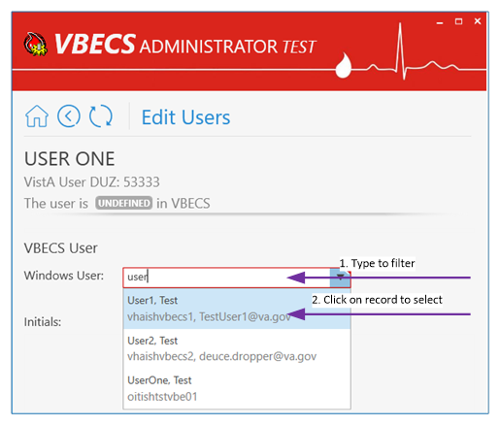
7) Enter the initials of the user in the Initials box if not populated.
8) After all values are specified, the Define VistA user in VBECS button is displayed. Click on the button to save.
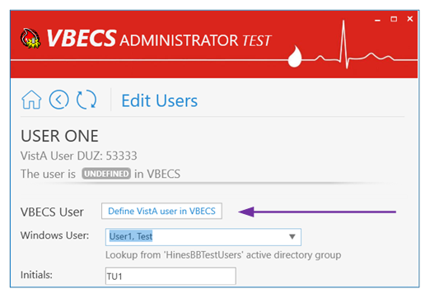
9) A new window populates the screen.
10) Initially, the user does not have any divisional access assigned. Under the Divisional Access section, locate the local VBECS Division; it should be defined.
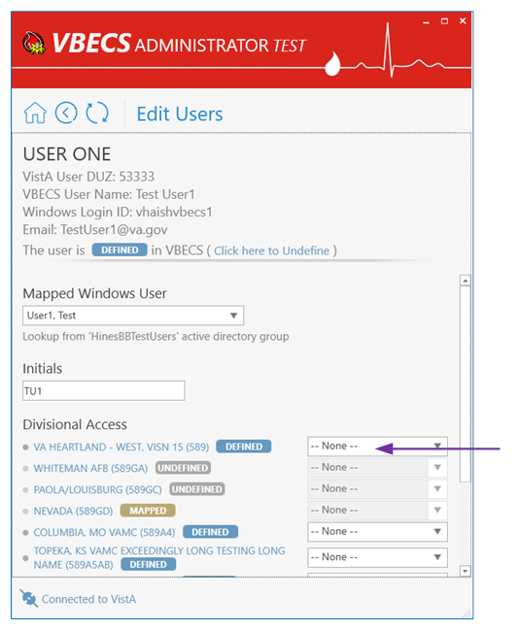
11) From the drop-down menu to the right of divisional access, select the user’s level of access/user role for that local VBECS division an necessary. Note: You can assign divisional access only for defined divisions that are present in the user’s entry in the NEW PERSON file (#200) in VistA.
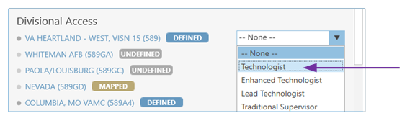
12) After all user’s roles are assigned, the Change Divisional Access button is displayed. Click on this button to assign the user’s divisional access.
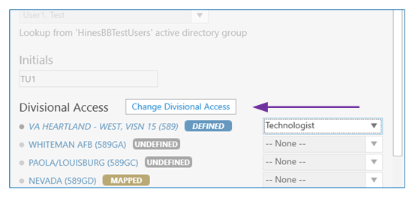
13) The new user is now defined in VBECS and will have access to the program.

Maintain an Existing (defined) VBECS User
(Refer to the screen captures in the previous steps for a visual if needed.)
1) Log into VBECS Administrator.
2) Select the Edit Users menu option. This option is only enabled if the Administrator application is connected to VistALink
3) Make sure the Filter drop-down menu is selected to show all or defined users. You can further filter the list by typing the user’s name or DUZ in “Type here to search…” search text box.
4) Locate the existing (defined) user’s record you would like to maintain and click on it.
5) Once the user is chosen, a new window populates the screen. On this window you can:
5.1. Map VBECS User to a Different Windows Account:
Note: Be careful with this functionality, make sure the user is being mapped to the correct windows user.
5.1.1. Expand the Mapped Windows User drop-down box and select a new windows account to map the current VBECS user to; you can narrow down records by typing the user name, e-mail or Windows ID at the top of the text field of the Windows User drop-down box.
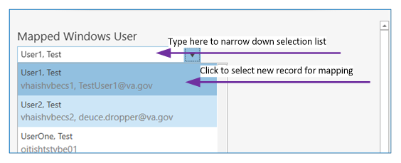
5.1.2. Once a new windows account for mapping is selected, the Map VistA user to different Windows User command button is displayed.
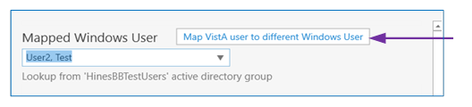
5.1.3. Click on this button to map the current VistA user to a different Windows user.
5.2. Assign new user’s initials:
5.2.1. Enter the new user’s initials in the text box under the Initials section. After the new value is entered, the Assign new user’s Initials command button is displayed.
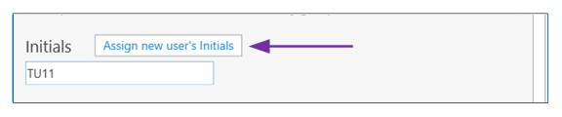
5.2.2. Click on this button to assign the newly entered user’s initials. All user initials must be unique; if the initials you choose are already taken, you will be notified and must choose different initials.
5.3. Change user’s divisional access:
5.3.1. Under the Divisional Access section, locate all defined divisions where you would like to change the user’s access.
5.3.2. Select different user’s roles from the drop-down boxes on the right side for each division as necessary. As soon as the first user’s role is changed, the Change Divisional Access button is displayed. Note: In order to remove the user’s access to the division, select the “-- None --” option for this division.
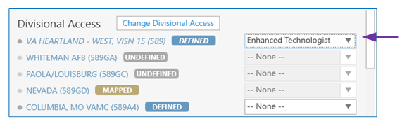
5.3.3. After all user roles are assigned, click the Change Divisional Access button.

Undefine a VBECS User
(Refer to the screen captures in the previous steps for a visual if needed.)
1) Log into VBECS Administrator.
2) Select the Edit Users menu option. This option is only enabled if the Administrator application is connected to VistALink
3) Make sure the Filter drop-down menu is selected to show all or defined users. You can further filter the list by typing the user’s name or DUZ in the “Type here to search…” search text box.
4) Locate the existing (defined) user’s record you would like to undefine and click on it.
5) Once a user is chosen, a new window populates the screen. Click the “Click here to Undefine” link button at the top portion of the screen.
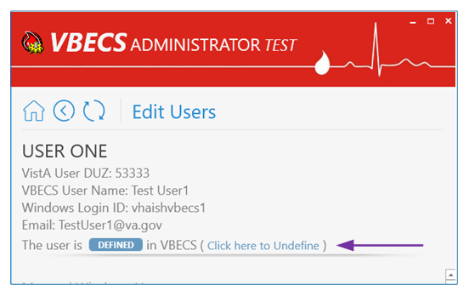
6) “This operation will remove all VBECS access for current VistA user” confirmation window is displayed. Click OK to confirm.
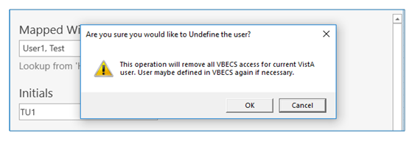
7) The VistA user has been successfully undefined in VBECS. The screen returns back to Select VistA User list.

Clear Invalid VBECS Users
If a previously defined VBECS user is not found in VistA or the Active Directory Group, the corresponding record will be marked as invalid. It is recommended to clear invalid records, because an invalid record might hold a DUZ or NT Logon ID. Invalid records are cleared together with all divisional roles.
If invalid records are found, the users’ list will be pre-filtered to invalid records when opened.

1) Log into VBECS Administrator.
2) Select the Edit Users menu option. This option is only enabled if the Administrator application is connected to VistALink
3) If invalid users are not found, the Filter drop-down menu will be pre-selected to show all and you will not see the invalid option if you expand it. You can stop here, since you do not have any invalid users.
4) If invalid users are found, the Filter drop-down menu will be pre-selected to show invalid users and an informational message will be displayed asking you to review the invalid users.
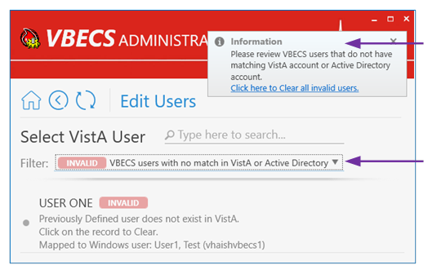
Every invalid record will have an explanation of what is wrong. For example, on the screen capture above, it says that User ONE is invalid because “Previously Defined user does not exist in VistA”.
5) To clear invalid users, there two options:
5.1. Click on the invalid user record in the list and click OK on the confirmation message to clear it.
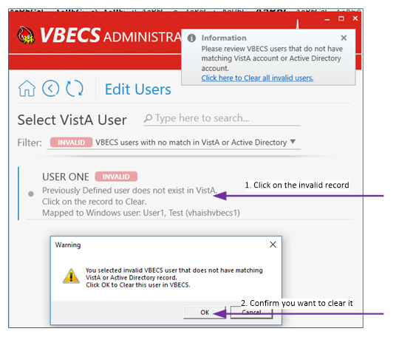
5.2. Or if you reviewed all invalid records and agree to clear them all at once, you can click the “Click here to Clear all invalid users” link button on the toast message and click OK on the confirmation message to clear all of them.
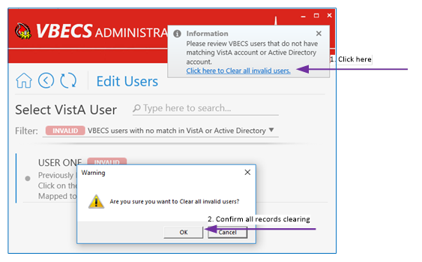
6) After all invalid records are cleared, the Filter drop-down menu will not present the invalid selection option.

Edit Printers
Printers must be maintained only through VBECS Administrator software. If you need further printer support file a ticket.

The VBECS Administrator configures the printers that may be used on the VBECS system.
This option displays printers already configured and allows printers to be added or removed. For example, if you need to change a printer’s IP address or associated driver, you must remove the printer (save the printer’s name if you would like to re-use it) and re-add the printer with new properties. Adding or removing printer includes the following steps:
1. User adds or removes a new printer using this option. The printer record will be marked with or labels, and the printer’s information gets added or removed respectively in the VBECS database.
2. This option automatically reflects the current state of system printers (it auto updates its information every 2 seconds):
a. will become after a system printer and printer port is created on the application server.
b. Printer record with will be removed after system printer gets removed.
3. The Desired State Configuration (DSC) process checks the VBECS database every 15 minutes. Any printers that were added or removed will be added or removed on the application servers.
If a new printer is required which does not work with our current supported drivers, the product support team may temporarily install the unsupported printer driver and related printer. Note that for the Production environment both application servers will have to be configured. To add a non-standard printer, execute the following steps as a system administrator:
1. If you plan to re-use the printer’s name that was previously defined in the VBECS Administrator, remove that printer using this option: Remove VBECS Printer
2. Install a new driver
3. Open PowerShell console as Administrator and run the following command to confirm that new driver is listed as available:
Get-PrinterDriver
4. Run the following PowerShell command to add printer’s port:
Add-PrinterPort -Name "<printer_ip>_" -PrinterHostAddress "<printer_ip>"
5. Add the printer (use DriverName name from step 3):
Add-Printer -Name "<printer_name>" -PortName "<printer_ip>_" -DriverName "<driver_name>"
They must notify the VBECS team via a ticket that a new print driver requires support. These manually installed printers will be displayed with a different label () on the screen. The VBECS team will officially support the new driver as soon as possible. Once the ticket to support the new driver is addressed, all non-standard printers must be removed and re-defined as VBECS printers through VBECS Administrator software. To remove non-standard printer run the following PowerShell command as Administrator on all nodes:
Remove-Printer -Name "<printer_name>"

Define a New VBECS Printer
1) Log into VBECS Administrator.
2) Select the Edit Printers menu option. This option initially enabled.
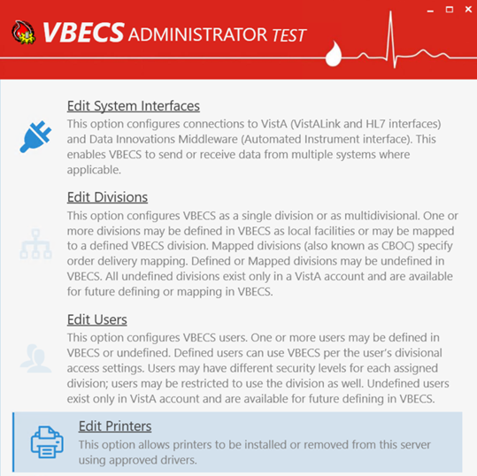
3) Edit Printers configuration panel:
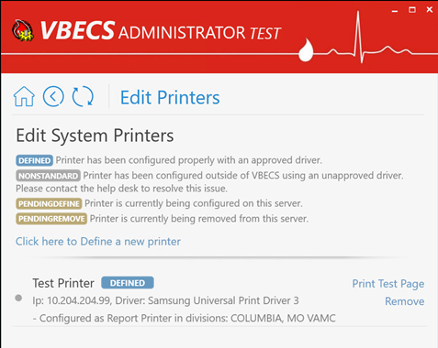
3.1 Printer Title: Displays name of the currently configured printer.
3.2 Printer State: Reflects state of the currently configured printer:
a. DEFINED: if printer exists in VbecsPrinter table and at OS level (checked by printer name) and printers ports name is: "<printerIp>_VBECS"
b. PENDINGDEFINE: if printer exists in VbecsPrinter table, but not at OS level.
c. PENDINGREMOVE: if printer exists in OS level but not in VbecsPrinter table and printer’s ports name is: "<printerIp>_VBECS"
d. NONSTANDARD: if printer exists in OS level but not in VbecsPrinter table and printer’s ports name is not: "<printerIp>_VBECS"
3.3 Printer IP address and driver name.
a. IP – the printer's physical (LAN) address supplied by an administrator at time of printer addition. (At the time of adding printer, the printer must be physically connected to this address and turned on.)
b. Driver – the driver used for this printer selected from the list of available drivers by administrator at time of printer addition. (The driver must already be installed on the server while adding this printer).
3.4 Printer usage in VBECS: Lists all divisions (if any) that use the printer for printing Reports or Order Alerts.
3.5 Print Test Page Link button: Displayed only for the DEFINED printers and allows user to print a test page on the printer:
a. This is a test page printed from VBECS Administrator.
b. Printed by: {userName} at {time}(UTC)
c. VBECS server: {serverName}
d. Printer name: {printerName}
e. Printer IP address: {printerIp}
f. Print driver selected: {printerDriver}
3.6 Remove Link button: Displayed only for the DEFINED printers and allows user to remove the printer from the servers. After the printer is requested for removal, it will be marked with PENDINGREMOVE label before the DSC process removes the printer from the system.
4) Click here to Define a new printer, link button. When clicked, toggles fields visibility for defining a new printer.
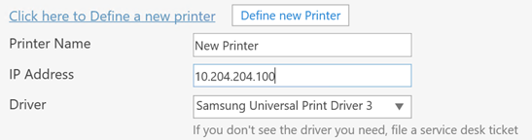
4.1 Printer Name Textbox: Allows user to specify new printer name. Printers with the following names are filtered out from the list: “Microsoft XPS Document Writer” and “Microsoft Print to PDF”.
4.2 IP Address Textbox: Allows user to specify printer IP address.
4.3 Driver Combo Box: Allows user to select printer driver. Available printer drivers are defined by DSC node configuration (see “VBECS Components Installation Workflow” for more information).
4.4 Define new Printer Command Button: Allows user to define new printer. Initially not visible and appears after the valid values are entered in the previous fields. After new printer addition is requested by selecting this button, a new printer will be added to the list with PENDINGDEFINE label (The printer must be physically connected to the supplied IP address and turned on). After the DSC process adds the printer, the label will be automatically changed to DEFINED.
5) Enter Printer Name, IP Addres and select Driver and Define new Printer button. The new printer state in the list may take up to 15 minutes to update from PENDINGDEFINE to DEFINED.

Remove a VBECS Printer
1) Log into VBECS Administrator.
2) Select the Edit Printers menu option. This option initially enabled.
3) The Edit Printers configuration panel is displayed:
4) Click Remove link button next to the printer to be removed and confirm printer removal. Printer's state will be changed to PENDINGREMOVE and in less than 15 mins printers record will be removed.

Assumptions
• Printers needing to be configured have been connected to the network.

Limitations and Restrictions
• Scheduled reports are not evaluated for their printers. Removing a printer may cause scheduled reports not to print.

Additional Information
• None.

Index

Clear Invalid VBECS Users 38
Customer Support 4
Define a New User 32
Define a New VBECS Printer 42
Edit Divisions 21
Edit Divisions Steps Description 21
Edit Printers 40
Edit System Interfaces 12
Edit System Interfaces Steps Description 12
Edit Users 31
Edit Users Steps Description 32
Handle Invalid VBECS Divisions 30
Introduction 3
Maintain an Existing (defined) VBECS User 36
Maintain Auto Instrument 19
Maintain BCE COTS 20
Maintain CPRS HL7 OERR 18
Maintain Existing (defined) VBECS Division 25
Maintain VistALink 16
Related Manuals and Reference Materials 3
Remove a VBECS Printer 44
Revision History 46
Undefine a VBECS User 37
Undefine VBECS Division 28
VBECS Administrator Operations 10
VBECS Maintenance Operations 4

Revision History

Date | Revision | Description | Author
9/20/21 | 1.0 | Initial Version.  Modified VistA Blood Establishment Computer Software (VBECS) 2.3.2 Admin User Guide, Version 3.0 to create VistA Blood Establishment Computer Software (VBECS) 2.3.3 Admin User Guide, Version 1.0. | BBM team

This is the last page of VBECS 2.3.3 Admin User Guide.

