

VistA Blood Establishment Computer Software (VBECS) 2.4.0

Release Notes Version 2.0

Department of Veterans Affairs
Enterprise Project Management Office

Table of Contents

Introduction 1
Changed Features and Functions 1
Untestable System-Level Maintenance Changes 1
VistA Software Dependencies 1
VBECS User Documents 2
Customer Support 4
References 4
VBECS SharePoint Site 4
Installation Qualification (IQ) Documentation 5
Validation Planning 6
Table 1: Updates by Option (Non-Read-Only Site) 7
Table 2: Updates by Option (Read-Only Site) 9
Revision History 11

Introduction
VistA Blood Establishment Computer Software (VBECS) 2.4.0 Release Notes contains information for changes and corrections made to VBECS in the 2.4.0 Rev A patch.
Perform a local evaluation and risk assessment of the changes to determine the requirements for local validation of the changes, including documentation of the assessment activities. See Validation Planning.

Changed Features and Functions
This code patch release is focused around providing read-only access to sites transitioned to Cerner PathNet and providing solutions to customer reported issues and enhancements.
VA initiatives
- Provide read-only data for Cerner PathNet transitioned sites with limited menu access in VBECS.
- Provide a read-only watermark for all accessible reports & queries for all sites transitioned to VBECS Read-Only.
- Continue to provide JLV access for sites transitioned to VBECS Read Only.
- Continue to provide compliance with federal records and information management regulations.
Solutions to Known Requests and Defects
- Fix known requests and defects related to Maintain Collection Facility to allow all security levels access to this function.
- Fix known requests and defects related to reports and printing.
- Fix known requests and defects related to canned comments.
- Fix known requests and defects related to the VBECS Help.
Table 1: Updates by Option (Non-Read-Only Site) and Table 2: Updates by Option (Read-Only Site) provide a complete list of included changes with suggested validation scenarios. For sites with the Read-Only setting being enabled use Table 2. All other sites use Table 1.
NOTE: The validation scenarios included in Table 2 can be used in the future if a site transitions to VBECS Read-Only.

Untestable System-Level Maintenance Changes
- Implement xUnit for unit testing and code coverage.
- Implement Azure Monitor Agent (AMA) for monitoring.
- Renew Remote Desktop certificates.

VistA Software Dependencies
- VistA informational patch VBEC*2*14

VBECS User Documents
The following is a list of all the VBECS user documents that apply to the VBECS 2.4.0 Rev A patch release. The Updated column identifies the documents that have been updated with this VBECS 2.4.0 Rev A patch release.
These user documents are available from the VBECS SharePoint site at REDACTED
User Document | Version | Updated
VBECS 2.4.0 User Guide | 1.0 | Yes
VBECS 2.4.0 Admin User Guide | 1.0 | Yes
VBECS 2.4.0 Known Defects and Anomalies | 1.0 | Yes
VBECS 2.4.0 Technical Manual-Security Guide | 1.0 | Yes
VBECS - Echo Interface Configuration and Setup Guide | 6.0 | No
VBECS - Erytra Interface Configuration and Setup Guide | 3.0 | No
VBECS - ProVue Interface Configuration and Setup Guide | 6.0 | No
VBECS - Vision Interface Configuration and Setup Guide | 5.0 | No
VBECS Product Information | 11.0 | Yes

The following is a list of all the VBECS FAQ documents that apply to the VBECS 2.4.0 Rev A patch release. The Updated column identifies the documents that have been updated with this VBECS 2.4.0 Rev A patch release.
These FAQ documents are available from the VA SharePoint site at REDACTED
FAQ Document | Version | Updated
FAQ ABO Subgroup Interpretations | 11/22/16 | No
FAQ Accreditation Questions Regarding Laboratory Information Systems | 6/9/23 | No
FAQ Ancillary VistA Validation | 11/28/17 | No
FAQ Antibodies with No Antigen Negative Requirement | 10/15/14 | No
FAQ Blood Product Table Processes | 2/21/23 | No
FAQ CAP Comprehensive Transfusions Medicine Crossmatch Survey | 11/22/16 | No
FAQ CPRS VBECS Order Details | 04/01/09 | No
FAQ Database Conversion Oddballs | 09/15/09 | No
FAQ Documenting Unhandled Exceptions | 05/21/07 | No
FAQ Handling ABO Incompatible Transfusion Situations | 09/23/14 | No
FAQ How to File a New Service Request for Changes to VBECS | 12/08/16 | No
FAQ How to take faster screen shots from Remote Desktop Session | 12/17/14 | No
FAQ Identifying a Comparable Blood Product Code | 09/03/21 | No
FAQ Local Facilities | 06/12/20 | No
FAQ Modification Target Not Available | 11/28/17 | No
FAQ Multidivisional QC Rack Workaround | 11/28/17 | No
FAQ Order Status Clarification | 11/15/17 | No
FAQ Polyspecific AHG Not Used for Testing | 01/29/10 | No
FAQ Proper Use of PIV Card with VBECS | 09/14/21 | No
FAQ QC Setup | 01/29/10 | No
FAQ Retesting QC | 11/01/11 | No
FAQ Retrieving an Expired Order | 12/07/17 | No
FAQ The Difference Between Transfusion Only and Full Service Facility Types | 02/08/10 | No
FAQ VBECS Blood Product Hierarchy | 03/28/19 | No
FAQ VBECS Computer Crossmatch Decision Tree | 02/08/12 | No
FAQ Weak D Policy | 01/11/10 | No
FAQ What is VBECS Read-Only | 04/04/24 | Yes
FAQ Workload Assignments Single vs Batch Processing | 07/01/20 | No

Customer Support
Contact your Local/Regional Office of Information Technology (OIT) or Laboratory Information Manager (LIM) if you encounter VistA or CPRS connection problems and for training support before contacting the Service Desk (SD).
Please ensure local/regional VistA Support contact information is available at all times.
If you experience an FDA reportable adverse event (patient death or serious injury) that VBECS may have caused or contributed to, contact the Service Desk directly to enter a ticket for Blood Bank software support.
If the problem remains unresolved after local VistA triage, call the Service Desk (below) and specify the Affected Service be set as VBECS (VistA - Blood Establishment Computer Software)
Service Desk Contact
Call the Service Desk REDACTED
For troubleshooting error messages in VBECS that read similar to Contact Your System Administrator, contact the Service Desk.

References
- None

VBECS SharePoint Site
The VBECS SharePoint site provides a location for additional information related to the VBECS application such as FAQs, installation status, remote desktop and report share shortcuts, and release history.
REDACTED

Installation Qualification (IQ) Documentation

Test Account Upgrade to VBECS 2.4.0 Revision A
Required Patch Installation | VistA Patch: None  Server Patch: VBECS 2.4.0 Revision A
Installation Process for VBECS 2.4.0 Rev A | Installed by the BBM team. A small number of sites will be installed each day over several days.
Expected Downtime | Patch installation is expected to take several hours but may take up to 24 hours.
Installation Communication for VBECS 2.4.0 Rev A | The BBM Team will communicate the date of patch installation. The status of migration will be communicated directly to the affected users.
Site Responsibility | - Join VBECS-L message board on ListServ, if needed (http://vaww.listserv.va.gov/scripts/wa.exe?SUBED1=VBECS-L&A=1).  - Communicate any changes to your site supervisor and Point of Contact (POC) since the last patch install to the BBM team to the email group “VA OIT BBM Team”.  - Perform local validation, training, and set-up requirements prior to Production installation.
Site Record of Patch Installation | Sites should take and save a screenshot of the VBECS Help, About window after the Test installation is performed. This displays the VBECS updated version information.

Production Account Upgrade to VBECS 2.4.0 Revision A
Required Patch Installation | VistA Patch: None  Server Patch: VBECS 2.4.0 Revision A
Installation Process for VBECS 2.4.0 Rev A | Installed by the BBM team. Each site will schedule a date for installation. The BBM team will contact sites for installation date/time when the production installation window begins.
Expected Downtime | Patch installation is expected to take several hours but may take up to 24 hours. The site will follow downtime procedures until installation completes.
Installation Communication for VBECS 2.4.0 Rev A | The status of production installs will be provided on the VBECS SharePoint site.
Site Responsibility | - Perform local validation, training, and set-up requirements prior to Production installation.  - Join VBECS-L message board on ListServ, if needed (http://vaww.listserv.va.gov/scripts/wa.exe?SUBED1=VBECS-L&A=1).  - Communicate any changes to your site supervisor and Point of Contact (POC) since the last patch install to the BBM team to the email group “VA OIT BBM Team”.
Site Record of Patch Installation | Sites should take and save a screenshot of the VBECS Help, About window after Production installation is performed. This displays the VBECS updated version information.

Validation Planning
The following is a flowchart to help assess changes for validation planning.
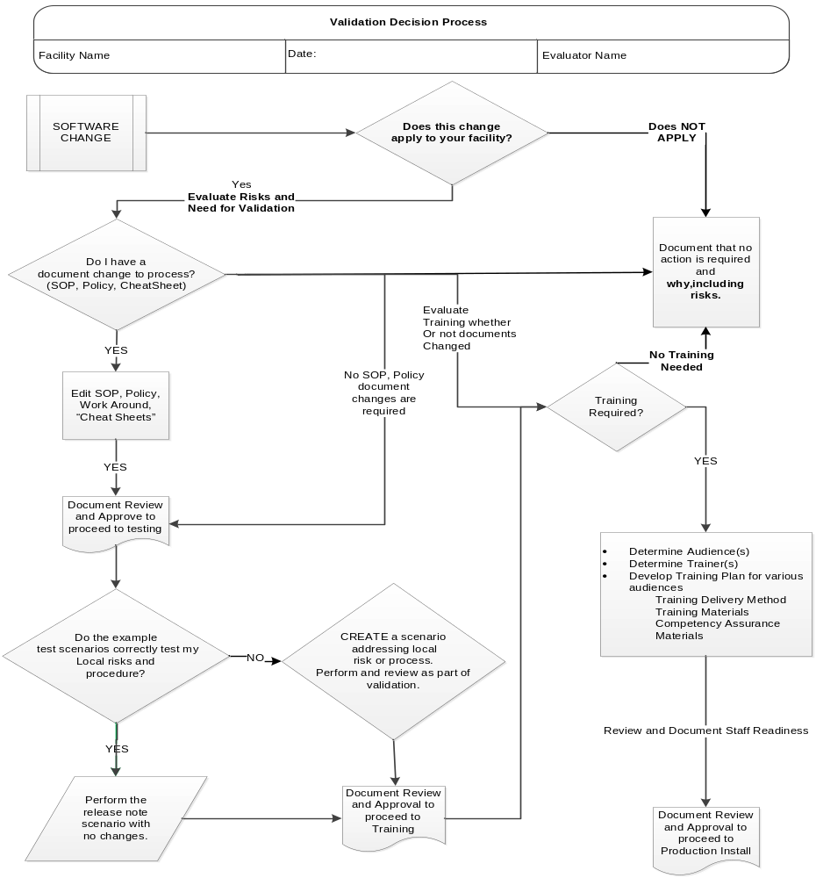

Table 1: Updates by Option (Non-Read-Only Site)
ID | Option | Problem Summary | Change Summary | Validation Scenario | Change applies to my facility. (Y/N) | Local risk Assessment  (Low, Med, High) | SOP revision required. If yes, identify it. | Staff training needed. (Y/N) | Scenarios or validation must be performed. (Y/N)
1 | Throughout VBECS | Added read-only access to VBECS | A VBECS site can be configured by OIT for read-only access to VBECS with disabled menu items, allowing no user initiated changes but remaining active for all report generations, inquiries, and access to all patient historical information (NSR 20210910). | Open VBECS.  Verify you can open Accept Orders menu option.  Verify windows do not contain “Read-Only” in the title bar or heading.
2 | Throughout VBECS | Added read-only watermark | All screens and printed reports indicate when the read-only option is in effect. | Open VBECS.  Open the Administrative Data report. Set the Start Date year to 2000 and view the report.  Verify the report does not contain “VBECS DATA IS READ ONLY” in the report header of any page.
3 | JLV | JLV continues to display VBECS data. | VBECS data remains accessible via JLV. (VBECS already supports JLV. No application change needed.) | If you have access to JLV, verify you can pull up the Blood Bank Report for any patient.  JLV is supported and maintained independent of VBECS by the JLV team. If you have issues accessing JLV, please refer to Logging Into JLV in the JLV User Guide for detailed information about how to access JLV. If you are still having issues accessing JLV, please contact the Enterprise Service Desk for assistance at 855-NSD-HELP or https://yourit.va.gov.
4 | Throughout VBECS | Continue to provide federal records compliance | VBECS data continues to be in compliance with Federal records and information management regulations. (VBECS already supports this. No application change needed.) | Validation not required
5 | Maintain Collection Facility | Allow all users to add new facilities | Permission to add a new collection facility has changed from Enhanced Supervisor (Level 5) to Blood Bank Technologist (Level 1). | This requires a Level-1 (Technologist) for validation.  Open VBECS.  Open Tools-> Local Facilities.  In the FDA number type 4444444.  Verify the form opens, allowing you to enter more fields. There is no need to save.
6 | Report Printing | Known defects and anomalies | - Clicking the 'Print' button for large reports while the report is loading no longer freezes the session and printer.  - No longer displaying a warning that the report will be longer than 50 pages. | Validation not required.
7 | Maintain Canned Comments | Known defects and anomalies | Canned comments now allow for up to 250 characters. | Validation not required.
8 | VBECS Help | Known defects and anomalies | - A typo on the Help About screen has been corrected.  - The VBECS Manufacturer Address on the Help About screen has been corrected.  - The Help menu correctly shows the shortcut "F1". | Validation not required.
 NOTE: The table below is for sites with the Read-Only setting enabled.

Table 2: Updates by Option (Read-Only Site)
ID | Option | Problem Summary | Change Summary | Validation Scenario | Change applies to my facility. (Y/N) | Local risk Assessment  (Low, Med, High) | SOP revision required. If yes, identify it. | Staff training needed. (Y/N) | Scenarios or validation must be performed. (Y/N)
1 | Throughout VBECS | Added read-only access to VBECS | A VBECS site can be configured by OIT for read-only access to VBECS with disabled menu items, allowing no user initiated changes but remaining active for all report generations, inquiries, and access to all patient historical information (NSR 20210910). | Open VBECS.  Verify that most menu options are disabled and those enabled only allow you to view/print/export data (i.e., you are not allowed to edit existing data).  Screens will contain “Read-Only” in the title bar or heading.
2 | Throughout VBECS | Added read-only watermark | All screens and printed reports indicate when the read-only option is in effect. | Open VBECS.  Open the Administrative Data report. Set the Start Date year to 2000 and view the report.  Verify the report contains “VBECS DATA IS READ ONLY” in the report header of every page.
3 | JLV | JLV continues to display VBECS data. | VBECS data is accessible via JLV when the read-only option is in effect. (VBECS already supports JLV. No application change needed.) | If you have access to JLV, verify you can pull up the Blood Bank Report for any patient.  JLV is supported and maintained independent of VBECS by the JLV team. If you have issues accessing JLV, please refer to Logging Into JLV in the JLV User Guide for detailed information about how to access JLV. If you are still having issues accessing JLV, please contact the Enterprise Service Desk for assistance at 855-NSD-HELP or https://yourit.va.gov..
4 | Throughout VBECS | Continue to provide federal records compliance | VBECS data continues to be in compliance with Federal records and information management regulations. (VBECS already supports this. No application change needed.) | Validation not required.
5 | Maintain Collection Facility | Allow all users to add new facilities | Permission to add a new collection facility has changed from Enhanced Supervisor (Level 5) to Blood Bank Technologist (Level 1). | The Local Facilities option is not available. Validation not required.
6 | Report Printing | Known defects and anomalies | - Clicking the 'Print' button for large reports while the report is loading no longer freezes the session and printer.  - No longer displaying a warning that the report will be longer than 50 pages. | Validation not required.
7 | Maintain Canned Comments | Known defects and anomalies | Canned comments now allow for up to 250 characters. | Validation not required.
8 | VBECS Help | Known defects and anomalies | - A typo on the Help About screen has been corrected.  - The VBECS Manufacturer Address on the Help About screen has been corrected.  - The Help menu correctly shows the shortcut "F1". | Validation not required.

Revision History
Date | Revision | Description | Author
4/4/24 | 1.0 | VBECS 2.4.0 Rev A  Initial version | BBM Team
4/25/24 | 2.0 | VBECS 2.4.0 Rev A  Updates from IOC testing. | BBM Team

This is the last page of VBECS 2.4.0 Release Notes.

